
United International University

Internship Report
On
Managing Value Delivery Network: A Study on Gemsclip.com

SUBMITTED TO:
Muhammad Hasan Al-Mamun
Assistant Professor
School of Business and Economics
United International University

SUBMITTED BY:
Proloy Kumer Das
ID: 111 172 023
BBA Program
School of Business and Economics
United International University

SUBMISSION DATE: 31 August, 2019


Managing Value Delivery Network

Acknowledgement

This would be one of my great opportunities to make a report with such a topic under a domestic organization. At first, I will thank to my Almighty and then the other people who gave me supports and guidance to prepare this report.

In my university life, I had the opportunities to attend many classes of many faculty members of my university. If I had to recall one of my best faculty I would say something about Muhammad Hasan Al-Mamun Sir. He has such a nice personality with proper guiding capacity and teaching method. Fortunately, I had the chance to have him as my internship supervisor. He has given me excellent supports and proper motivation to prepare the report.

Finally, I am thankful to my supervisor Ms. Tajema Islam, Senior Executive, Gemsclip.com. Without her supports it would have been difficult for me to get the relevant data. She was such a friendly mentor and motivator as well.

LETTER OF TRANSMITTAL

August 31, 2019
To
Muhammad Hasan Al-Mamun,
Assistant professor
School of Business and Economics
United International University

Subject: Submission of the Internship Report

Dear Sir,

With due respect, I have the honor to state that I am a student of Department of Business Administration. As a part of completing my BBA program I have to submit an internship report. Here I am submitting that report based on Managing Value Delivery Network of Gemsclip.com.

I have given my best efforts to prepare this report. It would be so kind if you consider my report with involuntary mistakes.

Sincerely Yours,
Proloy Kumer Das
Id: 111 172 023
United International University
Executive Summary

Bangladesh has great potential for the E-commerce platform as it is being digitalized. Thus the government has declared tax free purchases from online businesses. Here comes gemsclip.com. It started its business with that scope to fulfill all the necessity of office maintenance. There are lots of businesses organizations that need lots of items such as stationary, IT, pantry, cleaning. Gemsclip.com is trying to provide the smart solutions to those necessities. A company can purchase from local suppliers even from direct producer. But the company might face tax issues on the total yearly purchases. Moreover, they might have to purchase at MRP (Marginal Retail Price). Businesses now have become more specific, smarter, and convenient.
Gemsclip has mainly four departments. Business Development, Business Operations, Supply Chain Management and Credit Control. Business Development is the soul of that organization. They are the core promotional team and the responsible department those actually on board new clients and maintain profitable long term relationship with existing clients. They mainly focus on serving the clients as the agents of the organization. Supply chain management team works in two ways. One is purchase and another one is stock management. Along with that they deliver the ordered items to the client’s address. This team is fully involved in financial activities. They process the full data and finally input the whole transaction data as cash flows to the Accounting Information System. Gemsclip.com has dedicated Key Account Managers that serve on behalf of the organization. They always consider clients’ demands as top priority.

Key Words: Value Delivery Network, B2B

Table of Content

Si No | Contents |  | Page No
1 | Introduction | Topic in Hand | 8
1 | Introduction | Context of the Study | 9
2 | Organizational Background and Competitive Scenario | Organizational Background | 10
2 | Organizational Background and Competitive Scenario | Competitive Scenario | 17
3 | Objectives and Methodology of the Study | Objectives of the Study | 27
3 | Objectives and Methodology of the Study | Methodology of the Study | 27
4 | Limitations of the Study |  | 28
5 | Findings |  | 29
6 | Recommendations |  | 40
7 | Conclusion |  | 41
8 | References |  | 42

List of Figures
Figure No | Title | Page No.
1.1 | Value Delivery Process | 8
2.1 | Management Team Hierarchy | 11
2.2 | Product List | 13
2.3 | Customer Retention Rate | 15
2.4 | Core Strengths(Sindabad) | 17
2.5 | Website Home Page(Sindabad) | 18
2.6 | Types of Products(Sindabad) | 18
2.7 | Core Strengths(OfficeNeeds) | 19
2.8 | Website Home Page(OfficeNeeds) | 20
2.9 | Types of Products(OfficeNeeds) | 20
2.10 | Core Strengths(Daraz) | 21
2.11 | Website Home Page(Daraz) | 22
2.12 | USP of Gemsclip.com | 23
2.13 | SWOT Analysis of Gemsclip.com | 24
4.1 | Percentage Based on Limitation Criteria | 28
5.1 | Brief Process of Business Strategy | 29
5.2 | Client Engagement | 30
5.3 | Sample of Price Quotation | 31
5.4 | Sample of Purchase Order | 32
5.5 | Core Functions of Business Development | 33
5.6 | Sample of Delivery Challan | 34
5.7 | Core Functions of Business Operations | 35
5.8 | Core Functions of Supply Chain Management | 36
5.9 | Sample of Accounts Challan | 37
5.10 | Core Functions of Credit Control | 38

- Introduction
1.1 Topic in Hand:
Value delivery network works as a chain in any organization that leads to the addition of values through different departments or sectors of that particular organization. It may include the process from production to after sales service. All the employees from top to bottom are involved to maintain this network. Here we can find two parts in value delivery. One is external and another is internal. In External part we find three parties: Customer, Supplier and Distributors. And in Internal part there is the company or organization that leads the whole value delivery network. In this report we only discuss about managing internal part of the value delivery network system that means only the company.

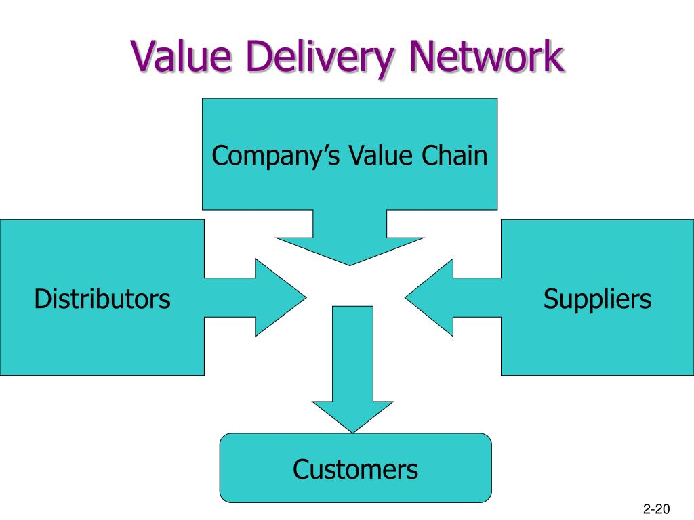

Figure 1.1: Value Delivery Process
1.2 Context of the Study:
Gemsclip.com is one of the leading B2B E-commerce platforms that is operating its business from 2017 in our country. Our government has given huge investment opportunities in the E-commerce sites to digitalize our country. It is more cost efficient and smarter way to just sit in the office and order through a computer click for the day to day office needs. Here I will discuss about the value delivery system of gemsclip.com.
- How the departments work to deliver values?
- In which way the employees contribute to the best output?
- How the departments co-ordinate with each other to provide the maximum values to the clients?
We will have the brief answers reviewing this report.

2.0 Organizational Background and Competitive Scenario

2.1. Organizational Background
Gemsclip is providing office supplies to Business Facilities through our E-Commerce platform. We sell hassle-free, cost efficient and totally transparent procurement service Gemsclip is a sister concern of eGeneration Ltd, the first listed software solutions company to go to IPO. Gemsclip.com was founded in 2017 as a sister concern of eGeneration Ltd (established: 2003).It was incorporated in 15th May, 2017 but was operational on a pilot basis from March of 2017.
INTRODUCTION
Bangladesh is on a digital stride. The country is overcoming newer challenges every day and striding towards its goal of the Digital Bangladesh. There are obstacles on the way, but only to make Bangladesh more agile in its race towards its dream. Under the leadership of the present government and its policy makers, the goal is now more achievable than ever. Bangladesh has become a wonder to the world with its achievements and successes. Taking Bangladesh forward in the digital front in the B2B sector in Bangladesh is eGeneration B2B Ltd-(Gemsclip).
OVERVIEW OF ORGANOGRAM

MANAGEMENT TEAM

Gemsclip is being led by Shameem Ahsan as Chairman; Faheem A Romi, Managing Director; Md. Kamrun Ahmed and Mirajul Haque, Co-founder & Director of Gemsclip.com. Currently, the organization employees 28 full-time employees with immediate expansion plans of recruiting 18 more employees to cater to growth. In the next page there is a brief chart of Management Team.

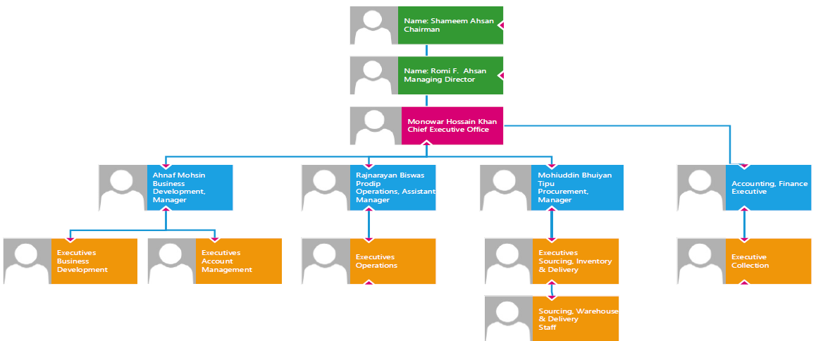

Figure 2.1: Management Team Hierarchy

KEY MANAGEMENT FIGURES

Here is brief overview of management team and the brains behind the organization. A team is the key determining factor to any organization’s success and our team is what differentiates us from other organization.
SHAMEEM AHSAN, CHAIRMAN
Shameem Ahsan is one of the foremost figures in the Bangladeshi ICT industry. Mr. Ahsan is an ICT entrepreneur, widely recognized for his work to improve the reputation of the Bangladeshi ICT industry in the global space. He has played a pivotal role in the implementation of numerous major policy changes related to the ICT sector in recent years. Mr. Ahsan playing an instrumental role through eGeneration brought in a Silicon Valley based venture Capital firm, Fenox Venture Capital, to Bangladesh. He is the General Partner of the VC and is also the only Bangladeshi based businessman who is a fund manager for a global company of such stature as Fenox, which is a 1.5-billion-dollar investment firm. He is also a Director of Agrani Bank, one of the largest banks in the country.
Notable Engagements:

- Best Young Entrepreneur Award from Prime Minister of Bangladesh
- One of the three most influential persons in Bangladesh. Tech sector according to Future Startup
- Member of Prime Minister's Digital Bangladesh Task Force, GoB
- Board Director, Agrani Bank Ltd.
- Board Director, Federation of Bangladesh Chamber of Commerce & Industry
- Former Chairman of Bangladesh Association of Software & Information Services (BASIS)
- Founder, TiE Bangladesh

KAMRUN AHMED, MANAGING DIRECTOR

Notable Experiences:
- Former CEO, BAGDOOM.com
- Chairman, BASIS Standing Committee on Digital Commerce

Key Achievements
- National ICT Award 2016 for Best Ecommerce
- JCI TOYP 2016 Award for Outstanding Contribution in Technological Development
- Best IT Use Award from the ICT Minister
- Award for Best eCommerce Website from BBJF

ROMI F. AHSAN, MANAGING DIRECTOR
Notable Experiences

- Founder & CEO of Red Velvet International Ltd. CEO of Topstar Fashion lnc.
- Director of V-Knitwear & Composite Ltd.

Key Achievements
- 10+ years’ experience in International Fashion Industry with veterans specialized in sourcing, product development and distribution
- Developed businesses with Global Brands such as Inditex (Zara), E| Corte Ingles and Citizen Watch co. in partnership with local business giants Babylon Group and Rangs

AHNAF MOHSIN, BUSINESS DEVELOPMENT MANAGER

Notable Experiences
- MNC Sales Experience working at British American Tobacco, Bangladesh
- Key Account Management experience working at Standard Chartered Bank, Bangladesh
- Project Management experience in restructuring functions and Performance Transformation at Banglalink Digital Services Limited (VEON)
- Management experience as Managing Director of Rainbow Enterprise (non-woven PP bag) in Chittagong Division

OUR PRODUCTS

Stationaries
IT & Electronic Products
Cleaning Supplies

Pantry Items

Figure 2.2: Product List

We are a procurement service provider procuring a range of products for our customers based on their needs. We provide products in following category: Stationary, Pantry, Cleaning, Electronics, Manufacturing Machineries & Raw Materials, Safety & Security Products and anything else that our clients inquire about. Currently, we are procuring over four thousand products with many more SKUs for our 60 corporate clients spread throughout the country.

BUSINESS MODEL
Gemsclip, country’s first ever B2B e-commerce service provider to include procurement tracking and easy reordering with bulk buy facility while also providing Key Account Managers to provide support to businesses with procurement needs. Their vision is to provide a B2B platform with a complete solution for all procurement needs, focusing on everyday office supplies. The aim is to provide our customers with the highest of convenience, with primary focus on simplifying supply hassles and serving the best of quality products, at the exact quantity and at an accurate time.

VISION
Gemsclip brings all that you need for your office or business at one place ensuring utmost transparency with a pick of 100% genuine products in one open platform with zero counterfeit chance and guaranteed cost efficiency. Organizations can now order virtually (online), get door-step delivery and buy in bulk to save. Already we are catering to a good number of renowned local and multinational companies, the numbers are increasing rapidly and accordingly sales prospects of our partnered products are increasing similarly. Gemsclip is working with the vision to transform and digitalizing the procurement industry of our country through technological innovation, transparency along with utmost priority to cost minimization.

AWARDS & RECOGNITIONS
The mission of Gemsclip is globalizing the retail industry of our country like Amazon, Alibaba, Staples etc. In its journey to that, Gemsclip has received several recognitions along the way. Gemsclip won ‘South Asian Business Excellence Awards 2017’ in ‘Start-Up of the Year’ category in 2017 followed by an even greater achievement by being selected ‘Winner of the World Summit Awards (WSA) Bangladesh’ in the category of Business & Commerce. Gemsclip is now competing to win the Global WSA awards with the hope of bringing further international recognition to the country and their business.
Categories of Product: (Current)
- Stationary
- IT
- Cleaning
- Pantry.


RETENTION RATE
Customers Retained 97%
Customers Lost 3%

Figure 2.3: Customer Retention Rate

INDUSTRY
We are currently serving the following industries: Healthcare, Education, FMCG, IT, Electronics, Real Estate, Marketing & other Agencies, Pharmaceutical and more. We provide our procurement service to local companies & MNC’s alike. We are especially attractive to MNCs because of the transparency we are able to bring to their procurement department and tracking of sourcing.

List of Prominent Clients:
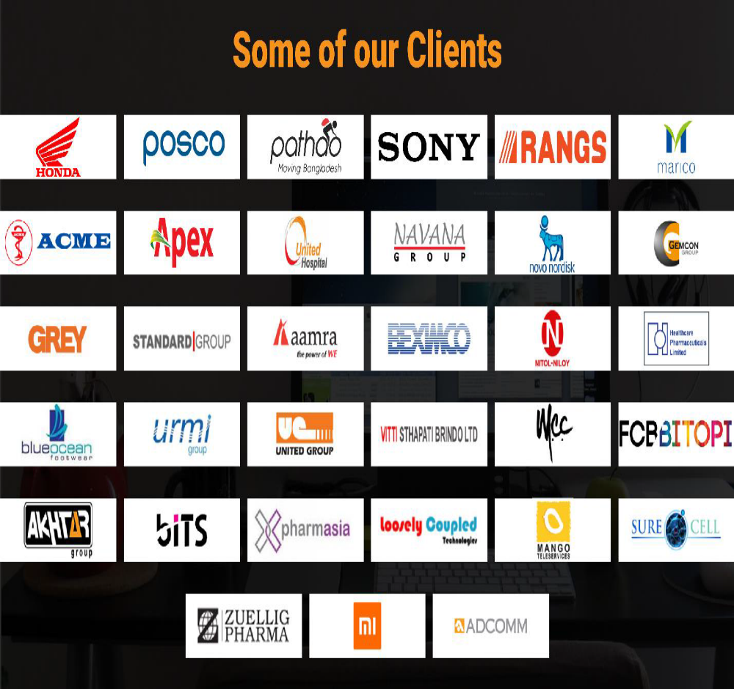

2.2 Competitive Scenario
In B2B E-commerce industry there are many participants those are competing with gemsclip.com. Here we will discuss only about B2B E-commerce platform those are serving day to day office needs with dedicated Key Account Managers. Some of them are:
A} Sindabad.com: It is a B2B e-commerce platform that facilitates office necessity purchases. It has started its journey in 2016. In the B2B online office supplies industry this website is in the top position. It mainly focuses on daily operational purchases like machines & spares, computer & IT, stationary & office and more for office and factory in our hands. It is serving 500+ customers. The main strengths are:

Figure 2.4: Core Strengths
It is now in the leading position in this industry. It offers variety of products.
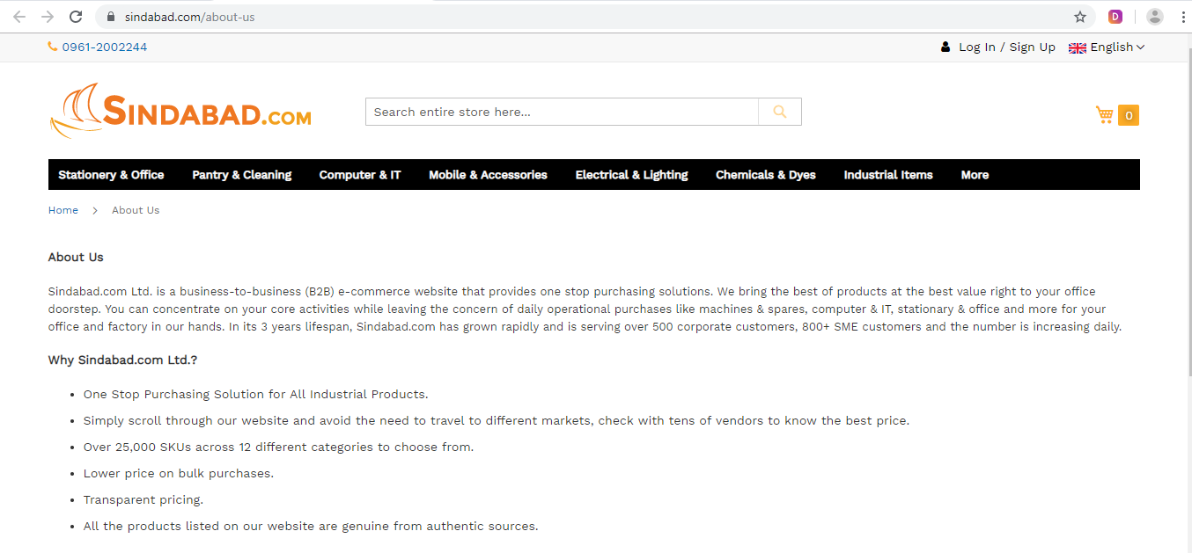
Figure 2.5: Website Home Page

It mainly focuses on day to day office needs like:

Figure 2.6: Types of Products
They have some delivery policies. They deliver within 3 to 4 business days. They do not provide any credit policies. Clients can return items within two days of delivery. And, they only take orders from website registration process.

B} Officeneeds.com.bd: It is an E-commerce shop from Triumph technologies limited. It provides every type of products that are necessary to run a business. The main Strengths are:

Figure 2.7: Core Strengths

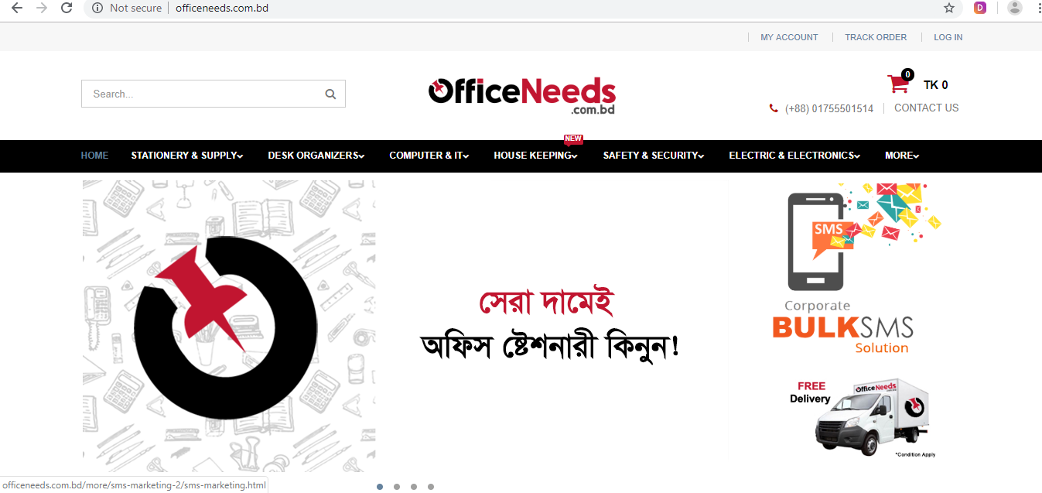

Figure 2.8: Website Home Page
Officeneeds.com is currently offering wide range of products.

Figure 2.9: Types of Products
Other than that they have some policies. There is brief information about delivery policy. They deliver their products within four working days. For outside Dhaka it may be longer up to 2-3 days. They deliver from Sunday to Thursday (10 am to 5 pm). Delivery charge is free of cost for orders over 2500 tk. And if the order amount is less than 2500 tk it will be 100tk. But, for outside Dhaka it will be minimum 500 tk regardless of the amount of purchase.
C} Daraz.com.bd: Daraz has recently started its journey as B2B office necessity supplier. Previously it was only B2C online shop. It is basically a Chinese owned online shop and logistics company that operates in south Asian market. Previously it provides day to day commodities and necessary products from different brands to the single consumers in our country. But now they started to compete in the B2B business. The core strengths of Daraz are:

Figure 2.10: Core Strengths

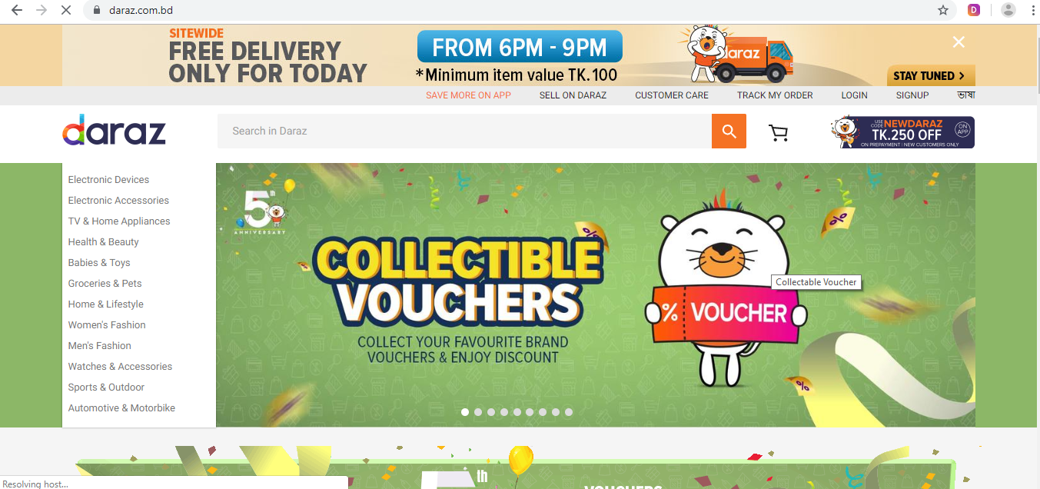

Figure 2.11: Website Home Page
Daraz.com provides cash on delivery, debit or credit and Bkash payments. Delivery timeline is given below.
- For Dhaka Metropolitan it is 1-3 working days.
- For Chittagong and Sylhet it is 2-4 days,
- And for other areas it is 2-5 days.

SWOT Analysis:
Gemsclip.com has its own unique selling proposition.
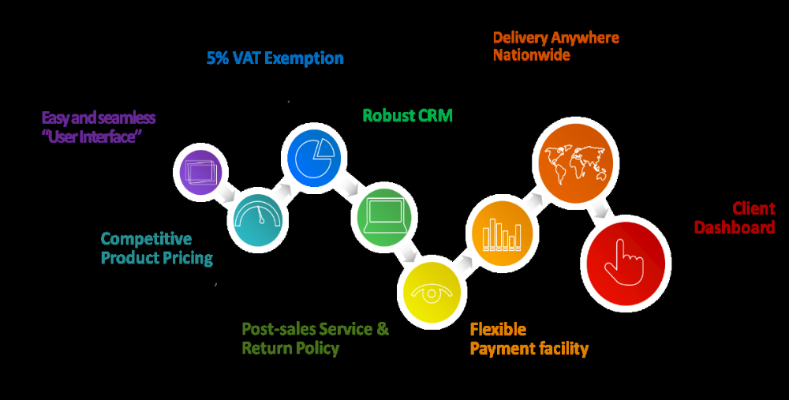

Figure 2.12: USP of Gemsclip.com
Easy and Seamless User Interface: Along with dedicated Key Account Manager it has easy to access and recognizable user interface.
Competitive Product Pricing: it collects products in most of the cases from direct producers like: bashundhara, Double A, Meghna Group etc.
5% VAT Exemption: Government has declared 5% VAT exemption for IT enabled platforms for promoting vision of Digital Bangladesh.
Post sales Service and Return Policy: After sale services especially for IT products and proper return policies for faulty products are given.
Robust CRM: Gemsclip.com tries to know its clients better than themselves through helping, tracking, analyzing, forecasting, targeting and upsell.
Delivery anywhere nationwide: delivery time predetermined and communicated( 12 to 72 hours) depending on product frequency level.
Flexible Payment Facility: Payments can be made on delivery through cards, Bkash, Rocket, cash. Credit terms are also used for regular customers.
Client Dashboard: Each client has personalized dashboard for tracking, forecasting and monitoring purchase information.
Based on the competitive scenario gemsclip.com has multi sided Strengths, weaknesses, opportunities and threats.

Figure 2.13: SWOT Analysis

Strength Chart based on Gemsclip.com
Gemsclip.com | Sindabad.com | Officeneeds.com | Daraz.com
Online Services | Yes | Yes | Yes
Dedicated KAM(Key Account Manager) | Yes | Yes | Yes
Complaint Management | Yes | Yes | Yes
Proper Delivery Service | Yes | No | No
Genuine Products | Yes | Yes | Yes
Professional Management Skills | Yes | No | No as less KAM
Lower Price | Moderate | Moderate | MRP
Saturday to Thursday Service | Yes | No | Yes
Delivery Charge | No | Yes | Yes

Weakness Chart based on Gemsclip.com
Points | Gemsclip.com | Sindabad.com | Officeneeds.com | Daraz.com
24/7 Services  Helpline | No | No | Yes | Yes
Holiday Services | No | No | No | Sometimes
Stock Management | Poor | Moderate | Moderate | Strong
Key Account Managers | Less for more clients | moderate | Less for more clients | moderate
Product Variety | 4 types only | Almost every types | Almost every types | Daraz is currently offering stationary and IT items as B2B

Opportunities and threats would be same for these B2B e-commerce platform those are serving day to day office needs. But Sindabad has huge investment and as a pioneer it will definitely gather few more benefits. On the other hand Daraz.com is more resource efficient and has strong brand familiarity.

3.0 Objectives and Methodology of the Study
3.1 Objectives of the Study:
There are several objectives those are interlinked with each other to prepare the report. But, the main objective is to complete the BBA degree submitting the report to the respective supervisor. Other objectives are given below.
- To learn how the value management system in an organization works.
- To know about the IT enabled B2B organization and industry where day to day office needs are fulfilled.
- Gathering information about Professional Key Management System
- Get acquaintance with Supply Chain and Stock management system.
- Being familiar with the credit management system.
- Familiarity with Vendor Management.
- And, finally how IT enabled B2B platform integrates its value system through different departments.

3.2 Methodology of the Study:
The data are sourced from different areas. Some are primarily sourced and some are sourced through secondary process.
In primary process I was solely involved with this organization. I got training on Business Operations and Client management. Apart from that, I attended some seminars and practical work presentation along with decision making projects. I talked with my supervisor, my line manager also.
Contrary in secondary process, I collected data from Gemsclip’s website, other industry related websites and a brief presentation file on Gemsclip.com.
Finally I figured out those information and prepared this report based on my own judgment.

4.0 Limitations of the Study
Here I have come with some challenges and limitations of this report. As B2B online sales especially for office necessities are not that much old idea it lacks huge information on websites. If we want to search for industry related information we could hardly find proper and accurate data. As part of the report I am going to mention some limitations of this report.

Figure 4.1: Percentage Based on Limitation Criteria

5.0 Findings
Gemsclip has mainly four departments. Business Development, Business Operations, Supply Chain Management and Credit Control. These four departments are the four pillars of this organization. In a brief I would like to discuss about the value creation and integration of these departments.

Figure 5.1: Brief History of Business Strategy
Here I will discuss all the parties and their actions briefly.
5.1 Client:
Clients are the 1st party those give Purchase Orders (PO) to Business Development team. Here clients are the organizations that require day to day office needs. One question may arise that how the clients know about Gemsclip.com. they gather information from different sources such as:

Figure 5.2: Client Engagement
They can be familiar with any of these ways. First of all they get a short presentation of the organization and its products along with terms and conditions. As they are convinced with the idea they demand for a basic Price Quotation. One thing to mention that there is person ( key contact person) from that particular client organization who basically deals with the KAM or gemsclip.com. he may be the procurement manager or officer.

5.2 Business Development:
Business Development is the soul of that organization. They are the core promotional team and the responsible department those actually on board new clients and maintain profitable long term relationship with existing clients. They mainly focus on serving the clients as the agents of the organization. When clients demand for price quotations, they prepare the quotation such a way so that the clients will be benefitted as well as company. The price will be higher than the purchase cost and lower than the MRP ( maximum retail price).
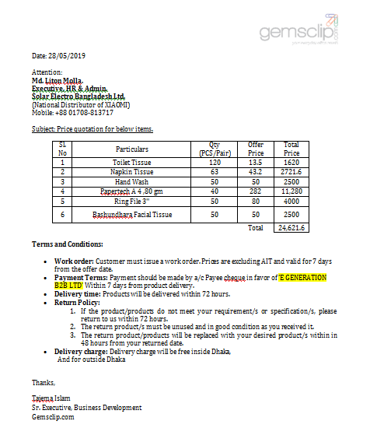
Figure 5.3: Sample of Price Quotation
When the clients get the price quotation, as they become convinced, they prepare a purchase order and provide it to dedicated KAM who is dealing with that client through mail or telephone call.
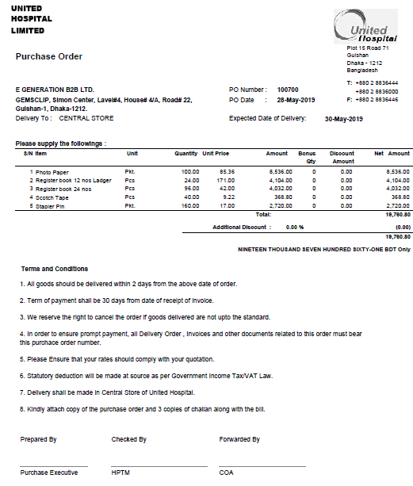

Figure 5.4: Sample of Purchase Order

When KAM get the mail they actually give a thank you receipt mail to the client and forward it to Business Operations as well as supply chain department. Here in gemsclip.com there are 6 dedicated KAM to serve about 65 clients.

Figure 5.5: Core Functions of Business Development

5.3 Business Operations:
In gemsclip.com business operations mainly focuses on order generation along with delivery challan editing. This portion incurs huge time as order generation is the process through which client demands are converted into company language. That means description of the products as clients demand are in most of the time not matched with the market. For example: clients demand for floor cleaner but in the market it is named as floor mop.
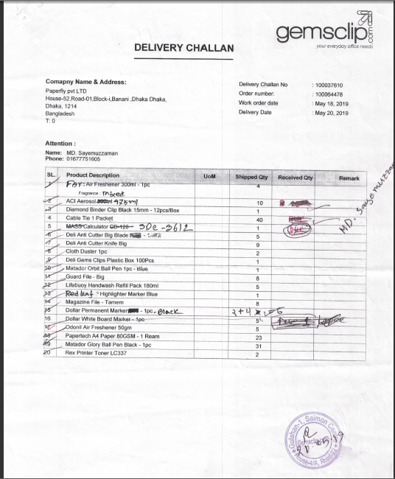
Figure 5.6: Sample of Delivery Challan
Again sometimes clients only demand about the product generic category like sugar, but do not mention the brand name. if not mentioned, operation team communicate with KAM and KAM finally contact with the clients. Gemsclip.com maintains an online excel sheet as database of the clients regular purchases. Business operation has the access to that and they basically generate the data with proper details. When it comes with the price of the product business operations communicate with KAM and mention the price while order generation. Order generation is the process that ends up with delivery challan creation. When the challan is created, it is forwarded to supply chain, so that supply chain can go for purchases. In gemsclip.com there is only one employee who is involved in order generation and editing.
Sometimes it is seen that editing is required as to match with actually delivered items. There are some possible reasons.
- Client did not receive his ordered quantity
- Supply chain failed to purchase full quantity, thus partial delivery done
- In between purchase and delivery customer requested to change the quantity or item
- Client may cancel the full order
- Sometimes, client may require a single delivery challan and bill copy for all the purchases
- When full delivery is done which was previously partially done

Figure 5.7: Core Functions of Business Operations

5.3 Supply Chain Management:
Supply chain management team works in two ways. One is purchase and another one is stock management. Along with that they deliver the ordered items to the client’s address.
Stock Management: When the purchase order mail comes to supply chain from KAM, they try to assure that is the stock enough to fulfill the requirements. If possible, they try to deliver the items from the stock. But there is strategy to maintain the stock the most regular demanded items are kept in stock here. Suppose most of the clients demand for Bashundhara Facial Tissue. It will be kept in stock in huge quantity. There is a manager who is solely involved in stock management process. Sometimes refunded items are kept in the stock as to resell to other clients.

Figure 5.8: Core Functions of Supply Chain Management

Purchase management: When it comes for purchases supply chain follows a rule. Suppose a client has given the order before 12 pm on a particular day. Supply chain would consider it as on that day’s order and will go for purchases. That means after 12 pm supply chain go for purchases. There is a van and some purchase men. They mainly purchase from old Dhaka and Gulshan DCC market area (for urgency). When the purchase is complete, they bring all the items to warehouse and calculate the cost per each item.
Delivery: there is a delivery time written in the conditions. 72 hours or three working days are considered as the maximum delivery time. But, in most of the cases clients order on urgent basis. Here supply chain faces a huge challenge due to resource problem. Some clients might want the required items on the order day or the day after the order day.

On that case supply chain has to deliver on priority basis. Priority can be set in many ways.
- Client’s Importance
- Clients Bulk Size
- Delivery Location
- Client’s Urgency
When the delivery is done, contact person or client is given two copies of delivery challan. He signs both copies and give one copy to the delivery boy.
Accounts Challan: As delivery is fully complete delivery boy submits the signed and sealed delivery challan to the supply chain office. Here is a dedicated person as financial officer in the supply chain who prepares the accounts challan for that particular delivery. This challan includes only the item names, quantity and all the respective cost of that delivery including purchase and delivery. A sample of accounts challan is given on the next page.
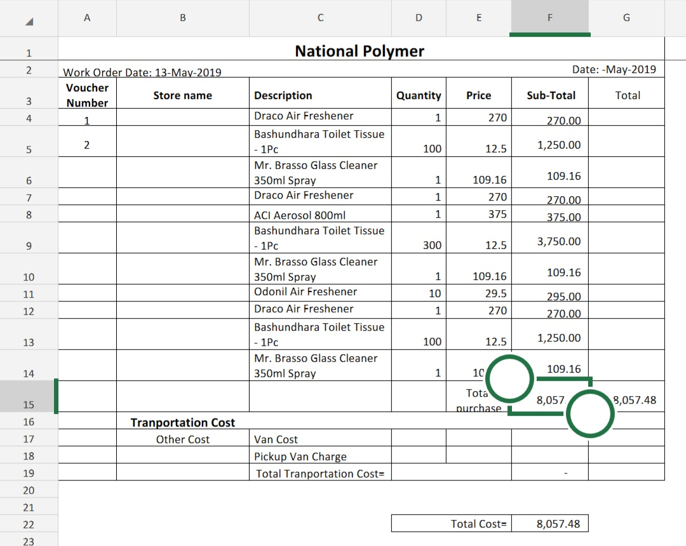

Figure 5.9: Sample of Accounts Challan

This accounts challan is sent to the Credit Control team for bill preparation.
In gemsclip.com there are 12-14 delivery boys (also involved in purchases), One purchase officer, one financial officer, one IT product executive, three supply chain officer and two inventory executive. Two managers basically manage full team. One is for purchase and another is for stock management and procurement.
5.4 Credit Control:
This team is fully involved in financial activities. They process the full data and finally input the whole transaction data as cash flows to the Accounting Information System. When they get the accounts challan from the supply chain, they start to prepare bill for the client.

Figure 5.10: Core Functions of Credit Control
They process cost in one hand and in other hand the offer price, in which customer was convinced to buy. Here they basically prepare the bill only for actual delivered items with the offer price. Then they send the bill to the client’s office by post, physical visit, or mail. Then clients cross check the bill and submit it to the client’s accounts office. In between that there is a time gap. Credit control team is to give follow up call to clients for the bill payment. Thus they are also directly involved in client communication. Here are two dedicated employees in this department to prepare bill and follow up. And they also collect the payment. After collection the bank checks are kept as record. One person is here as financial executive to maintain the whole data after all the collections. He mainly processes the accounts challan and collection data and finally manages the cash flows.
The credit control team faces some challenges also:

- Payment Delay
- Rude Behavior from Clients
- Payment Mitch match
- Actual Delivery not matched with Prepared Delivery Challan
- Excessive Outflow in Cash

Tax Savings (Mushok Challan): It basically refers to the tax that the clients pay to the government on the basis of their purchases. But in E-commerce platform there is no tax to be paid. Credit control team provides bill with a delivery challan and a Mushok Challan. This Mushok Challan works as a tax saver.

6.0 Recommendations: B2B E-commerce platform does mean the online purchase order creation and selling to the business organizations only. Business to business transactions occur here. But gemsclip.com is somehow different. They basically registered themselves as E-commerce platform due to provide the tax benefits to the clients. This works as USP for e-commerce platform. Thus the whole process must be digitalized. From the findings I would like to recommend some key points for gemsclip.com.
- Business Development team receives the purchase orders through mail, whereas, clients should order their required items from website. They should have the proper access to visit the website as account holder and could order observing the offer price.
- The system which is used by operation team to generate orders is very critical to use. Sometimes it lags, sometimes multiple orders cannot be generated at a time. System must be up grated and monitored properly.
- Supply chain faces many challenges as most of the clients have urgency in delivery. Thus the clients should be managed in such a way so that their expectations can never be increased
- In some cases the employees have to do multi tasks like: Operation team is going for collections, preparing bills. There is no specific job description for the employees.
- Digital marketing is a vital part of promotion now-a-days. Gemsclip.com does not have such kind of efficient people to manage this marketing strategy.
- Sometimes it is seen that, clients are ready to make payments, but due to less employees the checks cannot be collected instantly.
- Finally, this organization does not follow proper stock management. It occurs due to excessive cash outflows. Most of the cash are kept in the client’s credit policy. Gemsclip.com might be strict to maintain the credit policies.

Conclusion
Gemsclip.com is a E-commerce platform that facilitates only the offices. An organization has regular needs to maintain the office functions. Gemsclip.com has come here and provides door to door delivery service. It has more efficient development team that communicates with the clients and keep long term relationship. This is necessary to be more professional in corporate sales. Gemsclip.com has achieved the faith of the clients and served them as well. There might be some recommended aspects, but as gemsclip.com is a newer addition to Bangladesh digital platform it will develop itself as time passes.

References
- Products, Types of. 2019. All Categories. Retrieved August 21, 2019 from http://www.gemsclip.com/
- Strengths, Core. 2019. About Us. Retrived August 21,2019 from https://sindabad.com/about-us
- Products, Types of. 2019. All Categories. Retrieved August 21, 2019 from https://sindabad.com/
- Strengths, Core. 2019. About Us. Retrived August 22,2019 from http://officeneeds.com.bd/about-us
- Products, Types of. 2019. All Categories. Retrieved August 21, 2019 from http://officeneeds.com/

