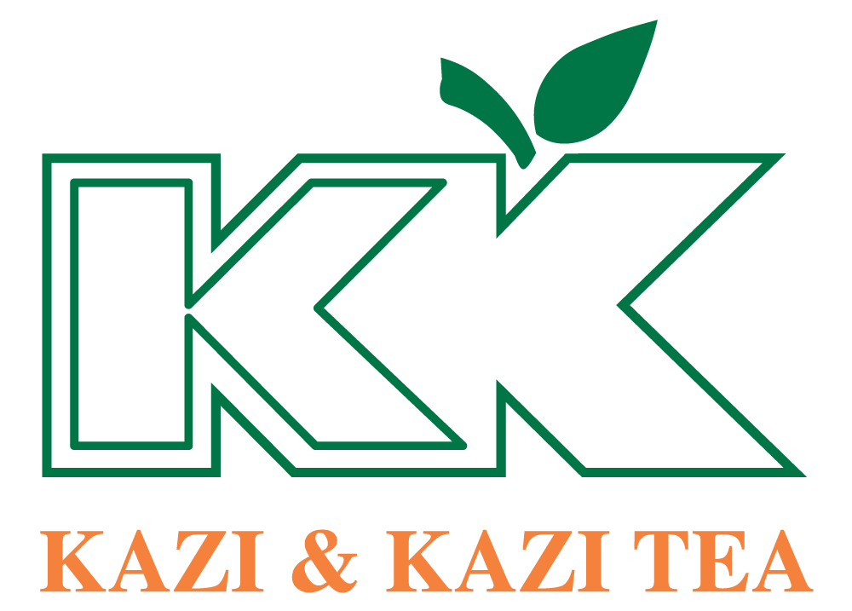

How HR Adds Value in Factory Operations: A Case Study on Kazi & Kazi Tea Estate Ltd.


Internship Report On
How HR Adds Value in Factory Operations: A Case Study on Kazi & Kazi Tea Estate Ltd.
INT 4399

Prepared for
Nasrin Akter
Assistant Professor
School of Business & Economics
United International University

Prepared by
A.S.M. Zabin Sazzad
111191096

August 2, 2023
United International University

Letter of Transmittal
August 2, 2023
Nasrin Akter
Assistant Professor
School of Business & Economics
United International University

Subject: Submission of internship report on "How HR Adds Value in Factory Operations: A Case Study of Kazi and Kazi Tea."

Dear Ma’am,
I am pleased to submit my internship report on "How HR Adds Value in Factory Operations: A Case Study on Kazi and Kazi Tea." as part of the requirements for the completion of my internship program at Kazi & Kazi Tea Estate Ltd. In-depth study of HR's contribution to improving factory performance is provided in the report, which also shows HR's options for enhancing organizational value.
I am also pleased to do my internship with your guidance. The study goes into detail about the HR practices that support these goals and how they affect the achievement of the organization.
I am grateful to my supervisor of Kazi & Kazi Tea Estate Ltd.-PU Office team members and would like to thank Md. Faruk Hossan, Assistant Manager of HR & Admin, Kazi & Kazi Tea Estate Ltd., Md. Latiful Kabir Mamun (Manager, Operations & HR) for supporting & instructing me to learn about the HR practices in Kazi & Kazi Tea Estate Ltd.
I'm hoping that this study will be useful in shedding light on important issues, helping to advance efforts to strengthen HR procedures and raise factory productivity. If you have any inquiries or need additional information, please let me know.
Thanks for your consideration.
Sincerely
A.S.M. Zabin Sazzad
111191096

Declaration of Student
I am A.S.M. Zabin Sazzad and my id is 111191096. I am a student of the BBA department with a major in Human Resource Management at the School of Business & Economics of United International University. I acknowledged that this report has been created in my own words and I have created it from the practices and knowledge which I learn from my workplace. I also confirmed that I am the only one who has created this report on my topic.
I declare that all the information presented in this report is accurate and based on my personal experiences and observations during my internship at Kazi & Kazi Tea Estate Ltd. Any references, citations, or sources used in this report have been duly acknowledged.
I affirm that this report has not been submitted for any other academic or professional purpose, and it is solely prepared for the fulfillment of the requirements of my internship program.

Sincerely Yours,
A.S.M. Zabin Sazzad
111191096
BBA in Human Resource Management
School of Business & Economics
United International University

Acknowledgment
To begin with, let me thank Almighty Allah for giving me the capacity to produce such a memorable, important, and successful report.
I want to express my sincere appreciation and respect to Nasrin Akter, an assistant professor at United International University's School of Business and Economics. She was a great mentor to me and gave me all the tips and direction I needed to complete this report for a temporary position.
I also thank my organizational supervisor, Md. Faruk Hossan, Assistant Manager of HR & Admin in Kazi & Kazi Tea Estate Ltd - PU. His instruction & guideline helped me to understand the official environment and HR culture in Kazi & Kazi Tea Estate Ltd – PU. He also helps me to complete my report & internship journey smoothly with his fantastic concept, cooperation & data collection.
Additionally, I would like to point out to you that despite my best efforts to ensure accuracy, faults may nonetheless have sneaked into this report. Any errors, please accept my heartfelt apologies.

Executive Summary
This internship report is based on the "How HR Adds Value in Factory Operations: A Case Study on Kazi and Kazi Tea." topic. United International University requires this report for the bachelor's degree.
The factory's performance and efficient operation are greatly dependent on the HR department. To prevent operational disruptions, HR makes sure that the plant is sufficiently filled with trained personnel through strategic workforce planning and recruitment. Additionally, HR places a strong emphasis on talent development and training, giving the workforce the ability to adapt to new technology and uphold high standards in tea manufacturing.
A happy work environment is a result of HR's efforts to increase employee motivation and engagement, which raises productivity and quality in industrial operations. HR aligns the efforts of manufacturing workers with corporate objectives by developing performance management systems that assist identify areas for improvement and offer chances for skill development. Additionally, HR is essential for assuring adherence to labor rules and regulations, reducing legal risks, and upholding a favorable employer-employee relationship.
In general, Kazi & Kazi Tea Estate Ltd.'s HR function contributes value to factory operations by strategically managing the workforce, cultivating talent, encouraging employee engagement, putting performance management tools in place, and guaranteeing compliance. By concentrating on these areas, HR helps the plant run more successfully and efficiently, allowing it to produce high-quality tea and keep a competitive edge in the market.

Table of Contents
Letter of Transmittal I
Declaration of Student II
Acknowledgment III
Executive Summary IV
Chapter 1: Introduction 6
1.1. Introduction of the topic 7
1.2. Scope of the report 7
1.3. Objectives of the report 8
1.4. Methodology 8
i. Primary data: 8
ii. Secondary data: 9
1.5. Limitation of the report 9
Chapter 2: Literature Review 10
2.1. Value Addition 11
2.2. How Value-Addition Helps an organization 11
2.3. Contribution of HR in Factory Management and Cost Reduction 13
2.4. How HR contributes development of organization 14
Chapter 3: Organizational Overview 16
3.1. About Kazi & Kazi Tea Estate Ltd. 17
3.2. Mission, Vision, and Values: 17
3.3. Products Categories: 17
3.4. Sustainable Practices: 18
3.5. Factory Operations: 18
3.6. Kazi & Kazi Tea Packaging Unit: 18
3.7. Corporate Social Responsibility (CSR): 19
Chapter 4: Analysis 22
4.1. Analysis 23
Chapter 5: Findings, Conclusion & Recommendation 28
5.1. Findings: 29
5.2. Recommendations: 31
5.3. Conclusion: 32
Bibliography AA

Chapter 1: Introduction

Introduction of the topic
To ensure an organization's profitability and efficiency, human resources (HR) play a critical part in manufacturing operations. Implementing efficient rules and processes, managing, and training the personnel, and fostering a great workplace culture are all responsibilities of HR departments. HR is crucial in the context of factory operations because it maximizes employee performance and efficiency.
Kazi & Kazi Tea, known for producing high-quality tea, is aware of the value of HR in its factory operations. For the business to achieve its objectives and keep a competitive advantage in the market, having a trained and engaged workforce is crucial. To maximize the value HR provides to its manufacturing operations, Kazi & Kazi Tea focuses on HR procedures that improve employee engagement, talent acquisition, training and development, performance management, and general employee well-being.
This internship report explores the subject of "How HR Adds Value in Factory Operations: A Case Study of Kazi and Kazi Tea." The purpose of the report is to examine the unique HR strategies used by Kazi and Kazi Tea and how they affect the factory operations of the company. This research aims to offer insights into the way HR contributes to the general success of the factory operations at Kazi and Kazi Tea by a thorough review of the company's HR strategy.
The focus of this internship report is "How HR Adds Value in Factory Operations: A Case Study of Kazi and Kazi Tea." The purpose of the report is to examine the unique HR strategies used by Kazi and Kazi Tea and how they affect the organization's manufacturing processes. This research aims to offer insights into the way HR contributes to the overall success of the factory operations at Kazi and Kazi Tea through a review of the company's HR initiatives.
This report's main objective is to clarify the role of HR in the production process and offer suggestions for further enhancing HR procedures at Kazi and Kazi Tea. Kazi & Kazi Tea may continue to improve its HR strategy by utilizing the conclusions and suggestions from this research, ensuring a trained and motivated workforce that contributes to the expansion and accomplishment of the company's factory operations.

Scope of the report
The scope of this internship report on "How HR Adds Value in Factory Operations: A Case Study on Kazi and Kazi Tea Estate Ltd." is centered around examining the specific HR practices employed by Kazi and Kazi Tea and their impact on the organization's factory operations. The report focuses on several key areas within HR management that contribute to adding value to factory operations.

Objectives of the report
There are two types of objectives in the report. They are Primary Objective & Secondary Objectives.
- Primary Objective
The primary objective of the report is to evaluate the influence of various HR practices used by Kazi and Kazi Tea in their factory operations on the effectiveness and productivity of the organization.
- Secondary Objectives
- To evaluate the company's activities for employee engagement and the effect they have on industrial workers' motivation and happiness.
- To assess Kazi and Kazi Tea's training and development programs and how well they work to improve the knowledge and abilities of production workers.
- To review the steps taken by Kazi and Kazi Tea to give employee safety and well-being a priority in the factory.

Methodology
A research study's ability to be completed successfully depends on the consideration of an appropriate and effective technique. I used both primary and secondary sources of information to successfully prepare this report. I combined and assessed the information I had to produce this report.
Data collection: Relevant data and information were gathered from a variety of sources, including corporate records, studies, and published literature on human resources procedures in the industrial sector. Here are the two different methods I used for collecting data:

Primary data:
Primary data was gathered through internships, interviews with managers, seniors, and employees from other departments, as well as through my personal observations of routine functional and operational duties. My supervisor was able to provide me with the additional information I needed to finish my internship report.

Secondary data:
I also collect data from several secondary sources. Like –
- Kazi & Kazi Tea Estate Ltd. Official Website
- Gemcon Group HR Service Manual
- Kazi & Kazi Tea Estate Ltd. – PU Production Manual
- Different Types of Journals, News & Websites
Data Analysis: The quantitative and qualitative data that were gathered were both evaluated utilizing the right methods of analysis. A thorough understanding of how HR contributes to industrial operations has been made possible by the themes and patterns that have been found.
Cross-functional Collaboration: Working with HR experts, factory managers, and other relevant stakeholders enabled the development of a comprehensive understanding of the influence of HR on factory operations. Through conversations and feedback, this method made sure that various points of view were considered.
Report Compilation: To provide a comprehensive knowledge of how HR provides value to factory operations at Kazi & Kazi Tea Estate Ltd., the analysis findings were combined and organized. The study was put together with an emphasis on essential ideas, advantages, and suggestions for improving HR procedures in the plant.

Limitation of the report
Though I have tried to make a good internship report, there have also been some limitations regarding the data collection.
- The report is based on data that was available during the internship program, which may have access and availability restrictions. Some information and insights might not be available right once or might need to be verified further.
- The depth and breadth of the study may be constrained because the report is focused on a narrow window of time during the internship program. It's possible that factors and developments that happened after the internship time weren't adequately considered.
- The report is based on observations made during the internship program and self-reporting. The ability and desire of employees and supervisors to offer accurate and thorough data determine the correctness and dependability of the information they supply.

Chapter 2: Literature Review

Value Addition
Value addition is the process of increasing the worth of a good, service, or resource by adding new elements, making changes, or changing it in some way. It entails going beyond a product or service's fundamental or original form to produce something that provides users or consumers with more advantages or utility. Value can be added at multiple different stages of the production and delivery process, including design, manufacturing, packaging, marketing, and customer service.
The phrase "value-added" in economics refers to the distinction between the price of commodities and the cost of the resources utilized to produce them. It is computed by taking the price of the products and services a company bought from other companies and subtracting it from its overall sales. This price includes profit as well as labor, salaries, interest, depreciation, rent, and taxes. (Vedders, 2022)
Value added is the process of increasing a product's economic worth by altering its location, time, and form features to ones that are more valued by customers. Producers should consider themselves employees of a food company that processes and sells goods to customers. (Coltrain, Barton and Boland, 2000)
Value-Add is a term used to describe special improvements added to a product or service to increase its monetary value and desirability to consumers. It is often used to distinguish a product from competitors or increase profit margin by finding new uses for staple goods and services. (Ward, 2023)

How Value-Addition helps an organization
Matthews explores organizational value models and libraries' traditional value creation strategies. He discusses the 5C's in the current information environment, including content creation, digitization, online portals, user-contributed content, knowledge management platforms, self-publishing, and social content. (Bartlett, 2016).
Employee engagement is all about a worker's emotional and intellectual commitment to a workplace community. An engaged employee is always eager and fully involved in the duties given to them. (Falcon, 2006). Talented individuals will contribute more when they feel valued, which will help the organization achieve its goals. It enables them to feel acknowledged, respected, and inspired while also being in line with the goals and objectives of the firm. (Davies & Davies, 2010).
According to a survey conducted by the Society of Human Resources Management in 2012, talent management enables all employee levels to be focused on generating revenue, which will lead to increased employee engagement, better performance, happier customers, and a decrease in turnover and absenteeism. These effects will all influence the organization's bottom line.
Many organizations placed a high focus on retaining talented individuals, and doing so is what makes human capital management unique. The difficulty of keeping talent as major corporations compete in the international markets is present today. (Schuler et al., 2011; Scullion et al., 2010; Tarique &Schuler, 2010).
According to 75% of chief executive officers, managing organizational talent is their top responsibility. (CIPD, 2010). The success of an organization's strategy depends increasingly on people, intellectual capital, and skill. (Frank & Taylor, 2002). Talent management is a technique to increase organizational capabilities through performance management, talent development, succession planning, and career planning, all of which finally result in organizational success. (Iles, 2007).
The "everybody counts mantra" is an overly simplistic view of organizational talent since employee talents and competencies provide value to the organization in varied degrees. In the end, talent management is different from other human resource strategies in this regard. Identification of the key designation arrangements that have the potential to differentially affect the organizational competitive advantage and subsequent filling of them with "A performers" are the two main goals of talent management. (Huselid et al. 2005).
Organizations realized that employing people management strategies that are strategically matched will aid an organization in accomplishing its objectives. Because of this, 73% of American executives concur that the business strategy and people management process work well together to ensure the success of the firms. (Ramstad & Boudreau, 2007).
Employees are a terrific method to provide value to a firm by offering it a competitive edge in today's knowledge-based market. Most researchers claim that knowledge workers are adept at solving everyday issues while being flexible enough to adapt to changes in the business environment. The organization's performance and productivity have increased as a result. (Davenport et al., 2002). It's crucial to offer opportunities for talent development that are based on business needs and competency standards. Employee competency and attitude development as well as improved organizational performance are all made possible by high-quality talent management (Abel, 2008).

Contribution of HR in Factory Management and Cost Reduction
It has been recognized in earlier studies (Blasco and Moya, 2002; Cristobal, 1996) that efficiency measures can be used to assess the performance of diversified organizations. Productivity (Quirós and Picazo, 2001; Ferrel and Hartline, 2006), is defined as the ratio between inputs such as the number of employees, and outputs such as the number of units produced or sold for a specific good or service (Hansen, 2007), is the most notable metric for gauging efficiency in the service sector. As a gauge of organizational productivity, the logarithm of revenue per person is also frequently utilized (Ichniowski and Prennushi, 1996). Utilizing the logarithm of net income per employee is another method for measuring productivity. (HUSELID, 1995). (Halima Begum, 2020)

The knowledge of workers and their productivity will be a 21st-century institution's most asset, whether it be a business or non-business, according to Drucker (1999a). Increased productivity of knowledge work and knowledge workers is, in Drucker's words (1999b), "the most important contribution management needs to make in the 21st Century." Human capital encompasses an organization's know-how, capabilities, skills, and expertise, influencing its performance through collective interaction. It includes individual capabilities, knowledge, skills, and experience relevant to the task, as well as the capacity to add to this reservoir through individual learning. (Sujata Priyambada Dash, n.d.)
The HR function plays a crucial role in manufacturing enterprises, ensuring efficient payroll, administrative duties, and liaison between management and employees. It plays a vital role in recruiting the right talent, handling training, and ensuring readiness for work. HR teams also manage benefits administration, evaluate overtime work, and ensure fair compensation. Reporting is essential for maintaining equipment efficiency and adherence to workplace safety guidelines. With increasing demands and investment interest, the industrial sector requires a full-fledged HR department for organizational success. HR plays a multifaceted role in intergenerational employee experiences, diversity and inclusion, workplace safety, and contractor management. HR management in the industrial and manufacturing industry needs more consideration and care than ever in the current dynamic global market. (Nagendran, 2023)
Organizations should prioritize finding, keeping, and using great people to cut expenses. HR can speed up hiring, onboarding, and employee engagement by utilizing digital technologies including robotic process automation (RPA), artificial intelligence (AI), voice-first solutions, and social media. Regular staff guidance and training can lower attrition and boost productivity. Automating repetitive processes can be a cost-saver, but businesses often miss out on 50% of all automation opportunities. Promoting talent mobility is crucial, but hiring external talent can be expensive and more time-consuming. Consolidating discretionary activities, such as office parties and team outings, can help optimize external resources and reduce costs. By focusing on these areas, organizations can reduce costs and improve overall performance. (Giri, 2021)

How HR contributes development of organization
Organizational development (OD) focuses on enhancing productivity, effectiveness, efficiency, and knowledge inside an organization; hence HR and OD are closely associated. HR focuses on developing and managing employees, while OD focuses on improving individual and team skills. Both OD and HR aim to enhance a company's efficiency by working together. OD is strongly tied to human resource activities like hiring, paying, providing benefits, performance management, and employee relations. HR's direct relationship with OD helps them understand the company's needs and act, accordingly, ensuring efficient organizational development.
HR can significantly contribute to corporate strategy development by addressing human capital constraints and talent limitations and organizational flexibility. This can help firms overcome constraints and enhance their ability to execute their strategies effectively. (Mohrman, 1998)
The HR system is a strategic asset, consisting of scarce, appropriable, and specialized resources that give a firm a competitive advantage. A well-developed HR system is an "invisible asset" that enhances a firm's capabilities by embedding it in its operational systems. This interpretation aligns with Prahalad and Hamel's emphasis on core competencies, which are people-embodied skills. HR focuses on the level of practice, but the best practice effect is more likely to be in the "architecture" of a system. High-performance work systems have characteristics like employee performance being valued and rewarded, which have a generalizable effect on firm performance. The best HR system architecture may exist, but individual practices must align with each other and be consistent with the HR architecture to influence firm performance. Case studies of Lincoln Electric and Hewlett-Packard demonstrate that companies with different HR practices can have similar HR architectures, such as linking pay to desired behaviors and performance outcomes.
Researching diverse business units with different objectives may shift researchers away from a standard metric. HR practices may contribute to profitability but not growth, and if defined solely by profitability or growth, an empirical study may find little relationship between HR and unit performance. (Becker and Gerhart, 1996)

Chapter 3: Organizational Overview

3.1. About Kazi & Kazi Tea Estate Ltd.
Kazi & Kazi Tea Estate is Bangladesh's first internationally recognized organic tea producer. The best quality tea is produced naturally in its own garden using organic fertilizers made from dung obtained from cooperative dairy and organic pesticides produced by herbs, which play an important role in preserving the biodiversity of nature.
The journey started in 2000. In the meantime, it has been recognized internationally as the first 100% organic tea producer in Bangladesh certified by NOP/USDA, EU, JS, Rainforest Alliance, Fair Trade, and HACCP.
Their flat tea estate is in Tetulia, the northernmost district of Panchagarh, Bangladesh, just 50 km south of Darjeeling. To maintain the natural organic processes of their garden, their tea production process uses neem-based bio-pesticides and dung-based organic fertilizers which are eco-friendly. They manage and market both forward and backward operations. They are known as "single garden tea" as their tea is not mixed with any other garden tea.
With its several significant advantages, Kazi & Kazi Tea has a rich flavor and heavenly aroma in every sip. They are driven to manufacture premium organic tea to satisfy rising domestic and international demand. Only top-tier tea is exported by them to nations throughout the world, including the USA, UK, Japan, and Germany.
In addition to making tea, they are driven to uphold social responsibility.

3.2. Mission, Vision, and Values:
The obvious aim of Kazi and Kazi Tea is to deliver the highest caliber tea to customers while advancing fair-trade and sustainable business methods. Both within the business and the communities in which it conducts business, the organization is dedicated to preserving moral principles, environmental stewardship, and social welfare.

3.3. Products Categories:
Black tea, Green Tea, hite tea, Masala Tea, Ginger Tea, Orthodox Tea, Family Pack, Bai-mu-dan Tea, and specialty blends are among the many tea products that Kazi and Kazi Tea offer. To ensure great flavor and aroma, the firm only purchases its tea leaves from prestigious tea gardens. Kazi & Kazi Tea strives to provide its consumers with a distinctive tea experience by focusing on organic and natural growing techniques.

3.4. Sustainable Practices:
Kazi & Kazi Tea supports sustainable practices throughout all aspects of its operations because it is an ecologically conscientious company. The business emphasizes biodiversity preservation, organic farming methods, and a reduction in chemical use. To guarantee fair salaries and better living conditions for tea workers and farmers, Kazi & Kazi Tea also promotes fair trade practices.

3.5. Factory Operations:
To ensure the manufacturing and processing of high-quality tea, the company's factory operations are essential. The plant for Kazi and Kazi Tea is outfitted with cutting-edge equipment and adheres to stringent quality control standards throughout the whole production process. The business makes use of educated professionals who are knowledgeable in the art of processing tea, guaranteeing the retention of the tea's original flavor and aroma.

3.6. Kazi & Kazi Tea Packaging Unit:
Kazi & Kazi Tea Estate Ltd.’s Packaging Unit is situated in Ramchandrapur, Beribadh, Mohammadpur. After processing the tea, it reached the packaging unit for processing as a finished good. There are 3 processing rooms in the factory & Office & the rooms are the Production Room, Machine Room & Storeroom.
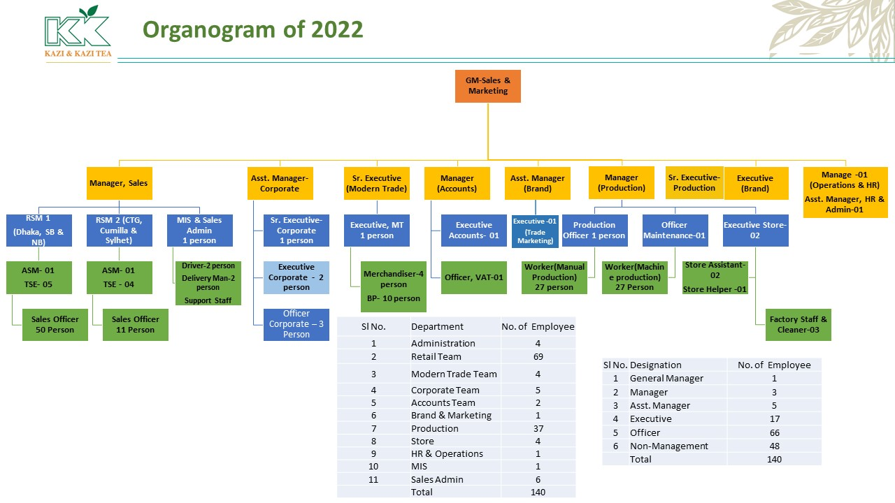
Fig: Organogram of KKTea - PU
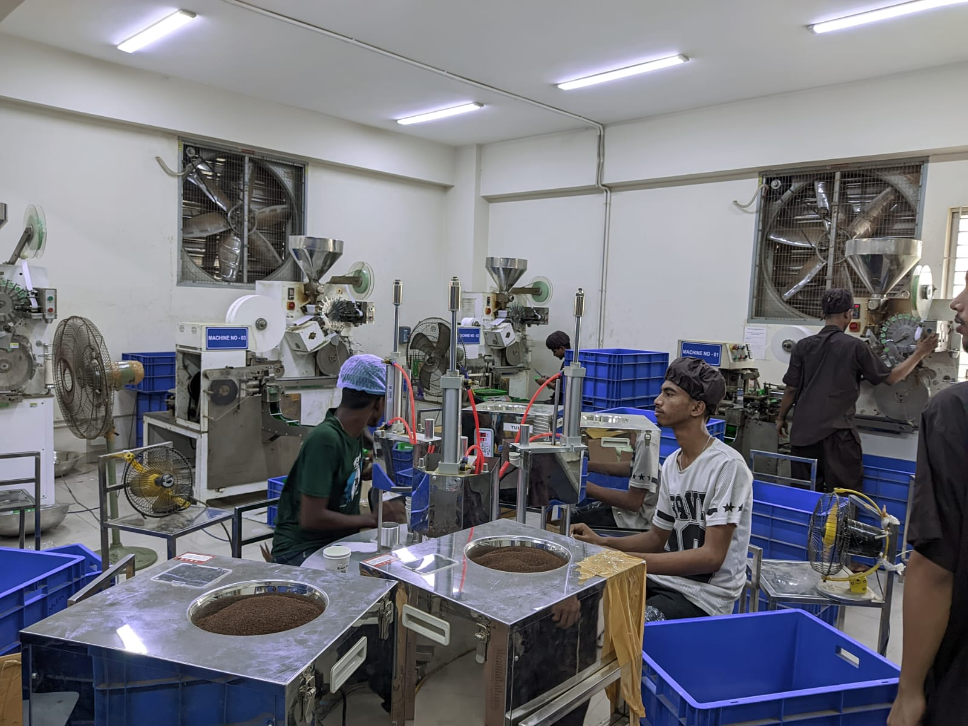
Fig 1: Machine Room, KKTea-PU
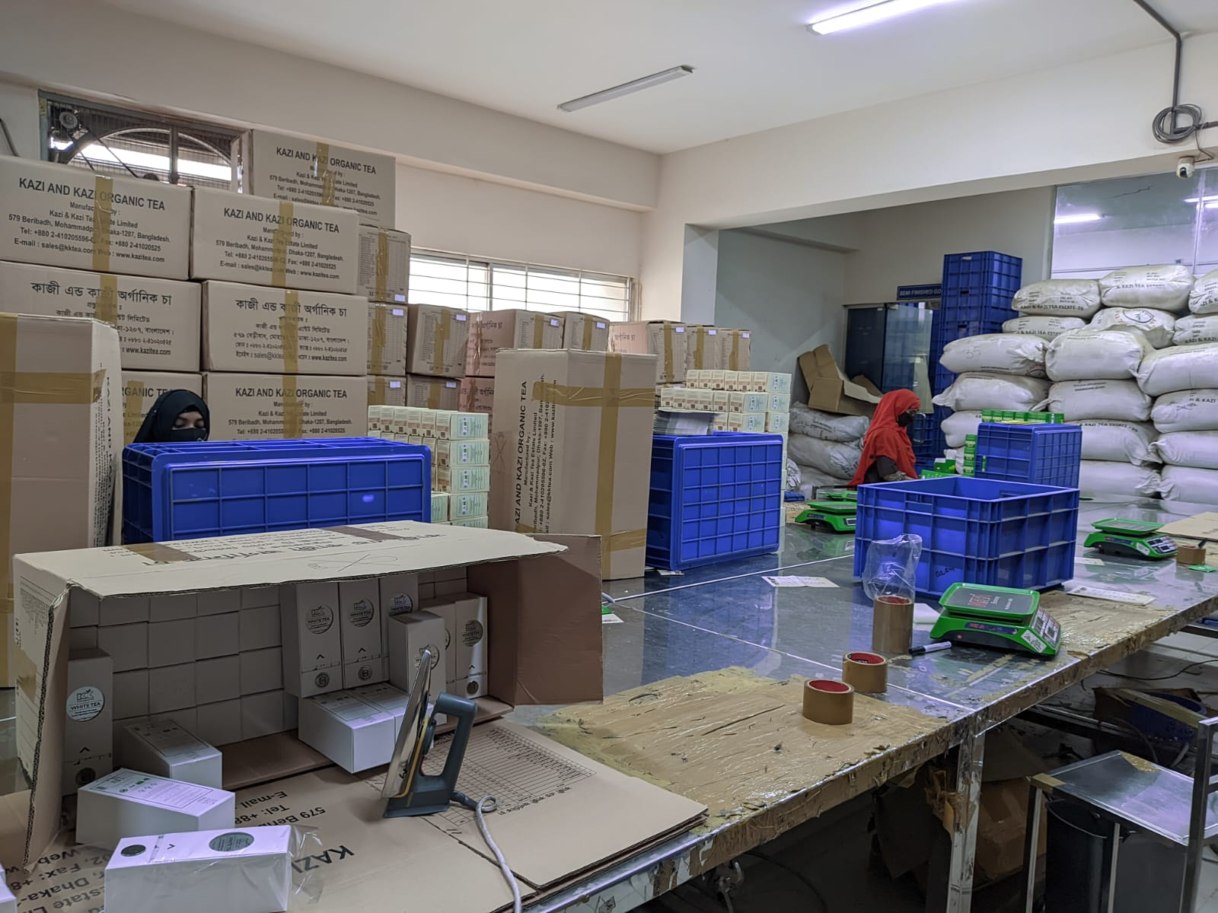
Fig 2: Packaging Room, KKTea-PU

3.7. Corporate Social Responsibility (CSR):
The Kazi Shahid Ahmed (KSF) Foundation represents the Gemcon Group's CSR initiative. Kazi Shahid Ahmed, the head of the Gemcon Group, formed KSF. KSF collaborates with Kazi & Kazi Tea Estate (KKTE), the first and only organic garden in the country. To promote rural electrification and further the goal of enhancing lives in this remote and undeveloped section of the area through the KKTea Tea industry, Gemcon first arrived in the district's northern region of our country. The KSF's infrastructure, including its organic vegetable farming, biofertilizer production, organic tea plucking, supply, and basic education initiatives, has helped women's assets and income grow rapidly. The CSR programs of Kazi & Kazi Tea Estate Ltd. concentrate on a few important areas, like:
- KSF offers healthy beneficiaries a cow loan as an innovative approach to improve their economic and social status, particularly for rural women in Panchagarah. This loan is repaid by selling milk and cow dung to KSF. The cow's beneficial nature and contract dairy farming improve their economic and social status.
- Ten years ago, the University of Liberal Arts introduced the KSF Biogas program to beneficiaries, but brick-layered plants caused disadvantages. KSF has signed a partner organization agreement to improve the program, offering cheaper cooking costs, continuous fertilizer supply, and eco-environment maintenance benefits.
- KSF in Panchagarh has initiated organic tea plantations, encouraging native farmers to grow tea. The project covers 43.7 acres and can increase annually.
- KSF introduces organic vegetable farming in Panchagarh, providing financial capital, resource materials, and knowledge to support farmers in generating healthy food and reducing poverty by selling vegetables.
- Two learning centers, 'Kazi Shahid Shikhan Kendra' in Madhupur, Panchagarh district, aim to create a warm, stimulating environment for children, promoting proper education and basic accomplishments for rural children without formal education access.

Fig: Two Children of Tea Workers of Kazi & Kazi Tea Estate Ltd.


- Community development programs are actively supported by Kazi & Kazi Tea Estate Ltd. In the areas where it conducts business, the corporation supports several social initiatives, such as those that advance healthcare, infrastructure, and education.
- The health and well-being of its employees is a top priority for Kazi & Kazi Tea Estate Ltd. The business offers a secure and healthy work environment as well as training and development opportunities to improve employees' abilities and knowledge.

Chapter 4: Analysis

Analysis
Based on the internship report on how HR adds value in Factory operations of Kazi and Kazi Tea, the following analysis can be highlighted:
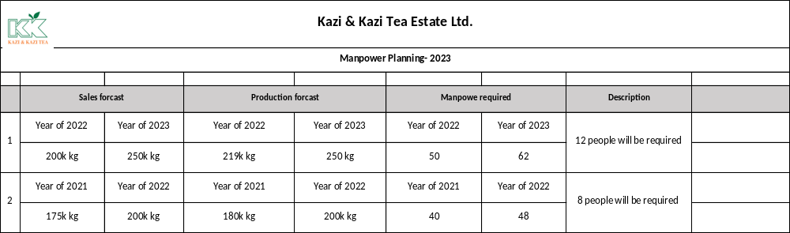
- Strategic Workforce Planning: The human resources (HR) department of Kazi and Kazi Tea serves as an example of the value of strategic staff planning in manufacturing operations. They guarantee that the correct talent is accessible at the appropriate time by coordinating human resource requirements with production objectives. The production process is less disrupted because of this tactical approach.

Fig 3: Manpower Planning
As we know that, the Production Forecast is dependent on an organization’s yearly sales forecasting. Kazi & Kazi Tea Estate Limited also depends on forecasted data like other companies for production. From the above data we can get a similar idea. The target for tea sales in 2021 was 175 kg and in 2022 it was 200 kg. That means 25 kg of tea more than the previous year. But in 2021, there were 40 total workers in the factory. With a capacity of 40 workers, the production target was 180 kg against 175 kg. That is, production is done more to control the immediate situation than the sales forecast. Now it is possible to produce up to 180 kg with the capacity of 40 workers. However, to meet the target of 200 kg, additional manpower is required. 48 workers are required to meet the target of 200 kg in 2022. That is, if it is possible to meet the shortage of additional 8 workers through the human resource management department, production can be done properly.
On the other hand, to meet the target of 200 kg, 219 kg is produced by 2022 with 50 people instead of 48 people. And this year i.e., in 2023 the target of tea sales has been set at 250 kg i.e., 50 kg tea more than the previous year. But in 2022, a total of 50 workers in the factory were 50 people. Although it is possible to meet the target of 200 kg with 50 workers, the production department has given the requirement of additional 8-10 workers to meet the target of 250 kg. The HR department will recruit 8-10 more workers as per the requirement of the production department.

- Recruitment and Selection: According to the report, HR is essential to the selection and hiring of qualified workers for factory operations. To attract applicants with the necessary experience and skills in tea manufacturing, the HR staff uses efficient recruitment tactics. First, the sales and production forecast are done. Then existing data analysis is done. That is, how much is the productivity in terms of manpower, in short, it is called Need Analysis. Then the planning is done. After planning, segmentation and recruitment are done as per requirement. Factory workers have a high turnover rate. And for this manpower is needed at different times. All arrangements are made by the HR department through the supervisor in charge of this requirement factory.
- Training and Development: The report emphasizes how important HR's efforts are in giving factory workers opportunities for training and growth. HR provides the staff with essential skills and information through specialized training programs, workshops, and initiatives to improve skill sets. The factory benefits from increased productivity, higher quality goods, and innovation thanks to this investment in staff development. First training needs analysis is done. Then the annual training calendar is made accordingly. Training arrangements are made following that calendar. After 2 months of training output feedback and an orientation program are arranged to show the development of the workers about their performance & environment.
- Employee Engagement and Retention: The results show that HR concentrates on raising employee retention and engagement in factory operations. They carry out several initiatives, including open channels of communication, team-building exercises, and staff recognition programs. Various segments or events are organized to increase employee engagement such as birthday greetings, warm-up speeches before starting work, annual banquets, idea-sharing opportunities, and performance rewards, etc.
- Performance Management: The relevance of HR's engagement in performance management procedures is emphasized in the report. HR puts into place thorough processes for performance evaluation, establishes precise performance objectives, and gives staff members regular feedback. In Kazi & Kazi Tea Estate Ltd, there are several steps to follow in performance management.
    - First KPIs are set for each worker.
    - It then updates the supervisor according to the KPI and sees whether the KPI criteria are filled up or not.
    - Productivity Reporting & Idea Generation
    - After submission of supervisor report concerned officer (in charge) ensures it. Then the production manager reviews it.
At Kazi & Kazi Tea Estate, 75% is counted from performance and 25% from behavior and after final review from Production Manager, HR department makes proposal regarding increment along with management. Then comes the final decision regarding the increment for the workers.
- Health and Safety: The analysis places a strong emphasis on HR's responsibility for preserving a secure and healthy working environment in the production & packaging unit. To create and implement workplace health and safety regulations, HR works with the appropriate departments. By reducing workplace accidents and injuries, this commitment to employee well-being not only protects the workforce but also boosts productivity.
- Continuous Improvement: The results indicate that HR actively supports a continuous improvement culture inside manufacturing operations. HR promotes an innovative and effective attitude through employee suggestion programs, process optimization projects, and quality management systems. This commitment to ongoing improvement fuels manufacturing performance and boosts organizational success.

We can illustrate this point of continuous improvement through a case. Suppose Liza Akter joined in January 2021. After joining he has worked for 1 year and his production target is 7 cartoons per hour. That is, his production target is 7 cartoons every 8 hours. And a new worker named Mim has joined today, her target is 6 cartoons. The question is, why the difference in the production target of Razia and Sultana? Because Razia Expertise places are coming. He can easily produce 7 cartoons in 7 hours without any trouble even after taking two breaks of half an hour a day. But in the case of Sultana, it will be seen in 3 months whether 6 cartoons can be produced. After 3 months of observation productivity analysis will be done then after management review will be made permanent and after another 1 month of observation if his productivity is satisfactory then production target will be increased, and his productivity analysis will be done every month and if then he cannot achieve that target then his Training is arranged, and motivation provided. Even if his results are not satisfactory then he is given separation.
- Productivity Analysis: In General, there are two categories in the factory and productivity analysis are also two types. Machine & Manual. In my report, my topic is about Manual Productivity Analysis. Manual Productivity Analysis means Workers Productivity Analysis.
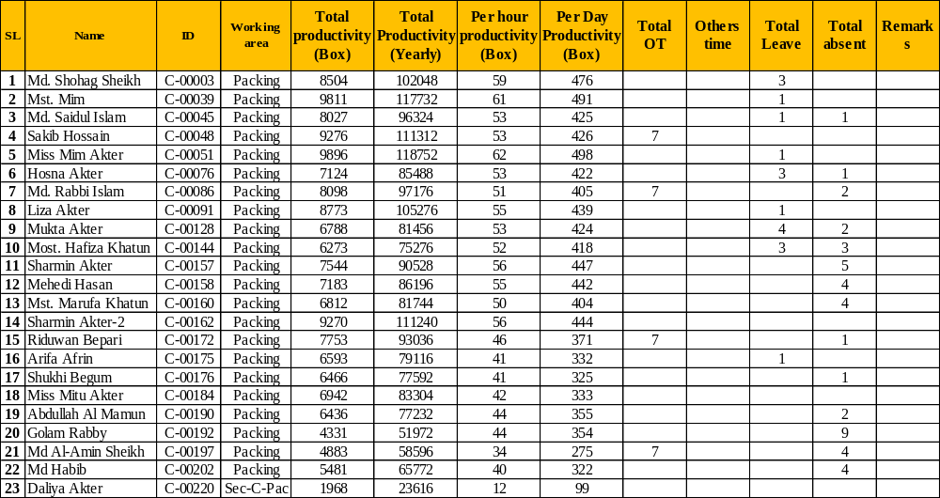
Fig 4: Productivity of Box (Yearly/Monthly/Hourly/Daily) Analysis of Packing Unit
Average Productivity | Unit
Average Productivity Per Year | 85686
Average Productivity Per Month | 7141
Average Productivity Per Hour | 49
Average Productivity Per Day | 388
Fig 5: Average Productivity of KKTea-PU
From Fig-5, the Average Productivity Per Hour of Kazi & Kazi Tea Estate Ltd. is 49 Units (Box). That means, a worker produces 49 tea boxes in an hour & in a day, he/she can produce 388 tea boxes. The Average Productivity Per Month is 7141 Units (box) & Average Productivity Per Year is 85686 Units (box).
The wastage rate is 4%. This means that 1 kg of tea contains 4% wastage.
Overall, the analysis of the internship report highlights the critical role of HR in adding value to factory operations at Kazi and Kazi Tea. The production endorses planning, recruitment and selection, training and development, employee engagement, performance management, health and safety, and continuous improvement initiatives undertaken by the HR department to demonstrate their significant contribution to optimizing factory performance, ensuring quality tea production, and creating a positive work environment.

Chapter 5: Findings, Conclusion & Recommendation

5.1. Findings:
- Strategic Workforce Planning: The HR department at Kazi and Kazi Tea effectively aligns human resource needs with production goals, ensuring the availability of the right talent at the right time. In Kazi & Kazi Tea Estate Ltd., some of the factors have been found. Like –
  - Turnover rate: In workforce planning, it has been found that the turnover rate is very high or increases during two periods of the year. Due to the high turnover rate during the two Eid’s of the year, workforce planning becomes challenging at times.
  - Internally promotion for filling up vacant Ratio is quite low.
- Recruitment and Selection:
  - CVs are mostly collected from internal sources in recruiting workers. As a result, outsiders know less about recruitment.
  - CV collection from internal sources has a negative impact on the factory work environment.
  - As workers are recruited as non-management. So, in this case the whole process is done by the factory management. As a result, the direct role of HR is practically less in this regard.
- Training and Development: HR's investment in training and development programs enhances employee knowledge and skills, leading to improved efficiency, product quality, and innovation. But several problems have been noticed in the training and development in Kaji & Kaji Tea factory, they are –
  - Workers do not receive any training in any other subject or section outside their assigned section.
  - Workers have little interest or enthusiasm for self-development at work.
- Performance Management: HR's implementation of robust performance appraisal systems and goal-setting processes enhances accountability and aligns employee performance with factory objectives. However, there is no half-yearly performance evaluation. Also, they are not informed about their scope of work. As a result, they cannot provide any kind of feedback. Again, the performance assessment or evaluation is done in English in the existing format, which is not possible for many workers to understand.
- Health and Safety: Female workers are not specially warned about personal hygiene. Also, fire safety training is conducted for everyone in the factory, but the drill every 6 months is not effective.
- Continuous Improvement: HR promotes a culture of continuous improvement through employee suggestion programs and process optimization, driving factory performance and innovation. But there have some also problem on that. They are -
  - Productivity gap analysis is not done at the right time. As a result, there is a chance of productivity decrease.
  - Both male and female workers are given similar production targets. But sometimes it becomes difficult for female workers to achieve this production target.

5.2. Recommendations:
- Strengthen Succession Planning: HR can focus on developing a robust succession planning strategy to ensure a seamless transition of skilled employees in key positions, mitigating any potential talent gaps. Since the turnover rate is high during 2nd part of the year, alternative solutions should be kept. In addition, we should try to keep a ratio in the case of internal promotion.
- Foster a Learning Culture: HR can encourage a culture of continuous learning and development by providing additional training opportunities, mentorship programs, and knowledge-sharing platforms within the factory.
- Leverage Technology: HR should explore and adopt technological solutions, such as HR management systems and employee self-service portals, to streamline HR processes, enhance data analytics, and improve overall efficiency.
- Regular Performance Feedback: HR should ensure that performance feedback is provided to employees on a regular basis, fostering open communication and continuous improvement.
By implementing these recommendations, Kazi and Kazi Tea can further enhance the value addition of HR in factory operations, leading to improved productivity, employee satisfaction, and overall organizational success.

Conclusion:
The findings demonstrate that, at Kazi & Kazi Tea Estate Ltd., HR is crucial to improving industrial operations. To maximize production levels and minimize operational disruptions, HR strategically manages the workforce to make sure that the factory is sufficiently staffed with trained people.
HR provides the staff with the required training and skills to adapt to new technologies and uphold high production standards for tea through talent development initiatives. Additionally, HR promotes a good work atmosphere where employees are inspired to perform at their highest level, resulting in enhanced efficiency and quality in industrial operations.
The deployment of performance management systems by HR enables the identification of areas for improvement and presents chances for skill development, enabling factory workers' efforts to be in line with corporate objectives.
Additionally, HR manages legal risks and promotes a favorable employer-employee relationship by ensuring compliance with labor laws and regulations. Overall, HR's contributions to Kazi & Kazi Tea Estate Ltd. improve output, operational efficiency, and the company's market advantage.

Bibliography
- Bartlett, J. A., 2016. U knowledge. [Online]
Available at: https://uknowledge.uky.edu/cgi/viewcontent.cgi?article=1277&context=libraries_facpub
- Division, F. S. a. E., n.d. Personal communication from the National Marine Fisheries Service, Silver Spring, MD.
- Falcon, 2006. Preserving restless top performers: keep your top performers engaged so they don't jump ship once job opportunities arise. HR Magazine, pp. 117-122.
- Giri, Y., 2021. five strategic measures through which HR can reduce costs. [Online]
Available at: https://www.randstad.in/hr-news/hr-trends/five-strategic-measures-through-which-hr-can-reduce-costs/
- Halima Begum, F. B. A. F. A. A. H. A. M. M. M., 2020. Researchgate. [Online]
Available at: https://www.researchgate.net/publication/340418876_Cost_reduction_and_productivity_improvement_through_HRIS
- Hansen, D. R. M. M. M. &. G. L., 2007. Cost Management. Accounting & Control 6th Edition. South-Western Cengage Learning.
- HUSELID, M. A., 1995. THE IMPACT OF HUMAN RESOURCE MANAGEMENT PRACTICES ON TURNOVER,PRODUCTIVITY, AND CORPORATE. Academy of Management Journal, Volume 38, pp. 635-872.
- Mohrman, G. &. L., 1998. HR AS A STRATEGIC PARTNER. [Online]
Available at: https://www.washingtonandco.com/pdf/hr_strategic_partner.pdf
- Nagendran, S., 2023. darwinbox. [Online]
Available at: https://blog.darwinbox.com/hr-in-manufacturing-industry-issues-solution
- Sujata Priyambada Dash, V. A., n.d. Role of Human Capital Management in Economic, s.l.: s.n.
- Vedders, J., 2022. Understanding Value-Added Manufacturing. [Online]
Available at: https://whittakerassociates.com/understanding-value-added-manufacturing/
- Ward, P., 2023. Value-Add: Term Meaning and Usage in Business. [Online]
Available at: https://nanoglobals.com/glossary/value-add/
- Ichniowski, S. and Prennushi (1996) ‘Human Resource Management Systems and the Performance of U.S. Manufacturing Businesses’, Gerhart &amp; Milkovich, p. 779.
- Becker, B. and Gerhart, B. (1996) ‘The Impact of Human Resource Management on Organizational Performance: Progress and Prospects’, Academy of Management Journal, 39(4), pp. 779–801. doi: 10.5465/256712.

