
United International University
Project Report
on
" Recruitment & Selection Process Of
Acorn Infrastructure Services Limited- Bangla Trac”

Prepared for
Shayla Khanam
Assistant Professor
School of Business & Economics
United International University
Prepared by
Nusrat jahan
ID: 111 153 082

Date of submission: 15 November, 2021
Letter of transmittal
Shayla Khanam
Assistant Professor
School of Business and Economics
United International University
Subject: Project Report on Recruitment and Selection Process of Acorn Infrastructure Services LTD.
Dear Ma’am,
With due respect and great pleasure, I submit my project report on” Recruitment and selection Process of Acorn Infrastructure Services LTD” Experience was great for me for creation this project report, I was learning so many things.
I am grateful because you allow me for selecting the topic and also helping me to make this report on it. I deliver this project report with my hard work that is full of information and facts.
Sincerely Yours
Nusrat jahan
111 153 082

Acknowledgment

In the beginning, my first work is to thanks my faculty Shayla Khanam, Assistant Professor, of United International University who deliver all the required direction and also appropriate guidance to complete this project.

Here, my sincere thanks that is going to everyone who helped me for sharing some ideas that is given me the righteous care to do the grounding of this report.

Table of Contents

Executive Summary | 5
Chapter 1:  Introduction | 6-8
Chapter 2:  Organizational background & Industry perspective | 9-16
Chapter 3:  Objective | 17
Chapter 4:  Methodology of the Study | 18-20
Chapter 5:  Literature review | 21-22
Chapter 6:  Findings and analysis | 23-37
Chapter 7:  Conclusion & recommendation | 38-41
Appendix | 42-45

Executive Summary

My report narrates the Recruitment and Selection process of Acorn Infrastructure Services Limited- Bangla Trac that is one of the private organizations. During this study, I have gained some practical knowledge of Recruitment and selection process of this organization. Acorn Infrastructure Services Ltd is based on an Electricity Generation and Transmission company.
Discussing recruitment and selection process at Acorn infrastructure services are one of prime context in my project report. Phone interview and online survey are two types of data collection methods of my report. As right person on the right job is necessary for every organization so recruitment and selection plays an emergent role. HR department also faces many challenges during recruitment and selection process of the organization.

Chapter 1 Introduction

Introduction of the Recruitment and Selection process
Human Resource Management plays a significant activity in the recruitment and selection process. Employer’s destination and motive are increasing by this. Generating and choosing the right candidates are the procedure for recruiting and selecting.
various perspective of the recruiting and selecting process remain discussing in my project report.

The Scope of Recruitment and Selection
Recruitment and Selection process of Acorn Infrastructure Services Ltd is my report topic so that definitely the report have to give a transitory sight of the organization that is showing the right people for plugging a post. I think, the act of Human Resources Department used in Acorn Infrastructure Services Ltd will help in future.
Such as:
- various section of HRD
- scheme of working in the recruitment and selection process
- encouraging their employees to work in Acorn Infrastructure Services Ltd.
- Have to deal with excess or deficit of assets

- different categories of the employees in preparation of Employment Policy

- Analyzing organizational procedures and process.

- There may be improvement opportunities in identification the area.

- There may have Streamline employment method with proper approvals.

- Selecting the top appropriate mechanism to employment the properties of effective.

Thus, I believe this project will present a distinct picture of Acorn Infrastructure Services Ltd and their roles.

Recruitment

Attracting potential workers and stimulating them for implementation an organizational work is the process of recruiting.
Organizations have to appoint the right candidate for recruiting the right workers; there are mainly held by two fields in Recruitment process and selection activities: ·
- There is a general directional human resources management or employee management aspect

- There is a very technical psychology literature that is focused on the rationality of exhibiting, suitability, and many sorts of psychometric.

Benefits and Importance of Recruitment:

- Creating a pool which is most talented for the advantage of the company for the potential candidates.
- searching job for the contestants in lowermost prices.
- Enhancing for attaining the selection amount and decreasing the qualified candidates for the inspection or multiplication.
- suitable candidates for the job have to identify and prepare prospective job applicants.
- At last, the number of recruitment strategies and various types of job candidates and personal functioning organizations are increasing.

Selection

selecting people with comparable experiences for meeting the job in the group.it is very necessary that an applicant wants to do and what the agency needs and what needs to be done.it is important to choose the best workers in presentation.

Essentials and Prerequisites for Selection:

- Have to put individual in the keeping of appropriate educations.
- Have to find eligible Applicant in job achievement.
- Have to contest the necessities with candidates for working the outline

- Have to use multiple tools and techniques for finding the most well-matched

Chapter 2: Background of the organization &
Industry perspective

Background of AISL
Acorn Infrastructure Services Ltd. (Associate Company of Bangla Cat) Specialized in Electricity Generation and Transmission (100MW HFO Based Power Plant) whose power plant is in Juldha, Chittagong. The parent company of the organization is known as Bangla Trac. Since January 2009, nearly 40 contracts have been signed to increase the capacity by 4,504 MW using light diesel oil, natural gas or heavy fuel oil (HFO). The investor, Dhaka-based Acorn Infrastructure Services Ltd. (AISL), signed a five-year rental agreement with BPDB and Caterpillar Power Generation Systems. Under the agreement, Caterpillar provided equipment and services for eight Cat® 16CM43 HFO-operated generator sets. Local Cat dealer, Bangla Cat, supported the project with onsite supervision and engineering service

Acorn Infrastructure Services Ltd.
Place: Juldha, Chattogram.
Present Volume: 100 MW
Fuel Category: HFO
2. Acorn Infrastructure Services Unit-3 Ltd.
Place: Juldha, Chattogram.
Present Volume: 100 MW
Fuel Category: HFO
3. Bangla Trac Power Unit-2 Ltd.
Place: Noapara, Jashore
Mission and Vision of AISL

Mission
“Confirming greatest client package, providing feasible & sustaining energy solution to use state-of-the-art technology, invention and persons sovereignty,”
Vision
“A Dynamic Global Company driving Stakeholders’ Achievement over sovereignty, modesty, morality & Individuals Management”.
Values
- client Foremost
- Client’s attainment
- sovereignty over modesty
- morality
- novelty
- leadership
- Communally & Ecologically Accountable

.

Company Details

Website
https://www.aisl.com.bd/
Headquarter
House No: 04, Road No: 19/A, Block: E, Banani, Dhaka.

Year originated
2010

Company category
Confidentially Apprehended

Company scope
Approximately 400 workers

Specialisms
Energy & Power, Power Plant, and Infrastructure Services

.

Organizational structure of AISL

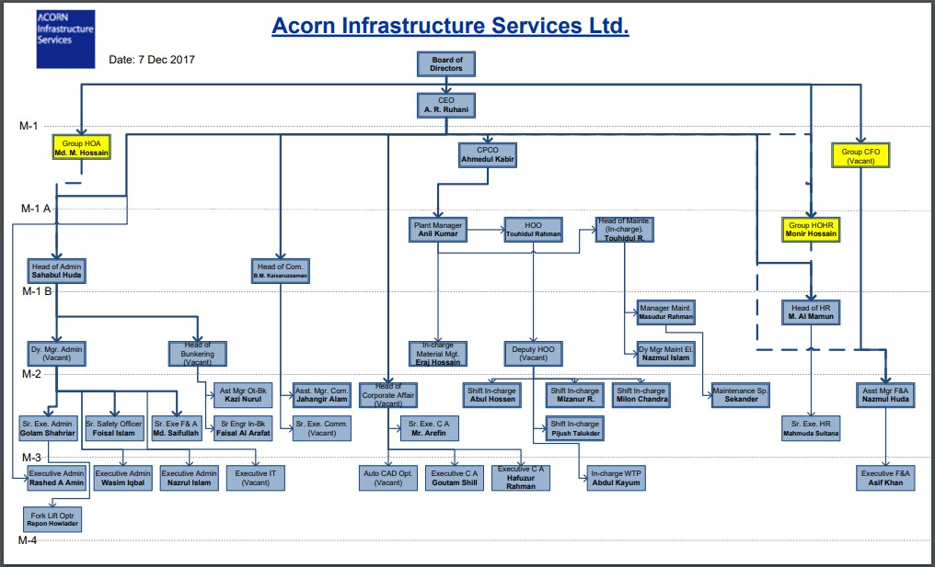

Management Team

Tariqul Haque
Managing director
Tariqul Haque has joined in Acorn infrastructure ltd as managing director

Palash Dey
Head of Supply Chain Management
Palash Dey has joined in Acorn Infrastructure ltd as head of supply chain manager

Sajib Guha
Senior Engineer
Sajib Guha has joined in Acorn Infrastructure ltd as senior engineer

Health, Environment and Safety (HES)
- health and safety of the workers are given in full priority.
- rising health and safety blue-collar, measures and also establishing best performs at all their sections.
- enhancing their health and safety system, permanent and temporary workers directs on-site instructing and natural responsiveness and refresher sessions.
- reviewing their health and safety system and perceiving the necessity to capacity the safety processes and improving them for top levels.
- acquiring safety resolve of ‘Zero Accident”, having set forth on the secure cultural conversion journey.
- inspiring employees and training a value for certain disagreement amongst their conducting plants and internal safety award programs.
- appreciating all the employees and sections for their prominent safety agreement that are availing drastically in acquiring operational skills.

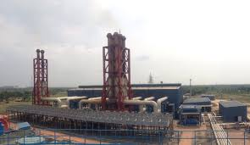

Human resource function: some function is given below
- Recruiting and Selecting entrants
- Working out and Emerging applicants.
- By HR Contract
- Managing Transportation
- Employee Rewards and Assistances

Human resource practices of this company
Dress code for men
Lengthy or semi shirt
Formal Shirt pant.
Jacket/Blazer/Suit
Dress code for women
three pieces
Formal shoes
Jacket/Shawl/Sweaters

Discussion
worker should communicate in all their companions; sellers, buyers or officers officially and humbly with avoidance any collation.
Rules to be maintained with mobile phones
Employees are restricted to make private calls during office time but they can do so while during lunch breaks and if under some emergency but while making calls or talking over the phone they must talk silently and if possible far from the other employees so that nobody is disturbed by the phone call.

Using company’s property
property or things should be used by all employees that are providing to them with care. But prohibited things should not be used by them and restricted for them to their personal use.

Employees personal property
It is best for all employees to not bring anything valuable in the office and even if they do, they must take care of their own belongings as the company is not responsible for any of the employ’s personal things

No smoking
No employee is allowed to smoke inside the office building of AISL but if someone wishes to smoke than that person can leave the office premises and then smoke and come and employees are allowed to take small breaks during office hours

Chapter 3: Objectives of the Study

Primary Objective:
Most important purposes of this report giving essential ideas and facts around the process of Recruitment and Selection process pursued by the ACORN INFRASTRUCTURE SERVICES LTD. (AISL).

Secondary Objective:
Recruiting and selection process is identified by principal and thought that are studied in BBA program.
The purposes of the report are
- Taking part in recruitment and selection system in HR activity.
- Getting information around numerous recruitment and selection actions that is pursued by Acorn Infrastructure Services Ltd.
- gaining information that must be used in the upcoming growth for boosting the company’s presentation.
- presenting view and proposals to administration for their additional rehearsal on the process

Chapter 4: Methodology of the Study

Recognizing and gathering data; analyzing, interpreting and presenting in a methodical process is the viral point of this process.
Straight inspection, personally conversation with the workforces which is done on websites and based on practical work which is conducting by study includes methodology.

Types of data
If we want to make the data more significant and judicious, we have to use both primary and secondary of data. There are two types of data:

Primary sources
- doing the organization investigate.
- having discuss with administrative members and experts.

Secondary sources
We can find secondary sources of data in different Books of HRM
- researching the different reports which is done on year.
- Investigating the Newspapers
- ensuing Internet
- studying main books

Data collection process:

- Online, over phone interview and online survey is the main source to collect the data that is more popular in nowadays. It is also easiest system for collecting data.

- Sample size:

- Selecting Acorn Infrastructure Services Ltd for realizing the recruiting and selecting process. collecting 5 numerals samples in this survey.

Scope:

“Recruitment and Selection process of Acorn Infrastructure Services Ltd.” Which is given about view about the organization to select the right people for the selecting post. Different organization have different procedure to select and recruitment process. But this report doesn’t any relate to others.

Area: Industry and company.

Time: collect information through online in 6 days and 1 day for interview

Limitation
Facing some limitation to make this report because some website is not helpful for me to share the information. And also, most difficult thing is to gather the data.
I faced some problem when I was making the report.
That are given below

- Requiring time is too short for me to collect the data.
- the website was not much helpful to share data.
- people cannot access the internal action.
- organizing analytical data and theoretical data is very hard for me that is completed in limited time.
- It was very difficult to increase a better situation in the organization within this time.
- important data collection was very hard because websites keep it personal
- I prepare this report with huge work pressure

Chapter 5: Literature review

Indication
Recruitment and selection to accepted and become the right persons for the right jobs of an organization. Then the recruitment, selection process begins. Recruitment as the set of performances an organization to tempt job candidates who have the behavior needed to support the success of the hiring depends on the ability to create a large pool of reliable applicants. There are of recruitment internally and externally that can be classified as two (Aswathappa 2008:150). Internal sources of recruitment are current employees, employee referrals. External sources of recruitment are professional associations, newspaper ads, on-campus recruitment, unwanted.
Literature review definition
Edwin Flippo defines that the hiring and selection procedure as "a process of finding potential employees and encouraging and encouraging them to apply for a job at an organization."
Simply put, appointments and selections are simultaneously canceled from the process and without the each other. They are significant different from components of the organization. It helps to discover the potential and potentiality of applicants for expected or real. This is a relation between job and job candidates.
Effective organizational performance depends on of the human resources in different managed areas. an organization to allocate the right kind of qualified employees in appropriate job positions to ensure organizational effectivity. The playing an important role in the economic development of Bangladesh by creating employment opportunities every year and recruiting. However, till date there is study on the techniques and practice. The including identifying the most commonly used recruitment sources, identifying selection procedures, hiring and strategies for maintaining the effectiveness of the selection process. Both qualitative and quantitative methods were followed. Preliminary data were collected from private commercial using a well-structured questionnaire that combines both open and closed questions. Statistical analysis software SPS-20 version was used for analysis. The main finding of the study is that most banks have different choice levels for using recruitment sources and selection methods. They follow different selection methods for entry-level vacancies. There are also common issues in job analysis, some hiring sources and methodologies, providing human resource managers.
Work by Korsten (2003) and Jones et al. (2006)
Accordance with Korsten (2003) and Jones et al. (2006), Human Resource Management theories emphasize into techniques is recruitment and selection and outline the benefits of the interviews, assessment and psychometric examinations as well as employee selection procedure. They also started that recruitment process may be internal or external or may also be directed online. Typically, this procedure is based on the equality of recruitment prudence, job postings, advertising, job application and interviewing procedure, assessment of the candidates, decision making, formal selection and training (Korsten 2003).
Jones et al. (2006) revealed these examples of recruitment policies in the healthcare, business or industrial sector may grant insights among the processes engaged of establishing recruitment policies and identify managerial objectives.
Successful recruitment craftsmanship entangles a incivility analysis of the job, the labor conditions and interviews, and psychometric tests in order to find out the potentialities of job seekers. small and medium sized enterprises lay their hands-on interviews and assessment to job analysis, emotional intelligence in inexperienced job seekers, and corporate social responsibility. Other approaches to selection outlined by Jones et al. (2006) role play, group discussions and group tasks, and so on

Chapter 6: findings and analysis

Recruitment and selection process

Ensuring to attain correct candidate on correct time to correspond the HR requirement across the organization in Acorn Infrastructure Services Ltd.
While recruiting and selecting employees the company follows some steps:
1st step
When any department needs to hire a new employee then they give out application along with the other necessary details for the post to the hr. department
2nd step
When hr. gets the application then the hr. team starts to raise manpower requisition based on the vacancy
The hr. then looks for the suitable candidate in the following ways
They start sourcing cv by
Giving ADS in
BDJobs
Paper
LinkedIn
Social media posting
And internal references
After sourcing out the CV’s the department sort lists the candidates and selects certain candidates to choose from them .
Interview process
At first the candidates has to go for a written test which is applicable only while recruiting freshers if the company is recruiting any experienced candidate then this step is not necessary
Then if a candidate is selected that particular candidate is called for a 1st level interview
Here in this 1st level interview the candidate is presented in front of three persons
1st person is a hr. department person
2nd person is an employee of concerned department
3rd person is a cross department’s employee
If the concerned candidate passes the 1st level interview then that particular candidate is called is called for 2nd level Interview. Here also the candidate faces 3 persons
1st person is the head of hr. of AISL company
2nd person is the CE0 of the company
3rd person is an employee from the concerned department

Then if the particular candidate is selected to work in the company the recruitment approval is given by the CEO of the company.
Appointment letter is then provided to the candidate
At last comes the joining and orientation for the new employee .and also selecting suitable candidates needs to be fulfilled the conditions.
For freshers:
Some conditions are needs to recruit the fresher.
1. CGPA matters in highly. a fresher must have CGPA 3 or above
2. University preference: A good university indicates good student. That’s why candidate should be from reputed university.
some university are called standard according to Bangladesh perspectives which is
North South University, United international university, East West University, American university of Bangladesh, Independent university of Bangladesh.
Aimed at Knowledgeable:
CGPA and University preference are not needed for recruiting experienced candidate.
Manpower requisition form
Division/department are filled up by Manpower department. There are four features. These are:
1) Situations: manger will write division/department position name, sections, partitions, vacancy number, number of workers demanded, date. Manager request to adjoin these ranks. Vacancy are two types which is:
i) One is Substituting ii) The other is Original place
2) Manager’s Work explanation: candidates in the blank occupation have to do the task which is described by the manager. “Role play”.is written when work description is matched with work description book.
3) Manager’s work specification: employees need to perform that it is provided by manager with information and abilities. Also, educational background, knowledge, and special services are written by manager.
4) Approvals of Managers: signature is needed for approval that’s why HR head, Divisional Head must sign and approval is given. Signing the paper, the department have to sign that is given by manager. Then, human Resource department deputy managing director has to sign for continue this process. Human resource division will begin their recruitment works when the get grant from deputy managing director. manpower requisition form will be transmitted the photocopy by HR division that original copy will be retained. Then, it will be ready for applicants’ sight. There are two ways of collecting resumes. These are:
Internal sources: internal sources collected many resumes that are helpful for Human Resource division. Because the price is reduced by it. Sources utilizes internal resources. Such as

- Referrals: There are many employees in Acorn Infrastructure Services Ltd that origins for Acorn Infrastructure Services Ltd are prominent and strong. here, applicant’s resume will be signed by Acorn Infrastructure Services Ltd. when signature is not possible for officer, Employee have to contact with him. There, reference is getting by Internees employees.

- On Notice board: Advisement of vacancy in Acorn Infrastructure Services Ltd are provided in a poster panel in the company that attracting applicants for applying their position. Safety protector, driver, and mechanic in Acorn Infrastructure Services Ltd are taking responsible by external human resource.

- Transfer and promotion: HR Division follows transfer and promotion.
when vacant position is instantly necessary.
External sources: External recruitment are needed if all these things are happened. Selection method followed the abilities, educations, knowledge and services that is required to plug in appropriate role.

- Advertisement in Newspaper: Advertises are provided by HR Division for vacancy position. In the beginning, An advertisement a prepared by them. After that administration accepts it, newspaper published the add.

- Announcement through Online: some job circular like Bdjobs has given post in social media and also agreement with HR Division of Acorn Infrastructure Services Ltd. Circular are posted by HR manager.

- Interns: Interns is top outdoor causes. different Universities which is standard also choose interns in Acorn Infrastructure Services Ltd by human resource.CV are sent to the company by student.

- CV Bank: HR Division of Acorn Infrastructure Services Ltd preserved CV bank.CV banks are two parts.
1. one is Unsolicited CVs. CVs on their holder service email are transmitted by few candidates which are collected by HR Division when Acorn Infrastructure Services Ltd admit it as suitable.
2.different selection rejects few CV which is kept in a separate file.

Shortlisted
HR division starts their selection process as soon as they collect their CV. Resumes are separated in three groups.
1. In the beginning, selected applicant’s resumes are chosen by HR division.
2.Following, resumes are orderly organized also and transmitted these to the segments.
3. And finally, last collection is contented and Human Resource division gives back resumes.

Candidate informs
- Following task is informing candidates which is called Telephone Interview short as TI.
- common questions are facing by candidates which is their current condition if employees are present.
- After that HR informed them for joining the interview in exact period and date. Some applicants can’t join that interview due their personal issue that time HR request them to inform and change their time.

Attending sheet
attendance pages are arranged Earlier viva.
1. Interviewees’ name,
2.last institution,
3.campus names,
4.phone number and
5. autograph case

Viva
1. In the schedule date, candidates have to contemporary for giving viva.
2.Divisional head, HR head and other administrators are existing because they have personal rights to give comment when employees are on the viva board.
3.the managers ask different question to the applicant. Such as
- What is existing salary and
- what type of amount they expect in present day?
When Viva is completed, all the managers express their opinion. After that, everyone’s view, selection is final and salary is negotiated for everyone.

These are:
- Informative Highest
- Elementary Practical Information
- In-depth Practical Information
- Communication Talent
- Body Language, Appearance and Smartness
when evaluation is completed, candidates are selected when HR division confirms and calling them for making sure their selection of the job. At last, management inform them about their salary. selection process is completed when they agree with their salary. When they can’t agree with this, they have to negotiate it

After being employed
The new comer must bring the necessary things which will be needed
1.Resume: The new comer must bring an updated CV with him/her
2.Certificate and transcript: All document should be brought.
3. Employee information form: their information such as name, address.
4.3 passport sized photo: At the back of the photos his/her signature must be there
5.National ID photocopy
6.Nayinality certificate
7. Birth certificate (Optional)
8. Nominee form
9. Bank account
10. Medical certificate
11.blood group
Some major findings in my research program:
1.Acorn infrastructure service limited has given the full power to the Managing Director to take the decisions. when director give the decision and also advised them to take the responsibilities, then HR Division follow the instruction.

2.Maintaining CV or resumes very poorly which are done by HR department and sometimes they lose their resumes because they cannot maintain them.
3.One senior administrative in HR branch face huge pressure and have to do all the work in alone because lack of employees. .
4. publishing add is one the most important things for any organization but AISL doesn’t put their advertisement in any website.
5. providing any necessary things which are needed for the employees to ensure their safety because it is top priority thing for the employees.
6.working willingly is not like being forced to work that all of them seems to happy face when they are doing their duty.

Advertisement of employee recruitment

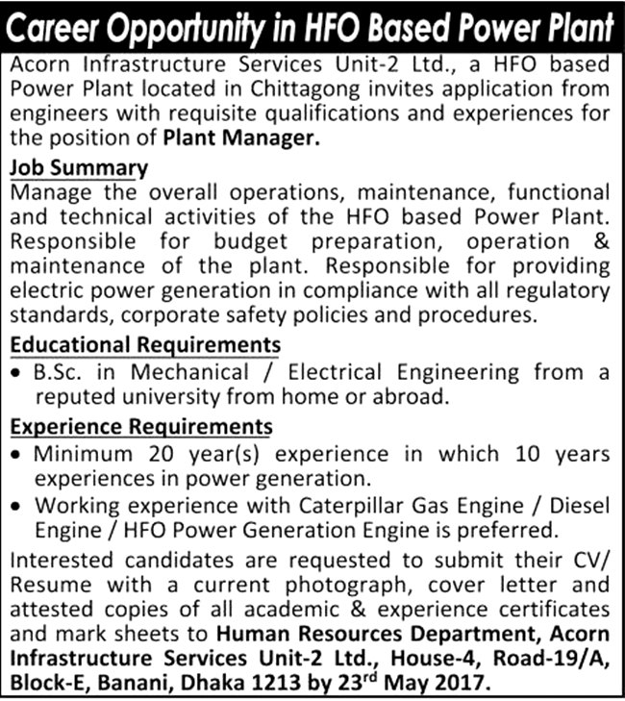

Analysis

From this diagram, it is clear that the company follow formal recruiting process.

It is showing that company hires 50% new employee from different organization

In this diagram,54% are strongly accede that recruiting and selecting process are more useful for organization fundamental and moral objective

From this diagram, it is obvious that most of the workers speak that their recruitment process is variant.

From this chart,50% are accede and 30% are strongly accede with this statement.

42% sections are powerfully acceding this narration other hand, 39% are accede with this statement. But,division response is impartial.

There are 26% dissent in this narration and 39% admit in this narration that enrolment should be founded on knowledge and skill.

80% sections conduct with on paper test and face to face interview for selection process and personal interview are receiving 10%.

Chapter 7: Conclusion and recommendation

Recommendation
1.organization have to improve their documentary system because the organization is quite big that’s why they don’t keep their document in confidential way.
2. without the wastage of time, they can make interview in phone call for the benefitable of applicants and them.
3. Online requisition form is one of the best ways to save time. I think, they can apply this process.
4.CV and necessary document have to keep in online so that it can reduce the time and also prevent from lost.
5. hiring more people can reduce the work pressure in HR department.
6. training the interns so well so that they can aware of the organization’s things and also, they can save time
7.mental preparation is more important for training session so that they should understand them.
8. have to motivate employees and also understand them the benefits of training that can helpful for their life.
9. taking skype interview which saves the time.
10.must have giving the idea about rejected candidates for the beneficial of company which can bring positive thought.
11.training the managers so well so that he can take best employee with best interview.
12. Highlighting their task to the workers in which they can bring a positive thought about the company
13 arranging annual picnics and get together for knowing each other personally.


14. career counseling should be provided to their employees which can bring energy to work with much efficiently
15. freedom should be must provide so that they can give their best.
16.If they feel bored, their work should be rotated can at least say their opinion.
17.Encouraging the employees so that they at least say their opinion.
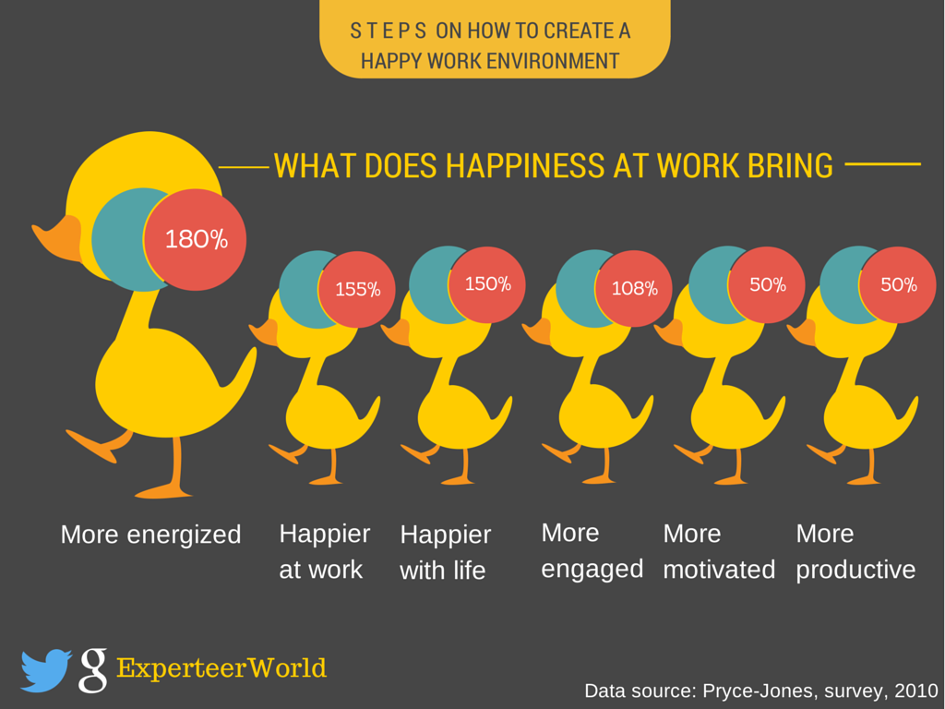

It can be clearly concluded that recruitment mentions a job for suitable applicants that has overall process of attracting, shortlisting, selecting and appointing within an organization. It can also mention a method that elaborate in opting people for undefined roles. Managers, human resource generalists and recruitment specialists may be done with bearing out recruitment, but in some cases public-sector employment agencies, commercial recruitment agencies, or authority search consultancies are used to participate on the process. Internet-based technologies that assists all views of recruitment have become normal.

Recruitment plays an important role for any company. In any business, opting the best people for the organization is called Recruitment and selection that can help the organization in future. Paying more attention to choose a person is very important for the organization. Promoting the organization in terms of expansion, standards and morals which is only possible by people. Most of the organization most powerful resource is expensive material. Ensuing the skills and morals should more observant for the organization.

Appendix

● Sarkar J B & Ahmed, H (2007),” disclosure on corporate governance by listed companies in
Bangladesh”, ‘the cost and management’ No 1 Volume XXXV January February
http://citeseerx.ist.psu.edu/viewdoc/download?doi=10.1.1.1067.6204&rep=rep1&type=pdf
● Garrison, R. H, Noreen, E.W.& Brewer, P.C (2010), Management Accounting, NY; McGraw Hill Irwin,13th E

● https://www.aihr.com/blog/selection-process-practical-guide/
● https://www.aisl.com.bd/about.php
● https://www.nrgedge.net/company/acorn-infrastructure-services-limited
● https://bizfluent.com/info-8212981-recruitment-process-hr.html

Questionnaire of survey
Designation:
Section:
Your Gender
1. Man 2. Women
year experience
● 0 to 6 years ● 6 to 12 years ● 12 to 18 years ● 18 to 24 years

 | Strongly agree |  |  |  | Strongly Agree
  Agree
  Neutral
  Disagree
1 | 1 | 2 | 3 | 4 | 5
  How can you believe that recruitment and selection process are effective for organization
2  Do you confide that Recruitment and Selection process progress the efficiency of this system? | 1 | 2 | 3 | 4 | 5
3  Is enhancing the efficiency of the management the great source? | 1 | 2 | 3 | 4 | 5
4  Which initial riddle are used in the Recruitment and Selection method in interview? | 1 | 2 | 3 | 4 | 5
5 how can you believe that knowledge and experience are used on it? | 1 | 2 | 3 | 4 | 5
6 how can you believe that your organization used different method in interview? | 1 | 2 | 3 | 4 | 5
7  In the process of recruitment, can you perfectly have satisfied with the process? | 1 | 2 | 3 | 4 | 5

Qs 8 for recruitment policy, is any process to recruit people ?
Qs 9 experimenting a petitioner, what steps are required for interviewer.
Qs 10 In selection process, which steps are followed?
Qs 11 creating a pool of candidates, which method should be used ?
Qs 12 what things you are looking in a CV for better look?
Qs 13 evaluating CV if is it decent or immoral?
Qs 14 how can recruitment and selection process are more effective?
Qs 15 is it possible to differ successful requirement to unsuccessful one?
QS 16 What can the management do to help improve work performance?

Comment briefly below:



