United International University


Department of Economics

Thesis Paper on Online Banking
in Bangladesh

SUBMITTED TO

Dr. Mohammad Ali Ashraf
Associate Professor
Department of Economics
United International Univesity

SUBMITTED BY

Syeda Faika Arefin
ID: 121151030
Department of Economics
United International Univesity

Submission Date: 12.07.2020
Date : 12.07.2020

Dr. Mohammad Ali Ashraf
Associate professor
Department of Economics
United International University

Dear Sir,

I am submitting this final thesis paper on "online banking in bangladesh" , which you authorised. This paper is descriptive in nature. To prepare my study, I strictly follow all your instructions and requirements.

Sincerely,
Syeda Faika Arefin
ID : 121 151 030
Department of Economics
United International University

ABSTRACT

Online Banking is very much essential for our country. My study tried to show the present condition of online /Electronic Banking in Bangladesh as well as the common features of online Banking in our country. My studies find out that the popularity as well as significance of online Banking is increasing day by day in Bangladesh. From my valuable information or data, a descriptive research paper is made to show the present condition of online Banking in Bangladesh.

Key words:Online Banking, Electronic Banking, Descriptive Paper.

THESIS PAPER
ON
Online Banking in Bangladesh

INTRODUCTION

Online banking normally means that clients are able to handle all banking tasks such as transfer fund, pay bills, download transaction, monitor accounts, checking accounts, including payment and application through internet connection using the banks own websites.
In Bangladesh, there are many multinational, private, nationalized and specialized banks are providing banking services but their service qualities are not same. In our country, private as well as multinational banks provide better service as those banks try to provide door to door services and try to provide banking service with Electronic (Online banking) banking. Online banking usually means provide banking services like pay and cash management through internet services.

BACKGROUND OF THE STUDY

In Bangladesh, online service is rapidly increasing day by day in multinational as well as private sector. People always want to finish their banking task within a short time and it can only possible by online banking. That’s way people are very much interested in online banking and all private as well as multinational banks try to offer the demanded services. So the study tries to show the present condition of online banking in Bangladesh.

PROBLEM STATEMENT :

Without online banking, it’s very much time consuming to finish the usual banking tasks. But people can take banking service very quickly and by lower cost through online. That’s why internet banking is very popular way to take the banking service. And all banks in our country try to satisfy their customers by providing better online banking services.

RESEARCH OBJECTIVES :
The prime objective of my study is to show the present condition of the online banking in our country. But my study tries to accomplish the following specific objectives:
- To highlight the Electronic baking structure in our country.

- To highlight the online service provided by various banks in Bangladesh.

- To show the common features of online banking.

- To increase the awareness about online baking.

SIGNIFICANT OF THE STUDY:

At present, online banking is very much significant in the digital world. This banking system increases the quality of banking service all over the world that increases the customer’s satisfaction as well. That helps to improve the overall banking sector as well as overall economy. As this study can increase the awareness about online banking and try to show the present condition of online banking in Bangladesh, this study has a great significance.

SCOPE AND LIMITATIONS:
This study helps to understand about the concept of online banking, present situation of online banking in Bangladesh, structure as well as features of online banking. And prime limitations of my study are given below:

- The study prepared only based on Bangladesh perspective.

- The study was very much time consuming to conduct.

- Have faced difficulty to collect enough information about the study topic.

LITERATURE REVIEW
Different Researchers have different opinion regarding the online banking. Researchers and experts give both negative and positive opinion towards the online banking. And this section is conducted by reading different newspapers articles and books. Rekesh H M (2014) tries to find out the factors that affects the internet banking service. And he also found that PLS has a big influence on online banking by its perceived reliability. So, marketing expert of any banks should emphasize to increase awareness about the benefits of PLS as well as online banking.

All banks must improve the quality of their service and must provide different kinds of services to the customers. If they don’t get quality service, they don’t show any interest in banking service and they will defect which has a negative impact on overall economy (Dr. P.K Agarwal, 2013)

Mr. Nisha Malik (2013) also highlighted to his study about the importance of the quality of banking services. He said that the quality of service is the prime factor to satisfy the customers. He also tried to find out the difference between public and private banking service.

Generally, different factors like brand perception, easy to use, security, responsiveness is the prime indicators to increase the satisfaction of the customer in online banking. So every bank must be responsible to increase the quality of those factors to satisfy the customers (Vijay, 2011)

PoojaNelbetara (2009) highlighted to his study that about 57% of Indian commercial banks provides the online service and those banks are more profitable banks than non-internet banks. So, online banking has a positive impact on overall economy.

Shaza (2012) find out through his study that electronic fund transfer, mobile banking , and ATM service has a big positive impact customers satisfaction. And that’s why the popularity as well as the importance of online banking is increasing day by day. And almost all banks try to provide online service as much as possible.

Nabil Hassan (2013) found that some participants were very much satisfied with the online banking as they did not face any problem with online banking to use it and they had enough experience with online banking .But some participant were concerned about security, ease of use, trust and awareness.

Educated people are very much interested in online service that means educated people have greater interest in online technology as they have better knowledge about the digital technology, And young are more interested in online banking than the old person (TinashaMukwazhe, 2015).

The different perception towards online baking depends on different age group and different occupational group of people. Corporate and young people have greater interest in online service but some old person are very much concern about the security issue and that’s why they have little interest in online service (Ms.Fozia. 2013).

Malhatra (2015) found his study that some major factors influence the usage of internet banking such as profession, education, age, income. He said that public awareness should be increased about the online banking. This banking increases the satisfaction of the customers and helps to develop the overall condition of banking sector as well as the overall economy.

Rahman ( 2001) hilighted on his study that authenticity, non repudiability , security, and availability are the most important issues regarding online banking. He also said that effective and efficient security of online banking have a positive impact on E-commerce as well.

Huda ( 2004) observed that the importance of online banking is very high in Bangladesh. So without proper online banking, continuous success is not possible in Banking sector in Bangladesh .

Rahaman (2007) observed that online banking or electronic banking technology is not familiar to all because of the digital divide and the Internet experience and environments are not same for all. So without proper Internet facilities, people can not get proper online banking services.

Khan (2007) observed that 29 out of 48 banks provide online banking services. All banks try to provide be online services as much as possible. And this online services helps to gather more clients.

Chunk and sayter (2009) suggested that electronic banking offers electronic services that allows clients to pay bills electrically, transfers funds among accounts, check the balance in their account, apply for loans , and can download information about own account, actual funds through online.

Ayo (2010) showed that the effectiveness of online banking depends on observability , compatibility, complexity, relative advantages etc. He also said that the main concern of online baking are privacy and security.

Buffam (2000) suggested that online banking is very much effective to modern banking industry. Online banking increase the effectiveness and efficiency in all banking sector .And modern people are very much interested to electronic banking as its very much cost effective way of banking

Kalam (2012) suggested that the most significant part of mobile banking is security issues and more improvement is needed in order to make mobile banking more user friendly, And the demand for mobile banking is increasing day by day as its very way to conduct baking task through mobile phone.

RESEARCH METHODOLOGY :

My study covered several private commercial and multinational banks, and some govt. banks. Different clients of those banks were interviewed to collect data or information. This paper is prepared based on primary as well as desk study. And different books, articles, and journals were used to make the desk study.

Research framework:

Collect information through interview and different websites

Prepared study

So, structure interview was taken to collect the primary data and secondary data. Data was also collected from different websites to conduct the study.

Study design:

1. Formulation of participant’s interview

2. Prepared the literature review

3. Data collection (Primary and secondary)

4. Made descriptive research paper

5. Findings and discussion

Data collection:

To conduct this study both primary and secondary data were used. And paper is prepared based on these Primary and secondary data.
Primary sources: primary data was collected through structural interview and discussion with different clients, different executive of those banks.
Secondary sources: secondary data was gathered through newspaper, relevant books, journals, websites, official files and published documents.

Data collection procedure:

In my study data collection procedure are as following-

- Identification of the research problem

- Defining the concept of the online banking.

- Collection of data through primary as well as secondary source.

- Finally, prepared the study findings based on primary and secondary data.

Sampling procedure:

The clients, officials and executives of those banks were asking to take a part in a structural survey. And respondents were asked some structural questions relevant to my study. And then valuable information was collected to prepare my paper.

Technique to prepare study findings:

For achieving the study aims a qualitative data collection technique was adopted and a descriptive research paper is prepared based on the data.

- At first, selected the qualitative focus group.

- Then took the interview and find out the valuable findings of the study from the valuable information or data.

FINDINGS OF THE STUDY

Online banking is a great innovation of modern banking world. Necessary information regarding online banking services was collated through face to face interview and secondary source to find out the valuable findings. Different electronic facilities such as saving current, FDR, PDS, DEBIT/CREDIT, ATM, SWIFT, EASY PAY machine are provided by different private and foreign commercial banks in Bangladesh.

History of online Banking :
NationalcityBanks(NewYork)firstintroducedtheconceptofelectronicbankingin1961.Atthattimethisbankprovidedsomespecificservicessuchasfundtransferservice,pointofsale,ATM,andAutomatedclearinghouse.

TheBarclaysBank(UK)firstestablishedthefacilityofcashdispenserin1967.Andaftersometime,plasticcardswereintroduced.AndthenSwitzerland,FranceandSwedendevelopedthecashdispensernetworkwithinoneyear.

Lloyd'sBank(UK)firstdevelopedtheonlinecashpointin1972.Andclientscantakethefacilitybyamagneticstripesonaplasticcard.

InBangladesh,asof2007,29outof48banksprovidedonlineservicesandonlinebankingfacilitieswerestartedsince2001.Andnowalmostallbanksprovodifferenttypesofonlineservices.

Characteristics of the participants:

- All participants were the clients of different banks.

- Different officials and executives of different banks were also interviewed.

- Majoring of the participants was educated that means had completed bachelor level and others completed secondary level of education.

- All participants are Bangladeshi.

- Majoring of the clients, officials, and executives were in the age range between 18 to 50 years.

Common structures of online banking:
At first, different multinational banks were introduced the idea of electronic banking in Bangladesh in1992. But now most of the banks are maintain the online banking. So my study finds out some common structure of the online banking in our country.
- Almost all banks provide 24 hours cash deposit and withdrawal services.
- All banks can enquiry balance at any time.
- Almost all banks can provide shopping facilities for more than 10 hours.
- All clients can pay the utility bill through online.
- Banks provide the VISA, MASTER, PLUS, MAESTRO and other credit / debit card facilities.
- Any client can change personal identity number through online.
Clients can transfer own fund to other accounts through online.
- Clients can inquiry account activity in any moment through online.
- Almost all banks provide ATM security
- All clients can withdraw local currency from dollar account.

Development of online banking in Bangladesh:

Electronic banking:

It is a great innovation of modern technology and introduced in the world in 1980. It increases the effectiveness and efficiency of banking industry. Application of this technology reduces the people and paper. Modern banks increase their market share by offering different types of electronic devices that also reduce the cut of labor and helps to increase the profit. Modern banks use electronic technology because of the following reasons:

- It helps to increase overall market share.

- It reduces the physical labor cut.

- Overall, helps to increase the profit.

Because of those reasons member of electronic banks increasing day by day. Let’s see a graphical table -

Number of electronic bank
Year | No. of electronic banks | Years | No. of electronic banks
1994 | 1 | 2000 | 20
1995 | 2 | 2001 | 30
1996 | 3 | 2002 | 34
1997 | 4 | 2003 | 37
1998 | 9 | 2004 | 40
1999 | 14 | 2007 | 44

Structure of online banking:

Electronic banking systems can be divided into two parts. Such as, back –office, and front- office. And generation can be grouped into three parts such as, first, second and third generation

Online banking service categories :

Generation | Back-office | Front-office
First | - Management of cash  - Management of ledgers  - MIS of head office | - Dispensers of cash
Second | - Transfer of fund  - Keeping the record  - ACHS  - Offline transaction processing | - Authorization services as ATMs  - Verification of all check  - Facility of pos  - Payment of telephone bill
third | - Transfer processing of inter banks  - Service of internet banking  - Centralized processing at country level  - Transaction processing(online) | - Service of online banking  - Direct deposit  - Online home banking  - Transaction of check  - Automatic fund transfer  - Electronic fund transfer  - Internet banking

Banks account: current, saving, term deposit, FRD, PDS:

All modern banks in Bangladesh provide these services in the electronic way that always increases the customer satisfaction. By the facility, all clients can deposit and withdraw money through online that reduce the time Cost of all clients.

Debit/credit card:

By the debit card, any client can withdraw own money from the bank in any time and easily We can transfer money Other Customer Account

and by the credit card, clients can credit their amount while clients are in shopping. And Easily Buy Anything With Lots Off Disscount .

According to the financial sector reviewing by Bangladesh bank between June and December 2010 the monthly volume of credit transaction grew by 124% and debt card increased by 112% .

A large num of people are not familiar with the advantages and different features of using a credit card credit card play an important role in Bangladesh in peoples living standard or lifestyle .use of credit card reducea the complexity of human life .

Serval Banks Like Mercantile Bank LTD , Standard Chartered Bank, Prime Bank, Eastern BANK , Trust Bank , Dhaka Bank And So On exists in the credit card market of Bangladesh

Pros :

- Debit /credit card are less risky

- clients can build credit

- Have high limits

Cons :

- it can promote overspending
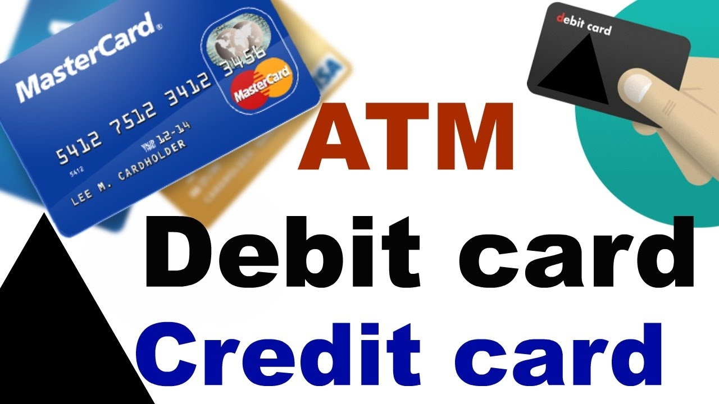

Internet banking:

All modern banks in Bangladesh provide the internet banking facility to their clients. All banks provide a specific user and secret password any clients can access to their own account. Here any clients can check the balance, sent any request to the bank and transfer money through internet. InternetBankingAndOnlineBankingIsUsedInterchangeably. Bangladeshi Customers Can are now able to do banking form any place of the globe. Internet Banking in 2011 - 2015 in billion taka . Amount of money transfered is shown in the following graph :

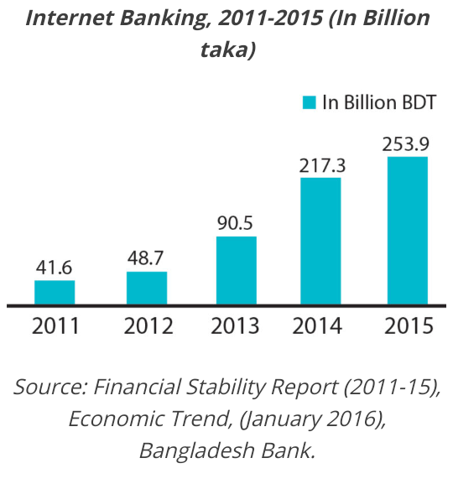
Pros :

- friendly environment

- it saves paper

- it saves time

- it saves money

Cons -

- there is no face to face contact

- problem of phishing Scams

Mobile Banking :

Mobile banking, the banking services are provided to the customers having the credit card accounts with bank. In mobile banking cellular service providers through SMS provides the services or In Bangladesh,most of the banks provide mobile banking services to their customers. Example : Common Mobile Banking Services Are Bkash ,Nagad , Rocket Banks are already carrying out activities such as disbursement of inward remittance
financial Transaction through agent / bank / branch / ATM / mobile payment of buisness organization by individual payments of individuals by buisness organization.

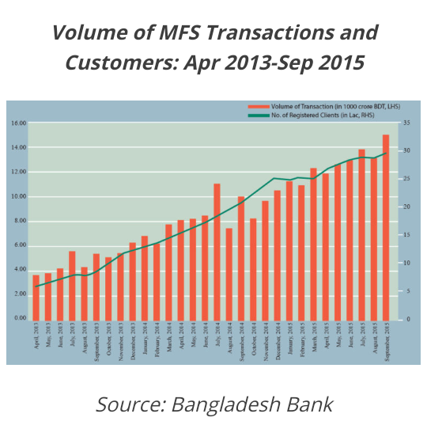

Electronic Fund Transfer :

Bangladesh Electronic Fund Transfer Known As BEFTN . Many Private Companies Pay Are Now Paying Their Cash Through BEFTN .

Easy Pay Machine :

Some Banks Have This Machine It Is A Mechanical Device Easily We Can Pay Our Land Phone Bill ,Current Bill , Wasa Bill .

Home banking

Home banking was introduced in 1980s but become popular in the mid 1990 when the use of internet raised. By the home banking facilities, any clients can conduct banking transactions from home rather than of branch locations. It also refers to the mobile banking transaction by using mobile phone through internet.

Pros :

- reduce costs
- save time

Cons : -
some face difficulties to understand the programme

Points Of Sale Terminal :

The ATM networks the bank also giving on increasing their post network covering their major outlets for purchase for the customers.
In 2011 total num of post in Bangladesh was 11,852 And the end of 2015 it stood 30,032 . 2015 total transaction was recorded at 1.54 core . most of the post are being operated in divisions town .

pros :
- it always provide detailed sale report

- it always helps to reduce Shrinkage of Employment

Cons :

- it quite costlier

- must require proper Internet connection & ISP

Security Issue And Other Challenge In Online Banking In Bagladesh :

(ATM) automated teller machine
By the ATM clients can take money and banks can give money over the counter. ATM machine run automatically through the identification of card by a password. This technology reduced the demand of cheque. Bank provides a secret single password against every single ATM card. This service is given for 24 hours. The ATM both was first introduced in Bangladesh in 1992 -1993. The grind lays bank them after standard chartered bank, American express bank, IFIBC, bank Asia and seven others local private banks are the followers. At the end of 2015 total 8,582 ATM has been installed in Bangladesh . that show a moderator increase in previous years . Most Of The ATM has been installed in divisional cities and district level .

Pros :
- it can save time & by using it, clients need not visit branch for withdraw cash.
- can pay utility bill at any spot

Cons :
- created noise by old machine
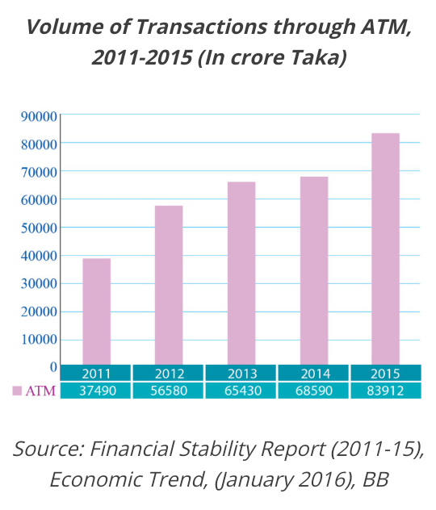
- some time ATM machine have fake pin pads

Swift:
It is the bank owned and nonprofit co-operation based in Belgium servicing. The financial community worldwide. Swift is a very popular as well as much secured messaging network. By this technology, any bank can send and receive fund transfer, and other important messages to other banks that are active in the network. This technology can increase the satisfaction and trust of the clients, especially those who are connected with export and import and remittances. So it’s very much helpful for transactions .

Pros :

-its very brief

- it very easier to read and maintain

- good speed support cross device

Cons :

- lack of safety compared to other cars like the polo and Figo
- poor quality

Easy pay machine:
It is very popular and useful technology which can accepted different bill like gas bills, land phone, WASA, DESA bills, cell phone bills e.t.c. this technology reduce the time Copt of the clients.

Pros :

- Save time
-save cost

Cons :

- face difficulties to understand the programme

Others:
Sothosearethemostimportantandpopularelectronic/onlineserviceofthemodernbankingsectorinBangladesh.ThosebanksalsoprovidetheTVbanking,mailbankingandsmsbankingservices.

Application software :

Almost all modern banks develop different types of application software by its personal resources such as foreign exchange return software, Employment tax management, cash transaction system, and reconciliation system etc for regular operation. Amost 80 application software are being used for regular operation. Among the software, 20% are foreign software, 55% are developed by the banks and 22% are local software.

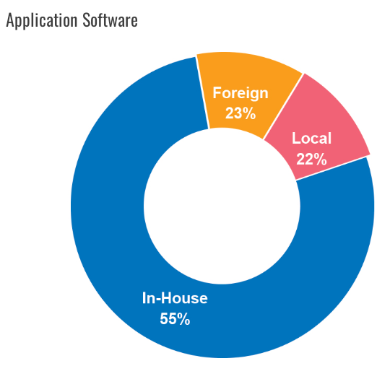

Advantages and disadvantages of online banking:

Some clients have positive opinions towards online banking and some have negative opinions towards online banking. so based on these opinions advantages and disadvantages of online/ electronic banking are given below-

Advantage | Disadvantage
- Lower Copt  - Online bill payment facility  - Save time  - Can take 24/7 hours service  - Speed and efficient  - Help to improve the overall banking sector  - Helps to improve overall economy. | - Uneducated people sometimes do not understand technology issues.  - Some people have negative opinion on security issues.  - Some time it becomes inefficient at complex transaction.  - Some people sell inconvenient to make deposits  - Create lack of relationship with personal banker.

So those are the prime advantages and disadvantages of online and internet banking.

CONCLUSION AND RECOMMENDATION

Online/electronic banking becomes very popular and important technology in modern generation. It’s very cost and time effective technology in present banking sector in Bangladesh. Almost all multinational and private banks trying to provide electronic service as much as possible. Almost all modern people like this technology. It helps to improve the overall banking sector and overall economy as well. But some people have not much trust on technology, so all banks must take proper action to improve the public awareness towards this technology. All banks must improve this security and complexity of transactions must be reduced. So overall it can be said that online / electronic banking is very much effective and efficient way of modern technology in banking sector in Bangladesh.

REFERENCES :

- www.traditional banking in.

- www.onlinebanking in.

- Indian banking-S natarjan

- www. Bangladesh bank. Org

- consumer adoption of electronic cash-hodges.R

