An Internship Report on

‘Recruitment and Training Process of Social Islami Bank Limited (SIBL)’

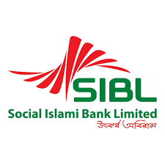
Recruitment and Training Process of SIBL



Submitted To

Nasrin Akter
Assistant Professor,
School of Business and Economics (SOBE)
United International University

Submitted By

Sanjana Tasnuva Pushan
ID: 111 132 045
School of business and economics (SOBE)
United International University

Date of Submission

8th / October / 2018

Letter of Transmittal
8th October 2018

Nasrin Akter
Assistant Professor,
School of Business and Economics (SoBE)
United International University.

Subject: Submission of Internship Report.

Dear Madam,

It is a great opportunity for me to submit my internship report on Recruitment and Training Process of SIBL which is an prerequisite for finishing the level of BBA Program. It is a great accomplishment for me to work under your dynamic supervision.

Woking on Social Islami bank Limited as an intern at Mohammadpur brunch, I have learned a various types of banking activities performed by SIBL, among most of the work are similar with what I have learned during my BBA courses.

I pray, and hope that your honour would be great enough to accept my Internship report and oblige thereby

Sincerely yours,
Name: Sanjana Tasnuva Pushan
ID: 111 132 045
School of business and economics
United International University

Executive Summary

SIBL is anything but an uncommon case of the dynamic universe of business where they stay with a mission of "Significance in Banking". One of the central money related banks of the country center to exhibit the impressiveness by impelled and particularly arranged workforce with a broad calling.

The report concentrated generally on the Human Resource Division. As private business bank work weight is high in SIBL, so they require astoundingly capable people who are amazingly given to their work, for the most part, the whole task will mess up. This is an unimaginable test for any relationship to find such skilled people.

To understand the upcoming enthusiasm of HR in SIBL, the Human Resources Division gives the different branches and divisions of the head office a general structure toward the beginning of the year. From the information amassed from these structures, the HR division gets an assessment of the work essentials for the year. The HR division at that point sets out to enroll and select the vital number of capable and viable people in the bank. SIBL sharpens both the enrollment and decision technique, anyway as it is a tremendous affiliation, the system contrasts for different work positions.

A banking association must be sharp in perceiving the human resource and train and develop them to do what needs to be done the banking assignment genuinely. Training and Development of the worker are basic for a bank to run effectively. This development can enormously influence the economy of the country. Along these lines, a bank like Social Islami Bank Ltd should have a suitable training and development office to redesign the learning and productivity of the representatives. An authentic Human Resource Division with adequate training and development office can make Social Islami Bank Limited more capable and make it the best bank in Bangladesh.

Acknowledgement
Most importantly, I express my profound appreciation to the Almighty Allah who made and support us in this short-lived world furthermore engaged me to create the report inside booked time.


I might want to express my significant appreciation and wholehearted admiration to my Supervisor Nasrin Akter, Assistant professor, United International University for his motivating rules, important proposal, productive feedback and consistent help in the mean time while I was creating this report.

For sure, I appreciate to all Faculty Members of United International University from whom I was roused and bolstered in different courses. Amid the exploration and at the season of study I am additionally paying off my humble honour to the manager Md. Jashim uddin and other officer and staffs in the Social Islami Bank Ltd, Mohammadpur Branch. Every one of them helped me in taking an interest and performing distinctive authority of works, information accumulation and other mental guidence while working in the bank while each exertion has made to guarantee exactness, Still though it cannot be assured that the report is completely mistake free. If there should arise an occurrence of any amendment, perplexity or uncertainty of any part of this report, I might be changed whenever it is necessary.
Table of Contents
Chapter 1
Introduction Part 4
I. Background of the study 5
II. Origin of the report 6
III. Scope of the Study: 6
V. Objectives of the Report: 6
VI. Sources of Data 7
VII. Limitation 8

Chapter 2
Literature Review 9
I. Definition of Training 11
II. Approaches of Training: 11
Chapter 3
Organizational profile 12
I. Functions of Social Islami Bank 15
II. SIBL Core Value 17
III. Mission of SIBL 17
IV. Vision of SIBL 18

Chapter 4
Recruitment process of Social Islami Bank Limited 19
I. Recruitment process of Social Islami Bank Limited 20
II. Internal Recruitment 21
I. Promotions and Transfers: 21
II. Employee referrals: 21
III. Previous Employees: 22
IV. Dependents of deceased employees: 22
V. Reviews: 22
VI. Retirements: 22
VII. Inside warning (promotion): 23
2. External Recruitment 23
I. Expert or Trade Associations: 23
II. Advertisements: 24
III. Employment Exchanges: 24
IV. Contractual workers: 25
V. Specialists: 25
VI. Head Hunters: 25
4.2 Recruitment Process Followed By Social Islami Bank Limited: 26
I. Identifying and prioritizing jobs: 28
II. Candidates target: 28
III. Sources of recruitment: 30
IV. Trained recruiters: 30
V. Evaluate the candidates: 30

Chapter 5
I. Training process 32
II. Steps of Training: 36
III. Methods of Training: 36
IV. Foundation training: 38
V Workshops: 39

Chapter 6
Findings and Recommendations 41
STEP-I: Conducting SWOT Analysis of SIBL 43
STEP-2: SWOT Analysis on Human Resources of SIBL 46
6.2 Recommendations 49
6.3 Conclusion 50
Bibliography 51

Chapter 1

Introduction Part

Recruitment and Training Process of SIBL

1.1 Background of the study
Social Islami Bank Limited (SIBL) is a 2nd era Islami bank performing banking activities since 22 November 1995 focusing Shariah Principles. Presently, SIBL has 95 branches everywhere throughout the nation with 2 backup organizations SIBL securities ltd. as well as, SIBL investment ltd. The bank opened 10 branches in 2013 to bring more individuals under the inclusion of banking administration. SIBL was a new Bank with an approved capital of Taka 10,000,000,000 out of 2013 and paid up capital of Taka 7,031,415,640 of every 2013 and furthermore taka 6,393,925,700 separately as of December 2012.
Branch activity part will portray the item and administration gave to the clients by a branch. For planning my temporary job I have been set in Social Islami Bank Limited, Mohammadpur Branch, Dhaka. There are 03 areas in Mohammadpur Branch. They are:
1) General and HR exercises Banking.
2) Investment Department
3) Foreign Exchange Department.
I will work primarily on general banking and HR areas. I will give my most extreme exertion and thoughtfulness regarding taking in HR's capacities. After finishing the entry-level position, I will render my learning to exhibit the provide details regarding Recruitment and preparing elements of Social Islami Bank Limited-A Special Focus on the recruitment procedure and training process. In the hierarchical part will quickly depict a review of the banks' verifiable foundation, capacities, business reasoning, possession design, remote journalists and abroad tasks and advantages gave to clients by the bank.

1.2 Origin of the report

As an component of the Bachelor of Business Administration (BBA) prerequisite, it is a 12 weeks in length internship program that teaches a student a proper practical knowledge by working in an organization. I took the internship with Social Islami Bank Limited. I am pleased to got an chance as an intern in SIBL and this experience will unquestionably assist me a lot in my future. The internship program and the investigation have following purposes:

To get and organize detail knowledge on the job responsibility.

- To experience the real business world.
- To compare the real scenario with the lessons learned at United International University
- To fulfill the requirement of BBA Program.

1.3 Scope of the Study:

The scope of my internship is so greater as I was taken to work various sections of the bank in Mohammadpur Branch. There, I observed and learnt a lot from the HR especially Recruitment and training activities and various daily functions perform in this bank.

1.4 Objectives of the Report:

The Primary objective of the internship report is to conclude my BBA program and to acquire real life experience of banking activities in Bangladesh. There are also some others important objectives. These objectives are given as follows:

- To collect practical knowledge about the functions of HRM departments of the bank.

- To analysis employee recruitment process of Social Islami Bank Limited.

- To learn Training process and programs of Social Islami Bank Limited.

1.5 Sources of Data

There are a lot of source from where I had collected data. Mainly, these all sources can be divided into 2 parts:
- Primary Source.
- Secondary Source.

The “Primary Sources” are as follows:
Information, gathered out the first time, is called primary information. The strategies used to gather such information include:
- Formal and Informal discussion with the customers.
- Practical experience from the distinctive work areas of the Branch.
The “Secondary Sources” of data and information are:

The secondary data sources are annual reports, manuals, and brochures of SIBL and different publications of Bank.

Methods used to collect secondary data includes:

- Annual Report of Social Islami Bank Ltd.

- Internet.

1.6 Limitation

Clearly, every Study has a few limitations. The report I have made is of awesome significance and required me colossal work. Those restricting variables that hampered my smooth workings in the bank lastly in setting up this report are as per the following:

    - Lack of adequate books, papers, and diaries and so on. Most of the time, progressive data may not be accessible.

    - Large-scale examination isn't conceivable because of imperatives and limitations posted by the bank.

    - Duration of the investigation was too short to have a sound comprehension of the general banking.

    - This investigation totally relied upon official records and yearly reports

Chapter 2

Literature Review

Recruitment and Training Process of SIBL
2.1 Definition of Recruitment
The way toward finding and enlisting the best-qualified human resource (from inside or outside of an organization) for an employment opportunity, in an auspicious and practical way. The recruitment procedure incorporates examining the necessities of an occupation, pulling in employees to that activity, screening and choosing candidates, procuring, and coordinating the new employee to the organization.

2.2 Importance Of Recruitment
Recruitment is the process of having the perfect individual, in the correct place, at the correct time. It is important to organizational execution. Recruitment is a basic action for the HR group as well as for line supervisors who are progressively engaged with the selection process. Every one of those associated with recruitment process with the proper information and abilities.

For any organization dealing with individuals requires a decent human resource management effective working of the organization. Banking has been and will dependably be a "People Business". Productive and viable management of the human resource in the organization turns it an effective one.

For banking, the significance of human resource management has developed complex in light of the fact that the idea of banking industry, which is for the most part benefit based. The management of individuals in the organization alongside taking care of the money related and financial dangers at the more extensive level is the most powerful difficulties before the banking business in any given time period.
Though there are a lot of risk in banking sector, but Banks shoud take care of the interest of their clients. HR need to ensure that the employee, those who are daily communicating face to face with the clients of the bank, are qualified individuals. Before starting their work, all the employee need to be given vital training.

2.3 Definition of Training
Training is the learning process it looks for a moderately change in a person which enhances the capacity to perform better job. Training can include in the changing in skills, learning, states of mind towards to work. It implies change in what representatives know, how they work, their mentalities towards to work and their interaction with their co-workers and supervisors.

2.4 Approaches of Training:
There are two approaches of training and they are:

1. Traditional Approach: In past organizations never utilized training method. They were holding the traditional view that directors are conceived they are not made. They additionally trust that training is an expensive program for the organization and it doesn't convey any advantage for the organization. Organizations used to put stock in administrators squeezing.

2. The Modern Approach: Now the situation is changing in the organizations the modern approach of training and improvement they know the significance of corporate training for the organization. Training is presently a greater amount of retention instrument than a cost. Presently the training framework has been changed for to make the organization a more quick witted workforce and yield the best outcomes.

Chapter 3

Organizational profile

Recruitment and Training Process of SIBL

3.1 The History: Social Islami Bank Limited

The SIBL, a second-era commercial bank, working after 22nd November, 1995 in light of Shariah' Standards, has now 121 branches wherever all through the country with two another organizations - SIBL Securities Ltd. furthermore, SIBL Venture Ltd. Concentrating on poverty, SIBL is actually a thought of 21st century participatory three zone sparing cash demonstrate in one. In the formal zone, it fills in as an Islamic participatory business save money with human face way to deal with oversee credit and putting money on the preferred standpoint and affliction sharing. It has a Non-formal saving money area too with accommodating record and hypothesis bundle that engages and changes genuine poor family and make adjoining wage openings and incapacitates inside development.

The bank has another division to adjust the vital part and administration of Waqf, Mosque properties and has introduced cash Waqf system unprecedented for the authentic background of sparing money.

In the commercial division the Bank along with others, proposes mainly leap forward sparing cash administrations through releasing of different sorts of store and personal accounts, financing entrepreneurs, giving LC’s, aggregation of bills, rental of rigging and clients' solid, get purchase and segment bargain for principal items, enthusiasm for negligible exertion hotel and administration of authentic spaces, participatory enthusiasm for various mechanical, agrarian, transport, educational and prosperity assignments and so on.
Human resource administration is the path toward picking up, getting ready, assessing, and compensating specialists, and of dealing with their work relations, prosperity and security, and conventionality concerns. Enrollment and decision are 2 main crucial components of staff administration. Enrollment works before decision as well as helpers in selecting a accurate contender. Recruitment, a system to discover to meet the need of the employment plan as well as to use convincing process for pulling in to work in adequate figures to energize effective assurance of beneficial job compel. National bank confined has been approved by the governing body of Bangladesh as an arranged business bank in the private part in similarity of system of progression of dealing with a record and cash related administrations and workplaces in Bangladesh.

3.2 Functions of Social Islami Bank

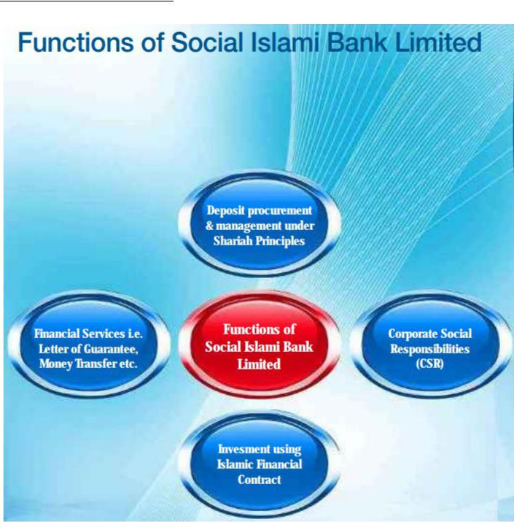

3.3 SIBL Core Value

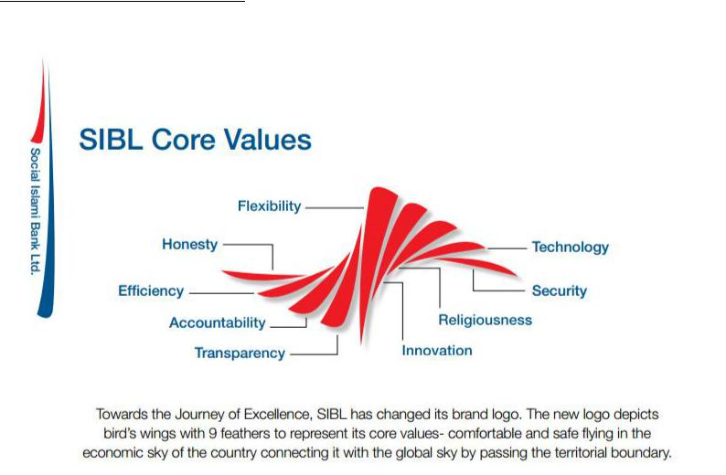

Mission of SIBL

- High quality financial services with the latest technology.

- Fast, accurate and satisfactory customer service.

- Balanced & sustainable growth strategy.

- Optimum return on shareholders’ equity.

- Introducing innovative Islamic banking products.

- Attract and retain high quality human resource.

- Make powerful the poor families and create local income opportunities.

- Providing support for social benefit organizations-by way of mobilizing funds and social services.

3.5 Vision of SIBL
In SIBL performing towards ceaseless brilliance it is looking to achieve the Nation's leading Islamic Bank by offering advance service of an extensive variety of significant worth included items and services addressing the necessities of its customers; directing its business morally as per the laws of Shariah while improving best usage of the most current best in class innovative arrangements through making of an expert active authoritative culture in view of sound cooperation, decency, common understanding and commonsense administration dependably stay open to new thoughts and versatile to the accepted procedures in the market guaranteeing acknowledgment and quality banking knowledge to its customers and convey best an incentive to every one of its partners also.

Chapter 4

Recruitment process of

Social Islami Bank Limited

Recruitment and Training Process of SIBL

4.1 Recruitment process of Social Islami Bank Limited
A well recruitment process is exceptionally vital as a result of development of the bank. Progression organizing moreover call for recruitment on occasion to fill the unfilled post can't be filled from inside. There is a noteworthy number of enrolling sources used by this bank. SIBL distributes in the every day paper to make applications for different passage level post. The decision method in SIBL is the same as what is performed in numerous associations. The work starts with beginning screening and a candidate is finally picked through a last meeting. The present selection and recruitment process, its insufficiencies are elucidated in the accompanying segment as it is the key domain of the report.

For SIBL applicant, selection is the path toward putting right men on right position. It is a technique of planning authoritative necessities with the capacities and abilities of people. HR depends on the utilization of forward techniques methodologies for picking and choosing probability for work.

Each alliance has the choice of picking the contender for its enrollment shapes from two sorts of sources: internal and outside sources. The sources inside the association itself (like exchange of workers from one office to other, movements) to fill a position are known as the internal wellsprings of selection. Candidates from the diverse sources (like outsourcing associations and whatnot) are known as the outside wellsprings of selection.

1. Internal Recruitment

Internal recruitment looks for candidates for positions from inside the organization. The different inward sources include:

- Promotions and Transfers:
Promotions refers to the whole arrangement of exercises, which present the product, brand or administration to the customer. The thinking is to make people careful, attract and incite to buy the item, in inclination over others.
Work compel records discover delegates who are doing assignments underneath their educational abilities or fitness levels. Progressions has various central focuses like it is awesome advertising, collects certainty, invigorates capable individuals who are energetic, improves the probability of good decision since information on the person's execution is speedily open, is more affordable than going outside to choose, those picked inside are familiar with the affiliation thusly reducing the presentation time and imperativeness moreover goes about as a readiness contraption for making focus level and best level administrators. In any case, headways limit the field of assurance shielding fresh recruits and contemplations from entering the affiliation. It in like manner prompts inbreeding in the affiliation. Trades are also basic in outfitting laborers with a wide based viewpoint of the affiliation, crucial for future headways.

- Employee referrals:
Employees can develop unimaginable prospects for their families and accomplices by adjusting them with the upsides of an occupation with the affiliation, outfitting them with the partner and empowering them with apply. This is a to a great degree effective means a similar number of qualified people can turn out to be too effortlessly to the association.

Exchange positive conditions are that the labourers would bring only those referrals that they feel would have the ability to fit in the affiliation considering their own specific experience. The affiliation can be ensured of the immovable quality and the character of the referrals. Thusly, the affiliation can in like manner fulfill social duties and make altruism.
- Previous Employees:

These incorporate resigned representatives why should willing work on low maintenance premise, people who left work and will return for higher remunerations. Indeed, even conserved workers are taken up at the end of the day.

- Dependents of deceased employees:

Usually, banks tail this approach. On the off chance that a representative bites the dust, his/her companion or child or little girl is enrolled in their place. This is typically a viable approach to satisfy social commitment and make goodwill.
- Reviews:

When administration Faces a problem, that can be solved just by an administrator who has went on a leave, it should be chose to review that persons after the problem is solved, his leave might be increased.

- Retirements:

Often It is hard to find a worthy person who had resigned, after commendable administration. Considering the present situation, administration may choose to call resigned supervisors with new expansion.

- Inside warning (promotion):

Often, bank issues an inside notice for the upside of existing delegates. Most specialists know from their very own understanding about the need of the occupation and what sort of individual the association is hunting down. Routinely laborers have buddies or partners who meet these necessities. Fitting people are designated at the vacant posts.

2. External Recruitment

The different outside sources include:

- Expert or Trade Associations:

Numerous affiliations give position organization to its people. It contains amassing business searcher's summaries and offering access to people in the midst of regional or national conventions. Also, the creations of these affiliations pass on requested ads from supervisors captivated by choosing their people. These are particularly useful for pulling in extremely educated, experienced or skilled staff.
- Advertisements:

It is a well known methodology for searching for volunteers, a similar number of selection delegates lead toward advertisements in perspective of their wide reach. Need advancements portray the occupation focal points, recognize the business and prompt those captivated how to apply. Day by day paper is the most broadly perceived medium yet for astoundingly specific enrolled individuals, notification may be set in master or business journals. Advertisements must contain fitting information like the employment content, working conditions, zone of occupation, pay including coincidental focal points, work particulars, development viewpoints, and so forward. The promotion needs to offer the association and employment are perfect for the candidate. Enlistment advancements can similarly fill in as corporate promotions to manufacture association picture. It moreover practical.

- Employment Exchanges:

Employment Exchanges have been set up wherever all through the country in regard to the obtainment of the Employment Exchanges (Obligatory Warning of Opportunities) Act, 1959. The Act applies to each and every mechanical establishment having 25 workers or simply more each. The Act requires all the mechanical establishments to educate the opening before they are filled. The genuine components of the exchanges are to expand the pool of possible candidates and to do the preliminary screening. In this way, occupation exchanges go about as an association between the organizations and the arranged specialists. These work environments are particularly significant to in enrolling hands on, proficient and specific employee.

- Contractual workers:

They are used to enlist accommodating experts. The names of the professionals are not entered in the association records and, to this degree; inconveniences experienced in keeping up interminable workers are kept up a key separation from.
- Specialists:

The bank is usually calling for enrolling and choosing regulatory and official staff. They are useful as they have the huge contacts and credit worthy expertise to the enrolling methodology. They moreover keep arranged administrator and delegate obscure. In any case, the cost can be a snag variable.

- Head Hunters:

They are useful in particular and skilled work experience in a particular association. An expert is sent to address the enrolling association and offer is made to the confident. This is a useful source when both the associations included are in a similar field, and the agent is reluctant to take the offer since he explanations behind alert, that his association is attempting his dependability.

4.2 Recruitment Process Followed By Social Islami Bank Limited:

Recruitment is of the most pivotal parts of the human asset experts. The level of execution of an organization relies on upon the viability of its Recruitment capacity. Associations have created and take after enrollment methodologies to procure the best ability for their association and to use their assets ideally. An effective enlistment procedure ought to be all around arranged and pragmatic to draw in progressively and great ability to apply in the association. For defining a viable and fruitful enrollment system, the methodology ought to cover the accompanying components:
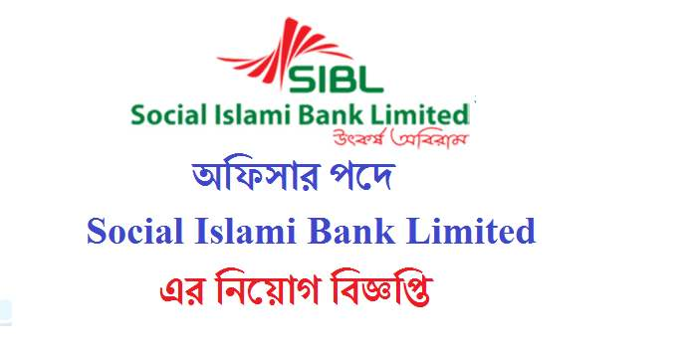

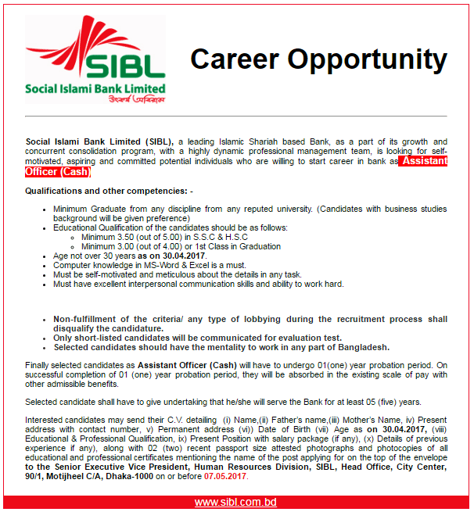

1. Identifying and prioritizing jobs:

Prerequisites continue emerging at different levels in each association; it is very nearly a ceaseless procedure. It is difficult to fill every one of the positions promptly. Along these lines, there is a need to distinguish the positions requiring quick consideration and activity. To keep up the nature of the enlistment exercises, it is valuable to organize the opportunities whether to concentrate on all opening similarly or concentrating on key occupations first.

2. Candidates target:

The enrollment procedure can be compelling just if the association totally comprehends the necessities of the kind of hopefuls that are required and will be useful for the association. This covers the accompanying parameters too:

- Performance level required:

Different systems are required for concentrating on enlisting superior workers and normal entertainers.
- Experience level required:

The system ought to be clear with reference to what is the experience level required by the association. The applicant's experience can go from being a fresher to experienced senior experts.

- Category of the candidates:

The technique ought to plainly characterize the objective competitor. He/she can be from the same business, distinctive industry, unemployed, top entertainers of the business and so forth.

3. Sources of recruitment:

The method should portray distinctive sources (outside and inward) of enrollment. Which are the sources to be used and focused for the enrollment purposes for various positions? Specialist referral is a standout among the best wellsprings of enrolment.
.

4. Trained recruiters:
The enrolment specialists leading the gatherings and the other selection practices should be especially arranged and experienced to coordinate the activities. They should think about the genuine parameters and capacities (e.g.: social, concentrated and so on.) to focus while meeting and choosing a candidate.

5. Evaluate the candidates:
The distinctive parameters and the ways to deal with judge them i.e. the entire selection technique should be organized early. As though the rounds of particular gatherings, HR interviews, formed tests, psychometric tests and so forward.

Chapter 5

Training Process of Social Islami Bank Limited

Recruitment and Training Process of SIBL

5.1 Training process

With a specific goal to keep up a focused edge in the commercial market, each organization must put resources into the training and development of the representatives. Human Resources Development (HRD) centers around both training representatives for their present employments and creating abilities for their future jobs and duties. HRD activities include; training for administrators, directors, and groups; educational cost repayment programs; customer service training; performance management; provocation anticipation training; 360 degree reviews (multi-rater feedback system) and vocation instructing.

360 degree reviews: A 360-degree evaluation is an appraisal tool that gives representatives the chance to get performance feedback from managers, peers, associates and furthermore outside gatherings, for example, suppliers and clients. The 360-degree evaluation process also empowers SIBL to pick up understanding into the execution and capability of future pioneers, and to decide the improvement needs of employees.

Human Resource is the foundation for quick and managed improvement of any association. SIBL perceives the significance of gifted human resources for general development of the bank. The exemplary and skilled HR group is the key for ceaseless advancement of the association. Predominant HR is an imperative wellspring of upper hand. To pull in capable HR group and to make brand picture bank have figuring and executing HR frameworks, HR arrangements and exercises that create the worker abilities and practices which the Bank needs to accomplish. The bank has been attempting to guarantee extreme yield with least assets. So quality labor with great scholastic foundation is being selected in all levels of the bank each year for rendering quality administrations to its clients. SIBL has opened 11(eleven) new branches in the year 2015 and turn into the bank of 111 Branches. Thus, a decent time was spent on enrolment of experienced bankers. Other than that, the enlistment procedure of Probationary and Trainee Officer for the bank has been started. The aggregate labour quality of the bank was 2130 as on 31.12.2017. SIBL is a representative welfare-arranged association. Consequently, the administration of the bank dependably tries to deal with all conceivable ways it considers beneficial to advance its representatives' expert aptitude and effectiveness. It has its own particular Training Institute, which rendered valuable preparing to 1270 workers a year ago. Prominent Bankers, researchers, and other asset persons were welcome to convey addresses. In addition, 431 no. of representatives were sent to Bangladesh Bank Training Academy, Bangladesh Institute of Bank Management, Bangladesh Association of Banks, Bangladesh Foreign Exchange Dealers Association, the Central Shariah Board for Islamic Banks of Bangladesh and numerous other presumed foundations of the nation for preparing against 510 no. of workers in 2014. Along these lines, it is watched that the representatives who were prepared, render great execution. Other than that, amid the year under survey, Social Islam Bank Training Institute itself had led 4(four) establishment instructional classes for aggregate 102 no. of crisp Officers and 27 training, workshops and Seminar on various contemporary issues identified with managing an account commercial enterprises where 839 no. diverse Officers and administrators had taken an interest. There are some charts given below:

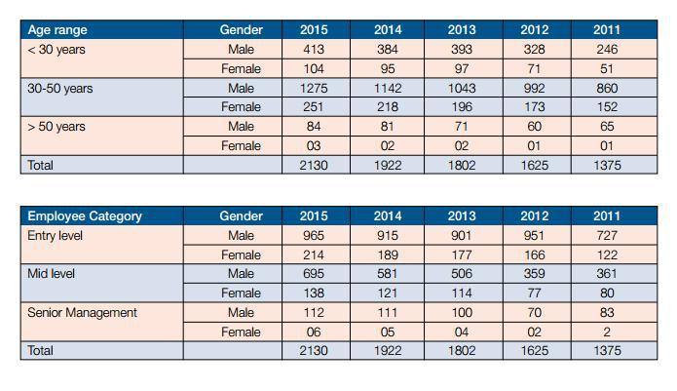

To provide developed and quick services to customers with full satisfaction is a very challenging job in the competitive banking era. Keeping this challenge in view, they have focused on the development of human resources and best HR practices in SIBL. There are various types of training program available in SIBL.

  - Process of Training:

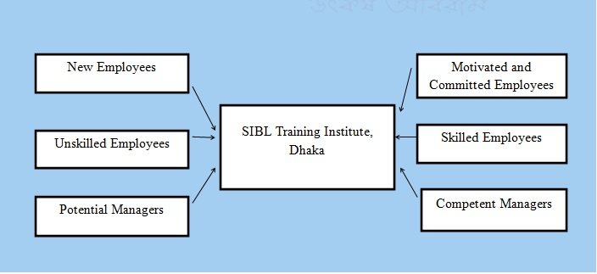
  - Steps of Training:
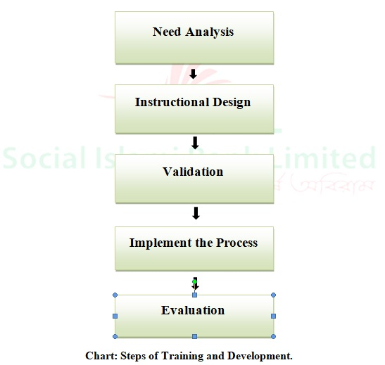

5.4 Methods of Training:
Social Islami Bank Limited has their own Training institute in Dhaka, Called SIBL training Institute. This Training institute follows two mathods of training:

1. On-the-job Training: On-the-job is the core of training program. This training program is otherwise called "Cleanser Training". The process of on-the-job training program is given beneath:

• Instructor Preparation: Instructor isolates sensible parts to make a lesson plan and select the training procedures.
• Trainee Preparation: Place the trainee at the coveted training program. Relate the requirements appraisal of trainee with respect to his promotion.
• Present the Task: Present the general task to the trainee. Depict him the known to obscure things and simple to troublesome things. Make him the modification with the place. Depict every progression of task.
• Tryout the Performance: Need to disclose every single earlier advance to the trainee and know about inclining and motivation. Ought to give the input of the performance.
• Follow Up: Surrender a positive take after toward the begin.

2. Off-the-job Training: Off-the-job training methods are:
• Classroom Lectures: Lectures are intended to convey the interpersonal strategy or critical thinking skills.
• Films and Videos: Utilizing multi Medias to specific skills that are difficult to present by other training methods.
• Simulation Exercises: trainings are really to perform the work. This incorporates case examination, pretending and gathering discation and so on.
• Computer Training: Computer is the most vital thing at work put. Representatives need to take in all the innovation so computer training is so critical.
• Case Study: Giving trainees case study and influence them to unravel it is great. Case study will clear the theoretical concept.
• Outdoor Seminars: Sending workers to go to seminars. Us ease numerous university compose program and calls them to go to those class.
• University Related Programs: Some university organizes programs and calls workers for motivational discourse of the understudies. So organizations send representatives with the goal that their interpersonal skill creates.
Nevertheless, all those training fall under these processes that are given below:

- Foundation training:

Foundation training is the training that every employees of SIBL has to take after joining the bank. This training is mainly a classroom-based training. Here, they can learn about the basics of banking and how their main software works. This is a long-term training program. After the training period the trainees give a examination on their learning through the time and being evaluated by the trainers. This is mainly for the newly appointed employees or fresh graduates.

Various types of training program are done by lectures or conferences. Every now and then, the training institute of SIBL arranges training programs of 1 or 2 days trainings on different topics. They select different employees for different topics from different branches. Sometimes these trainings last for 7 days or 15 days depending on the topic of the training. Here the trainers give their lectures and the trainers listen to them and try to learn what they are saying. The trainees can ask questions if they have any and the trainers try to answer those. Some of the training names are given below:

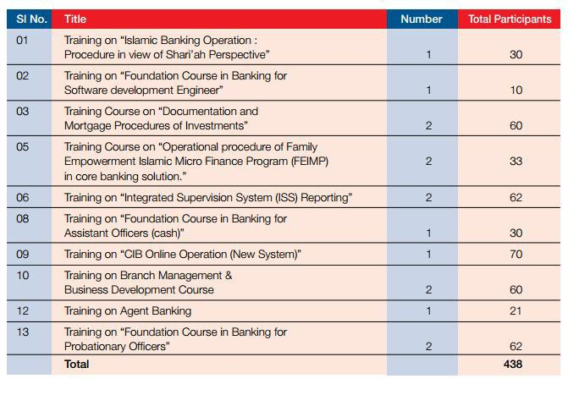

- Workshops:

Workshops are the common type of training process in SIBL. The training institute arranges several workshops for the employees on different sectors. They choose suitable employees to join the workshops, which helps the employees to know their job better and to perform their jobs more effectively and efficiently . There is some workshop’s title and the numb er of employees who has participated on those are given below:

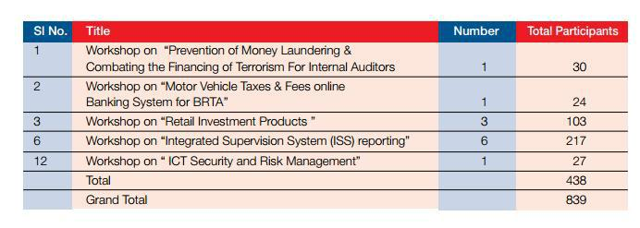

Chapter 6

Findings and Recommendations

Recruitment and Training Process of SIBL
6.1 Key Findings

- The bank has skilled manpower with excellent academic track along with highly professionalism that leads the ability of getting any job done effectively.

- The bank has an approved organogram with proper-reporting authority that clearly shows whom to report by whom. Thus the works are done very smoothly with effective follow up & monitoring.

- The bank follows excellent recruitment & selection procedure that leads to inflow of the genuine & deserving manpower in the bank.

- SIBL pays a lot of importance on training programs inside their own training institute. Sometimes the Training Institute cannot provide necessary training to all the employees and sometimes the right person was not nominated for the training courses as a result the officials have to work with inadequate knowledge that reduces efficiency & accuracy of the works.

- The bank has a proper succession planning. That is why in case of vacancy in any top management post it can be fulfilled as per the succession planning and the smooth operation of the bank is not hampered.

- They do not have HR department in every branches, they have only one HR department in the head office.

- The employees have no participation in the capital structure. They are just treated as salary paid employees.

- In some cases, Directors of the bank interfere in recruiting & selection process.

- The publicity of the bank job circular both in electronic & printing media is very limited. As a result, mass people are not completely aware about their vacant position’s circular provided by the bank.

I have created two SWOT Analysis after All the necessary study of my Internship report on Recruitment and Training process of Social Islami Bank Limited. The SWOT Analysis of Social Islami Bank Ltd (SIBL) is given below:

STEP-I: Conducting SWOT Analysis of SIBL
Strengths:
- The bank is financially sound to operate its banking activities. It has adequate capital to run the operation.

- The bank stores skilled, competent, eligible & experienced employees who are the asset of the bank. A number of young, energetic & skilled employees render their service that makes operation of the Bank very smooth.

- The branches of the bank are situated at prime business locations so that the bank could provide services to the potential clients.

4. The bank has an approved organogram with proper reporting-relationship (attached herewith).

5. The bank is fully computerized with real time banking facilities that attract the people to the bank.

6.The bank has a proper succession planning. That is why in case of vacancy in any top management post it can be fulfilled as per the succession planning and the smooth operation of the bank is not hampered.

- SIBL follows almost the same recruitment policy like other organizations do.

- SIBL pays a lot of importance on training programs.

- They have their own training institution.

- They do not have HR department in every branches, they have only one HR department in the head office.

Weaknesses:
1. The number of branches is not sufficient in respect of the age of the bank. So the branches are not able to cover the services throughout the country.

2. The employees have no participation in the capital structure. They are just treated as salary paid employees.

3. In some cases, Directors of the bank interfere in recruiting & selection process.

4. Downward trend of net income of the bank in the last two consecutive years is acting as a de-motivating factor of the bank.

5. The publicity of the bank both in electronic & printing media is very limited. As a result, mass people are not completely aware about the diversified services provided by the bank.
6. Sometimes the Directors and other influential groups create pressure for low quality investment. This becomes difficult to recover those investments, which increases the classified investment of the bank and reduces its profit position.

Opportunities:
- The bank is based on Islamic Shariah. The majority people of the country believe on Islam that toward to the bank.

- The bank is a three sector banking model i.e. Formal, Non-formal & Voluntary, while formal sector deals in general commercial activities as a scheduled Bank, Non-formal Sector aims at " Empowering Family"- by creating investment opportunities to Micro and SMEs client. Voluntary sector deals in Cash Waqf Certificate Scheme-an innovative financial product towards welfare to the mankind

- As the business is expanding globally day by day. The banking activities are also increasing with match the situation.

- Non-political environment prevail in the bank. The employees are not involved any political activities in the bank area. The employees of the bank do their duty without interferences of any political pressure.

Threats:
I.The employee turnover is high due to lower salary than other banks. This turnover causes high cost of the bank.

2. Political instability of the country is harming the banking sector along with other business organization.

3.Sometimes extravagant call money rate hamper our banking activities

4. Bangladesh bank plays an important role to control the commercial banks. Sometimes Bangladesh bank want to interfere in internal affairs of the commercial bank, which is not at all desirable.

STEP-2: SWOT Analysis on Human Resources of SIBL

Strengths:
1. The bank has skilled manpower with excellent academic track along with highly professionalism that leads the ability of getting any job done effectively.

- The bank has an approved organogram with proper-reporting authority that clearly shows whom to report by whom. Thus the works are done very smoothly with effective follow up & monitoring.

- The bank follows excellent recruitment & selection procedure that leads to inflow of the genuine & deserving manpower in the bank.

- Bangladesh bank plays an important role to control the commercial banks. Sometimes Bangladesh bank want to interfere in internal affairs of the commercial bank, which is not at all desirable.

- The bank operation directly engaged in money market where exchange rate fluctuation create problem for the bank.

- Sometimes World Bank & International Monetary Fund prescription / domination which has no applicability in the context of our country may become burden for us.

- Some private commercial banks are functioning with very aggressive banking, which creates an unhealthy competition in the banking sector increasing risk involvement.

- The bank strictly follows obligatory privileged leave for 15 days along with one month basic pay for each employee each year which gives the employee a chance for recreation with bank's finance and it enables the bank to reduce fraud & forgery through deputing & checking the desk works of the employee on obligatory privileged leave.

Weaknesses:

1. The compensation package of the bank is comparatively poor than that of other banks which lead to higher tendency of outflow of manpower and the bank cannot attract the promising officials to joint the bank.

2. Sometimes the Directors of BOD interferes the recruitment and comparatively inferior officials are recruited which affects negatively on the internal working environment, customer service as well as on the image of the bank.

3. Sometimes the Training Institute cannot provide necessary training to all the employees and sometimes the right person was not nominated for the training courses as a result the officials have to work with inadequate knowledge that reduces efficiency & accuracy of the works.

Opportunities:

1. Bangladesh is a country of huge unemployment. A good number of brilliant students are coming out of the universities having graduation. The fresh university graduates now-a days have a good fascination towards the Shariah Based Islamic Banking. So as a result being a Islamic shariah based bank, Sibl has a good opportunity to recruit brilliant officials from the fresh graduates.

- Having retirement (usual or voluntary) from the Nationalized Commercial Banks the people have a common tendency to work with a shariah based bank, so SI BL has a good opportunity to attract the retired experienced bankers to join with SIBL.

Threates:

- Most people think that there is no task difference between traditional & Islamic banking and they think that Islamic banks are Changing the people. They also try to research thesis concept to others. It makes a negative image against the bank and some people do not feel interest to work in an Islami bank like SIBL.

- The traditional banks sometimes offer higher salary than the shariah based lslami banks. As such somebody do not feel interest to join in SIBL

6.2 Recommendations

- HR department cannot perform their works properly as it is tough to monitor all the branches centrally. Therefore, I would suggest SIBL to enhance their HR department.

- The Priority and Importance For HR department should be increased as it is one of the leading banks in Bangladesh and Hr department is one of the most important departments for any organization.

- The number of branches is not sufficient in respect of the age of the bank. So the branches are not able to cover the services throughout the country.

- The employee participation in the capital structure is necessary. When They get priority, they can be the beneficiaries to the bank. So They should not just treated as salary paid employees.

- , Directors of the bank should not interfere in recruiting & selection process for a fair recruitment process.

- The publicity of the bank job circular both in electronic & printing media need to be increased as employees are very important part for any banking Organization like SIBL. So, mass people will aware about SIBL’s vacant position’s circular provided by the bank.

6.3 Conclusion

Social Islami Bank Limited (SIBL) is a developing bank in Bangladesh Banking Industry, which is slanting and earned goodwill inside in a very short time. The SIBL has as of now earned goodwill in the banking sector. This has been conceivable due to the human asset that is the representatives who are working in the bank. On the other hand that the workers gives their best effort than any association can become rapidly. In spite of the fact that there is some issue in the preparation and advancement part yet with a appropriate preparing and advancement office SIBL can become speedier and the efficiency will likewise increment. With the assistance of legitimate preparing and improvement assuming each and each representative of Social Islami Bank Limited can be created legitimately than proficiency and salary of SIBL will increment to an expansive degree.

Bibliography

www.sibl.com (2017) Available at: http://www.siblbd.com/annual_report_2017

- SIBL (2017) Available: http://wwwat:.siblbd.com/home/selection_p 2016)

- Noor, A. and Begum, K.A. (2016) ‘recruitment and July.

- http://www.siblbd.com/home

- SIBL Annual report 2013-2017

- https://www.facebook.com/SIBLDHAKA

- Different Study materials from BIBM.

- www.google.com

- Operational manual of Bangladesh Bank.

