Procurement and Vendor Management Practices at Beximco Ltd.
A Case Study of the Textiles, PPE and Apparel Division

Shama Akter

This report is submitted to the school of Business and Economics, United International University as a partial requirement for the degree fulfillment of Bachelor of Business Administration
Procurement and Vendor Management Practices at Beximco Ltd.
A Case Study of the Textiles, PPE and Apparel Division
Submitted to:
Name: Ms. Mahbuba Sultana
Lecturer at School of Business & Economics (SOBE)
United International University
Submitted by:
Name: Shama Akter
ID: 111193083
Major: Supply chain management
School of Business & Economics
United International University

School of Business and Economics
United International University
Date of submission: 22th July, 2026

LETTER OF TRANSMITTAL
Date:22th July, 2026
Ms. Mahbuba Sultana
Lecturer, School of Business and Economics
United International University
Subject: Submission of Internship Report
Dear Madam,
With due respect, I am pleased to submit my internship titled, "Procurement and Vendor Management Practices at Beximco Ltd. A Case Study of the Textiles, PPE and Apparel Division" in partial fulfillment of the requirement for the degree of Bachelor of Business Administration from United International University. This report elaborates on some of the key insights I learnt throughout my procurement operations and supplier coordination workflows as part of my 3-month internship at Beximco Ltd.
I am extremely grateful for your mentorship and your constant guidance throughout this journey. I humbly submit this report for your honorable consideration and acceptance.
Sincerely,
Shama Akter
ID: 111193083
Major: Supply chain management
School of Business & Economics
United International University

Certification of Similarity Index

This is to certify that this report has been checked for similarity/plagiarism using the plagiarism-detection tool designated by the School of Business and Economics, United International University, and the similarity index was found within the limit prescribed by the university's academic guidelines.
[The originality/similarity index certificate, generated and attested by the department, should be attached on this page before final submission.]

DECLARATION OF THE STUDENT

It is a matter of great pride for me to declare that the internship is titled "Procurement and Vendor Management Practices of Beximco Ltd. A case study on Textiles, PPE and Apparel Division" has been successfully prepared by me as an academic fulfillment of my degree Bachelor of Business Administration (BBA) under United International University.
I also certify that this report is my original work and has not been submitted for any degree, diploma or qualification in another university, institution or organization.
Every piece of information, data, and materials collected from different sources have been properly cited. The resemblance is purely due to usage of well cited academic and organizational sources which have been published earlier.

Name: Shama Akter
ID: 111193083
Major: Supply chain management
School of Business & Economics
United International University

SignatureDate:22th July 2026

Corporate Evidence
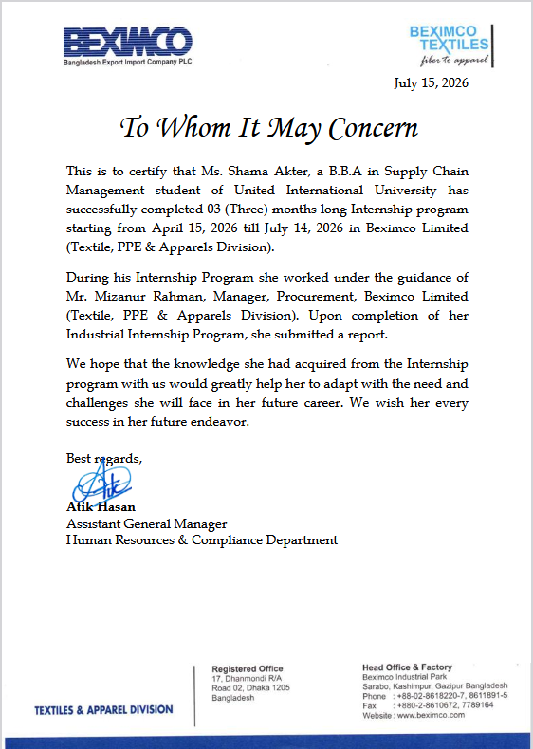

ACKNOWLEDGEMENT
First of all, I praise God Al-Mighty, who gave me strength to complete the internship program and this report. My sincere gratitude goes to my academic advisor, Ms. Mahbuba Sultana, Lecturer School of Business & Economics United International University for her immense support, constant encouragement and guidance.
I will also express my gratitude to the management of Beximco Ltd, for allowing me to work as an intern under their Procurement and Vendor Management Department in Textiles, PPE and Apparel Division. I am truly thankful to my organisational supervisor and colleagues for their hands-on guidance and coordination provided me with thorough, pragmatic insights of supply chain and inventory management practices.
Lastly, I would like to thank my family and friends for their constant support and motivation in this academic milestone.

Shama Akter
ID: 111193083
Major: Supply chain management
School of Business & Economics
United International University

EXECUTIVE SUMMARY
This report is entitled "Procurement and Vendor Management Practices of Beximco Ltd. A study on the Textiles, PPE and Apparels Division" which has been done to fulfil some phases through Nursing-lectures for the degree of a BBA at United International University. The research is derived from a three-month rigorous internship (April 20, 2026, to July 20, 2026) at Beximco’s Procurement and Vendor Management Department that provides extensive ground-level insight into the operational dynamics of supply chain mechanics.
The main focus of this report is to understand how Beximco uses sophisticated procurement processes along with intentional, systematic supplier partnerships to support the scale and scope of its textile, PPE, and apparel production activities. It provides a thorough assessment of the methods used by the company in vendor selection, cost control, inventory monitoring and raw material management.

FOR INTERNSHIP REPORT
Table of Contents

LETTER OF TRANSMITTAL iii
Certification of Similarity Index iv
DECLARATION OF THE STUDENT v
ACKNOWLEDGEMENT vii
EXECUTIVE SUMMARY viii
List of Figures xi
List of Tables xii
List of Equations xiii
No mathematical equations have been used in this report. xiii
List of Acronyms & Abbreviations xiv
1
CHAPTER 1: INTRODUCTION 2
1.1 Background of the Report 2
1.2 Objectives of the Report 2
1.3 Rationale of the Report 3
1.4 Scope and Limitations of the Report 3
Scope of the Report 3
Limitations of the Report 4
1.5 Definition of Key Terms 4
CHAPTER 2: COMPANY AND INDUSTRY PROFILE 7
2.1 Company Analysis 7
2.1.1 Overview and History 7
2.1.2 Trend and Growth 8
2.1.3 Product / Service / Customer Mix 8
2.1.4 Company Operations / Activity 9
2.1.5 SWOT Analysis 11
2.2 Industry Analysis 13
2.2.1 Specification of the Industry 13
2.2.2 Size, Trend, and Maturity of the Industry 14
2.2.3 Industry SWOT Analysis 15
CHAPTER 3: INTERNSHIP EXPERIENCE 18
3.1 Position, Duties, and Responsibilities 19
3.2 Training and Development 20
3.3 Contribution to Organization / Operations 21
3.4 Evaluation 21
3.5 Skills Applied 22
CHAPTER 4: CONCLUSIONS AND KEY FACTS 25
4.1 Recommendations 25
4.2 Key Understanding 26
4.3 Conclusion 27
List of References 28
Appendix-A 30

List of Figures

- CHAPTER 2 — Company Operations / Activity Figure 1: Procurement Process Flowchart
- CHAPTER 3 — Position, Duties, and Responsibilities Figure 2: Vendor Selection Process
- CHAPTER 3 — Position, Duties, and Responsibilities Figure 3: Inventory Management Process
- CHAPTER 2 — Overview and History Figure 4: Supply Chain Flow of Textile Division

List of Tables
- Table 1: Objectives of the Report
- Table 2: Product Portfolio of Beximco Ltd.
- Table 3: SWOT Analysis of Beximco Ltd.
- Table 4: Industry SWOT Analysis
- Table 5: Duties and Responsibilities During Internship
- Table 6: Recommendations Summary

List of Equations

No mathematical equations have been used in this report.

List of Acronyms & Abbreviations

Acronym | Full Meaning
PPE | Personal Protective Equipment
PO | Purchase Order
RFQ | Request for Quotation
SCM | Supply Chain Management
ERP | Enterprise Resource Planning
HR | Human Resources
KPI | Key Performance Indicator
DGDA | Directorate General of Drug Administration
PPED | Personal Protective Equipment Division
PVM | Procurement and Vendor Management
RMG | Ready-Made Garments

CHAPTER 1: INTRODUCTION



CHAPTER 1: INTRODUCTION

1.1 Background of the Report
Internship is a crucial part of Bachelor Of Business Administration (BBA) that fills the gap between academic knowledge and actual working in a Business fir Considering a Career in Business. It is a chance for students to get practical experience working at a firm and learn about the organization and its particular processes.
Procurement & Vendor Management are the greatest pillars to ensure an uninterrupted supply of raw materials, maintaining product quality, reducing operational costs and maintaining good rapport with suppliers as well. In sectors like textiles and personal protective equipment (PPE) production, effective procurement plays a key role in plant efficacy and overall success. Practical exposure to vendor sourcing, procurement data collection and management, raw material handling and inventory tracking, supplier calling out and procurement decision was acquired for the duration of our internship. It was an eye opener to see how Beximco optimizes its procurement processes to enable its scale, especially in textiles and PPE manufacturing.
Hence this report will be on the procurement and vendor management practices adopted by Beximco Ltd. and how that impacts the operational efficiency of Textiles, PPE & Apparel Division.

1.2 Objectives of the Report
The main purpose of this report is to evaluate the procurement and vendor management in Beximco Ltd. Textiles, PPE Apparel Division.
1.2.2 Specific Objectives
Specifically this report aims to achieve the following:
- To learn about the procurement process of Beximco Ltd
- To explore the processes for selecting and managing vendors.
- This is to assess the role of procurement in ensuring continuity in production.
- For identifying the challenges faced in procurement and vendor management activities.
- Procurement operations are critical for organizational goals.

1.3 Rationale of the Report
As Beximco Ltd. competes in the hotly contested textiles and PPE markets, which are dependent on product quality and operational efficiency to meet corporate profits targets. This results in effective procurement practices which must reduce the cost of acquisition, identify and mitigate risks inherent in the supply chain, minimize compliance issues, and maximize the effectiveness of long-term relationships with suppliers. This study also adds to the body of literature on the importance of procurement functions that support the production and manufacturing of textile products, PPE equipment, surgical masks, garments and related products. This report also has implications for future students, researchers and practitioners of supply chain management and procurement.

1.4 Scope and Limitations of the Report

Scope of the Report
- Procurement and Vendor management practice in its Textiles, PPE and Apparel Division. The study covers
- Procurement activities and procedures.
- Vendor selection and evaluation practices.
- Raw material sourcing operations.
- Inventory monitoring and supplier coordination.
- Procurement Activities Related To Production of PPE, Masks
The report is prepared on practical observations, organizational information, conversation with employees and actual internship experience that were collected during the intern period.

Limitations of the Report
That is the first of many limitations the report shares quite frankly despite their best efforts:
- Company policy restricted access to corporate-sensitive material.
- Due to time constraints, not all procurement activities could be studied in detail.
- Some of the information was from observations and informal conversations, which might have limited our analysis.
- Aspects of the data related to financials and strategic procurements could not be included in detail due to confidentiality concerns.

1.5 Definition of Key Terms
- Procurement
Procurement is the overall process of identifying organizational needs, sourcing suppliers, purchasing goods and services, and ensuring that materials are delivered to move production downstream.
- Vendor Management
Vendor Management refers to the process of selecting, evaluating, monitoring and maintaining relationships with suppliers in order to deliver quality products and services.
- Raw Materials
The basic materials for manufacturing are raw materials, including fabrics, yarns, non-woven materials, packaging materials and accessories!
- PPE (Personal Protective Equipment)
PPE meaning Personal protective equipment are products specifically designed to protect workers from health and safety risks. Those include surgical masks, isolation gowns, face shields and protective suits.
- Supply Chain Management
Supply Chain Management deals with the integration of the flow of materials, information and product from supplier to manufacturer to customer.
- Inventory Management
Inventory Management is basically keeping track of goods moving in and out, controlling quantity/quality that goes in this manner.

CHAPTER 2: COMPANY AND INDUSTRY PROFILE

CHAPTER 2: COMPANY AND INDUSTRY PROFILE

2.1 Company Analysis
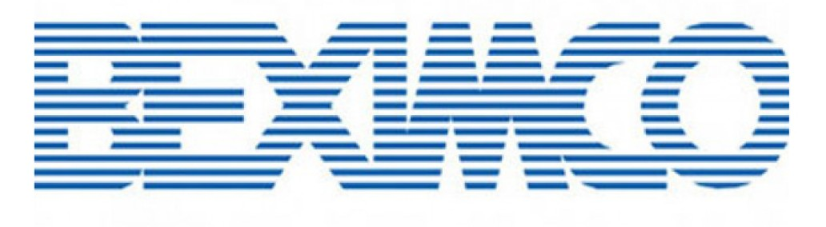

2.1.1 Overview and History
Beximco Ltd: one of the largest and most diversified business conglomerates in Bangladesh. It works in fields of textile, apparel manufacturing, pharmaceuticals, PPE manufacturing ceramics and media, information technology, and consumer products. Beximco has been a pioneer in Bangladesh's industrial development and exporting ever since.
Beximco's Textile, PPE and Apparel Division is one of Beximco's leading business units. Its division is in the vertical integration full production system, meaning that it can take charge of each step of production from raw material source to finished product sent out. It facilitates product quality, operational efficiency, and on-time delivery of orders.

2.1.2 Trend and Growth
For decades Beximco has shown vibrant growth through commercial investments, technological developments and market diversification. It has increased its capacity in textile and apparel manufacturing to cater for globally endorsed fashion brands, enabling it to expand further.
The PPE Division took off after the surge in international demand for medical protective equipment. To produce surgical masks, isolation gowns, face shields and other PPE-related items; Beximco has invested in modern machinery and production technology along with the assistance of leading manufacturing experts.

Key growth factors include:
- Expansion of textile manufacturing capacity.
- Establishment of fully integrated manufacturing plants
- Adoption of advanced production technologies.
- Dabbling in healthcare and PPE products

2.1.3 Product / Service / Customer Mix
Beximco serves a diverse customer base consisting of international buyers, healthcare institutions, wholesalers, retailers, and end consumers.

Textile Division Products
- Yarn
- Woven Fabrics
- Denim Fabrics
- Knit Fabrics
- Home Textiles
- Bed Linen
- Table Linen
- Kitchen Linen
Apparel Division Products
- Men's Formal Shirts
- Casual Shirts
- Women's Tops
- Blouses
- Trousers
PPE Division Products
- Surgical Masks
- Medical Face Masks
- PPE Suits
- Isolation Gowns
- Surgical Gowns
- Patient Scrubs

2.1.4 Company Operations / Activity
Beximco Ltd. has divided the operational functions of its Textile, PPE and Apparel Division into three tightly inter-connected key activities which guarantee uninterrupted production & smooth delivery of products.
- Procurement Activities
Sourcing of raw materials: The company strategically sources the finest quality raw materials including premium cotton, synthetic yarn, non-woven fabrics and textile dyes from reputed domestic and international vendors.
Supplier Selection: A thorough evaluation framework is used to select trustworthy vendors, based on critical factors such as product compliance, production capacity and pricing competitiveness.
Supplier Evaluation: Existing suppliers are assessed on a regular basis to keep a track of their deliverables in terms of timeliness, quality and responsiveness to meet the corporate needs.
Purchase order processing: The procurement team ensures the proper management of legal documentation, formally raises purchase orders (PO) and coordinates payment terms to execute smooth shipment of raw material.
- Production Activities
Fabric manufacturing: under stringent quality controls, raw fibers and yarns are transformed into premium-grade woven, knit and denim fabrics using advanced vertically integrated machinery.
Garment manufacturing: The fabrics are transported to state of the art apparel factories, where computerized cutting of clothes, accurate sewing, and a severe pressing process creates the finished fashion clothing.
PPE Equipment Manufacturing: CMC ensures that exceptional quality sterilized cleanroom facilities are held to produce sandblasting-proof medical protective wear like high-filtration surgical masks and a number of other professional hazard wear, for instance, medical isolation gowns.
- Supply Chain Activities
Get 10% data-driven inventory management wonk: Automated basic enterprise resource planning (ERP) tracking software are used to monitor stock levels in a real time basis, safety stock and the optimal point at which a material should be reordered.
Warehouse management: Warehouses are maintained on a large scale but they are well organized to manage the safe preservation of raw materials and finished goods without damage or mixup.
Logistics coordination: The logistics department ensures that factory dispatches, local transport networks & port customs procedures are in perfect tune, enabling seamless and timely global shipping & buyer deliveries.

2.1.5 SWOT Analysis
A Strategic wargaming a deep dive into the ways an organization’s internal capabilities can meet it to market and how the 2 forces collide. A detailed SWOT analysis of Beximco Ltd. Textiles, PPE and Apparel Division can be found below:
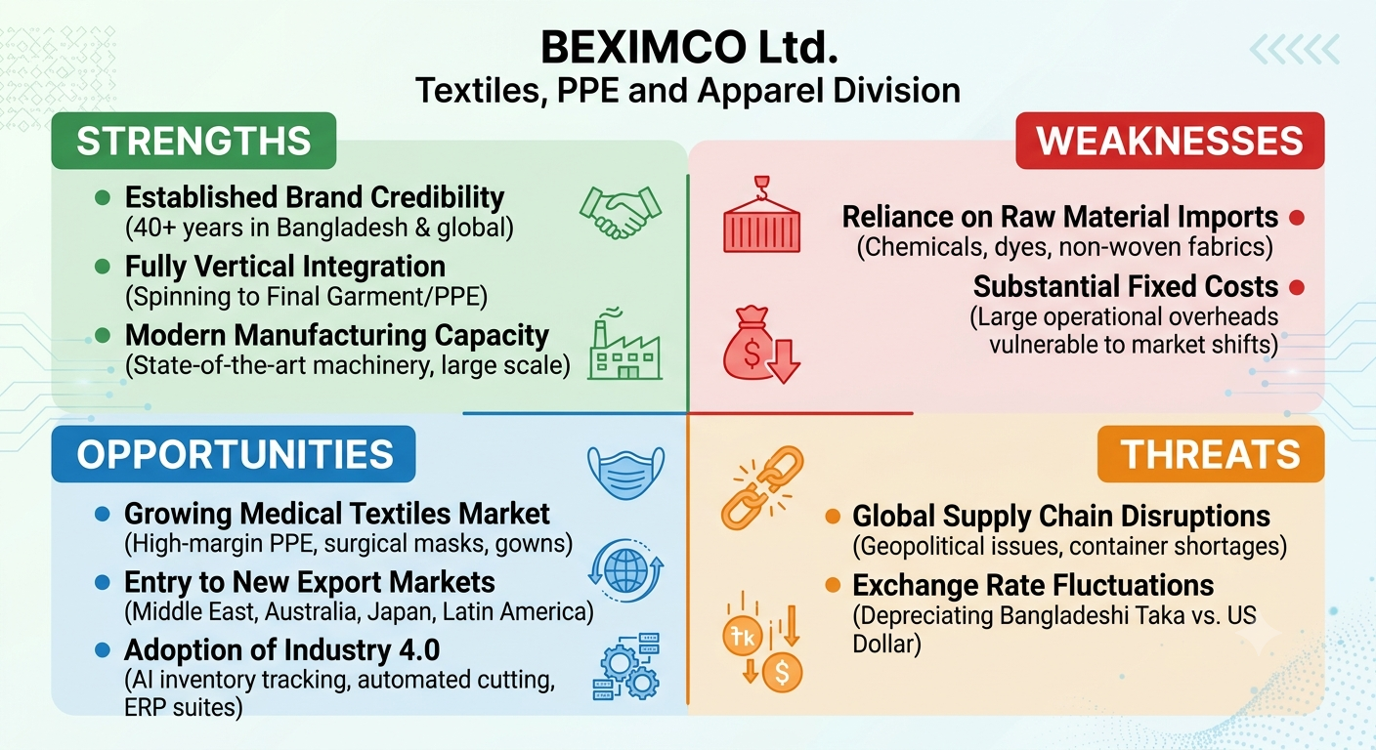
Strengths
Beximco is one of those prestigious corporate brands to enjoy strong brand credibility in Bangladesh. Operating successfully for more than four decades has given it significant credibility with worldwide purchasers, which is a substantial competitive edge when bidding on high-value contracts.
- Beximco Key Strengths: Fully Vertical Integration In-house spinning, weaving, knitting, dyeing, finishing and final garment or PPE construction under a single infrastructure significantly shortens production lead times while maintaining impeccable raw-material quality control.
- Modern Manufacturing Capacity: With state-of-the-art machinery and enormous facilities, Beximco is able to handle simultaneous bulk international orders. This enormous economies of scale allows them to easily meet the high volume demands of leading global fast-fashion and retail brands.
Weaknesses
- Reliance on Import of Raw Materials: Beximco has a strong spinning setup, but most of its specialty textile chemicals, technical textiles, non-woven fabric and top-grade dyes are imported. This reliance on external supply options sometimes creates logistical bottlenecks when it comes to local production time schedules.
- Substantial Fixed Costs for a Globally Risktopic Market: The operational costs of running such an enormous manufacturing ecosystem entails large fixed overheads. In the case of sudden global market changes, energy scarcity or international freight rates jumps, daily operational costs scale quickly and impose massive immediate compression on the company margins.
Opportunities
The important international market for medical textiles created by a permanent change in attitude towards safety in healthcare post pandemic This is an opportunity for Beximco to increase its production of high-margin surgical masks, isolation gowns and protective suits, which are all certified.
- Entry to New Export Markets: With an immense portfolio of garments, the company also has a wonderful opportunity for entering new and huge, untapped markets such as the Middle East, Australia, Japan and Latin America; outside its traditional bastion i.e. EU/USA.
Implementing AI-based inventory tracking, automated cutting equipment and ERP suites will expedite production floor efficiency while reducing waste and consequently accelerate adoption of Industry 4.0 technologies.
Threats
- Global Supply-Chain Disruptions: Geopolitical issues, blockades and international container shortages represent a serious risk. These disruptions resulted in delays of critical raw material imports causing a delay in timely delivery to buyers.
- Exchange Rates: The ongoing depreciation of the Bangladeshi Taka relative to the US Dollar affects materially large fluctuations in import costs. This financial instability largely affects the large scale operations bottom and net profit margins.

2.2 Industry Analysis

2.2.1 Specification of the Industry
Another sector that is gradually on its way to growth direction is the PPE industry in the lieu of proven increase in global knowledge concerning healthcare safety and infection control. The manufacturers started to focus on producing medical protective products certified abroad in the following month, and now they are able to provide these goods according to both domestic and international customer needs.
The industry's major characteristics include:
- Labor-intensive production.
- Export-oriented operations.
- Dependence on global supply chains.

2.2.2 Size, Trend, and Maturity of the Industry
Bangladesh's Ready-Made Garments (RMG) and textile industry is a great monument of the national economy, and it boasts to be the world's second largest apparel exporter only after China. Today, this multi-billion-dollar industry has become a key source of over 80% of the export earnings for the country and around 11% of national Gross Domestic Product (GDP), while providing direct employment for more than four million workers, most women.

Emerging Industry Trends
Right now, the rapidly changing technological evolution and global compliance mandates are triggering a paradigm shift and forcing the industry to reshape its structure.
- Automation And Digitalisation: In the next step of Industry 4.0, modern manufacturing units are rapidly adopting computerized 3D-sampling, automated fabric cutting systems and advanced AI-based Enterprise Resource Planning (ERP) frameworks to maximize the efficiencies of existing production lines while ensuring a dramatic decrease in material wastage.
- Sustainable and Green Manufacturing: The major industrial shift towards eco-friendly processing, water recycling (ETP) and reducing carbon footprint has established Bangladesh as a global leader in sustainable apparel production with the most US Green Building Council (USGBC) LEED certified factories recognised globally.
- Factories switching from basic wear to medical textile: factories are deciding whether they should invest in special "Technical Textiles", certified medical clothes or begin investing in new automated pieces of equipment, constructing facilities such as advanced melt-blown cleanrooms which will manufacture a high-filtration surgical mask or anti-bacterial fabric apparel.
Industry Maturity and Strategic Evolution
The scale of manufacturing capability, labor dexterity and volumetric infrastructure in the Bangladeshi textile and garment industry have undeniably matured to a point which has cleared the low-cost hurdle with no turn back there on for any complex apparel designs or bulk order requirements. But this sector is now witnessing a changing growth dynamic into a new form of maturing that reflects on more structural value addition and not just riding on low-cost labor.

2.2.3 Industry SWOT Analysis
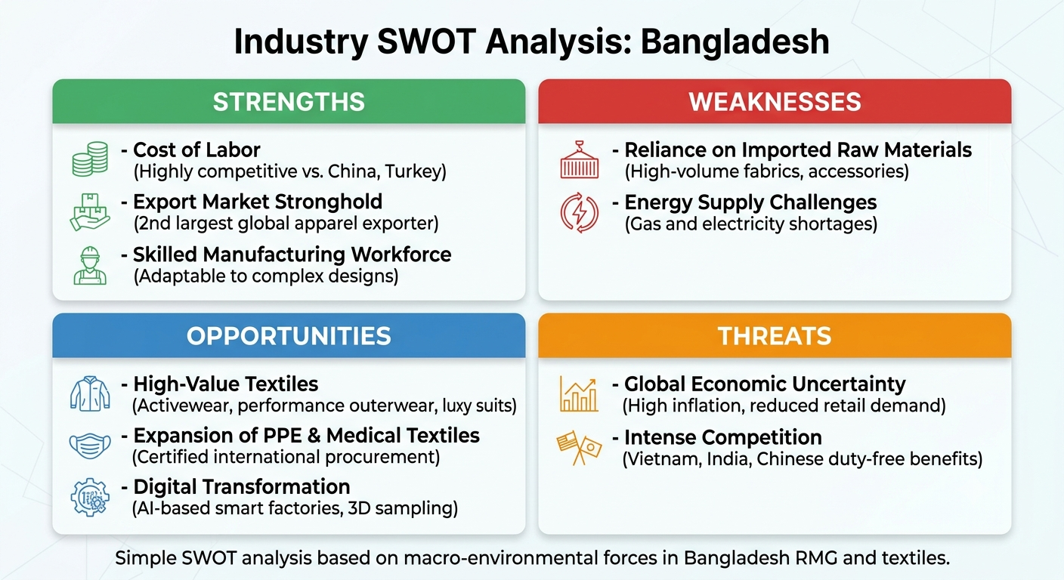
In order to position Beximco within the market, an analysis of the macro-environmental forces influencing the Bangladesh Ready-made Garments (RMG), textiles, and healthcare apparel industry will be assessed:
Strengths
- Cost of labor: Bangladesh stays much more competitive on its cost of labor than over other global hubs like China or Turkey. This economization provides the country with an opportunity to offer best-in-class products at an extremely competitive price point globally.
- Export Market Stronghold: Bangladesh RMG sector proudly stands as the second-largest global apparel exporter. Strong commercial ties built over decades and the global acceptance of the 'Made in Bangladesh' tag promise a continuous inflow of foreign trade.
- Skilled Manufacturing Workforce: The country has a large, well-trained workforce of specialized technicians and operators that can swiftly adapt to more complex product configurations and bulk production designs.

Weaknesses
- Reliance on Imported Raw Materials: There is a significant gap in backward linkages for the local industry heavily reliant on high volume woven fabrics and specialized accessories imported from China and India. This pushes the industry average lead time for executing agile fashion orders.
- Energy Supply Challenges: Weak and supply of gas and electricity have forestalled the 24 hour operations that are required for capital-intensive textile mills. Powering with diesel generators on backup is extremely expensive in terms of total electricity cost.
Opportunities
- Moving beyond Basic Textiles: Instead of low margin garments (such as plain t-shirts) the need for functional high value textile items is expected to grow. The ramp up of production for activewear and performance outerwear along with luxury suits, will propel industrial revenue to unprecedented heights.
- Expansion of PPE and Medical Textile Markets: The international demand for accredited medical clothing has been skyrocketing, creating the opportunity for Bangladesh to become a global procurement center after accreditation from WHO and foreign testing institutes.
- Digital Transformation Efforts: Investing in solutions for smart factory automation, digital supply chains and 3D sampling will both reduce structural waste, correct mfg errors and drive tech-savvy overseas buyers
Threats
- Uncertainty in the global economy: High inflation and economic contractions across Western consumer economies would threaten to specifically reduce retail demand, putting pressure on global fashion buyers to reduce or delay order placements.
- Vietnam, India and Chinese competition: Vietnam has ultra-fast shipping lead times while India boasts of a very large domestic raw cotton standby. In addition, some of the duty-free benefits of Vietnam’s various Free Trade Agreements (FTAs), which Bangladesh does not benefit in certain places at this time.

CHAPTER 3: INTERNSHIP EXPERIENCE

CHAPTER 3: INTERNSHIP EXPERIENCE

3.1 Position, Duties, and Responsibilities
Internship at Beximco Ltd | Procurement and Vendor Management Department of Textiles, PPE, and Apparel Division (October 14 to November 20) -- As an intern assigned to support various procurement and supplier management activities. The internship offered real-time insights on procurement processes, interacting with vendors, inventory management, and raw material management.
My primary responsibilities included:
- Vendor Selection Support
The role was to help purchasing professionals find and assess suppliers of different kinds of raw materials used in textiles and for PPE manufacture. For vendor selection, we reviewed supplier quotations, compared costs and cost structures, delivery capacities and timings, as well as assessed the reliability of suppliers.
- Raw Material Supply Coordination
A continuous supply of raw materials is vital for running production processes. I helped coordinate with suppliers and internal departments to ensure timely supply of materials required in production activities. This reduced production delays and shortages in inventory.
- Inventory and Storage Monitoring
I used to spend time monitoring warehouse processes and stock levels of various inputs. These activities provided me the opportunity to learn the real world of stock management, material handling practices and inventory control systems.

3.2 Training and Development
The internship program provided significant opportunities for professional learning and skill development.

Understanding Procurement Operations
A key learning outcome we were able to fulfil was an understanding of the entire procure-to-pay cycle. I understood how procurement departments identify what materials they need, reach out to suppliers, evaluate quotes, and get the materials delivered on time.
Vendor Management Knowledge
Internships made me better understand the vendor management process. I saw the buyers selected on the basis of product quality, price, services offered, and historical performance in terms of delivery schedules followed by long-term business association.
Inventory Management Experience
My performing some warehouse visits and stock monitoring tasks allowed me to realize how crucial it is to keep one suitable level of stock. For organizations, the easiest way to avoid production interruptions while maintaining a low inventory holding cost is effective inventory management.

3.3 Contribution to Organization / Operations
As old as it may sound, I was still an intern but I was involved in some operational functions that aided the Procurement and Vendor Management Department.
Supporting Procurement Activities
New GOCOP PUC and I supported procurement personnel by gathering information from various sources, cleaning data and organizing procurement management system related data for easier decision-making & documentation.
Supporting Production Continuity
I indirectly played a role in uninterrupted supply of raw materials known to be vital for production of textiles, PPE and surgical masks by assisting with procurement and inventory related matters.
Procurement Process Observation
During these rounds, I investigated the ordering process and learnt timely supplier coordination, effective inventory management on time-out supplies alongside vendor evaluation would boost operational efficiency.

3.4 Evaluation
The Beximco Ltd. being a corporate house already gave us the field exposure to procurement and vendor management through this internship. The experience really connected the theory to what happens in actual business.
Positive Aspects
- Exposure to real-world procurement operations.
- Chance to work under experienced professionals.
- Understanding of vendor management practices.
Areas for Improvement
Concluding thoughts: While this internship experience was the most valuable we could have wished for, there were some weaknesses, that in our perspective should be worked on to improve learning even more.
- More participation in strategic procurement decision making
- Method: More exposure to procurement software and electronic systems
- Additional supplier evaluation activities.
To sum up, the internship was a very fruitful one which greatly contributed to my professional development and understanding of procurement management practices.

3.5 Skills Applied
This internship was a chance to implement the different academic and professional skills learned in a business work environment.
- Analytical Skills
Analyzed data by studying procurement data, inventory information, and business processes relevant to procurement.
- Communication Skills
Communication skills were also useful in dealing with procurement personnel, warehouse staff, supervisors and suppliers. Such interactions sharpened my oral and professional communication skills.
- Problem-Solving Skills
Procurement operations are riddled with inventory shortages, scheduling deliveries, and coordinating suppliers. Watching those things and leading those caused me to see problems more like puzzles.
- Professional Ethics
This showed me the value of confidentiality, accountability, professionalism and business ethics for future work in a corporate environment.

CHAPTER 4: CONCLUSIONS AND KEY FACTS

CHAPTER 4: CONCLUSIONS AND KEY FACTS

4.1 Recommendations
Depending on observation and hands-on experience in the internship period at the department of procurement & vendor management of Beximco Ltd, some suggestions are listed below to enhance further effectiveness in procurement efficiency and supplier management.
- Strengthening Digital Procurement Systems
By utilizing integrated digital procurement and inventory management systems, the organization can make improvements in overall procurement efficiency. These ERP-based solutions can enhance real-time monitoring, increase reporting accuracy and better decision-making capabilities.
- Expanding the Vendor Base
Keeping a bigger pool of qualified suppliers allows you to decrease procurement risk and dependence on few vendors. By aggregating more than just customers, a diversified supplier network can help bolster supply continuity and expand the competitive pricing advantage potential.
- Regular Vendor Performance Evaluation
Regularly implement a structured vendor assessment ship mechanism. Some industry-standard key indicators to evaluate supplier performance are product quality, delivery performance, responsiveness, compliance and price competitiveness.
- Enhancing Inventory Forecasting
Minimizing stock shortages and excess inventory holding costs can be achieved with more accurate demand forecasting and inventory planning. Increased forecasting keeps production lines running without a hitch.
- Strengthening Supplier Relationships
Long-term strategic partnerships with reliable suppliers can increase procurement effectiveness and create opportunities for better costs, quality assurance, and timely delivery.

- Employee Development and Training
It can ensure a continuous proficiency through conducting training programs pertinent to procurement management, supply chain analytics, negotiation techniques and digital procurement technologies which would ultimately help in better productivity among employees as well as operational efficiency.

4.2 Key Understanding
This internship helped me gain useful experience of the procurement operations and vendor management practices in a leading manufacturing organization.
However, given the internship period I was able to come by a few key learnings:
- To Recognize Procurement As A Strategic Function
Procurement is not simply buying things. Instead, it is a strategic business process that directly affects production efficiency, product quality, operational costs and competitiveness of the organization.
- Importance of Vendor Management
Vendor management is an essential thing. It plays a vital role in the next steps of ensuring product quality, timely delivery of materials, and the sustainability of business over time. Operational excellence often relies on strong supplier relationships.
- Role of Procurement in Manufacturing
A ready availability of raw materials directly impacts production performance. In securing the continuity of manufacturing operations, procurement departments are instrumental.
- Importance of Inventory Control
By carefully tracking inventory, organizations are able to uphold the best balance of stock levels in equal measure with keeping excessive costs related to holding inventory low as well. Inventory management helps in operational efficiency as well as effective financial performance.
- Significance of Communication and Coordination
Establishing and maintaining a productive procurement operation involves constant coordination between the procurement team, suppliers, warehouse teams, production departments and management. Smooth operations rely on effective communication.

4.3 Conclusion
This internship provided me an end to end, practical learning of strategic procurement and vendor management processes at Beximco Ltd’s Textiles, PPE and Apparel Division. The research also emphasizes that harmonious supply chain workings serve as the backdrop to manufacturing continuity, precise cost control, and strict quality assurance—especially across high-traffic production lines with channels for apparel, PPE, and surgical masks. This experience connected theory from the classroom with a complicated reality of corporate operations, managing raw materials and communicating directly with suppliers. The key analytical, negotiating and risk-management skills we have learned in Beximco's rigorous work culture can quite possibly form an extremely competitive base to progress with a long career in global supply chain management.

List of References

- Ahmed, S., & Khan, R. (2024). Strategic Vendor Management Practices in the Post-Pandemic Apparel Sector: A Case of Vertically Integrated Firms. International Journal of Global Supply Chain Management, 9(2), 112–129.
- Bangladesh Garment Manufacturers and Exporters Association (BGMEA). (2025). Trade Information and Export Performance Report of Bangladesh RMG Sector. BGMEA Industry Insights.
- Beximco Group. (2025). Annual Report 2024-2025: Textiles, PPE, and Apparel Division Operations. Beximco Ltd.
- Beximco Group. (2026). Corporate Profile and Supply Chain Vertices. Retrieved from http://www.beximco.org
- Chopra, S. (2019). Supply Chain Management: Strategy, Planning, and Operation (7th ed.). Pearson. (Used for Inventory Monitoring and Safety Stock theories).
- Directorate General of Drug Administration (DGDA). (2024). Guidelines and Compliance Requirements for Manufacturing Personal Protective Equipment (PPE) in Bangladesh. Ministry of Health and Family Welfare.
- Handfield, R. B., & Monczka, R. M. (2021). Purchasing and Supply Chain Management (7th ed.). Cengage Learning. (Used for Vendor Selection Frameworks and RFQ processes).
- Haque, M. S., & Rahman, M. (2025). Analyzing Backward Linkages and Supply Chain Resilience in the Ready-Made Garments (RMG) Industry of Bangladesh.
- Lysons, K., & Farrington, B. (2020). Procurement and Supply Chain Management (10th ed.). Pearson Education. (Used for Purchase Order cycles and Procurement workflows).
- Sultana, M., & Islam, T. (2024). The Role of Enterprise Resource Planning (ERP) in Streamlining Inventory Management: A Case Study on Large-Scale Conglomerates in Bangladesh. UIU Journal of Business and Economics

Appendix-A

