INTERNSHIP REPORT
ON

STRATEGIC SALES MANAGEMENT OF CODERSTRUST BANGLADESH

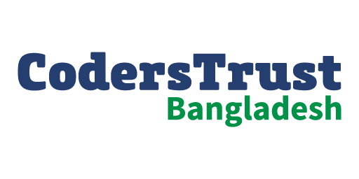

INTERNSHIP REPORT
On
Strategic Sales Management of CodersTrust Bangladesh
Submitted To
Muhammad Hasan Al-Mamun
Assistant Professor
School of Business and Economics
United International University
Submitted By
Jannatul Atika
ID – 111 171 091
School of Business and Economics
BBA Program, Major in Marketing
United International University
Date of Submission: May 29, 2022


UNITED INTERNATIONAL UNIVERSITY

Acknowledgment
I would want to begin by expressing my thankfulness to the all-powerful God, who has provided me with the courage and self-assurance to complete my internship program and my studies.
I would like to thank my supervisor, Muhammad Hasan Al-Mamun, Assistant Professor at SOBE United International University, for his assistance and praise. He instructed me to include something distinctive in my work report and encouraged me to work throughout my internship to produce an excellent report. His open approach and motivation provided me with the additional energy I needed to overcome any challenges that stood in the way of my success and really it was a great opportunity for me to complete the study of the report under his supervision.
In addition, I would like to express my gratitude to every employee at CodersTrust Bangladesh who assisted me in compiling this report. I worked with people in a realistic manner, I have made an effort to share their experiences and thoughts, and I have crafted my report from the standpoint of my own perspective, based on what I have learned. In conclusion, I would like to express my gratitude to everyone who has perused this report and who, both now and in the future, stands to gain from the information contained within it.
I would want to extend my gratitude to all of my lecturers over the last four years, during which they have instructed, aided, directed, and inspired me in order to prepare me for a career in the corporate world.

Letter of Transmittal
May 29, 2022
Muhammad Hasan Al-Mamun
Assistant Professor
School of Business and Economics
United International University
Subject: Submission of Internship report.
Dear Sir,
It is with great pleasure that I am submitting you this report on my internship course, which has been required of me as a significant part of a course for the "Bachelor of Business Administration" degree that I am pursuing at United International University. In addition, it is my great pleasure to submit over to you the internship report that is titled "Strategic Sales Management of CodersTrust Bangladesh."
I have done all in my ability to do the task in accordance with your instructions, as well as my subjective perception and evaluation of my willingness. Therefore, I would appreciate it if you would review this report and provide your insightful feedback. And it would be a pleasure to hear from you with any clarifying questions.
Sincerely

Jannatul Atika
Student ID: 111 171 091
Bachelor of Business Administration
Major in Marketing
School of Business Economics
United International University

Executive Summary
The term "sales management" refers to the practice of successfully reaching sales objectives by means of detailed finance and investment forecasting. The purpose of sales management is to assist a company in maximizing the potential of its sales force and accomplishing its sales objectives in the most productive manner possible. On the other hand, many developing countries, such as Bangladesh, are shifting their attention to the digital economy, which is a worldwide market for digital outsourcing, as a result of the increasing acceleration of the digitalization process. The digitization of an economy not only spurs innovation inside that nation's service sector, but it also creates new employment prospects within the country, which in turn enables quicker economic development. Many big firms in industrialized nations such as the United States, United Kingdom, and Australia are outsourcing their IT work to countries such as Bangladesh in an effort to reduce costs and risks. This trend has recently led to a surge in the number of people seeking work as freelancers.
CodersTrust is a company that focuses on providing students from developing countries with access to microcredit and training in both soft skills and technology. The company, which is backed by either the Danish International Development Agency or the Daniela Development Fund, was founded with the mission of helping students from developing nations improve their programming abilities in freelancing sector. The primary objective of this report is to analyze the concept of strategic sales management as well as the manner in which CodersTrust Bangladesh, an organization that specializes in the training and development of skills, manages its revenue by using various sales and marketing techniques. In conclusion, some recommendations are made for CodersTrust Bangladesh based on several proven areas that have been identified as needing to be addressed such as live consultancy, improvement of client satisfaction, advanced customer responsiveness, increasing the number of campuses and branches, campaign on university in order to assist the company in increasing both their sales volume and the development of the organization.
Keywords: Strategic Sales Management, Marketing Strategies, Outsourcing market, IT Training Institute, CodersTrust Bangladesh.
Table of Content

Executive Summary iii
Chapter 01: Introduction
1.1 Introduction of the Report 2
1.2 Objectives of the Study 2
1.2.1 General Objectives 2
1.2.2 Specific Objectives 3
1.3 Methodology of the Study 3
1.3.1 Primary Sources 3
1.3.2 Secondary Sources 3
Chapter 02: Company Profile and Competitive Analysis
2.1 Company Profile 5
2.2 Success Story 5
2.3 Mission 6
2.4 Vision 7
2.5 Slogan 7
2.6 Organogram 7
2.7 Product and Service Line 8
2.8 Operational Activities of CodersTrust Bangladesh 8
2.9 Competitive Analysis 10
2.10 SWOT Analysis 11
2.10.1 Organizational Strengths 12
2.10.2 Organizational Weakness 16
2.10.3 Environmental Opportunities 18
2.10.4 Environmental Threats 20
Chapter 03: Analysis and Findings
3.1 Sales and Marketing Strategy of CodersTrust Bangladesh 23
3.2 Marketing Mix Strategy (7Ps) of CodersTrust Bangladesh 26
3.2.1 Products and Services (Training Courses) 26
3.2.2 Place (Coverage Location in Bangladesh) 28
3.2.3 Prices (Fees of Courses) 29
3.2.4 Promotions 30
3.2.5 People 30
3.2.6 Physical Evidence 31
3.2.7 Process 31
3.3 Sales and Customer Relationship Management of CodersTrust Bangladesh 32
3.3.1 Sales Campaign in Zoho CRM 34
3.3.2 Sales Order 34
3.3.3 Invoice 34
3.3.4 Potential Clients List/ Lead 34
3.3.5 Contacts 35
3.3.6 Accounts 35
3.3.7 Sales Forecasting 36
3.3.8 Modules 36
3.3.9 Recording 36
Chapter 04: Recommendations and Conclusion
4.1 Recommendations 38
4.2 Conclusion 39
References 41

CHAPTER 01
INTRODUCTION

Introduction of the Report
Bangladesh has become the world's second biggest exporter of online labor as a result of its rapidly increasing digitalization and high proportion of educated unemployment. Many developing countries, such as Bangladesh, are shifting their attention to the digital economy, which is a worldwide market for digital outsourcing, as a result of the increasing acceleration of the digitalization process. As a country's economy becomes more digitalized, it not only encourages innovation in the service sector, but it also creates more jobs at home, resulting in quicker economic development. Large firms in affluent countries like the United States, the United Kingdom, and Australia are increasingly relying on IT outsourcing from countries such as Bangladesh, which has resulted in a recent rise in freelance work (Zamana, 2019).
Numerous freelancing and outsourcing markets allow both freelancers and businesses to locate people to outsource work. One of these companies is CodersTrust. In addition to growing their skills, these independent experts export their knowledge worldwide. They are cautiously optimistic that Bangladesh would join other thriving exporters. The main purpose of the report is to study on how CodersTrust Bangladesh implements their marketing strategies to increase the sales volume of the company as well as growth of the organizational performance.
Web and internet access have opened up a wide range of options and opportunities for many people throughout Country. Individuals were motivated to pursue freelance professions rather than sit about and whine about a lack of employment prospects in the physical work market. Over 5.5 million Bangladeshis are operating in a one-of-a-kind freelancing marketplace, according to BASIS (Bangladesh Associations for Software and Information).

Objectives of the Study
The study's purpose is to get a comprehensive understanding of the company's marketing and sales strategies, as well as its strengths and weaknesses, as well as the opportunities and threats external to the firm. Conceptual learning and practical understanding may be achieved via this internship. The following are the objectives of the study:

General Objectives
- To know and analyze on the sales and marketing strategies of CodersTrust Bangladesh.

Specific Objectives
- To know about the overview of CodersTrust Bangladesh.
- To identify the strengths, weakness, opportunities and threats of CodersTrust Bangladesh.
- To analyze the sales and marketing strategies of CodersTrust Bangladesh.
- To analyze the sales and customers relationship management of CodersTrust Bangladesh.
- To find out the challenges of marketing activities that impacts on the sales volume of CodersTrust Bangladesh.
- To provide recommendations and suggestions to develop the marketing tactics and practices of CodersTrust Bangladesh.

Methodology of the Study
The information included in the reports originates from two different sources:

Primary Sources
- The information and data have collected from the employees of CodersTrust Bangladesh by a series of conversations.
- Some information has been collected from practical experiences and personal observations on marketing department at CodersTrust Bangladesh.

Secondary Sources
- Official Website of CodersTrust Bangladesh.
- Journals, articles and books which are relevant to the marketing and sales concept in training institution business industry.
- Annual Report of CodersTrust (Global).

CHAPTER 02
ORGANIZATION PROFILE

Company Profile
CodersTrust is indeed a purpose, worldwide organization dedicated to IT talent development and training. It was established with the goal of improving the lot of the poor, weaker sections of society, and the underprivileged in society as a whole. They are most concerned about the condition of the younger generation, particularly the female members of that demographic.
CodersTrust's purpose is to offer students and trainees in the developing world with both technical and soft-skills training. In their opinion, they will have a far better chance of joining the global workforce if they provide them with the appropriate tools for learning skills that are now out of their grasp. Because of this, their major goal is to develop an educational system that focuses on information technology (IT).
Their tuition, on the other hand, is really affordable. In addition, individuals who are unable to pay might take advantage of their scholarship programs. UNDP, DANIDA, World Bank, Dutch Foundation, WFP, Swanirvar Bangladesh, CARE Bangladesh, BRAC, Ministry Of ICT Bangladesh, Ministry of Expatriates' Welfare, and Overseas Employment and PKSF have all cooperated with them effectively in their work. Because of their effective training and mentoring program, we've received recognition from the ICT Division of Bangladesh, the National Skill Development Authority (NSDA), BASIS, and BITAC. Improved training facilities and the introduction of new programs are always a priority for them.

Success Story
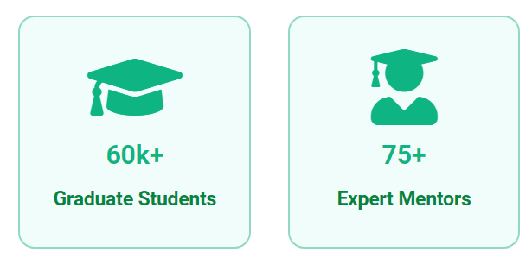
Both Captain Ferdinand Kearwolf and global business leader Mr. Aziz Ahmad are proud Bangladeshi-American technologists who formed CodersTrust in 2014 with a purpose to make practical education accessible to the general public at a reasonable cost. Making the employment level capable of meeting the needs of the global workforce and enabling people make a livelihood by acquiring current digital skills are the objective of this initiative.
Founded in New York City, CodersTrust has worked with a number of international organizations, including the United Nations Development Program (UNDP), World Bank, World Food Program (WFP), Save the Children, and the Rockefeller Foundation. Several venture capital funds from throughout the globe contributed to our efforts, as well as the Danish International Development Agency and the United Nations Development Program.
As of 2015, their Bangladesh business has one campus and one lab. They have five contemporary campuses in Dhaka, 11 well equipped laboratories, and over 150 team members. One includes residential amenities. Chittagong and Khulna are the first two cities outside of Dhaka where we want to grow their operations.
To date, CodersTrust Bangladesh has helped over 60,000 individuals become self-employed by working on worldwide IT projects, earning it the title of one of Bangladesh's most reputable skill development organizations.

Mission
“Learn a Skill; the World is yours”

The mission is to link impoverished and marginalized groups of people to education and online labor marketplaces in order to greatly increase quality income-earning options as well as economic self-sufficiency. A unique environment is created when education and job production are brought together. Here, individuals from all around the world work together for the greater good. So the missions of CodersTrust Bangladesh are following below:
- To become the leading provider of cutting-edge solutions for the development of a digitally transformed country.
- To become the institution that hosts a good career session.
- Provide world-class talent development and training services to organizations.
- To become the only one-stop service for outsourcing assistance and solutions in the industry.
- To ensure quality and cost-savings, be an environmentally friendly education/training organization.
- Providing free and low-cost online education for students.
- To overcome the difficulties associated with being unemployed.

Vision
- The vision is to expand the CodersTrust Ecosystem for worldwide education and employment growth. They provide a platform for clients wishing to employ freelancers and users may utilize their services to gain relevant skills. They are willing to break down barriers to make skill development outsourcing education and training accessible to all ages and genders with great earning potential.

Slogan
Its tagline or slogan is "BECOME A ROCKSTAR FREELANCER".

Organogram
Co Founder/ Board Member
Executive
Business
Developer
Student Operations
Executive

Executive
Career Adviser
Team
Digital Marketing
(Head)
Accounts
(Head)
Educational
Department
HR
(Head)
Sales
(Head)
Student Affairs
(Head)
Country Director

Figure 2.1: Organogram of CodersTrust Bangladesh

Product and Service Line
Advance Web Development
Responsive Web Design
Graphic Design
3D Game Development
Advance Excel
Accounts Management System
English Learning
Video Production
Content Writing
Web Design
Digital Marketing
SEO

Figure 2.2: Product and Service Line of CodersTrust Bangladesh

Operational Activities of CodersTrust Bangladesh
CodersTrust, Bangladesh has been in charge of these six departments from its formation.
- HRD: The role of human resource management in these firms is to maintain their employees in a methodical manner so that they may efficiently fulfill their job duties to the best of their abilities. Specifically, they follow the steps listed below:
  - Initially, the organization advertises its job ads, sources candidates, screens applications, conducts preliminary two-face interviews, and coordinates recruiting activities with managers who are ultimately responsible for making the final selection of candidates.
  - Coders Trust provides new employees with a substantial orientation programs to help them adapt to a new workplace culture, surroundings, and mentors.
  - Employee remuneration is determined by the firm and analyzed to ensure that it is competitive with other companies' compensation practices.

- Accounts Department: The department is responsible for all financial transactions, including:
  - Making payments and keeping track of the invoices that have been paid (Cash Flow).
  - Receiving and processing incoming payments (Cash Inflow).
  - Ensuring that each and every employee receives compensation (payroll).
  - Preparing financial reports, such as statement of financial position, balance sheets, and budgets.
  - Controlling financial activities in order to prevent mistakes, fraud, and theft.

- Educational Department: The team of career consultants oversees the education department. CodersTrust has appointed highly qualified mentors to each of the courses it offers. Only mentors with a scientific background and extensive computer expertise, as well as those who work as freelancers, are considered for this position. In accordance with their schedules, the construction crews build up the course material and modules and enroll in both offline and online courses at regular intervals. They provide freelance advice at various points throughout and after the training. As part of their duties, they also plan and schedule all of the students' lessons, tests, and final assessments. There is also an online operation that provides 24 / 7 help to students who have technical difficulties or questions about customers' orders or jobs, as well as to career advisers.

- Student Affairs Department: Every current student is served by the student affairs department, which provides career advice, supplementary training outside of lecture halls, and more. Students are notified through email, phone, and text message when a course begins after they've been accepted into one. The student affairs department makes it a crucial part of the organization. When it comes to keeping pupils on track, this is essential. Every time a student skipped a lecture or provided valuable knowledge, the other students found out about it.

- Business Developer: When it comes to finding new markets and making strategic choices, the enterprise developer team works closely with the company's executives. It is essential that the commercial business improvement team keep up with current tasks including upgrading the database, policies, and structures. They interact with students who are within their reach and provide additional assistance with the admissions process so that they may continue their current business.
Individuals in the business development department are responsible for a wide range of internal and external objectives. They look into the services and activities of other organizations and, if necessary, give consultation services. In addition, they examine the company's external environment, which includes government rules and prohibitions. Analysts in the field of business development utilize their findings to boost revenue and profitability at their organizations. New sales leads are discovered by the commercial business developer's section.
- Pitching and Marketing Services.
- Ensuring that productive connections are maintained with current customers.
- Putting together PowerPoint presentations and storefront displays for selling.
- Getting in touch with customers to update them on any recent changes to the services offered by the organization.
- Putting together estimates and business plans.
- Talking things out over the phone, via email, and in person throughout the negotiation process.
- Determining the team's sales objectives and working to achieve those objectives.
- Training staff/employees and assisting other members of the team in the development of their talents.

- Digital Marketing Department: CodersTrust conducts the majority of their marketing activities online. They engage in a variety of internet marketing strategies. This division's primary concerns include promotion, online advertising, social media marketing, the generation of advertising research files, and the preparation of market survey documents, among other things. The Marketing Department is responsible for these and other issues. The marketing department makes regular posts on social media platforms to highlight their newest machine improvements, price cuts, and new product offers, as well as upcoming intake dates and other benefits.

Competitive Analysis
Comparing an organization's marketing strategy with those of its rivals is done using a competitor analysis model or tool. This concept may be used to construct a visual framework for an analysis of marketing. The competitive analysis identifies the revenue streams, business plans, and marketing strategies of an industry's direct rivals. In the assessment process, the information obtained is organized using a competitor analysis model. SWOT analysis is one of the techniques for identifying competitive analysis (Competitive Analysis – Meaning, Examples And Importance, 2021).

SWOT Analysis
During times of indecision, a strengths, weaknesses, opportunities, and threats analysis, or SWOT analysis for short, has become an essential tool for organizations to use in order to evaluate their position in the market. This type of analysis is also widely used in order to evaluate the internal and external environments of organizations (Rozmi, 2018). Each of the four components identifies either an internal or an external factor. The internal aspects of an organization that make the business get closer to achieving its objectives are referred to as the company's strengths, whilst the aspects of the organization that get in the way of its success are referred to as the company's weaknesses. A company's opportunities aren't only external factors that assist it achieve its objectives, but also opportunities to repair gaps and start new projects. Organizational threats, on the other hand, are external factors that may or may not hinder the organization's ability to achieve its objectives (Jehad S. Aldehayyat, 2008).
CodersTrust Bangladesh is able to do a SWOT analysis in order to analyze the current state of the organization with regard to both its internal and external situations. All over the strengths, weakness, opportunities and threat of CodersTrust Bangladesh have been shown in the figure of
Strengths | - Organizational Culture and Environment  - Market Reputation  - Skilled and Experienced Mentors  - Effective Sales Team and Employees  - Support System for Trainee and Students  - Varieties of training Programs and Courses  - BTEB Approved  - Success Rate  - Collaboration Robi Axiata
Weakness | - Limited number of campuses and branches  - Turnover rate of employees and Staffs  - Fees for courses are high  - Drop out Students  - Lack on online marketing
Opportunities | - Introducing more freelancing courses  - Spreading capacity for countrywide On-campus service  - Providing online facilities and services  - The possibility to propose meritorious candidates expands  - Reducing unemployment  - Increase program for off-camping training
Threats | - Entering new training institutions  - Negative Review  - Economic condition of the target market  - Government support and policies
Figure 2.3: SWOT Analysis of CodersTrust Bangladesh

Organizational Strengths

Strength is the quality that distinguishes anything from the rest and makes it stand out from the rest. When comparing one thing to another, "strength" refers to the superiority of that object. When used in this way, the term "strength" denotes an attribute that is good and advantageous, as well as innovative. Anything that an organization is excellent at doing or a trait that the organization has that provides it an essential capacity is an example of strength (Thompson & Strickland, 1989 ). In the context of this discussion, strength refers to a resource, skill, or other advantage that an organization has in comparison to its rivals and the requirements of the markets it now serves or plans to service in the future. It is a unique capability that provides the company with a competitive edge in the market space. It's possible that we have certain strengths when it comes to our financial resources, image, market leadership, buyer/supplier interactions, and other elements (Pearce, 1991).
Organizational strengths are those capabilities that contribute to the achievement of organizational objectives. Before taking action in response to a problem or opportunity, an organization must first understand its own potential and the features that provide it an edge over its rivals. A success of an organization depends on its ability to withstand mistakes and capitalize on opportunities. Otherwise, there is no way to take advantage of the chances presented by the outside world. As a result, the organization must use its strengths to respond to challenges from the outside world. All of these problems demonstrate the significance of a company's strengths (Pearce, 1991).
Strengths of CodersTrust Bangladesh
CodersTrust Bangladesh stands out from the competition in the field of skill development due to a number of significant competitive advantages that set it apart from other existing businesses in the industry. The following is a list of the strengths of CodersTrust:
- Organizational Culture and Environment
The culture at CodersTrust Bangladesh is assured to be completely structured. Every employee is inspired by the way of life of the association to contribute to the well-being of others and to be employable by multiple parties. In this setting, employees are strongly encouraged to take on tasks outside of their normal job responsibilities that are related to the development of the organization and the assistance of another group. This makes it easier for representatives to push themselves to their full potential.
- Market Reputation
As CodersTrust is a multinational corporation, it has had an outstanding reputation on the market from its establishment, and its management team is able to effectively manage its employees and clients.
- Experienced and Skilled Mentors
CTBD has a distinct advantage over its rivals because of the expertise of its mentors. As a result of a variety of factors, CTBD has selected highly competent instructors for a variety of online and offline courses. They take into account a variety of factors, such as the ones listed below:
- Maintain a basic education standard.
- Varying levels of standard knowledge and expertise in a certain subject.
- Both professional experience and professional performance are taken into consideration.
- Expertise in teaching and training, and ability to comprehend learners of various levels.
- Competence to understand students of various academic levels.
- Professional freelancing expertise and the potential to generate revenue via freelancing.
- Qualified and able to support themselves financially via freelancing.
- Global standard certification that is certified on a worldwide scale in this area.
- Independent, cooperative, and efficient in communication with learners and educators.
- The capacity to operate under pressure, meet deadlines, work in a dynamic workplace, and work in a dynamic setting is all skills that are desirable.
It is common for mentors to take on extra duties, such as recognizing and reacting properly to other people's ideas and concerns; maintaining high moral integrity and diplomacy in a politically-sensitive and highly-complex setting.
- Effective Sales Team and Employees
CTBD has the best sales employees, and those employees are playing an important part in the organization's profitability. The majority of people in Bangladesh are unaware of what freelancing is or that it is possible to make money via it; hence, sales employees play a significant role in this context; the following are some examples of sales employees:
- Make contact with the individual who has shown an interest (by signing up for the CTBD website or Face book page or by sending a message via the messenger).
- Provide clients information (course specifics, length, significance) and encouragement regarding freelance work.
- E-mail or text them to inform them about a recent discount or special offer, and provide them with the course material and contact information.
- Provide them the necessary guidance so that clients may choose the suitable course of study based on their educational background and career aspirations.
- And request registration from everyone who is interested.

- Support System for Trainee and Students
For all participants, CodersTrust offers a strong support network. CTBD provides a convenience for all of its participants, so that their journeys are as easy as possible. They include ELMS Talents, a student support group, a Face book support group, a student affairs team, and others. They are all available 24/7 on online.

- Varieties of training Programs and Courses
There are a variety of courses offered by CodersTrust Bangladesh based on a variety of factors. Some courses not only assist participants learn how to be successful as a professional freelancer, but they also teach skills that may be applied to more conventional employment.
- BTEB Approved
Regulation and development of secondary technical and vocational education in Bangladesh are the responsibilities of the Bangladesh Technical Education Board (BTEB).
It is the organization that establishes the curriculum, creates learning materials, gives affiliation to technical and vocational institutions, controls admissions, and conducts tests.
- Success Rate
When it comes to learners' achievement, ignoring the rules and regulations is the most important factor. In each class, the academic affairs department keeps a close eye on the present situation and keeps tabs on each and every student's progress. When compared to other Bangladeshi educational institutions, the CTBD has a better graduation rate for its students. Throughout the whole learning process, the CTBD maintains the quality and availability of each and every step of the route. The quality and accessibility across a vast array of domains, such as highly effective management teams, highly qualified mentors, and efficient operations management systems; they also monitor the individual mentoring activities inside the course. Regular basic assignments, quizzes, and work activities are some of the things that students have their mentors force upon them, and this is one of the keys to reaching a greater student success rate. A strong student boundary is maintained both throughout and after the course via social media. Overall, this is how the greater student rate is shown in this situation.
- Collaboration Robi Axiata
CTBD students in rural regions will get a free 30-GB Robi operator for 3 months. The arrangement allows coding enthusiasts to become professional freelancers on both the global web and local markets. Robi Axiata Limited will supply a 4.5G modem with high-speed digital access to disseminate freelancing training nationwide. CTBD plans to reach freelancers in Bangladesh's rural regions. This agreement may help CTBD execute freelancing training in Bangladesh's rural regions, where high-speed internet and network access are required. Robi Axiata Limited is a prominent 4G mobile phone operator in Bangladesh. Robi Axiata Limited offers good network coverage in rural regions.

Organizational Weakness

Lacking the form and expertise required for anything is what we mean when we talk about weakness. A comparison with another reveals that one object has more negative aspects than another. This quality is known as weakness. In this context, weakness is a trait that is considered to be negative and unfavorable characteristics.
Situations in which an organization's existing existence and capabilities are weaker than those of other organizations or those of its rivals are considered organizational weaknesses. An organization's weaknesses might be defined as those components or operations that are less effective and efficient than those of its rivals. As a result, the organization's overall performance suffers, which in turn makes it less competitive. As a result, the organization is unable to react to a potential crisis or opportunity, and is unable to adapt to changes.
A circumstance that puts an organization at a disadvantage is referred to as a weakness. A weakness might be anything that an organization does not have or does badly in contrast to other organizations (Thompson & Strickland, 1989 ). In the context of this discussion, "a weakness" refers to a restriction or deficit in resource, skills, and competencies that significantly hinders the effective functioning of an organization. A company's facilities, financial resources, managerial capabilities, marketing abilities, and brand image may all be potential areas of vulnerability (Pearce, 1991).
Organizations must identify both their strengths and weaknesses. Since no strategy can be founded on weaknesses. The organizational deficiencies that might contribute to inefficiency and ineffectiveness should be identified and remedied. Solving current issues that impede long-term goals and strategies, and anticipating future issues, are necessary.
Weakness of CodersTrust Bangladesh
The following is a list of the weaknesses that CodersTrust Bangladesh (CTBD) has:
- Limited number of campuses and branches
The Coders Trust has a presence in Dhaka with five campuses via its network of branch offices. At the moment, it is a rapidly expanding business organization. It has only just recently progressed from the beginner's level. However, expanding this firm across the country will need some time. Despite this, Coder Trust is working hard to spread its operations to other locations around the nation as rapidly as they can. Some of the restrictions that have been placed on rural communities, in particular, may shortly be lifted.
- Turnover rate of employees and Staffs
The highest staff turnover rate in the market is one of the most problematic aspects of this organization. The low wage scale is to blame for this issue, and employees have said that they do not want to remain in their jobs for an extended period of time. High employee turnover may also be caused by factors such as extreme working pressure, enormous sales targets, and the absence of a set work schedule.
- Fees for courses are high
The cost of this course is far greater than that of any other institution offering skill development, and it is even more expensive to take lessons in a traditional setting. Because of the cost of the courses, a significant number of prospective participants choose not to enroll.
- Drop out Students
Dropout antecedents are commonly referred to as the "pivotal event" in the process of a participant's eventual downfall. This is a challenge Coders Trust has to deal with. For the following reasons:
- Boredom: CodersTrust participants typically leave because of boredom or indifference. According to Psychology Filled, their learners commonly remark that the study content is irrelevant to their daily lives. Boredom is a problem that children, parents, teachers, and educational agencies must address.
- Academic Struggles: Students may also see a decline in their grade point average as a result of their increased focus on CodersTrust courses. CodersTrust is also academic. However, this is semi-academic. Due of their failure to afford attention in both subjects, participants have opted to withdraw from CodersTrust.
- Family and Economic Issues: A family's financial well-being might be threatened if unanticipated problems arise. Due to these adjustments, many individuals may be forced to work part-time in order to make ends meet for their families and themselves. For students who are already under a lot of stress, family-related events like a funeral or a separation might exacerbate the problem. Individuals who are concerned about balancing their academic and extracurricular obligations may decide to skip research altogether.
- Students are Unfamiliar on Online Courses: Students in online courses frequently feel uneasy. Though not challenging, students are not accustomed to it. They're in various places. In the traditional learning system, which applies to instructors, many students still study face-to-face with a book. Modern civilization changes people's lifestyles to meet societal needs.
- Lack on online marketing
Numerous businesses provide services through the internet. Online service promotions are, to put it mildly, expensive. Promote online services via the use of social media sites such as Face book, Twitter, and YouTube by organizations. In addition, it is less costly. Because they aren't interested in the promotions, many ignore them. They don't spend a lot of time focusing on digital marketing via social media and other channels, such as Google Ad Words. They should promote their existing and forthcoming courses and online services to the students and explain the advantages of taking the course and utilizing the online service to the students.

Environmental Opportunities

The term "opportunity" refers to a circumstance or setting that is favorable for engaging in a certain activity. The potential for success and the impetus for action are both embodied in the concept of opportunity. Because of this, it has a quality that may be considered beneficial and advantageous.
When it comes to managing an organization, an opportunity is a moment or condition that is opportune for the company to accomplish its objectives. Analyzing the organization's surroundings helps identify opportunities that might provide beneficial outcomes for the company. Intense competition and hard labor provide companies with a wealth of possibilities. Opportunities are external situations that enable an organization to take advantage of organizational strengths, overcome organizational shortcomings, or neutralize environmental risks (Harrison, 2004).
Opportunities of CodersTrust Bangladesh
The following is a list of the opportunities available at CodersTrust Bangladesh:
- Introducing more freelancing courses
CTBD is now providing basic and medium-level computer science and business experience courses in order to better grasp the overall capabilities of the people in these countries. A high or advanced level, as well as an upper advance level, may be provided by the CTBD. As a worldwide chain industry, the CTBD is capable of expanding the potential. Without higher expertise or other channels to handle this predicament, global collaboration addresses the issues.
- Spreading capacity for countrywide On-campus service
CodersTrust Bangladesh (CTBD) is rapidly moving forward with plans to quickly open many locations around the country. There is a possibility that they will be able to service their clients all over the globe. This site does not provide access to all of the available online courses. Therefore, for CTBD, this is an excellent opportunity to provide support on campus.
- Providing online facilities and services
CodersTrust Bangladesh has taken the effort to give all available assistance and extend its service to an entirely online platform in order to keep up with the times. this initiative was a success in the CORONA pandemic because CodersTrust was able to contact a larger number of the students.
- The possibility to propose meritorious candidates expands
Meritorious students are given the option to work in different project businesses for a period of time. All functions are performed by CTBD. CTBD offers several courses in its different departments. CTBD student affairs have multiple divisions for different courses. Each and every course includes one or two excellent or deserving students based on daily accomplishment in courses, assignments, quizzes, and other factors the mentors determine. The mentors pass on the distinguished students to the CTBD student affairs wings at the conclusion of each course. So CTBD student affairs wings look for applicants locally. In most situations, prominent firms in this nation reward deserving CTBD student applicants based on their remarkable talents. Good opportunity for CTBD students to find such industries. CTBD students do well in local businesses.
- Reducing unemployment
CodersTrust Bangladesh (CTBD) is a learning and revenue network that gives endless mentor assistance around the clock and the greatest tools to boost the freelancing career, from learning to code to mastering online marketing, to prepare people for the 50000 jobs listed regularly on freelance portals. Aside from refrigeration, students must write cover letters, engage with cultural differences, and understand how to brand themselves on various freelancing platforms, and so on. Their learning and earning route was meant to educate coding and produce competent freelancers.
- Increase program for off-camping training
CodersTrust Bangladesh provides courses for beginners as well as those for more advanced programmers. The company also conducts market research in order to determine which emerging topics are of most interest to students. As a result of this research, CodersTrust frequently adds new classes in response to customer demand.

Environmental Threats

A scenario or condition that poses a risk to the successful completion of an activity is known as a threat. It is used to refer to a circumstance that is unfavorable. Because of this, it has an unfavorable quality that makes it something that need to be avoided.
A threat to an organization's success is anything that makes achieving its objectives more difficult or impossible. Threats are events that emerge as a consequence of changes in the near or distant environment and are unfavorable for the organization, since they would prohibit it from sustaining its existence or from losing its competitive advantage (Harrison, 2004).
It's important to recognize that an organization's future success or failure may be influenced by a variety of external factors, including but not limited to those in the following areas: economics, social and cultural trends; demographics; the environment; politics; legal and regulatory frameworks; technology; and market forces. The term "external" refers to opportunities and risks that are primarily out of the control of a particular business. An organization's controllable operations that are executed particularly successfully or badly are referred to as its internal strengths and weaknesses. A company's business activities include management, marketing, finance/accounting and production/operational research and development, and management information systems. Strategic management requires that a company's functional strengths and weaknesses be identified and evaluated. Organizations attempt to implement strategies that take advantage of and address their own internal assets and deficiencies (David, 2003).
Threats of CodersTrust Bangladesh
CodersTrust Bangladesh is subject to the following threats:

- Entering new training institutions
CodersTrust may experience problems because of the competitiveness of some of the other consultancies in this field like Creative IT Institute and Careers Hub Bangladesh and this might have a significant negative influence on the company's growth.
- Negative Review
CodersTrust Bangladesh is a non-profit organization. Negative feedback from students and from other training institutes' sponsored agents is not uncommon. As a result, CodersTrust's reputation and market growth are greatly impacted.
- Economic condition of the target market
Our country's economic situation has a direct influence on the growth of their businesses, and this inhibits students from enrolling in skill development programs.
- Government support and policies
CodersTrust is an organization that operates on a global scale. Therefore, multinational businesses must sometimes comply with a variety of laws and regulations. There are instances when such regulations are quite difficult for foreign businesses.

CHAPTER 03
ANALYSIS AND FINDINGS

Sales and Marketing Strategy of CodersTrust Bangladesh
Many firms' success may be traced to their ability to implement the marketing plan alternatives they have selected, as well as to their well-developed marketing strategies describing where, when, and how they will compete (Aimin, 2016). The proper and efficiently executed marketing strategies are necessary to productively lead the deployment of the limited available resources through the firm’s marketing capabilities in pursuit of desired goals and objectives (Jayachandran, 1999). The standard STP framework for marketing strategy, which focuses on market segmentation, target, and positioning, deals with segmentation and targeting decisions here. Marketing strategy content establishes where a company will compete in order to achieve the strategic marketing and sales goals.
CodersTrust Bangladesh places a high amount of importance on its target audience. In order to determine who its ideal client is, the company conducts market research. Following an evaluation of the research's findings, the company categorizes the characteristics of the typical group of CodersTrust's target audience, including their appearances, behaviors, and demographics. They are mostly thinking about:
- How one should approach one's intended audience is an important question.
- To stimulate the attention of the viewers in the particular material that will be shown on the page.
- Which of their marketing strategies makes the most sense to them?
- Will they do so voluntarily to acquire the course?
- How much are they willing to spend?
This assessment of CodersTrust Bangladesh's target audience provides a number of advantages to the company as well as increasing the sales volume of the business.
- Using this data, CodersTrust is able to identify and target just those clients who can benefit from their products and services.
- The highest levels of customer satisfaction are maintained via the development of long-term relationships with clients.
- Keeping more cost effective.
- Providing competitive advantages.
- It also contributes to a rise in the number of prospective clients and success rates of the clients.
CodersTrust Bangladesh has the following individuals as its primary focus (target customers):
- Freelancers: The term "freelancer" refers to those who are currently working as freelancers but desire to further their knowledge and abilities by taking different IT courses. There are a large number of freelancers who are taking courses to improve their present talents or learn a new one. And for CodersTrust Bangladesh, this Freelancer group is very significant, accounting for 25% of the company's revenues.
- Universe Students: Skill development courses are offered to students at the university level. Courses like this are essential for students who want to get the most out of their academic educations and prepare for careers as independent contractors. Over 15% of students at CodersTrust Bangladesh come from this demographic.
- Job Holders: At this time, many individuals are considering freelancing as a way of boosting their income, thus they're looking into freelancing training. For CodersTrust Bangladesh, more than 20% of students are from this demographic.
- Unemployed People: Over 35 percent of the students enrolled in the freelancing programs at CodersTrust Bangladesh are part of the 35 percent of students who are currently unable to find work in their home country because there are not enough jobs there. This is the case because there are not enough jobs available there.
- Retired Person: Freelancing is becoming more popular among retirees in today's society since it enables them to put their spare time to productive use while also providing a significant source of income. It has come to our attention that a number of formerly employed individuals are making their way to Bangladesh in order to get training in freelancing and to enroll at CodersTrust Bangladesh. In addition, a minimum of 5 percent of the student body is comprised of those admitted from this category.
CodersTrust Bangladesh's client acceptance percentages are shown graphically in the following figure:

Figure 3.1: Target Customers of CodersTrust Bangladesh
While CodersTrust Bangladesh defining its Target Audience, they are some more steps before starting with a deep target audience research-define common characteristic of their usual buyers. As a result, CodersTrust Bangladesh places a high value on understanding the demographics of the country's citizens, including their needs, wants, dislikes, potential challenges, and more. CodersTrust Bangladesh will be able to participate in more market activities that will have the highest opportunity to attract clients.
Demographic and Geographic Segmentation
CodersTrust Bangladesh relies heavily on demographic data in their overall operation, which refers to the primary attribute or description of their target audience, client base, or population. There are various essential components accessible in CodersTrust demographic analysis, including:
Demographic Segment
Age | 15-20 years | 20-25 years |  |  | 25–30years |  | 30 years +
Age | 18% | 34% |  |  | 38% |  | 10%
Income | High Ranged | Middle Ranged |  |  |  | Low Ranged
Income | 12% | 60% |  |  |  | 28%
Gender | Male |  | Female
Gender | 55% |  | 45%
Level of Education | From S.S.C Pass
Location | Inside Dhaka |  |  | Outside Dhaka
Location | 62% |  |  | 38%
Table 3.1: Demographic Segments of CodersTrust Bangladesh

Marketing Mix Strategy (7Ps) of CodersTrust Bangladesh

The term "marketing mix" refers to a collection of marketing tools, both strategic and tactical, as well as controlling components of the business, that allow a firm to create a product or deliver a service to a consumer according to the demand of the market. How an organization or a corporation connects the marketing mix in order to display the product or service on a target market determines whether or not the consumer demand for the product or service is met. In addition to this, it is quite helpful when doing research and planning for marketing, putting new strategies into action, and finding other possibilities for market targeting (Badi, 2018). In order to be a successful business or organization, it is essential to have the appropriate product, the right price, the right time, the right location, and the proper product promotion in order to be successful.
This section of the report focuses on the most important aspects of CodersTrust Bangladesh's marketing strategy. As a result, we'll analyze the 7Ps of marketing and see how they connect to one another.

Products and Services (Training Courses)
CodersTrust Bangladesh considers the product or things itself to be the most important component. CodersTrust's products are well-received and useful to a wide range of students and professionals in the business world. These solutions are essentially a collection of training materials for a variety of different types of job skills. In addition to being visually beautiful, CodersTrust Bangladesh has built a solution that is both highly effective and adapted to the specific needs of each customer. This is where CodersTrust concentrates its attention on product diversity, product differentiation, and product elimination, all of which are dictated by the needs of its customers. Students may find the supplies they need both online and at brick-and-mortar locations.
Coders Trust has developed programs that are in great demand on the freelancing market and that give freelancers with a steady income. Coders Trust offers 10 to 12 programs ranging in length from three months to ten months, depending on the topic and complexity of the programming. In order to encourage young individuals to continue their education, the firm offers both private freelancing sessions and seminars. For a project called "Women skill development and empowerment," they have recently worked on plans to provide free freelance training to 2000 female students by the year 2022. They want to achieve this goal via the project. In addition, CodersTrust offers a 50% discount to those who are disadvantaged or disabled. The short-term courses offered by CodersTrust are listed below; long-term courses are also available.
Training Courses (Short Term)
Sl. | Title of the Course | Duration of the Programs | Training Areas
01. | Graphic Design | 3 months/ 72 hours | Adobe Photoshop/ Adobe Illustrator
02. | Digital Marketing | 3 months/ 72 hours | You-Tube, Face book, Email, Instagram and Twitter, Marketing
03. | Responsive Web Design | 4 months/ 96 hours | CSS3, HTML5, Bootstrap, theme customization and Word Press
04. | Accounts Management System | 2 months/ 48hours | Zero and QuickBooks
05. | Advance Web Development | 5 months/ 120hours | Laravel and PHP
06. | Android App Development | 3 months/ 72 hours | Google Map, working and sensors API Integration
07. | Professional Video Editing | 2 months/ 48 hours | Premier Pro, Edius, , Davinci and Final Cut Pro
08. | Execelarete | 2 months/ 48hours | Valuation, Financial statement, data visualization, graphs, chart, forecast trade analysis of sales
09. | 3D Game Development | 3 months/ 72 hours | Substance Painter, Marmoset Toolbag3 and Maya
10. | Word Press theme Customization | 3 months/ 72 hours | Premium Theme and Plunging
11. | Business Communication | 2 months/ 48hours | Prepare reports, development of interpersonal skills, utilization of electronic presentation and software
Table 3.2: Training Courses at CodersTrust Bangladesh
Additionally, CodersTrust offers Diploma Courses that last for a long period of time and include special services for organizations, such as lifetime support (mentors can be contacted at any time and receive service from the team of this organizations) and an international certificate for the diploma courses.
Diploma Training Courses
Sl. | Title of the Course | Duration of the Programs | Training Areas
01. | Diploma in Entrepreneurship | 9 months | Graphics Design and Word Press theme customization
02. | Diploma in Professional Freelancing | 10 months | Graphics Design, Responsive Web Design and Digital marketing
03. | Diploma in Web Development | 11 months | Advance web development, Graphics Design and Responsive Web Design
Table 3.3: Diploma Training Courses at CodersTrust Bangladesh

Place (Coverage Location in Bangladesh)
The company has managed projects in 11 countries across Europe and Asia, including India, Kosovo, Malaysia, Bangladesh, Bhutan, Iraq, Kenya, Honduras, Poland, and Jordan. The company has four offices in four countries (Denmark, Bangladesh, the United States of America, and Kosovo), and it is headquartered in Denmark. They are Bangladesh's exclusive provider of skill development and IT training at their Center. They provide a total of five locations around the city of Dhaka.
Number of Branches/ Campus
District | Area | Campus
Dhaka | Banani | 01
Dhaka | Dhanmondi | 01
Dhaka | Malibag | 01
Dhaka | Mirpur | 02
Chittagong | Opening Soon
Table 3.4: Number of Branches and Campuses of CodersTrust Bangladesh
They announced recently that they are planning to open an additional 8 branches in various districts around the nation. They have already begun construction on their Chittagong campus, and they want to open it very soon.

Prices (Fees of Courses)
When it comes to developing a new product, price is one of the most important factors, as it directly affects the company's bottom line. The price of a product is determined by a number of factors, including its target market, production costs, the ability of the target market to absorb the product's costs and the economy as a whole (Badi, 2018). As a result, CodersTrust Bangladesh has gained a large market share in the Bangladeshi skill development business because to its commitment to offering high quality products and services at competitive prices.

Promotions
In order for a product to be successful in today's market, it has to be communicated effectively to prospective customers in order to pique their interest in purchasing the product. Effective product marketing is critical to a product's success. CodersTrust employs TV advertisements, holding an event, BP activation, Conference and publishing, social media and corporate advertising as well as billboards for product promotion.
- Billboard Advertisement: CodersTrust has a number of billboards spread out across the city of Dhaka. The target areas for these billboards are places like universities and official areas of the city. CodersTrust frequently updates the information on their billboards to reflect new courses, new facilities, and discount promotions.
- Social Media Marketing: The advertising platform that is now the most successful is social media, and CodersTrust makes excellent use of this platform by using a variety of strategies, including Pop-up advertising, maintaining WebPages, marketing on YouTube and Instagram, search engine optimization, and more.
- Advertisement on Television: Television advertising gives CodersTrust Bangladesh with broad involvement, therefore CodersTrust Bangladesh continues to produce eye-catching advertisements on various TV channels to promote its product information.
- Website: Every facility and service is available via CodersTrust Bangladesh's website, which has a well-optimized server. The website's product information, discounts, and phone number are all regularly updated. As a result, the https://coderstrustbd.com/ website plays an important part in spreading the word about it as well.

People
People are the most critical component of marketing management for the promotion of any commodities or products. It also ensures that the massage process is intertwined with the company's workforce. For this role, CodersTrust Bangladesh assigns members of its business development and digital marketing teams. There are more than 100 employees working for the firm in Bangladesh, and they represent the company in various parts of the country. The organization's marketing team is well-versed in customer service and corporate involvement. Maintaining strong client relationships and running a company's sales are two of the key responsibilities of sales team. They strive to make the process as easy as possible for potential customers by phoning and inviting them to come in for face-to-face consultation. The business team accepts the course money and begins the admission process if the client has accepted to take the course.

Physical Evidence
Currently, Bangladesh's top IT firm is CodersTrust Bangladesh. One of the most challenging tasks in advertising is to get clients' eyes to shift from the product to the competitor's. For a product's attractiveness to be measured, brand image is the most important factor. As a result, brand image may be anything from classic to cutting-edge. Brand management is a key part of CodersTrust Bangladesh's marketing strategy. They provide branded t-shirts, mugs, cups, pens, and other items for its employees. They also provide a variety of course options depending on market need. This is why they conduct a number of measures to improve their service, including providing highly skilled workers, developing communication services, high-quality training and teaching tools, and so forth.

Process
A service's process relates to the numerous ways in which it may be supplied to the client. As a result, a variety of methods are open for providing the service. As a part of their service delivery process strategy, CodersTrust Bangladesh has a series of steps that begin with customer or client contact and successfully complete with a course review.

Figure 3.2: Product Solution Process of CodersTrust Bangladesh
Extended selling is a procedure that has a variety of different definitions in business and selling literature. Some see processes as a means of achieving a certain result, such as a thirty-first market share achieved via the implementation of a sales strategy.

Sales and Customer Relationship Management of CodersTrust Bangladesh

As was mentioned earlier, customer relationship management (CRM) practices are an essential component of an organization's position. Not only do they enable businesses to keep a close relationship with their potential customers, but they also help businesses simplify their strategies and increase their sales and profitability.
The CRM practice that CodersTrust Bangladesh has been using is being continued with the assistance of Zoho CRM in order to continue attracting prospective students, keeping previous students, and collecting different student papers from spreadsheets in order to update their data in Zoho CRM. Throughout the whole of this procedure, CodersTrust keeps track of the following information pertaining to students:
- Take the student's name, email address, phone number, and current mailing address from Face book and other websites and enter them into a database. This is known as KYC (Know Your Customer).
- Creates Zoho CRM spreadsheets with the KYC data.
- Conduct a thorough review of the data to eliminate the possibility of errors and redundant entries.
- Make any necessary corrections to the material in the event that any errors or duplicates are discovered.
- As a last step, a green tick should be placed on the student worksheet file if the information has not been duplicated.
The information will be sent to the sales manager as soon as the business developer is satisfied that it has been gathered thoroughly and correctly. The department head only gives the go-ahead to work with these trainees after going over all of the client information and determining that it is acceptable. As a result, the following is a list of the duties that are assigned to business developers and sales team:
- Get in touch with the clients who have already registered via the website and the Face book page by contacting them.
- Gain an understanding of their objectives by meeting them with a kind greeting, and find out whether they are still interested in attending the class for which they enrolled.
- Mark the student as one who is not interested in Zoho CRM if they provide a negative response to this question.
- Business developers take notice of a student's academic history if the answer is positive.
- Inquire of the students whether or not they have the necessary background knowledge for the course, since most courses demand a certain set of prerequisites.
- It is important to inform clients of course information, and if these customers are less engaged in the course, the business developer may strive to boost their confidence by sharing their achievements and encouraging them to keep going.
- Customers are often asked if they'd like to come to the office to understand more about courses and resources, and then an appointment is set.
- When consumers decline to come into the office, the advisor provides them with relevant information. After that, they'll understand about the prices of online and in-person training from the company's business development team and advisor.
- Finally, the clients are given a few days to make a decision, and they are informed that representatives from CodersTrust will contact them again to better comprehend their preference.
An orientation session will be held for new students at CodersTrust's Bangladesh office, where they will know about their tutor's previous students, as well as how they have gone on to become successful entrepreneurs. There have been reports from some students that they are having financial issues and are unable to register for the whole semester at once. They provide the option of paying the first payment before the start of the segment and two installments in the final installment after a month. The student then fills out the online registration form with their personal information, including a reference's contact information. As soon as CodersTrust has completed all paperwork and processes, they update their list of winning offers in Zoho CRM software and make cash revenue by filling out the admission forms, charging students for their fees and providing receipts. There are just a few spots left in the final phase for new students.

Sales Campaign in Zoho CRM
The overall cost of marketing efforts may be organized and recorded using Zoho CRM. CodersTrust’s campaign may be marked at various phases, and all actions, events, and contacts can be linked to each other. Additional features include a comprehensive picture of all marketing initiatives that a single client is involved in.

Sales Order
An order confirmation sent by CodersTrust is called a sales order once the client has placed an order based on a quotation from CodersTrust. With a simple click, marketers can convert offers into client orders.

Invoice
A seller sends a client with an invoice to request that the client pay for the products or services that the seller has already provided. Offers have the ability to be transformed into sales orders or invoices with the touch of a single button.
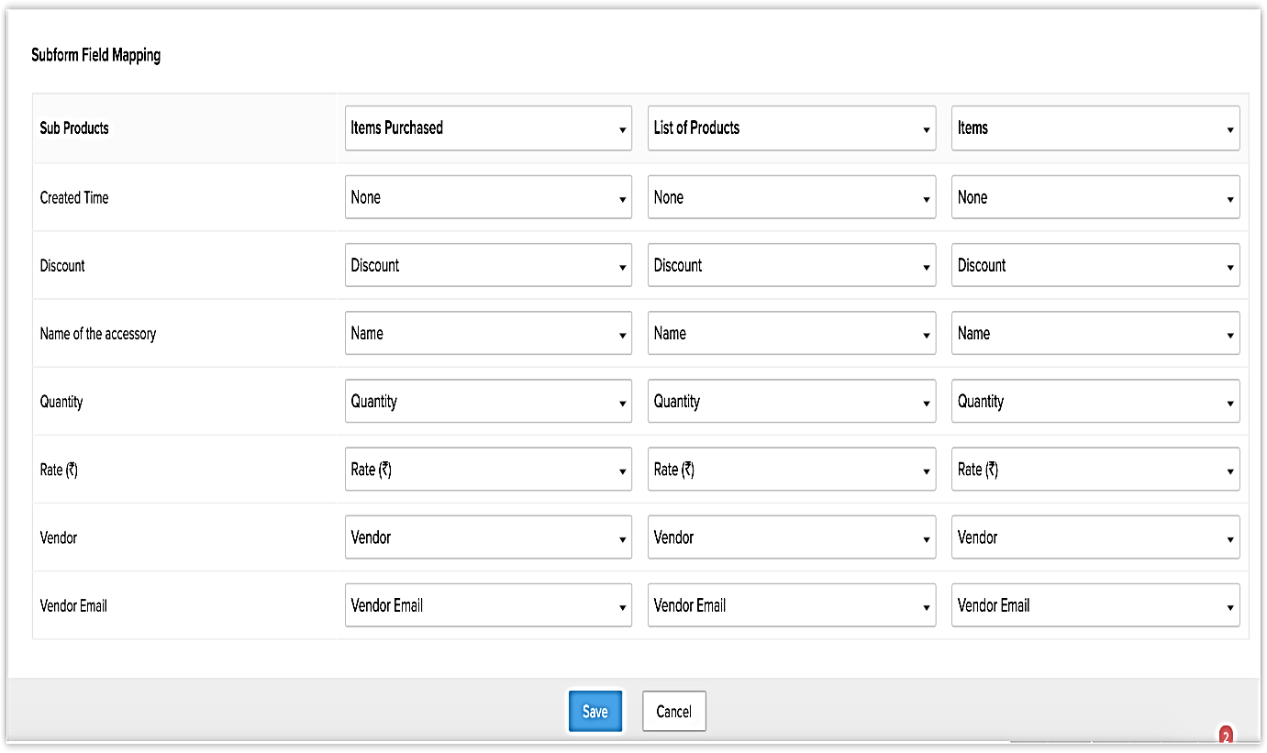
Invoice Page in Zoho CRM

Potential Clients List/ Lead
CodersTrust's client prospect list aids in the development of new sales prospects. Information obtained via trade shows, seminars, advertisements, and other forms of promotional outreach about specific persons or organizations. Customers, contacts, and transactions (opportunities) will be created for leaders in Zoho CRM when they meet the criteria.
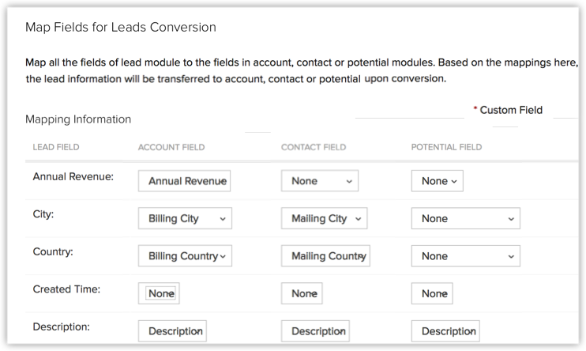
Zoho CRM's page for lead generation
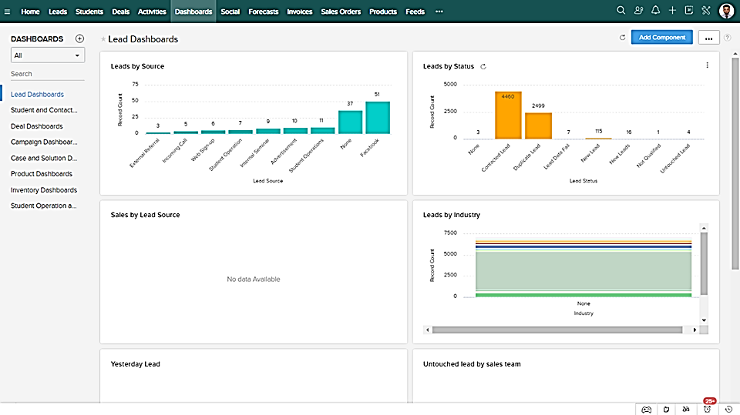
Dashboard for Prospects and Leads in Zoho CRM

Contacts
Companies (such as Up work and Fiverr) engage with reputable programmers in order to locate employment possibilities. There may be many contacts from the same firm, or contacts from different departments, throughout this list. CRM contacts are often converted from qualified leads, imported from an existing list, or added to CodersTrust's database based on a commercial connection.

Accounts
A CodersTrust account is a business or division of a firm that uses CodersTrust's services. Zoho CRM allows businesses to link as little as one contact to a specific account or as many as a hundred contacts. When a business sells goods or services to another business, keeping track of essential information about that business is a critical part of doing business in the B2B world.

Sales Forecasting
As a business owner, forecasting is essential to making great decisions and predicting future sales. Personal, real-time views of CodersTrust's business are provided to monitor and optimize sales processes inside the organization.

Modules
Data in Zoho CRM is organized into subsets depending on how closely they resemble one another. The term "table" refers to any department that collects data in a similar way. In the example of a lead module, for example, it holds all the information on a company's leads. Other modules include customers, contacts, quotations, and quotes. Also in Zoho CRM, there are two primary categories of modules: preconfigured and user-generated.

Recording
A recording is the term given to any module item that has been recorded. If the Leads module has 10 leads, then each of them is a record. For example, if the Contacts module has ten contacts, then each of those contacts is a record.
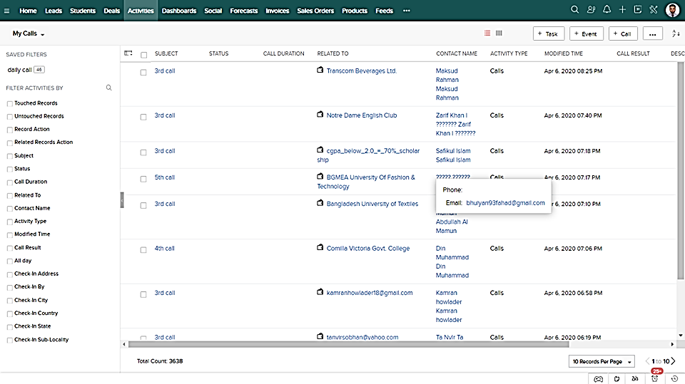Documentation related to customers' leads

CHAPTER 04
RECOMMENDATIONS AND CONCLUSION

Recommendations
CTBD adhere to the leadership style of autocracy. The environment of a whole company is sensitive to variation if it has strong leadership. In the section regarding weaknesses that I just addressed that CTBD has an issue with a high turnover rate of its employees. Employee retention is very important for an organization because it takes a lot of time and effort to train one employee. In order to retain employees, an organization needs good leadership that can provide a healthy environment and make it so that employees can easily perform their jobs. As a result, I believe that CTBD should hire an experienced and skilled individual who also has a leadership skill. Besides, in order to assist CodersTrust in regaining its sales management in this competitive business environment, the following recommendations, which are based on a few proven areas of enhancement, are presented:
- Increasing client involvement via the provision of live consultation and other forms of real-time support
According to research conducted by the (Aberdeen Strategy & Research), businesses that make use of visualization tools have seen an increase in yearly income of 83 percent as well as a decrease of 2.7fold in the amount of workload scores customer feedback. Clients are covered from direct financial interactions during the face-to-face video chat help offered by the real-time vulnerability platform. This enables customers to better manage their funds. Co-navigation solutions have a substantial influence on an agent's ability to access a client's browser as well as the agent's capacity to give online customer assistance by filling out help or forms on the appropriate page. Real-time supports, such as live streaming, are important communication channels that training institutions need to have in order to improve their communication with their students and trainers. The CodersTrust Bangladesh ought to make real-time available because real-time supports are among these channels. Setting up a number of different customer journey scenarios and working to improve customer satisfaction may be of great assistance to Coders Trust Bangladesh.
- Improve Client Satisfaction
There are three elements that influence customer service expectations: convenience of service, emotional involvement in service and service success. (Avila, 2008)’s study found that these three factors are connected. Providing a positive experience for CodersTrust clients begins the minute they land on the Bangladesh website and continues until they become a paying user of the company. CodersTrust Bangladesh's customer satisfaction may be increased by putting customer expectations first and working hard to satisfy them.
- Advanced Customer Responsiveness
The possibility of a client receiving a delayed answer is what drives customers away from CodersTrust in Bangladesh. If a company does not instantly respond to a customer's inquiry, there is little that can be done to increase the level of happiness and fulfillment experienced by such clients. A poll that was conducted by Ubisend found that one in five customers believe that interacting with a chat-box is the simplest method to engage with a business. As a consequence of this, CodersTrust is able to redefine customer satisfaction in Bangladesh by automatically reducing customer response times, interactions, and interests through the use of the best chat bots. Real-time services are extremely valuable for both maintaining existing relationships and developing new ones. Chat-bots may also aid CodersTrust Bangladesh by:
- Recognizing and responding to the most frequently asked queries, so that replies follow a consistent pattern for future clients.
- Secondly, directing clients to prior replies on the same issue might assist to manage the space on a website.
Besides, CodersTrust Bangladesh needs to some steps for increasing their sales volume which are:
- In response to popular request, CodersTrust Bangladesh should enhance the number of courses it offers in the near future.
- Needs to increase their branch count across Bangladesh.
- CodersTrust Bangladesh should priorities the campaign in universities and institutions to raise public awareness.

Conclusion
The study of the report’s objectives include analyzing the idea of sales and marketing strategies, analyzing sales and CRM practices implemented by CodersTrust Bangladesh, and recommending improvements to CodersTrust Bangladesh's sales management. CodersTrust Bangladesh uses Sales Management as a combination of marketing strategies, practices, and customer relationship management technologies to manage their customer experiences and data throughout their lifecycle, with the purpose of improving customer service and helping customers to maintain and drive sales growth, as outlined in the study of the report.
CodersTrust is a Danish firm that has set up a branch in Bangladesh in order to help the impoverished students of Bangladesh have access to online education. In order to keep current students and attract new ones, the organization is providing a wide range of educational opportunities. CodersTrust utilizes Zoho CRM software to keep track of all of its students' basic data. CodersTrust is able to stay in touch with students and keep them up to speed on course changes thanks to the programs. Tutors, professors, and business experts are all readily available via CodersTrust to assist students in meeting their individual requirements. The Face book group and the 24-hour online assistance centre are also made available to students who use Talent ELMS as a result of this arrangement. In addition, CodersTrust publishes numerous alumni success stories on its Face book page and website to assist current and future students discover how successful students have used the principles of CodersTrust. When it comes to improving customer service standards and increasing the sales growth of the organization, the firm should build live streaming services, automated chat-bots, and include its customers in all of the stories and updates about its organization.

References

Aberdeen Strategy & Research. (n.d.). Retrieved from Custom Research Solutions: https://www.aberdeen.com/
Aimin, N. M. (2016). Exploring the Value and Process of Marketing Strategy: Review of Literature. International Journal of Management Science and Business Administration, Volume 2, Issue 2, 7- 18.
Avila, S. A. (2008). Preparing the next generation of sales professionals through social, experiential, and immersive learning experiences. Journal for Advancement of Marketing Education , 13(4), 47-55.
Badi, K. S. (2018). The Impact of Marketing Mix on the Competitive Advantage of the SME Sector in the Al Buraimi Governorate in Oman. Business and Management - Research Article, Volume: 8 issue: 3.
Company Profile. (n.d.). Retrieved from Coderstrust Bangladesh | Global Skills Development and IT Training Institute: https://coderstrustbd.com/
Competitive Analysis – Meaning, Examples And Importance. (2021, November 8). Retrieved from Harappa Diaries: https://harappa.education/harappa-diaries/competitive-analysis/
David, F. R. (2003). Strategic Management-Concepts and Cases, (9th Edition). USA: Pearson Education.
Harrison, J. S. (2004). Foundations in Strategic Management. USA: South Western.
Jayachandran, P. R. (1999). Marketing strategy: An assessment of the state of the field and outlook. Journal of the Academy of Marketing Science, 27(2), 120−143.
Jehad S. Aldehayyat, J. R. (2008). Strategic planning tools and techniques in Jordan: awareness and use. Strategic Change, 17(7‐8), 281-293.
Pearce, J. a. (1991). Strategic Management (4th Edition) . USA: Irwin, Inc.
Rozmi, A. N. (2018). The perception of ICT adoption in small medium enterprise: A SWOT analysis. International Journal of Innovation Business Strategy, 19(1), 69-79.
Thompson, A. A., & Strickland, A. J. (1989 ). Strategy Formulation and Implementation (4th Edition). USA: Irwin, Inc.
Zamana, A. (2019, June 23). A freelancing boom is reshaping Bangladesh and its economy. Retrieved from Online Article: https://theprint.in/world/a-freelancing-boom-is-reshaping-bangladesh-and-its-economy/252971/

