Internship Report
On
Recruitment and Selection Process of Hotel Bengal Blueberry
Course code: INT 4399
Submitted To
Shayla Khanam
Assistant Professor
School of Business and Economics
United International University
Submitted By
Farah Binta Alam
ID: 111 163 106
Enrollment: Fall 2021
Bachelor of Business Administration
Major in Human Resource Management
United International University

Date of Submission: February 15, 2022

Letter of Transmittal
February 15, 2022
Shayla Khanam
Assistant Professor,
School of Business and Economics,
United International University
Subject: Submission of Internship Report.
Dear Miss,
With due respect, I am submitting my internship report on “Recruitment and Selection Process of Hotel Bengal Blue Berry” which is the part of fulfillment of Bachelor of Business Administration degree and the INT course 4399.
As a consequence, I am delighted to submit my report, which serves as both a learning experience and an illustration of the distinctions between theoretical and practical action.
Therefore, I would like to express my gratitude to you for all of the support and guidance you have provided me. I hope this report will meet your expectations. I would be grateful if you would accept my internship report with the utmost appreciation.
Sincerely

Farah Binta Alam
ID – 111 163 106
BBA Program, Major in Human Resource Management
School of Business and Economics
United International University

Declaration of the Student
I am Farah Binta Alam, student of Bachelor of Business Administration, major in Human Resource Management, United International University; I do hereby declare that the internship report on “Recruitment and Selection Process of Hotel Bengal Blue Berry” is a presentation of my original work.
This study combines contributions from a number of persons who have been involved in providing suitable references to the literature review, conducting surveys for the purpose of analyzing the topics and discussions, and analyzing the data collected altogether. And this report has been prepared under the supervision of Shayla khanam, Assistant Professor, Business and Economics, United International University.
I additionally declare that I have not engaged in any unethical ways in the course of completing the report, and that the report has been prepared solely for the purposes of academic research.
Farah Binta Alam
ID – 111 163 106
Enrollment: Fall 2021
BBA Program, Major in Human Resource Management
School of Business and Economics
United International University

Acknowledgement
At first I would thank to Allah for providing me with the strength to perform my internship report obligations and responsibilities as well as to complete the study and report within the time frame.
After that, I would like to convey my heartfelt appreciation to my course supervisor, Shayla Khanam, Assistant Professor, Business and Economics, United International University for her constructive guidance and valuable support. It is true that I would not have been able to complete the report on time and with accuracy if it had not been for her valuable direction, support, and collaboration throughout the process. I am delighted to have the opportunity to complete my internship report under her supervision.
Finally, I would like to express my gratitude to all employees and staffs of Hotel Bengal Blue Berry for participating and giving their valuable time to complete the formal and informal interview sessions.

Table of Contents

Executive Summary viii
Chapter 01: Introduction
1.1 Background of the Report 2
1.2 Objectives of the Report 2
1.2.1 Broad Objective 2
1.2.2 Specific Objectives 2
1.3 Scope of the Report 2
1.4 Limitation of the Report 3
1.5 Methodology of the Report 3
1.5.1 Primary Sources 3
1.5.2 Secondary Sources 3
1.5.3 Data Collection Method and Analysis Plan 3
Chapter 02: Literature Review
2.1 Human Resource Management 6
2.2 Human Resource Management in Hospitality and Hotel Industry 6
2.3 Role of HR in Hospitality and Hotel Industry 7
2.4 Types of HR Development in Hospitality and Hotel Industry 7
2.4.1 Job Analysis 7
2.4.2 Purpose of Job Analysis 8
2.4.2.1 Human Resource Planning (HRP) 8
2.4.2.2 Recruitment and Selection Potential Personnel 8
2.4.2.3 Training and Development 8
2.4.2.4 Job Evaluation 8
2.4.2.5 Performance Evaluation 8
2.4.3 Recruitment 9
2.4.4 Selection 9
2.5 Challenges of HRD in Hospitality and Hotel Industry 9
Chapter 03: Company Analysis
3.1 Take a Look at Hotel Bengal Blueberry 12
3.2 Vision 12
3.3 Mission 12
3.4 Strategic Plans 13
3.5 Core Values 13
3.6 Facilities and Accommodations 14
3.6.1 Blue Liscious Restaurant 15
3.6.2 Swiss Delight 15
3.6.3 Blue Berry Banquet 16
3.7 Organization Chart (Functional) 16
3.8 Departmentalization 17
3.9 HR Department of Hotel Bengal Blue Berry 18
Chapter 04: Analysis and Findings
Data Analysis and Presentation Plan 21
Analysis of the Study 22
4.1 Staffing Strategy of Hotel Bengal Blue Berry 22
4.2 Types of Recruitment 23
4.3 Recruitment Approach of Hotel Bengal Blue Berry 24
4.3.1 Planned Personnel Development and Posting Job Openings 25
4.3.2 Candidates’ Qualification 25
4.3.3 Recruitment Channel 25
4.4 Selection Process of Hotel Bengal Blue Berry 27
4.4.1 Flow Chart of Internal Recruitment Process in Hotel Bengal Blue Berry 28
4.4.2 Flow Chart of External Recruitment Process in Hotel Bengal Blue Berry 29
4.5 Recruitment and Selection Process Cycle of Hotel Bengal Blue Berry 30
4.6 Impact of COVID 19 on Recruitment and Selection Process of Hotel Bengal Blue Berry 30
4.7 Findings 31
4.7.1 Key Challenges in Hotel Bengal Blue Berry Recruitment 31
A. Finding Potential Candidates 31
B. Attracting Potential Candidates 31
C. High Turnover Rate 31
Chapter 05: Internship Experience
5.1 Internship Experience at Hotel Bengal Blue Berry 33
5.1.1 Regular Activities 33
5.1.2 Trainings and Career Development from Internship Period 34
5.2 Critical Observation Founded during Internship Period at Hotel Bengal Blue Berry ……………………………………………………………………………………...34
Chapter 06: Recommendations and Conclusion
6.1 Recommendations 37
6.2 Conclusion 37
References 39
Appendix 40
Exhibit A: Interview Questionnaire 40
Exhibit B: Employee Requisition Form of Hotel Bengal Blue Berry 41
Exhibit C: Advertisement Job Openings for Product Departmentalization 42
Exhibit D: Advertisement Job Openings for All Departmentalization 43

Table of Tables
Table 1.1: Employee Recruitment Trend in Hotel Bengal Blue Berry (2018-2020) 23
Table 1.2: Candidates’ Qualifications for Functional Department at Hotel Bengal Blue Berry 25
Table of Figures
Figure 1.1: Core Values of Hotel Bengal Blue Berry 14
Figure 1.2: Organization Chart of Hotel Bengal Blue Berry 16
Figure 1.3: Departmentalization of Hotel Bengal Blue Berry 17
Figure 1.4: Existing Employee Status of Hotel Bengal Blue Berry 23
Figure 1.5: Employee Recruitment Trend at Hotel Bengal Blue Berry 24
Figure 1.6: External Source of Recruitment 26
Figure 1.7: Selection Process of Hotel Blue Bengal Berry 27
Figure 1.8: Internal Recruitment Process of Hotel Blue Bengal Berry 28
Figure 1.9: External Recruitment Process of Hotel Blue Bengal Berry 29
Figure 1.10: Recruitment and Selection Process Cycle of Hotel Blue Bengal Berry 30

Executive Summary
The internship report was prepared as a requirement for the completion of Bachelor of Business Administration (BBA) degree. I acquired great hands-on experience while working as an intern at Hotel Bengal Blue Berry, which I have outlined in my report.
I have completed the study on “Recruitment and Selection Process of Hotel Bengal Blue Berry and the changes during COVID 109 pandemic." The major objective of this report is to illustrate how the human resources department of Hotel Bengal Blue Berry operates and implements the recruitment and selecting process in their hospitality service sector. I have described the HR activities, following staffing strategy, recruitment and selection process, the changes of the process during COVID 19 and my internship experience in this report and divided the whole write up into six chapters.
The first chapter includes an introduction part such as background study, objectives, scope, limitations, and methodology of the report.
The second chapter includes the literature review part. It is the purpose of this chapter to provide information collected from relevant literature addressing the subject matter of this study.
The third Chapter deals with the overview of Hotel Bengal Blue Berry, its strategic plan for hospitality services, facilities & accommodations, HR operations and so on.
In fourth chapter, I have explained the Recruitment and Selection process of Hotel Bengal Blue Berry as well as the new changes during Covid-19 and what alterations they have made in these functional activities during Covid-19.
However, my internship experiences such as positions, duties, responsibilities, training, and contributions to department are elaborated in chapter five.
On the basis of analysis part and internship experiences at Hotel Bengal Blue Berry, some obstacles for HRD of Hotel Bengal Blue Berry are highlighted in chapter six and added some recommendations. Finally, I have concluded this report in this chapter.

CHAPTER 01

INTRODUCTION

Background of the Report
This internship report is prepared for a partial requirement for the degree fulfillment of Bachelor of Business Administration. I have gained hands on experiences about the HR activities and following practices in Hospitality industry in Bangladesh. And these issues are a significant source in the main study of this report which has been done under the supervision of my course supervisor, Shayla Khanam, Assistant Professor, Business and Economics, United International University.

Objectives of the Report

Broad Objective
The main objective of this study is to be exploratory and constructive in nature. Specifically, it is concerned with increasing understanding about the recruitment and selection process of Hotel Bengal Blue Berry.

Specific Objectives
- To know about the overview of Hotel Bengal Blue Berry.
- To analyze the factors of recruitment and selection process of Hotel Bengal Blue Berry.
- To find out the challenges of recruitment and selection process of Hotel Bengal Blue Berry.
- To provide some recommendations that can help to HR manager to develop and implement effective recruitment and selection process for getting potential manpower of their hospitality and hotel services.

Scope of the Report
For the duration of my internship, I had the opportunity to discuss with the head of HR, HR Coordinator of Hotel Bengal Blue Berry about their recruitment and selection process and the taken steps in recruitment and selection process as well as the changes of HR practices during the pandemic situation. I have been able to raise the degree of complexity of my knowledge by connecting theoretical ideas to real-world experiences.

Limitation of the Report
Some of the limitations for completing the report are listed below:
- Some information cannot be made available due to confidentiality and other hotel obligations.
- The head of HRD of Hotel Bengal Blue Berry had not given so much time on my interview sessions.

Methodology of the Report
In this study, qualitative data collection methods like interviews, group discussions, observations & company’s documents, annual report & HRM report revision etc will be used. This report and study's data was gathered from two distinct sources. These are the specifics:

Primary Sources

The information for this report has been gathered from several primary sources, and I have also gathered primary information from respondents to conducting formal and informal interview sessions for studying of the topic. Another method is used to obtain primary data:
- Face to face interaction and discussions with employees, staffs of Hotel Bengal Blue Berry.
- An observation from internship experiences and HR related tasks and job responsibilities.

Secondary Sources
The secondary data was gathered from the following sources:
- Articles, Newspapers, Journals, books which are related to the concept of recruitment and selection process as well as HR practices in Hospitality industry in Bangladesh.
- Official Website of Hotel Bengal Blue Berry.
- Internal reports of Hotel Bengal Blue Berry.

Data Collection Method and Analysis Plan
For the purpose of analyzing the topic, a standard level questionnaire has been designed. This questionnaire is based on prior study on recruitment and selection process of Hotel Bengal Blue Berry and includes a wide range of valuable information. The information and data has been collected from the employees, HR Coordinator and Head of HR at Hotel Bengal Blue Berry through conducting formal and informal interview sessions.
For presenting the data and information, I have not included any quantitative techniques in this internship report. More specifically, the paper is concerned with a practical hand on experience. I mostly utilized verbal analysis to explain recruitment and selection process of Hotel Bengal Blue Berry, as well as to identify the types of practices they have explored using those activities.
Some tables, graphs have been used in the analysis and presentation of the data.

CHAPTER 02

LITERATURE REVIEW

Literature Review Part
This main purpose of this chapter is to provide theoretical concept obtained from the study's subject matter's relevant literature.

Human Resource Management
A firm's human resources (HR) department is responsible for overseeing all managerial activities that have an impact on the work – force (Reddy, 2011). Many academics have described human resource management in a number of ways.
According to (Daud, 2006), Human resource management (HRM) is a set of procedures, policies, and standards that may affect the lives of those who work for a company. Additional definitions are offered by (Juyal, 2006) everything that has an influence on personnel in a company is covered under human resources management (HRM). According to (De Cieri, 2008) an employee's behavior is influenced by HRM rules and practices. Employee well-being and the company's bottom line are intertwined in HRM, which aims to strike a healthy balance between employee needs and the company's needs (Ahmad, 2012). Human resource management (HRM) is a deliberate and unambiguous strategy to managing the organization's most valuable asset: its people, according to (Burma, 2014).

Human Resource Management in Hospitality and Hotel Industry
Human resource management (HRM) is the process of directing an organization's workforce in order to improve employee morale and productivity. Recruiting, selecting, training, developing, rewarding, and maintaining an organization's workforce is all aspects of human resources management (Mondal, 2021).
Any successful firm relies on a team of hard-working, innovative, and efficient employees. This is especially true in the case of the service sector. Employees that are customer-oriented and hardworking, as well as having necessary skills, are the backbone of successful hospitality and hotel operations.
When it comes to hotels and hospitality services, the human resource department is tasked with anticipating and meeting the requirements of current and prospective employees. This includes acquisition, selection, and development. It also encompasses the procedures of employment appraisal, recruiting, selection, and orientation, amongst other things.

Role of HR in Hospitality and Hotel Industry
According to (Mondal, 2021) Human resource management (HRM) is a process that, in an organizational setting, assists the workers of an organization in a continuous and planned manner to achieve the following things:
- The ability to execute numerous duties linked with their existing or anticipated future jobs is developed or sharpened.
- Individuals and teams may improve their overall talents and find and maximize their personal and organizational growth and development potential.
- Build an environment where strong connections between managers and their subordinates, cooperation, and collaboration throughout departments all contribute to the professional well-being, motivation, and sense of accomplishment of all workers.

Types of HR Development in Hospitality and Hotel Industry
Developing people's competences and abilities is an important part of HRD, which aims to prepare employees for both current and future roles within the firm (Mondal, 2021). The HRD also aids workers in better appreciating their own strengths and weaknesses, allowing them to make the most of their potential and achieve both their professional and personal goals.

Job Analysis
Gathering information on an individual employment position is the goal of a job analysis. As an example, it may be described as an analysis of the operations and duties of a certain position. A significant amount of information about a job is generated throughout the appraisal process (Mondal, 2021). There are several subcategories of data that may be subdivided into:
- Job Description: An employee's obligations, responsibilities, and tasks are all laid forth in the job description. It outlines the limits within which a task should be completed. Also included are reporting connections, working conditions, leadership and responsibility, collaboration with other departments, position within the hierarchy of the department, equipment and supplies, and other information that is relevant to the hotel's operations.
- Job Specification: A job specification is a document that outlines the abilities and qualities needed for a position. Personal characteristics, talents, proper education, relevant skills, job experience, general knowledge, prior training, physical abilities, equipment expertise, and communication abilities are all included.

Purpose of Job Analysis
The HR department may benefit from the usage of job analysis. The following tasks within the department are made easier with the use of data gathered via job analysis:

Human Resource Planning (HRP)
Human resource planning is the process of determining the organization's current and future personnel needs. A human resources manager may use a job analysis to determine whether employees in the business have the necessary abilities to carry out the organization's current and future duties.

Recruitment and Selection Potential Personnel
After the company examines its current and prospective workforce needs, the recruiting process starts. Once a recruiting post has been identified, the scope of the job and the necessary abilities are defined by creating a job description and specification for that role.
Therefore, managers can better allocate duties, and human resources professionals will have a better sense of the qualifications to seek for when hiring new staff.

Training and Development
It is possible to customize the training and development activities to suit the job. For both current and prospective workers, a job analysis may assist determine what training is needed as well as how it should be delivered.

Job Evaluation
In order to set salaries and pay packages, job assessment is used to determine how much each job is worth. The foundations for determining the relative value of a job are the job description and the job specification.

Performance Evaluation
The job description provides a framework for evaluating the performance of individuals in the workplace. An employee's performance evaluation serves as the foundations for determining whether they are transferred, promoted, or require more training.

Recruitment
A company's requirement for employees is met by recruiting the suitable individuals to fill both current and future jobs in the company. As a recruiting process, it is all about attracting and enticing the right qualified people to apply for the right roles. Finding and recruiting qualified job candidates is what recruitment is all about. When new recruits are sought for, the process starts and finishes with the submission of their applications. In order to accomplish these goals, recruitment is used:
- Recruitment pulls individuals that are highly skilled and competent.
- It offers a cost-effective pool of potentially suitable individuals for a variety of employment jobs.
- It complies with the organization's legal and social responsibilities in terms of worker makeup.
- In this way, it's possible to find people who are a good fit for different employment roles.

Selection
The process of selecting the most qualified applicant from a pool of candidates who have applied for a position is known as selection. Only those who meet the job's requirements are considered for the position. One who meets all of these requirements is chosen for the position. Selecting amongst candidates in order to find individuals with a better chance of succeeding in a job is what we mean by the term "selection."

Challenges of HRD in Hospitality and Hotel Industry
The following are some of the industry's most pressing issues in regard to human resources:
- Because of the long hours, antisocial hours, poor pay, instability, and low status associated with hotel and catering employment, the industry continues to experience substantial employee turnover and difficulty in attracting and retaining talented workers.
- During holidays like Christmas, Special Holidays, and long weekends, the hotel's staff works extra hard. As a result, hotels are often fully booked during peak festival and vacation times, necessitating the need of additional workers.
- Individuals' psychological and physical health may be adversely affected by excessive working hours. A rise in family strife and marital strain might be one of the social impacts.
- If employees are working long hours but aren't fully engaged in their jobs, this might have a negative impact on the productivity of the company's workforce.
- Employees and employers must be included in the process of changing working conditions to ensure that reforms are compatible with both groups' objectives and wants for larger profitability, productivity, and a better work-life balance.
- Once you've taken steps to improve working conditions, the next step is to find and keep the right kind of employees. Some companies have taken a more proactive approach to addressing this issue by focusing on employee happiness and implementing incentive schemes. Retaining key employees is essential to a company's long-term success.
- To ensure customer satisfaction, product sales, succession planning, and deep organizational knowledge and learning, the best workers must be kept in place for the long term. Follow - up interviews should be analyzed by HR, and then remedies should be developed and implemented.

CHAPTER 03

ORGANIZATION PROFILE

Take a Look at Hotel Bengal Blueberry

The remarkable five-star standard Hotel Bengal Blueberry is more than simply a beautiful hotel; it is also a symbol of contemporary Dhaka. It is situated in the central of the city's diplomatic zone at Gulshan 2. Benefit from our enviable location approximately six kilometers from Shahjalal International Airport (DAC), and it is close to the areas, many embassies and high commissioners. Gulshan, Dhaka's safest area, is home to several restaurants, leisure alternatives, and corporate headquarters. No matter whether you are in Dhaka for a business meeting or just to relax and take in the sights, their historic hotel provides everything you need. Each of their guest rooms, with the majority of them facing the peaceful Gulshan 2, provides beautifully designed and tastefully designed accommodations.

Vision
Hotel Bengal Blue Berry has its own vision which is to be the number one Five Star Hotel in Bangladesh although at present this Hotel is a Four- Star Hotel.

Mission
With the aim of vision, this hotel sets its mission, objectives and goals and creates its plan to run the hospitality services.
The mission of the Hotel Bengal Blue Berry is to provide the best quality of hospitality services possible in order to meet and exceed the needs and expectations of its guests. Their goal is to create the Hotel Bengal Blue Berry for a meeting place, a location of business success, a place of enjoyable gatherings, and a place for grand celebrations.

Strategic Plans
The strategy of Hotel Bengal Blue Berry is based on the following:
- Collaboration with Guests: The satisfaction of their guests is the most significant key to them, and they make every effort to surpass their expectations with their high-quality hospitality services. Their aim is to make every guests feel at home, and they hope that as a result of this, customer would pick Hotel Bengal Blue Berry as his next accommodation option. Guests' needs and expectations are met and exceeded by providing services at the best level possible. They identify the needs and expectations of their customers and respond to them through open communication, satisfaction monitoring, and analysis of praises and complaints.
- Employees: It is necessary for development to occur that people accept new information and technology, as well as get high-quality training and education. The education and training of all of our personnel, as well as continual communication between all of their departments, are the foundation of their approach. They encourage cooperation, individual responsibility, and initiative on the part of all of their employees.
- Good Relationship with Suppliers: They must choose trusted suppliers in order to be able to deliver the best quality and most suitable accommodations to their guests, who are the ultimate users of their services. Purchase is one of the more significant departments in our hotel and needs a selection from a pool of dependable vendors. They must try to build their relationships with suppliers on the basis of shared interests and the establishment of long-term business relationships.
- Gratification Derived from Interesting Events: It is expected that Hotel Bengal Blue Berry will increase the volume and structure of hospitality services, thereby meeting the needs and expectations of all parties involved: guests and business partners; travel agencies; non-governmental organizations; governments; and sports organizations; employees; and owners and suppliers.

Core Values
Every Moment Matters is their brand promise, which is at the core of everything they do at Hotel Bengal Blue Berry. With their basic principles or core values, they inspire their team members to create memorable moments and contribute to the success of the organization.

Figure 1.1: Core Values of Hotel Bengal Blue Berry
Source: Website of Hotel Bengal Blue Berry

Facilities and Accommodations
Hotel Bengal Blue Berry has its own vision which is to be the number one Five Star Hotel in Bangladesh although at present this Hotel is a Four- Star Hotel. So, continuously they are trying to bring new innovations and facilities for their customers, visitors and guests.
- There are 110 luxurious rooms and suites.
- Two Restaurants.
- Five Banquet and Conference rooms are available.
- Butler Service that is personalized.
- Restaurant and Coffee establishment of international renown.
- Sauna, Steam bath, and Jacuzzi are all options.
- Limousine Service to and from the airport.

Blue Liscious Restaurant


In the Blueliscious Restaurant, which is located on the first level, visitors will find a delectable selection of exquisite international cuisine produced by their team of culinary specialists. It is important to them that their cuisine is prepared with fresh ingredients and served in a beautiful setting by workers who are passionate about what they do for all of their all customers, visitors and guests. The Blue Liscious Restaurant offers a welcoming, relaxing, and elegant atmosphere for its guests. The restaurant has a wide variety of selections for you to choose from, whether you want from their buffet or a la carte menu. Their delectable Indian, Bengali, and international meals are flavored with unique spices and delicate (but hot) tastes that will leave you wanting more. Alternatively, inhale the invigorating perfume of their delectable Western cuisine, which ranges from well seasoned, well-marbled, and incredibly juicy steaks to the savory flavor of delicious pasta that melts in your tongue like butter. Delicious cuisine, a laid-back atmosphere, and all while staring at the gorgeous terracotta fountain next to the glass wall- another Blue Berry experience that will last a lifetime.

Swiss Delight

Their Swiss Delight, which is conveniently located next to the foyer, serves distinctive coffee that is prepared on-site. Pick grab a cup of coffee on your way to or from work, or just rest and unwind in their well-designed enclosed area while you commute. Whatever you do, you will notice a distinct change in flavor. Their selection of cookies, bagels, croissants, and donuts make for a delicious snack or special treat at any time of the day. Whether you want to cater an event or purchase a single item, their bakery always makes the freshest and most skillfully designed pastry, which can be smelled from a quarter-mile away.

Blue Berry Banquet

The venue is located on the top level and has a seating capacity of 150 people. It has state-of-the-art amenities. No matter whether you want to plan a conference or meeting, a reception or dinner, a social event, or anything else, they can take care of all the necessary details. Their culinary experts provide high-grade services and foods that are of the highest quality. Their first concern is to ensure that you and your guests are completely satisfied. You will see that their expertise is reflected in phrases such as: where your event makes the difference.
They recognize how important your event is to you, and our staff will give serious consideration to your culinary recommendations. In addition, they would create a menu for you that were tailored to your personal requirements as well as your budget. They are now accepting reservations for any kind of corporate event, such as a birthday party, wedding reception, AGM, MGM, and so on.

Organization Chart (Functional)
Managing Director

General Manager

Figure 2.2: Organization Chart of Hotel Bengal Blue Berry

HR
(Head)
Marketing
(Head)
GSA
(Head)
Supervisor
Finance
(Head)

Departmentalization
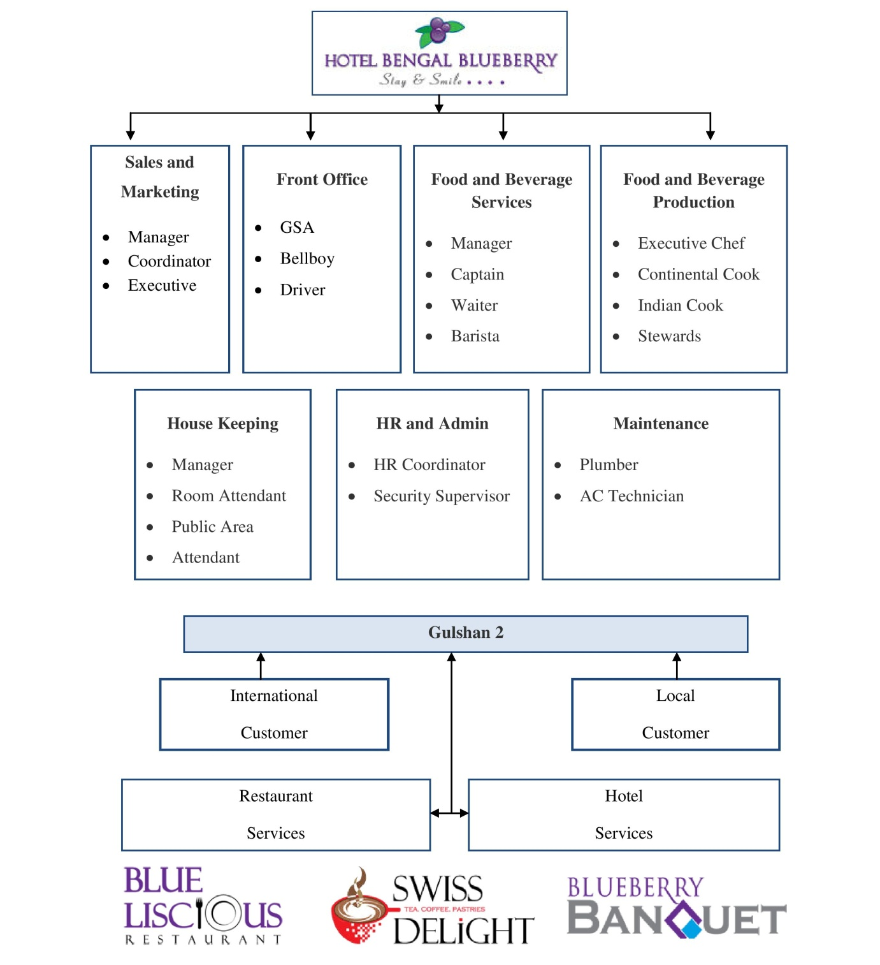
Figure 3.3: Departmentalization of Hotel Bengal Blue Berry
Hotel Bengal Blue Berry has four basic bases for departmentalization which are By Function, By Services, By Customer, and By Location. All departments are controlled by one area expert. In functional departmentalization we have GSA, Finance, and Marketing and Human resource. Product departmentalization is consisted on the basis hotel services and restaurants service. They are divided their customers based on the region such as Local and International. They have only one office where they run the overall business which is situated in Gulshan 2.

HR Department of Hotel Bengal Blue Berry
The Human Resources Department (HRD) of the Hotel Bengal Blue Berry works under the overall supervision of the Hotel General Manager and is responsible for assisting the functional and production team in their day-to-day operations. They build and implement the hotel's talent development strategy by developing Business and hotel-specific training programs and recruiting for non-management positions inside the hotel. Additionally, the HRD assists all teams in adhering to the Hotel's standards and processes and in meeting staffing demands on a timely basis, from advertising through interviewing and recruiting qualified candidates. Duties and Responsibilities of HRD of Hotel Bengal Blue Berry are listed below:
- Arranging and participate meetings on behalf of the General Manager/Managing Director.
- Ensures that all social activities for the workforce are properly planned and executed.
- Organizing and coordinating events and activities for Hotel Associates.
- Putting together payroll and absence data.
- Managing the Human Resources Dashboard and Statistics.
- Organizing culinary festivals and entertainment activities for the workforce.
- Daily transportation for staff to and from their places of employment is coordinated.
- Provide assistance and resolution to hotel personnel and management inquiries.
- Keeping pay and benefits information up to date.
- Provides assistance to the HR manager in the formulation of the budget, and is well-versed in all budgeted positions and approvals for recruitment.
- Create job descriptions, shortlist applicants, interview them, and selecting the right candidates; prepare personal files for coworkers; and supervise trainees.
- Developing policies for concerns including employment conditions, performance evaluation, fair treatment, disciplinary processes and absence management.
- To aid in the development of service excellence in the workplace, assist workers in identifying particular behaviors that will do so.
- Assistance the internship or training program and ensure that all interns get the required support and direction during their industrial experience training.
- Analyze employee turnover and sick leave in order to create measures for reducing them.
- Complete and submit HR documents and reports on a monthly basis to the General Manager and Managing Director of Hotel Bengal Blue Berry.

CHAPTER 04

ANALYSIS AND FINDINGS

Data Analysis and Presentation Plan
For the purpose of analyzing the topic, a standard level questionnaire has been designed. This questionnaire is based on prior study on recruitment and selection process of Hotel Bengal Blue Berry and includes a wide range of valuable information. The information and data has been collected from the employees, HR Coordinator and Head of HR at Hotel Bengal Blue Berry through conducting formal and informal interview sessions.
For presenting the data and information, I have not included any quantitative techniques in this internship report. More specifically, the paper is concerned with a practical hand on experience. I mostly utilized verbal analysis to explain recruitment and selection process of Hotel Bengal Blue Berry, as well as to identify the types of practices they have explored using those activities.
Some tables, graphs have been used in the analysis and presentation of the data.

Analysis of the Study

Staffing Strategy of Hotel Bengal Blue Berry
With some steps, Hotel Bengal Blue Berry is always striving to maintain the effectiveness of the organization through the process of acquiring, deploying, and retaining a workforce that is of sufficient quantity and quality to have a positive impact on the organization's overall effectiveness. When they are recruiting applicants, they constantly emphasize the positive interaction between the candidate's qualifications and job qualities, whether they are a good fit for one another or not. Basically, they strive to match the right candidate with the right task at all times. Furthermore, they place greater focus on developing talent than obtaining it. The Hotel organization has a dedicated training and development section under HR department of Hotel Bengal Blue Berry that trains and develops existing staff in order to make them more productive in their current positions.
Every year, Managing Director, General Manager and HR department of Hotel Bengal Blue Berry completes an annual business plan. This plan is completed once a year and is used to establish the needed manpower for the next year. And it is on the basis of this data that they recruit personnel. They prefer internal employment for product departmentalization positions over external hiring. But for the position of functional departmentalization, they utilize external sources for hiring staffs. In Hotel Bengal Blue Berry the number of staffs is 120 and all the staffs are involved in the growth of the business of the hotel and restaurant services. But few members are involved in making the plan of the growth of the business on the basis of different levels. The people who are responsible for the planning activities are:
- Managing Director
- General Manager
- Departmental Heads (Product and Functional)

Figure 4.4: Existing Employee Status of Hotel Bengal Blue Berry

Types of Recruitment
Hotel Bengal Blue Berry has two distinct methods of recruiting:
- Yearly Recruitment: According to the HR strategy, this is done each year,
- Recruitment on the basis of need: This is done when there is an unforeseen vacancy.
It is quite difficult to predict the future of Hotel Bengal Blue Berry’s recruitment. It is possible that they will recruit more or fewer depending on their needs and projections (Pick and off pick season of traveling) at any given point in time. The following chart depicts the recruiting status of Hotel Bengal Blue Berry’s employees from 2018 to 2021:
Year | S.M | F.O | F & B. S | F & B. P | H.K | HR | Maintenance
2018 | 5 | 3 | 15 | 3 | 12 | 4 | 4
2019 | 6 | 4 | 17 | 4 | 17 | 7 | 2
2020 | 0 | 0 | 0 | 0 | 10 | 0 | 0
*S.M= Sales and Marketing, F.O= Front Office, F& B.S = Food and Beverage Service, F & B. P = Food and Beverage Production, H.K = House Keeping.
Table 1.1: Employee Recruitment Trend in Hotel Bengal Blue Berry (2018-2020)

Figure 5.5: Employee Recruitment Trend at Hotel Bengal Blue Berry

Recruitment Approach of Hotel Bengal Blue Berry
Hotel Bengal Blue Berry begins its hiring procedure when new workers are required and concludes when the application has been approved. It results in a pool of applications from where new workers are recruited.
Hotel Bengal Blue Berry, for their hospitality business requires larger pool of candidates on the basis of seasonal in every year in various boosting activities are carried out at various levels such as production and functional departmentalization.
Manpower is required for common business functions, though, and it falls into two groups. These are the ones listed below:
- New Graduates, and
- Experienced and Skilled People in hospitality sector.
In a short period of time, the recruiting process is followed by the selection process, the final interviews and the decision-making process, as well as communication of the decision and the formalities of the appointment. When it comes to hiring new employees, Hotel Bengal Blue Berry follows the following procedure:
- Planning for human resource management and posting job openings
- Qualifications of Candidates
- Recruitment Channels

Planned Personnel Development and Posting Job Openings
Currently, the Human Resources department of Hotel Bengal Blue Berry is overseen by the head of Human Resource. Requisitions for recruitment from any department or division of the Hotel Bengal Blue Berry are received by the human resource department, which then initiates the recruiting process. Human resource division (HRD) makes decisions about the jobs that need to be filled by using personnel planning and forecasting techniques. Human Resources Department puts out a notice to all divisions to find out about their personnel requirements, and after receiving responses from top management (Managing Director, General Manager, Departmental Heads-Product and Functional), HRD makes a decision on the vacancy.
Moreover, the head of human resource and HR coordinator collaborate to define the roles and duties of the personnel. The sample of employee requisition form & Job Description of is given: Hotel Bengal Blue Berry: (See the Exhibit B and C)

Candidates’ Qualification
- Common Recruitment qualification for functional and product and service department
Business Administration/ Hotel Management | Communication and Flexible
Well Administration | Good Looking and English Skills
Business (Revenue Minded) | Good Media Networking
Basic from Restaurant or Hotel are preferred | Age 25-35
Table 2.2: Candidates’ Qualifications for Functional Department at Hotel Bengal Blue Berry

Recruitment Channel
Hotel Bengal Blue Berry hires its workers via two different channels, which are as follows:
- Internal Recruitment Channel: Existing workers are a valuable source of potential new hires. Internal candidates are already familiar with the informal structure and are well-versed in the formal policies of the company, whether they are applying for recommendations and promotions. In practice, for Hotel Bengal Blue Berry, this kind of recruiting was only possible via the use of special purpose experienced employee recruitment.
- External Recruitment Channel: Sometimes the work necessitates the addition of something that cannot be provided by internal resources. This method is used for Hotel Bengal Blue Berry recruitment of functional department’s post in the Hotel when the HR department is forced to search outside the organization.
For external recruiting in the Hotel Bengal Blue Berry, a total of three approaches are used, each of which happens either directly or indirectly depending on the amount of recruitment required. The ones that are, are as follows:
Figure 6.6: External Source of Recruitment

BD Jobs
LinkedIn
Face Book Page
Walking in Interview
Employee Referrals
Advertising

Selection Process of Hotel Bengal Blue Berry

Applicant job Interest
Medical Exam/Drug Test
Conditional job offer
Additional Interview
(Optional)
Application
Pre-Employment Screening
Background Investigation
Interview
Test

Job placement

Figure 7.7: Selection Process of Hotel Blue Bengal Berry

The application form of Hotel Bengal Blue Berry is available in their website and sometime gives instruction to the candidates to apply for the opening jobs via sending CV on the their providing email address.
They receive many applications. The HR of the company creates a short list for the applicants and divides them according to the departments. Each head is responsible for the interview session. Applicants who are selected will go for the grooming session. After that there will be 2 to 4 shooting session from where many of the applicants will be eliminated. This is to verify their ability.
After 15 days of the test session the applicants will be considered as the interns of the organization. After 3 months of their work, they have the opportunity to become the assistant and after six months, they can be the associates too.
Human resources are carefully organized and maintained in this organization. There is recruitment and training group who handles the interview process of picking up a random interviewee and grooming them till they become the intern. And after being the intern they go through lots of assessments.

Flow Chart of Internal Recruitment Process in Hotel Bengal Blue Berry
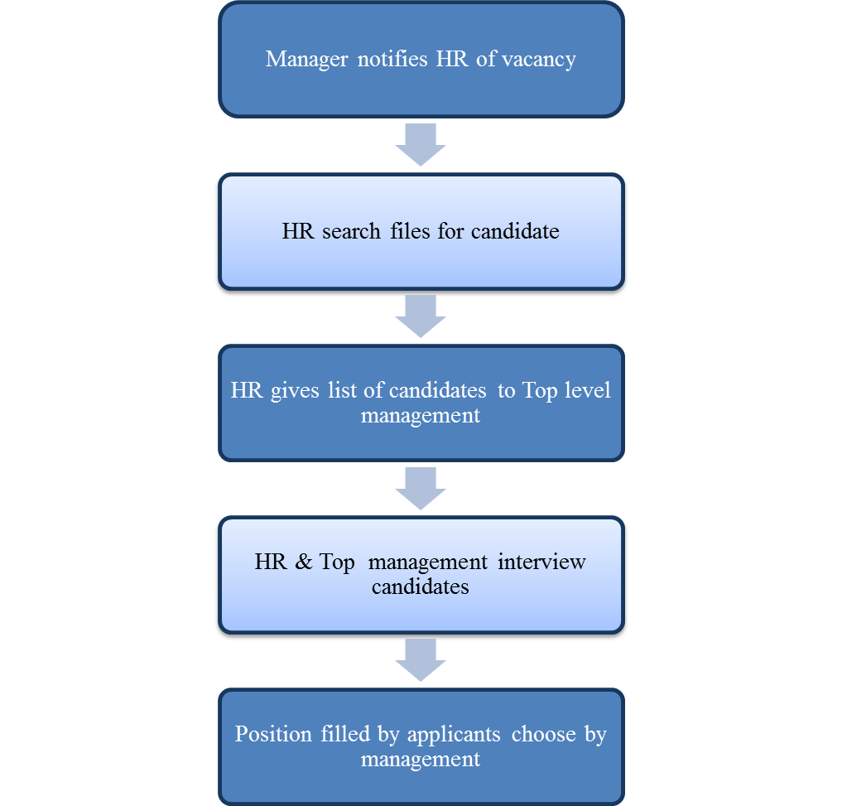
Figure 8.8: Internal Recruitment Process of Hotel Blue Bengal Berry

Flow Chart of External Recruitment Process in Hotel Bengal Blue Berry
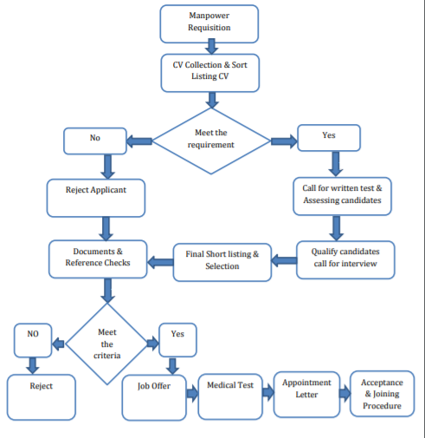
Figure 9.9: External Recruitment Process of Hotel Blue Bengal Berry

Recruitment and Selection Process Cycle of Hotel Bengal Blue Berry
In order to conduct a thorough recruiting process, the Human Resources Division will need at least 45 days. The following is a breakdown of the 45-day period:

Figure 10.10: Recruitment and Selection Process Cycle of Hotel Blue Bengal Berry

Impact of COVID 19 on Recruitment and Selection Process of Hotel Bengal Blue Berry
According to the statement of Head of HR & general manager of Hotel Bengal Blue Berry, during the COVID 19 pandemic and lockdown, their restaurants and hotel service business was impacted on the growth of sales and profits. And for it, the top management and HR department took decision to stop hiring new employee on the year of 2020 (shown in table 1.1 and figure 1.5). On this year, for reducing their expenditure, they have been followed employees layoffs strategy.

Findings
In the hospitality industry, recruiting is the process of identifying and hiring qualified employment applicants for establishments such as food and beverage services, hotels restaurants and others. A number of recent developments have had an impact on the recruiting of hospitality professionals. As a consequence, when it comes to hiring hospitality workers, human resource professionals and recruiters confront several difficulties.
According to the analysis and internship experience in HR department at Hotel Bengal Blue Berry, some of the findings are listed below which are based on their current recruitment and selection process of at Hotel Bengal Blue Berry:

Key Challenges in Hotel Bengal Blue Berry Recruitment
The following are the three most significant problems in the Hotel Bengal Blue Berry recruiting for functional and product departmentalization:

Finding Potential Candidates
The country of Bangladesh does not have an abundance of’ skilled' hospitality workers, but on the other hand, it does have an abundance of unskilled labor, all of whom are eagerly awaiting the opportunity to learn the necessary skills in order to begin earning a living in the country's expanding hospitality sector. Searching is not an issue in Bangladesh since the country has a large number of human resource professionals; nonetheless, finding and developing talent is a difficult task which are facing the HRD of Hotel Bengal Blue Berry on conducting recruitment and selection process.

Attracting Potential Candidates
Working in the hospitality business is frequently regarded as low-wage and entry-level, with limited possibility for development in one's professional career. Hospitality and restaurant work are sometimes seen as low-status, poorly compensated vocations that are connected with slavery in various cultures.

High Turnover Rate
According to the Head of HR in Hotel Bengal Blue Berry, the rate of turnover in the hospitality business is 2 to 3 times higher than the rate of turnover in all other industries combined. Employees in the hospitality industry quit their employers for a variety of reasons, the most common of which being the effectiveness of the selection process.

CHAPTER 05

INTERNSHIP EXPERIENCE

Internship Experience at Hotel Bengal Blue Berry
I have obtained the opportunity to work at Hotel Bengal Blue Berry as an intern for three (03) months from November, 2021 to January, 2022 to fulfill my full academic courses of Bachelors of Business Administration (BBA) degree.

Regular Activities

Involvement in Recruitment and Selection Related Tasks

Every day, I have the responsibility of compiling a list of interviews that will be used to select applicants for different roles within Hotel Bengal Blue Berry. Prepare two types of lists for this interview: a single list that includes the serial number, name of the candidate(s), Father's name, Home district and signature, and a detail list that includes the serial number, name of the candidate(s), fathers name, age, home district and information about the candidate's educational and work experience, as well as information about the candidate's viva status and any other remarks. For the purpose of the interview, I prepared a list of single and detailed questions.
- Communication with Clients and Candidates
Participating in phone conversations is another integral part of the everyday routine throughout the internship. Because of a meeting or their own busy schedules, many personnel in the human resources department are unable to answer phone calls when they are received. In such circumstance, I'm required to talk on the phone with a number of highly recognized individuals as well as report the information provided by him. In addition, I must contact people who have brought their difficulties or issues to the attention of the HR department and arrange for them to be discussed with a senior HR coordinator.
- Updating HR information in HR Software
The updating of information in the HRMS software about employees' leaving, the reason for their leaving, work shifting, and candidates' list is another integral daily routine. Additionally, collecting any appointment letters that are missing and handing the appointment letter over to the HR short list is another important daily routine.
- Preparing Data about Previous Candidates
Hotel Bengal Blue Berry’s HR department compiles the list of requirements and sections each year. An enormous number of people applied for the post after they circulated the job ad on numerous channels (websites, social media and LinkedIn etc). Only the selected candidates' CVs are recorded, not those of all applicants. As a result, it is impossible to estimate how many applicants apply and how many CVs they get. My job entails compiling all previous resumes in accordance with the categorization system in order to produce the records due to the estimating issue.
Beside of all above of the tasks, I was involved in assessing to HR Coordinator to Prepare HR Report.

Trainings and Career Development from Internship Period
- During my Internship, I gained a thorough understanding of the subject by seeing and participating in all aspects of human resources planning, scheduling, recruiting, and selection, as well as communication with and interaction with applicants.
- HR coordinator and top management were always there for me when I needed it most, and they walked me through my missteps carefully. He gave me some comments that helped me respond positively and learn how to manage these conditions, although I made errors again at that time.
- My office time was 8:30 am to 5:15 pm while I was at work every day. As a result of my experience at this Hotel Bengal Blue Berry’s, I learned how to effectively manage my time under pressure at work and consistently finish my assignments.

Critical Observation Founded during Internship Period at Hotel Bengal Blue Berry
Some observations that I made while doing my work duties at Hotel Bengal Blue Berry. The recruitment and selection process more time consuming and difficult. If the issues are to be remedied, this sector must be given the attention it deserves. The following are examples:
- Candidates who have been invited for interviews by phone have sometimes expressed reluctance to show up since they submitted their CVs months ago and have now received an offer to work for another organization.
Job career email boxes aren't being checked on a frequent basis and appropriately, resulting in this issue. In order to save time and find qualified applicants, Job career email boxes should be checked on a frequent basis.
- Some applicants were apprehensive about working in their selected night shift. At first, they are enthusiastic and willing to join any shift on the interview board, but when they report back to the supervisor or HR Coordinator of Hotel Bengal Blue Berry, they seem indifferent.
In the event that the authority hints at stricter restrictions in this plan, this type of situation will not happen again.
- My project took longer than it should have because of a time constraint in the manual HRM Software application. During the process of updating the data, certain commands were not taken correctly, and a few error codes showed, requiring me to enter all of the data from the beginning, which made my project take longer to complete.
In order to minimize this kind of delay in the enlisting process, appropriate actions should be made to construct more advanced HRIS software.

CHAPTER 06

RECOMMENDATIONS AND CONCLUSION

Recommendations
The following steps that can be help to HR coordinator of Hotel Bengal Blue Berry to overcome the challenges on recruitment and selection process:
- The process of attracting and retaining top talent to an organization is not easy and involves a great deal of patience and skill, which is the challenge. Many hotel owners are unwilling to spend money in order to achieve the KPIs of recruiting because they believe it to be a time-consuming and expensive investment. As hotels and restaurants are trying to grow their hospitality industry on international level so for it, they need to more skilled candidates therefore, Hotel Bengal Blue Berry must place more emphasis on Skill development on their manpower.
- In the case of attracting potential candidates and in order to become an employer of choice, you must first establish a strong Employer brand and then manage your reputation. Word of mouth is the most effective source of new employees, followed by print media, web sites, and job postings on the internet. Nonetheless, a business should attempt to engage in employer branding initiatives in order to generate widespread "Word of mouth" or "viral" publicity about itself. However, in Bangladesh, it is difficult to find employees with strong supervisory and management competencies. Employers should choose applicants based on their "experience and merit."
- In the case of reducing turnover rate, a hotel with a positive working atmosphere, in which employees are rewarded and shown great respect for their abilities, as well as given recognition and advancement based on merit, and which provides a competitive remuneration package can readily attract the attention of qualified individuals. While international hotel companies are known for having excellent Human Resource Departments that strive for a positive workplace culture, workers in the hospitality industry tend to favor 'brands' over other options. However, there are one or two local brands that are just as excellent as the national names.

Conclusion
It is the mission of Human Resource Management (HRM) to ensure that all of the demands of the workforce are met, both in terms of their potential and their quality. Recruitment and selection, a foundational element of HR management, thereby meets the requirements of both the company and its workers.
Employees are the most important resources for the growth of the organization, according to the conclusions of the study "Recruitment and Selection Procedure of Hotel Bengal Blue Berry done under the Human Resources department. There are various aspects that must be addressed in the construction of these vital materials. Consideration should be given to the "Recruitment and Selection Procedure" in this regard. An effective and dynamic approach of hiring and selecting is critical to increasing the productivity of a company. When it comes to hiring and selection, Hotel Bengal Blue Berry adopts a progressive technique. Hotel Bengal Blue Berry’s human resources personnel are now expected to go beyond the bounds of their contracts and policies in order to directly contribute to the company's operations and success.
It is a fundamental Human Resource function that is responsible for recruiting, getting, and keeping competent individuals to meet the organization's future workforce needs. In order to effectively manage employees in the workplace, the report's analysis uncovers both positive and negative procedures that could be changed. Hotel Bengal Blue Berry’s threats can more easily be turned into assets if the hotel considers this study.

References

Ahmad, H. a. (2012). Mostly discussed research areas in human resource management (HRM) – a literature review. International Journal of Economics and Management Sciences , 2(3), 10-17.
Burma, Z. (2014). Human resource management and its importance for today’s organizations. International Journal of Education and Social Science, 1(2), 85-92.
Daud, N. (2006). Human resource management practices and firm performance. The Moderating Roles of Strategies and Environmental Uncertainties.
De Cieri, H. K. (2008). Human Resource Management in Australia: Strategy, People, Performance.
Juyal, S. &. (2006). Human resource management practices and organizational commitment in different organizations. Journal of the Indian Academy of Applied Psychology, 32(2), 171-178 .
Mondal, D. (2021, November 23). What is Human Resource Management in Hospitality Industry. Retrieved from Hotel Management Tips: https://www.hotelmanagementtips.com/human-resource-management-in-hotel/
Organization Profile. (n.d.). Retrieved from Hotel Bengal Blue Berry: https://www.bengalblueberry.com/
Reddy, P. B. (2011). HRM Practices and Its impact on Performance- Exploratory Literature Review in the Context of Indian SMEs. NJRIM, 1(2), 73-87.

Appendix

Exhibit A: Interview Questionnaire
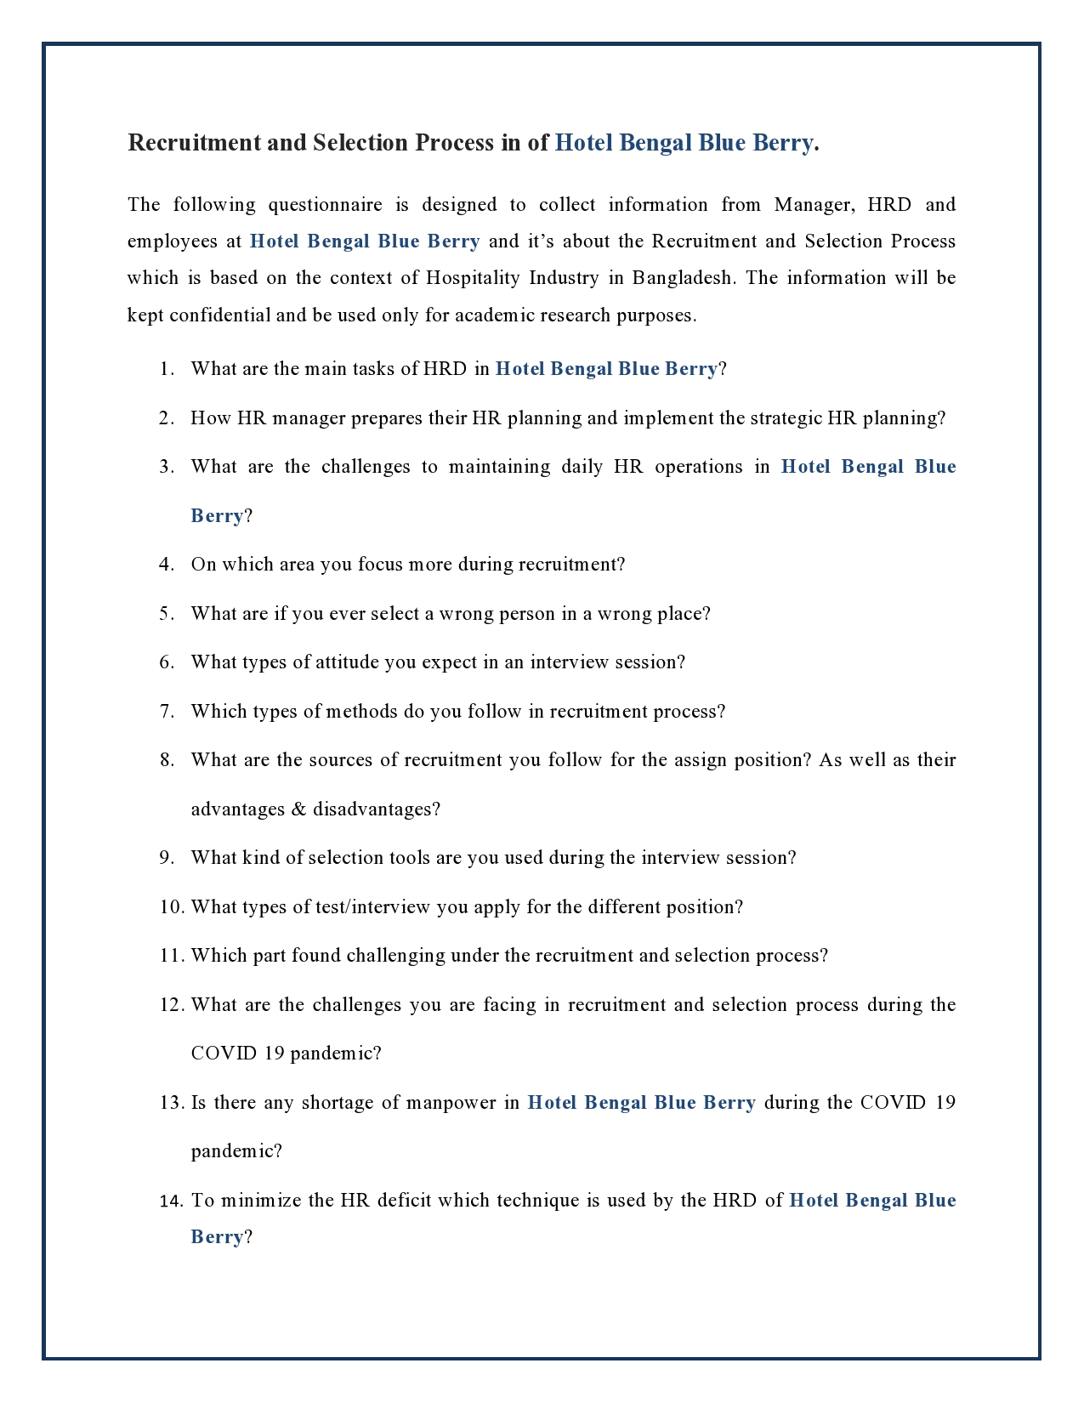

Exhibit B: Employee Requisition Form of Hotel Bengal Blue Berry
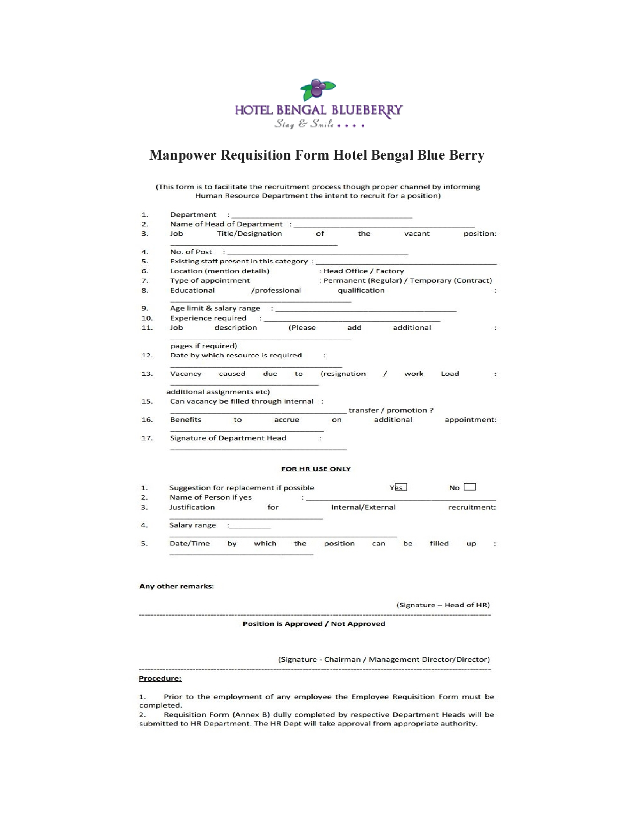

Exhibit C: Advertisement Job Openings for Product Departmentalization
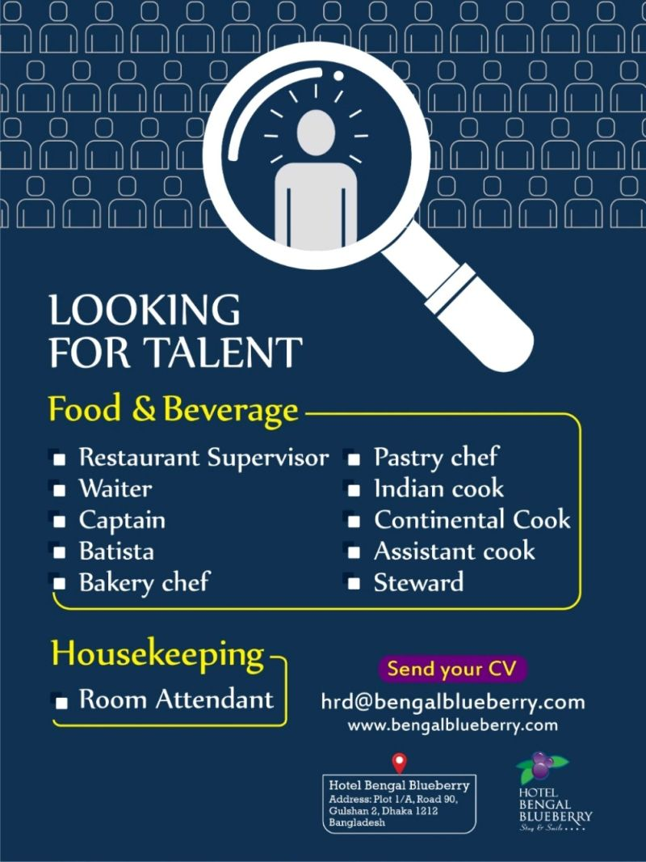

Exhibit D: Advertisement Job Openings for All Departmentalization
