



Sales Administration & Customer Loyalty Activities of Hemas Consumer Brand (Pvt) Ltd-Bangladesh

S M Maria Chowdhury

The Report is submitted to the School of Business and Economics, United International University as a partial requirement for the degree fulfillment of Bachelor of Business Administration
Sales administration & Customer Loyalty Activities of Hemas Consumer Brand (Pvt) Ltd-Bangladesh

Submitted By
S M Maria Chowdhury
ID: 111201257
Course Code: INT 4399
Major: Marketing
School of Business and Administration
United International University

Supervised by
Dr. Kawsar Ahmmed
Professor
School of Business and Administration
United International University

Date of Submission: October 7, 2024

Letter of Transmittal

October 7, 2024
Dr. Kawsar Ahmmed
School of Business and Administration
United International University

Respected Sir,
I am happy to be submitting my internship report titled “Sales Administration & Customer Loyalty Activities of Hemas Consumer Brand (Pvt) Ltd-Bangladesh" since it is a requirement for the completion of BBA program.
I had the chance of working as an intern at Hemas Consumer Brands for four months where I learnt a lot about challenges in sales administration and trade marketing within a multinational business organization. In this opportunity, I was able to refine my skills and identify areas that needed development, thus promoting me career wise.
The report presents a summary of what I experienced, observed and learned during the entire period of my attachment. When writing this report, I followed the directions you issued strictly. The insights offered in this report will not only meet academic standards but will also serve as an invaluable resource for my future practical activities.
Your guidance and support throughout are deeply appreciated, and trust me, I want the best grades from you. Please give your comments or feedbacks on where improvements need to be done.
Thank you in advance for considering this submission.

Yours sincerely,
S M Maria Chowdhury
ID: 111201257
Major: Marketing
School of Business and Administration
United International University

Declaration

I, S M Maria Chowdhury, swear that the attached internship report entitled Sales Administration & Customer Loyalty Activities of Hemas Consumer Brand (Pvt) Ltd-Bangladesh is an original document by me and it took me a lot of time to write it every day for four months when I was in employment at Hemas Consumer Brands (Pvt.) Ltd-Bangladesh. It includes all necessary details required and my own knowledge gained during the internship program.
Furthermore, I assert that this research work was conducted adhering to the set of ethical rules governing academic research, including non-disclosure of sensitive information about Hemas Consumer Brands (Pvt.) Ltd. I will be held accountable if any legal or ethical requirements are not observed in this particular document as there is no plagiarism nor academic dishonesty.

S M Maria Chowdhury
ID: 111201257
Major: Marketing
School of Business and Administration
United International University

Acknowledgement

First of all, I would like to express my deep gratitude to the most compassionate almighty Allah for giving me the strength and perseverance that helped me complete this degree successfully.
I am thankful to Dr. Kawsar Ahmmed, my supervisor, for his continuous guidance, valuable suggestions and constructive criticism during the writing of this research work. His unwavering support and motivation were instrumental in the completion of my report; hence I am highly indebted to him.
There are a number of people I would like to thank for helping me put together this internship report. My sincere thanks go to my parents for their unflinching support, unwavering direction, and tender care throughout my academic life.
Their instruction was invaluable in navigating the intricacies involved in assembling this report so that I sincerely thank them again for mentoring me through difficult issues related to key subject areas.
I would like to sincerely thank all the senior management of Hemas Consumer Brands for allowing me to serve as an intern in their renowned multinational corporation. The collaboration, guidance and encouragement from them were indispensable to my learning process and I really appreciate the incredibly useful ideas that I gained during my stay at the company.

Finally, I want express my feeling of deep gratitude to everyone that has helped in making this report a reality. Their counsel, backing and inspiration have been very useful beyond expression; thus, for assisting me in coming up with this enterprise.

Executive Summary

The Fast-Moving Consumer Goods (FMCG) sector is one of the largest sectors in the economy of Bangladesh with well established distribution channels, cutthroat competition among the organized and unorganized portions, and cheap operating costs. FMCG is gradually becoming a large market with developing economies like Bangladesh. While buying fast-moving consumer goods, the household buying decisions, which are called in-home decisions, before a purchase is made are mostly not changed at the point of purchase. However, when buying convenience and low involvement products, persons are likely to make more changes from what they had intended to purchase in terms of brand at the point of purchase.
In this regard, several variables impact the creation of consumer brand loyalty. The purpose of this report is to show the impact of price consciousness, brand functional benefits, brand trust, and brand symbolism on consumer brand loyalty in the case of Hemas Consumer Brands in Bangladesh.

Hemas Consumer Brands is one of the developing contenders in this sector who started operations in Bangladesh in 2010 and is still performing quite well in the market. In this report, it will be explained how the Hemas sale administrators perform their activities and what methods they apply to preserve sales reports in the central office of Hemas. Furthermore, this report will also focus on several trade marketing activities that aim at achieving particular and significant influence on sales.

There are four parts in the report. In the first section, the report is introduced by stating its objectives, scope, and limitations, which prepares the way for the whole analytical work.
For example, the second section emphasizes the country’s industry analysis in Bangladesh, which includes aspects like industry specifications and size, industry trends, technology, regulation, and competition. It ends with an explanation of the opportunities and threats in the industry.

The subject of discussion in the third section is, in a broad aspect, a well-informed “an analysis of the organization inside,” normally referred to as its customer mix, history, products/services to customers, hypotheses, and service quality of the institution in general. At the end of the SWOT analysis, strategic actions are proposed based on existing problems and existing chances from the market to make the firm more prosperous.

The final section is similar in most respects in that it also deals with brand loyalty of customers as well as methodology of the research, analysis of the results, and recommendations for enhancing loyalty among the researched customers. It ends with very short and salient explanations along with some references for supporting the finding.

Keywords: price consciousness, brand functional benefits, brand trust, brand loyalty, Hemas Bangladesh

Table of Contents
Letter of Transmittal 3
Declaration 4
Acknowledgement 5
Executive Summary 6
Chapter 01 9
Introduction 9
1.1 Primer 10
1.2 Objective of the Report: 10
1.3 Limitation of the Report: 11
1.4 Industry Specification 11
1.5.Size, trend and Maturity of the Company: 12
1.7 .Political, Legal, and Regulatory Factors 14
1.8 .Industry Rivalry 14
1.9. Challenge Summary and Opportunities 16
Chapter 02 19
Company Overview and SWOT Analysis 19
2.1. Overview and history 20
2.2 Product of Hemas 22
2.3 The Customer Mix 23
2.4 Product mix/Service mix: 24
2.5 SWOT Analysis 28
2.6 Strategies to Meet Challenges and Opportunities by Hemas 29
Chapter 03 31
Analysis of Consumer Brand Loyalty 31
3.1 Introduction 32
3.2 How Consumer Brand Loyalty Works for Companies 32
3.3 Factors Impacting Consumer Brand Loyalty: 32
3.4. Study Model: 34
3.5 Methodology 36
3.6 Evaluation of Consumer Brand Loyalty at Hemas Consumer Brands 37
3.7 Discussion 39
3.8 Recommendations 48
Chapter 04 49
Internship Experience and Conclusion 49
4.1 Internship Experience 50
Nature of Position of Intern and Responsibilities 50
Responsibilities as Sales Administration Intern 50
Responsibilities as Trade Marketing Intern 51
4.2 Conclusion 51
References: 52

Chapter 01

Introduction

1.1 Primer
During four months I spent with Hemas Consumer Brands, it was an eye opener to me on how business works in an ever-changing world and this has change my perspective as a student. This journey exposed me to various understanding, skill and experience that are bound to be part of my career development.
In this report I present a complete overview of my internship experience, highlighting important achievements, challenges faced and lessons learnt at Hemas Consumer Brands. Guided by Dr. Kawsar Ahmmed who is a reputable Professor at UIU, I diligently adhered to the tasks and topics assigned to me in order to ensure that both academic rigor and professional growth could be pursued.

I have written this report so as not only meet requirements of the curriculum but also get involved in finding out Hemas Customer Brand’s activities. This report signifies my earnest desire for learning more & making improvements; showing gratitude for the invaluable support Dr. Kawsar Ahmmed and the whole of UIU faculty extended towards me.
When I look at the details of this study, it reminds me of how experiential learning has the power to transform and provide infinite possibilities for personal and professional development. It is my hope that this report will motivate others engaged in their own inquiries and discoveries about business.

1.2 Objective of the Report:
The goals planned within this study are these;
• To know how sales administration collects field information for decision making purposes
• Understand Hemas Consumer Brands Pvt. Ltd’s trade marketing strategy and procedures
• Examine sales administration & trade marketing activities
• Know the countrywide sales force operations
• Investigate into selling distribution process
• Appreciate departments and structure of the company
• Learn from practical jobs at Hemas Consumer Brands Pvt. Ltd.
• Identify both strengths and weaknesses of a company
• Benefit from experienced people
• Describe Hemas’ product offers as well as their consumer base

1.3 Limitation of the Report:
There were severals things that were bad about the internship. This is because of short time. Four months is not enough to understand the whole structure of the organization, but my supervisor has taught me much about how work process in a company like this is done.
Hemas Consumer Brands’ website and software should be bettered for more use and effectiveness.

1.4 Industry Specification
To begin with, I will pen down an Industry Specification for Hemas Consumer Brands in Bangladesh’s Cosmetics Sector:
Hemas Consumer Brands’ Company Background in Bangladesh is as follows:
The establishment of this company was done on 10th December, 1948 and the Founders are Sheikh Hassanally Esufally. In Colombo, Sri Lanka, there is the Headquarters of Hemas Consumer Brands but in Dhaka, Bangladesh it is located at 56/A,Level-4,Road No:132,Gulshan-1,Dhaka., Bangladesh, 1212 BD. In total Hemas Consumer Brands has More than Four thousand five hundred workers.
Consumer (Cosmetics), Healthcare and Mobility are essentially sectors of the Hemas Consumer Brands Industry.

The industry of Hemas Consumer Brands which is a well-established Sri Lankan company has achieved significant presence in Bangladesh riding on the back of its knowledge of Sri Lankan market. Focused on empowering families for a better future; Hemas is prioritizing a skilled workforce, strong partnerships and impactful products for all stakeholders.
Hemas Consumer Brands Market Entry and Products

To dominate the Bangladesh cosmetics market, Hemas made a strategic entry into it. They have an extensive product range that includes mostly skincare such as moisturisers, cleansers, lotions and sunscreens; haircare like shampoos, conditioners, hair oils and styling products; personal grooming including soaps, body washes, deodorants and grooming kits and beauty which include makeup, facial care items and beauty accessories.

Then Core Focus and Competition Hemas Consumer Brands
Actually when it comes to skincare and haircare products for the quality brand name Hemas they make a point of producing natural stuff for Bangladeshi people’s needs: nevertheless some of their main rivals are not only local but also worldwide brands i.e. known all over the world. Such major competitors as Unilever (Dove, Fair & Lovely), Marico (Parachute hair oil) or Keya Cosmetics are well-known companies in this field.
Purpose of Hemas: Make Healthful Living Happen
Vision: To be the best at Enriching Lives

1.5.Size, trend and Maturity of the Company:
The presence of Hemas Consumer Brands in Bangladesh’s cosmetics industry means it plays a crucial role in the market, although it faces intense rivalry from both local and international players. Here is an assessment on the size, trend and maturity of Hemas consumer brands industry within Bangladeshi context.

Size: Hemas Consumer Brands may not have the biggest share in this country when it comes to its cosmetics sector but it has a significant presence especially in areas where it excels. Range of skincare products, hair care products as well as color cosmetic products offered by the company are targeted towards different consumers hence contributes to the overall size of Bangladesh’s cosmetic market. The size of Hemas Consumer Brands’ market is influenced by factors such as brand recognition, product availability and customers’ preferences.

Trend: In other words; Hemas Consumer Brand works within specific trends that are prevalent in this sector for instance; increasing appetite for organic and natural goods also emergence of premium and luxury cosmetics among some segments if buyers. Moreover, there are possible ways where our brand could fit into local beauty trends and desires like traditional skin care practices or general interest on one product line e.g hair care specific to Bangladesh. Keeping up with shifting customer tastes.

Maturity: Hemas Holdings, a historic Sri Lankan conglomerate with over 70 years of experience, brings a certain level of maturity and knowledge to the cosmetics industry in Bangladesh. However, within the Bangladeshi market especially, the maturity of Hemas Consumer Brands may be deemed moderate although there is room for further expansion and market penetration. The firm’s ability to maneuver regulatory barriers, develop distribution networks and adapt product offerings based on local preferences will make it matured and profitable in Bangladesh in the long run.

1.6 Technological factor:
In Bangladesh, there is an ever evolving corporate environment influenced by different technological factors which shape business operations. Below are some technological considerations that are relevant to Hemas Consumer Brands within the context of Bangladesh:
Production Technology: For high-quality cosmetics production at higher efficiency levels, Hemas Consumer Brands uses innovative production technologies. This encompasses automated manufacturing lines, precision machines as well as top end devices that help maintain uniformity, dependability and scalability in industrial processes. By adopting modern manufacturing methods, this company manages to reduce its production time thereby reducing wastages while increasing quality of products.

R&D: Hemas Consumer Brands’ research and development projects are heavily dependent on technology. The firm invests in state-of-the-art technology for R&D, like laboratory instruments that can be used to test formulation, ingredients and products. Advanced research tools and software ensure that the company remains competitive by creating new product formulas, enhancing existing products as well as keeping ahead of market trends.

Digital Marketing and E-commerce: Technology has changed how consumer brands market their products and distribute them to consumers in the digital era. To communicate with people from Bangladesh, Hemas Consumer Brands uses digital marketing tools such as social media platforms, search engines, and online advertising. Besides, they make use of e-commerce whereby they sell their goods directly to buyers through online platforms thus making it more convenient in an era characterized by improved connectivity.

consumer Relationship Management (CRM): Hemas Consumer Brands employs technology to improve customer interaction and loyalty. The company has CRM systems that track client contacts, handle inquiries, conduct analysis of consumer behavior or preferences. Through combining data analytics with customer insights, Hemas Consumer Brands can better personalize their marketing campaigns, enhance product offerings as well as deliver amazing experiences to customers.

1.7 .Political, Legal, and Regulatory Factors
For Hemas Consumer Brands to do well in Bangladesh's business environment, there are political, legal and regulatory factors that they have to navigate. The following is an overview of how these things affect the company:
It is within a political setting that Hemas Consumer Brands operates in Bangladesh. Business continuity and confidence among investors depend on political stability. Changes in governmental policies, political instabilities, or turbulence can disrupt business operations, supply chains, and market dynamics. Hence, Hemas should be vigilant about this issue by keeping its ears on the ground with regard to politics and accordingly revising its strategy so as to mitigate risks while exploiting opportunities.
To ensure compliance of Hema’s operations in Bangladesh with local rules and regulations requires adherence. This includes maintaining corporate policies; complying with tax legislation; observing labor laws; maintaining the intellectual property rights (IPR). Hemas must make sure that their business processes, product labeling , marketing campaigns and employee recruitment practices are all done in accordance to the required legislations of Bangladesh so as not to face legal actions and also protect its name from being damaged.
Government authorities like DGDA and BSTI regulate the beauty industry in Bangladesh. The Hemas Consumer Brands Company must abide by regulations regarding safety standards, labeling requirements, product testing, and product registration. Changes of regulatory requirements or enforcement actions may affect the availability of products, their pricing or their access to the market for Hemas.

1.8 .Industry Rivalry
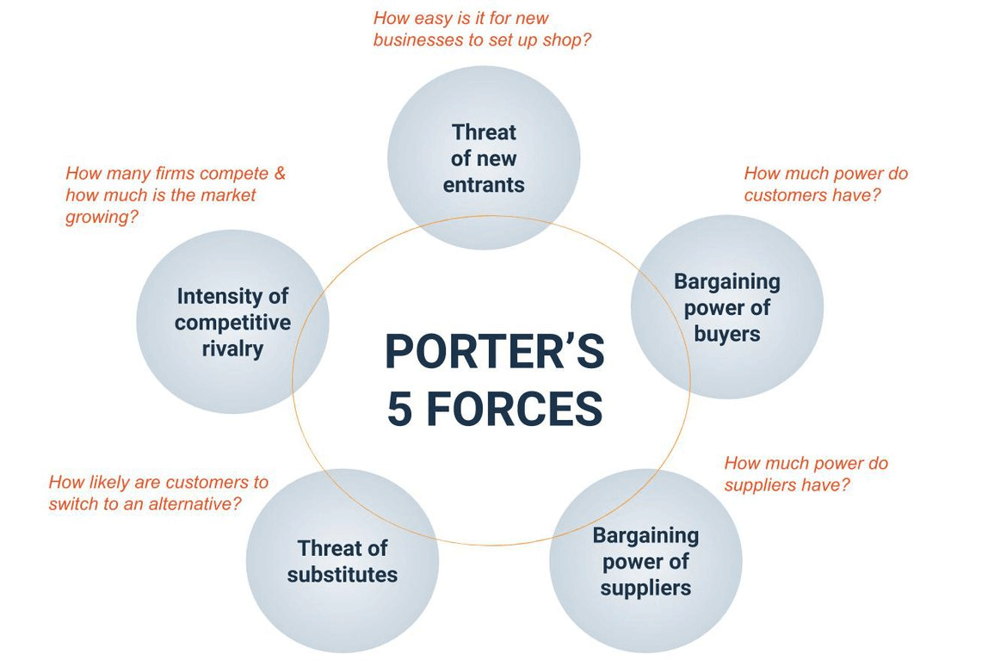
Hemas Consumer Brands’ rivalry in Bangladesh as per the Porter’s Five Forces model:

Threat of New Entrants:
- Low to Moderate: Although, due to the growing population and increasing demand for personal care products, it may appear that the cosmetic business is attractive in Bangladesh, yet there are very high barriers to entry. Hemas Consumer Brands as well as other incumbent companies have economies of scale, brand awareness and distribution channels that make it difficult for new entrants to compete effectively. In addition, stringent regulatory requirements, research and development (R&D) investments and a need for massive marketing/distribution channels discourage potential entrants into this market.

Bargaining Power of Suppliers:
Moderate: There is a moderate level of bargaining power from suppliers of raw materials, packaging materials and ingredients related to cosmetics products. However there few places where some ingredients or components are bought by Hemas Consumer Brands which means few vendors can influence them. Nonetheless, Hemas Consumer Brands can counter this through maintaining strategic supplier relationshios, diversifying its supplier base, and negotiating favorable terms so as to minimize the effect of supplier bargaining power.

Bargaining Power of Buyers:
High: In the Bangladeshi cosmetics business, buyers such as retailers and consumers have a lot of bargaining power. Given that in this market there is a broad range of choice from both local and global labels, customers can easily move between brands based on factors like prices, quality and brand reputation. Hence, Hemas Consumer Brands must always be mindful of customer preferences, offer competitive prices and differentiate its products to retain their loyalty while reducing the possibility of patrons shifting to competitors.

Threat of Substitute Products:
Moderate: The threat of substitute goods in Bangladesh’s cosmetics industry is moderate. However, although there might not be any direct substitutes for cosmetic products, customers may still use do-it-yourself remedies or natural ingredients or go back to traditional methods regarding beauty treatments. In addition, purchasers might prefer generics or non-brands instead premium or luxury lines of cosmetics. To counterbalance this dangerous situation , Hemas Consumer Brands should highlight unique advantages and value proposition over other alternatives so as to convince them that these are better options than the rest.
How High is the Intensity of Competitive Competition?: - High: In Bangladesh, competition among cosmetics business entities is very high because there are many competing local and international brands. The competitors in the market include Hemas Consumer Brands that have to be innovative all along, make their products distinguished and increase their market share in order to survive within a highly competitive environment characterized with both domestic challengers as well as global titans.

1.9. Challenge Summary and Opportunities
Challenges and Opportunities faced by Hemas Consumer Brands In Bangladesh Cosmetics Industry:

Challenges:
What makes for an intense competitive rivalry? Hemas Consumer Brands has stiff rivalry from domestic as well as foreign firms that are functioning in the same industry of cosmetics. These rivals use aggressive promotional techniques, price wars and continuous introduction of new products which make it tough for Hemas to maintain its position in the market or ensure profitability.

Price sensitivity: Most buyers in Bangladesh look for low priced alternatives thus they prefer lower priced options most of the times which creates problems for Hemas on how to price its goods competitively while still making profits.
Compliance with Regulations: Besides, strict compliance to local regulations regarding product registration, labeling and safety standards complicates HEMA’s operations in Bangladesh. This organization keeps facing evolving compliance rules.

Managing Supply Chain: Hemas should ensure efficient supply chain processes; raw material sourcing, inventory control and distribution are among the most important ones for efficient operations of the company. Prolonged shipping times due to logistics restraints, supply chain disruptions such as strikes leading to factory shutdowns and managing stock levels can all impact on an organizations ability to satisfy customer demand.

Altering Consumer Preferences: Changing consumer tastes in fashion trends is a huge challenge for Hemas that needs to be considered. To anticipate and meet changes in consumer behavior requires continuous market research, new products development through innovation and effective marketing approaches.

Opportunities:
A Growing Market: Increasing disposable incomes, urbanization process as well as rise in personal grooming awareness result into a fast growing cosmetics market in Bangladesh which creates enormous opportunities for Hemas expanding its marketplace and capturing larger proportion of the increasing customer base.
Product Innovation and Differentiation: Hemas can create differentiation from others by introducing new products, using creative product packaging techniques and employing different marketing strategies. The more technology and brands that Hemas acquires the more it will remain competitive and be responsive to consumer changes in tastes.
Digitalization and E-commerce: Due to the growth of digital channels as well as e-commerce platforms, Hemas stands a chance to serve a larger market. If Hemas uses digital marketing means as well as collaborates with various e –commerce platforms, it could reach more people hence increase online sales.

Brand Building and Customer Engagement: Bangladesh is a highly competitive market where strong brand equity creation along with customer loyalty are paramount for success. In order to improve its brand image and maintain customer loyalty, Hemas must invest in social media interactions with customers; use influencer marketers who have large followings on social platforms among others; improve customer experience at every touch point etc.

Niche Categories Expansion: To broaden its product portfolio and meet the tastes of individual consumers, Hemas targets niche categories in the cosmetics market such as natural or organic products, premium cosmetics and men's grooming products. To seize new market opportunities and stimulate growth, Hemas can identify underdeveloped market niches and create special offers.

Chapter 02

Company Overview and SWOT Analysis

2.1. Overview and history
Hemas Holdings PLC was established in 1948 as a public limited company. It has become one of Sri Lanka’s most important listed businesses with a mission to make families healthier. Hemas has grown to more than 6,000 people employed by it offering world-class consumer goods across health care delivery system, consumer goods or mobility spaces in general. The firm has a strong presence in Bangladesh, West Bengal and Myanmar apart from Sri Lanka.
Bangladesh was entered into by Hemas as part of their plan to extend healthy living further ahead. Hemas Consumer Brands is already recognized as a major player in the Bangladeshi market because of the company’s emphasis on premium quality consumer products taking into account Bangladesh’s developing economy coupled with increasing demand for high-end consumer items.

History & Development in Bangladesh
An entrance into Bangladesh was made by Hemas Consumer Brands, with the objective of emulating its success in Sri Lanka through quality differentiation and myriad offerings. Hemas has concentrated on understanding the local market dynamics and consumer needs and designing products and services accordingly since it embarked upon operations in Bangladesh.
Hemas began its operation in Bangladesh with a collection of personal care and household items, using the strength of its brand name as well as quality standards that had been set in Sri Lanka. Since then, the company has broadened its product line to cover various kinds of consumer goods such as personal care, health and wellness products among others thus giving it an opportunity to address large number of consumers in Bangladesh.

In a bid to make its products available in many places, Hemas has engaged in strategic partnerships with local distributors and retailers. These deals have been instrumental in enhancing market reach as well as brand recognition. For instance, Hemas maintains high quality control for all its products ensuring that they meet strict quality standards. This relentless pursuit of quality has helped instill trust and loyalty among consumers within the Bangladeshi market.

Hemas has carried out various corporate social responsibility (CSR) projects in Bangladesh, which is consistent with its fundamental belief of making lives better. The organization’s efforts are geared towards health, education and community development, thus re-affirming its commitment to the welfare of those who benefit from its services.

Vision and Future Plans
Continuing on this path of enriching lives in Bangladesh is what Hemas Consumer Brands pledges. With the mission: To be the best at Enriching Lives,’ Hemas aims at investing into different kinds of energetic teams; creating meaningful offerings; developing reliable partnerships; supporting an inclusive world. Through this it is believed that Hemas can bring about a positive change for all stakeholders in Bangladesh.

History of Hemas:
A short history of Hemas is given below in terms of the key milestones:

Year | Description
1948 | Started its journey as Hemas (Drugs) Ltd
1962 | Started manufacturing toiletries in the collaboration with French Multinational
1967 | Diversified its journey in travel and tourism
1978 | Started exporting business
1990 | Lunched Clogard Toothpaste
1992 | Re-entry into apparel manufacture and freight and logistics
1993 | Hemas Drugs renamed as Hemas Holdings (Pvt) Ltd
1994 | Started Airlines Business
1998 | Acquisition of Goya perfume Brands
2003 | Hemas Holdings listed in Colombo Stock Exchange
2003 | Established Power Plant
2003 | Entry into Food Sectors
2008 | Established Hemas Hospital
2010 | Started business In Bangladesh as “Hemas Consumer Brands Pvt Ltd.

Diversified Sectors of Hemas:
Hemas, at present, is successful in different areas in Sri Lanka and other places it trades. It is also expanding its market globally.
FMCG
HEALTHCARE, HOSPITALS
TRANSPORTATION
LEISURE
FOOD
POWER PLANT

2.2 Product of Hemas
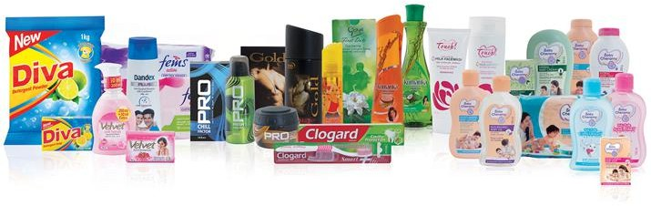

International Market of Hemas Group:
As of today the group sells its FMCG products to 12 countries worldwide. See below for a list of those countries:
International Marketplace of Hemas Group
Bangladesh | Labanon
Maldives | Australia
New Zealand | Zambia
Pakistan | Malaysia
Belize | Middle esat

2.3 The Customer Mix
Hemas Consumer Brands’ cosmetics business in Bangladesh: A study of the customer mix

(a) Demographics: - Hemas consumers are diverse as they cater for all age brackets and gender groups through their varied products.
They have a lot of options for customers with different incomes, although they do not target specific income brackets but their pricing policies make it reachable to many.

(b) Geographic Location: - Hemas Consumer Brands operates in both urban as well as rural markets within Bangladesh.
Wherever one goes in search of these products, he/she can expect to find them anywhere. This is because they are available virtually everywhere from small local kiosks to large supermarkets.

(c) Lifestyle and Psychographics:
For instance, the company conducts extensive researches on consumer interests, values, lifestyle among others so that it can tailor its products accordingly.
The company’s products are developed with cultural nuances and health issues in mind to suit their target customers’ interests and needs.

(d) Behavioral Factors: - In this regard, Hemas undertakes research on consumer purchasing behavior to determine the factors that influence purchase decisions, frequency of purchases, brand loyalty and switching among others.
Thus, they seek to understand why they prefer Hemas’ products at the expense of competitors hence allowing them to change marketing strategies therefore make it better for its customers.

(e) Market Needs: - These targeted product offerings solve specific market needs recognized by Hemas. This entails emphasizing health benefits, unique formulas as well as flavors that distinguish Hemas from other companies in the same line making it compatible with certain consumer habits.

(f) Competition: - To compete effectively in the cosmetics industry, Hemas monitors competitors closely and evaluates their target customer segments.
It makes provisions for aligning their USPs (Unique Selling Propositions) and marketing strategies so as to differentiate itself within the market amidst competition.

2.4 Product mix/Service mix:
My main point is the product mix. A company’s product mix is the quantity of product lines it maintains. Hemas Consumer Brand, on the information i have found out, has now 11productlines in the cosmetics business.

There are many brands that Hemas has in Sri Lanka and they are popular here too.
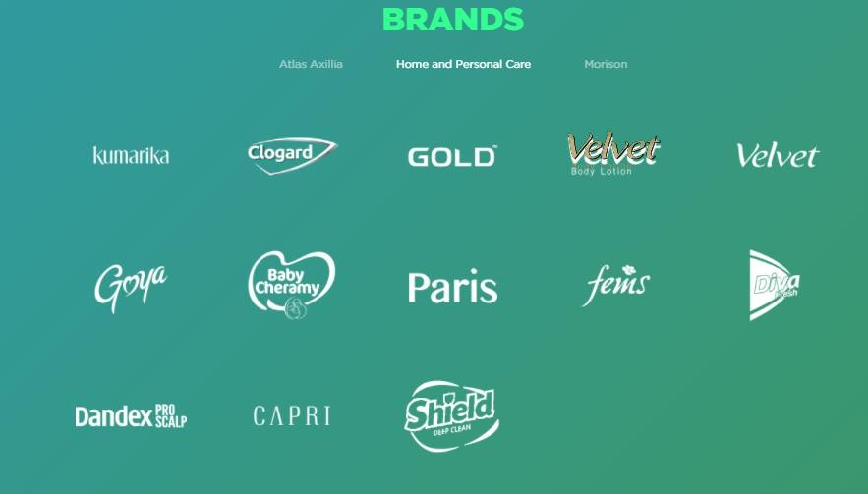
However, no other brand is present in Bangladesh. Hemas manufactures and markets three different brands in this country. These are:
• Karamika
• Actisef Soap
• Bic (Bangladesh) Ltd.
• Iva Hair Oil
• Colombo Hair Oil
Kumarika
Kumarika is the most popular Hemas’ brand which is well known in Bangladesh. However, it took a relatively short time for the brand to stir some market participants in Bangladesh.
Some of the item categories of Kumarika include:
1.Kumarika Hair oil
2.Kumarika Face Wash
3.Kumarika soap
4.Kumarika Shampoo

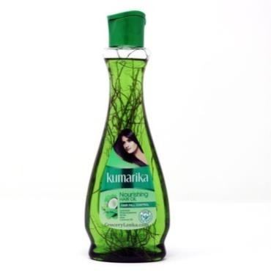
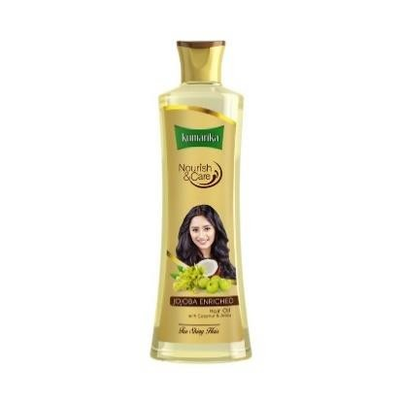
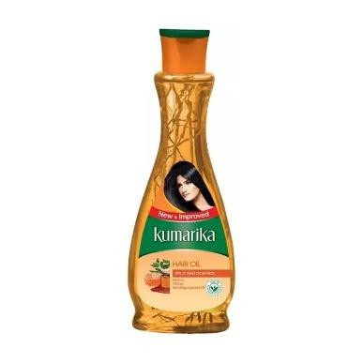
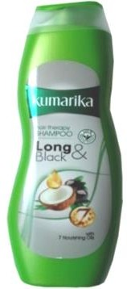
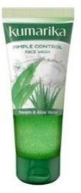
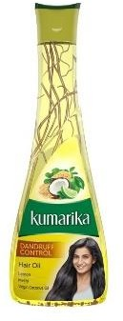
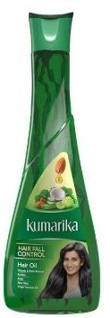
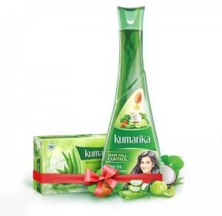

Below are the detailed explanations of each Kumarkia product usefulness:

Kumarika Hair Oil: • Weight: Comes in 100ml, 200 ml and 300 ml bottles. • Price: BDT 90 to 250. • Scent: Herbal, thin, and comforting. • Usefulness: This hair oil is mixed with amla, aloe vera and coconut oil. It reduces hair fall, strengthens root, nourishes scalp and promotes the growth of healthy hairs. Its everyday use is very good for maintaining fuller as well as stronger hairs.

Kumarika Shampoo • Weight: Comes in bottles of 100ml or 200ml • Price: Ranges from BDT 75-150 • Scent: An invigorating herbal fragrance. • Usefulness: Variations like anti-dandruff variant, moisture restore variant and damage repair shampoo are available in addition to ones that supplement the hair oil. It cleanses the scalp while keeping moisturized hair leaving it soft and manageable. It can be frequently used.

Kumarika Soap: • Weight: Available in bars weighing either 75g or 100g. • Price: Ranges between BDT30-45 • Scent: Soft with an herbal touch which refreshes your spirit. Usefulness: Made out of natural ingredients this soap is mild on the skin giving it proper balance between cleaning it up completely without drying it off at all which makes it suitable for daily usage leaving your skin soft , refreshed minus feeling dry.
Kumarika Facial Cleanser: Weight: 50ml,100ml Price: 75-120 BDT Smell: Soft herbal fragrance Usefulness: With natural extracts such as aloe vera, neem and turmeric the face wash ensures deep cleansing. For sensitive skin it takes away dirt and impurities without being harsh. When it comes to maintaining facial moisture levels and preventing pimples, it is ideal for oily skins.

Acisef Soap:

Actisef Soap is designed to offer a gentle cleansing experience with a subtle, mild fragrance and effective antibacterial protection. The soap comes in 75g bars and 100g bars with prices ranging from BDT 30-45. The formulation is meant to keep the skin hygienic while being harmless enough for everyday use. It is great for households as this enables families to enjoy both germ killing properties and skincare features that make it ideal for all types of skins.

Bic (Bangladesh) Ltd.:

It manufactures affordable, long-lasting stationery goods such as pens, shavers and lighters under Hemas in Bangladesh. The brand has become synonymous with quality and affordability which attracts wide range of customers throughout the country.

Iva Hair Oil:

Iva Hair Oil contains natural extracts that strengthen hair and promote healthy growth through nourishing formulae. It’s available in 100mls and 200mls bottles within BDT range of 80-150; it has light texture which gives non-greasy feeling on your head with slight smell of nature; preventing hair loss.

Colombo Hair Oil:

The target for Colombo Hair Oil is deep nourishing and revitalizing of hair, specifically those with dry or damaged hair. It comes in 100ml or 200ml bottles and prices range from BDT 85-160. Its fragrance is rich and natural with its reputation for smoothing frizz while at the same time softening hairs that may reduce split ends. This oil will be best suitable to keep your tresses strong and healthy.

2.5 SWOT Analysis

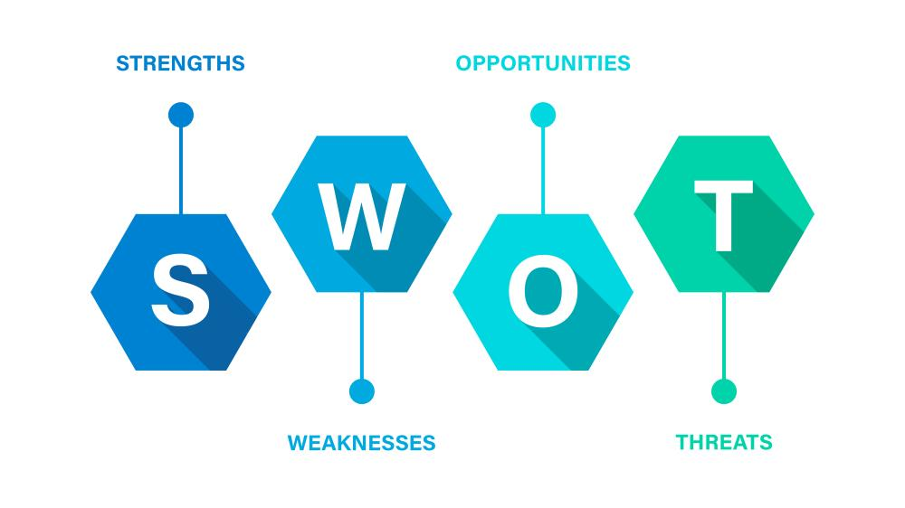
Below is a SWOT analysis of the Hemas Consumer Brand in Bangladesh, with a specific focus on the cosmetics industry:

Strength to Hemas Consumer Brands in Bangladesh
Hemas has built a strong presence and brand name recognition in the cosmetics sector by capitalizing on its reputation from Sri Lanka.
Wide Product Range: Hemas has an array of personal care and cosmetic products that appeal to many different groups of people.
Quality Assurance: The company’s celebrated dedication to offer superior goods ensures development of loyal and dependable customers.
Well-established Distribution Network: Hemas is supported by a network of powerful distributors which ensure access to its products throughout Bangladesh.

Weakness to Hemas Consumer Brands in Bangladesh
Market Penetration: In comparison to regional and large established global operations, Hemas may still be working on creating stronger brand awareness and deeper market penetration.
Limited Local Adaptation: Better alignment with cultural peculiarities as well as regional preferences might demand additional customization for the products.
Reliance on Key Markets: An overdependence on particular segments of markets can become risky if there is any change in customer patterns.

Opportunities for Hemas Consumer Brands in Bangladesh
Growing Cosmetic Market: The growing cosmetics business of Bangladesh gives a great opportunity to grow Hemas.
E-Commerce Expansion: The market reach and revenue of Hemas can be increased by using e-commerce platforms.
New Product Lines: Since the new products are more sustainable, such as natural or organic make-up it can attract health conscious consumers.
Collaboration with Partners: Entering into strategic collaborations with local companies increases brand awareness and opens up new markets.

Threats to Hemas Consumer Brands in Bangladesh
Intense Competition: Because of fierce rivalry from international cosmetic brands and domestic ones, penetrating the market becomes difficult for the company like Hemas.
Weak economy: An unsteady economy affects consumer spending on non-essential items like cosmetics in Bangladesh.
Regulatory Challenges: Constant changes in local laws and regulations can hinder compliance and operations.
Changing Consumer preferences: Due to frequent shifts in consumer tastes, the need arises for constant adaptation of product offerings at Hemas so they remain relevant.

2.6 Strategies to Meet Challenges and Opportunities by Hemas

REVENUE STRATEGY OF HEMAS: Hemas may devise products targeting the unique beauty market of Bangladesh such as cheaply priced items that can meet cultural tastes. Also, it can extend to offering skincare, natural beauty and hair care ranges which address the increasing interest in wellness among buyers.

STRENGTHENING DIGITAL AND E-COMMERCE PLATFORMS ON THE OTHER HAND: As we live in a digital world first, Hemas must optimize its online presence through robust e-commerce platforms, user-friendly payment gateways and customer-centric interfaces. That is possible by partnering with giants like Amazon and other local platforms where customers can easily reach the business at any time.

LEVERAGING MARKET RESEARCH FOR PRODUCT INNOVATION: Hemas would be innovative by investing in consumer insights and research that result into localized products. The product development should also consider changes in customer preferences such as organic or chemical-free options.

EXPANDING DISTRIBUTION AND RETAIL PRESENCE: Therefore, to maintain competitiveness, distribution could be improved across urban as well as remote areas including supermarkets, pharmacies or smaller convenience shops for retail coverage.

AGGRESSIVE MARKETING AND BRAND POSITIONING IN OTHER WORDS…: Influencer marketing alongside collaborations with domestic celebrities can boost visibility of the brand created by Hemas through creative campaigns. Consumer engagement could also be driven by tailoring campaigns according to local customs and festivals too.
The Partnership and Community Collaborations: The partnership between a local beauty salon, fashion brands or community events can help in increasing the company’s brand awareness and reaching the untapped market niche.

Concentrate on Sustainable and Ethical Practices: One of the ways that Hemas will be able to differentiate itself from others is by focusing on eco-friendly packaging, cruelty-free products and socially responsible initiatives as consumers increasingly value sustainability.

Digital Transformations Integration with AI: By incorporating AI-driven tools like personalized recommendations, virtual try-ons and chatbots for enhanced customer service, Hemas will stay abreast with the rapidly evolving digital landscape.

Chapter 03

Analysis of Consumer Brand Loyalty

3.1 Introduction
Consumer brand loyalty is when consumers become so attached to a certain brand that they continue to buy it over the years. Such loyalty stems from the satisfaction of experiences, the emotions created, and the belief in the company's offered goods and services. Such loyalty is gained when a brand adequately satisfies clients’ needs and offers more than was expected of it creating an excellent attachment of the brand to the consumers. Customers become more resistant to competitor influence and are eager to praise the brand to others thereby bringing in word of mouth promotion and enhancing the brand equity.

3.2 How Consumer Brand Loyalty Works for Companies
Many companies reap the benefits of consumer brand loyalty by getting consistent revenue, decreasing their marketing expenditures and improving corporate image. Loyal customers have been successfully created by Apple through inventive products, unmatched quality of service and by virtue of the Apple brand. In this way this loyalty can also bring about repeat purchases, even if other alternatives are available which are much cheaper, and customers become advocates for the brand. When customers are attached to a brand, they are also more likely to overlook occasional blunders that would normally drive other customers away thereby providing the companies leeway to manage and expand their customer base.

3.3 Necessity of Consumer Brand Loyalty
The importance of consumer brand loyalty is that it results in repeat purchases which are cheaper than using resources to attract new customers. Customers that are loyal to the business will most likely suggest that brand to other consumers and that is an effective way of advertising. It is also common for loyal customers to sit tight during periods of recession or stiff competition when the loyalty is strong since they are not too quick to switch to other brands. This loyalty makes it easy for the company to grow its brand in the long run which is profitable to them business wise.

3.3 Factors Impacting Consumer Brand Loyalty:
Following discussions assembled the factors impact on consumer brand loyalty in the FMCG section in Bangladesh.

Price Consciousness: Consumers are inclined to remain brand loyal when they feel that there are services worth the cost especially to price focused consumers. These users are keen on price tactics and discounts thus need for price competitiveness.

Brand Functional Benefits: Quality and other attributes that deliver value to a product are functional promises and therefore attract loyalty when delivered as expected or even beyond average. Functional advantages provide and rationalize a loyalty base which is very important in standards where performance is key.

Brand Trust: The force that obtains loyalty from consumers via a brand is called trust in the brand. Brand trust is built over time through consistent service delivery, professional communication, and excellent service support. Consumers can be very disloyal due to competitive advantages, but with high trust in the brand, this disloyalty is mitigated.

Brand Symbolism: It is possible to build emotional ties between the projected brand and the customers when the brand represents specific values and or lifestyle. This makes consumers to be very loyal to such products since they purchase items that define who they are and who they want to be. For example, more brand loyalty is directed towards construction of brands such as Apple or Nike not because of the benefits of the goods but because of the way they enhance lifestyle and position.

3.4. Study Model:

Figure: Study model

1.Price consciousness is the extent to which a consumer considers the price of a product in their purchasing activity. It has an instant effect on consumer brand loyalty especially in cases when the customers highly consider price in comparison to the benefits they perceive in the products.
When such consumers develop price consciousness, the attachment to the product is dependent on the prices. They may decide to change the brands they use if they are able to get the same quality at cheaper prices. Nevertheless, when a brand such as Kumarika is believed to provide a good quality product at an affordable price, its perceived value is further increased due to the perception of the benefits which the product will bring to the consumers in relation to the price charged on it.

2. Brand functional benefits concern the concrete practical gains that a consumer can get from a product, including usefulness, quality, or efficiency. All these benefits are crucial to consumer brand loyalty because these aspects have a direct effect on whether or not the consumer perceives that the product meets a certain need. Functional benefits may also affect perceived value where customers measure the value of the functional benefits of the offering against its cost. In such cases, the price may not even be a concern to many as long as the product performs exceptionally well—like the Kumarika Hair Oil which is said to contain natural extracts that promote healthy hair. This enhances loyalty as the offering meets both utilitarian and affective functions.In the case when the consumers are assured that a product will always fulfill the functional benefits sold with that product, they tend to become loyal to the brand because of its usefulness to them.

3. Action that builds brands leads to the development of consumer motivation to remain loyal to the brand further emphasising that trust is the critical link between the consumer and the brand. If targeting the brand, the consumers feel the quality of the product or service will always be maintained, the promises will always be kept and the consumers will be put first. Such trust provides emotional security and confidence which are critical for loyalty in the long term. This is perhaps particularly true when the perceived value of the offering is associated with brand trust. When there is trust in a certain brand the consumers feel that whatever benefits that they will get from that product, which they purchased at a price, is worth the money and that the benefits meet their expectations. This perceived value is not only limited to price but also encompasses compelling accuracy and guarantees of the quality of the offerings. For example, whenever consumers believe that Kumarika Hair Oil will deliver up to their expectations with the hair improvement promised realities, they will highly appreciate this product, thus enhancing their loyalty levels. A greater brand trust increases perceived value since the consumers are more confident of what they are buying and as a result, it leads to loyalty for a longer duration.

4. Brand symbolism is the meaning, associations and values imbued to a brand by consumers in terms of a brand. It is not only about the practical value available with the product but also the personality, way of living and honor that the product offers. There are brands with such strong culture that people revel in through their choice of brands, interacting with like-minded people or simply living a particular way or aspiring such a life. Such emotional connections usually develop towards the consumers and are easier to create, and usually lead to greater devotion. This strategy is mostly used when consumers categorize a brand within the dynamics of a certain lifestyle, a belief or even an identity. They tend to put high value on that brand. Such perceived value goes beyond the simple, and competitive level of the product in terms of price and quality, it involves the possible emotional and symbolic value gained while using such a brand. For example, It can be expected that the consumers will be more considerate of the brand than the competitors which have similar products even if Kumarika represents healthy and beauty naturalism in case its users are those who adhere to these values rather than those with a hot trend.

3.5 Methodology

For the purpose of gaining insight on consumer brand loyalty towards Hemas’ Kumarika brand, I undertook a mini-survey of 20 respondents with 40% female and 60% male. Four factors were examined with the aim of determining which ones enhanced their loyalty to the brand: Price Consciousness, Brand Functional Benefits, Brand Trust, and Brand Symbolism.

1. Survey Setup I prepared an opportunity for myself, since it was a six-scale questionnaire, for twelve items. 5-item measurement scales were designed for questions on: - The extent to which respondents consider themselves loyal to Kumarika brand. - The extent to which respondents consider the price of the product (Price Consciousness). - The extent to which respondents consider the product as useful (Functional Benefits). - The extent to which the respondents have trust for the brand (Brand Trust). - The degree of the respondents’ attachment on the brand (Brand Symbolism).

2. Respondent Group The subjects were recruited in a way that they are heterogeneous. Both males and females who use products from Kumarika range were included in the group.

3. Data Collection The survey was done through use of online google forms. Persons were asked to answer several questions based on their experiences to the brand.

4. Bar Chart Analysis In order to find out how people rated these different factors, I created bar charts. Thus the relationship of loyalty with their opinion towards price, trust and symbolism was demonstrated in graphical form. That section offered great assistance in closing the gap between consumers’ loyalty and their opinion towards price, trust and symbolism.

5.Limitations As just 20 people filled in the questionnaire, such a sample may not be representative of the whole population of Kumarika users. With a bigger sampling, a better understanding would have been achieved. It adds to the understanding of what drives loyalty in customers and what areas require attention in order to retain customers.

3.6 Evaluation of Consumer Brand Loyalty at Hemas Consumer Brands
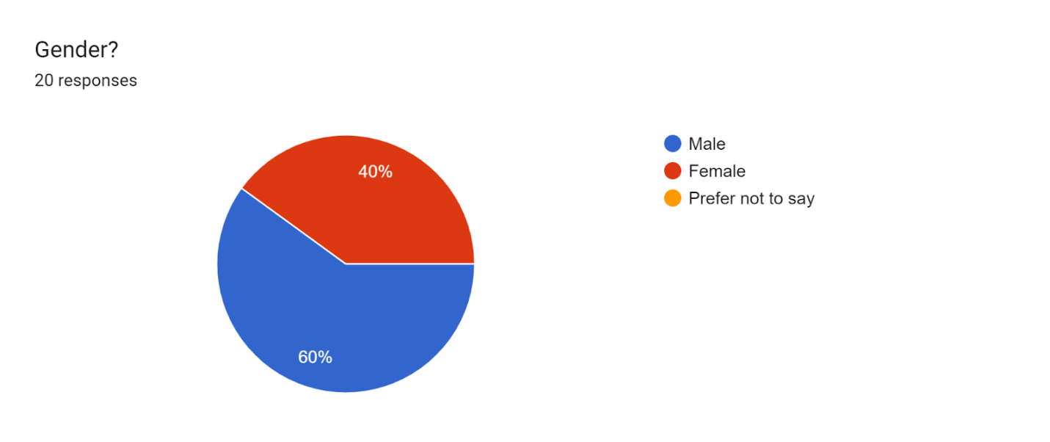
Chart 1: Gender allocation

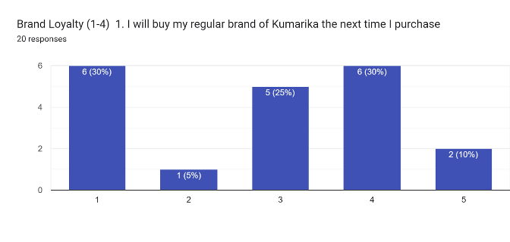
Chart 2: Purchase regularity
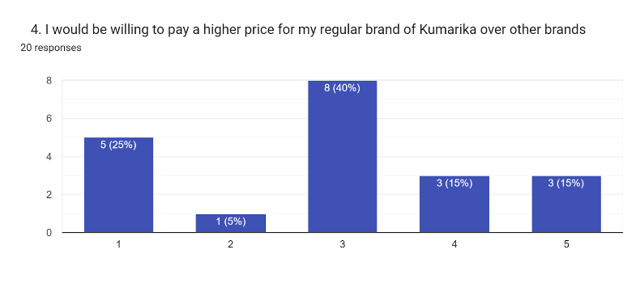
Chart 3: Price sensitivity
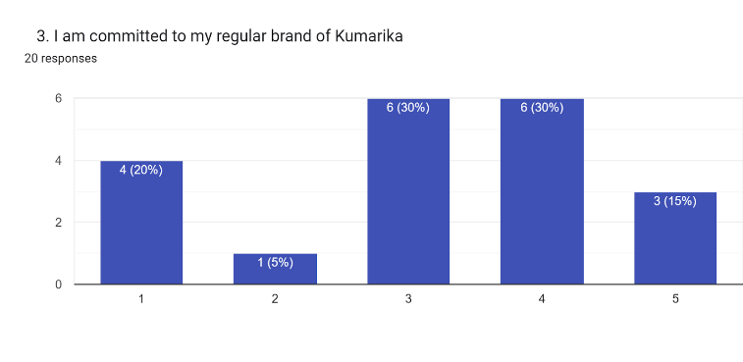
Chart 4: Brand commitment
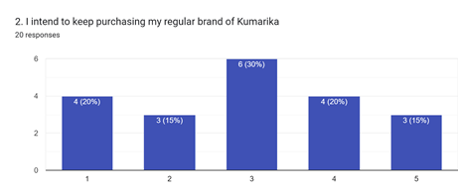
Chart 5: Repeat purchase

Based on my evaluation, looking at 20 respondents who are composed of 40% females and 60% males, the brand loyalty for Hemas products such as Kumarika appears to be moderate to strong. Most of the respondents rated their loyalties as average (3) or agree (4) on the scale which means the customers have positive feelings towards the brand but they lack more advanced loyalty due to the requirements that need to be met.

Hemas can work on strategies which would encourage greater consumer involvement and value addition towards their products to help consolidate this loyalty. The gender distribution of respondents of the study indicates that the brand has been successful to woo people from both sexes, however, there is a scope for the improvement for overall loyalty scores by implementing focused campaigns on the specific aspects of each segment.

Good levels of satisfaction are seen with respect to “agree” responses and further building strategies or plans to enhance emotions, trust, and commodity meaning would be fruitful in changing a good percentage of “average” responses to “strongly agree” in the next evaluation.

3.7 Discussion

- How Price Consciousness impact on consumer brand loyalty?
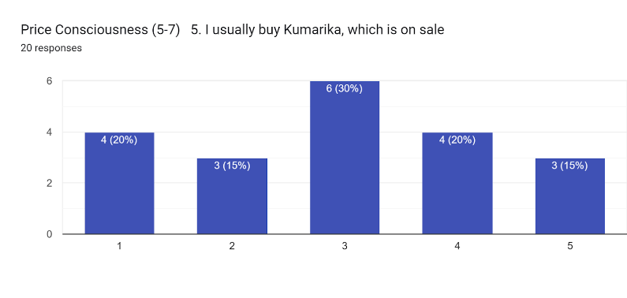
Chart 6: Price Consciousness
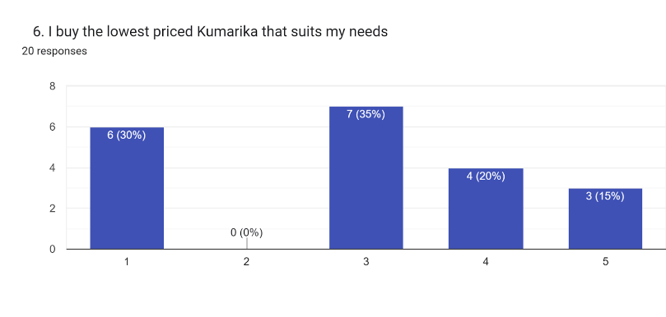
Chart 7: Price and requirement consideration
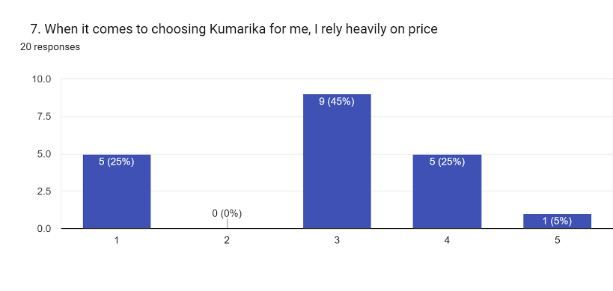
Chart 8: Price consideration

In my survey, I saw that the majority of respondents rated their brand loyalty to Kumarika either “average” (3) or “agree” (4) on a linear scale. For this reason, their level of loyalty may be considered moderate. Their price consciousness was also expressed as “average.” This means that while consumers are somewhat sensitive to price, the same price does not prevent loyalty to Kumarika. In this sense, price consciousness may influence brand loyalty in a more subtle manner. Their likelihood of showing loyalty to Kumarika deviates due to other motives like perceived value, product quality, product brand, and not only due to the price of the product. The “average” score for price consciousness means that price does have a bearing on their loyalty, but it is not the main reason for it. Rather, a reasonable combination of price and quality helps to retain their loyalty to the brand. Seeking to account for the findings reflected in the bar chart, there is an obvious sense where “average” scores for both price consciousness and brand loyalty are reasonably aligned and it means a greater success for Kumarika. Nevertheless, pricing strategy can be adjusted further or go beyond differentiation and price show more of the brand. Such transition would necessitate devotion of more consumers towards the stronger loyalty long-term.

From the survey conducted by me at the last, one can see that the greatest part of respondents rated their brand loyalty to Kumarika of average (3) or agree (4) on a linear scale. For this reason, their level of loyalty may be deemed as moderate. “Average” preference for price sensitivity was also noted. This means that while consumers are to some extent, price-sensitive, the same price does not translate into lack of loyalty to Kumarika. In this regard, price consciousness may also affect brand loyalty in a less direct way. They are good to show loyalty towards Kumarika based on other aspects such as the value perception, the quality of the offered products, the brand of the products, and not only the price of the products. The average score in price preference indicates that on their loyalty price plays some role. An average price does not explain their loyalty. Instead, there is a fair price and fair quality that creates value for the brand and encourages retention of customers. In order to make sense of the results illustrated in the bar chart, it is quite easy that both price consciousness and brand loyalty scored ‘average’ for practicality reasonably explains why it is beneficial for Kumarika.

All the same, pricing strategy can still be changed or go beyond differentiation and price more in line with the brand. Such transition would call for a more extended commitment of consumers towards the despite the stronger loyalty long term.

- How Brand Functional Benefits impact on consumer brand loyalty?

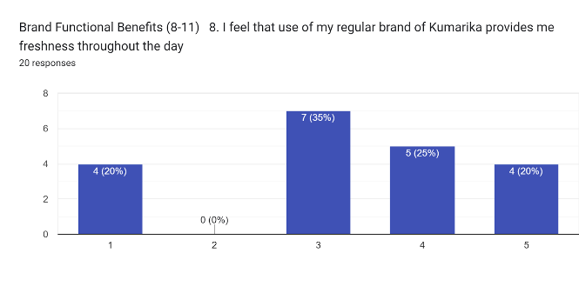
Chart 9: Functional benefits
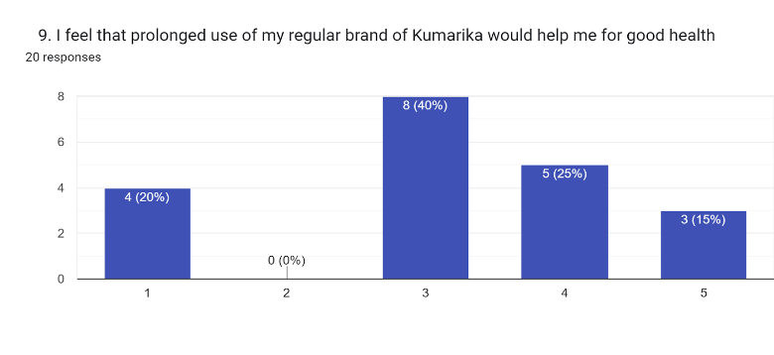
Chart 10: Brand long-term benefits
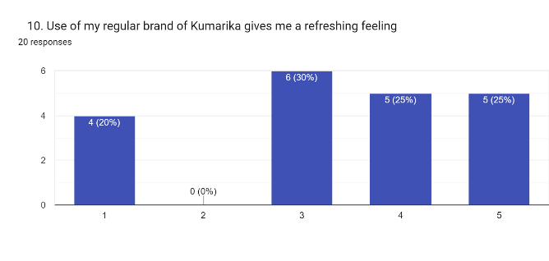
Chart 11: Brand experiential value
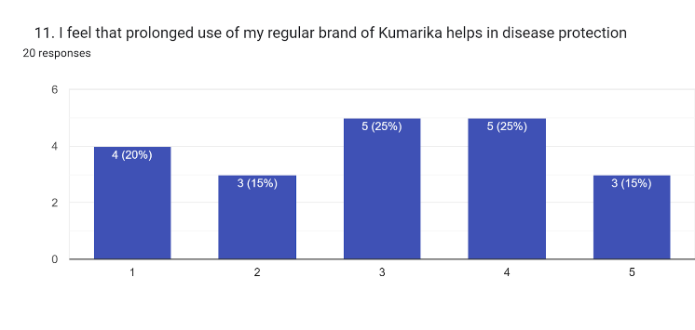
Chart 12: value-added features

Impact of Brand Functional Benefits on Consumer Brand Loyalty: Explanation Based on Survey Findings for Kumarika

In the survey, "Kumarika" was rated “average” (3) or “agree” (4) which indicates that there is a moderate level of consideration towards brand loyalty. Similarly, the functional characteristics of the products and their effectiveness in hair care of Kumarika were also evaluated with mean values of “average” (3), “agree” (4), and “strongly agree” (5). The paragraph outlines the reasons why there appears to be a significant level of customer loyalty towards Kumarika regarding brand equity attributable to the products purchased in the study.

This alignment suggests that the reason for sustained loyalty to the brand is the actual performance of Kumarika products in enhancing causes that consumers value. When consumers feel that the products help them in some way, like in achieving healthy hair, they feel even more loyal to the brand. This breech recommendation recommend that the increases in the satisfaction of functional benefits increase also the loyalty of the customers.

The completion of a bar chart suggests that more functional benefits awards correspond with higher ratings of loyalty levels. For instance, people who very strongly agree (5) with the functional benefits of Kumarika would tend to be those who exhibit high levels of brand loyalty. This means that marketing maneuvers and positional advantage that development of functional benefits bring to the range of Kumarika products incase consumers concern could correspondingly make emerse loyal in many higher conforms of loyalty spectrum.

Finally, the data indicates that while brand loyalty is fairly good at present, it is expected that this will be fortified even more by improving the offered functional benefits of the products.

- How Brand Trust impact on consumer brand loyalty?
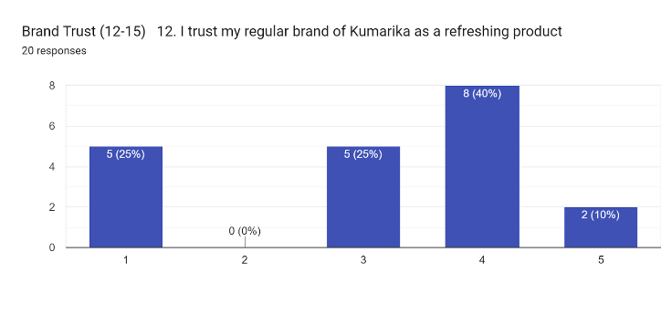
Chart 13: Brand trust for benefits
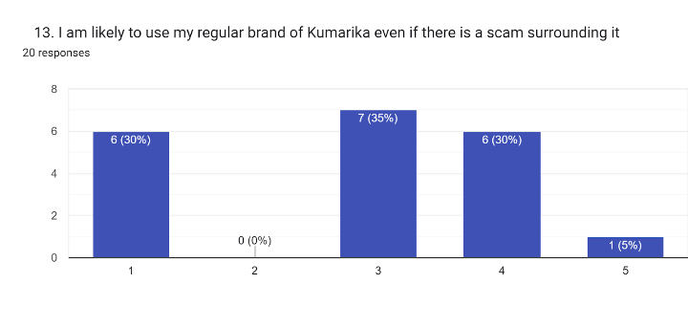
Chart 14: Brand trust against scam
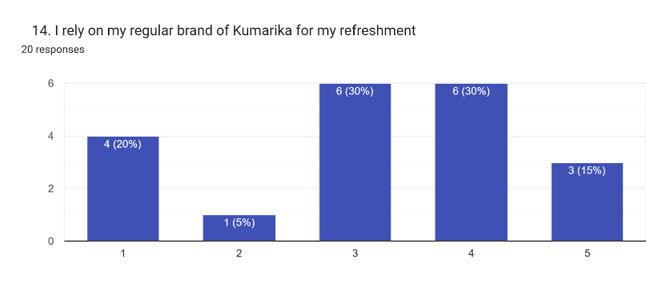
Chart 15: Dependency on the brand

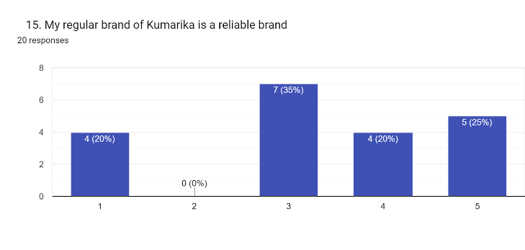
Chart 16: Brand reliability

From my survey responses, most of the respondents rated their loyalty towards Kumarika in the range of 3 to 4 (average to agree). This thus shows that the respondents have an average to good level of loyalty to the brand. At the same time also, Brand Trust was rated in the same range where most of the respondents chose average (3) and agree (4). The low scores for Brand Trust were negligible.

The bar graph most probably indicates the existence of a close relationship between Brand Trust and Brand Loyalty. This indicates that Brand Trust is an important factor that contributes to consumer loyalty towards Kumarika. Even at low trust levels, relatively high loyalty persists; this implies that consumers believe in the product’s quality and dependability. The relationship in the investigation implies that in order to boost brand loyalty further, work should be done towards instilling trust in the consumers. When consumers develop positive ratings towards the brand, which is a sign that they will be loyal to the brand.
So, the bar chart effectively supports the position that though trust does not reach very high levels of confidence, such levels are adequate to support substantial loyalty towards the brand. This consistency means that improving trust scores would assist in bettering the consumer loyalty levels and it is necessary to make that one of the priority target areas.

- How Brand Symbolism impact on consumer brand loyalty
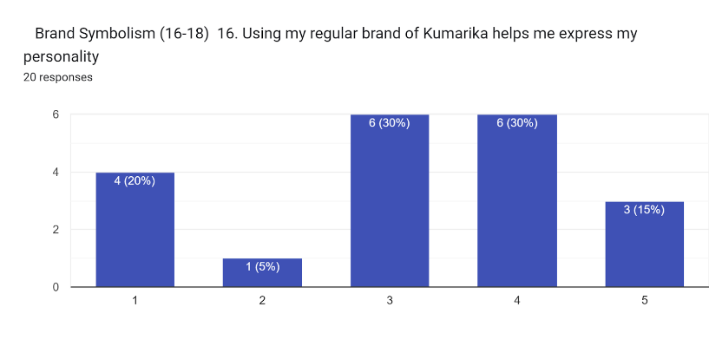
Chart 17: Brand symbolism
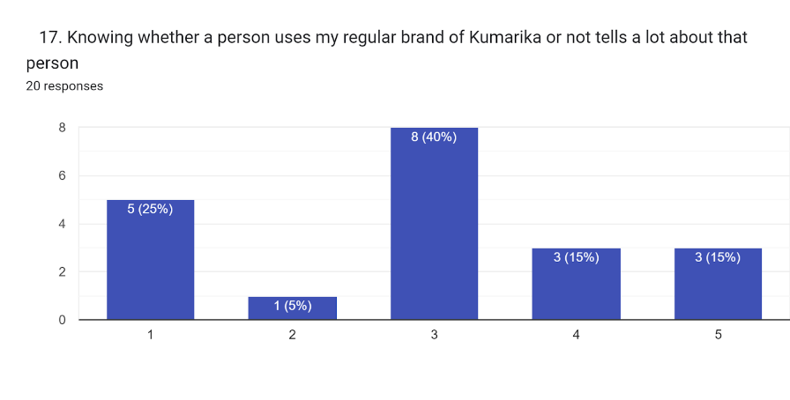
Chart 18: Brand personality
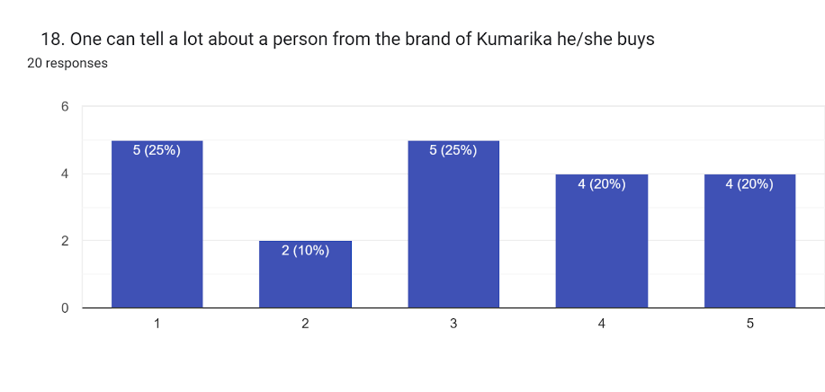
Chart 19: Brand perception

As per my survey, Kumarika’s respondents were mostly neutral and slightly loyal as more respondents have scored brand loyalty in ‘average’ (3) and ‘agree’ (4) categories. Conversely, it’s how the brand communicates who the consumer is or what values they hold, brand imagery, was rated about the same. Most respondents rated it as average (3), agree (4), and a few strong agree (5). This indicates that such customers who possess strong symbolic attachment of Kumarika tend to be more loyal to the Brand.

Reinforce that the relationship brand symbolism has with brand loyalty means that the more the consumers would relate to the imagery of Kumarika the more loyal customers they are likely to be.

Since both brand symbolism and brand loyalty have similar distribution of scored, it follows that developing more symbolic image of the brand, consistent with the values needs and identities of the Buying audiences would be enhancing customer retention even more.

While most of brand users appreciate the symbolic benefits that are attached to Kumarika, there is potential to foster bigger loyalty towards the brand at a closer psychological tie especially for those who rated lower on brand symbolism.
.

3.8 Recommendations
Gaining and keeping customers is a dilemma challenging many marketers, and with regard to Kumarika brand in Bangladesh, there are some recommendations that can possibly help the company.

- There must be ways of advertising that Kumarika products are natural in the sense that they contain natural ingredients. Trust can also be improved and loyalty maintained by enhancing the degree of bluntness regarding acquisition of such certifications or the focus of the brand itself.

- Commercials on pediatricians, barbering and hair styling should aim at addressing the ordinary inconveniences of disease like elution of hair, or dehydration of hair. This will make the customers understand the reason for the development of Kumarika and thus making it worthwhile in their eyes.

- Some economies may be attractive to consumers through cheap bargains offered in smaller quantities and less expensive products including loyalty schemes and giving reasonable consideration to the fact that there is a definite price threshold that consumers are very sensitive to on particular items but no delicate items are compromised. Floor tactics should also be put in place here.

- Making Kumarika developments appealing by associating the product with wellness values and or eco friendly needs will be important when trying to win consumer characters and keeping it for a longer time.

- Extending the marketing scope of Kumarika especially through social and other virtual marketing channels will allow the organization to gain a younger target market and expand sales volume.

Chapter 04

Internship Experience and Conclusion

4.1 Internship Experience

Nature of Position of Intern and Responsibilities
The intern is quite a useful position for Hemas because there is internage done on a regular basis most especially if the position is sales intern. This is because the executive is too busy as they also have a lot of things they have to do. It is the reason why there are always some selected tasks that are done by the intern. As sales and trade marketing intern, there were many responsibilities that I had to perform with respect to sales and trade marketing especially a major task. The primary duty was to gather different kinds of relevant reports and basically make those develop them so that the higher authority is able to act upon those reports. The responsibilities are described hereafter into two main categories as I had to perform both sales related tasks and trade marketing related tasks. I had to carry out lots of responsibilities as sales and trade marketing intern. One of the most noticeable among them is presented below:

Responsibilities as Sales Administration Intern

Data Collection: In terms of this data the following data that I needed to collect on a monthly basis:
➢ obtaining no objection certificate (NOC)
➢ Getting claim Clarence etc.
➢ Verification
Communication with the field sales force: Some regular information that I shared with the field team:
➢ Letting them know the cutoff time to submit closing stock
➢ Remind field sales force to submit no objection certificate, claim clearance, etc
➢ Taking follow up and giving reminder who did not send in time etc.
➢ Taking follow up with mailers regarding material POSM that has been sent to them.
• Legal file maintenance system, case files.

Responsibilities as Trade Marketing Intern

In contrast to customer marketing, trade marketing is a broader marketing approach that seeks to stimulate demand not only at the final customer level but also at wholesalers, retailers, or distributor level as well. Trade marketing is also referred to as B2B marketing or business marketing. Incorporating Business to Business Marketing Conducting Business By Marketing a Product to Business Customers Kerin et al., 2009)
As far as trade marketing intern goes, there are a lot of such things which I had to perform. Some comply with the definition and some does not because real world always works in a different way.

During my internship the following tasks were performed by me:
• Tracking the execution of Point of Sale Materials.
• Compilation of reports: Here are some of the reports which I was supposed to prepare daily and hand them for submission to the respective authorities:
Retailer QPS Wise Sales
CP, Hanger, Sticker, Poster Execution Update etc.
• Update of launching of the product in the market and taking the order
• Taking Follow Up
• Negotiation with the vendors

4.2 Conclusion
To sum up, it can be stated that Hemas has rapidly expanded and shown dedication towards the development of the Bangladesh market through its well – established distribution system along with focus on new developments and development of its product range. It is interesting to note that the company can be diverse in its target market segments however it can be tamed into possessing a specific organizational culture. Spending about 4 months on Hemas proved to be very useful as I was able to experience multinational business, strategic marketing, and product management. I'm sure that this experience will be very useful for me and will help to advance the career ladder in business.

References:
- Consumer Brands: https://hemas.com/consumer-brands.html
- https://www.hemas.com/
- https://www.scribd.com/document/544138911/Internship-Report-on-Hemas-Consumer-Brands-full
- The New FMCG Consumer (Challenge for FMCG Sector). Retrieved from https://doi.org/10.5373/jardcs/v12sp8/20202558
- Kerin, R., Hartley, S, &Rudelius, W. (2009) Marketing. McGraw-Hill/Irwin.
- Hemas Holdings. Retrieved from https://en.wikipedia.org/wiki/Hemas_Holdings
- Hemas at a Glance. https://hemas.com/about.html
- https://www.signalhire.com/companies/hemas-consumer-brands-pvt-ltd-bangladesh

