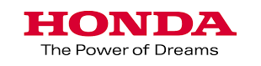

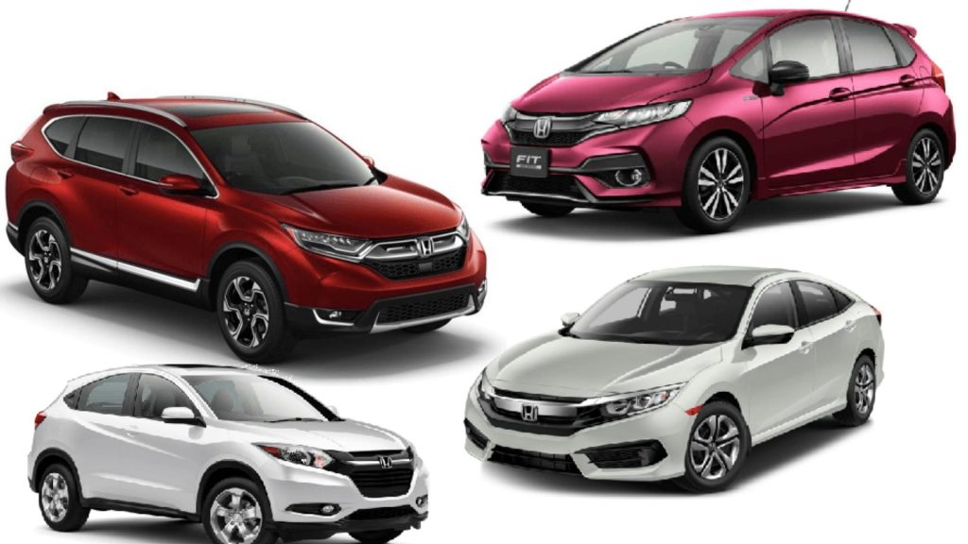

This report is submitted to the school of Business and Economics, United International University as a partial requirement for the degree fulfillment of Bachelor of Business Administration Program.

Analysis of Marketing Strategy: A Study on Honda - DHS Motors Limited

Internship Report
On
Analysis of Marketing Strategy: A Study on Honda - DHS Motors Limited
Course code: INT 4399
Submitted To
Dr. Md. Shariful Alam
Professor and Deputy Director
School of Business and Economics
United International University
Submitted By
Md Jawad
ID: 111 143 145
Bachelor of Business Administration
Major in Marketing
School of Business and Economics
United International University
Date of Submission
March 27, 2023

Letter of Transmittal
March 27, 2023
Dr. Md. Shariful Alam
Professor
School of business and economics
United International University
Subject: Submission of Internship report.
Dear Sir,
Here is a report on my internship on “Analysis on Business strategy of Honda - DHS Motors Limited," which you assigned to me as a requirement for my BBA degree. I made every effort to obtain all relevant documentation that may offer a complete picture of this subject. I worked closely with and saw the activities of DHS MOTORS LIMITED. In addition, I researched various rules and regulations, as well as paper works and processes, which may have an influence on the issue I operated on. I'm hoping that this report will live up to the expectations.
I had a terrific time putting the report together. I'm giving you this internship report as a thank you for all your help and guidance over the years.

Md Jawad
ID: 111 143 145
Bachelor of Business Administration
Major in Marketing
School of Business and Economics
United International University

Declaration of the student

I am Md Jawad, and I prepared the report "Analysis on Business strategy of Honda, DHS Motors Limited," in which I detailed all my own experiences and insights. Furthermore, all the goods available are the result of my own hard work. It did, however, need the cooperation of several persons, all of whom are appropriately mentioned.
I will also make certain that this report is used sparingly. However, because it is an academic work, it may only be used for educational purposes. As a outcome, information may be kept confidential from third revelries.

Md Jawad
ID: 111 143 145
Bachelor of Business Administration
Major in Marketing
School of Business and Economics
United International University

Acknowledgement

First and initially, I would want to thank Allah for giving me the opportunity to prepare this report as well as all those who assisted me prepare it.

To begin, I'd like to thank my widely respected supervisor, Dr. Md. Shariful Alam, Professor in United International University's Marketing Department, for mentoring and instructing me by offering helpful suggestions.

Then I'd want to thank the personnel of Honda's Tajgaon Branch, particularly my boss, Partha Protim Izarder, my Assistant Manager B.M.Vaskar Hitlar. In addition, I want to thank all the DHS Motors (HONDA) employee who have helped me throughout my internship period.

Finally, I would like to thank my parents for always being there for me and enabling me to complete this internship program.

Executive Summary
The automobile industry in Bangladesh is still in its nascent stage and has yet to realize it’s potential fully. With the growth of the middle class and increased urbanization, there is a growing demand for passenger vehicles in Bangladesh. In particular, there is a high demand for affordable small cars and hatchbacks. The Bangladeshi government has set a target of having 20% electric vehicles on the road by 2025. In line with this, several automobile manufacturers are introducing electric vehicles in the market. Overall, the automobile industry in Bangladesh is expected to grow rapidly in the coming years, driven by the rising demand for passenger vehicles, electric vehicles and the expansion of local manufacturing. Nonetheless, competition among businesses operating in the automobile sector market in Bangladesh is fierce due to the presence of many distributorship organizations, such as Pragoti Industries Limited, PHP Automobiles Limited, and Uttara Motors Limited. The main purpose of preparing this report is to study how DHS Motors Limited implements their marketing activities and strategies for their Honda Branded car segments in the automobile industry of Bangladesh.
Honda is a popular car brand in Bangladesh, but like any other foreign car brand, it faces several challenges when it comes to selling and marketing their cars in the country. Based on the results, this report offers some suggestions for DHS Motors Limited that may help the company overcome the obstacles it faces in expanding its Honda passenger car business in Bangladesh. DHS Motors Ltd has to employ a wide range of materials for their protective barriers, and they also need some fresh approaches to advertising and promotion.

Table of Contents

Executive Summary iv
Chapter 01: Introduction
1.1 Introduction of the Report 2
1.2 Objectives of the Report 3
1.2.1 Broad Objective 3
1.2.2 Specific Objectives 3
1.3 Motivation of the Report 3
1.4 Scope and Limitation of the Report 4
Chapter 02: Industry Analysis
2.1 Overview of the Automobile Industry 6
2.2 PESTEL Analysis: Automobile Industry of Bangladesh 6
2.2.1 Political Factors 6
2.2.2 Economic Factors 7
2.2.3 Social Factors 8
2.2.4 Technological Factors 9
Chapter 03: Company Analysis
3.1 Overview of DHS Motor Limited 12
3.2 Mission and Vision Statement 12
3.3 Business Policy of DHS Motors Limited 13
3.3.1 The Three Delights 14
3.4 Environmental Situational Analysis of Automobile Industry of Bangladesh 15
3.4.1 Key Players 15
3.4.2 Market Trends 16
3.4.3 Challenges 16
3.4.4 Future Growth Prospects 16
3.5 Competitive Situation Analysis 17
3.6 SWOT Analysis 20
Chapter 04: Internship Experience
4.1 Internship Experiences 25
4.1.1 Daily Activities 26
4.1.2 Weekly Activities 26
4.1.3 Monthly Activities 26
4.2 Training 26
4.3 Contribution to the Marketing Department 27
4.4 Skill Development from Internship Period 28
4.5 New Skills Developed 28
Chapter 05: Recommendations and Conclusion
5.1 Challenges and Recommendations 31
5.2 Conclusion 32
References 33

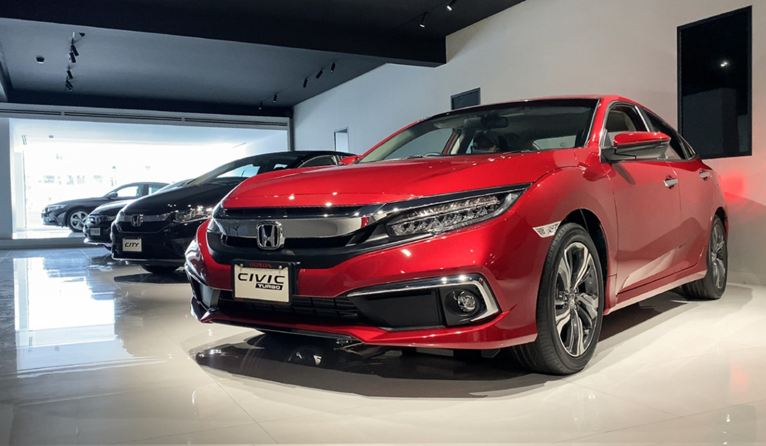

Introduction of the Report
The automobile industry in Bangladesh is still in its infancy, with a relatively small market size and limited local production. Most vehicles are imported from countries such as Japan, South Korea, and India. The Bangladesh government has implemented a number of policies to promote the local automotive industry, including reducing import duties on vehicle parts and offering tax incentives for local production. However, progress has been slow, and the local industry remains largely dependent on imports.
In recent years, there has been some growth in the local production of motorcycles, and several companies have started assembling motorcycles in Bangladesh using imported parts. However, the production volumes are still small, and the industry is dominated by a few large players.
One of the main challenges facing the automobile industry in Bangladesh is the poor state of the country's road infrastructure. Many roads are poorly maintained, and traffic congestion is a major issue in major cities. These factors can make it difficult for automobile companies to expand their operations and develop a strong local market. Despite these challenges, there is potential for growth in the Bangladesh automobile industry, particularly in the area of electric vehicles. The government has set a target of having 20% of all vehicles in the country be electric by 2030, and several companies are exploring the potential for local production of electric vehicles. However, significant investment will be needed to overcome the challenges facing the industry and realize this potential.
After finishing all academic credits, I must engage in an internship program to gain applied or business knowledge and use his qualitatively acquired information gained over the academic session. So, after completing those requirements, I was transferred to the Honda DHS Motors Tejgaon brunch. The internship program will run from April 01, 2022 to June 30, 2022.

I worked in after sale service and managed customers and their requirements throughout my three-month internship at Honda. It was a terrific involvement that allowed me to use my academic skills in a disciplined setting while also providing me with vision into the business world. As a result, as part of my internship program, I must prepare an internship report in order to obtain certification for my BBA degree. Consequently, Dr. Md. Shariful Alam, my respected supervisor, has recommended the report. The main purpose of this report is to analysis of marketing strategies and activities of Honda, DHS motors.

Objectives of the Report
The objectives of the report are separated into two sections:

Broad Objective
The main and primary objective of this study is to study and do an analysis on how DHS Motors Limited carries out their marketing operations for Honda passenger car.

Specific Objectives
- To be familiar with the corporate profile, as well as the business units and rivals in the automobile industry of Bangladesh.
- To determine the internal and external elements that may have an effect on the expansion of automobile industry of Bangladesh.
- To have a better understanding of the difficulties associated with marketing efforts and how such difficulties may affect the expansion of their company within the automobile industry of Bangladesh.
- To present some recommendations that may be used to alleviate some of the difficulties that have arisen as a result of DHS Motors Ltd's lack of marketing efforts for the Honda brand passenger car.

Motivation of the Report
The main goal of completing the research is to obtain a BBA degree from United International University, which requires each student to complete an internship or project program. Students in the internship program must join any organization where they may learn about the practical working culture of that organization. To complete the BBA degree, they created and submitted a report based on their instructor's recommended and accepted topic.
The primary purpose of this paper is to investigate and appreciate Honda, DHS Limited's strategic market in Bangladesh. As previously said, the research topic is "Analysis of Business strategy and market of Honda, DHS Motors Limited," therefore the study's major purpose and emphasis is to learn about HONDA's business and market in Bangladesh. Even though there is no dictionary definition for strategic market analysis, it is a market study related with a firm strategy or corporate strategy. Strategic market analysis is designed to help firms of all sizes make informed business decisions, particularly those addressing strategy.

Scope and Limitation of the Report
Each research has its own set of limitations. The reader will understand why the results should be interpreted under those settings if the study's limitations are clarified. A good assessment of a study's limits also demonstrates that the researcher has a comprehensive comprehension of his or her research. As a result, the following are the limits of my research:
- Prepared in a short period of time: The report is completed in between internship tasks at HONDA, DHS Motors Limited. It was tough to prepare such a comprehensive and detailed report in just three months.
- Organizational secrecy: Honda maintains organizational confidentiality. When it comes to using sensitive material in the media, DHS Motors has various confidentiality constraints. Lack of resources: There are relatively few main and secondary resources about HONDA, DHS Motors Limited that include accurate and relevant information. To get useful information for my studies, I need to organize a lot of formal and informal interactions

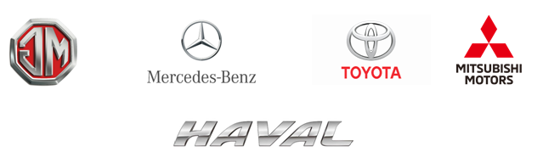

Overview of the Automobile Industry
The automobile industry in Bangladesh has been experiencing steady growth over the past few years. Although the country has a relatively small market for automobiles, the demand for cars and other vehicles has been steadily increasing, fueled by the country's economic growth and rising middle-class population.
One of the key drivers of the growth of the automobile industry in Bangladesh is the government's efforts to promote local manufacturing of vehicles. In recent years, the government has introduced various incentives and policies to attract foreign investment in the automobile sector and encourage local manufacturing. As a result, several international automobile manufacturers have set up manufacturing plants in Bangladesh, producing a range of vehicles, including cars, buses, trucks, and motorcycles.
Another factor contributing to the growth of the automobile industry in Bangladesh is the increasing demand for transport and logistics services. The country's rapidly growing economy has led to a surge in trade and commerce, which in turn has driven up demand for commercial vehicles such as trucks and buses.
Despite the growth potential, the automobile industry in Bangladesh still faces some challenges. One of the key challenges is the lack of adequate infrastructure, including roads, highways, and transportation networks, which can impede the growth of the industry. In addition, the high cost of imported raw materials and the relatively low purchasing power of consumers also pose significant challenges.
Overall, the growth of the automobile industry in Bangladesh is expected to continue, driven by rising demand for vehicles, government support for the sector, and increasing investment in infrastructure.

PESTEL Analysis: Automobile Industry of Bangladesh

Political Factors
The automobile industry is affected by various political factors that can influence its operations, profitability, and sustainability. Some of the key political factors that affect the automobile industry are:
- Government regulations and policies: Governments impose regulations and policies that affect the production, distribution, and sale of automobiles. These regulations include safety standards, emission regulations, fuel efficiency standards, and trade policies. Automakers must comply with these regulations to avoid penalties and maintain their licenses.
- Taxation policies: Governments can use taxation policies to encourage or discourage the production, purchase, and use of automobiles. For example, tax incentives can be given to consumers who purchase electric or hybrid vehicles to promote green transportation.
- Political stability: Political instability and uncertainties can affect the automobile industry. Instability in a country or region can result in disruptions in supply chains, increased costs of production, and reduced demand for automobiles.
- Trade policies: Trade policies such as tariffs, import restrictions, and trade agreements can impact the automobile industry. These policies can affect the cost of production and the availability of raw materials and markets for finished products.
- Consumer protection laws: Governments can impose consumer protection laws that require automakers to ensure the safety and quality of their products. These laws can affect the design, manufacturing, and marketing of automobiles.
- Environmental policies: Environmental policies such as carbon emissions regulations and incentives for green technologies can affect the automobile industry. Automakers must comply with these policies to reduce their carbon footprint and promote sustainability.
Overall, political factors play a significant role in the automobile industry, and automakers must closely monitor and adapt to these factors to remain competitive and sustainable.

Economic Factors
The automobile industry in Bangladesh is relatively new and still in its early stages. However, it has the potential to contribute significantly to the country's economy, as it can create jobs, generate revenue for the government, and promote industrial growth. Some of the key economic factors that affect the automobile industry in Bangladesh are:
- Market size: The size of the market is a critical factor in the automobile industry, and in Bangladesh, the market is relatively small compared to other countries. However, the country's growing middle class and increasing purchasing power have led to an increase in demand for cars, which is expected to drive growth in the industry.
- Import tariffs: The government of Bangladesh imposes high tariffs on imported cars to protect the domestic industry. As a result, the cost of imported cars is significantly higher than in other countries, which makes it difficult for international automakers to compete in the market.
- Infrastructure: The infrastructure in Bangladesh is not well-developed, which makes it difficult for automakers to set up manufacturing facilities and supply chains. However, the government is taking steps to improve infrastructure, which could lead to increased investment in the industry.
- Labor costs: Labor costs in Bangladesh are relatively low compared to other countries, which makes it an attractive location for manufacturers. However, the availability of skilled labor is limited, which could pose a challenge for the industry's growth.
- Government policies: The government of Bangladesh has implemented various policies to encourage investment in the automobile industry, such as tax incentives and subsidies. However, there are still some regulatory hurdles that need to be addressed to attract more investment in the sector.
Overall, the automobile industry in Bangladesh has significant potential for growth, but it faces several challenges that need to be addressed. By improving infrastructure, investing in skills development, and implementing favorable policies, the government can create a favorable environment for the industry to thrive.

Social Factors
The automobile industry in Bangladesh is influenced by various social factors, which include:
- Demographic factors: The age, income, and lifestyle of the people in Bangladesh influence the demand for automobiles. As the population grows and incomes rise, more people can afford to purchase cars, leading to an increase in demand for automobiles.
- Cultural factors: The cultural norms and beliefs in Bangladesh also affect the automobile industry. For example, in some cultures, owning a car is a status symbol, while in others, it may not be as important.
- Urbanization: The growth of urban areas in Bangladesh has led to an increase in demand for cars as people need to travel longer distances to get to work, school, or other activities.
- Government policies: Government policies, such as taxes and regulations, can affect the automobile industry in Bangladesh. For example, high import duties on cars can increase the cost of owning a car, making it less affordable for many people.
- Environmental concerns: Environmental concerns are becoming increasingly important in Bangladesh, and the automobile industry is being impacted as a result. For example, the government is encouraging the use of electric vehicles to reduce air pollution.
- Consumer preferences: Consumer preferences also play a role in the automobile industry. Some people may prefer smaller, more fuel-efficient cars, while others may prefer larger, more powerful vehicles.
Overall, social factors play an important role in shaping the automobile industry in Bangladesh. Understanding these factors is crucial for automobile manufacturers and policymakers to make informed decisions and meet the evolving needs of consumers.

Technological Factors
The automobile industry in Bangladesh is still at an early stage of development. However, there are a few technological factors that are shaping the industry's future:
- Electric Vehicles (EVs): The demand for EVs is increasing worldwide due to their environmental benefits, and Bangladesh is no exception. The government has already announced plans to promote the use of EVs, and several companies have started to introduce EV models in the market.
- Advanced Safety Features: As the number of vehicles on the road increases, there is a growing concern for safety. Many car manufacturers are introducing advanced safety features like airbags, lane departure warning systems, automatic emergency braking, etc., in their vehicles to ensure maximum safety for the passengers.
- Connected Cars: The concept of connected cars is becoming increasingly popular, where vehicles can communicate with other vehicles and the infrastructure around them. This technology can improve safety, reduce traffic congestion, and enhance the driving experience.
- Autonomous Vehicles: Autonomous or self-driving cars are still in the early stages of development worldwide, but the technology is rapidly advancing. In Bangladesh, the government has already approved a policy to test autonomous vehicles on a limited scale.
- Improved Fuel Efficiency: With the increasing cost of fuel, car manufacturers are focusing on improving the fuel efficiency of their vehicles. This is achieved through the use of lighter materials, hybrid technologies, and more efficient engines.
- Advanced Manufacturing Techniques: The use of advanced manufacturing techniques like 3D printing, robotics, and automation is improving efficiency and reducing costs in the production of automobiles.
Overall, the automobile industry in Bangladesh is slowly adopting these technological advancements, which will shape the future of the industry and improve the driving experience for consumers.

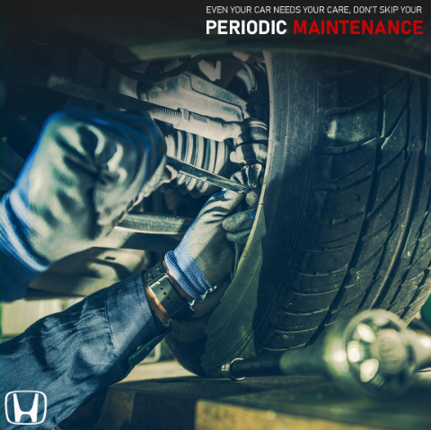

Overview of DHS Motor Limited
DHS Motors was established in 1994 as Bangladesh's exclusive distributor of Honda cars. DHS Workshop was founded a year later to provide further assistance to Honda customers who had benefitted from Honda's basic after-sales service.
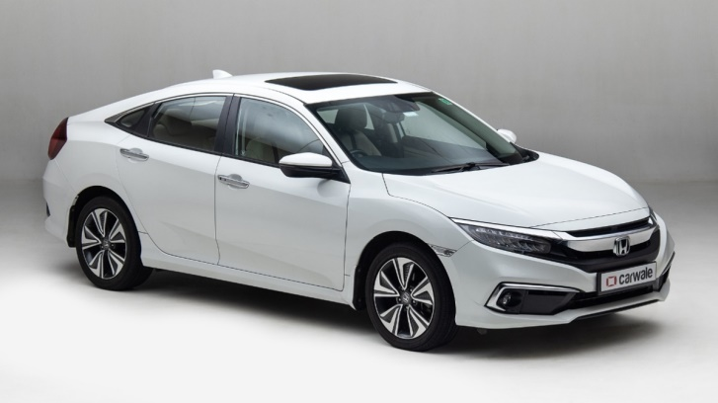
The original automobile lineup includes the HONDA Domani, Honda Accord, and CR-X. Later, in 1996, the civilian market saw the introduction of the Honda Integra, Civic, and Legend, as well as the sale of new sedans. In the years thereafter, DHS Motors has released other models such as the CR-V, HR-V, and City. At the age of 28, DHS Motors became Bangladesh's first hybrid automotive distributor.
The current aim of DHS Motors is to improve the customer experience through advanced training, advanced training and workforce skill development, competitive segmentation pricing, competitive advantage expanded segmentation, and extended maintenance. We intend to become Honda the leading vehicle brand in Bangladesh by building a national distribution network for Honda sales, parts, and accessories. A second showroom in Dhaka's city center, in the Tejgaon industrial zone, is already under construction.

Mission and Vision Statement
Mission:
DHS motors limited is likely to be a private company that is involved in the automotive industry, either as a manufacturer, distributor or retailer of vehicles, parts, and accessories. Based on this assumption, their mission might be to provide high-quality, innovative and affordable products and services to their customers.
They may also have a focus on sustainability and environmental responsibility, seeking to minimize their carbon footprint and promote the use of eco-friendly technologies in their operations. Additionally, they might prioritize customer satisfaction, employee development, and ethical business practices in their mission statement.

Vision:
Based on the information available publicly, DHS Motors Limited is an Indian-based company that manufactures and sells electric two-wheelers. Their vision might include:
- To become a leading electric vehicle manufacturer in India and globally.
- To contribute to a greener and more sustainable future by promoting the use of electric vehicles.
- To innovate and develop cutting-edge technology to enhance the performance and safety of electric two-wheelers.
- To provide exceptional customer service and create a loyal customer base.
- To maintain high ethical standards and be a responsible corporate citizen.

Business Policy of DHS Motors Limited
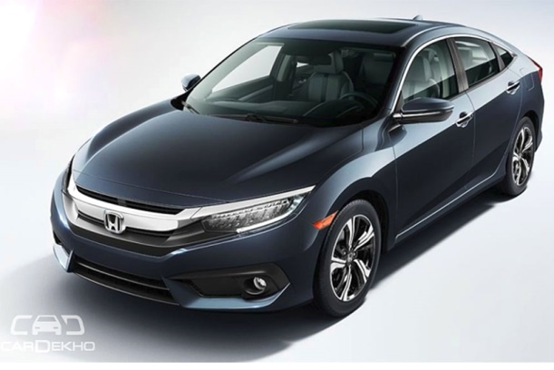
Their pioneers, Soichiro Honda and Takeo Fujisawa, formed their fantasy into our Honda reasoning. It is based on two central establishments: regard for the individual and something we call The Three Delights. Indeed, even today, it is shared by the entirety of our partners and is mixed into all of our corporate exercises. In any case, the Honda vision is something beyond words. Our partners realize the organization confides in them and urges them to take on difficulties without apprehension about disappointment. Everybody is regarded inside Honda. Soichiro wouldn't have it differently. Honda is an organization established on regard for each other. We realize individuals have their own thoughts, so we urge our partners to follow up on them as well as assume a sense of ownership with them. Our way of life of typical trust assists us with depending on each other and sharing information among ourselves. The auto business is presently at a significant defining moment. For Honda to get by, it should keep offering items that satisfy the necessities of clients and more quickly than at any other time in recent memory previously. Simultaneously, Honda should make new an incentive for people in the future. To this end, Honda fortified the construction of its Car Business. To begin with, to answer all the more quickly and deftly to changes in the business climate, the Chief Bad habit President will act as the Central Official of Car Tasks, administering the whole auto activities, in this way empowering choices to be made more expeditiously. Moreover, to develop joint efforts with Vehicle Activities, Honda Research and Development recently settled the Vehicle Center, which will have practical experience in the advancement of car items. Honda is near commercializing the new energy business it has been dealing with for the beyond a couple of years. To speed up this drive, Honda will add energy business to the area of the obligation of Force Items Tasks. With the expansion of new organizations for the future, including Energy Business, to existing Power Items Business, Honda's business activity in this space has developed into the capability to offer new benefits for versatility and regular routines. All things considered, Honda has extended this business area and renamed it the Life Creation Business.

The Three Delights
- Delight of Purchasing: We believe our clients should feel that they have pursued a shrewd decision and encountered long periods of devoted help from their Honda.
- Delight of Selling: Our reach ought to rouse our retailers. A vendor can only with significant effort sell an item that doesn't rouse certainty.
- Delight of Making: On the off chance that our clients and vendors are fulfilled, our improvement groups can invest wholeheartedly in their work - nicely done.
Everybody on a Honda manufacturing plant floor wears white overalls - even the president. The soil appears on white garments: on the off chance that you make the plant as perfect as could really be expected, there'll be no soil to appear. This was Soichiro Honda's thought, back in 1952, and we've followed it from that point onward.
The delight of work, In the Honda world, we believe that everybody should partake in their work, talk transparently, and continue with desire and worth undertaking. We imagine that assists our partners with creating superior-grade, great-worth items. Our objective? Complete consumer loyalty. Unwavering discernment Soichiro Honda had wearing white overalls to represent a perfect work space right all along. Today, every one of our specialists around the world actually wears white overalls to respect Soichiro's unique thoughts. Honda utilizes a grid-the-board framework. In this framework, the upward pivot addresses associations for every locale, while the level hub represents every business. On the upward pivot are associations in Japan and six abroad districts (North America, South America, Europe, Asia and Oceania, China, and Africa/Center East). In view of Honda's Essential Convictions, these associations take part in business grounded in every district from a drawn-out viewpoint. On the even pivot are the business spaces of the Auto Business and Bike Business, as well as the Existence Creation Business, which incorporates power items. Every association creates medium-to-long haul plans for their particular items and directions endeavors with locales to streamline and work with worldwide business tasks. Additionally on the flat pivot are the Organization's Useful Activities — Brand and Correspondence, Business The executives, HR and Corporate Administration, IT, Creation, Buying, and Client First. Every one of these utilitarian tasks backing and direction endeavors to expand the viability and proficiency of the Honda Gathering all in all. Also, Research and development exercises are led for the most part by free auxiliaries. These exercises are done with Honda Research and Development Co., Ltd. what's more, its auxiliaries for items, and Honda Designing Co., Ltd. what's more, its auxiliaries for creation advancements to make unmistakable and universally serious items through the utilization of trend-setting innovation.

Environmental Situational Analysis of Automobile Industry of Bangladesh
The automobile industry of Bangladesh has been growing rapidly over the past decade. The industry has witnessed an influx of new players, new models, and technology upgrades. In this competitive situational analysis, we will look at the current state of the automobile industry in Bangladesh, key players, market trends, and future growth prospects.

Key Players
The automobile industry in Bangladesh is dominated by local players. Some of the key players in the industry are:
- Runner Automobiles Limited: Runner is the largest motorcycle manufacturer in Bangladesh. The company also produces cars and is one of the leading players in the automobile industry.
- Pragoti Industries Limited: Pragoti is a state-owned company that produces commercial vehicles such as trucks, buses, and ambulances.
- Walton Hi-Tech Industries Limited: Walton produces motorcycles, cars, and other vehicles.
- Runner Automobiles Limited: Runner is the largest motorcycle manufacturer in Bangladesh. The company also produces cars and is one of the leading players in the automobile industry.
- PHP Automobiles: PHP Automobiles produces motorcycles, cars, and other vehicles.

Market Trends
The automobile industry in Bangladesh is heavily dependent on imports. The government has implemented policies to promote local production, but the industry is still largely dominated by imports.
One of the key market trends in Bangladesh is the increasing demand for motorcycles. This is due to the growing middle class and the need for affordable transportation. The demand for cars is also growing, but it is still relatively low compared to other countries in the region.
Another trend is the growing demand for electric vehicles (EVs). The government has implemented policies to promote the use of EVs and has set a target of having 500,000 EVs on the road by 2025.

Challenges
The automobile industry in Bangladesh faces several challenges. Some of the key challenges are:
- Lack of infrastructure: The roads in Bangladesh are often in poor condition, which can impact the performance of vehicles. There is also a lack of charging infrastructure for EVs.
- High import taxes: The government has implemented high import taxes on vehicles to promote local production. This has made vehicles more expensive for consumers.
- Lack of skilled labor: There is a shortage of skilled labor in the automobile industry, which can impact the quality of vehicles produced.

Future Growth Prospects
The automobile industry in Bangladesh has significant growth potential. The government has implemented policies to promote local production and the use of EVs. Some of the key growth prospects for the industry are:
- Increased local production: The government has set a target of producing 100,000 vehicles locally by 2021. This will create new job opportunities and reduce the dependence on imports.
- Growing demand for EVs: The government has set a target of having 500,000 EVs on the road by 2025. This will create new opportunities for companies that produce EVs and charging infrastructure.
- Expansion into regional markets: Bangladesh is strategically located between India and Southeast Asia. This presents an opportunity for the automobile industry to expand into regional markets.
The automobile industry in Bangladesh has significant growth potential. The industry is dominated by local players, but the government is implementing policies to promote local production and the use of EVs. The key challenges facing the industry are the lack of infrastructure, high import taxes, and a shortage of skilled labor. However, with the right policies and investments, the industry has the potential to become a major player in the regional market.

Competitive Situation Analysis
Porter's Five Forces Analysis is a framework used to analyze the competitive environment of an industry. It was developed by Michael Porter, a professor at Harvard Business School, and it provides a structured approach to understanding the dynamics of competition within an industry. The five forces that make up the framework are:
- Threats of substitute products
As we all know, the availability of a close substitute product increases consumers' readiness to accept it in response to rising prices. This suggests that, when compared to its competitors, Honda can deliver both economic value and higher performance. This item will be used to replace Honda products that are currently on the market. As a result, both Honda's market share and profitability are decreasing. DHS Threats and Engine Replacements Many automobile manufacturers compete with Honda, both indirectly and directly, in the high bid market, including Suzuki, Hyundai, Nissan, Toyota, KIA, and Mitsubishi. As a result, the threat of alternative products in the Bangladeshi vehicle industry is significant.
- Customer's bargaining power
It is indisputable that any business trying to develop must build favorable relationships with its customers. Even though Honda is challenging, it is important to note that Honda has many rivals in the Bangladeshi market. Customers are usually bewildered while deciding which brand is the best choice. It is defined not only by the well-known company, but also by quality and affordability. In this position, the consumer has considerable bargaining power. The Honda CIVIC HYBRID, for example, is a sporty and elegant model with the most fuel-efficient machine technology. Young individuals were quickly drawn to the company. On order to charge a premium price, the firm often produces a shortage of air blades in the market.
- Bargaining power of suppliers
HONDA is worried about the provider's bartering power. DHS Engines Restricted, Honda's just a wholesaler, and doesn't gather autos; rather, its imports them from HONDA. Thus, the seller has a ton of exchanging power. DHS Engines Restricted is compelled to depend just on Honda.

- Threats of the arrival of new competitors
Since large numbers of its rivals are now working great, any organization's benefit in advertising will be lower than the high level of the more fragile comic market. Bangladesh has an administration strategy that no nearby industry might make vehicles since the nation has an agreement with Japan. Bangladesh might import autos from different makers in the meantime. Honda permits one dealer for each country. Subsequently, the danger of new contenders entering the market is genuinely low. Since the level of contention is high and the gamble of new contenders is negligible, any organization in the vehicle business, like BD Wholesalers, may introduce itself as a net shipper.
- The competition between present contestants
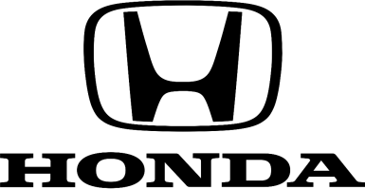
The five qualities portrayed above are significant for the vehicle business since they take into consideration serious examination. Honda and DHS Engines rival Uttara Engines Positions, Rankon Engines, Navana Engines, and others. Changes to one of these contenders will meaningfully affect Honda's exhibition. Honda has kept on exploring, making, creating, and working to contend with its three opponents in the car business. Honda's ongoing rival in the Bangladeshi auto area, DHS Engines, is profoundly prevailing and controls most of the market. Different opponents are more grounded too, in light of the fact that current contenders make a more noteworthy difference.
Since a considerable lot of its rivals are now getting along nicely, each organization's benefit in showcasing with many present contenders is projected to be more modest than the high level of the lower comic market. Since the nation has an agreement with Japan, Bangladesh's true strategy determines that no native organizations might make cars. In the meantime, Bangladesh might import vehicles from different makers. Honda permits one seller in every country. Accordingly, the probability of new contenders entering the market is incredibly low. Since the level of rivalry is high and the gamble of new contenders is negligible, any business in the auto area, like BD Merchants, may introduce itself as a net shipper.
Honda and DHS Engines contend with Uttara Engines Positions, Rankon Engines, Navana Engines, Haval, MG and others. Changes to one of these contenders will affect Honda's exhibition. Honda has kept on exploring, making, creating, and working to contend with its three adversaries in the auto business. Honda's ongoing rival in the Bangladeshi car area, DHS Engines, is profoundly prevailing and controls most of the market. Different opponents are more grounded too, in light of the fact that current contenders make a more prominent difference.
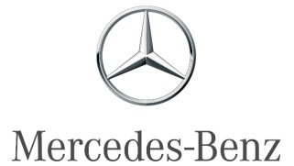
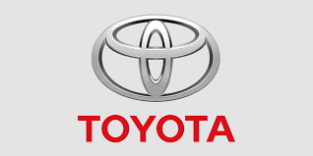
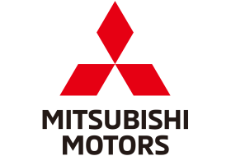


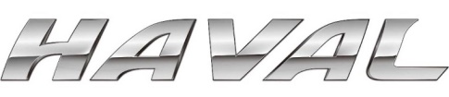

SWOT Analysis
SWOT examination is a business approach that helps an individual or association in looking at the qualities, shortcomings, open doors, and dangers related to an organization's opponents or promoting plan. Its goal is to explain the organization's objectives and to distinguish unfriendly, inner, and outside viewpoints that are helpful for accomplishing these objectives. SWOT examiners regularly ask and respond to inquiries to produce huge data for every classification to send the procedure and reveal its upper hand (Keller, 2016). SWOT examination has been lauded as a proven vital investigation approach; however, it has likewise been censured for its insufficiencies. In this situation, a SWOT examination of HONDA and DHS Engines Restricted was done.
- Strengths
DHS Motors Limited is a dealership that sells Honda cars. Some strengths of DHS Motors Limited for selling Honda cars are:
- Strong brand reputation: Honda is a well-known brand with a strong reputation for producing high-quality, reliable cars. This reputation can attract customers to DHS Motors Limited's dealership.
- Wide range of products: Honda offers a diverse range of cars, from compact cars to SUVs and trucks. This allows DHS Motors Limited to offer a variety of products to different customer segments and increase its potential customer base.
- Customer service: DHS Motors Limited can differentiate itself by providing excellent customer service to its customers. This can include providing information about the cars, assisting customers in choosing the right car for their needs, and offering after-sales support.
- Location: DHS Motors Limited's location can be a strength if it is in a high-traffic area or near a population center. This can increase visibility and accessibility for potential customers.
- Experienced sales team: DHS Motors Limited can have an experienced sales team that can effectively communicate the features and benefits of Honda cars to potential customers. This can increase the likelihood of making a sale and building customer loyalty.

- Weakness
- Competition: The automobile industry is highly competitive, and there are many other dealerships selling Honda cars. DHS Motors Limited may face challenges in differentiating itself from other dealerships and attracting customers.
- Economic Factors: Economic factors such as inflation, recession, and exchange rates can significantly affect the demand for cars, which can, in turn, affect the sales performance of DHS Motors Limited.
- Customer Service: Providing excellent customer service is crucial for car dealerships. If DHS Motors Limited fails to meet customer expectations, they may lose potential customers to competitors.
- Location: The location of the dealership can also be a weakness. If the dealership is in an inconvenient or hard-to-reach location, it can discourage potential customers from visiting the dealership.
- Inventory Management: Maintaining an adequate inventory of Honda cars is essential to meet customer demand. However, overstocking or understocking can result in lost sales or increased costs, respectively. DHS Motors Limited needs to manage its inventory effectively to avoid such issues.
- Marketing: Effective marketing is essential for attracting new customers and retaining existing ones. DHS Motors Limited needs to have a solid marketing strategy in place to promote its Honda cars and attract potential buyers.

- Threats
- Competition: The automobile industry is highly competitive, and companies must continually innovate and improve to stay ahead of their rivals.
- Economic conditions: The industry is also sensitive to changes in the economy, such as recessions and changes in interest rates, which can affect consumer demand for vehicles.
- Regulatory requirements: Automobile manufacturers must comply with a variety of safety and environmental regulations, which can be complex and costly.
- Supply chain issues: Automakers rely on complex supply chains to source materials and parts for their vehicles. Disruptions in these supply chains, such as natural disasters, labor strikes, or transportation issues, can cause production delays and impact profitability.
- Technological advancements: The industry is rapidly evolving, and companies must stay up-to-date with the latest technological advancements in areas such as electric and autonomous vehicles.
- Brand perception: The perception of a brand is crucial in the automobile industry, and negative publicity or quality issues can have a significant impact on sales and brand loyalty.
- Changing consumer preferences: Consumer preferences and expectations are continually evolving, and companies must adapt to these changes by offering vehicles that meet the changing demands of their customers.

- Opportunities
DHS Motors Limited can benefit from the opportunities offered by Honda cars in the following ways:
- Diversification of product line: Adding Honda cars to its product line will enable DHS Motors Limited to diversify its offerings and appeal to a wider range of customers. Honda cars are known for their reliability, fuel efficiency, and advanced safety features, which can attract customers who prioritize these attributes.
- Brand reputation: Honda is a well-established brand known for producing high-quality cars that are reliable and durable. By associating with Honda, DHS Motors Limited can benefit from the brand's reputation and attract customers who trust and prefer the Honda brand.
- Increased sales and revenue: Offering Honda cars can help DHS Motors Limited increase its sales and revenue. Honda has a wide range of vehicles, including sedans, SUVs, and hybrid cars, which cater to different customer needs and preferences. This can increase the chances of DHS Motors Limited attracting new customers and retaining existing ones.
- Competitive advantage: By offering Honda cars, DHS Motors Limited can gain a competitive advantage over other car dealerships that do not offer Honda vehicles. This can help the company stand out in a crowded market and attract customers who are looking for specific Honda models.
- Innovation and technology: Honda is known for its innovative technology, such as its hybrid and electric cars. By offering these advanced vehicles, DHS Motors Limited can position itself as a dealership that is committed to offering the latest in automotive technology and innovation. This can appeal to customers who are interested in eco-friendly and sustainable cars.



Internship Experiences
I began working at Honda on April 01, 2022, to June 30, 2022. Working with Honda was an incredible encounter. During this three-month entry-level position, I gleaned some significant knowledge about corporate work. All the more altogether, it worked on my down-to-earth insight, which will help me in fostering my financial calling before very long. As a marketing executive in the automobile industry, specifically in the Honda car industry, DHS Motors Limited, I am involved in responsible for promoting Honda cars and other products, increasing brand awareness, and generating leads for the sales team. My job duties may include:
- Developing and implementing marketing campaigns: I am working with the marketing team to develop and implement marketing campaigns that effectively promote Honda cars to target audiences. This could include creating TV, radio, and print ads, developing digital marketing strategies, and coordinating promotional events.
- Conducting market research: I am working to gather data and analyze market trends to identify customer needs and preferences, as well as to evaluate the effectiveness of marketing strategies.
- Managing the marketing budget: I am responsible for managing the marketing budget to ensure that all campaigns and activities are financially feasible and aligned with business objectives.
- Collaborating with other teams: I work closely with the sales team, product development team, and other departments to ensure that marketing efforts are integrated with other business activities.
- Building and maintaining relationships: Regularly I build and maintain relationships with dealerships, vendors, and other business partners to ensure the success of marketing initiatives.
To be successful in this role, I need to build strong communication and interpersonal skills, be creative and innovative, have a solid understanding of marketing principles and techniques, and possess a deep knowledge of the automotive industry. I also have a bachelor's degree in marketing, business, or a related field, and prior experience working in marketing in the automotive industry would be highly beneficial.

Daily Activities
- Identify potential students.
- Communication with students and parents.
- Proper filling & scanning of papers or other documents.
- Identifying new customers, marketing methods, campaign channels and strategies.

Weekly Activities
- Meeting with Management Team to develop mutually beneficial proposals.
- Posting on Face book regarding the events, marketing activities.
- Providing reports to the management and marketing manager.

Monthly Activities
- Meeting with top management team of DHS Motors Limited.

Training
The team of DHS Motors Limited, they provided me one week of training at initially. My training includes the following:
- Developing and implementing marketing strategies.
- Create analyses and report on campaigns.
- Planning and organizing operational activities.
- Communication with students and parents.
- Presentation and hosting skills.
I made errors throughout my working days, but my senior coordinators and top management were really encouraging, and he guided me with care. But I made mistakes again at that time, so he gave me some comments that helped me stay optimistic and learn how to deal with these situations.

Contribution to the Marketing Department
Marketing functions include tasks such as both offline and online marketing activities in DHS Motors Limited:
- Offline or Outbound Marketing Activities
- Event Planning and Execution: Organize and participate in events such as open houses, automobile fairs, and information sessions to attract prospective Honda’s customers and clients.
- Flyer and Brochure Distribution: Distribute flyers and brochures in the local community and dealers point to raise awareness about the Honda brands and its’ car segment.
- Word-of-Mouth Marketing: Encourage current students, staff, and families to spread the word about the Honda brands and its’ car segment to their friends, family, and networks.
- Advertising: Place advertisements in local newspapers, magazines, and other media to reach a wider audience.
- Networking: Attend local events and conferences to network with dealers, businesses, and other organizations that may be interested in partnering with the Honda passenger cars.
- Online or Inbound Marketing Activities
- Social Media Management: Create and manage social media accounts (e.g. Face book, Twitter, Instagram) to promote the DHS Motors Limited events, achievements, and updates to the wider community.
- Content Creation: Develop engaging and automobile industry content such as blog posts, info graphics, and videos to share on the school's website and social media channels.
- Email Marketing: Send regular newsletters and updates to parents, alumni, and other stakeholders to keep them informed and engaged with the DHS Motors Limited.
- Online Reputation Management: Monitor and respond to online reviews, comments, and feedback to maintain a positive online reputation for the DHS Motors Limited and its’ car segment.

Skill Development from the Internship Period
During my internship in the marketing department of DHS Motors Limited, I enabled to develop a variety of skills, including:
- Organization and time management: Working in DHS Motors Limited’s marketing department often involves managing multiple tasks and deadlines, which helped me to develop strong organizational and time management skills.
- Communication: As an Intern, I was likely work with a variety of people, including customers - clients, staff, and dealers, which assisted me to develop strong communication skills.
- Attention to detail: Many tasks in the marketing department require attention to detail, such as data entry and records keeping, which also assisted me to develop this skill.
- Problem-solving: Interns may be called upon to help solve problems that arise within the automobile industry, which assist me to develop strong problem-solving skills.
- Adaptability: DHS Motors Limited is fast-paced environments, and interns will need to adapt to new situations and changing priorities that developed my adaptability skill.
Overall an internship in the marketing department of DHS Motors Limited contributed to developing important skills that are valuable in any field.

New Skills Developed
Cooperation: I began by learning with my specialization, then, at that point, I teamed up with various groups, and lastly I helped another office in their work. Our objective was to cooperate collectively to fulfill a client's need on time. My group's administrator showed me the accompanying:
- Using time productively: At Honda, my contracted time was from 10 a.m. to 5 p.m. Keeping to this timetable assists me with carrying on with a restrained life while as yet submitting to the clock. It assisted me with working on my aptitude, which helped me in my work.
- Speaking with Clients: Our branch gets a great many clients day to day. I expected to converse with them in a gracious way as well as report their concern. This aided me in building associations.
- Critical ability to think: Consistently, I would need to manage various provokes to take care of the client's concern. It empowers me to smoothly adapt to and manage those hardships. Therefore, it further developed my critical ability to think.
- During the temporary position time frame, my scholastic information assisted me with playing out my obligations at my office. Those are:
- MIS: I was familiar with utilizing programming and applications. For plan handling, the whole interaction has depended on various gainful applications. They utilized a few MIS instruments to task the executives.
- Bookkeeping: Bookkeeping wording was at that point comparative for me, having followed through with three bookkeeping courses.
- The board: The executives trained me to see the value in the association's way of life and work and perform various tasks.
- Business correspondence: Business correspondence was essential in my growth opportunity and upheld me in turning into a skilled cooperative person.

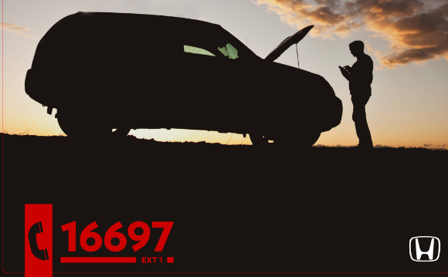

Challenges and Recommendations
Honda is a popular car brand in Bangladesh, but like any other foreign car brand, it faces several challenges when it comes to selling and marketing their cars in the country. Here are some of the challenges that DHS Motors Limited faces in Bangladesh for selling Honda passengers cars:
- Challenges:
- High import duty: The import duty for vehicles in Bangladesh is very high, making the price of imported cars significantly higher than in other countries. This can make it difficult for car companies to sell their products in Bangladesh, especially if they are priced higher than competitors.
- Lack of infrastructure: Bangladesh's road infrastructure is underdeveloped, particularly in rural areas. This can make it difficult for car companies to reach potential customers and lead to high vehicle maintenance costs due to poor road conditions.
- Limited financing options: Many people in Bangladesh do not have access to financing options that would allow them to purchase a car. This can limit the potential market for car companies, particularly for those selling higher-priced vehicles.
- Competition: There are several established car brands already operating in Bangladesh, including Toyota, Nissan, and Mitsubishi. This can make it challenging for new entrants like Honda to gain a foothold in the market.
- Strategies:
- Localization: To reduce the impact of high import duties, car companies could look at localizing their manufacturing or assembly processes in Bangladesh. This would help to reduce the cost of their products and make them more competitive.
- Developing infrastructure: Car companies could work with the Bangladeshi government to improve the country's road infrastructure. This would make it easier to reach potential customers and reduce maintenance costs for vehicles.
- Offering financing options: To reach a wider audience, car companies could partner with local banks to offer financing options for their products. This would help to make their vehicles more accessible to potential customers who may not have the funds to purchase a car outright.
- Marketing and branding: To compete with established brands, car companies could focus on developing strong marketing and branding strategies. This would help to build awareness of their products and create a strong reputation in the Bangladeshi market.
Overall, selling cars in Bangladesh can be challenging due to a variety of factors. However, by adopting the right strategies, car companies like Honda can overcome these challenges and tap into the country's growing vehicle market.

Conclusion
Customers in Bangladesh want the best for their families at a reasonable price. The festival is a significant aspect of Bangladeshi culture. According to the study, instead of focusing on the export market, the company can focus on lowering the price of replacement parts to draw in the broader market. It will also lead to a positive shift in client perception. HONDA and DHS Motors Ltd must develop a variety of large commercial vehicles to meet market demand in the industrial sector. Honda's competitive advantages in this respect might be highlighted as follows: reliability, energy efficiency, value for money, timely delivery, cutting-edge service, and cost reduction.

References

About Company. (n.d.). Retrieved from Honda Bangladesh: https://www.bdhonda.com/
Bangladesh Automobile Industry: Current Trends and Future. (2021, September 06). Retrieved from Business Inspection: https://businessinspection.com.bd/automobile-industry-of-bangladesh/
Keller, P. K. (2016). Marketing Management, 15th ed. Hoboken, NJ: Pearson Education.
Rahman, N. (2020, October 25). Automobile Industry in Bangladesh. Retrieved from PRITI Research & Consultancy Limited: https://pritibd.com/market-corporate-research/commercial-vehicle-industry-business-research-consultantin-bangladesh/
Report, S. B. (2022, September 19). Automobile Industry in Bangladesh. Retrieved from The Daily Star: https://www.thedailystar.net/business/news/rangs-motors-wins-volvo-eichers-best-commercial-vehicle-dealer-2020-21-award-2153581
Shawkat, T. (2022). Automobile Industry in Bangladesh : Rolling the Wheels of Economic Growth. Bangladesh: IDLC Finance Limited.

Top of Form

