Women Banking Service in Bangladesh: A Case Study from United Commercial Bank (UCB)

Nasrin Sultana

This report is submitted to the school of Business and Economics, United International University as a partial requirement for the degree fulfillment of Bachelor of Business Administration

Women Banking Service in Bangladesh: A Case Study from United Commercial Bank (UCB)

Submitted to:
Dr. Mofijul Hoq Masum, FCMA, ITP
Associate Professor SoBE
Director IQAC
United International University

Submitted by:
Nasrin Sultana
ID: 114 221 008
Major: BBA in AIS
Registration Trimester: Spring 2026


Date of submission: July 22, 2026

Letter of Transmittal
July 22, 2026
Dr. Mofijul Hoq Masum
Associate Professor, SoBE, UIU
Director, IQAC
Subject: Submission of internship report on United Commercial Bank PLC.
Dear Sir,
I am pleased to submit my internship report which has been written during my internship at United Commercial Bank PLC for Partial fulfillment of the requirement to complete my degree BBA in AIS. In this report, I have incorporated the knowledge and skills that I acquired through my academic coursework as well as the practical experience gained during my internship. While doing the internship and preparing this report I have faced several challenges. However, I have done my best to finish the report in an accurate, sincere, and professional manner. I would like to thank you for your valuable suggestions during the preparation of this report. Also, your instructions help me to complete my report in a systematic and effective manner.
I sincerely hope this report will meet your expectations and fulfill all the academic requirements. Thank you.
Sincerely,
Nasrin Sultana
ID: 114-221-008

Certificate of similarity index

Declaration of student

I am Nasrin Sultana, ID: 114221008, a student of BBA in AIS at United International University. I want to say that I made this report on ‘Women Banking Service in Bangladesh and it is a case study from United Commercial Bank’. I had to do this report as part of my internship. We have to do an internship report as part of our Bachelor of Business Administration program.
However, I got help from my supervisor Dr. Mofijul Hoq Masum, FCMA, ITP. I did this report to finish my Bachelor of Business Administration degree in Accounting and Information Systems, from United International University.

Corporate Evidence

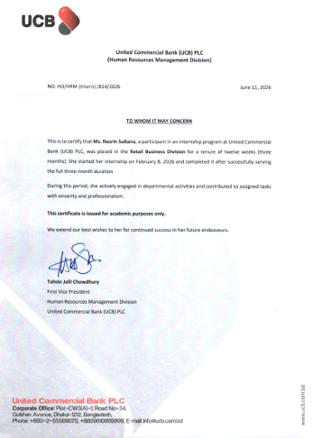

Acknowledgement
To begin with thanking the Almighty Allah for having bestowed me with strength, wisdom, and opportunity to complete my internship and the report. Also, I want to thank all those people who have assisted me in the preparation of this report. Firstly, I want to thank Dr. Mofijul Hoq Masum, FCMA, ITP who is my supervisor for his guidance in this report. His suggestions and motivation were of great help in writing this report. Secondly, I would also like to thank Mr. Syed Zubair Hossain, First Vice President, Retail Business Division, United Commercial Bank PLC, who was my mentor throughout the period of my internship. Through his mentorship and co-operation, I learned many things. He imparted me with his knowledge and also gave me the necessary information regarding my internship and the report. Thirdly, I wish to extend my sincere thanks to my senior employees of my card department of United Commercial Bank PLC for their support, cooperation, and encouragement during my internship period. They have provided me with the opportunity of gaining knowledge and practical skill through their friendly advice and professionalism, creating an environment that was very conducive for learning. The skills and information that I have learned throughout the internship have been a great contribution to my development. Lastly, I would like to acknowledge those who have contributed either directly or indirectly to this process.

Executive summary
This report presents a comprehensive overview of my three-month internship experience at United Commercial Bank PLC (UCB), Corporate Branch, within the Retail Business Division, specifically in the Card Section. The primary objective of the internship was to bridge the gap between academic knowledge and practical exposure in the banking sector, with a focus on retail banking operations and credit card services.
During the internship, I was engaged in a variety of analytical and operational tasks under the supervision of Mr. Syed Zubair Hossain, First Vice President of the Retail Business Division. A significant component of my internship was my involvement in a key project focused on the development of a women’s credit card. As part of this project, I prepared detailed documentation outlining the business model, target market, value proposition, and strategic positioning of the proposed “UCB Ayma Platinum Women Credit Card.” This project emphasized financial inclusion, market expansion, and customer segmentation, particularly targeting the underrepresented female segment in Bangladesh’s credit card market. I also compiled and analyzed Ramadan promotional offers using Microsoft Excel to identify market positioning and strategic differences among competing banks.
Overall, the internship provided valuable insights into real-world banking practices, enhanced my analytical and problem-solving abilities, and contributed significantly to my professional development.

Table of Contents

Table of Contents
Letter of Transmittal ii
Certificate of similarity index iii
Declaration of student iv
Corporate Evidence v
Acknowledgement vi
Executive summary vii
List of Figures x
List of Tables xi
List of Acronyms & Abbreviations xii
Chapter 1: Introduction 1
1.1 Background of the Internship 1
1.2 Objective of the Internship 1
1.3 Scope and limitations of the Report 1
Chapter 2: Company and Industry Profile 3
2.1 Company Analysis: 3
2.1.3 UCB’s Operations/Activities: 10
Department Overview 10
2.2.2 Size, Trend, and Maturity of the Industry 16
Trends 17
Chapter 3: Women Credit Card of UCBL 23
3.2Why Women Are Being Targeted for This Credit Card 23
3.3 Why Women Will Choose This Card Over a Regular Credit Card 23
3.4 Target Segments for This Card 24
3.7 Challenges and Expected Outcomes 36
How to Overcome the Challenges? 36
3.8 UCB Women Credit Card Design 36
Chapter 4: Internship Experience 38
4.1Internship Position 38
4.2Responsibilities and Tasks 38
Ramadan Offers Comparison: 38
4.3 Findings that I found during my internship project: 39
Recommendation 40
Conclusion 41
References 42
Appendix A 43

List of Figures
Figure 1: Annual fees/ Renewal Fees
Figure 2: Welcome Benefits (Value Share)
Figure 3: Interest Free period (Time share)
Figure 4: Supplementary Cards (Quality share)
Figure 5: Local Lounge Access (Value & Policy Strength)
Figure 6: International Lounge Access (Access Strength)
Figure 7: Meet & Greet Services (Frequency & Access)
Figure 8: Installment / EMI Schemes (Merchant Scope & Tenure)
Figure 9: Bonus Rewards System (Earnings Power)
Figure 10: Dinning offers (BOGO Network Strength)
Figure 11: Medical Benefits (Discounts & Cashback)
Figure 12: Lifestyle Discounts (Perks & Structural Cashbacks)
Figure 13: Grocery Benefits (Cashbacks & Multipliers)
Figure 14: Health Insurance Coverage (Max Financial Protection)

List of Tables
Table 1: Name of the employees whom I have taken the interview
Table 2: Introduction of women banking in Bangladesh
Table 3: Size, Trend, and Maturity of the Industry
Table 4: Target Segments for This Card
Table 5: Comparing Industry Value Propositions of competitive banks and UCB’s Unique Offers

‘’

List of Acronyms & Abbreviations
- UCBL- United Commercial Bank PLC
- AIS – Accounting Information System
- BBA- Bachelor of Business Administration
- BB- Bangladesh Bank
- ATM- Automated Teller machine
- POS- Point of Sale
- SME- Small and medium Enterprise
- CMSME- Cottage, Micro, Small and Medium Enterprise
- NRB- Non-resident Bangladeshi
- RFCD- Resident Foreign Currency Deposit
- DFS- Digital Financial Service
- MFS- Mobile Financial Service
- EMI- Equated Monthly Installment
- NID- National Identity Card
- IT- Information Technology
- CEO- Chief Executive Officer
- M&A- Mergers and Acquisitions
- ESG- Environment, Social and Governance
- UN- United Nations
- SDGs- Sustainable Development Goals
- UIU- United International University
- IQAC- Institutional Quality Assurance Cell
- FCMA- Fellow Cost and Management Accountant
- ITP- Income tax Practitioner
- AVP- Assistant Vice President
- BDT- Bangladeshi Taka
- EBL- Eastern Bank PLC
- BRAC- Building Resources Across Communities (BRAC Bank PLC)
- MNC- Multinational Corporation
- SMS- Short Message Service
- SWOT- Strengths, Weakness, Opportunities, Threats

Chapter 1: Introduction

1.1 Background of the Internship
As part of my graduate program, completing an internship is a mandatory academic requirement aimed at bridging the gap between theoretical knowledge and practical application. To fulfill this requirement and explore my career path, I joined United Commercial Bank (UCB), Corporate Branch, as an intern in the Retail Business Division. This internship provides me with the opportunity to gain real-world experience in the banking sector and to understand banking operations function in a professional environment. Through this experience, I am able to observe and participate in various activities that contribute to my overall career development.

1.2 Objective of the Internship
The primary objective of my internship is to gain practical experience and to apply the theoretical knowledge I have acquired during my academic studies. I aim to develop professional skills such as communication, customer service, and problem-solving, which are essential in the banking sector. Additionally, I seek to enhance my understanding of retail banking operations and to learn how financial services are delivered to customers. Another important goal is to gain hands-on experience by working on real tasks and projects, which will help me to build confidence and to prepare for my future.

1.3 Scope and limitations of the Report
This report provides an overview of my internship experience at United Commercial Bank (UCB), Corporate Branch. It includes a brief introduction of the bank and its operations, particularly in the Retail Business Division. The report also describes my roles, responsibilities, and the tasks I have performed during the internship period. Furthermore, it highlights the knowledge and skills I have gained, along with the projects I have been involved in. Finally, the report evaluates my overall learning experience and its impact on my career plans.
I have also taken an interview session of 5 senior female employees of my card department. They are:

The following questions I have asked them:
- How you have learned about women credit card?
- Do you use any women credit card?
- If yes, then what type of criteria or benefits you look forward?
- Which bank’s women’s credit card are you familiar with?
- Is women credit card is useful to you?
- How satisfied are you with the benefits offered by your credit card?
- Would you recommend other women to use women’s credit card?

Chapter 2: Company and Industry Profile

2.1 Company Analysis:
The full legal name of the organization is United Commercial Bank PLC (UCB), one of the leading private commercial banks in Bangladesh. The bank operates in the banking and financial services industry, specifically within the private commercial banking sector, contributing significantly to the country’s economic development through financial intermediation and service delivery.
United Commercial Bank PLC (UCB) which was formed mid-way through 1983. It is a privately owned first generation commercial bank of Bangladesh. Throughout four decades, it has developed from a typical banking entity into a full financial services organization, listed in the Dhaka and Chittagong Stock Exchange and also considered as the member of the coveted DSE30 Index. Being headquartered in the capital city of Bangladesh, Dhaka, it provides services to varied clientele across 236 branches in Bangladesh as well as through 700 ATM booths that employ more than 5,600 staffs. Apart from this, it has established a robust ATM network as well as agent banking branches so that people who do not have access to their branches can also avail themselves of their services. The Bank has associations with 611 foreign banks and financial organizations around the world. Vision of being the “bank of first choice” of the UCB is founded upon the principles of responsibility and purposefulness. UCB has always done things in a way that supports the United Nations Sustainable Development Goals. The main part of this commitment is the "Investing in Society" program. This program is important to UCB. They make sure to use some of their profit to help the community. UCB thinks child education and welfare are very important. They also want to help women become stronger and more independent. They give special care to older people. UCB really cares about the Investing, in Society program and the United Nations Sustainable Development Goals.
2.1.1Overview and History of UCB:
Vision:
To become the first choice bank by transforming into a truly world-class financial institution.
Mission:
To provide high-quality financial services with the latest technology, ensuring customer satisfaction and sustainable growth.
Core Values:
- Customer focus
- Integrity and transparency
- Innovation and excellence
- Teamwork and professionalism
- Commitment to growth and sustainability

2.1.2 Products/Services/Customer Mix of UCB
Liability Products of UCBL:
Liability products of UCBL is collecting deposits from their customers. These deposits are considered liabilities on the bank's balance sheet because the bank is liable to repay the money to depositors. UCBL offers various type of liability products for individuals, businesses, NRBs (Non-Resident Bangladeshis), students, women, and pensioners. They are;
- Current Account- The current account of UCBL is basically a general banking account where the customer can do any transaction without any restrictions as long as they have money in their account. Using this account customer can do daily transactions. The opening balance of a current account in Urban is 2000 BDT and in Rural 1000 BDT.
- Savings Account- UCB Savings Account is basically a chance to make customer’s money grow with a good interest rate. It refers a starting of saving to make their future safe. The UCB Savings Account has a savings rate that helps in money growth. The opening balance of a saving account in Urban is 2000 BDT and in Rural 1000 BDT.
- Dynamic Benefits Savings Account- It is a savings account that offers dynamic features not similar to other accounts. The more you add your savings, the more benefits you get. The opening balance of this saving account for both Urban and Rural are 50,000 BDT.
- UCB NRB Savings Account- UCB appreciates all the non-resident Bangladeshis living in aboard and values their contribution on our economic growth. The bank ensures their earned money becomes secured. The opening balance of this saving account in Urban is 2000 BDT and in Rural 1000 BDT.
- UCB Youngsters Savings- UCB offers youngsters an amazing way to start their savings in an early age. The age limit is below 18 years and its opening balance is 100 BDT.
- Sabuj Shanchay Account- UCB appreciate paperless banking to protect environment that is why they bring a new concept of account which is Sabuj Shanchay Account. It is a low cost savings account with lucrative that deals for conscious people who wants to reduce carbon footprint at every step ahead.
- RFCD (Resident Foreign Currency Deposit Account)- UCB offers this account to any ordinary residential person of Bangladesh with foreign exchanges brought in at the the time of their return from travel.
- Pensioner Savings Account- A savings account for government/semi-government/Autonomous Bodies/Private officials to keep their retirement savings/pension income safe and earn attractive interest.

Asset Products of UCBL:
Asset Products of UCBL refer to the financial products by which the bank collect loans or invests its money in order to generate their income. Asset Products are shown under the assets part in the bank’s balance sheet since these are income-generating instruments for the bank. The main Asset Products of UCBL include different kinds of loans and advances to customers.
- Personal Loan- UCB gives their customer a support to live their life smoothly that is why they provide personal unsecured loan for them such as education, travel, medical expenses, or household purchases. The maximum loan limit is 20 lac BDT.
- Auto Loan- UCB offers auto loan to their customer so that they can fulfill their luxury wishes without any barriers like card loan. The maximum loan amount is up to 60 lacs BDT or 60% of the card value, whichever is lower. There is no hidden charges. Convenient loan repayment tenure is up to 6 years.
- Home Loan- UCB provides home loan to their customer so that they can buy their dream home with an easy financing solution, featuring competitive interest rates and a host of benefits. The maximum loan amount is up to 2.00 crores. It has flexible repayment tenure up to 25 years. It has no hidden charges. It has attractive variable interest rate and fee.

Opening bank account:
The following are some of the guidelines and principles that should be adhered to by the bank while opening new accounts. For this purpose, some genuine certificates need to be provided by the clients such as NID (national identification card), students ID, a valid document containing the address of the visa photographs. Client has to maintain a certain proportion of cash balance for opening the account which is called security cash and that no client ever denies. After providing the required documents and confirming the documentations, the specific authority is waiting for the signatures of the departmental head. Once the authority receives signatures, the concerned client will open his account. But in case of the death account, nominees of the deceased person has to collect the money-
- Death Certificate
- Proof of relationship from council
- If 'no candidate 'is found then right beneficiary/beneficiary ought to bring the progression endorsement from the court
- Permission, from the cemetery where the person is buried
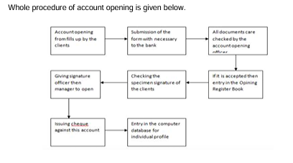
UCB’s Card Facilities
United Commercial Bank Limited offers various card facilities to its customers. These include 5/6 credit cards. Their blue and green cards are for ordinary customers. In accordance with their customers and their deposits, they offer gold and platinum cards. The customers with an annual fee of six lacks of BDT will be offered gold credit cards and with 28 lacks of BDT will be offered platinum credit cards.
Beside these cards, UCB also provide business card, Visa card etc.
UCBL’s most widely used credit card is called the Visa Platinum Card. This credit card provides the best features to its customers across the globe. The unique credit card is classified according to the facilities offered into gold, platinum, bronze, blue, and black color. This unique credit card is available throughout the world except the Middle-East.
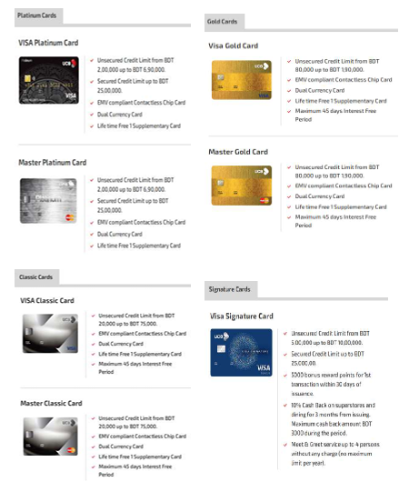
Cheque Issue:
Cheque is an instrument through which we get money from the bank. It is a good policy in which we start getting money from one place and continue up to next without any failure. If somebody opens the bank account, he/she can ask for a cheque book according to the request form. After verifying the signature of the record holder by its authority, we can get our cheque book. Then we can assign numbers for escapes and registration and numbers of the leaves in register book. We can make record numbers on each leave of the registration. Two authorities make the record numbers and leaf numbers. We can verify the register book also after that by the capable authority. Finally, the registration will be given to the party after taking the signature on the register book.
Clearance Section:
Clearing may be considered as an agreement between the branch banks on accounts that are raised against each other on account of the resistance drawn by them in the chosen period of time. Clearing House can be defined as a place in which a certain branch bank and other branch banks agree to meet and exchange the resistance drawn on each other in exchange for the instrument drawn against them. Total receivable and payable balances are maintained with the controlling banks.

Organizational Structure
United Commercial Bank PLC follows a hierarchical organization structure. At the top of the pyramid, the Board of Directors is charged with making strategic decisions and formulating policies. The Managing Director & CEO is in charge of overseeing the bank’s operations.
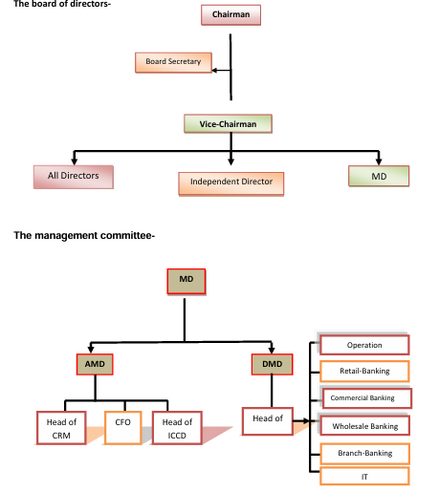

The organization is divided into several key divisions, including:
- Imperial Banking Division
- Corporate Banking Division
- SME Banking Division
- Operations Division
- Human Resource Division
Each division is managed by experienced professionals and further structured into departments and branch-level units. During my internship in the Retail Business Division, I worked under the supervision of branch officials and gained practical experience in banking operations and customer service.
Key Achievements
- Established as a leading first-generation private bank in Bangladesh
- Expansion to a wide network of branches and ATMs nationwide
- Introduction of modern digital banking platforms
- Recognition for strong financial performance and customer service quality

2.1.3 UCB’s Operations/Activities:
- UCB Investment Limited: A 100% owned, award-winning merchant bank (Best Investment Bank in Bangladesh 2024) specializing in bond structuring, M&A, and corporate advisory.
- UCB Fintech Company Limited (upay): A 99.99% owned Digital Financial Service (DFS) brand offering mobile wallets, co-branded prepaid cards, and safe digital transactions.
- UCB Stock Brokerage Limited: Providing specialized capital market services and trading infrastructure.
- UCB Asset Management Limited: Focusing on wealth management and investment funds.
- UCB Exchange (SG) PTE. Ltd.: The group’s international arm in Singapore, facilitating cross-border financial needs.

Department Overview
During my internship at United Commercial Bank PLC, I was assigned to the Retail Business Division, specifically the Card Section. This department focuses on providing card-related banking services to individual customers, including debit and credit card facilities. It plays an important role in enhancing customer convenience and promoting cashless transactions.

Role within the Overall Company Structure
The Retail Business Division is one of the core customer-focused divisions of the bank. It operates under the broader banking structure alongside divisions such as Corporate Banking, SME Banking, Operations, and Human Resources. Within this division, the Card Section plays a significant role in expanding the bank’s retail services by offering modern payment solutions. It supports the bank’s objective of digital transformation by encouraging customers to use cards for daily financial transactions. This department also works closely with other units such as Operations (for processing) and IT (for system support) to ensure smooth card services.

Key Functions and Responsibilities of the Department
The Card Section is responsible for managing all activities related to debit and credit cards. Its key functions include:
- Card Issuance: Processing applications for new debit and credit cards
- Card Activation and Delivery: Ensuring cards are properly activated and delivered to customers
- Customer Support: Handling customer queries, complaints, and service requests related to cards
- Card Maintenance: Updating customer information and managing card renewals or replacements
- Dispute Handling: Supporting the resolution of transaction disputes and unauthorized activities
- Promotion of Card Services: Encouraging customers to use card-based payment systems
Through my involvement in this department, I gained practical exposure to how card services are managed and how customer interactions are handled in a professional banking environment.
2.1.4 SWOT Analysis of UCB
United Commercial Bank has already been in operation for 43 years, which means that this bank must have tasted many flavors of success as well as failure in their business journey. Therefore, it can be said that this bank must be having more strengths and opportunities than weaknesses and threats. The opportunities are plenty because this bank plays a very important role in the marketplace. SWOT analysis is an essential exercise for any company because without this no business strategy can be made.
In short, SWOT stands for “Strengths, Weaknesses, Opportunities, Threats”. Strengths are characteristics coming from inside the business that will enhance the company’s goals. Weaknesses are negative characteristics which are also inside the business. Opportunities and threats are characteristics coming from the external environment, such as changes in the market, technological advances, or competition. Opportunities are characteristics that will greatly enhance the company if seized properly. Threats are characteristics that can prevent the operations of a company and should always be on guard against.
Strengths:
- UCB is among the pioneering private banks in the country having high reputation in the banking sector of Bangladesh.
- UCB encourages an interactive corporate culture as well as idea freedom and development between executives and workers.
- UCB enjoys a good reputation of offerings quality services to its customers. There are large numbers of branches available strategically all over the country for convenience of the customers.
- Maintaining a modernized workplace environment equipped with modern facilities.
- Fostering a good relation with Bangladesh Bank through the years.
- The introduction of Agent Banking which is a type of banking facility provided in remote villages making easier and more accessible.

Weaknesses:
- Although the bank provides much better quality compared to other private banks in the area of Bangladesh, it could not match Multinational banks such as HSBC or Standard Chartered Bank.
- The marketing department is comparison to foreign banks is very weak.
- UCB earns its money through interest; therefore, it is liable to interest rate charges.
- Jobs diversification in UCB is less compared to foreign banks.
- Modern technology and system updating can help in improving efficiency.
Opportunities:
- Due to the better economic conditions UCBL income growth increase.
- UCB could try to grow in the rural areas by using Agent Banking, which it started last year.
- Improving recruitment strategy to hire more efficient employees for the junior and middle-level jobs.
- Since UCB is such a big bank, it could grow its portfolio, reducing business risks at the same time.
- The bank needs to consider investing in other products and services.
- UCB has good opportunities in the development of retail banking and consumer finances due to the growing middle class in Bangladesh.

Threats:
- UCB must be cautious regarding the dangers of defaults in each and every term of the loan process and steps should be taken to reduce them in order to maintain the financial market.
- Some of the restrictions and rules of Bangladesh Bank hinder the growth of the bank and even discourage investors.
- The younger banks display great aggression and take high risks which become very competitive for UCB.
- The younger banks also banks also spend a lot on their marketing campaigns; however, UCB does not, making them lose some good clients and investors.
- The growing danger of cyberattacks is also a risk for UCB.

.SWOT Analysis:
Here is the pictural figure of SWOT analysis of UCB;

2.2 Industry Analysis:
2.2.1 Specification of Industry
Introduction of women banking in Bangladesh:
Women's Banking Services is a concept related to the services designed for women of Bangladesh to fulfill their needs, hence ensuring their inclusion in the world of finance. Woman banking in Bangladesh is a specialized niche market in the larger field of banking, which serves to cater to the specific financial requirements of women. It has been strategically identified that women constitute a strong economic entity, but still, there are many obstacles faced by them to avail of financial services. Women’s banking services acknowledge the difficulties faced by women in accessing these financial services. In Bangladesh, the beginning of women's banking was introduced by BRAC Bank Limited in 2017 and they introduced the service named as "TARA" .With its introduction, women's banking was entirely revolutionized with various financial services provided to women of all categories including housewives and entrepreneurs. After BRAC Bank, EBL bank introduced many women banking factors such as, Women savings account in December 31st 2023, EBL Women Confidence DPS in May 1 2024, EBL Women Payroll suite in October 3, 2024, EBL Women’s Islamic Savings Account in September 2024. And, In January 2024 NCC Bank launched ‘NCC Parama’ to supports financial prosperity of women segment in the market, to actively participate in entrepreneur development, to provide specialized benefits to female customers, also offers deposit and loan services to women. Women has been made up 16.53% in banking workforce whereas there is only 9.38% at senior leadership levels. According to Bangladesh Bank mandates. The industry can be characterized as follows:
The industry is defined by several key features:
1. Bangladesh Bank, which is the central bank of Bangladesh, has made it a point to include women in the financial system. They want to make sure that women have access to money and loans just like men do. The Bangladesh Bank has come up with some rules to make this happen.
These rules include:
- Mandatory Quotas: The Bangladesh Bank says that banks have to give loans to women who own businesses. They have to give fifteen percent of all business loans to women by the year 2029.

- Specialized Units: The Bangladesh Bank is telling banks to create teams to help women who own businesses. These teams are called Women Entrepreneurs Development Units and Women Entrepreneurs Dedicated Desks. They will show women how to get loans and make their businesses successful.

- Agent Banking Quota: The Bangladesh Bank also wants to make sure that women are involved in a type of banking called agent banking. They say that least fifty percent of the people who do agent banking work should be women. The Bangladesh Bank is really pushing for this to happen even though it might be hard to achieve. The Bangladesh Bank is working to help women entrepreneurs by giving them access to loans and other resources. This will help the women entrepreneurs, in Bangladesh to grow their businesses and become successful.

- Women Financial Inclusion Data (WFID) Dashboard: It is a real-time database which tracks the progress of women’s financial inclusion in Bangladesh and is unique in South Asia.
2. Women-Banking Programme by Banks: Banks have also reacted to this challenge by developing women-banking programme. One such programme is the "Adbita" programs of Eastern Bank PLC (EBL). It is a capacity development programme where training is provided in business and finance. The women's portfolio of EBL is estimated to be about BDT 10,000 crore in deposits and BDT 1,000 crore in loan from women.
3. Women Entrepreneurs' Support Programme: The thrust area in this industry is supporting women entrepreneurs and SMEs who contribute to the national economy. Products are designed to solve typical problems like need for collaterals. Some banks have also launched small ticket savings account along with overdraft facility based on saving records of the women. Another new banking paradigm is focusing on data-driven intelligent credit scoring for women based on their transactional histories without paperwork.

2.2.2 Size, Trend, and Maturity of the Industry
The industry is in a phase of rapid growth and expansion, moving from a niche concept to a mainstream banking focus, although it is still maturing.
The sector has been remarkable growth since 2017:
Metric | 2019 | 2024 | Growth
Female deposit accounts | 33.45 million | 55.32 million | +65%
Women’s share deposit accounts | 30% | 35% | +5%
Female loan accounts | 918,980 | 2.15+ million | +134%
Women’s share loan accounts | 8.31% | 16.49% | +8.18%

Trends
Several key trends are shaping the industry:
    - Digital as a Great Equalizer: The digital approach to financial services is now seen as the most effective way for inclusion. Women use mobile banking services such as bKash and Nagad actively, with females accounting for about 42% of 239.3 million MFS accounts opened. The problem is that the majority of women are customers, not agents of services.
    - The Main Focus Is on "Agent Banking": Agent banking, providing access to services to remote rural areas, is one of the main ways of expanding the customer base. Agent banking has attracted more than BDT 472 billion in deposits and works as an important link for rural women. 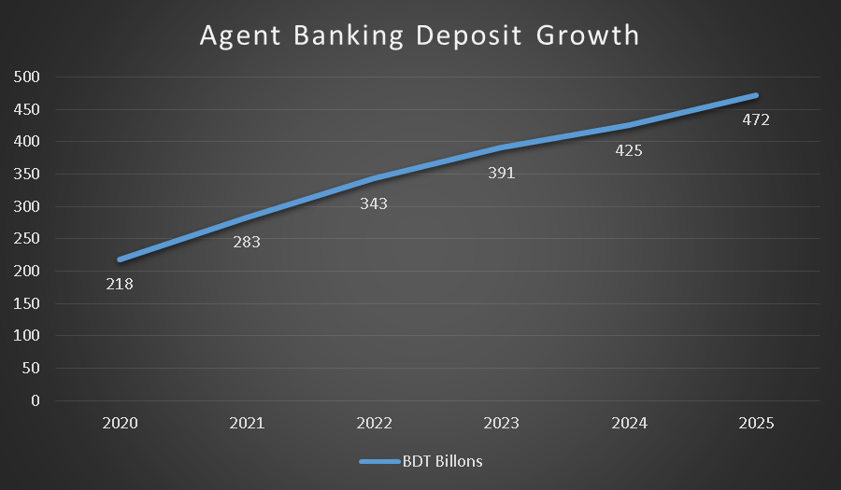
    - Gap between Policy and Implementation: Policies are progressive, but there are problems with their implementation. For instance, the requirement of 50% of women among entrepreneurs of agent banking services is the reason for slowing down development of agent banking due to a lack of qualified women among the potential candidates in rural areas.
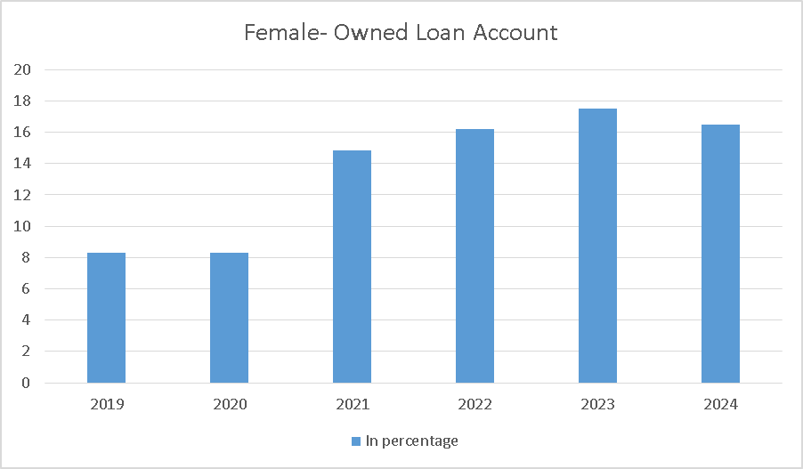
    - Emergence of Gender-Intelligent Products: Financial institutions have started launching innovative gender-specific products. Some examples of such products include unsecured loans and products which provide access to both savings and credit.
    - The 1% Problem: Even though women form half of the customer base for digital financial services, traditionally less than 1% of MFS agents are women. This has been a major weakness in the industry but has been addressed through innovations which highlight the importance of female agents. Studies suggest that women agents help build trust and encourage more female customers to use the service.

Maturity
The industry is currently at a "Growth" stage where it has progressed beyond the awareness stage and is rapidly scaling up thanks to favorable government policies and innovations in the private sector. Nonetheless, the industry is not mature enough yet.
Most Important Characteristics of Its Current Maturity:
- Government Policies: Strong government policies have formed the bedrock of the industry but enforcement remains difficult.
- Experimentation and Innovation: There is experimentation and innovation taking place among banks with initiatives such as EBL's "Adbita" and the savings-based overdrafts of Mutual Trust Bank.
- Remnant Gaps: The huge disparity in the number of women who have deposits as opposed to loans and the low percentage of loan assets indicates that although women have the capacity to save, getting substantial credit remains a major challenge.
- Ecosystem Development: It is increasingly being acknowledged that addressing the issue needs an ecosystem approach with banks, regulators, finteches, NGOs, and women’s business organizations all playing their part .

- 2.2.3 SWOT Analysis of Industry

UCBL Women Banking: Ayma
Introduction of Ayma
AYMA is a separate banking segment of United Commercial Bank PLC which mainly serves female customers. The bank introduced this special segment in an effort to economically include women in the country. Through AYMA banking services, the bank assures its customers that female customers are their topmost priority.
Objectives of AYMA
AYMA helps women customers to become self-sufficient by offering them a wide range of banking facilities. UCB AYMA wants women from all sectors of the society to join its special segment and promote saving as well as entrepreneurship.
Main Products of Ayma
Among different women-oriented products offered by AYMA. The type of products UCB is offering:

AYMA Savings Account
AYMA Savings Account can be opened by any woman of Bangladeshi Origin who is aged 18 or above. Different services under AYMA savings account includes; Visa Debit card, MasterCard debit card, cheque book, internet banking, SMS Banking, e-Statement and branch, ATM, POS, UCBONE and UPAY transactions. The features of AYMA Savings Account:
- The opening balance of this account is for urban 1000 BDT and for rural 500 BDT.
- The internet banking fee is free.
- The debit card issuance fee is 400 BDT.
AYMA Entrepreneur Facilities for Women
Different women-specialized facilities like AYMA entrepreneur facilities which comprises a) Sonirvor Current Account and b) Dipti Term Loan are introduced to help women run their business smoothly with latest banking facilities.
AYMA Sabolombi Easy Account
This is a current account product offered under the AYMA women-targeted SME banking line of UCB. This account is tailored for female-owned sole proprietorship businesses; however, there are other versions of this account for female farmers and micro-activities. The features of AYMA Sabolombi Easy Account:
- The minimum opening 10 BDT only,
- Unlimited transactions,
- 24 hours access to ATMS,
- Internet Banking (on demand and free),
- SMS Banking facility.
AYMA Prottoyi Monthly Deposit Scheme
This is a monthly savings plan provided for women CMSMEs across the country. This plan allows the women entrepreneur to develop savings through regular monthly deposits; here the minimum monthly deposit would be BDT 500 and tenors of 3, 5, or 10 years.
AYMA Fixed Deposit
AYMA Fixed Deposit is a deposit plan offered by UCB for women-oriented SME customers as part of AYMA deposit products. The publicly available rate sheet shows that UCB has been offering different AYMA fixed deposit rates by tenor like 90, 180, or 360 days, although the rate will change from time to time. The features of AYMA fixed deposit:
- It has monthly/ Quarterly / Half-yearly interest payment.
- The minimum opening balance is 50000 BDT.
- It is flexible tenor from 1 to 10 years.
- Its interest will be credited automatically to UCB current/savings Account.
AYMA Debit Card
The AYMA Debit Card is a debit card connected with AYMA account holders to facilitate daily banking of AYMA women customers. In layman’s language, it facilitates cash withdrawal, merchant payment, and transaction using account funds without cash holding. The features of AYMA Debit Card:
- The credit limit of unsecured card is from BDT 20,000 up to BDT 75,000.
- It has EMV compliant contactless chip card.
- It has Dual Currency card facility.
- A life time free 1 Supplementary card.
- Maximum 45 days interest free period.

Chapter 3: Women Credit Card of UCBL
3.1 Introduction of Women Credit Card
There are many cases where women take part in working, becoming entrepreneurs, and leaders in Bangladesh. The economic progress of Bangladesh has been significantly enhanced due to the contribution of female members. In the past decade, female labor force participation rate has increased to approximately 36% to 38%. Moreover, the total number of female entrepreneurs has also been rising. Especially, there are many cases where women become entrepreneurs through small and medium-sized business ventures and online enterprises. There has also been an increase in the number of female customers who use the services offered by financial institutions.
Women credit card is a symbol of empowerment, financial freedom, and recognition for women. It focuses on the lifestyle, financial needs, and objectives of women. Approximately 0.3 million to 0.65 million women are using women credit cards in Bangladesh. The main difference between a woman credit card and other traditional types of credit cards lies in their benefits in various domains such as health and well-being, education, leisure trips, shopping, safety, and entrepreneurial assistance.

3.2Why Women Are Being Targeted for This Credit Card
Females are one of the fastest-growing but underserved customer segments in the banking sector of Bangladesh. The employment rate for females back in 1990 was only 27%, but currently, the percentage has risen to 34.02%. The numbers of female entrepreneurs in the country are on an increasing trend as they own 20-25% of SMEs in Bangladesh which is responsible for generating jobs and stimulating economic development. Despite their rising numbers, many women do not have access to traditional financial products such as credit cards.
Offering new financial products and services to this particular market segment would enable UCB to increase its outreach, develop a base of loyal customers, and fulfill global
environmental, social, and governance requirements. Moreover, research shows that compared to male borrowers, female borrowers are relatively riskier because of their higher rates of repayments.

3.3 Why Women Will Choose This Card Over a Regular Credit Card
Women Credit Card is unique in comparison with a regular credit card in respect of target, cost, and value proposition, whereas the difference does not exist with regard to the basic characteristics and functionality of the card. Both a regular credit card and Women Credit Card provide similar services, like cash withdrawal at ATMs, POS, and through Internet transaction, etc. But there is a significant distinction with regard to the target of Women Credit Card, which has been designed specifically for women. Its issuance is normally done in relation with women banking package, and provides exclusive benefits to women cardholders in the form of reduced cost, no cost, and other lifestyle advantages including discounts on clothes, health, wellness, and retailing, etc. Apart from it, Women Credit Card also provides additional advantages in respect of loan facility and EMI to women cardholders, particularly women entrepreneurs. However, a regular credit card is a regular product that is provided for the benefit of general public with same cost and benefits for all. Therefore, Women Credit Card is the segmented version of regular credit card with added value.

3.4 Target Segments for This Card
The main targeted customers of the UCB Women Credit Card will be corporate workers, government workers, teachers, women entrepreneurs, freelancers, young professionals, and working mothers. This is a quickly rising and financially active group of customers in Bangladesh.
The contribution of women to the national workforce has grown considerably in the last few decades. According to statistical information provided in 2024-2025, women comprise about 34.02% of the labor force of Bangladesh. There are around 23.7 million women who work as part of the labor force of Bangladesh. The number of women workers employed in the garments sector is 17 lakh, and those employed as corporates or in companies is 50-70 lakh.

Professional Women | In Numbers | Percentage(approx.)
Banking and Finance | 3-5 lakh | 6.7%
Pharma & Healthcare (corporate) | 4-6 lakh | 8.3%
Corporate/MNCs | 8-12 lakh | 16.7%
Education | 10-12 lakh | 18.3%
Hospitals/Clinics | 6-8 lakh | 11.7%
Retail & SMEs | 8-10 lakh | 15.0%
IT & Tech | 2-3 lakh | 4.2%

Furthermore, the number of entrepreneurial activities being conducted by women is gradually increasing. Presently, there are about 720,000 female entrepreneurs in Bangladesh that participate in SMEs, e-commerce, and microbusiness activities. Meanwhile, more than 60% of women working as employees in various establishments conduct self-employment and small business ventures, showing a high demand for finance that can be conveniently availed.
The freelance economy is likewise rapidly growing in Bangladesh, which consists of approximately 650,000 freelance workers; many of whom are females in the area of digital and online business establishments. The scenario brings to light the existence of a new generation of women earners who are presently not served by traditional banking institutions.
Despite differences in profession and income levels, these women share common needs:
- Convenience in financial transactions
- Access to tailored financial benefits
- Financial independence and control over spending

3.5 Current Credit Card Users vs Non-Users & How to Convince Them

As of now, there are fewer credit card holders in the country as not even ten million credit cards are available out of the total population of around 170 million people. Among those who use credit cards, males constitute a larger number compared to females.
Many women have to depend on their supplementary cards because of various reasons like:
- Low financial awareness
- Security issues
- Banking services availability problems
But this difference provides great potential to make use of.
For attracting more female customers, UCB should concentrate on providing financial education, simple application processes, reduced minimum income levels, and improved safety measures. And in order to attract more credit card users, stressing on the advantages of the card in line with lifestyles will definitely help in getting customers for the Women Credit Card.

3.6Comparing Industry Value Propositions of competitive banks and UCB’s Unique Offers
UCB competing banks in terms of market are BRAC Bank, CITY Bank and EBL Bank. From them I did little research on the value proposition those competitive banks provide to their women customer using their Women's credit card. I also went through some of the articles through which I found where women needs are more and where they are lacking behind. So considering market demands, bank's research, surveys and my own perceptions, I designed a Value proposition/ benefits/ features of UCB Women' Credit Card.
- Annual / Renewal fees (Lower is better share)
This reflects the cost aspect where the higher percentage share means that the bank is charging a higher baseline fees.

Bank / Card | Details | Proportional share value
EBL | BDT 3000 (P), BDT 10000(S) | 42%
BRAC | BDT 5000 (W), BDT 2500(P) | 24%
City Alo | BDT 3000 | 10%
UCB | BDT 4500 | 22%

- Welcome Benefits (Value Share)
This value share reflects which bank is giving more rights if value to the customer.

Bank / Card | Details | Proportional share value
EBL | None stated | 0%
BRAC | BDT 1000 cashback + Exclusive Vouches | 45%
City Alo | None stated | 0%
UCB | 5000 Activation Reward points | 55%

- Interest Free period (Time share)
As all the banks are providing same benefit so the percentage is equal.

Bank / Card | Details | Proportional share value
EBL | Up to 45 days | 25%
BRAC | Up to 45 days | 25%
City Alo | Up to 45 days | 25%
UCB | Up to 45 days | 25%

- Supplementary Cards (Quality share)
Here, the maximum number of cards that bank is giving are sharing the highest percentage.

Bank / Card | Details | Proportional share value
EBL | First 2 cards free | 28.6%
BRAC | First 2 cards free | 29%
City Alo | First 2 cards free | 29%
UCB | First card free | 14.2%

- Local Lounge Access (Value & Policy Strength)
It is rated by the frequency of visits allowed and guest privileges.

Bank / Card | Details | Proportional share value
EBL | SKYLOUNGE access (24/7, 1 guest + kids under 12) | 25%
BRAC | BALAKALOUNGE (Primary + up to 3 guests) | 25%
City Alo | Free 5 visits/ year (Domestic & International) for cardholder + 3 companions | 20%
UCB | Unlimited Free access to UCB Domestic Lounges + 1 guest | 30%

- International Lounge Access (Access Strength)
The highest rank is the bank that provides the widest global footprint and best free visit allocations.

Bank / Card | Details | Proportional share value
EBL | Priority Pass (1300+ lounges) | 20%
BRAC | Lounge key (1100 to 1500+ lounges); 4 free visits/ year | 20%
City Alo | Same as local lounge( capped at 5 visits/ year total) | 15%
UCB | Unlimited free access to Imperial Lounges  + PriorityPass (1800+ lounges) | 45%

- Meet & Greet Services (Frequency & Access)
Here, Airport Assistance features are compared.

Bank / Card | Details | Proportional share value
EBL | Complimentary at Dhaka Airport (booking required) | 25%
BRAC | Complimentary up to 3 times/year | 25%
City Alo | Unlimited access to the Amex lounge via reward points | 25%
UCB | Complimentary at Dhaka Airport | 25%

- Installment / EMI Schemes (Merchant Scope & Tenure)
It is evaluated based on tenure flexibility and merchant network size.

Bank / Card | Details | Proportional share value
EBL | EBL (3-36 months) + Want 2 Buy conversion | 25%
BRAC | Pay Flex (0% EMI) at 1700+ merchants | 30%
City Alo | 0% interest flex buy up to 36 months | 20%
UCB | 0% EMI specialized for maternity, delivery, and professional courses (36 months) | 25%

- Bonus Rewards System (Earnings Power)
It is evaluated based on the multipliers and diversity of point-earning categories.

Bank / Card | Details | Proportional share value
EBL | SKY Coins on retail purchases | 15%
BRAC | 1000 points on milestone blocks (Aarong/ Bata/ Parlors/ Passport) | 30%
City Alo | 2 points per BDT 50; 10 points at selected merchants (caps apply) | 30%
UCB | 10x points on dining (double dates), Local Reward point (2 points per BDT 80), Ross Border reward point (2x points per USD 1) | 25%

- Dining offers ( BOGO Network Strength)
It indicates which banks are providing the heaviest coverage of 5- star premier partner hotels.

Bank / Card | Details | Proportional share value
EBL | BOGO offers year-round | 15%
BRAC | Buy 1 Get 1 or 2 Free buffet at top restaurants | 25%
City Alo | Companion dining at Radisson, Dhaka Regency, Sarina, etc. | 20%
UCB | BOGO 2 times/month at a massive roster of 5-star chain hotels | 40%

- Medical Benefits ( Discounts & Cashback)
The medical benefits that the banks are providing;

Bank / Card | Details | Proportional share value
EBL | None stated | 0%
BRAC | Up to 25% discount at Labaid Hospital, 7% discount at Square Hospital, 5% discount at United Hospital | 50%
City Alo | 15% discount on pathology, 10% discount on imaging/rooms at Labaid Hospital | 35%
UCB | 5% cashback or max cap BDT 300 on pharmacy | 15%

- Lifestyle Discounts (Perks & Structural Cashbacks)
It is evaluated by lifestyle coverage and direct money-back rewards.

Bank / Card | Details | Proportional share value
EBL | General discounts available | 10%
BRAC | Double points on Tuesday + year-long discounts | 25%
City Alo | 20% at VLCC + 10% cashback (up to 1500 BDT per month) | 45%
UCB | Year-long 10% discount at leading lifestyle stores | 20%

- Grocery Benefits (Cashbacks & Multipliers)
It indicates which bank is providing the most daily essentials offers to its clients.

Bank / Card | Details | Proportional share value
EBL | General discounts available | 10%
BRAC | 6x points on Saturday groceries | 25%
City Alo | 10% cashback(up to BDT 1000/month) | 45%
UCB | 10% cashback ( max BDT 800/year) | 20%

- Health Insurance Coverage (Max Financial Protection)
It is based on the ceiling cap of the insurance payouts.

Bank / Card | Details | Proportional share value
EBL | Max BDT 10 Lac (outstanding waived + equal paid) | 15%
BRAC | Credit Shield (Max BDT 40 Lac for accidental, 20 Lac natural death) | 40%
City Alo | Max BDT 20 Lac DBI + outpatient/hospitalization matrix | 25%
UCB | 400% of outstanding coverage + BDT 3 LAC for critical illness | 20%

3.7 Challenges and Expected Outcomes
As, there is many women credit card in the market, UCB can face the following challenges while launching new product as well as to grab new female customers. Here, is the challenges and outcomes that UCB can face in future.
Challenges in Selling Women-Based Credit Card
- Low interest in using credit card
- Fear of debt and misuse
- Lack of financial knowledge about credit card
- Trust issues (fear of hidden charges and fraud)
- Complicated application process
- Irrelevant offers that don’t match real needs
- Weak targeting and lack of customer data use

How to Overcome the Challenges?
- Promote card as a useful daily tool, not a luxury
- Show benefits like convenience and safety
- Provide spending limits and alerts
- Run financial awareness campaigns
- Keep fees transparent, send SMS/app alerts for every transaction, ensure strong fraud protection
- Make process simple and digital, reduce paperwork, offer quick approval
- Provide useful & everyday offers, customize based on lifestyle
- Analyze customer data, segment women customers & personalize offer

3.8 UCB Women Credit Card Design
Color Theme: Royal Blue (primary) & Ocean Blue gradient (secondary). The combination of royal blue and ocean blue is chosen to create a perfect balance of trust, elegance, and emotional comfort, which are essential for a premium credit card like UCB Ayma Platinum; royal blue represents strength, stability, and reliability—key qualities that build confidence in banking services—while ocean blue adds a sense of calmness, smoothness, and approachability, reducing users’ hesitation toward credit usage, and when blended together in an aurora-style gradient, these colors produce a modern, luxurious, and visually appealing design that feels both empowering and sophisticated without relying on traditional or stereotypical color choices.

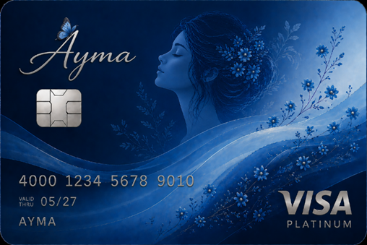

Chapter 4: Internship Experience

4.1Internship Position
During my three-month internship, I served as an intern under the supervision of Mr. Syed Zubair Hossain, First Vice President of the Retail Business Division, who assigned me regular tasks involving comparative analysis of the activities performed by other major banks and those carried out by our bank and also for an upcoming project focused on the development of a women’s credit card. As part of my reporting structure, I initially reported directly to him. This opportunity allowed me to gain exposure to both routine analytical work and strategic project involvement within the organization.

4.2Responsibilities and Tasks
During my internship, I carried out a range of responsibilities under the guidance of my supervisor Mr. Syed Zubair Hossain, who provided me with foundational knowledge about how credit cards operate and how banks design benefits for their customers. I regularly performed tasks such as drafting customer communications for various occasions and promotional offers, conducting competitive analysis of travel and grocery credit cards across different banks, and preparing detailed credit card comparison reports. I also compiled and organized lists of Ramadan promotional offers from major banks, including City Bank, EBL, BRAC Bank, and MTB, using Microsoft Excel. I contributed to a project on a proposed women’s credit card by preparing comprehensive documentation. In this project, I analyzed key factors required to launch a credit card, developed a structured business model, and incorporated strategic considerations into the report. Throughout my internship, I utilized tools such as Microsoft Excel and Microsoft Word to complete analytical, documentation, and presentation tasks efficiently.

Ramadan Offers Comparison:
After analyzing the offer list from Excel among UCB, City Bank, BRAC Bank, DBBL, MTB, and EBL, City Bank appears strongest in terms of highest cashback percentages, offering up to 25% cashback on major lifestyle brands like Bata, Yellow, Aarong, Apex, and Blucheez along with strong dining and online shopping savings, making it ideal for fashion and retail spenders. DBBL stands out for its wide merchant network coverage, providing consistent 20% cashback across numerous POS partners, food delivery platforms, and ticketing services, which makes it highly suitable for everyday spending. BRAC Bank excels in travel and EMI benefits, offering up to 55% resort discounts and 0% EMI facilities, along with solid dining offers, making it attractive for travelers and large purchases. EBL focuses more on electronics, furniture, hotel, and lifestyle discounts, providing notable cashback on appliances and premium hotel buy-one-get-one deals, while UCB offers balanced but slightly lower cashback rates across major brands and groceries. MTB has comparatively fewer categories but provides useful EMI cashback benefits. In summary, City Bank leads in maximum cashback value, DBBL in everyday usability, BRAC in travel and EMI advantages, EBL in electronics and hotel benefits, while UCB and MTB offer moderate, targeted benefits depending on spending habits.

4.3 Findings that I found during my internship project:
Card department details with various type of card transactions daily, also they offer various campaign based on different types of customer in the market. As, I have worked on UCB credit card offerings on Ramadan, Eid-ul-Adha, Pohela Boishakh, Puja etc. I have faced many challenges like the partner companies don’t provide exact information to the bank, again sometimes their logo become invisible. I have also worked on excel by finding out data from Bangladesh bank website and calculate the economic trends of UCB cards. The findings I have learned are that it takes much time to collect sources of data from website and to match the logo of partner companies. But with the full support and instructions of supervisor the work become easy. Again, the work environment matters a lot if the company has a good and friendly work environment then it became sufficient to do the work properly and smoothly.

Recommendation
As I have taken the interview of senior employees of my department about women credit card, they have responded my interview session individually but I am writing it altogether. They said they have learned about women’s credit card by different bank articles, promotional activities, social media platforms and so on. They mainly use BRAC VISA TARA Platinum and CITY Alo. But, as an employee of UCB they use UCB Ayma dedit card and they are eagerly waiting for Ayma credit card. As they use women’s credit card they always look forward the benefits the banks are providing which is making differenciation from regular credit cards like: cashback/ discounts on lifestyle, grocery, pharmacy, medical etc. insurance coverage, reward points, travel benefits. I have mentioned earlier what type of credit card they are familiar with. They said the credit card is really useful as Munira apu mentioned a story with me that one day her father became sick suddenly and she had to take her father to the hospital as his condition was critical, on that moment she did not have that much cash on her hand, so she used her credit card and made the payment. On that moment, she realized how much important a credit card in daily life specially a women’s credit card as its annual fee is lower than regular credit card. They all said they are very satisfied with using BRAC TARA and City Alo. And, their recommendation to other salaried women is that the women who are still dependent on cash in their daily life should use a women’s credit card once so that they can realized the value of credit card and what they are lacking behind.
In the bank market, there are many women credit card which is used by different section of female professionals. UCB is also thinking about launching Ayma credit card with many useful and realistic benefits to female clients, while creating the value proposition UCB faces difficulties like where to provide more benefits comparing to other banks so that it will meet the needs of female clients of our country. Still, analyzing all the banks I realized UCB falters in giving benefits on baby products, medical facilities, entertainment facilities etc.

Conclusion
The internship at United Commercial Bank PLC has been a highly valuable and enriching experience that allowed me to gain practical exposure to the banking industry, particularly in the area of retail banking and credit card operations. It provided me with the opportunity to apply theoretical knowledge in a real-world environment while developing essential professional skills such as analytical thinking, communication, and problem-solving.
Through my involvement in various tasks, including competitive analysis, customer communication development, and promotional evaluation, I developed a deeper understanding of how banks design and position their financial products in a competitive market. The hands-on experience with tools such as Microsoft Excel and Word further enhanced my ability to analyze data and present findings in a structured and professional manner.
My participation in the women’s credit card project was particularly significant, as it allowed me to contribute to a strategic initiative focused on financial inclusion and market expansion. This experience improved my understanding of product development, customer segmentation, and business model design within the banking sector.
In conclusion, this internship has played a crucial role in shaping my career perspective by providing practical knowledge, industry insights, and professional confidence. It has prepared me to take on future challenges in the financial sector and has strengthened my interest in pursuing a career in banking and financial services.

References
- UCB - United We Achieve. (2019).
- ‌City Bank - Ramadan Offer. (2026).
- Eastern Bank PLC. | Ramadan 2026 Celebration with EBL Cards. (2026).
- BRAC Bank Limited. (2025). BRAC Bank | Leading Private Commercial Bank in Bangladesh. BRAC Bank.
- Ramadan Campaign - Mutual Trust Bank PLC. (2022, March 22).
- Eastern Bank PLC. | Visa Women Signature Credit Card. (2025).
- Eastern Bank PLC. | EBL Visa Women Platinum Credit Card. (2025).
- TARA –BRAC Bank. (2017).
- Anannya Visa Platinum Credit Card - ONE Bank PLC Cards. (2025, August 20). ONE Bank PLC Cards
- NCC Bank - Parama. (2026).
- Meghna Bank PLC. (2026). City Alo – The dedicated women banking division of City Bank. (2022).
- https://thefinancialexpress.com.bd/economy/bangladesh/womens-financial-inclusion-rises-notably-in-five-years
- https://en.prothomalo.com/bangladesh/fyjbnif060
- https://www.thedailystar.net/supplements/international-womens-day-2025/news/women-making-their-mark-3842106
- https://www.ucb.com.bd/reports/sustainability-report/UCB%20Sustainability%20Report%202023%20Inner%20Final.pdf
- Bangladesh Sangbad Sangstha
- The Daily StarThe Daily Star

Appendix A
- https://today.thefinancialexpress.com.bd/first-page/agent-banking-loses-steam-amid-new-female-participation-rule-1764007216?date=25-11-2025
- https://thefinancialexpress.com.bd/economy/fast-growing-agent-banking-squeezes-after-regulatory-compliance-order
- https://www.microsave.net/2024/10/22/insights-to-innovations-designing-financial-services-for-women-entrepreneurs/
- https://www.microsave.net/2025/05/27/the-road-to-equality-the-role-of-gender-intelligent-banking-in-addressing-credit-access-challenges-for-women-entrepreneurs-in-bangladesh/
- https://www.microsave.net/2025/12/22/the-policy-paradox-at-the-heart-of-bangladeshs-digital-finance-story/#search
- https://www.dhakatribune.com/amp/opinion/op-ed/400529/women-must-power-the-digital-economy?
- https://today.thefinancialexpress.com.bd/special-issues/agent-banking-catalyst-for-financial-inclusion/agent-banking-expansion-slows-down-amid-regulatory-intervention-1768923869
- https://ebl.com.bd/news/ebl-hosts-women-entrepreneurship-development-summit-2025
- https://today.thefinancialexpress.com.bd/last-page/womens-financial-inclusion-rises-notably-in-five-years-1755626887?date=20-08-2025
- https://today.thefinancialexpress.com.bd/public/special-issues/agent-banking-2025/swot-analysis-of-agent-banking-in-bangladesh-1737308459
- annual-report-2025.pdf

