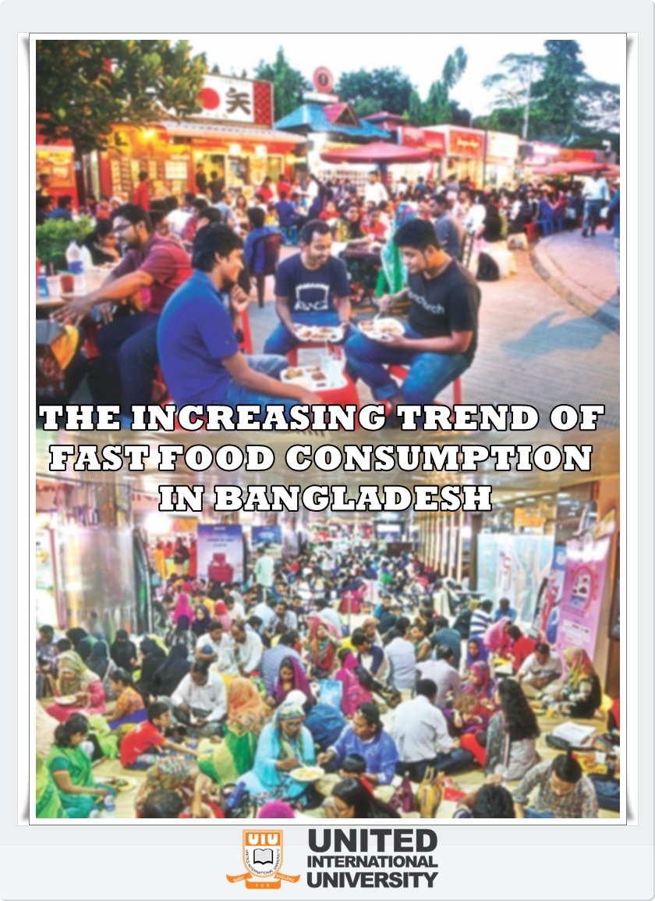

Project Report on
THE INCREASING TREND OF FAST FOOD CONSUMPTION IN BANGLADESH


Submitted To
S.M. Asif-Ur-Rahman
Assistant Professor,
School of Business and Economics (SoBE)
United International University

Submitted By:
Nusrat Jahan Nipa
ID: 111 132 129
School of business and economics (SoBE)
United International University
Submission Date: 5th November 2018
Letter of Transmittal

5th November, 2018
S.M. Asif-Ur-Rahman
Assistant Professor,
School of Business and Economics (SoBE)
United International University
Subject: Submission of project report on “The increasing trend of fast food consumption in Bangladesh”
Dear Sir,
This is to inform you that I have finished my project report as an essential part of my BBA program and according to the topic you had guided me on "The increasing trend of fast food consumption in Bangladesh"
While composing this report, I have adhered to the guidelines that you have given to me, and I have additionally connected relevant ideas that I have learned all through my BBA program. All the discussion that I have shared in this report are relevant to my topic and some data and references have been taken from my reading material and distinctive offline and online sources to support my report. I might want to concede that it was a great experience and an exceptionally fascinating background.
I modestly ask for you to acknowledge this report for your kind assessment. At last, I would like to offer my thanks for your helpful guidelines.
Your obedient student,
Nusrat Jahan Nipa
ID: 111 132 129
School of business and economics (SoBE)
United International University
Acknowledgement

I greatly thank to the Almighty Allah that I have been able to successfully come at the end stage of my BBA program. All the paths during this time was not so easy for me. But it’s a help from Allah that I have finished it and created my Project report.

I would like to take the opportunity to express my gratitude and deep regards to my respected project supervisor “S.M.Asif-Ur-Rahman”, Assistant Professor, United International University for his high attention, guidelines, and regular motivation that helps me a lot while I was gathering the troublesome information related to my report on "The increasing trend of fast food consumption in Bangladesh”. He invested his maximum valuable time to achieve the objectives of the report and provided helpful ideas for my survey and guided me at the last of my finishing my project report.

Most importantly I would like to share my heartfelt gratitude to all those participants and fast food restaurants, who had sincerely taken part in my survey part and helped me by their point of views and shared highly important ideas with me of the growing fast food trend of Bangladesh, most importantly in Dhaka city.
Abstract
Hundreds of customer chosen from various significant fast food shops, restaurants in Dhaka and also from the canteen of united International University, had been interviewed with by my pre-designed survey questionnaire to get the actual reasons of the rapidly increasing fast food business in Bangladesh, most importantly in Dhaka City. Survey assessment demonstrates that the greater part of the members was young, educated and in addition financially well off. The interpersonal relationship was the essential source related to the acknowledgment of fast food and most of them saw fast food restaurants as a place of recreation, amusement, entertainment as well as for refreshment. The visit of people in fast food restaurants demonstrates this fast developing business in Bangladesh. But since of costly rate from the food value greater part individuals are maintaining a strategic distance from to go to this sort of restaurant. Barbecue thing appeared to be fast alternatives thing pursued by a treat. The agreeable outlook of things, great food test, distinctive environment and uniquely the components of time reserve funds rouses the clients firmly to fast foods over homemade food. There is extremely a need to instruct these fast food sellers concerning the caloric requirement according to sex, age and also as a profession and additionally the health education to empower them to learn the balanced diet. The rate should grow up at this kind of level, where a lot of Bangladeshi people can generate and earn their own livelihood and truly it can create a great impact on our economy.

Table of Content
Chapter 1: Introdution
Introduction 1
1. Origin of the report: 1
2. Scope of the report: 2
3. Objectives of the report 2
4. Methodology of the report 3
5. Limitation of the report: 4
Chapter 2:
Literature Review 6
Chapter 3:
3.1 History of Fast Food in Bangladesh 8
3.2 Fast Food and Homemade Food 10
3.3 Current situation of Fast food industry 11
3.4 The Factors that influences to increase the trend of fast food in Bangladesh 13
a) From customer perspective: 13
i. Greetings 15
ii. Sitting arrangement 15
iii. Quality of food 15
iv. Variation in foods 16
v. Employee Behaviour 16
vi. Speed of service 17
vii. Child corner 17
viii. Decoration 17
ix. Security 18
x. Fair price 18
b) From Owner perspective: 19
Chapter 4:
Survey Questionnaire 20
Chapter 5:
Findings of my Survey 24
Chapter 6
Recommendation 30
Conclusion 33
REFERENCES 35

Chapter 1
Introduction of the report
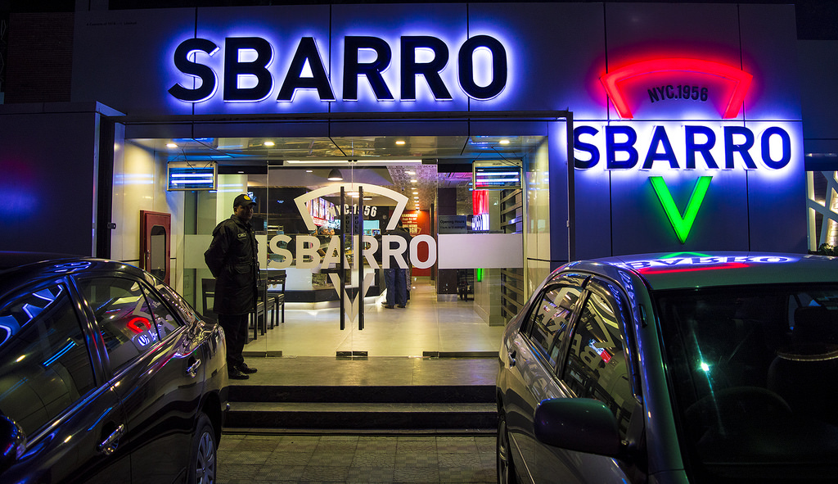
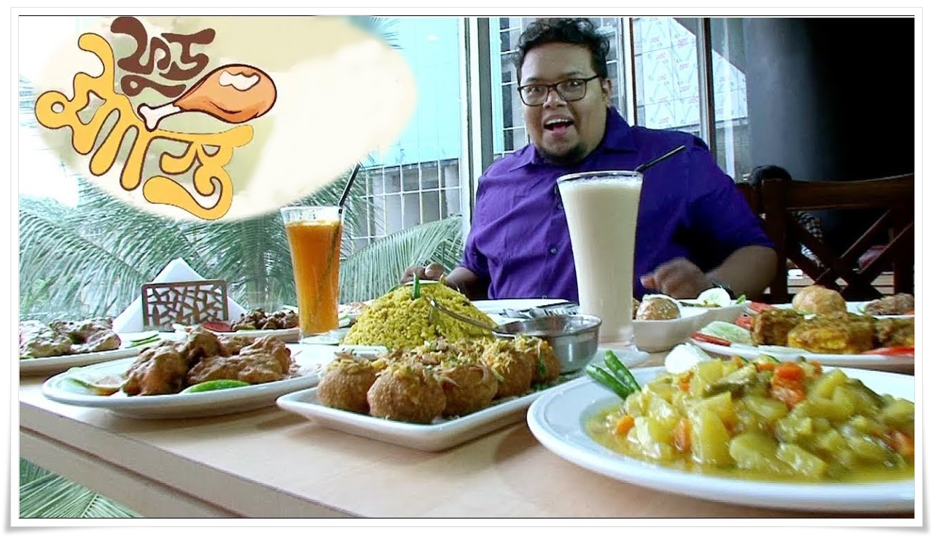

Introduction
Though fast-food restaurants are regularly seen as a portrayal of present-day innovation, the idea of "Readymade food to go" is as old as urban areas themselves; one of a kind varieties are chronicled in different societies. Old Roman urban communities had bread-and-olive stands, East Asian societies include noodle shops. Flatbread and falafel are universal in the Middle East. Mainstream Indian "fast" food luxuries incorporate Vada pav, Papri-Chaat, Bhel-puri, Pani-puri, and Dahi-Vada. In the French-talking countries of West Africa, in the meantime, roadside remains in and around the bigger urban communities keep on offering as they have improved the situation ages a scope of prepared to-eat, chargrilled meat sticks referred to locally as "brochettes" (not to be mistaken for the bread nibble of a similar name found in Europe). Albeit fast food regularly infers customary American fast food, for example, burgers and fries, there are numerous different types of fast food that appreciate broad prevalence in the West.

Origin of the report:
In Bangladesh, most of the general population for their food consumption still depend on their home. But in the same time, out of home food consumption is expanding because of the enhancement of urbanization, separating of the traditional joint family framework, want for quality, time which converts into an expanded requirement for comfort, expanding number of working ladies, ascend in per capita income, changing ways of life and expanding level of abundance in the middle-income group had realized changes in food propensities. Over the most recent two decades, the offer of the urban populace has expanded from 23.30 percent in 2015 to 27.80 percent in 2017. During a similar period, the female work investment rate had expanded from 19.70 to 25.70 percent. The per capita wage expanded from $816-$848 in 2018. These changes in food habits are visible from the growth of the fast food businesses in Bangladesh.

Scope of the report:

The report will show the opportunities of opening fast food business, how to maintain a good relationship, what are the things that customers are preferring from the fast food shops and other a lot of information. So, it can be very helpful to an entrepreneur, who is going to start a fast food business.

Objectives of the report
There are actually two types of objectives included fo doing the report. Both are so important and carries important roles. The objectives and goals of this report are describing below:
- Primary Objectives: Project report is the last part of my BBA program to achieve my honour’s degree from United International University. Every students must have to take project/ Internship program at the end of completing 120 credits. This project holds 3 credits which will be added with the previous 120 credit. And finally it will be 123 credits to earn the BBA degree. So it is my primary objective to prepare the report.
- Specific objectives: I am so grateful for getting such an opportunity to get the topic where probably very rare study maybe conducted. The specific objectives I have set up to get from this report are:
- To find out the differences between fast food and homemade foods.
- To show why people are choosing more to eat fast food than the homemade food.
- To study and evaluate all the factors that are influencing people to eat fast food.
- To evaluate how the fast food business is increasing rapidly.
- To provide some recommendation to improve the quality of the Fast Food business.

Methodology of the report
I have collected all the necessary information from going to several fast food shops in Mirpur, Dhaka area to know from the fast food owner about what are inspiration that maybe worked, to open a fast food in Dhaka city when there are a lot of other professions to choose. However, I have separated the methodology part into 2 types.
- Primary Sources:
- Formal and informal conversation with the shop owner and their customers.
- Communicating various fast food restaurants and from their brochures.
- While doing Survey, I gathered a lot of info related to my report.
- Secondary Sources:
- Some recent Bangladeshi journals helped me a lot.
- Collected data from Bangladesh national economic review 2017.
- Learned a lot from various books and websites on Fast food and its growing trend.

Limitation of the report:
There are some lacking while interviewing the consumer for my survey of this report. There are also some other limitation what I couldn’t ignore. The limitations of my report are given below:
- Some of the Fast food shop owners were reluctant to provide me their business secrecy and some other provide biased information for their brand value.
- The study area was inside of Dhaka Metropolitan Area, It maybe be not applicable for other district or markets.
- Huge differences exists in the consumer’s opinion of different fast food shops, some even provide wrong information of fast food, just because their relatives operating that shops.
However within this short period of project time I have time, I have tried my best to make my project report a very rich one with valuable information of current trend of fast food industry.

Chapter 2
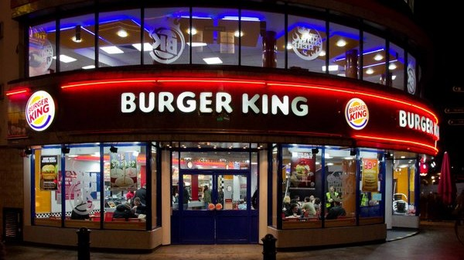
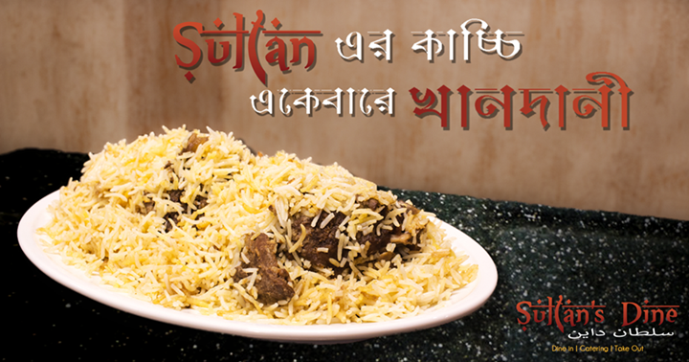
Literature Review

Literature Review
The report is to deliver the proper knowledge of Fast food restaurants and share all the factor that are influencing the increasing trend of it. A survey will be conducted by me and the results will also be shared with the consumer view of point of why they are rapidly going to fast food shops. At the stating of the main part, we need to clear the idea of Fast Food.

A fast-food restaurant otherwise called a Quick service restaurant (QSR) inside the business, is a particular sort of restaurant that serves fast food cooking and often holds some sitting arrangements. The food served in fast food restaurants is commonly part of a "Healthy eating routine", offered from a constrained menu, cooked in mass ahead of time and kept hot, completed and bundled to arrange, and normally accessible for taking endlessly, however, seating might be given. Fast food restaurants are ordinarily part of a restaurant network or establishment task that gives institutionalized fixings and additionally incompletely arranged foods and supplies to every restaurant through controlled supply channels. The expression "fast food" was perceived in a word reference by Merriam– Webster in 1951.

Undoubtedly, the first fast-food restaurants began in the USA named White Castle in 1921. Today, American-established fast food chains, for example, McDonald's (est. 1940) and KFC (est. 1952) are multinational enterprises with outlets over the globe. The minor departure from the fast food idea incorporate fast-easygoing restaurants and providing food trucks. Fast-easygoing restaurants have higher sit-in proportions, offering a distinctive food service on daily basis in the targeted locations.

Chapter 3
The increasing trend of Fast Food consumption in Bangladesh
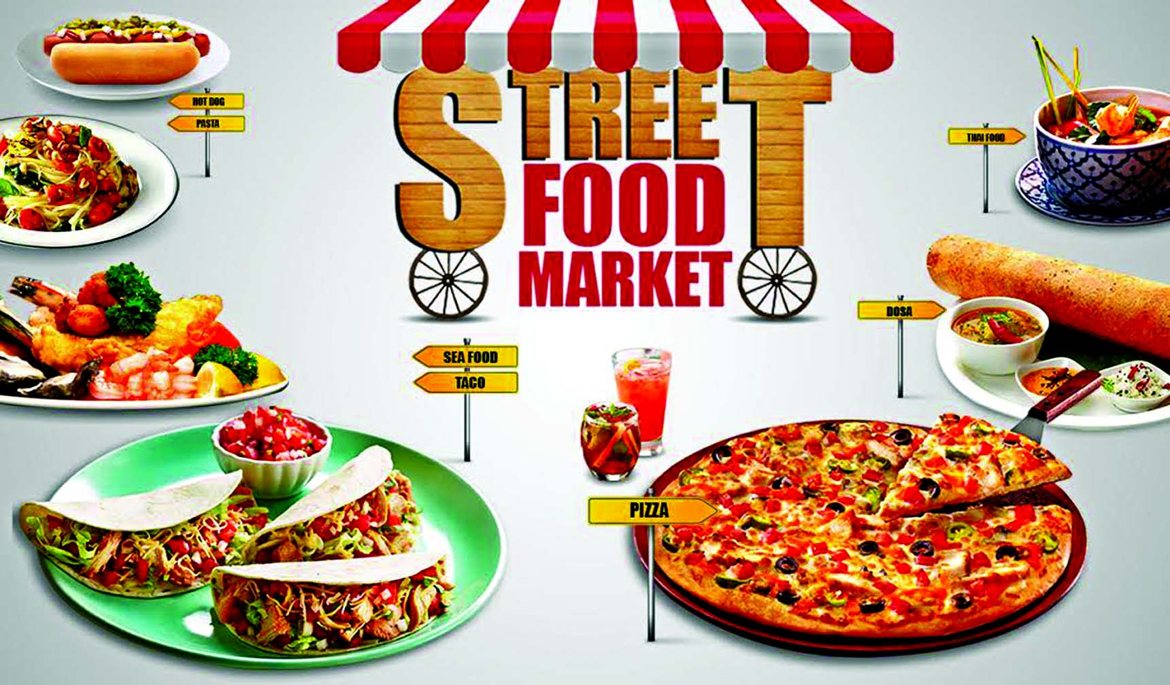

3.1 History of Fast Food in Bangladesh
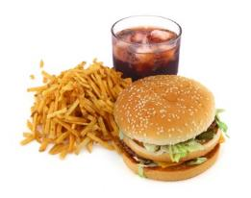
In Bangladesh, the fast-food culture began in the early 1990s. It was mainly aimed at young and employees of the business sector. The fast-food culture in Bangladesh has taken over the country. The first fast food started its activity on Bailey Road in Dhaka. Subsequently, several fast food outlets began to expand exponentially in different parts of the city of Dhaka. Local entrepreneurs are pioneers of the fast food industry in Bangladesh. New brands, such as Swiss, Helvetia, etc., derive their name from some fast food restaurants in Bangladesh trained in the franchise system. At the beginning of the year 2000, Bangladesh saw the entry into the country of the first international fast food franchise brand. Pizza Hut and KFC entered the Bangladeshi market with a franchise from Transcom Foods Limited (TFL). Pizza Hut and KFC are subsidiaries of the world's largest restaurant company, Yum! International Restaurants TFL has opened three Pizza Huts and three KFC stores in Bangladesh in five years. Pizza Hut opened its flagship restaurant in 2003 in Dhaka. After the great success in Dhaka, the Chittagong store opened in 2005. The third Pizza Hut restaurant opened in Dhaka in 2008. Meanwhile, Kentucky Fried Chicken (KFC) is perceived as a fast food high quality in a popular variety. Complete meals to enrich the daily life of the consumer. TFL successfully launched the flagship KFC product in 2006 and has attracted public attention for its taste, high levels of hygiene, cleanliness, attractive interiors, affordable prices, and more. After the great success achieved in Dhaka, the second and third outlets were opened in 2008. Two major changes took place in the fast food sector in Bangladesh. In September 2005, the Bangladeshi government launched a massive campaign against companies that had discovered adulterated fruits, pesticides used, unauthorized food colors, and expired food products at the date of use, etc. These units have had a serious impact on the public health sector in Bangladesh. Many renowned restaurants and fast food restaurants have been found guilty and the press and media have widely spoken about it. This led to mistrust of the common people and brought about a temporary decline in the sale of fast food products. As a result of this reorganization, many small and medium-sized fast food restaurants were closed and there were only a few restaurants, most expensive and franchised. This caused huge losses after the surprise raids caused by moving cuts. Ordinary snack bars in Dhaka no longer attract the same attraction after September 2005. Mobile courts have been attacked and almost 60% of cases have been refused. Most of the customers in these stores were teenagers and students. Many of them had stopped going for snacks after the announcement of sold items. The 10 best fast food restaurants in Bangladesh are Pizza Hut, Kentucky Fried Chicken (KFC), Best Fried Chicken (BFC), American Fried Chicken (AFC), Domino’s Pizza, Helvetia and Stars, Western Grill, Kostury, and Shwarma House.

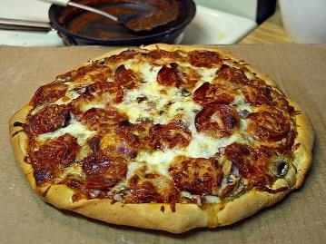

3.2 Fast Food and Homemade Food
Homemade foods are most of the time thought to be healthier than fast food. This is on account of fast food dinners ordinarily contain elevated amounts of calories, immersed fat, sugar, and salt, as per a 2017 article in "The New York Times Health Guide," a medicinal reference certify by the American Accreditation HealthCare Commission. Regardless of the health changes that accompany fast food consumption, individuals keep on eating it. In fact that numerous individuals have no opportunity to choose and get ready food at home. In any case, fast food requires not be as unhealthy as its value implies.
Some researcher indicated that the favourable position of homemade dinners over fast food is its less expensiveness. Be that as it may, in light of the fact that we additionally spend on flavouring, fixings and gas and power at whatever point we cook at home, the cost distinction is potentially not as extensive the same number of accepting. What's more, homemade foods, by and large, set aside greater opportunity to get ready and expect us to have cooking aptitudes. Then again, the essence of homemade suppers is, for the most part, better, since we can choose new fixings. We are additionally ready to guarantee the fixings that go into your food are perfect and free of contaminants.
Homemade foods vary from fast food meals as far as serving size and by and large healthy benefit. A run of the mill fast food burger utilizes a blend of ground meat, bread, and sauces that winds up having around 71 cal/oz for a sandwich that is around 3.5 oz. It is conceivable to make homemade burgers healthier by utilizing lean ground meat and wheat bread and also healthy fixings. On the off chance that we pick our fixings deliberately, it is conceivable to make a homemade burger that just has around 67 cal/oz for a 4.5 oz sandwich.

3.3 Current situation of Fast food industry
The fast-food industry is amongst the fastest developing segments in Bangladesh. Rivalry in this segment has turned out to be exceptionally intense. Because of serious rivalry, fast-food restaurants are progressively perceiving the significance to persistently enhance their client accommodation to hold and pull in clients. This paper embraces to distinguish the variables influencing fast food industry in Bangladesh that are helping to increase this trend.
Fast foods are taking prevalence by the single-family since working guardians possess less time for food arrangement for their family members. The larger part of working guardians with school going youngsters are in pressure. Youngsters invest the majority of the energy far from home by going to educational cost classes after school hours. Youngsters take breakfast at home and fast food in school or outside the school. A positive connection between expanded fast-food consumption and expanded weight was found among young people. Financial status is a vital factor identified with fast food consumption. Youngsters from high financial status incline toward fast foods to homemade foods in spite of their better healthful learning. It has been seen that kids, who are overweight, are altogether more known to take food from a fast food restaurant than homemade foods. Additionally, families' from the upper classes, can acknowledge more of food brands. Components identified for increasing the trend of fast food by Bangladeshi college students are: The comfort, simple availability, taste, and cost in the fast food shop. A large portion of the fast food clients takes such sort of food. However, they have known well about negative impacts on themselves related to fast food consumption as well.
This is why a lot of Fast food shops are opening to offer fast food meals with various targeted customer in Bangladesh. Hundreds of Fast food restaurant started their business in last 10 years 2008-2018 and many some are very old and famous for the Bangladeshi people. Some of the name of this Fast foods in Dhaka city are Latitude 23, Nando’s, Kolkata kacchi Ghar, Hajir Biriani, Star Kabab, Takeout, The coffee beans, Gloria Jean’s Coffee, Deshi Ahar, Pasta streets, Mid night Café, Voot restaurant, and so on
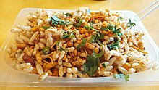
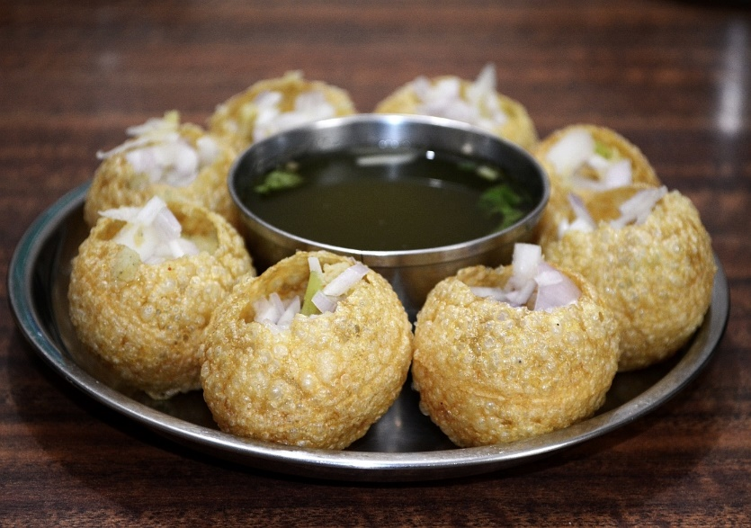
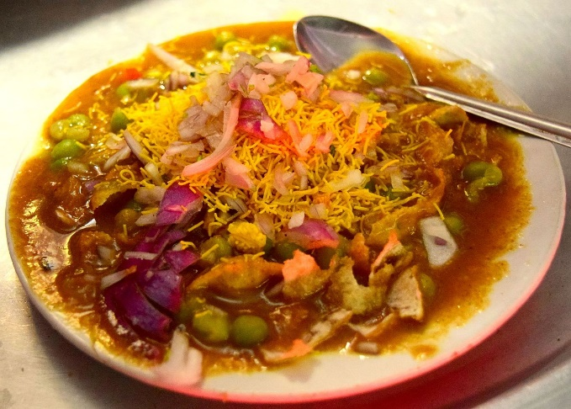
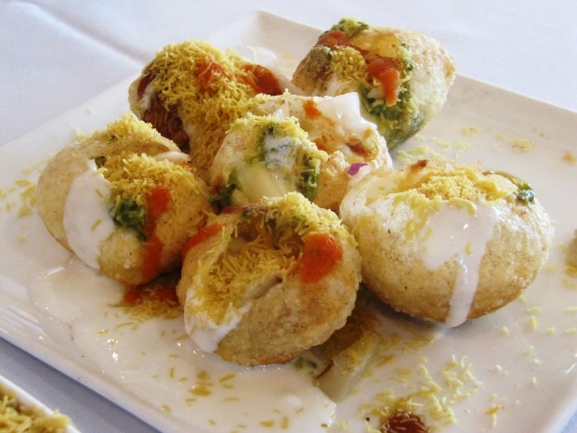

3.4 The Factors that influences to increase the trend of fast food in Bangladesh
There are various factors that have important influences to increase the trend of fast food business. The factors can I would like to divide into two parts.
- From Consumer perspective
- From Owners perspective
- From customer perspective: In Customer perspective, I want to include all the factors that customer ask from a fast food business, and for the factors, they are preferring fast food more than their home made foods. Customer preference for fast food is extremely solid in Dhaka city. This is a result of the parallel changes in working and public activity and the propensities for feasting out. In a social setting, continuously the quantities of working families are expanding around the world. This permits the families less time to cook and eat at home. Presently, we have to associate with individuals around us, partners and companions, neighbours more than before for business or social purposes. The traditions today are to do the socialization over some food things from home. Because of the deficiency of time, numerous cutting-edge family units will in general favour helpful, fast dinners to rather conventional long suppers. Here family unit alludes to the kind of family comprising of just spouse and one to two kids. Today individuals want to eat before television with the relatives than to eat in the feasting table. Also, an ever increasing number of families will in general hold programs i.e. birthday events, commemorations, other unique events and so on out of home. Impacts on the decision to eat out incorporate deficient time to cook at home, chances to mingle or direct business, accommodation or the requirement for a fast supper, satisfaction and family trips or festivities (birthday events, commemorations and other unique events). Such changes in feasting propensities have driven restaurants and other eating out units to offer an extraordinary assortment of foods and drinks giving clients numerous more decisions. This has urged individuals not to cook at their homes.
In this report, I try to share the factors which are mostly influencing the customers towards the fast food industry in Bangladesh. These factors are:

List: Factors that influence customers toward fast food in Bangladesh

Greetings
Welcoming greetings with a smiling face in the fast food shop can make delight the customer to appreciate the service. The customer section is crucial from the beginning that the person must complete making the correct decision to enter this restaurant. As Pizza Cabin usually insists on this factor. A reception is a demonstration of correspondence in which individuals (as well as individuals different from all animals) deliberately know each other, try to think and propose a type of relationship or social position between individuals that bring together people who interact with each other. The one with the other although the cosy traditions are exceptionally linked to the culture and the circumstances and can evolve within a culture subordinated to the well-being and the economic relations, they exist in all the known human societies. Greetings may be communicated in a perceptible and physical manner, and often include a combination of both. (Wikipedia)

Sitting arrangement
An important attraction for client friendliness of the fast food industry in Bangladesh is the sitting arrangement. If sitting arrangement isn't adequate for the clients, food shop may not fulfil the customer enjoyment. Hardly any restaurants have diverse sitting arrangements to pull in guests.

Quality of food
Food quality incorporates outside variables as appearance (estimate, shape, shading, shine, and consistency), surface, and flavor; factors, for example, government review gauges (e.g. of eggs) and inward (synthetic, physical, microbial). Food and drinks are most likely the greatest pointers of value that a client takes note. Food quality isn't just critical to the clients' impressions of the general restaurant encounter, yet it is essential for their well-being, too. Purchasers' wellbeing ought to never be endangered. In spite of the fact that not all restaurants can flaunt the best quality food around the local area, they can at present take measures to guarantee that food is put away and arranged securely. Food quality likewise manages item traceability, e.g. of fixing and bundling providers, should a review of the item be required. It additionally manages to mark issues to guarantee there are right fixing and healthful data. (Buttle 1986; Bareham 1995)

Variation in foods
The verity of the menu will guarantee the opportunity of decision for the clients. Menus that the clients love to eat ought to be in the rundown. The store should offer countless to their clients. It will be much more attractive if the store guarantees that they are offering both the neighborhood and universal foods. In Bangladesh, clients love to eat different foods. On the off chance that a store can give all these different foods then the client will get fulfill and will never proceed onward.

Employee Behaviour
In any restaurant or food service condition, addressing clients ought to dependably include the most extreme regard and affability. This goes for all labourers, from drive-through chaperons to servers at fancy foundations. A client might be disappointed with his supper or may observe the quality to be underneath his models. Now and then customers will discover the need to vent outrage or inconvenience before the issue can be settled. Make certain to prepare servers the correct approaches to deal with client grumblings. Maybe significantly more imperative than food quality is the service the clients encounter from the time they enter the restaurant until the point that the time they exit the entryways. In spite of the fact that restaurants thrive on account of offers, the deal ought to never be put the client's needs.

Speed of service
Service Speed ​​is an essential expression for most fast food restaurants. These restaurants earn their accommodation and their pace with their speed. They often have to target a service speed integrated into their patch. The ever-changing country of services, there are incredible desires for customers who come directly or in the store access lines: Get quality food fast. The customer's interest in more reasonable food makes it an opportunity and a quick test for services.

Child corner
Children affect the choice procedure of their folks when settling on the decision of fast-food restaurant. A gaming zone considered to be versatile for such an organization must be re-established to different customers. For the child, the original ingredient is fun. The collection must be started in minutes. Similarly, it is essential that the children know that they have their own personal space.

Decoration
When designing a fast food restaurant, power size and office space need to be considered. Examine or outsource an organization of professional structures to help build design projects and make arrangements for fast food companies for banquets and production areas. Interior decoration and outdoor decoration will show the adequacy of fast food. Decoration should be interesting and the decorations will be beautiful. Using exceptional design furniture and exceptional restaurant design, the food court will be able to uniqueness. A very rich and decorated dinner is a real place of excellence for the client. The elegance of the store will make the customer happy from the customer. The store can go as a picture of customer status. Due to the stores used in the interior and exterior decorations and furniture stores, Bangladesh customers are very careful. They look great and go in this store equipped with inside and outside.

Security & Safety
Safety and sequirity is a key factor for fast food. Customers demand a secure domain where they can get the best out of their harmonious food and congratulate their Bonaparte. The country must offer privacy to customers. Customers are constantly looking for a place to eat like they do at home. All fast food restaurants must have safety protection, fire protection, etc. In Bangladesh, customers tend to have fast food that offers maximum safety and maximum confidentiality. Most fast food chains have developed a standard menu with safety equipment and equipment for all stores. These include video recognition boxes, warning boxes, delayed security boxes, reinforced boot windows, and the expectation that thieves prepare all staff. As the danger of a restaurant increases, the level of security measures should increase. For example, higher-risk files must extend the appearance of security assessments and monetary assessments to check compliance with the agreement. Visiting studies are ignored for support corrections for frames, lighting, video and precautionary frames. Similarly, it is a good sign that leaders and staff in high-risk areas receive notifications of visits that prepare them for their safety.

Fair price
The price is the amount of Taka that is given by one to another as a by-product of products or services. The price of food must match the size, quality, and fixation. Restaurants cannot charge excessive prices unless they give the customer an estimate. The food’s price must be measurable as opposed to your service. Stores must ensure that their customers receive the best food for a modest price. In Bangladesh, the vast majority of fast food chains charge excessive prices for food and services. However, they do not meet the standards for restaurant services and quality estimates.
- From Owner perspective: Though the upper components that I have shown are related to the consumer point of view. There are also some components for what the owners are encouraged to open the Fast food shops frequently and think to be good investment in Bangladesh. They are:

List: Factors that are influencing owner to open fast food shops

Chapter 4

Survey Questionnaire
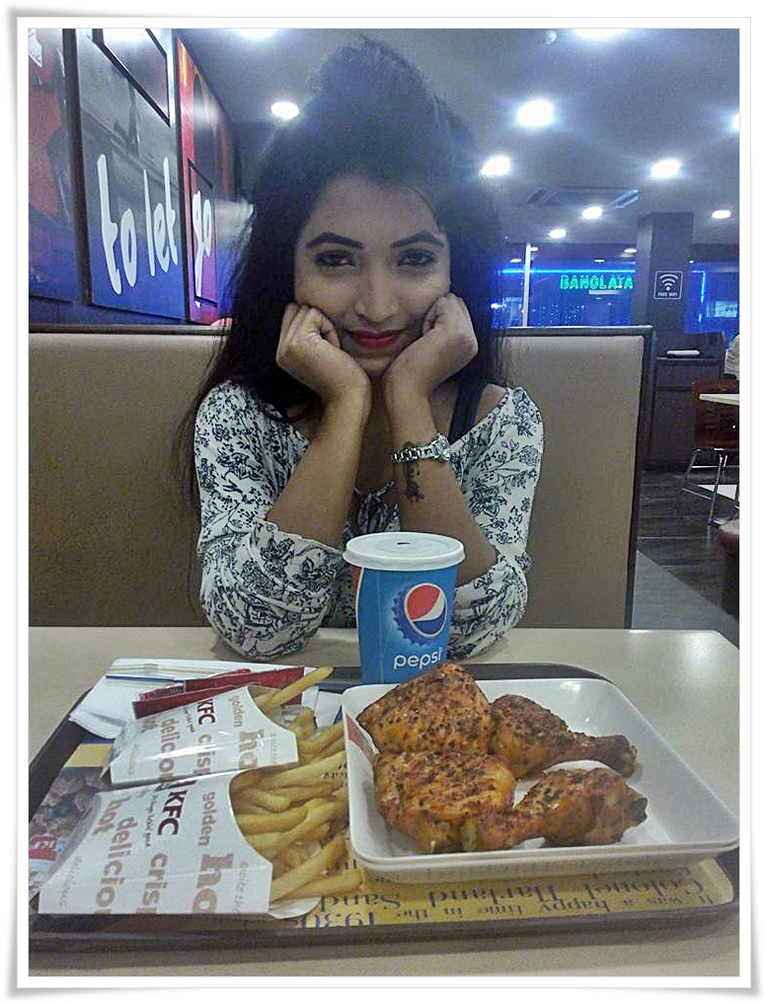
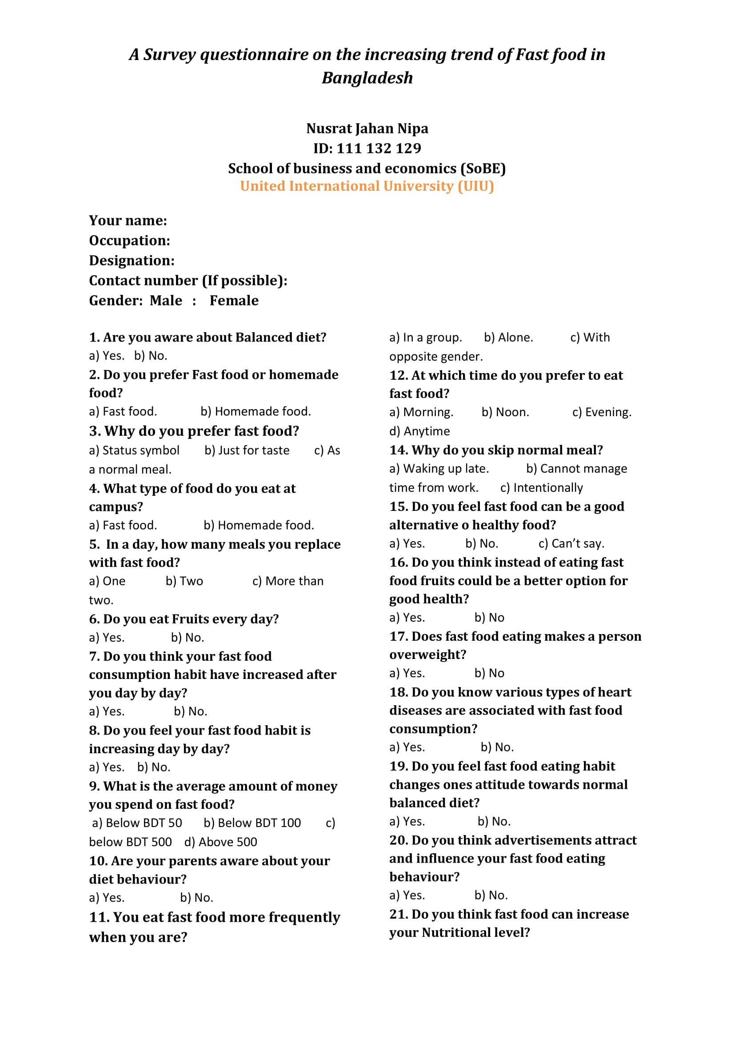
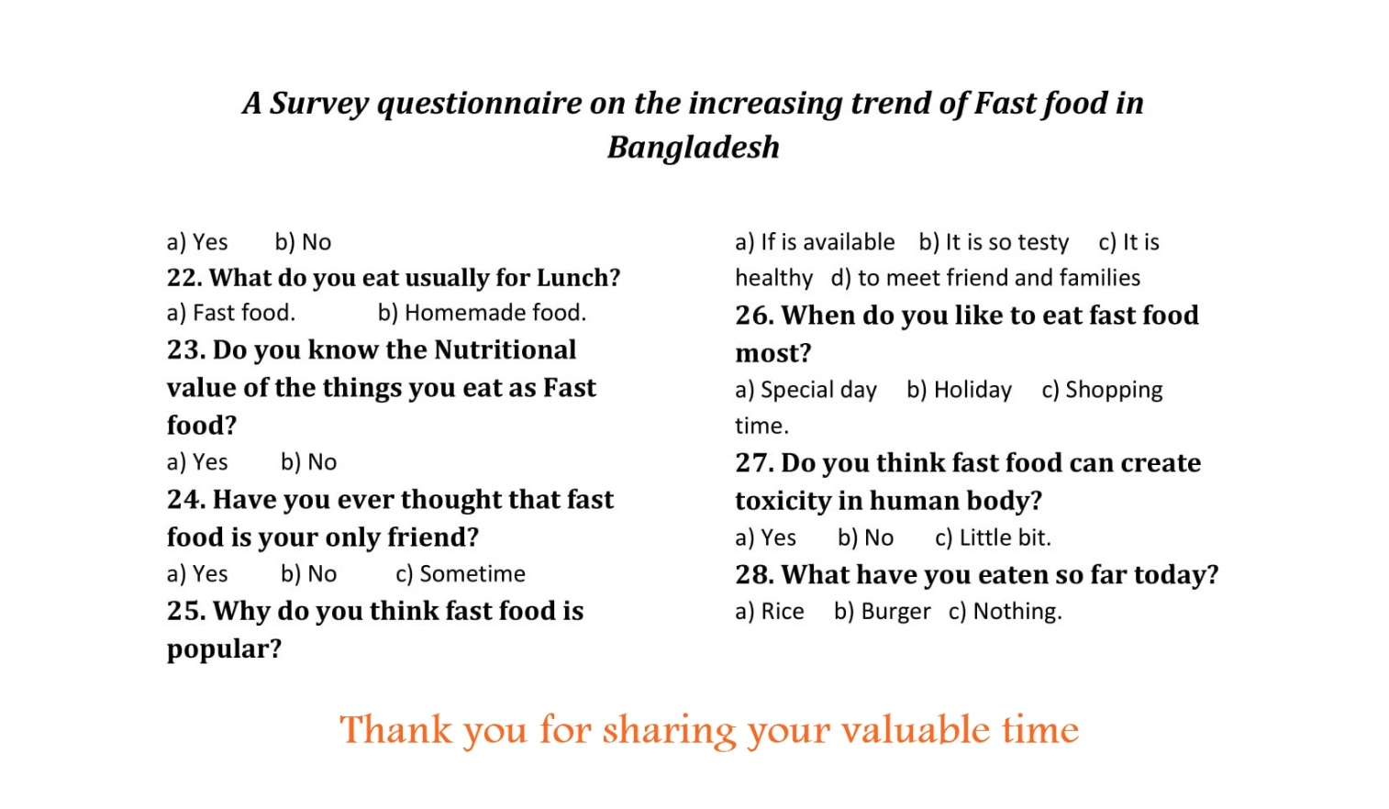

To increase the value of my report, I had prepared this survey questionnaire. I had surveyed total 100 people randomly from various locations in Dhaka city. I usually go to restaurants to taste various food items. When I went there I also took 2- 10 questionnaire so that I can also get data to enrich my project paper. Various results I found after conducting this report, what I added in the next (findings) part of my report. I highly appreciate to those, who managed to answer/tick my survey questionnaire. I love to thanks them all here.

Chapter 5
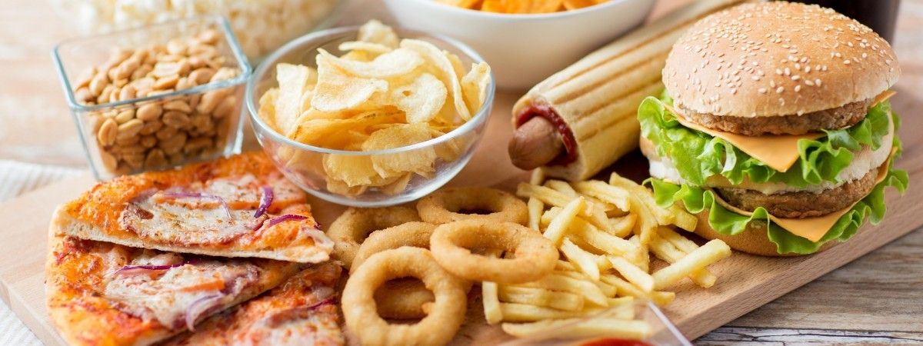
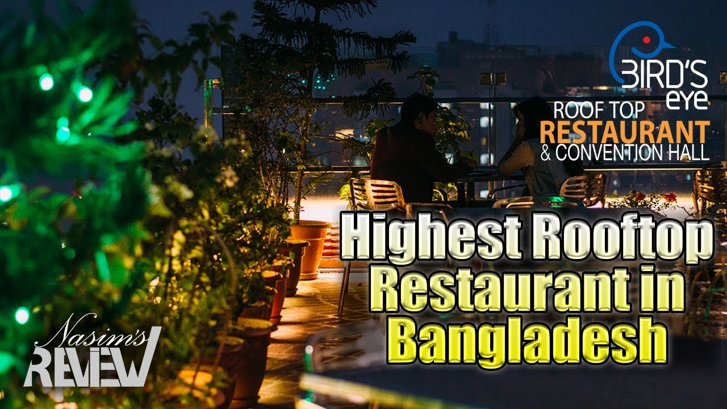
Findings of the Survey

Findings of my Survey
According to the survey questionnaire, I provided before, the below results, that I have shown in the PIE chart as percentages, I had found.
I surveyed to a 100 of people from various part of Dhaka city such as United International University, East West University, Mirpur area, Dhaka Cantonment area, Dhanmondi area, Bashundhara residential area, and from Mohammadpur area.
      - 70% of the people to whom I had surveyed, were men and the rest of others were women.
      - Interestingly, most of the interviewer prefer more to eat on fast food rather than homemade food. Different factors of fast food have created a lot of impact in their mind for what they are now getting addicted to fast food foods.
      - Almost 87% of them prefer fast food from their university canteen than homemade foods.
      - Surprisingly, 25% of people are so much addicted to fast food that they eat two to three times a day.
      - 30% participant’s parents don’t have any knowledge of fast food. 14% realize fast foods are not good for health and rest are also visit fast food restaurant at least once a month.
      - 58% of the participants replied they visited fast food in the evening. 27% replied they visited at noon and the others prefer to go too fast food at morning or any time.
      - 87% of the participants agreed with my title that fast food consumptions are increasing day by day as fast food provides them the place to meet with their friends and family members and offer delicious foods. For this reason, they can pass some happy moment outside their home. Most of them responded ‘YES’ that fast food eating makes a person overweight and can create cancer. But still they are being obsessed so much that they don’t want to miss a chance to go to fast foods.
Now, some other questions that are very related and important to my Project paper, I would like to show with PIE CHART so that it can help to understand more easily why fast food trend is increasing day by day in Bangladesh. Hopefully, these findings also help to the owner who is going to start a fast food business.
- How old are you?
        - Below 20 years b) 20-30 years c) 30-40 years d) Above 40 years

Surprisingly 35% of the respondents were below 20 years old, 25% were 20-30 years old. 36% were 30-40 years old and only 4% were above 40 years old those who usually visit any fast food in a week.

- What is the average amount of money you spent on fast food in per week?
- Below 50 Taka b) Below 100 Taka c) Below 500 Taka d) Above 500 Taka

7% responded that they spent money below 50 taka on fast food in a week. 18% replied that they spent 100 in a week on fast food. 48% said they spent below 500 taka and 27% responded that they spent above 500 taka each week on fast food.

- You eat Fast Food more frequently when you are…..?
a) In a group. b) Alone. c) With opposite gender.

- Why do you think fast food is popular?
a) Availability b) It is so tasty c) It is healthy d) to meet friend and families

- Which of the following fast-food restaurants have you heard of?
- KFC
- Pizza Hut
- American Fried Chicken (AFC),
- Dominous Pizza,
- Helvetia,
- Yummy Yummy,
- Five star,
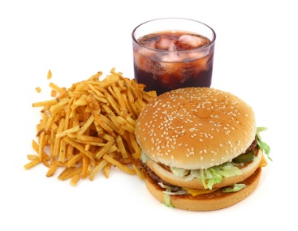
- Western Grill,
- Kastury!,
- Shwarma House.
- Star Kabab

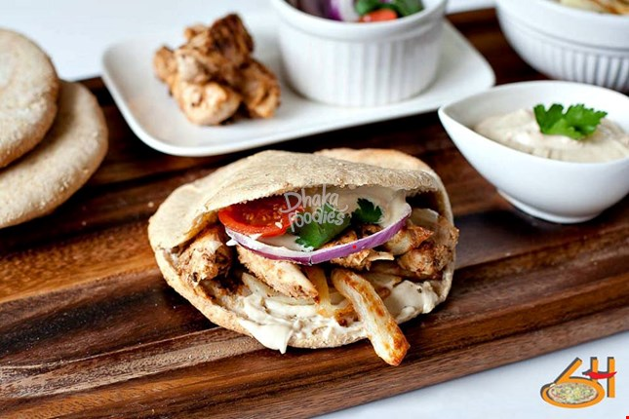
Chapter 6
Recommendations and Conclusion
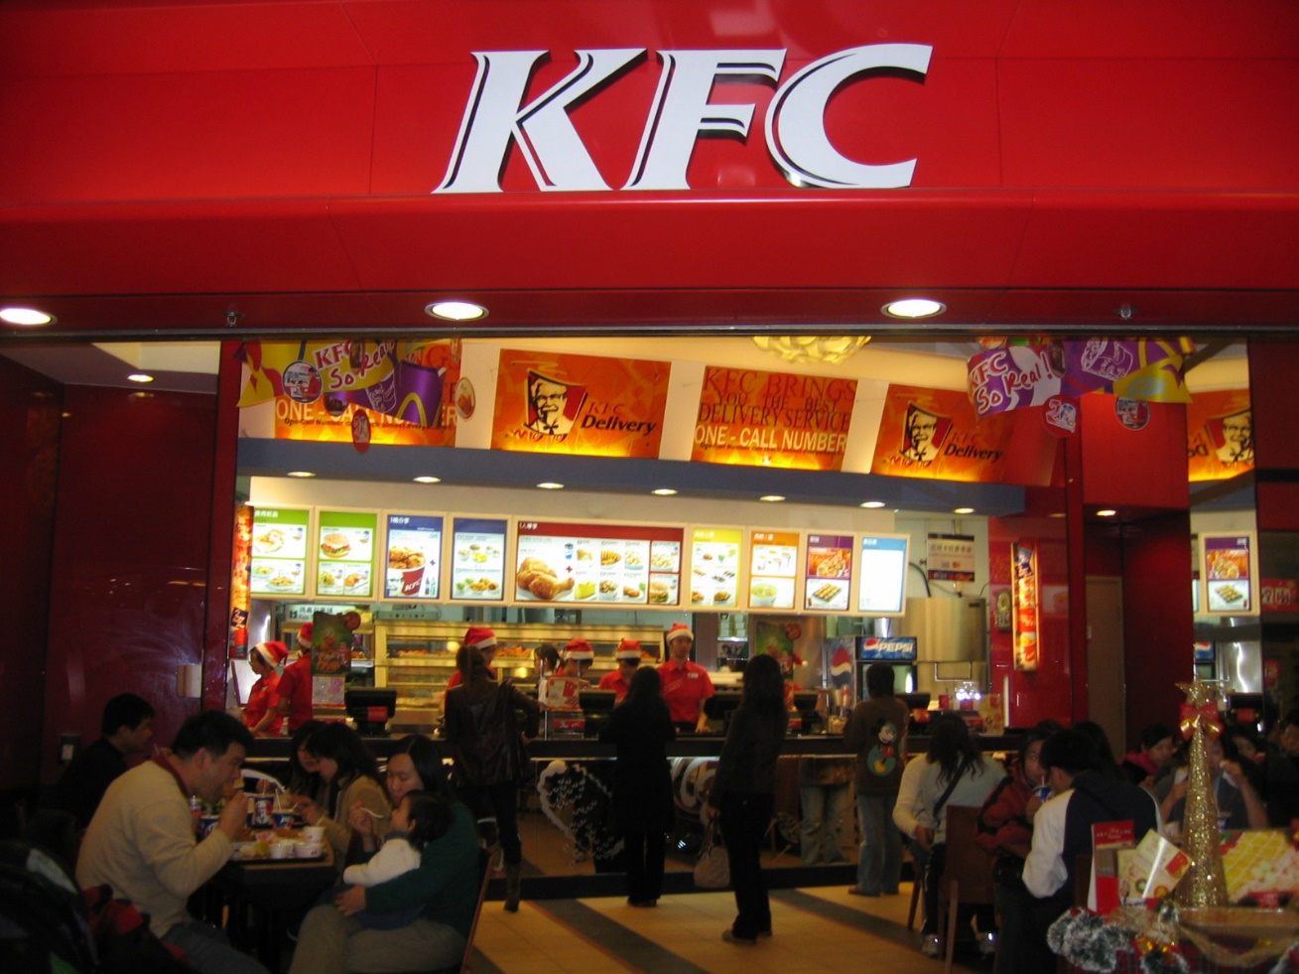

Recommendation
Food lovers and customers of fast food in Bangladesh, especially college and university students, considered brand reputation to be the most critical factor, choosing fast food restaurants pursued their proximity and availability, comparability in terms of taste, convenience, less price and high taste, cleanliness, charisma and beautification, Fats and Cholesterol and Personal Benefits. The surprise in the persistent fast-food sector in Bangladesh has been motivated. Revelation From the side of operational practices some fast food organizations, which brought customers has to trust prestigious fast food brands. In the same way, fast food restaurants with a well-known brand and recognition, namely KFC, CFB, pizza, coopers, etc., typically create the Organizations Them, more rod than their hard activity. Most fast food brands are far outweigh the quality review of the multipurpose court could strengthen or renew their brand image. Ultimately, you are suggested slab exploratory discoveries, Students will choose THESE fast-food brands that have Brand Reputation. In addition to the value of the brand, other key elements were the proximity and the openness of the comparable fast food, is value for money and taste. In the event of proximity or proximity to availability, buyers want to go too fast food establishments located near their home or at their study organization. You can see that fast food restaurants in Bangladesh are now thinking it has components installing their sales points near a huge commercial college and box privatization. In particular, at Dhaka, training centre of restaurant training is located in Bailey Road Street, where most of the fast foods are found. Near to there are Bailey Road Street 3 schools for girls and universities, 3 boys and 2 separation schools. The relatively comparable circumstances they triumphed in the Gulshan, Banani Area of the city where the KFC Pizza mail outlets found both Close to college privatization. CIO And from the fact that the justified double learners within these organizations consider fast food restaurants in the vicinity, regardless of when they choose to spend it fast food. In any case, there is an open door for fast food restaurants to fight today's fast food.
1. The construction of other stores in truly aggressive commercial places is expensive and problematic, the new fast food organization can present multipurpose fast food. Thanks to portable fast food, new fast food organizations can expand their fast food into stores, which are sharp, but warm and reach the students in a fraction of a second, with their decision, odor enhancers It is a tomato sauce, a cheaper cheese, and so on. This multipurpose fast food restaurant may end up in a small truck, a truck, etc.
2. A comparative taste of the fast food factor, regardless of how the taste should be comparable, regardless of the fast food purchased. For example, if a chicken burger is bought at a KFC store, then there is a taste similar to another chicken burger bought at other KFC stores. Other fast food outlets may be tastes different, because different organizations use the taste as a separation factor for food emergency situations. However, companies should keep in mind that additional inequality among fast food comparative materials creates confusion for customers.
3. Costs and quality is also an essential factor that accepts fast food customers’ accounts. In the higher distances of remote food costs, it is generally considered to be in a large quantity and vice versa. In this way, fast food agencies should be careful when deciding on fast food costs. An approximate accounting should be proposed to increase the aggressive price appreciation of customers in order to ensure satisfactory net earnings for the fast food company.

4. Finally, in the case of discount / discounts and flavors, buyers consider fast food accessibility. In most cases, these discounts are proposed as discounts for collections, which are organized or organized into a set of depreciating prices, etc. Consumers consider this option when they collect fast food products. They cannot use this factor quickly, but they keep the fast food store in their minds for use.
The notice said that in Dhaka, more attention will be given to fast food manufacturers or wholesalers, costs, quality, discomfort, even the reputation of taste, proximity or exposure. If they can meet these requirements, then they should eat and drink fast food in Bangladesh while they are away from the country.

Conclusion
My Recent findings add to the comprehension of customer observation and preference for fast foods in the Bangladeshi market, a region that includes getting little consideration inside the academic literature. Moreover, this report gives knowledge into the components adding to the apparent development of fast food in Bangladesh which is because of urbanization, individuals working for extended periods of time, developing enthusiasm for outlandish dinners, promoting, and accessibility of business structures and ascend in wage. These customers, who presently support fast food, do as such for the reasons that they see them be advantageous, efficient, scrumptious, useful for a change and fun and in addition inclination of the earth. The individuals who don't expand fast food, notwithstanding, see fast food as undesirable, very costly and excessively remote as related, making it impossible to Bangladeshi dishes. The report has a natural confinement because of its emphasis on tertiary understudies making it very hard, to sum up the discoveries. It, be that as it may, gives the chance to advance examinations. For instance, later on, it will be essential to additionally look at customer discernment and inclination as per sexual orientation, financial and societal position. Concentrate on the chances and difficulties in the fast food industry will likewise improve writing on fast foods. In the nutshell, the examination uncovered a critical open door for advertisers to the extent purchasers' conduct in regards to inclination, use the example, and comprehension of the food showcase is concerned. The discoveries can be utilized as a premise to design showcasing methodology towards the fulfilment of fast food advertising.

Fast food is advantageous and delicious, however, arranged with low sustaining or unfortunate fixings. Fast food organizations are focusing on youths through extraordinary advancement procedures, scrumptious formulas, and appealing ad. There are considerably more prominent reactions of fast food and individuals are unconscious of its evil results which can watch out for some impending ailments; expanded utilization of fast food is also a reason for medical issues and heftiness. Regular workers lean towards fast food at their working environment because of their bustling calendars and trade-off with the food quality because of the deficiency of time and simple entry. In addition, fast food is additionally a dependence on the vast majority of the general population. It is prescribed that guardians should watch out for the eating routine of their kids as youths spend more cash on low-quality nourishment and must have a fair eating routine for appropriate development. In addition, policymakers should point of confinement or boycott the undesirable fast food restaurants that are utilizing shabby quality elements for food readiness; media should likewise spread mindfulness among individuals about the reactions of taking fast food as often as possible

REFERENCES
1_Food Guide, Restaurants, Restaurant Reviews & Reservation of Bangladesh
2_Bangladesh economy in 2017 and the way forward | The Daily Star:
https://www.thedailystar.net › Opinion › MACRO MIRROR
3_BAREHAM, J. 1995. Consumer Behavior in the Food Industry. A European Perspective, Butterworth Heinemann, Oxford, U.K.
4_Binkley, James K. (2008), Calorie and Gram Differences between Meals at Fast Food Table Service Restaurants, Review of Agricultural Economics, Volume 30, Number 4—Pages 750–763
5_Bowman, Shanthy A., Steven L. Gortmaker, PhD; Cara B. Ebbeling, PhD; Mark A. Pereira, PhD; and David S. Ludwig, MD, PhD (2004) Effects of Fast-Food Consumption on Energy Intake and Diet Quality Among Children in a National Household Survey, PEDIATRICS Vol. 113 No. 1 January 2004
6_Buttle, F. 1986. Hotel and Food Service Marketing – A Managerial Approach, pp. 76–191, Cassell Educational, London, England.
7_Clark, M. and Wood, C.R 1998. Consumer loyalty in the restaurant industry: A preliminary exploration of the issues. Int. J. Contemporary Hospit. Mgmt. 10(4), 139–144.
8_Carey, R.A. and Genevieve, L. 1995. USA snapshots: Factors influencing choice of sit-down restaurant. USA Today, June 23, p. D1.
9_Kuchler, F.E. Golan, J.N.Variyam, and S.R. Crutch-field. 2005. Obesity Policy and the Law of Unintended Consequences. Amber Waves 3:26–33.
10_Lawrence, J. M., E. Devlin, S. Macaskill, M. Kelly, M. Chinouya, M. M. Raats, K. L. Barton, W. L. Wrieden & R. Shepherd (2007) Factors that affect the food choices made by girls and young women, from minority ethnic groups, living in the UK. The British Dietetic Association Ltd 2007 J Hum Nutr Diet, 20, pp. 311–319

