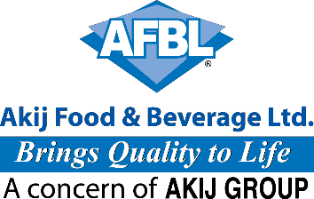

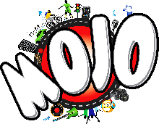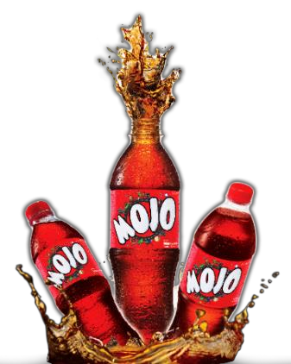





Internship Report On


“Developing and Managing a Consumer Brand: A Study on “MOJO" of Akij Food & Beverage Limited.

Submitted to

Dr.Abu Zafar Md. Rashed Osman
Associate Professor, School of Business & Economics

United International University

Submitted by

Md. Faisal Ahhmed (Bidhan)

ID# 111 151 169

BBA Program

School of Business United International University Trimester: Fall 2019

Date of Submission:

17th December, 2019

Acknowledgement

From the start, I might want to pass on my heartfelt appreciation to my all-powerful Allah for invigorating me and the presence of mind to end the allotted work inside time. At that point I might want to thank my regarded Supervisor Dr.Abu Rashed Osman, Associate Professor, School of Business and Economics, United International University, because of his benevolent direction. I am exceptionally appreciative to him for controlling me in each circumstance.

Simultaneously, I likewise pay my generously appreciation to Muntasir Arman Asst, Brand Manager of Akij Food and Beverage Limited (AFBL), Hasan Al Mamun Asst,Manager Research And Development. Md. Hosney Mobarak Bappy, Senior Executive HR.Mr. Rezaul Karim, Senior Executive, Brand Marketing, of Akij Food and Beverage Limited (AFBL), Who stretched out their assistance to me to assemble viable information and fit it with my hypothetical learnings on Brand Section.

At last, I submissively valued the help of the whole work power of Brand Department at Akij Food and Beverage Limited (AFBL), for their opportunity to assist me with excursion to know numerous things. Be that as it may, there may be a few blunders or mix-ups Situation happen. But As you most likely are aware I am still during the time spent learning; I trust your thoughtful thought.

January 12, 2019

Dr. Abu Rashed Osman

Associate Professor
Letter of Transmittal

School of Business and Economics

United International University

Subject: Submission of the Internship Report on Developing and managing a Consumer

Brand: A Study on Mojo of Akij food & Beverage Limited (AFBL).

Dear Sir,

It is a great pleasure for me to submit my internship report on “Developing and Managing a consumer Brand: A Study on mojo of Akij food & Beverage Limited (AFBL)”. I have completed my internship period at Akij Food & Beverage Limited (AFBL) from 10th July
2019 to 10th September 2019 as a part of my BBA Program. It was a great experience to harmonize

the theoretical and practical knowledge. I have tried my level best to explain my learnings and experiences briefly in this report.

I hope that my report will fulfill your expectations and my academic requirement and aid you in getting a clear idea about the project in hand.

Sincerely,

………………………. Md. Faisal Ahhmed (bidhan)
ID: 111 151 169
BBA Program

United International University

Executive Summary
Branding is a big piece of advertising. Yet, it is anything but a simple Situation to recognize a brand from others. It's a strategic and long-haul process As Well. This sort of report educates all concerning creating and dealing with a buyer brand. During my entry level position period I engaged with the Brand Mojo at Akij Food and Beverage Limited (AFBL). Where I had the chance to do think about and for all intents and purposes watch their marking rehearses and limited time exercises over the organization. In this way, I escalated my report on the title 'Creating and dealing with a buyer brand: A Study on Mojo of Akij Food and Beverage Limited (AFBL)".

Akij Food and Beverage Ltd. (AFBL) is an effective unit of Akij Group, which began its activity about a period back in the year 2006. AFBL makes a wide scope of Snacks and Beverage things and Mojo is one of their significant brands which incorporate all dairy items. To be the main nourishment and Beverage brands exceeding expectations in item quality, social, specialized and showcasing imagination is the vision of AFBL. They likewise have explicit crucial. In FMCG industry, they have numerous qualities including great notoriety. As indicated by watchmen five powers hypothesis investigation model, the FMCG advertise is exceptionally aggressive. AFBL is doing fine through ideal utilization of qualities and openings. For this report this data has been gathered from various essential and auxiliary sources. In such manner balanced meeting and perception of works are done, to gather information. Furthermore, discoveries state that AFBL has large measure of spending plan for magic consistently just for marking reason. Their R&D and Brand office assume an extraordinary job here. In the wake of building up an item including STP, Marketing Mix they do each conceivable thing to make position in customers mind. Their image group runs every one of the kinds of battles throughout the year. Among ATL battles they have they have numerous well-known Radio, TV projects and TVCs. Rancher is the one of their best TVC till now. Among BTL battles they have many supported occasions, including a mark crusade "mojo Pitha Utshob". They have numerous computerized challenges and correspondence plans dependent on different event under the TTL battles. Much after the crusades, AFBL measure the brand value execution and takes further choice. A quarter of a year isn't sufficient to comprehend marking practices of an organization. Still I attempted my best to display how AFBL really create and deal with a Brand. Indeed, even at last I prescribed them to concentrate more on dairy brand Farm Fresh, as like they center around their CSD (Carbonated Soft beverages) brands.

Table of Contents
1. Introduction: 1
2. 1.1 Background of the examination: 2
3. 1.2 Objectives of the examination: 3
4. 2.0 At a Glance AFBL 6
5. 2.2 Mission: 6
6. 2.3 Core Values: 6
7. 2.4 Employees: 7
8. 2.5 Board of Directors: 7
9. 2.7 Export: 9
10. 2.11 MOJO- A CSD Product of AFBL 10
11. 2.21 MOJO Marketing Mix: 13
12. Direct marketing: 15
13. Sales promotion: 15
14. Personal Selling: 15
15. Public Relation: 15
16. 17
17. 3.0 Brand Equity of MOJO: 17
18. 3.1 Factors of MOJO‟s Brand Equity: 17
19. 3.2 Competitive Brand Analysis: 18
20. 20
21. 3.3 Connecting Brand Equity with Promotional Campaign: 20
22. Campaign Mode: 20
23. MOJO‟s ATL Pro mo tio n: 20
24. MOJO‟s BTL Pro mo tio n: 21
25. Deals Promotion: 22
26. Mo jo ‟s TTL Ca mpa i g n: 24
27. 25
28. Online Video Campaign (OVC): 25
29. 3.4 Measuring Brand Equity Performance: 25
Retailer Survey: 27
30. 3.5 Data analysis of MOJO‟s Brand Equity: 27
31. 3.6 SWOT Analysis of MOJO 35
32. 3.7 Findings 36
33. Problem Identification: 37
34. 4.0 Conclusion & Recommendations: 39
35. References 40
36. QUESTIONNAIRE 41

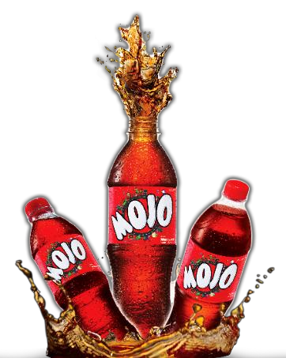

CHAPTER ONE: INTRODUCTION

As my report depends on the title Building Brand Equity of MOJO through Promotional Campaign-A Study of Akij Food and Beverage Limited, I have attempted to depict the idea of brand value and special crusade.

"Brand value is a piece of brand resources and liabilities connected to a brand name and image, which add to or subtract from the worth gave by an item or administration"-

David Aker Brand value improve and develops because of a client's encounters with the brand and Customer based brand value brings about making of solid brand and this is accomplished when brand mindfulness and picture are at elevated level. In this way, brand value can be separated into three segments:

❖ Consumer recognition

❖ The impact this recognition has on the organization

❖ The estimation of this impact

• quantitative qualities income, benefit (or misfortune) and deals numbers.

• subjective qualities purchaser consciousness of the brand, and altruism

Kevin Lane Keller, advertising teacher announce that so as to construct brand value, you need to shape how customers contemplate your item. These contemplations and sentiments are distinguished by four inquiries that speak to what shoppers subliminally pose about your image.

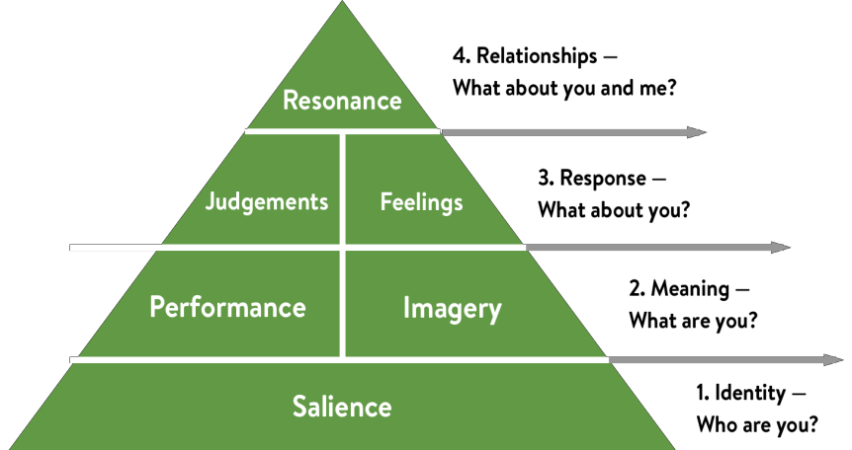
Figure: Brand value Model

Along these lines, brand value has for the most part four structure measurements. first one is Brand mindfulness which implies the notability device identifying with acknowledgment, commonality and review. Brand Association, the second square means something connected in memory to a brand execution and symbolism. third square demonstrate apparent quality about how clients judge an item's general improvement and feel to separate the brand. At long last, the last square not the rundown, reverberation conveys the faithfulness and relationship as an earlier element of brand value.

Basically, Brand value center around two alternate points of view budgetary viewpoint that estimates the estimation of the brand to the firm and purchaser viewpoint that portrays brand value as the estimation of a brand to the shopper.

Special battle is a progression of commercials utilizing distinctive advertising instruments that offer the comparable messages and musings to advance a business or an occasion. It can encourage in expanding brand mindfulness just as in making the correct brand picture. These Campaigns can be executed both on the web and disconnected. Fundamental motivation behind these crusades to contact individuals, make them act with their battle message, convert the activity to deals, more client commitment, and rehash buy.

1.1 Background of the examination:

Information and learning become immaculate when it is related with hypothesis and practice. For any business understudy, just educational program movement isn't sufficient for dealing with the genuine business circumstance, accordingly, it is a pre-imperative for the consummation of BBA program to include with an association through the temporary job program.

Fundamentally, I got a chance to think about the genuine business situation Of Akij Food and Beverage Ltd (AFBL). My report depends on the title Building Brand Equity of MOJO through Promotional Campaign-A Study of Akij Food and Beverage Limited which I referenced previously. What's more, my chief He officially affirmed the report and approved me to set it up with strong directions. I have

attempted my best to relate the down to earth circumstance of AFBL based on working involvement with the entry level position.

1.2 Objectives of the examination:

Expansive goal:
The significant target of this investigation is to portray Branding Practices of Mojo at Akij Food
and Beverage Ltd.

Explicit goal:

❖ To pick up information about AFBL and its carbonated soda „MOJO‟.
❖ To dissect the situating of the brand MOJO increasing higher Top of Mind

Mindfulness (TOMA).

❖ To depict limited time exercises of the brand MOJO
❖ To prescribe a few proposals to the current issues

1.3 Methodology:

The examination is exploratory and illustrative in nature. For Data assortment it has utilized both essential and optional sources.

Essential Sources:
❖ Depth interviews were directed for get-together data from Brand Manager, Assistant brand supervisor and senior administrators.
❖ Communication with HR individuals, Media and structure dept and chief at Akij house
❖ Direct Observations of standard movement and cases
Auxiliary Sources:
❖ Information gathered from profile of AFBL
❖ Various productions in print media
❖ Data from Company Websites
❖ Data from various authority sources and records.
Research Approach: Survey technique Research Instruments: Questionnaire Types of Questions: Close finished inquiries Sample Size: 80 examples
Method of Collection Data: Convenience inspecting procedure was utilized to choose
test.
Techniques for Data Collection:

I have attempted my hardest to do a subjective research where it took me balanced meeting from numerous higher administrators of AFBL. I concentrated my full investigation on the most favored brand Mojo of AFBL. I likewise visited market to create indispensable data. The investigation is upgraded through study of 80 respondents. A short time later, all gathered information have been outlined, arranged lastly arranged for report reason.

1.4 Limitations:

In spite of the fact that I knew and approached a lot of data, however there are still some significant things which I couldn’t get hold of and they didn’t want to unveil. Certain confinements while directing the investigation are as per the following:

❖ Inadequate data of related field
❖ Work weight of officials limited this report from being increasingly point by point and scientific.
❖ Lack of reconciliation among all offices.
❖ Time expending as there was less data in web search and the residency of the temporary position program was extremely short.
❖ Competitors‟ data couldn't be accumulated because of their security approach.
❖ Confidentiality rule of the association blocked the investigation.



CHAPTER TWO: COMPANY PROFILE

2.0 At a Glance AFBL

For the past 50 years AKIJ GROUP, one of the biggest conglomerates in Bangladesh has been serving the country with full of confidence and glory. Now it consists of 24 big concerns with diverse activities & different products. Among them Akij Food & Beverage Ltd is the most popular and ground-breaking unit worth of $70 million, founded in 2006. It manufactures a wide range of Snacks and Beverage of both National & International Market. In three years after its inception, most of its brands became either number one or are almost on the verge of becoming number on respective categories.

2.1 Vision:

To be the number one pioneer brand in food and beverage industry in terms of quality, excellence, marketing creativity, honesty and proper service to the consumers by means of commitment and ceaseless effort.

According to Visionary Entrepreneur Late Mr Sheikh Akij Uddin, he said –

“We will not only manufacture and provide high quality products in the market for consumers but also for our family‟s usage as well; and thus, not to let our family to consume foreign products”.

2.2 Mission:

• To discover new things and meet the satisfaction level of consumers.

• To build a good communication relation among consumers, employees and those business partners
• To deliver quality food and beverage to the market thus bring quality

2.3 Core Values:

• Innovation and Transformation

•Teamworkand Cooperation

• Integrity and Righteousness

• Customer Focus

• Trust and Respect

2.4 Employees:

300

2.5 Board of Directors:

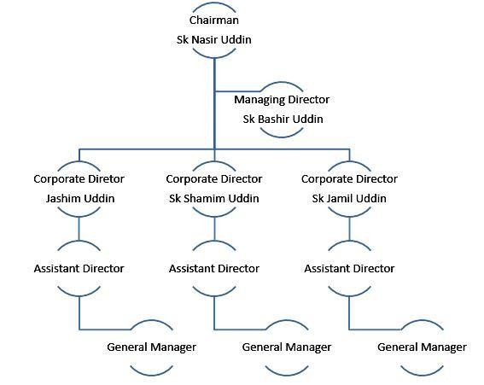

2.6 Product & Service:

• Cola -MOJO

• Cloudy Lemon- Lemu

• Orange Drink- Twing

• Clear Lemon -Clemon,

• Energy Drink -Speed, Houston, Hero (Discontinued)

• Spicy Drinks -Aafi Jeera Pani, Clemon Masala

• Mineral Water- Spa, Rivera, Aafi

• Juice- Frutika (Mango, Red Grape, Apple, Orange, Pineapple. Guava,), Aafi

(Mango drink; orange drink)
•Dairy - Farm Fresh UHT milk, (Mango enhanced, Chocolate seasoned), Farm Fresh Pasteurized Milk, Farm Fresh Ghee, Farm Fresh Butter, Farm Fresh Powdered Milk, Farm Fresh Yogurt (Sweetened, acrid, low fat).

• Malt Beverage - Wild Brew

• Snacks - Cheese Puffs, , Aafi Chanachur

• Fruit Bar - Aafi Mango Bar

Administration offering-Aladdin: Call Aladdin is the home conveyance administration brand of Akij Food and Beverage Ltd. conveying the administration of all items just as day by day products of the organization. Be that as it may, the pace of use of this administration is low.

Channel message: Now request all your most loved Akij Food and Beverage items directly from your Home or Office. Look over a huge choice of Food, Beverage and Dairy items and request just by calling 16609 or 08 0000 16609 (Toll Free).

2.7 Export:

Country: South East Asia, Easter Asia, Middle East and Africa.

Local sales 95%
Export sales 5%
total 100%

2.8 Machineries:

Aseptic Filing line in the entire country as well as subcontinent and modern European technology for processing and packaging like Crones, Tetra Pak, Alfa Laval, Sipa

2.9 Factory:

The factory is located at 50km outside capital the Dhaka Krishnapara, Dhamrai, covering above 100,000 square meter area.

2.10 Head Office:

Akij House 198, Bir Uttam Mir Showkat Road Gulshan Link Road Tejgaon Dhaka where the main office of AFBL is situated and all the work is directed from here.

2.11 MOJO- A CSD Product of AFBL

Among all the eight brands of AFBL, most consumed and preferred brand is MOJO, a carbonated soft drink (CSD) in cola flavor. It was 1st launched in 14th April (Pohela Boishakh) portraying the concept of fun and enjoyment targeted for the youth group. Since then MOJO has successfully won the hearts of thousands of customers bearing local heritage and culture with fusion.

2.12 Initiation:

14th April, 2006

2.13 Ranking:

3rd (Brand awareness)

2nd (Sales volume)

2.14 Vision:

MOJO will be market leader by volume in cola segment by ten years & by next two years will be

2nd position in TOMA.

2.15 Objective:

TOMA, Brand awareness, strong brand equity, sustainable growth

2.16 Pay off tagline:

• “ONTORE ONTORE – IT‟S INSIDE U” (1st)

• “ONTOR IS ON” (2nd)

• “MY LIFE MY MOJO” (present)

2.17 Big Idea:

Engage individual part of life

2.18 USP:

Bearing local heritage and culture with fusion

2.19 Elements:

Culture, heritage, life style

2.20 Segmentation, targeting & Positioning (STP):

Segmentation(s)

Geographic

Continent Asia

Country Bangladesh

City Dhaka (Main Focus) Size/Population Approximately 16 cores Demographic
Gender Male and Female

Age Basically 15 – 30, below 40

Income Minimum 5000

Occupation Mainly Students and other Businessman & Professionals

Psychographic

Social Class Middle class, Upper middle class
Life style Preferring Trendy, fusion, Fun, Fashionable, Choosey, Always Foorti, General and tip top

Behavioral

User Status Potential users, Regular users Benefits Better service and quality Attitude Positive

Target Market

❑ Urban

❑ Semi urban

Target Market Segmentation

❑ Individual

❑ Couple

❑ Corporate

❑ Family (Young Small)

More specific target:

• Primary target (16-26)

• Focused (15 to 25)

• Youth (26 to 35)

Social Economic Class (SEC): A, B+ & B

Positioning (P):

MOJO for long run creates a certain position in the consumer’s mind through inner charm, inspiring fun, foorti, fusion and trendy. Its brand positioning has always been as a refreshing cola drink for the youth that are inspired by own motives. It creates culture and embraces individuality portraying POD and POP, brand mantra and benefit around its brand image.

Brand Mantra: Culture, heritage, Life style

Point of Difference (POD):

• Attractive brand name & easy to pronounce

• Priority on local heritage

• Packaging and style

Points of Parity (POP):

• Consistency in taste

• Properly delivered

• Strong brand image

Benefit: The benefits that consumers perceive are-

Functional: High quality sound

Emotional: feel like rock star

2.21 MOJO Marketing Mix:

Product:

Ingredient: carbonated water, refined sugar, color (caramel), phosphoric acid (as acidulate) & flavor (including caffeine).

MOJO SKU (Stock Keeping Unit)

• MDQC (MOJO diet quarter can -250 ml)

• MQC (MOJO quarter can-250 ml)

• MQP (MOJO quarter pet-250 ml)

• MHP (MOJO half pet-500 ml)

• MOP (MOJO One-liter pet)

• MTP (MOJO two-liter pet)

Brand Extension: MOJO Zero (No sugar)

Price:

Competitive price: As the beverage market is very price sensitive, so the price is close to the

competitors‟ price.

Market oriented price: MOJO considers the market-oriented price using a single price in all area.

Product Brand Size Price

250 ml pet bottle BDT. 16

250 ml CAN BDT. 25
Cola MOJO 500 ml pet bottle BDT. 35

1000 ml pet bottle BDT. 60

2000 ml pet bottle BDT. 85

Place

Coverage:

Region Area

Dhaka South Dhaka – 1, Dhaka – 3, Zinzira, Narayanganj Dhaka North Dhaka – 2, Dhaka – 4, Gazipur, Narshingdi Mymensingh Mymensingh, Tangail
Chittagong Chittagong – 1, 2, 3

Comilla Comilla, Chandpur, Noakhali

Sylhet Sylhet, Moulavibazar Jessore Jessore, Khulna, Kustia Barisal Barisal, Faridpur
Bogra Bogra, Rajshahi, Rangpur, Dinajpur

Promotion

Advertising:

MOJO creates a positive brand image in youths mind through their advertising campaign strategies in order to win long-term customers. For any kind of advertising issue Adcomm Ltd (agency) works with AFBL. For any promotional campaign of MOJO, AFBL generally use three types of advertisement tool- newspaper, billboard, electronic media advertisement

Direct marketing:

In this era of internet, MOJO gives special importance to promote the campaign through their Facebook page MOJOMasti, YouTube-OVC, and official website.

Sales promotion:

Mojo gives short term incentives to both retailer and consumer. For example, free sample to customer at different sponsored event or campaign, 3 or 4 MOJO 250 ml pet free per case to retailer and other Point of Sales Material (POSM): poster, sticker, buntings, PVC, vinyl sticker, dangler as display etc.

Personal Selling:

Mojo generally avoids this promotion but they count corporate selling as personal selling for example, providing MOJO to super shop of ACI. Meena Bazar etc.

Public Relation:

Public relations or PR involves a sustained attempt to develop reputation as a business by using the media to help create the image company desires. It is a way of keeping the business in customers‟ eyes.

Mojo relates a large number of interested public by the following:
➢ Press relations with local newspapers like, Prothom Alo, Dhaka Tribune, Somokal, Kaler Kontho etc.
➢ Sponsoring events and charitable donations.

➢ Arrangement of concert program at mojo pitha uthsob or pohela boisakh.

➢ Attendance at seminars also helps Mojo to promote the image of its business.
Touchpoint:

Visual Operational Both
TVC ✓
RDC ✓
Digital Engagement ✓

Retail Branded ✓
Logo ✓



CHAPTER TTHREE: DISCUSSION & FINDINGS

3.0 Brand Equity of MOJO:

At the point when individuals talk about "brand value" they mean the open's valuation of a brand. It goes about as a structure for understanding the intensity of purchaser's feelings in relationship to organization's situating.

MOJO‟s brand value mirrors the advertising impact to recognize item from others as an offer. It attempts to adjust what it says about the brand in promoting with what it really conveys. In spite of the fact that it went to the market in 2006 however as a neighborhood brand it got commonplace in 2008. From that point to now approx. 13 years, it constantly speaks with the client to review and hold the brand picture. During that range of time RC cola likewise attempted to catch a similar piece of the overall industry however MOJO for its image value creates more cash by making it significant, effectively unmistakable and unrivaled in quality and dependability.

3.1 Factors of MOJO‟s Brand Equity:

Name awareness: The brand MOJO was first acquainted with its intended interest group through the continuous commercial "Asmane Pakha Melo-Antore Antore".With the sound of that signature tune the adolescent could get effectively thrilled and recognize the brand MOJO.

Acknowledgment: Most of the individuals at youthful age in Bangladesh presently effectively relate solid relationship with MOJO and clients become acquainted with the brand and remember it in a store or somewhere else.
Review: Every year MOJO expands the recognition of the brand through rehashed introduction. Magic by and large evaluates the review rate by requesting that their client notice some focused carbonated sodas to realize which brand starts things out as Top of Mind Awareness (TOMA)
Trial – Pretty much every crusade has an objective to arrive at client by their limited time battle. For instance, in MOJO Pitha Uthsob it targets both youthful and family bunch around the region. A large portion of the guests buy MOJO as a preliminary or inclination.

Inclination – When a shopper has a decent involvement in MOJO, it turns into the favored decision. Magic 250ml is profoundly favored for youthful age. From the
contender investigation of inner source, we came to realize that MOJO is currently positioned as third
in cola classification.
Loyalty – After a progression of good brand encounters, clients not just prescribe it to other people, it turns into the just a single they will purchase and use in that classification. A few retailers favor MOJO as it gives free item as opposed to Pepsi or Coca-Cola. A few clients likewise relate their feeling for a neighborhood brand with culture and legacy.

3.2 Competitive Brand Analysis:

MoJo is rivaling two worldwide brands Coca-Cola and Pepsi and with barely any nearby brands RC Cola, Pran Maxx Cola, Virgin, Uro Cola and Color Cola. Let‟s think about its two-goliath rival.
Coca Cola is progressed in liter pack and getting a charge out of urban premium portion of purchasers because of its long legacy and brand picture. Presenting 250 ml pack against MOJO was the greatest risk for MOJO to contend with as there is immense icebox position, shopper advancement, shop marking, and sticker posting at CNG and so on.
Pepsi is trying to grow and taking strategy to compete with Coca-Cola. It also introduced GO PACK (250 ml) against MOJO 250 ml with aggressive pricing strategy Tk. 15. It too invests in extensive promotion like refrigerator placement, hop branding, sales promotion
etc.

Uro cola

RC cola Maax cola
1%

Mojo
31%
2% 2%

Coke
33%

Pepsi
31%

Figure: 250 ml contribution

Source: Research & Devlopment Dept. of AFBL
Overall Competitive view:

Brand

MOJO Coca Cola Pepsi Max cola

Antor is on Taste the Feeling Live for Now Masti Sarabela
Positioning
Communication
Objectives

Communication agenda

Follow the trend, fusion own style
Cultural occasion

Follow the brand reputation

Sports & occasional communication

Follow the brand reputation
Promotes occasion

Follow the brand promise

Promotes occasion
Engagement High Moderate Moderate Average
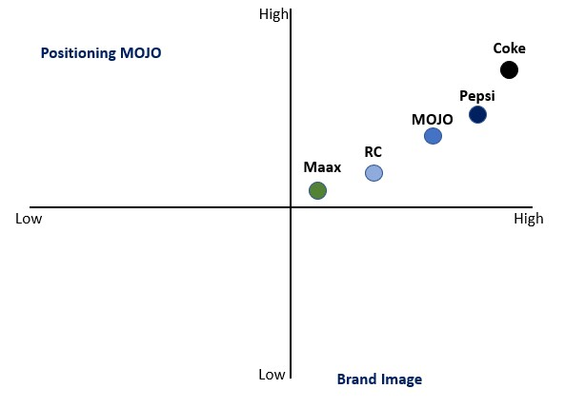Page like 381596 107866355 204796 937417

Figure: Brand image positioning

Market Share:

SALES

8%
10%

23%

59%

Coca cola Pepsi Mojo
Rc

Source: Research and Development Dept. of AFBL

3.3 Connecting Brand Equity with Promotional Campaign:

There‟s no normal perspective to conceptualize or gauge brand value. It by and large centers the marking job in showcasing exercises. Magic from its initiation thought of broad ad focusing on youngsters of the nation which brings about most elevated brand value in the time of 2014 as neighborhood CSD item. Rather than conventional promotional mix, MOJO categorized all its promotional activities into three basic campaigns.

Campaign Mode:

ATL (Above the Line): Above the line marketing includes mass marketing strategies which are largely untargeted and are focused on building the brand. It basically covers TVC, RDC, song making, SMS integration etc.

MOJO‟s ATL Pro mo tio n:

Radio:

MOJO FM Dosti and its radio commercial is a radio program at DHAKA FM 90.4 which grabs the attention of young generation talking about friends and friendship.

Television:

- In 2015 MOJO cola gave a clever advertisement (Bamboo is on) in pretty much every Bangladeshi channel at the hour of Bangladesh VS India One day cricket Series.

- Magic presents Drama shohore notun premik, Choto chele which had broadcast on RTV channel where MOJO advertisement and logo were appeared to look for the consideration.

- Topical crusade My Life My MOJO is one of the ongoing gigantic spending plans spending TVC acted by acclaimed cricketer DJ Bravo. Following the slogan, it has a run a few TVC like-my life my snap, my life my music and so forth.

BTL (Below the Line): Below the line marketing includes direct marketing strategies directed to specific target groups and focused on conversions rather than building the brand. It includes All kinds of campaign, outdoor advertising, direct mail, sponsorship, public relations and in store promotion.

MOJO‟s BTL Pro mo tio n:

Mojo mark battle:

#MOJO Pitha Uthsob: consistently MOJO commends the MOJO Pitha Uthsob the nation over. To associate individuals with nearby legacy and combination, for 2 days in length it offers kids play zone, Shahi Bari fascination, photobooth, band show and many game shows like pitha khadok, pitha chor and so on.

#MOJO Pohela Boisakh: This year MOJO commended its 12 years or first time with its mark battle and birthday MOJO Pohela Boishakh. The program was run for 3 days in length with the greatest show at Uttora companions club. Some notable band and artist like Tanjib Sarawar, Warfaze, Fusion, Hrydoy khan, Mila, Daag, lamppost, Inside u were there to relate their crusade "Ek Jug Eksathe Boishakhi MOJO despise".

HORECA (Hotel Restaurant Café): MOJO is currently focusing on some lodging, eatery and bistro like close by eatery of Basundhora City to benefit their item and better association with client. Our Dhaka University MBA building Café is likewise brightened with MOJO standard and presented with its diverse SKU.

HSC Celebration – „My result my MOJO‟ with this topic magic observed HSC bring about various school inside Dhaka city and outside Dhaka to value their enthusiasm about vocation.

Consistently at Dhaka International Trade Fair (DITF), MOJO beautifies its business stall with enlivened floor configuration, creates game, offers rebate coupon, free example and blessing things like pendrive, top, wrist band and so forth.

Deals Promotion

Exchange advancement: To advance "Magic UTVOT OFFER" crusade, MOJO visited all the principle streets crosswise over Bangladesh with 3 camels which was given to the fortunate 3 retailers as Ed-Ul-Ajha festivity.

Shopper Promotion:

• „MOJO Ticket is on‟ offered every hour 10 tickets of plane, AC transport, and dispatch at

Ramadan through Unicode message.

• MOJO Notun Jama Offer to 100 individuals was gone through SMS sending.

• MOJO Car Tumi Kar offered blessing bundle on each 500 ml, 1 liter, 2-liter

Magic pet jug and an alluring vehicle to the fortunate jug top holder.

Supported occasion:

Magic frequently gets sponsorship proposition for various varsity program, occasion, battle, sports and so on. All things considered MOJO removes some limited time focal points like-

• Banner publication advancements

• Online crusade (special recordings, joins)

• Pre-occasion crusades (online and disconnected like street show technique + volunteers T-shirt, ID card and so on.)

The sponsorship bundle is sorted into 3main criteria dependent on their degree of advantages in special exercises.

Title ***** Platinum or powered by ****
Gold or co-branding ***

A portion of the exceptional supported occasions of MOJO‟s are-

• Folk Fest 2017 as drink accomplice

• Daffodil International University Alumni program 2018

• Pitha Uthsob at Faculty of Business Studies ,University of Dhaka

• Intra University Football competition at Dhaka city

• first National remain by satire fest at United International University
Social Awareness Campaign: MOJO alongside DMP Dhaka Metropolitan Police showed a drive to make street side mindfulness by giving message at zebra crossing, foot over extension to the bystander.

TTL (Through the Line): Through the Line promoting includes advertisers to make showcasing efforts which incorporate both ATL and BTL methodologies. Taking into account that both ATL and BTL exercises, all TTL techniques lead to more readily mark perceivability and brand review. It incorporates Digital promoting (Facebook, You tube, Google Display Network-GDN, Local Display Network-LDN).

Mo jo ‟s TTL Campa i g n:

Mojo propelled their new crusade named HAMBA is ON in a year ago Eid-Ul-Azha. They excited the rage on their Facebook page requesting to transfer a humbafie with a bovine and handover 15 Cows to the champ.

Digital Contest:

• Mojo loathe khela dekhar ojuhate: This continuous test regularly breathed life into the online life customer to comment their explanation behind watching cricket game plan Bd versus West Indies as a strategies customer duty.

• Commntrybaz challenge was held for last Asia cup 2018 reliant on 15 seconds video/sound exchange with the subject - my publication my Mojo. Here the champ got the chance to take in examination from Jafor Ullah Sharafat.

• "ONTORER DAAK" was a valentine fight on fourteenth February to celebrate

the day of love where the lucky name suppliers of their sweetheart one got the gift hamper.

• During Football world cup, it displayed MOJO Mania games application where lucky champ got the gift hamper by playing the game.

• Profile picture diagram campaign was a Facebook challenge to change the profile picture with MOJO layout

• Celebrity support: MOJO moreover arranges challenge for young VIP like pithar loray, enchantment pitha class, etc. This year Mishu Sabbir got the Bangkok air ticket for the program, Mojo‟s Aj kar iftar.

Online Video Campaign (OVC):

• In December 2018, through an online Video making, MOJO enabled just suitable for every occupant of the country with the topical campaign my life my vote.

• Mojo propels some static picture, circle video, GDN (Google Display Network) to get impression, reach and viewpoints. For that it partners with Facebook, MOJO Masti page, Instagram and some online news portal like, Dhaka tribune, kaler kontho, prothom alo, etc.

Immensity: Investing huge money on constrained time campaign like 15 to 20 focuses every year, in all likelihood MOJO is in the mind of most outrageous people in Bangladesh. While entering the market to fight with 2 noteworthy all inclusive brand Coca Cola and Pepsi, MOJO‟s 250 ml. SKU Captured the market which was an exceptional hazard for the contenders. After that they additionally began the 250 ml SKU in their thing class. However simultaneously MOJO endeavors its best to build their picture esteem organizing progressively constrained time fight, landing at more customer and customer coordinated effort. It also keeps the worth low than Coca-Cola, upgrades thing feature and improves customer saw quality concentrated R and D, beneficial arrangements progression, signature fight, HORECA, sponsorship and modernized activities. Its picture office executes all the work demand, spending plan, Standard Operating Procedure and Gantt graph to shape the campaign progressively practical and isolates a motivation from the customer.

3.4 Measuring Brand Equity Performance:

To get to the soundness of the brand, MOJO gives opportune, precise and significant data to Brand Department for taking momentary strategic choice and long haul vital choice. Magic for the most part quantifies its image value in 4 different ways:
Target advertise review:

To get to the adequacy of the brand, MOJO gives advantageous, precise and huge information to Brand Department for taking transient key decision and long stretch crucial decision. Enchantment all things considered appraisals its picture an incentive in 4 distinct manners:
Target promote audit: In reliably Mojo‟s R and D office people visit differing zone of consideration (School, College, and Varsity) to contemplate on directly around 1500 respondents about the brand tendency relating to enchantment. Next graph addresses 3 consecutive audit of forceful brand as brand esteem.

120%
100%
80%
60%
40%
20%
0%

97% 96% 96%
88% 88% 81%

84% 85%

71%
Coke Pepsi MOJO

2015 2016 2017

Figure: Brand Recall Percentage.
Here the surveyors ask the respondent without giving any decision to name some cola drinks. The brand which starts things out to their cerebrum is situated as first audit, and a short time later next brand names are moreover situated as second, third, and fourth consecutively. Along these lines they can know the circumstance of a brand comparative with various brands and choose the Top of Mind Awareness (TOMA) as brand esteem.
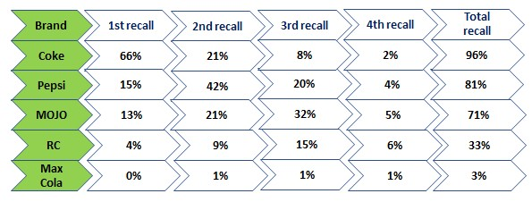

Top of Mind Awareness in Cola Drinks
Brand 2015 2016 2017
Coke 57% 50% 66% Pepsi 20% 22% 15% MOJO 16% 21% 13% RC 6% 5% MAxx1% 2% 2

Source: Research & Development Department

In brand recall, Mojo brand has 3rd highest recall followed by Coke and Pepsi. Mojo here is downward stage though the total recall has marked by 71% in the year 2017

Retailer Survey: Business designer of Panthopath office basically runs the audit on retailer to know the thing availability, bargains volume, buyers demand, publicize position, etc. As an Intern I too much was assigned for promote visit for a specific domain Puran Dhaka where among 32 shops Coca Cola closeness was 88% and MOJO was 84%.

Post appraisal Campaign: Mojo‟s event Management bunch executes the evaluation by using pariah to know whether the campaign could make long stretch effect on buyers mind or not. Plus, reliably it screens the full scale points of view, like, impression, reach through its propelled media.

Focused Group Discussion: MOJO here call the quantum explore association to have a trade with focused assembling where each part gives veritable information about the thing, getting a charge out of, despising and tendency. Being accessible Mojo‟s Branding people in like manner watch the talk without letting them know. Research shows that 15 to 20 juvenile people (generally school and school going) lean toward MOJO at its insignificant exertion and more foam than various brands. 20 to at least 30 developed people lean toward Coke as an overall brand. So progressively increasingly close appraisal is possible through this FGD system.

These all information shows how the brand esteem is assessed similarly as customer demeanor and motivating force to the firm. That is the explanation Mojo is situated third in customer wisdom yet in bargains volume it is by and by at second position according to Neilsen Company Bangladesh.

3.5 Data analysis of MOJO‟s Brand Equity:

From the review of 80 individuals, 48 appear to be understudy, 25 as employment holder, 5 as representative and 2 as housewife. These individuals fall into two age bunch where 71% is male and 29% is female.

Age gathering:

• 18-24 age (38%)

• 25-29 (62%)

User Status and recall:

Last time purchase Frequency Percentage
In the last month 23 28.7
In the last 3 months 8 10
In the last 6 months 8 10
In the last 12 months 8 10
1 year before 25 31.3
I haven‟t purchased 8 10
Total 80 100

31%

10%

10%

10%

29%

10%
In the last month
In the last 3 months In the last 6 months In the last 12
months

1 year before

I haven’t purchased

From this diagram we see that the pace of MOJO use in a month is 29% and the pace of eating up it in 3months, a half year and 1 year is same for instance 10% which suggests a lower purchase rate to the brand. Additionally, an increasingly critical social affair didn‟t even eat up it. The reason for it may be the strong relationship with other two mammoth brand Coca cola and Pepsi or who don‟t support any cola class soft drink pops.

Preferred brand:

Preferred brand Frequency Percentage
Coca cola 61 76.3
Pepsi 13 16.2
MOJO 6 7.5
RC cola - - Max cola - -
Total 80 100

16%
8% Coca cola Pepsi Mojo
RC cola
76%

Max cola

In spite of the fact that MOJO runs numerous limited time exercises for client however it‟s insufficient for long haul customers‟ solid relationship with Coca cola and Pepsi. In any case, contrasting with other nearby brands MOJO is a path ahead for purchaser decision. Here the aggressive brand value magic is considerably less that is just 8% where the brand inclination covers 77% of Coca cola.
Perceived quality:

Reason of Purchase Frequency Percentage
Flavor 9 11.3
Packaging 3 3.7
Quality 8 10
Price 31 38.7
Overall Taste 26 32.5
Popularity 3 3.7
Total 80 100

32%
4%

11% 4%

10%

39%

Flavor Packaging Quality Price
Overall Taste

Popularity
In order to satisfy the customer wants and needs the association must tune in and fathom their customer. The examination shows well which are the requirements in the customer when it‟s about MOJO. An increasingly conspicuous rate for instance 38% to pick MOJO as a brand is moderate expense and as a rule taste is 33%. Other variable possibly differences to the buyer acknowledgment.

Impression:

Impressive factor Frequency Percentage
Advertisement 34 42.5
Event arrangement 10 12.5
Online activities 0 0
Publicity and Social awareness 7 8.7
Concert 10 12.5
No comments 19 23.7
Total 80 100

Advertisement

24%
Event arrangement

43%
Online activities

12%

9%

0%

12%
Publicity and Social awareness

Concert

No comments

Here we run over how Mojo separates itself in their limited time contact point from others brand. Practically 43% backings MOJO in its predictable commercial to review the brand. Next, its occasion and show turns into a POD for client covering 13%. Exposure and social mindfulness likewise impacts marginally for purchaser consideration. Negative brand value may emerge where respondent didn‟t need to remark. This area should be appropriately assessed to serve them better in since a long time ago run.

Taste:

Overall taste Frequency Percentage
Very good 3 3.8
Good 24 30
Okay 43 53.8
Bad 5 6.3
Very bad 5 6.3
Total 80 100

4%

6%
6%

54%

30%

Very good

Good Okay Bad
Very bad

Clients reacted back towards the request of us whether they like the item or not. Through the entire limited time exercises, it increased just 4% of enchanted client who holds solid relationship with the brand, 30% as fulfilled clients for good taste, 6% has a place with disappointed client and practically 54% clients approve of the taste. As of late MOJO thinking about it has improved its quality and did a visually impaired test to numerous FGD individuals which brings about an ideal input for the brand.

Brand association:

Brand association Frequency Percentage
Fun and fusion 3 3.8
Culture and heritage 24 30
Excitement 43 53.8
Antor is On 5 6.3
My life my MOJO 5 6.3
Total 80 100

4%

6%
6%

30%

54%

Fun and fusion

Culture and heritage

Excitement

Antor is On

My life my MOJO

At whatever point it‟s about MOJO, greatest individuals for example 54% related the brand with energy. Just 6% implied MOJO with its slogan Antor is On and My Life My MOJO. A distinctive factor, MOJO‟s culture and legacy spread 30% which could be conceivable just for the customary occasion like MOJO Pitha Uthsob and Pohela Boisakh.

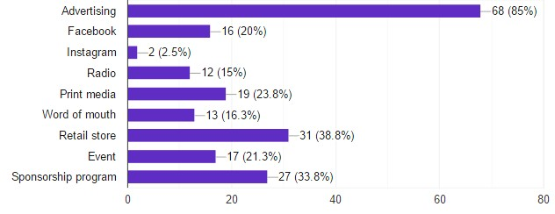Media for awareness and recall:

Through this overview we can expect that, Often individuals become acquainted with about MOJO predominantly through publicizing which covers 85% next by retail location (31%) which shows a positive accessibility of the brand, another eye getting media is through sponsorship program(27%) set apart as more prominent generosity. Occasion, radio and Facebook are likewise dynamic to catch the client eye.

Most familiar Campaign:

familiar Campaign Frequency Percentage
MOJO Pitha Uthsob 28 35
MOJO Pohela Boisakh 15 18.8
Udvot Offer 4 5
Humba is On 16 20
Digital Contest 1 1.2
My Life my MOJO 2 2.5
None 14 17.5
Total 80 100

2%

1%

20%

18%

5%

19%

35%
MOJO Pitha Uthsob MOJO Pohela Boisakh Udvot Offer
Humba is On

Digital Contest
My Life my MOJO None

Among all crusade where respondents relate the Brand is MOJO Pitha Uthsob (35%) which is one of the mark battle of MOJO. Through deals advancement Humba is On crusade is additionally seen by a more prominent rate (20%). others demonstrated the centrality sequentially on MOJO POhela Boisakh, Udvot offer, computerized challenge and topical battle My Life My MOJO. Yet at the same time 18 % individuals are ignorant of these occasions which couldn‟t create any brand value for the Brand.

Brand loyalty:

Brand loyalty Frequency Percentage
Yes 34 42.5
No 13 16.3
May be 33 41.3
Total 80 100

41%
43%
Yes

No

May be

16%

The pie chart shows that only 16% customers are the loyal users and won’t switch the brand even if other brands provide the same quality and price. 43% and 42% are switcher and shifting customer for whom superiority of the brand should be made through better quality and innovation.

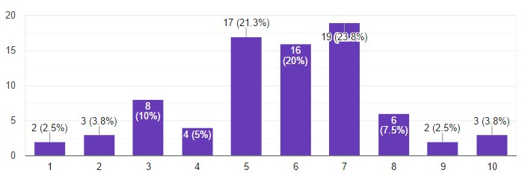Brand Recommend rate:

Here from the bar outline we see that normal individuals rate the magic more than 5 out of 10 points. Just 4% evaluated MOJO 10 out of 10. Explanations behind disappointment of the client should be considered in a manner to all the more likely serve them in future.

Remarks and recommendation:

A few respondents demonstrated numerous motivations to legitimize their assessment. Not many of them are referenced beneath:

• Improving quality would work better

• Spice up the taste as a variety
• It'll be better if the quality and taste stay same consistently.
• I don’t like soda pops.
• Need to bring some advancement
• Excellent brand from youth however needs some desi variety.

3.6 SWOT Analysis of MOJO

Quality

➢ Huge interest for MOJO 250 ml pet jug.
➢ Fair and Competitive cost.
➢ Good piece of the overall industry and brand value
➢ Latest innovation, appealing and imaginative correspondence
➢ Strong notice and mark battle

Shortcoming

➢ Lack of refreshment cooler in retail shop
➢ No utilization of glass bottle.
➢ Less inclination of brand acknowledgment.
➢ Less visibilities near to coca cola and Pepsi

Openings

➢ Engagement with Hotel, café, and cafeteria (HORECA)
➢ Increase brand picture through open connection.
➢ Create interest for higher SKU.
➢ Introduce Vending Machine

Risk

➢ Competitors’ escalated enactment with retailer
➢ Strategic coalition of contenders with different brands
➢ Increasing substitute item like games drink, caffeinated beverages, and juice

➢ Market pioneer solid brand picture

3.7 Findings

Positive aspects:

1. AFBL‟s target is tied in with getting quality life to client. This is an endless duty. It doesn't simply occur. They get it going through advancement, broadening the item class, utilizing top notch innovation and condition benevolent hardware.

2. Magic accepting a section as nearby CSD item, focusing on the young and making them feel like a hero with bubble sound, bundling, simple and critical brand name contending with two monster worldwide brand Coca cola and Pepsi.

3. Other than fun and combination MOJO centers around culture and legacy and they first

presented MOJO Pitha Uthsob which catches eye a huge number of nourishment darlings in Bangladesh. Besides it commends its birthday in each time of Pohela Boisakh by giving slow down, orchestrating show, Shahi Bari fascination, games stall and so forth.

4. As a large portion of the individuals of Bangladesh are value affectability, Mojo here serves them better in term of lower cost particularly for 250ml MOJO pet and can.

5. MOJO‟s topical crusade like my life my magic, my outcome my MOJO, my

music my MOJO these are more client situated which can without much of a stretch relate their feelings utilizing the brand.

6. To assemble Brand value for the firm MOJO puts a great deal in deals limited time exercises like Udvot offer for retailer, Humba is On for its client.

7. Some recognizable social battle like roadside mindfulness for the driver, traveler and bystander can without much of a stretch improve client recognition and idealness to the brand.

8. Magic consistently keeps the buzz of youthful age particularly careful the TTL battle where we see diverse advanced challenge, games, exercises are run for more prominent commitment of this gathering.

9. Research and development division of AFBL is currently working with its quality improvement where the FGD bunch valued its new taste.

10. Magic has positioned in third at Top of Mind Awareness and second at deals volume for

building its image value.

Problem Identification:

From the overview we run over that disregarding tremendous interest in Promotional crusade the brand value of MOJO is descending comparative with Pepsi and Coca cola which is an extraordinary danger for the brand MOJO. Following reasons can be depicted as an ID of the issue.

1. Competitor‟s presenting 250 ml cola drink like MOJO made it simple for client to

switch the brand.

2. On clients request, MOJO is as of late increasingly improved as far as taste and quality. In any case, it‟s falled behind the Coca cola and Pepsi for the solid relationship with the old brand and not going for buy MOJO once more.

3. Like different contenders MOJO doesn't give as a lot of fridge or ice cooler in retail shop which causes less of control on item accessibility.

4. As AFBL needs to put resources into other refreshment item like clemon, speed, frutika it can't put more cash in MOJO.

5. The administration offering Aladin for conveyance of refreshment item isn't notable to the client.

6. Despite the fact that MOJO offers blessing hamper through various limited time crusade however it doesn't go for any co-marking with other accomplice as opposed to AFBL item.

7. Magic is favored chiefly to class and school going understudy at its reasonable cost.

In any case, others individuals organize on the worldwide brand as opposed to magic dependent on status and long haul relationship with those brands.

8. Research division covers just 1500 respondent consistently which hushes up little example size to know the client in general.



CHAPTER FOUR: CONCLUSION & RECOMMENDATIONS

4.0 Conclusion & Recommendations:

Nourishment and refreshment industry are for the most part quickly developing segments in Bangladesh. Because of exceptional challenge organizations currently are perceiving the significance to improve their image value through various limited time battle. For a long time long MOJO has been giving its client an air wherein they can feel the vibe of culture, legacy, fun and combination. In any case, all in all, it has a few downsides as well. With the examination of discoveries of this investigation and Following related proposal, the value Gap can be lessened and make the clients consequently purchase.

1. Special crusade ought to be focused for different SKUs alongside MOJO

250 ml.

2. Research and development dept. should review by making individuals taste the new improved MOJO
first, at that point request survey. Through this negative apparent quality can be changed and can fabricate positive brand value.

3. Increasingly more passage through HORECA with candy machine or ice cooler ought to be presented then make individuals purchase MOJO with incredible experience of taste.

4. Magic ought to be organized as star at BCG Product classification and put more in creative component for keeping up brand steadfastness.

5. For online conveyance through Aladin, Mojo may give little level of rebate to the client in condition for transferring their acquired pictures in Face book page with the pace of taste.

6. Energize item packaging like joining a few items or administrations into one "bundle" and offering them at a solitary cost.

7. FGD study may work better for dazzle trial of three focused brands and rate them in various criteria like effervescence, sugar sum, taste and flavor. By connecting with them, close assessment is conceivable to quantify the brand value.

8. Close finished review through Google structure or committed brand advertiser can contribute decidedly to arrive at more clients making fundamental data for R

and D dept. Accordingly coordinating "voice of client", MOJO can catch their

expressed and implicit needs or necessities in all business choices.

References

❖ Books:

Keller Lane Kevin. Strategic Brand Management.4th ed. United States: Pearson education, 2013

❖ Websites:

• https://modicum.agency/blog/building-brand-equity/

• https://www.shopify.com/encyclopedia/brand-equity

• https://scialert.net/fulltext/?doi=ajm.2017.13.20

• http://dspace.uiu.ac.bd:8080/handle/52243/245

• https://www.akij.net/akij-food/portfolio-category/food/

• https://www.facebook.com/mojomasti/

• https://www.akij.net/akij-food/#

❖ Document:

• PDF file of MOJO‟s Brand Management.

• Power Point presentation of Research and Development Dept.

❖ Google Form Questionnaire: https://goo.gl/gpbN3X

QUESTIONNAIRE

Dear Respondent,

As an understudy of United International University, I need to gather data of your experiences and conclusions on the status of the brand Mojo, a Carbonated soda pop of Akij Food and Beverage Limited for report reason. I will value your significant time and backing in addressing the inquiries. All the data gathered will be kept severe and private for study reason.

Name: Gender:
Male
Female

Occupation:

Student
Job Holder Businessman House Wife

AGE:

Under 18
18-25
26-30
30-35
35+

When was the last time you bought Mojo?

In the last month
In the last 3 months In the last 6 months In the last 12 months
1 year before
I haven‟t purchased

Which brand do you prefer as a soft drink?

Coca cola
Pepsi

RC cola Mojo Max cola

What can make you purchase the brand MOJO?

Flavor Packaging Quality Price
Overall Taste
Popularity

What do you associate with the brand MOJO?

Fun and fusion Culture and heritage Excitement
Antor is On
My life my MOJO

In which way you often get to know about MOJO? (you can tick more than one option)

Advertising Facebook Instagram Radio
Print media Word of mouth Retail store Event
Sponsorship program

Which campaign are you most familiar with?

MOJO Pitha Uthsob MOJO Pohela Boisakh Udvot Offer
Humba is On
Digital Contest
My life my MOJO None

In what aspect MOJO is more impressive than others?

Advertisement Event arrangement Online activities

Publicity
Social awareness
Concert
No comments

How well the MOJO tastes?

Very good
Good Okay Bad
Very bad

Will you switch to other brand if they provide the same quality and price?

Yes
No
May be

How luckily You will recommend our brand?

1 2 3 4 5 6 7 8 9 10

Comments or Suggestion

------------------------------------------------------------------------------------------------------------
------------------------------------------------------------------------------------------------------------
---------------------------------------------------------------------------------

Images related to Promotional Campaign:

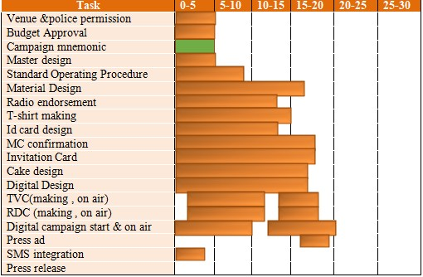

Campaign Gantt chart Of Mojo Pitha Uthsob

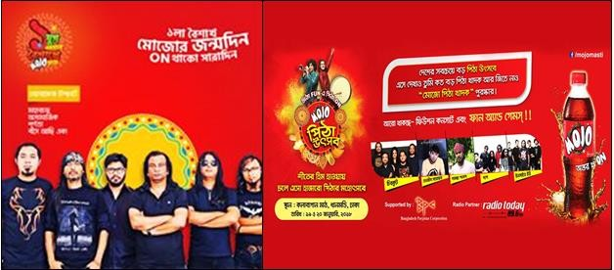
Signature campaign

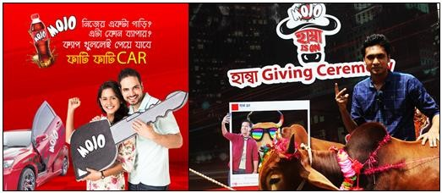
Sales Promotion

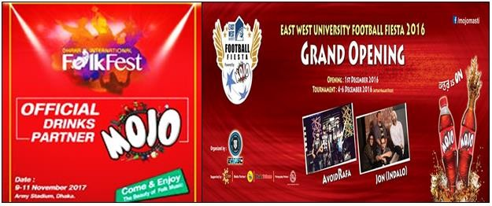Sponsorship program

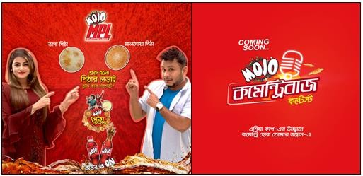
Digital contest

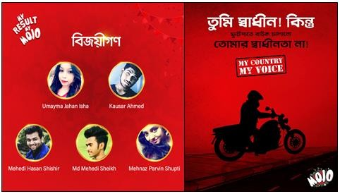
Social activities

