United International University

Internship report
on
FOREX Division of Mercantile Bank Limited

SUBMITTED TO:
Mohammad Tariq Hasan
Assistant Professor
School of Business and Economics
United International University

SUBMITTED BY:
S.M.Laizur Rahman
ID: 114 133 011
Department: BBA in AIS
United International University

DATE OF SUBMISSION:
April 19, 2019
Letter Of Transmittal
April 19, 2019
Mohammad Tariq Hasan
Assistant Professor,
School of Business and Economics,
United International University.

Subject: Submission of internship report on “FOREX Division Of Mercantile Bank Limited”.

Sir,

Here, I present my internship report titled “Internship report on foreign exchange division of a commercial bank” with due gratitude and appreciation. As per partial fulfillment of the requirements for the BBA Degree, I have completed the internship from Mercantile Bank Limited, Gulshan Branch, Dhaka.

The report is based on the knowledge, experiences and the skills that I have acquired in this period.

While doing my internship, I have the opportunity to meet all employees in the Gulshan branch (MBL). Almost each employee I came across had been very helpful.

However, should you need any clarification I will obligate to provide further explanation.

Thanking you
Yours sincerely,
S.M. Laizur Rahman
ID: 114 133 011

Letter of Acknowledgement

Toward the starting, I might want to offer my genuine thanks to Almighty, the most forgiving and gainful for enabling me to set up the report inside the booked time.
I additionally need to thank particularly to my internship supervisor Mohammad Tariq Hasan, Assistant Professor, BBA in AIS, United International University for his motivating rules, profitable proposal, valuable analysis and steady help all through the work and in readiness of this report.
I additionally offer my warm thanks and friendly gratitude to the administration and authorities of Mercantile Bank Limited, Gulshan Branch who have allowed me the chance to work with them and helped a great deal by giving the data and empowering me to set up this report. I have gotten their liberal help and backing.
I might want to accept the open door to offer my wholehearted thanks to my kindred companions, precious ones who offered consolation, data, motivation and help over the span of developing this report.

Declaration:
I hereby declare that the information furnished below is true and genuine to the best of my knowledge.

--------------------------
S.M. Laizur Rahman
ID: 114 133 011

Table of Contents
Executive summary 7
CHAPTER ONE: INTRODUCTION 8
1.1 Introduction 8
1.2 Context of Mercantile Bank Limited (MBL) 8
1.3 Origin of the study 8
1.4 Background of the Study 9
1.5 Rationale of the report 9
1.6 Scope of the report 9
1.7 Limitations of the study 10
Short time period 10
Data insufficiency 10
Lack of records 10
Lack of experience 10
CHAPTER TWO- METHODOLOGY OF THE REPORT 12
2.1 Methodology 12
A. Determination of the point: 12
B. Discovering data sources: 12
C. Collection of information: 13
D. Sampling/ inspect: 13
E. Categorization, exploration, explications and appearance of information: 13
F. Detection of the study: 13
G. Preparation of final report: 13
CHAPTER THREE: ORGANIZATIONAL BACKGROUND AND INDUSTRY PERSPECTIVE 14
3.1 Analysis of banking business 14
3.2 Banking business System in Bangladesh 18
3.3 Glimpse of Economy of Bangladesh: 18
3.4 Overview of Mercantile Bank Limited 21
3.4.1Mission: 22
3.4.2 Vision: 22
3.4.3 Main objectives: 23
3.4.4 Core Values 23
3.4.5 Mercantile Bank Limited (MBL)’s business philosophy 24
3.4.6 Business nature of Mercantile Bank Limited (MBL)’s 24
3.4.7 Some features of Mercantile Bank Limited 24
3.4.8 Mercantile bank Limited (MBL)’s management structure 25
3.4.9 Managing the risks 26
3.5 SWOT analysis of Mercantile Bank limited (MBL) 29
Strength 29
Weakness 29
Opportunities 29
Threats 30
3.6 Division of Gulshan Branch 30
3.7 FOREX Division 30
3.7.1 Interpretation of FOREX 30
3.7.2 Duties of FOREX Division 30
3.7.3 Exchange Rate Policy 31
3.8 Sections 31
3.9 Import Section 31
3.9.1 Import Mechanism 32
3.9.2 Import Registration certificate (IRC) 32
3.9.3 Activities of Import Sections 33
3.9.4 Procedures of Import 34
3.10 Export Section 35
3.10.1 Types of Export 35
3.10.2 Export Functions of MBL 36
3.10.3 Legal Requirements of MBL for the Export 36
3.10.5 Process of Export (local) with real life example: 37
3.10.6 Process of Export (Foreign) with real life example: 48
3.10.7 Mercantile Bank Limited (MBL)’s advising export L/C’s 51
3.11 Foreign Remittance 52
3.11.1 Classification of Remittance (Foreign) 52
Inward Remittance (Foreign) 53
Types of Foreign Inward Remittance 53
Collection procedures of Foreign Inward Remittance 53
Revocation of Foreign Inward remittance 54
Outward Remittance (Foreign) 54
FC (Formal Channel) 55
IC (Informal Channel) 55
3.12 Letter of Credit (L/C)’s for import and Export 55
3.13 Classification of L/C’s 56
Revocable L/C 56
Irrevocable L/C 57
3.14 Types of L/Cs 57
3.15 Required documents for opening a L/C at MBL 58
3.16 Proclaiming the L/C by the MBL 58
3.17 Process of L/C’s 59
3.18 Parties Involved in Letter Of Credit (L/C) 60
CHAPTER FOUR-Findings and Analysis of the Study 62
4.1 Analysis 62
4.2 FINDINGS: 65
4.2.1Findings from financial performance analysis of MBL: 66
CHAPTER FIVE-CONCLUSION AND RECOMMENSATION 68
5.1 Conclusion: 68
5.2 Recommendation: 68
CHAPTER SIX: APPENDIX 70

Executive summary

“FOREX Division of Mercantile Bank Limited” is all about the functions or activities of Mercantile Bank Limited (MBL) and its main concentration is all about the foreign dealings and their concentrated areas. This is large business conveyed out by the Mercantile Bank Limited (MBL) is a adventitious commerce transaction is a non- native nations in esteem of imports, exports and remittance go under the foreign exchange department of a Mercantile Bank Limited (MBL), Gulshan Branch. MBL always play a important part to connection between the vendee and vendor. From the very first part of the report we found origin of the report, objective of the report, scope of the report and limitations of the report. Secondly, it includes the methodology of the report. Thirdly, it describes the industry, about the Mercantile bank and it includes vision, mission, features, structure, organ gram, division, section, process of export, import and remittance, real life example and so on. From these we can find overall picture of Mercantile Bank, Gulshan Branch, how they actually work, what types of services they provide. Fourthly, we can find some findings and analysis to see the actual scenario of MBL. In fifth, we point some conclusion and recommendation to assess the situation of this branch and how it would perform in greater in rivalry. Lastly, we mentioned out from where get helped to prepare this report.

CHAPTER ONE: INTRODUCTION

1.1 Introduction
Bank is characterized as money related foundation that gathers stores from different individual and associations and gives credits to the individuals who need it. Be that as it may, present day banks don't mean just the methods for gathering and dispensing cash to different substances. Or maybe it gives different administrations to different elements which encourage their business activities. An outside trade task of banks is one of those administrations that encourage the matter of representatives as well as ads to the improvement of the economy all in all. Remote trade is characterized as the instruments by which the money of one nation is changed over into the cash of another nation. Outside trade is the methods and techniques by which rights to riches in a nation's money are changed over into rights to riches in another nation's cash. Outside trade division of banks assumes huge jobs through giving distinctive administrations to the clients.

1.2 Context of Mercantile Bank Limited (MBL)
Mercantile Bank Limited, joined on May 20, 1999 and initiated business on June 02, 1999, is presently a standout amongst the most vital substance in the financial business of Bangladesh. With the progression of time it has extended its number of branches and assortment of administrations alongside its center business of taking stores and giving credits. Presently MBL has risen as another business bank to give productive financial administrations and to contribute financial advancement of the nation. Rising pattern of the banks gainfulness throughout the most recent 8 years is additionally emerged. The MBL is focused on the conveyance of the unrivaled investors' esteem. FOREX department of this branch a standout amongst the most vital divisions. Presently it has turned into the foundation of the bank. With the plan to be the 'Bank of decision', it is working in the business with a group of gave faculty to exceed expectations both their own profession and the bank's future.

1.3 Origin of the study
This report is begun as the course prerequisite of the BBA in AIS program under the business thinks about personnel of United International University. Under this program students of every department of this faculty must go through an internship program of 3(Three) months duration. I was sent by the division of Accounting Information System to take genuine presentation of the exercises of banking budgetary organization.

1.4 Background of the Study
Mercantile Bank Limited (MBL) is one of the ascending, successful bank in our country. In 2018 they proclaimed 41% profit to all investors. Mercantile Bank Limited (MBL) has 138 branches situated in better regions and furthermore is going to set up 22 branches all over the country.
This internship program is a basic as well as required of the Bachelor of Business Administration (BBA) Program of United International University. Succeeding fruition of four years hypothetical preparing, I received the open door as a pragmatic presentation to commerce skyline via temporary position of internship program. Mercantile Bank Limited (MBL) is one of the all around presumed private business bank of Bangladesh with paid up capital of BDT 739.16 ( crore, 31.12.2016). Banks solid money basis enables and it makes vast piece of proceed to its corporate customers.
My entry level position manager, regarded instructor Mohammad Tariq Hasan, Assistant Professor, Department of Business Administration in AIS program, United International University, appointed me the theme "FOREX Division of Mercantile Bank Limited." I trust this report would ready to depict the genuine image of the task of outside trade branch of Mercantile bank Ltd (MBL).

1.5 Rationale of the report
“FOREX Division of Mercantile Bank Limited” is extensively sorted out infatuated with 2 (two) wide segments. In first segment (initial three parts) is a diagram of the association itself. In second the segment focuses on the doled out theme "An examination on the Foreign Exchange Operations of Mercantile Bank Limited." In the end it incorporates the assessment of FOREX execution, discoveries, along with proposal in making of comprehended extent of by and large FOREX with its limitations of Mercantile Bank Limited (MBL). The purpose of this examination is to secure a comprehension of the empirical financial bustle and agnate all of them with speculative data, expanded via the conjectural planning in the school along with different chronicles of bank. Contiguous this, the admirers are the definite goals, which will endeavor to engulf in “FOREX Division of Mercantile Bank Limited”.

1.6 Scope of the report
One account of I was sent to one of the leading bank, Mercantile Bank Limited (MBL), Gulshan Branch, the range of the “FOREX Division of Mercantile Bank Limited” this at best restricted with this branch. The “FOREX Division of Mercantile Bank Limited” engulfs its overall FOREX execution. “FOREX Division of Mercantile Bank Limited” engulfs export, import and remittance functions of Mercantile Bank Limited (MBL). Other than it engulfs point, for example, advancement of banking trade and commerce, development banking trade and commerce in BD, Our economy situation, foundation of Mercantile Bank Limited (MBL) has additionally been examined.

1.7 Limitations of the study
In transit of the “FOREX Division of Mercantile Bank Limited” I confronted all the issues that are stated beneath and it might be locution as the impediment or weakness of the “FOREX Division of Mercantile Bank Limited”.

Short time period
The elemental block is duration. Because of as far as possible, the degree and measurement of the study has been shortened. For a logical reason sufficient time is required. Be that as it may, I found a brief timeframe to set up the “FOREX Division of Mercantile Bank Limited”.

Data insufficiency
For preparing it was extremely hard to gather information, in light of the fact that this branch of Mercantile Bank Limited is substantial. Be that as it may, the information is basic to set up the report. The majority representatives of this branch are occupied. Affecting the duration confinement they couldn't ready to nimble my theme associated information.

Lack of records
Adequate register or out ward books, publications, raw numbers limited the extent of precise investigation. In the event that this impediment was not been there, the report would have been progressively valuable and alluring.

Lack of experience
Skill and practical knowledge makes a man effective. I was doing determiner sort of experiment movement out of blue. That is the reason inability makes snag to pursue the methodical and intelligent research system.

Internship at Mercantile Bank Limited (MBL)
My internship duration (Three months) at the Mercantile Bank Limited (MBL), Gulshan Branch as an internee had been the most satisfying time in my life. Doing my entry level position at one the leading private bank in our country, I trust I have aggregated an encounter unmatched to some other.
The authority sends me to the FOREX division of Mercantile Bank Limited (MBL), as my venture disclose. I was very upbeat to practice in such a venture.
For the entry level position programs the HR executives of the head office sends me to the Gulshan branch of this bank. My goal was to find an unmistakable thought regarding the capacity of the outside trade of the branch. Be that as it may, my supervisor sent me first to the Local Export to have a primer thought and to be familiar with different sorts of neighborhood trade charges and related issues; I worked there for 50 days and scholarly the system of issuance of pay request, demand draft (DD), and technique for keeping up books for the previously mentioned exercises. At that point I was sent to the clearing segment, of worked there for 25 days and figured out how internal and outward checks are cleared, how exchange conveyance starting with one branch then onto the next branch is made. From that point forward, I was sent to the IT bureau of this branch. I worked there for 10 days. Here I figure out how to give bank explanation, Tax reason articulation. After that I was sent to the fare area of the outside trade bureau of this branch. I work there for the remainder of the time of my entry level position program. In the fare segment I predominantly watched the fare techniques, records and archives of various exporters, send out continue gathering strategies and consistence of fare methodology with the set principles of fare arrangement and Bangladesh bank rules. As a matter of fact this period was my territory of fixation and exercises of this period is for the most part centered in my report. I stretched out my best exertion to gather however much data as could be expected to set up my report. The workplace of this division of the Mercantile Bank Limited is conductive and well disposed. The staffs are spent significant time in their particular fields. Every one of them takes a shot at their own and there is supervision from the top. The inspiration of the staff, I trust originates from the very awareness of other's expectations for his or her work.

CHAPTER TWO- METHODOLOGY OF THE REPORT

Methodology is the exact, conjectural scrutiny of the techniques correlated with a ground of my study. It contains the conjectural scrutiny of the accumulation of the procedures along with measures linked with a piece of erudition. Consistently, it wraps thoughts, for instance, perspective, and conjectural replica, juncture along with perceptible or emotional procedures.
A methodology does not place out to game plan— it is as such, not identical to a procedure. A procedure propose the hypothetical holding for apprehension which framework, reinforced of methodologies, or greatest implementation can be related with a particular occurrence, for instance, to enroll a particular outcome.

2.1 Methodology
The “FOREX Division of Mercantile Bank Limited” requires a deliberate strategy from determination of the point to definite report planning. To play out the investigation the information sources are to be distinguished and gathered, they are to be ordered, broke down, translated and exhibited in a precise way and key focuses are to be discovered. The overall procedure of system is given in the accompanying page in a type of stream outline that has been pursued in the “FOREX Division of Mercantile Bank Limited”.
- Determination of the point: The point of the examination was doled out by my supervisor. Before allocating this subject it was talked about with me so as to an efficient entry level position report can be readied.
- Discovering data sources: Both primary and secondary sources are recognized which will help us to finish the study. To get together the recompense of information, primary information is utilized along with think about additionally necessary meeting with authority along with staffs were fundamental. The “FOREX Division of Mercantile Bank Limited” additionally recommended secondary information.
i) The primary sources are:
- Browbeat conversation with the officers of this branch.
- Empirical table job.
- Applicable register books, and out ward was providing me by officers.
ii) The secondary sources are:
- Mercantile Bank Limited (MBL)’s annual report.
- FOREX division of Mercantile Bank Limited (MBL).
- Mercantile Bank Limited (MBL)’s intermittent report.
- Bangladesh Bank (BB)’s annual report.
- Some publication and website of Bangladesh Bank (BB)..
- BIBM’s publication.
- Internal office circular of Mercantile Bank Limited (MBL).
- Communal publicize report.
- Applicable reports, books, journals etc.
- Management Trainee Officer (MTO)’s recruitment policy of Mercantile Bank Limited (MBL).
- Information retained by head of branch, GB in charge, FOREX in charge and credit in charge.
- Collection of information: Primary information are gathered by utilizing in interrogating method. The “FOREX Division of Mercantile Bank Limited” is an experimental probing and for subjective overview, open finished inquiry to the officers.
- Sampling/ inspect: Whole banking system, all the branches of Mercantile Bank Limited (MBL) is taking as sample.
- Categorization, exploration, explications and appearance of information: some number juggling and pictorial examination are utilized in “FOREX Division of Mercantile Bank Limited”.
- Detection of the study: The gathered information was examined great and were brought up and appeared as discoveries. Scarcely any suggestions are additionally made for development of the present circumstance.
- Preparation of final report: Based on the proposals of our decent workforce manager a few revisions were made to exhibit the paper in this structure.

CHAPTER THREE: ORGANIZATIONAL BACKGROUND AND INDUSTRY PERSPECTIVE

3.1 Analysis of banking business
Analysis of banking business: The word bank, which implies a money related go-between that gathers stores from savers and dispenses advances to the reserve searchers and goes about as the foremost vehicle of inner assets activation of an economy, isn't the aftereffect of a brief period. Rather, it needs to go through an extensive stretch.
In the antiquated age, individuals needed to fulfill the majority of their needs without anyone else. At this stage, there was no surplus creation. Henceforth the idea of exchange was yet to be presented. In any case, as the bisection of tasks occurred in the public, there was excess just as deficiency creation in every general public. This guide to the presentation of BARTER SYSTEM' in which wares were traded for products legitimately. Be that as it may, this exchange framework couldn't keep going for quite a while for certain issues, for example,
- Dual conjunction of demands: These methods the necessities of two people must meet the surplus that they have. For instance, one individual has some excess oil and someone else has some excess vegetable. On the off chance that they the individual with oil has the need of vegetables and the individual with fabric demands oil, at exactly that point the exchange will happen. However, that was troublesome.
- Entangled of products: all merchandise are not detachable and not of same worth. This caused a major issue for exchange. For instance, a dairy animals isn't replaceable for 1 meter material, neither one of the it’s can be dividable in littler units.
Therefore, individuals needed to think for a system that would tackle these issues and encourage the exchange procedure. This brought about the presentation of cash as stone, metals, bones and so on.
After the presentation of cash, the volume of exchanges expanded all things considered. Individuals with surplus cash began to feel shaky about their cash. At that organize, goldsmiths, ministers, agents were the most fair and confided in individuals in the general public. Individuals began to keep their surplus cash and adornments stored with them. They loaned this cash with no charge to the individuals who required cash. This was the 'exchange of most extreme confidence'. From here, the historical backdrop of bank checks.
This discussion can be presented in the following diagram:

Insecurity in Safety of Money
Problems in Adjusting Needs
Family System

Introduction of Banking System
Introduction of Money as Media
Creation of Barter System

Problems in Cash Transaction
Problems in Division of Goods
Division of working

Figure3.1
Expansion of banking business

After some time, business people began to charge a few charges on the individuals who took advance from them. It was the goldsmiths who presented the 'store slips' in the history. Step by step, volume and intricacy of exchanges continued expanding, so as the idea of bank. The financial frameworks of antiquated age and the financial frameworks of current age are two unmistakably separate substances. The circumstances and defects that came about the financial frameworks in the present structure are featured underneath:
As in front of calendar as 2000 B.C., Babylonians had developed a plan of bank. In out of date Greece and Rome the demonstration of giving credit was commonly won. 'Indications of Credit by pay and by trade' orders were found in Assyria, Phoenicia and Egypt before the system accomplished full improvement in Greece and Rome. The book of old Hindu saw supplier, MANU, is overflowing with rules for managing credit. He discusses lawful strategies credit instruments were called for, energy on advances, on agents, customers and even of the reclamations of business papers. In Rome, agents were called Argentarii. A couple of banks passed on business in solitude record and others were assigned by the Government to get the evaluations. Advance banks which lent money to the poor with no excitement on the security of land for a period of 3 of 4 years were furthermore ordinary in Rome. The Bank of Venice, built up in 1157, should be the oldest bank. It was anything but a bank in the cutting edge sense being basically an office for the exchange of open obligation. History exhibits the nearness of a 'Monte' in the Florence in 1336 the significance of 'Monte' is given in the Italian Dictionary 1959 as 'a standing bank or measure of money, as they have in arranged urban networks of Italy'. Banbrigge, an English creator, discusses 'the three banks of Venice' which implies the three open credits of Monte.
The beginning of the English banking may adequately be credited to the London goldsmiths. They used to get their customers' benefits and resources for security guardianship and issue receipts perceiving the proportional. These notes, over the range of time, ended up payable to bearer on intrigue and consequently refreshing critical scattering. Frankly, the goldsmiths' notes may be considered as the harbinger of the guaranteed receipt. The matter of the goldsmiths got an impolite paralyze by the abhorrent treatment of the Government of Charles II, under the Cabal administration. In the declarations of Bagehot; "It had executed one of those massive cheats which are in like way net goofs". The goldsmiths used to store their spare of fortune in the 'Exchequer' with the consent and under the thought of government. Regardless, Charles II shut down the Exchequer and paid nothing to the goldsmiths. Nevertheless, the ruin of goldsmiths signifies a vital turning point ever of English banking. It incited the advancement of private banking and the establishment of the 'Bank of England'. In the India, as on schedule as Vedic period, banking existed in the crudest structure. The bloods of Manu contain references regarding stores, guarantees and approach of advances and rates of interest. Really, banking in those days, all things considered, inferred money advancing and they didn't know the tangled instruments current banking. This is certified in case of India just as in case of various countries. The progression of banking foundations ended up being progressively increasingly formed as the time passed. In various periods, unmistakable modifications were made in different countries all through the world. Along these lines, exceptional countries have unmistakable responsibilities
the money related associations to appear in the present structure.

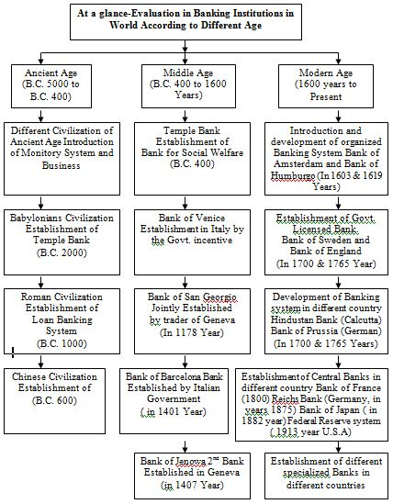
Figure: 3.2
Evolution of banking institution at different Age

3.2 Banking business System in Bangladesh
Our country has a blended financial framework involves commercialized, nationalized, private banks. Bangladesh Bank (BB) has functioning as the national bank of the nation since the autonomy of the nation. Its main employments incorporate providing monetary forms, keeping up remote trade save and giving exchange offices of all open money related matters. BB is in charge of arranging and executing the administration's money related approach.
Banking industry ordinance:
This Ordinance was proclaimed on June 7, 1962. It has been received in our country and is relevant to the financial organizations as it were.
Main job of banking industry
- Taking adoption, gathering, withdraw of cash.
- Taking or giving loan with or without security.
- Conduct in securities and speculation.
Categories of Banks:
There are three kinds of banks in our country and they are:
- Central Bank
- Commercial Bank
  - Nationalized Commercial Bank
  - Private Commercial Bank
  - Foreign Bank
- Specialized Bank

3.3 Glimpse of Economy of Bangladesh:
Amid FY08 (July 2007 – June 2008), the Bangladesh economy kept up a solid development supported for the most part by vigorous development in administrations and remarkable extension in assembling exercises, notwithstanding confronting high and unstable oil costs in the global market. With the end goal of accomplishing higher financial development, the Government and the Bangladesh Bank kept on embracing arrangements to help monetary exercises to the most astounding manageable dimension, while keeping up a moderate Consumer Price Index (CPI) swelling. These approaches contributed toward a solid genuine GDP development of 6.5 percent in FY07, marginally lower than 6.6 percent of FY06. Monetary development was additionally helped by expanded inflow of laborers' settlements from abroad and sensible development in fares.
In U.S. dollar terms, trade income recorded a moderate development of 15.9 percent, while the development of import installments stayed to a manageable dimension at 16.7 percent. In the meantime, settlements from non-occupant Bangladesh nationals expanded generously by 24.6 percent. The nation's outside current record balance kept on account a critical surplus with a generous increment in settlements more than counterbalancing exchange shortfall and administrations shortage. A noteworthy surplus in current record balance and a sharp ascent in money related record surplus prompted a sizeable surplus in the general equalization, which improved the universal save position. Swelling was on uptrend amid FY07 due for the most part to rising import costs of fuel oil, metal, nourishment grain and some different fundamentals in the universal market combined with issues in the household supply chains like political unrest in the principal half of FY07; disengagement of market structure made by hostile to storing drive and crackdown on degenerate business houses; and lower development of yield creation. Expanding local interest actuated by high fiscal and credit development added to the uptrend in buyer costs. The yearly normal expansion expanded to 7.20 percent in June 2007 from 7.16 percent in June 2006, while year buyer cost swelling on point to point premise expanded over a similar period to 9.20 percent. Complete local credit developed by 14.5 percent, while credit to private area expanded by 15.1 percent in FY07.In more recent period, the economic situation of Bangladesh is like this:
The IMF expects that the genuine GDP development of Bangladesh will be conceivable 5.5-6.0% in FY 08. The IMF has prior anticipated the nation's GDP development at 5.0-5.5% because of catastrophic events and log jam in monetary exercises because of components like enemy of crowding drive and negative development in fare amid the principal half of the financial year. Because of increment of fare and solid Boron gather, genuine GDP development expected to be higher than foreseen before. IMF likewise recommended to improve the productivity of the state claimed business banks.
Exports: amid July February, 2007-08 send out increment by US$ 908.72 million or 11.33% to US$ 8932.59 million against US$ 8023.87 million amid a similar time of the earlier year.
Import payments & Fresh opening of import LCs: Amid July-February, 2007-08, import installments expanded by US$ 2327.20 or 21.04% to US$ 13387.90 million contrasted with US$ 11060.70 million amid July-February, 2006-07.
Crisp opening of import LCs: amid July-February, 2007-08 expanded by US$ 3887.33 million or 34.70% to US$ 15089.56 million against US$ 11202.23 million amid July-February, 2006-07.
Remittances receipts: Amid July-March, 2007-08 settlements increment by US$ 1288057 million or 29.55% to US$ 5649.90 million against US$ 4361.33 million amid July-March, 2006-07
Gross foreign exchange reserves: Net remote exchange stores of Bangladesh Bank stood lower at US$ 5302.46 million as of end March, 2008, against US$ 5978.60 million as of end February, 2008 due o ACU portion of US$ 733017 million on 6th March, 2008. Regardless, this was higher than the US$ 4199.52 million spares as of end March, 2007.
Inflation: The yearly typical rate of extension extended to 9.79 in February, 2008 from 9.56% of January, 2008. The rate of swelling on point premise, regardless, decreased to 10.16% in February, 2008 from 11.43% of January, 2008.
Full scale financial pattern: This is a diagram of example of all out national yield of Bangladesh at market costs assessed by the International Monetary Fund with figures in countless Taka. In any case, this reflects only the formal division of the economy.
For purchasing power parity comparisons, the US Dollar is exchanged at 12.86 Taka only. Average wages in 2008 hover around $2-3 per day.

3.4 Overview of Mercantile Bank Limited
An Overview of Mercantile Bank Limited
Banking framework involves an essential spot in a country's economy. A financial organization is basic in current society. It plays a progression of monetary arrangements in Bangladesh. Trade Bank Limited rose as another business bank to furnish effective financial administrations with the end goal of improving the financial advancement of the nation.
Trade Bank has been joined on May 20, 1999 in Dhaka, Bangladesh as a constrained organization with the consent of the Bangladesh Bank; MBL initiated formal business banking task from the June 2, 1999. The bank stood 15 branches everywhere throughout the nation up to 2001. The Authorized Capital of the Bank is 3000.00 million taka and the Paid-Up Capital is 1498.90 million taka as on December 31, 2007.The Bank gives an expansive scope of monetary administrations to its clients and corporate customers. The Board of Directors comprises of famous identities from the domain of trade and enterprises of the nation.
There are thirty Sponsors associated with making MBL the Sponsors of the Bank have a long legacy of exchange, trade and industry. They are exceptionally respected for their enterprising skill. The Sponsors happen to be individuals from various expert gatherings among whom are additionally prestigious financial experts having tremendous scope of banking learning. There are likewise individuals who are related with other monetary establishments like insurance agencies, renting organizations and so forth.
Mercantile Bank Limited proceeded with its extension program amid the year finished as on December 31, 2007. Its center loaning and store taking business have expanded essentially. Rising pattern of the banks gainfulness in the course of the most recent 8 years is additionally appeared. The MBL is focused on the conveyance of the predominant investors' esteem. With the expect to be the 'bank of decision', it is working in the business with a group of staff gave to exceed expectations both their own vocation and the bank's future.

3.4.1Mission:
Shall turn out to be most minding, centered for evenhanded development based around broadened organization assets, and all things considered would stay solid and beneficially gainful Bank. Commercial Bank Limited expects to end up one of the main banks in Bangladesh by judiciousness, style and nature of tasks in their financial division. The bank has some mission to accomplish the authoritative objectives. Some of them are as per the following as:
- Mercantile Bank Limited (MBL) give lofty caliber budgetary administrations to fortify the prosperity along with achievement of personnel, enterprises along with business networks.
- It’s mean to guarantee their upper hands by redesigning banking innovation and data framework.
- MBL expects to assume increasingly vital job in monetary advancement of Bangladesh and its budgetary relations with the remainder of the world by interlining both futuristic and universal tasks.
- Mercantile Bank Limited (MBL) urges speculators to support high offer markets.
- The bank makes riches for the investors.
- The bank has confidence in solid capitalization.
- It keeps up exclusive requirement of corporate and business morals.
- Commercial Bank Limited expands most elevated nature of administrations, which draws in the clients to pick them first.
- The bank makes riches for the investors.
- The bank keeps up suitable climate for which individuals are pleased and anxious to word with Mercantile Bank Limited.
- Trade Bank Limited expects to give better advantages to their clients and great comes back to their investors.
- The bank expects to address the issues of their customers and upgrade their benefit by making corporate culture.

3.4.2 Vision:
"Would make best corporate native." is the primary vision of MBL. MBL dreams to turn into the bank of decision of the overall population that incorporates both the purchaser and the corporate customers. It has made a framework of youthful experts in banking calling which has helped boosting efficiency in the bank.

3.4.3 Main objectives:
Strategic objectives are:
- Accomplish positive Economic Value Added (EVA) every year.
- Showcase pioneer in item development.
- One of the greatest 3 budgetary foundations in our country as far as cost proficiency.
- One of the greatest 5 budgetary foundations in our country as far as piece of the pie in all noteworthy market portions we serve.
Financial objective:
To accomplish an arrival on investors' value of 20% or more, overall.

3.4.4 Core Values
Customers:
Furnishing with minding administrations by being inventive in the improvement of new financial items and administrations.
Shareholders:
Augmenting abundance of the bank.
Employees:
Regarding value along with nobility of personnel workers giving profit for the advancement of the bank.
Community:
Fortifying the corporate qualities and considering condition and social dangers and reward.

3.4.5 Mercantile Bank Limited (MBL)’s business philosophy
MBL’s business philosophy is ‘Carry coal to the new castle’

3.4.6 Business nature of Mercantile Bank Limited (MBL)’s
MBL’s offer administrations for all financial needs of the clients, which incorporate stores, making advances, limiting bills, directing cash exchange and outside trade exchanges and conducting other associated administrations, for example, accumulations, issuing ensures, acknowledgments and letter of credit (L/C)’s.

3.4.7 Some features of Mercantile Bank Limited
There are such a significant number of explanations for the better execution of Mercantile Bank Limited (MBL) than some other recently settled banks: Mercantile Bank Limited (MBL) has built up a center Research and Planning Division containing talented individual from the very beginning of the bank. Very qualified and proficient experts deal with the bank. The internal conditions of the all parts of Mercantile Bank Limited (MBL) are all around adorned. Banking activities of the all parts of Mercantile Bank Limited (MBL) have been automated to give the immediately and oftentimes clients administration. The bank has built up reporter association with 102 of remote banks. The bank has propelled some monetary items, which isn't accessible in some other banks, as Ajebon Pension Scheme. Mercantile Bank Limited (MBL) gives alluring loan fee than the other budgetary establishments. The bank gives advance to the clients at lower enthusiasm with simple and adaptable condition than the other do. The bank visit masterminds clients meeting to accomplish their important recommendations. Letter of Credit (L/C) commissions and different charges are very lower than different banks. Benefit acquiring isn't the fundamental point of the MBL. The bank is capable to keep up the social obligations.
The bank is resolved to give the seraph sum inside 30 seconds of accommodation the angel.

3.4.8 Mercantile bank Limited (MBL)’s management structure
Management hierarchy are given below

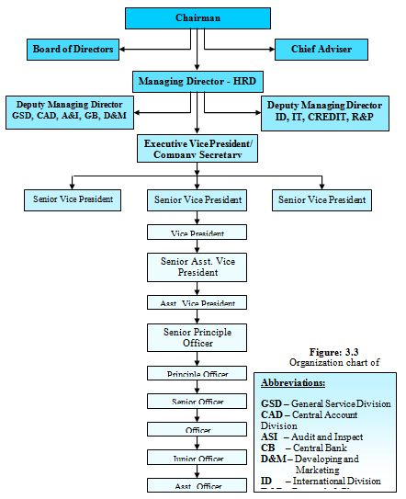
Figure 3.3 :
Organ gram of MBL

3.4.9 Managing the risks

Risk of solvency
Approbation occur when the borrower unable to repay the or fails to repay their loans. All are they exhibited to solvency chance via regular advancing functions along with trades including arrangement in the middle of their accomplices.
Objectives
Keep up an all around enhanced resource portfolio inside endorsed hazard resilience levels and gain an arrival suitable to the hazard outline of the wrapper.
Approach
Ability examination of bank personnel, initially assess credit exchanges for business along with communal advances. Credit division gives along with autonomous evaluation of every huge exchange, and a simultaneousness structure this capacity is normally required to make a loaning responsibility to a client. Their internal auditor and scrutiny division additionally surveys the executive’s forms so as to guarantee that set up credit strategies are pursued. Likewise, Credit Management Committee performs intermittent surveys of critical and higher hazard exchanges.
Market Risk
Market chance is the prospective for misfortune from convert in the estimation of money related apparatus. Estimation of a budgetary apparatus would be influenced by converting in loan costs, remote trade rates and value and product costs. They are presented to showcase chance while it go to the accompanying exchanges:

Loans and Advances (LDOs)
Deposit with other Banks
– Financing
–financial instruments like treasury bill
– financial instruments like treasury bonds along with share

FOREX positioning
• Objective
Recognize, evaluate, screen along with all report of market hazard pursuing exercises, guaranteeing that subjection stay inside affirmed chance resilience altitude along with that the arrival from market chance exercises is satisfactory.
• Approach
They have built up Asset Liability Committee (ALCO) to screen their market hazard exercises. The essential hazard estimation technique is Reprising Gap and its affectability to loan cost changes. Repeating Gap more than year time frame remained at positive BDT 4251.76 million as at Dec 31, 2008. Repeating Gap as level of complete resources remained at 14.72%, which is inside the worldwide standard of 20%. In the position, the Net Interest Income (NII) of the Bank may increment by BDT 42.52 million if there should arise an occurrence of 100 premise point increment in financing cost. In any case, if there should arise an occurrence of 100 premise point expire in financing cost, the NII of the Bank will go somewhere around BDT 42.52 million.

Liquidity Risk
Objectives
Primary adequate fluid assets and discovering ability to meet their money related responsibilities, under all conditions, without raising assets at nonsensical costs or sell resources on constrained premise.
Approach
Their way to deal with liquidity the executives is to extend liquidity necessities dependent on expected and focused monetary, showcase, political and undertaking explicit occasion. This empowers them to guarantee that they have adequate supports accessible to meet their money related duties even in the midst of emergency. Assets envelop both fluid resources close by and capacity to raise extra funds. Their substantial based of plan stores structure people and solid capital positions give a long haul stable wellspring of subsidizing. The essential hazard estimation philosophy is to screen fluid resource proportions, stores blend, center stores as level of all out stores and net liquidity hole.
Operational Risk
Operational risk is the danger of misfortune coming about structure lacking or fizzled inside procedures, individuals and frameworks or from outside occasions.
Objective
Functioning hazard is intrinsic in all business exercises, along with administration of these dangers is vital to the accomplishment of hierarchical objectives. When functioning dangers wouldn’t be dispensed with, it would be overseen, alleviated along with now and again guaranteed against to safeguard and make esteem.
Approach
Functioning hazard is overseen via the foundation of powerful framework along with controls. In the end, we have set up an all around figured structure that utilizes the qualities and particular information of our way of trade and commerce. This system is to boost our capacity to oversee and quantify functioning hazard via usage of a structure, taking focal points of the prescribed procedures of business.

3.5 SWOT analysis of Mercantile Bank limited (MBL)
SWOT analysis is a vital instrument for assessing the company’s strength, weakness, opportunity and threats. SWOT analysis of Mercantile Bank Limited (MBL), Gulshan Branch is discussed below.

Strength
- MBL has a bright notoriety as well as entrenched, most seasoned private commercial bank in our country.
- It has an extremely skillful along with expert top management.
- Solid amount of collection of money.
- Powerful lucidity posture.
- Rate of favorableness is high.
- Task among workers along with amicable condition.

Weakness
- Mercantile Bank Limited (MBL) doesn’t have conventional limited time action, doesn’t have pay any kind of promotion. As a result particularly Gulshan branch isn't unique in relation to the others.
- The on the web and versatile financial offices contemporary so as a result officers aren’t coming to numerous clients.
- Lack of sufficient ATM booths.
- The credit card, debit card, master card is contemporary to all.
- Basic leadership proceeding is very moderate while they need to get hold of each choice talking about with the relevant authority.

Opportunities
- While loan fee is up above from all in that case they can gather clients very easily.
- Intensifying attention to monetary framework.
- They are recruiting new officers as they can provide services in a smooth way to the clients.

Threats
- For this zone, somewhere around 5 global manages an account with their additional offices.
- Beside these there are other set up banks who are putting forth preferred client administration over any Bank.
- Inadequate advertise data

3.6 Division of Gulshan Branch
- General Banking Division (GB)
- Credit Division
- FOREX (Foreign Exchange) Division

3.7 FOREX Division

3.7.1 Interpretation of FOREX
Outside trade is the fare of trade in the both nation's currency. FOREX is a procedure by changing over particular country's cash into another along with exchanging cash made by particular nation from different nations. While, further than distinct money is associated with outside exchange, it offers ascend to trade of monetary standards which is known as remote trade. From this system one may import or export their goods in a secured way. For this none of the party would affected. They get pre scheduled money or prescribed money what they ask for in creation of contract. This is the easiest way of converting currencies from one to another by doing international business.

3.7.2 Duties of FOREX Division
There are so many duties they need to perform in the division of FOREX (foreign exchange). Some of the major duties are:
- Assist importation along with fare exchanges.
- Furnishing supported along with less-subsidized mortgage office.
- Furnishing less-business settlement.
- Keep in existence remote money narration.
- Vending outside money security.
- Preparing and submitting proclamations identifying with outside money.

3.7.3 Exchange Rate Policy
The swapping scale technique of Bangladesh Bank goes for keeping up the forcefulness of Bangladeshi things in the worldwide markets, engaging inflow of providers' settlements, keeping up inside esteem steadfastness, and keeping up a down to earth outside record position. Going before the inception of skimming swapping scale plan, alterations thusly fare was present create phase of holding on to scene the instances of Real Effective Exchange Rate (REER) list subject to an exchange weighted bushel of monetary standards of authentic exchanging collaborators of Bangladesh and the instances of other vital interior and outside domain pointers. All things considered, the interbank outside trade include sets the trade rates for client exchanges and interbank exchanges subject to premium supply exchange; hold on to the trade fares of BB’s smudge buy along with courses of action. Our central bank (BB) doesn’t get a handle on any onward exchange. Assistant Director (AD)’s be present allowed to allude to self one of a kind macula along with onward trade fares for entomb bank exchanges along with for exchanges with outsiders customers.

3.8 Sections
There are three sections divided in the Mercantile Bank Limited (MBL), Gulshan Branch and they are:
- Import
- Export
  - Local
  - Foreign
- Remittance

3.9 Import Section
Import is the surge of stock and undertakings obtained by budgetary head remaining in the nation from money related professional remaining far and wide. We would improve import like a methodologies buy of stock along with undertakings done by the outside nations of our country. Routinely customers, firms along with Bangladesh government, import remote things to come to face with undoubted prerequisite. Import divide assist commerce along with distinctive individuals stock of import. Within by along with large condition, purchasers and venders are a broad portion of the cases obscure to one another. So vendor dependably scans for affirmation for the part for his things passed on. At this point the movement financial institutions like banks. Bank contributes to pass on confirmation that it would settle up with the things for the purchaser. This accreditation is defined letter of Credit (L/C). Thusly the understanding among dealer along with vendor is gives appointed a genuine format by the agent by L/C’s. Exactly while vendee is going to import a couple of items done by a remote vendee, he appeals his bank construct portions to the vendor of stock. Furthermore, the bank recoups the total done by the shipper.

3.9.1 Import Mechanism
To vendee, an individual would be able to be a shipper. As stated by or in vendee along with charge jurisdiction act, 1950, the bank employee of the focal chairperson of import along with toll gives the enrollment (IRC) to the shipper. Ensuing to getting this, this individual needs to confirm a L/C’s endorsement from our central bank (BB) along with after that an individual transforms into a guaranteed dealer. This is the person who requests to open a L/C’s from a particular bank. So now we can call him opener or contestant of the mortgage.
There are some vital procedures which will need to complete by the importer (according to import export control act 1950). They are:

3.9.2 Import Registration certificate (IRC)
The essential examine one have to bring on commerce and trade of import is defined by IRC (Import registration Certificate). In any case, enlistment isn't essential for import items, a fact which do excluded repayment of outside interchange similar to medication; examining objects, etc would be vendee short of selection by the customers inside cash related most extreme. Reports to be required for Import Registration Certificate are according to the accompanying—
- Income Registration Certificate
- Nationality Certificate
- Certificate from Chambers of Commerce and Industry Registered Trade Association
- Bank Solvency Certificate
- Copy of Trade License
- Requisite expenses
By getting appeal, particular separate CCI&E employee would investigate the archives along with lead corporeal check along with concern request note to the planned shippers to outfit the accompanying documents via their selected financial institution like bank—
- Main document of repository prepayment as IRC payment.
- Strong point guarantee: attestation from the first class magistrate.
- Lease slip.
- Photograph: passport size of two copies.
- Cooperation legal document in case of cooperation.
- Registration certificate, Memorandum of Association (MOA) along with Articles of Association (AOA)for the limited company.
Ensuing to researching along with affirming doled out Financial institution like bank would propel the identical to the different CCI&E employees with sending plan for identical via financial institution like banks delegate. Finally the authority give the IRC (Import Registration Certificate) to the applicant;.

3.9.3 Activities of Import Sections
The form IMP contains the followings—
- Name and address of the Authorized merchants.
- Amount of settlement to be permitted (for instance L/C aggregate)
- LCA structure no. Date and motivator in Taka.
- Description of items.
- Invoice regard in remote money, (for instance L/C total)
- Country of cause.
- Port of shipment.
- Name of steamer/Airline (for instance By road/dispatch/air)
- Port of importation.
- Indenter's name and address.
- Indenter's enlistment number with CCI and E and Bangladesh Bank.
- Full name and address of the applicant.
- Registration number of the hopeful with CCI and E.

3.9.4 Procedures of Import
There are some procedures importer needs to maintain and they are:
- Purchaser and the dealer finish up a deal contract given to installment by narrative credit.
- The purchaser teaches their appointed bank (the Issuing bank) to circulate a credit for the vendor/ Beneficiary.
- Now the first bank (issuing bank) in this point give notice to different bank (this is called advising bank/confirming bank.
- In this point advising bank inform the dealer that bank credit has been issued.
- As soon as the vender gets the credit, if the credit fulfills him the he can answer that, he can meet its terms and conditions, he is in position to stack the products and dispatch them.
- The Bank at that point checks the archives against the credit. On the off chance that the records meet the prerequisites of the credit, the Bank at that point pay, acknowledge or consult as per the terms of credit. On account of credit accessible by arrangement, Issuing Bank will consult with response.
- The Bank, if other than the issuing bank, sends the records to the issuing Bank.
- The issuing Bank checks the record and in the event that they found the report has met the credit prerequisites, they understand to the endless supply of the sum due or different terms concurred among him and the issuing Bank.
- The purchaser sends transport report to the transporter who will convey the merchandise.

Importer needs to follow the following tasks:
- Money related equalization.
- IRC (import registration confirmation).
- TAX Identification Number (TIN).
- Pro-forma Invoice copy
- Enrollment confirmation
- LCAF structure appropriately approved.
- A pose of IMP structure.
- Insurance copy.
- Others task.

3.10 Export Section
The items and ventures sold by Bangladesh to outside nuclear families, authorities and Government are called exchange. The admission trade of our country is overseen by the imports and passages (control) Act, 1950. There are different traditions, which an exporter needs to fulfill when shipment of stock. The tolls from Bangladesh are at risk to convey trade control drilled by the Ministry Of Commerce through Chief Controller of imports and passages (CCI and E). No exporter is allowed to convey any product acceptable for toll from Bangladesh aside from in the event that he is enrolled with CCI and E and holds authentic Export Registration Certificate (ERC). The ERC is required to be reestablished every year. The ERC number is to be joined on EXP shapes and diverse records related with toll.

3.10.1 Types of Export
- Export contrary to L/C or contract.
- Export contrary to pre payment.
- Export under the basis of consignment.

3.10.2 Export Functions of MBL
Our country passes on an epic proportion of stock and dares to remote families. Readymade material vestments (both weaved along with knit), solidified pygmy, beetle leaf are the key stock that our exporters charges to outside nations. Bits of clothing zone are the best segment of our nation. Bangladesh trades the greater part of its readymade bits of articles of clothing things to United States of America along with European Union countries. Our country passes on more or less 45% of its RMG vestments things United States of America. Many exporters who trade via Mercantile Bank Limited (MBL) are RMG bits of clothing vendors.

3.10.3 Legal Requirements of MBL for the Export
In spite of the fact that installment parts of fares are the central bank (Bangladesh Bank)’s worry, fare strategy codification declared. Our central bank (Bangladesh Bank) has placed expand method along with placed point by point standards and guidelines pertain to export along with its installments. Whole fares, which are the necessity of assertion petition, should be proclaimed by the fare. Before ensuring any fare structure Gulshan branch ought to appraise along with pay heed to the accompanying:
- Export will planned substantial export.
- Certificate of registration.
- Remission of merchandise traded from our country ought to be gotten via our branch by unreservedly changeable outside cash if not money of a less- occupant money record of this bank office.
- Authority, financier along with any exchange energizes are allowable just from a limit of 6% to the estimation of merchandise.
- By requesting any kind of dodge outside trade from the nation, one should to follow this instruction:
a) Necessary documents need to arrange like fare endorsement within four months.
b) Necessary documents need to arrange as like receipt of BL (Bill of Lading), air war bill, challan copy etc.
- Form of export is marked by the exporter if not holding legitimating lawful intensity of lawyer by the exporter along with phase of intensity of lawyer are with the end goal that both the exporter and the lawyer might be considered dependable mutually and severally for acknowledgment of fare continues.
- In regard of fare of merchandise via land course or via ocean, the BL (Bill of Landing), truck or transportation receipt along with different archives of particle to freight ought to be attracted just by the request of Mercantile Bank Limited (MBL).
- Mercantile Bank Limited (MBL) inspect how the merchant transport, fixed the fare of merchant via air, airway bills etc.

3.10.5 Process of Export (local) with real life example:

SQ is one of the valuable clients of MBL (Gulshan Branch). Now let’s see how its works.
    - Documents submitted by beneficiary: They need to attach some proper documents and these are.
- Forwarding letter: From here we can find name of beneficiary bank and address, bill of exchange, commercial invoice, packing list, delivery challan/ truck receipt, certificate of origin, beneficiary certificate, L/C number.
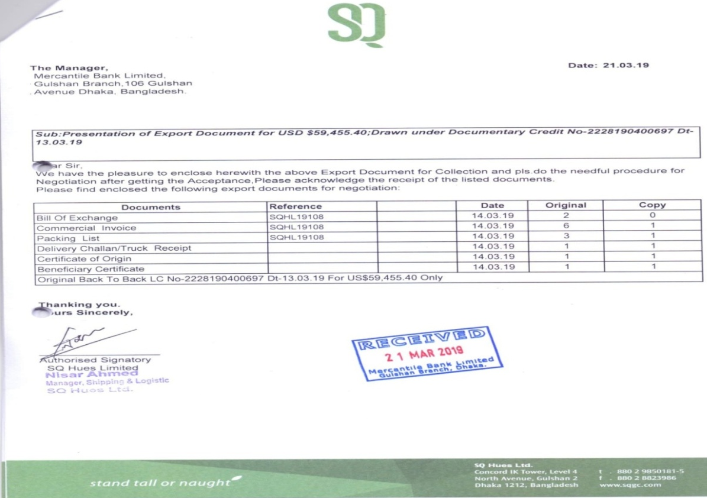
Figure: 3.4
forwarding letter from the beneficiary bank

  - Two copies of Bill of Exchange: A bill of exchange is a composed request utilized basically in worldwide exchange that ties one party to pay a fixed total of cash to another party on interest or at a foreordained date. Bills of exchange are like checks and promissory notes—they can be drawn by people or banks and are commonly transferable by supports. From here we can find the name of beneficiary and applicant bank, L/C number and amount money.
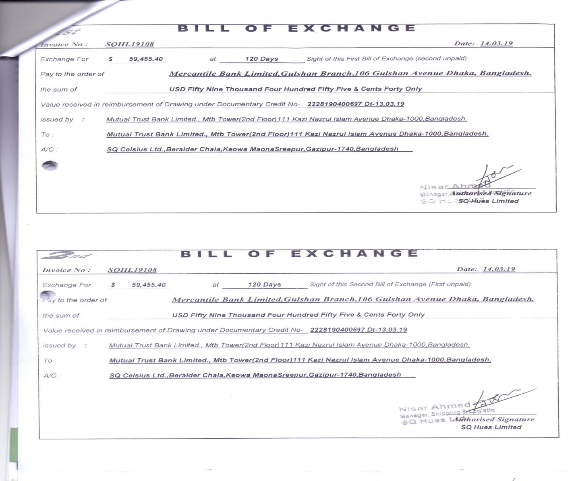
Figure: 3.5
Bill of Exchange

  - Commercial invoice: An invoice is a commercial document that organizes and records an exchange between a purchaser and seller. On the off chance that products or administrations were obtained using a loan, the receipt ordinarily indicates the terms of the arrangement and gives data on the accessible strategies for installment. Invoice may include a receipt, a bill of sale, debit note, or sales invoice.
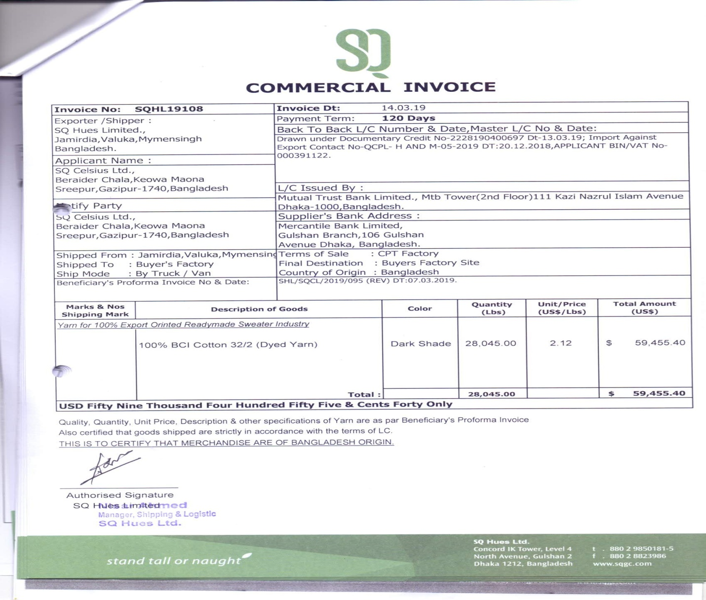
Figure: 3.6
Commercial invoice

  - Packing List: Ordered rundown of articles normally incorporated into each delivery bundle, giving the amount, depiction, and weight of the substance. Arranged by the shipper and sent to the representative for exact counting of the conveyed products. Likewise called bill of bundles, pressing slip, or unloading note.
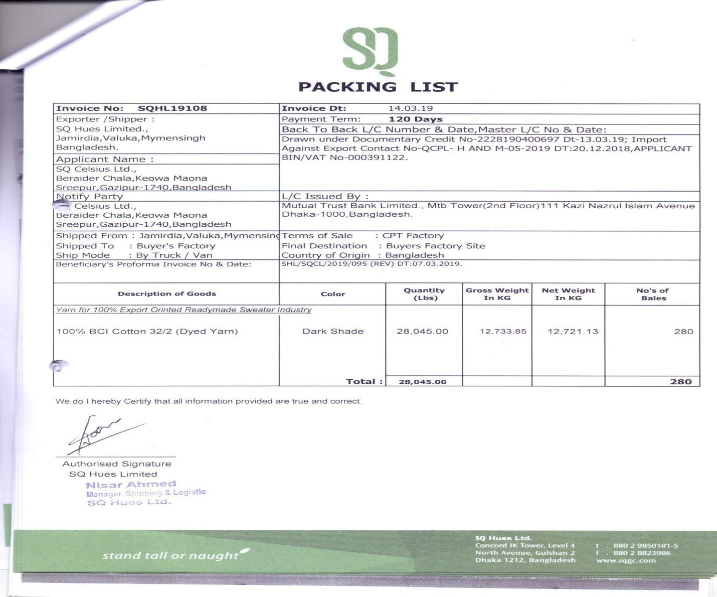
Figure: 3.7
Packing list

  - Certificate of Origin: Documents that guarantees a shipment's nation of starting point. It is utilized between individuals from an exchanging square or where exceptional benefits are conceded to products created in specific nations. Testament of root is regularly issued by an exchange advancement office, or an assembly of trade in the sending out nation. Additionally called it statement of birthplace.
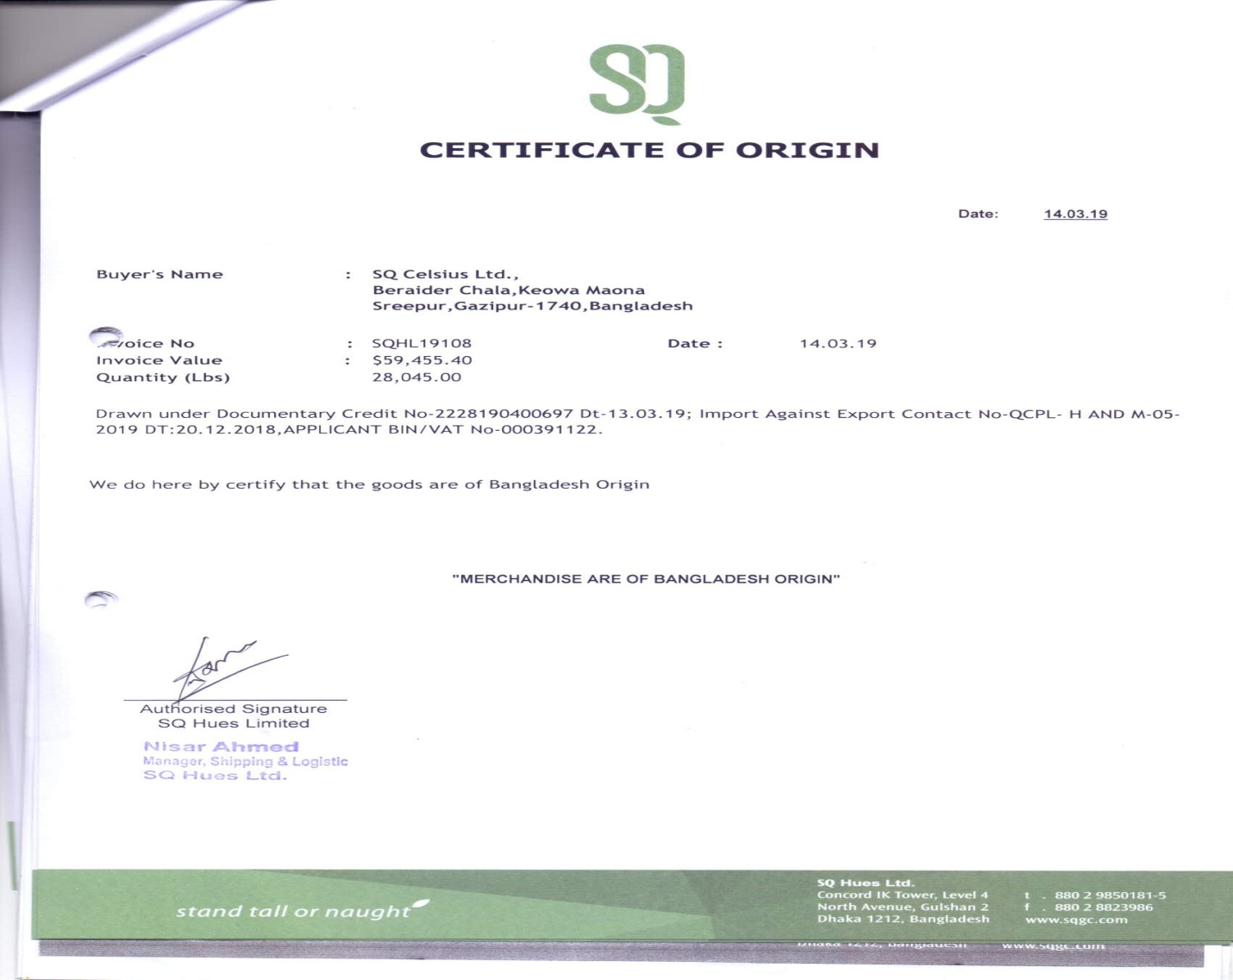
Figure: 3.8
Certificate of origin

  - Beneficiary’s Certificate: This assurance can be discharged with the introduction of the first arrangement, with the mark of the temporary demonstration of gathering or with the recipient's declaration which shows that the all out development has been gotten. From here we can find buyer’s name and address, invoice number, invoice value and quantity.
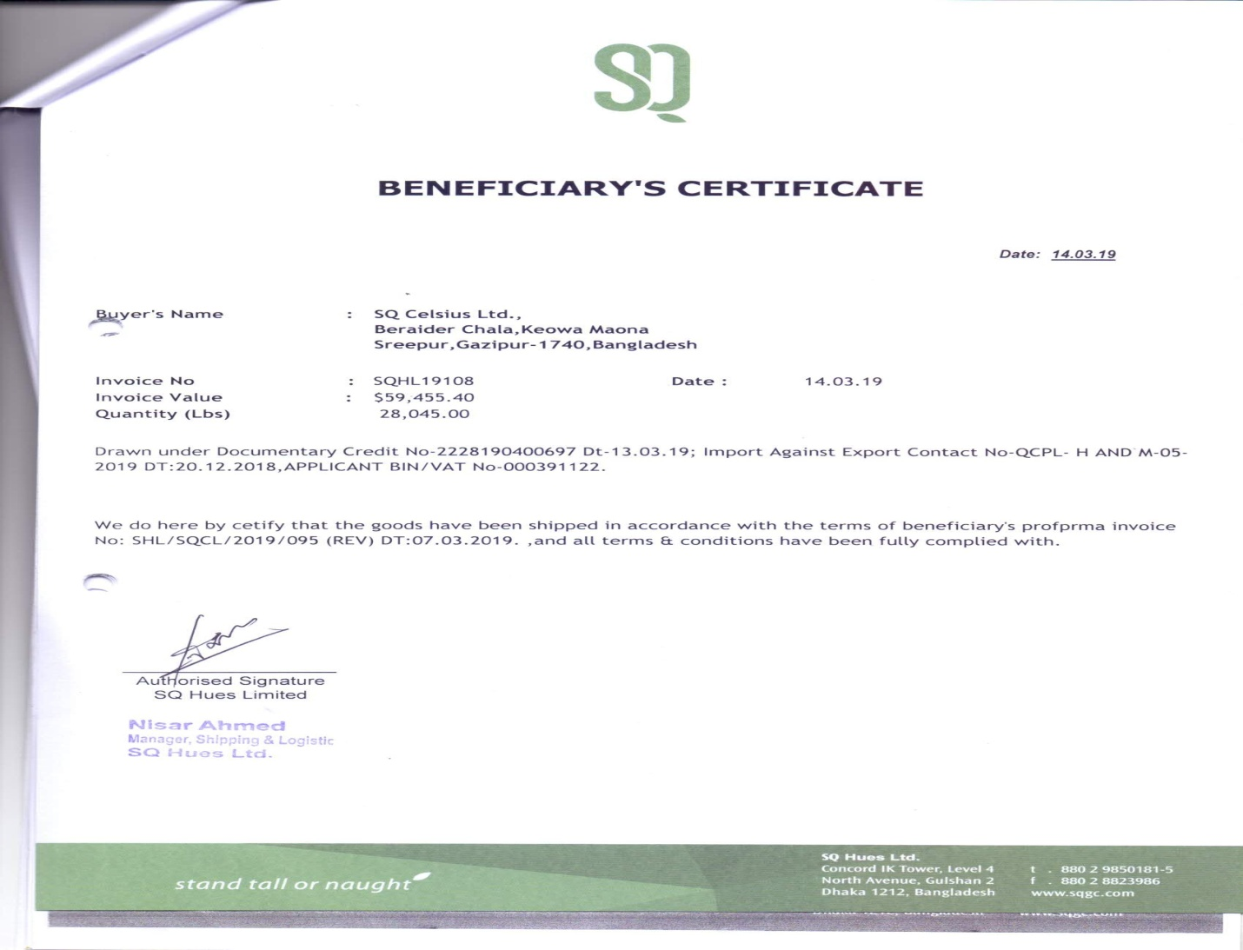
Figure: 3.9
Beneficiary certificate

  - Delivery Challan/ truck Receipt: A document bearing portrayal, condition and amount of goods with the end goal of areas of development of the predefined products
Utilization: Apart from deals receipt, it is fitting to have separate conveyance challan in copy for getting support of the recipient as a proof of genuine conveyance of the goods.
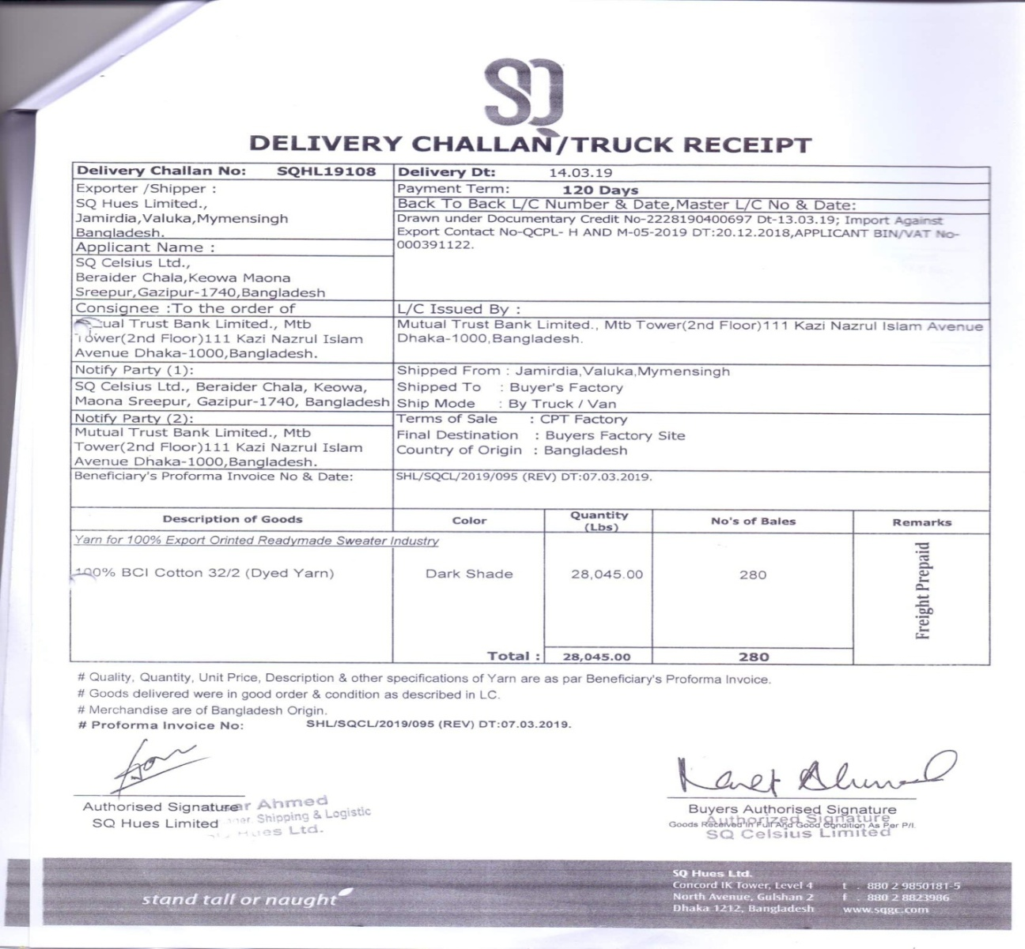
Figure: 3.10
Delivery challan/ truck receipt

- Endorsement: Before send to the applicant bank, they give endorse in two documents ( #bill of exchange # delivery challan). Here is the example of endorsement.

Figure:3.11
Seal of endorsement

- Documents send to the Applicant Bank: In this stage beneficiary bank give a forwarding letter to the applicant bank. From here they can find the name of purchaser and seller name and address, L/C number, terms and condition.
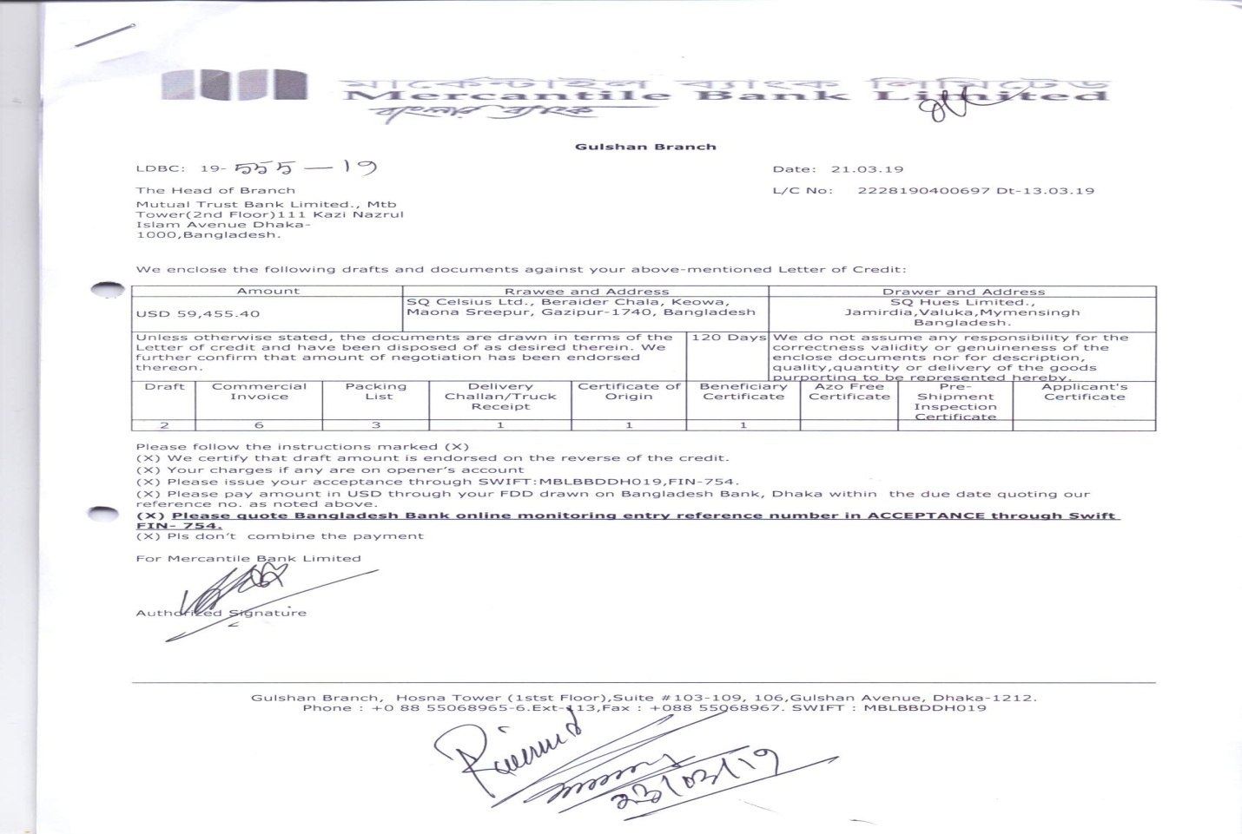
Figure: 3.12
Forwarding letter by beneficiary

- Applicant’s Bank give Acceptance: In this stage if the applicant bank can’t find any fault within 5 days then give acceptance by at sight. If they find fault in any documents then they received as a deferred L/C. This would be take time 90 days/ 120 days/ 150 days or 180 days. They give discrepancy to the beneficiary bank.
- Applicant’s Bank made Payment by FDD: They give payment to the beneficiary bank through FDD (Demand Draft is a physical method of cash exchange. It is helpful for the sender to make a bank draft since it is secure and must be credited to the predetermined recipient's financial balance. Through NBP Exchange, you can without much of a stretch prepare your Demand Draft).
Before getting realize if the drawer wants to withdraw cash from the beneficiary bank then they withdraw only 85% of total amount.

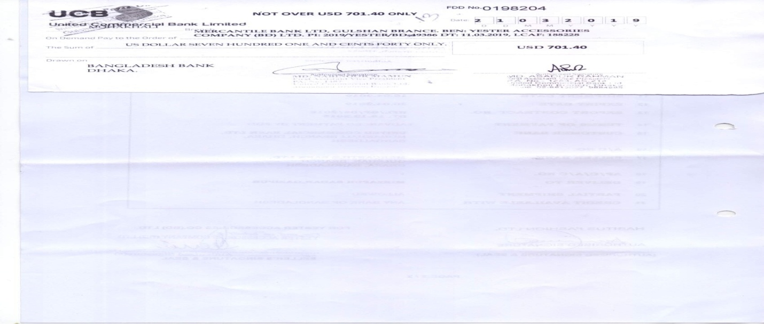
Figure: 3.13
Foreign Demand Draft (FDD)

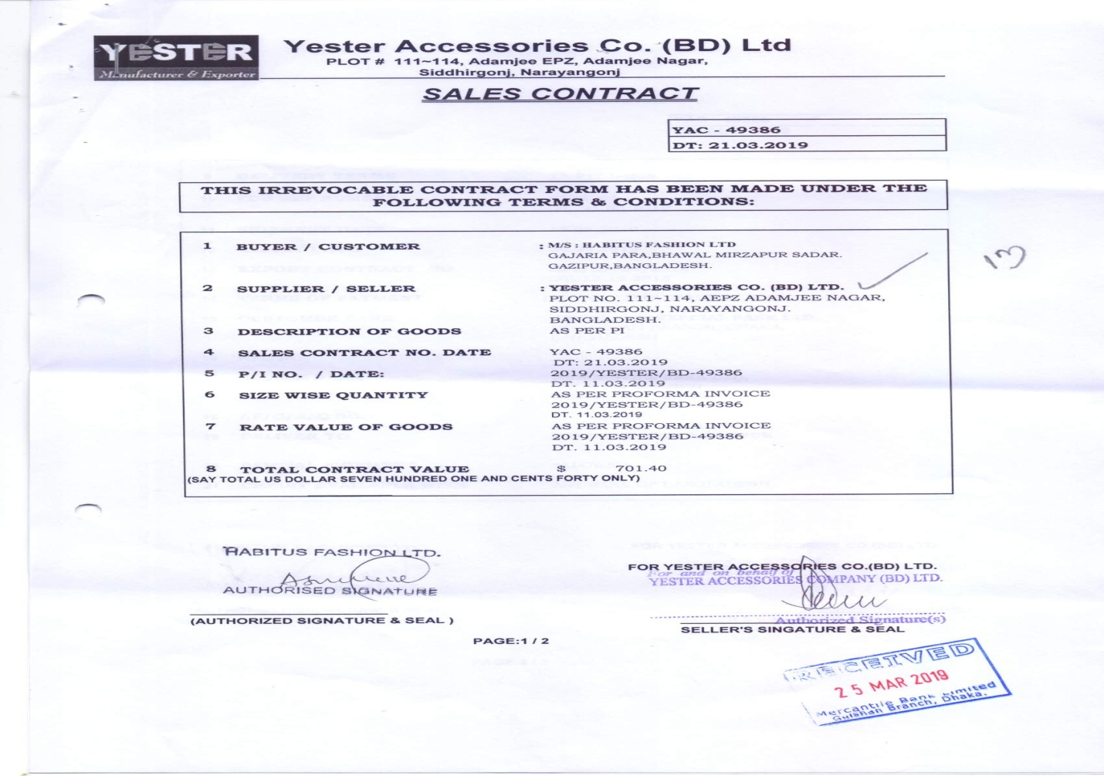
Figure: 3.14
Two copies of sales contract attach with FDD

- Realize: In this stage beneficiary bank realized the some L/C. Drawer can withdraw money any time.
3.10.6 Process of Export (Foreign) with real life example: Which company situated in EPZ area, MBL take it as foreign company to do their job in a easy way. There are same procedures the process of export (foreign and local) but there are extra 2 steps which are different from export (local).

    - Pre shipment Inspection Certificate: An inspection of agreement products preceding shipment to find out their quality, amount or cost. Shippers may demand PSI, requiring the exporter to outfit a declaration of assessment – ordinarily issued by impartial, universally regarded firms, for example, SGS o Bureau Veritas) – so the merchant is guaranteed of accepting merchandise of value/amount determined in the deal contract. Government organizations may require review endorsements as respects cost, in order to keep parties from under or over invoicing trying to pay lower traditions obligations or avoid remote trade limitations. See testament of review. Model of Certificate of Inspection.
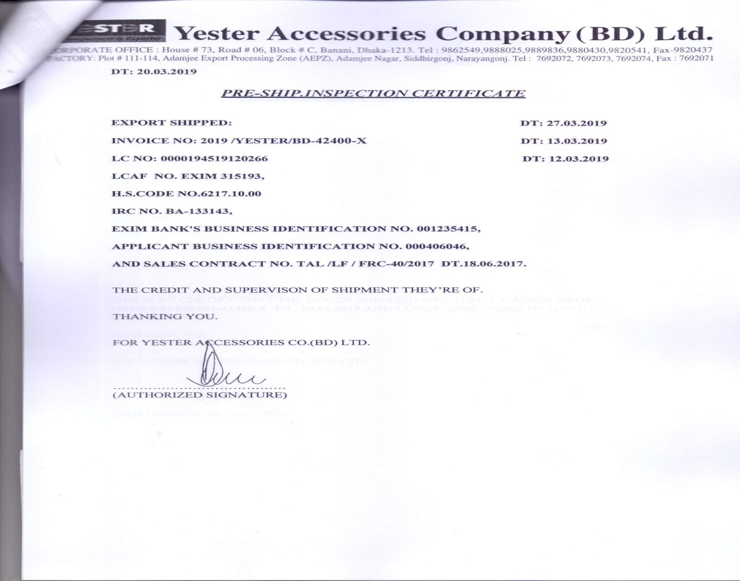
Figure: 3.15
Pre shipment Inspection Certificate
    - Bill of Entry/ Export: A statement by a shipper or exporter of the careful nature, exact amount and estimation of products that have landed or are being delivered out. Arranged by a certified traditions agent or dealer, it is analyzed by traditions specialists for its precision and similarity with the tax and guidelines. it likewise known traditions passage.
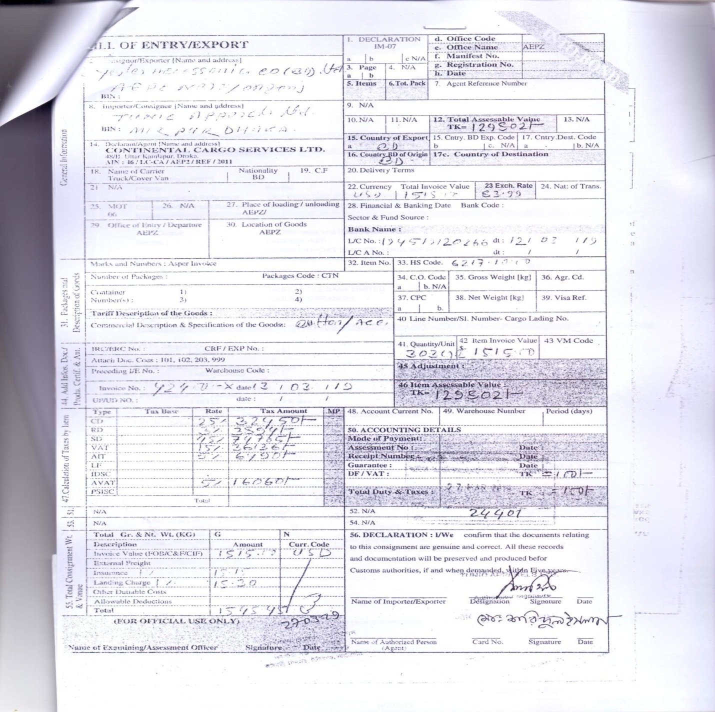

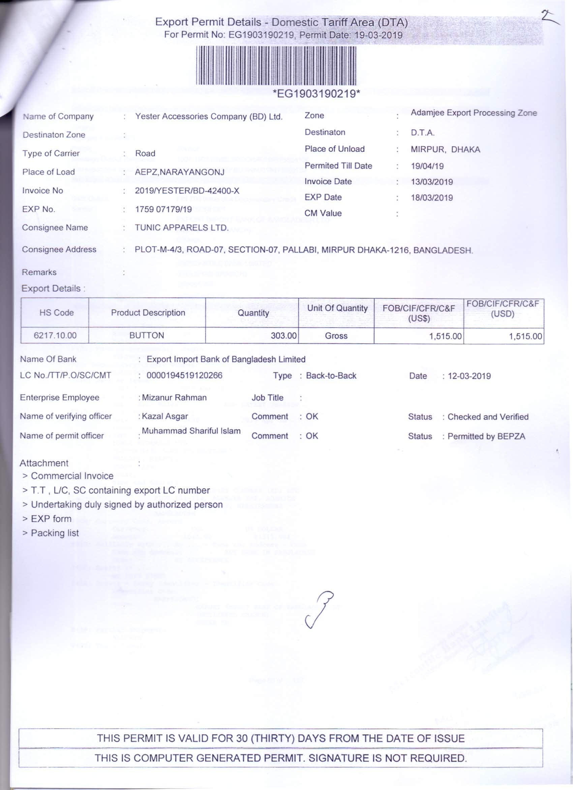
Figure: 3.16
Bill of Entry/ Export

3.10.7 Mercantile Bank Limited (MBL)’s advising export L/C’s
Universal exchange of merchandise from our country is constructs via the medium the Letter of Credit (L/C)’s preceding by the outside bank in line with shippers for exporters from our country. This fares of Letter of credit (L/C)’s are en-steered via the bank who has reporter association with the previous. MBL advising L/C by this way:
- Shot telex
- Full telex
- Airmail

3.11 Foreign Remittance
Foreign remittance is the exchange of outside money starting with one nation then onto the next nation. All things considered, outside settlement is buy and closeout of uninhibitedly convertible foreign monetary standards as passable under trade control guidelines of the nation. Remittance is vital for a nation for a developing nation like our country. Every year our country gets a huge amount of remittance from the outside of the nation. Amounts are the huge in total of government earnings.

3.11.1 Classification of Remittance (Foreign)
Remittance is one of the main earnings of our nation. There are two kinds of foreign remittance and they are:
- Inward
- Outward
Remittance (Foreign)

Outward
Inward

Figure:3.17
Classification of remittance (foreign)

Inward Remittance (Foreign)
Remittance originates caused by outside nations in our nation is defined by foreign inward remittance. By the financiers if not foreign inward remittance implies buy of outsider money by approved vendors. For the most part, inward remittance are gotten by draft, mail exchange, TT, buy of outside bills& explorer's check, send out bills; fundamentally, there are some prescribed channels for accepting internal settlement. A domestic bank like MBL likewise gets grooving authority of a domestic company additionally goes beyond domain foreign inward remittance.

Types of Foreign Inward Remittance
- TT (Telegraphic Transfer)
- MT (Mail Transfer)
- FDD (Foreign Demand Draft)
- PO (Payment Order)
- TC (Travelers Check)
- FCN (Foreign Currency Notes)

Collection procedures of Foreign Inward Remittance
- By making section in outside receipt collection book.
- By getting ready sending prescribed in tetrad.
- By getting ready slip above acknowledgment by continues clearance methodology.
- By checking up the patronage assertion.
- By counseling buy understanding.
- By getting the marked telegraphic transfer along with checking equivalent along with the past mark by the recipient of the telegraphic transfer.
- By making passage ledger for travelers checks and foreign demand draft obtained.

Revocation of Foreign Inward remittance
In case of an internal settlement a fact which has just prevailed accounted for our central bank (Bangladesh Bank), being accordingly dropped, full or partly, due to less-accessibility of assignee. Approval trader should circulate the wiping out of internal settlement like as inward settlement of structure ―
- The date of return in which the internal settlement was accounted for
- The name and address of the recipient
- The measure of the buy as affected
- Reasons for wiping out

Outward Remittance (Foreign)
When remittance goes from our nation to another nation then it defined as a foreign outward remittance. Offers of outside s money by the approved vendor if not authorized medium might be tended to foreign outward remittance. Approved sellers should be most extreme alert for guarantee that outside monetary forms transmitted if not discharged from them, utilized just for the reasons for which they are discharged. Foreign Outward remittance might be constructed by proper technique of the nation for that foreign remittance should be approved. Almost same foreign outward remittances are affirmed by from the approved seller in the interest of Bangladesh Bank.
- TT (Telegraphic Transfer)
- MT (Mail Transfer)
- FDD (Foreign Demand Draft)
- PO (Payment Order)
- TC (Travelers Check)
- FCN (Foreign Currency Notes)
Foreign outward remittance contributing outside of our nation may be develop by two following manners:

FC (Formal Channel)
One can transfer money from one nation to another nation via the approval, authentic medium. For instance: one can transfer their money via the bank, any other financial institution, post office, Western money union, any kind of financial administration, Neno cash technique and so on.

IC (Informal Channel)
One can transfer money from one nation to another nation via the unapproved, unauthentic medium like hand by hand, over phone call. “Hundy” is one of attractive informal channel in our country. Hundy is also popular in the Middle East but it is unlawful in the United Kingdom.

3.12 Letter of Credit (L/C)’s for import and Export
L/C is a certification if not tackle if not responsibility of the recipient for constructing installment made by the issuing bank for the benefit to the endless supply for certain situation. As separation engaged with universal exchange, purchasers and merchants don't have any acquaintance with one another. It is troublesome for both the purchasers and vender to value every others' trustworthiness and credit value. Aside from this it is likewise hard to realize different guidelines winning in their individual nations in regards to fare and import. In this way the purchaser needs to be guaranteed of merchandise and venders need to be guaranteed of installments. National Banks, consequently guarantee these things to happen at the same time by designing L/C’s ensuring installments to merchant and products to purchaser. By opening a Letter of Credit in the interest of purchaser for dealer, business banks attempt to make installments to a merchant subject to accommodation of records attracted on carefully consistence by L/C’s conditions and procedures making subtitle of products of the purchaser. This is a contingent certification. L/C’s along these lines establishes a standout amongst the most vital techniques for financing outside exchange. Then again letter of acknowledge might be characterized for a ―mortgage contract while the purchaser's financial institution is submitted (in the interest of the purchasers) to put a concurred measure of cash at the dealer's transfer under some concurred conditions. Since the concurred conditions incorporate in addition to another thing, introduction of some predetermined archives, this is called documentary letter of credit.

3.13 Classification of L/C’s
There are different kinds of Letter of Credit (L/C)’s. These works in a different methodology, terms and condition and the most important thing is that there feature are also same. Here we discuss about the classification of L/C’s. Some of them are described below.

Letter of Credit
(L/C)’s

Irrevocable L/C
Revocable L/C

Figure: 3.18
Forms of Letter of Credit

Revocable L/C
A credit which is revocable might be altered if not dropped by the proclaiming financial institution in any minute along with in the absence of earlier declaration to the recipient. In other words, this sort of letter of credit can be renounced or dropped whenever without assent of, or notice to the recipient. If there should arise an occurrence of dealer (recipient), revocable credit includes chance, as the credit might be changed or dropped while the merchandise are in travel and before the reports are introduced, or in spite of the fact that displayed before installments has been made. The vender would then face the issue of getting installment then again revocable credit gives the purchaser most extreme adaptability, as it very well may be changed or dropped without earlier declaration to the dealer beyond the snapshot of installment purchase the proclaiming financial institution like bank at which the issuing bank has made the loan accessible.

Irrevocable L/C
An irreversible credit is an account credit, which can't be denied, contrasted or changed/adjusted or dropped without the consent of all social events buyer (Applicant), vendor (Beneficiary), Issuing Bank, and Confirming Bank (in case of insisted Letter of Credit). Unavoidable Credit gives the seller increasingly noticeable attestation of portions, yet he/she remains dependent on an undertaking of a remote bank. Commitment of the Issuing and Conforming Banks: An unavoidable credit involves an unmistakable undertaking of the Issuing Bank, gave that the stipulated reports are shown to the Nominated Bank or to the Issuing Bank and that the terms and conditions of the credit.

3.14 Types of L/Cs
BTB (Back to Back) L/C’s
Consecutive L/C’s are characterized even as a loan, something which is created at the guidelines along with the solicitation for recipient of the first fare letter of credit above the quality loan. Consecutive is a procedure of making for an auxiliary loan, something which emerges conversely the vender's uses the loan, allowed by the proclaiming financial institution to its provider.
BTB L/C’s are several kinds of:
- BTB L/C’s (Foreign)
- BTB L/C’s (Local)
Revolving L/C:
Successive L/C’s are characterized even as a loan, something which is created at the guidelines along with the solicitation for recipient of the first fare letter of credit above the quality loan. BTB is procedure making by a helper loan, something which rises where the merchant’s uses the loan, permitted to them by the proclaiming financial institution to its vendee.
- Time
- Amount
Transferable Letter of Credit
A transferable credit is a kind of credit that it might be moved from one party to another party in full or part of the entire first recipient is get. When the first beneficiary doesn’t supply their merchant then they go for a delegator between the provider and purchaser.

3.15 Required documents for opening a L/C at MBL
Importer should submit some legal documents for opening a L/C at Mercantile Bank Limited (MBL).
- Justifiable import enrollment endorsement (business/mechanical).
- TIN authentication.
- VAT enrollment endorsement.
- Membership authentication of a perceive Trade Association according to IPO.
- A revelation that the merchant has settled salary regulatory obligation or submitted pay government form (suitable for 1st year).
- Carry out receipt if not mark appropriately acknowledged.
- Insurance copy attach with money payment receipt.
- Appropriate letter of credit application structure marked by the transporter.
- LCAF (Letter of Credit Authorization Form) is required for a business if not modern all things considered, appropriately marked by the merchants along with consolidating.

3.16 Proclaiming the L/C by the MBL
In this phase Mercantile Bank Limited (MBL) issue the letter of credit by finishing some legal procedures with relevant documents document with some terms and condition.
- Fix a bill.
- Country of origin of the particular products.
- Currency and aggregate ;
- Duration along with place where the expire the L/C.
- Written description of products and quantity with authorization.
- Legal file is required for the trade.
- Direction for the bank.
- Shipment last date.
- Some numbers like LCA Number. HS code. IRC number.
- Method of transport- air/ ship/ truck and so on.
- Assignee’s name and address.
- Inciting bank’s name and address.
- Candidate’s name and address.
- Proclaiming bank and particular name of the branch.
- History of all the L/C’s which they own from before.
- Negotiation duration.
- Introduction Duration.
- Name of the port of loading and discharge.
- Name of the recompense financial institution.

3.17 Process of L/C’s
Some legal steps are required:
- The merchant and exporter have made an agreement before a L/C has been issued.
- The merchant applies for a L/C from his financier known as the issuing bank. He may need to utilize his credit lines.
- The issuing bank opens the L/C that is directed through its abroad Correspondent bank, known as the prompting bank.
- The exhorting bank advises the exporter (recipient) of the entry of the L/C
- Exporter boats the merchandise to the shipper or other assigned spot as stipulated in the L/C.
- In the interim, the exporter likewise readies his very own records and gathers transport reports or different archives from applicable gatherings. Every one of these archives will be sent to his investor, which is going about as the arranging bank.
- Negotiation of fare bills happens when the financier consents to furnish him with fund. In such case, he acquires installment endless supply of records. If not, the records will be sent to the issuing bank for installment or on an endorsement premise as in the following stage.
- Archives are sent to the issuing bank for repayment or installment
- Issuing bank praises it's endeavor to pay the arranging bank on condition that the records consent to the L/C terms and conditions.
- Issuing bank discharges reports to the merchant when the last makes installment to the previous or against the last's trust receipt office.
- The merchant takes conveyance of endless supply of the vehicle (generally sending) archives.

3.18 Parties Involved in Letter Of Credit (L/C)
The Applicant
The applicant is the gathering who approaches a bank so as to issue the L/C. For the most part, the applicant is a merchant who achieves a concurrence with the exporter before moving toward the bank to issue the L/C. The applicant is likewise ordinarily committed to repay the issuing bank for any installments made under the L/C.
The Issuing Bank
The bank issuing the L/C is known, as the issuing bank and it is normally the save money with which the merchant keeps up a record. The issuing bank embraces a flat out commitment to endless supply of reports attracted exacting similarity with the terms and states of the L/C.
The Advising Bank
The correspondent bank in the recipient's nation to which the issuing bank sends the L/C is regularly alluded to as the exhorting bank. The exhorting bank just prompts the L/C with no commitment on its part. Be that as it may, the exhorting bank will take sensible consideration to check the clear authenticity of the credit that it prompts.
The Beneficiary
The recipient or exporter is the gathering qualified for draw installment under the L/C. The recipient should exhibit the expected records to benefit installment under the L/C.

The Confirming Bank
The affirming bank affirms that the issuing bank has issued a L/C. The affirming bank turns out to be legitimately committed on the credit to the degree of its affirmation and by affirming, it obtains the rights and commitments of a guarantor. The exhorting bank for the most part does L/C affirmation or a third bank in the recipient's found.

Arranging/ Negotiable Bank
Bank that consents, look at definite reports beyond the L/C along with endow the recipient that is known as the arranging or negotiable bank. Commonly, exhorting financial institution to be selected as the arranging financial institution.
Compensate Bank
The financial institution assigned by the proclaiming financial institution to give repayment by the arranging financial institution if not The recipient financial institution is alluded to the repaying financial institution.

CHAPTER FOUR-Findings and Analysis of the Study

4.1 Analysis
Import performance of MBL:
Year | Amount in BDT in Million
2005 | 28325.20
2006 | 33271.90
2007 | 42442.80
2008 | 40380.10

Amount in BDT in Million

In 2011, amount of import was BDT 128.46 billion from the 34272 number of letter of credit (L/c)’s. It increase by 0.88% from the early year.

Export performance of MBL:
Year | Amount in BDT in Million
2005 | 17411.00
2006 | 24108.57
2007 | 34592.10
2008 | 32670.10
 | Amount in BDT in Million

From the chart we found that the Export level expanded over year 2005, 2006 and most astounding Export was in the time of 2007 which was BDT 34,592.10 million and it diminished somewhat toward the finish of year 2008. Anyway MBL dependably attempt to raise their current condition superior to past.

Foreign remittance of MBL:
Year | Amount in BDT in Million
2005 | 671.30
2006 | 679.10
2007 | 2,989.10
2008 | 3,510.40

From the above diagram, we can without much of a stretch illuminate that measure of settlement expanded over year to year. It is a positive sign for the Bank.

Performance of Import L/C Commission:
Year | Amount in BDT in Million
2006 | 265.48
2007 | 378.82
2008 | 366.32

The execution on L/C commission was better in year 2007 contrast with year 2006 and 2008. It was moderately in great condition in 2007.

4.2 FINDINGS:
The study fundamentally centers around the "financial performance" and "foreign Exchange Operations" of MBL. Every one of the discoveries that are started from my examination are counted underneath under two expansive heads:

4.2.1Findings from financial performance analysis of MBL:

Liquidity: The liquidity dimension of the Bank is fluctuating year to year however it isn't in attractive dimension. The proportion of fluid resources for absolute resources remained at 25.69% at December 31, 2008 as against 24.18% at December 31, 2007 .The greater liquidity a firm is, all the more better for the firm.
Operating Efficiency: The proportion has been expanded over year and in the most recent year (2008) it was 75.09% as against 74.54% in 2007. (Page no: 39) The working proficiency of the bank is standard and the bank has effectively worked every one of the issues.
Profitability: The bank is working with moderate benefit. ROE and ROI proportion is declining than year 2007 and 2006. The bank is losing their productivity. (Page: 38)
Capital Structure: The bank's capital structure incorporate both obligation and value capital. The bank has financed a large portion of its absolute resources with obligation. The bank's capital sufficiency proportion remained at 11.67% in 2008 as against 10.68% in 2007.
Market value: The bank's fairly estimated worth (Value to the financial specialists) is expanding year to year. It is a positive sign for the bank. The measure of ventures is expanding over year.
Different Means of Payment: The bank give diverse methods for installment to the shippers and exporters while they lean toward. The customers make their installment with Cash ahead of time, Open Account, Collection Method, Letter of credit.
Concentrate on Export Incentives: The bank is presently focused on various sorts of fare motivators to draw in the real and potential clients. They are Financial Incentives, General Incentives, and Other Incentives. A large portion of them are as of now executed.
Growing fastest Correspondent Relationship: The quantity of outside reporters is 584 as of December 31, 2008. Endeavors are being kept on assisting extend the Correspondent Relationship to encourage Bank's developing outside exchange exchanges. The Bank is utilizing SWIFT correspondence framework for quick and exact dealing with for remote exchange. The Bank is associated with REUTERS likewise for forward-thinking data.
Different Accounts related to Foreign Exchange Transaction: The bank gives distinctive records offices to keep up Foreign Exchange Transaction. The customers can pick their appropriate records office to make remote exchange which is increasingly ideal
- Nostro Account
- Vostro account
- Loro Account :

Performance of foreign Exchange department: Export and import execution of outside trade branch of MBL is higher in year 2007. In 2008, it was marginally diminished. Measure of Foreign settlement is upward however L/C Commission was generally lower in 2008 as opposed to in 2007.

CHAPTER FIVE-CONCLUSION AND RECOMMENSATION

5.1 Conclusion:
Banking is winding up increasingly more crucial for monetary improvement of Bangladesh in activating capital and different assets. Trade Bank, being a third era bank, is likewise stretching out such commitments with regards to the headway of the financial state of the nation.
It is beyond the realm of imagination to expect to go anyplace particularly for those associations which with mass individuals. MBL has a few issues however it is empowering that they are attempting to conquer these obstructions.
My fundamental target of doing entry level position in a bank was to think about the Banking methods. In spite of the fact that my theme is "Outside Exchange Operations of MBL" So I have invest the majority of the energy in this segment. My involvement in MBL remote trade office has given me knowledge in the day – to-day activities of a bank.
The general execution of MBL notwithstanding some analysis is over the normal of present financial industry. Strong income development together with exacting control on costs and a culture of sound hazard the executives have updated the Bank to a dimension of magnificence. In its quest for magnificence, the Bank always surveys its frameworks, strategies, procedure and costs of its items and administrations in accordance with the changing business sector reality. In this way, MBL plans to prepare for another time in banking.

5.2 Recommendation:
Commercial Bank Limited has had the capacity to work its everything issues capably and all the more capability in the activities of remote Exchange and other related point of view around the Bank. To improve the administration culture and remote trade office's execution in future, MBL ought to receive a portion of the business best practices as of now. This are— -
The bank should give close consideration on its advantage cost. This expense is ascending over year to year. It has an effect on intrigue pay. The bank should attempt to deal with it on carefully and close checking framework have been kept up.
Measure of import and fare was turn down a year ago however it is a concerning issue to have direct checking framework. Outside Exchange division's principle work is to deal with fare and import methods and there is an immediate connection between measure of Export and Import and Exchange gain which is charged to clients on letter of credit and letter of assurance are credited to salary at the season of affecting the exchanges. The immediate checking and supervision procedure ought to create where branch director and head/accountable for the related office are consider mindful
The bank stayed particular in fare exchange financing in 2008. An aggregate of 13,078 organizations were taken care of worth BDT 32,670.10 million of every year. This is the primary key to convergence of Financial institution of fare subsidizing to been pieces of clothing line of work. For that MBL should give diverse motivator offices all the more appealingly to pull in genuine and potential customers.
Complete remote settlement in a solitary year, in 2008 made a record high to the tune of BDT 3510.40 million. So the bank has developed its progression on the outside soils further by building up increasingly more settlement game plans with abroad trade organizations where Bangladeshi ostracizes are working.
Besides for brief and safe conveyance of this well deserved cash to their precious ones in each edge of the nation, the bank can built up office game plans with some huge banks.
Deficiency of talented human asset in outside trade division is a noteworthy issue In MBL. Opening should top off with qualified and experienced work force by offering alluring motivators. The bank ought to give preparing office to its current manager for their improvement.
The technique related with Export and Import and different conventions of remote Exchange is lengthy to the point that it would require greater investment to conclude one exchange. The bank and Foreign Exchange office should step up and trim down the official customs as could be expected under the circumstances
For appropriate documentation and keeping the record, it is basic to refresh Management Information System (MIS). Be that as it may, as of now they have PC Bank 2000, which isn't sufficient for the bank.

CHAPTER SIX: APPENDIX

Table 3.1
General Information of MBL
Name of the Bank | Mercantile Bank Limited
Status | Public Limited Company
Date of Incorporation | May20, 1999
Date of Commencement | June 02, 1999.
Subscription for Shares | October 21-22, 2003
Listed in Dhaka Stock Exchange | February 16, 2004
Listed in Citation Stock Exchange | February 26, 2004
Head Office | 61, Dilkusha Commercial Area, Dhaka- 1000
Phone | +880-2-9559333, 01711-535960
E-mail | mbl@bol-online.com
Website | www.mblbd.com
Chairman | A.K.M Shaheed Reza
Number of Employees | 1104

Table3.2
The name of the branch and location are given below.
- Main Branch | Dhaka
- Dhanmondi Branch | Dhaka
- Kawran Bazar Branch | Dhaka
- Agrabad Branch | Chattogram
- Joypara Branch | Dohar, Dhaka
- Banani Branch | Dhaka
- Rajshahi Branch | Rajshahi
- Naogaon Branch | Naogaon
- Sylhet Branch | Sylhet
- Board Bazar Branch | Gazipur
- Nayabazar Branch | Dhaka
- Khatunganj Branch | Chattogram
- Mohakhali Branch | Dhaka
- Mirpur Branch | Dhaka
- Ashulia Branch | Savar,Dhaka
- Uttara Branch | Dhaka
- Jubilee Road Branch | Chattogram
- Elephant Road Branch | Dhaka
- Motijheel Branch | Dhaka
- Madam Bibir Hat Branch | Chattogram
- Khulna Branch | Khulna
- Rangpur Branch | Rangpur
- Satmasjid Road Branch | Dhaka
- Jhilongja Branch | Cox’s Bazar
- O. R. Nizam Road Branch | Chattogram
- Bogura Branch | Bogura
- Chowmuhani Branch | Noakhali
- Konabari Branch | Gazipur, Dhaka
- Gulshan Branch | Dhaka
- Hemayetpur Branch | Savar, Dhaka
- Feni Branch | Feni
- Moulvibazar Branch | Moulvibazar
- Bijoynagar Branch | Dhaka
- Moghbazar Branch | Dhaka
- Sapahar Branch | Naogaon
- Beanibazar Branch | Sylhet
- Barishal Branch | Barishal
- Bhojeshwar Bazar Branch | Shariatpur
- Cumilla Branch | Cumilla
- Green Road Branch | Dhaka
- Sheikh Mujib Road Branch | Chattogram
- Engineers' Institution Branch | Dhaka
- Dagonbhuiyan Branch | Feni
- Darus Salam Road Branch | Dhaka
- Dinajpur Branch | Dinajpur
- Jashore Branch | Jashore
- PragatiSarani Branch | Dhaka
- Chattogram EPZ Branch | Chattogram
- Faridganj Branch | Chadpur
- Narayanganj Branch | Narayanganj
- Nabiganj SME/Krishi Branch | Habiganj
- Amishapara SME/Krishi Branch | Noakhali
- Patiya SME/Krishi Branch | Chattogram
- Patuakhali Branch | Patuakhali
- Rajnagar SME/Krishi Branch | Feni
- Demra SME/Krishi Branch | Dhaka
- Mymensingh Branch | Mymensingh
- Aganagar Branch | Dhaka
- Dholaikhal Branch | Dhaka
- Rangamati Branch | Rangamati
- Bangla Bazar Branch | Noakhali
- Chapainawabganj Branch | Chapainawabganj
- Kushtia Branch | Kushtia
- Maijdee Court Branch | Noakhali
- Ring Road Branch | Dhaka
- Damudya Branch | Shariatpur
- Thakurgaon Branch | Thakurgaon
- Shishahat Branch | Naogaon
- Imamganj Branch | Dhaka
- Sunamganj Branch | Sunamganj
- Asuganj Branch | Asuganj
- Rampura Branch | Dhaka
- Nilphamari Branch | Nilphamari
- Debiganj Branch | Panchagarh
- A. K. Khan More Branch | Chattogram
- Chuadanga Branch | Chuadanga
- Bhola Branch | Bhola
- Kishoreganj Branch | Kishoreganj
- Subidbazar Branch | Sylhet
- Nazipur Branch | Naogaon
- Niamatpur Branch | Naogaon
- Patherhat Branch | Chattogram
- Gobindaganj Branch | Gobindaganj
- Bhulta Branch | Narayanganj
- Sakhipur Branch | Tangail
- International Airport Road Branch | Dhaka
- Atibazar Branch | Dhaka
- Nawabpur Road Branch | Dhaka
- PabnaBarnch | Pabna
- Bhalanagar Branch | Narsindhi
- Abdullahpur Branch | Dhaka
- Jhalokathi Branch | Jhalokathi
- Modonpur Branch | Narayanganj
- Khulshi Branch | Chattogram
- KoraisMunshi Bazar Branch | Feni
- Laxmipur Branch | Laxmipur
- Chandpur Branch | Chandpur
- Jhitka Bazar Branch | Manikganj
- Kalaiya Branch | Patuakhali
- Bazra Bazar Branch | Noakhali
- Donia Branch | Dhaka
- Gareeb-E-Newaz Branch | Dhaka
- GazipurChowrasta Branch | Gazipur
- SAMIR MUNSHIR HAT BRANCH | Noakhali
- BAIPAIL BRANCH | Savar, Dhaka
- SUAGANJ BRANCH | Cumilla
- MADARIPUR BRANCH | MADARIPUR
- BARAIYARHAT BRANCH | Chattogram
- SUBARNACHAR BRANCH | noakhali
- Asad Gate Branch | Dhaka
- Lalmonirhat Branch | Lalmonirhat
- Natore Branch | Natore
- Sadarghat Branch | Chattogram
- Shimrail Branch | Narayanganj
- Goshairhat Branch | Shariatput
- Kankirhat Branch | Noakhali
- Mandari Bazar Branch | Laxmipur
- Gorai Branch | Tangail
- Gouripur Branch | Dhaka
- Netrokona Branch | Netrokona
- UdaySadur Hat Branch | Noakhali
- Khepupara Branch | Patuakhali
- TejgaonGulshan Link Road Branch | Dhaka
- Chitoishi Branch | Chadpur
- Chandragonj Branch | Lakshmipur
- Ishwardi Branch | Ishwardi
- Manikganj Branch | Manikganj
- Access Road Branch | Chattogram
- Munshirhat Branch | Feni
- Nawabganj Branch | Dhaka
- Sirajganj Branch | Sirajganj
- Kabirhat Branch | Noakhali
- Barodi Bazar Branch | Narayanganj
- Jhenaidah Branch | Jhenaidah
- Mathbaria Branch | Pirojpur
- Rajbari Branch | Rajbari
- Chhagalnaiya Branch | Feni
- Kalai Branch | Joypurhat

Table 3.3
List of some important Ancient Banks
Name of the Bank | Place of Establishment | Year of Establishment | Remarks
Shansi Bank | China | 600 B.C. | 1st Bank in the World
Bank of Venice | Italy | 1157 | 1st Government Bank
Bank of San Georgio | Geneva | 1178 | Jointly established by traders
Bank of Barcelona | Italy | 1401 | Established by Govt. incentive
Risk Bank of Sweden | Sweden | 1656 | 1st licensed Bank in World which issued notes
Bank of England | U.K. | 1694 | 1st Central Bank in the World
Hindustan Bank | Calcutta | 1700 | 1st commercial Bank in Indian subcontinent
Bank of Prussia | Germany | 1765 | 1st Bank in Germany
Bengal Bank | India | 1785 | Ancient Bank of Indian Continent
Central Bank of India | India | 1785 | Ancient Bank of Indian Continent
Bank of France | France | 1800 | Central Bank of France
Bank of Calcutta | Calcutta | 1806 | 1st Precedence Bank of India
Bank of Netherlands | Netherlands | 1814 | Central Bank of Owned by private owners but controlled by Govt. members
Bank of Norway | Norway | 1817 | Central Bank of Owned by private owners but controlled by Govt. law.
National Bank of Denmark | Denmark | 1818 | Central Bank of Owned by private owners
Bank of Bombay | Bombay | 1840 | 2nd Precedence Bank of India
Bank of Madras | Madras | 1843 | 3rd Precedence Bank of India
Reichs Bank | Germany | 1875 | Central Bank of Germany
Bank of Japan | Japan | 1882 | Central Bank of Japan Owned by both private and Government owners.
Bank of Italy | Italy | 1893 | Bank of establish in private ownership, which gets right to issue note at 1926
Switch National Bank | Switzerland | 1907 | Central Bank owned by both private and Government owners.
Federal Reserve System | U.S.A | 1913 | Central Bank of U.S.A
Imperial Bank of India | India | 1920 | Largest commercial Bank of India in the period
Bank of China | China | 1928 | Bank of establishment in private ownership, which was nationalized in 1949
Bank of Canada | Canada | 1934 | Central Bank of Canada, which was nationalized in 1949
Reserve Bank of India | India | 1935 | 1st central Bank in Indian Subcontinent.
Habib Bank Ltd. | Bombay | 1941 | 1st Muslim Bank in Indian subcontinent.
The Ban coda Brazil | Brazil | 1941 | Central Bank of Brazil owned by both private and Government owners.
State Bank of Pakistan | Pakistan | 1948 | 1st Central Bank of Pakistan
National Bank of Pakistan | Pakistan | 1949 | 1st Commercial and enlisted Bank of Pakistan
Eastern Mercantile Bank | Chittagong | 1959 | 1st Bank established in Ben
Table :3.4
Reprising Gap: 2008
Particulars | Volume
Rate Sensitive Assets (RSA) | 17656.56
Rate Sensitive Liabilities (RSL) | 13404.80
Repricing Gap (RSA-RSL) | 4251.76
Repricing Gap as % of Total Assets | 14.72%
For 100 basis point increase in interest rate | 42.52
For 100 basis point decrease in interest rate | (42.52)

Table: 3.5
Macro-economic trend
Year | Gross Domestic Product | US Dollar Exchange | Inflation Index  (2000=100) | Per Capita Income  (as % of USA)
1990 | 1,054,234 | 35.79 Taka | 58 | 1.16
1995 | 1,594,210 | 40.27 Taka | 78 | 1.12
2000 | 2,453,160 | 52.14 Taka | 100 | 0.97
2005 | 3,913,334 | 63.92 Taka | 126 | 0.95
2008 | 5,003,438 | 68.65 Taka | 147 | –

Head Office and Branch Network
Head Office
61, Dilute Commercial Area
Dhaka-1000, Bangladesh
Tel: +880-2-9559333, 01711535960
Fax: +880-2-9561213
E-mail: mbl@bol-online.com
Website: www.mblbd.com

References:
- http://www.mblbd.com/
- https://www.investopedia.com/terms/f/foreign-exchange.asp
- https://www.primadollar.com/letterofcredit.php?gclid=EAIaIQobChMIvv6NsLfK4QIV1QorCh3Z3AXkEAAYASAAEgJAs_D_BwE
- https://en.wikipedia.org/wiki/History_of_banking
- https://en.wikipedia.org/wiki/Banking_in_Bangladesh
- https://www.bb.org.bd/

