Project Report
Impact of COVID 19 on HR Operations in Banking Sector of Bangladesh
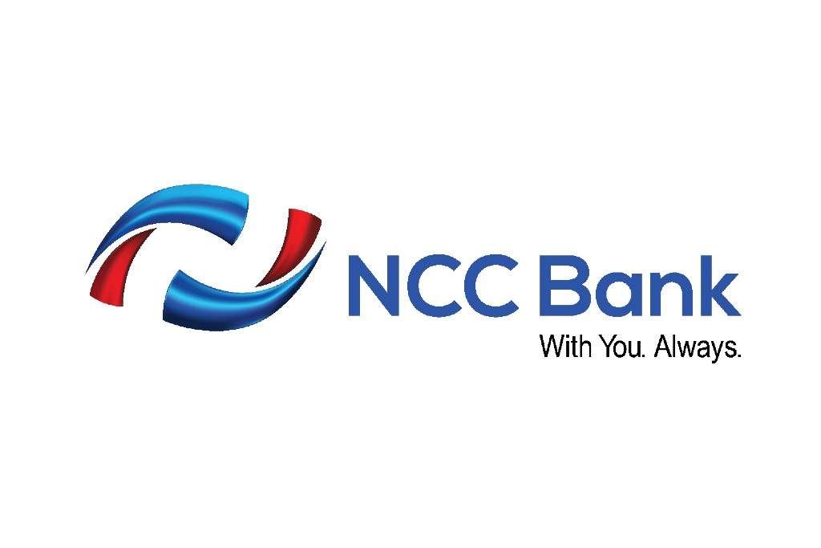
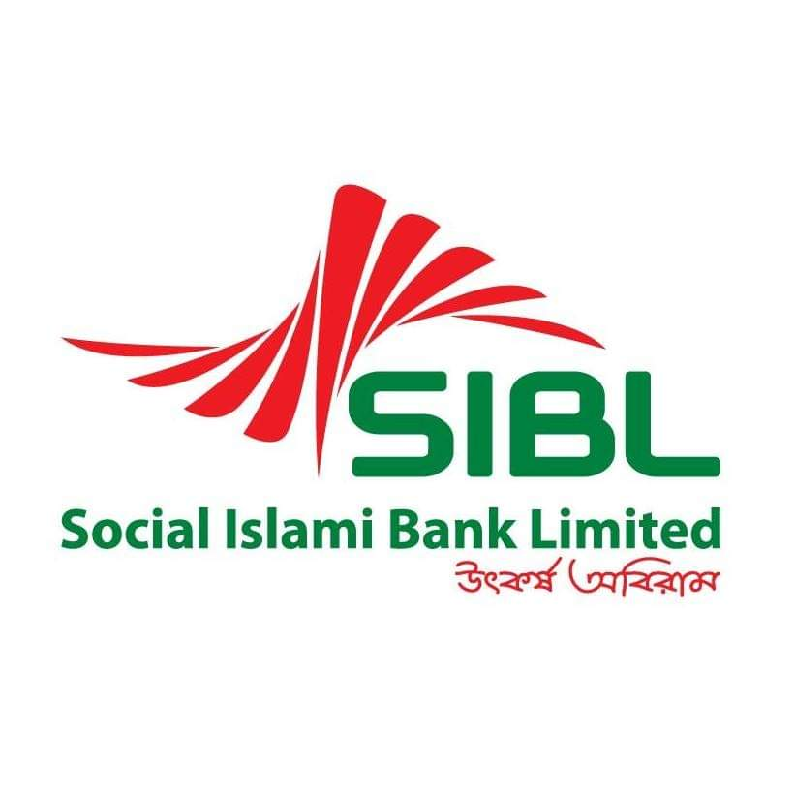


A Project Report Submitted to the School of Business and Economics in Partial Fulfillment of the Requirements for the Degree of Bachelor of Business Administration.

Project Report
Impact of COVID 19 on HR Operations in Banking Sector of Bangladesh
Course code: INT 4399
Submitted To
Ishrat Sultana
Assistant Professor
School of Business and Economics
United International University

Submitted By
Tanjina Jahan
ID: 111 153 001
School of Business and Economics
Major in Human Resource Management
United International University
Date of Submission
February 2, 2022
Letter of Transmittal
February 2, 2022
Ishrat Sultana
Assistant Professor,
Department of School of Business and Economics
United International University.
Subject: Submission of Project Report.
Dear Mam,
With deep respect, it is my pleasure to present the project report on “Impact of COVID 19 on HR Operations in Banking Sector of Bangladesh (SIBL and NCCBL)". This report is being submitted in order to complete the requirements for the BBA degree. Preparing the project report has given me the opportunity to gain practical experience and knowledge. It is true that without your diligent supervision, it would have been difficult for me to prepare the report. So with appreciation I would like to express my sincere gratitude to you. I have done my best to properly explain the topic and also tried to prepare an informative report.
I hope that my efforts will meet up your expectations, if you have any questions or inquire about the study and analysis of this project report, I would be happy to answer any questions you may have. I wish that you would be very pleased to accept my report and oblige thereby.
Sincerely,
Tanjina Jahan
ID: 111 153 001
Program: BBA, Major in Human Resource Management

___________________________

Declaration of the Student
I am Tanjina Jahan, student of United International University of Bachelor of Business Administration, major in Human Resource Management. I do hereby declare that the Project on “Impact of COVID 19 on HR Operations in Banking Sector of Bangladesh (SIBL and NCCBL)" is real work and has not previously been submitted for a degree or accreditation.
I also hereby declare that this report work is solely done by me under my supervisor, Ishrat Sultana, Assistant Professor, Department of School of Business and Economics, United International University. This project report is completed for the fulfillment of my undergrad degree, BBA Major in Human Resource Management from United International University.

Tanjina Jahan
ID- 11 153 001
School of Business and Economics
Program: BBA, Major in Human Resource Management
United International University

Acknowledgment
An internship program is a highly significant and necessary way of gaining practical knowledge since a student's knowledge is not complete until he or she has acquired theoretical and practical information.
I can't take full credit for the study's completion. There were many persons that assisted me in completing my report on time by offering useful information, advice, and direction. But first and foremost, I want to thank Almighty Allah for providing me with the strength and calmness to complete the work on time.
Finally, I want to express my heartfelt gratitude to my honored Supervising instructor, Ishrat Sultana, Assistant Professor, Department of School of Business and Economics, United International University, for his time, guidance, and advice in preparing my internship report.
I am grateful to HR manager and the employees of SIBL and NCCBL for participate on my interview session and their kind assistance to preparing this challenging research with vital facts and data.
Table of Content

Executive Summary vii
Chapter 01: Introduction
1.1 Background of the Report 2
1.2 Objectives of the study 2
1.3 Methodology of the Report 3
1.4 Scope the report 3
1.5 Limitation the report 4
Chapter 02: Literature Review
2.1 Human Resource Management 6
2.2 Human Resource Planning (HRP) 8
2.3 Recruitment and Selection 8
2.4 Training and Development 8
2.5 Work Life Balance 9
Chapter 03: Organization Overview
PART A: Social Islami Bank Limited (SIBL)
3.1 Overview of SIBL 11
3.2 Mission of SIBL 11
3.3 Vision of SIBL 11
3.4 Core Values of SIBL 12
3.5 Organizational Hierarchy System of SIBL 12
PART B: National Credit & Commercial Bank Limited (NCCBL)
3.6 Overview of NCCBL 13
3.7 Mission of NCCBL 14
3.8 Vision of NCCBL 14
3.9 Core Values of NCCBL 14
3.10 Organizational Hierarchy System of NCCBL 15
Chapter 04: Banking Industry Scenario
4.1 Banking Industry Scenario during COVID 19 (2020-2021) 17
4.1.1 Digital Transformation 17
4.1.2 Work from Home and Virtual Working Activities 17
4.1.3 Employees Layoffs 18
4.1.4 Pay Cuts of Employees 18
Chapter 05: HR Acquisition, Training and Development of SIBL and NCCBL
PART A: SIBL
5.1 Human Resource Planning in SIBL 21
5.2 Recruitment and Selection Process in SIBL 21
5.2.1 Approach of Recruitment 21
5.2.2 Recruitment Procedure for Entry level position 22
5.2.3 Sources of Recruitment 23
5.2.4 Selection Process in SIBL 25
5.3 Training and Development in SIBL 26
5.3.1 Training Methods Followed by SIBL 26
5.3.2 Major Training Providers 27
5.3.3 Steps of Training and Development 28
5.3.4 Evaluation of Training 29
5.3.5 Training and Workshops of SIBL 30
PART B: NCCBL
5.4 Human Resource Planning in NCCBL 31
5.5 Recruitment and Selection Process in NCCBL 32
5.5.1 Approach of Recruitment 32
5.5.2 Recruitment Procedure for Entry level position 32
5.5.3 Sources of Recruitment 34
5.5.5 Selection Process of NCCBL 36
5.6 Training and Development in NCCBL 39
5.6.1 Training Methods Followed by NCCBL 39
5.6.2 Major Training Providers 40
5.6.3 Steps of Training and Development 41
5.6.4 Evaluation of Training 42
5.6.5 Training and Workshops of NCCBL 44
Chapter 06: The Impact of COVID 19
PART A: Managers' Statement
6.1 Challenges on managing day to day task 46
6.2 Changes of Recruitment and Selection Procedure 46
6.3 Challenges on providing training to employees 48
PART B: Employees' Statement
6.4 Work life balances during pandemic situation 48
6.5 Findings 49
Chapter 07: Recommendation and Conclusion
7.1 Recommendation 54
7.2 Conclusion 55
References 56
Appendix 58
Questionnaire 60

Executive Summary
Human resource management is vital to the development of any business or companies and companies require skilled employees as well as skilled forces personnel to achieve the primary goal, and the fundamental goal of Human Resource Management is to develop skilled manpower, which is the heart of HRM. Human resource management is the practice of effectively and efficiently recruiting, selecting, developing, and measures consistency person to accomplish an organization's objectives. As a result, in today's competitive marketplace, every firm's Human Resource department must be well-planned and organized.
In this study, I want to learn about a well-structured HRM process and practices on HR Acquisition, Training & Development and Employees’ Work life Balances which are critical for any company in today's changing business climate. And for the study, I have selected two reputed private banks of Bangladesh which are Social Islami Bank Limited (SIBL) and National Credit & Commercial Bank Limited (NCCBL). By taking interview from HR manager, employees of SIBL and NCCBL, I look forward to learning about the two reputed organizations' Human resource planning, Recruitment & Selection processes, Training Process as well as challenges of HR operations, changes of Recruitment and Selection Process, challenges on providing training facilities to their employees and also the employees’ work life balances during the pandemic situation of COVID 19. A standard HRM process establishes and provides particular suggestions for HR policies and practices with the objective of maintaining quality management system and sustaining any business's recognized standards of operation.
Both two banks are private banks and although their basic HR planning & organizing, recruitment and selection process, training process are similar but the banks have some distinct features flourishing on their HR practices, which have been described in analysis and findings chapter on this report.
Since the outbreak of the pandemic situation, the HR managers of SIBL and NCCBL bank both bank have been facing many challenges in practicing of HR activities like Managing Work life balances of bank employees, Mental Health & Wellbeing, Managing Remote work & providing remote working tools and trainings and employee engagement etc. In terms of the recruitment and selection process and providing training facilities to their employees both banks have made some changes on it. All these factors and issues have been studied on this report. And lastly, according to the analysis and findings part, I have provided some of the recommendations on my project report.

CHAPTER: 01
INTRODUCTION

Background of the Report
An internship or project program is a pre-requisite for acquiring a BBA program. Before completion of the program, a student must undergo the Internship Program/Project. I have selected project report to complete my BBA program and the requirements of INT 4399 course at United International University. The topic of project report is “Impact of COVID 19 on HR Operations in Banking Sector of Bangladesh (SIBL and NCCBL)". I have prepared this project report under the supervision of Ishrat Sultana, Assistant Professor of School and Business Economics, United International University.

Objectives of the study
There are two types of objectives: broad and specific, as mentioned below.
Broad objective- The broad objective of this report is to get a clear understanding about the impact of COVID 19 on HR Operations in Banking Industry of Bangladesh in Social Islami Bank Limited and National Credit & Commercial Bank Limited.
Specific Objective-
- To get an overview of HR operations in SIBL and NCCBL.
- To accrue knowledge about the recruitment and selection process in SIBL and NCCBL.
- To know about the training process of SIBL and NCCBL.
- To find out the challenges of HR operations during the pandemic situation in SIBL and NCCBL.
- To find out during the pandemic situation the changes of Recruitment and selection process of SIBL and NCCBL.
- To find out the challenges for HR managers on providing proper training to the employees of SIBL and NCCBL during the pandemic situation.
- To find out the factors to maintain work life balances during the pandemic situation.
- To make some recommendations on the developing HR practices of SIBL and NCCBL during the pandemic situation

Methodology of the Report
    - Sources of Information
Individual discussions with HR managers, employees of SIBL and NCCBL, theoretical knowledge & various articles and other qualitative data collection methods have been be used for analyzing this study.
All of the information for this research & study was gathered from two different sources. They are as follows: -
- Primary Sources
- Secondary Sources

The following of basic overview of the data collection and analysis are used to prepare this report:
      - Primary Sources of Data
The following sources have been used for collecting the primary data, include:
- Conducting interview with the employees of SIBL and NCCBL.
- Interacting & discussions about the topic of the project report with employees of SIBL and NCCBL.
- Direct observing the current scenario of HR practices and activities in Banking Industry of Bangladesh.

    - Secondary Sources of Data
The following sources have been used for collecting the secondary data, include:
- Journals, Newspapers, Articles, annual reports which are related to HR practices and activities in Bangladesh.
- Official Website of SIBL and NCCBL.

Scope the report
In Bangladesh, both Social Islami Bank Limited (SIBL) and National Credit & Commercial Bank Limited (NCCBL) is well-known Bank. Many newcomers to the HR sectors find it difficult to gather all of this information at once. My report might be a great piece of information for them, as it contains a lot of useful information related to the HR practices on Human Resource Planning, Recruitment, Selection, Training and Career Development and Work life Balances during the pandemic situation between two banks (SIBL and NCCBL) all at once.

Limitation the report
One of the major problems, I faced on during the COVID 19 situation, concerned about the health and safety of bank employees, most of branches of SIBL and NCCBL do not allow academic students for the purpose of any interview or survey sessions.
Another Limitation was, most of the employees of SIBL and NCCBL are passing busy schedule on their lives and they have no much time to complete the interview questionnaire. So, in the case of collecting information of the maximum questions, I had to rely on the internet.
And the last one was, I wanted to study and cover all of the HR practices in my report, but since it was difficult to take long time interview with the employees of the bank, on this report only I have covered HR operation, Recruitment and Selection process, Training Procedure and Work life balances of SIBL and NCCBL. The other HR Practices on Performance Evaluation and Compensation Policy of SIBL and NCCBL have not included on my study.

CHAPTER: 02
LITERTURE REVIEW

Literature Review

Human Resource Management
Human resource management (HRM) is the branch of business that focuses on human resources. From recruiting to employment relationships, Human resource management is concerned with all elements of an organization's human resources. HRM is concerned with the human aspect of management. It is a system for acquiring, growing, encouraging, and managing human capital in a company.
Human resource management is also a systematic and complete method to dealing with people, as well as the workplace community and climate. It also encourages workers to participate productively and effectively to the company's general direction and achievement of its objectives.
Human Resource is in charge to ensure that an organization's employees are successful. Human resources departments are in charge of managing an organization's intellectual assets as well as creating rules and procedures. They may specialize in finding, employing, training, and improving workers in addition to managing employee relations and remuneration. Employees are adequately taught and developed over time thanks to professionals in training and development. Training courses, performance assessments, and opportunity for growth are used to accomplish this.
Employee relations address issues that occur when policies are violated, such as mistreatment or discrimination. Employee benefit planning includes the development of salary systems, family leave policies, promotions, and other opportunities for personnel. An HR department is a vital component of any business, regardless of its size. An HR department's job is to boost employee productivity while simultaneously safeguarding the firm from possible personnel concerns. Compensation and incentives, hiring and replacing workers, and maintaining current on any rules that may affect the business and its employees are all HR activities.
Organizations have become more people-centered than they have ever been in the modern age; especially when this strategy pays off in terms of increased worker productivity and lower turnover rates. Human resource management is essential in assisting employers and organizations in meeting their objectives.
HRM functions are important to the organization's long-term growth and development. When employees grow and improve their abilities. The firm will naturally develop and expand in the long run. HRM's major responsibilities include
- Employment planning and analysis,
- Recruitment/hiring and placement,
- Training and development,
- Compensation and incentives,
- Performance management,
- Organizational relations and labor relations.
The objective of HRM
- Effectively manage human resources.
- Promote individual growth
- Foster positive working relationships among all members of the organization
Refeneces: UKEassays. (2015, Jan 01). Human Resource Management. Literature Review Human Resource Management, 5434 words (22 pages). Retrieved from UKEssays.
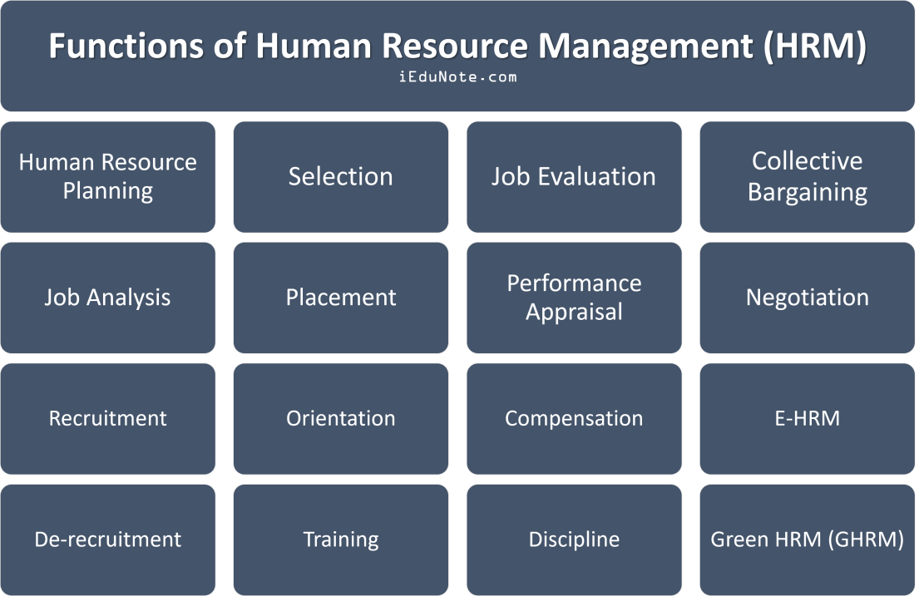
Source: https://www.iedunote.com/functions-of-human-resource-management

Human Resource Planning (HRP)
HRP is generally explained as the method of identifying the number of people a company employs, as well as their quality and quantity, and is thus seen as either a regular or structured planning process. The main objective of HRP is to ensure that employees have the greatest possible connection with their jobs. This type of planning also assures that employee numbers are right, with neither a surplus nor a shortage of manpower. Human resource planning has three main functions:
- HR forecasting,
- Managing employee demand and market supply, and
- Maintaining a balance between manpower supply and demand projections.
Refeneces: Monica Belcourt, K. J. (2017-2018). Strategic Human Resource Planning. 5e. Global Edition: Nelson Education Ltd.

Recruitment and Selection
Recruiting and selection is a key activity in HRM that is organized to improve workforce power in order to accomplish the company's strategic objectives and priorities. It's a process of finding, screening, short listing, and selecting the best candidates for open positions. The recruitment and selection process, namely the selection component of the system, entails
- Screening candidates,
- Conducting interviews,
- Short listing the best prospects,
- And ultimately selecting the best candidate for the job.
Following this procedure is one of management's key priorities. Indeed, a company's success is largely determined by its employees' productivity. Recruiting workers with the proper qualities may have a big impact on a company's bottom line. It can cut costs by hiring employees at a rate or compensation that the business can afford. Employees, like any other asset, should be selected, managed, and maintained with care.

Training and Development
The goal of training and development is to improve the effectiveness of enterprises, as well as the individuals and teams who work inside them. Training is connected with immediate changes in organizational effectiveness via structured instruction, whereas improvement is involved with the creation of longer-term organizational and worker goals. While the terms "schooling" and "improvement" have different meanings, they are sometimes used interchangeably and/or in the same sentence. Training and development has historically been a topic of applied psychology, but it has been more linked to human resource management, skills control, human resource improvement, instructional design, human factors, and information management in recent decades.
Refeneces: Recruitment & Selection - Overview. (n.d.). Retrieved from tutor 2u: https://www.tutor2u.net/business/reference/recruitment-selection-overview

Work Life Balance
Work-life balance describes the degree to which personal and professional activities are emphasized in a life of the individual, as well as the extent to which work-related activities are involved at homes. Work-life balance is a widely discussed topic, due to advancements in technology that have reduced the relevance of physical location in determining work-life balance. Taking work home used to be difficult and time - consuming, and there was a clear distinction between professional and personal life. The spread of the internet, together with advances in mobile technology and cloud-based software, has made it more simpler for people to be ‘permanently' at work, blurring the line between professional and personal life.
Refeneces: Parth Salunke, D. A. (2020, June). WORK LIFE BALANCE IN PHASE OF PANDEMIC. An international bilingual peer reviewed referenced research journal, 10(38), 229-240.

CHAPTER: 03
OVERVIEW OF THE ORGANZITION
PART A: SOCIAL ISLAMI BANK LIMITED (SIBL)
PART B: NATIONAL CREDIT AND COMMERCIAL BANK LIMITED (NCCBL)

Part A
Social Islami Bank Limited (SIBL)

Overview of SIBL
SIBL (Social Islamic Bank Limited) was founded on July 5, 1995, as a result of the dedicated efforts of a group of well-known Bangladeshi entrepreneurs and international leaders. On November 22, 1995, the bank began commercial operations with a clear manifesto demonstrating the critical operational relevance of economic, banking, and financial activities as a part of the Islamic life code. SIBL, which is aimed at alleviating poverty, is actually a notion of participatory banking practices for the twenty-first century. This bank would provide the most up-to-date banking services in the formal commercial sector, including the opening of various types of deposit and investment accounts, commercial financing, the delivery of guarantee letters, the opening of letters of credit, the collection of invoices affecting national and international transfers, the rental of equipment and durable consumer goods, and so on. This would include, among other things, the Waqf cash certificate and the development and management of Waqf and Mosque properties and trust funds in the non-formal non-corporate sector.

Mission of SIBL
Social Islami Bank Limited's mission is to recruit and maintain high-quality human resources, empower genuine impoverished families and generate local income possibilities, as well as attract and retain consumers through financial services. High-quality service that is fast, efficient, and pleasurable, as well as using the most up-to-date technologies. And also Islamic banking goods and services that enable the bank to maximize profit.

Vision of SIBL
The Social Investment Bank Limited was founded on the concept of a participatory Islamic banking model for three 21st-century sectors:
- The voluntary sector mobilizes social capital through programs such as the Cash WAQF and others. Finally, our goal of "lowering poverty levels," which is one of the key topics of the Association's association protocol, is critical, as is the promise of working together for a connected society.
- With latest technologies combined establish commercial sector in the banking industry.
- Family empowerment through microcredit and microenterprise program.

Core Values of SIBL

Source: Website of SIBL

Organizational Hierarchy System of SIBL
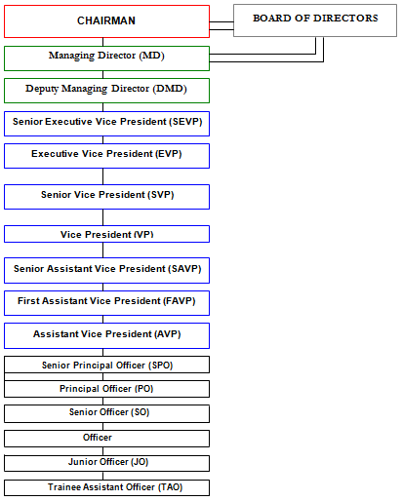
Source: https://www.assignmentpoint.com/business/banking/performance-analysis-social-islami-bank-limited.html
Part B
National Credit and Commerce Bank Limited

Overview of NCCBL
Around a decade ago, National Credit and Commerce Bank Limited began its magnificent path of greatness to enhance Bangladesh's financial system. That is, by supplying the finance industry with successful and innovative banking and financial commodities, Bangladesh's economic condition would be improved. National Credit and Commerce Bank Limited is one of Bangladesh's second-generation domestic non-public banks, established after the country's independence and subsequent conflict. It is a private sector schedule created under the Bank Company Act of 1991 and incorporated as the Public Limited Company Act of 1994 on May 17, 1993. The history of National Credit and Commerce Bank Limited is unique. As an investment business, the organization first entered the country's financial market in 1985. The goal of the firm was to mobilize and invest resources from inside the country in order to grow the country's commerce and industrial sector and to act as a catalyst in the establishment of the stock market. In this sense, the company's position on the stock exchange has been extremely beneficial. Since its inception in 1993, NCCBL has grown to become a major player in all financial markets, overcoming a number of significant difficulties. The bank was able to earn a good CAMEL score, and its profitability performance for the year ending 2000 was exceptional. The bank functioned with 16 branches until 1992, when it was turned into a fully scheduled private commercial bank in May 1993, with a paid-up capital of Tk. 39 core and a large network to represent the country, with the consent of the central bank. National Credit and Commerce Bank Limited has grown into one of Bangladesh's financial sector's focal points throughout the years. NCC has developed through time to become one of Bangladesh's financial sector's pillars, and it plays an essential role in expanding the private sector's economic engagement. National Credit and Commerce Bank Limited has grown into one of Bangladesh's financial sector's focal points throughout the years. NCC has developed through time to become one of Bangladesh's financial sector's pillars, and it plays an essential role in expanding the private sector's economic engagement.

Mission of NCCBL
- To deliver exceptional financial service to their consumers and clients while maintaining a positive customer relationship.
- Providing a long-term strategy that combines our smart and latest technology, knowledge, and financial power for our clients and stakeholders.
- Creating a productive and supportive environment in which their customers and employees may thrive.

Vision of NCCBL
To become one of the most prominent commercial banks by combining credit and trade for the better benefit of shareholders and long-term economic growth while serving the country as a progressive and socially responsible financial organization.

Core Values of NCCBL

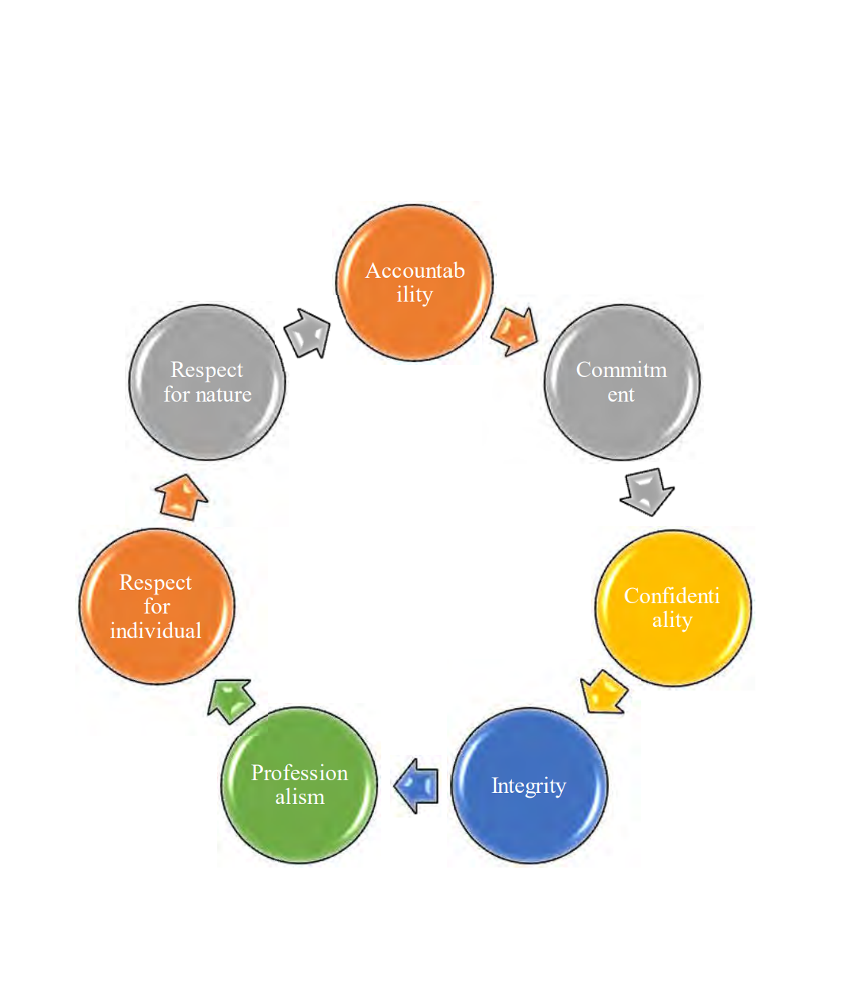
Source: Website of NCCBL

Organizational Hierarchy System of NCCBL
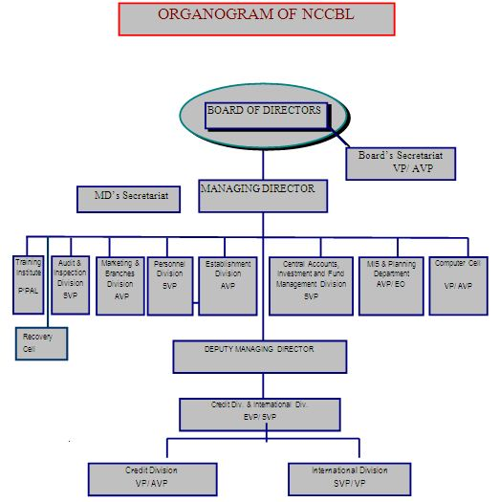
Source: http://www.msrblog.com/business/overall-banking-system-ncc-bank-limited.html

CHAPTER: 04
BANKING INDUSTRY SCENARIO

Banking Industry Scenario during COVID 19 (2020-2021)
Outbreaks of the corona virus have paralyzed the global economy as well as the domestic economy. It has had a negative impact on the overall economy of the country. The banking sector, the main driving force of the economy, has suffered the most. On the one hand, there is pressure on the banks to disburse loans but it is not being recovered. As a result, the income of the bank has decreased. Besides, the country's banking sector is facing various crises including defaulted loans, liquidity crisis and declining profits.
If a country's banking sector collapses, there is no chance for the economy to stay afloat. In any major crisis, the need for the banking sector to restructure the country's fragile economic system is immense. Therefore, Bangladesh Bank has taken various steps as a way to overcome the potential crisis in the banking sector.

Digital Transformation
Although the country's economy, especially the banking sector, has suffered in the pandemic situation of COVID 19, it has also taught a lot. Since Corona started, direct transactions to the bank have been reduced due to social distance. Banks are desperate for the development of digital banking so that customers can transact from a safe distance and there is a huge potential to increase transactions digitally.
During the pandemic situation & impact on COVID 19, People are attracting to digital transactions. At this time, banks have introduced various facilities of online banking for the convenience of various bank customers. Some banks in the country have added some special methods including launching insured deposit products, easy online money transfer, opening bank accounts, online shopping.

Work from Home and Virtual Working Activities
Corona taught the banks how meetings, trainings, workshops, etc. can be done through technology while maintaining a safe distance. Virtual meetings used to happen, but they were limited. During the coronation period, the banks are holding their annual general meetings (AGMs) including board meetings and executive meetings. Before Corona, there was not much introduction of virtual training in the country. But during the coronation period, training of workers, workshops are being arranged in a virtual manner. At present, virtual meetings are being held in different banks almost every day. As a result of virtual meeting, room rent, utility usage, hospitality, travel etc. are not required. As a result, banks are saving time and money in organizing training. At the same time, it is possible to bring more trainees under training. Corona has made virtual meetings, trainings, workshops, etc., very popular all over the world.
Many employees have set up virtual offices from home to avoid the risk of corona infection and to continue banking activities. On the other hand, senior officials have released files through e-filing system and are giving instructions to their subordinates through technology.

Employees Layoffs
In the history of the bank, most of the employees in the private banks have been laid off during the Corona period. Thousands of layoffs are reported in many of the world's largest financial institutions. It is known that more than five hundred workers have been laid off in Bangladesh by several banks including private sector AB Bank, The City Bank and South East. Occasionally there are rumors of layoffs in the country's banks, but never before have so many workers been laid off at once. The lesson from Corona is that in order to deal with such undesirable situations, bank employees need to be proficient in banking as well as other subjects.

Pay Cuts of Employees
In the history of Bangladesh Bank, no private bank has ever been heard to reduce its salary allowance. Due to intense competition among the banks, the banks have increased the salary allowance of their employees at different times. But no one ever thought that the salary could be reduced. In the wake of the epidemic, a number of private banks have cut their salaries as well as reduced their salaries to cut costs. Corona taught the bankers about the mentality of accepting the situation like reduction of salary allowance of the bank officials.
Despite the proliferation of technology in banks, the battle for the development of technology has begun with how to deal with the prolonged epidemic and bring banking services to the doorsteps of customers. In the last few years, IT services have added banking services to mobile banking, internet banking, online payment system, online CIB report, credit card, debit card, e-commerce through Visa card. All state-owned and private sector banks are now providing technology-based banking services. Using these technologies, people are able to provide basic banking and financial services such as remittance distribution, utility bill payment, salary-allowance payment, ATM, etc. Even after all this, the epidemic slows down banking activities and banks face huge financial losses.
Banks are currently focusing on the development of state-of-the-art automation or artificial intelligence and machine learning technologies to reduce the risk of corona infection. Therefore, the public and private banks have focused heavily on the development of their own technology to deal with the negative impact of the Corona epidemic on the economy. This is expected to have a positive impact on the financial system of banks in the future.
Source: M. A. Massom (2021, September 16). What did Corona teach the banks? Retrieved from Banikbarta Newspaper.

CHAPTER: 05
HR Acquisition, Training & Development in Two Private Banks

PART A: SOCIAL ISLAMI BANK LIMITED (SIBL)
PART B: NATIONAL CREDIT AND COMMERCIAL BANK LIMITED (NCCBL)

Part A
Social Islami Bank Limited (SIBL)

Human Resource Planning in SIBL
Human resource managers at SIBL can generally foresee the future with the help of human resource planning so that they can continue to supply skilled professionals & qualified employees. It's also known as workforce planning for this reason. Through this process SIBL can assess and meet their requirements of workforce as well as assist in advance and future planning. In order to adapt to the changes in the long term business environment, SIBL’s HRP is enough flexible and adaptable in meeting the challenges of short term employees. Human Resource Planning of SIBL analyses and evaluates of current human resource capacity and skills at a first stage as well as finds out the surplus & shortage of manpower in their workplace. One of the challenges & difficulties in HRP is to manage the changing workplace such as an employee who is in vacation or illness or get promotion. Human Resource Planning ensures it, as well as the optimum match between employees and employment, preventing surpluses and shortages of manpower. The HRD of SIBL generally plans the following measures to fulfill the objectives of SIBL:
- Recruit and hire qualified personnel.
- The best candidates should be selected, trained, and rewarded in the right way.
- Absenteeism and conflicts management should be done easily and properly.
- Employees are either promoted or fired.
The assessment of HRP is one of the most important decisions a company can make. After all, businesses are the only ones that have the ability to do so. The distinctions between product lenses and products will offer benefits if workers are employed and best practices are adopted.

Recruitment and Selection Process in SIBL

Approach of Recruitment
The recruiting and selecting process is one of the most important aspects of human resource managers' duties at SIBL. The degree of execution is determined by the efficacy of an organization's hiring capability. SIBL has devised and executed a registration strategy to assist them in achieving their objectives and making the most of their resources. An efficient and realistic recruitment method must be established in order to gradually employ it and gain extraordinary power of application. In order to build an efficient and cost-effective registration system, the approach must include the following features:

Recruitment Procedure for Entry level position
- Identify and prioritize tasks:
While the preceding situations continue to arise at various levels inside every organization, it is a process that is almost continuous. It's difficult to fill all of the jobs in a timely way. It's critical to distinguish between views that need quick thinking and those that require action based on these ideas. The options (focusing on all jobs in the same position or focusing on key professions first) are helpful in keeping the admissions activities' character.
- Requirements of the Candidate
SIBL requires a certain degree of candidates, which must be specified in the system. Candidates' backgrounds might range from recent graduates to seasoned professionals. SIBL Bank establishes a competency level for entry-level employees based on which they can select applicants.
- For Trainee Assistant Officer: SIBL prefer applicants for the post of with minimum four years Undergraduate degree of BBA holder from any public university or Private University candidates are given a lot of significance at SIBL Bank. Aspiring applicants must have a minimum GPA of 3.50 on a 5.00 scale both in S.S.C and H.S.C, as well as a CGPA of 3.05 on a 4.00 scale in BBA. Candidates for the SSC and HSC must have a first-class division, with no third-class divisions permitted. And Age not over 30 years.
- For Probationary Officer: SIBL Bank establishes a competency level for entry-level employees based on which they can select applicants. They prefer applicants with minimum Master/MBA/MBM with a four years Undergraduate degree of BBA holder from any public university or private university. MBA candidates are given a lot of significance at NCC Bank. Aspiring applicants must have a minimum academic grade 10 points including at least two 1st divisions. CGPA 3 & above in exams = 3 points, CGPA 2.25 to 2.99 = 2 points. No third-class divisions permitted. And Age not over 30 years.

- Category of Candidates
In SIBL, the target competitors have been properly identified through technology. It might be from the same firm, belong to the same category, or include the unemployed, the company's best animator, and so on.
- Source of Employment
Various data sources must be incorporated into the approach (external and internal). What are some of the future uses and sources of centralized monitoring? In SIBL, one of the most effective ways to gain early admission is through expert references.
- Employers who are qualified
Experts who have registered for management meetings and other selection procedures are well-prepared and have previously coordinated operations. The HRD of SIBL, They consider the real factors and capabilities (for example, social, particular, etc.) while meeting and choosing applicants.
- Candidate evaluation
The entire selection process, as well as the unique factors and strategies for dealing with these, must be determined ahead of time. It appears to be a sequence of
- Specialized meetings,
- Human resources interviews,
- Official examinations,
- Psychological testing, and so on.

Sources of Recruitment
The requirement for recruiting is more acute when a new position is formed as a result of the bank's expansion. If a vacant position cannot be replaced from within, succession planning may need recruiting. This bank employs a variety of different recruiting methods. SIBL places ads in the newspaper to attract applicants for various entry-level positions. In SIBL, the selection procedure is similar to what is used in most companies. The procedure begins with preliminary screening and concludes with a final interview to choose a candidate. The present selection and recruiting procedure, as well as its flaws, are discussed in the next chapter, as this is the report's main focus. Each organization has the option of selecting a candidate for its enrollment forms from two types of sources: internal and external. The inner wellsprings of enlistment are the sources of enlistment within the organization itself (such as employee transfers from one office to another, promotions). The outside wellsprings of enlistment are enlistment hopefuls from various sources (such as outsourcing companies and so on).
- Internal Recruitment
- Promotions and Transfers
- Employee referrals
- Previous Employees
- Dependents of deceased employees
- Reviews
- Retirements
- Inside warning (promotion)
- External Recruitment
When SIBL Bank gets the application form from the offices, HR offers the job to the general public. For job postings, the SIBL use a variety of methods like:
- Online portals like BDjobs. Com,
- Prothom alo jobs.com
- Social Media Pages
- Directly in University
- Head Hunting Organization
- Newspapers,
Every bank has a distinct employment portal with which they have an arrangement. SIBL Bank also has a partnership with BDjobs.com, an employment platform. SIBL Bank inquires about recruiting details, but does not reveal how many candidates they will select.

Source: Career – Social Islami Bank Limited

Selection Process in SIBL
Selection usually entails a number of activities or processes. Social Islami Bank Limited employs its own created selection method to find the suitable people. Before the requester moves on to the next stage in this method, each step is successfully removed. The Social Islami Bank Limited (SIBL) selection procedure begins with an assessment of the CVs that are available for a certain vacancy.

Source: Noor, A. and Begum, K.A. (2016) ‘Recruitment and Selection process of SIBL’. Interview with 28 July
Following the categorizing of the interview, the bank's human resources department qualifies the candidate for the position and invites them to take the written exam. In the written test of Islami Bank Bangladesh Limited, many tests are required.
The goal of curriculum selection is to exclude unqualified applicants. It's basically a classification process in which relevant information about a candidate's education, talents, and experience is obtained from them.

Training and Development in SIBL
All personnel must participate in a training and development program if the organization is to succeed. It improves the organization's performance. Individuals and teams have an important role in retaining employees and developing future projects. SIBL committee creates an atmosphere that encourages all workers to learn, grow, and accomplish personal goals. Employee dedication and desire to learn, grow, take on new roles and responsibilities & duties, and explore opportunities for self-development are also critical to the company's accomplishment of this promise. The main objectives of SIBL to provide trainings to their employees are:
- To assist employees in doing their duties successfully and perform efficiently,
- To provide supervisory and other management training to personnel in order to prepare them for future growth and progress,
- To improve communication and interpersonal skills in order to form productive teams,
- To instill a sense of commitment of the greatest level and quality,
- Keeping employees updated about changes in the business environment.

Training Methods Followed by SIBL
Several ways are available to meet the organization's goals. Their training was divided into two groups by the Social Islami Bank:
- External vocational training and certification (Off-the-job): The following are examples of external vocational training methods:
- Simulation exercise: It's all about doing the job when it comes to training. Reviewing cases, simulations, and collecting conversations are all part of this process.
- Monthly meetings: Meetings are used to teach interpersonal skills or analytical thinking.
- Training through Film and Video: To educate some abilities that are difficult to express through conventional means, use multimedia material.
- Case Study-Based Training: The case studies will help students comprehend theoretical concepts.
- IT training: At work, IT is the most significant item. To make IT training so important, delegates must adopt all creative ways possible.
- University-related activities: Some institutions host programmes that require employees to provide motivational speeches in a variety of formats. Then set up a training programme for sending reps to improve their interpersonal skills.
- Outdoor seminars: Workers are being sent to seminars. Many university writing courses are facilitated by us, and they are required to take this course.

- Internal training program (On-the-job): Work is at the centre of the training strategy in these techniques. "Cleaning training" is the name of this training programme. The following is the procedure for a vocational training programme:
- Follow-up: establish a positive understanding from the start.
- Employee preparation: includes enrolling workers in the appropriate training programme. An examination of apprenticeship requirements may be found here.
- Instructor preparation: includes isolating sensitive regions in order to create lesson plans and choose training techniques.
- Exam results: It is important to convey any past progress to employees and to comprehend their motives and inclinations. I need to start acting.
- Request an assignment: Request a general activity from the workers, along with a brief explanation of what makes things confusing and troublesome. Make adjustments based on your current location. Inquire about the status of each action.

Major Training Providers
The SIBL Training School is a training institution run by Social Islamic Bank Limited in Dhaka. In addition, they send their representatives to get trainings from:
- Bangladesh Bank Training Academy,
- Bangladesh Institute of Bank Management,
- Bangladesh Association of Banks,
- Bangladesh Foreign Exchange Dealers Association,
- The Central Shariah Board for Islamic Banks of Bangladesh
- And numerous other presumed foundations of the nation

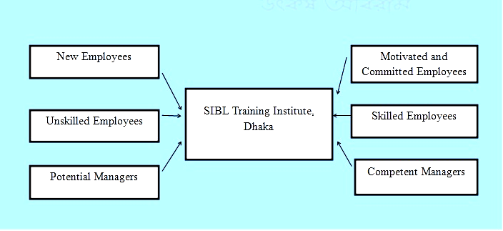
Source: Annual Report of SIBL, 2019

Steps of Training and Development
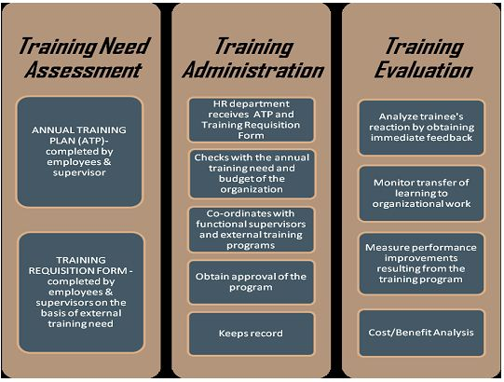
Source: Annual Report of SIBL, 2019

Training Need Assessments
The initial phase in the training and development process is need assessment, which involves identifying and resolving performance issues. The goal is to evaluate whether there is a requirement for training and the type of the content of the reveal ancestor determiners. It's also a train that identifies a training requirement that SIBLs may target and choose.

Training Administrations
This discussion part handles all of the grouping’s governance responsibilities, such as supplying the gear train as a conduit between employees and their supervisors. This is done to keep any confirmation of a young lady communist to a minimum in order to ensure that the staffs are of a better level.

Evaluation of Training: This part is discussed below.

Evaluation of Training
Every training programme is carried out with the goal of reaching a predetermined object glass and determining whether or not those cooked. SIBL is a company believer in lifelong learning. As a result, public presentations must be evaluated in order to determine the efficacy of the existing approach. This will also aid in the correction of any bay 8 sentences of window in the outgrowth that may have occurred throughout the review procedure. The following are the steps of breeding appraisal that will be covered:
- Employees are put through a response training programme.
- Analysis of what the employees have learnt from the curriculum in terms of knowledge and skills
- New Stimulus trainees were constructed for the event.
This section of Training & Development Social Islami Bank Ltd is managed by employees and management. It's thought that, at the end of the day, four personnel attend the gathering with others' remarks and report to their line supervisors for training evaluation. This information format notes on training evaluation three parts, i.e.
- Reaction,
- Instruction
- As well as success in the organizations work Supervisors in the front lines.

Training and Workshops in SIBL
 | Serial No |  | Name of Training Courses and Workshops
 | 1. |  | Orientation courses on banking |  | Full general banking of SIBL,
 |  |  |  |  | Ethics in Banking are Bookkeeping,
 |  |  |  |  | Accounting
 | 2. |  | Refresher Course |  | General Banking,
 |  |  |  |  | laundering,
 |  |  |  |  | SME
3. |  | Basic Course |  | Meaning
 |  |  |  | Definite ingle entry
 |  |  |  | double entry
4. |  | Financing in Foreign Trade |  | International trade
 |  |  |  | concept
 |  |  |  | Kinds of foreign investment
5. |  | Documents |  | Recognize the trainee with loan
 |  |  |  | Bursting charge documents
 |  |  |  | Bond opinion
 |  |  |  | conservation
6. |  | Workshop on Anti money laundering |  | To fight money laundering Act
Source: Annual Report of SIBL, 2019

Part B
National Credit and Commerce Bank Limited

Human Resource Planning in NCCBL
The human resources of NCC Bank Limited are the ultimate strength for them which is helping them in their efforts to meet the continuous improvement goals of the bank. The main responsibility of their Human Resource Department is to enhance and maintain the skills of the employees as well as to play a role in achieving long term success with active employees through the best manpower in the right place. In addition, they are responsible for HR planning, recruitment & selection process of potential candidates, arranging training & development, providing incentives & facilities, performance appraisal and proper management & monitoring of all HR related activities. In the face of this Corona epidemic and lockdown, NCC Bank’s HR departments are firmly engaging themselves with new technologies to future activate themselves, which is particularly helpful in developing their comprehension and skills.
NCC Bank, this financial bank service company uses FLORA designed HRD computers, called Core Banking Software, where all employees and officers of their bank’s HR department are allowed to use it. Employees of all branches of NCC Bank can randomly contact with any employees of head office through HRD system if they have any query about a leave request, discharge order, transfer order, training & development, compensation and benefits or anything else
The NCC Bank’s Human Resource Department’s objective is to increase performance of the company and competitive advantage by recruiting, training & development, and rewarding organizationally strong employees in a winning community to achieve competitive goals. The Human Resources Department generally plans the following measures to fulfill the NCCBL's objectives:
- It's about hiring the best candidate for the appropriate position at the right time.
- Reduce turnover rates.
- Encourage & motivate employees to work at a high degree of passion.
- To avoid wasting time on ineffective interviews
- Discrimination should be prohibited in the workplace.
- Within the organization, establish strong moral and interpersonal relationships.
- Maintain Keep peace in the organization.
- Attract and keep qualified personnel in the bank.
- Recognize and fulfill employees’ desires & needs.

Recruitment and Selection Process in NCCBL

Approach of Recruitment
The HRD plays a major role in determining the bank's overall personnel requirements. NCC Bank Ltd offers equal employment opportunities to all Bangladeshi residents. The NCC Bank has a strategy for recruiting, developing, and empowering skilled and professional employees. The Bank's recruiting policy is generally decided by the board of directors on a regular basis. A Master's degree is the minimum entry-level qualification for any official position. However, for the designated junior officer, known as the management trainee officer level, NCC Bank requires a minimum Masters Degree or MBA in any subject. The recruiting process begins with a structured written test given and supervised by the Institute of Business Administration (IBA), University of Dhaka Bangladesh Institute of Bank Management for entry-level positions at NCC Bank (BIBM). Following the written test, successful applicants are subjected to a three-phase interview conducted by a panel of experts comprised of the country's most prestigious and prominent bankers.

Recruitment Procedure for Entry level position
- Job Analysis
An in-depth assessment of the activities, responsibilities, and skills necessary to properly perform an employment role is referred to as a job analysis. In other words, work analysis is the method for determining the key components of a job, such as the duties and skill criteria of a job, as well as the sort of person who will be hired to do it. The data for producing the job description and role definition is defined by the job review. The NCCBL contains a thorough job analysis that includes
- Job descriptions,
- Job definitions,
- And job evaluations.
The recruiting process should ideally begin with a study of the job description and job requirements.
Prior to initial recruiting, NCC Bank conducts a job analysis. They attempt to inform real-world employment practices about the job analysis. NCC Bank does a job analysis once a year. It's a time-consuming procedure. The interviewing of five to six workers will take a few days, and the managers will be involved in describing the method and goal of the analysis.
- Job Description
The process of a particular job's comprehensive and written statement, based on the results of a job evaluation, is known as the job description. The primary goal of a job description is to collect job-related information in order to advertise a certain position. It is used to determine what needs to be provided in a given task. It specifies what employees are required to perform in response to the specific job opening. The job description explains the job title, responsibilities, summary, location, and working conditions. NCC Bank developed a job description that included tasks conducted inside the job, information about job tasks and responsibilities, reporting to and from workers, a job summary, and a requirement of working conditions.
- Job Specification
Job specifications are another part of the job analysis. It specifies the sort of person required (in terms of skill, knowledge, and a unique attitude, as well as many types of test results) and the working conditions to be encountered.
- Conduct recruit survey
NCC Bank determines which department they need to hire in first. As a result, the officer's first assignment from the HR department was to perform an internal poll to determine where the recruit was required and how much was required. If there is a shortage of personnel in any area, they submit a requisition to HR stating that they require this number of applicants. As a result, NCC Bank initially recognizes the need for a recruit.
- Requirements of Candidates
NCC Bank establishes a competency level for entry-level employees based on which they can select applicants. They prefer applicants with minimum Master/MBA/MBM with a four years Undergraduate degree of BBA holder from any public university or BRAC, NSU, EWU, ULAB, IUB, AIUB, IIUT. MBA candidates are given a lot of significance at NCC Bank
- Both Junior Officer and Management Trainee Position: Aspiring applicants must have a minimum GPA of 4.00 on a 5.00 scale, as well as a CGPA of 3.00 on a 4.00 scale. Candidates for the SSC and HSC must have a first-class division, with no third-class divisions permitted. Candidates who passed the O and A levels must have a GPA of at least 3.00 on a scale of 4.00.

Sources of Recruitment
NCC Bank initially determines which recruits are required in various areas. The HR head receives a requisition form, following which HR posts the employment circular on several job websites or sites. NCCBL utilizes a variety of venues to publicize their employment openings. When NCC Bank gets the recruitment application form the offices, HR offers the job to the general public. For job postings, the NCCBL use a variety of methods like:
- Online portals,
- Web searches
- Newspapers,
- Employment portals and so forth.
Every bank has a distinct employment portal with which they have an arrangement. NCC Bank also has a partnership with BDjobs.com, an employment platform. NCC Bank inquires about recruiting details, but does not reveal how many candidates they will select. For example:
- Newspaper Advertisement
The notice of the vacancy is widely disseminated through the publication of advertisements in national publications. The most well-known and widely circulated newspapers are selected for ad publication. The advertisement, which will be published in major publications, is attractive. It contains information about
- The job,
- The objective of the appointment,
- The location,
- Major duties,
- Terms and conditions,
- The age limit,
- The minimum level of education,
- Work experience,
- Employment qualifications,
- And special requirements.
Job advertising is sent to HR in a certain manner, along with an employee application. If there is no advertising confirmation, HR decides on the advertisement based on the job description and provides an alternative for his or her comments to the line manager. The public relations department is in charge of design and graphics before submitting any advertising to newspapers.
- Online Job Portal
NCC Bank participates in the online employment site as well. Every bank has a contract with a certain job site. NCC Bank has also partnered with BDjobs.com. As a result, BDjobs.com requested the materials, but they did not specify the exact needs. NCC Bank provided all relevant details regarding the employment opportunity, including
- Education requirements,
- Job responsibilities,
- Minimum requirements of age
- Pay packages,
- Work experience,
- Location,
- And special requirements.
- Career Fairs
A job fair has become a fairly popular source of headhunting in recent years. NCC Bank participates in a variety of employment fairs hosted by several well-known colleges.
- Internal recruiting
Internal applicants who are qualified and competent for the existing or new role and satisfy the criteria for the current and future positions are encouraged to apply. With the consent of the authority, NCC Bank might make the appointments by promotion, up-grading, or transfer. When it came to internal hiring, it was primarily experienced people that were favored. Nobody is allowed to apply for a job during the probationary term. Internal staff should be educated on the notion of succession planning.
- External recruiting
Proper preparation and coordination are required for a successful external recruitment campaign. NCC Bank conducts external hiring in a very private and technically sound manner. It's a one-on-one conversation. Recruiters will generally identify, evaluate, and propose the most suitable candidates to the heads of the various departments where the opening exists. For external hiring, it also favors the experienced person. NCC Bank strives to hire the finest employees possible.

Selection Process of NCCBL
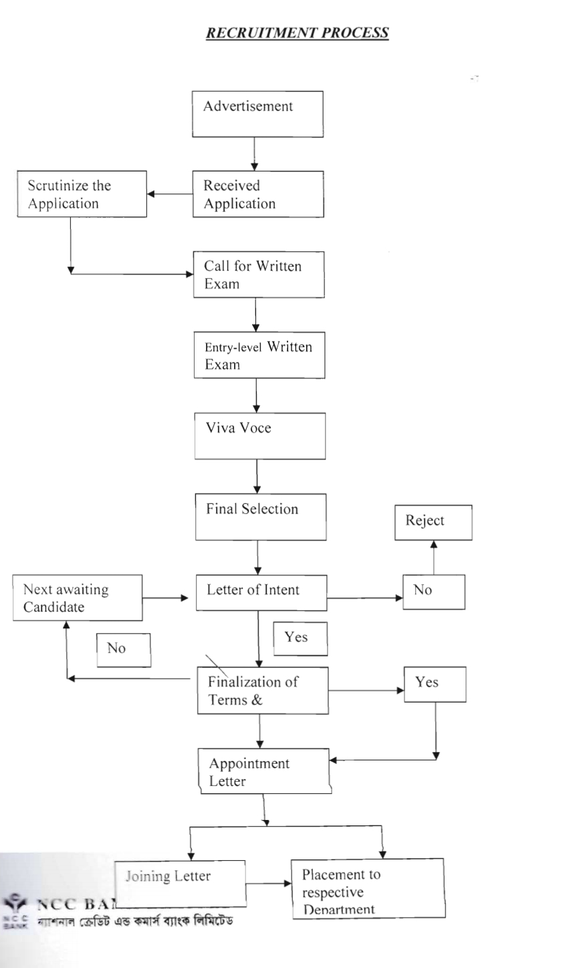
Source: Website of Career – National Credit & Commercial Bank Limited
- Submission of CV
After formulating the job requirements, they were published with the address, email address, and instructions on how to send the CV, as well as how to drop the CV off at the NCC bank's website or send a physical copy to the HR department. A deadline for sending the CV has also been specified. As a result, the candidate must submit his or her curriculum vitae within this specified timeframe.
- Sorting of CV
When the CV is submitted, NCC Bank goes through the process of sorting CVs. It's to check if it meets the job's requirements. The sorting continues till the criterion is met.
- Conduct a written test
Following the first screening, selected applicants will take the written test. This competitive written test is administered by the IBA or BIBM. A database is built for the sorted CV, which is then sent to IBA or BIBM. The IBA or BIBM will then create a questionnaire. The questions for the written test come from a variety of subjects, including Bengali, English, Math, Computer, Analytical Ability, and general. The written exam is announced by NCC Bank to the shortlisted applicants via their email ID and address. Candidates get their admission cards from NCC Bank, which accepts the exam schedule.
- Marking criteria
IBA creates a question-answer sheet and does the marks when the test is completed. They examine all of the candidates' marks in accordance with the requirements. The highest mark is listed first, followed by the lowest mark. The applicant who received the highest grade will be ranked first, and the process will continue up to number 100.
- Selection of eligible candidates for the Interview
A recruitment board or team exists at NCC Bank. An HR director, top management, and the MD make up this recruitment team. The list of candidates who have been selected is then provided to them. After that, the members make a decision as a group. As a result, eligible applicants will be contacted for an interview.
- Employment Interview
The recruitment team, which includes the HR director, senior management, and the MD, conducts the interview. The interview is divided into 3 stages. Various types of questions are posed during the first portion of the interview. Because the applicants are recent graduates, it is assumed that they are well-versed in new facts and knowledge, and questions are posed accordingly. The most typical questions posed on the interview board include expressing something about yourself; the important thing to look for is how well applicants respond to this topic. It also looked at how well a candidate communicated, presented him, and how knowledgeable he was, among other things. Here, NCC Bank also takes presentation sessions and IT test from the candidates.
- Appointment Letter
After making the final decision, NCC Bank sends the candidates an appointment letter. When the newly hired employees arrived at the bank, Head Office allocated them to a certain branch for a probationary term.
- Joining Process and placement
Provide the appointment letter to the shortlisted applicants as NCC Bank. The term of the appointment letter is stated, and the candidate must join the organization within this time frame. In most cases, the period is little longer than one month. If the candidate is a recent graduate, the management committee will set a decision date for them and they will be expected to start on that day. If the candidate has previous experience, NCC Bank will provide the candidate a one-month notice to join within that time frame. If the applicant is unable to start within the next month owing to the lack of a release letter, the candidate must apply to HR before the end of the month, stating the reason. An orientation will be conducted after the joining on that day. The new candidate was introduced to all of the department heads, and then the new employees were placed. Employees at NCC Bank will begin their careers in the HR department. HR will later reassign them to a new department.

Training and Development in NCCBL

Individual and group performance is the emphasis of training and development, which is an organizational function in NCCBL. To improve employee performance, training is an educational and learning approach in NCBBL that includes
- Honing abilities, ideas,
- Enhancing behavior,
- And acquiring new knowledge.
Effective and effective workforce preparation aids in the development of their knowledge and abilities, allowing a business to progress in NCCBL. In NCCBL, The development has a long-term outlook. It's all about preparing their employees for current and future jobs, providing them with opportunity to gain new skills, and engaging them in more difficult and productive activities.

Training Methods Followed by NCCBL
As a result, after evaluating the training requirements assessment, NCCBL plans a training programme for both newly hired workers and incumbent employees. Every business employs one of two types of training and development programmes.
- On the job training
- Off the job training
- On the job training: At this time, the NCC financial institution's head office has assigned the newly hired employee to a training programme that allows them to learn on the job and increase their productivity. NCC Bank provides on-the-job training while employees are doing their jobs. Because employees are learning on the job, this training seeks to familiarize them with typical working circumstances. As a result of the employee's performance, he or she is learning. Employees at NCC Bank were required to learn something new in addition to their regular duties. Employees in the HR department are also given credit department training. The trainee will be shown how to do a certain task by the supervisor or experienced employees. The learner completes the assignment by following the directions. It is carried done by experienced workers. Apprenticeship, job rotation, and special assignments are all part of the on-the-job training programme.

- Job Rotation: Job rotation throughout the company's many departments is merely a horizontal technique of rotating job responsibilities. To gain knowledge, experience, and a thorough grasp of the operations of diverse divisions. NCC Bank employs job rotation, which is transferring staff from one position to another.
- Coaching: Workers at NCC Bank are frequently mentored by supervisors and senior executives who teach them on the job. It means that employees not only understand the task through training, but they also have direct influence on pressure points to do the job.
- Job Enlargement: NCC Bank also employs job enlargement, which is a horizontal restructuring approach in which the number of tasks connected with a particular position is increased. It improves the workforce's adaptability. Employees are working on additional projects in addition to their regular work in order to expand their responsibilities.

- Off the job training: NCC Bank's training centre provides off-the-job training to both new and existing employees. NCC Bank invites experts from a variety of organisations to deliver seminars and workshops for its staff. The approach is widely utilised in NCC bank lectures. Employees are given a lecture about the work criteria and the essential skills for implementing the job in a lecture. Instead of disseminating knowledge and skills through reading assignments and experience, this lecture approach focuses on comprehension. NCC Bank also provides new employees with an orientation and foundation training. Along with class sessions, the NCC Bank Ltd Training Institute employs a variety of different options to this approach, including workshops, seminars, presentations, case studies, organized training and computer-based training.

Major Training Providers
Almost every bank in Bangladesh has its own training facility. The Credit And Commerce Bank Training Institute is NCC Bank's own in-house training and development facility. It's located in the Human Resources division. This training centre follows a training principle. In addition, this training facility offers a variety of training opportunities for its employees. Besides that, NCC Bank has several other training providers, including
- BIBM (Bangladesh Institute of Bank Management),
- BBTA (Bangladesh Bank Training Academy),
- And SCB (Standard Chartered Bank).
NCC Bank also arranged for its workers to receive training from the prestigious school.

Steps of Training and Development
The training design program at NCC Bank is based on the current requirements. Many changes have been made to training programs in recent years. As a result, while designing a training program, it is important to consider who will be doing the training. They start by determining the level, such as
- Junior,
- Mid-level,
- And senior.
When training is offered to junior level employees, a separate model is created, one that includes graphical information, database information, and a different video. When training is offered to them at a mature level, the material must be traditional. As a result, the form of the training program is determined by who will be receiving the instruction. It is divided into five levels: the root level, the senior root level, the middle level, the senior middle level, the senior level, the senior level, and the management level.

Figure: Training Design Process of NCCBL (Source: Annual Report of NCCBL, 2019)
- Training Need Assessment
A successful training programme starts with a representation of the employees' training requirements. The term "training" refers to the process of determining the difference between expected and actual performance levels. The training needs evaluation is also done by NCC Bank. The following are three methods for determining training requirements:
- Organizational Analysis: NCC Bank does an organizational analysis to evaluate if training supports the organization's strategic decisions, supports managers, colleagues, and training operation employees, and decides what training tools are accessible. On the basis on which a resource is assessed, it determines the organization's finest asset.
- Personal Analysis: The characteristics of a person are stated in a person analysis. NCC Bank also considers the competence level of its employees. It aids in determining whether or not an individual is ready for training. It assesses if an employee's production requires training. It's about observing their team's interpersonal relationships, communication, learning capacity, and attitude. The need for training may arise through changes in the nature of the profession, the use of new technologies, performance issues, and the inability to adapt to technological developments.
- Task Analysis: The competency of the employee is determined by NCC Bank. It is used to assess their job performance, knowledge, skill, ability, and responsibility. It's to examine if the employees are doing their jobs correctly and under what conditions they're doing them. It is mostly intended for freshly hired staff.

Evaluation of Training
The Kirk Patrick Model is used by NCC Bank to assess the efficacy of the training program. The Kirk Patrick Models are divided into four phases, which are explained below.
- Reaction
- Learning
- Behavior
- Results
Level 1: Reaction: The trainee's perception of the programme, including the equipment, the trainer, and the training material, is referred to as reaction outcomes. NCC Bank Ltd usually refers to a questionnaire filled out by trainees, but it might also refer to a verbal interview. They then make a decision based on the employee's remarks; if employees have negative feelings about the training, it's doubtful that the other person will be interested in it, or that the employees who are taking it will benefit in any way. The questionnaire technique is frequently utilized to collect input at NCC Bank because the team of trainees is unavoidably large.
Level 2: Learning: The learning outcomes are used to determine how well learners understand the training program's idea, details, methods, and processes. It examines the abilities that trainers have developed as a result of the programme. The NCC Bank determines whether or not the trainee is capable of making decisions. If workers have had minimal experience, we should expect little change in their behavior. Occasionally, the administration may set up success evaluations in which the trainees will complete specific projects or demonstrate the abilities they have learned during the training programme.
Level 3: Behavior: The amount of technical skill or conduct is determined using behaviour outcomes. Observation was a popular method of measurement at the NCC Bank. NCC Bank may conduct checks to see if employees are doing better or dealing with difficulties in a certain way. NCC Bank may put their findings to the test in the workplace. The trainees will be asked to comment on their own actions or talents. In addition to coworkers, supervisors and subordinates can help evaluate trainee performance based on their own experiences.
Level 4: Results: The combined results of the training, as well as the influence of the training on effectiveness, production, consistency, customer service, or any other factor, are examined in the evaluation of outcomes. Finally, management assesses whether the training curriculum, as well as the skills or experience gained by participants in such programmes, has benefited the employees and the firm as a whole. Workers' unemployment rates, staff efficiency, employee competitiveness, income, customer complaints, employee efficiency, and the many divisions of the company may all be assessed.

Training and Workshops of NCCBL
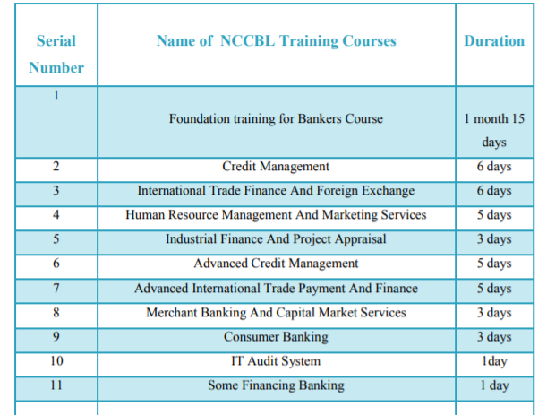
Source: Annual Report of NCCBL, 2019

CHAPTER: 06
The Impact of COVID 19 on HR Acquisition, Training & Development and Employees’ Work – Life Balance

PART A: Managers Statement
PART B: Employees Statement

Analysis
The Impacts of COVID 19 on Employees work life balances, HR operations, Recruitment, Selection and Training Processes in SIBL and NCCBL.
Part A
HR Managers’ Statement

Challenges on managing day to day task
Since the outbreak of the pandemic situation, the HR managers of SIBL and NCC bank have been changed their strategies differently for their HR planning, decisions and day to day operations. They have being facing many challenges in practicing social distance since the epidemic situation as well as creating a new work environment. In terms of day to day operations, some of their notable challenges are:
- Mental Health & Wellbeing
- Managing Work life balances
- Managing Remote work & providing remote working tools and trainings
- Lack of Agility
- Employee Communication
- Uncertainty
- Employee Engagement

Changes of Recruitment and Selection Procedure
No aspect of their personal and professional life has been spared by the Covid-19 issue, and recruiting is no exception. In several industries, the economic impact has been significant, influencing the recruiting market. Within a month following COVID 19's arrival in Bangladesh, new job advertisements dropped by 85 percent and 93 percent, according to the HR manager of SIBL and NCCBL. As a result, rather of hiring more people to expand, SIBL and NCCBL have been driven to reduce their workforce and focus on the areas that are less profitable or difficult. As a result, the impacts of COVID on recruiting have varied from one bank to the next. But one thing is certain: people are living in an unpredictable era, which necessitates a far more compassionate and comprehensive approach to recruiting than normal. So, while the COVID problem has been a significant stumbling block, this does not necessarily imply that banks have stopped recruiting. They (SIBL and NCCBL) bring some changes their process on recruiting and selection procedure. While there have been some changes in the process of recruiting and selection candidates, but all other steps remain the same.
When it comes to hiring staff, they are first and foremost prioritizing internal sources. In the case of recruitment from external sources,
- Online Advertisement: SIBL and NCCBL places ads their circular in the online platforms like BD jobs, Career. SIBL.Com & erecruitment.nccbank.com.bd, online posts on Face Book pages.
- Virtual Interview and Online Test Exam: Considering of health, hygiene and safety maintenance, the recruiters of SIBL and NCCBL are using videoconferencing through Zoom & Skype and online Quiz exam to evaluate and interview applicants, as well as text messaging to communicate with them.
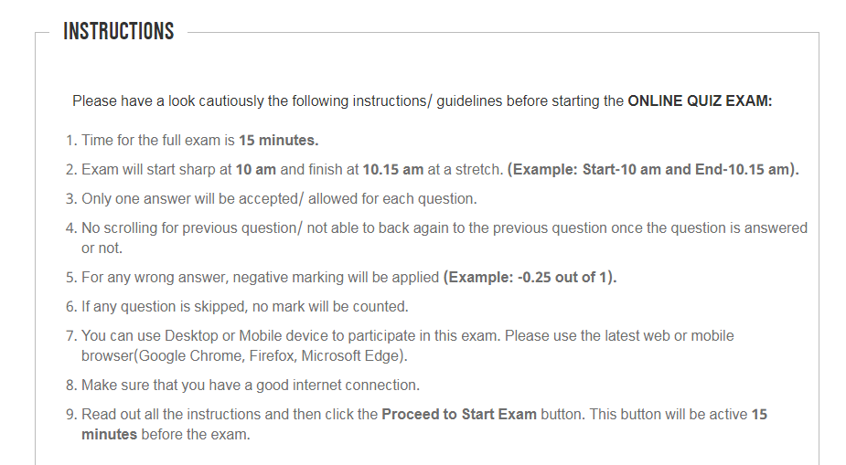
Source: SIBL’s Online Quiz Exam held on 2021 for Entry level post (Probationary Officer) in Career - SIBL
- Qualifications and Skills Requirements: SIBL and NCCBL, both banks are giving priority to skilled candidates who are mentally fit, confident, and skilled on updating communication tools and technologies and problem solving to run their new transformation banking activities.

Challenges on providing training to employees
Due to the Corona epidemic situation since banks activities have changed, employees require a variety of skills in order to maintain a work-life balance. And for large percent of employees and staffs, adequate training is required to overcome this problem and learn new skills. In that case, both SIBL and NCCBL have been faced to provide proper trainings to their banks’ employees and staffs.
Part B
Employees’ Statement

Work life balances during pandemic situation
- In the case of maintaining work – life balances, employee stress levels are quite high during a corona epidemic in both SIBL and NCCBL. They claimed that their organization puts a lot of pressure on them to meet their targets. Few staffs of NCCBL feels their company is particularly friendly, and they are not under any pressure to complete their office job and maintain a work-life balance. Because in the situation of Corona is quite difficult for certain employees. Because they are unable to take such stresses.

- Employee efficiency in the case of work from home, most of the employees of SIBL and NCCBL said that, work from home is new environment for them. And it takes time to effectively manage it. They also claimed that it had an impact on their job. The majority of employees stated that work from home had a negative impact on their productivity. Cause at the same, they are managing their both personal and professional life. As a result, it reduces their productivity.

- In the case of Employee health issue to maintain work-life balance during pandemic situation, the employee of SIBL and NCCBL are troubled with a variety of diseases. As a result, they are unable to maintain a good work-life balance. The majority of SIBL and NCCBL’s employees reported that their health-related issues influence both their workplace and home work at the same time. Because it creates obstacles to their productivity work. Few employees think that the corona epidemic is a major concern for their mental health and has an impact on their ability to maintain a work-life balance.

- In the case of Flexible working hour for banking employee, the employees of SIBL and NCC bank, they are working really hard to serve their customers and keep their banking activities alive and there is no such thing as a set working hour. The majority of SIBL’s employees work six days a week. Because senior management puts pressure on him to effectively conduct their branching activity during this particular period, there is no particular work hour for them in this corona pandemic circumstance. In that scenario, they do not maintain a healthy work-life balance during the corona epidemic. However, a few employees are delighted to report me that they only work five days a week. During the corona epidemic, however, they are having difficulty balancing their professional and personal lives. On the other hand, the employees of NCCBL get flexible working hour from the top of the management and their supervisors.

- In the case of Online Communication, Meetings and Trainings, the employees of SIBL and NCCBL reported that, some of the remote employees are facing difficulties on online activities because of the low speed of internet. But in the urban areas’ employees said that, the banks learn them how meetings, trainings, workshops, etc. can be done through technology while maintaining a safe distance. Virtual meetings used to happen, but they were limited. During the coronation period, the banks are holding their annual general meetings (AGMs) including board meetings and executive meetings. Before Corona, there was not much introduction of virtual training in the country. But during the coronation period, training of workers, workshops are being arranged in a virtual manner. At present, virtual meetings are being held in different banks almost every day. And they have used to on it.

Findings
In previous chapters, two different financial institutions’ human resource practices on HR Acquisition, Training & Development and Employees’ Work life Balances are described where their HR planning & organizing, their recruitment and selection process, training process and also impact of the COVID 19 on these HR practices and also the impact of COVID 19 on work life balances of bank employees have been discussed. Both two banks are private banks where SIBL is an Islamic Bank. Al though their basic HR planning & organizing, recruitment and selection process, training process are similar but the banks have some distinct features flourishing on their HR practices (HR Acquisition, Training & Development and Employees’ Work Life Balances).
- Similarities
- Both bank’s central management and HR department are playing in the decision making of HR planning programs.
- Both banks use internal & external sources of recruiting the potential candidates.
- In both banks, written exams and final interview are used for selecting candidates.
- For the purpose of recruiting, both banks have different committees.
- The committees differ according to the job description and the members of each committee are explicitly specified.
- Both banks are using same training methods (On the job training & off the job training)

The Impact of COVID 19
- Since the outbreak of the pandemic situation, the HR managers of SIBL and NCC bank both have been facing many challenges in practicing of HR activities like Managing Work life balances of bank employees, Mental Health & Wellbeing, Managing Remote work & providing remote working tools and trainings and employee engagement etc.
- In terms of the recruitment and selection process, both bans have made some changes on it.
- Within a month following COVID 19's arrival in Bangladesh, new job advertisements dropped by 85 percent and 93 percent in SIBL and NCCBL.
- When it comes to hiring staff, both banks, they are first and foremost prioritizing internal sources.
- SIBL and NCCBL places ads their circular in the online platforms like BD jobs, online portals and online posts on Face Book pages.
- SIBL and NCCBL, both banks are giving priority to skilled candidates who are mentally fit, confident, and skilled on updating communication tools and technologies and problem solving to run their new transformation banking activities.
- During the Corona epidemic situation and lockdown, training of the staff, workshops are being arranged through virtually or online in both banks.
- But, due to the Corona epidemic situation since banks activities have changed, employees require a variety of skills in order to maintain a work-life balance. In that case, both SIBL and NCCBL have been faced to provide proper trainings to their banks’ employees and staffs.

Employees Statement about work life balances during pandemic situation
- In the case of maintaining work – life balances, employee stress levels are quite high during a corona epidemic in both SIBL and NCCBL.
- Both bank’s employees stated that, Work from home had a negative impact on their productivity. Cause at the same, they are managing their both personal and professional life. As a result, it reduces their productivity.
- The majority of SIBL and NCCBL’s employees reported that the corona epidemic is a major concern for their mental health and has an impact on their ability to maintain a work-life balance.
- In the case of Online Communication, Meetings and Trainings, the employees of SIBL and NCCBL reported that, some of the remote employees are facing difficulties on online activities because of the low speed of internet. But in the urban areas’ employees said that, the banks learn them how meetings, trainings, workshops, etc. can be done through technology while maintaining a safe distance.

- Differences
- Recruiting process in NCCBL begins with the collecting of job requisitions from various departments and branches all over the Bangladesh through Flora HRD software in order to determine the number of employee need to hire. This stage is not included in SIBL’s recruitment procedure.
- Along with other external sources, SIBL bank use On-Campus recruitment in order to hire fresh graduates for entry level position which are not followed by NCCBL
- In contrast to SIBL and NCCBL has clearly defined their different criteria for entry level position who are eligible and who are not eligible for employment on their bank.
- NCCBL has clearly defined the criteria for questions to be asked in written test and interviews for entry level of candidates but SIBL does not such a standard.
- In the case of evaluation of training, SIBL uses three phases (Reactions, Instructions and the result of the employees in the job). And NCCBL uses four phases (Reactions, Learning, Behavior and the result of the employee in the job.

The Impact of COVID 19
- In the selection of the Entry level of position, Firstly SIBL takes online written exam, then takes written exam on their selected branches by physically, then takes final interview from their candidates. On the other hand, NCCBL at first they take Initial Interview through online, then take written exam by physically on different branches and finally final interview.

Employees Statement about work life balances during pandemic situation
- Few staffs of NCCBL rather than SIBL feel their company is particularly friendly, and they are not under any pressure to complete their office job and maintain a work-life balance.
- The employees of NCCBL rather than SIBL get flexible working hour from the top of the management and their supervisors.

CHAPTER: 07
Recommendation and Conclusion

Recommendation

For Social Islami Bank Limited (SIBL)
I have identified some facts that have to be improved in the recruitment and selecting sector as a result of HRD activities.
- The procedure of recruitment and selection is not computerized in SIBL. To make this process easier, banks should utilize human resources management software to simplify this recruitment and selection process.
- SIBL only prepares a procurement budget once a year, at the start of the fiscal year. When a bank has to hire new workers on a regular basis, it must do so.
- There is no distinct HR department in charge of hiring. Employees who exclusively recruit and choose human resources candidates must be assigned to banks.

For National Credit and Commercial Bank Limited (NCCBL)
I have provided several HRM recommendations that may assist NCC Bank's HR division in utilizing its people resources for the bank's long-term sustainability.
- Flora financial software is used by NCC Bank since it is not advanced banking software. As a result, they require extensive and specialized financial services’ tools.
- NCC Bank needs to be transparent about its efforts to recruit from outside sources, such as a job fair. In addition, they should evaluate the virtual recruitment procedure.
- To obtain productive and effective workers, the bank should implement sufficient training and development initiatives.

HR Practices during COVID 19
The following some of the recommendations can be help to maintain employee work life balances in SIBL and NCCBL:
- During a corona pandemic, every employee should have the freedom to choose their own flexible working hours so that they can maintain a work-life balance.
- During the Corona epidemic, all the employees of the bank should have been given an alternative option so that they could share the work with their colleagues and in this way all their work would be completed on time.
- Employees should be provided with all kinds of remote working facilities during this pandemic situation. Employees can maintain a work-life balance during a corona epidemic by this using remote working facility.
- During this corona period, employers of SIBL and NCCBL should pay special attention to their employees' health.
- During the Corona epidemic, both SIBL and NCCBL need to implement diverse working life policies to ensure that their employees maintain a work-life balance.

Conclusion
During this COVID 19 epidemic, it is important for HRD of all the banking service institutions in Bangladesh to play a role in their daily HR operations, Recruitment – Selection process, managing to provide proper trainings to their employees and maintaining work life balances of their employees. In this project report, two private banks (SIBL and NCCBL) in Bangladesh have been analyzed in their HR related planning, organizing, recruitment & selection process, training process as well the impact of COVID 19 on these activities and maintaining of employees work life balances have been highlighted. There are some features and differences between the two banks in the different functions of their Human Resource Management.
In conclusion, it is vital for a bank to create an excellence organizational culture to use of their Human resources by responsibly addressing the challenges that HR has been facing in their HR related activities during the COVID 19 and it can make an organizational more profitable and sustainable business by increasing employees’ performance and their productivity.

References

Annual Report. (2019). Retrieved from NCCBL: https://www.nccbank.com.bd/assets/files/annual_report/annual_report_2019.pdf
Annual Report of SIBL. (2019). Retrieved from SIBL: https://www.siblbd.com/assets/reports/annual/SIBL_AR2019_BOOK.pdf
Armstrong, M. (2006). A Handbook of Human Resource Management Practice. Gale virtual reference library: Kogan Page Publishers.
Chand, S. (n.d.). Recruitment: Meaning, Definition, Process and Factors influencing Recruitment. Retrieved from Article Library: https://www.yourarticlelibrary.com/recruitment/recruitment-meaning-definition-process-and-factors-influencing-recruitment/25950
Company Oberview . (n.d.). Retrieved from SIBL: https://www.siblbd.com/
COVID-19: Impact on the banking sector. (2020). Retrieved from KPMG: https://home.kpmg/xx/en/home/insights/2020/07/covid-19-impact-on-banking-m-and-a-2020.html
Dhanonjoy Kumar, S. B. (2021, June 06). COVID-19 AND RISK INVOLVEMENT IN THE BANKING SECTOR OF BANGLADESH: A STUDY. Retrieved from International Journal Of Research : https://www.granthaalayahpublication.org/journals/index.php/granthaalayah/article/view/4021
Harness, J. (2019, August 09). The Recruitment and Selection Process of HR. Retrieved from biz Fluent: https://bizfluent.com/info-8212981-recruitment-process-hr.html
Johnason, P. (2009). HRM in changing organizational contexts. In D. G. Collings & G. Wood (Eds.), Human resource management: A critical approach, 19-37.
Joshi, D. (2018, March 23). What is HR Operations? What activities are included in HR Operations on a day-to-day basis? Retrieved from Quora: https://www.quora.com/What-is-HR-Operations-What-activities-are-included-in-HR-Operations-on-a-day-to-day-basis
Masoom, M. (2021, September 16). What did Corona teach the banks? Retrieved from Banikbarta: https://bonikbarta.net/home/news_description/240460/%E0%A6%95%E0%A6%B0%E0%A7%8B%E0%A6%A8%E0%A6%BE-%E0%A6%AC%E0%A7%8D%E0%A6%AF%E0%A6%BE%E0%A6%82%E0%A6%95%E0%A6%97%E0%A7%81%E0%A6%B2%E0%A7%8B%E0%A6%95%E0%A7%87-%E0%A6%95%E0%A7%80-%E0%A6%B6%E0%A6%BF%E0%A6%95%E
Monica Belcourt, K. J. (2017-2018). Strategic Human Resource Planning. 5e. . Global Edition : Nelson Education Ltd.
Noor, A. a. (2016). Recruitment and Selection process of SIBL. Dhaka: Interview with 28 July.
Organization Overview . (n.d.). Retrieved from NCCBL: https://www.nccbank.com.bd/
Parth Salunke, D. A. (2020, June Wednesday). WORK LIFE BALANCE IN PHASE OF PANDEMIC. An international biningual peer reviewed referenced research journal, 10(38), 229-240.
Recruitment & Selection - Overview. (n.d.). Retrieved from tutor 2u: https://www.tutor2u.net/business/reference/recruitment-selection-overview
Recruitment and Selection Activities. (n.d.). Retrieved from Career - Social Islami Bank Limited: https://www.siblbd.com/career
Recruitment and Selection Activities. . (n.d.). Retrieved from Career - NCCBL: https://www.nccbank.com.bd/
TRAINING AND DEVELOPMENT BANKING SECTOR IN BANGLADESH. (n.d.). Retrieved from The Lawyers & Jurists: https://www.lawyersnjurists.com/article/training-and-development-banking-sector-in-bangladesh/
UKEassays. (2015, Jan 01). Human Resource Management. Literature Review Human Resource Management, 5434 words (22 pages). Retrieved from UKEssays.
Vyas, N. B. (2021). The impact of working from home during COVID-19 on work and life domains: an exploratory study on Hong Kong. Retrieved from Taylor & Francis Online: https://www.tandfonline.com/doi/full/10.1080/25741292.2020.1863560
What is Human Resource Planning ? (n.d.). Retrieved from Management Study Guide: https://www.managementstudyguide.com/human-resource-planning.htm

Appendix

Examples of SIBL’s Recruitment Advertisement
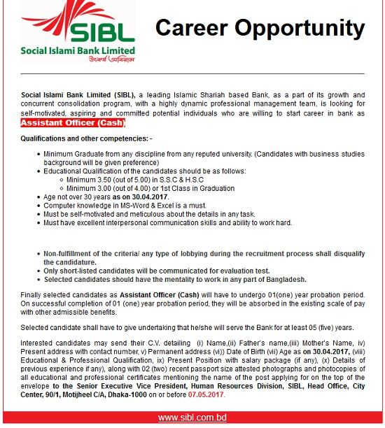

Examples of NCCBL’s Recruitment Advertisement
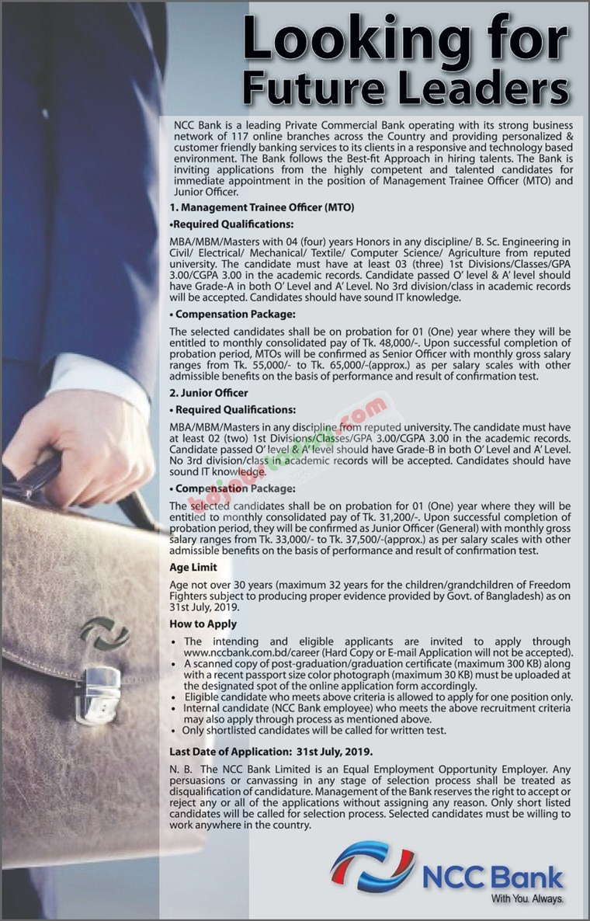

Questionnaire

Topic: Impact of COVID-19 on HR Operations in Banking Sector of Bangladesh (SIBL and NCCBL)
Interview Questionnaires for NCCBL & SIBL
HR Managers
Planning & Organizing
- How many roles are being played by human resources in the decision making of HR planning programs?
- How do you plan for the numbers you need in the future? Describe the planning process?
- For the pandemic situation, is it challenging task on managing day-to-day operation to you?
Recruitment & Selection Process
- What is the recruitment and selection procedure for entry-level position in your Bank?
- What are the qualifications required for the position of management trainee?
- What are the guiding principles for the employee when recruited and selected?
- What are the recruitment sources of your Bank?
- What are the impacts of the pandemic situation on the recruitment & selection process in your organization?
- During this pandemic situation, do you organize an orientation program for newly appointed staff?
Training & development
- How your Bank did their training need assessment?
- How your Bank design their training process?
- Who are the major training providers in your Bank?
- Say something about the training institute at NCCBL/SIBL?
- What is the training materials used in NCCBL/SIBL?
- What are the trainings and workshop arranged by NCCBL/SIBL for their employees?
- What are the training techniques followed by NCCBL/SIBL?
- How NCCBL/SIBL evaluate the training?
- How the top management support in determining the importance of training and learning?
- What kinds of challenges is your bank facing on providing training to their employees due to the pandemic situation?
Interview Questionnaire for Employees
Work Practice during Lockdown
- During the pandemic situation & lockdown, are you at ease working from home?
- Work from home does it impact on your work efficiency?
- In COVID 19 situation, do you think your health is suffering to maintain work life balances?
- Does your company consider you in flexible schedule timing?
- Work from home; is it much easier to communicate with your workers?
- What challenges you are facing on online communications, online meeting & attending on online office?

