

Analysis of Lubricant Business of Bangladesh & Asian Petroleum Limited-Idemitsu Lubricants Bangladesh- An Internship Experience Perspective

Submitted to:
Dr. Md. Mohan Uddin Professor
School of Business & Economics United International University

Submitted By:
Md. Sajidul Mohsin
ID: 111 163 034
School of Business & Economics
United International University
Date of Submission: March 8, 2021

Letter of Transmittal
8th March, 2021
Dr. Md. Mohan Uddin Professor,
School of Business& Economics
United International University, Dhaka.
Subject: Submission of Internship Report
Dear Sir,

I am very much pleased to present my internship report which was a three months internship program at Idemitsu Lubricants Bangladesh, Tejgaon. Like the title of the report " Analysis of Lubricant Business of Bangladesh & Asian Petroleum Limited-Idemitsu Lubricants Bangladesh- An Internship Experience Perspective" substance inside the report examined about it as it was the prerequisite of this internship program.
While setting up the report I attempted to give my best to introduce the report as useful as possible, by utilizing the educational insight, I mastered during my undergrad program and furthermore by utilizing the information which I gained from the organization during my internship period. Other than during setting up this internship report I have learnt new aptitudes and information which I accept will be extremely useful for my future activities at the serious work market.
I am actually quite thankful for the ceaseless help and guidance I get from you to finish this report effectively. Without your direction it won't be conceivable to make it occurred and for this very explanation I feel extremely fortunate to have you as my faculty supervisor for the internship program. I am appreciative for the help I get from you.

Sincerely Yours,
Md. Sajidul Mohsin
ID: 111 163 304
Acknowledgement

Toward the start, I am a lot of thankful to the Almighty Allah for giving me the solidarity to finish the report appropriately. Without divining favors of my Almighty Allah, it could never be feasible for me to finish my internship and get an professional encounter effectively.

A unique thanks and appreciation goes to my supervisor the respectable faculty Prof. Dr. Md. Mohan Uddin School of Business and Economics, United International University who guided me while setting up the report as my faculty supervisor for the internship. Without his important oversight and headings, it would not have been conceivable to finish this report.

Here, I might want to offer my utmost thanks to our HR team & the whole admin panel of this organization for organizing a particularly significant internship experience for me.

At that point, I offer my significant thanks to Mr. Omar Abbas (Assistant Finance and Accounts Manager), Mr. Md.Kamrujjaman (COO), just as every ranking manager and employees of Asian Petroleum Limited-Idemitsu Lubricants Bangladesh, Tejgaon. I might want to express gratitude toward them for their consistent help, direction and oversight on my time in here. Without their collaboration this report may have stay deficient. This internship experience truly makes students of any caliber equipped for knowing professional works prior to entering the corporate world.

Executive Summary

The report depends on the analysis of lubricant business in Bangladesh and furthermore the examination of the internship insight at Asian Petroleum Limited-Idemitsu Lubricants Bangladesh. For the completion of the Bachelor in Business Administration (BBA) graduation the program of internship mandatory and this was held down by the supervision of Professor Dr. Md. Mohan Uddin, United International University. The core objective of the report is to comprehend the lubricant business of Bangladesh and their exhibition examination finding the difficulties and open doors for the business in the competing market as well. Likewise analyzing the operation of Idemitsu Lubricants Bangladesh on this respect is the piece of the report as well.

The general report is separated in all out six sections including the Chapter-1 as the presentation where the introduction of the lubricant business of Bangladesh as the report depends on lubricant business, the objectives and the significance of the report where identified and end as the last part named as Chapter-6 of the report. At the Chapter-2 the industrial analysis of the lubricant business in Bangladesh, the barrios for the business the difficulties they are confronting and the open door they need to fill in the market has been extravagantly talked about. On Chapter-3, as a piece of analysis of Idemitsu Lubricants Bangladesh about their administration is additionally examined alongside my three months internship insight. Ultimately, on Chapter-5, here the suggestions are referenced which will help the organization and myself to grow more effectiveness to perform great at the quickly developing competitive market.

Table of Contents
1 Introduction 2
1.1 Background 2
1.2 Objectives 3
1.2.1 Broad objective: 3
1.2.2 Specific objective 3
1.3 Significance of the Report 4
2 Analysis of the business 7
2.1 Specification of the business 7
2.1.1 History of lubricant business in Bangladesh 8
2.1.2 Market insight of lubricant business in Bangladesh 8
2.1.3 Types of Lubricants 10
2.1.4 Types of lubricants available in the market of Bangladesh: 10
2.2 Size, Trend and Maturity of the Business: 16
2.2.1 Size 17
2.2.2 Key Trends of Lubricant business 17
2.2.3 Maturity 20
2.3 Seasonality 21
2.4 External Economic Factors 23
2.5 Technological factors 24
2.6 Political, legal, and regulatory factors 26
2.6.1 Political factors 26
2.6.2 Legal factors 26
2.6.3 Regulatory factors 27
2.7 Barriers to entry 28
2.8 Supplier power 29
2.9 Buyer power 30
2.10 Threat to substitutes 33
2.11 Business rivalry 34
2.12 Summary of challenges and opportunities 36
2.12.1 Challenges for Lubricant Business 36
2.12.2 Opportunities for lubricant Business 37
3 Analysis of the organization 40
3.1 Overview and History 40
3.1.1 Core Information about Asian Petroleum Limited 41
3.1.2 Organogram of Asian Petroleum Limited: 42
3.2 Trend and Growth 43
3.2.1 Growth of Asian Petroleum Limited over 5 years 44
3.3 Customer Mix 47
3.4 Product/ Service Mix 49
3.5 Operations 52
3.6 SWOT analysis 58
3.6.1 Strengths 58
3.6.2 Weaknesses 60
3.6.3 Opportunities: 61
3.6.4 Threats: 62
3.7 Steps/ Strategies to meet the challenges and opportunities 63
3.7.1 Strategies to meet the challenges for Asian Petroleum Limited 63
3.7.2 Strategies to meet the opportunities for Asian Petroleum Limited 64
4 Internship Experience 66
4.1 Position, Duties, and responsibilities 66
4.1.1 Position 66
4.1.2 Duties 66
4.1.3 Responsibilities 69
4.2 Training 69
4.3 Contribution to departmental functions 70
4.4 Evaluation of internship performance 71
4.5 Skills Applied 73
4.6 New Skills Developed 74
4.7 Application of Academic Knowledge 75
5 Recommendation 78
5.1 Recommendation for improving departmental operations 78
5.2 Recommendations for improving self-performance 79
6 Conclution 82
7 References 83

List of Tables:
Table 1: Types of Lubricants 10

List of Figures:
Figure 1: Lubricant Market Volume, by Product Type, Bangladesh (Ineliggence) 19
Figure 2: Lubricant Market Volume, by End-user Industry, Bangladesh, 2019 (Ineliggence) 20
Figure 3: Technology Management Hierarchy (Jim Fitch, 2002) 25
Figure 4: Lubrication System (GlobeCare, 2017) 25
Figure 5: Power of supplier 30
Figure 6: Bargaining power of buyer 33
Figure 7: Threat of substitute 34
Figure 8: Market Share of Lubricant in Bangladesh (Wing, 2015) 35
Figure 9: Asian Petroleum Limited logo 40
Figure 10: Administrative Divisions of Asian Petroleum Ltd. 41
Figure 11: Organogram of Asian Petroleum Limited 42
Figure 12: Financial Figure of Asian Petroleum Limited 44
Figure 13: Total Asset of Asian Petroleum Limited 44
Figure 14: Total Revenue of Asian Petroleum Limited 45
Figure 15: Operating profit of Asian Petroleum Limited 45
Figure 16: Net Income After Tax of Asian Petroleum Limited 46
Figure 17: Gross profit Ratio of Asian Petroleum Limited 46
Figure 18; Base & Lube Oil growth 47
Figure 19: Customer Wise Sales 48
Figure 20: OEM Idemitsu Products 50
Figure 21: Idemitsu Products 51
Figure 22: Finance and Accounts department hierarchy 52
Figure 23:Cash or Credit sales system 54
Figure 24: Admin Department hierarchy 54
Figure 25: Sales Department hierarchy 55
Figure 26: System of selling process 55
Figure 27: IT Department hierarchy 56
Figure 28:Asset purchase system in IT 56
Figure 29: HR Department hierarchy 56
Figure 30: Process of recruit by HR Department 57
Figure 31: Process of importing 58

Chapter-1

Introduction

Background

Lubricant may be a substance that is employed to regulate (more usually to reduce) friction and wear of the surfaces during a contact of the bodies in relative motion. looking on its natural elements, lubricants also are a byproduct to eliminate heat and wear scrap, offer additives into the contact, transmit power, protect, seal. A lubricating substance will be in liquid (oil, water, etc.), solid (grapphite, grapheme, molybdenumdisulfide), gaseous or perhaps grease forms. The classification or the various types of liquid lubricants will be named as synthetic/semi-synthetic, mineral or environmentally acceptable (biodegradable) oils. The lubricants are created with supplements of 5.5-30.5% to enhance their performance. the applying determines that oil, usually noted because the base oil, ought to be used. In extreme conditions, artificial oils are usually used. Wherever the setting is of concern, environmentally acceptable lubricants should be used. Lubricants market of Bangladesh may be a competitive one. The Bangladesh Lubricants Market is divided by Product sort (Engine Oil, Transmission and Hydraulic Fluid, metalwork Fluid, General Industrial Oil, Gear Oil, Grease, and alternative Product Types) and End-user business (Power Generation, Automotive and alternative Transportation, serious instrumentation, Food and potable, science and metalwork, Chemical producing, and alternative End-user Industries).The lubricating substance shelves of overall market have already placed quite one hundred brands altogether and therefore the range of brands is increasing day by day .And the state of affairs is being worsened whereas numerous by name merchandise are taking the various shelves of various clusters. This market has become additional overdone in terms of brand name names and native merchandise. Around one hundred million liters, whereas base oil demand around a hundred and forty-five million liters. However, the bottom oil demand of Bangladesh is growing for increasing automotive sector and therefore the agriculture-based economy. Lubricants consumption within the industrial sector has inflated considerably within the last five years. There are some significant opportunities to increase the demand as well as the supply for the Bangladesh Lubricant Market.

Objectives
Here we divide the core objectives of this report into two parts. These objectives can be identified as (i) Broad Objectives and (ii) Specific Objectives

Broad objective:
As of the idea for the broad objective is to have a transparent synopsis of the lubricant business of Bangladesh, in turn getting a full picture of the existing scenario of lubricant business, market trend & size and the growth of this business in Bangladesh. This will determine the basic objectives this lubricant business to sustain in the market of Bangladesh and by creating a strong position in the market there comes obligation toward the economy of Bangladesh which is essential part of the broad objectives. By putting aside all of the above mentions, one of the core broad objective for this report is to give the explicit outline of the Internship at Asian Petroleum Limited-Idemitsu Lubricants Bangladesh.

Specific objective

Aside from the broad objectives here the specific objectives are given as well and these objectives are given below:
- Studying and analyzing lubricant business of Bangladesh.
- Analyzing the business of Asian Petroleum Limited.
- Evaluation of the internship experience in Asian Petroleum Limited.
- Providing some recommendations to overcome difficulties here in the organization and also for myself to the extent that it can help to attain new skills furthermore.

Significance of the Report

As of talking about the significance of this report one thing needless to say that, this report signifies considerable meaning to itself. So, taking that meaning in account, the significance of this report is substantial in all manner related to this field. In this report, it determines the utmost knowledge and the initial experience for the students to work in a competitive environment. In this report it gives a depiction about the organization. So, I utilized descriptive methods since it depicts the generally speaking operation, sales, marketing, monetary attributes of Idemitsu Lubricants Bangladesh. For this examination I gathered information from both primary and secondary sources. As of it recalls the early experience in the first hand while demonstrating the aura through the words. For the first time experiencing in a professional sector, it talks about the different situation for to cope and give an extensive idea about the professional environment as well. Here the information provided are a direction for the betterment of the learning in a competitive place while developing brand-new skills. Specifying about the real-life experience where one can imply the learnings of his or hers academic or theoretical knowledge and experience both. These are the basic information about the professional environment which are provided in here. In this report the industrial analysis which describes the work conducted in Idemitsu Lubricants Bangladesh and the invaluable experience at APL-Idemitsu Lubricants Bangladesh are portrayed also. What is more, depending on those data the recommendation for the lubricant business’s’ improvement on the overall performance in the organization and also for the internal departments, there mentioned recommendations about how to outlive the individual barriers discussed too. In there, the overall base experience about the internship program at Idemitsu Lubricants Bangladesh, was also provided which will help others to have a clear understanding about how a corporation works and how to sustain in an organization and how to act in order to cope up in any situations in a professional environment.
Aside from all signification based on different remarks from all experiences, additional significant of the report is the proficiency which I was lucky attain while getting information and studying as well in order to formulate this report in the first place. The internship period APL-Idemitsu lubricants Bangladesh was not a long one as it was a three months contract which an intern needs to sign in the beginning his/her journey, so basically as a writer of this report I gave all my efforts to provide the skills and knowledge I reasonably obtained in a professional way. Likewise, the utilizations of my own aptitudes and educational information while I was working there. So, it tends to be useful for the perusers to comprehend about the tasks. Additionally, the examination of the lubricant business, the difficulties and openings of this business in Bangladesh have likewise depicted which will incredibly uphold the perusers to comprehend the lubricant business as well. From the experience in here one thing goes without saying is that, what an entry level position program can give is to placed them in a difficult climate of the important field, where the understudies get test occasion to apply their hypothetical information into reasonable applications. During the internship period, many students have the occasion to receive themselves into the specific environment of the association. It gives an exceptional occasion to see the truth of business during student life, which empowers them to building certainty and working information ahead of time of the beginning of their profession.

Chapter-2

Analysis of the business

Specification of the business

The lubricants oil business in Bangladesh is one of the temperamental business sectors. Many oil advertisers are making the most of their lubricant business and more brands are entering this market. Notwithstanding, the market study on this industry has plot not many perceptions. It has discovered least revealing or appropriate information on quality lubricant oil, which are the fundamental purpose behind lingering behind this market. As of late, the force area has stood out enough to be noticed to media due to the public plan by the present govt. A short examination of the contextual analysis and market bits of knowledge has drawn the idea of the lubricants oil market in Bangladesh. The absence of statistical surveying and the most un-covering this market may see as the constraints to its tendencies. These qualities are restricted to both correspondence and business methodology of the lubricant business.

The whole lubricant business is conceivable to see as not many unmistakable business sectors just as fragments with different lubricants oils. With regards to Bangladesh, this business can be depicted as a market which contains not many sections like motor oil, cruiser oil, truck and substantial motor oil, automotive oil and mechanical oil, and so forth. Another perception can likewise recognize more portions like railroad oil, marine oil, and avionics oil; however, these are irrelevant contrasted and other grease oil sections. The market of automotive oil is a remarkable one, however the clients are generally utilizing the substantial motor oils for the vehicles. In any case, a couple of value lubricant oils are additionally accessible for automotive vehicles.

The modern lubricant market is a somehow one can say a little bit of delicate, where the utilization of suggested oil is required, which is firmly directed by the originators. The development of intensity areas and different businesses has livened this mechanical oil fragment up. Clients are very proficient about the lubricant brand and quality at this point. Indeed, for purchasers, the principal wellspring of data emerges from peer proposals. Retailer recommendations likewise have an impact in influencing the buy. Retail retailers prescribe their favored image to the clients more often than not. Because of this, clients frequently buy marks as alluded by the retailers. The clients of this market would prefer not to hazard anything happening to their vehicles for not utilizing excellent oil. The sole merchants consistently run advancements for the regulars, however it has an immaterial impact in the buy choice. Accessibility of brand doesn't influence individuals' buy choice. Or maybe, it's directed by the brand's ubiquity. Utilizing these market experiences, recently marks are taking their passage in this developing grease business. In any case, the famous brands like Mobil, BP, Total, Shell, and Castrol are making the most of their current piece of the pie with solid brand inclinations. Additionally, the clients of this market have a superior acknowledgment of those grease marks however numerous quality items are likewise accessible in this market.

History of lubricant business in Bangladesh

In Bangladesh the journey of lubricant business started from the very beginning of the country’s independence. This business started its the journey with Mobil & Shell way before they entered into the market collaborating with state owned or private companies in Bangladesh. In 1998, the journey of lubricant started with Mobil Jamuna Lubricants Ltd. as collaborating and making a joint venture between state claimed Oil Company of ‘Jamuna’ and EC Securities Limited. Before that the lubricant business was looked after by the government of Bangladesh under different government vendors which were needed for the automotive sectors and industrial usage. The excursion of mixing top notch lubricant in Bangladesh began when Mobil Corporation after the consolidation known as Exon Mobil Corporation chose to set up Mobil Jamuna Lubricants Limited in organization with the state possessed Jamuna Oil Company Limited.
MJL Bangladesh Ltd. imagined that Bangladesh would be one of only a handful few nations in the locale to mix excellent greases. Likewise, in May 2003, MJLBL authorized a cutting-edge Lube Oil Blending Plant is the first of its sort in the nation. From that point forward the creation of this plant and showcasing exercises of MJL Bangladesh Ltd. have extended enormously.

Market insight of lubricant business in Bangladesh

The market for different lubricants-based goods has extended at a normal pace of around 7 percent over the most recent nine years following an ascent in the quantity of vehicles and force plants in help.
However, the end clients are yet to appreciate the advantages that typically go with a competing market, for example, item variety and lower costs, because of an absence of neighborhood creation. The modern area will be profited when motor oils are mixed in the nation as really at that time will costs descend. Lube handling is anything but a cutting-edge industry.
Lubricant based goods are materials gotten from raw petroleum and handled at petroleum treatment facilities to make engine oil, motor oil, motor greases and a large group of different items. Customers of Lubricant based commodities in the mechanical area utilize imported motor oils or privately mixed ones as there are no accessible other options. Just when the items are prepared in Bangladesh would consumers be able to analyze costs and appreciate benefits. In the event that the global organizations structure joint endeavors with nearby organizations to mix oil-based commodities in Bangladesh, at that point the mass clients would be incredibly profited.
Around 22% assessment is forced on the import of lubricant oils, while the duty for lubricant import is just 10% to 12%. So, this framework isn't empowering for organizations who need to mix the grease locally, which mixes serious evaluation oil named Omera brand close by Mobil.
In 2020, the market size for oil-based goods arrived at around Tk 5,000 crore, with absolute interest remaining at 1.59 lakh tons. The interest for the items will keep on ascending in accordance with the expanding populace as it is a fundamental piece of keeping up or working any sort of hardware, as indicated by market insiders.
Fully expecting the developing motor oil market, Pertammina Lubricant, an Indonesian state-claimed oil and gas organization, dispatched their Bangladesh tasks a sometimes ago. Customers can profit by market immersion as it prompts lower costs and better quality, whose items are being promoted through their nearby accomplice Intracco CNG.
The interest for lubricants will keep on ascending for the following 15 years in any event, with rental force plants and the modern area together representing around 40% of all out utilization. With the quantity of intensity plants working in the nation having leaped to 133 over the most recent nine years, power creation has expanded almost four and a half times, as indicated by information from the Bangladesh Power Development Board. The Bangladesh oil market is solidified by the main five players - MJL Bangladesh (Mobil), Navanaa Petroleum (Caltex or Chevron), Trade Services International (Total), Rahimaafrooz and Ranks Petroleum (Royal Dutch Shell). They represent around 54% of the all out piece of the pie while the excess half is separated between different brands, as per industry insiders.
Mobil drives the graphs with 29 percent piece of the overall industry; it is trailed by British Petroleum (BP), whose piece of the pie is 13 percent. French worldwide Total control 10 percent of the market, while Shell, Castrol and Caltex appreciate 2 percent each. SERVO sits at the base with one percent of the complete piece of the pie.
In spite of the developing business sector for motor oils, purchasers are yet to encounter any advantages seeing as the Original Equipment Manufacturers state that the oils utilized in their hardware should meet certain necessities - and the nearby makers can't meet them. Buyers ought to follow OEM rules in the event that they need their motors to last. Be that as it may, shoppers will at last be profited by expanded rivalry on the lookout (Hasan, 2019)

Types of Lubricants

Lubricants can be differentiated by many forms based on some specific categories. These are:
Liquid lubricants | All the fluid lubricants which incorporate mineral, regular, synthetic oils, emulsions and so on.
Solid Lubricants | Lubricants in strong structure, including powders, coatings and composites (graphhite, polyethyline, Mollybdenum disulffide, and so on)
Gaseous Lubricants | Ordinarily its air, yet can be some other gas.
Semisolid Lubricants | Oils, by and large comprises of a cleanser emulsified with mineral or vegetable oil
Table 1: Types of Lubricants

Types of lubricants available in the market of Bangladesh:

A wide scope of lubricants imported and being distributed in countrywide of Bangladesh in later 2000. Various sorts and characteristics of lubricants are made according to enhanced interest in the market of lubricants. So, basically lubricants in the market of Bangladesh includes:

- Automotive Passenger Vehicle Lubricants:

Two sorts of Automotive Passenger Vehicle Lubricants are advertised by Bangladeshi Lubricant organizations. Significant Lubricants under this product offering are as per the following:

Synthetic Oils: The world's driving Synthetic Engine Oils have unbeatable motor insurance with superb protection from High Temperatures, Low-Temperature execution, Cleaning properties, Low Fuel Consumption just as significantly increment the motor in general life.

Mineral Oils: High quality premium Mineral Engine Oils are intended to give elevated level of execution and assurance under serious working conditions. They give unrivaled motor insurance against hurtful stores, muck and stain, erosion and have excellent cleaning properties under an assortment of driving conditions.

- Automotive Commercial Vehicle Lubricants:

Substantial diesel motor oils are to meet all necessary determinations for Bus, Truck, Covered Van, Earth Moving Equipment, Diesel Generator, and so on Significant oils under this product offering are as per the following:

Synthetic oils: The world's most driving Synthetic Engine oils have top notch motor insurance, better opposition than high temperatures, extraordinary Low-Temperature execution, astounding cleaning properties, low fuel utilization just as increment the overall motor life for of all diesel motors.

Mineral Oils: The most developed science of Diesel Engine Oils give exceptional execution both in generally current, requesting low-discharge diesel motors and more seasoned diesel motors working on low or high sulfur energizes. Lube oils mixed with elite base stocks and utilizing reformist added substance innovation frameworks to give better control of oil thickening due than ash develop and high temperatures just as remarkable protection from oxidation, consumption, and high temperature stores.

- Automotive CNG Engine Oil:

The exceptional armada motor oil planned to give dependable security to traveler vehicles, trucks and transports utilizing Compressed Natural Gas (CNG) or Liquefied Natural Gas (LNG). This motor oil is planned from great base stocks and a fair added substance framework under exclusive definition. This high-level low debris detailing gives astounding oxidation, nitration, and warm dependability to limit ignition chamber debris stores and give long oil channel span.

- Automotive Gear and Transmission Fluid:

Significant Lubricants under this product offering are

Synthetic oils: The Synthetic base oils synthesis empower magnificent execution even in the severest of working conditions. They offer extraordinary stuff moving and power move execution. Manufactured oils have opposition against warm breakdown at high working temperatures, while as yet giving extraordinary execution as they improve generally transmission sturdiness and neatness.

Mineral Oils: These oils are figured from excellent base oils joined with exceptional added substance innovation frameworks including VI improvers, enemies of oxidants, and Anti-froth properties giving smooth and controlled erosion/wear where outrageous pressing factors and stun loadings are normal just as increment the hardware life.

- Brake Oil:

The additional elite pressure driven Brake Fluid for use in car plate, drum and hostile to slip stopping mechanisms and grasp frameworks. The Potential Benefits of this item is Consistent and Safe Brake Performance under serious slowing down pressing factor, Rubber Seal similarity Reduces spillage and loss of liquid to a base level. It gives magnificent Corrosion Protection and broadens life and unwavering quality of stopping mechanism segments.

- Antifreeze/Coolant:

This item is appropriate for cooling frameworks of various vehicle, transport, truck and so on Mobil Concentrated liquid catalyst detailing is difficult water viable and can be blended in with faucet water prior to filling into the cooling System. The expected advantage of this item is to help decrease scale stores, consumption in the motor.

- Industrial Gear and Circulating Oils:

Uncompromising Industrial Oils arrangement are additional superior stuff oils, which are planned from top notch Synthetic or Mineral base oils and advance outrageous pressing factor added substance innovation.

Synthetic oils: The Synthetic Lubricants are perceived and acknowledged far and wide for their novel creation and extraordinary exhibitions. Points of interest and Potential Benefits of these items are-Extend hardware high temperature working ability, Minimizes slime and stores for inconvenience free activity and long channel life. Adjusted added substance mix gives superb execution regarding rust and consumption anticipation, remissibility, froth control and air discharge execution guaranteeing smooth activity in a wide scope of mechanical applications and decreased over every single working expense.

Mineral Oils: The additional elite mineral base stuff oils having out-standing extraordinary pressing factor qualities and burden conveying properties, planned for use in a wide range of encased stuff drives with course or sprinkle oil frameworks. The expected advantages of these items are improved stuff wear insurance from miniature pitting, diminished flotsam and jetsam imprinting from created wear particles, extraordinary similarity with a scope of seal materials, superb protection from oil oxidation and warm debasement just as increment the hardware life.

- Turbine and Circulating Oils:

Synthetic Oil: The turbine series oils are planned explicitly to address the issues of the most extreme mechanical gas turbine applications. The possible element of these items under the arrangement is exceptional high Thermal/Oxidative Stability and Deposit Control, awesome protection from Foaming and great Air Release property, guarantee long oil life just as lessen upkeep cost.

Mineral Oils: The mineral-based oils have been the decision for turbine administrators worldwide for more than 100 of years. These items meet or surpass most significant turbine hardware developer determinations and industry details. These items additionally give a definitive adaptability to the administrator since they can be utilized in all turbine types: steam, gas, outfitted, hydro-turbines.

- Hydraulic Oils

Significant Lubricants under this product offering are

Marine Applications: These oils are built from chosen base oils and an exclusive added substance innovation to give even execution in a wide scope of utilizations. The items show excellent oxidation and warm soundness permitting long oil life and limited store arrangement in serious water powered frameworks utilizing high pressing factor, high yield siphons with better remissibility properties. The inventive ultra-keep clean execution shields basic water powered framework parts from breakdown, for example, close resilience servo and corresponding valves in numerous cutting-edge pressures driven frameworks.

Mechanical Applications: These oils are planned with excellent base oils and a super-settled added substance innovation that kills the arrangement of destructive materials. They are intended to work with frameworks working under serious conditions where significant levels of hostile to wear and film strength insurance are required.

- Textiles/Garments Machinery Oils:

These oils are excellent execution items principally intended for the oil of sewing and rapid axles in material machines. They are likewise utilized in some basic water driven, flow frameworks and carrier oilers where the suitable thickness grade is chosen. They are figured from select top notch, low consistency base oils and added substances that give great protection from oxidation and assurance from rust and consumption.

- Gas Engine Oils:

The up-and-coming age of different lubricant organizations marked superior gas motor oils are intended to give the present high yield, low-emanation four-cycle gas motors with the most elevated levels of security. The reasonable detailing to give remarkable enemy of wear qualities to secure vigorously stacked valve train segments, cylinders, liners, course, and stuff trains. Their cleanser dispersant framework controls the development of carbon and stain stores to limit oil utilization and keep up motor tidiness in any event, during broadened channel spans. This lubricant can help clients keep their motors running longer and cleaner with improved dependability.

- Compressor Oils

Significant Lubricants under this product offering are

Synthetic Oils: The Supreme exhibition oils essentially proposed for the grease of serious obligation rotational Screw and Vane and Reciprocating air blowers. These oils give fantastic wear insurance and remarkable protection from oxidation and warm corruption, significantly better than mineral oils

Mineral Oils: The top-notch execution debris less air and gas blower greases intended to meet the rigid prerequisites of the significant blower makers. They are figured with top notch mineral base-oils and a superior added substance innovation intended to give extraordinary gear security and dependability for blowers working under mellow to serious conditions.

- Refrigeration Compressor Oils:

The elite Synthetic oil and Naphthenic base restricted cut mineral oil basically proposed for use in refrigeration blowers. They have a low pour point and great smoothness at extremely low temperatures.

- Other Industrial Oils:

There are different kind of different oils mixed with great base oils and exclusive added substance innovation for planned use in different fields of apparatus application, for example, high temperature worked chain oil, electric Transformer Insulating oil, Thermic Fluids and Metal Cutting oil.

- Marine Lubricants:

The exceptional, additional elite high and medium TBN motor oils are intended for use in the most extreme lingering fueled medium-speed diesel applications found in marine and fixed force enterprises. These diesel motor oils have been extraordinarily detailed to give remarkable remaining fuel similarity qualities for astounding motor neatness, particularly in crankcase, camshaft zones, cylinder ring belt and under cylinder crown. They give astounding high temperature oxidation and warm steadiness, low instability, and high burden conveying properties and consumption assurance.

- Greases:

Oils are called performer's lubricants and are as semi strong or sold qualities. Oils are utilized where the oil will drop out, measure of oil discharge should be controlled and hardware access is troublesome.

Synthetic oils: These oils are mixed with particular Synthetic base oils and progressed added substance innovation under exclusive innovation to maintain and play out the required capacities in gear's working under most serious conditions. These oils are utilized where working temperature is extremely high. Significant oils under the product offerings are as per the following:

Mineral oils: These oils are figured with excellent mineral base oils and particular added substance innovation to meet or surpass the necessary interest or determinations for a large portion of the gear fabricates. These oils are utilized in moderate to higher working temperatures

- Aviation:

Greases are the favored brand for the majority of the main flying gear producers. Lubricant companies are additionally showcasing some lubricants marked as flying top-notch Lubricant in Bangladesh. Avionics Lubricants offer nose-to-tail oil arrangements that help make flying simpler and more secure.

Size, Trend and Maturity of the Business:

Size

Now in Bangladesh, the current market size of lubricant business is approximately 1.1 million barrels (Bbl). Yearly demand for lubricant is around 13.5 million liters in Bangladesh. In Bangladesh, the base lubricant demand to address the public issue is around 17.5 million. The market estimation of lubricant is around $500 million. It isn't so hard to compute the market size of the lubricant in Bangladesh. Nonetheless, business Insiders has thought about this market as an unaddressed exchange correlation with others. The yearly homegrown utilization has gotten practically 4% yearly development, which is comparable to India yet behind other countries. The market size of the lubricant is required to increment in Bangladesh, because of its financial development. Lately, the development of intensity area has likewise provoked a powerful interest for the industrial lubricant market in Bangladesh. (Hasan, 2019)
The demand from the modern hardware and gear application additionally represents a significant portion of the all-out lubricant market and is driven by the end-client areas, for example, power, fabricating, coordination’s, car assembling, and others. Like other lubricant sections, the bike engine oil market is looking at huge development due to the positive that supports bike amassing, prompting the possible assembling in our nation. Additionally, the fame of ride-sharing has just expanded the two-wheeled traffic in Dhaka. Particularly, the cruiser populace zeroed in on ride-sharing has expanded a 46% take-up in the offer of motorbikes. Along these lines, the projected two-wheeled populace has framed the bedrock for bike lubricants for engine as of now. By 2020, the cruiser lubricant market is projected to arrive at 20–25 million liters for each year. At that point it will transform into a predominant market.
Furthermore, this general lubricant market presently is an aggressive one. As of now, lubricant players have set up their tractions here, with global brands. Among them, Mobil is the most settled lubricant brand, with a solid presence in the lubricant racks. Bangladesh lubricant market is a growing one. Nonetheless, market insiders consider need govt. intercession on the strategy to screen this exchange make this market uncontrolled one. (Sambit.K, 2020)

Key Trends of Lubricant business
- Expanding Construction Activities: In ongoing years, the development exercises in Bangladesh are expanding, attributable to the developing per capita pay and rising expectation for everyday comforts of the shoppers in the nation. Significant economies, similar to China, Dubai, Saudi, Netherland, India, Japan, Korea, and the United States are quick to put resources into the framework area of Bangladesh, attributable to its great land to water availability, port tasks, and different components driving Bangladesh to be an essential area to complete business. As per the World Bank Business report, Bangladesh has improved its positioning in the terms of simplicity of working together in the development area as of in the beginning of a business, holding the minor speculators and managing development licenses are needed. As indicated by collected data, the entire cycle to begin another venture in Bangladesh takes around 240-255 days including pre-arranging. Bangladesh is the fourth quickest developing economy around the world, with GDP of Bangladesh encountering a persistent ascent since the previous 5.5 years. Bangladesh recorded a GDP development pace of 7.76% in 2018 over the past 7.31% in 2017. The development exercises represented an estimation of BDT 7,465.7 million of every 2017-2018 ($87.13 million), seeing an expansion from BDT 6,648.3 million ($78.59 million) in 2016-2017. In late years, the commitment of the development area towards the nation's GDP has been increasing at a critical rate. Development area's commitment rose to 7.7% of all out GDP in the 2017-2018 financial year from 7.39% in the 2016-2017 monetary year. Thus, the developing development exercises in the nation are probably going to drive the utilization of greases through the gauge time frame.
- Motor Oil Segment to Dominate the Market: Motor oils are broadly utilized for greasing up the inside ignition motors in various sorts of car and are by and large made out of 75%-90% base oils and 15%-26% added substances. Motor oils are normally utilized for applications, for example, don decrease, erosion insurance, and guaranteeing the smooth activity of the motor internals. The oils work by making a dainty film between the moving parts, for improving warmth move and lessening pressure during contact of the parts. The interest for motor oils in Bangladesh has been rising consistently since the previous five years, inferable from the fast development in the deals of engine vehicles which are both locally fabricated and imported in the nation. Notwithstanding a decrease in 2018, the car deals in Bangladesh rose again 2019, accordingly further boosting the interest of the market contemplated.
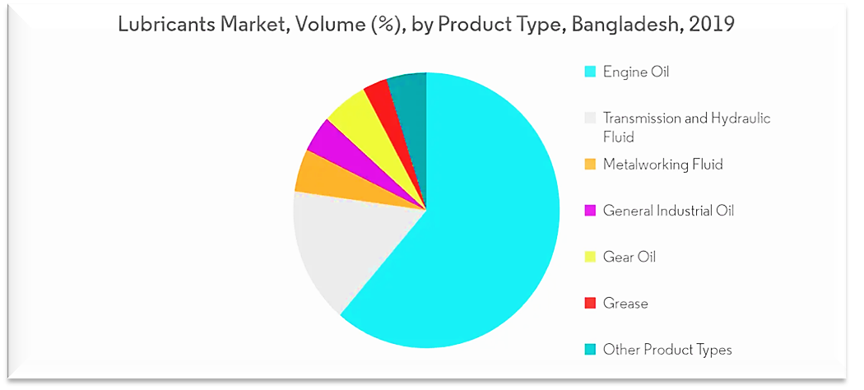
Figure 1: Lubricant Market Volume, by Product Type, Bangladesh (Ineliggence)

- Car and Other Transportation Segment Expected to Dominate the Market: Lubricants are utilized in car for different applications, for example, motor, slowing mechanisms, fuel frameworks, transmission producing, guiding frameworks, fumes frameworks, and numerous others. Oils in car lessen rubbing by making a slight layer or film (leeway) between the moving parts. Stun assimilation during hefty burdens and the retention of toxins are a couple of the different points of interest. Lubricants in marine transportation are utilized to scatter heat, for diminishing grating, and battle mileage between the surfaces of two moving segments. Also, lubricants help battle erosion and rust in the motor, regardless of whether it’s an avionics motor or a wheel consuming on a vehicle. The car industry in Bangladesh is considered as the third biggest in South Asia. Bangladesh is foreseeing an ascent in the interest for mechanized vehicles. Until September 2018, 283,344 vehicles were enrolled against the 428,978 vehicles enlisted in 2017. Although the deals of new vehicles have been diminishing in the nation for as far back as three years, the deals of pre-owned vehicles have expanded fundamentally in the nation, consequently driving the interest for car lubricants. The car industry in Bangladesh is overwhelmed by imports of new vehicles, generally by Japan, China, and India for an enormous scope and a couple from Europe and the United States. Bangladesh is envisioning a development in the flying business sector, with the 175 million populaces expanding the utilization of the ethereal course for voyaging, inferable from the developing working class pay. Because of this, air travel is expanding in the nation, which thusly is prompting the market development for avionics greases. The demand for lubricant will continue ascending with the expanding car vehicles, which thus will build the market for lubricants in Bangladesh.
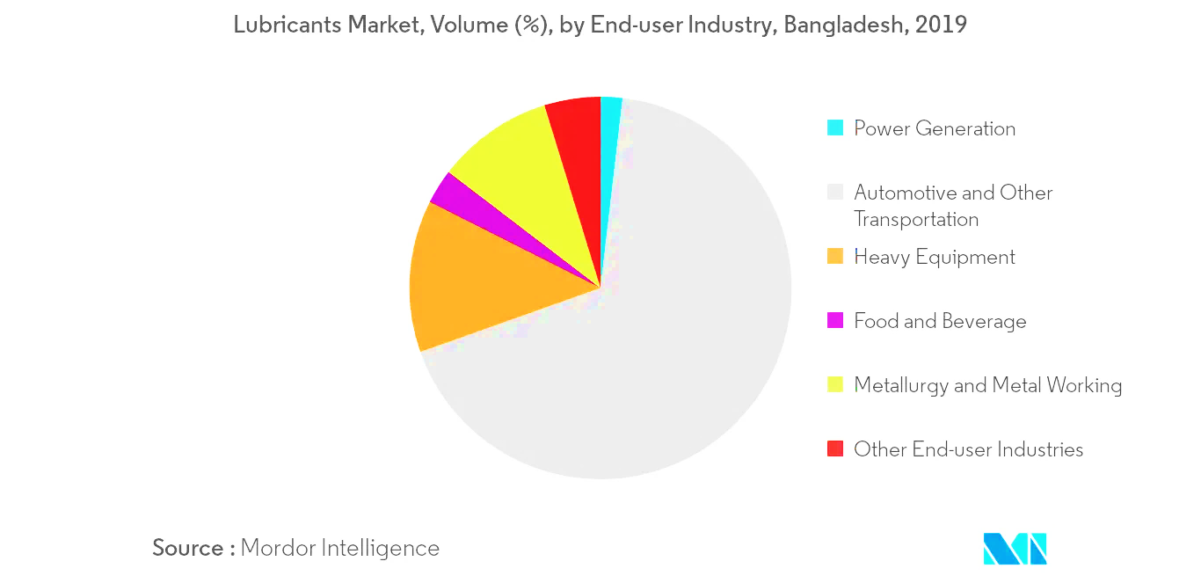
Figure 2: Lubricant Market Volume, by End-user Industry, Bangladesh, 2019 (Ineliggence)

Maturity

The market for engine oil, known as lubricant, is developing quickly, determined by an expanding number of engine vehicles in Bangladesh. Over the last few years, the growth is exponentially increasing and it assumed to be increase more in the upcoming years.

Overall of Tk 1,300 crore lubricant market in 2010, the vehicle business devoured 79 percent, while the assembling area burned-through the rest, market information shows. An analysis by market researchers shows, an innovator in motor oil mixing and deals in Bangladesh, has projected grease utilization at 63,600 tons for 2011. Such utilization was more than 61,000 tons in 2010 and 59,300 tons in 2008. The survey shows the motor oil market, which develops at 3.2 to 3.7 percent a year, can possibly develop as a large number of new engine vehicles are employing the streets consistently. World interest for oils is estimated to progress 2.7 percent a year to 42.3 million tons in 2009. In any case, an interruption in assembling and modern action in light of the energy crunch has decreased the potential for additional development of the item.

Motor oil utilization could undoubtedly develop by 6 to 7 percent every year, if there was a consistent stockpile of gas and power. Mobil Jamuna, a joint endeavor of state-claimed Jamuna Oil Company and Mobil Asia, set up its own mixing plant in 2003 to mix and market quality lubricants for the developing Bangladeshi market. The organization imports all fixings, including base oil and added substances to make lubricants. Mobil Jamuna is likewise the leading Bangladeshi organization that is trading lubricants. It fares to nations like Nepal and Bhutan. The organization has sent out lube oil worth more than $ 455,050 to Nepal in 2010. The fare focus during the current year has been set at 1.5 million dollars.

Lubricant, otherwise called engine oil, is a fluid item used to grease up different kinds of inside burning motors, for example, vehicle and modern motors. It is likewise utilized in marine, rural, train and plane motors. The critical capacity of the oil is to grease up and clean the moving pieces of machines or motors. It likewise forestalls consumption and rust and keeps the motors cool via diverting the warmth from the sliding parts.

The oil business in Bangladesh in the private area is not exactly 10 years old. Until 2000, just the state-possessed oil organizations were permitted to import, mix and disseminate oils here. Around then, greater part lube oils (67 percent) contained no added substances.

The public authority changed the market and restricted non-additised lubricants in 2001, to guarantee least norms. From that point forward, in excess of 52 brands of greases, including prestigious multinationals, have entered the market. However, about six brands represent almost 53% of the all-out business. Again, one thing needs to be said above all that the lubricant market will sustain in long term in Bangladesh seeing its rapid growth in the earlier years of 2017 to 2018. (Saha, 2014)

Seasonality

Like some other area the seasonality of lubricant business likewise follow an example which was made by thinking about the interest for lube services and exercises. The example is inspecting the lubricant execution to comprehend the irregularity of this area over most recent 15 to 20 years. The fundamental example of which is that the time of low is from late December to January in Bangladesh. Increments of selling and disseminating of lubricants start from February, rises pointedly at prior happy months. For the most part it compasses to its top at May mainly.

So essentially, rest of the rainy season till August there isn't a lot of demand of lube services among the clients and vendors. At that point, from September to initial segment of December it increases consistently. In January the lubricant business performs most exceedingly terrible however it encounters most elevated selling at February to April, at that point from September to December

There are some co-factors that determines the seasonality of lubricant business are:

- Longevity: Lubricants have an ideal life expectancy, and once it's finished, they should be supplanted. Inability to do so can result in runout, metal-on-metal contact, pulverized orientation and different issues prompting personal time and higher costs. In Bangladesh from the month of July to August the imported lubricants are the big deal to handle and carefully preserve in the form of liquid for the usage of industrial purposes. The issue is that it's not generally evident when this is going to happen. One significant approach to follow a lubricant's life expectancy is by observing the working temperature of your gear. Abundance heat obliterates oils. Each ascent in temperature of 11 degrees C over 66 degrees C will slice the oil's administration life down the middle. This implies a lubricant that would regularly most recent one month at 150 degrees Fahrenheit will last just more than about fourteen days at 170 degrees Fahrenheit, multi week at 188 degrees Fahrenheit, and only three or four days at 206 degrees Fahrenheit prior to waiting be supplanted or restored. From that point onward, it will stop to take care of its work, basically offering practically no security regardless of whether oil levels show up high. For the month of July to August is basically crucial time for the engineers to have an observation as this pushes the sells downward for the season.

- Festivals: The selling are higher long before celebrations and summer and by and usually lower in rainy seasons. This example has been followed since the excursion started for the lubricant in Bangladesh. Along these lines, the best an ideal opportunity to sell is the point at which the rate is high for the purchasers. As there's an expansion for use of lubricants in all the service centers during the festival occasions, those months are the best an ideal opportunity for having a gigantic benefit with an extraordinary margin line during that time of the year.

- Demand: While all importers rely upon lubricants to keep working, recollect that not all lubricants are being sold at a fixed rate in every months of the year. It very well may be a genuine mix-up to just buy a modest lubricant without considering the seasonal factors should be broke down. Breakdowns are costly and can have a reverse impact. Keen organizations invest as much energy considering how much lubricant they should buy about the following demand in the market which is especially low at the year end. It follows the month of December to January where importers have to buy lubricants with a higher price considering the market demand. Likewise, the demand is low, the buying is low, thus the sell drops at that time of the year.

External Economic Factors

The economy of Bangladesh is connected straightforwardly to the lubricant business. This lubricant business is relied upon to profit by the drastic fall in inflation that kept on zooming out. The resulting buyer advantage relies upon the value change at the domestic ground equivalent with the global price. Lower inflation and an uprising economy help decline the living cost for basic items through sustainable automotive servicing which is conceivable as such of selling of the lubricants. Lower inflation rate furthermore went by through immediately into increase in lubricant price.
As because of the Covid-19 situation all over the world the economic factors such as business, wages, costs or expansion, loan fees and buyer certainty affected the lubricant business also in a negative way as other businesses of which, impacted the trade of between customers and sellers. The two months of strict lockdown in Bangladesh has shattered a lot of business, while the lubricant business as of that time was hanging by the thread. In light of end-use industry, the market is divided into transportation and modern lubricants. The basic demand for lubricant is high in the transportation portion because of huge number of vehicles on street in Bangladesh. With the lockdown across the globe, the exercises in transportation area are nearly stopped causing decreasing demand for lubricant oils while other economic factors decided to push lubricant business to the edge.
Furthermore, in Bangladesh importing income is lower at a prevalent rate than exports which is actually natural, and here export GDP proportion more noteworthy than before in the 2014 though import-GDP proportion diminished. In spite of the fact that domestic dissemination, especially that of worldwide prices impacts yield and value soundness, expansion in Bangladesh is likewise to a great extent controlled by global prices since the nation needs to rely upon some basic items including lubricant items. In Bangladesh, 46% of the lubricant utilizes in the vehicle area, 24% in the force area, 18% in the agribusiness area, 5% in the ventures and 6.9% in the family area. Thusly minor changes in inflation speed at the inflation velocity at current have been a known issue for the increase in lubricant price. Numerous frameworks, vehicles, producing ventures, house hold works are overseen utilizing lubricants as the way to operate their business in Bangladesh. Bangladesh is a lubricant merchant. Bangladesh is totally dependent on imports for fulfilling up its need for lubricant products. So the practical agitation or any sort of trouble will influence the lubricant business directly. (Hasan, 2019)

Technological factors

In view of utilization, the market is fragmented into turbine oil, blower oil lubricant, gear oil, water driven lubricant, fireproof pressure driven lubricant, atomic safe lubricant, bearing lubricants, heat move lubricants, re-refined base oils and lubricants, nanomaterials based lubricant and others. Water driven oil lubricant is a holds the greater part share in the worldwide lubricant market because of its wide scope of uses, for example, car, airplane, modern hardware, development gear and marine applications.
In significant manner, lubricant organizations are as often as possible building up their innovation to stage to building up their strategy. These days individuals have more fascination on utilizing Social systems administration through Internet, all the organizations may get chance to publicize through Internet, business can utilize EPC for constituent purpose of controlling deals to assess their correct stock, card installment against deals to assist the buyer on holding money. So quality is focusing on those issues. Moreover, there are engineers according to the hierarchical view from the lubricant organizations who manages and quality taste for these lubricants to approve for the market of Bangladesh.
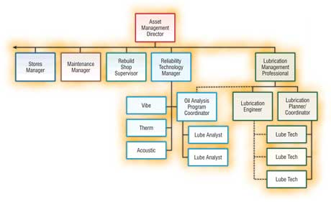
Figure 3: Technology Management Hierarchy (Jim Fitch, 2002)
Lubricants are fundamental for keeping up motors in ideal condition. That is the reason our researchers from the Lubricants Laboratory at lubricant producer Technology Lab research, test, dissect, and establish substances that ensure the climate. Specialists are consistently watching out for any mechanical advancement that could add to improving lubricants much further. The point is lubricant engineers have become progressively more updated technological wise to provide more insurance to motors and other segments, inside vehicles and other apparatus, to make them work all the more adequately, and to decrease contamination.
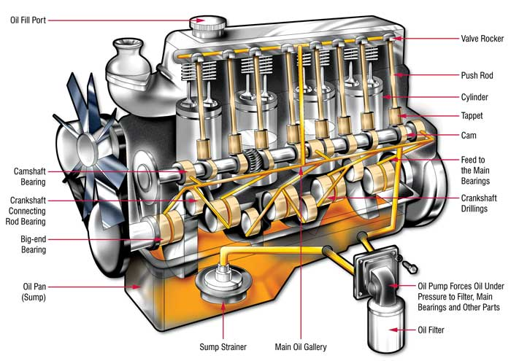
Figure 4: Lubrication System (GlobeCare, 2017)
Although technological development is mandatory and the lubricant business should be updated with any respect but sometimes there are also risks associated with the technological factors. Technology consistently assumes a basic part in any business worry that guarantees better administrations to the clients and diminishes the expense in different viewpoints. Any development of new and more savvy innovation may cause mechanical outdated nature and negative operational proficiency. Moreover, any serious deformities in the plant and machines may affect efficiency and benefit because of extra venture for substitution or support.

Political, legal, and regulatory factors

Political factors
characterizes as government dependability, tax collection strategy, presenting new law and guideline by the government. The political is directed by chose government. The policy centered issues in Bangladesh are a lot of suitable than the past times for lubricant business. Chosen government as a rule force the new approach as indicated by their political race plan. Bangladesh government is wanting to dispatch some extremely compelling plan for the new financial advisors with reduction add in value tax, business taxes and also income tax.
A continuous distribution of appropriate selling of lubricant it is significant keep a superior world of politics for any country. In Bangladesh, the government laws can straightforwardly influence this lubricant business. The public authority can mediate in the matter of bringing in this lubricant structure another nations. Defilements among ideological groups, authoritative laws, for example, work laws, exchange limitations, duties and political dependability will influence the selling of the lubricant. So, despite the fact that lubricant business looks sufficiently able to support in this climate yet it is defenseless to the public authority.

Legal factors
The lubricant business is all around the world affected by a few laws. Among then particularly in Bangladesh the lubricant business needs to observe the consumer and labor law as countless business is connected with this business, exchange structure which effect on affirm the framework of the business. The Customer concerns and corporate social obligation (CSR) caused the public authority to present a few laws which has followed by the lubricant organizations carefully. There is likewise a lawful issue which would influence quality, for example, new work law, expanding least wages.
The fundamental legitimate components which the lubricant business just as the vast majority of the business needs to confront are:
- There is on a basic level no victimization outsider, however the legal framework is moderate, wasteful and effectively tolerating of pay-offs. Being an outsider without relations can along these lines demonstrate an impediment.
- In common and lower courts, Bengali is the authority language, however English may likewise be utilized. In the higher courts, English generally overwhelms, albeit Bengali not prohibited.
- The law specifies that if the observer doesn't comprehend the language utilized by the court, he should be furnished with an interpretation in a language he gets it.
- The laws of Bangladesh have been acquired from the British general set of laws and adjusted to the nation's socio-social and strict setting.

Regulatory factors
Despite the fact that the world lubricant price has been fallen. As of our government of Bangladesh is bringing in the lubricant at expanded rate however the public authority isn't eager to build the selling price of the lubricants on the grounds that at past BPC needs to go through a ton of cash for each year as appropriation with the end goal of oil. To be mentionable here that BPC is making safe overall revenue per liter for grease. In addition, the appropriation price of lubricants is a ton high for each liter yet the clients are getting it for less as of now, giving the public limited enterprise a benefit by insignificant edge per liter. Taking into account the way that overall lubricant prices began to fall in mid-2015, domestic lubricant prices have not been changed. Lubricant endowments have adequately turned negative, and the specialists have not demonstrated any designs to change them in the close to term. In this regard the effect of the Bangladesh government administrative arrangements may be as; The organizations who import these lubricants are enduring political disturbance made inside the past few years.
Notwithstanding, oil business may have the option to remain in the safe zone concerning the last a few years the price has been expanded with a fine edge. While the lubricant companies are getting the advantages from expanding lubricant price as an of imported. Be that as it may, customers and the dealers who convey these lubricants in Bangladesh have not profited if there should arise an occurrence of the increase lubricant price. Higher lubricant circulation prices if save should have a nice affect for domestic development. Basically, the ascent in lubricant consumptions may prompt more prominent buying power and thus add to genuine return for business.

Barriers to entry

Lubricants market currently has a place with an uncontrolled exchange our nation. Shockingly, the lubricants racks are as of now expanded with in excess of 105 brands and the quantity of brands is expanding. The circumstance is debased as so numerous by name, nearby items are entering into this market. Routinely, dealers are inviting the agents of recently entered marks as well.

As of now, business Insiders has portrayed this greases market as a quiet exchange with an absence of guidelines. A market with such a large number of brands isn't just the difficulties of this market. The offer of reused motor lubricants, particularly by the names of well-known brands is a key boundary as well, has expanded in the far-off regions because of careless observing by any concerned specialists. Different sources said that motor lubricants are being corrupted slowly. Generally, deceitful brokers blend paraffine based stocks with reused lubricants gathered from the marine and different assembling enterprises. Without paraffine, they use lamp fuel lubricant to taint the motor lubricants. At that point those are provided to the clients.

In any case, because of lower costs of ground lubricants, contrasted with the virgin base lubricant, untrustworthy brokers are more urged to showcase reused lubricants. Just at the low costs, these most un-quality ointments have been influenced by the market. Many sellers and specialists are engaged with circulating of such lower standard motor lubricant.

It has discovered no organization is exclusively answerable for controlling the debasement instead of a couple of assaults by the unique portable court. In an indirect manner, the offer of sullied powers is another test of this exchange. Generally, deceitful lubricant brokers blend a high extent of condensate in with lubricants like synthetic, semi-synthetic and mineral. Also, the condensate can be blended effectively in view of its comparability with different lubricants. The treatment facilities for the most part purchase condensates delivered in gas fields run by a state-claimed organization and other global lubricant organizations under an administration agreement to create fills, for example, synthetic, semi-synthetic and mineral lubricants which is BNO.

Prior, BPC has given show-influence notification to more than 1650 specialists, vendors, and merchants for their supposed association in illegal fuel exchange and contaminated. Still now, a segment of untrustworthy fuel lubricant merchants in various district get the unrefined condensate from the gas fields with low cost and blend it in with the fuel lubricants wildly.

These issues that talked about above are the key obstructions that made this market intemperate one which enhanced the barrier to entry in this lube market even harder. In any case, the govt. should act firmly to screen this market for the prosperity of this exchange.

Supplier power

Suppliers are the main asset for the manufacturer that supply materials and different items into the business. The system received during the energy emergency was to decrease reliance on imported lubricants through its substitution by native fuel. Accordingly, practically all plants worked after the energy emergency depended on petroleum gas utilized as fuel. Inclination for this fuel is additionally persuaded by its nearly low cost for power age. By and by because of the lubricant and energy emergency everywhere on the world, import of unrefined petroleum has been expensive. So, it has influenced the tasks and productivity of the organization. It should likewise be said that, the organization may confront rivalry in the event of bringing in fuel from abroad.
So, basically, suppliers of different types of raw materials to the lubricant business rather ground-breaking and few providers are accessible provincially and their items are additionally specific items which restricted to specific applications. Despite the fact that it considers an inventory on a specific material
A monopolistic circumstance, it would not be the right equivalent word to be utilized. Since, association wide they are in an inventory network the executives. Thusly, items they produce primarily for their hierarchical utilization. for example, in worldwide setting, they are in vertical combination. Practically the entirety of the items provided are innovation driven and not brand driven. Explicit mechanical boundaries are taken into concern and expect an affirmation on the item execution in a few senses. Where it would expect substance execution as well as actual exhibitions, for example, scattering, miscibility and similarity.
The bargain power of the supplier’s depends two factors which has given below:

- Availability of supplier: In the current state of lubricant business the bargaining power are very high in here. As there are very suppliers who provide the raw materials in the business to operate which is not that much in the market. Hopefully, the scenario will change in near future opening more opportunities for newcomers.

- Threat of forward integration: As of now it can be said that there is no forward integration for lubricant business in Bangladesh because the manufacturer is too much limited and no direction to move the business elsewhere

Figure 5: Power of supplier

Buyer power

With regards to the dealing intensity of the buyers or customers, it is in two kinds. for instance, retail buyers and mass shoppers. Retail market dynamic pretty much on brand dependability. Mass customers have some level of haggling power however that additionally acquired with administration level help. Which an organization can overwhelm indeed. As buyers are the individuals or associations who provoke interest in an industry. In the force and grease industry and general individuals are the purchasers. As, the price is constantly set by the government of Bangladesh buyers don't have the bartering power as expected.

With regards to the dealing intensity of the clients or buyers, it is in two kinds. for instance, retail buyers and mass purchasers. Retail market dynamic pretty much on brand dedication. Mass purchasers have some level of bartering power however that likewise acquired with administration level help. Which an organization can overwhelm indeed. As purchasers are the individuals or associations who drive interest in an industry. In the force and lubricant industry and general individuals are the purchasers. As, the cost is constantly set by the public authority purchasers don't have the haggling power true to form.

The bargaining intensity of purchasers in lubricant business is generally little because of the idea of this industry. buyers are keen on the cost and the nature of an item. So, it is evident from the over that the purchasers can't influence the lubricant price. Higher bartering power have the buyers just which burn-through huge measures of lubricant, for example, Europe, Dubai, China, USA, Japan, and India in correlation with different nations. At long last to specify that the solitary dealing intensity of buyers in the lubricant business is just what nature of the lubricant they will purchase.

The purchasers can browse various sorts of lubricant as per their quality attributes (thickness and sulfur content), however every one of them are evaluating to the three known lubricant benchmarks that can be examined. Likewise, until the buyers can utilize an elective fuel source rather than lubricant, the bargaining intensity of the buyers will be critical low.
The buyer power of lubricant business is very little. The factors that determine the bargaining power of buyer. While directing a study for certain dealers or suppliers of lubricants across Katabon, Dhanmondi and Mohammadpur to acquire a superior comprehension of the purchaser market. Some fascinating bits of knowledge are introduced underneath:
- Nature of Lubricants: Buyers are generally worried about the nature of the lubricant. They would prefer not to chance anything happening to their vehicle for not utilizing top notch lubricant. This is substantiated by the way that in regions like Dhanmondi, where numerous wealthy individuals live, the market driving item – regarding quality – sells the most.

- Brand Image: Buyers proposals likewise have an impact in influencing the buy. Retail dealers prescribe their favored image to the buyers more often than not. Because of this, buyers frequently buy marks as alluded by the dealers (15.12% reactions from the study). What's intriguing to note is that the elevated brands will in general be lined up with the best net revenue or biggest volume. This, as a result, squeezes the dealers as price of the following bulk gets diminished. This, notwithstanding, doesn't mirror the genuine condition of the brands on the lookout. Besides, the recommendations they make change contingent upon whether a vehicle needs what type of lubricants. As per them, the lubricant required is dependent upon the fuel utilized.

- Brand quality: In lubricant business still, there are not that much highly great quality lubricant except the major player in the market around these areas. The quality and different type of low-price lubricant are very less. As the amount is very little buyers don’t get that much liberty in choosing between quality lubricant. Which in turn reduce the bargain power for the buyers.

- High switching cost: the switching cost is very low. Almost all lubricant offer very high price margin. That determines the switching cost from one brand to another costly as possible. Switching lubricant from one brand to another gives the quality much higher if switch in a high price lubricant. It makes the actual buyer to switch less in frequency to lubricant brands. This is why higher switching cost basically reduce the competition for lubricant companies.

- Price: Price is the subsequent dynamic rules that buyers consider when purchasing lubricants. In regions like Dhanmondi, individuals don't deal much with the dealers when purchasing lubricants; they expect that they are getting phenomenal item at the price they are paying. Interestingly, in Mohammadpur, clients are more dubious about the item quality and they frequently contend and haggle with the retailers to choose a price.

- Promotional Activities: Different types of promotions don't have any critical impact in buyers' buy choice. Accessibility of brand doesn't influence buyers' buy choice. Or maybe, it's directed by the brand's notoriety.

- Awareness of buyers: As indicated by dealers most buyers are very educated about the oil brand and quality. Indeed, for shoppers, the fundamental wellspring of data emerges from peer recommendations. Discoveries recommend that purchasers themselves and their companion bunches play the most critical and equivalent jobs. 43.79% of the reactions from retailers met expressed that the customers themselves settle on the buy choice. An equivalent level of reactions expressed that the shoppers' buy choice is a consequence of proposals from peer bunches like family, companions or partners.

Figure 6: Bargaining power of buyer

Threat to substitutes

The threat of substitute in this lubricant business is very much lower comparatively to other business and in this industry since government consistently set the cost for power, gas, oil. Thus, individuals don't have the choice or motivation to substitute. Along these lines, fundamentally, they are no effective substitute for any lubricant items up until this point. Just some solid factorial lubricants are existing as an answer and those can be pertinent for few applications.
The presence of substitute items can bring down industry engaging quality and benefit since they limit value levels. The danger of substitute items relies upon:
- Purchaser's readiness to substitute
- The overall cost and execution of substitute
Lubricant items such as importing, they have no substitutes at all as there are not enough manufacturer of lubricants like BNO.

Figure 7: Threat of substitute

Business rivalry

In a competitive business the organizations needed to contend all the more forcefully which caused less benefit. So, it is essential to know how much business contention exist in the market to decide how much serious and beneficial that business can be on the lookout.

Market onlookers state the quantity of existing brands of lubricant in Bangladesh are more than 250 and the number is expanding step by step. Additional greasing up oil brands are yet to enter
in this open market. In the present circumstance, the greases dealer is inviting new agents consistently. Shockingly there such countless brands in Bangladesh, even in India there aren't that numerous lubricant brands.

The major players in the market of lubricant in Bangladesh are Bangladesh Limited (Exxon Mobil), Trade Services International (Total), Ranks Petroleum Limited (Royal Dutch Shell PLC), Rahimafrooz (Bangladesh) Ltd (BP PLC), Navana Petroleum Limited (Caltex/Chevron) MJL etc. Notwithstanding, brands like Mobil, Shell, Castrol, and BP are making the most of their image esteems which hold 30-35 percent of the all-out piece of the pie. The remainder of the share has a place with other existing nearby and unfamiliar brands. Here, Mobil is the market leader with more than 25 percent share, trailed by British Petroleum at 11 percent, French brand Total at 5 percent and Shell, Castrol and Caltex with 2 percent each. Mobil has even seen an expansion in the measure of its piece of the pie throughout the long term, from 2008 to 2014. The car area represents 75 percent of complete ointment utilization in Bangladesh and the businesses the excess 25 percent. In any case, the development in the lubricant business over the most recent couple of years has generally been because of the development in the modern areas, particularly the force area. Concrete, steel and manure enterprises likewise devour a decent measure of lubricants. The extent of lubricant utilized by mechanical area is relied upon to increment much more later on as enterprises develop and the interest for lubricant to be utilized in this area increments.

The yearly demand of lubricants is expanding altogether. This market is now over-overflowed with numerous brands and it will be more serious. Therefore, the business rivalry is a complex one in this lubricant market of Bangladesh. (Rahman, 2020)

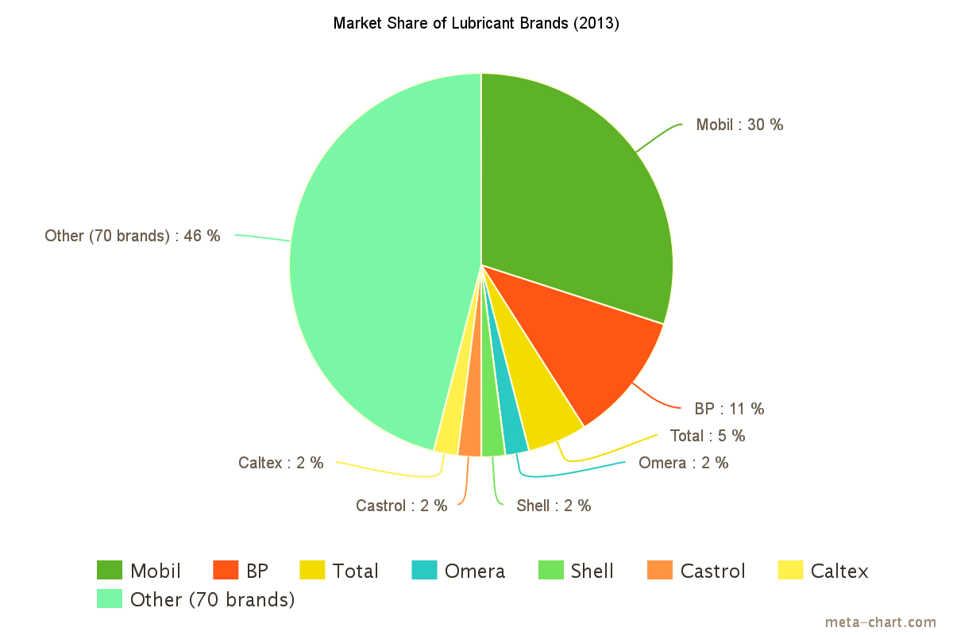
Figure 8: Market Share of Lubricant in Bangladesh (Wing, 2015)

Summary of challenges and opportunities

Challenges for Lubricant Business
Significant companies in the Bangladesh lubricant business need to confront strict challenges while leading their business in Bangladesh. Numerous company’s' deals sneaked through the initial three quarters of the last monetary year, its year-on-year lubricant deals are on a coasting edge on account of some interior and outside elements influencing the business. A portion of the speedy rental force plants and cars are the two significant clients of the organization. Both the areas are presently encountering a log jam. Also, some neighborhood merchants are acquiring inferior quality lubricants. Import of the unacceptable and modest items is on the ascent, harming the mainstream brands.
Power production companies are the greatest private area customers of lubricants. The speedy rental plants comprise 35 percent of the absolute lubricant demand in Bangladesh. As per the BRTA, vehicle deals dropped by seven percent in the last monetary year, and dull deals additionally proceeded because of the pandemic. The vehicle area comprises almost 65 percent of the all-out demand of lubricants.
Lubricant is the existence blood of motor and simply like the veins in individuals. It is needed to satisfy various sorts of elements of motors and machines
Challenges and dangers:
- Customers don't know about greases that much in Bangladesh which makes it a challenging task to reach-out to the people.
- Adulteration of greases. which is one of the core problems to deal with in case of lubricant business in Bangladesh.
- Low quality item imported from Middle East which is impacting the whole lubricant business.
- Wholesalers like to deal inferior quality items because of high overall revenue.
- Uneducated workshop mechanics are sometimes put the owner into predicament which is not easy to handle and takes years of training.
- The exorbitant cost of manufactured greases is relied upon to frustrate the development of the market.

Opportunities for lubricant Business
Despite the fact that there's certain difficulties for the lubricant business there are numerous opportunities for the area to develop as well. A portion of the possible chances for the area in Bangladesh which the business can utilize on the off chance that they can be given legitimate insights are:
- The car and other transportation overwhelmed the market in 2019, and it is relied upon to develop during what's to come.
- Growing interest for new engine vehicles is probably going to go about as a chance for lubricant business in Bangladesh later on.
- The motor oil market has grown up around 12 to 14% over the most recent three years in view of different reasons, generally due to the ascent of cars and it is bringing ointment business up in bd.
- By seeing the data of BRTA, the quantity of enlisted petroleum and diesel-controlled vehicles is 3,593,983 units which is a lot of accommodating for lubricant business in Bangladesh.
- The number of car vehicles has expanded by 3 times over the most recent eight to nine years and it is expanding step by step.
- The interest for motor lubricant will rise staying up with the expanding car vehicles, with a normal 4% yearly developments.
- The in general lubricants request has expanded likewise for the development of the force area, which has made an exceptional market for modern lubricants oil.
- The lubricant market size for enterprises has multiplied over the most recent five years because of the foundation of various force plants the nation over.
- The interest for mechanical oil will keep on ascending at any rate for the following 10 to 16 years, as the snappy rental force plants need a gigantic amount of lube oil to run.
The utter need of lubricants in Bangladesh are such as population thickness, shortage of developing area, river-oriented country, biggest transport breaking and reusing yard, helping worldwide accomplices like CHEVRON & CAIRN ENERGY and develop lasting base oil source .As, there's a great deal of area where just lubricant business can reach and make the work simpler for the automotive and manufacturer industries which are the motivations to expand the requests of this business more step by step therefore the chances for this field in the market is very high as well.

Chapter-3

Analysis of the organization

Overview and History

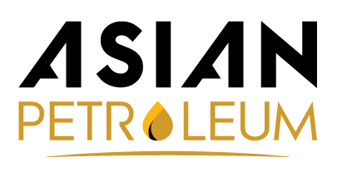

Figure 9: Asian Petroleum Limited logo
Asian Petroleum Limited as the authorized merchant of IDEMITSU Lubricant, Japan, an organization established in 1911, has item range numbering in the large numbers, traversing oils, forte liquids, oil that have been created to supplement each other. Our production network currently incorporates dissemination all over pertinent business sectors of Bangladesh. The company mainly formed as “Rancon Petroleum Limited in 2014 by Dewan Shajed Rahman who holds 90% of the share of the company and other 10% share are hold by Md. Arman Rashid who is the Director of Operation in Asian Petroleum Limited. In 2015 Asian Petroleum limited started its business with Idemitsu with Honda 4W & Suzuki 2W products. In this year of the time Idemitsu Lubricants where distributed under Rancon Petroleum Limited. The next year in 2016 Rancon Petroleum changed name to “Asian Petroleum Limited”. As of that date Asian Petroleum Limited became the official distributer of Idemitsu Lubricants in Bangladesh from where Asian Petroleum Limited started its journey in this country and this was the time when Asian Petroleum Limited changed their logo which is given above. In 2017, Asian petroleum Ltd. expanded their product line with Honda 4W & Idemitsu products. Finally, in 2019 Idemitsu Lubricants Bangladesh started their business with ILIN.

Core Information about Asian Petroleum Limited
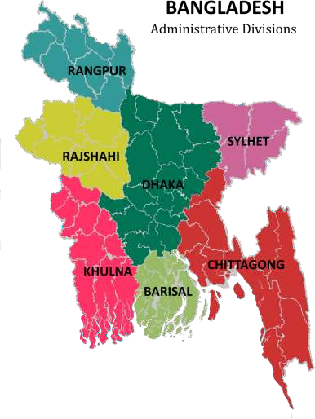

Number of Dealers: 49
Across all of Bangladesh except Chittagong Currently focusing on spreading distribution in Dhaka Division
Storage Warehouse: 2
Bosila, Dhaka & Ulukhola, Dhaka
Corporate Office:
277, Tejgaon I/A, Dhaka

Figure 10: Administrative Divisions of Asian Petroleum Ltd.

Organogram of Asian Petroleum Limited:

Asian petroleum Limited is a partnership business. It’s started its operation in 2016 in Bangladesh. From that day to now it follows an organ gram which is led by the Managing Director. Asian petroleum Limited organ gram contains human resource, finance & accounts, admin, sales, marketing, showroom staff & supply chain department. Flow chart of Asian petroleum Limited is given below:

Managing Director

Director Operation

COO

Admin
Human Resource
Sales
Supply Chain
Finance & Accounts

Marketing
Showroom Staff

Figure 11: Organogram of Asian Petroleum Limited

As we can see at the organogram of Asian Petroleum Limited beginnings with the most elevated places of the Managing Director followed by chief operating officer and director operation. There the organogram partitioned into one area from here. Under the Managing Director both COO and Director Operation work to accomplish their objective. Different officials worked under them at different department.

Trend and Growth
There are several important figures which impact the trend and growth of Dutch- Bangla Bank Ltd. it will be described below:
Financial focus of Asian Petroleum Limited of last 5 years
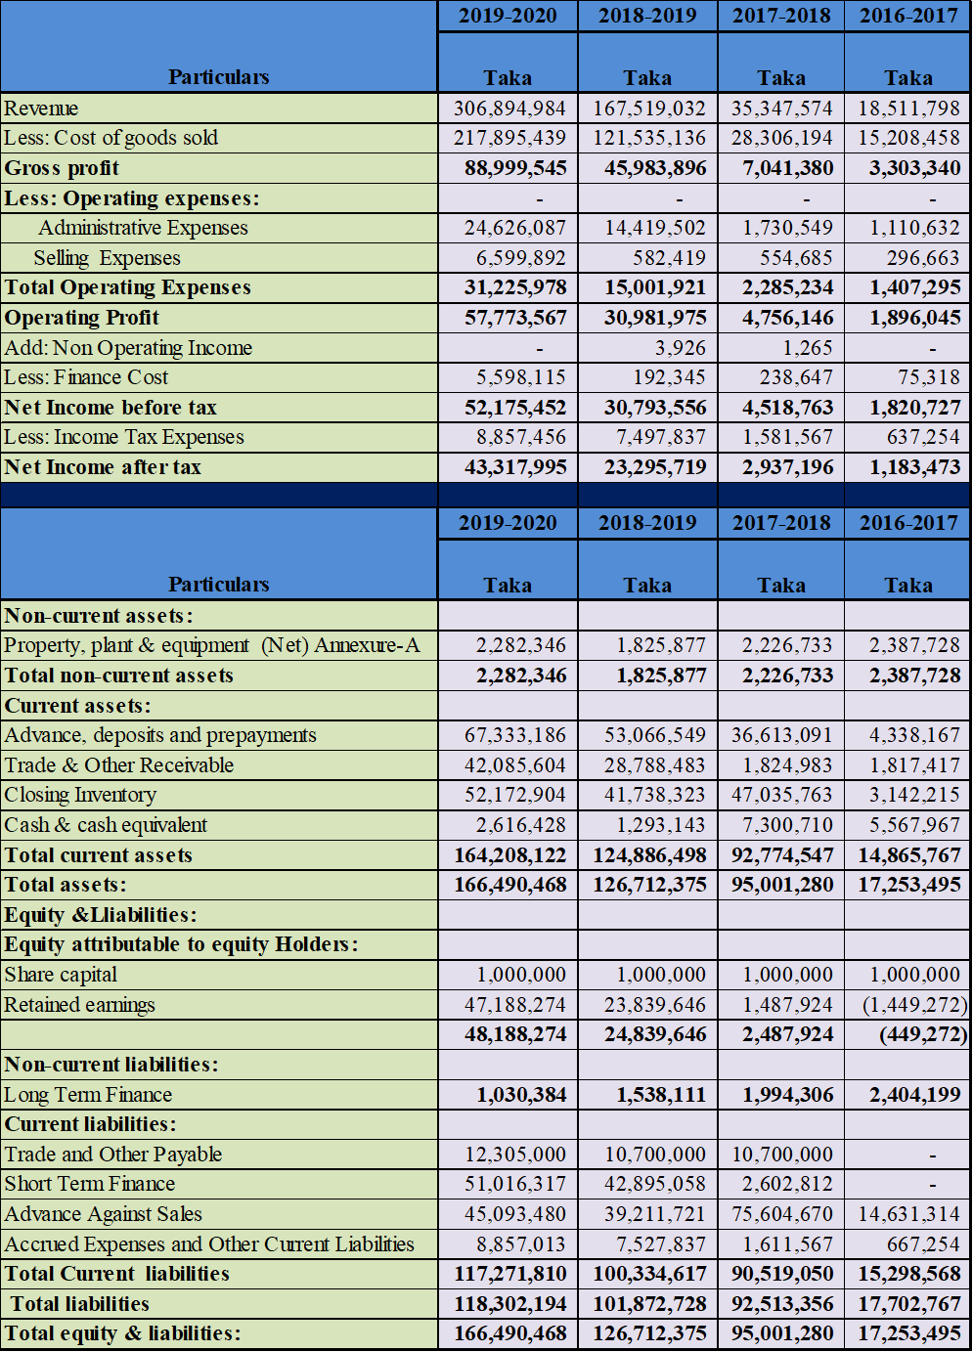

Figure 12: Financial Figure of Asian Petroleum Limited

Growth of Asian Petroleum Limited over 5 years

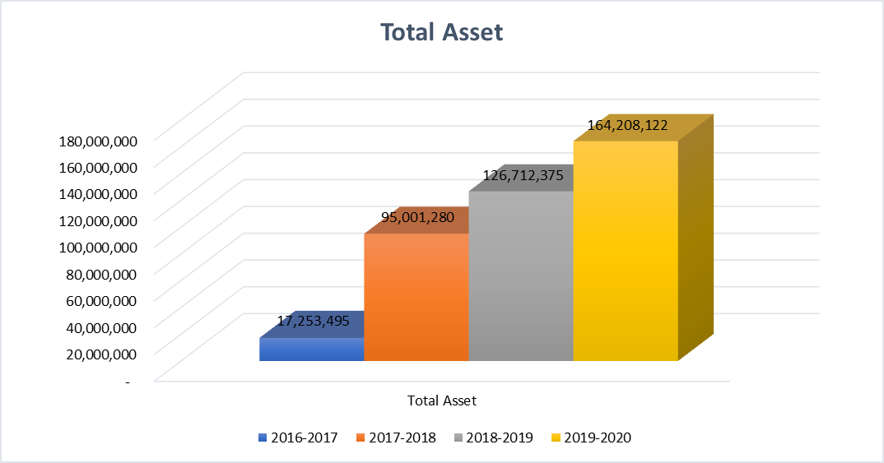

Figure 13: Total Asset of Asian Petroleum Limited

In 2016-2017 the total asset for Asian Petroleum Limited was only Tk. 17.25 million whereas in 2019-2020 the total asset turned into Tk. 164.21 million. From the above data one thing to observe is that, in the last five years the total asset of Asian Petroleum Limited increased drastically.
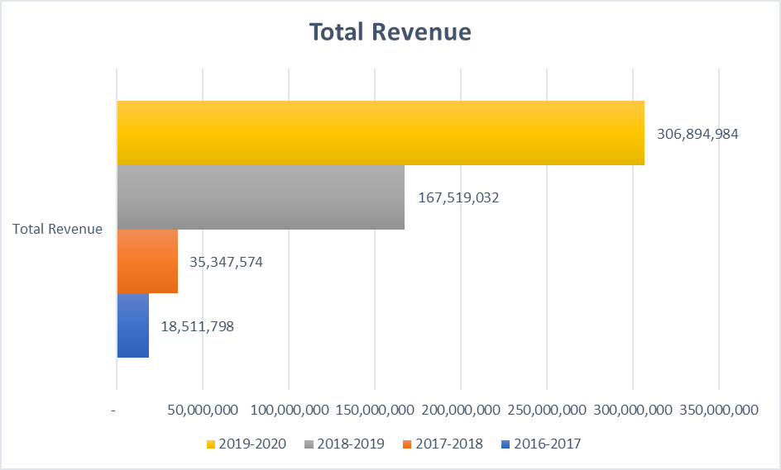

Figure 14: Total Revenue of Asian Petroleum Limited
From the above graph one thing need to be observed carefully which is the total revenue in 2016-2017 was only Tk. 18.5 million which increased by a very high margin in 2019-2020 which is Tk. 306.89 million.

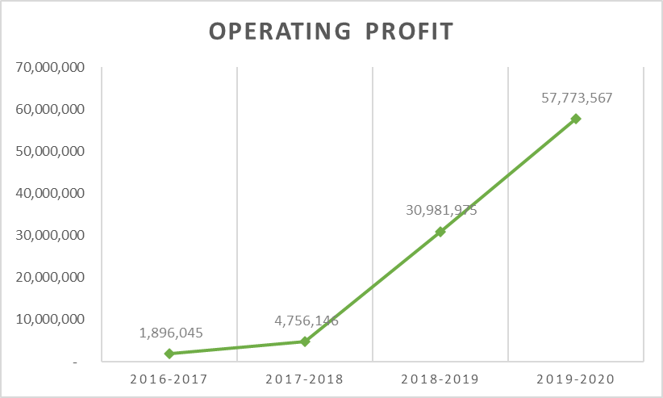

Figure 15: Operating profit of Asian Petroleum Limited
From the above graph the operating profit of Asian Petroleum limited in 2016-2017 was Tk. 1.89 million which in 2019-2020 stands in Tk. 57.77 million.

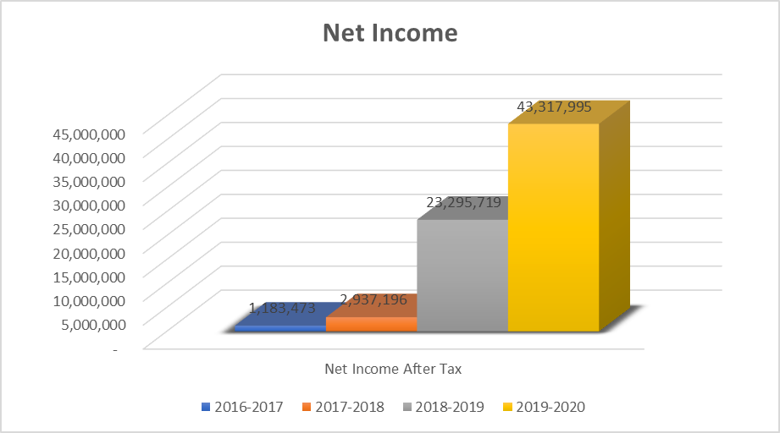
Figure 16: Net Income After Tax of Asian Petroleum Limited
Here the Asian Petroleum Limited has the net income of tk. 1.18 million in 2016-2017 which increased by a great margin in 2019-2020 which is Tk. 43.31 million. It can be seen that the growth of Asian Petroleum Limited has risen high in the last five years. This huge growth over the last five years was possible because of the low expenditure for the company as well as the other operating expense for the company during the period reduced very highly.

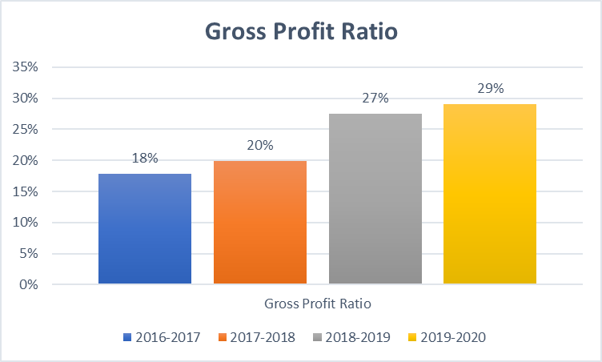

Figure 17: Gross profit Ratio of Asian Petroleum Limited

From the above figure we can observe one thing that the gross profit ratio increased from 2016 to 2020 by more than 11% which is quite high for Asian Petroleum Limited which basically shows the potential growth of this company as a remarkable one. The cost of goods sold was decreased at a high rate which made this possible for the GPR to increase so much.
Figure 18; Base & Lube Oil growth
Comparing the 2017 vs 2018 & 2018 vs 2019 the base oil and lube oil growth has increased in a positive figure which tends to increase the growth of Asian Petroleum Limited with a good margin. While seeing the big future of the lubricant market in Bangladesh the growth is a sustainable one and it will rise along with the high demand in the market.

Customer Mix
Customer mix determines what all client portions are being overhauled by the business. It shows which client portion is the most significant in boosting the sales and which fragment is lingering behind. In Asian Petroleum limited-Idemitsu Lubricants Bangladesh the customers or the clients can be segmented in two portions for running their business. These two customers have been briefly discussed below:

- Corporate Clients: Corporate clients, otherwise called business clients, buy items or administrations to use in the creating or maintaining different items. The corporate clients are the core customers for Asian Petroleum limited-Idemitsu Lubricants Bangladesh. The corporate client for the APL includes Bangladesh Honda Private Limited (BHL), Rancon Motor Bikes (Suzuki) & DHS Motors Limited. These clients of Asian Petroleum Limited vary from customer markets in a few regards. Since the clients are big organizations, they general are bigger purchasers than buyer markets. This regularly brings about nearer purchaser merchant connections for them to APL, in light of the fact that the individuals who work in this lubricant market should depend all the more altogether on each other for supply and income. Corporate clients likewise are more focused. Request of high demand for any kind of business associated by the corporate clients, sometimes indicates the high demand for corporate products. Like Asian petroleum Limited provide the Original Equipment Manufacturer (OEM) product to BHL, DHS & Suzuki which they cannot sell to anyone except them. Corporate clients are likewise particular in that purchasers are proficient buyers of Asian Petroleum Limited who are profoundly gifted in arranging contracts and boosting productivity of Asian Petroleum Limited. Furthermore, a few people inside the business typically have immediate or aberrant effect on the buying cycle unlike the corporate clients. In case of Asian Petroleum Limited the corporate clients hold the lion share of sales for the company.

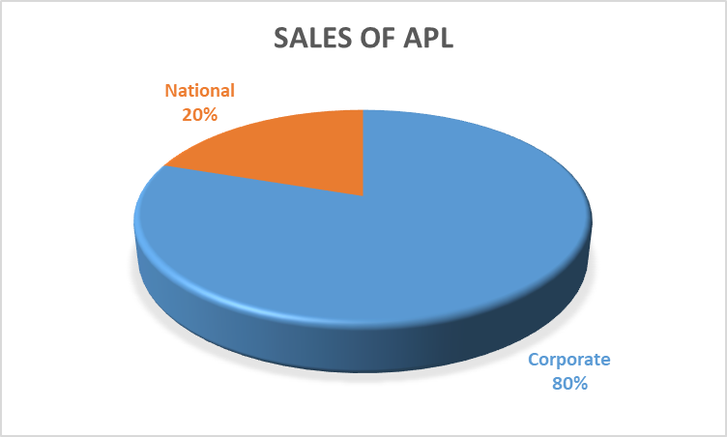
Figure 19: Customer Wise Sales
- National Clients: National Clients can be characterized as a gathering of potential clients allocated to an individual salesman at a given timeframe. In Asian Petroleum Limited various regions are given to the regional heads as per the geological limits. Despite the fact that the geographic market may have a heterogeneous blend of both existing and possible clients, a choice based on geographic inclusion has particular points of interest.

National clients are fundamentally the dealers of these territories which are overseen by the regional salesman of Asian Petroleum Limited. National clients open opportunities for APL to coordinate the business openings with the selling exertion. In Asian Petroleum restricted a specific sales representatives are given a bunch of comparative clients and possibilities for adjusting. This task without help from anyone else encourages the arranging and control of the business activities. Every territory has its own solid and powerless focuses and the board can utilize these deliberately. Deals arranging is concerning the regions made. A regional division additionally draws out a component of adequacy in the business activities. It likewise helps the evaluation of the business effort.

Product/ Service Mix

In Asian Petroleum Limited there are three types Original Equipment Manufacturer (OEM) products which are only for the corporate clients. However for the national clients there are four categories of products provided by the company which includes Gasoline Engine Oil, Diesel Engine Oil, Motorcycle Engine Oil and Transmission or Auto-Gear Oil. Under these four categories the products of Idemitsu are the following:
- Original Equipment Manufacturer (OEM):
- Honda 4W
- Honda 2W
- Suzuki 2W
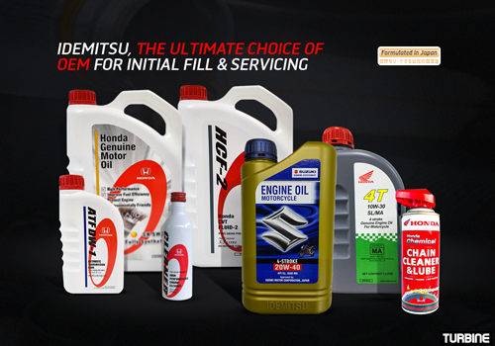
Figure 20: OEM Idemitsu Products

- Gasoline Engine Oil:

- IDEMITSU SJ/CF 20W50
- IDEMITSU SN/CF 10W-40 S-S
- IDEMITSU SN/CF 20W50
- IDEMITSU SN/CF 5W-40 F-S
- IDEMITSU SN/GF-5 0W-20 F-S
- IDEMITSU SN/GF-5 5W-30 F-S

- Diesel Engine Oil:

- IDEMITSU DIESEL CF 20W-50
- IDEMITSU DIESEL CF-4/SG 15W-40
- IDEMITSU DIESEL CH-4/SJ 15W50 S-S
- IDEMITSU DIESEL CI-4/DH-1 15W40

- Motorcycle Engine Oil:

- IDEMITSU 4T SL/MA 10W-30
- IDEMITSU 4T SL/MA 10W-40
- IDEMITSU 4T SL/MA 20W-50

- Transmission/Auto-Gear Oil:

- IDEMITSU ATF
- IDEMITSU CVTF(4L*6)
- IDEMITSU GEAR GL-5 140 (4L*6)
- IDEMITSU GEAR GL-5 80W90(1L*24)
- IDEMITSU GEAR GL-5 90 4LX6
- APOLLOIL WHEEL BEARING GREASE NO.3
- Daphne Grease NO2

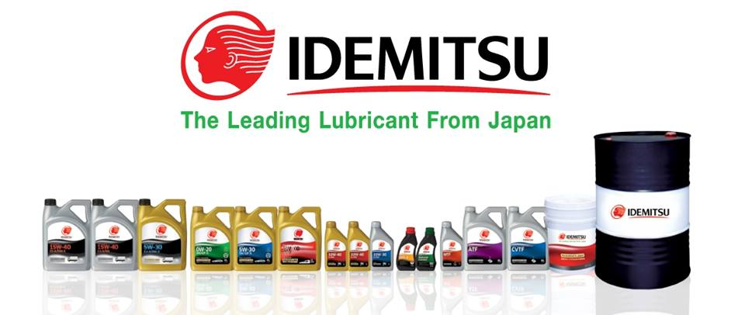
Figure 21: Idemitsu Products

Operations
The operation of Asian Petroleum Limited-Idemitsu Lubricants Bangladesh is being provided department wise. Here the department wise whole operation of Asian Petroleum limited and how they function as a company has been briefly discussed:

- Finance & Accounts:
Organogram followed by Asian petroleum Limited: Though Asian petroleum Limited is a limited liability company that’s why Managing Director is the head of every individual departments. Under MD in Finance & accounts department; deputy manager, assistant manager & executive works on that department.
Assistant Manager

CFO

Managing Director

Manager

Executive

Figure 22: Finance and Accounts department hierarchy

Activities of Finance & Accounts Department: In Asian Petroleum Limited the functional activities of maintaining books of accounts are directed in two ways which is given below:

- Tally software
- Payroll sheet
On the other hand, the core functions of Finance & Accounts department are basically posting of various transaction to Tally software. Then fund approval & approved management and finally preparing voucher. In Asian petroleum Limited there are various types of voucher system to incorporate with all the works they do day to day which are significant in their own manners. These systems are basically the work they do on a daily basis or sometimes once in a month. These vouchers can be entered in by the ERP system of the company. The list of these systems includes:
- Advance receipt from clients.
- Payment to parties.
- General expenses
- Fixed assets purchase
- Cheque issue system
- Petty cash system
- Voucher preparation system
- Intercompany transaction system
- System of advance to employee
- Bank deposit system

Cash/Credit Sale System: The basic procedure of cash or credit sales has been given below:
1. Received Purchase Order from Customer

2. a. Cash
2. b. Credit

3. Calculate the amount & Specify payment procedure

4. Deposit the amount and place a final order by customer

6. Send a delivery order to Showroom

5. Prepare Invoice

7. Received delivery order from Head office

Figure 23:Cash or Credit sales system

- Admin Department
Organogram followed by Asian petroleum Limited: Organogram of administrative department consists manpower like senior executive, executive & technician Though Asian petroleum Limited is a limited liability company business Managing Director is the head of every individual departments. Under MD in Finance & accounts department; deputy manager, assistant manager & executive works on that department.

Managing Director

Senior Executive

Executive

Technician (Cleaner, Driver, Polish man)

Figure 24: Admin Department hierarchy

Activity of Admin Department: The prime functions of the Admin Department are basically maintenance of inventory, check Log Book and utility Bill Register. One more function is to maintain the book of product information file.
- Sales Department
Managing Director

Director Operation

COO

Head of Sales

Executive

Figure 25: Sales Department hierarchy

Activities of Sales Department: The sales department is the heart of this organization and without their continuous support it is not possible to achieve the desired goal for this organization. The sales department puts up all their effort in making the business successful by maintaining relation with the customers and the list of some of the core functions of this department has given below:

- Searching customers.
- Discussing with customers.
- Making good relation with customers for making sales to customer.
- Negotiating pricing.
- Taking necessary step for selling.

System of Selling: How the sales department works or how they sale; the process of selling system has been provided.
Greetings

Attract customer via advertisement & other means of communication
Attracted them by giving different type of offer and promotion.

Make personal contact

Negotiation about price
Collecting corporate information all type of customer

Conversation about Selling

Send to (CR) for rest Procedure

Figure 26: System of selling process
- Information Technology (IT):

Manager

Senior executive

Figure 27: IT Department hierarchy

Activities of IT Department: The core activities or the function of IT department in Asian Petroleum Limited are giving hardware and software support, also providing network support, and most important thing is to purchase of IT related assets.

System on IT’s Assets Purchase:

Receive requisition

Circulate Quotation

Vendor Selection

Approval of authority

Give work order

Receive item and payment bill via Accounts &
Finance

Figure 28:Asset purchase system in IT

- HR Department:

Managing Director
Senior Executive

Figure 29: HR Department hierarchy

Activities of HR Department: The basic function of HR Department is to maintaining the leave register, employee information file and attendance registers (digital). These three things are the prime things which are maintained on a daily basis in this department. Again, Maintain & update employee’s file. arrange meeting as per management requirement, maintaining & coordinating inter-development communication and preparing payroll; all of these are the day to day activities of this department in this organization.

Process of recruit:

Raise requisition from concern department

Approval by board of directors

Advertisement

CV collection & selection

Call for written test

Successful candidates are called for interview

Select & send appointment letter

Collection joining letter

Probation period permanent for a certain time

Figure 30: Process of recruit by HR Department

- Supply Chain Department
The supply chain department in this company is constructed with just two people and by the support of others they run this department. So, basically, there are not too much information about this department that can be disclosed. However, the importing process of lubricants by this department has been provided.
Process of Importing product:

Requisition received

Order placement

Performa Invoice (PI) received

L/C opened at bank and send to Importer

Received Bill of lading, Commercial Invoice, Shipment document etc.

Unloading the ship at port through C&F agent

By transport goods are store in Showroom/ warehouse

Figure 31: Process of importing

SWOT analysis

SWOT investigation indicated an associations openness and potential in context of its strengths, weaknesses, opportunities and threats. It additionally encourages an association to choose about their current presentation and steps need to take to exist in the serious market. the SWOT investigation of Asian Petroleum restricted has given underneath:

Strengths

- Strong product portfolio: The product portfolio has continued to grow larger and stronger with brand lubricants import for customer. Day-by-day the lubricant market is going strong and competitors of Asian Petroleum Limited has increased. There are so many competitive brands in the market that Asian Petroleum Limited has expanded its product line and now they are importing more types of products for the customers. Customers for this market are now searching for alternative and low-price lubricant in the market. Idemitsu is providing low price product with a quality exceptionally high. This value pricing is attracting the customers and the increasing product portfolio is attracting new customers in the lubricant market. As of these reasons this is one of the core strengths of Asian Petroleum Limited.

- Net income is increasing: Asian Petroleum Limited has a rising net income in the past few years. It can be seen that the growth of Asian Petroleum Limited has risen high in the last five years positively. This is because of the expanding business extensive business proposition of the Director Operation who is the in-charge of the whole business operation. This huge growth over the last five years happened because of the increased net income which is one of the strengths which is making the company to move even further.

- Country of origin: Country of origin has been distinguished significantly in the market of Bangladesh which prompt that may be utilized by worldwide advertisers to impact customers valuation of the brand. In Asian Petroleum Limited the products they provide are Japanese products which in turn creates a brand image in the mind of the customers for the company. As Idemitsu products are from one of the leading lubricant industries in Japan, the customers are naturally attracted because of the country of origin
Its impact on buyer discernments, influence and social goals has been broadly recorded, in light of customer reviews and lab tests. Regardless of this exact proof, it is contended that country of origin is a great influencing factor among numerous extraneous which sustains the shopper in a genuine buying decision. For Asian Petroleum Limited as it has a strong country of origin for the product it can be used as a great strength for increasing the selling.

- Customer focused management: Customer oriented management is imperative for every companies in conveying a prevalent client experience. Asian petroleum Limited has a strong management which is in literal term can be called a customer focused management. The management here are always trying to find new ways how to make their product more exclusive for their customer which has resulted to increase the sales in the earlier years of the business. A few examinations found that a viable correspondence, solid administration responsibility, and chance to learn are factors that influence representatives' capacity to offer good types of assistance. Moreover, Asian Petroleum Limited got a management which is customer oriented and this quality of a management that lead into consumer loyalty. The utmost goal is the customer necessities which makes a fine strength for this organization in the long term to sustain in the lubricant business.

Weaknesses

- Weak internal control system: In Asian Petroleum limited the internal control system is not up to the mark as it should be. As a result, absence of worker observing is a danger frequently connected with inner controls which is weak in some prospects. Indeed, even with a compelling internal control system, dangers can happen if employees aren't intermittently observed. Customary audits and assessments ought to be essential for an inside control framework. This incorporates spot-checking exchanges to decide whether employees here agree with guidelines and rules & policies of APL. The auditors should likewise watch out for financial statements, continually searching for inconsistencies or sporadic movement. Administrators can likewise perform shock money and resource checks, considering employees answerable for any errors. But in the event that a company finds there are mistakes in its fiscal summaries, there may be an issue with the company's internal control system. It happened in here for sometimes and this need to be rectified as early as possible. One essential thing of internal controls is the guideline of detachment of obligations. This implies that various representatives handle various regions of the bookkeeping obligations. On the off chance that in Asian Petroleum Limited only one financial manager handles all obligations, it is an indication of a powerless internal control system. Whenever mistakes happen in the financial reports, company should investigate the bookkeeping methodology which is being implied. So, these things are a big draw back for Asian Petroleum Limited.

- Limited sales resource: Sales can change a ton relying upon what a company is selling and who they are offering to. Though Asian Petroleum Limited is growing its product offering yet their resources are very limited. This organization's business people who sell well and arrive at their objectives in a single territory, for instance, those dealing with new business deals, may not be as fruitful in a situation where they are offering to long haul clients and customers. Again, rather than boosting deals, the sales persons are more centered around client support which is cutting out the resources inefficiently which should not be done in the first place.

- Absence of marketing department: A marketing department is definitely not a misuse of cash! Indeed, it is the most ideal approach to make a ton cash and great marketing can take an organization to another level. But here in Asian Petroleum Limited there is no marketing department working for the promotional activities for the company. It isn't the solitary brands' acknowledgements; however, it is capacities and cycles of cross-disciplinary cooperation to accomplish better return and great financial advantages, also it is important for brands image to grow. But not having marketing team is a going to hamper Asian Petroleum Limited in the long run, it also states zero spotlight on regional and regionalization, item and brand the executives, and market-section the board. Additionally, APL won't set up a grid association comprising of both item and market administration which can turn out to be a loss in future.

Opportunities:

- Increasing market demand: The demand of lubricants is expanding altogether in the current market of Bangladesh. Asian Petroleum Limited is looking forward for the high demand in the market for the last few years, thus, it is planning to increase its product line according to it so that they can provide the customer need in anytime they demand for those particular products. This increasing demand in the market has opened the doors for Asian Petroleum Limited in many ways. That is why this makes an opportunity to expand the business for lubricant furthermore.

- High profile customers: Asian Petroleum Limited has some very high-profile customers who gives the core business return to them. There are these clients who only has high demand for the lubricants which are only provided by Idemitsu. These products are called OEM products and these high-profile clients are corporate client which includes Bangladesh Honda Private Limited (BHL), Rancon Motor Bikes (Suzuki) & DHS Motors Limited. These clients of Asian Petroleum Limited vary from customer markets in a few regards. Since the clients are big organizations, they general are bigger purchasers than small enterprises in the lubricant market. Thus, it creates a market opportunity for Asian Petroleum Limited.

- Pricing: Asian Petroleum Limited is providing and marketing their product at a very low price comparing to all its competitors. Idemitsu products are being manufactured in Japan for over 100 of years and it is one of the Japan’s leading lubricant oil. So, it indicates the product quality of Idemitsu Lubricants. With this high grade of lubricant quality APL sets out the price very low in the Bangladesh market. The price of the lubricants for the same product line in the market is very high comparing to the products of Idemitsu. The customers expect that they are getting premium items at the price which is worth of money. So, Asian Petroleum Limited-Idemitsu Lubricants Bangladesh has an upper-hand in case of the pricing which creates a fine opportunity for the company.

Threats:

      - Governmental regulation and policies: Governmental regulation and policies can significantly increase costs and affect how company does business. Foreign organizations who provide quality products are permitted to offer assistance in Bangladesh besides in areas that are dependent upon authoritative authorizing measures. However new businesses face critical limitations concerning most managed business fields and the cycle for setting up legitimate substances such exchanging business is dependent upon exacting administrative necessities. Asian Petroleum started its journey in Bangladesh not long ago and as of an importing business they are facing a lot of restrictions from the government. They are facing licensing trouble in some of the areas and they are using alternatives sources because of it. There have been reports that licenses are not generally granted in a straightforward way. Move of control of a business from a foreign company needs earlier endorsement from the public authority of Bangladesh. Moreover, in Bangladesh corruption is there in every corner of the city where anything from the outside country is being imported which turns a genuine obstacle to bringing in products in Bangladesh. While the public authority has set up enactment to battle pay off, theft, and different types of defilement, authorization is conflicting. Thus, this becomes a tremendous threat while conducting business for Asian Petroleum Limited.

      - Competitive market: The market of lubricants in Bangladesh is very much competitive right now as there are a lot of big fish in the market who are moving forward with a high pace. There are a lot of brands of Lubricants already holding a strong position in the market and comparing to them Asian Petroleum Limited-Idemitsu Lubricants Bangladesh has just started to learn the ropes. Though Asian Petroleum Limited caught up with the pace of this lubricant business and it be frank the business they have done in the last few years, in a nutshell, they are good at it. But looking at the market competition it is also hard to make a strong position in the market for them. As of today, this competitive market is a direct threat for Asian Petroleum Limited.

      - Fluctuations in interest rate and tax rate: Fluctuation in interest rates and tax influence prime rates. This rate is the most reduced at which banks will loan cash. On the off chance that the loan fees go up, at that point the interest rate goes up too. While the interest rate fluctuates, the banks will expand charge card rates and credit rates making it more costly for organizations to acquire the assets they need. This will influence the matter of Asian Petroleum Limited straightforwardly from various perspectives and it will hamper the extension of business. To consider Asian petrol Limited, it will take much more to take care of obligation and they should pay more cash when loan fees increment. Also, an increment of the tax will affect the importing cost which will increase the product prices in the market of Bangladesh. So, it is considered to be a major threat for Asian Petroleum limited for doing business.

Steps/ Strategies to meet the challenges and opportunities

Strategies to meet the challenges for Asian Petroleum Limited

While conducting business Asian Petroleum Limited faces some challenges when they are still trying to make a strong position in the market. With proper planning they can overcome these challenges waiting for them in the market of Bangladesh. There are some steps and strategies to get rid of the barriers created because of situational unrests. These are:

- APL should monitor the government rules and regulations regularly. If any changes are being made then they need to be well prepared for making any changes in the trading policies for the company according to the new rules provided by the government in order to sustain in the market with a strong position ahead.
- APL must need a marketing department as there are no marketing department which is a big challenge to be able to compete with other brands in this era of marketing, thus, opening a marketing department can boost the brand image in many ways which will help to overcome a lot of difficulties they were facing previously.
- In a competitive market if APL have to create a strong position then they need to expand their product line more and they have to increase their regional grab for the market which will take some time but hopefully they will be able to make a strong hold in this competitive market in Bangladesh

Strategies to meet the opportunities for Asian Petroleum Limited
Already in the earlier part the opportunities for Asian Petroleum Limited has been discussed. As some strategies or steps need to be make in order to get a hold of those opportunities for Asian Petroleum Limited.
- In order to get an advantage out of the increased market demand for lubricants, Asian Petroleum Limited need to follow different marketing strategies to grab this opportunity. Increment of promotional activities, digital marketing, direct marketing, sales offer needs to be done and these things need to be prioritized in order catch the attention of the consumers.
- Asian Petroleum Limited has a high-profile customer base which creates a huge opportunity in order to have a grab in this lubricant market. These high-profile clients are basically the corporate clients likewise who are focused than other business enterprises. These corporate clients request high demand for the OEM products which sometimes indicates the higher market grab. This creates a sustainable opportunity for APL to expand their business in this lubricant market of Bangladesh. They can use this opportunity to market their brand image to the consumers mind and which can be used to create a genuine brand value in order to increase their business opportunities
- APL has a huge market opportunity while considering their low price. As they provide such high grade of lubricant quality APL sets out the price very low in the Bangladesh market. This creates an opportunity to attract the customers using this value pricing technique. In order to execute this, what they need are promotional activities through which they can covey their message to the customers.

Chapter-04

Internship Experience

Position, Duties, and responsibilities

Position

For the internship program I was offered the contractual appointment as an Intern under the Finance Department of Asian Petroleum Limited- Idemitsu Lubricants Bangladesh for the period of 10 November, 2020 to 10 February, 2021 (3 months). During this contract period, I was entitled of consolidated salary per month according to the company policy. My reporting authority was the Assistant Manager – Finance & Accounts department of Asian Petroleum Limited. The working hour was from 10.00 A.M. to 7.00 P.M. from Saturday to Thursday and there was a one-day weekly holiday which was Friday.

Duties

While working in Asian Petroleum Limited there were some aspects which I got to consider while I was assigned for the duties and responsibilities toward this company I am working for. Most important aspect I had to keep on my mind that, this is basically a trading company and any kind of mistake from behalf of my side will affect the reputation of my university and myself for any kind of future enrolment in here or anywhere else. So, I was very careful from the beginning in case of the job getting done. In here from the very first I was assigned in the finance department which is why my duties lied upon over and above in the Finance & Accounts department of Asian Petroleum Limited most of the times. Some of the duties I was given by the company has been given below:

Daily Collection:
My prime duty for Asian Petroleum Limited was to keep the record of the daily collection for the company. The company has the policy to give the Idemitsu products to the dealers with due credits and the dealers pay up the sum of the product they have taken in installments according to the invoices. Thus, there were daily transactions throughout the entire month of the dealers some of which are given in cash, cheques and by fund transfers. I used to keep a track of those transaction made by the dealers as a daily responsibility for me to get a clean and steady record for all of the collections. The record of he collection made daily given notification to the COO of the company who notified me through a whatsapp group and there I found all the records of the collections. From the notifications I used to check the bank statements, typically the banks are Dhaka Bank, Dutch Bangla Bank Limited (DBBL) & Standard Chartered Bank (SCB). After checking the bank statements, I get to know if the collections are being deposited to the banks or not. I had to cross check every collection from the notification from the whatsapp that if all the collections are alright or not.
Notifying issues:
While checking the bank statement and the notification from the COO there might be some error in the notification or there maybe some cheques which might have been bounced which I need to keep track off. So, basically, I had to lookout for any errors in the collections or missing notifications or any missing amount in the bank statement. If I had to found any error in the cross check, I had to report it directly to the COO who later on cleared all the issues related to the collections I found.
Giving Entries of the collection:
After I am done checking the bank statements and the notification of the collection, now it was time for me to give the entries for all the daily collection I have received throughout the day. The entries took place in the ERP system of Asian Petroleum Limited. Here I gave entries according to the bank statement as Customer Receive Voucher (CRV). These entries could be view later in the customer ledger which basically is the statement for the entries I gave earlier. It was pretty much important to give those accurately without making any mistakes in the first place. Sometimes there are issues with cheque bounce and some other missing data in the notification which I had to be cleared by the COO before giving the entries. For getting a errorless ledger I had to be certain about the entries, like which collection is for which dealers or who gave a particular amount that day, for all of the questions there were an answer to the COO as basically he got all the notification beforehand and knew who made a particular transaction for a certain amount. That is why I used to have clear picture about the dealers who are giving the money for that day with the help of other sales persons in the. As for the record, I knew that the cash collections used to enter the bank on the day they have been deposited and the cheques and the bank transfer used to take one to three working days to enter the bank. So, to be on the safe side I used to give entries in the ERP system of our company the day after the collections are deposited. By doing this I was able to give accurate entries for each collection and prepare a correct ledger for the company.
Documentation (Voucher & Invoice Creation):
I had to create voucher for all the entries I have given the ERP system of the company. Here, I had to create physical evidence for all the entries I had given on a daily basis. In this process of physical documentation which is by far one of the important tasks done by me where I had to make proper documentation for all the Customer Receive Voucher (CRV). Starting from the bank statement, then the receipt of the invoice, the screenshot of the whatsapp notification, the screenshot of the bill; all of these physical print-out need to be attached alongside the customer voucher. These documents need to be signed by the top authorities to get a proper information and sight of the daily collection. Beside these, I had to prepare some of the invoices for the clients and these invoices are used to be the main document for distributing the product to those particular clients.
Petty Cash Management:
In Asian Petroleum Limited, as this is a trading company calculation of expense on a daily basis is utter important for the management to keep a track of short-term expenses. For the company, I was assigned the duty to keep a record of the petty cash for the company and maintain an excel file for it to update the expense regularly. It gave a clear understanding about the short-term expenditure of the company and the admin group and the audit team was in constant touch with me while I was preparing this petty cash as the office day to day expenses were included in this petty cash management.
Bank Reconciliation:
I was given the task to do the bank reconciliation for the company for both Dhaka Bank & DBBL. At first it was a enormous task I thought, but when I continued doing it, I got a hand for this in someway that I never did it before and this exploration of finding new ways of doing reconciliation were unknown to me up until I was taught how to do it by my supervisor in there. He had shown me the simplest way of doing it and it made me learn sorting out bank statement with company ledger. Then checked if there was any error or missing entry in the ledger or any missing amount in the bank statement.
Weekly and Monthly Report:
In Asian Petroleum Limited each Saturday need our finance and accounts team need to give a weekly report to our Managing Director which includes the expense for a week, the net sales for the week, the volume or the stock we had in our inventory. This was a weekly briefing which I need to cover for the company and I was assigned to do it. As for the monthly report I helped the Assistant Finance Manager for the completion of the month end report where the most important part I helped him doing was making the profit & loss statement (P&L statement). These reports helped the top authority to know about the current state of the company and what to do next for the upcoming periods.

Responsibilities

For the most of the financial and accounting works I tried to do my duty at the very top-notch level and thus, it gave me a lot to responsibilities as well. Most of the entries I gave for the company was very much important for the book keeping for the company. Here the ledger was completely depended on me as the entries were shown as ledger in the ERP system. The COO & other top authorities used to check it on a daily basis and this was very much important for the sales team as well because it was showing who had sell more over one another. I was fully responsible if any entries were entered inaccurately. As for creating the documentation and all other vouchers I had created, this impacted the audit for the company, so, I had to be very careful about every document were signed properly or not or if there were any mistakes in creating one. For most of the parts, I was responsible for any miscalculation in the ledger or any sales report in the ERP system as I was the one who had been given the job to put all the entries and make a proper assessment for the collections I had made. If any errors were to take place in the ledger or the bank statement it was my responsibility to report it to our COO of the company and get it fixed as soon as possible.

Training

The internship period is very much limited to get a proper training in this corporate field. Although the time was very limited for me in there but I got the proper training in this short amount of time just because I got some of the most experienced people around me to guide me through. The very first lesson I got was from the assistant finance manager to learn how to do a proper evaluation while giving entries and preparing documentation. The one thing I learned here helped me here doing the job more effectively and that is being thorough for all the daily and monthly transactions are being made and double-check them before getting the approval for it from the upper level. I was learned how to input daily cash expense into the company’s system and how to put the data of bank charges into the system alongside with other vouchers by my supervisor in there and he taught. After I was able to give the entries for vouchers then I learned how to make a cash expense statement for the month for a company by keeping a record of all the daily expenses of the company. My supervisor taught me how to give entries of many financial transaction for the company and keep a track of debit and credit for both the company and the banks. Learned how to prepare an invoice by using the software system of the company and keep a track for the transaction. Got the proper training for preparing the graphs and chart for the financial data of the company and prepare a presentation to present it. My time here was very much limited but precious as I got to learn a lot from my seniors in here who have enormous experience in this corporate sector. This learning was something which will help me in every way possible in near future.

Contribution to departmental functions

All through the program for internship was just lasted not more than three months, but, I attempted to provide my insight and effectiveness to every division I was appointed, while I had involvement in some of the departmental functions, I was constantly developing myself so I can offer more to my allocated offices. I was purely committed to my duty and did my very best to had some contributions to some extent to the departmental tasks. The commitment on every division I had the option to give are momentarily portrayed beneath:

Finance & Accounts Department:

For the most of my time in Asian Petroleum limited as an intern I was somehow directly & indirectly involved in all kinds of financial and accounting activities of this company. I helped in making the ledger for the company which is one of the most important part of this department. I helped my seniors in this department by providing proper data while they were making any financial reports. Whatever data I inputted in the ERP system of the company, all of those data were extremely crucial for the auditors to audit properly and for the finance & accounts managers to get them in a proper way to create internal reports. The invoices I made during my time there helped the department to get some ease of doing work with less pressure, this impacted the efficiency in a positive way and all the other executives were more efficient in this manner. I tried to do the documentation as proper as possible so that this could help the accounts department to follow up on their past data without any hassle. Before I came in here the documentation was not proper at all, thus it affected many tasks while searching for past data, but, as I started doing it on my own way it become easier for the finance and accounts department to get a grab on the internal data, they lookout sometimes. I helped my seniors in here for doing the salaries of all the personnel and I cross checked every factor that could affect anyone’s salary. I write cheques for the salary and helped my seniors to make the salary be given properly without making any mistakes.
Sales Department:

One of the core tasks for me was to help the sales persons by providing them authentic information about their sales with proper data. All the sales persons are given monthly targets for their individual sales. I always tried my very best to help them in any manner as a finance intern it was my duty to remind them their dues for the clients, or if there are any missing collection any dealer, I informed them immediately to check onto it. Sometimes the sales persons asked me to give them a customized sales report according to their needs and I made all of those reports which in turn helped them to determine which dealers of them are paying regularly and who are irregular in term of payments. Most of the time the sales team wanted me to provide data which they want and I always helped them with those tasks. I reminded them their remaining target sales and notified about the deadline if any targets were not fulfilled. This helped them to know about their current whereabouts and made them efficient to do their job in time with utmost effectiveness.

Supply Chain Department:

In the supply chain department, I learned a lot from the Assistant Supply Chain Manager and I helped him with some of the works. I double-checked the LC documents as he prepared them and notified him if there were any mistakes in the documents he had created. I helped him creating the invoices for Daraz and it reduced the pressure upon him even if a little bit from his tasks. Sometimes I provided him information which he need in term of opening a LC and this information had to come always from my side. This helped him opening the LCs in the given time and with my help he could do it precisely within the given timeframe.

Evaluation of internship performance

While working as an intern in Asian petroleum limited, I generally made an honest effort to accomplish the work appropriately which was appointed to me yet here and there botches were made by me while working. Everyone in the office were super helpful and always guided me to do the right work and provided me valuable advices. They depicted the errands to me extravagantly and regardless of whether I commit any error they were in every case extremely strong and assisted me with finishing my undertakings. I was constantly propelled by them to proceed with my work with full excitement in light of their ceaseless help. So, the evaluation of my internship performance in there, to briefly describe it I would like to present it in a more comprehensive form which is delivered below:

Qualities:

- As an intern in that organization I liked to think myself as I was a devoted worker who comprehends my job and duties, yet the bigger mission of our business. I didn't just endeavor to manage my work, however to helped make this organization a triumph.
- In Asian Petroleum limited I used to communicate with all the people in the office properly without any hesitation and from that one thing I had learned that I was a decent communicator who remained focused and helped rally the group when collaboration is expected to fulfill a time constraint or take care of an issue. As an ambivert I did the job well done in there.
- I was an inventive individual who can think of novel arrangements and refine customary methods of getting things done. I tried to did it in my time in here.

Shortcomings:

- I was to some degree disrupted, which regularly impacts my effectiveness. I had been figuring out how to all the more likely deal with my time and deliberately direct my endeavors. While it stayed a test, but to some extent I had seen some improvement and anticipate consistently improving my internship performance.
- Then and again I didn't request help when I could be profited by help. I was continually able to help my colleagues, and I realized they feel a similar way, so I attempted to be more vocal about when I need some assistance pushing ahead. though somehow affected my performance in here, but I was able to cope up with that.

Basic beliefs:

- I had confidence in collaboration and participation to beat any hindrance.
- I esteemed regard and straightforwardness among workers and administrators.
- I esteemed fellowship and building warm connections inside the work environment.
- I endeavored to be an inviting and accommodating presence to my colleagues.

Achievements:

- I never missed a cutoff time in the previous year and, indeed, frequently presented my work early.
- I had blown away my expected set of responsibilities to guarantee our group works at an ideal level, remaining late and helping other people at whatever point it could add to our aggregate objective.
- I made and conveyed an introduction, venturing outside my customary range of familiarity to do as such. It was generally welcomed and supported my certainty with respect to public talking.

Skills Applied

Despite the fact that as an intern with three-months period I got exceptionally restricted time for implementing some sort of skills, I generally attempted to apply the abilities I have acquired at Asian Petroleum Limited, my workplace. I'm generally a snappy student and during the temporary job time frame, I basically attempted to adapt rapidly the guidance they gave me with respect to my duties and responsibilities.

I was very good at communicate with people from the very start. This relational ability of mine helped me through my internship program a lot as I was in constant touch with all the people working in the office and communicating with them the whole time I was working there. This set of skill helped me to get messages precisely to and from others by talking or recorded as a hard copy, without misconceptions. I had this skill and I knew I was very good at it. So, there it goes, it really helped me to connect with everyone in the office very easily and got to know them really quick. I got an enthusiastic insight – or the capacity to perceive, comprehend and deal with your own and others' feelings, and use them decidedly to accomplish the ideal results. This particular skill, I had it from my university life and used it there and then again, I used it in my internship period also. This skill helped me to solve any issue others were carrying around. I could solve it by providing them with ideal solutions.

I was always good at group working. Capacity to work with others in gatherings and groups, both formal and casual were always my strong side. Not every person is needed to work in an affectionate group in spite of the work type—however the capacity to work well in a gathering is a fundamental expertise in many positions and I had shown really good team work in my internship performance.
During my internship period I had to do a lot of work using the Microsoft office suit and I was very proficient in it so it made my job more approachable in all the manner. I had used these sets of skill the most and the outcome of it was very pleasant which made my superior quite happy while I was providing them the daily and weekly reports. All the skills I applied it constructed my work there much compelling and it made me learn a lot about the environment of professional workplace which will help me with my forthcoming career.

New Skills Developed

During my internship position period, I got a few chances to grow new abilities. Even however I was acceptable at correspondence, it was extraordinary while applied that expertise in a professional workplace, how to deal with circumstances while doing. I got the opportunity to find that quick learning capacity from that point. But the most important sets of skills I got to acquire and developed was to be dependable, reliable and faithful which is considered the emotional skill and needed in every workplace to get a sustainable position.
While I developed those skills, before that m importantly, doing what I say I will do implies being coordinated, and dealing with my time successfully. I need to realize what amount of time things will require, and that I had the opportunity to do them to the necessary norm. I likewise should have the option to distinguish what to do first, so that in the event that anything was missed, it was less significant.
Nevertheless, I acquired of being dependable likewise implied being reliable and faithful also. For instance, that may mean not going home when things actually need doing. What I learned and developed from there was reliability and uprightness were the two pieces of self-guideline or self-administration, which thusly was a significant piece of passionate insight. Self-guideline implied that I had the self-control to do things that I might not had any desire to do, yet which I know were important.
Something else which is some sort of different type of skill one could presume is that individuals who were self-controlled and dependable assumed liability for their own activities and guarantee that they satisfied their qualities. They monitored cutoff times and convey to them without waiting be pursued up. Moreover, being dependable didn't, nonetheless, implied that I need to do everything myself. Now and then, it might mean requesting help when I saw that I might not had the option to comply with a time constraint in any case. The last component I acquired of being dependable was utilizing my drive to distinguished where work needs doing, and getting on and doing it.
In my time there I learned a lot of things besides I developed some skills and these learning could develop my perception and myself for the subsequent jobs. My supervisors and other seniors taught me about readiness to learn. From them I have learned and developed this readiness to learn. What I learned is that it implies being available to groundbreaking thoughts and encounters, and continually hoping to improve my abilities and information. In some cases, this was alluded to as self-improvement, yet that term was additionally utilized for a more conventional cycle, of objective setting, activity, and reflection. Regardless of whether I decided to make my learning interaction formal or casual, there was no doubt that the cutting-edge world requires we all to consistently refresh and change our abilities.
Something valuable I had discovered that innovation was a consistent in many working environments and the most significant representatives were the individuals who embrace individual innovation and perceived that it offered a larger number of chances than dangers. Managers by and large need individuals who were strong, versatile and adaptable; another vital piece of self-guideline and enthusiastic knowledge.

Application of Academic Knowledge

In a corporate field it is very difficult to exercise your academic knowledge into professional environment which is a well-known fact to be precise in our competent ambience. However, there were some circumstances where I got to display my academic knowledge within an explicit framework. I got a pretty good idea about our academic learnings which I tried to utilize throughout my internship program, while I was able to use some of the insights of my academic expertise which I had learned during my time in UIU.
While I was working in Asian Petroleum limited as an intern I used to do bank reconciliation for the company and this was something important I had learned in my major courses in finance. I was able to use my knowledge from the earlier university days learnings into the corporate field and I did it quite successfully. The bank reconciliation was a very essential part to be sure about whatever I entered in the ERP system of the company were accurate or not. It was the way I could be sure of being impeccable at my job in there. This was one of the most useful things which I think every other finance background student need to be learned thoroughly in their universities.
In my internship program, I used to make a lot of reports for both financial and sales purpose. Some of my knowledge from my academic were put into practice while I was preparing those reports. My academic knowledge from earlier student life helped me through those times and I learned the Microsoft office suit during my student life and this really helped me bunch. I was able to complete any reports or tasks given me in form of using Words, Excel or PowerPoint. I tried my best to use my academic knowledge during my internship period. In some case, I think I was undoubtedly successful.
One important thing I had learned during my internship program was that the academic knowledge doesn’t mean to always teach you the work or the task you will use in your professional career, but this academic knowledge tries to teach you the discipline you need in a professional environment. For me I think that is the most important knowledge one can gain during their student life.

Chapter-05

Recommendation

Recommendation for improving departmental operations

As I had worked in Asian Petroleum limited as an intern, but I tried to make the best of my time in there and I had observed that this company might need to change some of their work pattern to make the departmental operations more functional. Beneath here I have given some recommendation according to the departments:
- Finance & Accounts Department:

- Significant accounting policies was not maintained as par IAS. Thus, management should take proper initiatives to prepare and follow Financial Manual.
- In Asian Petroleum Limited there weren’t any supporting document on Loan to director transaction, so, every transaction should be supported with relevant and sufficient evidence. Net amount of loan should be calculated and evidence.
- What I have seen that advance against sales commission had not adjusted since long which is impacting the sales that is why advance sales commission, measures to auto adjustment period should be introduced.
- In order to cup with competitor’s business an efficient senior executive should be introduce who supervise executive and control whole department smoothly more than before.
- While working with the ERP system one thing I have noticed that the actual balance of accounts receivable was not shown in ERP software. That is why I think System should be like that I will able to identify receipts for sales and receipts for advance separately so that the actual figure of service/product to be delivered is detected in a much hustle-free manner.
- Negative Bank balances was shown ERP software for Asian Petroleum Limited even though it was not possible at that time that is why I think management should scrutinize the issue and make necessary step to regularize issues as early as possible.
- Ledger balance did not match with MD sir’s approval. The management should take necessary step regarding this issue.
- Salary & Allowances expenses was not incurred but had not been shown as expenses on Auto imports ltd. Thus, salary & Allowance should allocate rationally.
- Whereas other competitors of Asian Petroleum Limited provided “Provident Fund” & “Group Insurance” facilities to the employees, Asian Petroleum Limited didn’t provide that facility. Management should introduce “Provident Fund” & “Group Insurance” facilities for the employees.

- Admin Department:
- Concern department should maintain log book, movement register and utility bill register properly. Registers were not maintained by Asian Petroleum Limited. Management should introduce all of these registers.

- Sales Department:
- Organization should maintain a register for information including customer satisfaction.
- Management should arrange performance evaluation at the end of particular period.

- HR Department:
- No performance evaluation report is prepared for measuring effectiveness and efficiency of the employees in case of promotion. That is why performance of the employee cannot be justified as well as create employee dissatisfaction. So, I recommend highly that performance evaluation report should be prepared in case of promotion.

Recommendations for improving self-performance

As I was working in Asian Petroleum Limited, I likewise discovered that there are some aspects which I need to consider to improvise myself as the best version of me following the upcoming term of my life. Fundamentally, there are some modifications that need to be done for myself. The impediments I confronted and the suggestions for improving my self-execution I accept ought to follows are portrayed beneath:

- I might want to keep building up my introduction and public talking abilities. As a shortcoming that I recorded on past self-appraisals, it was satisfying to see that I have gained some ground on this range of abilities and I might want to twofold down on the development.
- Regarding proficient development, I seek to enter an administrative job. I appreciated working intimately with my colleagues and thinking about the master plan, and I regularly helped direct assets in a productive manner. I could consider myself to be an influencer who encourages collaboration and urges others to put forth a valiant effort.
- My supervisor in Asian Petroleum Limited was charming and straightforward. I never need to think about where I stand. I appreciated the receptiveness and direct correspondence so I realized what was anticipated from me and how well I was meeting those assumptions.
- I might want to be more engaged with dynamic at the group level. I accepted each colleague had extraordinary bits of knowledge that managers can't completely comprehend since their point of view was unique, and now I think including staff individuals in essential arranging could significantly improve results.

Above I have discussed what precisely I suggest myself for developing my self-performance. Generally speaking, the wide range of various representatives were in every case strong and consistently gave me the chances to address my errors. Each time I committed any error they persistently portrayed me those and assisted me with distinguishing my shortcomings which additionally assisted me with recognizing my restrictions and taught me how to deal with my impediments, which in turn led me to acknowledge my own abilities by myself.

Chapter- 06

Conclution

The lubricant business is possible to see as relatively few undeniable business areas similarly as parts with various lubricant oils. Concerning Bangladesh, this business can be portrayed as a market which contains very few areas like engine oil, cruiser oil, truck and significant engine oil, car oil and mechanical oil, etc. The market of car oil is a noteworthy one, anyway the customers are for the most part using the generous engine oils for the vehicles. Two or three worth lubricant oils are also open for auto vehicles. The cutting-edge lubricant market is a by one way or another one can say a smidgen of sensitive, where the use of recommended oil is required, which is solidly coordinated by the originators. So, basically, this was a sector where I felt privileged working and beside so many qualified co-workers were there to assist me in every way possible.

I can't say it some other way around, in any case, the first time through is in every case exceptional I have heard once and I think there is no uncertainty about the statement that it is valid. This internship experience was the absolute initial step for me to get a closer look on the corporate life. I became more acquainted with the genuine importance of being proficient and being a part of something significant. It was an encounter which has shown me numerous things which I can't fail to remember while I will develop my vocation. The time I spent here was priceless from countless angles and this will assist me with making a solid situation in my forthcoming occasions. All the events encompassing this internship program, in this short measure of time I have learned and encountered a ton about a corporate culture, how to mix in with everything or how to set myself up for various conditions. There were a few times when I believed that being professional is only easy, as when my time came and passed by, I realized that it isn't an effortless concept of getting things done without any uphill battles. When I saw the ups and downs in a few corporate events, I ended up founding the real picture of a professional field and also the surroundings where every now and then all the students need to encounter it eventually. This was a sort of involvement which was by a wide margin the most ideal approach to learn something. While working in Asian Petroleum Limited, it was vital for me as this work experience offers me the chance to assemble information about a corporate workplace, I had the option to acquire new abilities and something more than that; I precisely found the best possible version of myself by working in here.

References
GlobeCare. (2017). Lubrication system. Lubrita. Retrieved from http://www.lubrita.com/news/78/671/How-The-Lubrication-System-Works-In-An-Engine/
Hasan, M. (2019, October 14). Lube market grows by leaps and bounds. Dhaka Tribune, 1. Retrieved from https://www.dhakatribune.com/business/2019/10/04/lube-market-grows-by-leaps-and-bounds
Ineliggence, M. (n.d.). BANGLADESH LUBRICANTS MARKET - GROWTH, TRENDS, COVID-19 IMPACT, AND FORECASTS (2021 - 2026). GROWTH, TRENDS, COVID-19 IMPACT, AND FORECASTS (2021 - 2026). Retrieved from https://www.mordorintelligence.com/industry-reports/bangladesh-lubricants-market
Jim Fitch. (2002, November). The Role of Lubrication Management Professionals. Machinery Lubrication. Retrieved from https://www.machinerylubrication.com/Read/413/lubrication-professionals
Rahman, N. (2020, October 23). Lubricant Market in Bangladesh. PRITIBD. Retrieved from https://pritibd.com/market-research/how-to-top-market-and-corporate-research-companys-in-dhak-bnagldesh/
Saha, S. (2014, July 8). Growth Forecast for Bangladesh Market. Lube Report Asia. Retrieved from https://www.lubesngreases.com/lubereport-asia/growth-forecast-for-bangladesh-market/
Sambit.K. (2020, July 19). Bangladesh Lubricants Market 2020-2024 | Latest Industry Updates, Projections, Consumption Analysis, Investment Cost, Profits Data Forecast to 2024. Primefeed. Retrieved from https://primefeed.in/news/607134/bangladesh-lubricants-market-2020-2024-latest-industry-updates-projections-consumption-analysis-investment-cost-profits-data-forecast-to-2024/
Wing, L. A. (2015, December 13). Market Insight: Lubricant Industry. Light castle Partners. Retrieved from https://www.lightcastlebd.com/insights/2015/12/market-insight-lubricant-industry

