

Internship Report
On
Management of Customer Insights: A Study on Nestle Bangladesh PLC

Course Code: INT4399

Submitted to:
Muhammad Hasan Al-Mamun
Assistant Professor, School of Business & Economics
United Internal University

Submitted by:
Faiaz Araf Ahmed
ID: 111201144
BBA Program
School of Business & Economics
United International University




Management of Customer Insights: A Study on Nestle Bangladesh PLC

Letter of Transmittal
December 15, 2024
Muhammad Hasan Al Mamun,
Assistant Professor
School of Business and Economics,
United International University.

Subject: Submission of the Internship Report titled Management of customer Insights: A Study on Nestlé Bangladesh PLC

Dear Sir,

With due respect, I am pleased to say that I have completed my 3-month internship in the Sales function of Nestlé Bangladesh PLC, specifically within the Commercial Development Team, and have written my internship report titled “Management of Customer Insights: A Study on Nestlé Bangladesh PLC.” I have diligently followed the important instructions and standards given by you and my organizational supervisor. This report exemplifies the practical knowledge and abilities gained during the internship at Nestlé. I would like to express my gratitude for your time spent reviewing the paper, as well as for your guidance and encouragement. Considering the report, I have compiled what I consider to be the most pertinent facts to ensure the final report is as meaningful, relevant, and reliable as feasible. In conclusion, I found this study to be quite compelling and informative, which I hope will assist me soon.
I would like to express my gratitude for the opportunity to compose and present this report on the given topic, as well as for your unwavering support throughout its preparation. I am happy to provide clarifications regarding the report for any inquiries.

Sincerely yours,
Faiaz Araf Ahmed
ID – 111 201 144
BBA Program
United International University

Acknowledgement

In the name of ALLAH, The most Gracious, The most Merciful. Praise be to The Almighty, The One who has answered our prayers in a variety of ways and blessed us throughout this journey with patience, courage, and fortitude. My sincere gratitude to The Almighty ALLAH for enabling me to study, comprehend, and complete this report.
Secondly, I am obligated to my internship supervisor, Muhammad Hasan Al-Mamun, for providing me with the chance to do this internship report on a topic that has the potential to be very useful to me in the foreseeable future and for consistently and patiently guiding me throughout my journey.
I would like to send forth my earnest gratitude to Nestlé Bangladesh PLC for according to me the invaluable opportunity to pursue an internship with their esteemed organization. The degree of concern, empathy, and warm care that I gained from the Nestlé Sales (CDT) department during my time in the organization was delightful at its optimum. My gratitude goes out to my organizational supervisors, Md. Moniruzzaman Bahar (Commercial Development Manager: Coffee & Confectionary) and Halima Akter Akhi (Commercial Development Officer-Breakfast Cereals) for instructing me and for showering their unwavering support and patience towards me.
In addition, I would like to acknowledge my family for being supportive throughout the years, without whom I would not have been able to achieve the achievements that I have.

Executive Summary

This report provides a systematic analysis of Nestlé’s efforts to generate meaningful and usable customer insight in terms of their “Understanding Shopper Behavior and Preferences During Inflation” project, conducted under Nestlé Bangladesh PLC’s Commercial Development Team. The project investigates the effects of inflation on consumer buying patterns across diverse demographics and retail channels within Dhaka, aiming to help Nestlé align its strategies with evolving consumer needs during economic shifts.

The project examines how inflation influences consumer choices, focusing on four main retail channels: large and small general stores, and large and small grocery stores and modern trade. By engaging directly with customers at these locations, our team gathers data on consumer priorities, managed and visualized in Power BI for structured, real-time trend analysis.

As a Commercial Development Intern, my role includes data collection, channel segmentation, and Power BI analysis. Through systematic shopper engagement, we capture insights into shifting purchasing behaviors, segmented by retail channels to support channel-specific strategies. Power BI visualizations provide Nestlé with clear trends to inform pricing, placement, and promotional decisions.

The project underscores the importance of understanding consumer needs during inflation. By analyzing purchasing behavior across channels, Nestlé gains actionable insights for optimizing its market approach. This experience has enhanced my skills in consumer analysis and data management, equipping me for a future in commercial development with a nuanced understanding of market dynamics.

Key words: Nestlé, Customer Insight

Table of Contents
Letter of Transmittal 3
Acknowledgement 4
Executive Summary 5
Chapter One: 8
Introduction 8
1.1 Contextual Overview: 9
1.2 Customer Insight Definition: 10
1.3 Job Responsibilities: 10
1.4 Skills Learned: 11
1.5 Observed Attitudes and Gained Values: 12
1.6 Most Challenging Task Performed: 12
Chapter 2 14
Organizational Background and Industry Overview of Nestlé Bangladesh PLC 14
2.1: Nestlé Overview: 15
2.2 Vision, Mission and Objectives: 17
2.3 Brief History: 18
2.4 Categories offered by Nestlé Bangladesh PLC: 21
2.5 Product offerings: 22
2.6 Corporate Divisions and Departments 24
2.7 Functions of the department (Sales Department): 26
2.8 Operation Details 27
2.9 Market Segmentation 28
2.2.1 Philanthropic Initiatives and Corporate Social Responsibility (CSR) 29
2.2.2 Industry Overview & Competitive Analysis: 31
2.2.3 SWOT Analysis of Nestlé Bangladesh PLC 36
CHAPTER 3 38
Objectives & Methodology 38
3.1 Objectives of the Study 39
3.2 Methodology of Studies 40
CHAPTER 4 43
Findings of the Study 43
4.1 Key Findings of the Study 44
4.2 Problem Identification, Consequences of the Problem, Solutions 45
CHAPTER 5 52
RECOMMENDATIONS AND CONCLUSION 52
5.1 Recommendations: 53
5.2 Conclusion 54
References 55

Chapter One

Introduction

Contextual Overview:
Through this internship report, I present the observations and experiences firstly developed at Nestlé Bangladesh Ltd., which is a leader in Bangladesh’s FMCG sector. Nestlé Bangladesh is known for innovative products and widespread distribution networks, and it is well known for continuously adapting to the changing needs of its consumer. The company is succeeding in such a competitive, constantly changing business environment with a strong focus on elevating the quality of life of diverse demographics. Business and consumer behavior is influenced by inflation, the report highlights. Companies such as Nestlé are more dependent than ever on market-driven insights as inflation has greatly changed customer perceptions and reduced their amount of purchasing power. As part of the Commercial Development Team (CDT), the Shopper Insight Project was a core initiative to which I was fortunate to be attached to this internship. This project aims to investigate how inflation affects consumer behavior and defines Nestlé's response to these challenges. For this internship, I primarily spent most of my time collecting and analyzing primary data in the field. My duties included visiting retail outlets and distribution points like supermarkets and mobile wholesale vendors all over Dhaka to see how Nestlé products were seen, which were the best and worst performing, how the ranges performed against actual economic pressures, and how their positions changed. Directly engaging with retailers and shoppers offered a hands-on experience pinpointing the highland lows of the market. Finally, this fieldwork taps into how Nestlé sustains its competitive edge through the combination of product offerings in line with consumers' demand on the one hand and their solidity against inflationary pressures on the other. Nestlé’s Commerce Development Team is the driver of product launch & regional growth initiatives. This team keeps in good with distribution networks and gains actionable feedback through the market to make sure products resonate with local consumer needs. CDT creates strategies to enhance the positioning of products and ensure they remain relevant and reachable within various demographics through data-driven insights in projects like the Shopper Insight Project. I watched this strategic alignment in action and saw how data lead to strategy that responds to market needs and keeps brands loyal. In Bangladesh, already a highly sensitive landscape when it comes to price fluctuations and purchasing power, inflation has caused serious issues in the FMCG landscape. Nestlé provides affordable product options and optimizes the distribution that they use, as well as coming up with specific promotions. Nestlé’s Shopper Insight Project is key to this process, in allowing them to collect and analyze the data required to take consumer inspired
decisions. Through this internship, I have seen most of the concepts learnt in classrooms come to life, and I have gotten deeper knowledge on how things work in the real world. Watching the theoretical frameworks work into
Real strategies have enriched our understanding of FMCG operations inner working. This experience not only

provided me with essential skills in data analysis, consumer behavior insights, and strategic planning, but also helped me build a solid foundation of knowledge that is crucial for a career in sales and business development. This report incorporates these learnings and underscores the need for data-driven strategies to support consumer nostalgia and inflation-fueled insights to maintain market leadership and growth.

1.2 Customer Insight Definition:
Customer insight management involves the collection and analysis of data to understand consumer behaviors, preferences and motivations for business purposes and provide strategic consumer focused decisions. Serving as an important tool for Nestlé Bangladesh Limited to find out the impact on the consumer behavior considering inflation at Nestlé Bangladesh Limited. This was a data driven project finding how economic pressures impact purchasing patterns, product preferences, and spending habits of different demographics and different locations of Dhaka. The project collects and analyzes data from relevant sources systematically, thereby providing actionable insights that Nestlé can leverage via strategy in product offerings, pricing, promotions etc. to ensure conformity with changing consumer needs. In an inflation sensitive market, knowing these insights are essential to maintain brand relevance, competitive edge and consumer trust on the brand. Nestlé stays sensitive to market demands through the Shopper Insight Project, which also strengthens its position in Bangladesh’s favorable FMCG market.

1.3 Job Responsibilities:
Over the three months of my tenure in Nestlé Bangladesh PLC, I have managed to learn a variety of different skills while giving me an excellent opportunity to learn in depth about how the FMCG industry operates. It was one of the most rewarding experiences. The shopper insight project has been an incredible opportunity to learn first-hand and gain insights from the traders all over Dhaka city and to understand how the customers think and behave.
Through this incredible internship opportunity, the knowledge I managed to acquire are:
A better understanding of the FMCG industry. How for fast moving goods, having a solid distribution system is crucial and how competitive the market is with various companies constantly trying to get the upper hand in the market. I gained the ability to comprehend market patterns, competitive strategy and company growth strategies.
I have learned about whole distribution operations, how the products from factories reach our local stores all over the country. I worked closely with distribution houses and the DSRs who assigned me to take orders and submit them to the system. Kept track of the FMCG industry, trying to better understand the practices and frameworks and how they are leveraging technology to ensure maximum growth.

Doing field level work, talking to consumers, I have learned about socioeconomic behavior, consumer psychology and factors that determine if customers make decisions while buying products.
My understanding of the impact of price hike and inflation has also improved with this experience. Talking to consumers from all walks of life, I’ve heard firsthand experiences how they are struggling to make ends meet and as a result cutting down their consumption. Keeping the national level aside, I got to understand better how it impacts individuals in continuing their lifestyle.
The survey also looks for the reason for the changes in consumer choices. Why consumers prefer Nestlé’s products and why they do not are one of the key topics of this survey.

1.4 Skills Learned:
The skills that I have learned are:
Teamwork: the project was carried out with a team, which meant cooperation and collaboration among different members and individuals. With this experience I think I have learned to be a better team player with more patience and have a team mindset to do it all together to reach our combined goal.
Communication: Having to communicate with team members as well as the stakeholders of the project, I got a chance to improve my communication skills and making sure what I want to communicate is concise and clear.
Survey work: To come up with a questionnaire that answers all our questions with ease, we developed a questionnaire and then made analysis of the data collected. For this work, I’ve learned more about survey design, data analysis and visualization.
Professionalism: working in such a big name from the FMCG industry, I’ve acquired first-hand experience of the corporate culture and how these workplaces operate which in turn helped me.
build up my interpersonal skills and enlightened me about the professional attitude that is crucial for a workplace.
Emotional Intelligence: Working here has also helped me strengthen my emotional intelligence, mixing with a lot of different people in the workspace and interacting with consumers in the market, I found that it is crucial to keep my own emotions in check while also paying attention to how the other individuals are feeling. Being respectful toward their emotions and showing empathy is something that I’ve learned.

1.5 Observed Attitudes and Gained Values:
Nestlé believes in the tag line, good food, good life. While providing the people with nutritious food Nestlé ensures that they are recognized as a force for good. Nestlé globally works to unlock the power of food to enhance the quality of life for everyone and generations to come. That goal and its work is reflected in the work of Nestlé Bangladesh as well. They are very strong on their values for nutrition while also complying with all local and international policies.
In short, all in all the values are rooted in respect. Their attitude towards respecting own self, others, diversity and the future. Working with passion to come up with innovation and serving the community is a shared value reflected in the whole team and work culture of Nestlé.

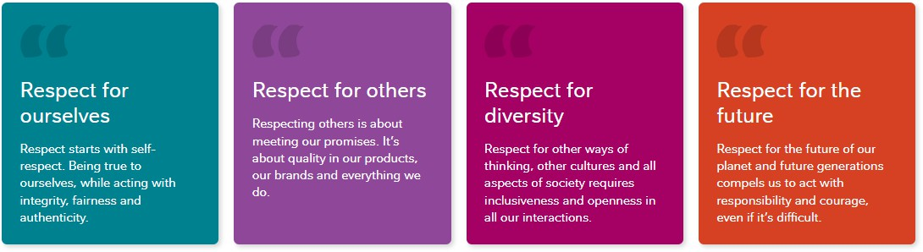
Figure 1: Core Values

1.6 Most Challenging Task Performed:
During my internship I’ve worked both in office and in field. For the project I was working on, our team was more in the field working in markets rather than going to head office everyday like the other interns. It has been
a learning experience. coordinating with distribution points and teammates have been learning experience. As we did market research, collecting primary data ourselves, the challenge I faced most was extracting responses from shoppers.
Doing market research was going to be a new learning experience, that was expected. But when doing the work, I realized many unprecedented circumstances might occur that I might not have anticipated beforehand. External factors like the weather, market condition etc. have hampered research progress. Lack of shoppers during the end of the month, scorching heat, dealing with rejection etc. are some things we learned to deal with. The most challenging part for me was convincing the shoppers to take time out of their shopping trip and take two minutes to talk to me as in most cases the people are generally reluctant to talk given that they are in a rush or have other priorities to attend to.

Chapter Two

Organizational Background and Industry Overview of Nestlé Bangladesh PLC

2.1: Nestlé Overview:

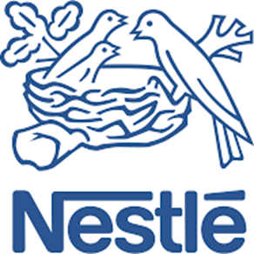
Figure 2: Nestlé Logo
Nestlé is a global leader in food and beverage innovation, renowned for its commitment to quality and nutrition across diverse product categories. With an expansive presence in nearly every corner of the world, Nestlé continually adapts to meeting evolving consumer needs. “Nestlé S.A., established in 1866 and headquartered in Vevey, Switzerland, is the world's largest food and beverage company. With a presence in 188 countries and a workforce of approximately 270,000 employees, Nestlé offers a diverse portfolio of over 2,000 brands, including household names like Nescafé, KitKat, Maggi, and Purina.” (Nestlé, 2024). “In 2023, Nestlé reported sales of CHF 92.998 billion, reflecting its extensive global reach and market influence.” (Nestlé, 2024). “The company's product range encompasses baby foods, bottled water, cereals, chocolates and confectionery, coffee, culinary products, dairy items, ice cream, pet care products, and more.” (GlobalData Plc, 2024). Nestlé's mission is to "Unlock the power of food to enhance quality of life for everyone, today and for generations to come." (Nestlé, 2024). This commitment is evident in their focus on nutrition, health, and wellness, aiming to provide consumers with nutritious and enjoyable food and beverage options. “The company operates through several business segments, including Zone North America; Zone Europe; Zone Asia, Oceania, and Africa; Zone Latin America; Zone Greater China; Nespresso; and Nestlé Health Science.” (Stock Analysis, 2024) “In recent years, Nestlé has emphasized sustainability and responsible sourcing, aiming to achieve net-zero greenhouse gas emissions by 2050. The company has also invested in research and development, with an annual investment of CHF 1.7 billion, to drive innovation and meet evolving consumer preferences.” (Nestlé, 2024).

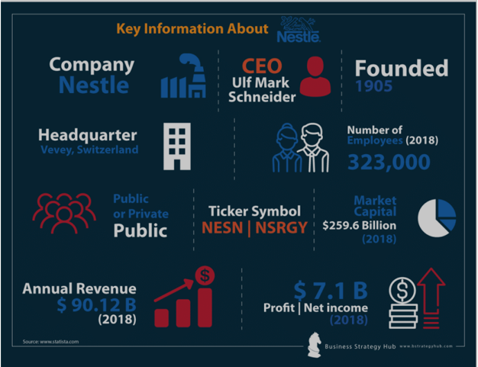
Figure 3: Source: Nestle – Dr. Myles Bassell, Official Website (professorbassell.com)

Nestlé Bangladesh PLC Address
https://maps.google.com/maps/search/Nestl%C3%A9+Bangladesh+PLC-Nestle Bangladesh PLC
In Bangladesh, the corporate office is located at:


Figure 4: Ninakabbo
Address: NINAKABBO, Level 4, 227/A, Tejgaon-Gulshan Link Road, Tejgaon Industrial Area, Dhaka 1208, Bangladesh.
Phone: 09609609222 (available from 10:00 am to 6:00 pm, Sunday to Thursday).
Consumer Engagement Centre: 08000 161271 (toll-free).
Email: WeCare@bd.nestle.com

2.2 Vision, Mission and Objectives:
Nestlé Bangladesh PLC, aligned with the global mission of the brand, works with the mission statement “Good Food, Good Life” ensuring consumers with a wide range of nutritious options for food and beverages in a mission to become the leading nutrition, health and wellness company.
The vision the company strives to achieve is enhancing the quality of life for everyone, today and for generations to come. Nestlé Bangladesh PLC is working to provide healthier lives to shape a better and healthier world. A world where a certain quality and value of life is ensured for everyone. To achieve the power of food and nutrition, the pursuit of growth is happening through rapid innovation, operational efficiency and disciplined allocation of resources.
The objectives the organization is trying to achieve can be divided into two core parts. First, ensuring healthy and nutritious options that help to enhance people’s quality of life. This is achieved through providing and developing products of the most nutritional value. On the other hand, the organization not only focuses on the healthy lifestyle today but also on the future generations. Also working towards sustainable development goals to provide a better sustainable environment and make the earth livable for the generations to come.

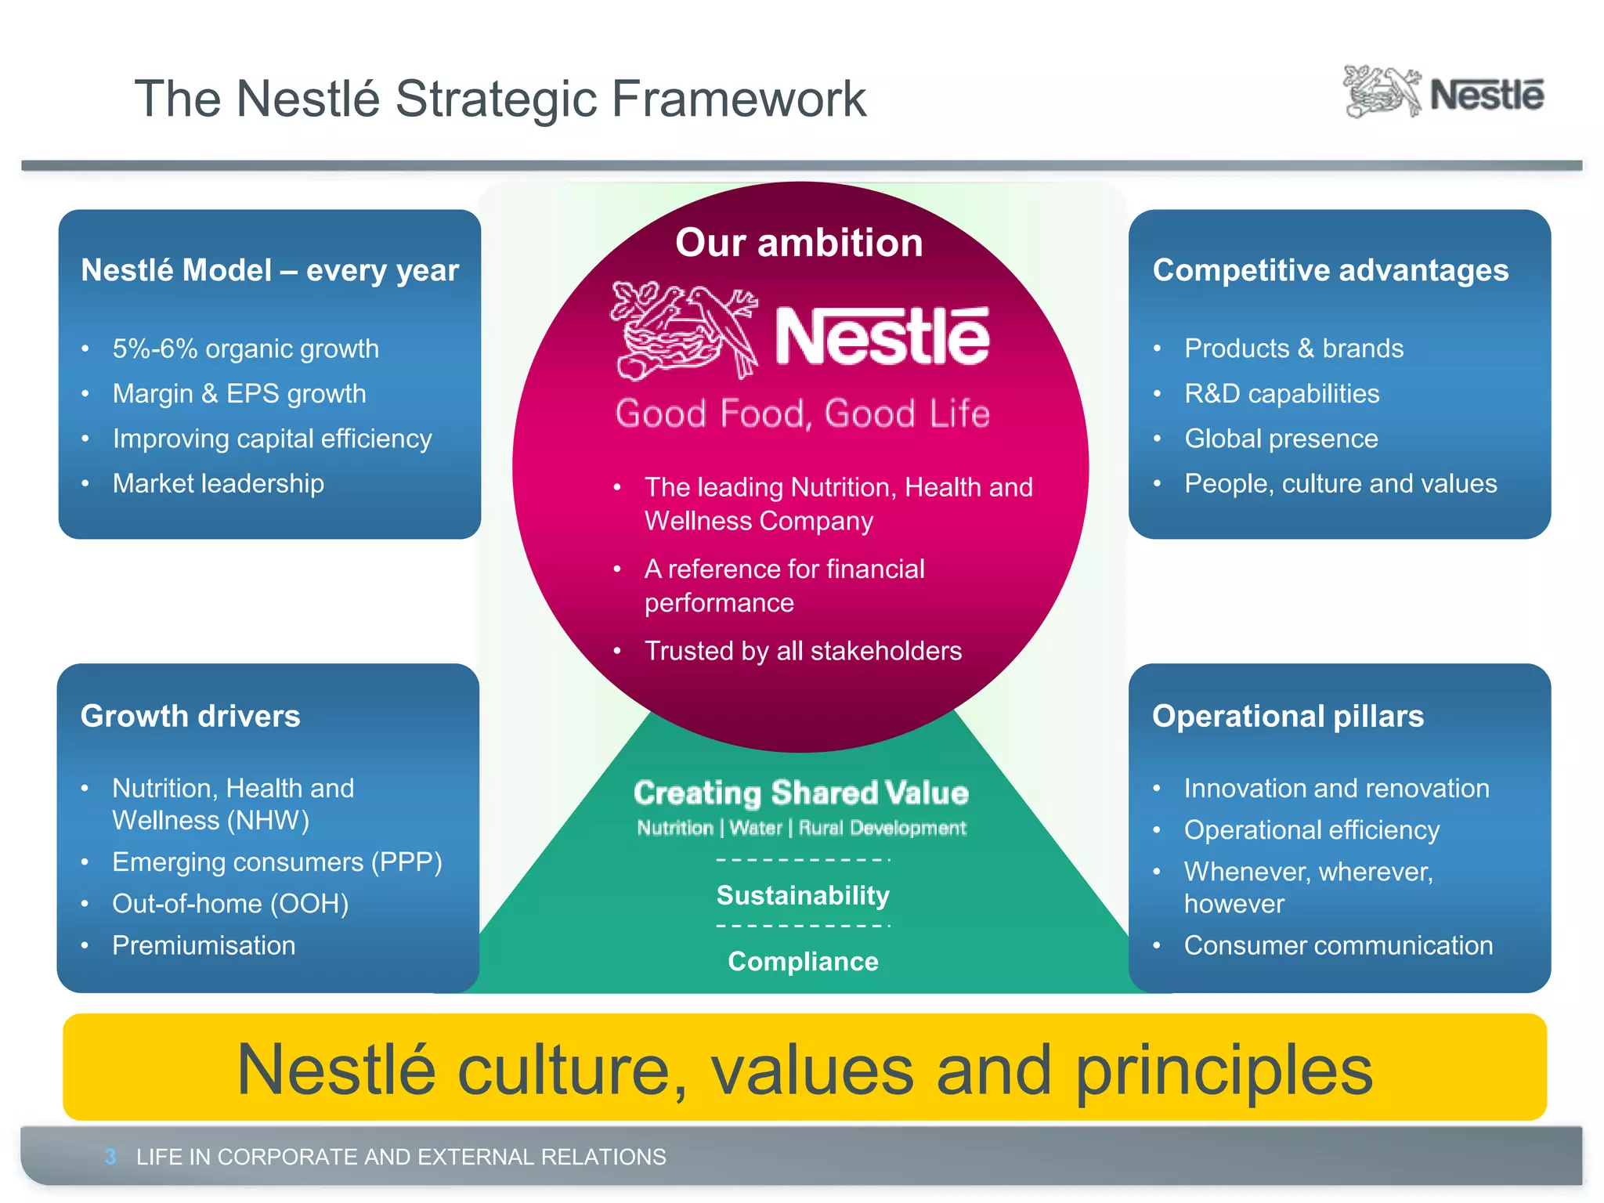
Figure 5:Nestlé Growth & operations

2.3 Brief History:
Nestlé S.A.

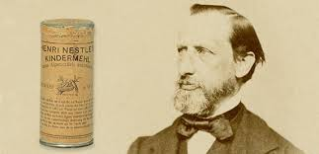
Figure 6: Henri Nestlé
Nestlé’s origins trace back to 1866, when brothers George and Charles Page founded the Anglo-Swiss Condensed Milk Company in Switzerland, aiming to provide a safe, long-lasting alternative to fresh milk. In 1867, Henri Nestlé, a German-born pharmacist, developed “farine lactée,” a life-saving formula created from cow’s milk, wheat flour, and sugar. This formula was specifically designed to nourish infants who could not be breastfed, and it quickly became recognized for its role in reducing infant mortality rates—a powerful beginning to what would become the world’s largest food company.
By 1905, the success of Nestlé’s infant formula and Anglo-Swiss’s condensed milk led the two companies to merge, forming the Nestlé & Anglo-Swiss Milk Company. This merger enables a fast-growing product portfolio and globalization. In 1929 the company decided to diversify and expand into other food types; Nestlé entered the chocolate market after buying Peter-Cailler-Kohler, the largest chocolate manufacturer in Switzerland. During the Second World War, Nestlé’s situation was most complex because supply trails were disrupted, and many global markets were inaccessible. However, probably due to these challenges, the company over time shifted its focus, targeting to sell such life necessities as powdered milk and instant coffee. During early 1930 Nestle launched a new brand of instant coffee called Nescafé and during World War II it became the major coffee brand for soldiers and civilians because of its portability and long durability on shelves. It showed the organizational strength of Nestlé to adapt to change and not limit itself to the ordinary during the worse time. The post war decades were a phase of growing, viz Nestlé acquired Maggi in early forties, providing flagship products such as instant soups and seasonings into the sweep. Nestle diversified into the world of water delivery when it acquired a range of water brands including Nestle Water. and they expanded through the 1970s, propelled by acquisition of Alcon Laboratories that allowed them to expand into heath care and entry into the pet care segment.
By 1988, the purchase of Rowntree added KitKat and Smarties to Nestlé’s already vast array of products.
Entering the 21st century, Nestlé took a decisive turn towards health and wellness, establishing Nestlé Health Science in 2007 to lead advancements in nutritional therapies. This was followed by the acquisition of Pfizer’s infant nutrition business in 2012, further solidifying Nestlé’s leadership in child nutrition. With a strong focus on sustainability, Nestlé committed to achieving net-zero greenhouse gas emissions by 2050 and began implementing eco-friendly practices across its global operations. (Nestlé, 2024).

Nestlé Bangladesh PLC
Nestlé Bangladesh started as a joining venture with Transcom limited in 1992 with a view to providing a healthier future. In 1998, it became 100% owned subsidiary of Nestlé S.A. over more than two decades, the organization has made their mark in the food and beverage market with diverse range of quality products. In addition to that, Nestlé Bangladesh PLC has prioritized community engaging in activation programs with farmers, educating community about proper health and nutrition and promoting environmentally sustainable action plans. The aim of Nestlé Bangladesh is to establish the company as the leading food, beverage, nutrition, health, and wellness provider in Bangladesh, earning a reputation for reliability and long-term, profitable growth. The business is primarily concerned with making sure that every facet of its objectives can be carried out. Globally Nestlé has 2000+ brands, among all of them there are a variety of brands that Nestlé Bangladesh works with. Nestlé Bangladesh provides the local consumers with a range of food and beverages for a healthier and happier life by ensuring quality, taste and nutrition across all products. The brands of Nestlé Bangladesh are MAGGI, NESCAFE, KITKAT, NIDO, Breakfast cereals etc. The following is a chronology of events of Nestle Bangladesh PLC:

★ “Nestlé Bangladesh commenced its commercial operations in 1992.
★ In 1994, the company began producing sweetened condensed milk. The repackaging of infant nutrition, infant cereal, and milk powder also was initiated during this period.
★ In 1997, the process of forming the initial Noodle queue was initiated.
★ Nestlé Bangladesh experienced a transformation in 1998, assuming the status of a wholly owned subsidiary of Nestlé SA. The manufacturing of breakfast cereal commenced, and the Distribution Centre was inaugurated.
★ In 2002, the inception of a domestically produced infant cereal commenced.
★ In 2004, the production of Breakfast cereal ceased. It was decided to switch from the practice of locally repackaging infant nutrition items to the importation of finished goods (FG).
★ In 2007, the Distribution facility experienced an expansion and effectively obtained ISO 14001 and OHSAS 18001 certifications. The NQMS and ISO 22000 certifications were obtained by the organization in 2008.
★ Nestlé Bangladesh commissioned its second Noodle line in the year 2009.
★ In 2010, the Nestlé Healthy Kids (NHK) program was launched.
★ In 2012, a third Noodle line was initiated. A mechanized system was implemented at the distribution center. The company achieved the Standard Chartered-Financial Express CSR distribution center. The company achieved the Standard Chartered-Financial Express CSR award for the year 2010-11.
★ The initiation of confectionery production occurred in the year 2013. The Warehouse Monitoring System underwent a transition to digitalization. The efficiency of warehouse management and surveillance is enhanced through the implementation of digital techniques via the Digitalized Warehouse Monitoring System (WMS). An experimental knowledge-sharing initiative was implemented.
★ The company commenced a partnership with 2030 Water Resource Group (WRG) in the year 2014.
★ In 2016, the company launched the manufacturing of dairy products as well as the repackaging of bulk tea enhancers.
★ Fruit Drinks and Nectars were introduced to the marketplace in the year 2017” (Nestlé, 2024).

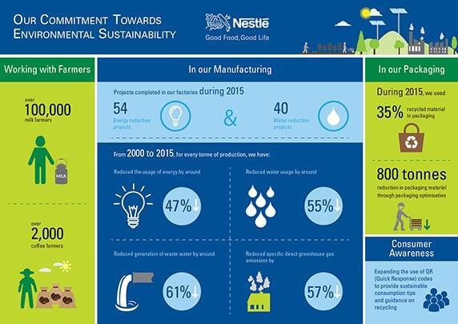
Figure 7: https://www.nestle.in/media/news-feed/world-environment-day

2.4 Categories Offered by Nestlé Bangladesh PLC:
Throughout the years, Nestlé has grown and provided consumers with a line of products to add to the health, nutrition and wellness mission. In Bangladesh, Nestlé operates in 7 different categories with over 109 SKUs serving the nation to fulfill nutritional needs. From age old brands like MAGGI, NESCAFE and NIDO that have become a part of family life to introducing new and exciting products like fried rice seasoning. These 7 categories cover all that Nestlé Bangladesh has to offer to its customers.

Cereals
To have an energetic start that provides a much-needed boost to get on with the day breakfast cereals have been a popular option. Nestlé has 4 brands under the cereals category. These are corn flakes, koko krunch, koko krunch duo & milo. These cereals contain dietary fiber which provides nutrition and works as a good source of calcium and iron.

Coffee
Portraying as an energy boost to start your day, NESCAFE has a good market share in the coffee market in Bangladesh as the most common household name for coffee. The delightful aroma and wonderful flavor help the body become reenergized. The coffee category houses a range of different products which are NESCAFE Classic. Coffee mate, NESCAFE 3 in 1original, NESCAFE 3 in 1 creamy latte, NESCAFE 3 in 1 Hazelnut Latte, NESCAFE 3 in 1 Iced Frappe.

Confectionery
KITKAT is one of the most successful brands globally amassing a huge number such as over 12 billion KITKAT fingers sold in a year. KITKAT is the brand most known in the confectionery category. Other than that, confectionery also oversees brands like milky bar and Koko Krunch bar.

Diary
The category focuses on different brands of milk that Nestlé offers. The milk brand, mainly known as NIDO, has different varieties. NIDO has been a household name for mothers in more than 80 countries for over 70 years. In Bangladesh it’s no different. For kids aged 5+, NIDO offers NIDO Forti grow to boost growth. Nestlé Every day is the milk brand used for making a cup of hearty and warm milk tea. There’s also a malt beverage that Nestlé offers which is Milo. Milo is chocolate flavored malt drink for kinds with cocoa fortified with vitamins and minerals, making it delicious and nutritious at the same time.

Food
This category basically works with MAGGI. Category MAGGI has different subcategories and flavor division under it. MAGGI now offers noodles, soups and seasonings. For MAGGI noodles, for 20+ years in Bangladesh it has been the most common household item for Nestlé. With the vibrant yellow packaging and the classic 2 minutes instant noodles tagline, MAGGI masala is one of the most easily recognizable categories Nestlé offers that can be found in any corner of the nation. Other than MAGGI Masala, there are also some variants doing equally well in the noodles market, which are MAGGI Masala Blast and MAGGI Korean.
MAGGI also offers delicious warm soup options which are filled with flavor and a lot of nutrients at the same time. The MAGGI Healthy Soups line offers Thai, Corn with chicken flavor and winter vegetables. MAGGI Seasoning is a new addition compared to the brands that have been operating in the market for decades. But with a very short span of time MAGGI Shaad-e-magic has become a national sensation with sales booming and consumers opting to use this seasoning for various dishes. MAGGI seasonings have also introduced a new fried rice seasoning mix.

Nestlé Professional
This category looks over the kiosks and vending machines. For any public places, corporate use or experience zones, this category looks to provide hygienic and safe food and beverage options with double or triple option vending machines and kiosks.

Nutrition
Nutrition ensures proper nutrition for kids, making it an option for mothers to feed their kids with tasty, nutritious and stomach filling food with all the nutrients that is required for the growth & development of their growing child. CERELAC and CEREGROW are the main brands under this category.

2.5 Product Offerings:
1. Dairy Products:
- NIDO: Milk powder for children and families.

2. Infant Nutrition:
- CERELAC: Infant cereals with milk for babies aged 6 months and above.
- LACTOGEN: Infant formula for babies.
- NAN: Infant formulas designed to meet the nutritional needs of infants.

3. Breakfast Cereals:
- KOKO KRUNCH: Chocolate-flavored whole grain cereal.
- CORN FLAKES: Classic breakfast cereal made from corn.

4. Food Products:
- MAGGI Noodles: Instant noodles available in various flavors.
- MAGGI Soup: Instant soup mixes.
- MAGGI Shaad-e Magic: Seasoning mix to enhance the taste of dishes.

5. Beverages:
- NESCAFÉ: Instant coffee in various blends.
- COFFEE-MATE: Non-dairy creamer for coffee.
- MILO: Chocolate malt beverage.
- FRUITA VITALS: Premium fruit juices.

6. Confectionery:
- KITKAT: Chocolate-covered wafer bars.
- MILKYBAR: White chocolate bars.
- POLO: Mint-flavored candies.

7. Nestlé Professional Products:
- NESCAFÉ 3in1 Regular Coffee
- NESTEA Lemon Tea
- NESTEA Milk Tea
- MAGGI Chicken Stock Powder
- MAGGI Vegetable Stock Powder
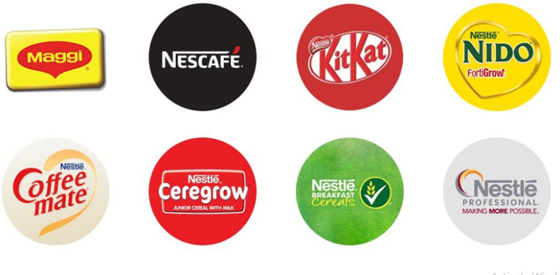
Figure 8:Nestlé Brands in Bangladesh

2.6 Corporate Divisions and Departments:
The whole of Nestlé Bangladesh is divided into nine functions for the organization to operate all its operations seamlessly. The nine functions are
- Technical
- Supply Chain
- Procurement
- Human resources
- Corporate Communications
- Marketing & Sales
- Legal & Compliance
- Information Technology
- Finance

Technical
The technical team oversees the whole manufacturing sector. Ensuring manufacturing excellence by providing safety of people, products and brands. The team works to make the factory operate with the highest industry standards and aids to support sustainable options to preserve the environment for generations to come.

Supply Chain
The team strives to accelerate growth, profitability and capital efficiency. Starting from raw and packaging materials to finished goods getting into the hands of the customers, the people in the supply chain are the ones working to get it done on time in a way that is sustainable and profitable.
Procurement
Procurement works to integrate solutions in the business processes while enhancing efficiency and creating value in such a way that drives cost savings. Procurement teams come up with new strategies that will benefit the organization while also keeping the ambition of sustainable development in mind.

Human Resources
Enabling individuals to do their jobs correctly is the main responsibility of the human resources department. Since HR assigns employees to any department based on need, it is implicitly in charge of managing the entire business.HR looks after rigorous activities like talent acquisition, learning & training, rewards, people development etc.

Marketing and Sales
At the core of the marketing, sales & strategic business units’ team, there is a passion to build brands that excel in winning over customers. From developing a brand, marketing it to the shoppers and monitor to increase sales. The whole process is taken care of by the marketing and sales unit of the organization.

Legal and Compliance
This function is the trusted guardian for Nestlé’s business, assets and policies. They protect the company, its partnering business and practices advocacy. Legal and compliance are responsible for making sure all actions taken by the organization are well within the law and comply with existing international and local guidelines.

Information Technology
In this modern day and age, technology is the driving factor, automation and digitalization of business operations and processes is at the core of most organizations. This team strives to achieve that by harnessing innovation and shaping the future with a new realm of possibilities. From taking care of digital security to providing knowledge and learning. Information technology provides the organization with a variety of tools.

Finance
The finance & control function is the key to achieving the organization’s purpose. With a team that is constantly working towards co-piloting value creation and unlocking new opportunities in the economic environment.

Corporate Communications
To protect the reputation and image and showcasing Nestlé as a force for good, the corporate communications team oversees all engagement and communication both internally and externally. From digital media content, public affairs, media relations to employee engagement and good rapport with all stakeholders in maintained by the excellent team of corporate affairs.

2.7 Functions of the department (Sales Department):
This is the department I have worked in. The function of the sales department is to look after the overall sales target on a regular basis. Nestle Bangladesh has various sections under the sales department itself. The sections are BFC, POP Excellence, CCSD & CDT. These various teams look after the overall sales of the company. Below I have elaborated the duties of each section of the department.
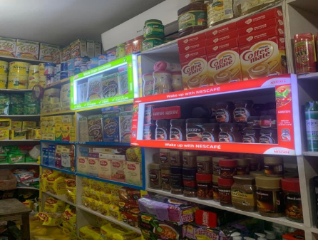
BFC Team (Breakfast & Cereals): The BFC team looks after the breakfast and cereals of Nestle. Starting from product development till marketing the product, all of it is looked after by this team. The products include Corn Flakes, Koko Krunch and Milo.
POP Excellence (Point of Purchase): The POP team basically looks after the point of purchase units. The shelves at the shops are designed and decided by the POP excellence team all over the country.
CCSD (Channel Category Sales Division): This team works with the commercial development of the products at every level. This team approves and initiates product launches for all the products.
Figure 9: POP Excellence Works
CDT (Commercial Development Team): CDT is responsible for all the regional commercial activities and product launches of the company. This is the team I am currently working with. The Commercial Development Team (CDT) at Nestlé Bangladesh PLC is integral to the company's sales and market expansion efforts. Their primary responsibilities encompass:
Category Leadership: “The CDT defines shopper segmentation and develops strategies to drive category growth. This involves understanding consumer behavior and market trends to inform long-term business strategies.
Channel Expertise: They identify opportunities within prioritized channels to execute key category initiatives, ensuring a seamless online and offline consumer experience. This includes developing winning strategies and solutions tailored to specific channels.
Shopper Expertise: The team ensures that shopper insights are integrated into all relevant outputs, applying this understanding in category, channel, brand, and customer plans. They equip customer teams with actionable insights to inspire customers and align category strategies and initiatives.
Commercial Planning: The CDT is accountable for ensuring coherence, accuracy, and visibility of the total category commercial plan across channels and key customers on a monthly, quarterly, and yearly basis. They monitor, analyze, and report category performance, ensuring alignment with business objectives.” (Nestlé, 2024).

2.8 Operation Details:
The operations of Nestlé Bangladesh heavily depend on the well thought supply chain that looks after the whole process from supplier process, inventory management to distribution and sales. The operations include a lot of activities like sourcing, manufacturing, demand forecasting, and other inbound and outbound logistics.
Responsible sourcing is the motto Nestlé follows while sourcing materials from suppliers to make their products. To be a force for good this is something that is paid a lot of heed whether anything is sourced within the country or from abroad then shipped here.


Manufacturing & Packaging
Figure 10: Sreepur Factory

The Nestlé factory in Bangladesh is in Gazipur's Sreepur. It is close to the Rajendrapur Cantonment and is about 55 kilometers north of Dhaka. The factory has state-of-the-art production facilities, including a beautifully constructed social block for every employee, a revised water consumption and recycling program, as well as several assembly buildings with top-notch architecture Together with packaging lines for prominent products. All Nestlé products are packaged and distributed all over the country from here.
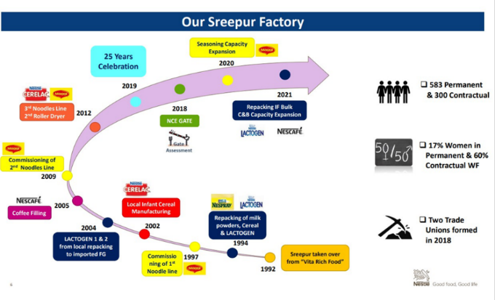
Figure 11: Distribution Management
The whole Bangladesh is divided into regions under which are different territories. The territory offices look after generating sales in their specific area and the territory distribution point is the place from where the products get distributed in that area.

2.9 Market Segmentation:
Geographic Characteristics
Nestlé Bangladesh introduced Nescafé ice in response to the prevailing perception of Bangladesh's hot climate. Customers prefer to consume this coffee with hot or cold water and an ice crystal during the warmer months to refresh their bodies and minds.

Demographic Characteristics
Age: Consumers’ age was utilized by Nestlé to segment the demand for its leading brands. Examples include NIDO, Nesquick, KOKO Krunch, and Lactogen.
Income: Nestle effectively implemented market segmentation based on consumer expenditure. For instance, KitKat Chocolate and Cornflakes are specifically marketed towards individuals who possess a moderately high-income bracket including Maggie Shaad-E Magic, are designed with low-income individuals in mind.

Psychographic Characteristics
Lifestyle and Individuality: Nestlé introduced 2-minute Maggi noodles targeting time-crunched mothers. It will help mothers in efficiently preparing dinner or refreshments for the evening in less than two minutes. Nescafe 3 in 1 is specifically formulated for individuals with demanding schedules who lack the time to brew their own coffee by consuming ‘Nescafe 3 in 1’ in one sitting, they will effectively conserve time. There has been a combination of sugar, coffee, and tea.

Behavioral Characteristics
Advantages/Benefits: Nestlé Bangladesh's operations were effectively segmented according to benefits. Consequently, Cerelac is made available to clients desiring to maximize the performance of their products. Cerelac is a nutrient-dense infant formula designed for children younger than one year.

2.2.1 Philanthropic Initiatives and Corporate Social Responsibility (CSR):
One of Nestlé's core business tenets continues to be creating shared value. Because the resilience and overall health of the society in which the firm operates are inextricably linked, improving quality of life and making a positive impact on a healthier future are the company's goals.

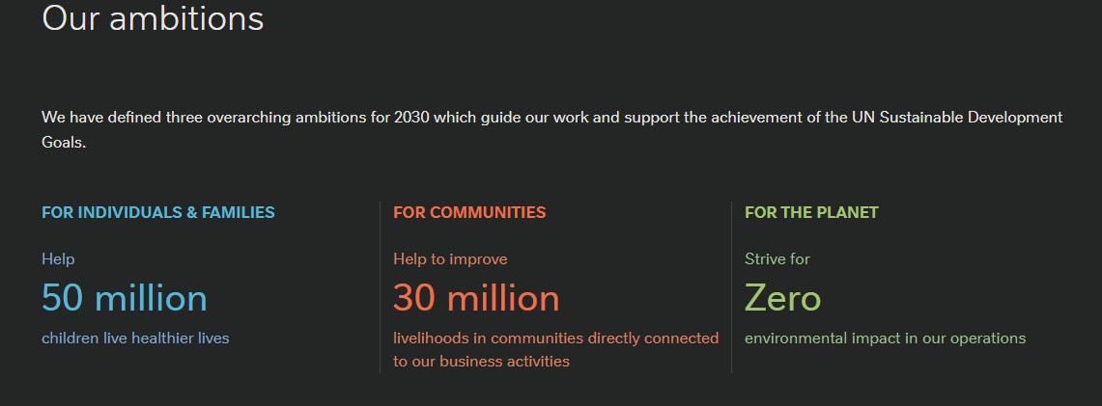
Figure 12: Sustainable Development Goals

Other than empowering community, Nestlé has also been working to cut down the adverse environmental impacts. To diminish the carbon footprint, Nestlé has come up with a net zero roadmap in 2020 to transform their business into an environment friendly organization by cutting down greenhouse gas emissions, restoring natural habitats and reforestation programs. The program aims to have 50% emissions reduced by 2030 and zero emissions by 2050.
In Bangladesh as well, the CSV initiative has created a positive impact on the farmers they work with and the community of people that support the organization’s operations. Nestlé Bangladesh has launched various initiatives like initiatives on clean drinking water, Nestlé healthy kids, amra Korbo joy etc.

“Clean Water project
Nestlé Bangladesh built water tanks in several primary schools around the nation and offered training on sustainable water usage as part of a global commitment to encourage best practices in water management. The number of female pupils dropping out of Gazipur's village schools has significantly decreased because of our effective installation of sanitary facilities for girls.

Nestlé Healthy Kids (NHK)
As part of the global program, Nestlé Bangladesh has also commenced their Nestlé Healthy Kids (NHK) program in 2010 around the Sreepur, Gazipur area. With a view to encouraging educators and students with Nutrition education inspiring a healthy lifestyle in schools. In collaboration with nutrition officers, more than 18000 students around the Gazipur district are provided with ample knowledge about wellness tips and healthy lifestyle. The program assists in transferring nutritional information from students to senior family members at home, fostering the development of resilient and healthy communities.

Amra Korbo Joy
Nestlé actively works on providing knowledge to all. With the ‘Amra Korbo Joy’ program, unemployed street vendors learn to enhance healthcare knowledge and livelihood while also focusing on promoting breastfeeding awareness. The organization also partnered with 2030 water resource group to advocate sustainable water usage. In addition to that, in collaboration with local NGOs, the organization also works to train farmers with a view to enhancing their employability.” (Nestlé, n.d.)
By focusing on these CSR programs, Nestlé Bangladesh demonstrates its commitment to creating shared value for its stakeholders, the communities it serves, and the environment. Each initiative reflects Nestlé’s dedication to fostering long-term positive impacts, from empowering individuals to promoting sustainable practices that support a healthier planet.

2.2.2 Industry Overview and Competitive Analysis:

Analysis of Industry/ Markets
Fast Moving Consumer Goods, or most known as FMCG, typically have short shelf life. This is widely regarded as a low margin, high volume business. This term includes different types of commodity products encompassing food & beverages, household care and personal care. FMCG industries offers products that are daily essentials like food, beverage, self-care, toiletries etc.

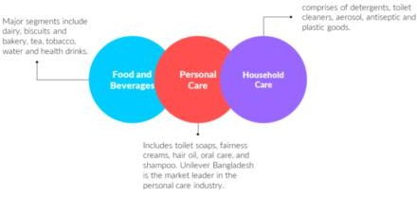
Figure 13: FMCG Umbrella

In times of economic instability, as uncertainty hovers over most industries, FMCG is one industry that is the epitome of stability throughout all that. It is because of the nature of goods that this industry offers that, like other industries, they do not face a steep fall. Even in unstable situations, with consumers having money on their hands to spend they tend to have the need to buy these products. Thus, the plethora of options available from different brands made the market rise. As one of the fastest-growing industries, in the year 2023, the market size in Bangladesh is roughly USD 4 billion. The industry is expected to grow to become one of the top FMCG industries in the world with a growth rate of 16.18% from 2022-2027.

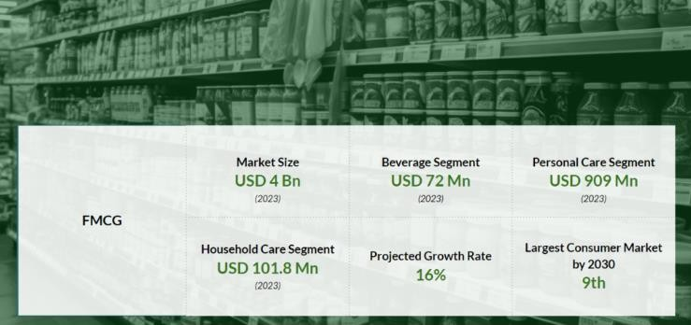
Figure 14: FMCG in Bangladesh

Analyzing the Main Competitors
Nestlé products are mainly segregated into two parts. Nutrition and food & beverages. While nutrition contains infant formula, our focus here is the Food & beverages industry. With nutrition, Nestlé has been the market leader for many years whereas for the food & beverages there are many multinational and local competitors always trying to cope with each other. The market is quite saturated and with many companies in the run for the top position. Now many local brands such as Pran, Teer, Ruchi, Fresh, Radhuni, ACI etc. are competing neck to neck with international names like Nestlé, Unilever, Marico etc.
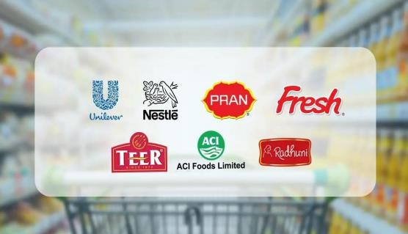
Figure 15: FMCG Industry Big Players
Some big competitors with products of the same categories as Nestlé are briefly discussed to understand better the market.
Unilever Bangladesh


The British multinational company, Unilever is among the biggest FMCG competitions in the world. Approximately 3.5 billion people in more than 190 countries use the 400+ household products that Unilever offers around the world. Unilever Bangladesh offers 28 products under 10 categories from which in 9 of those they are in the leading position. Most of them are household items with brand names as popular as LUX, Rin, Glow & Lovely, Lifebuoy, Vaseline, Pepsodent Etc. Unilever is a direct competition for only one category of Nestlé, that is MAGGI soups. Knorr is a direct and the primary competitor for MAGGI soups.

Pran


One of the biggest FMCG brands in Bangladesh is Pran. About 200 products are available from Pran in 10 distinct food categories, such as dairy, confectionary, biscuits, juices, drinks, carbonated beverages, mineral water, bakery, snacks, and powdered spices. Popular names like All-time Bun, Frooto, Mama Wafer, Lychee drink, Milk candy etc. are some key
products of this local brand. Pran competes with Nestlé with both the food and beverage category. Pran recently introduced a coffee brand named KOFI House. On the other hand, Mr. Noodles, a key competitor in the instant noodles market, is also owned by Pran.

New Zealand Dairy

New Zealand Dairy has been a key competitor for Nestlé in terms of both noodles and dairy. Having started mainly with the concentration of dairy products, in 2014 New Zealand dairy has extended their hands to even penetrate the snack and culinary industry as well with brand names like Doodles, Diploma, Happy cow, Bellame, Poppers, yokozona etc.
Having been a dairy parent company, they operate with multiple products in this dairy section with big and popular names like Diploma, Happy cow and red cow. They also operate in the Noodles industry with their
very own Doodles. Having a variety of flavors, doodles have been able to capture a portion of the market in a very short span of time.

Arla



Operating in Bangladesh since 1961, Arla has been a key household name when it comes to milk powder. With multiple brands like Dano daily Pushti, Dano Power being one of the oldest dairy brands in Bangladesh. Even operating only in the Dairy category, this has been a key competitor in the industry.


Square Food & Beverage Limited

Since its inception in 1958, Square has been a conglomerate that has been working on various industries like pharmaceuticals, toiletries, food and beverage etc. in the Food & Beverages part of the company
They have five significant brands with a range of products under those categories.
Under the Radhuni brand, seasoning mix sachets are the key competitors of MAGGI Shaad-e-magic seasonings. Apart from that the different flavored noodles under the brand of chopsticks are equally popular in the market with sales rising very quickly giving MAGGI noodles tough competition over their long dominance in the noodles business.

Abul Khair Consumer Goods



Abul Khair group one of the biggest conglomerates in Bangladesh started initially as a tobacco company back in 1953 in the commercial capital city. Slowly they expanded their business to a multi-business portfolio with consumer goods, tobacco, ceramics, trading business etc. The Consumer goods division of Abul Khair Group or commonly known as AKCGD, started its journey in 1994 when Star Ship Condensed Milk was first introduced. Star Ship Condensed Milk continues to lead the market with dominant market share. Now AKCGD has products like starship, Aura Pushti, marks milk powder, AMA coffee, AMA milk powder, Aril, coffebite, Kurmure Chanachur etc. The milk powder brands, and the coffee are Nestlé competing products with AMA coffee being the primary competitor gaining popularity with cheaper prices than Nestlé NESCAFE products.

2.2.3 SWOT Analysis of Nestlé Bangladesh PLC:
Strengths
- A motivated and disciplined team with a positive mindset to drive growth.
- Ensuring product availability through optimized Route-to-Market (RTM) strategies.
- Distributors are fully aligned with the company’s purpose and values.
- Strong brand image and visibility, ensuring market dominance.
- Robust purchasing power of shoppers and traders.

Weaknesses
- Traders are highly sensitive to profit margins and trade benefits, which directly impact sales.
- Dependence on a limited number of outlets for core business revenue.
- Consumer promotions are less lucrative compared to competitors.
- Higher market returns due to lower intake of major contributing SKUs.

Opportunities
- Opportunities to enrich shopper profiles that align with the company’s portfolio.
- Post-pandemic market adjustments have disrupted gray market supply chains.
- Stock holding by traders has reduced due to supply constraints, allowing the market to stabilize and liquidate existing stocks.

Threats
- Rapid growth of online and e-commerce businesses poses challenges.
- Expansion of the Nestlé parallel imports portfolio outpacing the NBL portfolio.
- Reduced disposable income is affecting the consumption of non-essential goods.
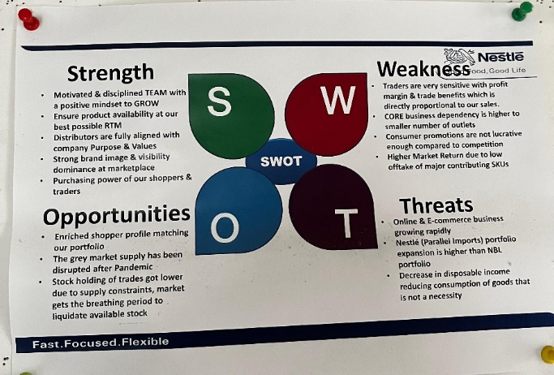
Figure 16: SWOT Analysis

Chapter Three

Objectives and Methodology

3.1 Objectives of the Study:
The objective of the report is to collect and critically assess data and transform it into a form that might be useful for data driven decision making in general and especially in these inflationary times. This helps understand the customer behavior and their differences in buying pattern in different channels. This report gives an overall idea of achieving some goals such as:
- To comprehend customer behavior in the current market dynamics and how inflation alongside the changed customer preferences is affecting their purchasing pattern.
- To contribute to the "Shopper Insight During Inflation" project led by Nestlé's.
- To identify how inflation has influenced the contemporary FMCG market as a project of the Commercial Development Team.
- To understand the consumer behavior and preferences in key markets where Nestlé operates.
- To provide recommendations about how the current market should be adapted and how the findings can help Nestlé Bangladesh Limited to capture the market more effectively.
- To develop a comprehensive, real-time insight dashboard using Power BI from the collected data, providing key metrics and detailed analysis of shopper behavior and preferences segmented by channel, category, and territory.
- To analyze the market and form strategies to drive sales according to contemporary market demand.
- To get practical learning by interacting with consumers and understanding their behavior in food, beverage, and cereal categories, providing recommendations for market adaptation.
- To acquire expertise in distribution operations, consumer psychology, and socioeconomic factors.
- To describe findings to Nestlé’s Managing Director and Chairman, Deepal Abeywickrema, and Sales Director and Board Member, Syed Iqbal Mahmud Hossain.

3.2 Methodology of Studies:
To gather all relevant data for the study, both primary and secondary data sources have been used. Mostly depends on the primary source where a market survey is conducted.

Research Design
- Descriptive Research: Focuses on describing Nestlé Bangladesh's sales operations, processes, and consumer interaction strategies.
- Exploratory Research: Examines specific factors, such as the effects of inflation on consumer purchasing behavior and the efficiency of point-of-sale marketing strategies.
- Mixed Methods Approach: Combines qualitative (shopper interviews, field observations) and quantitative (survey data, sales performance metrics) methods to ensure a comprehensive analysis.

Data Collection
Primary Data:
- Observations: Conduct regular visits to sales distribution houses and retail outlets across Dhaka to observe shopper behavior, product display arrangements, and retailer interactions.
- Interviews: Engage with shoppers to understand their purchasing decisions, preferences, and the factors influencing their choice of Nestlé products. Also, it includes communication with traders on how they perceive different brands
- Surveys: Design and administer structured questionnaires to gather insights about consumer behavior, focusing on the impact of inflation, product preferences, promotion preferences and purchasing patterns.

Secondary Data:
- Internal Reports: Review company sales reports, performance dashboards, and marketing strategy documents for contextual understanding.
- Market Research: Study industry trends, inflation impact studies, and competitor performance analyses from reliable sources.
- External Sources: Refer to academic journals, trade publications and online databases for additional insights into consumer behavior and market dynamics.

Sampling Strategy
- Purposeful Sampling: The following strategic communication goals in the retail market consist of: This study therefore identified different channels in Dhaka that would be most relevant to understanding how inflation affects consumers.
- Random Sampling: Systematically intercept shoppers in various outlets to capture different realistic and unbiased shopper scenarios.

Data Analysis
Qualitative Analysis:
- Thematic Analysis: Determine recurring themes from consumer interviews, including the perceived value of Nestlé products during inflationary periods and the primary determinants of product choice.
- Content Analysis: Examine survey responses and company documents to derive actionable insights regarding consumer preferences and marketing effectiveness.

Quantitative Analysis:
- Descriptive Statistics: Determine inflation sensitivity, average expenditure, and product preference rates for various demographics.
- Comparative Analysis: Evaluate consumer behaviors and sales trends in various geographic regions and retail channels.
- Trend Analysis: Correlate inflationary pressures with changes in purchasing patterns over time while identifying and interpreting them.

Ethical Considerations
- Informed Consent: Assure that all participants, including retail employees and consumers, are apprised of the study's objectives and provide their consent to participate in surveys and interviews.
- Anonymity and Confidentiality: Maintain the anonymity of all respondents and secure the confidentiality of data collected during the study.
- Objectivity: Avoid bias by employing standardized data collection tools and ensuring transparency in analysis and reporting.

Limitations of the Report
The study conducted for the internship is subject to a few limitations that confined the research of the topic.
As an intern, I did not have access to all the internal and confidential information which I could not use which could have added value to the findings.
The sample size taken for this focuses largely on some areas of the Dhaka metro. This might not be the complete picture all over the country so the sample to determine strategies to be implemented all over the country might be skewed.
Since Inflationary issues are still very prevalent in the market, it is constantly evolving so the data if not being updates constantly might become irrelevant.

Chapter Four

Findings of the Study

4.1 Key Findings of the Study:
Some of the key findings which aligns with Nestlé Bangladesh PLC and the project I worked in are explained below:

1. Operational Efficiency and Processes
Supply Chain Resilience: “Nestlé Bangladesh has demonstrated robust supply chain management, ensuring consistent product availability across Dhaka's retail outlets. This resilience minimizes stockouts and maintains product quality, even amid inflationary pressures.” (Nestlé, n.d.)

2. Consumer Behavior and Experience
Impact of Inflation on Purchasing Decisions: “Field observations and shopper interviews indicate that rising inflation has led consumers to become more price-sensitive, often opting for smaller pack sizes or alternative brands to manage expenses.” (The Business Standard, 2024)
Brand Loyalty Amid Economic Challenges: “Despite economic constraints, many consumers continue to prefer Nestlé products, citing trust in quality and brand reputation as primary factors influencing their purchasing decisions.” (Business Insider, 2024)

3. Sales Performance and Market Dynamics
Adaptation to Market Conditions: “Nestlé Bangladesh has implemented strategic pricing and promotional activities to sustain sales volumes during periods of high inflation. These measures have been effective in mitigating potential declines in consumer spending. (Business Insider, 2024)
Competitive Landscape: “The company faces competition from both local and international brands. However, its extensive product portfolio and strong brand equity provide a competitive advantage in retaining market share.” (Naquib Khan, 2018)

4. Point-of-Sale Marketing Effectiveness
Promotional Strategies: “In-store promotions and point-of-sale displays have been effective in attracting consumer attention and making impulse purchases, particularly in urban retail settings.” (Naquib Khan, 2018)
Retailer Engagement: “Collaborative relationships with retailers have facilitated the effective implementation of marketing strategies, enhancing product visibility and availability.” (Naquib Khan, 2018)

5. Consumer Feedback and Satisfaction
Product Quality Perception: “Consumers consistently express satisfaction with the quality of Nestlé products, reinforcing the brand's reputation for reliability.” (Business Insider)
Areas for Improvement: “Some feedback suggests a desire for more affordable options and greater variety in product offerings to cater to diverse consumer preferences, especially during economic downturn.”

6. Recommendations
Enhance Affordability: Develop and promote smaller, cost-effective product packages to cater to price-sensitive consumers affected by inflation.
Strengthen Retail Partnerships: Continue to build strong relationships with retailers to ensure optimal product placement and the successful execution of promotional activities.
Monitor Consumer Trends: Regularly assess consumer behavior and preferences to adapt marketing strategies and product offerings, accordingly, ensuring alignment with market demands.
Leverage Digital Platforms: “Utilize digital marketing channels to engage with consumers, gather feedback, and promote products, thereby expanding reach and enhancing brand presence.” (Naquib Khan, 2018)

These findings provide valuable insights into the current market dynamics and consumer behavior in Dhaka, offering a foundation for strategic decision-making to enhance Nestlé Bangladesh's market position amid economic challenges.

4.2 Problem Identification, Consequences of the Problem, Solutions:

Problem Identification
The main characteristic seen for FMCG industry products can be seen directly from its name is that these are fast moving goods. These are household, selfcare or food and beverage items that people may use daily. But in recent years shelves have not cleared up as fast as they should while there is a significant increase in the sales of products of smaller packs. The declining purchasing power of the consumers with the inflation in place are impacting the sales with people limiting their purchase or switching to smaller packs of cheaper brands. Like every other company in the industry, Nestlé has also been affected by the inflation factors. With people changing their buying patterns the big names in the FMCG are left with no option but to comply with consumer behavior to drive their sales. For that they need to understand how differently the shoppers are thinking during their shopping trip. The most seen phenomenon is the rise in the sales of smaller packs. But according to income level, shoppers who can afford it will continue to buy in bulk. Without understanding the target group customer in real time, it is not possible, especially in an industry like FMCG, to survive.
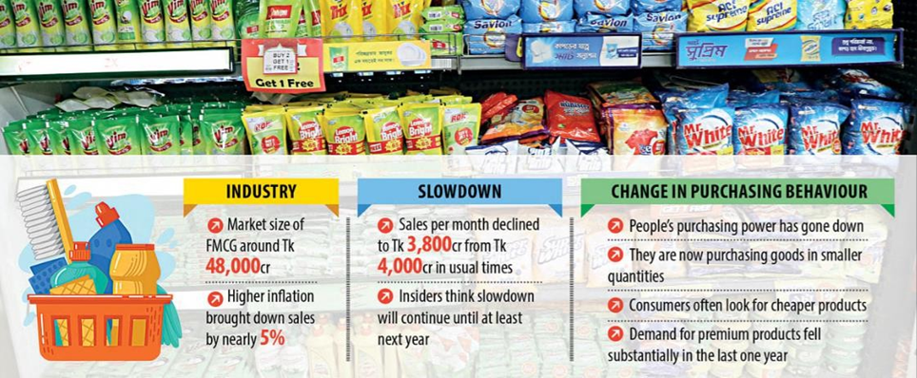
Figure 17Inflation Impact on FMCG Industry
Consequences of the Current Problem
FMCG must come up with new and changed sales strategies that align with the buying pattern of the shoppers. Without that with the existing sales strategies in place the sales volume is going to decline as the buying pattern and their demands have changed. For that it is essential for the industries to understand the market. There’s no other reason for the industry to suffer such sales decrease unless the external economic environment creates that disruption.
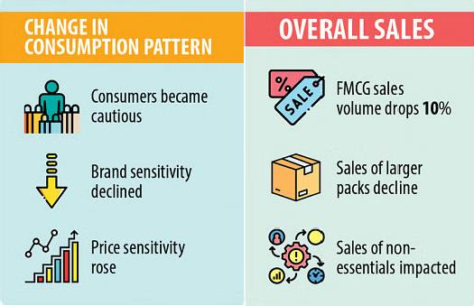
Thus, not only Nestlé but all the other companies operating in this sector will have to face the same problem. To get the upper hand, understanding and capturing the pattern is crucial as soon as possible to receive a head start from other leading companies.
Figure 18: Effects of Inflation

Challenges of FMCG in Tackling Inflation
By working at the field level, interacting with shoppers during their purchase has helped me and the team gain a better insight into how the larger crowd are thinking and trying to tackle the inflation problem while still trying to buy all the essentials that they are going to need. Through the market research conducted in some of the key areas of Dhaka city, we have found some very interesting.
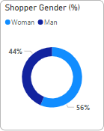
To form or modify sales strategies, it is first crucial to understand who the customers are. The target group and the shopper demographic are crucial. The
demographic along with their mindset and interaction with products need to be observed closely. What can be seen from the data collected from markets is that most shoppers doing the shopping for their family are female. There used to be a misconception that the male members of the family mainly do the groceries which over the years have changed a lot.
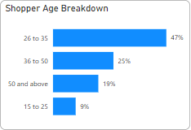
The footfall observed mostly are young professional or housewives. When asked mostly females were either housewives or jobholders. The age range that dominates most markets is young adults aged from 26 to 35.
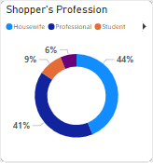
The ramifications of inflation can be clearly seen from the change in shopper interaction and sales volume in the market. The
People’s perception is changing about why, which brand and how much of a product they are going to buy and how much they are willing to spend on it.
Most people nowadays are doing planned shopping and are much more aware about the prices of things that they are buying. They know what brand they want, what size they want and how much it’s going to cost them. Some traders’ advocacies or instant decisions are still in place but specified pre-decided shopping is mostly seen for most people.

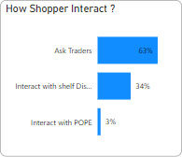
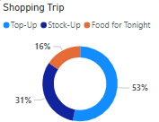
People are also now moving away from stocking up things and mostly do shopping to top up the products that they have used up or will soon be emptied out.
To tackle inflation, shoppers are now prone to buying smaller
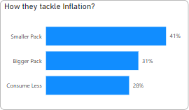
packs. And repurchase when needed. They are not willing to spend money on larger packs as most people do not have the additional amount to buy all at once. The rise in demand for smaller packs and the average number of shopping trips increasing than before clearly shows that. Shoppers are having to make more trips to the market as
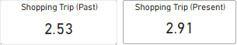

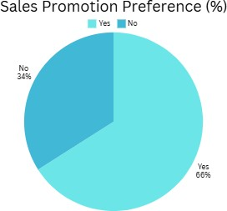
They are opting for smaller packs to save money. With inflation rising this has been the most notable change. Most consumers are cutting down their consumption as a result by cutting down their pack size.
Consumers also have a changing mindset about promotions. It’s a general assumption made that most people like any kind of sales promotions offered by the brands. They like to avail offers such as price off, bundle
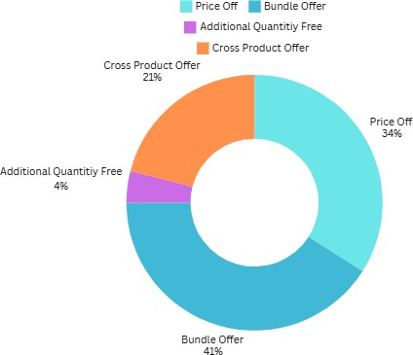
offer etc., even though there’s still
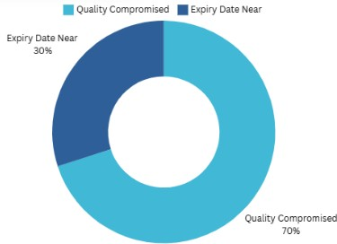
Liking toward good offers, a large portion of people absolutely steer clear from promotion offers thinking either the quality of the products is compromised or the
expiry date is very near which is why companies are clearing out their shelves. Here we see the side-
by-side comparison of how many of the shoppers like promotion offers and what type of promotions they prefer. On the other hand, for the people who do not like promotion offers we can see main reasons behind not liking it.
Nestlé in The Market
In the market research conducted we only focused on three categories of products in which Nestlé operates. Dairy, Food, Beverage. Under this category we looked into the brands NESCAFE, MAGGI and Nestlé breakfast cereals. During the visits we looked at target customers who either bought Nestlé products or products from a direct competitor.
Looking at Nestlé products and competitors of all the categories we can see how well they are doing compared to their rival brands.
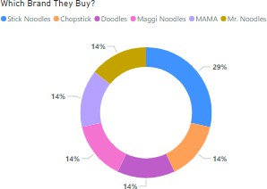
For MAGGI, there are three categories under this, instant noodles, soups and seasoning. Noodles being the oldest food product operating here and are a household name in vast amounts of homes. But with time many other competitors have come up with products that have pushed down MAGGI’s dominance in the noodles market.
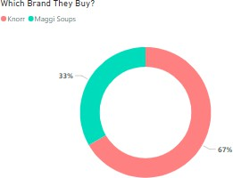
For soups the only rival there is in the market is Unilever’s Knorr soups line. They are slowly gaining popularity in the market but MAGGI soups with their different variety of flavors are still dominating the shelves.
MAGGI shaad-e-magic is a new product on the market. From
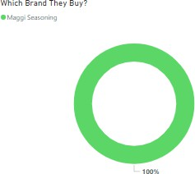
Its inception has created a buzz monopolizing the market with having no other alternative available in the market. But in recent times some parallel brands can be found in specific areas. Square’s Radhuni has also come up with a seasoning mix that has started to hit the shelves nationwide which might hamper the market
penetration of MAGGI seasoning in the very near future.

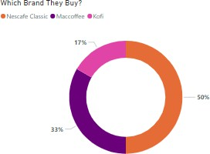
NESCAFE has long been a household name where for people another name for coffee used to be NESCAFE. But with time, now there are cheaper alternatives in the market. There are just Nestlé parallel products imported from abroad that also hamper the sales of Nestlé Bangladesh even when a Nestlé product is being sold.

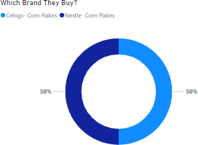
Kellogg’s is the main competition with a variety of different cereals also offering products identical to the Nestlé breakfast cereal such as cornflakes. Both the companies have almost similar market presence but are sold mostly from modern trade and minimarts. Cereal visibility is low in general or in grocery channels.

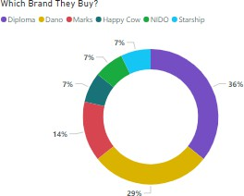
Dairy is the category where Nestlé products lag. Mainly because the perception NIDO has among consumers is the NIDO is basically a milk powder for kids and not used for general daily consumption like milk tea. Thus, most shoppers picking up NIDO are seen having children at home. So, for the dairy section, other brands like Diploma, Dano, Marks etc. are seen to do much better than Nestlé brand NIDO.

Solutions

Like most multinationals around the world now, Nestlé Bangladesh also understands the importance of data and its impact on all other operations. Thus, to capture the real picture of what is happening in the market, they launched this shopper insight project to get their very own authentic primary data and not collect it through any third-party research organizations. Because Nestlé Bangladesh realizes for them to form their business strategies and to set goals for upcoming quarters measuring the situation of buyers and having accurate data is of utmost importance. From the findings of the research.
With the information collected from the market research the vast about of shopper data can be used and analyzed to come to better conclusions that will help drive the sales. Data driven decision making will help to be crucial even in tackling a recent phenomenon like Inflation.
We can already see people are more prone to buying smaller packs, an increased number of trips to the market and buying decisions are becoming more price sensitive than before. What Nestlé can do to tackle this problem is various and depends on the channels. As the behavior seems to vary from channel to channel.
- To Introducing a small pack of noodles and breakfast cereal while driving up the visibility of existing sachets of coffee.
- Changes should be made starting from the factory tweaking with packaging decisions.
- Promotions should be offered in modern trade whereas in general and grocery channels shoppers have a negative impression about different promotion offers.
- Generate ideas and campaign to change market perception of NIDO being a milk powder only suitable for kids.
- Store and update the data in a real-time dashboard so while making more decisions about any sales, marketing or any other functions the team can use the data to base their decisions on.
- More in-depth insight into specific SKUs might be of crucial help if that result can be taken out of market research.
- Traders also should be compensated accordingly so that the traders’ advocacy of Nestlé products in the market increases.

Chapter Five

Recommendations and Conclusion

5.1 Recommendations:
Certain Key Success Factors are essential for any FMCG to thrive. These must be fulfilled to maintain a strong foundation, but additional strategies can help boost sales, especially during inflationary times. With people becoming more cautious about spending, companies must adopt innovative strategies to remain relevant in the market.
Key Success Factors like understanding the local market, maintaining a strong supply chain, and building a good rapport with distributors will always be critical. However, beyond these basics, the recommendations a company can consider include the following:

Recommendations for Thriving During Inflation
Here are some additional recommendations based on my understanding:

- Optimizing Prices with a Dynamic Revenue Model
It is essential to adjust prices during inflationary times. Businesses may find it difficult to meet expenses if prices are not appropriately adjusted to reflect inflation, leading to lower profit margins or even losses
- SKU Sensitivity Analysis
Companies should launch a SKU sensitivity analysis to understand which SKUs are most inflation-sensitive and adjust sales strategies accordingly.
- Resolving Interdepartmental Conflicts
Conflicts between sales and marketing teams can hinder performance. Department heads should conduct regular meetings to ensure teams are aligned with the shared goal of maximizing sales cost-effectively.
- Improving Supply Chain Efficiency
Supply chain delays can be mitigated by decentralizing warehouse operations. Opening smaller warehouses in key districts can ensure quicker delivery to distributors, especially in distant regions, reducing dependence on a single central facility.
- Bridging Communication Gaps with Consumers
Clear and targeted marketing campaigns can improve consumer awareness of the brand’s objectives and product benefits. For instance, campaigns highlighting Nestlé's commitment to nutrition and advising parents to consult health professionals before product use can enhance trust and credibility.

5.2 Conclusion:

The FMCG market is very dynamic, with low-cost high-volume products and the shelves clearing out fast. But even though most items in this industry are commodities or essential items, due to high competition in the market companies must constantly change their campaigns, pricing strategy, marketing, and sales operations. A crucial factor like inflation can also affect a company very much. Having ample real-time data on how the company is doing in the market will help form decisions that might boost the sales.
This report addresses the opportunity of implementing base data taken from primary sources and changing the pricing strategies, sales drivers, and promotion offers that might be most beneficial for the current situation of the market. This helps to get brand-specific and channel-specific data for different SKUs. Thus, helping companies use the data through analysis to come up with the best possible outcome to generate revenue.
Nestlé Bangladesh exemplifies how a strong operational framework and dedicated sales force can navigate challenges in the FMCG sector. As a pioneer with over 150 years of global experience, the company has established itself as a leader in Bangladesh's competitive market.
The company’s ability to maintain stability even in turbulent times highlights its steady and collaborative approach to operations, empowering its employees to drive meaningful progress. By aligning its operations with consumer needs and leveraging innovative strategies, Nestlé Bangladesh continues to set benchmarks for excellence in the FMCG industry.

References

Business Insider. (2024, November 18). Business Insider>Home>Economy. Retrieved November 18, 2024, from Business Insider-Website: https://www.businessinsiderbd.com/economy/news/25984/nestl%C3%A9-raises-its-food-prices-in-bangladesh#google_vignette
GlobalData Plc. (2024). Home>All Companies >Nestlé SA>Nestlé. Retrieved November 4, 2024, from GlobalData: https://www.globaldata.com/company-profile/nestle-sa/
Naquib Khan, F. C. (2018, November 06). Retrieved November 2024, from ICE Business Times: https://ibtbd.net/naquib-khan-president-bcms-nestle-bangladesh-ltd/
Nestlé. (2024). About us: At a glance: Nestlé. Retrieved November 4, 2024, from Nestlé- Web site: https://www.nestle.com/about/overview
Nestlé. (2024). Home >About us>Nestlé in Bangladesh. Retrieved November 18, 2024, from Nestlé-Web site: https://www.nestle.com.bd/aboutus/nestle_in_bangladesh
Nestlé. (2024). Home> Careers> Career Areas>Sales. Retrieved November 11, 2024, from Nestlé-Web Site: https://www.nestle.com/jobs/career-area/sales
Nestlé. (2024). Home>About us>At a glance>Nestlé. Retrieved November 5, 2024, from Nestlé: https://www.nestle.com/about/overview
Nestlé. (2024). Home>About us>Nestlé. Retrieved November 4, 2024, from Nestlé-Web site: https://www.nestle.com/about
Nestlé. (2024). Home>About us>Our history>Travel through our history timeline. Retrieved November 18, 2024, from Nestlé-Website: https://www.nestle.com/about/history/nestle-company-history
Nestlé. (2024). Home>Investors>Annual Report. Retrieved November 4, 2024, from Nestlé Web Site: https://www.nestle.com/investors/annual-report
Nestlé. (n.d.). Nestlé. Retrieved November 18, 2024, from Nestlé-Website: https://www.nestle.com.bd/nestle-in-society/other-initiatives
Nestlé. (n.d.). www.nestle.com.bd-jobs-career-area-supply-chain-procurement. Retrieved November 18, 2024, from https://www.nestle.com.bd/jobs/career-area/supply-chain-procurement: https://www.nestle.com.bd/jobs/career-area/supply-chain-procurement
Stock Analysis. (2024, November 2). profile>stock analysis. Retrieved November 4, 2024, from Stock Analysis- Web site: https://stockanalysis.com/quote/otc/NSRGY/company/
The Business Standard. (2024, November 18). The Business Standard. Retrieved November 18, 2024, from The Business Standard-Website: https://www.tbsnews.net/economy/food-fashion-bangladesh-sees-consumption-crunch-975481

