An Internship Report on
The American Express Card
Of City Bank Limited

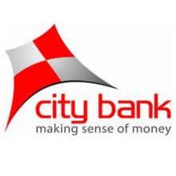


An Internship Report On
American Express Card of The City Bank Limited

Submitted to:
Muhammad Rehan Massom
Assistant Professor
School of Business & Economics

Submitted by:
Samiun Basri Islam
ID: 111 143 118
Major in Marketing
Bachelor of Business Administration

Date of Submission: May 22, 2019


Letter of Transmittal

22 May, 2019
To
Muhammad Rehan Massom
Assistant Professor
School of Business & Economics
Satarkul, Vatara, Dhaka-1213
Subject: Submission of Internship Report for summer 2019

Dear Sir,
I have recently finished my internship under your supervision. My major is Marketing, and I was appointed as an intern at The City Bank Limited from 17th January, 2019 to 14th April 2019.I am submitting my internship report following the guidelines provided by you. This report is a reflection of my working experience at City Bank, the office environment, the people I worked with and also the knowledge I gathered while working there as an intern.
I hope you will find this report up to the mark as your expectation and my work as an intern satisfactory. Thank you for guiding me with the internship and being patient throughout the trimester.
Sincerely,

Samiun Basri Islam
ID: 111 143 118
Bachelor of Business Administration
United International University
E-mail: samiunbasri95@gmail.com

Acknowledgment
I would like to show, at the very beginning, my gratitude to the Almighty Allah for blessing me enough to complete this report. This Internship report is a result of many others help and guidance. I am obliged to these people for their suggestions, support, and opinions on how to make this report better. I would like to take this opportunity to express my sincere gratitude to these people.
At first, I would like to thank my supervisor of all Muhammad Rehan Masoom, Assistant Professor of SOBE at United International University for his guidelines and suggestions on writing this report. He has been patient throughout my internship period and guided me well.
Then, I would like to thank my Organizational Supervisor Mohammad Reajul Islam Branch Manager of The City Bank Limited. He helped me by giving his opinions on how I can do better inthe banking sector. I thank him for motivating me and.
Last but not least, I would like to thank my family members for encouraging me always. This internship would not be possible without their continuous support. All of them extended their help and guidance, which helped me to complete this report. I expect that it will help me in the future.

Table of Contents
Executive Summary v
Chapter 1: Introduction
1.1 Background of the study 2
1.2 Scope of the report 2
1.3 Objectives of the Report 2
1.4 Limitations of the study 2

Chapter 2: Methodology of the report
2. Methodologies of the report 5
2.1 Data Collection procedures 5
2.2 Data Analysis: 5

Chapter 3: Organizational profile
3.1 Background of City Bank Limited 7
3.1.1 Vision 7
3.1.2 Mission 7
3.1.3 Objective 8
3.2 Business Strategy 8
3.3 Organizational Structure 8
3.4 SWOT Analysis of City Bank Limited 9
I. Strengths: 9
II. Weakness: 10
III. Opportunity: 10
IV. Threats: 10

Chapter 4: Findings and Analysis of American Express cards of city bank
4.4.1 City Bank American Express Platinum Credit Card 13
a. Welcome Offer 14
b. Travel Benefits 14
c. Lifestyle Benefits 14
d. Membership Rewards® Program 15
e. Exclusive Discount Program 15
f. Insurance Benefit (City Shield) 15
g. Other Benefits 15
4.4.2 City Bank American Express Gold Credit Card 16
a. Travel Benefits of American Express Gold Card 16
b. Lifestyle Benefits 17
c. Membership Rewards Program 17
d. Exclusive Discount Program 17
e. Insurance Benefit (City Shield) 17
f. Other Benefits 17
4.4.3 American Express Green Blue Credit Card 18
a. Travel Benefits 18
b. Lifestyle Benefits 18
c. Membership Rewards® Program 19
d. Exclusive Discount Program 19
e. Insurance Benefit (City Shield) 19
f. 0% Interest Flexi Buy program 19
g. Other Benefits 19
4.4.4 Agora American Express Card 20
a. Welcome and Renewal Vouchers 20
b. Lifestyle Benefits 21
c. Travel Benefits 21
d. Insurance Benefit (City Shield) 22
e. Other Benefits 22
4.4.5 University of Dhaka American Express Credit Card 22
a. Welcome Benefit 23
b. Insurance Benefit (City Shield) 23
c. Membership Rewards Program 23
d. Other Benefits 23

Chapter Five: Recommendations and Conclusion
5.1 Recommendations 26
5.2 Conclusion 27
References 28

Executive Summary

The internship program report is prepared on the American Express card of City Bank Limited. And this report is covered about the American Express Cards of City Bank Limited. The report is made of using both primary and secondary data. During the study, it is found that City Bank Limited has a strong based of products. From all the products American Express Cards highlighted here as the topic of the report is American Express cards of City Bank. City Bank has verities of AMEX card like-, American Express Gold Credit Card, City Bank American Express Platinum Credit Card, Agora American Express Card, and American Express Green Blue Credit Card. They have some membership facilities that are included in this report. They also have good asset product like CITY CARD, SME, etc. At present, it's market position is 4 in the case of profit. They are also taking some initiatives to achieve their goal.
This internship report contains background, scope, objectives, and limitations of the report in chapter one. Chapter two is about the methodology of the report that consists of the information collection and analysis procedures that are being used in the report. Chapter three is about the organizational profile of the bank where the bank’s background, its mission, its vision, objectives, and SWOT analysis are being discussed.
The most important chapter of this report is chapter four, which is the findings and analysis of the report. In this chapter, I have described the various credit cards of American Express Cards of City Bank Limited. Later the benefits of each card are discussed as well. Chapter six is about the recommendations and conclusion part of the report where few suggestions are shared for the betterment of the card section of CBL from my academic knowledge. Hopefully, the suggestion will help to overcome the current crisis related to CBL credit cards.

Chapter 1

Introduction
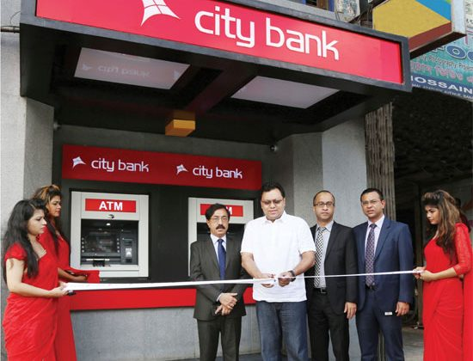

1.1 Background of the study
As the requirement of my BBA completion, I was assigned to an internship program in The City Bank Limited. In this connection, this report is prepared for undertaking my Professional skill as well as practical knowledge into theoretical and written format. I have gained practical knowledge during my internship period.

1.2 Scope of the report
The report portrays the American express card of City Bank Limited. While preparing my internship report, easily collected my information from my colleagues that I wanted to know. This report will allow exploring my excellence and can measure my skilled that Ilearned as an intern from my internship.

1.3 Objectives of the Report
The objectives of the report are the goals for what the internship report is being prepared. The objectives are sectioned below:
1.3.1 Primary objectives: The primary objective of the report is to attain a BBA degree from United International University through submitting the report.

1.3.2 Specific objectives: The specific objectives refer the actual goals of this report, and that is to analyze the American Express Card of City Bank Limited. The objectives are:
- To analyze the City Bank Limited.
- To find out the types of AmericanExpress card, the bank is offering.
- To share the benefits of each card so that the consumer may purchase.
- To recommend a few ideas so that the bank can improve its shortcomings.

1.4 Limitations of the study
Though many problems had been faced in the path of conducting the report, I tried to prepare the report more realistic and accurately accepted by the authority. However, the limitations have appeared are mentioned below.
- Short time makes me hastier.
- Shortage of information constrains my report short.
- The policy of the bank not disclosing the confidential data and one of the main limitations was to get the exact information.
- Insufficient records, magazines and publications as per my requirement.

Chapter 2

The methodology of the report



2. Methodologies of the report
This report on City Bank has been set up based on the understanding accumulated from my entry level position. To set up this report, I have gathered data from various branches of this bank. To set up a true and instructional report, I have contemplated the association's yearly information, sites, and other important things. I have collected data from two sources:

2.1 Data Collection procedures
2.1.1 Primary Sources:
- The information was gained from the officers who are working in this bank, especially the Branch manager of the new market branch- Mohammad Reajul Islam discussing with practice.
- Formal and informal communication with several personnel of City Bank.
- Leaflets and brochures of City Bank Limited.
- Annual Report of the City Bank Limited.
2.1.2 Secondary Source:
- Several published online blogs and articles on the services of City Bank Ltd.
- Website of City Bank Ltd.
- Different internship report submitted by several students.
- Several books that are written on the benefits of issuing cards through the banks across Bangladesh.

2.2 Data Analysis:
The report is prepared through exploratory (descriptive) techniques where both quantitative and qualitative information are utilized to analyze general information of the American express cards of City Bank Limited.

Chapter 3

Organizational profile

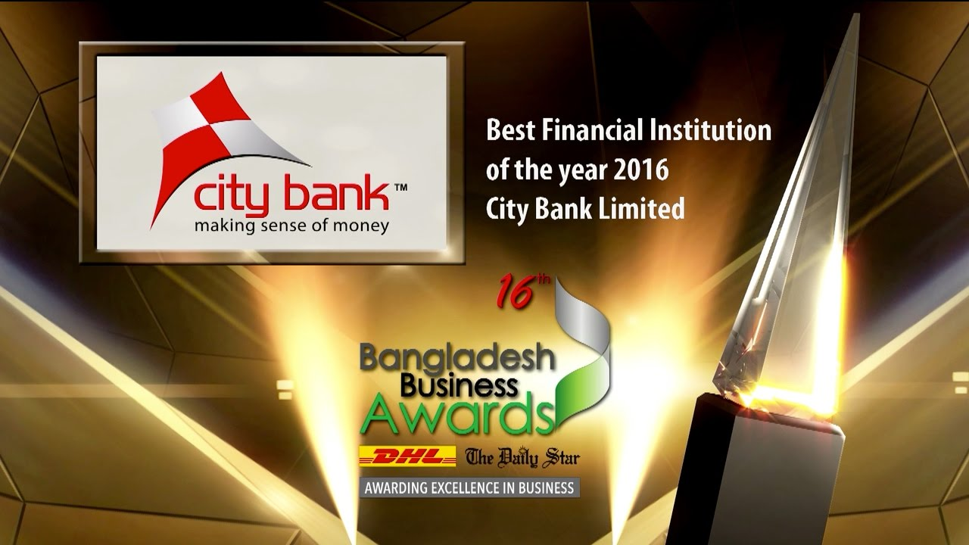

3.1 Background of City Bank Limited

The City Bank Limited is one of the first generation private commercial banks in Bangladesh, which started operating on March 27, 1983, in the city of Dhaka. The bank currently has 84 online branches and five centers for SMEs throughout the country, which include a full-fledged Islami Banking branch. In addition to these traditional delivery points, the bank is also very active in the alternative delivery area. It currently has 35 own ATMs; Agreement to share ATMs with an associated bank that has 225 ATMs; SMS Banking; Bank interest and so on. Your Customer Service Center will soon start working. The bank has a plan to end the current year with 50 of its ATMs.

The City Bank is the first bank in Bangladesh that has issued a double currency credit card. The bank is an important member of international VISA and issues card limits in local currency (Taka) and foreign currency (US dollar) in a single plastic. The VISA debit card is another popular product that the bank is pushing to eliminate queues at the branch created by its amazing base of around 400,000 retail customers. The launch of the prepaid VISA for the travel sector is currently underway.

A couple of years ago, CBL had an ambitious goal of becoming the first private commercial bank in Bangladesh. To achieve this, CBL is undergoing a massive restructuring process. On its 25th anniversary, CBL has created a new dynamic logo and slogan.

3.1.1 Vision
Their main vision is to be the leading bank in the country with the best practices and highest social commitment.

3.1.2 Mission
- CBL's mission is to constantly maintain market share growth to guarantee quality.
- CBL's mission is to contribute to the socio-economic development of the country.
- Their mission is to guarantee the participatory management system and the empowerment of human resources.
- They want to achieve the highest level of customer satisfaction during the expansion of their services.
- Their mission is to promote a favorable environment in which innovation and performance are rewarded.
- Its mission is to maximize the bank's profits to ensure its steady growth.
- Its mission to maintain high moral and ethical standards.d

3.1.3 Objective
To become the no.1 private commercial bank in the country in 3years. The newly launched logo and the pay-off line of the bank are just one initial step towards reaching that point.
(Source: The City Bank (2018). Overview and history. Retrieved from http://www.thecitybank.com/highlights.php)

3.2 Business Strategy
According to the City Bank annual report, As a general practice City Bank will definitely concentrate its business in Trade Finance/ Export-Import business and all types of Commercial Loan, Industrial/ Project Finance / Syndication and structured Finance / SME Financing/ Retail Financing and other specialized programs except otherwise restricted by the Government or indicated as unethical and banned items.
The Bank will emphasize to diversify its business portfolio commensurate with the economic and business trend and cyclic aspect of the economy & appetite for growth of each sector, (PLC) products life cycle, social and national obligation, demand supply gap and so on. The Bank’s financing policies in the different major division are described as follows:

3.3 Organizational Structure
According to the City Bank website, the City Bank does not maintain the branch based traditional, decentralized, geographically managed business or profit model. In exchange, the bank issues its services and operations vertically from the central office to 4 different business divisions, they are:
• Corporate and Investment Banking.
• Treasury and market risks
• SME Bank and
• Retail bank (including cards)
With a real-time online-based platform, these four business divisions are backed by a solid delivery of services or configuration of operations and also by an intelligent IT infrastructure. This business and operational model based on segmented centralized businesses guarantee treatments and services specialized for the various customer segments of the bank.
(Source: The City Bank. (, 2018). About the City Bank.Retrieved from https://www.thecitybank.com/)

3.4 SWOT Analysis of City Bank Limited

Strengths:
- City Bank Ltd has a reputation for being a good quality service provider for its current and potential customers.
- City Bank Ltd is already well established in the banking sector of the country. It is one of the leading commercial banks in the first generation private sector in Bangladesh.
- High commitment to the customer
- Excellent management
- Strong network
- Qualified and experienced human resources
- City Bank Ltd has already achieved a high growth rate. Deposits, as well as loans and advances, are growing rapidly.
- Sophisticated automated system

Weakness:
- Employees depend heavily on the HR department to make decisions.
- Lack of motivation to work with some employees.
- The Bank's promotional activities are not sufficient to expand its market share.
- City Bank Ltd does not provide an ATM card, which limits its expertise in the rapidly changing banking sector.
- Some of the positions of City Bank Ltd do not have a path of growth or progress that causes dissatisfaction at work for some employees.

Opportunity:
- Relationship management
- Increased demand for customer finance.
- Like many private banks, they have been operating on the market lately. City Bank Ltd needs to expand its product line to strengthen its sustainable competitive advantage.
- The bank can set up a special business program for business clients or service providers depending on the professions, such as engineers, lawyers, doctors, etc.
- Most of our population belongs to the middle class. Different types of consumer credit products are of great interest to this class. Therefore, a wide variety of consumer credit products is very large and easy to negotiate market. Therefore, City Bank Ltd can adopt a variety system for personal loans.

Threats:
- Industries are getting worse, and the growth of industrialization is very slow in the country. As a result, it is very likely that weak industrial growth will affect the potential of City Bank Ltd.
- Similar types of retail banking products.
- Some commercial/foreign banks and some government banks.
- Customer awareness of prices and services.
- Some rules and regulations of the Bangladesh Bank.
(Source: The City Bank (2018). City Bank proudly sponsors "Bangladesh 2030: Strategy for Growth". Retrieved from https://www.thecitybank.com/Sponsor_Bangaldesh_2030.php)

Chapter 4
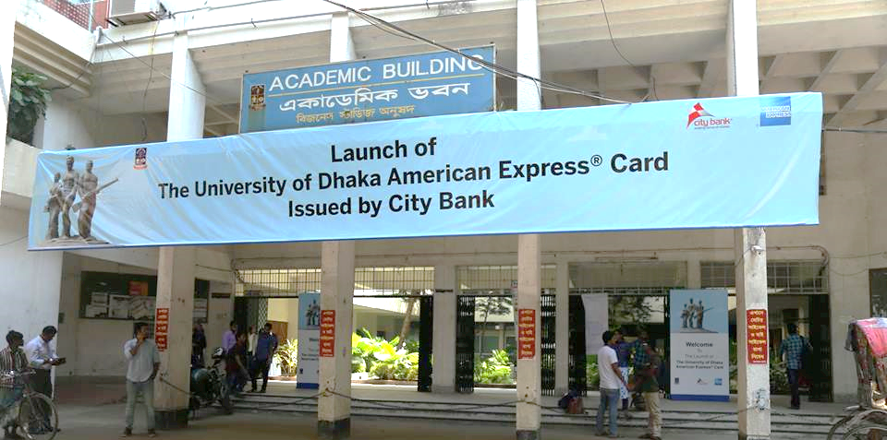
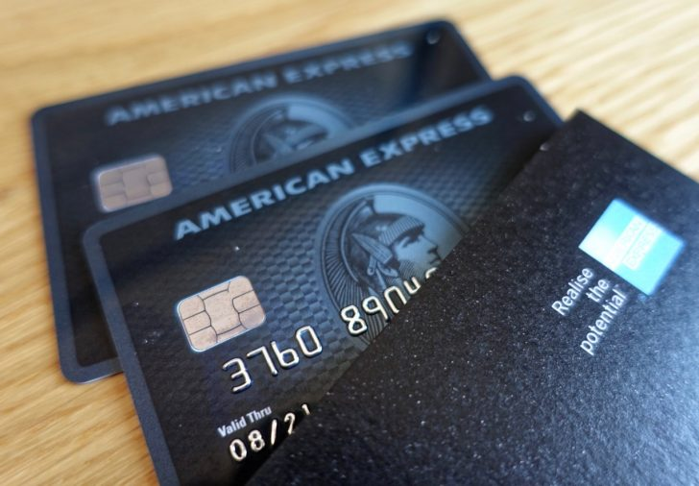
Findings and Analysis of the report

4.4 American Express cards of city bank
There are so many sections or card under American express cards, and these are given below:

4.4.1 City Bank American Express Platinum Credit Card
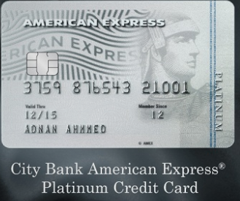
Welcome to the world of City Bank Platinum American Express credit card, a world built for your passions: the passion for exploring the unseen, the passion for savoring the delicious, the passion to live the finer things in life.

City Bank American Express Platinum Credit Card

Welcome Offer
One can avail one of the following exclusive offers:
- On Executive Health Checkup packages at Square Hospitals Ltd, one can get BDT 15,000 savings.
- One can get complimentary companion priority Pass Lounge Visits.
- On Jet Airways to 15,000 savings.
- 25,000 bonus membership rewards points.
- One can stay one night at The Palace Luxury Resort.
- Tk. Fifteen thousand savings on Partex Aviation.

Travel Benefits
- The Platinum cardholders can get the Priority Pass subscription and unlimited access to over 1200 Priority Pass lounges worldwide.
- Global concierge service, medical emergency, and assistance abroad.
- You can have free and exclusive unlimited access to the Platinum Lounge at Hazrat Shahjalal International Airport.
- You can enjoy unlimited and free access to the VIP lounges of the international and national Hazrat Shahjalal airport in Dhaka.
- The user can enjoy a free night's stay at the Palace Luxury Resort after paying only the first night from Monday to Friday. This offer is not valid on Thursday, Friday, and Friday.
- The Card Holders can enjoy savings of up to 20% at all Biman Bangladesh Airlines, Biman Holidays points of sale and the offer is valid until 30 June 2019.

Lifestyle Benefits
One can enjoy 1-for-1 Complimentary Companion Buffet at:
- Dhaka Regency Hotel & Resort, Dhaka
- Latest Recipe Restaurant, Le Meridien, Dhaka
- The Exchange of Radisson Blu Chittagong Bay View
- Water Garden Brasserie of Radisson Blu Dhaka Water Garden
- Amaya Restaurant, Amari Dhaka
- The Eatery Four Point By Sheraton Dhaka
- Sky Pool & Bunka Restaurant, Six Seasons Hotel
- The Way Dhaka
- Summerfield Restaurant, Hotel Sarina Ltd
- Long Beach Suites Dhaka
- Elements of Intercontinental Dhaka

Membership Rewards® Program
- Earn 2 Membership Reward Points for every BDT 50 spent at any POS or E-commerce Terminals with your AMEX Platinum Credit Card.
- Earn 5 Membership Reward Points for every BDT 50 spent at any POS or online spend at leading supermarkets across the country.

Exclusive Discount Program
The card member can enjoy the offers and discounts through the American Express Selects program. Wherever one finds themselves in the world, one will enjoy exceptional value and privileges in travel, leisure, dining, and shopping.

Insurance Benefit (City Shield)
- All accidental death insurance (AADI): the cardholder automatically receives all accidental death insurance without cost. This is due to an acciden, and the coverage for each card member is 500,000 BDT which will be paid to the candidate of the Platinum cardholders in the event of accidental death.
- Double benefit insurance (DBI): card members are insured in the card balance in the unfortunate event of death or total permanent disability (DPT). Platinum cardholders will automatically receive a premium rate of 0.35% each month.

Other Benefits
- 0% interest Flexi Buy program
- Card Cheque
- Balance Transfer
- Equal Monthly Instalment
- Easy Pay
- American Express Service Center
- Customer Service Center for 24 hours
- E-Statements
- Replacement of card

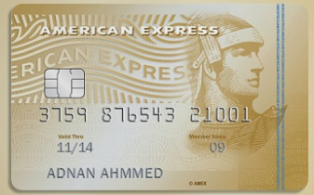
4.4.2 City Bank American Express Gold Credit Card
American Express Gold Credit Card

a. Travel Benefits of American Express Gold Card
- Cardholders can get a free subscription to Priority Pass and unlimited access to more than 1,200 airport lounges around the world.
- The user can enjoy the free night offered at the Palace Luxury Resort after paying only the first night from Monday to Friday. This offer is not valid from Thursday to Friday, from Friday to Saturday and the closing days.
- Free access to the American Express Lounge at City Bank at Hazrat Shahjalal International Airport.
- Emergency assistance and medical assistance abroad.
- Cardholders can enjoy incredible savings of up to 20% on all Biman Bangladesh Airlines, Biman Holidays listed establishments and the offer is valid until June 30, 2019.

b. Lifestyle Benefits
One can enjoy 1-for-1 Complimentary Companion Buffet at:
- Complimentary companion buffet round the year at Radisson Dhaka, Radisson Chattogram, Amari Dhaka, InterContinental Dhaka, Le Meridien Dhaka, Four Points by Sheraton, THE WAY Dhaka, Long Beach Suites Dhaka, Dhaka Regency Hotel & Resort, Hotel Sarina Ltd. and Six Seasons Hotel under BOGO buffet offer.

c. Membership Rewards Program
- One can earn one membership reward points for every BDT 50 spent at any POS or E-commerce terminals with their AMEX Platinum Credit Card.
- Earn 5 Membership Reward Points for every BDT 50 spent at any POS or online spend at leading supermarkets across the country.

d. Exclusive Discount Program
The card member can enjoy the offers and discounts through the American Express Selects program. Wherever one finds themselves in the world, one will enjoy exceptional value and privileges in travel, leisure, dining, and shopping.

e. Insurance Benefit (City Shield)
- Double Benefit Insurance (DBI): Card members are insured on the balance of the card in the unfortunate event of death or permanent total disability (PTD). The Card members will be charged a 0.35% premium rate automatically every month.
- All Accidental Death Insurance (AADI): A Card member automatically receives all the Accidental Death Insurance free of cost. This is due to any accident, and the coverage for each card member is BDT 500,000 which will be paid to the Card member’s nominee in case of accidental death.

f. Other Benefits
- Balance Transfer
- 0% interest Flexi Buy program
- Replacement of card
- Card Cheque
- Easy Pay
- American Express Service Center
- Equal Monthly Instalment
- Customer Service Center for 24 hours
- E-Statements

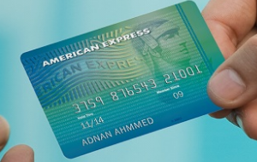
4.4.3 American Express Green Blue Credit Card

American Express Green Blue Credit Card

Travel Benefits
- Medical and emergency assistance abroad.
- One can enjoy a free night at Palace Luxury Resort after paying only the first night from Monday to Friday. This offer is not valid from Thursday to Friday, Friday and Saturday and closing days.
- One can enjoy incredible savings of up to 20% in all Biman Bangladesh Airlines and Biman Holidays outlets. This offer is valid until June 30, 2019.

Lifestyle Benefits
One can enjoy 1-for-1 Complimentary Companion Buffet at:
- The Way Dhaka
- Long Beach Suites Dhaka
- Dhaka Regency Hotel & Resort
- Summerfield Restaurant, Hotel Sarina Ltd.
- Sky Pool & Bunka Restaurant, Six Seasons Hotel

Membership Rewards® Program
- With your AMEX Green Blue credit card, you can earn one loyalty point for every BDT 50 spent on any point-of-sale or e-commerce terminal.
- Earn five membership bonus points for every 50 BDTs spent at points of sale or in stores in major supermarkets in the country.

Exclusive Discount Program
The card holders can take advantage of American Express Selects offers and discounts. Wherever you are in the world, you will enjoy exceptional values ​​and privileges for travel, leisure, dining, and shopping.

Insurance Benefit (City Shield)
- Double Insurance (DBI): In the event of death or permanent total disability (PTD), card members are insured in the card balance. The cardholders will automatically receive a premium rate of 0.35% each month.
- Accidental Death Insurance (AADI): A member of the card receives accidental death insurance for free and covers death by accident. Coverage is 150 000 BDT for each card member and will be paid to his candidate in case of accidental death.

0% Interest Flexi Buy program
One can enjoy at 0% interest rate if they use the Flexi Buy program and the plans of installment range from 3 - 36 months.

Other Benefits
- Card Cheque
- Easy Pay
- American Express Service Center
- Equal Monthly Instalment
- Dedicated 24-hour Customer Service Center
- Card Replacement
- E-Statements
- Balance Transfer

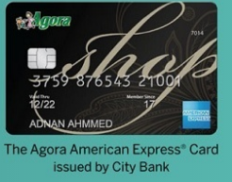
4.4.4 Agora American Express Card
Agora American Express Card

Welcome and Renewal Vouchers
- You can celebrate each year of registration on the card; be rewarded with a good Agora worthy of TK. 1000 on the date of renewal of the card.
- The experience of belonging to the card can be improved with a good Ágora worthy of Tk. 2000 in the welcome pack.
- Members can exchange vouchers for all products available in Agora stores in Bangladesh when presenting the card. All vouchers will be valid for two months.
There are also advantages, such as:
- An additional gift voucher worth Tk. 2000 when you pass Tk. 100,000, in addition to spending Tk. 200,000 in the same year of registration.
- Tk. 1000 in the Tk expense. 200,000 each year of registration.
There are also reward points from Aponjon.
- Card-holders can earn ten reward points from Aponjon when they spend Tk. 100 in all the points of sale of Agora in Bangladesh.
- Card-holders can buy with the City Express Agora American Express card and collect their daily expenses in the form of incredible prizes.
- Across Bangladesh, only in Agora stores, 1 Aponjon prize point equals taka 1 and can be redeemed.
- Card-holders can also earn one reward point from Aponjon when they spend Tk. $ 100 or $ 2 for POS/e-commerce transactions elsewhere or locally.

Lifestyle Benefits
Enjoy 1-for-1 Complimentary Companion Buffet at:
- The Way Dhaka
- Long Beach Suites Dhaka
- Dhaka Regency Hotel & Resort
- Summerfield Restaurant

Travel Benefits
- A consumer of this card can benefit from up to 20% incredible savings on all points of sale and offers selected by Biman Bangladesh Airlines, Biman Holidays and valid until June 30, 2019.
- A consumer can enjoy a free night at Palace Luxury Resort after paying only the first night during the week, and this offer is not valid from Thursday to Friday, Friday and Saturday and the days of breakdown.

Insurance Benefit (City Shield)
1. Double loss insurance (DBI): in case of death or permanent disability (PD), the card members are insured on the remaining balance of the card. Card-members will be automatically billed at a rate of 0.35% each month.
2. Absolute risk fatal accident insurance (AADI): a card member receives insurance against all risks and covers death due to an accident. Coverage is BDT 150 000 for each card member and will be paid to his agent in the event of accidental death.

Other Benefits
- 0% interest Flexi Buy program
- Balance Transfer
- American Express Service Center
- Equal Monthly Instalment
- Card Replacement
- Easy Pay
- 24-hour dedicated Customer Service Center

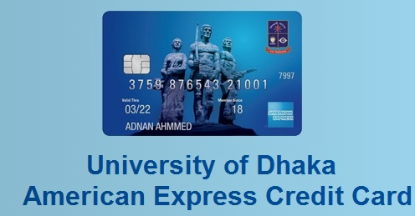
4.4.5 University of Dhaka American Express Credit Card
University of Dhaka American Express Credit Card

Welcome Benefit
It is possible to improve the enrollment experience with welcome vouchers at various recognized merchants, offering savings of 15% to 20%. And all the coupons will be valid for two months from the date of accession to the charter.

Insurance Benefit (City Shield)
Double Loss Insurance (DBI): In the event of death or permanent total disability (PTD), card members are insured on the remaining balance of the card. Card-members will automatically receive a premium rate of 0.35% each month.
All death insurance (AADI): A member of the card receives insurance against all accidental damage and covers death by accident. Coverage is BDT 150 000 for each card member and will be paid to the card-designated candidate in case of accidental death.

Membership Rewards Program
- One can earn 1 point for every BDT 50 or USD 1 and spent through POS and online transactions.
- Across the country, one can earn 5 points for POS and online transactions at leading supermarkets.
- There are some complimentary companion dining-
- “Top of the Way" restaurant, The Way Dhaka
- "Cozy Sizzler," Long Beach Suits Dhaka
- "Grandiose Restaurants," Dhaka Regency
- "Sky Pool" & "Bunka" Restaurants, Six Seasons Hotel
- "Summerfield Restaurant," Hotel Sarina
- Financial Flexibility
- Cardmembers can charge everyday expenses and manage their finances while enjoying the flexibility of paying their balance over time.

Other Benefits
- 0% interest Flexi Buy program
- Supplementary Cards
- Card Cheque
- Balance Transfer
- Equal Monthly Instalment (EMI) Plan
- Easy Pay
- American Express Service Center
- 24-hour dedicated Customer Service Center
- E-Statement service
- Auto Debit instruction
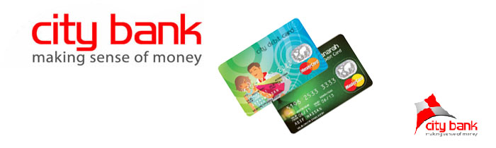
Chapter Five
Recommendations and Conclusions

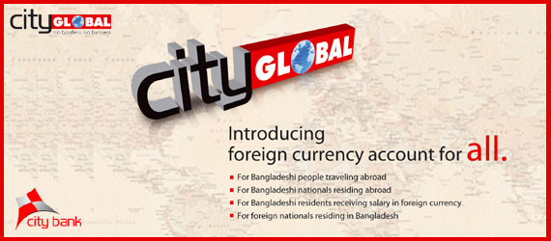

5.1 Recommendations
According to the previous findings and analysis of the American Express Cards of City Bank Limited, it can be said that the bank provides a lot of benefits to its credit card customers and there are five types of cards the bank is offering. At this chapter I want to share some suggestions based on my academic knowledge for the betterment of the credit card section of the City Bank Limited. The recommendations are shared below:
- Though credit card holds a secure law of credit, the City Bank Limited should be careful of issuing credit card and improve their examination process of creditworthiness before releasing the card to a consumer.
- High pressure exists on the credit card section to sale the cards and achieve the monthly targets, and usually these targets are so large in amount. The bank needs to reduce the target amount so that the employees may not feel it a burden.
- In case of any consumer wishes to open a joint account, they have to submit a copy of the declaration and operational instructions of the account to the branch along with their signatures.
- The City Bank Limited has to promote its American express cards so that the consumer may be aware of the benefits they are going to be received if they purchase a credit card from the bank.
- The bank needs to increase its POS (Point on Sale) and provide several promotional offer and discounts on the existing consumers of its American Express cards.
- The bank should introduce more cards for other university students like the University of Dhaka American Express Credit Card as there are a lot of reputed and highly populated graduate universities exist in Bangladesh.

5.2 Conclusion
The City Bank is considered as a reputed bank in Bangladesh. This bank is structured to operate in both the local and foreign market. It has many experienced and qualified human resources who can work for meeting the opportunities. They work to make opportunities into strengths. The bank has to remove its weakness and enrich the sectors. As it was the pioneer in introducing American Express Credit Card (AMEX), it may introduce more advanced services in the product categories. Depending on customers demand and savings, the bank introduced four new deposits, and one DPS skim. It has set up a retail finance center, collections management unit, etc. In my internship period, I tried to develop my knowledge as much as possible. As I have tried to cover most of the sections and department, I have no depth knowledge about all the activities and functions of the divisions because of time limitation and confidentiality of banking system. After all, It was more satisfactory for me. The staffs of this bank are very cooperative.

References
(1) The City Bank (2018). Overview and history. Retrieved from http://www.thecitybank.com/highlights.php
(2) The City Bank (2018). Policies and practices. Retrieved from http://www.thecitybank.com/retail_banking.php
(3) Wikipedia.(2018). List of banks in Bangladesh. Retrieved from https://en.wikipedia.org/wiki/List_of_banks_in_Bangladesh
(4) The City Bank. (2018). About the City Bank. Retrieved from https://www.thecitybank.com/
(5) The City Bank (2018). Product mix. Retrieved from https://www.thecitybank.com/
(6) The City Bank (2018). City touch. Retrieved from https://www.thecitybank.com/citytouch.php
(7) The City Bank (2018). City Bank proudly sponsors "Bangladesh 2030: Strategy for Growth". Retrieved from https://www.thecitybank.com/Sponsor_Bangaldesh_2030.php

