

Internship Report on Inventory Management at Tiger New Energy Ltd

Syada Tasmiah Haque Eyana

This report is submitted to the school of Business and Economics, United International University as a partial requirement for the degree fulfillment of Bachelor of Business Administration

Inventory Management at Tiger New Energy LTD

Submitted to:

Ms. Mahbuba Sultana
Lecturer
School of Business & Economics (SoBE)

Submitted by:
Syada Tasmiah Haque Eyana
ID: 111 202 122
Major: Supply Chain Management
Registration Trimester: 261 - Spring 2026



School of Business and Economics
United International University

Date of Submission: 22 July 2026

Letter of Transmittal
Date: 22/07/2026
To
Ms. Mahbuba sultana
Lecturer
School of Business & economics (SoBE)
Subject: Submission of Internship Report
Dear Ma’am,
I am happy enough to present Internship Report on topic, “Inventory Management at Tiger New Energy Ltd.” for the partial fulfillment of my internship program.
I received hands-on experience and developed hands-on knowledge on inventory management processes at Tiger New Energy Ltd such as inventory control, demand forecasting, Supply Chain coordination. The report is an attempt at learning, observing and analyzing their inventory system and recommending the changes that could be made for improvement.
I have tried to make this report accurate, complete and compiled in compliance with the instructions given. I feel positive about the internship because I firmly believe that the knowledge that I will acquire and experiences that I will have during this internship will be helpful for both my educational and professional growth.
Many thanks for your guidance and support during this time. I will be grateful if you kindly accept this report.
Sincerely yours,
Syeda Tasmiah Haque Eyana
ID: 111 202 122
Department of BBA, SoBE
United International University
Certificate of Similarity Index
This report has followed all requirements as stated in the Policy on the requirements of the United International University in terms of Similarity Index and the United International is also suitable for this purpose. The author agrees to be liable to punishments as per guidelines if proper reference is not given to the authors without their reference. The institutional policy on this aspect. Submission of report which will be subject the policy and practice of the force is to do a 'similarity evaluation' according to the policy, applicable and interpretable on date of similarity evaluation and time of the evaluation was done.
Declaration of the Student

I, Syada Tasmiah Haque Eyana, a student of the Bachelor of Business Administration program at United International University, hereby declare that this report is entirely my own work. I have not knowingly violated any copyright regulations, and to the best of my knowledge, this report is an original and authentic piece of work.
Furthermore, I confirm that this report has not been submitted, in whole or in part, for the purpose of obtaining any degree or certificate at any other institution.
I have strictly followed all academic rules and guidelines in the preparation of this report.

Syada Tasmiah Haque Eyana
ID: 111 202 122
Date:
Corporate Evidence
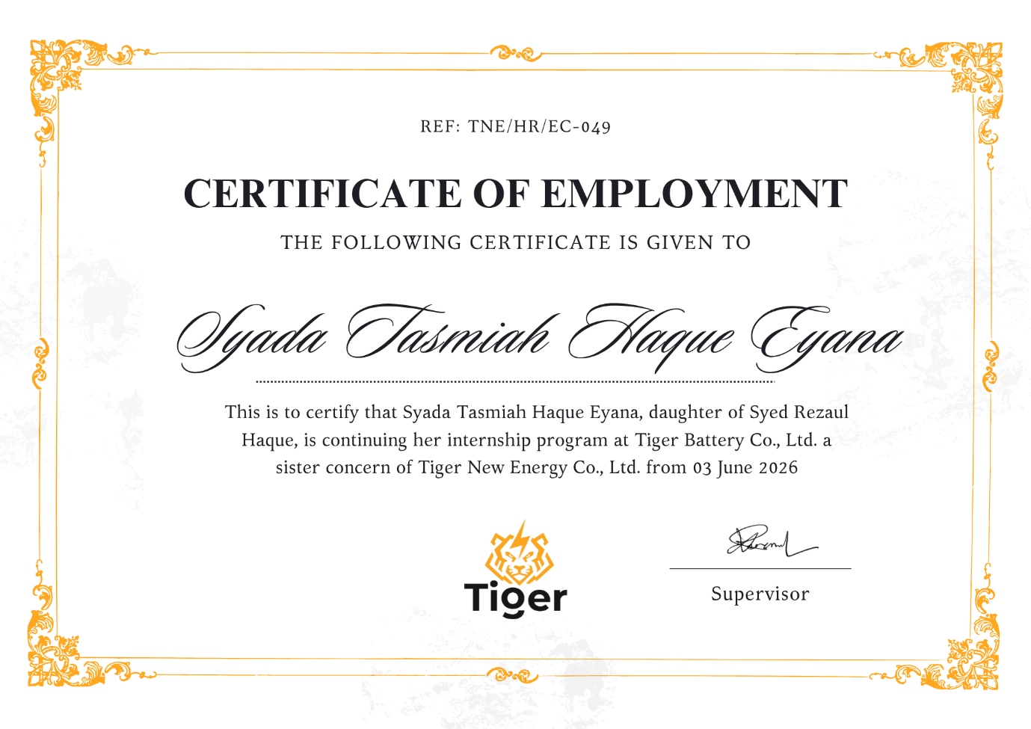

Acknowledgement

First of all, I would thank to Almighty Allah who granted me the power, patience and ability to accomplish this internship program as well as write up this professional report.

I would also like to express my deep sense of gratitude to Ms. Mahbuba Sultana, Lecturer, School of Business & Entrepreneurship, United International University for his valuable advice and suggestions as well as constructive criticism during the preparation of this report. Her guidance has been impactful in influencing my thinking about the principles of supply chain management.

I would like to express my sincere appreciation to Tiger New Energy Ltd for giving me the chance to be an intern in their great company. A big thanks to the entire Supply Chain Management team for their co-operation, support and direction throughout my three-month long internship.

Special thanks to my in-field supervisor and inventory management team for teaching me hands-on supply chain operations, inventory control systems and warehouse management. I have greatly benefited from their down-to-earth wisdom.

I also want to say a big thank you to my fellow interns and coworkers at Tiger New Energy Ltd. who were the best sidekicks a girl could ask for, more than that they make my internship impactful by collaborative efforts and friendships.

Last but not least I would like to thank my family and friends for their endless support, encouragement and understanding during my internship period and the composing of this report.

Thank you all for your contribution in making our learning meaningful and worthwhile.

Executive Summary

This internship report provides a detailed analysis of the inventory management practices of the company Tiger New Energy Ltd, which is a fast-growing company in renewable energy sector in Bangladesh engaged in manufacturing of batteries and providing Electric Vehicle (EV) battery-swapping services. The study is carried out through a 3-month internship experience in the Supply Chain Management (SCM) department with emphasis on inventory control, warehouse management and integration of the system with ERP.
Founded in 2021, Tiger New Energy Ltd. is emerging as a leader in sustainable and clean mobility solutions. The company has to deal with a dynamic and rapidly evolving industry, and run efficient supply chain systems in raw materials, work-in-progress (WIP) & finished goods. The report incorporates both theory and practice as observed during the internship.One of the major strengths that the company offers is its mixed-control inventory management that integrates manual controls with automated management via the Odoo ERP system. This integration improves accurate and traceable SC management and decision-making throughout activities.

Key Findings:
If you implement Odoo ERP, you will get real-time inventory levels, providing operational transparency and control.
Using FIFO (First-In, First-Out) helps to maintain the quality of products, especially important for battery lifecycle management.
ABC Analysis technology gives the support in prioritizing the inventory by value and importance to aid optimum allocation of resources.
Proper racking systems, safety and quality control measures are in place for smooth warehouse operations. Coordinate cross functional with procurement, production and inventory team improves workflow efficiency.
The internship gave hands-on experience in day to day activities like Stock Reconcile, Order Processing, Co-ordination of warehouse. It pointed out that there is a difference between theoretical models and actual challenges especially when the operations contain fluctuation in demand, limitation and other challenges present in the system.
Table of Contents
Letter of Transmittal III
Certificate of Similarity Index IV
Declaration of the Student V
Corporate Evidence VI
Acknowledgment VII
Executive summery VIII-IX
List of Figure XII
List of Acronyms & Abbreviations XIII
CHAPTER 1: INTRODUCTION 1-6
1.1 Background of the Report 1-2
1.2 Objectives of the Report 2-3
1.3 Rationale of the Report 3
1.4 Scope and Limitations of the Report 4-5
1.5 Definition of Key Terms 5-6
CHAPTER 2: COMPANY AND INDUSTRY PROFILE 7-19
2.1 Company Analysis 7-13
2.1.1 Overview and History 7-8
2.1.2 Trend and Growth 9-10
2.1.3 Mission & Vision 11
2.1.4 Product / Service / Customer mix 11-12
2.1.5 SWOT Analysis 13
2.2 Industry Analysis 14-19
2.2.1 Specification of the Industry 14-15
2.2.2 Size, Trend, and Maturity of the Industry 15-18
2.2.3 Industry SWOT Analysis 19
CHAPTER 3: INTERNSHIP EXPERIENCE 20-23
3.1 Position, Duties, and Responsibilities 20
3.2 Training & Development 21
3.3 Contribution to Organization / Operations 21-22
3.4 Evaluation 22
3.5 Skills Applied 22-23
CHAPTER 4: CONCLUSIONS AND KEY FACTS 24-25
4.1 Recommendations 24
4.2 Key understanding 24-25
4.3 Conclusion 25
Reference 26

List Of Figure
Figure | Page No.
Fig1: Moto Max Motorcycle Battery | 12
Fig2: Advantages of Swap Station | 12
Fig3: SWOT analysis of Tiger New Energy | 13
Fig4: Industry SWOT Analysis | 19

List of Acronyms & Abbreviations

BBA | Bachelor of Business Management
ERP | Enterprise Resource Planning
EV | Electric Vehicle
FIFO | First In, First Out
LIFO | Last In, First Out
ABC | Action-Based Categorization
WIP | Work in Progress
RM | Raw Materials
FG | Finished Goods
SKU | Stock Keeping Unit
JIT | Just in Time
EOQ | Economic Order Quantity
SCM | Supply Chain Management
SWOT | Strengths, Weaknesses, Opportunities and Threats
KPI | Key Performance Indicator
SOP | Standard Operating Procedure
QC | Quality Control
UIU | United International University
F.C | Frequent Customer
B.C | Business Customer

CHAPTER 1: INTRODUCTION

1.1 Background of the Report
Supply chain is everywhere now. It's not just a supporting role, it's something greater. Supply Chain Management (SCM) is a key factor in creating the competitive advantage and the whole organization's performance in today's global business environment. Maintaining effective warehouse management and proper stock management is crucial for businesses. There is no choice at all these are required. They are essential in manufacturing the keys that line and supply chains must move, stored and delivered how well these factors perform can be the difference between operational excellence and failure.
Meanwhile, there's something else going on. The corporate world is gradually tending towards going green or sustainable. Renewable energy is no longer just a geographical specialty. Grows rapidly almost unexpectedly fast. Meanwhile, the models of the supply chains are also evolving. Adapting some difficulty keeping up.
This report is based on an internship experience in Tiger New Energy Ltd, one emerging company which is active in the renewable energy sector and in battery technology, in Bangladesh. Students had to take an internship for completion of their B.B.A. from UIU. This internship was compulsory for students to complete their B.B.A. program from UIU. But in reality, it was not considered a mere obligation. It was a chance, that. An opportunity to experience theory in the real world. Or occasionally, how it doesn't!
Tiger New Energy Ltd. was founded in 2021, a representative of new generation augmentative socially responsible, tech-savvy businesses in Bangladesh. It specializes in its battery production and battery swapping services for EVs. Clean mobility. That’s their thing. And it’s growing. Fast. The way that they operate is quite different, as it is sustainable and business solutions as well. This made it an interesting organization to research. Not flawless, but very dynamic.
This internship was selected because of a great curiosity. It's a simple question after all. How do the concepts of value chains as taught in the books work in a real company? Rather than in an emerging field such as renewable energy. The 'supply chain' here is not the same one slightly more complicated to some extent. The challenges are apparent from sourcing raw materials for making batteries, through to the delivery of finished battery products. But sometimes all works out fine is incorrect.
This report is an attempt to provide an overview and holistic view of the Tiger New Energy Ltd. Supply Chain practices relates academic theories with observations in practice. Emphasis is placed on inventory management, warehouse function, and transportation. There were areas that worked out well but some needs improvement which is normal.
From 3rd June 2026, I took the opportunity to work in the Supply Chain Management department as an intern. The opportunity of the same period allowed me to develop an experience handling inventories, coordinating in the warehouse, using the ERP system and communicate with others in a Cross Functional way. The learning was practical sometimes challenging but valuable. It got me a better grip of what operations can be like in supply chains in a business climate that is quite overwhelming.
This report is no mere academic one. It's actually based on actual experiences and real observations. The findings and recommendations are intended to add a contribution to the theory as well as to the practice of supply chain operations. Although it might be small, it makes a difference.
1.2 Objectives of the Report
This internship report has been prepared with the following objectives in the front of the mind, which helps in shaping its structure and content and for its analysis. The goals should not only achieve the educational purpose, but also benefit stakeholders. Primary and secondary aims are shown as follows:
Primary Objectives:
- To measure the performance of Tiger New Energy Ltd in controlling their stock level in relation to their inventory management practice.
- To observe warehouse management activities and assess the efficiency of warehouse activities such as storing, handling, and distribution.
- To gain awareness of ERP (Odoo) implementation and aptitude for putting into practice it to ease the flow of the supply chain.
- To capture experimental learning & relationship with theory academy of Supply Chain Management.
Secondary Objectives:
A complete report of Tiger New Energy Ltd. such as its strategic plans, organization structure and the company's strengths and weaknesses
- SWOT analysis of the company and renewable energy industry of Bangladesh
- To gain insight into the barriers and enablers faced in Renewable energy industry Supply Chain operations
- To push forward actionable ideas on how to enhance productivity and efficiency in actionable supply chain.
- To talk about your growth as a future professional or gaining new knowledge, skills, and abilities that arose from your internship.
- Support the development of academic understanding of the management of suppliers in emerging markets.
1.3 Rationale of the Report
This report is prepared as a requirement for the completion of the BBA program at United International University. However, it is not only for academic purpose. It also serves as a bridge between theoretical knowledge and practical application. Concepts like inventory management, warehouse operations, and ERP systems were applied during the internship at Tiger New Energy Ltd., though in reality they do not always follow textbook models. From a professional perspective, the report highlights practical experience gained in supply chain activities. In today’s competitive job market, such exposure is important, sometimes even more than academic results. It reflects basic readiness and understanding of real business operations. The report also provides an external view of the company’s supply chain practices. Using simple analysis, it tries to identify strengths and areas for improvement. Additionally, since research on supply chain practices in Bangladesh’s renewable energy sector is still limited, this report contributes some practical insights.
Overall, the rationale includes academic requirement, professional development, and contribution to organizational and industry understanding.
  - Scope and Limitation of the report
Scope of work: Inventory management and warehouse business in the Supply Chain Management only.
Organization Size: The constraint of the study bounds up till Tiger New Energy Ltd.'s Bangladesh operations regarding their office headquarters and warehouse premises.
Industry Coverage: Renewable energy, battery technology.
Technologies/tools used: Odoo ERP System, Inventory Management, it also can be applied to company and industry SWOT analysis, operating process review, as well intern practice summary writing.

Limitation of the report:
Although our best attempt was made to be comprehensive and accurate, the report has some limitations that need to be acknowledged:
Time Limits: Although over three months’ work experience may seem to be quite a long time, it can only represent a very small segment of the annual or seasonal changes in flow disruption and recovery and short-term FIFO behavior.
Confidential information: There is some material which an intern may not have access to like confidential business strategies which might affect the quality of financial and strategic decision making.
Limits of role: Interns obviously have limited purview and decision-making power, which can keep interns out of discussions about strategic direction or other high-level decisions.
Single Institution Study: The report is based on the practices of one institution, which may not be generalizable to current industry practice or best practice for renewable energy companies.
Technology Learning Curve: As time is scarce to excel at Odoo ERP system there will be limitations in the depth of a technical review for the capabilities.
They were taken into account in the analysis and discussion of results. Where relevant, we have attempted to cross-check the information in various sources and confirmed conflicting reports with supervisors. We have also described the varying levels of uncertainty about some facts. The resulting recommendations are mindful of these constraints and are couched in a real-life context.
  - Definition of Key Terms
Some terms need to be clear. Otherwise, things get confusing. So, here are the key ones. Simple, short but important.
- Supply Chain Management (SCM): It is about managing the full flow. From sourcing to delivery. Everything connected with the goal is value. For customers and stakeholders.
- Inventory Management: Keeping the right amount of stock. Not too much, not too less. It includes buying, storing, and controlling. Sounds easy, but actually not always.
- Warehouse Management: What happens inside the warehouse, storage, movement and safety. Sometimes messy sometimes organized.
- ERP System: A software that connects everything. Finance, sales, HR, operations. All in one place makes life easier, if used properly.
- Odoo: The ERP used in Tiger New Energy Ltd. Open-source and flexible. It handles inventory and supply chain tasks.
- FIFO (First In, First Out): Old stock goes first new stays. Very useful for batteries, because they can degrade over time.
- ABC Classification: Not all items are same. Some are very important (A). Some moderate (B). Some low (C). Control depends on that.
- Work in Progress (WIP): Products that are not finished yet, half done, still in process.
- Raw Materials (RM): The starting point. Basic inputs. Without this, nothing begins.
- Stock Keeping Unit (SKU): A unique code for every product has one. It helps tracking each product. Without it, confusion maybe.
- Battery Swapping: Instead of waiting to charge, just replace the battery. Which is quick and efficient. That’s the idea.
- Lead Time: Waiting time from order to delivery. Sometimes short sometimes longer than expected.
- Safety Stock: Extra stock kept just in case. For uncertainty because things don’t always go as planned.
- Inventory Turnover: How fast stock moves. Sold and replaced. Higher usually better, but not always.
- Economic Order Quantity (EOQ): The best order size and balances cost. But in real life it not always exact.
- JIT (Just-in-Time): Materials arrive only when needed no extra storage. This is efficient but risky sometimes.
- Stock Taking: Checking actual stock with system records. Differences can happen and they do.
- Clean Energy: Energy from renewable sources solar and battery. Sustainable options which is growing fast now.
- SWOT Analysis: A way to look at strengths, weaknesses, opportunities and threats. Simple but powerful.
- Standard Operating Procedure (SOP): Step-by-step instructions. To make sure work is done correctly in every time.
CHAPTER 2: COMPANY AND INDUSTRY PROFILE

  - Company Analysis

2.1.1 Overview and History
It began with a thought. Well, simple… maybe. Clean mobility. But in reality, not that easy. Since 2021, Tiger New Energy Ltd. is among the pioneer firms involved in the new energy industry in Bangladesh. Still young but growing fast. Founded by two Harvard Business School graduates Nicole Mao and Yiwei Zhu. They noticed something that others failed to leave undone or that they did not do themselves a gap. Cities in the emerging markets sector were preparing to make a gradual move towards clean energy and it was a massive opportunity. Their decision was to relocate early.
Their experience in strategic management was a great asset. But more than that it was the entrepreneurial attitude among them. They desired to construct something useful. Not just theory a thing which might actually work in the developing markets. That's how the Tiger New Energy Ltd. is born. From the outset, the company centred its development on two aspects. Production of batteries and battery swapping stations that’s a dual approach. The one on the other hand is making quality lithium-ion batteries. On the other side, providing 'stations' for EV consumers to quickly replace batteries if they choose not to wait for charging. It sounds efficient and it is. This model targets to address both supply and demand issues of the EV ecosystem. Not quite, but rather effectively. Though, the company is headquartered at Suvastu Muskan Tower, 56 Gulshan Avenue, Dhaka. A prime location. Midcenter of the business center. Near political and financial authorities and among corporate customers. Some advantage to this location. In particular, the operations of the Co-ordination and Supply Chain.
Tiger New Energy Ltd. is a private limited company. It's a company with two principal subsidiaries. Tiger Battery Co., Ltd., the manufacturer's arm. And Tiger Lithium Co., Ltd., which is the source and process lithium raw material. This is a system that enables specialization. Work is done at the unit level, but is linked to the rest of the business. There is certainly integration, but sometimes the coordination may be tricky. According to today, the company has approximately 134 staff members working there. Delivered through the departments such as production, Supply Chain Management, sales, Marketing, Finance, HR, and the Research & Development. Combination of technical and business skills and different backgrounds with different ideas. Foster an active working atmosphere. Sometimes not so plain and tranquil but full of activity.
The company is making remarkable achievements in a few years. A number of manufacturing facilities are built. Electric vehicle battery exchange stations are deployed in the major urban areas. Electric vehicle makers and ride sharing services have established partnerships. Gradually organising growth is taking place. The expansion is symptomatic of something as much larger. Growing need for clean solutions to energy needs. As well as the company's execution of its strategy. Not everything does happen smoothly, however there is some improvement seen.
Thus, in a span of a few years, Tiger New Energy Ltd. has progressed from a mere concept to a rising participant in the renewable energy and EV infrastructure sector. Still evolving and learning but moving ahead all the same.

2.1.2 Trend and Growth
The expansion was no gradual business. It was quick or almost sudden. Tiger New Energy Ltd had a strong and somewhat surprising growth from its inception which took place in 2021. The timing helped here was growing concern around the world for cleaner energy supplies. The same trend was happening in Bangladesh. Rising gas prices and awareness of the reality of environmental issues. The company came into this moment great, more or less.
It wasn't offset with sparkle at first. The company prioritized developing its user base in the year 2021. Manufacturing facilities were set up. Ties were made with caterpillars in the chain. Linkage with chain caterpillars was organized. They were put to great effort to gain insight into exactly what customers require. It was expensive with heavy investment. But revenue was very little. It was at that time, more a process of preparation than profits. Then came 2022 a transformation point, if you will. In Dhaka the first battery swapping station has been opened not for everyone though. The company-award actually initially focused on ride-sharing drivers which smart move. These drivers required solutions which did not involve long charging times. Commercial fleets were then introduced thereafter. This provided revenue which was predictable and also provided to the company valuable information about operations. They learned fast and adjusted things. Not always a perfect but try to improving. Growth started to become evident in 2023. Quick and excessively distracted. The battery swapping network grew in Dhaka and Chittagong with five stations. The volumes of batteries grew approximately 150%. Demand was growing very rapidly. Relationships with electric vehicle manufacturers also were a factor. It rendered Electric Vehicle easier to adopt and more appealing. This is a growth of almost 200% compared to the previous year, a report says. That’s significant it wasn't always smooth sailing in managing all this growth.
The company went into a new line in 2024. More flexible pricing subscription fee for each user and add pay-per-swap options. A plan of how they will be using the computer often. Through this, it extended its market share. The company also settled its cash flow. At approximately the same time, Tiger New Energy Ltd started exporting batteries to neighbouring nations. A new milestone foreign income which may be insignificant initially. The staff grew as well from approximately 80 to 134. Growth brings complexity with needs greater numbers and coordination.
Today, in 2026 it's a little classier. Less about just expansion more about efficiency. The company is using the Odoo ERP system. It aids the management of supply chain visibility, inventories, and decision-making. Things aren't perfect, but it's getting better. 10 more battery swapping stations are to be opened by the end of the year too. Sitting negotiations with the government on foot and cycle transport electrification continue as well. Very early stage no confirmation as yet.
There have been some general trends that have aided this growth. Market demand is one such. A rise in fuel costs coupled with heightened environmental consciousness is driving consumers to EV. Many governments have also introduced incentives such as rebates, lower import taxes and other measures that increase EV popularity. It's also technology. With high quality battery technology, the system becomes increasingly safe and reliable, in terms of power usage and life.
The infrastructure is gradually recuperating as well. As for the power grid, although there are still a number of flaws, it is improving. Battery-Swapping Stations can be more easily located and positioned in strategic areas with urban development. Being a ‘first-mover' is also working for Tiger New Energy Ltd. First-mover advantage matters. It gains recognition and loyalty from its customers even as competition begins to mount. Investment climate has also been good. Growing interest in sustainable businesses.

2.1.3 Vision and Mission
Vision

To make clean mobility accessible to everyone in emerging

To offer cutting-edge and cheap battery swap services to facilitate the massive uptake of EVs. To make a positive social difference and minimize carbon footprint by working in partnership with governments, community and network partners.
Mission

2.1.4 Product / Service / Customer mix
- Tiger Battery Co., Ltd.

  - Motorbike Batteries (3 variants):
    - Mighty Max – Premium high-performance battery that delivers reliable power with a 9Ah capacity over 10 hours.
    - Moto Max – Cost-efficient standard battery. Ideal for powering small vehicles and devices that require consistent performance.
    - Power Max – Heavy-duty, long-life battery. Designed to deliver consistent and efficient power for various small vehicles and devices.
  - UPS Batteries – For continuous power supply.
  - Solar Batteries – For renewable energy applications.

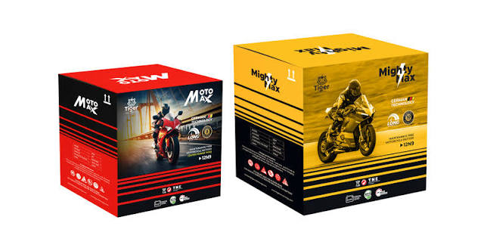
Revenue Source: Revenues are generating through direct product sales to retailers, distributors, and customers.

Fig1: Moto Max Motorcycle Battery
- Tiger Lithium Co., Limited
  - Battery Swapping Stations – RFID-enabled system where EV operators exchange discharged batteries for recharged ones.
  - Revenue Streams:
    - Franchise Clients (F.C).
    - Business Clients (B.C).
    - Subscription services for EV users.

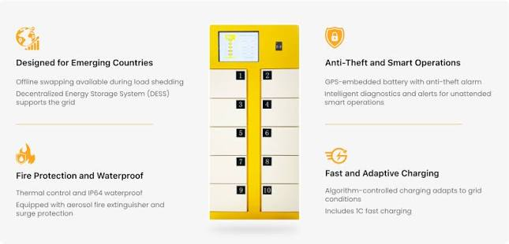
Fig 2: Advantages of Swap Station

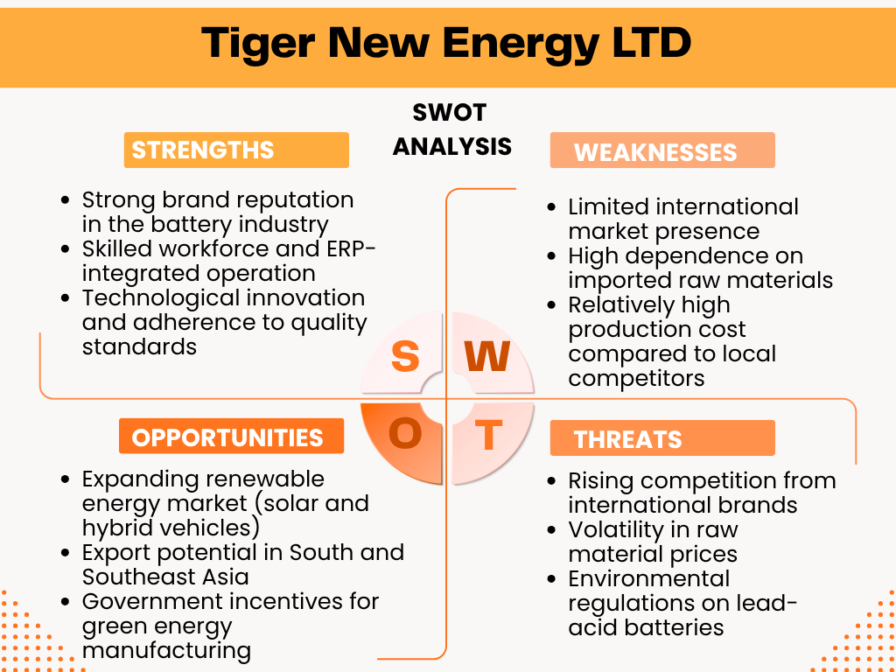
2.1.5 SWOT Analysis:
Fig3: SWOT analysis of Tiger New Energy

2.2 Industry Analysis:
2.2.1 Specification of the Industry.
Tiger New Energy Ltd. is in the business of providing renewable energy, specifically in the battery business and Electric Vehicle infrastructure. It's not just your typical industry it brings together people, ideas, and innovations within the clean energy, the transportation and advanced manufacturing sectors. A remarkably rapid growth area. Throughout the world and in the city.
Traditionally, renewable energy was solar and wind energy in Bangladesh. It was the prime emphasis. However, times are changing now they are shifting focus to new applications such as energy storage and e-mobility. Gradually at a low speed first, then increase the speed. This is where Tiger New Energy Ltd. falls into place. Its presence in the battery manufacturing and battery swapping services business puts it in an emerging area. The business it is engaged in battery manufacturing and battery swapping services is an emerging one. Still developing but growing at a very rapid rate. The Company's activities are covered by numerous international industrial standards. An example of ISIC Code 2720 is manufacture of batteries and accumulators. There is also ISIC Code 3511, which encompasses electric power generation and distribution – which is pertinent for charging infrastructure. Another category is ISIC Code 5229, which includes transportation support services, such as battery swapping. So, it’s not limited to one category. It overlaps multiple areas.
The technology is much involved in this industry. Requires a considerable amount of capital. Not easy to enter. Supply chains are complicated and can be sometimes unpredictable. This is in addition to the changing regulations that add pressure to businesses. It also a knowledge-based industry. It deals with ideas of electrochemistry, electronics, logistics management and software systems. A range of disciplines in collaboration. Often difficult to control in this ecosystem, there are multiple important stakeholders, local and outside battery manufacturers. Manufacturers and importers of EVs. Charging infrastructure providers and regulatory authorities of energy and transportation. Suppliers of electricity or as the eyes and ears of the communicator, Water safes and that banks will fund for clean energy. All have a part to play. The system is interrelated.
Given the value chain, the beginning is raw materials extraction. Lithium, cobalt, nickel. It then proceeds on to the production of the battery cells. Then comes the pack assembly and Vehicle integration and infrastructure development. At the end of their life, the recycling. Tiger New Energy Ltd. mainly operates in the midstream and downstream parts. This includes pack assembly and battery swap services. A strategic position. There are a number of global trends which are driving the industry. The price of batteries has decreased over the last ten years almost 80 percent. Also, there is an improvement in the performance and energy density. There is increasing regulation on the environment. Fossil fuel prices are increasing. Urban areas are becoming more congested. These are also more efforts towards the commitments regarding sustainability. More efforts into the commitments associated with sustainability. These are all propelling the industry forward.
Government policies have also been supportive in Bangladesh. The government has introduced EV-incentives like tax advantages for green energy investments and lower import tax for EV parts which have made it a positive ecosystem. These policies are supportive. Our growth can be made easier with them. This support has enabled companies such as Tiger New Energy Ltd. to grow rapidly.
In general, the world of industry is developing fast. Not easy to always there are opportunities. And Tiger New Energy Ltd. is in the middle of this transformation.
2.2.2 Size, Trend, and Maturity of the Industry
It is no longer a small industry. Used to be, that's probably a couple years ago. Currently, however, there are changes underway fast.
By 2025, the number of off-grid and distributed renewable energy has already reached 700 MW in Bangladesh so far, so good. Whereas over six million rural households are already running solar home systems. Improvement in energy access quietly but massively. Now, in comes EV and battery space. That's right where the real action is going on. It is likely that the market size is around $150-200 million per year. And it is growing at around 45–50% CAGR. But lo and behold, it's pretty high not normal growth. Rapid one more than 50,000 electric two/three wheelers have been road-tested in cities. These are now in abundance not future. It’s already here. The battery demand for the application is estimated at 200–250 MWh per year. To be expected to be three times larger by 2027. Thus, the demand curve is not horizontal it’s rising suddenly. This is where Tiger New Energy Ltd. comes in not just as a participant, Much more of an early bird. While the market for switching batteries is still early and total sales of such batteries are estimated to be somewhere between $10-$15 million, players such as them are imprinting their own designs on it. They have a market share of approximately 30–35%. That’s significant in particular, in an emerging market.
Over the past three years, alone, there have been over $50 million invested in EV infrastructure. Charging stations. Swapping points. Backend systems. The eco-system is being crafted, one piece at a time. On the scale it is small when compared to India. Obviously. However, it's a quicker pace than in Pakistan. Slightly more aggressive and then there is geography. Bangladesh is really located in an interesting part of the world. Between India and the Southeast Asia. That positioning might make a difference. Maybe not today but soon.
Trend of the Industry:
When done properly, some patterns will be most obvious some expected some surprising. The adoption of EVs is ramping up quickly and suddenly. Prices for gas and oil are growing that people are noticing. Government incentives are assisting aiding just too. And cars are getting better with better designs and better efficiency. This is being driven even further by ride-sharing and delivery. Due to higher usage, EVs are more economically practical with simple math. Infra is catching up slowly but little by little. Investment by both government and private companies. The plan is to have charging stations across highways and urban centres by 2030. Sounds ambitious but necessary.
Tiger New Energy Ltd. has ramped-up its battery swapping efforts which makes sense. Charging takes time swapping doesn’t. That difference makes all the difference to high-use vehicles. A lot. Yet another change is in the direction of more local production. Rather than importation, companies are attempting to develop batteries in-house. Even look at making components. It reduces dependency also creates jobs. The same is true for Tiger New Energy Ltd. which, while still a fledgling company, is working on the same process.
Another trend at the moment is to integrate with solar. It's not large just yet, rather it's growing. This combination of solar power and storage opens up new use-cases, backup power, peak shaving, cost savings. This is now beginning to be caught on by businesses. Financial models are also in the process of change. BaaS, leasing and green financing. These are helping the adoption of EVs. Because even though cost is not a deterrent for many, it is not a deterrent for many simply because they don't have the money up front. That's why alternative financing comes in handy. Smart grids are also of interest managing renewable fluctuations and stabilizing the system. It’s still developing but important. And locally Bangladesh is seeking to work together cross-border electricity trade. EV standard alignment when it is going to be working, the market can spread beyond the border.
Maturity of the Industry:
The concept of maturity is a bit more complex now. Not every sector of the industry is on a par with the other.
Solar energy is mature over 20 years of evolution established supply chains, known technologies and experienced players. It is stable now. However, EV batteries and charging are very different story. These sectors are still young around 3–5 years old. Moving to a new place still settling down. The industry is in growth stage. There are obvious indications with high growth. But not profitable not always certain. There are numerous companies conducting experiments trying different technologies different business models. Some will work some won’t.
Competition is increasing new competition are emerging. Regulations are evolving. It hasn't been fully resolved at this time. The level of customer awareness is still improving but not full. People are learning slowly. The supply chains are also being established. Not fully developed with gaps. In particular, swapping batteries is in early growth phase. Tiger New Energy Ltd has emerged as one of the first to do so. It's that way and it's advantageous that way but also responsibility. The need to educate the market applies to them too. Build trust even design the way the system should operate. Based on the forecast to 2030-2035, the industry is projected to reach Maturity status. The forecast to 2030-2035 indicates the industry will mature from 2030-2035. At that time, things will be more settled and technologies will standardize. The dominant player will be a strong player. The race will be hot or maybe there's some smaller growth rates. At the moment, it's a combination, opportunity and risk both exist.
This is the opportunity for business such as Tiger New Energy Ltd. To lead. To form up the market. But, of course, to endure the uncertainties, too. Since it is a rapidly changing world. Not all things will go as planned and that's not necessarily a bad thing.

2.2.3 Industry SWOT Analysis:
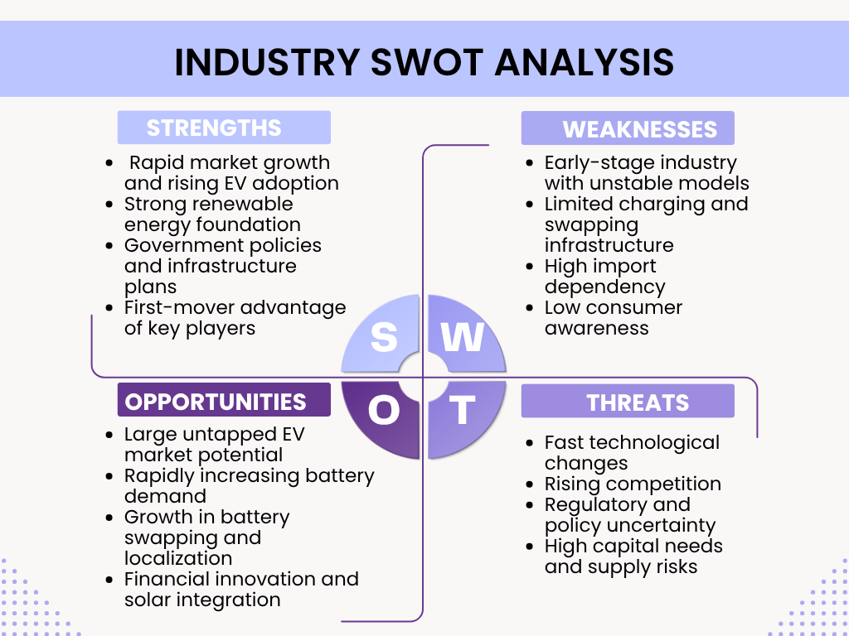
Fig4: Industry SWOT Analysis

CHAPTER 3: INTERNSHIP EXPERIENCE
3.1 Position, Duties, and Responsibilities
Throughout the course of my three-month internship, I worked on the ground in many inventory management roles including: daily cycle counts and stock reconciliation demand forecasting order processing This chapter describes the examined practical inventory management practices in a structured format as well as if they conform to academic models. My three months internship with Tiger New Energy Ltd. was spent in the two departments – Supply Chain Management (SCM) and Warehouse Management. The Warehouse Management function at Tiger New Energy is the operational backbone supporting the company’s innovative battery swapping network. The primary focus is on the safe, accurate, and efficient handling of high-value Li-ion batteries and their associated components. I went through intern programme and gained a lot of experience in that. Not just observation but also real involvement. I have worked in inventory and retail business. In fact, it was taken great care of. I was engaged in taking inventory, confirming purchasers order and verifying that all of the items were accurate prior to their being stored. The difference even if it is little, there might be issues later on. So, accuracy mattered a lot. I also helped to place materials properly. Organized warehouse, however, if not careful items can go astray. An important aspect of my job was emergency response or “Dispatch” work. Assisting to get completed battery packs from storage to delivery points. Here it was necessary to get the timing right. It was decided to have cycle counting as a routine task almost daily with system records, identifying and counting part of a number of objects. Sometimes everything matched, sometimes it didn’t. There's where “stock reconciliation” stepped in. Being informed on the issue because that the system was a problem or a human error. It needed patience. I also witnessed a bit of forecasting for demand and accepting orders. Not very high level but if they know how decisions are taken. Monitored the number of requisitions being done from the Odoo ERP and matched up purchases if required. It highlighted how much automation does and in which direction human intervention must go. Another of the roles involved preparing reports. Stock control (Volume, Channel and Turnover). Therefore, the various reports used by the supervisors had to be true. No guesswork. Due to strict safety measures for handling lithium-ion batteries, they had to be handled in special ways. Always careful. No shortcuts. The errors here have a small effect.
3.2 Training & Development
I was given a basic training on the working of the company at the beginning of my internship. That was not too abstract but more practical which was more difficult to understand. The intern's role typically involves supporting the Supply Chain and Warehouse Management teams.
The warehouse operations are evaluated based on critical Key Performance Indicators (KPIs), including picking accuracy, order cycle time (the time to move a battery from the charging station to a swap), and space utilization rate. One of the largest portions of my training consisted of learning the Odoo ERP system. At first, it was a bit complicated. Too much choice, too much modules. However, after a while it'd gotten to be a familiar feeling. I have been trained to record sales, keep stock counting and record stock in multiple locations. The real time updates were particularly helpful. Another important area of learning was the barcode and QR code system. Each battery pack was an individual package. All information will appear when you scan it. Model, production date, service history. It was really advanced, don't mind me. And also minimized manual errors.
I also received the inventory classification training. Raw Materials, WIP, and Finished Goods. There are distinct differences between the categories. Because of the long lead times, it is important to plan the raw materials. WIP must move quickly or it will impede production. Finished goods should be in place at the time required. Simple concept. Not so easy to control. Safety training was also provided. In particular for the processing of lithium-ion batteries. Appropriate storage, temperature sensitivity and risk management. There were some rules that were very strict, but it's just right.
The majority of my learning has not been through training sessions. It was self-made. Daily involvement. Observing others. Sometimes this even from minor errors, which is normal.
3.3 Contribution to Organization / Operations
As an intern, I helped out with the daily activities in a number of ways little but significant contributions. Participated in cycle counting to increase inventory accuracy. Regular checks minimized discrepancies in physical stock and system records. That matters helped with stock reconciliation when discrepancies were noticed. Identifying issues, supporting corrections. It assisted in keeping the system more reliable. If data is not accurate, then decisions will not be accurate.
I also assisted with procurement indirectly. I tracked reorder points and system generated reorder requests to make sure materials were reordered timely. Production can be halted due to delays in procurement. Hence, this is a crucial step. Another aspect of my involvement was data entry and scanning. Through careful utilization of a bar code system, I was able to minimize manual mistakes. Time was also saved with faster operations. I also helped to keep the warehouse organized. Not a major change but small improvements. Improved positioning, accessibility. It made work flow more smoothly.
In general, I worked operationally as a job. It would support the larger system, however. And that system is based on accuracy and coordination.

3.4 Evaluation
My work during internship is satisfactory. Slightly below average but not perfect. I was able to get used to the work environment pretty easily. Initially, there was confusion in new system and new processes. After a while, however, it was all clear. Gained more confidence in completing tasks. I had a lot of strengths and one of them was accuracy. Particularly when counting stocks and inputting data. I did my best to not make any errors. Even a minor mistake can cause larger issues down the road. Was punctual, completed tasks on time. My supervisors were impressed with my learning ability and consistency. Did not shy away from asking questions if there were any doubts.
I feel, however, that there are aspects of analysis that I still have a way to go. Demand forecasting, inventory optimization, and more comprehensive supply chains planning. Knows the basics, but not an expert. More practice required. Overall, the internship experience was very beneficial. It really provided exposure for me not just theory.

3.5 Skills Applied
I used a combination of technical, analytical and interpersonal skills throughout the internship. There were some ready-mades. Some were bettered with the passage of time. Theoretically, I worked with the Odoo ERP system, barcode scanners, and Microsoft Excel. These were instruments that were used nearly every day. It was a slow start but I worked up to it slowly. The analytical skill is used in stock reconciliation and identification of discrepancy. I needed to be logical in my thinking. What is the problem with the mismatch? What could be the reason? It was a job that demanded attention to detail. Problem solving skills were also utilized. Numerous small problems. But they needed swift action. Communication was important as well. Met Warehouse staff, supervisors and procurement team. Because of clear communication, work was easier. Otherwise, confusion happens. Time management was also an important capability. Doing several things simultaneously. Limited time. An urgent need for prioritising tasks arose.
Overall, this internship was beneficial to me to link my studies to real-life business operations. Well, they're a bit different at times. Real learning occurs, however, when that is not the case.
CHAPTER 4: CONCLUSIONS AND KEY FACTS
4.1 Recommendations
During this internship, I observed that there are several suggestions that have been made to improve the efficiency of the warehouse and inventory operations further. These are not serious problems, but places where the performance could be further enhanced. The one key suggestion is to improve the automation by using RFID technology. Bar code and QR are working well at the moment. However, for high-volume processes, the use of RFID can be faster. It cuts down on human input required for scanning. Additionally enhances tracking accuracy. Ideal for warehouses, particularly for large-scale operations that demand efficiency.
A regular system audit and training is another important component. Audits of stocks are already carried out, but a more systematic and regular audit programme will help to ensure a better level of control. Meanwhile, ongoing training of the employees with WMS and handheld scanners should be implemented. Minor mistakes can occur from a lack of understanding. This can be minimized with regular training. Optimization of warehouse layout is also crucial. There is space available but it could be used more effectively. Space utilization and layout redesign, particularly by vertical storage, can lead to improvement of operations. It can cut order cycle time. Also makes it easier to move within a warehouse. These recommendations are practical and can be implemented in a gradual manner without significant disruption.

4.2 Key Understanding
While doing my internship, I learned a few key points about inventory and warehouse management. Some of them were predicted from theory. However, it was not the same when they were operating in real situations.
The first is that the Warehouse Management System (WMS) is not a tool. It's a strategic resource. Odoo Stock is a core module in inventory management that is vital for handling stock across all locations. If it wasn't for it, there would be no real time visibility. Then the operations would be slower. One other thing is that data need to be accurate. Data entry mistakes can cause big problems later on. QR codes and barcode scanning are used to ensure accuracy. Each battery is unique. This helps in keeping track. Also helps in monitoring the service life of batteries. I also learned how critical it is to have good stock control. Automatic reorder system maintains the proper stock levels. It takes into account lead time, consumption and safety stock. This will make sure there is neither a shortage of stock nor an excess. There should be a balance here. Overall, these ideas demonstrated that today's inventory management is very data-intensive. And is highly dependent on the accuracy of the system.

4.3 Conclusion
The internship experience at Tiger New Energy Ltd. gave an in-depth understanding of how inventory management can facilitate large-scale operations in the clean energy sector. The company is part of a growing market, where efficiency and accuracy are critical factors. No time to waste or get it wrong. Businesses that rely on a battery swapping network heavily on their supply chain and warehouse operations. Tiger New Energy's battery swapping network is strongly supported by its supply chain and warehouse operations. There are several aspects of the movement, storage and tracking of lithium-ion batteries that are not just operational. It is very important. These batteries are high value assets and directly related to customer service. One of the most significant findings is the significance of the Warehouse Management System (WMS) and the Odoo Stock module. It is the support of the whole operation. It allows to see inventory in real time in various locations, such as the main warehouse, production floor and swapping stations. This visibility makes sure that batteries are ready when they are required. It also aids to minimize user downtime.
Another important factor is data integrity. Barcode scanning and QR codes guarantee that all transactions involving inventory are accurate. Detailed information is included on each battery pack, including cell type and service history. This enables improved tracking, quality control and lifecycle management. The company also exhibits good automation usage. The automatic reorder point system supports data-driven purchasing decisions. It takes into account the lead time, consumption pattern and safety stock. This will minimize inventory holding and also provide a continuous supply. It also has the effect of increasing the inventory turnover rate.
Overall, it can be concluded that the internship has been successful in verifying that the inventory management function is not just supportive. It is a strategic need. In a dynamic field such as green energy, in particular. Tiger New Energy's systems and practices are well suited to the current principles of supply chain. They enable the company to expand its business, sustain efficiency, and help achieve the objectives of sustainable transportation. Overall, the experience was both practical and academic. It gave an insight into the application of theory in the real world of industry. But sometimes it's more complicated than the theory.

References
ADB Ventures. (n.d.). ADB Venture. Retrieved from Tiger New Energy: https://ventures.adb.org/tiger-new-energy-2/
ISIC. (2025, February 25). Analysis of the Global Electric Vehicle Supply Chain. Retrieved from ISIC: https://tradecouncil.org/isic-based-analysis-of-the-global-electric-vehicle-supply-chain/
Katharina Buchholz. (2025, May 15). Global Electric Car Sales Nearly Triple in Three Years. Retrieved from Global electric car sales: https://www.statista.com/chart/26845/global-electric-car-sales/
Odoo S.A. (n.d.). Inventory and manufacturing (MRP) documentation. Retrieved from Odoo: https://www.odoo.com/documentation/19.0/applications/inventory_and_mrp.html
Tiger New Energy Ltd. (2023). Tiger New Energy. Retrieved from https://tigernewenergy.com/

