Status of Female Labor Force Participation in Bangladesh

Name of Course: Guided Research
Course Code: ECO 4395 (A)

Thesis Submitted by:
Name: Huma Aamir
ID: 121 171 004

Supervised by:
Mohammad A. Ashraf
Department of Economics
United International University

Contents
ABSTRACT 1
CHAPTER I 2
INTRODUCTION 2
1.1 Introduction 2
1.2 Background of the study 3
1.3 Problem Statement 4
1.4 Aims & Objectives 5
1.5 Significance of the study 6
1.6 Limitations of the study 6
CHAPTER 2 7
REVIEW OF RELATED LITERATURE 7
2.1 Literature Review 7
CHAPTER 3 10
RESEARCH METHODOLOGY 10
3.1 Data Source and Collection Methods 10
CHAPTER 4 11
RESULTS 11
4.1 Trends and Patterns of Female Labor Participation Rate in Bangladesh 11
4.2 Data Analysis of Trends and Factors 12
4.2.1 Contribution of women in the GDP with the increase in the population 12
4.2.2 Shifts in the Female Labor Force Participation Rate over the time in Bangladesh 14
4.3 Status of Employment and Sector Composition in the Labor Market 15
4.3.1 Labor force involvement in urban and rural areas 16
4.3.2 Employment trends in formal and informal sectors 18
4.4 Discriminations Present in the Labor Market 19
4.4.1 Gender wage gap in the labor market 20
4.4.2 Diversity in profession 21
4.5 Education of the Female Labor Force in Bangladesh 22
4.6 Analysis and Findings of the Study 26
4.7 Policy Implementation 28

CHAPTER 5 30
CONCLUSION 30
BIBLIOGRAPHY 31

Status of Female Labor Force Participation in Bangladesh

ABSTRACT

The participation of female labors drives up the economic growth to a huge extent. As women make half the population of a country it is very important that they do not fall back in the path of economic development. In this study we are going to know about the status of female labor force participation in Bangladesh. The participation of female labor force are seen to increase along with the economic growth as of the mid-1990s, and has already surpassed the 6% level of GDP growth in 2003 to 2004. The growth is slower compared to the males because of the various barriers and discriminations the female labor force has to face in both the corporate and personal life. The different policies and initiatives taken by the government and NGOs like taking maternity leaves and equal wage rate for both the genders will motivate the women force to work more and participate in the economic growth with more enthusiasm and will help the GDP to rise sharply.

KEYWORDS: female labor force, economic growth, barriers, GDP

CHAPTER I

INTRODUCTION

1.1 Introduction
One of the main issues of every economy is regarding its growth and development. For Bangladesh, the concerns are even more, as there is another concern of poverty reduction. All of these points can be improved with efficient and productive employment features. Although labor is a vital factor for every economy, but it constitutes of gender differences and differences in skills. Hence, female labor supply is comparatively less in developing countries like Bangladesh itself. Women are mainly involved in the agricultural sectors and contribute as unpaid family labor. As agriculture is the highest source of employment for women, if this sector was included as a paid job, the female labor force participation rate would have been much higher than it is seen. Urbanization and modernization is increasing eventually, and the gap between the rate of being employed of men and women are decreasing.

The major goal of this study is to make judgments of the changes in FLFPR and its driving factors. Women in developing countries play an important part in the contribution of household income, which adds up to the increase in FLFPR, in return improving the economic standards of the country. Being a developing country, half of Bangladesh’s population is constituted by women, stated by Population and Housing Census 2011. In a whole, 59% of the population is economically active, in which the size of female labor is increasing significantly. As stated by Bangladesh Bureau of Statistics (BBS), the total labor force increased by 2.3% in 2019, in which the size of female labor increased by 4.6% and the male labor force size by only 1%. Women are involving themselves in the RMG sector, which has a convenient working environment unlike many other sectors. One of the main reasons of the slow acceleration of female employment are the barriers that they face in their daily lives. Patriarchal family structures create many hurdles for the women, while also restricting their mobility. Social norms have worked wonders in creating obstacles for the female labor force. However, these barriers have loosened a bit than before, for which women can enjoy more of their freedom and work as they desire. We will further perceive about these changes in the FLFP and the factors that affect this change and also the effects these changes bring about.

1.2 Background of the study
Bangladesh has kept a sensibly steady monetary development in the course of the most recent twenty years GDP development pace of 6% in addition. Simultaneously, the country is encountering fast segment progress, with steady decrease in the rates of both fertility levels and the level of mortality. The nation's labor force that is aged 15 years or more has ascended from 40.7 million to 63.5 million somewhere in the range of 2000 and 2016-17 (56% growth); the complete population expanded from 127.5 million to 161.3 million, which was 26.5% of the growth that is over the comparing time frame. The working age group has expanded from 74.2 million to 109.1 million over a similar time frame (an ascent of 47 percent) (BBS, 2001; 2018). Bangladesh has entered a phase of demographic dividend, with a moderately bigger young workforce than dependent population, due to an increase in the working-age population and a decrease in the dependence ratio (Hayes and Jones, 2015). The benefits of the demographic dividend, on the other hand, are seldom designed. This link's most probable source is related to the FLFP which has, to a great extent, stayed undeveloped in Bangladesh.

In in the light of rising awareness about gender inequalities and their negative consequences effects on society, furthermore, the economy, specifically the problem of female contribution to the national economy is being focused on to be developed in many nations. There is no rejecting that coordinating ladies' contribution has evolved into a need in terms of equity and proficiency reason for any economy. This is now generally acknowledged that FLFP further develops their relative economic position, and according to a more extensive viewpoint likewise invigorates the effectiveness and advancement potential of the economy. Nonetheless, customary gender norms and man centric qualities frequently confine female versatility and oblige in the work market, they engage in a variety of activities.. This situation is especially normal in South Asian nations, resulting in considerably reduced female involvement and concentration in low-paying jobs as compared to their male companions.

1.3 Problem Statement
Female employment in Bangladesh has been lower than that of males because of both demand and supply-side constraints. In terms of supply, female labor participating in the market relies on various socioeconomic elements, which includes family pay, duration of lifetime, conjugal position, literacy, family reliance ratio, and so forth. Interestingly, from the demand side point of view (for example female labor is in high demand among businesses.), employment of women can rely upon characteristics such as the size of the company, its nature, innovation utilized, area, and so on. There are also certain industry-specific obstacles that may have an impact on the expansion of female employment in particular financial transactions.
Bangladesh's average annual economic growth rate has been approximately 5.5 percent, with the most recent year's figure during 2016 to 2017 being 7.7 percent, over the past two decades, along with an a variety of socio-demographic indices, such as the fertility rate, newborn and child mortality, maternal mortality, and so on, have made significant progress. The major distinguishable shift that has been perceived in terms of growing female labor market participation, the rate has risen from approximately 8 percent in the middle of 1980s to over 36 percent in 2016 to 2017. However, given the country's patriarchal and conservative social structure, such developments in FLFP should be scrutinized more closely for a variety of reasons.
Firstly, although the participation of women labor has increased, the female participation rate is still lower by a huge margin than the male participation rate.
Secondly, the pace of development of the female workforce as well as the yearly normal shift in the level of cooperation rate eased in the last ten years or somewhere in the vicinity, and thus the support rate is still drifting around 36%.
Thirdly, at the point when the topic of quality of work is raised, female are found for the most part in low-paid and low-usefulness jobs, and over the long haul There hasn't been much advancement in their position on the professional ladder. A critical number of ladies are also engaged with neglected exercises on family cultivates, and accordingly, regardless of being remembered for the workforce, are not in a position to practice monetary office.
Lastly, recently, there have been developing worries that female specialists are more powerless than their male partners in the period of innovative headway and expanded robotization. Thus, from both a mathematical and a subjective perspective, it tends to be contended that female are secured in a sub-par position in the labor market. This merits an inside and out investigation from both the supply and the demand viewpoints.

1.4 Aims & Objectives
The specific objectives of the study are about the female labor market scenario of Bangladesh. The objectives are as follows:
- Trends and characteristics of female participation
- The wage discrimination between male and female labor and the wage gaps
- Schooling and training of female labors
- Policies that should be implemented for further improvements

1.5 Significance of the study
In recent years, population has severely increased in our country, as well as industrialization. With rise of industries, employment has heightened too in the labor market. But there are many discriminations in the labor market among the female and the male labors. Although the economy of the country is flourishing with time but FLPR is yet not as much as the participation rate of male. All this is due to some ignored developments that are needed in the management of the labor market, that too keeping in mind about the equality between the genders. In this paper I tried to show the lackings in our economy for which the female labor participation rate in still lagging behind to risein comparison to the male labor participation rate.

1.6 Limitations of the study
- Time was very limited so I did not get enough time to do more research on this subject.
- As we are in the middle of pandemic, field research and physical data collection was not possible.
- Direct data from online surveys could not be collected as most people from the labor force are technologically challenged.
- Hence, my only information sources were the previous papers relevant to my topic.

CHAPTER 2

REVIEW OF RELATED LITERATURE

2.1 Literature Review
Taking into account the experiences drawn from pertinent literatures and considering the developing highlights of the labor market of Bangladesh, this paper makes an endeavor to catch the elements of the female labor market of Bangladesh and the operators of female labor participation rate. By following the bits of knowledge gathered from the renowned literatures, the examination has attempted to identify the essential elements that impact as well as decide female labor participation rate in the Bangladesh setting, and in doing as such, this paper has been presented.

A paper by Saleha Begum and Martin Greeley (1979), titled as Rural Women and the Rural Labor Market in Bangladesh: An Empirical Analysis, analyses the female labor participation in rural areas of Bangladesh. It is seen that in the rural areas of the country, due to increasing poverty, require maximization of income earners in a family. This is one of the reasons of the growth in the number of female labor force involvements. The major aim of this paper is to show the relationship of the growing importance of female involvement in the labor market and the increase in the landlessness and decrease in the wage rate in agriculture. The nature of gender division of labor in the rural areas of Bangladesh is also analyzed here, relating it to the social and economic causes of the pattern of female wage employment and the economic betterment of rural women.

According to Francine D. Blau and Lawrence M. Kahn (2005), in their paper, Changes in the Labor Supply Behavior of Married Women: 1980-2002, they observed the supply changes of married female labor and the determinants that contribute to the changes in the labor supply. The paper states that women’s labor supply relates to their husbands’ wages and that the supply becomes less responsive as the husbands’ wages increase. As the timeline of analysis of this paper is from 1980 to 2002, it was observed that in the 1980s the supply function of annual hours increased but decreased in 1990s. This concept of married female labor supply was also analyzed under other alternative factors such as, level of education, selection into marriage, measurement error in wages and work hours, selectivity bias in observing wage offers, income tax and earned income tax credits.

The Dynamics of the Labor Market and Employment in Bangladesh: A focus on gender dimensions is a paper by Rushidan Islam Rahman (2005) which examines the gender gaps in the labor market and its characteristics in Bangladesh. It mainly focuses on the female labor force and their status in the labor market. The paper also analyses the areas in which the female labor force participation can be accelerated and also the factors that can improve their involvement.

The paper of Bradley T. Heim (2006), title as, The Incredible Shrinking Elasticities of Married Female Labor Supply: 1978–2002, exhibits the changes in the elasticity of the supply of married women labor force. The paper states that the married female labor supply elasticities are substantially larger than those of married men but has dropped over the past quarter century. It is also demonstrated that the changes in wages, tax rates and income are generated by the elasticities of labor supply.

According to Rushidan I. Rahman and Rizwanul Islam (2013), in their paper Female Labor Force Participation in Bangladesh: trends, drivers and barriers, there is a decline in female labor force participation rate at an initial level of a U-shaped association hypothesis of women's employment and economic growth, but the data of Bangladesh does not back that up. Instead, they state that there has happened a rise in FLFPR since 1990s along with economic growth. This increase is mostly seen in the labor-oriented sectors and not in all sectors. This paper also states that improvements are required for the female employment as they face gender differential in wages, challenges in freedom of association, and most often the social norms and the working environment act as a barrier for them.

The paper by Humaira Husain (2016), bearing the title,Economic Development, Women Empowerment and U Shaped Labor Force Function: Time Series Evidence for Bangladesh, shows the vast explanation of the quadratic U hypothesis of labor supply for women of Bangladesh. It states that there is a quid quo pro between female labor force participation rate and economic growth in the developing countries. The paper also observes a regression model explaining the relation of female labor force participation rate and economic growth.

According to Monira Parvin Moon (2019), in her paper Status of Female Labor Force Participation in Bangladesh: Trend and Factors, a major factor for economic growth and development is the participation of female labor force. This paper's major focus is on is to study this association of female involvement in the labor market and the extension of Bangladesh’s economy and the aspects that can improve the rate of women’s employment.

CHAPTER 3

RESEARCH METHODOLOGY

3.1 Data Source and Collection Methods
In order to observe the changes in FLFP and its effects, I have used the qualitative method. The data and their analyses are all based on the information collected from the past qualitative surveys.

As we are amidst a pandemic, primary data could not be collected as surveys could not be performed as it is done in field research. Hence, I have collected all the secondary data from Labor Force Surveys (LFS) 2013, 2015-2016 regulated by Bangladesh Bureau of Statistics (BBS) in 1990-1991, 1995-1996, 1999-2000, 2000-2003 and 2006. The information were also collected by examining other papers, some of which are published and some are not. The data that are monitored range from year 1980 to 2019.

The data that are gathered are then analyzed and interpreted in a comprehensive manner. The changes of the participation of female labor force are shown in forms of tables, graphs and diagrams. These graphs, tables and figures that are accumulated are then observed and explained accordingly.

CHAPTER 4

RESULTS

4.1 Trends and Patterns of Female Labor Participation Rate in Bangladesh
A very recognizable change in Bangladesh’s labor market throughout the years was a determined increase in the labor participation of women in the market. In Bangladesh, stated the recorded the lion's share of activity related to agriculture like a wellspring of job, it is vital to analyze the current position and past patterns of work from a territorial viewpoint. A gender-isolated investigation ought to be valuable regarding this. In the past decades, a significant change has happened in the sectional creation of jobs for women. Notwithstanding a decrease in the work of women in agricultural exercises in the previous part of this decade, from 2006 to 2013, lately, we notice an inversion of the pattern, and there has been quite a bit of an ascent in cooperation between women in low-productivity, low-paying agricultural tasks as shown in Table A.
The contrary pattern of rising work of women in agribusiness can be seen through the relating decrease in employment in blue-collar positions, which are the manufacturing jobs. The relating figures for the male labors, aside from a slight ascent somewhere in the range of 2010 and 2013, have been pretty much predictable with the generally underlying shift in the economy, which has witnessed a decrease in the agricultural area's commitment to public pay, and an ascent in the commitment of services and industry.

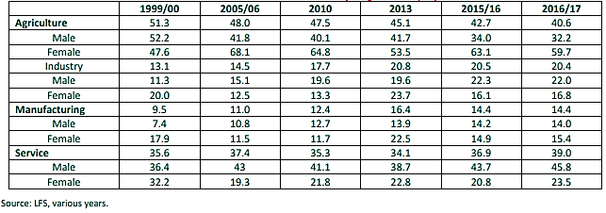
Table A: Share of broad economic sectors in employment (%)

4.2 Data Analysis of Trends and Factors
This section reviews the pattern of female labor involvement in the labor market of Bangladesh over the course of several years. The benefaction of the female labor force in the improvement of the GDP of Bangladesh is analyzed, along with the increase in their participation rate in the industry throughout the years.

4.2.1 Contribution of women in the GDP with the increase in the population
The main age group of the labor force in Bangladesh in between 15 to 59 year of age cohort will rise by 2061 significantly, as shown in Figure 1. There will be a rise from 86.7 million in 2011 to a high growth scenario of 152.3 million, a medium growth scenario of 130.8 million and a low growth scenario of 117.1 million by 2061. The population will decline soon after it stabilises at this level. Accessibility of countless youthful, sound and instructed laborers should be viewed as a huge benefit that anticipates Bangladesh eventually as she pushes ahead in the 21st century. Work of women will enact as a significant job in understanding the advantages building from the expected segment profit. Exceeding the following thirty to forty years, Bangladesh will be partaking in the advantages of the segment profit, with moderate reliance proportion and undeniable degrees of support in the labor force. Therefore, issues related to receiving the rewards of segment profit is of increased strategy and pragmatic significance as Bangladesh leaves on her middle-class income venture.

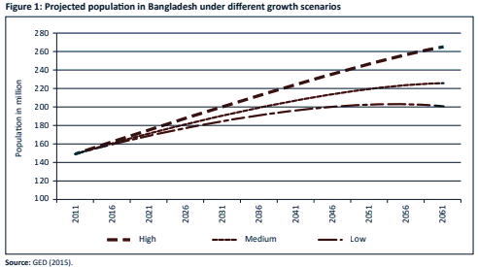

Commitment of females to gross domestic product is more than 36% around the world. Women's commitment to gross domestic product in China, Thailand, Vietnam and Singapore is higher contrasted in comparison to the world's normal. Notwithstanding, for Bangladesh (19%), India (18%) and Pakistan (11%), their commitment to the gross domestic product is altogether lower. Advancing the current circumstance of FLFP must be examined, that are at a low level, as a vital segment of the positions plan in the Bangladesh setting. The present state of affairs of representing females' commitment to gross domestic product in Bangladesh is likewise a highlight to be remembered. To be sure, the unaccounted-for value of women's labor was assessed to be comparable to about 77–87% of Bangladesh gross domestic product.

4.2.2 Shifts in the Female Labor Force Participation Rate over the time in Bangladesh
Bangladesh has gone through many ups and downs in the labor market. In comparison to other nations and economies, Bangladesh has a much lesser FLFPR, which was 22.8% in the year 2000 and for men it was 73.5%. Below, the changes are illustrated including the change in trends over time.
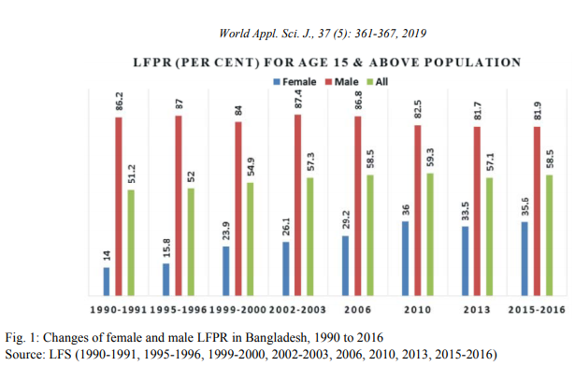
Fig. 2: Shifts of female and male LFPR in Bangladesh
Source: LFS (1990-1991, 1995-1996, 1999-2000, 2002-2003, 2006, 2010, 2013, 2015-2016)

Participation of female labor force has continuously progressed in number from 1990 to 2016. The increase eventually came to a slow decline from 2010 to 2013 but increased again till 2016. The total LFPR decreased during this time but in the later years, FLFPR increased till the year 2016. The initial low value of FLFPR contributed to the rise of female LFPR to some extent. It was 16 percent in 1996, while several Asian emerging nations had FLFPRs of more than 40%. It can, thus, be said that the rise of female labor force participation accelerated.

Table 1: Employed and unemployed population
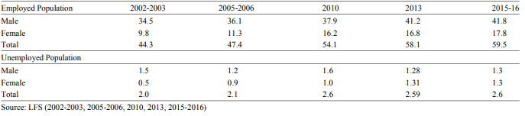

As shown in Table 1, the employed and unemployed population of male and female workers differ every year. Employment increased over the years while unemployment decreased proportionately. But if we see the scenario of each year separately, we can conclude that as population is increasing unemployed population is also increasing but it was found that the female participation rate is higher than men. In 2016, total employed population was 59.5%. On the other hand, 2.6% of the total working population was unemployed.

4.3 Status of Employment and Sector Composition in the Labor Market
Employment of the female labor force in Bangladesh is more concentrated in the informal sector rather than the formal sector. Rural areas have a higher percentage of women working as an unpaid population as they are more involved in the agricultural sector as seen in Table 2.
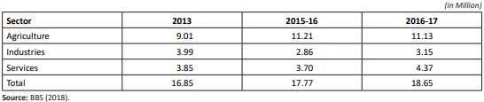
Table 2: Working female aged 15 years and above, by economic sectors

As seen above, the agriculture sector has always had the highest number of female labor participation in millions in comparison to the other industrial and service sectors.

Around 44% of workers in the country were self-employed and 39% of them were paid workers in the year 2016 through 2017. The rest of 16.6% were either the employer’s family helpers who were unpaid or were associated with a part of the uncategorized workers as shown in Table 3.
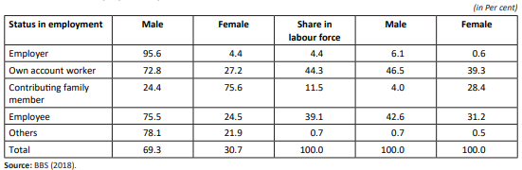
Table 3: Status of employment by sex

4.3.1 Labor force involvement in urban and rural areas
In 2012, the FLFPR in South Asia was 31.1 percent, whereas the global average was 51.1 percent. In contrast with India which experienced declining inclusion of ladies in the Indian Workforce, Bangladesh experienced significantly high female workforce interest in provincial and metropolitan region and it has the most elevated rate in the locale of South Asia, on account of expanded female workforce investment in labor escalated send out situated enterprises (particularly in RMG area) and miniature credit program in non-crop farming area.
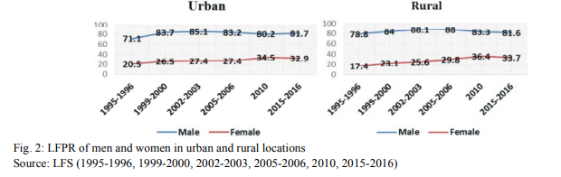
Fig. 3: LFPR of men and women in the urban and rural locations
Source: LFS (1995-1996, 1999-2000, 2002-2003, 2005-2006, 2010, 2015-2016)

The examination of country and metropolitan LFPR can assist with understanding linkages among LFPR and development of urbanization. Fig 3 shows the workforce support pace of people in metropolitan and country regions. . Female LFPR in both provincial and metropolitan regions have ascended during 1996 to 2010. Female workforce cooperation in metropolitan regions were 20.5 and 34.5 percent in 1996 and 2010 separately. In these years, cooperation of female workforce in provincial regions has ascended from 17.4 to 36.4 percent. Metropolitan and rustic FLFPR are, hence, very close and both have ascended in the course of the most recent 15 years. Consequently, the speed of urbanization or development of either the rustic or the metropolitan economy can't be singled out as the purpose for changes of LFPR of ladies. During the new years female LFPR is higher in provincial regions than in metropolitan regions.

One of the main considerations of the sharp expansion in female investment since the mid-1990s was identified with an ascent in the development of yield in agribusiness. The early ascent in female workforce development in Bangladesh appears to have been set off by an ascent in the development of agribusiness and expanding investment of ladies in that area. Thus, it very well may be inferred that country regions utilize the majority of the number of inhabitants in female workforce.

In emerging countries, industrialization is taking place, that are export- based, encourage development of labor supply and create employment that are suitable for women. For example, the RMG sector in Bangladesh has brought about a huge change in the participation rate of the labor force, especially of women. This is because this sector provides women with most of the facilities that they seek in order to overcome the barriers that they face in their daily lives.

4.3.2 Employment trends in formal and informal sectors
Around 92 percent of women were occupied with informal sector in 2016-17. Informal sector is described by low-useful positions and this sort of work are highlights of both rural and urban work market. Female employment that was informal, established 92.7 percent of female workforce as against formal work of 7.3 percent, in 2000. The separate shares remained at 91.8 percent and 8.2 percent in 2016-17 as per Fig. 4.
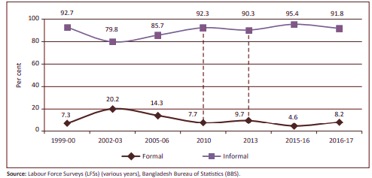
Figure 4: Proportion of formal-informal employment for women

It is a major challenge for the labor market of Bangladesh to make a complete move towards formalization. The meaning of formal–casual work was transformed in 2010 (delineated by the specked thread in Figure 4); this was reexamined in the year 2013 in order to make the definition more precise in accordance with the typical meanings of custom and casualness in the work market of Bangladesh.

4.4 Discriminations Present in the Labor Market
This segment offers bits of knowledge related to, the employment segregation and gender inequality that is present in Bangladesh’s labor market. From one perspective, The study discovers that there is a presence of gender isolation in the workplace which will in general be inflated in the urban labor market and fairly deflated in the rural labor market. Additionally, a generally 12.2% of salary disparity between men and women has been discovered in the labor market. Additionally, the examination sets up that a significant reason for the presence of the salary disparity between genders is because of the huge presence of casual work in the economy.

4.4.1 Gender wage gap in the labor market
Most women tend to look for workplaces with environments that are suitable for them. These facilities are not usually found in most areas of work. The female labor supply declines due to this and also for the barriers that the women face when deciding to work.
Gender discrimination is one the major obstacles that women face, which mainly includes the discrimination in wages and salary.

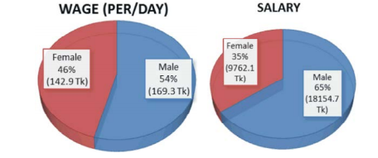
Fig 5: Wages and Salary for men and women, 2010
Source: HIES, 2010

According to fig 5, we can see that wage of male is 169.3tk (54%) per day while female is 142.9tk (46%). The salary of men is 18154.7tk and women get 9762.1tk. Although women receive less wage and salary, the rate of the women’s increment is much higher than men’s. This, in a way, is a proof that the barriers and discriminations that women used to face are declining with time.
Although there is no evidence that female employees take more leave or require more expensive physical facilities at work, employers are concerned about these issues, particularly in industries with few female workers. The hardwork of the female workforce are yet not appreciated rather they are discriminated among the other group.

4.4.2 Diversity in profession
Duncan and Duncan (1955) created The Dissimilarity Index given in Table 2, It shows the equity of the equalization of Bangladeshi occupation in the work market from 2002-03 to 2015-16. This file was determined for the nation in general just as for rural and urban work markets.
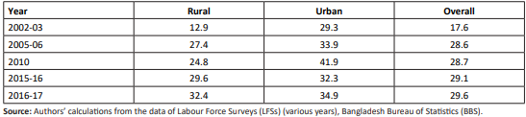
Table 4: Dissimilarity Index in Bangladesh labor market from 2002-03 to 2016-17

Table 4 demonstrates that there was a moderate degree of occupational segregation in the urban labor market in 2002-03 [DI=29.3]. Women's control in the rural labor market was more evenly dispersed, indicating lesser occupational segregation. In the case of the entire economy (DI=17.6), occupational segregation was less than moderate.
Surprisingly, within three years from 2005 to 2006, the segregation framework changed quite significantly in Bangladesh. Till the year 2010, both the rural and urban areas have had this continuous trend. In the urban areas, the DI rose to 41.9% sharply in 2010, showing a high level of occupational segregation. DI was equal to 24.8% in the rural labor market, indicating a medium level of occupational segregation. Be that as it may, some advancement has been made in occupation by gender in 2015 to 2016.

4.5 Education of the Female Labor Force in Bangladesh
Cooperation of educated females in the workforce are expected to rely upon the market’s demand and supply side components. The overall speculations identified with variety of FLFP in developing nations accentuate the beneficial prospect of education. Schooling will bring about a difference in a person's attitude. Also, A better educated society will have a more liberal viewpoint on the employment of women. Education of females brings their operability up in ventures utilizing present day technologies and this will prompt an ascent in the degree of their pay/wage. Higher income prospect, thusly, will result in more noteworthy agreeableness of women’s work. In any case, an assortment of primary and social components may interface on the demand perspective and the effect of schooling on FLFPR might not be noticed straightforwardly.

Production of work that is paid for school instructed females will rely upon the demand perpective and for that fact, on the speed of development of the advanced areas. The nature of schooling can likewise be significant at the point when the demand perspective is being thought of. The ones who employe will be interested about utilizing literate ladies just in case they are sure about higher usefulness of such specialists. In the event that young ladies (and young men) with more years training don't have an altogether more elevated level of literacy than essential taught ones, employers will incline toward the last in light of the fact that the better taught as a rule anticipate a more significant salary.
Thusly, a couple of long stretches of secondary education may antagonistically affect the possibilities of getting employed as a result of value factors, both genuine and perceived.
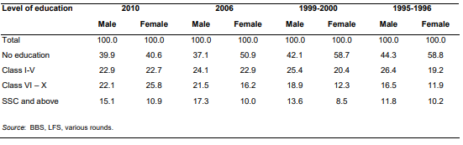
Table 5: Schooling levels of female labor force, 1996 to 2010 (per cent)

At the point when the number of educated workforce rises, industries are probably going to have the option to utilize such work on the off chance that they make an investment in the capital-escalated areas that utilize cutting edge innovation and require educated laborers. The questionable nature of schooling may debilitate such funding and lessen the chance of work of young women with lower-level schooling. The portion of women work power with no education has declined as of lately, adjusted by escalates in bunches with schooling above grade six as shown in Table 5.

The net impact can be seen from the exact outcomes presented in Table 6.

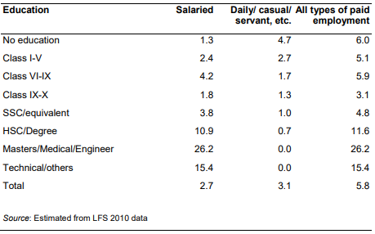
Table 6: Women’s participation in paid employment by education level (per cent)

Information shows that the female labor force participation rate ascends with schooling constantly. Does it truly imply that education has been successful in eliminating social marks of shame against female employment? It is ofcourse that the information is decoded carefully and that education does actually bring about an improvement in the participation rate of female labor force. The justification alert can be explained based on the connection among resources and female LFPR.

It was contended that the useful connection among resources and FLFPR hides the reality of the participation of female in paid easygoing employment is contrarily connected with resource possession, as family business is positively related. FLFPR determined based on a wide spectrum of work demonstrates a favorable link with resources. Long stretches of education have a favorable connection with resource possession. Admittance to obtain literacy and its standard is emphatically connected with financial power of families. In this way, the impact of training may likewise be like that of resource. Furthermore, the family's resource base increases women's self-employment. Consequently, a favorable connection of education with LFPR might really mirror a roundabout result of inequality in admittance to instruction. This multivariate analysis will empower us to determine the course of connection among instruction and the LFPR subsequent to directing for family resources.

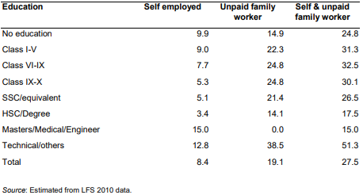
Table 7: Women’s participation in family employment by education (per cent)

4.6 Analysis and Findings of the Study
The changing idea of female participation in the workforce has been a significant measurement of the advancement procedure dating back to the Industrial Revolution. In any case, the connection among female participation in labor force and economic advancement is a long way from clear.

Economic growth is the main part that is influenced by the participation rate of female labor force. Development of yield ought to for the most part lead to increment in the interest for work, and the example of development can be significant according to the perspective of work of ladies. Improvement writing proposes, for instance, that financial development is related with a decrease in the extent of ladies in farming and an increment in non-horticultural exercises (World Bank, 2012). Moreover, development ought to be related with a decrease in the extent of ladies in independent work and an increment in wage business.

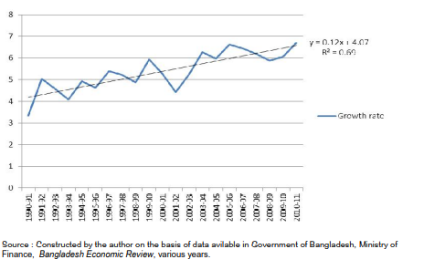
Fig 6:Annual GDP growth rate in Bangladesh, 1990-91 to 2010-11

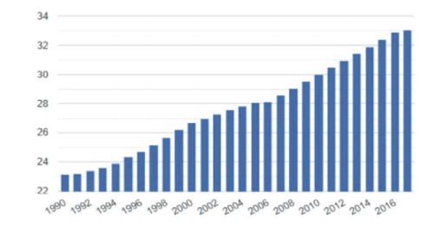
Fig 7: Female labor force participation in Bangladesh of WB, 1990-2016

Data presented in Fig 6 show that the pace of monetary development saw some speed increase since the mid-1990s and Gross domestic product development crossed the six percent mark in 2003-04. Information on the female support rate, displayed in Fig 7, that there was a sharp ascent in workforce development during the second 50% of the 1990s that has kept on rising even until 2016.

In the concluding analysis, it is clear that employment of female is driven by a scope of multi-layered components, including literacy, rates of fertility, social norms and the idea of the work development. There appears to be a favorable link between economic growth and the increase in FLFP for which the government should emphasize on improving the rate of participation of female in the labor market.

4.7 Policy Implementation
Considering the analyses and findings of this study, it can be claimed that it is very important for the government to focus on implementing certain measures and policies to improve the FLPR and encourage the female labor force to increase their involvement in the industry.

The government can implement some policies, as the following, in order to ameliorate the female labor participation in the labor market:

- Schooling with skills endowment
- Occupation driven macroeconomic policies
- Reforms in the labor market
- Guaranteeing evenness of occupation
- Diminish informality in female labor force participation
- Encouraging the entrepreneurship by women
- Policies to adapt to new innovational changes and automation

Furthermore, the Bangladeshi Government has chosen to raise the prices paid to female employees in order to offer them with legal maternity leave (World Bank, 1996). In fact, numerous investigations show that the expenses of giving maternity leave are not high. Nor is it alluring to decrease the maternity security benefits, if at all gave, at the hindrance of strength of ladies laborers and their kids. Consequently, there ought to be expanded acknowledgment by the businesses that if they could get a kick out of the chance to have a steady labor force in the RGM area, for instance, they ought to be ready to give the essential social advantages both for maternity security and kid care.

Non-Governmental Organizations encourage rising the age at which ladies wed, which would make a continuous work period for young ladies. They need to acquaint offices and backing administrations with assistance ladies do their positions all the more effectively, like childcare, transport to the working environment, working ladies' lodgings, etc. Existing offices are not just insufficient; they are additionally not accessible to low pay laborers. A large portion of the help administrations for female laborers are at present given by the (more distant family. Nonetheless, in case ladies are to have the option to take up appropriate jobs in the work market, formal and effective help administrations will be required.
These approaches and initiatives will encourage the female labor force to work and will improve the employment level of women in Bangladesh.

CHAPTER 5

CONCLUSION

In order for Bangladesh to flourish economically, the country needs to improve the facilities and break the barriers for which the rate of participation of women labor slows down. The FLFPR also slows down due to poverty, early marriage or their marital status and patriarchal family systems. Lack of education is also a major component to this matter. Poverty and women employment is interlinked, from which it is hard to get out. But the other components that are easily controllable should be taken into account.
New policies and prospects should be launched to empower the women and improve the female labor supply. Since the 1990s, policies that have aided the acceleration of general economic growth and the expansion of specialized sectors like as agriculture and the readymade garment industry have not been implemented with the explicit objective of expanding women's employment.Yet, these sectors have helped the increase of FLFPR the most.

What's more, there are strategies pointed explicitly at advancing an increment in the investment of ladies in standard monetary exercises. They remember an expansion for the portion of use on ladies improvement in absolute public use, measures to advance SMEs, and execution of ladies' amount in positions in different areas. The public authority has likewise received and executed various projects pointed toward upgrading ladies' ability through instruction and expertise advancement. Preparing programs run by different government services and NGOs, projects of giving admittance to credit, programs focused on food security and ability advancement of helpless ladies are some different instances of the public authority's endeavors at working on the limit of ladies.All that being said it is now seen that the economic growth of Bangladesh is rising with the increase of female labor force participation.

BIBLIOGRAPHY

- Moon, Monira Parvin. (2019). Status of Female Labor Force Participation in Bangladesh: Trend and Factors. World Applied Sciences Journal. 37. 361-367. 10.5829/idosi.wasj.2019.361.367.

- Rahman, Rushidan Islam, and Rizwanul Islam. Female labor force participation in Bangladesh: trends, drivers and barriers. International Labor Organization, DWT for South Asia and Country Office for India, 2013.

- Blau, Francine D., and Lawrence M. Kahn. "Changes in the labor supply behavior of married women: 1980–2000." Journal of Labor economics 25.3 (2007): 393-438.

- Husain, Humaira. "Economic development, women empowerment and U shaped labor force function: Time series evidence for Bangladesh." Asian Economic and Financial Review 6.12 (2016): 719.

- Heim, Bradley T. "The incredible shrinking elasticities married female labor supply, 1978–2002." Journal of Human resources 42.4 (2007): 881-918.

- Begum, Saleha, and Martin Greeley. "Rural Women and the Rural Labor Market in Bangladesh: an empirical analysis." Bangladesh Journal of Agricultural Economics 2.454-2016-36694 (1979): 35-55.

- Rahman, Rushidan Islam, and Naoko Otobe. "The dynamics of the labor market and employment in Bangladesh: A focus on gender dimensions." ILO Employment Strategy Papers 13 (2005).

- Bangladesh Bureau of Statistics (BBS), 2011. Report of the Labor Force Survey Bangladesh, 2010. Dhaka, Bangladesh: Bangladesh Bureau of Statistics

- Selim Raihan and Sayema Haque Bidisha. A research paper on “Economic Dialogue on Inclusive Growth in Bangladesh” (September 2018).

