INTERNSHIP REPORT
ON

“Cyber Risk for Banks & Approaches to strength the cyber security system”





Internship Report on
“Cyber Risk for Banks & Approaches to strength the cyber security system”

Submitted to
Mrs.Nusrat Farzana
Assistant Professor
School of Business & Ecomomics
United International University

Submitted by
Tajul Islam
ID-111 161 210
Major in Finance
School of Business
United International University

Date of Submission 11th February, 2021
Letter of Transmittal

11th February, 2021
Nusrat Farzana
Assistant Professor
School of Business and Economics
United International University
Dhaka,Bangladesh
Subject: Submission of Internship report on “Cyber Risk for Banks & Approaches to strength the cyber security system” on Shahjalal Islami Bank Ltd.
Dear ma’am
Assalamu Alaikum it is a great pleasure to present the internship report which was assigned to me as a partial requirement for the completion of BBA program.
Throughout the study I have tried with the best of my capacity to collect enough information and relevant issues as possible and try to follow the instruction as you have suggested me. I hope it will satisfy your requirement and also serve the purpose of my internship program.
I am thankful to you for your direction and kind cooperation at every step of my work on this report. I would be grateful if you kindly take some time to go through the report and evaluate my performance.
Sincerely yours,
Tajul Islam
ID-111 161 210
United International University

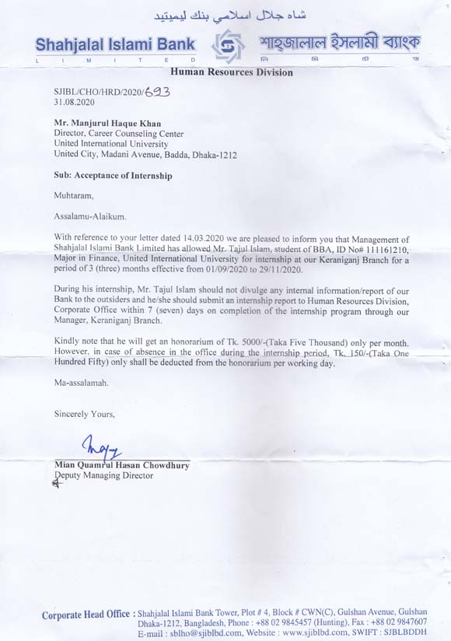
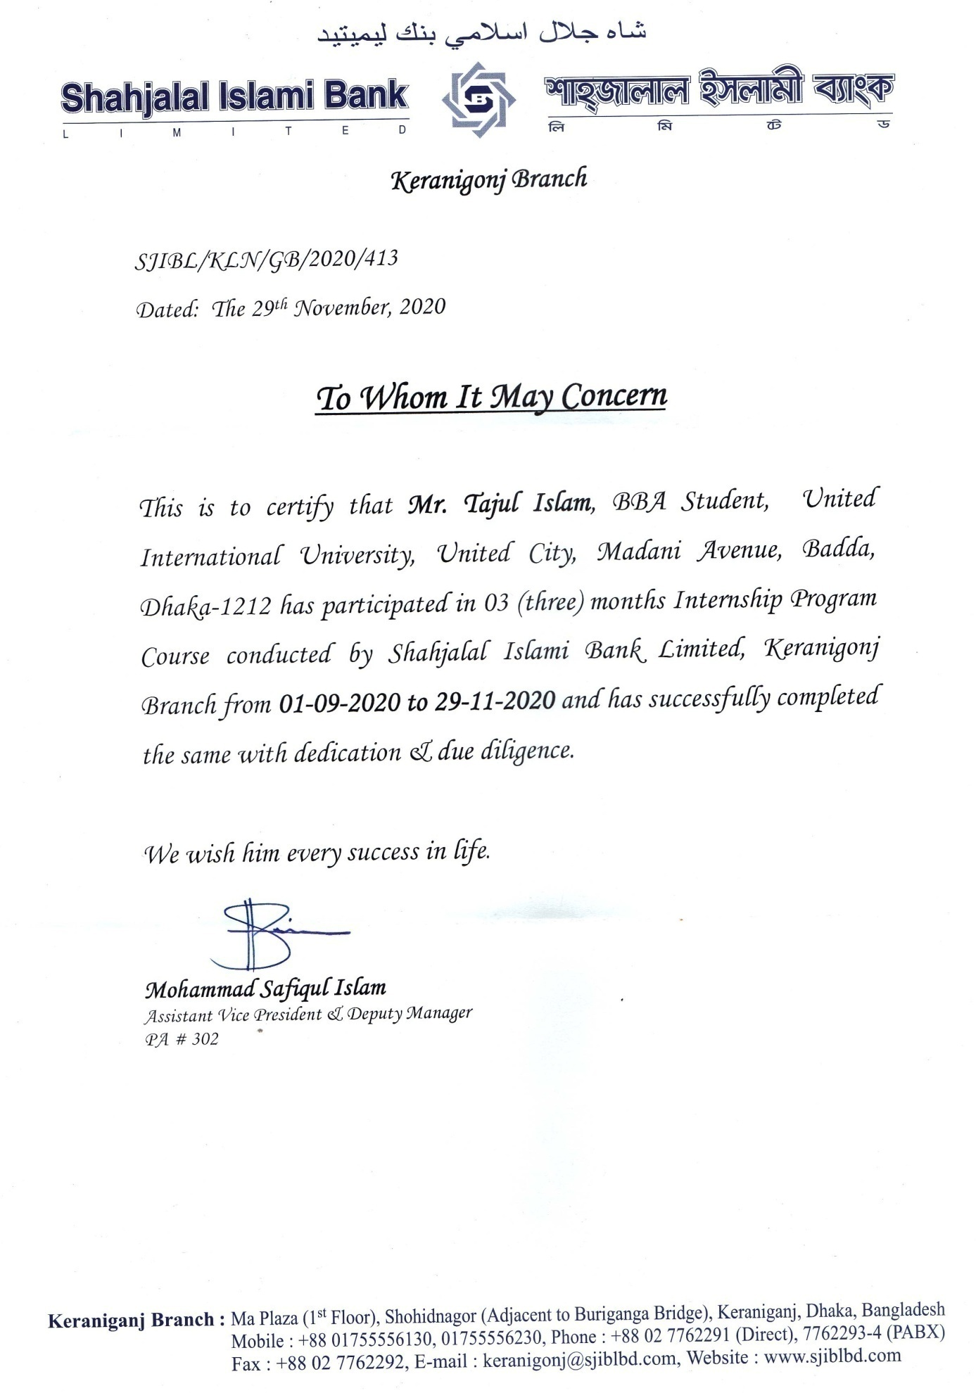

DECLARATION OF THE STUDENT

I, Tajul Islam hereby declare that the internship report entitled “Cyber Risk for Banks & Approaches to strength the cyber security system” on Shahjalal Islami Bank Ltd. This is my own effort to prepare the whole report after completing the three month internship program from Shahjalal Islami Bank Limited. This internship report shall be submitted as a partial performance of BBA.
I made this report only for my academic needs not any other purpose. I am sure that it has not been previously submitted to any other university for an academic qualification.

Sincerely yours

Tajul Islam
ID-111 161 210
Program BBA
United International University

Acknowledgement

At first I would like to thank my almighty Allah subhanahu wa ta’ala whom giving me strength and keep me sound in allside to complete the report in time.

It is pleasure to express my gratitude to my honorable teacher Nusrat Farzana(NF) for giving me the scope to prepare my report on “Cyber Risk for Banks & Approaches to strength the cyber security system” on Shahjalal Islami Bank Limited.
My honorable supervisor always helped me to make a healthy report and she helped me to solve the multiple difficult issues in several times. I also like to thank United International University for giving me the support to accomplish the BBA journey and provided the excellent academic environment which help me to gain the knowledge.

I would like to thank Mohammad Safiqul Islam, Assistant Vice President & Deputy Manager and also other official of Shahjalal Islami Bank Ltd., Keranigonj Branch, Dhaka for supporting me as well as cooperating me to completion my internship program in the organization.

Executive Summary

The Internship program creates the opportunities to gain the practical knowledge from different corporations. This program also gives the scope to learn the corporate environment and helps to work on technical things. I worked three month period in Shahjalal Islami Bank Ltd. as an intern to complete my report. I worked there in General Banking division (GB) where I work for opening new account.
The main concern of my report is how Shahjalal Islami Bank handles their cyber risk and security system. I describe my in report how Shahjalal Islami Bank Ltd. cope with that scenario.
I made this report based on seven chapters. In the 1st chapter I discussed about Company overview where I include company history, product & services, mission, vision, strategy, motto and company organoram. In 2nd chapter I discussed about the cyber risk and security and types of cyber security and safeguard software, importance of cyber security, emerging threat for digital world and losses make from cyber attack. In 3rd chapter I discussed the vulnerability of cyber risk of Bangladesh. And discuss some guideline from Bangladesh Bank and a case study. In 4th chapter I discussed the cyber risk and security system of Shahjalal Islami Bank. Here I explain which area increases the risk and how they can protect these. In 5th chapter I describe how Bangladesh and first world countries handle the cyber risk. In chapter 6 I make SWOT analysis and find the major problems in SJIBL. In chapter 7 I recommend some important things for the SJIBL and make a conclusions.

Table of contents
Chapter 1 1
Company overview 1
History 1
Products and services 1
Vision 3
Mission 3
Strategy 4
Motto of SJIBL 5
Company organogram 5
Organogram of the management 6
Chapter 2 7
Concept of cyber risk and security 7
Cyber risk 7
Cyber security 9
Types of cyber security 10
Using secured software as a safeguard for banks and financial institutions against the cyber attacks 12
The importance of cyber security 13
Cyber security is important in banking sectors some important notes are discussed in below: 13
Graphical overview of cyber attack losses from previous statistics 17
Chapter 3 20
Cyber risk scenario in Bangladesh and the increasing vulnerability 20
Bangladesh bank provides guideline to strong the cyber system 22
Case study 25
Chapter 4 26
Cyber risk and cyber security system in Shahjalal Islami Bank 26
Risk on information technology 26
Risk on information communication and technology (ICT) 26
To applicable management information system (MIS) 26
Shahjalal Islami Bank follows the approaches to manage the ICT risk as follow as: 27
Shahjalal Islami Bank has applied global standards information and security system to reduce the ICT risk. Shahjalal Islami Bank also attached different types of core technological development initiatives including: 27
To manage the ICT risk 28
Audit activities 28
The security risk management of information and communication technology (ICT) 29
Intangible Assets management 29
Chapter 5 31
How to control the cyber risk with effective way 31
Bangladesh follows some techniques to recover cyber security and minimize the cyber risk 31
First world foreign countries follow some techniques to mitigate the cyber risk 33
Chapter 6 35
SWOT Analysis 35
Major findings 37
Chapter 7 38
Recommendation &Conclusion 38
Recommendation 38
Conclusion 39
Bibliography 41

Chapter 1

Company overview

History
Shahjalal Islami Bank Limited (SJIBL) started their business which complies with Islamic Sharia from 10th may 2001 under the companies’ act 1991.Since that year they segment their services and opened new branches in different places. Before establishing any branch they find the best place where they can get the more opportunity to run their business and get some competitive advantage. They started to promote various services which are attached to Islamic sharia. Islamic sharia is not allowed any interest income and not to encourage invest in any haram business. Islam encourages a halal banking procedure system where not only interest free banking system but also encourage the people to invest halal business and make real money. This also helps the money market to boost up the GDP of national economy. SJIBL’s BOD maintains the highly credential in business arena of the country, The management team also work efficient and so much supportive and carry the excellent professional knowledge under the leadership of a experienced banker Mr.Mhuhammed Shahidul Islam. (SJIBL, 2009)

Products and services
Shahjalal Islami Bank Ltd. is differentiating their services system based on work appearances which are foreign trade service, general banking, and investment service. They provide some other services such as card operating services, SME banking, complaint desk operations and account statement submissions which are sub services of general banking and investment services. (SJIBL, 2009)

SJIBL is listed these services in foreign trade segments:
- Bank guarantee
- Letter of credit
- Bill passes
- Remittances activities

SJIBL categorized their product into investment and deposit form:
The deposit products are:
- Mudaraba millionaire
- Mudaraba double money
- Mudaraba monthly deposit
- SJIBL school banking
- Mudaraba monthly income scheme
- Mudaraba haji deposit
- Mudaraba cash waqf deposit

The investment products are:
- Housing investment
- Household durable
- Small and medium enterprise investment
- Small business investment
- Car investment
- CNG conversion investment
- Scheme for doctors
- Overseas employment investment
- Scheme for executives
- Scheme for marriage
- Scheme for education



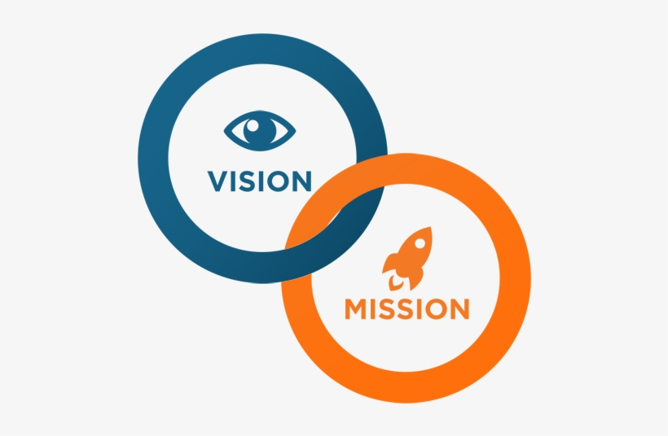

Vision
To be the unique modern Islami Bank in Bangladesh and to make significant contribution to the national economy and enhance customers’ trust & wealth, quality investment, employees’ value and rapid growth in shareholders’ equity.

Mission
- To provide quality services to customers
- To set high standards of integrity
- To make quality investment
- To ensure maximization of shareholders’ wealth
- To ensure sustainable growth in business
- To extend our customers innovative service acquiring state of the art technology blended with Islamic principles.
- To ensure human resource development to meet the challenges of the time.
(SJIBL, 2009)

Strategy
- To attempt for the customer’s satisfaction and get the customer’s confidence
- To create a friendly working environment.
- To work on well management system and operate the bank most effective way
- To find the customers need and screening the most effective need and work on their requirement
- To concern about the update policies and increase the practice on that updates and increase the ability to provide better services to the customers.
- To arrange training session for developing the employees skill and increase the resources to client satisfaction
- To make diversity in retail and wholesale markets
- To increase the efficiency through multi way communication system and share company plans and strategies in all division employees and supervisors.

Motto of SJIBL
Committed to cordial service

Company organogram

Organogram of the management
Chairman
Senior vice president

Deputy managing director

Sharia council
Audit committee
Deputy managing director
Senior vice president
Managing director
Sponsors
Executive vice president
Senior vice president
Executive managing committee
Trainee officer
Senior executive officer
First assistant vice president
Vice president
Assistant executive officer
Executive officer

Senior assistant vice president
Board of director

Chapter 2

Concept of cyber risk and security

Cyber risk
Cyber risk defines such as expected damage which is attached with the technological infrastructure practice in the organization. There have different types of cyber risk existences. For example, the system sometimes makes a difficult outcome of readily malicious acts, sometimes a cyber criminal attempt to complete an attack to get the authentic data, but many times they do not want it intentionally, As like as user error and the things make a system temporary stopped. There are two side risky area, inside the organization and outside the organizations. In case of inside the organization, the information disclosed by employees or contractors. On the other hand outside the organization, the information disclosed by supply chain partners or cybercriminals. There are two dimensions to leads us a practical view of framework such as inventorying and categorizing cyber risks:

Internal Malicious: Many of the cases we can see intentional robbery or destroying mentality and others irresponsible activities done by employees and different insider supervisors. For an example, a worker who punished by his supervisor he becomes unhappy end of the day and he try to destroy information such as erasing data before leave the organization.
Internal Unintentional: Sometimes employees or supervisors make mistakes to damage the data path which arises lots of difficulty in short time. For an example, it’s around 2013, NASDAQ faced internal technological issues where occurred fail the backup systems.
External Malicious: Most of the cases cyber risk is pre-relocated attacks from outsiders. Hares included criminal teams and other national states. For an example, integrated organization entry and mitigation of valid originality, and Denial-Of-Service (DoS) attack for system availability issues, there have some barrier in business to grow their business activities.
External Unintentional: Same as the internal unintentional mistakes occurs that make harm for the business, but that are not willful. For an example, from arising a third party assistant there some short of technical issues which can be impact system availability, such as natural disasters. From last ten years we are closely engaged with our national income and society in some, but we have done verity of work with practicing technology that make for sharing data and makes it worthy-not for protecting that information. There are little number of organizations are concern about themselves, for making new risk unintentionally.

Cyber security

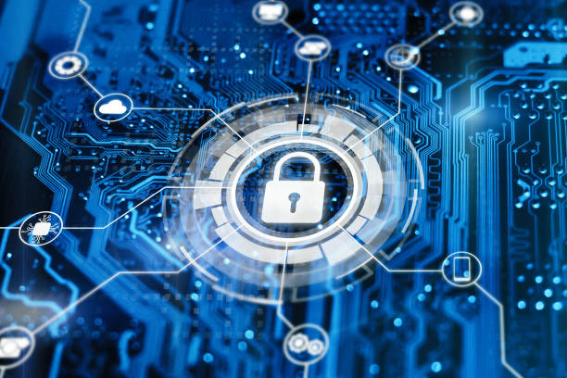

A security system (technologies, process and practices) design for secure the organizations gadget, software and network server from any digital attack.
Cyber security system basically wants to make sure that protect device and application as like computers, networks, and software from cyber attacks. Most of the cases hackers are accessing, altering and deleting valuable file and notes. And gets money from victims with using cyber threat. (Comodo, 2018)

Types of cyber security
Information security
This system basically protects the user’s private information from the unknown path, and which will make sure to identify the real theft.
Network security
Network security basically wants to make sure about protection of usability, integrity, and safety of a network which associated components and data shared throughout the network. When a network is secure from any cyber attacks that help to block to enter any message. For an example network secure authority add antivirus and antispyware programs. Firewall helps to screen the unauthorized access to the system.

Application security
These system goals to protect the application from inability for default in application design, development, install, upgrade or maintain. Cyber risk is most emerging threat for banking industry for regular transaction activities. Here discuss about some highlighted harmful activity as follow as:
1. Unencrypted data
This system is enough secure to protect an organizations valuable information. We know all data collected on computers where financial statement and online data might encrypt. Even though data is stolen by hackers, it cannot read in short time by them if it’s encrypt, if it remain unencrypted hackers can read it easily and use those data and making serious problem for the individual organization.

2. Malware
Integration of malicious variant that have been compromised by malware posture where a risk for a banks in cyber security system in every moment of connecting with that network. There are lots of sophisticated information passes through this connection, if the last user intentionally or unintentionally has installed malware on that devices without using security system then malware could attack that devices network system.

3. Third party services which not enough secure
Huge number of banks is using third party service where they have not enough resources to secure customers valuable information in digital platform. If third party service provider have not enough knowledge then it will difficult to handle the cyber security system where risk existence for damage the valuable information.

4. Manipulated data
Many situations hackers change their policy where they do not steal data perhaps go for changing data. Although difficult to hear those kinds of attack difficult to identify and that cause banking sector face lots of loses which can be millions of dollars. Sometimes the altered data as like unaltered data on the web surface, it is difficult to understand what is altered and what is not altered if the organization attacks in same manner

5. Spoofing
This is a new types of cyber security threat where hackers create a personify banking website’s URL where features and functions are same as original copy. If a user log in his or her website through that link then hackers will trace and get that information for criminal activities However main concern is new spoofing techniques are not use a little difference but similar URL .So it also risky for the real user where they can visit the right URL also.
(sqnbankingsystems)

Using secured software as a safeguard for banks and financial institutions against the cyber attacks
Security audit: Before lunching any new cyber security software have to audit that product several times. That output review will help to make a healthy decision for defining strong and weak zoon in that existing setup. This also helps to provide a good recommendation where organization can make their investment plan.
Firewalls: Banking cyber security system is not always depends on applications. Here in firewall secure system organization needs to right hardware to protect the attack from hackers. An update or old version firewall, bank can block malicious activity before the malicious reach other parts of the network system.
Anti-malware & anti-virus applications: When a firewall system is upgraded this need to increases protection; Otherwise it won’t be enough capable to stop attacks else antivirus and anti malware applications are updated. So, previous application dose not fill the latest needs.
Multi-Factor Authentication: This protection system also called MFA that is extremely difficult to protect those clients who practice online banking through mobile or computer applications. Most of the times users are not to change their passwords with several times. Even though change password with little bit. For implementing MFA which helps to decrease attacks from entering the network because it also reach the upper level of protection.
Biometrics: This is the updated version of MFA which is more secure than a texted code. There have some authentic step relies on retina scans, thumbprints, or facial recognition to conform the user’s identity.
Automatic logout: Maximum websites and applications are allowed to user to stay logged in if they allow it. So, they can easily enter into those apps at any short time without logged in again and facing no obstacle. Here, attackers can easily access to follow the previous records. So, automatic logout can minimize those types of criminal activities.

Education: All of the above instruction should be followed by banking sector with regular basis. Even, organization cannot protect their client when they fail to access their information from unprotected locations. For those several reason education must be important in digital platform. When banks notice to their client about that facts of vulnerabilities it may move themselves for changing their habits for fear of losing their investment asset.
(Katri, 2019)

The importance of cyber security
Cyber security basically works as a banks safeguard to protect the client assets and their transactions. As both B2B and B2C business and use cashless process, financial activities are done by physical credit policy through scanners and online checkout pages..
When data and information stolen by hackers, that not only affects the B2B and B2C clients but also hurts to banking sector also for attempting to pull through the data. When all information is stolen or hostage then the bank try to release those data and information from the hackers to pay huge amount of money. So, the overall client faith decreases to bank which makes a negative view or negative marking added to bank.

Cyber security is important in banking sectors some important notes are discussed in below:
Dissolution damage bank’s stability in the financial market
Information breaching is severe problems for a bank, for this reasons bank losing their client trust where customer involves insecurity. This express lower class cyber security tactics where it’s difficult to recover the data. This is necessary for the bank to discuss with their customer for this uncertainty and give them believe about the security system. These measures must uncover and shield their client personal and private information. This is necessary for a bank that should maintain a strong cyber security system to grow their customer trust.
Banks can face penalties for FDIC non-compliance
This is very difficult situation for a bank to get penalties from FDIC. This penalty not only losses for monetary activity but also increase negative point of view for that bank. Banks should develop their cyber security system to maintain the benchmark. When the performance and competence are same it measures this meeting the requirement of security agreement and safeguard over the client information.

Data breaches make lose client money and time also
If a bank or financial institutions fail to retain carefully client’s data and valuable information, client hope are decreased over the bank. Perhaps, banks can recover their money not full amount with using illegal methods and spends lots of money but it sometimes not working in all scenarios. The process of data recovering method is highly time consuming that builds a stress on customers. Those effects might be cancel different banks product.

Client data is perceptive
This is difficult for client to maintain their data breaches when they concern about their data is stolen by hackers and hackers can easily use this data. So, they attempt to cancel their cards and keeping up their funds that create a pressure on customer for their personal information hacked. They also get tension about their personal information can use against themselves .So, we understand that cyber security is most significant things for banks and other financial institutions as for they work on client personal information.

(Shah, 2019)

Cyber risk is arising as an emerging threat in digital world
Banking industry is doing their maximum task through online platform .So maximum time banks are involve in cyber system on the other hand that also carry potential risk from hack any information. Here we can assure that increase the overall cyber threat. A lot of client and business receive digital banking solutions, and trust on effective cyber security program. (Cimpanu, 2020)
A real life example with quantitative assessment framework
FBI sends a written private security notice toward the US finance sector where they highlighted about increasing number of credential stuffing attacks where criminals target their whole system which breaches data system and make losses.
Credential stuffing attack is a new thing in the cyber security industry.
It means to automated attack where hackers collecting id and passwords from online surface via data breaches at other companies and attempt it against the account holders.
This attacks aim to recognize the account where users reused their similar password, and then they can get unauthorized access in the user’s dashboard and link with their information.
Credential stuffing attacks many time not the main reasons. It begun one in late 2010s after hackers disclosed billions of usernames and password to hundreds of companies over last few years.
Then hackers start to collect the disclosed credentials resource and trying them against the various online services. First of all they targeted the online gaming and food ordering accounts and work on it with efficient manner, successful, and professional hacking groups and which switched to target accounts at online banking services and try to change the crypto currency and bitcoin and aim to steal the financial assets.

According to FBI, there have some recent major incidents included:
- July 2020,a medium size us organization reported its internet banking platform had faced a difficulty of login attempt with various credential from pairs, which it believe such as indicator of the use of bots. From the month of January 2020 to august 2020, this is not to identify actors used quantify software to link actor-controlled accounts to client accounts belonging to the same institutions which resulting in more than $3.5 milion in fraud check withdraw and also ACH transfers.

- From June 2019 to January 2020 NY based investment company faced credential stuffing attacks against their mobile, APIs to do international money transfer
- Between the month of June 2019 to November 2019, a small group of hackers fixed a target for a financial service provider organization and three major client information, compromising more than 4000 online banking accounts according to a credible payment around $40000 to themselves, where they wired to foreign banking accounts. In the year of 2020 case study on one of the firm, security researchers identified more than 1500 mail addresses and 6000 passwords exposed in more than 80 data breaches.

FBI security officer advice to the financial institutions to take protective steps about the whole ever-growing of credential stuffing.

Graphical overview of cyber attack losses from previous statistics (purplesec, 2020)
Statistic survey on malware attacks in last ten years
Years | 2009 | 2010 | 2011 | 2012 | 2013 | 2014 | 2015 | 2016 | 2017 | 2018
Attack in million | 12.4 | 29.97 | 48.17 | 82.62 | 165.81 | 308.96 | 452.93 | 580.40 | 702.06 | 812.67

- Around 92% of malware is attacked by email.
- Increase the new variants malware from mobile malware around 54% in 2018.
- There is some third party apps store which caused around 99.9% of new mobile malware.
- There are 250000 users who ware attracted by Trojan-Banker. Android and IOS malware software.
- Most of the android devices are targeted for mobile malware.
- The previous year MacOs malware is increased by 165 percent.
- After 2015 the malware attack for windows is decreased by 11.6%.
- Malware is still first choice for used 71.14 % from the last 12 month where PUAs were only used around 28.86%.
- United States is promoting the botnet server in the world. In the previous year around 36% of the server hosted in USA where 24% hosted in other countries.
- Most of the cases Trojans include up to 51.45% of all malware.
- There are 7 out of 10 malware in payloads ware ransomware.

Loses from data breaches in last six years
Years | 2014 | 2015 | 2016 | 2017 | 2018 | 2019
Amount in million($) | 3.50 | 3.79 | 4.00 | 3.62 | 3.86 | 3.92

The main things for data breaches as follow as:
- The statistic finds that the maximum data as like 63% of attacks done from internal sources either error or lack of control or fraud.
- There are around 33% of data breaches engaged the social engineering.
- Around 43% of data breaches engaged in small businesses.
- In 2019 the total number of data breaches was 1473 which is more than previous year 1257.
- In 2018 around 164.6 million records were exposed.
- The mean size of the data breach is around 25575 records.
- The average cost for per record is around 150 dollar.
- In 91% cases mails and spear phishig, is caused for data breaches in and around 95% of enterprise network.
- More than 50% of data breaches occur in United States by 2023.
- In next two years there 29.6% of companies will face the data breaches.

Chapter 3

Cyber risk scenario in Bangladesh and the increasing vulnerability

The online criminal activity increase day by day around the world it takes away 20 billion taka from last 1000 ATM booths of different public and private run bank to analysis the previous data which are certainly exposes the vulnerability of banking industry to online threats.
IT covers the big area in banking industry from last few years which also arising lots of uncertainty as like cyber attacks, information stolen and other things also that also alert the banking industry vulnerable. From Bangladesh perspective analyst says around 50% of banks is vulnerable to protect the cyber risk and they have not enough shield to defense that attacks.
Analysts say that most of the banks do not follow the Bangladesh bank guidelines perhaps Bangladesh bank include the strict rules and regulations also establish the IT governance and IT security for all banks. Therefore all public and private banks should collect a little portion of income to development for ICT infrastructure development and creates new training sections to develop the man power.
This is necessary for Bangladesh to develop their cyber system but Bangladeshi controllers are avoiding reinforcing the system. Because the absence of subservience and enough regulatory norms. The first world countries are trying to emphasis on major barrier as like cyber attacks and more focus on protection their valuable information in case of Bangladesh falls behind to take proper knowledge to absence of skilled manpower and update technology. This is so much disgrace for the Bangladesh local banks because they do not follow the Bangladesh bank’s guidelines and recommendation properly.
Information and Communication Technology (ICTs) is more attached in our growing economy.ICT has positive and negative effect also which can create good and bad environment also for the organizations and clients perspective. Good sides are client can easily transaction their money from long distance with a few minutes and client can use card service to avoid extra money bags which is also safest, flexible way to carry. Technological revolution affects all the sectors financial industry one of them and twenty century introduce FINTECH where lots of people are easily done online banking. People can send and receive their money from one country to another country. Banks can make a website and lay out their services and client can see and chose their best options also and client can buy air tickets and bus tickets from online banking.

After the technological revolution banks are getting more resources to develop their banking system and they are digitalizing themselves. On the other hand criminals’ also super active and they also update themselves toward different cybercrime activities. Day to day criminals becomes more powerful and they also use powerful technology to heist money from banks. So banks are in risky situations before they take some crucial steps. Though many cases banks are not disclose their cybercrime toward the public. After the heist of $81 million Bangladesh bank was confounded the heist was done by SWIFT system. First world country faces the same situation such as $15.33 billion fraudulent transfer in 2018 in Mexican central bank.NIC Asia bank lost their valuable customer data through SWIFT system in 2017.
Russian Globex bank lost around $940000 in 2017 from a cyber attack used by SWIFT system. Bancomxt is government owed export banks that also are faced $110 million heist in 2018.There are lots of organizations such as Tesco bank, Santander, Lloyds, RBS, HSBC, Clydesdale, and Yorkshire banking group and Barclays in the UK were forced to close their whole operation for two working day reasons was DDOS attack in 2018.Canadian well known bank as like Canadian imperial bank of commerce faced a huge loss for phishing and hacking in 2018.And bank of montreal lost their valuable customer data around 90000 that impact in their share price to decrease the overall share price. 2.5 million pounds were hacked over 9000 people from Tesco bank in United Kingdom.
The large organizations are doing their maximum transactions through banks and their overall faith depends on the banking sectors .Cyber attack can destroy their faith level so cyber security violation is more sensitive area for a banks. Client and organizations trust depends on the banks security procedure system.
After the cyber attacks clients are more concern about their information loses. So, their hope on the bank is declining and after sometimes clients start to close their account on the targeted bank and withdraw their liquid money. Clients also transfer their money to liquid form and bank makes a bad image in society. So, banks will face the liquidity risk and also increase the bad image toward to potential customers.
All over the world cyber attacks make a violating situation and create a bad environment in banking industry Bangladesh is one of them. A Cyber attack not only stole the money and information from the bank but also affects the whole system in internal banking system such as difficult to identify the actual accountholder, problem in cheque clearing, RTGS, fund transfer, account closing, account transfer and other things also. So, the authority of IT department in Bangladesh announce that cyber risk not only destroy the single institution but also collapse the overall banking and financial system.

This is the time for thinking about the good sides and bad sides of technology in banking sectors. Without using technology banks cannot think a single activity so it’s include their regular business activities in daily life.

Bangladesh bank provides guideline to strong the cyber system
The shortage of skilled manpower in IT industry in Bangladesh that affects the several cyber threats are increasing. After technological revolutions bank’s business are borderless they are transfer their data and money to another country and client can excess their account in abroad. On the other hand criminals update themselves also with develop their software and hardware. There have not enough training center and awareness system for cyber activities in Bangladesh. Now this is a difficult task to build awareness but should have to do this for future banks and financial institutions client.
Cyber attacks are increasing in banks and financial institutions. The maintenance of security system is more sophisticated and costly in upcoming days. This problem is not only inside the IT division now this is the main concern in boardroom meeting. This is very unfortunate that hackers are theft money, data and client accounts from the banks. It disrupts the service and sabotages the IT systems and creates the bad image. It becomes more risky when it hits the revenue generating process and also tough to retain the banks existence.
The national cyber security agency of Bangladesh should make a plan to protect and minimize the risk to steal data and server down. This is very much truth cyber attack is emerging threat to need a international solutions. Therefore, Bangladesh needs to work with international agency to develop the own system and technology and face the upcoming challenges. (Bangladesh Bank, 2015)

To increase awareness about the cyber security strategy in Bangladesh and identify the major activity such as:
- Increase the numbers of seminars on cyber system to build a awareness inside the country.
- To encourage the businessman to practice the cyber culture in their organizations.
- To encourage the directors to implement the cyber security plan in their organizations.
- Government should include the cyber security awareness education system in from primary level and also increase adult training center.
- Arrange different types of competition about cyber risk and security system
- To make a partnership with public and private companies to develop a new cyber relevant product.

The national strategy against the cyber attacks should be identify the mejor actions and also take some steps to decline the threats and vulnerabilities inter the country
- To identify a secure cyber risk measurement system this will help to define the upcoming risk and threats toward cyber system.
- To make a applications where include the safe cyber security system and strong infrastructure data. This application also recognized by the state government.
- To motive about the practicing law and increase the capabilities to investigation, protection and prosecution against the cybercrime.
- Using the standard level of software system.
- To increase the research center and infrastructure development for identifying the mejor area in particular situations.
- To assess the emerging threats and secure the system to protect the organizations online and offline activities.
- To attain the international cyber competition and gain knowledge, environment, difficulties. This also helps to develop the internet service and routing technologies.

Bangladesh Institute for professional Development (BIPD) has announced their program regarding the awareness for financial industry such as banks and others institutions. The overview of the program as follow as:
- To deliver basic ideas such as cybercrime, cyberspace, cyber security, cyber warfare and cyber terrorism.
- To understand why we need more knowledge and put more focus on the cyber issues.
- To discuss a brief summary of last several cyber incidents.
- Display the recent situation in cyber security and cyber risk.
- To understand the main threats in cyberspace.
- Different types of threats.
- Beginning of threats.
- Full description and presentation about threats
- What are the main things behind the threats and which things are not discovered.
- Why we are in risky positions
- Figure out the total loss caused by cybercrime.
- Some kinds of specialized virus, worms, Trojans and malwares targeting financial institutions: How these convolve, affect and cripple a company.
- The Path: International-National-Organization-Individual.
- Looking after of the international best practices.
- Our domestic policies, Regulations and initiatives regarding cyber security and cybercrime.
- Organizational Policy obligations.
- Find out the overall losses which caused by cybercrime.
- There are several types of virus such as malwares,trojans,and worms. Hackers are using these types of virus to hack a banks or financial institutions.
- The paths are international, national, organizations and individual.
- To learn from the international standard format practices.
- To develop and increase the practices seasons of domestic terms and conditions, and initiatives about the cyber system.
- Organizational rules and regulations.

Bangladesh Institute for professional Development (BIPD) is presents a workshop based on “cyber risk in financial sector: measurement and management” was held on july 29,2019 at Dhaka. The workshop was presented by Dr.Madhududan Acharyaa.He is a one of the senior lecturer in risk and finance department at Glasgow caledonian university and also program director of MNSc risk management and MSc international banking,finance and risk management at london campus.he also completed his PhD degree under the enterprise risk management(ERM) from the university of southampton,uk.

He discussed some topics and covered specific area from cyber security as follow as:
- To take knowledge from recent defect – case studies( Implications for practices in Bangladesh)
- To protect the client information through strong cyber security system.
- Loses the information from cyber spaces and reporting( to research and analysis the similer scenario in Bangladesh.)
- To make a framework based on cyber security system and also european GDPR.( Should analysis the simillar scenario in Bangladesh)
- The policys are including to cyber insurance,claims trend, and brokers perspective.
- To measure and assement the different types of cyber risk for banking sectors.(have to analysis the data and calculate it in excel sheet and use risk software)
- To get a secure cyber insurance to reduce the risk level.
- To gather the different types of cyber scenarios.
- Answare to the question in online method to gain the knowledge about cyber risk and banking sectors.

The course designs based on upper and mid level management which is connected with IT department, accounting, audit and administration of banks, insurance companies, merchant banks, mutual funds, broker house and other companies also. These types of seminar are help to individual’s organization for understanding and they also know how to decrease the business risk with using efficient management system. These types of cyber security plan should be on a continuous process. The seminar also gives a lot of knowledge about the particular subject so individual organization should implement the activity on their organizations.

Case study
History says Bangladesh bank faces around $101 million stolen on February 5, 2016 which occurred by outside hidden hackers. Hackers make a fake order from the federal reserve bank of New York with using SWIFT transaction system. So the authority did not read that particulars happening. It was one of the biggest crimes in cyber system in2016.

Chapter 4

Cyber risk and cyber security system in Shahjalal Islami Bank
Shahjalal Islami Bank is one of the renowned islami banks in Bangladesh. Shahjalal Bank plays a important role to retain the GDP growth. They are realizing on IT sector which is most important things in today’s life. So they take some decision to increase investment in cyber system and also increase the skilled manpower in IT sector. They attempt to work on some area such as:

Risk on information technology
This is very much challenging task for a bank to protect their IT risk. Maximum banks are works with IT available software. Bangladesh banking sector are not much secure and they have not enough equipment and skilled person to manage the risk. The previous year Bangladesh face a big cyber attack which give us a big alert from international hackers.

Risk on information communication and technology (ICT)
Nowadays banks are more attach with digital platform such as ICT sector which included electronic devices, internet, and computer pc. There are many risks surrounded the ICT sector. The risk makes from different types of failure of network, malfunction of system, have not sufficient knowledge for the use of technology. And other error also arises to damage the ICT like virus attack, hacking, and cyber attack.

To applicable management information system (MIS)
Bank has to manage their information system regarding with effective monitoring, risk measurement and management the system with enough risk monitoring practices and also address the all material risk. To usefulness of the main assumptions and data sources focus from the directors.

Shahjalal Islami Bank follows the approaches to manage the ICT risk as follow as:
Day by day ICT policy becomes update in all over the world and Bangladesh bank also takes some initiative to develop their strategy. Shahjalal bank also follows the strategy and policy development which comes from Bangladesh bank. The equipment in IT sector should be needed enough maintenance and review the whole technical things with year or month or week basis. To create strong zone in IT section in bank to face a higher level of risk and keep the strong position to relief the potential risk and threats also. All employees should follow the instruction which are provided from the authority and maintain the ICT policies. Shahjalal Islami bank should arrange the enough resources to link with employees work requirement.

Shahjalal Islami Bank has applied global standards information and security system to reduce the ICT risk. Shahjalal Islami Bank also attached different types of core technological development initiatives including:

To upgrade the whole core banking system and old version, update also the E-commerce system. The system also gives a sms alert to all ADC transactions the internet banking version also updated. To introduce the home banking and desk to desk solutions methods. To improve and implement the server health monitoring system. To upgrade the CIB automation and call center system. Everyone has to alert for constant change, uncertainty and unpredictability. So Shahjalal bank should increase the awareness program periodically in the organizations. Increase the practice field and work with real factors such as perimeter security, firewalls, vulnerability testing and create a barrier to prevent a cyber attacks. The internal banking audit is done by expert auditor who follows the central bank guidelines. The auditor goes to different branches to audit. The expert makes their own report and recommends the organizations to improvement.

To manage the ICT risk
For reducing ICT risk authority should make a proper plan and manage the whole things such as identifying the real factor cause for data damage or data erase and work on it to solve the problem. Shahjalal bank should find a effective way to reduce the overall development cost and implement the solution to mitigate the risk. Shahjalal Islami bank takes some initiatives and follow some policy to mitigate the error. They also do internal audit and increase training procedure based on ICT format.

Audit activities
Summary of main audit factors | SJIBL response to the main factors
The work activities on IT system and control procedure

The audit mainly works on the IT system and control procedure based on extending nature and difficult situation of IT environment. The big amount of transactions is made from different locations. Maximum times it works on automated methods and IT relevant manual system. We are focusing on master data management, user access management, and also developer access to production environment and also changes to the IT environment. These are the main factor for operating of the IT relevant software control system. | Before implementation any software SJIBL test the software and test the operating effectiveness of the group access of IT software to over the information system which are made with difficult financial data path.  They test the general control of IT section (that brings logical access, change the management and perspective of operational control in IT sector.). The review should imply on the tested software with appropriate way. And also review the group access software in periodically. If there have needed any kind of changes bank should do this. Bank should create a flexible control environment where they can attach to configuration, interfaces, and other operating software which they easily observe and audit. That will help a auditor for easily can make audit with friendly environment and fix the problem with short time.

The security risk management of information and communication technology (ICT)
In the point of view to BRPD notice no.14 dated 23 October 2005 according to “guideline on the information communication and technology for the scheduled banks.” BRPD notice no.21 dated 20 May 2010 and also BRPD notice no.09 dated 17 September 2015,here bank maintain the IT manual system where they deal with operational risk ,security control risk, upcoming disaster and other data center recovery and backup plan also. SJIBL plan to fix a technology where client can use 24/7 day facility in remote area through SWIFT, REUTERS,SJIBL visa card ,push and pull services and SMS banking .SJIBL also attached with Q-Cash consortium where included ATM and POS services which make easy for customer to make their demand within limited time. Shahjalal bank uses technology in a massive way to solve their technical problems and also use their core banking software.

Intangible Assets management
The intangible assets basically refers to there have no physical existence. Even there have no existence but it has a economical value in market and this asset is well recognized. The intangible assets are attributable asset entity which can be measured with reliably in accordance with IAS 38.The approximate expenditure on intangible asset define based on future economy increases. In the perspective of Shahjalal islami bank which is using expensive software system. The software has lots of yearly basis expense and protection expense. The applications might be a intangible asset for the bank because the applications and website are so much popular as the organization as well.

(SJIBL, 2019)

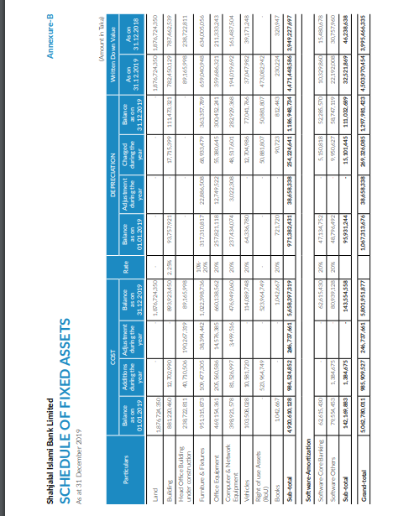

Chapter 5

How to control the cyber risk with effective way

Bangladesh follows some techniques to recover cyber security and minimize the cyber risk
According to experts opinion there are not enough knowledge and skilled people in Bangladesh. Government initiatives are not enough to control the cyber attacks. Although Bangladesh follows some strategy such as:
Firewall (security based device)
This security system protects the server when any unauthorized user wants to enter the system. This system allows only the valid user with very secure way.
Rapid password change
This is very effective strategy for an organization where multiple users can not access the same account. Password change within seven working days is very effective because the main user will concern about the policy and hackers cannot get password easily. And use the complex characters when remakes the password.
Safe surfing
This process helps the user to hide their own email address and do not permit the open conversation and helps the safe browsing to keep the personal information safe. Receiving data from safe sources and download from safe browser and access only safe sites to decrease risk.
Daily virus checks
Every user should check the computer virus in daily basis routine and also check the external device as like ROMS, floppy disks and CD for detecting virus before starting.
Email filtering
This system is checked the overall incoming mail and detect the garbage mail and send it to the delete box. This also reduce the risk level arise from the email.
Undergo
This is the data backup process. If data loss in any case user should not afraid about that because data has already in backup system.

Debit and credit card security
The card user strictly follows the banks rules and never shares their password and card number. They should not share their card number any unknown website. If cardholder faces any problem they should contact with authority as soon as possible.
To run a detecting applications
Nowadays websites are sending their cookies for collecting the user information for their business purpose. So build a security system where that application can detect the cookies and control over the system.
Works on internal network
There have need separation in internal and external network system and control panel. To strictly handle the internal control panel so that cannot mix the next time.
Create a backup system
To maintain a backup system where data will be secure and import data will recover safely. By any mistake or malfunction attack destroy the data then backup system will help to recovery with using extra hard disk.

Off the internet connections
Immediately remove the internet connection when device fail to run and do not follow the command. So take some initiatives such as:
1. To need update the download system to download any application with enough security and safest way and also update the operating system also.
2. To remove any kind of default things if the administrator password is default then remove it as soon as possible. If there is no single error in administrator password then need to increase the security to protect network system.
3. Try to stop file sharing from one device to another device.
4. If the device is not using long period then stop or turn off the network activities
5. Frequently changes the password and check all the account in certain time period. Look upon the entire transaction list are valid way or not. And avoid the similar password system in different account.
6. To avoid the unknown message reply and comment reply with using email.
7. Try to secure the phone number before using any online post.
8. Without any security system do not attach any email.

First world foreign countries follow some techniques to mitigate the cyber risk
To use safeguard against cyber attacks with secured application
This is very difficult task when they feel that they cannot stop the ongoing work then they must immediately replace the existence software and search the best safeguard. The first worlds countries have variety of develop strategy and security system applications.
Work on security audit
Audit is must require before implement any new software. Auditor explains the whole part overview where the strength and weakness in existence software is and what is the real requirement in network system. Auditor also recommends to safe and secure way where they can investment in maintain their network security system.
To maintain firewall
Firewall mainly create barrier to enter the unknown applications and protect the existence information to outsider. Developed countries are tried to implement the best firewall for detect and remove the malicious activity which come from hacker device.
Increase use of anti-virus and anti-malware software
During the update of firewall need more protection to support the cyber attack. Unless update the anti-virus and anti-malware software it can’t stop the cyber attack. Sometimes old version software cannot carry the latest information and virus identifications. The older version may destroy or remove the valuable information. So effort to increase the use of the anti-virus and anti-malware system.
Multi factor authentication
This is a popular protection system where client safe from using mobile banking and online banking also. This is also called MFA system. There are many clients who do not change their password several times but if they need change password they provide the similar category of password. In this types of case MFA protect the hackers with using authentic steps of identifications.

Biometrics system
This is more secure versions of MFA where users are connect with perception. The authentication makes with retina scan, thumbprints, and facial recognition to conform user identifications. After attach biometric system in network that will be tough for any hacker to hack any network.
Auto logout
To fix a schedule when automatic logout will happen because if user account is free for all then hacker will access and stole the information easily and use it against the user. So this is so much tough job for a website controller to identify the real hacker and also challenging job to detect who is the malicious senders’ .Automatic logout will help to reduce the risk because per viewer will receive limited time to access and if one try with several password in limited time he or she will be detected.
Education
To increase the training session and learning institution for future cyber security system. In the cyber crime activity hacker has different sort of knowledge where they can enter any kind of network and stole the information from user account. So this is necessity for ethical hacker to gain more knowledge to protect their server system. And also follow the above summery and try to learn from here. Large number of client should participant in training session for primary level protection in their own banking account and other online banking activities.

Chapter 6

SWOT Analysis


Shahjalal Islami Bank Limited makes a SWOT analysis in the organization and find out the strength zone where they can invest more time and money and find out the weaknesses where they need more focus to increase work activities to recover the bad situation. And find the opportunities where they can get potential achievement to overcome the potential threats. A SWOT summary for shahjalal Islami Bank is below table:

Strength | Weakness
- Skilled manpower exists in the organization.  - To have strong relation in renowned IT institution.  - Multiple training session scope arranged by the organization | - There’s a lots of lack of knowledge for complete solution of standard digital banking sector.  - Using old version of technology which is not carry update information and also not upgrade the CBS program.  - Scarcity in IT resources in bank.
Opportunities | Threats
- To increase awareness in the people and encourage them to join the digital banking platform and avoid practice the manual system.  - To need more resources in the IT section and attach multiple courses which relate with cyber system.  - Try to practice fast service with short solution. | - ATM booths are highly alert situation because last few years hacker are stole lots of money in ATM booth.  - The network system hire from third party so if firewall is damage bank will be under difficult situation.

Major findings
- To delay the online service in time: I had worked in Shahjalal Islami Bank as an intern. There was arisen lot’s problem in daily activities where maximum task was online relevant. Although they had experienced employee but they had been waited for technological command.
- Difficulties in ATM service: Shahjalal Islami Bank has lower number of ATM booth in their own place but they connect with VISA for extend their service. So clients are declining their interest in card service because VISA implied extra charge for every transaction.

Chapter 7

Recommendation &Conclusion

Recommendation
I worked in Shahjalal Islami Bank for 3 month as an intern. This is not enough time to recommend any renowned organization with whole things. Here I am trying to recommend the following in my little experience as follow as:
Need improvement the technological resources
They should come out the old version software system and get touch in modern technology. It is also necessary to counsel the client and change their thinking attitude. So IT division should work on that point of view.

To establish more information desks
They need to establish a specific cabinet. Clients are more curious sometimes to clear some specific point as like hidden charge to get loan, account closing charge and others. Although they are not actual customer but they are the potential customers. So if the bank establishes information desk then client not to go other division and to get their desire service.

To arrange proper training plan for employee
They need to increase training session for the employee and encourage them to attain every seminar. The training content should include multiple topic and real life case study. After training session employee will understand the changes in their working pattern and they will also get more maturity. Employee will serve the client with more concentration way.

Need to increase the number of ATM booth and branches:
Bangladesh economies are growing up since last few years so banks are also increase their activities in money markets. New banks are also increases every year so Shahajalal Islami bank need to participant that growing situation and also they have to increase their new branches and ATM services.

Need to increase the remuneration: Shahjalal Islami Bank is renowned organization in Bangladesh. So they have a standard brand value and they have lots of young and talented employee also. Nowadays work performance is depends on the employee motivation level.There are two types of motivation like monitory and non monitory. So SJIBL need to focus on that are and increase the remuneration which will increase the work performance and attract the other talented people to work in SJIBL.

To develop the new strategy and work on it: Day by day business becomes more competitive situation. So SJIBL needs to set a new plan for getting the competitive advantage to run the business and get more profit and customer satisfaction.

Conclusion
Shahjalal Islami Bank is renowned Islamic bank in Bangladesh which complied with Islamic sharia. SJIBL creates a new benchmark for the newcomer in market place. As for Islamic bank they get extra benefit from conventional banks and other financial institution because majority people are Muslim in Bangladesh. They establish their position with very much hard work and persistency. They include verity in their product list and try to add more attractive product also. They created strong customer base with friendly relationship and serve their customer beyond the office time.It was great experience for me to work in Shahjalal Islami Bank Limited (Keranigonj branch).I observed that there are big difference between bookish knowledge and practical practice. In the bank the bookish knowledge is limited for work and practical knowledge is more required things for accomplishing daily work activities. During the three month I learn how to work in general banking sectors and also get some knowledge from investment sectors and cash counter. In general bank desk I regularly work with client who interest to open a new account, collect new cheque requisition, card delivery, and update the form and other important things. I found there how a banker spend maximum time in the organization beyond the family. Actually they think bank is their second home and they also create a healthy environment in the bank. They always work in a synchronized method and I met some energetic officer there. They always support me and encourage me to do the creative task with easy method. SJIBL tries to help the growing economic condition with positive way in Bangladesh. They are also participant in CSR activities and follow the quran and sunnah rules and regulation. Their main goal is providing the cordial service to their client and makes profit.SJIBL is improving their overall service and I think one day they will be the market leader in banking industry. SJIBL should need more concentrate in customer satisfaction and work on the employee train up which I observed. The bank needs to increase their care for the customer’s service. SJIBL should touch in update if they fail they will lose their market share. They need to find the competitive advantage which will help to run the business successfully. SJIBL mainly focus on quality service and keep good relation to their customer in longer time. The three month of internship journey with SJIBL will help to cope with the upcoming corporate culture.

Bibliography
Bangladesh Bank. (2015). Guideline on ICT Security. Dhaka: Bangladesh Bank.
Cimpanu, C. (2020, September 14). FBI says credential stuffing attacks are behind some recent bank hacks. Retrieved from ZDNet.
comodo. (n.d.). What is Cyber Security? Retrieved from COMODO ONE: https://one.comodo.com/blog/cyber-security/what-is-cyber-security.php
Comodo. (2018, August 1). What is Cyber Security? Retrieved from COMODO ONE.
Katri, P. (2019, SEPTEMBER 25). The importance of cyber security in banking. Retrieved from THE GLOBAL TREASURER.
purplesec. (2020). 2020 Cyber Security Statistics. Retrieved from purplesec: https://purplesec.us/resources/cyber-security-statistics/#:~:text=In%202018%20there%20were%2080%2C000,30%20million%20attacks%20per%20year.&text=Ransomware%20attacks%20are%20growing%20more,businesses%20with%20under%201%2C000%20employees.
Shah, M. (2019, December 9). Reasons Why Cybersecurity Is Important In Banking. Retrieved from Hakin9: https://hakin9.org/reasons-why-cybersecurity-is-important-in-banking-by-mrudul-shah/
SJIBL. (2009). About SJIBL. Retrieved from SJIBL: https://www.sjiblbd.com/about.php
SJIBL. (2009). About SJIBL VISION & MISSION. Retrieved from SJIBL: https://www.sjiblbd.com/about.php
SJIBL. (2019). Cyber risk and cyber security system in Shahjalal Islami Bank. Dhaka: SJIBL Annual report.
SJIBL. (2009). SJIBL product. Retrieved from SJIBL: https://www.sjiblbd.com/index.php
sqnbankingsystems. (n.d.). The 5 biggest threats to a cyber security. Retrieved from SQN Banking System Fraud protection You can trust.

