

A Report on
“SWOT Analysis of Bengal Meat”

Supervised By:

Dr. Khandoker M. Rahman
Professor and Director, BBA Program
School of Business and Economics (SOBE)
United International University

Submitted By:

Mohammad Sami Iftee
Student ID: 111 181 021

Date of Submission:
13th August, 2023

Letter of Transmittal

Date: 13th August, 2023

Dr. Khandoker M. Rahman
Professor and Director, BBA and BBA in AIS Program
School of Business and Economics (SOBE)
United International University

Subject: Submission of Internship Report

Dear Sir,
It is a pleasure for me to present to you my internship report on “SWOT Analysis of Bengal Meat”, where I have worked sincerely and with great pride with Analyzen Bangladesh Ltd., who had been and still continues to serve Bengal Meat as one of the clients in their illustrious portfolio.
While crafting this report, I have earned a deep appreciation for the work that goes behind building brands, and it has also deepened my understanding of the operations of any business that truly wishes to operate through an omni-channel approach. More importantly, through my tenure at Analyzen, I had been able to have a vast array of experiences with the digital marketing landscape that had helped me grow and mature as an aspiring business professional.
I sincerely hope that the report that I am submitting to you will live up to the standards of your expectations and this institution. However, I am available to respond to any of your further queries and any necessary clarifications.

Sincerely,
Mohammad Sami Iftee
Student ID: 111 181 021

Acknowledgement

I would like to take the opportunity to convey my sincere gratitude to my Supervisor, Dr. Khandoker Rahman, Professor & Director - BBA and BBA in AIS Program, United International University, for providing me with the necessary guidance and the support in order to complete my internship report. The report prepared has been created on the “SWOT Analysis of Bengal Meat”, and it would have been immensely difficult to complete without his precise and resourceful pointers and guidelines. I am also grateful to my colleagues and superiors at Analyzen for helping me wherever necessary on my journey into the world of brands, and with this report. I’d like to thank my Line Manager - Fahim Ahnaf Towsif for his mentorship and guidance throughout my journey, as well as thank him for his encouragement, notes on self-improvement and also the co-operation that he has shown in brand management.

The information presented on this report has been collected from online sources, which include Bengal Meat’s website, and their social media pages and channels, and other publicly available sources.

Table of Contents
Letter of Transmittal ii
Acknowledgement iii
Table of Contents iv
Executive Summary 1
Introduction 2
Objectives of the report 3
Literature Review 4
Organizational Overview 6
Mission and Vision of Analyzen Ltd.: 6
Analyzen’s 4 Pillars of values: 6
What does Analyzen do? 7
Organogram: 7
Core Departments/ Teams: 8
Strategic Planning Team 8
Brand Management/ Client Servicing Team 8
Media Team 8
Visual/ Art Team 9
Query Management Team 9
HR and Admin Team (includes the Finance Team) 9
IT Team 9
Portfolio: 10
Bengal Meat 12
About the Brand 12
Bengal Fish 16
Breaking down SWOT 19
What does SWOT do? 23
SWOT For Bengal Meat 25
Strength 25
Weakness 30
Opportunity 32
Threat 38
Conclusion 40
Recommendation 41
Appendix 43

Executive Summary

In the current marketplace, Bengal Meat is arguably the leader in its own particular category - which is premium meats. The brand has been successful in its different product offerings and has had a steady market dominance over the last few years.

It is understood that market dynamics are constantly shifting, however, the brand has made such heavy investments in their particular sector that they have become the undisputed leaders of industry. Regardless of these accomplishments, the brand still faces immense competition from the local market and has their struggles in convincing the people that their product is superior.

This report details the different external factors and internal factors that go into making the brand successful and also highlight the blind spots that the brand needs to work on, which can help ensure further market dominance in the upcoming years.

Introduction

The report touches on the company that I have interned for - Analyzen Bangladesh Limited, and the brand which I have written the report on - Bengal Meat.
Moreover, this report covers the core attributes of the SWOT matrix, what it essentially is, and what it is used for, and the applications of SWOT analysis on the brand - Bengal Meat.
In order to speak elaborately on the SWOT analysis of the brand, the report also briefly covers the market operations of the brand, which includes what products they are selling, who their target demographic is, among other details.
The report also tries to inform the reader of the different communication approaches used by the brand, under the creative support and supervision of Analyzen Bangladesh Limited.

Objectives of the report

General Objective - The report tries to convey the application of the SWOT analysis on the brand Bengal Meat.

Broad Objective - The report also intends to highlight how this analysis can aid in business development and growth, while also providing insights into which blind spots the brand needs to work on.

Specific Objective - The report helps to pinpoint the core areas of focus for the brand, for upgradation and risk mitigation.

Literature Review

Albert S. Humphrey's SWOT analysis, a strategic management technique established in the 1960s, has become a cornerstone of corporate decision-making. By reviewing several academic works and real-world examples from notable businesses, this literature review intends to investigate the use, efficacy, and limits of SWOT analysis in diverse circumstances.
Based on SWOT analysis application, Hill and Westbrook (1997) carried out a thorough investigation on the use of SWOT analysis across many industries. They discovered that industry leaders in technology like Microsoft and Apple efficiently maintained their market leadership positions through the use of SWOT analysis. However, Ramanathan and Ramanathan (2010) emphasized how SWOT analysis assisted hospitals in the healthcare industry in identifying areas for improvement and developing strategic strategies, because this is an important part of advanced subsequent marketing programs
Hill and Westbrook (1997) conducted cross-industry research that highlighted how technology businesses such as Microsoft and Apple used SWOT analysis to retain market leadership. SWOT analysis, as illustrated by Ramanathan and Ramanathan (2010), assisted hospitals in the healthcare industry in identifying areas for improvement and developing strategic strategies.
There are many world wide companies existing who have preferred the usage of this tool to make strategic decisions for their organizations . P&G, one of the world's leading FMCG firms, has employed SWOT analysis extensively in its strategic planning and decision-making processes. Several case studies and publications have described their approach to SWOT analysis.Unilever, another FMCG behemoth, has used SWOT analysis to examine its market position, identify development prospects, and solve possible difficulties. Academic research and management literature have explored their usage of SWOT analysis.
Scholars have recommended using data analytics and artificial intelligence to improve the efficacy of SWOT analysis (Harrigan, 2021). Exploring SWOT analysis in non-profit and governmental organizations opens up new research possibilities.
It is also known as one of the tools that may help during crisis management. For example, a well completed SWOT analysis contributed to Ford Motor Company's effective recovery during the 2008 financial crisis (Carr et al., 2012). SWOT analysis has been useful in directing organizational adaptation and recovery during crises.
Some academics have criticized SWOT analysis. According to Furrer (2010), the lack of set rules for factor prioritization may result in subjective interpretations of the study. Furthermore, Grant (2003) suggested that SWOT analysis might oversimplify complicated strategic concerns while ignoring dynamic environmental changes.
Organizations continue to find great value in SWOT analysis as a strategic tool, but its efficacy depends on careful application and contextual awareness. By fusing knowledge from academic studies and practical organizational experiences, this literature review advances strategic management techniques.

Organizational Overview
Analyzen Bangladesh Limited started as the brainchild of two graduates from BUET back in 2008, and after the addition of a co-investor, the organization truly blossomed into a digital solutions hub. Analyzen considers itself to be the one-stop solution provider to all digital needs of different brands/ clients.

Mission and Vision of Analyzen Ltd.:
Vision: To change the advertising landscape of Bangladesh
Mission: To become the biggest and best data driven marketing and tech solutions agency in Bangladesh.

Analyzen’s 4 Pillars of values:
Passion – having an unbridled enthusiasm for the brands that we are made caretakers of, striving for the best creative output
Resilience – having a sense of unwavering commitment to the completion of any task or project despite facing any adversity
Delivery – making sure that the team has provided the client, the ideal output with quality assurances, and has made on time delivery
Teamwork – ensuring a healthy work environment and helping respective team members to the best of their abilities

What does Analyzen do?
Covering the Digital Eco-System:
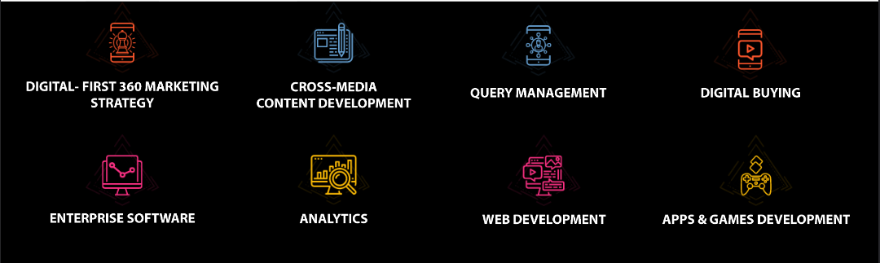

Organogram:

Chairman

Senior Account Director

Senior Manager

Key Account Manager

Creative
Director

Art Director

Lead Visualizer

Visualizer

Copy Supervisor

Senior Copywriter

Copywriter

Strategic Lead

Senior Planner
& Manager

Senior Planner

Junior Planner

Assistant Strategic Planner

IT – Team Lead

UX/ UI Designer

Developer

Media Planning Manager

Executive

General Manager

Senior HR Manager

Finance and Accounts Manager

Query Manager

Executive

Managing Director
The organization claims to have a flat hierarchy despite having a chain of command; the understanding is that a flat hierarchy allows for any member of the organization to have the freedom to interact with another member despite rank. Due to being a creative agency, it is imperative for the organization to have a free flow of ideas and easy communication amongst their members, so that the best idea can be crafted and executed.

Core Departments/ Teams:

Strategic Planning Team
This team is involved with providing the strategic direction for all the brands (clients) that the organization has in its portfolio. The team is the core driver of all brand activities, which includes brand building activities, campaign planning, content creation and content planning alongside the other associated teams, brand guideline creation, creating content pillars for day-to-day brand operations, creating brand communication lines and taglines alongside the creative team, etc.

Brand Management/ Client Servicing Team
This team is considered to be the brand’s custodian, as they act as the bridge between the client and the organization; they are integral to the operation of the brand’s activities. Their first order of business is to collect the different briefs from the respective clients and passing it on to the rest of the team, so that the team can work on their requirements. Being a digital first agency, the organization has to create a whole array of content for their clients, and the client servicing team has to ensure both content quality and content delivery. They are also responsible for the financial aspect of the business as they will be the ones to quote prices, do the budgeting activities and will try to negotiate with the clients.

Media Team
This team is involved with the digital media buying of the organization, i.e., running different ads on Meta (Facebook and Instagram), Google (via Google Display Network), and other platforms. This team is also responsible for creating media reports, i.e., performance reports on the different media buying activities, understanding consumer demographic, retargeting and remarketing if needed, etc.

Visual/ Art Team
This team is responsible for the execution of all the content that is created for each brand. The art team is capable of photo manipulation, photo editing, creating 2D characters and art (usage example: creating content for 7UP – Fido), and other types of content creation.

Query Management Team
Each brand that has a digital presence is in need of query management, i.e., the audience of each brand will have several queries or comments for the brand which need to be addressed. This includes queries about new product offerings, availability of specific products, etc. This team works to respond to these consumers via the brand’s page, and helps to build brand trust and foster an emotional connection with the brand.

HR and Admin Team (includes the Finance Team)
This team is responsible for all the HR activities, such as the hiring, selection process, firing, tending to the requirements and needs of all the functional teams. They are also responsible for salary disbursement, payment negotiations, they also manage the payment related matters with clients – i.e., sending invoices, managing company funds, maintaining the provident fund for the company, etc.

IT Team
The IT Team works on the tech solutions aspect of the business. Analyzen is proud to be a digital solution provider as well as offering communications and branding expertise, the IT team is responsible for creating websites, building a smooth UX/ UI, creating microsites for different campaigns, building games for a few activations, etc.

Portfolio:
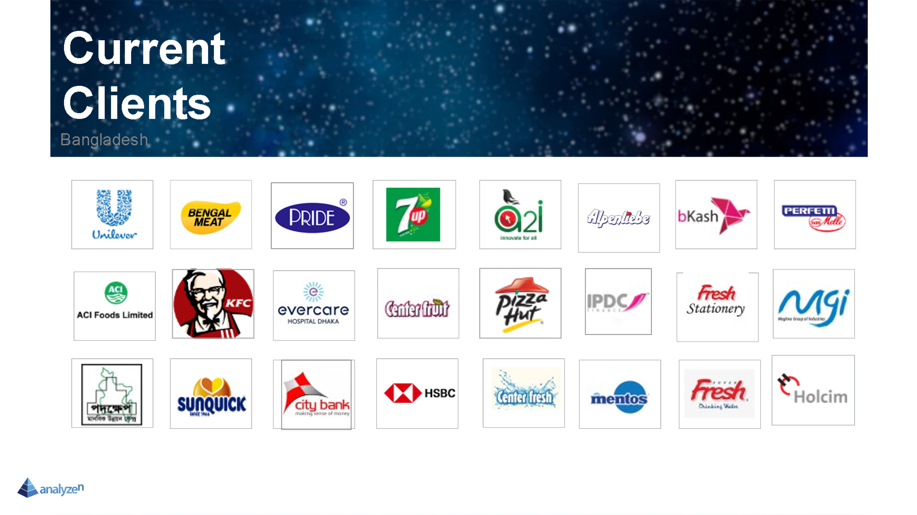
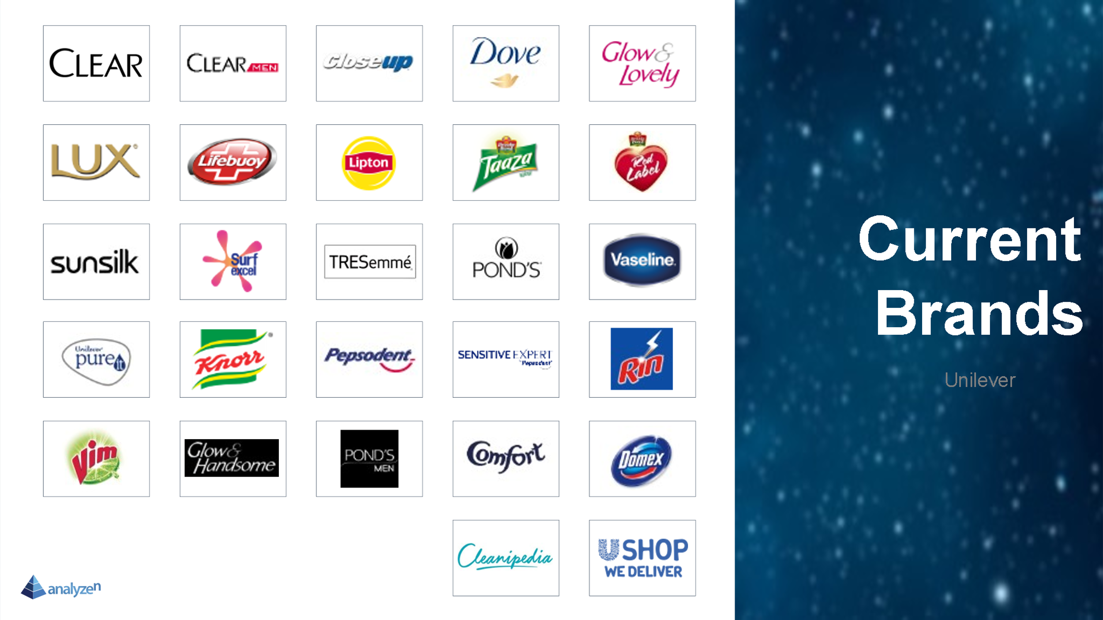

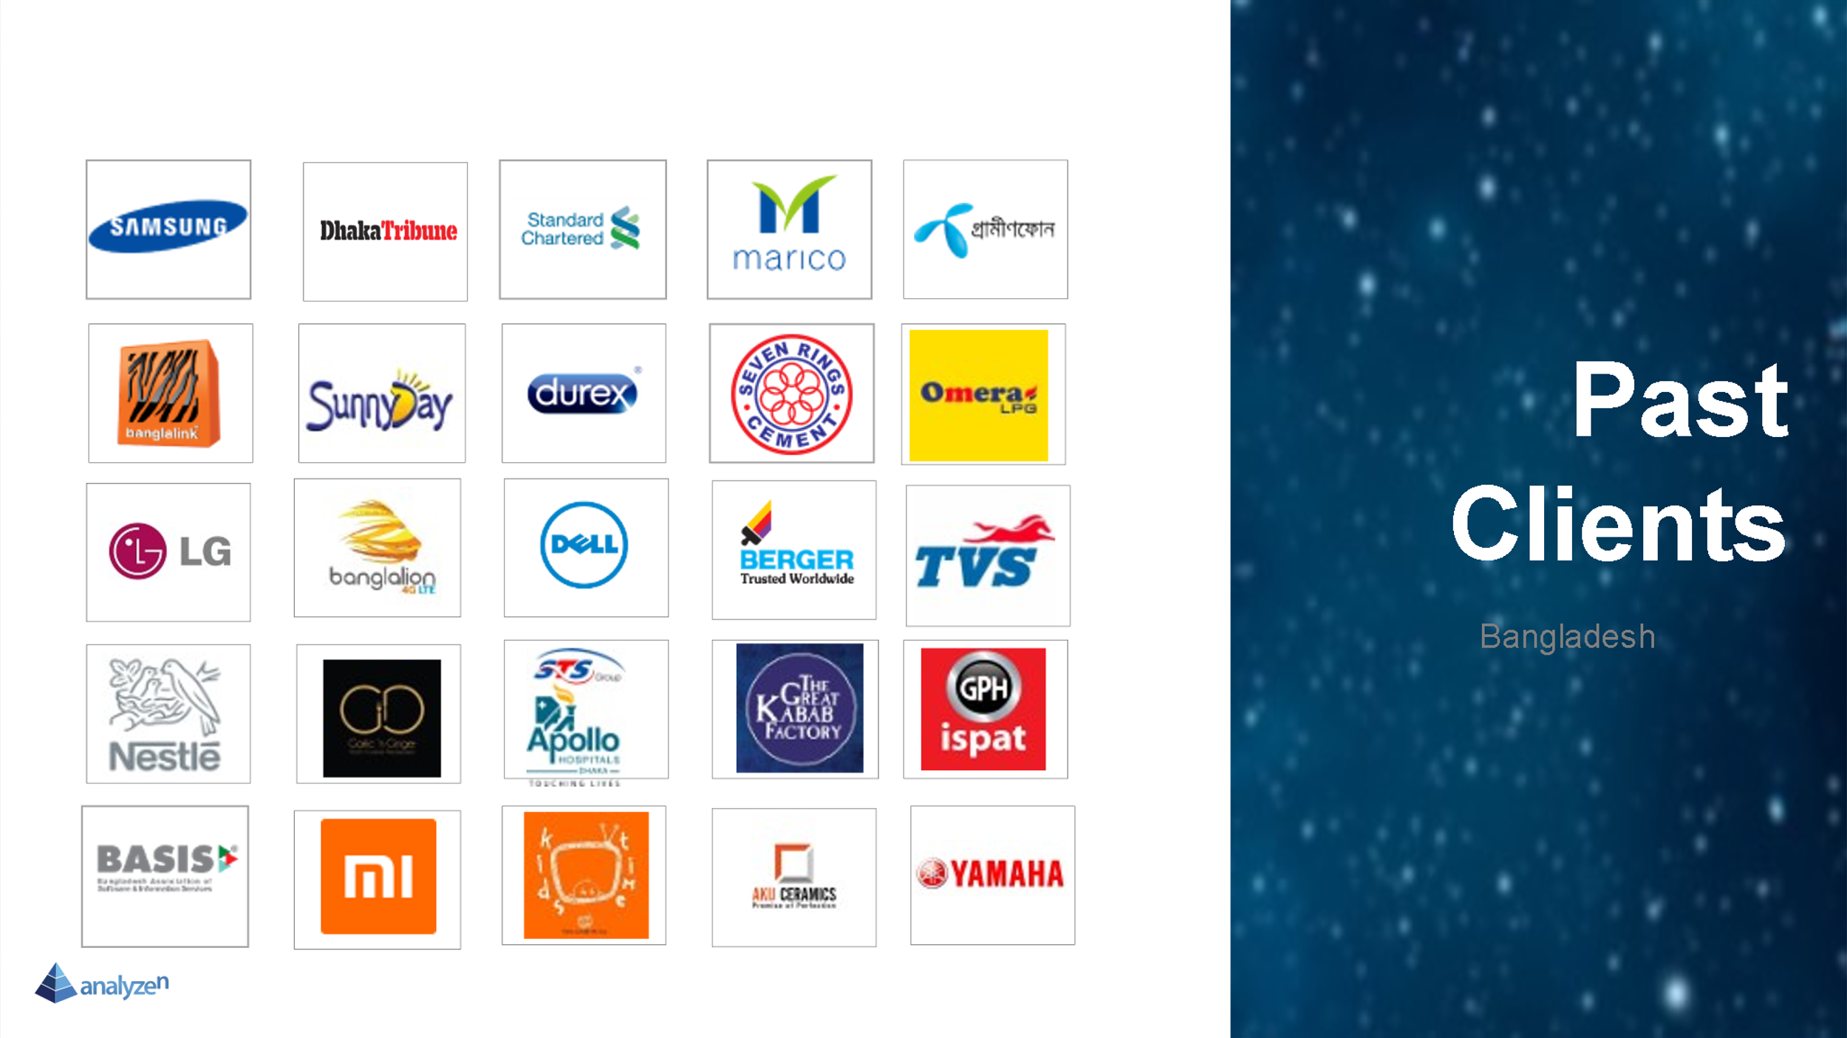

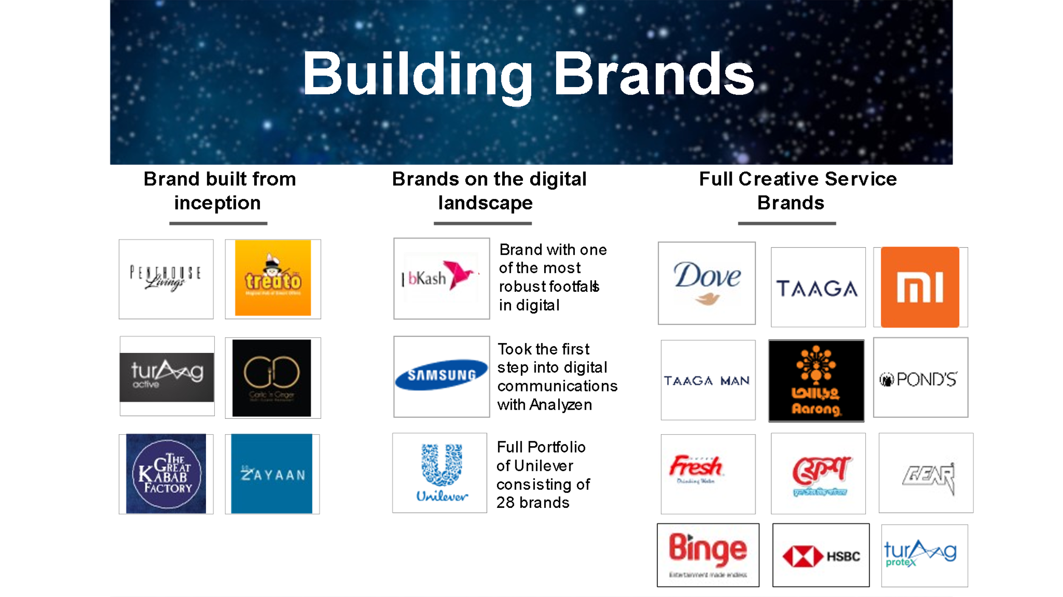

Bengal Meat

About the Brand
The organization started their journey in 2006 and has established themselves as the premier meat provider and meat brand in Bangladesh. Bengal Meat has been both a pioneer and a disrupter in the industry as they have brought forth modern practices of safety, hygiene and have ensured higher quality of meat. The brand has brought forth master butchers and animal husbandry experts from Australia, and have developed expertise in areas like export standard livestock rearing, to creating a world class abattoir.

The brand may have started small with their offerings, however, with the passage of time, they have expanded their portfolio to include more items after conducting thorough market research and understanding of untapped needs in the market - which includes Heat & Eat products, Snacks and Cold Cuts.

Bengal Meat currently occupies the current categories of products:
- Beef
- Poultry
- Mutton
- Fish
- Heat and Eat
- Snacks
- Sausages
- Cold Cuts
- Spices
- Others
It is understood that the brand doesn’t occupy a budget meal centric attitude towards fine dining due to their product offerings, but the prices have always been kept relatively affordable and within reach of consumers (under the Young Executive Demographic and also the Well-off student Demographic). The brand initially communicated the “Premium” nature of their items to their consumers but due to the slow shift in consumer perception regarding buying packaged meat, the brand has refocused their communication on communicating different aspects of their products - one of the new focus points being, the meat being organic and safe for consumption (in comparison to the local offerings).

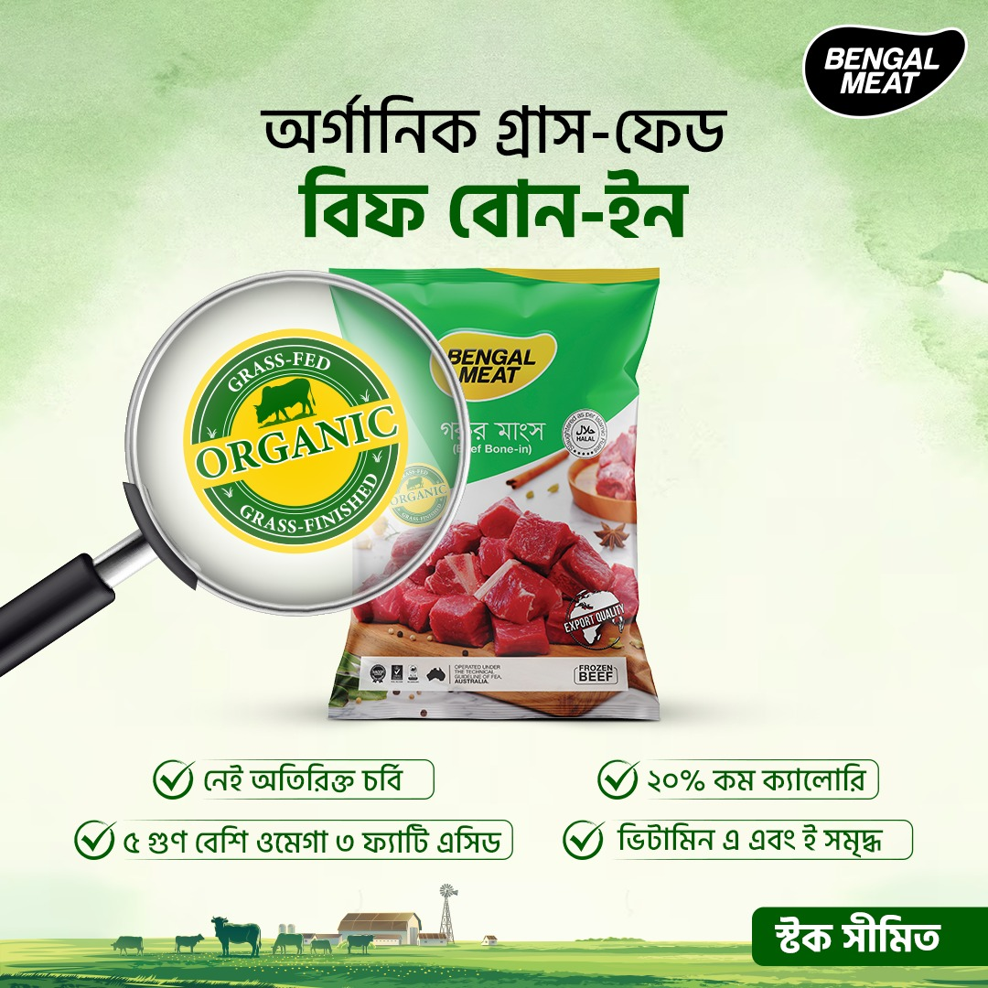
Example of the brand refocusing communications on “Organic” meat.
The example (Static Visual) provided above was created in collaboration with Analyzen Bangladesh Ltd. which is the Digital Marketing and Creative Agency hired by Bengal Meat. While the business of Bengal Meat is split into multiple departments, the brand manager, ecommerce manager and the marketing manager work in collaboration to ensure that the right creatives and communication are crafted for the brand. This helps to create a consistent and cohesive narrative for customers to latch on to.
The brand had a singular focus of communicating the “Premiumness” of their products, but after the collaboration with Analyzen, and under the guidance of their brand manager, more nuances were brought into their communication strategy.

More importantly there are other aspects of communication which the brand harps on which include:
Aspirational Angles of communication: e.g., “Cooking together”


Educative Angles of communication: e.g., Explaining the meat to bone ratio
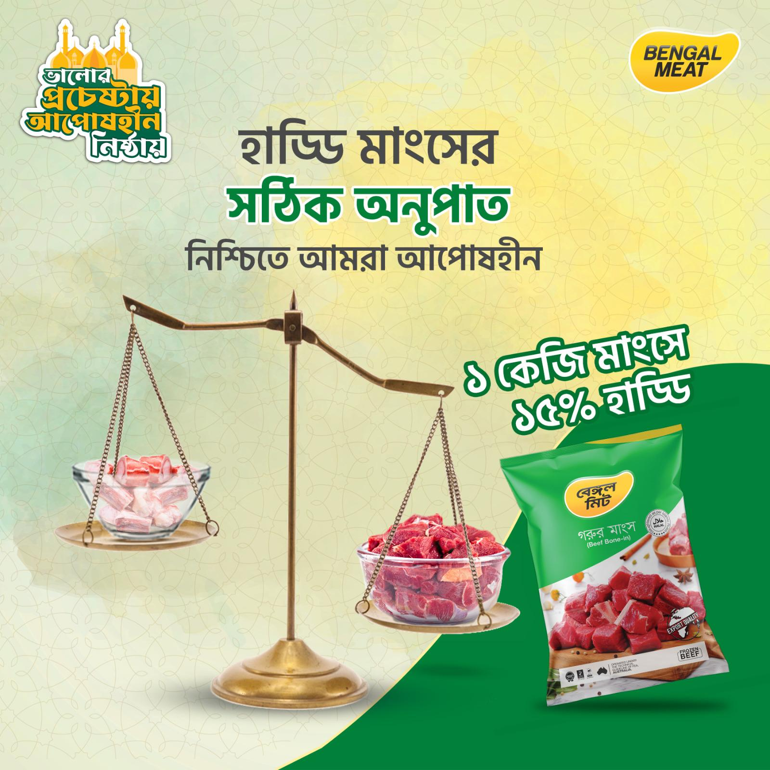

Functional Angles of communication: e.g., Showcasing the different moments of consumption

The brand has utilized the different concepts used in Brand Management and Communications in order to keep their audience informed, engaged and most importantly, converting. On their E-Commerce platform, the brand experiences a bulk of their business through remarketing and a loyal consumer base. Over 85% of orders that come to the platform are from repurchases and the brand experiences a steady growth of over 3% new customers on their platform Month on Month (MoM).

Bengal Fish
While the core brand is Bengal Meat, they have also branched out and created the Sub-Brand of Bengal Fish - which caters to all the protein needs of the fish category.

The brand has taken the initiative to branch out into a very difficult segment to cater to, which is fish. It was the logical next step for the brand to move into the fish segment, but sourcing and other issues were a challenge that the brand had to overcome. After the brand figured out the right items and could package them at the right quantity and right price point, the items were made available in the market.

Their current assortment of Fish can be divided into 3 sub-groups: Sweet Water Fish, Sea Fish, Prawn.

Sweet Water Fish contains the following collection:
1 Kg - Rohu Fish; Katol Fish, Bata Fish
500 g Fish - Gulsha Fish, Pabda Fish, Shing Fish
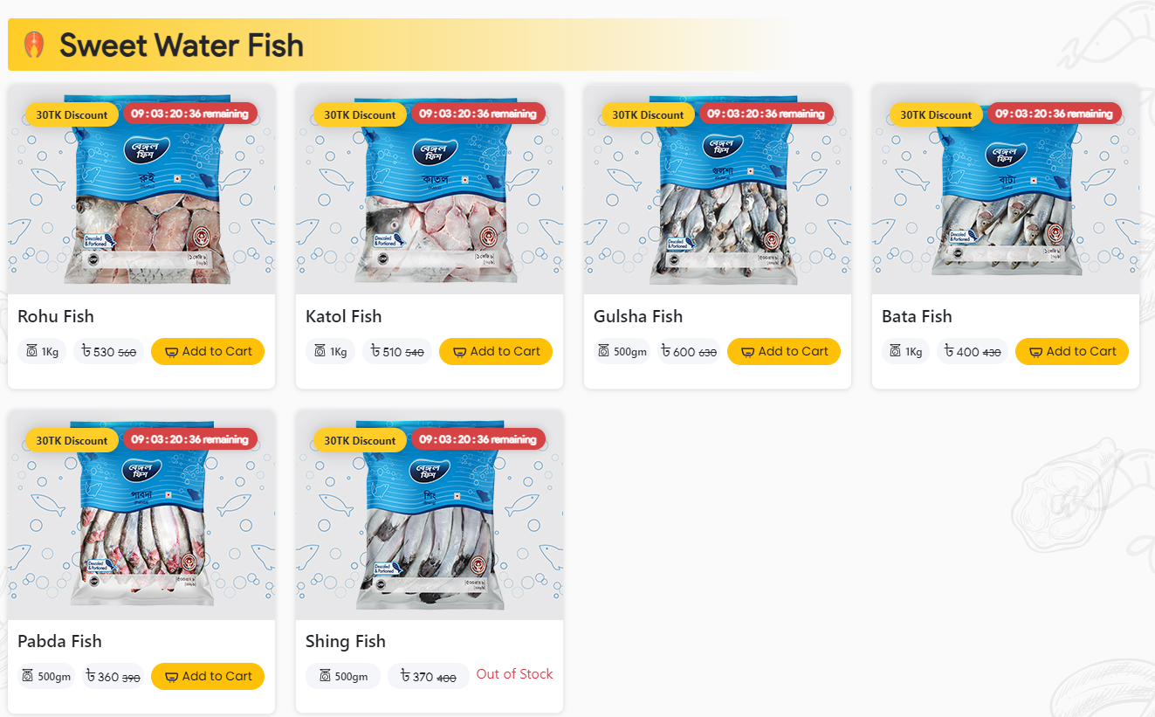

Sea Fish contains the following collection:
1 Kg - Basa Fish Fillet; Sea Bass Fillet; Red Snapper Fillet
500 g Fish - Rupchada Fish

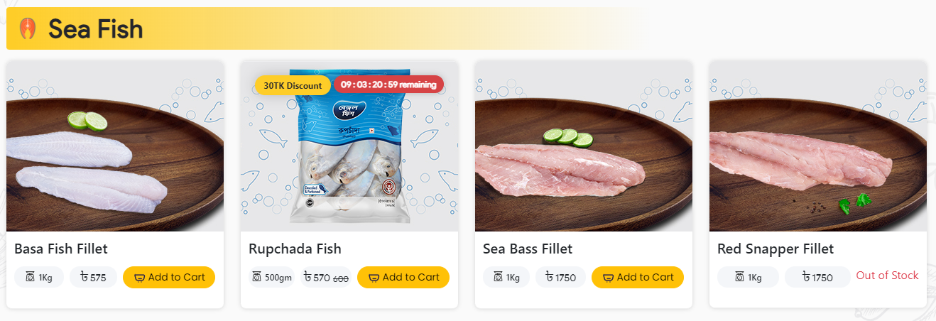

Prawn contains the following collection:
1 Kg - Black Tiger Prawn (Large), (Medium)
500 g Fish - Black Tiger Prawn (Large)
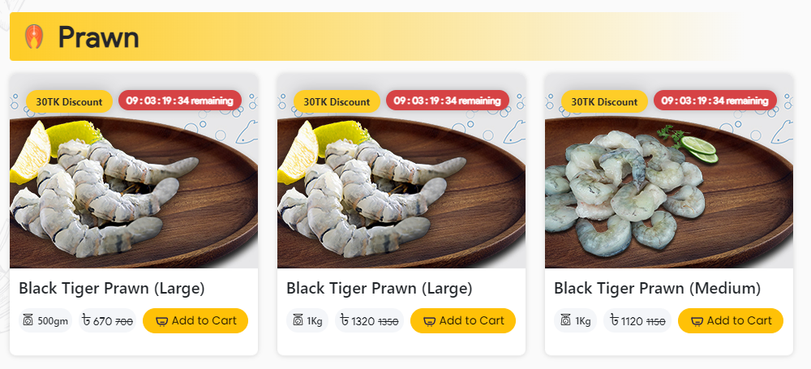
The brand has successfully branched out to this segment and is slowly but surely winning the hearts of the people that love fish.

Breaking down SWOT
Strengths, Weaknesses, Opportunities, and Threats, or SWOT, is an acronym. It is a commonly used strategic planning tool that assists individuals, companies, and organizations in evaluating their existing position and creating successful plans to reach their objectives.
SWOT is also defined as the breakdown of the strengths, opportunities, threats and weaknesses of an organization, i.e., it is the evaluation of the internal and the external marketing environment. (Kotler & Keller, 2016)
There are many important people in the world who would recommend SWOT as one of the dynamic tools. One of many, Michael E. Porter: Michael E. Porter is a renowned professor at Harvard Business School and a leading authority on competitive strategy and business competitiveness. While he is best known for his Five Forces model, he has also discussed the value of SWOT analysis as a complementary tool for businesses to assess their internal and external environment in his various works, including his book "Competitive Strategy: Techniques for Analyzing Industries and Competitors."
Individuals and organizations may learn a lot about their internal resources and external environment by completing a SWOT analysis. With the use of this knowledge, they can take well-informed decisions, play to their strengths, fix their shortcomings, grasp opportunities, and neutralize possible threats, eventually resulting in more effective and comprehensive development and success plans.
It is understood that the strengths and weaknesses of any organization are classified within the internal environment, while the threats and opportunities are classified within the external environment.
Any business unit has to make a proper assessment of their internal and external environment in order to make best use of their resources while also capitalizing on any prospects which might be untapped by the other players in the market. The SBU (strategic business unit) should also focus on mitigating any rising threats to the business for the sustainability of the business. This can be either via neutralizing any advantage obtained by competitors, or at times, it can also be via certain strategic acquisitions or mergers.
Understanding the external environment:
The macroeconomic environment provides unique opportunities to the businesses, which can range from:
- Introducing new product offerings based on emerging customer needs
- Introducing a delivery system
- Acquiring a part of the supply chain
- Introducing a new capability
- Shifting the price point to a more desirable level for the customers
The organization needs to be good at spotting different opportunities which may rise up every now and then; the aim can be to cause slight disruptions in the market or bring innovations in the market, which allow for first-mover advantages.

To seek opportunities, the business can opt for 3 simple strategies
- offer items which are in short supply
- offer a superior product or service
- creating a brand-new product or service for the market
The threats on the other hand are mainly defined as challenges which are posed by unfavorable trends or developments which when other factors are left to be constant, would lead to losses to the business in some form or fashion. Without defensive marketing or any proper contingency planning, any organization is likely to suffer.
Threat Matrix
Opportunity Matrix
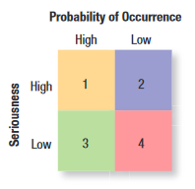
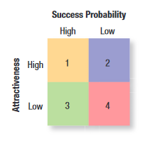

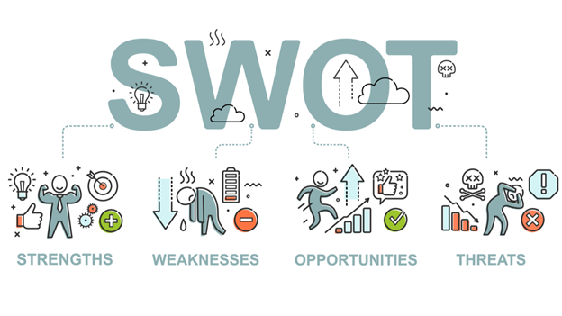
Strengths: These are the internal qualities and benefits that provide a company an advantage over its competitors or a leg up in its industry. Strengths might include exceptional abilities, priceless assets, a solid brand reputation, cutting-edge technology, knowledgeable staff, or any other advantageous elements that support the development of the company.
Weaknesses: Weaknesses are intrinsic constraints and flaws that prevent an entity from operating optimally or competing successfully in the market. Weaknesses may include insufficient resources, a lack of experience, inadequate infrastructure, or any other problems that put the business at a disadvantage.
Opportunities: All of these outside elements and situations have the potential to be advantageous or beneficial to the organization. Emerging markets, new technology, changing client wants, alliances, or any other favorable external situations may present opportunities.
Threats: These are external causes and problems that might jeopardize the entity's performance and success. Intense competition, economic downturns, regulatory changes, technological upheavals, or any other unfavorable variables that may harm the entity's activities might all be threats.


What does SWOT do?

SWOT analysis is a useful technique for strategic planning that benefits people, businesses, and organizations in a number of ways. Some examples with points are mentioned below for a better reference.
Self-Evaluation: SWOT analysis enables organizations to systematically assess their own strengths and weaknesses. They can gain a realistic grasp of their existing skills by recognizing their primary talents and limits. Having said that, it also helps evaluating business opportunities.
External Analysis: By highlighting opportunities and dangers, SWOT analysis pushes organizations to assess their external environment. Understanding market trends, possible growth areas, and potential dangers or problems is much easier by doing this.
Strategic Planning: SWOT analysis serves as the cornerstone for strategic planning. It offers critical insights that help define objectives, create attainable goals, and develop action plans that take advantage of strengths and opportunities while addressing weaknesses and risks.
Decision-making: With the knowledge gained from the SWOT analysis, organizations are better equipped to make data-driven decisions. This lessens the possibility of making choices based on unreliable information or assumptions.
Competitive advantage: Organizations may use their competitive advantages by understanding their strengths and shortcomings. It makes them stand out in the marketplace and sets their products apart from those of rivals.
Performance Evaluation: After implementing SWOT-based strategies, entities can utilize the tool to evaluate their performance. Comparing the actual outcomes to the preliminary analysis aids in determining the efficacy of the chosen techniques.
One of many scholars Jay Barney: Jay Barney is a prominent management scholar and professor known for his contributions to the resource-based view (RBV) of the firm. In his research, he has discussed how SWOT analysis can be used to identify and leverage a firm's unique resources and capabilities to achieve sustained competitive advantage.
Overall, SWOT analysis is a diverse and strong instrument for comprehensive strategy planning, decision-making empowerment, and improving an organization's capacity to traverse its competitive terrain successfully.

SWOT for Bengal Meat

Strength

Quality & Infrastructure (Safety): Bengal Meat has the utmost quality control protocols that suffice with their international quality assurance.
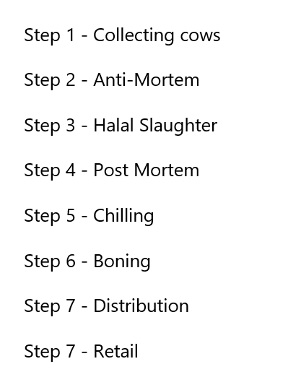


The Seven Quality Protocols That Makes Bengal Meat the Best of Quality

Product Variety: Bengal Meats has many distinctive products for different segmentation based on their needs & that may be essential for their lifestyle.

Examples:
Heat & Eat: Basically here Bengal Meats tried providing a very efficient solution for the consumers who don’t want to cook & save time. Recipes are already cooked and packaged in a way that will not rot & are perfectly healthy & ready to eat once you heat it up on a frying pan or inside an oven. They have recipes like: Beef Kala Bhuna, Mutton Rezala, Beef Mezbani, etc.
Snacks: They have different snacks like Beef Koliza Shingara, Beef Shami Kabab, Beef Minute Steak, and many more like Sausages & Cold Cuts.
Fish: The fish segment has a very interesting variety of products like Katol, Rohu Fish, Pabda Fish, Rupchanda, Red Snapper Fillet. The people of Bangladesh have been raised on the staple food of rice, and the main protein being fish - while this has gradually shifted to chicken over years, fish is still considered vital to the daily food intake of many people. The expansion into this category has been a game-changer for the brand as it has helped them reach a larger target audience, whom they could slowly remarket their main product offerings to as well.

Beef: On this segment we have Beef Bone In, Beef Tehari Cut for efficient Tehari making, & for the readymade Steak Lovers there are Beef Rib Eye, Beef T-Bone Steak, Beef Keema, etc. Bangladesh is a Non-veg country & Muslim people are the majority, “Beef” is considered as one of the most Premium and High Valued products. And hence Bengal Meats has brought one of the most interesting segments.
Supply Chain: Bengal Meats has a very interesting Supply Chain system that strengthens its integrity as a brand. But for what perks?

Sourcing: It's possible that Bengal Meats obtains its meat from a variety of vendors, including local farmers, animal growers, or other meat manufacturers. They might have special requirements for choosing suppliers based on aspects like quality, requirements for animal welfare, and sustainability norms.
Processing: It's possible that Bengal Meats obtains its meat from a variety of vendors, including local farmers, animal growers, or other meat manufacturers. They might have special requirements for choosing suppliers based on aspects like quality, requirements for animal welfare, and sustainability norms.
Storage & Distribution: To preserve their quality after processing, the meat products are kept in places that are suitable for storage, like refrigerators or freezers. For the storage of Raw Meat there are 2 options, one is Blast Freezing and one is using the Chiller.
Blast Freezer: Freeze the meat in a way that the brand wants, even if it doesn't let the water out. Keeping it as it is. Blast freezer is frozen for 24 hours. Negative (-) 40 degrees goes into the shelf life of meat. If it is not negative 40 degrees then it is not taken out.
Chiller: The meat of the store display is at 0 - 4 degrees Celsius. Which can be kept up to 7 days. The product that will be chilled does not need to be frozen. Protein snacks do not have a shelf life of less than 6 months. All products are provided in the blast freezer except the ones that are chilled. The temperature of the meat must be 6 degrees Celsius to come to the fabrication from the miller.
To get its products to different stores, markets, or eateries, Bengal Meats would use a distribution network. To make the distribution process easier, they might use their own fleet of vehicles or collaborate with other logistics companies.
Quality & Safety: Bengal Meat implements quality control procedures along the entire supply chain to guarantee that the goods adhere to the necessary requirements. This entails routine inspections, laboratory testing, and adherence to rules governing food safety.
The whole farm is a clean and fresh environment. There are no mosquitoes, flies, dogs or cats inside the factory. The farm is cleaned daily to keep the environment free from germs. Every department inside the factory is completely different.
Everything on the farm is under the direct management of Australian experts - designed and built. There are specific employees for all the work of Farm. Employees have specific attire depending on their designation and their scope of work. In the farm the cattle are taken care of, fed and reared.
Bengal Meat maintains their own clinic; in which they take care of each cattle separately. The machinery in the factory is also Australian. Bengal meat’s first priority is to provide safe meat, thus every product from their factory goes through a rigorous process while maintaining complete food safety standards. The main processing plant of the factory has a low temperature of 18 degrees Celsius. The QA team tests the bacteria in the meat.
Quality Assurance (QA) Team: Bengal Meat not only provides safe meat, it also provides safe meat as well as quality meat. They have their own QA team. Bengal meat controls the quality of meat in 6 stages. The QA team arranges quality meat supply for every product of Bengal Meat at every stage, and controls the quality of the meat according to ISO standards. The QA team does all the work to control the quality of the meat, from selecting the right cattle to supplying the meat. Every animal is tested during cattle sourcing. QA also looks after when the vaccine was given at the time of selection of cattle, how long it will remain in the meat, how the disease is treated. QA is the first to observe the issue of what is given to the animal.
The QA team monitors how the cattle will be taken and how the farmers have raised their animals. Conditional cattle are taken from the farmers subject to ensuring food security and quality. Cattle have health cards. There are benefits of feeding management.
Bengal Meat has 6 CCP (Critical Control Point) in QA. This is to check where the meat is likely to spoil. Quality checks are done at anti-mortem, such as: Whether the animal has been taken from an approved supplier, whether the animal is too dry, whether the disease has been controlled, etc. The state of the animal is seen before slaughter. It is seen whether 6 ducts have been cut during halal slaughter. Everything is done for 6 hours every day. At the postmortem, the internal organs of the animal are examined. If any problem occurs then action is taken as per SOP. After slaughtering the meat, it is washed well and kept in the chiller for 24 hours. After slaughter, lactic acid is made in the meat. In the early stages the microbiological load is high, placing it in the chiller balances the load line and lactic acid. The lactic level is kept right in the chiller. The temperature of the carcass is then observed.
Halal Certification: Bangladesh as a Muslim-Majority country values Halal Meat and Muslims need the assurance that the meat is indeed Halal. The brand has therefore ensured that they have international halal certificates. All the products and processing procedures are supervised by certified staff of Bangladesh Islamic Foundation. Bengal Meat is ISO (HACCP Inclusive), Halal and Environmentally Approved.
Their processed meat is halal certified - 1. Zakim of Malaysia and 2nd Islamic Foundation.
Bengal Meat has its own processing center at Kashinathpur, Pabna. Certified in ISO-22000, 2005 on Pabna cattle rearing, halal slaughter and meat processing methods. The meats of Bengal Meat are safe, including HACCP, AJA and UKAS certification.
Retail & Consumers: Bengal Meats' products would be available for purchase through their own retail outlets, as well as through partnerships with other retailers. Consumers can buy the products and use them for cooking or consumption.
Clientele: The brand is currently catering to a lot of high-profile clients which makes up for a large portion of their revenue share; their clients include the Bangladesh Navy, Grameenphone, La Meridian, etc. The brand being able to serve such a diverse and high-profile group of clients elevates their name and presence in the Bangladesh culinary scene.

Weakness
Cost of production (high)/ Price: Bengal Meats may face higher production costs due to factors such as maintaining quality standards, ensuring animal welfare, investing in modern processing facilities, and adhering to food safety regulations. As a result, their products may be more expensive than other local meat options.


Lack of adoption by the mass market: The higher price point of Bengal Meats' products may limit their adoption by the mass market. Price-sensitive customers may choose less expensive alternatives, especially if they perceive a similar quality or taste.
Lack of awareness regarding meat safety by consumers: Consumers may not prioritize meat safety if they are unaware of the issues that affect their health. Educating customers about the importance of meat safety, and informing them of the meat safety standards or the benefits of purchasing from a reliable supplier like Bengal Meat might assist raise awareness and demand. Informing consumers about the quality control procedures employed by Bengal Meats might also provide a boost in raising awareness and demand.
Capacity concerns and a high barrier to entry for suppliers: Bengal Meats' dedication to quality involves thorough supplier selection and quality monitoring. This can limit the availability of cows or other meat products because not all providers may match their specifications. Maintaining high-quality sourcing processes may need greater time and money, perhaps restricting the number of suppliers with whom they may collaborate.
Lack of backward integration across the supply chain: The dependence of Bengal Meats on many vendors for various components of their supply chain, such as procuring fish from one source and particular meat from another, can present complications and possible issues in ensuring consistent quality and delivery. Exploring alternatives for vertical integration or collaborations with dependable suppliers might help them optimize their supply chain and provide greater product quality control.

Expertise in premium or western cuts are not ideal for Bengali consumers: Bengal Meats' competence in premium or western cuts may not coincide with the tastes of Bengali consumers, who favor traditional cuts and cooking ways. Adapting their product offerings to local preferences and adding famous Bengali cuts or recipes might help widen their popularity.

Opportunity

Consumer awareness for healthier options (people know more about the usage of antibiotics in poultry and cattle)
There is a steep growth in the level of consumer mistrust on meat-based products. As more and more reports come out that animals are being fed antibiotics to increase their growth rate & also keep them healthier. The increase in these practices has led to consumers at times, opting out of meat consumption or looking for alternatives.


Bengal meat has ensured only the necessary usage of medication on their animals and thus doesn’t practice such overindulgence. This alongside their other safety protocols allow them to become a great option for the middle class (Socio-Economic Class B) and above to enjoy.

Bengal Meat has innovated and created specific products which target a unique combination of demographics - which includes the following:

i. Age Segment: 25 - 45
ii. Occupational Segment: Young Executives (people that don’t have a lot of time to cook for themselves)
iii. Income Group: Monthly Income >30,000 taka

Through their Heat & Eat section of products Bengal Meat has essentially created Product Innovation. There might be several small catering services which can provide food for small groups on a consistent basis, however, as a product, virtually no other brand provides cooked products (Heat & Eat Section) at a limited quantity and at an attractive price point. As they have targeted such diverse demographics for their different products, this product segment innovation has been a great success for the brand and a big hit with customers. Bengal Meat had essentially identified a huge gap in the market which they fulfilled themselves.

Increase in the disposable income for the people of Bangladesh
We understand that the people of Bangladesh have been experiencing greater levels of income over the last few years (as shown in the graph below, which contains the data from 2000 to 2023), and as their income rises, we can infer that that their spending power has also increased to a certain capacity; from this assumption, we can state that a larger target market is developing for Bengal Meat for their range of products. This can mean that soon enough there will be a larger customer base for the brand, which can cause a push in their revenue.
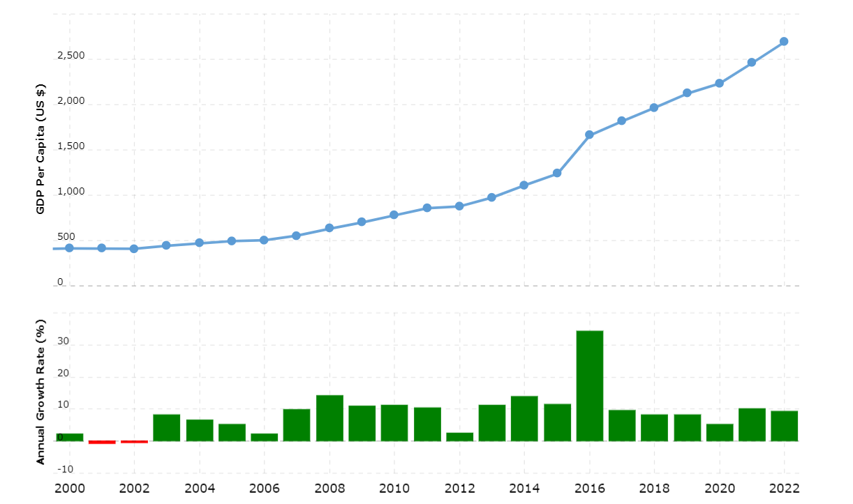
Image collected from the macrotrends.net website; data obtained from World Bank

Increased media exposure regarding western cooking and dishes, leading to growing demand for premium cuts
The audience of Bangladesh has been exposed to a huge variety of cooking shows since the 90s - which include Khana Khazana by Sanjeev Kapoor, Masterchef Australia, Hell’s Kitchen by Gordon Ramsey, etc.
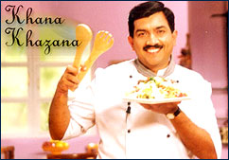


These cooking shows have led to the current rise in social media personalities and different avenues through which the art of cooking is highlighted. Currently there are several micro influencers and several cooking channels on YouTube that present different cuisines to the people. The rise of such content has caused a steady increase in consumer desire for a more refined palette - which can only be created using a higher quality of assortments.
Moreover, Bengal Meat themselves have collaborated with Kishwar Chowdhury (a Masterchef Australia alumni) for their campaigns. In their campaigns, Kishwar uses Bengal Meat products to create special dishes - which the audience can replicate at their own home kitchens.



Initiatives like these can lead to an increase in consumer demand for Bengal Meat’s products
The introduction of Super Star Key Opinion Leaders (KOLs)
Kishwar Chowdhury is the first KOL to work with the brand in a large capacity, and we can observe that the content (largely consisting of “How-to-cook” videos or recipe videos) are largely attractive to viewers and this can generate upwards of 600,000 views.
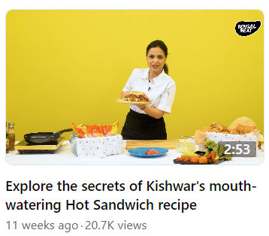
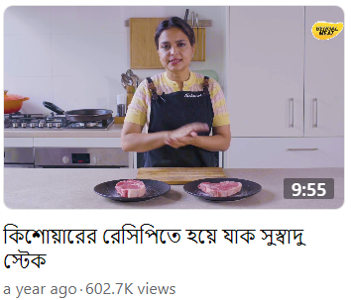

This strategy has been effective in strengthening the brand, moreover, the success of the Kishwar led campaigns have taught the brand the merit of choosing and utilizing the right KOL. When the brand faced a slight dip in their sales, they investigated the possible reasons behind it, and they identified that there were 2 factors that went into a lack of increase in the heat and eat category:
1. The lack of familiarity with the product
2. Mixed reactions to the flavors of the product
This led to the introduction of the Super Star KOL - Tommy Miah to join the Bengal Meat team and bring out his own twist to the Bengal Meat recipes. This has led to a very successful product rebranding campaign - as the product itself has been updated and the packaging itself has changed to reflect Tommy Miah’s inclusion.

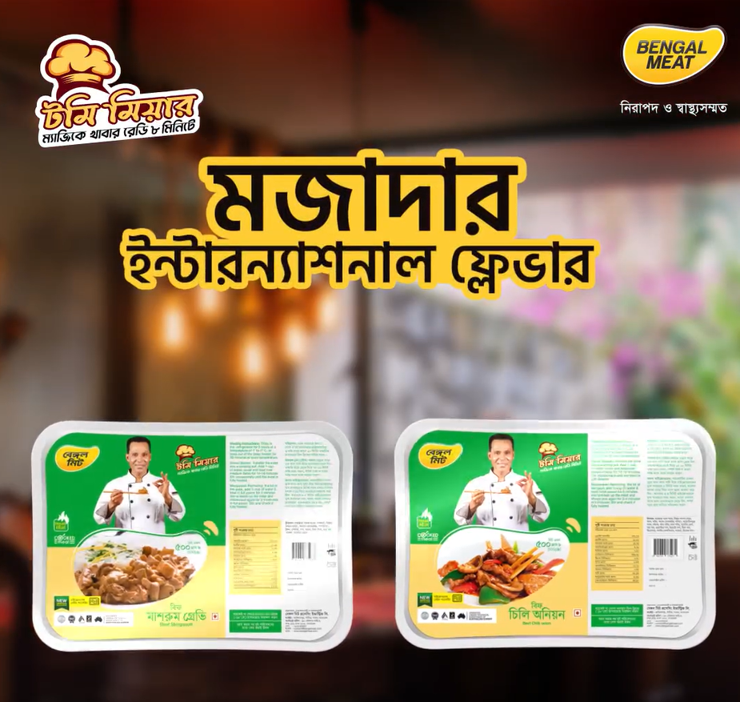
Reference of a content made for Bengal Meat’s page - which includes Tommy Miah’s new packaging.

It can be observed that the announcement itself has brought out a huge response with over 230,000 views.
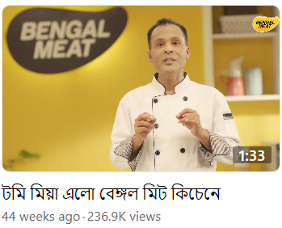
The campaign has been a great success for the brand, as it has elevated the brand to newer heights and has helped reach a larger audience - many of which are fans of Tommy Miah, thus the collaboration has been greatly successful for both parties.

Threat

Rise of newer (price) competitors entering the market and increase in alternatives
As more time passes, we understand that more competitors are slowly entering the market. They might be offering more competitive prices - in line with the wet market - but they may not be maintaining the same safety protocols that Bengal Meat is maintaining. However, while a large chunk of the population might feel the need for safety, all customers feel the sting of a higher price point. Thus, they might opt for reluctant to change or shift from purchases being in the wet markets and their local butchers.


Consumer behavior is set towards making purchases from the wet market (bazaar), as consumers in Bangladesh tend to have a higher propensity to haggle than other consumers. And consumers believe in establishing and maintaining relationships with the local sellers; customers tend to be loyal to certain hawkers and butchers for their nutritional needs.
Due to the inability to shift from this behavior, consumers may shift their consumption patterns to consume lesser quantities in times of inflation and might even switch to shopping in supermarkets (after increases in disposable income) but might still not opt for buying grocery items - which they prefer to buy from wet markets. Therefore, the consumer base might not increase at the desired rate; which can impact the company’s overall growth targets over the next few years.
Possibility of local butchers innovating or practicing higher standards of safety
Due to changes in modern technology and consumer wants and needs, even local butchers are practicing improved hygiene than before in terms of meat cutting and storage; which is minimizing the competitive advantages that Bengal Meat tends to have.
Bengal Meat tends to focus on their higher safety and superior quality of meat as their core USPs but the flexibility and the custom cuts that local butchers can provide along with lower prices, can mean that if the hygiene factor can be taken care of by these butchers, then customers might stick with them instead of shifting consumption towards Bengal Meat products.
Global shift towards newer lifestyles (e.g., vegetarianism, veganism)
There are different lifestyles being practiced by the people of the world, which includes vegetarianism and veganism, and while it takes some time for South Asia to adopt to these changes in lifestyle, and some lifestyle choices being merely trends and fads; we understand that there is a rising consumer perception that red meat consumption might have large adverse effects on the human body. This is why in the near future, we can assume that the current client base of Bengal Meat might make changes to their diet and eventually reduce their purchase of the brand’s products.

Possibility of bird flu and other diseases
Freak accidents and external factors (which includes Acts of God) which are uncontrollable, can adversely affect the business. And the increase in bird flu and other diseases can always cause massive ramifications to any business and Bengal Meat is not immune to this. Bengal Meat has taken sufficient precautions and has doctors and dedicated staff to take care of the health and hygiene of their cattle and poultry, but there is always a minute possibility that there might be a disease which can affect their livestock. This potential supply chain crisis can create a huge negative impact on both brand image and also on their revenue.

Conclusion
After conducting the SWOT analysis of Bengal Meat, we can understand that the brand has a lot of strengths and opportunities, while also keeping a few weaknesses and threats too. The next course of action would be for the brand to act on these points so that they can strengthen their position in the market.
Bengal Meat’s collaboration with Analyzen has helped them with crafting the right communications for the brand, and also helped with getting the right amount of Media Buying - which helps with reaching the right target audience within the brand’s budget. Now they need to strengthen the other aspects of the business which can use further improvements. This can include making improvements in the supply chain for their fish, it can also include buying different breeds of cattle, the brand can eventually consider starting their own cooking show which appeals to their core target demographic.
While these are primary suggestions that the brand can implement on their business operations, the brand needs to take a more holistic view of their business environment, do an audit of their operations and then make an assessment of their own capacity, before they make any action plan for their business.

Recommendation
The business can have a three stage plan which outlines how they’ll move forward. The brand can break this down into the following:
- Risk Mitigation
- Strength Enhancement
- Weakness Alleviation
In order to mitigate their risks, the brand needs to start focusing on leveraging their first mover advantage more deeply, i.e., They need to strengthen their position in the market by focusing on omni-channel marketing more. The brand already has a strong presence in Chaldal, Pandamart and has their own website, but they need to open more brick and mortar stores in strategic locations. Moreover they should also campaign the safety and quality of their products more loudly and with a mass audience in mind, as it is important for the mass consumers to be aware of the highlights and benefits of the products.
In combination with these approaches, the brand should also try to diversify their campaign modules and ways of communication, i.e., The brand is currently catering to a large group of people that can afford their products; and if the brand can start offering certain products at a smaller portion rate or offer combo packs or seasonal discounts then they might be able to tap into dormant customers, who can later become regular purchasers of the brand.
The brand can start reaching out to newer target demographics through different campaign modules, and more importantly Bengal Meat can try to associate with certain snacks or other purposeful brands, so that it can help them gain top of the mind awareness. E.g., A collaboration with Knorr Soup might be a feasible option for the brand, as they are promoting the concept of healthy and tasty cuisine.
Benefits belonging to the brand such as the halal certification can play a big role in their future success, and a very effective way of communicating to the target audience of the brand’s core capabilities would perhaps be to shoot a proper TVC with the right celebrity influencer, to capture the imagination of the audience.
In order to strengthen the brand’s supply chain, one possible recommendation that they can follow is to also open fisheries, which helps them reduce their dependencies on external suppliers entirely and helps shift the power of the supply chain completely back to their hands.
Another point that the brand could follow is to attempt further product innovation; we can observe that the heat and eat line of products have already been successful to varying degrees but if the brand can further innovate, and step into the consumers’ desire for new products, then the brand might have new successful product offerings.
One of the weakness reduction approaches could be tackling the misinformation about meat safety. Given that there is a lack of concern about meat safety from the people of Bangladesh, the brand can launch a national campaign alongside the Government of Bangladesh; which aims to inform the people that they should be consuming more hygienic and better processed meat. The communication of the campaign should be designed so that the local butchers and other sellers are not deprived of their business, but instead, should be taught about the values and benefits of processing meat correctly.
Given that the brand can follow some of the strategies outlined in this section, the brand might achieve either a larger share of the market, or might be able to turn over a higher profit, and if all goes well, then both are realistically achievable.

Appendix

Communication Content for the brand created by Analyzen BD Ltd.

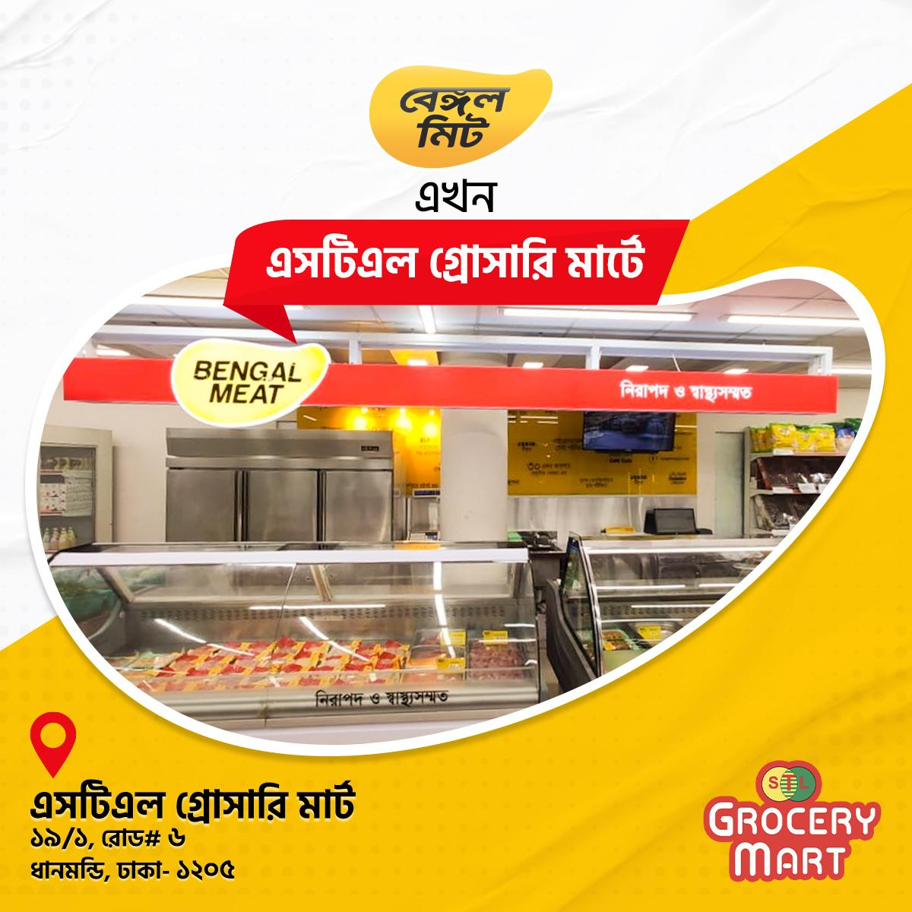

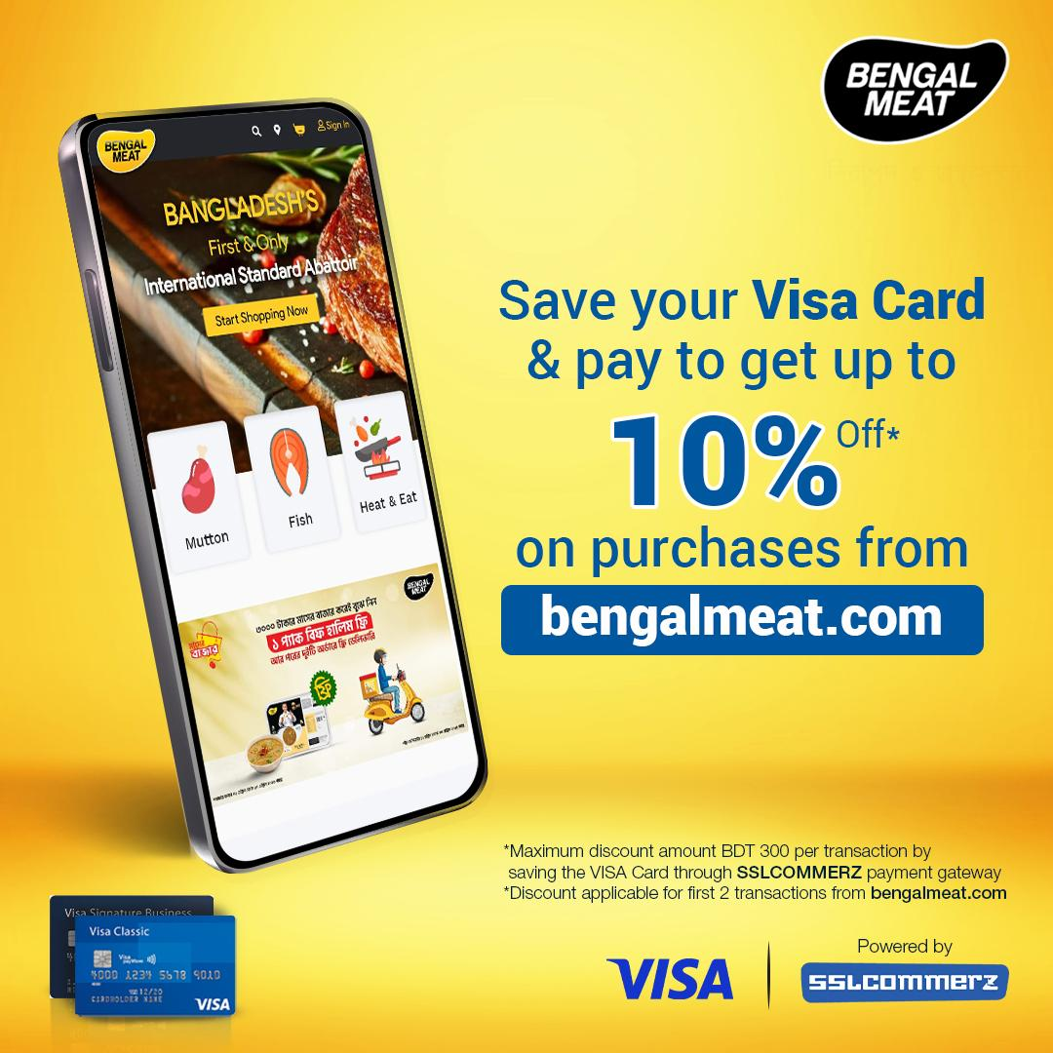

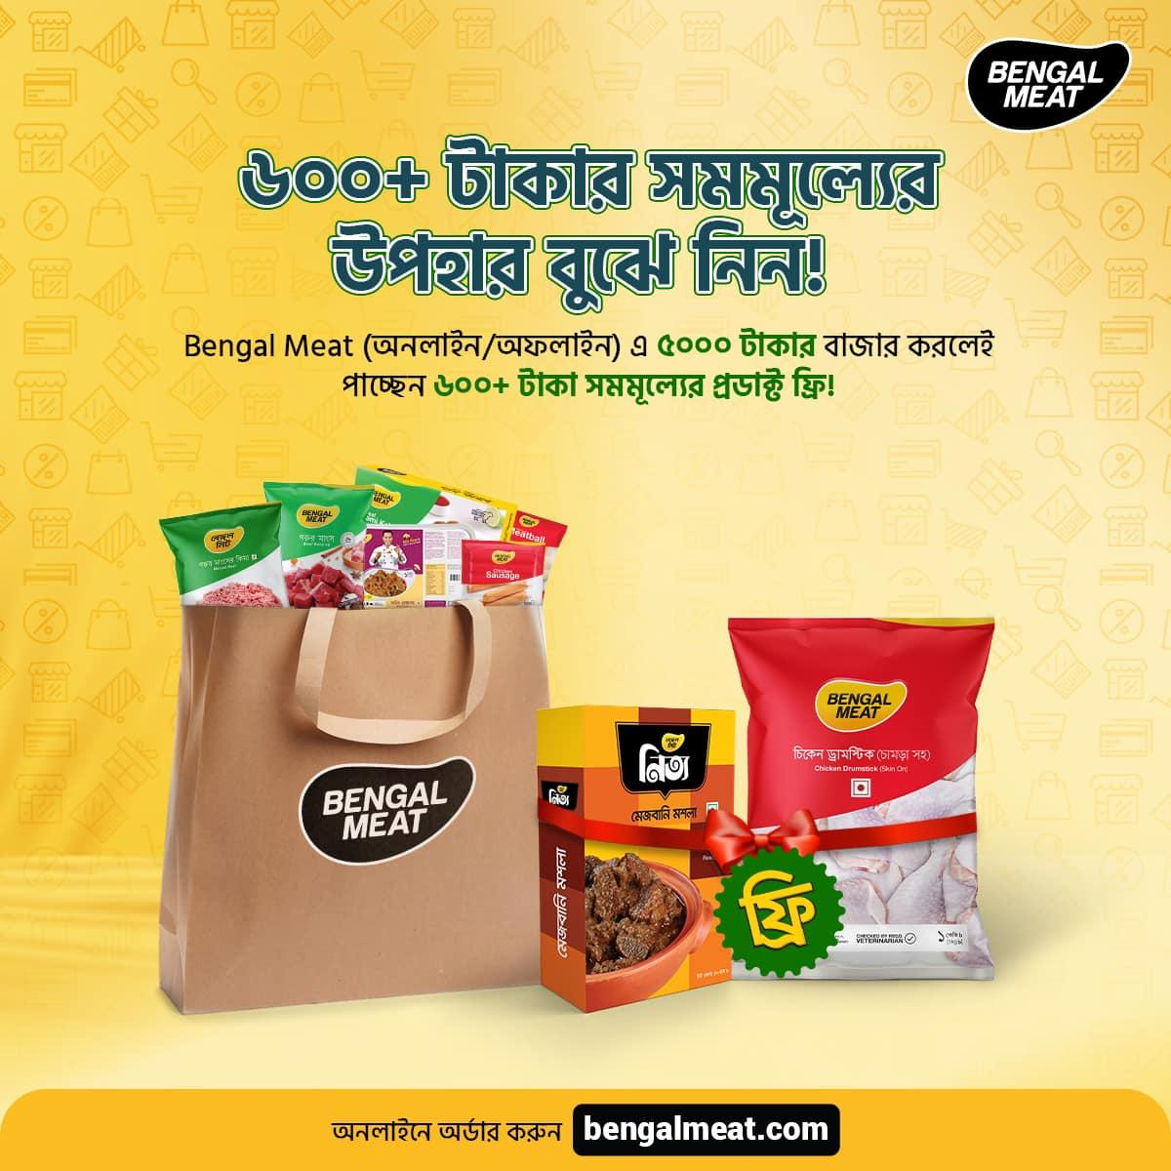


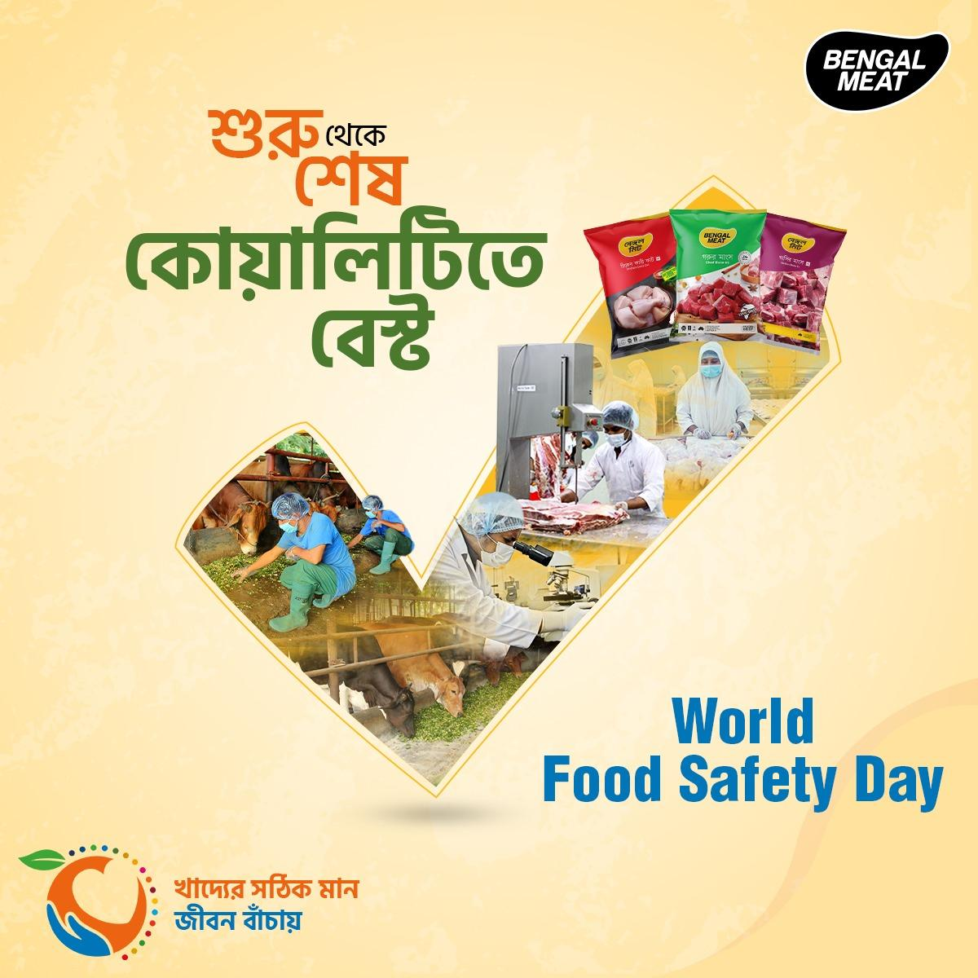

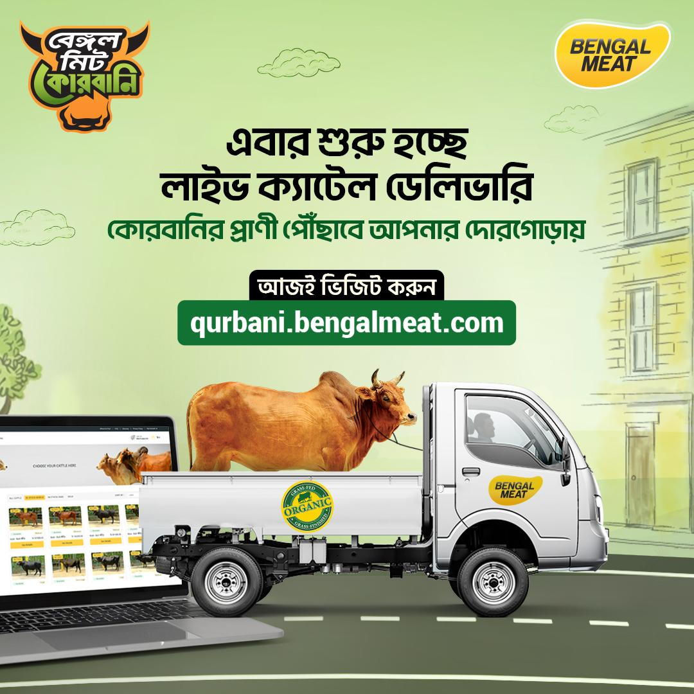
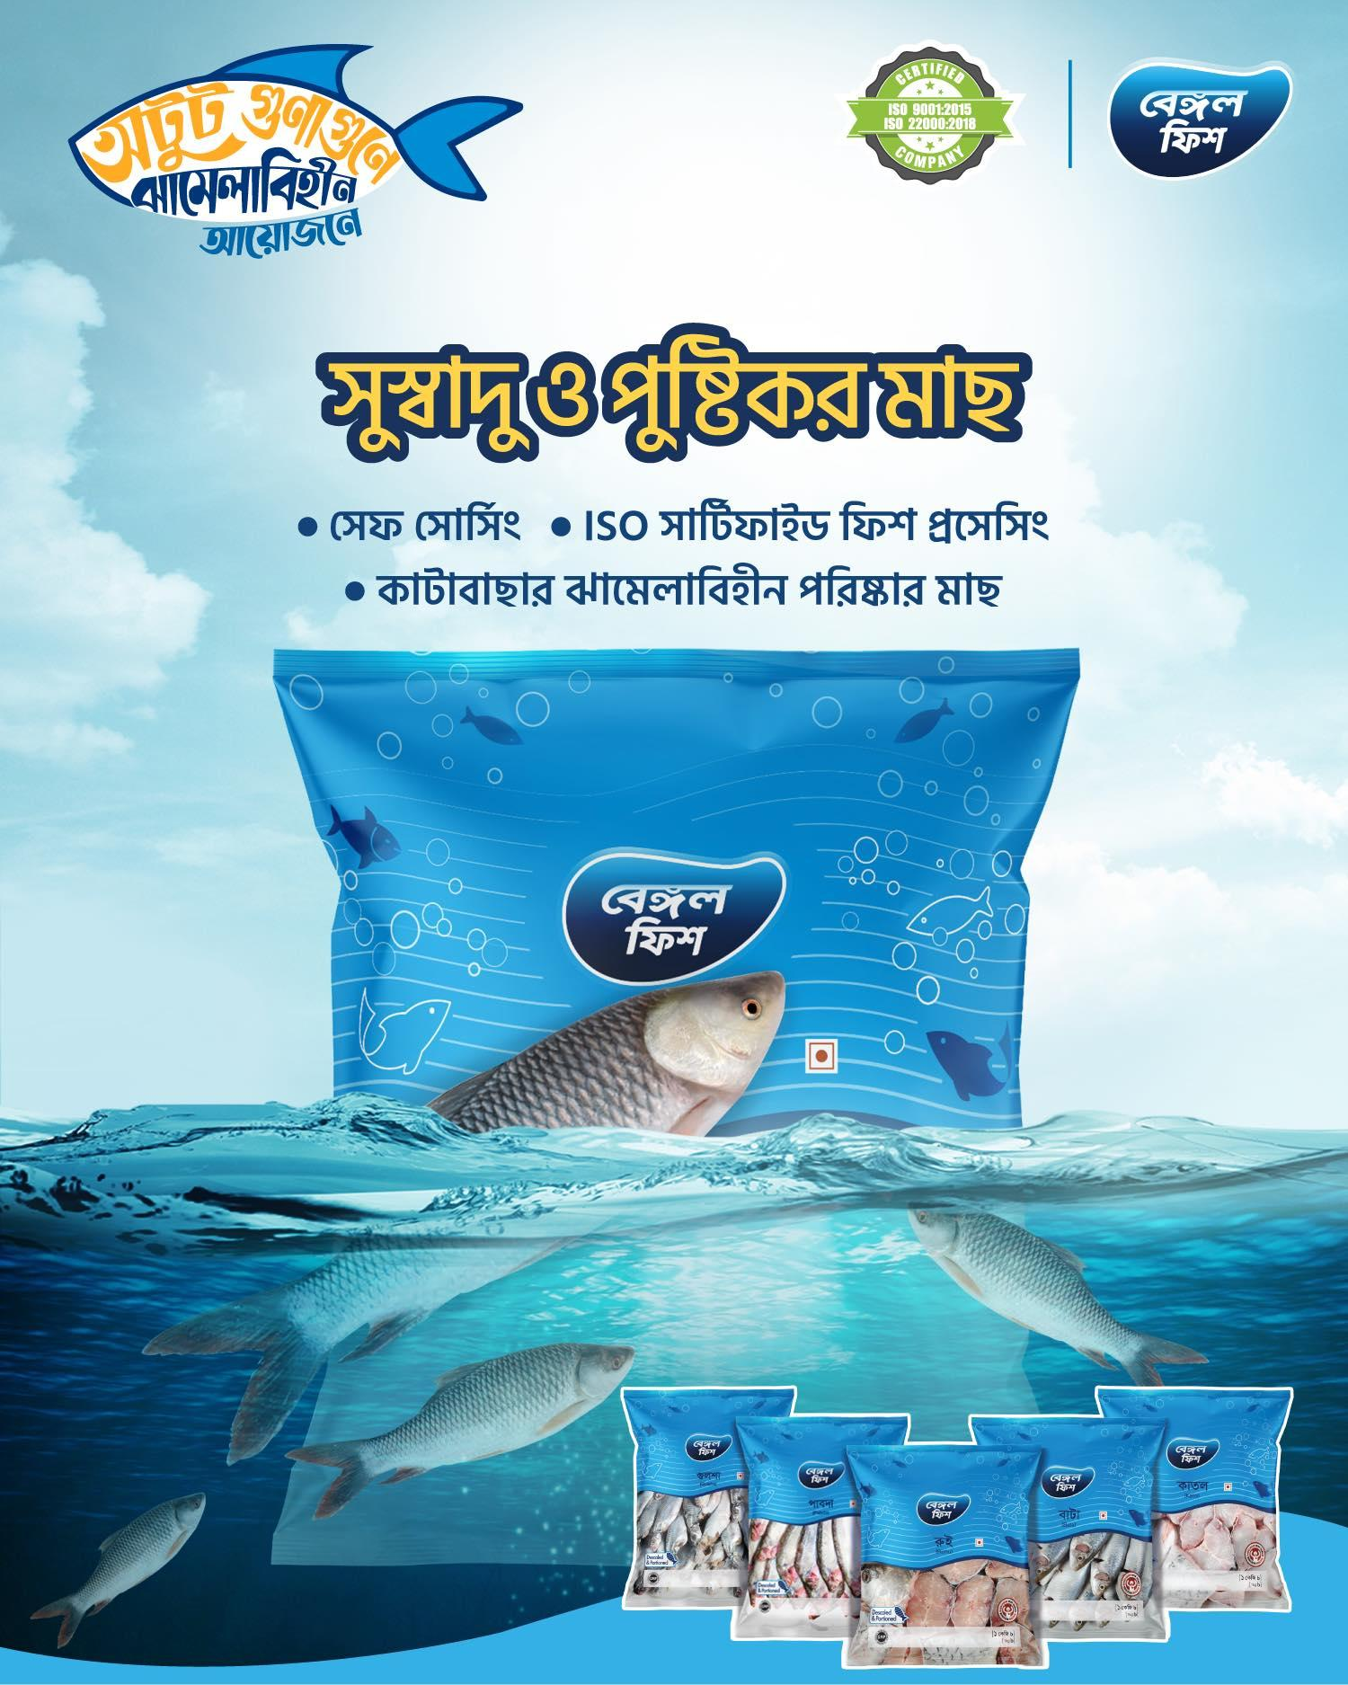

References

Grant, R. M. (2003). Strategic planning in a turbulent environment: Evidence from the oil majors. Strategic management journal, 24(6), 491-517.

Harrigan, P., Daly, T. M., Coussement, K., Lee, J. A., Soutar, G. N., & Evers, U. (2021). Identifying influencers on social media. International Journal of Information Management, 56, 102246.

Hill, T., & Westbrook, R. (1997). SWOT analysis: it's time for a product recall. Long range planning, 30(1), 46-52.

Nath, P., Nachiappan, S., & Ramanathan, R. (2010). The impact of marketing capability, operations capability and diversification strategy on performance: A resource-based view. Industrial Marketing Management, 39(2), 317-329.

Rummana, R., Rahman, K. M., Aziz, S., & Nishat, B. (2008, October). Urban pollution in Dhaka city: A tri-partite qualitative model for alleviation and prevention. In Proceedings: International Conference on Sustainable Urban Environmental Practices (p. 297).

Rahman, K. M., & Noor, N. A. M. (2016). In search of a model explaining organic food purchase behavior: The overlooked story of Montano and Kasprzyk’s integrated behavior model. British Food Journal, 118(12), 2911-2930.

Smith, K. T., Smith, M., & Wang, K. (2010). Does brand management of corporate reputation translate into higher market value?. Journal of Strategic Marketing, 18(3), 201-221.

