Internship Report on

CREDIT DEPARTMENT & LOAN SECTION

OF

JAMUNA BANK LIMITED



Internship Report on
Credit Department &Loan Section of Jamuna Bank Limited

Submitted To
Dr. Seyama Sultana
Assistant Professor
School of Business and Economics (SOBE)
United International University (UIU)

Submitted By
Jannatul Ferdous
111 131 436
BBA Program
School of Business and Economics (SOBE)
United International University (UIU)


Date of Submission: 20/05/2018

Letter of Transmittal
20th May, 2018
Dr. Seyama Sultana
Assistant Professor
School of Business and Economics (SOBE)
United International University (UIU)
United City, Plot 2, Madani Avenue, Badda, Dhaka 1212

Subject: Submission of Internship Report

Dear Madam
I am submitting my internship report entitled “Credit Department &Loan Section of Jamuna Bank Limited” as a requirement of completion of the internship program of BBA at United International University under the school of business and economics.
It was a massive chance about gain knowledge in such an expert situation through the internship program for me. It was incredible learning backgrounds for me and in this my aim is to uncover my learning. This report gives an outline of the encounters that I have accumulated amid of my 3 months internship period.
I should need to indicate appreciation to you for all the help and rules you gave, which can assist me with continuing later on.

Sincerely
Jannatul Ferdous
111 131 436
School of Business and Economics (SOBE), United International University (UIU)

Acknowledgement
All the praises are for the Almighty, who provide me with capacity and potentially come to an end to the assigned work. I am additionally admiring to the Mighty for empowering to draw a close this inside due time.
For making of this report I might desire to pass on my thanks my regarded manager Md. Abul Kashem (EO), Zainal Abedin (FO), Raqibul Hasan (FEO) and Mohammed Sahadat Hossain (FEO) for supporting me to learn about many organizational activities of Jamuna Bank. Throughout internship interlude I worked with their guideline to learn the organizational factors. They also help me to arrange this report by giving adequate information.
My extraordinary thankfulness goes to my honorable internship supervisor Dr. Seyama Sultana, Assistant Professor, School of Business and Economics (SOBE), United International University (UIU), who motivated me to choose this topic. She encourage me in each progression of my entry level position report composing by giving legitimate direction, guidance and motivation.

Executive Summary
Internship is must to fulfill enlightening essential. Report relies upon pragmatic association with the Jamuna Bank Limited, Shantinagar Branch, Dhaka. This examination relies upon five essential objectives to consider the definitive structure of the Jamuna Bank Ltd. I summoned mutually primary and secondary records to persuade this exploration. The part about the point of reference area of the Bank, their common mission and vision, how work out their business and public obligation are likewise coordinated. After that I have portray about the item and liberality of the Jamuna Bank Limited. A broadened resource and grinder item are offered by Jamuna Bank Limited. From my viewpoint a couple of issues are similarly perceived. I endeavored to have focus to a couple of proposition which I acknowledge working with the best edges worry of that the issues and the bank will be at an exceptional situation along with the every single one banks in Bangladesh. As a final point I scrutinized so as to Jamuna Bank Ltd. will ensure the better organizations to the boundless occupants of Bangladesh and they will perform on greater responsibility on change of economy of Bangladesh.

Table of Contents
Letter of Transmittal i
Acknowledgement ii
Executive Summary iii
Chapter 1: 1
Introduction 1
1.1 Theoretical Background 2
1.2 Objective of the Report 2
1.3 Scope of the Study 2
1.4 Limitation of the Study 3
Chapter 2: 4
Overview of Jamuna Bank Limited 4
2.1 Historical backdrop of the Bank 5
2.2 Major activities of Jamuna bank Ltd. 6
2.3 Mission, Vision 6
2.4 Core Values 6
2.5 Product/Service Offerings 7
2.6 Online Banking 7
Chapter 3: 8
Job Responsibilities and Observation 8
3.1 The Nature of the jobs and my Specific Responsibilities 9
3.2 Observation 10
Chapter: 4 11
Findings: “Credit Operation of Jamuna Bank” 11
4.1 Sources of Information 12
4.2 Credit Amenity of Jamuna Bank Ltd. 12
4.3 Kinds of credit of Jamuna Bank Limited 13
4.3 Securities alongside Advances 15
4.4 Sector Wise Structure of Loan 16
4.5 Divisional Loan 17
4.6 Maturity of Credit and Advances 17
4.7 How Jamuna Bank Convalesce their Loan 18
Chapter: 5 19
Conclusion & Recommendation 19
Conclusion: 20
Recommendation: 21
References 22
Appendix 23

Chapter 1:

Introduction

Theoretical Background
A business banks benefit depends basically on the abuse of its reserve. Also, the manufacture of credit and progress is constantly gainful to a bank. As the bank activates reserve funds from the general individuals as store, its most critical assignment is to allot the said store as credit or progress to the mass individuals for the improvement of business, mechanical, who need finance for venture. Credit empowers a bank to proactively oversee advance with a specific end goal to acquire a bleak circumstance the cost of reserve.
Jamuna Bank Ltd. Was complex to give term advance and other monetary help to quicken the pace of improvement to little industry of Bangladesh is likewise inclined to such baffling highlights of issue advances. The report basically centers on the credit working framework, their credit strategies and methods of advance supervision and recuperation, particularly their grouped advances.

Objective of the Report
There are two sorts of objectives in this report:
Primary objective:
My first of all review from my study during BBA life and review of the understanding I have accumulated from the organization I was committed as an internee.
Secondary Objective:
    - To sheltered the data on the subject of the credit array of Jamuna Bank Ltd.
    - To think about the hierarchical structure of the Jamuna Bank Ltd.
    - To feature a diagram of Jamuna Bank at 2016

Scope of the Study
Banks have been assuming a vital part in financial improvement and contributing tremendously to construct the nation. Keeping money segment is quick extending in our nation. To make due as a key player in this exceedingly aggressive and complex business condition a bank ought to build up its business centering the consumer loyalties. As a student, I have originated out about a bank; I additionally have taken in the report composing, as a huge sum of hypothesis is incorporated into this report. It will be likewise profited for the ordinary citizens who are intrigued to think about Jamuna Bank Limited.

Limitation of the Study
Three month internship isn't sufficient to gather sufficient knowledge about an organization well. I have attempted associated making of this report by social affair sufficient data from the workplace help of Shantinagar Branch. I couldn't make extraordinary report for the time confinement.

Chapter 2:

Overview of Jamuna Bank Limited

Jamuna Bank Limited (JBL) gives business managing an account benefits in Bangladesh. This organization above all else takes part in corporate saving money, venture fund, exchange back, retail saving money, shopper fund, and little endeavor back.

Historical backdrop of the Bank
As a 3rd generation Bank of Bangladesh, it focuses on
- Outstanding with time
- Supervision change
- Developing individual capital
- Build true customer’s value
The Bank offers both ordinary and Islamic banking through nominated branches. The Bank is synchronized by a gathering of especially talented and specific gathering of individuals with differentiated involvement in back and saving money. The Administration of the bank dependably centers on liberal and foreseeing clients' needs. As the need of clients is changing step by step with the progressions of time, the bank happenings its best to design techniques and acquaint new items attempting with adapt to the change. Jamuna Bank Ltd. has just accomplished radiant advance since it began. The bank is starting at as quality authority associations of the country.
At present it has continuous Online saving money branches. Other than ordinary conveyance focuses, it has ATMs of its own, imparting to other accomplice banks and gathering all through the nation.
The strategy hour of the Bank is 10:00 A.M. To 6:00 P.M. from Sunday to Thursday and the task hour is from 10:00 A.M. to 4:00 P.M. The Bank end its exchange on Friday, Saturday and government occasions.

Major activities of Jamuna bank Ltd.
The major exercises the bank do is to give all sort of productive bank exercises incorporate an extensive variety of administrations and in addition barring stores, creation advances, marking down bills, control cash exchange and remote trade exchanges and working other related administrations, for example, safe keeping, accumulations, issuing ensures, acknowledgments and letters of credit to its regulars through its branches in Bangladesh.

Mission, Vision
Vision
To end up a main managing an account establishment and to assume a noteworthy part in the improvement of the nation.
Mission
The Bank is resolved to fulfill differing necessities of its clients all the way during a diversity of items at a focused cost by utilizing proper innovation and giving opportune administration so maintainable development, sensible return and commitment to the advancement of the nation can be guaranteed with a roused and expert work-drive.

Core Values
- Trust
- Integrity
- Commitment
- Business Ethics
- Quality
- Fairness
- Teamwork
- Respect
- Courtesy
- Harmony
- Unique Culture
- Dependable Communal Inhabitant

Product/Service Offerings
Collection of form that prepared financial products and services, here used. Those products are based on Monthly Savings Schemes, Consumer Credit Schemes, Lease Finance and Special credit for Women etc. Jamuna Bank Ltd, also well known with ATM cards for its expensive customers giving 24 hours ATM services through the booths.

Online Banking
Jamuna Bank Limited has begun its ongoing any branch relying upon December 31, 2010. Presently, clients can drop out and introduce cash from all over of the 122 branches situated at Dhaka, Chittagong, Sylhet, Gazipur, Bogra, Naogaon, Narayanganj, Dinajpur, Kushtia, Rajshahi, Bashurhat, Sirajganj and Munshigonj et cetera. There are 7 branches around Bangladesh is prepared to be introduced soon. Customers can likewise hold 24 hours subsidizing administration through ATM card from any of ATMs situated at extraordinarily Dhaka, and after that Chittagong, Khulna, Sylhet and Bogra and etc.

Chapter 3:

Job Responsibilities and Observation

I was at the Shantinagar Branch of Jamuna Bank Limited to complete my internship program. During my three (3) months internship curriculum I enjoyed the work at the organization but most importantly, how to defeat anxiety with great responsibilities. Throughout this time I had worked with different department of JamunaBank Limited. There are diverse departments in Shantinagar Branch and they are:
- General Banking (GB)
- Credit Department (CD)
- Foreign Exchange Department (FED)
- Accounts Department
- Clearing Department
I worked at most 4 departments in the past 3 months. However, my main focus was on Credit department and thus, my work was at credit department section.

The Nature of the jobs and my Specific Responsibilities
In the primary week of my joining, I worked some days at General Banking (GB) department. I had various responsibilities at GB:
- Bring out the account opening books for the customers and verifying them,
- Attaching and counting the voucher of GB
- I have lookup the FD, DPS and old account opening forms
- Open account for new customers and aid them in the process
- Learn how to patent FD and DPS for new customers
I worked at Credit Department (CR). There I have learned many of the banking terms. I have to perform underneath activities-
- I have Print, type and do photocopy different papers allied credit.
- I sometimes organize all the customer files (e.g. car loan, home loan) & keep them at a specific place separately.
- Check and fill up various forms of loans
- Entries data in the computer.
- Show the clients that where to sign on the form.
- Sometimes helps my supervisor balancing credit & debit.
Besides working on Credit department, I have worked at Foreign Exchange Department.
  - Processing a new LC (Letter of Credit)
  - Matching the Voucher with the Supplementary
I also worked in Accounts Department (A/C) and there I have to count different salary amount of the staff worked at that branch. I also match the different bill and acknowledgment voucher of accounts department.

Observation
I have thought that it was particularly intriguing to work at Jamuna Bank. The general population with whose under supervision I was was extremely exceptionally decent and capable. I have seen and viewed the followings in the midst of time of internship:
- The Bank has a better than average climate to work at, and the officers and every single individual are exceptionally decent.
- Employees are exceptionally dynamic and true to their allotted work duties
- Work is never left pending unless it is completely vital
- The work improved quickly with PCs and working frameworks.
- There is dependably a surge of clients so standard on what the representatives do for the duration of the day depends a lot. The work exercises of a representative are set, however what to do when changes along the day.
- The work exercises are constantly set and isolated for every one of the representatives. This is the way it ought to be, yet when I saw it firsthand it was striking. Every single representative arrange of obligations. I saw that every last other staff individuals help each other.

Chapter: 4

Findings: “Credit Operation of Jamuna Bank”

Sources of Information
The information accumulation technique for think about comprises of both of primary and secondary sources. Be that as it may, here from secondary sources, greater division of the information was gathered.
Primary sources:
- Face to confront discussion with the officer.
- Direct perceptions.
- Face to confront discussion with the customer.
The secondary sources of information are given underneath:
  - Yearly statement of the Jamuna Bank Limited of 2016
  - Website of the Jamuna Bank Limited.
  - Different distributions of the Jamuna Bank Limited.
  - Theoretical books relating saving money part.
A bank's essential educational program is to make a channel through storing cash from the surplus unit and give financing to borrowers. For this there is a need of credit division in any bank. The credit division is an extremely vital bureau of a bank. The cash that collects extreme surplus units is partitioning through this office to a definitive setback unit (borrower).
Credits and advances are the core of benefit of every business bank. Everywhere throughout the world, Banks attempt more to make such a credit portfolio which serves to less the income to reduce the credit risk. Jamuna Bank continues enlarge credit office by offering diverse modified advance items to business substances and people.

Credit Amenity of Jamuna Bank Ltd.
The fundamental crucial of Jamuna Bank's Credit program is to financing business, exchange and mechanical exercises through a viable conveyance framework.
    - Jamuna Bank Ltd. offers credit to every single business part to do their exercises having beneficial reason.
    - The advance arrangements manage an extensive variety of credit programs.
    - Credit is likewise offered to real push areas, as set apart by the govt., at a diminished loan cost to create wilderness businesses.
    - Credit offices are offered to those of people and in addition housewives, representatives, little and enormous business houses, brokers, fabricates, corporate bodies, and etc.
    - Loan is given to the provincial individuals to agrarian generation and other homestead related exercises.
    - Credit offices are stretched out according to rules of Bangladesh Bank (Central Bank of Bangladesh) and operational methodology of the Bank.

Kinds of credit of Jamuna Bank Limited
- Loan (General)
Short, Medium and Long term credits are permitted to firms businesses and people for an unmistakable reason however for a constrained period and typically repayable by installments of this head. Credit gives framework basically permitted obliging financing under the class
- Industry estimate Large and Medium.
- Small and Cottage Industry.
- Agriculture financing term and others are likewise included here.
- Cash Credit (Hypo.)
Credit permits singular/firm to trade and in addition vast scale reason or to enterprises to get together the hazard capital prerequisites against charge of products as essential sort of loaning and a never-ending credit. It is permitted under the accompanying
- "Commercial Lending" when the client is other than an industry and
- "Working Capital" when the client is an industry.
- Cash Credit (Pledge)

- Cash Credit (Pledge)
Financial housing to individual or firms for dealings and for entire deal or to companies as working capital against vow of products as essential security falls under money credit vow. It is likewise a steady credit and like the above permitted under the followings
- "Commercial Lending" and
- Working Capital".
- House Building Loan (General)
Credit permitted to individual or endeavors for building house (private or business) are the sort of advance. The volume is repayable by inside an expressed period. Such advances are known as Loan (HBLGEN).
- Other Loans to Staff
The advance that permitted to workers other than for House Building should be under the head - Staff Loan (Gen).
- Consumers Credit Scheme
This is an exceptional credit plan is back buy of buyers' changeless to the settled wage gathering to raise their way of life. The credits are permitted on simple terms against individual certification and store of determined level of value by the clients. This credit is repayable by payment inside a settled period.
- SOD (General)
Credit permitted to singular/firms against monetary commitment (i.e. lien on FDR/PSP/BSP/Insurance Policy/Share and so on). Various advances could possibly a nonstop Credit.

Securities alongside Advances
Classifications of loan | Bonds
House building loan | Primary securities: pledge for territory or any property
Car loan | Primary securities: mutual registration and comprehensive insurance policy. Two valuable insurers.  Collateral securities: loan of land or any property. Any type fiscal obligation.
Auto loan | Primary securities: mutual registration  Two valuable insurers and post dated bond
Any purpose loan | Primary securities: two valuable insurers and post dated bonds.
Payments against documents(PAD) | Pledge or lien of stock-in trade, goods, produce and  merchandise, machineries, land or building on which machineries are setup
Loan against imported  merchandise | Assurance of imported merchandise
Loan against trust receipt | Import document trust receipt
Local bills purchased | The Bill itself
Overseas Invoice purchased | Shipping certificates for exports
Overdraft | Primary securities: Lien of book depth Collateral securities

Sector Wise Structure of Loan
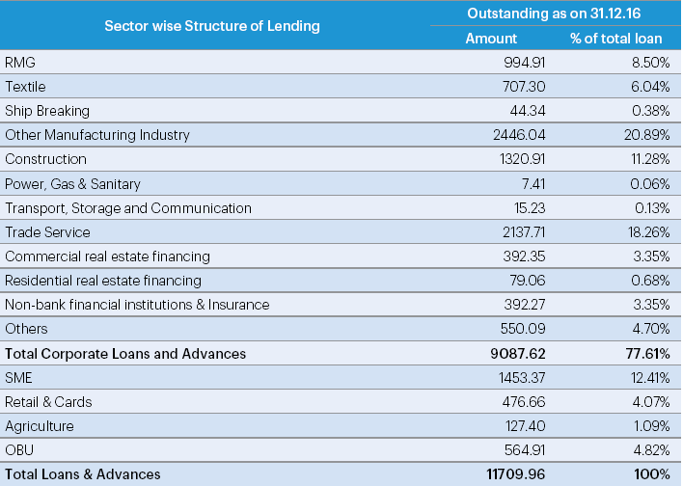
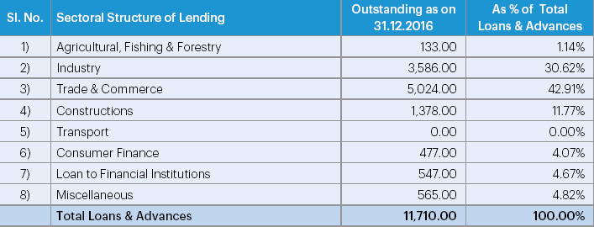

Divisional Loan
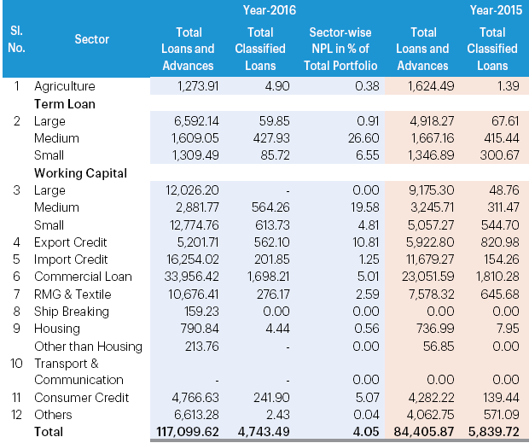

Maturity of Credit and Advances
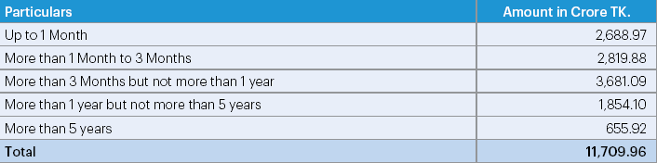

How Jamuna Bank Convalesce their Loan
At the point when Jamuna Bank approves credits and advances to its clients, they obviously express the reimbursement design in the advance assertion. Some investors don't pay their advances in due period. The joint and private part business banks need to confront such issues. This sort of circumstance is additionally found in Jamuna Bank as well. To defeat the issue of overabundance credit, the bank has taken some advance recuperation programs. Recuperation Programs taken by Jamuna Bank Limited:
- Establishing credit supervision and observing cell in the bank
- Re-organizing the credit endorsing and appropriating strategy
- Sanction credits and advances against satisfactory securities as most ideal as
- The branch administrator ought to have more power in credit administration basic leadership process
- Offering a bundle of motivators to the sound borrowers
- Giving more consideration on here and now credits and advances
- Imposing confinements on credits and advances for flawed businesses
- Taking legitimate activities as quickly as time permits against unsound borrowers as most ideal as inside the period
- Consumers Credit Scheme
This is an exceptional credit plan to fund buy of customers' lasting to the settled wage gathering to raise their way of life. The advances are permitted on simple terms against individual assurance and store of determined level of value by the clients. This credit is repayable by frequent pay inside a settled period.
- SOD (General)
Credit permitted to singular/firms against money related commitment (i.e. lien on FDR/PSP/BSP/Insurance Policy/Share and so forth). The advance can be possibly a consistent Credit.

Chapter: 5

Conclusion & Recommendation

Conclusion:
Jamuna Bank as being the main business bank began its curriculum in 2001. It has officially developed decent picture among its customers by offering its superb administrations by various divisions. Such sorts of progress originate from the steadfast, confirmation and dynamic influence, the banks administration over the periods. The workplace of Jamuna Bank Limited is well disposed. Credit allotment of Jamuna Bank gives a qualified administration by its devoted gathering of customers and officers. The officers of credit office dependably screen the credit in various divisions and their position. At first of letting credit the officers’ break down whether the advance will be beneficial and making customer is sufficient to reimburse the advance inside the given timeframe.
The primary upper hand of Jamuna Bank is that it has web based saving money where as other neighborhood business bank can't yet accomplish that favorable position. All the business banks of Bangladesh are currently endeavoring to accomplish this. In this bank and with alternate offices, the representatives are profoundly energetic by their compensations and different advantages. Here, the workers are particularly helpful with their clients, partners and basically guests.

Recommendation:
Jamuna Bank Limited is one of the notable banks in our nation. As I was just for few days with the pleasant workplace of the bank, it's very difficult to offer suggestion to such an entrenched bank. Still from my small learning and perception, I am giving after proposal to take after:
- Jamuna Bank needs to center on advance and propel administrations. Jamuna Bank likewise needs to offer appealing bundles to advance their credit and propel item.
- Maximum measure of credit is given to the stable mechanical divisions. They purposefully disregard the farming risk and security issues. Yet, for the general financial improvement of the nation must differentiate their advances in agribusiness segment.
- Jamuna Bank doesn’t have much of ATM Booths. So they need to put more attention to build more ATM Booths.
- The late advances ought to recoup through satisfactory moves made by govt. what's more, to find a way to give advances inside a point of confinement.
- The credit culture which is new can be developed in place of the old culture or lending system. Interest rate of credit should increase.
- Jamuna Bank offers 67.38% advance and advances to Dhaka District, though rest 7 is exceptionally poor to this site. Along these lines, Jamuna Bank should investigate those rests of the areas.

References

- http://jamunabankbd.com/
- http://dspace.bracu.ac.bd/bitstream/handle/10361/3253/09204068.pdf?sequence=1
- Yearly report of Jamuna Bank Limited (2016)

Appendix
For the Clients
Dear Defendant,
As a student of United International University, I am conducting a survey on “Credit Management & Loan section of Jamuna Bank Limited”. As an academic study and here the findings will remain confined within academic interests. I am not going to disclose any function. Your survey will highly cooperate here.
Please read the questions carefully and just put a tick (√) in the respective box and kindly give your judgments where necessary.
- How can you differentiate Jamuna Bank from other Banks?
- Low interest rate
- Easy loan & disbursement
- SME loan
- others
- What judgment can think about Service Increment?
- High
- Medium
- Low
- Is the credit preparing time protracted?
- fully agree
- agree
- disagree
- fully disagree
- How is the credit preparing arrangement of Jamuna Bank?
- Very Good
- Good
- Very Bad
- Bad
- The loan taking area should taking care
- Interest rate
- Installment period
- Service charge
- Loan preparing time

