An Evaluation of Service Quality at the Janata Bank Limited

Anika Anowar Srabonee

This internship report is submitted to the School of Businesses & Economics, United International University as a partial requirement for the fulfillment of Bachelor of Business Administration Degree

An Evaluation of Service Quality at the Janata Bank Limited

Prepared By:
Anika Anowar Srabonee
ID- 111 191 021
School of Business and Economics
United International University

Supervised by
Dr. Kawsar Ahmmed
Professor
School of Business & Economics
United International University

Date of submission: August 7, 2023

Acknowledgement

When it comes to acknowledgement and expressing gratitude, my Almighty always comes first. Its his blessing and kindness what took me this far. Secondly, the most important part of my life, my parents. My heartily gratitude and respect to my parents, who never compromised with my education. Besides that, I would like specially thank my mentor and instructor , Professor Dr. Kawsar Ahmmed Sir, who was always helpful and cooperative throughout the process. I specifically express my gratitude towards him, for taking his time out either in person or through online sessions in this whole internship period. He always tried his best to instruct and guided me though. Last but not the least, without Janata Bank I would never be able to complete this report and experience this journey. Janata Bank has taught me a lot and helped me to get an insight on corporate life and how it works. I would like to thank my mentor MS. Rezia Sultana, senior officer of Janata Bank. She was always friendly and helpful throughout this three month period. And she was also very active in answering my queries and tried to give me a real experience as much as possible. Lastly, I would like thank each and everyone, starting from my family to mentors who played the biggest part of my education life. I am grateful to each one of the people, who helped, motivated and inspired me throughout this journey.

Letter of Transmittal
August 7, 2023

Kawsar Ahmmed, PhD.
Professor
School of Business and Economics
United International University
Dhaka- 1212

Subject: Submitting an internship report on “An Evaluation of Service Quality at the Janata Bank Limited.”

Dear Sir,
With due respect, I would like to draw your kind attention to the fact that I, Anika Anowar Srabonee, bearing Id. No. 111 191 021, would like to submit an internship report on “An Evaluation of Service Quality at the Janata Bank Limited”. I have attempted to prepare the report according to your instructions and guidelines . In my report, I tried to uplift and highlight the procedures and activities of general banking (Janata Bank Limited) in Bangladesh. During my internship, As an Intern, I had the opportunity to splurge around to different departments of Janata Bank which helped me to learn the organizational culture, prospects, and activities of the bank and understood its mechanics.
I have outlined my observations and analysis and provided a detailed report on the findings and recommendations through secondary data collection.
I am grateful to you for supporting me as my internship supervisor and also to Janata Bank Limited for their guidance and encouragement throughout my internship. I hope you find the report insightful and informative .I sincerely, hope and
pray that you would accept my report and oblige thereby.

Regards,
Anika Anowar Srabonee
Id-111 191 021

Abstract

Service quality measures how well a company meets consumers expectations in terms of the services it provides. The aim of this report is to analyze the service quality and customer satisfaction of Janata Bank Limited. The report has been carefully prepared using the knowledge gained from the internship experience at Janata Bank Limited on service quality and customer satisfaction. To measure the level of service quality, a structured questionnaire was used that contains five service quality dimensions, including service reliability, responsiveness, assurance, empathy, and tangible. Starting from its inception to its latest achievements, the report covers the most significant attributes of this reputed bank. From the very beginning of its journey in Bangladesh, Janata Bank has constantly faced challenges and obstacles, but its image has only gotten better with time. In the current scenario, Janata Bank is one of the most dominant and prestigious banks in Bangladesh. Besides all of these, it is progressively contributing to society and the economy at large, which is a great achievement as well as an asset for our country. Over time, the demand and popularity of this bank increased to the point that it now has a total of 915 branches all over Bangladesh. And on this date, it is known as the second-largest commercial bank in the country. This report also discusses the values, strengths, and image of Janata Bank Limited. To identify and understand the image this reputed bank holds in its consumers minds, a survey has been designed and used to assess the satisfaction level of the consumers. And it has been measured with the help of five focal points known as “SERVQUAL Dimensions”. In this section, the image and impact of Janata Bank on customers minds have been analyzed, which had a fair share of both negative and positive feedback. And based on the feedback and evidence, certain recommendations were suggested in the report.
Lastly, it should be noted that, this report has been concluded based on personal experience, knowledge, and responsibilities. Hence, it is expected that the reader will gain valuable insight and outlook on this matter.

Keywords: Financial Service, Dimensions, Experience, Janata Bank Limited, Bangladesh

Contents
Acknowledgement 3
Letter of Transmittal 4
Abstract 5
Chapter One: 8
Introduction 8
Objective of the Report : 9
Significance of the study : 9
Limitations of the Report : 9
Chapter Two: 10
Overview of Banking Industry and 10
Janata Bank Limited 10
2.1 Overview of Banking Sector in Bangladesh 11
2.2 History of Banking Sector in Bangladesh: 12
2.3 Janata Bank 16
2.3.1 Inception: 16
2.3.2 Vision and Mission : 17
2.3.3 Core Values of Janata Bank: 17
2.3.4 Janata Bank ltd.: At a Glance 18
2.3.5 Products and Services: 18
2.3.6 International Trade: 21
2.3.7 Strengths of Janata Bank Limited: 23
2.3.8 Achievements: 23
Chapter Three 25
Internship Experience 25
3.1 Internship Experience: 26
3.1.1 Deposit Department: 26
3.1.2 Loan and Advance Department: 27
3.1.3 Accounts And Clearing Department: 28
Chapter Four 29
Methods, Analysis, and Discussion 29
4.1 Introduction 30
4.2 Method: 30
4.3 Sample: 30
4.4 Contact: 31
4.5 Analysis of the survey: 31
4.6 Measuring the Service Quality of the Janata Bank under Service Quality Dimension: 34
4.6.1 Tangibility: 34
4.6.2 Reliability: 35
4.6.3 Responsiveness: 37
4.6.4 Assurance: 38
4.6.5 Empathy: 39
4.7 Recommendations: 40
4.7.1 Customer Service: 40
4.7.2 Shortage in man power: 40
4.7.3 Courtesy and Behavior towards the consumers: 41
4.7.4 Computers and Operating system: 41
4.7.5 Car parking facility: 41
4.8 Conclusion: 41
Reference: 43

Chapter One:

Introduction

There are many banks in Bangladesh and I have chosen Janata Bank Limited to complete my internship. It is one of the leading private sector commercial banks in Bangladesh. It provides a wide range of services, which including leasing financing, foreign exchange, international trade, and client service.

Objective of the Report :

My report's main goals are to learn about the various services offered by the bank and to satisfy the criteria for the partial fulfillment of my BBA degree.
The following are the primary goals of the practical orientation program in banks:
- To determine the current state of banking industry in Bangladesh.
- To evaluate the level of service quality with the services of Janata Bank Limited
- To evaluate the influence of service quality dimension on the service quality of Janata Bank Limited
- To recommends some course of action for quality improvement of the financial services of Janata Bank Limited

Significance of the study :
This study is important for the following reasons:
- It helps to understand the activities of Janata Bank in Bangladesh.
- It helps to get an insight on the work culture and environment of Janata Bank.
- It helps to measure the services and its quality using the service quality dimensions.
- It helps to outline feedback and recommendation regarding the services and facilities provided by the Bank.

Research Methodology
The information I have gathered from numerous sources and applied to generate the report. My report is primarily made up of my practical observation and research.
All of the data and information needed to finish this study were gathered from both primary and secondary sources.

- Primary Sources
- One to One interaction with both clients and employees.
- Monitoring throughout my internship program.
- Practical banking work.

- Secondary Sources
- Documents and files,
- Annual report,
- Daily notes kept by me,
- Official website of Janata Bank Limited.
- Various websites searched in Google.

Limitations of the Report :
In this reports several limitations are available which are given below.
- The report was prepared with both of the primary and secondary data. Despite of using survey as a primary data, there was very little to no access to the information of Janata Bank. Hence, the survey was quite generic and broad.
- All the information were collected in a short period of time. So in this span of 3 months, it is not possible to collect the vast amount of information regarding an organization.As a result, this report might not showcase all the information and details about the company.
- As an intern you only get to experience and participate in a very small part of the activities , which does not allow you to express the real environment and culture of the particular company.
- Due to the limited access and experience, the recommendations and observations might not be proper and relevant.
- The data is collected from the websites, records and survey, which might not be completely accurate.

Chapter Two:

Overview of Banking Industry and

Janata Bank Limited

2.1 Overview of Banking Sector in Bangladesh

After independence, Bangladesh started its banking journey with six nationalized commercial banks, three state owned specialized banks and nine foreign banks. Interesting factor about the nationalized banks is that all of them were formed by merging 12 previously existed banks before the liberation war. Among them Agrani Bank was formed by merging national bank of Pakistan, Premier bank and Bank of Bahawalpur. On the other hand, Janata Bank was formed United Bank and Union Bank. Meanwhile, Sonali Bank started its journey by merging two different bank, Habib Bank And Commerce Bank. Likewise, Rupali Bank,Pubali Bank,Uttara Bank etc were also formed by merging various banks into one. The growth of bank industry in our country is quite commendable. Currently, Bangladesh has one prime or central bank known as Bangladesh Bank,four state owned commercial banks, four specialized banks, nine foreign banks and thirty private commercial banks. The banking industry of Bangladesh is basically consists of two different types of banks, which are known as :

- Scheduled Banks;
- Non-Scheduled Banks;

Scheduled Banks are basically those banks who follows and operates their activities under the Bangladesh Bank Order, 1972. Whereas Non-Scheduled Banks are the banks which are established for special and definite purpose but they do not follow or maintain the rules of Bangladesh Bank. They also do not fall under the characteristics of the scheduled banks. Their functions are limited compared to the other banks of our country.
As per rules, Scheduled banks are controlled and run by the supervision of Bangladesh Banks. Till now there are in total of 61 scheduled banks which religiously follow the rules of the central bank of Bangladesh. Scheduled banks can be classified into following types:

- State Owned Commercial Banks: Commercial Banks that are fully or majorly owned by the government of Bangladesh are known as State Owned Commercial Banks(SOCB). Currently, there are six types of SOCB operating in Bangladesh.
- Specialized Banks: These types of banks were established specifically for any definite purpose or objective like Agricultural or industrial development. Three specialized banks are actively operating in Bangladesh right now. Just like State owned commercial banks this kind of banks are also fully or majorly owned by the government of Bangladesh.
- Private Commercial Banks: Unlike the previous two kinds of banks these banks are owned by private entities or individuals. Surprisingly enough the numbers of Private Commercial Banks (PCB) are very high which is 43. PCBs again classified into two different types banks which are, Conventional Private Commercial Banks (CPCB) and Islami Shariah Based Private Commercial Banks (ISPCB) .
- Conventional Private Commercial Banks: As the name suggests, this kinds of banks follows the conventional methods or rules naming interest to operate the banks. There are 33 Conventional Private Commercial Banks actively functioning in Bangladesh.
- Islami Shariah Based Private Commercial Banks: There are in total of 10 banks which follows profit lose sharing mode to function their banking activities, these are referred as Islami Shariah Based Private Commercial Banks.
- Foreign Commercial Banks: Currently there are 9 Foreign Commercial Banks that are operating in Bangladesh that has branches incorporated in abroad.

However, currently there are five non-scheduled banks which are actively operating in Bangladesh, These are:

- Ansar VDP Unnayan Bank;
- Karmashongosthan Bank;
- Grameen Bank;
- Jubilee Bank;
- Palli Shanchay Bank;

2.2 History of Banking Sector in Bangladesh:

Before independence the first modern bank was established in Calcutta, Bengal back in 1770. It was known as the Bank of Hindusthan, which was basically a subsidiary of trading company Messers.Alexander and CO. But they could not carry this further for that long and had to end their operation in 1832. Few more banks also started journey in Calcutta but could not operate further than mid 19th Century due to their failed system and operation. Among them mention-able banks are Bengal Bank, General Bank Of India,General Bank Of Bengal And Bihar,The Commercial Bank,The Calcutta Bank etc.Later on, in 1846 The Dacca Bank was the first modern bank to establish their headquarter in Dhaka. But the functions of this bank was very limited and it did not run very well in the industry. Unlike others, East Mercantile Bank was very dominant and progressive in the banking industry. Before independence it reached up to in total of 106 successful branches. Incorporating with East Mercantile Bank, Eastern Banking corporation started their journey with the objective to help the local entrepreneurs in their business.
After the independence, the scenario of banking sector changed quite progressively. The numbers of banks not only increased but also played a very strong role in developing the economy. In 1971, the banking industry started their journey with two branch offices,former State Bank Of Pakistan and seventeen large commercial banks. Even in the 19th century, our government ensure the banking services to urban areas virtually. Initially State of Pakistan,Dhaka branch was announced as a Central Bank. Later on, it was named as Bangladesh Bank. The prime activities of the central bank was to regulate currency , control credit and monetary policy, administrate exchange control and the official foreign exchange reserves. Another initiative taken by the government at that time was to nationalize the whole banking system and rename it. Though the government gave foreign banks and insurance banks permission to carry their business in Bangladesh. Governments encouragement towards the agricultural development and private industry brought massive changes in lending strategies in the late 1970s. However , the most significant change was brought by the establishment of Krishi Bank, which helped the farmers and fishermen of country financially by lending. Bangladesh started to grow and develop more independently from then and there. The government initiative to make the bank accessible to every doorstep of the country will always be the biggest turning point for the growth of Bangladesh. Afterwards, the industry of banks started to grow more significantly. At this moment, both national and foreign banks are operating their activities in Bangladesh. Janata Bank, Sonali Bank, Rupali Bank, Pubali Bank, Standard Chattered Bank, HSBC Bank Bangladesh etc are the most prestigious and successful banks of our country.

With the view to digitalize Bangladesh and carry it forward more progressively Bangladesh government has recently introduced Mobile Banking in Bangladesh. Mobile banking is an extremely powerful addition to the industry of banking . It has completely changed the game of the banking industry and helped to facilitate individuals in the most significant way possible.The functions of mobile banking are quite fascinating and beneficial at the same time.The core functions of mobile banking are cash in,cash out, shopping and make payment with the help of it. Currently, there are many reputed and reliable mobile banking providing their services in Bangladesh. Some of them are:

- DBBL Mobile Banking (Rocket)
- Bkash
- Cellfin
- Upay
- OK Mobile Banking
- My Cash
- Nagad

From the above mentioned services DBBL Mobile Banking was the first one to start their journey in Bangladesh, May 2011. Following to that, Bkash launched their services just two months later than rocket which was on July, 2011. Dutch Bangla bank basically took the initiative and introduced Bangladesh to mobile banking through Rocket. Though with proper strategy and implementation, Bkash was always ahead of any other mobile bank services in Bangladesh. Brac Bank is the mastermind behind it. So, Bkash was created by Brac Bank basically. Both of the service providers partnered with reputed and prestigious mobile service providers like Grameen phone, Banglalink, Teletalk etc. Later on, My cash entered into the mobile banking industry which was introduced by Mercantile Bank in the year 2012. It has also followed the same steps like the other mobile banks. Following to that, OK Mobile banking and Upay were introduced in the market back to back , just in a difference of a month. The service provider of OK is One bank ltd Bangladesh and it is United Commercial Bank for Upay. The last and the latest mobile banking to introduce in Bangladesh was Nagad. Nagad started its operation in Bangladesh in March, 2019.

With the passing time, people are getting more used to mobile banking and its services. Not only it is flexible but also it is reliable at most area. Reports stated that,

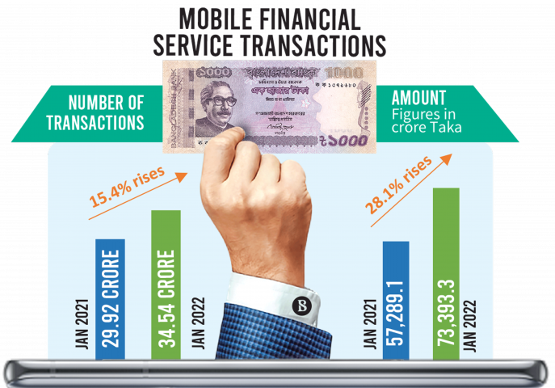

transactions using mobile banking increased significantly over the time. If we look at the graph here, number of transactions increased by 15.4% only in a year which is a huge step towards the digitization. Then again, In January, 2021 the amount of transactions was 57,289.1 Crore and in January, 2022 that reached up to 72,392.3 Crore which is 28.1% more than it was in the previous year. So this is a clear indication that, Bangladesh is moving towards a digital country holding the hands of mobile banking services.

Other than Banks and Mobile Banking there are certain non bank financial institutions which are regulated under Financial Institutional Act,1993 and controlled by Bangladesh Bank. They are known as Financial Institution and currently 35 of them are operating in Bangladesh. Among the, 2 of them are completely owned by Bangladesh government. Most of the funds of FIs comes from Term Deposit,Credit Facility from banks, Other FIs , Bond etc.

The basic differences between banks and Financial Institution are:

- FIs can not issue cheque , pay order or even demand drafts.
- Demand deposits can not be received by Financial institutions.
- The biggest advantage of financial institutions are they can conduct business with diversified financing modes such as syndicated financing, bridge financing,Lease financing etc.
- Unlike banks Financial institutions can not involve in foreign exchange financing.

2.3 Janata Bank

2.3.1 Inception:
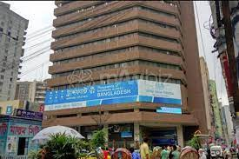
After independence, our government had formed banks by merging two or three pre-exist banks to rebuild the economy and save the country at large. On that process Janata Bank was one of those banks which has been formed by merging United Bank and Union Bank. The legacy and prestige of this government bank is unbeatable. Janata Bank started its journey in Bangladesh in 1972, right after the liberation war. From then and there, its success and achievement just grew over the time. Currently, Janata Bank has in total of 915 branches operating all across the country being the second largest commercial bank in the country. Not only that, it has also established four overseas branches in United Arab Emirates and providing their services internationally. The headquarter of Janata Bank limited is situated in Motijheel, Dhaka.

2.3.2 Vision and Mission :
The vision of Janata Bank is to become the effective largest commercial bank in Bangladesh to support socioeconomic development of the country and to be a leading bank in South Asia. This government owned bank had started to walking towards achieving its dream from the day one. Though it has not still reached to its destination, but it has successfully placed its position in the top two in Bangladesh. Janata Banks support to the socioeconomic development of our country is quite visible and praise worthy. Starting from financing women entrepreneurs to provide agricultural loan to the farmers of our country it has played significant role in the most important areas of the socioeconomic development. Janata Bank started its journey with the mission to be an effective commercial bank by maintaining a stable growth strategy , delivering high quality financial products. Janata Bank also promises to provide excellent customer service through an experienced management team and ensuring good corporate governance in every step of banking network.

2.3.3 Core Values of Janata Bank:
Followinf list shows the core value of the Janat Bank Limited.
- Proffesionalism
- Diversity
- Growth
- Accountability
- Intregity
- Dignity

2.3.4 Janata Bank ltd.: At a Glance

Topic | Description
Name | Janata Bank Limited
Legal Status | Public Limited Company
Chairman | Dr.S.M Mahfuzur Rahman
Authorized Capital | BDT 30,000 Million
Paid Up Capital | BDT 23,140 Million
Face Value Per Share | BDT 100 Per Share
Shareholding Pattern | 100% Share Owned by the Government of Bangladesh.
Branches Including Overseas | 921
Entity Rating as Government Supported Bank(Long Term) | AAA
Entity Rating as Government Supported Bank(Short Term) | ST-1
Entity Rating as Commercial Bank (Long Term) | A+
Entity Rating as Commercial Bank (Short Term) | ST-2

2.3.5 Products and Services:

Janata Bank has been successfully serving in our country for more than 50 years. And from the very beginning of their journey it is continuously proving to be one of the best in the country. With the excellence services and updated products, it has set the benchmark of perfection really high. The products and services of Janata Bank:

Products:

- Deposits:
- Current Deposit;
- Saving Deposit;
- Special Notice Deposit;
- Fixed Deposit;
- Schemes;

- Loans and Advance:
- Agricultural Loan ;
- Green Financing ;
- Working Capital Loan ;
- House/Building/Flat Loan for government employee;
- Rural credit loan;
- Tannery Trading ;
- Janata Bank Limited Commercial Real Estate loan ;
- Consumers Financing;
- Education Loan;
- Janata Care Health Support Loan;
- Janata Support special loan for pension;
- Special loan for women entrepreneurs, small business owners etc ;

- Cards:
- Credit Cards;

- Rate of Interest

Services:

- E-service:
- E-GP Payment Service:
The E-GP payment system is an online platform that provides services to carry out the procurement by the public agencies. This system is strictly owned, operated and developed by the central procurement technical unit , IME Division of ministry of planning.

- E-Janata:
E Janata is basically an internet banking application means the android base of banking.It allows the consumers of Janata bank to access banking services from anywhere and create a revolutionary.

- Cash Service:
- ATM Service:
Like any other modern facilities, providing ATM service is a great addition of Janata Bank Limited. Starting from mobile phone recharge to online tax payment it ensures effective services. Additional to that, card holders can use any ATM and Point of sales in Bangladesh.

- JB Pin Cash:
JB Pin Cash is one of the newest addition in the Janata Bank services. This system helps a consumer to send money to anyone and anywhere. Using this facility an individual can send or withdraw money from minimum one lakh to maximum five lakh Taka.

- Fund Transfer:
In simple terms, this service basically transfer funds from one party to another or itself through the banking system. Janata Bank has been providing this service with proper responsibility with the help of the following partners:

- BEFTN;
- JB Remittance;
- RTGS;
- SWIFT;

- Other Services:
- Automated Challan System;
- SMS Allert Service;
- National Savings;
- Online Banking;
- Locker Services;
- Utility Bill Collection;
- One Stop Service;

- Additional Services:
- Account Opening;
- Cash Withdrawl;
- Cash Deposit;
- SME Banking
- Pay Order;
- Cheque Deposit;
- Loan and Advances;
- Prize bond etc;

- Women entrepreneur dedicated special help desk:
It is one of the most unique and appreciative service introduced by the Janata Bank Limited. It is a priority basis service for SME Women Entrepreneur.

2.3.6 International Trade:

Janata Bank is recognized as an one of the biggest contributor in the area of international trading.Starting from foreign remittance to export and import Janata Bank left its dominant mark in all the branches. Facilities and accounts might be different for each department. For example, Accounts and US bonds offered to the Remitters are:

- Non Resident Foreign currency Deposit Account (NFCD)
- Resident Foreign Currency Deposit Account (RFCD)
- Non-Resident Investor's Taka Account (NITA)
- Wage Earners Development Bond (WEDB)
- US Dollar Investment Bond and US Dollar Premium Bond (US Bonds)

International Trade facilities offered by Janata Bank depending on foreign remittance, export and import:

Foreign Remittance | Export | Import
Facilities offered to the remitters | Export Finance | Import Products
Our Taka Remittance Arrangement | Export Products | Import Performance
Our Subsidiaries | Export Oriented Loan
Taka Exchange Houses | Export Performance
Online Forex Trading | Account Trade Arrangement
Foreign Currency Account opening form
Exchange Rate

Addition to that, to boost up the country's export , Janata Bank has been providing various services to the exporters. Some of the highlights of their assistance are:

- Providing pre shipment and post shipment services;
- Export Incentive programs;
- Concessional rate of interest for exports finance ;
- Banking at export processing zone;
- Back to back L/C under bonded warehouse facility etc;

These are the general and special services provided by the Janata Bank limited . Its constant and uninterrupted premium services are the key factors that make the bank even more unique and dominant. Over the time, it has gained popularity and placed a strong image in customers heart and mind. Besides these, There are certain other significant factors that contributed to the positive image and position of the Janata Bank Limited. Those are:

2.3.7 Strengths of Janata Bank Limited:

Strong and experienced regularity comitee
Skillful and Trained employees
Strong hold on capital and assets
Strong and large number of loyal customers

Solid and high experience

Skilled Management
Strengths of JBL

These are considered to be the most dominant and prominent strengths of the Janata Bank Limited. Since its inception, Janata Bank kept on progressing and made its name very bright and clear in the top banks of Bangladesh. Currently it is recognized as the second largest commercial bank of Bangladesh. Strong knowledge about the industry and skilled employees contributed the most to its position. The number of achievements are quite impressive and appreciative as well. Some of the greatest achievements of Janata Banks are:

2.3.8 Achievements:

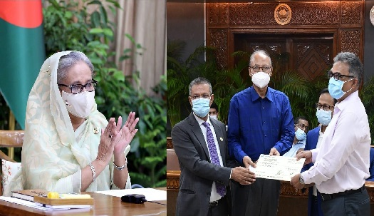
- Last year, in June 2022 , Janata Bank limited donated 3 crore Taka to PM’s relief fund for flood affected people.

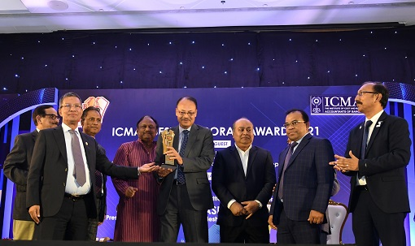
- Janata Bank Limited got awarded with the “ Best Corporate Award-2021” achieving the first position which is known as Gold 1st position.

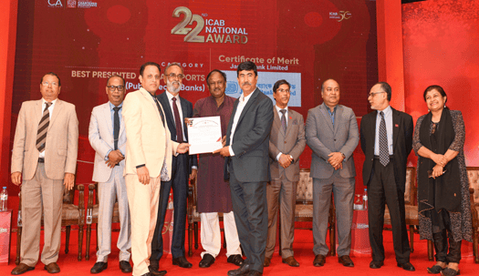
- Janata Bank Limited has been awarded the Certificate of Merit in the best-presented annual report category by The Institute of Chartered Accountants of Bangladesh (ICAB).

Chapter Three

Internship Experience



3.1 Internship Experience:
In my three months long internship program, by far I have completed almost a month. In March, I have joined as an intern in Janata Bank Limited. At first, I joined in the head quarter or the main branch of this reputed government bank ,which is situated in Motijheel, Dhaka. Later on, I have been shifted to Mohammadpur branch for the sake of my convenience and easiness. Unlike any other organizations, the work process and assigned tasks are significantly different in the banking Sector. It has various departments working for different purposes, mention able departments are cash department, deposit department, loan sanction and authorization department, foreign exchange department etc. At first I was assigned under a supervisor who is a senior officer of Janata Bank Limited. Basically the working hour of Janata Bank is from 10:00 am to 5 pm. But in the times of Ramadan the schedule has changed into 9:30 am to 2:30 pm. My first task is to sign in the attendance sheet as soon as I enter the bank. My initial days were basically consists of observing the daily tasks of my supervisor. And helped her in particular tasks including data entry, arranging forms , fill up forms etc.

3.1.1 Deposit Department:
Afterwards I was assigned under another supervisor , she is also a senior officer in the department of deposit. Under her assistance I got to learn about accounts and deposits more practically. I would like to outline few of my learning outcome till now:
- There are basically various types of deposit schemes in Janata Bank ltd, savings deposit, Fixed deposit, Current deposit, Special Notice deposit etc are the most significant of the deposits.
- The minimum required amount to open a savings account is 1000 Taka. And the interest rate is 2.75%.
- There is a special desk in the bank dedicated to only women entrepreneur, the prime task of that desk is to provide loan to the women entrepreneurs to make them capable and independent more effectively.
- Janata Bank provides one of the largest online bank services ensuring transparency and accountability at the same time.
- To open a fixed account the withdrawal duration limited to at least 3 months or more. In case of any emergency you will be required to write an application addressing the authority of the bank.

3.1.2 Loan and Advance Department:
After two weeks , I was shifted from deposit to loan and advance department. In Mohammudpur branch , this department is comparatively smaller than other departments, consists of four individual desks. There I was assigned under another senior officer of that particular department. I was amazed to know that Janata Bank provide loans to plenty of different areas with the view to develop and digitalize Bangladesh in the most righteous way possible. Starting from Agricultural loan to Education loan, Janata Bank tend to sanction their loans in various sectors. Another interesting factor about their loan and advance is that they generally provide a flexible timeline to payback the loan. Here are some specific things I got to learn under my supervisor:

- In case of education loan, the payback period is 5 years. And students can repay their loans with the help of 60 installments.
- Again , if we talk about agricultural loan ,the period of loan is valid till the 3 months of growing crops in the field. Addition to that, people can also avail loan to bear the expenses of rearing a cow.Which also falls under the agricultural loan. For one cow, an individual can take loan maximum of ninety thousand Taka and they can take loans for maximum of four cows. Here is the rule is a bit different and more resilient ,the loan period is applicable for 3 years and you are also not required to hold or submit anything as security against the loan.
- Janata Bank also provide loan in various kinds of rural activities known as rural credit. For instance, rural women employment loan , NGO linkage loan programme, Crop warehouse loan scheme, Self Independent loan programme etc all are the examples of rural loans.
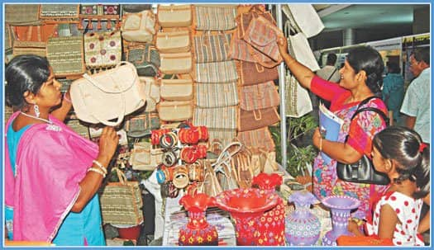
- Not to mention, one of the greatest edition to the loan scheme of Janata Bank is sanctioning loans for women entrepreneurs, small business owners, freedom fighters loan etc. This kind of loans have been introduced to empower and encourage women entrepreneurs and small business owners for the larger interest of our country. This loan programme is also known as special loan in the Janata Bank Limited. The loan period is starting from two to five years. And an individual can avail minimum of fifty thousand Taka loan without any security.

3.1.3 Accounts And Clearing Department:
Lastly, I am now working in accounts and clearing department of the bank. Again, I have been assigned under a different mentor in this department. I would say, this department is by far the busiest department out of all the departments I have worked in. All the documents and accounts are basically gets finalized here. All the transactions, printed documents, copies gets recorded in this department. In this department, I finally got the chance to learn more practically. Here my job was to entry various documents, office copies to record in their inward and outward register book . I was also assigned to stamp in the required documents with registered and authorized seal on a daily basis.

Chapter Four

Methods, Analysis, and Discussion

4.1 Introduction
This survey is designed to identify and understand what actually the customers of Janata Bank Limited think about their product and services, their customer support and brand at large. There are in total of 15 questions in the survey,which has been used to measure the satisfaction level of the customers of the respected bank. Most of the questions has been set in the 5 points likert scale.

4.2 Method:
As a method of the survey I have used a questionnaire to complete the survey faster and in the most efficient way possible. It does not require vast population or sample, which is quite inexpensive and less time consuming as well. Besides that, questionnaire helps to reflect the behavior, attitude and perspective towards a brand more accurately.

4.3 Sample:
In order to collect sample and run an effective survey, there are certain steps one must ensure and follow first. So the requirements to a successful survey are:

- Define the population:
In my questionnaire the targeted population are the regular customer of the Janata Bank. They all are familiar with their product and services which will result in a more accurate answers . Later on, it will help me to measure the satisfaction level effectively.

- Determine the sample size:
I have limited my sample size to 13 people. The reason behind it was to capture the most honest opinions. Time limitation was another reason of this small sample size yet it turned out as a quite successful one. Most of the participants are students currently. There are also participants who are businessman, journalist, designer and so on.

- Collect data from the sample:
Lastly, I have recorded all the samples individually and all together. Which will help to get a whole image regarding the survey. There are basically four different ways to collect data and they are: Telephone survey, paper survey, face to face survey and online survey. I have used online survey method to collect the data and information from the individuals.

4.4 Contact:
I have kept my sample size small and familiar so that I can reach them faster and in the shortest time possible. Basically I have contacted the participants using online platforms. At first I have sent all of them emails where the link of the questionnaire were attached. Those who were delaying to responses I sent them reminder through emails and social media. And this method was cost effective and less time consuming at the same time.

4.5 Analysis of the survey:
As mentioned earlier, the number of the participant in the questionnaire is 13 people and most of the respondents are students. One particular tendency can be seen in the survey that, almost all the students have savings account which is precisely 84.6%. This percentage can be considered pretty high and indicates the preference of saving money among the students. If we see the following pie chart closely only 15.4%

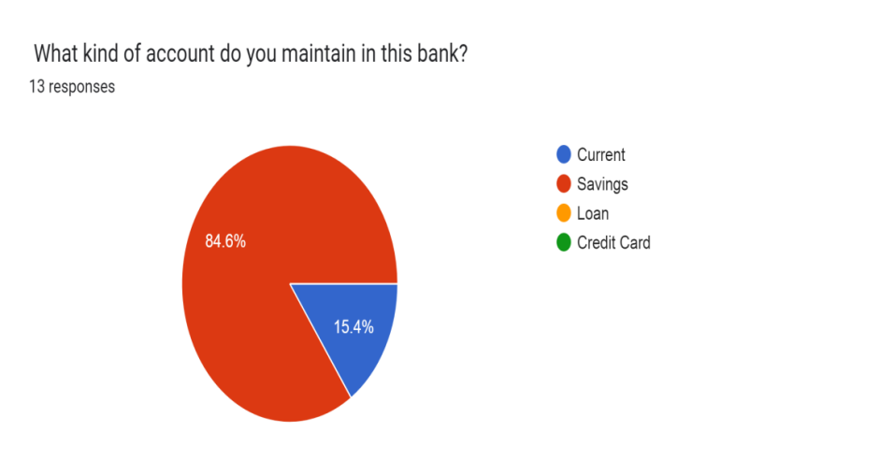

people uses current account and rest of the participants are savings account holders. While answering the question regarding bank staffs , the satisfactory level is quite impressive. Again if we look at the pie chart , we can see that about 76.9%
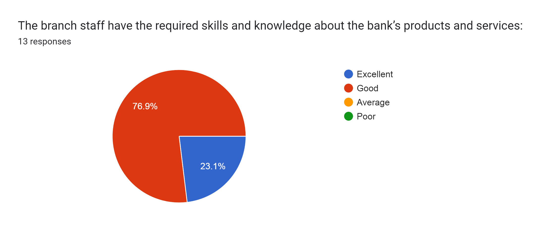

participants have complimented the branch staffs knowledge and skills as good. On the other hand rest of the respondents have found it excellent, which is precisely 23.1%. Hence it can be said that they are pretty satisfied with the knowledge and skills that the branch staffs have regarding the Janata Banks products and services. But if we talk about the communication and response towards the consumers and the delivery of the service, The answers were very much mixed. This particular question was created using likert scale, if we carefully look at the graph then we can see that
About only 38.5% people strongly agree to the statement which is below the average.
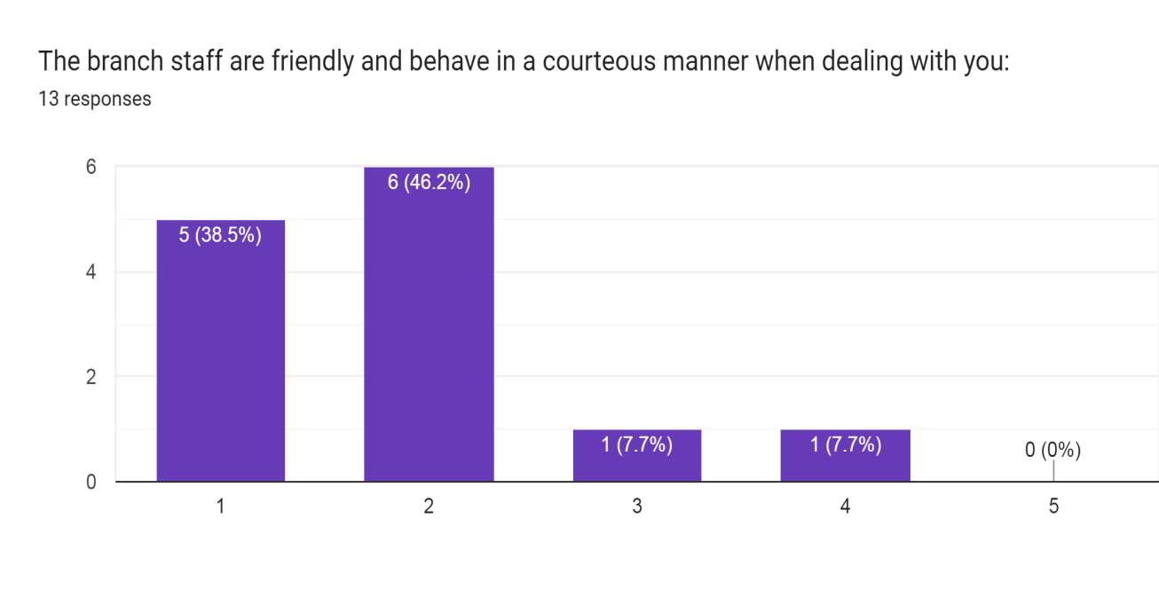

Even among the respondents 7.7% of participants disagree with the statement. Which reflects that there is service gap between the provider and the customers. And it needs to be improved to provide better quality service and ensure high satisfaction among the customers. Another likert scale question was created to identify the responsiveness of the service providers. In this section also the answers were not highly satisfactory.

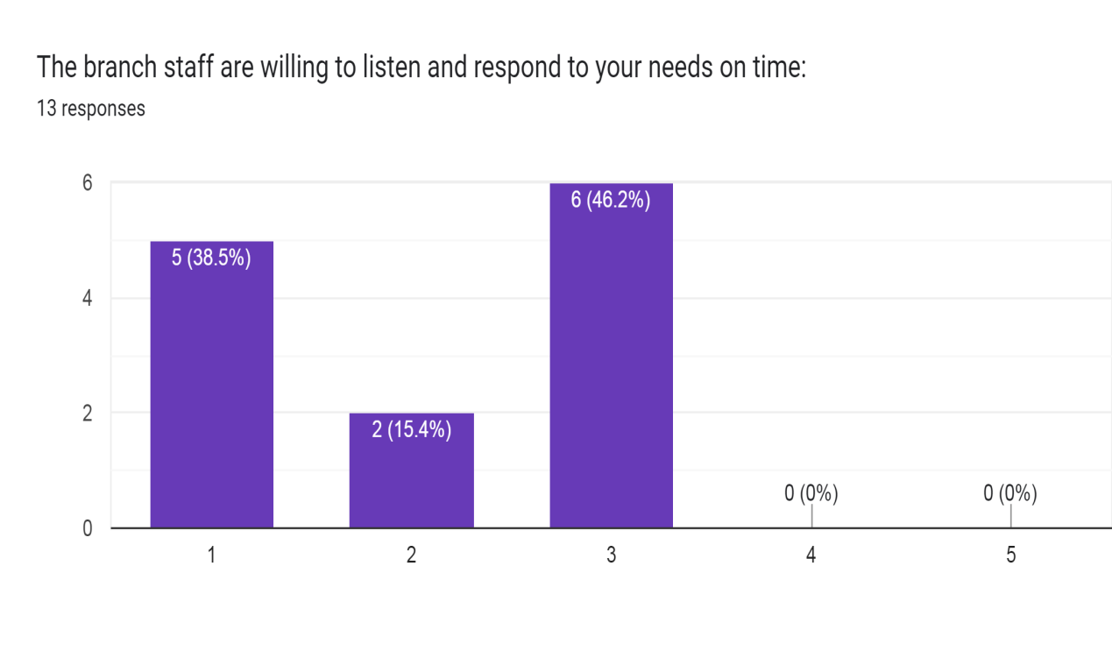

Only 38.5% respondents highly agree to this statement, other than that about 46.2% respondents answered as neutral. Seeing the percentage we can come to the conclusion that, Janata Banks responsiveness towards its customers is not adequate or up to the par yet and authority should provide more attention to increase the quality of their services.

4.6 Measuring the Service Quality of the Janata Bank under Service Quality Dimension:
Despite of having different service standards or degree, all the industry follow an universal and popular way to measure their quality of their service. Be it a bank or a hotel, every industry has their own way to deliver their services. Services varies depending on their brand promise, image and even solely due to their brand value. Similarly, the expectation of the customers also changes for the same reason. Customers who admitted themselves in an expensive reputed hospital will definitely have the expectation to get a better service than he or she could get from an affordable one. Same goes for a five star hotel and a roadside motel. So, it is very important to measure the satisfaction of the customers to minimize the service gap and deliver superior quality of service.

In this regard, we can use the five dimension metric to measure and analyze the service quality of Janata Bank limited. The five service quality dimensions are:

- Tangibility;
- Reliability;
- Responsiveness;
- Assurance;
- And Empathy;

4.6.1 Tangibility:
Tangibility refers to the physical appearance of facilities,equipment,personnel and communication materials. We all are familiar with the saying, First impression is the last impression”. In case of customers it is nothing different. Whenever customers enter in any shop, hotel or any bank, customers expect it to be neat and clean. Besides that they also want employees to look properly groomed and professional. Here in the questionnaire there is a question regarding the neat and cleanness of Janata Bank branches. Where 66.7% of the respondents stated it as neat and clean, while 33.3% disagreed. According the percentage, the satisfaction level is above the average, which is quite impressive.

4.6.2 Reliability:
The ability to perform the promised service dependably and accurately known as the reliability. In service market, it is very important to deliver the service according to exactly what you have promised. Even little bit of difference between the expected service quality and the reality makes a huge difference in consumer mind hence service gap arises. Janata Bank claims that customers are their main priority and they promise to deliver unbeatable and consistent services to all of its consumers.

In the questionnaire, it was asked if the branch staffs have the proper knowledge about their products and services, most of the participants were quite positive about it.
Here in the following graph we can see that about 23.1% of the respondents labeled it as excellent while 76.9% responded as good.

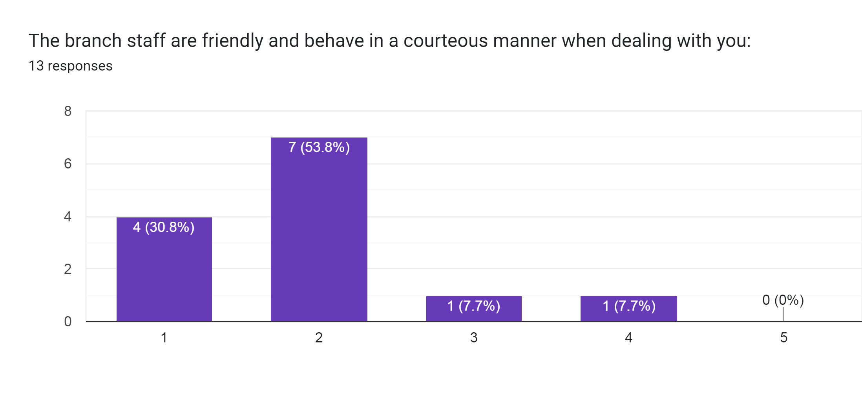
Under reliability, another question was about the courtesy and behavior of the employees of the Janata Bank. Here the responses were a bit different and mixed. 53.8% respondents were agree with the statement but 7.7% respondents expressed completely opposite. It indicates that customers are not happy and content with the behavioral approach of the employees. It is very obvious according to the graph the number of the satisfied customers are higher but in service industry even a fraction number of dissatisfied customers brings out the biggest conflict. Dissatisfaction among the customers works as confusion, ill reputation and negative marketing for the brand. So all customer are equally important and essential to maintain a stable and sustainable brand image in the long run.

4.6.3 Responsiveness:
Responding accurately and promptly is an essential element of communication. In the service industry, first and foremost condition is to survive and sustain is to communicate properly with the customers. Failing in communication result in a failure of delivering the service. In that manner, the willingness to help customers and respond to their need quickly or as soon as possible known as responsiveness. Whenever any customer ask for any query or complain about any service related to your business, they feel mostly vulnerable or doubtful towards the service. In given scenario, employees should attend to their query and solve it as soon as possible. It is very important to let them know you are willing to help and working on their request or demand. Responding quickly leaves a positive and strong impact on customers mind. They feel their importance and acknowledge that. As a result, it lowers the dissatisfaction which automatically rises the satisfaction level.
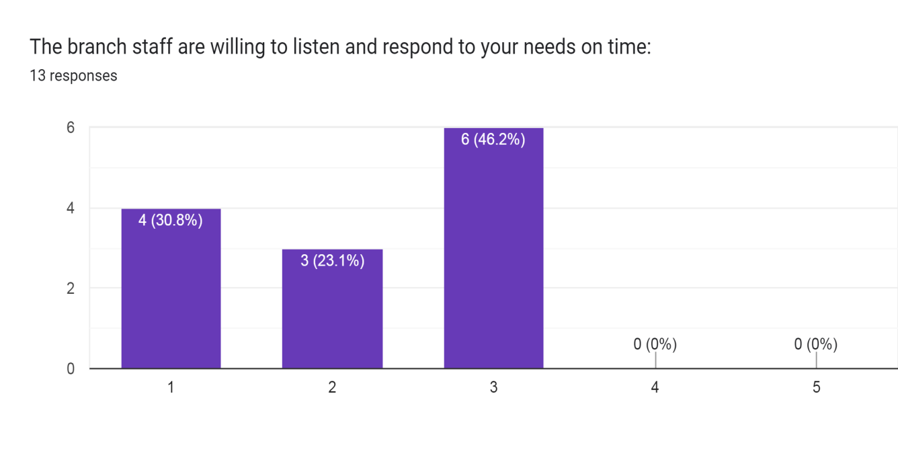
In the questionnaire, a question was set regarding the reliability of Janata Bank, where 30.8% respondents strongly agreed to the statement. 23.1% and 46.2% of the participants answered as agree and neutral consecutively. Agree and strongly agree both statement falls under the satisfied customers criteria. According to that, the level of satisfaction among the customers are above the average. Though almost half of the participants neither agreed nor disagreed to the statement, it is safe to say that no one actually disagreed to it. But considering a service industry 54% is quite disappointing. In this first pace world, communication rightly and accurately is as important as maintaining a good reputation. So it is high time for Janata Bank to work on their responsiveness to increase the satisfaction and decrease the dissonance among the customers.

4.6.4 Assurance:
When it comes to provide and deliver service, customers always expect the experts in the business to deliver the service. Experts having proper knowledge and idea about the products and services of their business tend to win the trust and confidence of consumers really fast.This is a process of assurance. Assurance is basically refer to the knowledge and courtesy of the employees regarding their service and business at large. It also mean the ability to convey the trust and confidence to the customers. It can be achieved by displaying credentials, expertise,industry certification or even by customer testimonials. In this first moving world, there are numerous options, high availability of products and access to it creates lack of trust and confidence in customers mind. In this situation, assurance plays a very significant role to gain customers confidence and reliability towards the brand. Which also helps to create a positive image and greater value for the brand.

One of the question in the survey was about the knowledge and skills of the employees regarding the bank’s product and services, where 76.9% customers labeled the knowledge as “Good”, whereas 23.1% stated it as “Excellent”. In another way, it can be said that, there is no dissatisfaction among the participants regarding the expertise and professionalism of Janata Bank. So it is very evident that, Janata Bank has been successful in gaining confidence and trust of the customers. As per the measurement of “SERVQUAL” dimensions, assurance has to be one of the dominant service deliver quality of Janata Bank Limited.

4.6.5 Empathy:
Customers tend to rely and trust the brands comparatively more which makes them feel important and heard. They prefer to be the center of the attraction.To create an effective and strong image in customers mind , it is very essential for brands to learn and show empathy to their customers. Empathy can be described as the individualized attention, preference and care the firm provides to it customers. Starting from welcoming them to your company to the after sale services every approach makes a significant difference in consumers mind. In case of building long term relationship with customers there is no exception but to show proper empathy and individualized attention towards them.

If we talk about the above graph, it falls under the empathy criteria. And it is noticeable that, not all the participants were happy with how they were treated in Janata Bank. That clearly indicates that Janata bank failed to show empathy properly towards their consumers. Though most of the participants were happy with their services, but it can be seen that there is a still room for improvement. As we know that, all the customers are equally important and supreme for any industry. Hence, Janata Bank should focus on treating their customers with more care and empathy to create a positive and sustainable image in the consumers mind as well as in the society as whole.

After the above discussion, we can come to the conclusion that, instead of giving tremendous services and facilities, Janata Bank still lacks in few significant sectors. Though the number of satisfied customers are high but we still can not ignore the dissatisfied customers no matter how small the number is. Among all the dimensions, in the responsiveness and empathy area customers expressed the most dissatisfaction. Which further creates an area and gap that Janata Bank should work on immediately. In the service industry, it is very important to minimize the dissonance and dissatisfaction among the consumers as soon as possible. Even a little bit of delay to fix and respond to the customers problems can lead up to a bigger dissatisfaction very fast.

4.7 Recommendations:

In my 3 months of internship, I got the opportunity to observe and experience the activities and procedures of Janata Bank very closely. And I can confidently say, they are one of the best bank in the country and they have earned the recognition and reputation with their hard work and dedication. But there are also certain things that I feel like Janata Banks need to upgrade and ensure in order to secure the first place in the country. According to my observation, I would like to point out or highlight few sectors that I believe Janata Bank needs to work on, those are:

4.7.1 Customer Service:
Instead of having a full packed skilled and trained team , I feel like from time to time Janata Bank fails to provide prompt and uninterrupted services to its consumers. There are days when I saw customers waiting in a line due to delayed service. At that time, the frustration and annoyance was so visible in consumers face. If this problem does not get solved as soon as possible then it can result in dissatisfaction which might led customers to switch to another bank for better service in future.

4.7.2 Shortage in man power:
One of the most significant reason of delaying in customer service is the lack of employees in Janata Bank. I have worked in the Mohammudpur branch of Janata Bank , what I have realized is they have shortage in manpower in the branch.Most of the department have at most 4 people or less in a team. And they serve a large number of customers everyday. Which naturally takes more time that it would have been with a large number of employees. So, I think to meet the crisis Janata Bank should solve this crisis immediately.

4.7.3 Courtesy and Behavior towards the consumers:
Janata Bank’s employees behavior towards its consumers is nothing extraordinary nor its praiseworthy. Due to the lack of manpower in the bank, the staffs stay more focused in getting done with a customer than to listen to them politely with time. During rush hours, the employees even get irritated and annoyed with the queries of customers. And the responses mostly comes out as rude. So , in this sector, my suggestion would be to deal with the customers more patiently and with courtesy. Polite and gentle behavior with consumers lead to higher satisfaction and helps to create a strong long term bond with the customers.

4.7.4 Computers and Operating system:
Since the beginning of its journey, Janata Bank has progressed a lot in terms of there contributions and digitization. But in there Mohammudpur branch, the picture was quite the opposite. Most of the computers run by the employees were backdated and old. Hence, the employers face difficulties in providing prompt and hassle free services from time to time. The lag in operating system often results in a whole system failure.

4.7.5 Car parking facility:
In the Mohammudpur branch of Janata Bank, there is no facility of parking cars. I have seen customers complaining about it. To attract more consumers and positive image, Janata Bank should try to arrange a parking facility for its customers.

4.8 Conclusion:
This three months internship period was nothing less than a roller coaster ride for me. Experiencing and exploring banking activities from these close would always be a great learning for me. Working as an intern in Janata Bank, helped me to gather knowledge of banking activities more practically. Which would never be possible theoretically. But what made me more delighted is the opportunity to work with the senior offices hand to hand, being able to participate in their daily activities. Though as an intern the learning outcome is not much but it is never zero. Janata Bank gave me an insight on the bank culture and its environment of Bangladesh. The struggle and work pressure of a banker is nothing less than a corporate officer. It can be quite exhausting and tiring from time to time. But I consider myself lucky to be able to work in a sector which is contributing in vastly in the economy of our country on a daily basis. Janata Bank will always play a big role in my understanding and knowledge of my future career. And I believe to contribute my learning and knowledge to my future job that I have gained throughout this internship period.

Reference:

- https://docs.google.com/forms/d/1MLdd5YxaimBPRujjYUXgu3Xosrlw0qmozQJjZN9b65s/edit
- https://www.jb.com.bd/
- https://en.wikipedia.org/wiki/Banking_in_Bangladesh
- https://www.emerald.com/insight/content/doi/10.1108/AJEB-08-2021-0094/full/html
- https://en.wikipedia.org/wiki/Janata_Bank
- https://www.jb.com.bd/about_us/bank_at_a_glance
- https://www.bb.org.bd/en/index.php/financialactivity/bankfi
- https://thefinancialexpress.com.bd/views/views/the-current-state-of-the-banking-industry-in-bangladesh-1556380055
- https://www.thedailystar.net/tags/bangladesh-banking-sector
- https://en.banglapedia.org/index.php/Janata_Bank_Limited

