Digital Banking Services of The City Bank Limited
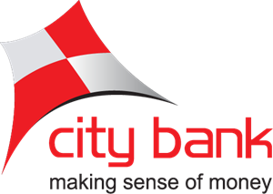



Internship Report
On
Digital Banking Services of the City Bank Limited

Submitted to
Mofijul Hoq Masum
Assistant Professor (SOBE)
United International University

Submitted By
Mahmud Hasan
ID- 111 151 229
Bachelor of Business Administration (BBA)
School of Business and Economics
United International University

Date of Submission: 18/09/2019

Letter of Acknowledgement
Firstly, I would like to thank the almighty Allah for the blessing.
Then, I would like to thank my honorable supervisor Mofiul Hoq Masum, Assistant Professor, Business & Economic School, United International University, for giving his continuous support and providing the valuable instruction to complete of my internship report. Without his support, I couldn’t finish this report.
Also I would like thank my honorable supervisor Mr. Imran Hossain Pervez, from City Bank Ltd, for providing the valuable information, and for huge guidance to complete my internship report in my whole internship periods.
Then, I would like to thank my all colleague and staff members for their huge support and cooperation from “The City Bank” who made my life easier, without their cooperation it would be not easy.
I am also thankful to my university friends who helped me a lot to complete this internship report by giving their valuable suggestions and huge support which helped me to complete my report successfully.

Letter of Transmittal
18th September, 2019
Mofijul Hoq Masum
School of Business and Economics
United International University
Subject: Internship Report on “Digital Banking Services of the City Bank Limited”
Dear Sir,
With due respect, I am Mahmud Hasan, ID: 111 151 229, I am too pleased to submit you the report on “Digital Banking Services of The City Bank Limited” finally I have become able to accomplish the report that is required for this report as the partial fulfillment of the course “Internship” and as a prerequisite for the completion of BBA program, and would like to submit it to you for evaluation.
I’m very grateful to you that you have given me this great chance to be familiar with this topic and also to understand “Digital Banking Services of The City Bank Limited” in this report, I have applied my best effort to make this report by your given guidelines. I have tried our best to make this report as close to perfect as possible. I have tried to discuss all the relevant points and information, which you give on report guidelines.
Therefore, I hope you'd be kind enough to acknowledge and oblige my harvest report.

Sincerely yours,
Mahmud Hasan
ID: 111 151 229
Bachelor of Business Administration & Economics
United International University

Declaration
I hereby declare that the my internship report named “Digital Banking Services of The City Bank Limited” is prepared by me and submitted by me to United International University as a requirement for the completion of BBA program. I have tried to make unique this report by me with guidance of Mofijul Hoq Masum Sir.
I’m also confirming that, this internship report made only for my academic purpose to submit as an internship report not for any others purpose, not submitted to any other university, and not for any third party.


Mahmud Hasan
ID: 111 151 229
United International University

Executive Summary
The topic of “Digital Banking Services of the City Bank Limited” report is required for the partial fulfillment of the course “Internship” and as a prerequisite for the completion of BBA program. This report is based on three month working experience of City Bank Limited. I worked on legal department of City Bank Limited at 10/Dilkusha, JibonBima Tower, Motijheel, Dhaka-1000.Twelve young businessmen set up the country's first private commercial bank in 1983, and now City Bank Limited is one of Bangladesh's finest private commercial banks. The City Bank Limited has won several awards for their outstanding banking facilities over the past three years. The City Bank Limited has total 132 branches all over the Bangladesh, they have 3858 employees and 17, 00,000 customers, they have 369 ATM + CDM, 3 Airport Lounges, and 7 priority centers all over the Bangladesh. The City Bank Limited is sole franchisee of American Express in Bangladesh. The City Bank Limited brings “Citytouch” to provide digital banking service for their customers. I think it’s the country’s best digital banking services in Bangladesh because last three years I’m using this “Citytouch” digital banking services, I got excellent service from the “Citytouch”. Citytouch - Digital Banking Service from City Bank brings you the simplest way to handle banking. The service brings all branch banking conveniences together to your internet-enabled devices screen. Now you can purchase air tickets from major distributors, pay mobile phone bills, credit cards & colleges; transfer funds, maintain track of your accounts: Current, Savings, Fixed Deposit or Loan, and do much more through Citytouch. Experience Citytouch's best-in-class digital banking services from all City ATMs throughout the nation. City Bank’s online banking application, Citytouch, has reached a user base of 121,780 people, representing a growth of 45.9% as compared to the user base in 2017. These services greatly help ease the customer’s banking experience, in line with the demand of e-commerce and electronic banking services in the country. Notably, the Citytouch app registered a throughput of 15 lac transactions (51% growth YoY) with a combined volume of BDT25,540 m (75% growth YoY) in 2018, which reflects the increased use of online transactions and services by their customers. Day by day increasing their digital banking “Citytouch” users and City Bank set target 5 lac Citytouch customers within 2021, which is our 50 years of independent day of Bangladesh.
Key words: Digital Banking, Citytouch, Digital Bangladesh, & E-commerce
Table of Contents
Table of Contents
Letter of Acknowledgement i
Letter of Transmittal ii
Declaration iii
Executive Summary iv
List of Acronyms vi
Chapter: 1 Introduction 1
1.1: Introduction 2
1.2: A brief introduction of the City Bank 3
1.3: Objectives of the Study 4
1.4: Rational of the study 4
1.5: Scope of the study 4
1.6: Limitations of the study 5
Chapter: 2 Methodology 6
2.1: Methodology of the Study 7
Chapter: 3 Organizational Background and Industry Perspective 8
3.1: Background of Banking Industry 9
3.2: Background of City Bank 10
3.3: Mission, Vision& Values of City Bank 11
3.4: Management and Focus of City Bank 12
3.5: Operational Activities of City Bank 14
3.6:Services and Products 14
3.6.1: Digital Banking of City Bank Limited 15
3.6.2: Citytouch Mobile Apps 16
3.8: Departments of City Bank 23
3.9: Financial Performance 24
3.10: SWOT Analysis 25
Chapter: 4 Findings & Analysis 28
4.1: Findings and Analysis of the Study 29
4.2: Digital Banking Transaction 29
4.3: Impact on mobile financial services & merchants payments 30
4.4: Achievements & Awards 31
4.5: Future target of City Bank Limited Digital Banking 31
Chapter: 5 Experiences during internship tenure 33
5.1: Experiences during internship tenure 34
Chapter: 6 Conclusion & Recommendations 35
Chapter: 6 Conclusion & Recommendations 36
6.1: Conclusion 37
6.2: Recommendations 37
Chapter: 7 Appendix: Reference 38
7.1: Reference 39

List of Acronyms

CBL= City Bank Limited
ATM= Automated Teller Machine
CDM= Cash Deposit Machine
BD= Bangladesh
NPLs= Non-Performing Loans
SME= Small & medium enterprise
AMEX= American Express
CEO= Chief Executive Officer
DMD= Deputy Managing Director
CSR= Corporate Social Responsibility
YOY= Year-over-Year



Chapter: 1
Introduction

1.1: Introduction
In 1983, 12 young businessman set up the country’s first private commercial bank, and nowadays the City Bank Limited one of the best private commercial bank in Bangladesh. Last three years the City Bank Limited achieved various award for their excellent banking services. My topic of the report is “Digital Banking Services of the City Bank Limited”.
The City Bank Limited brings “Citytouch” to provide digital banking service for their customers. I think it’s the country’s best digital banking services in Bangladesh because last three years I’m using this “Citytouch” digital banking services, I got excellent service from the “Citytouch”. We can do our all branch banking services on our internet enables devices from anywhere in the world. This digital banking services increased efficiency of banking services and saved customers valuable times. Customer can shop from retailers, pay bills of phone, university, schools, transfer fund, etc.

1.2: A brief introduction of the City Bank

In 1983, The City Bank Limited was established country’s first private commercial bank in Bangladesh, and still serving the bank with good reputation. They always like to work on new technologies for providing the good services. The City Bank Limited has total 132 branches all over the Bangladesh, they have 3858 employees and 17, 00,000 customers, they have 369 ATM + CDM, 3 Airport Lounges, and 7 priority centers all over the Bangladesh. The City Bank Limited is sole franchisee of American Express in Bangladesh. The milestones set towards becoming the most complete bank in the country, for that reason so many times The City Bank Limited has been awarded as the best bank in BD, like as Best Investment Bank, Best Premium Banking Services in Bangladesh.

1.3: Objectives of the Study

Broad Objectives
The main objective of the study is to analyze digital banking of the City Bank Limited through Citytouch digital banking services of City Bank Limited. From this study I can gather more knowledge about digital banking services of City Bank Limited. And also understand the organizational environment; learn practical skills, and capability of self-evaluation.
Specific Objectives
- To analyze about the digital banking of the City Bank Limited
- To be familiar with about the Citytouch mobile Apps
- To find about the future digital banking market

1.4: Rational of the study
This report is prepared for my internship program. My rationale of the study is to increase my knowledge on “digital banking services of the City Bank Limited”. One more rationale of this report is to find the benefits of digital banking services in Bangladesh and digital banking services will make a big contribution to future economic development in Bangladesh.

1.5: Scope of the study
- As an intern of CBL, it was huge opportunity to collect data from CBL
- All of colleague and staff were very friendly and cooperative to provide data
- Any information that I need, I got by my Supervisor. He was very helpful and responded person.
- Got a practical knowledge about the organization by meeting, training, and session
- Branch is also convenient to collect data from branch employees

1.6: Limitations of the study
- Lake of skills and knowledge of banking sector
- I am appointed on legal department of City Bank Limited, it’s totally different from basic banking services
- Some information were secret and didn’t give those information to their interns for their security purpose
- Its prepared in a short time
- Couldn’t collect all the information of CBL
- Need a lot of time for visiting different branches
- It is very difficult to collect information from the branch as they are always busy to serving the customers

Chapter: 2
Methodology

2.1: Methodology of the Study
Data collection process:
The information in this report is taken from several places. Basically we can divide into two, one is primary data and another one is secondary data.
Primary data collection:
- Personal experience by using the “Citytouch” Digital banking services from CBL last two years
- Face to face communication with different branch staffs and managers of the bank
- Personal inquiry by talking with the help desk employees.
- Collection of data through observing feedback of customers.
- By face to face questions

Secondary Data collection:
- Data necessary from the website of city bank Limited
- From the website of “citytouch” digital banking
- Different promotional leaflet and files from the City Bank Limited
- Got data from various types of bank Training and different works.
- Books on digital banking from library
- Other websites on digital banking
- Annual report of the City Bank Limited

Most of the data were collect directly from customers, employees, and managers of the bank. I worked there, so as a short time employee I got information what I need for my internship report.

Chapter: 3
Organizational Background and Industry Perspective

3.1: Background of Banking Industry
In the beginning of 1971, there were 1130 branches of 12 banks in operation in East Pakistan, Most of the banks controlled by the West Pakistan. In 1972 after independence by the Presidential Order No. 127of 1972, Through the Order, the eastern branch of the former State Bank of Pakistan at Dhaka was become as the central bank of Bangladesh bank. In 1972 The Bangladesh Banks (Nationalization) Order enacted nationalized all banks except foreign Banks, then Bangladesh bank were formed six nationalized banks through merging the existing banks of that time.
Banks are heart of the countries, for that reason banks are the key of economic development of the country. The rate of growth and development of the banking sector in Bangladesh was extremely slow after independence banks until 1983, when the government allowed private banks to be established and privatization began. Bangladesh did not have any national private commercial banks until 1982; when Arab-Bangladesh Bank Ltd. started private commercial banking in the nation. Five more commercial banks started their services in 1983 and introduced a moderate growth in banking financial institutions.

3.2: Background of City Bank
City Bank is one of the oldest private commercial banks in Bangladesh, It’s established in 1983.The Bank began its journey on 27th March 1983 through opening its first branch at B. B. Avenue Branch in the capital, Dhaka city. It is a well reputed bank among the top local banks in Bangladesh, which is well known for receiving global practices by doing away with the ancient traditional banking system and decentralized banking practices and cultures. City Bank was the visionary entrepreneurship of 13 local businessmen who endured the huge uncertainties and risks with bravery and made it possible for the Bank to quickly walk forward. At the time of 1983 they start the journey with a capital of only Taka 3.4 crores, & now which is worth an amount of Taka 2311.78 crores.
City Bank has 132 real time online branches, 369 ATM+CDM, 7 priorities center, card issued 1068034, & 3 Airport lounges all over the Bangladesh. City Bank Has employees around 3900, it has over 17 lac customers in Bangladesh. Day by day City Bank increase their branches, ATM, & Banking Services across the country. City Bank has launched prestigious American Express Credit Card in the country, and is the sole franchisee of American Express card in Bangladesh. City Bank is also the first bank; they have issued Dual Currency MasterCard and VISA Credit Card in Bangladesh. City Bank Ltd has been awarded best bank in last three years in Bangladesh. Like as Best Bank in Bangladesh, Best Investment Bank in Bangladesh, Best Online Bank in Bangladesh, and Best for premium Banking service, etc.
3.3: Mission, Vision& Values of City Bank
Vision:
- The Financial Supermarket with a Winning Culture Offering Enjoyable Experiences
Mission:
- Offer wide array of products and services that differentiate and excite all customer segments
- Be the "Employer of choice" by offering an environment where people excel and leaders are created
- Continuously challenge processes and platforms to enhance effectiveness and efficiency
- Promote innovation and automation with a view to guaranteeing and enhancing excellence in service
- Ensure respect for community, good governance and compliance in everything we do
Core values:
- Result Driven
- Accountable & Transparent
- Courageous & Respectful
- Engaged & Inspired
- Focused on customer delight

3.4: Management and Focus of City Bank
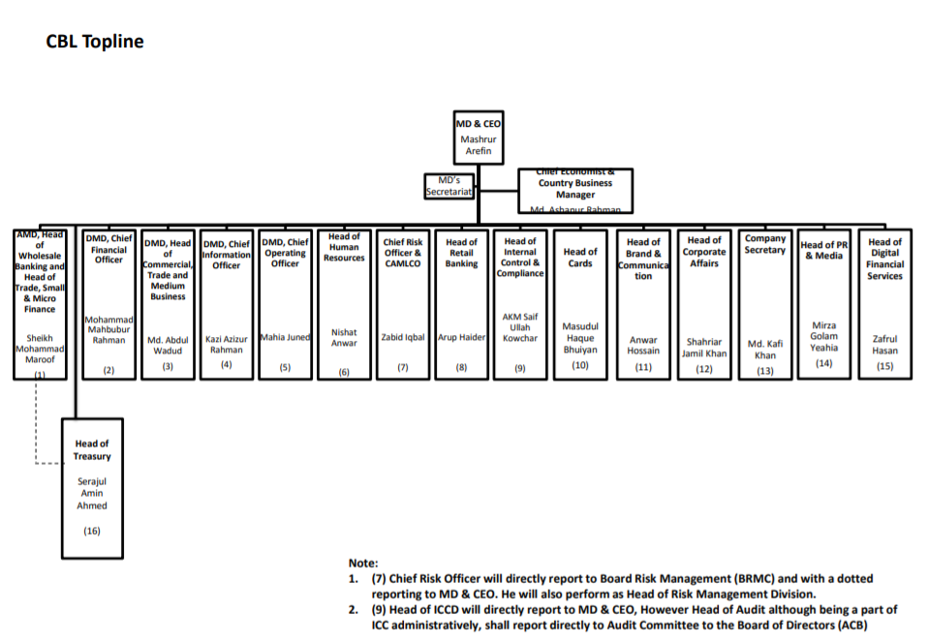
The sixteen management committee of city bank Ltd consist of Managing director and CEO, Additional Managing director, head of wholesale banking and head of SME small and micro finance, DMD, head of commercial trade and medium business, chief financial officer, chief operating officer, chief information officer, senior executive vice president and cluster head, RMG and textiles, chief risk officer, head of internal control and compliance, head of CRM and sustainable finance, head of legal, head of retail banking, head of human resource, chief economist and country business manager, company secretary and head of treasury.

City bank mainly focuses on winning the financial supermarket where they can provide the best experiences to the customers. City Bank always tries to give better services for their all customers, because City Bank believes that customer satisfaction is the main key to be top best bank in Bangladesh. The Bank's emphasis on the center business drivers of cost improvement, gainfulness and hazard craving appraisal has made the division a key piece of things to come vital heading of the Bank. Towards this degree, the Bank means to adjust its techniques so as to relieve focus dangers, in accordance with the general hazard hunger. Currently, the retail banking sector of the country is growing at a tremendous speed with the rise in disposable incomes in the hands of an increasing middle-class and also the service-oriented sectors of the country, making it an extremely aggressive market. For that reason recently City bank introduce woman banking that name is “City Alo” and City Bank has a Digital Banking Services that name is “Citytouch”. It is a best digital banking service in all over the Bangladesh through my personal experience and customer’s feedback. Their main focus is how to get better customer service from City Bank? Continuing with achieving consistent growth in the Corporate and Commercial Banking divisions, City Bank today is a versatile banking platform that focuses on extending the frontiers of banking in Bangladesh. Now City Bank has 20 SME-S Unit Office, 132 branches, 7 priorities centers, 3 airport lounges & 5 Amex service centers, 121780 Digital Banking customers, 154 Agent Banking outlets, 1068034 card issued, and over 17 lac customers, number of employees are 3858. Now, City Bank more focus on Digital Banking Services, because City Bank want to more convenient banking services for their customers. Even every year city bank stands beside the nation by contributing for the change in natural climates. City Bank donates to the many government CSR activities. Like as the support in disaster management in rural areas, supporting the rural society, poor children’s, Colleges and schools, etc.
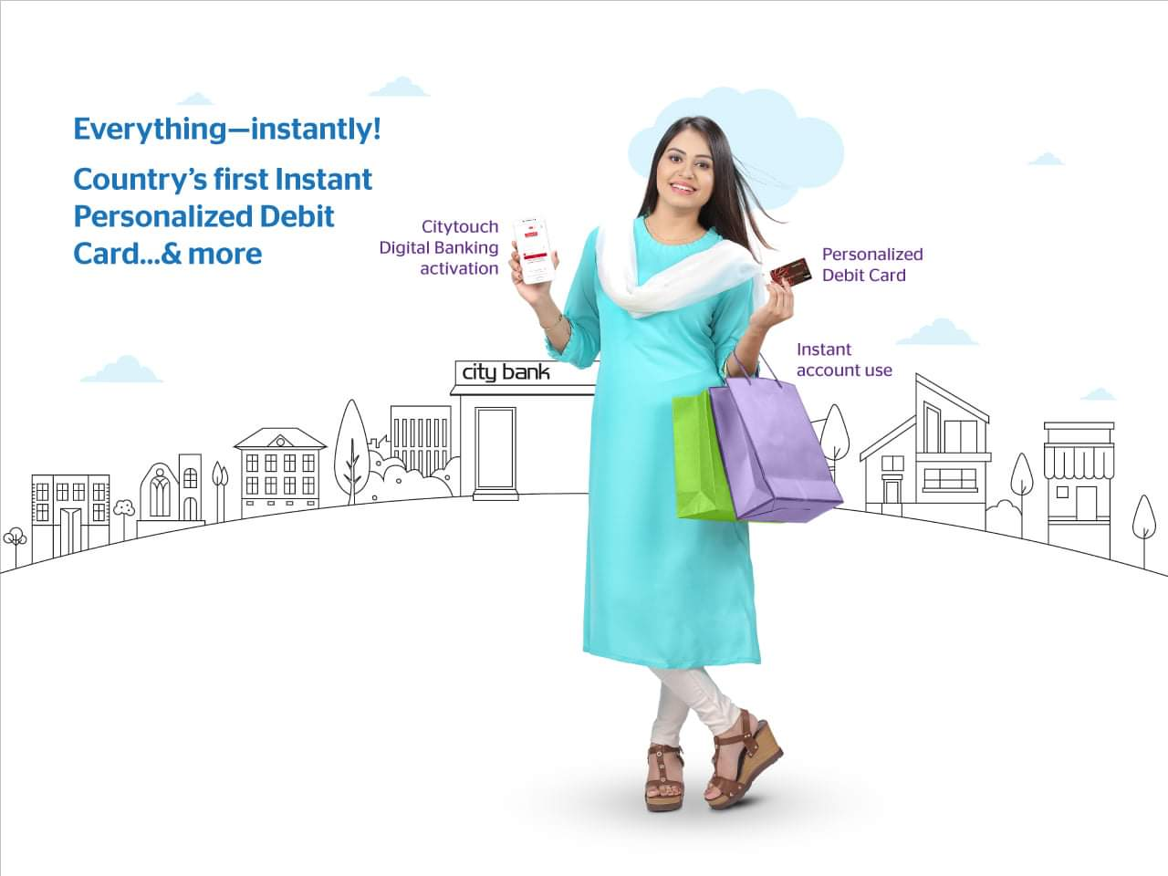

3.5: Operational Activities of City Bank
City Bank is providing to all kinds of consumer banking, and commercial banking services, treasury and foreign exchange services through their all branches. Their banking services are online based, so customer can get banking services from all branches of City Bank in all over the Bangladesh. City Bank has 24/7 customer services by the call 16234. The principal operational activities of city bank can be dividing into four parts. So operational activities are below:
- Corporate & Investment Banking
- Retail Banking (Cards, Loans)
- Treasury & Market Risks
- SME Banking

3.6: Services and Products
City Bank Ltd providing various kinds of services to their customers, these are:
- Corporate & Investment Banking
- Working Capital Finance
- Trade Finance
- Short/Mid-Term Finance
- Project Finance
- Islamic Finance
- Structured Finance
- Cash Management
- Investment Banking
- Schedule of Charges
- Interest Rate on Lending
- Retail Banking
- Deposit
- Loans
- Cards
- NRB Foreign Remittance
- Treasury & Market Risks
- Foreign Exchange
- Money Market
- Corporate Sales
- Market Research
- SME Banking
- Digital Banking ( Citytouch )
- Woman Banking ( City Alo)

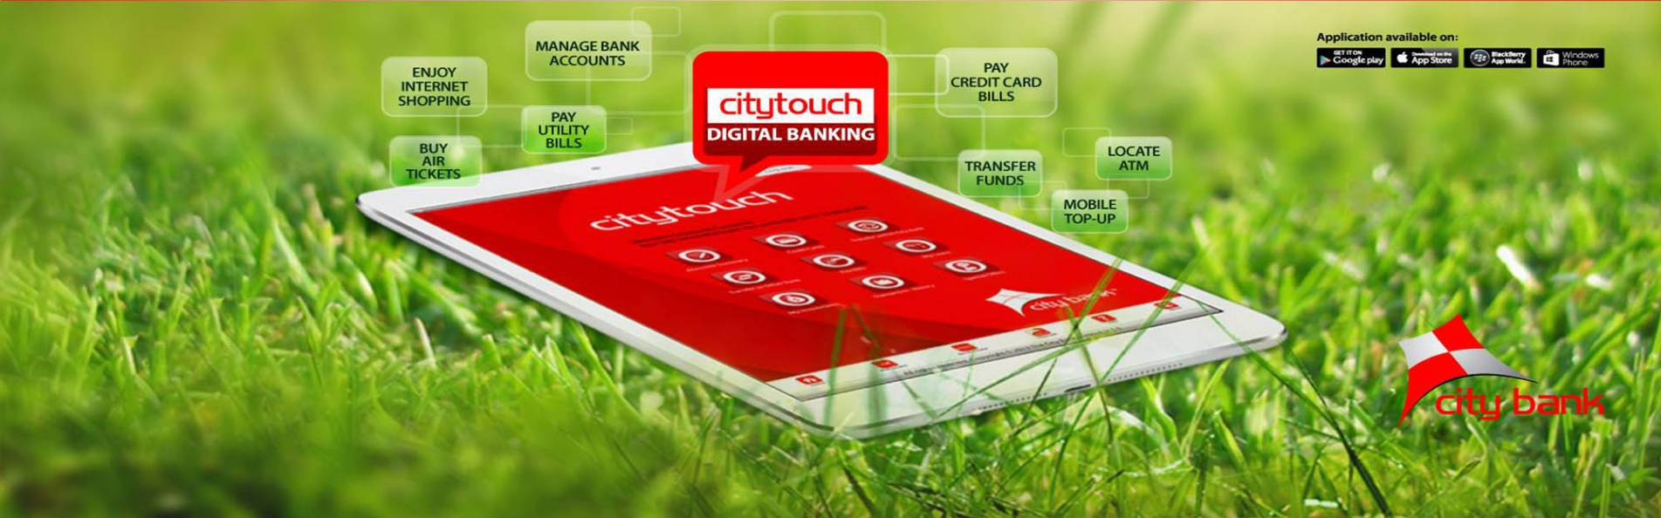
3.6.1: Digital Banking of City Bank Limited

What is Digital Banking of CBL?
City Bank's digital banking service provides you with the easiest manner to manage banking. The service brings all branch banking conveniences together to your internet-enabled devices screen.
Customers today desire much greater levels of convenience. This is underpinned by an urban lifestyle where time-pressured customers always seek expediency and ease.
The advent of digital banking was fostered by customers seeking more convenience, and powered by enhancing broadband speeds and network penetration so much so that a smart-phone could be typically used as a banking platform. Furthermore, the forward-looking digital framework of the Bangladesh Government gave wings to digital banking, which has today reached the remotest corners of the country.
City Bank’s digital banking platform has achieved considerable sophistication that has helped the Bank meet the banking aspirations of a young and youthful demography that values convenience above anything else. Their Digital Banking platform enables their customers to open accounts with City Bank in a paperless way through tab-based banking, requiring only customer’s thumbprint and national ID as identification.

3.6.2: Citytouch Mobile Apps


What is City touch?
Citytouch - Digital Banking Service from City Bank brings you the simplest way to handle banking. The service brings all branch banking conveniences together to your internet-enabled devices screen. Now you can purchase air tickets from major distributors, pay mobile phone bills, credit cards &colleges; transfer funds, maintain track of your accounts: Current, Savings, Fixed Deposit or Loan, and do much more through Citytouch.

Citytouch Apps Real time online registration
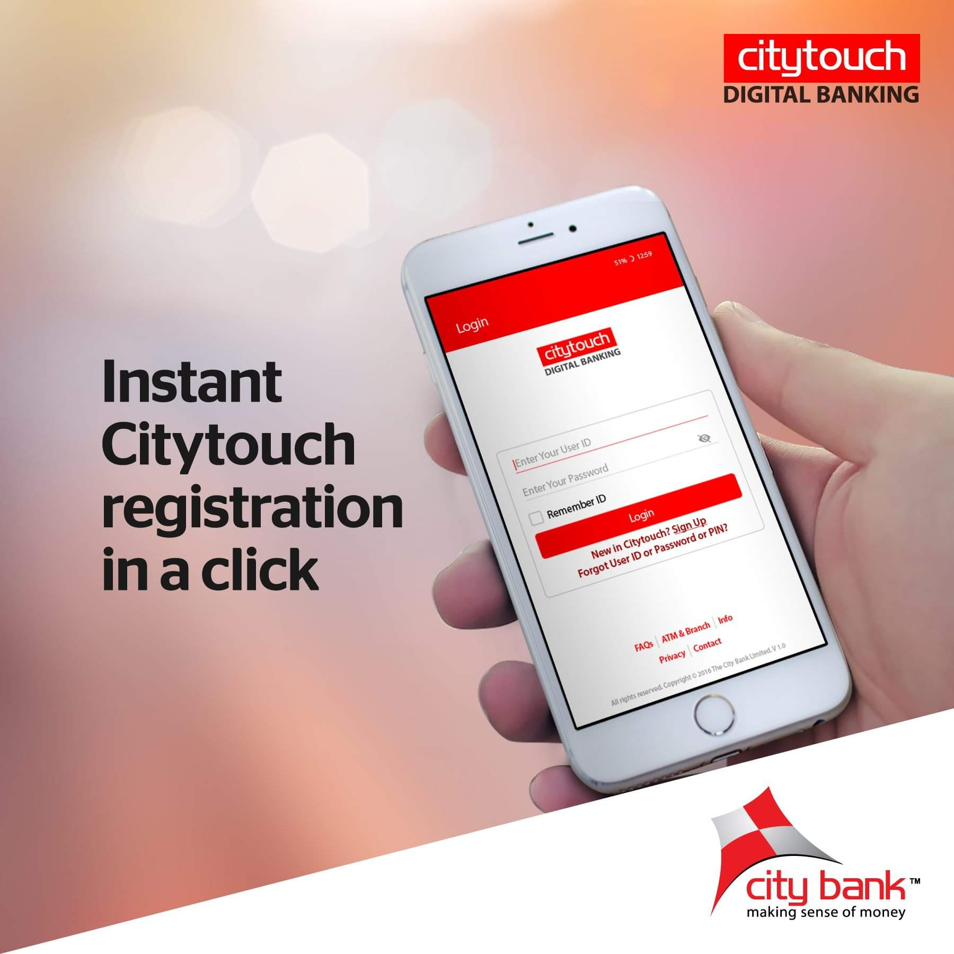
To register for Citytouch Digital Banking, you don't have to visit the bank now. To register and enjoy banking on the go, simply download the app from the app store or visit www.citytouch.com.bd.

Services include:
- Transfer funds
- View account statements
- control bank accounts
- Mobile top-ups
- Pay credit card and utility bills
- Activate or block your debit and credit cards
- Debit and credit card PIN change
- Issue, stop and manage your cheque books
- Buy national & international air tickets, film tickets and many more

Fund transfer
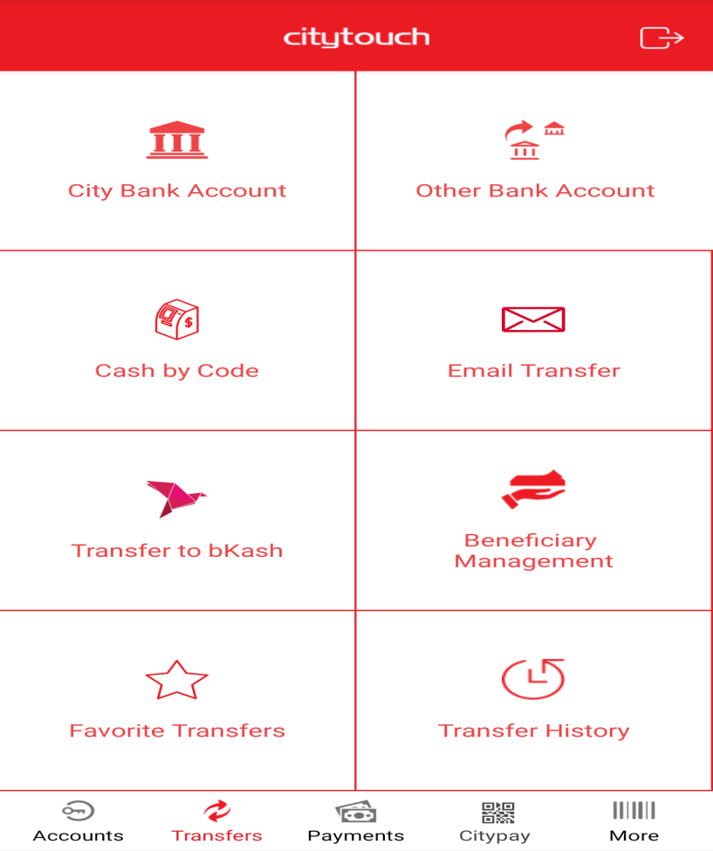

- Transfer funds to other City Bank accounts and local bank accounts from your account. Customers can transfer up to 5 lacs through as many transactions as you like, whenever customers want.

Account information details

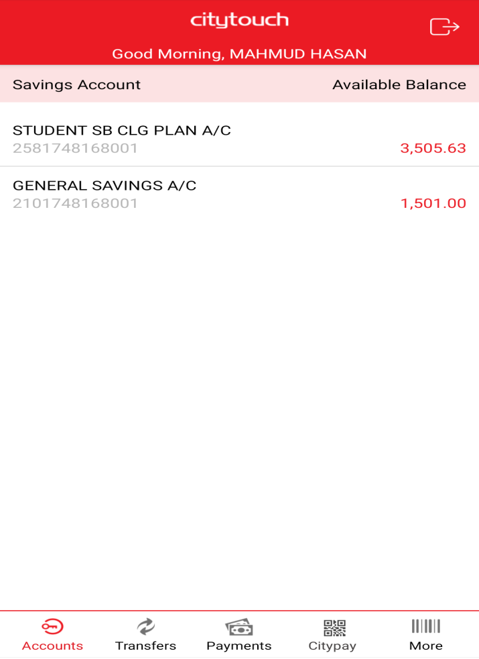

Keep track of your clockwise accounts. Keep your balance history updated, handle your checks, and keep tabs on your Fixed Deposit Accounts (maturity dates, interest payments) and loans.
- Customers can see account information from your Current, Savings, Loan and Term Deposit Accounts
- Can see account statement
- control your cheque books
- View clearing cheque status
- Customers can see detailed information of your Loan account, disbursement and repayment schedule of your loan

Transfer cash from Citytouch to bKash
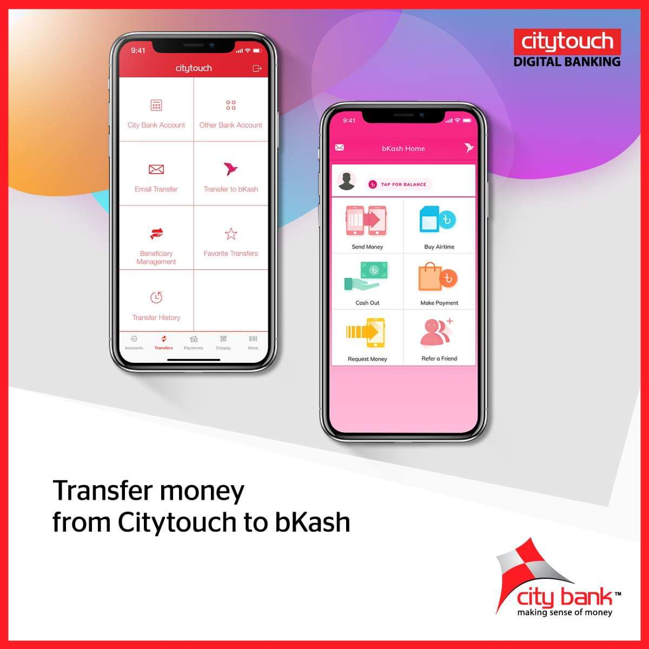
- It becomes easy to manage your finances. Now you can use Citytouch to move cash from your City Bank account to bKash. Moreover, the service is totally free.

Use Citytouch to open DPS and FD accounts
- Instantly customers can open FD and DPS account without visiting the branch office
- Up to 90 percent credit facilities against your FD and DPS account
- simple and convenient process

Use Citytouch for Pay Order
- Request for your Pay order without visiting the branch office
- On the next working day, the pay order will be prepared
- simple and convenient process

Place Positive payment instructions against your issued check
- Place favorable pay instructions when you offer a check to someone *
- Save time
- Simple and convenient process
* Corporate / Proprietorship account: check quantity BDT 1 lac and above
* Individual account: check quantity BDT 5 lac and above.

Use Citytouch to give or collect cash via e-mail
- Money can be sent to anyone even if there is no City Bank account for the beneficiary.
- Easy and convenient method to deposit into any preferred bank accounts
- Simple and convenient process

Use Citytouch to send cash to anyone with "Cash by code"
- City Bank's introduce this features for the first time in Bangladesh
- Send cash to anyone by Citytouch immediately
- Beneficiary can withdraw cash from all City ATMs across the nation
- Simple and convenient process

Air Tickets
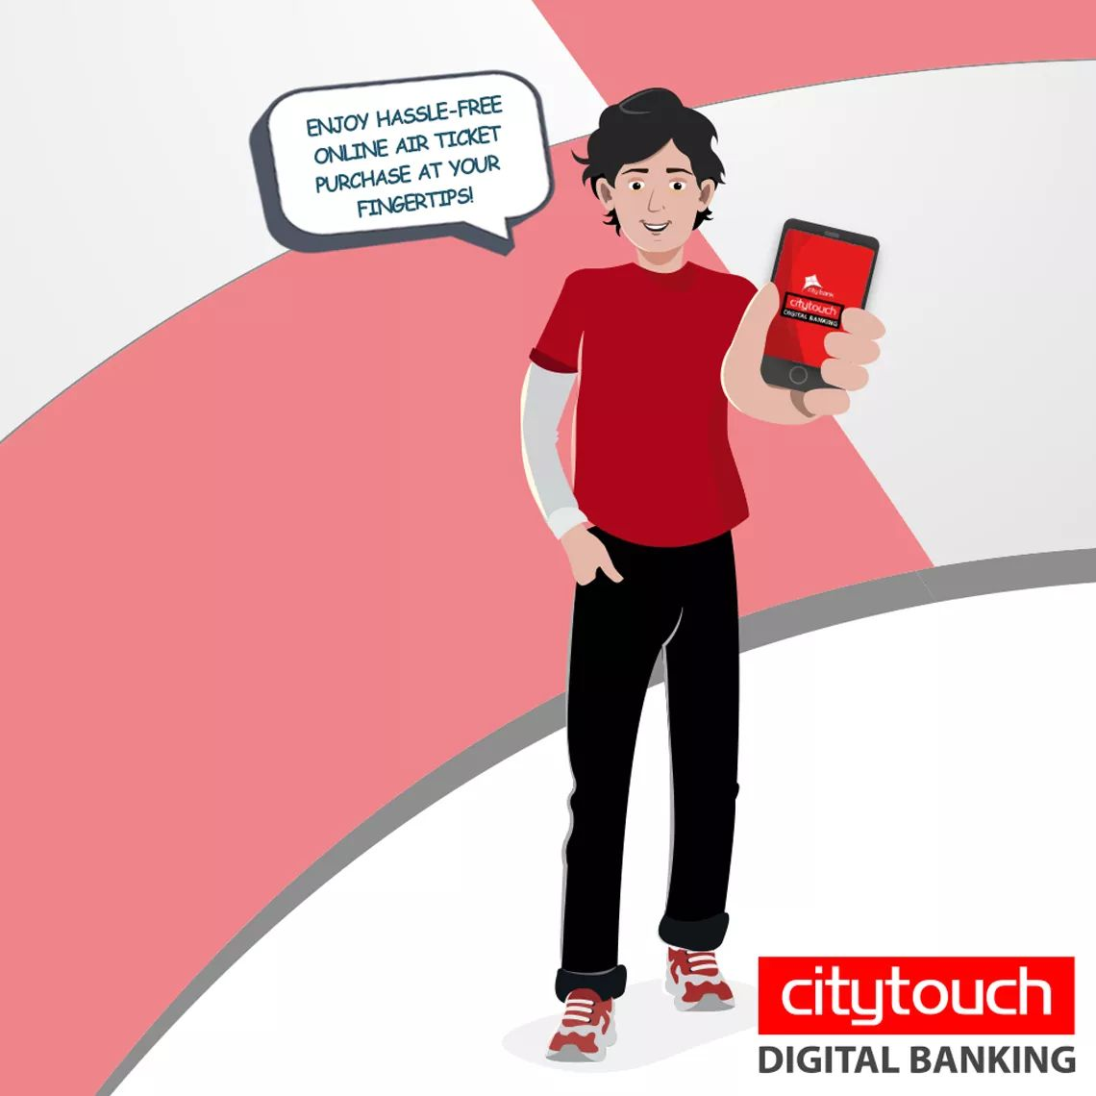
- Easier to fly anywhere in the Bangladesh, Now purchase air tickets straight through Citytouch from top carriers such as Novo Air, Regent Airways and US Bangla

Buy movie ticket &Shopping

- For the first time ever, enjoy e-shopping (online shopping) at the leading retailers across Bangladesh including Agora, Meena Bazaar and leading online shopping portals like www.daraz.com.bd

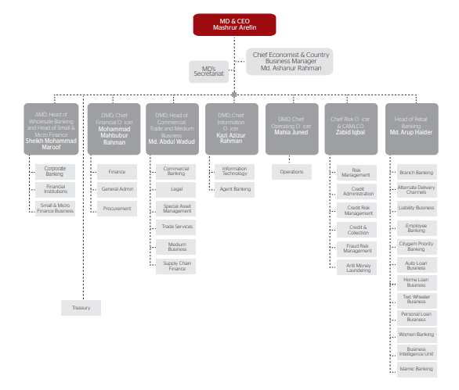
3.7: Organogram

3.8: Departments of City Bank
- Human Resources Division
- Finance Division
- Audit and Inspection Division
- Internal Control & Compliance
- Marketing Division
- Corporate Banking Division
- Consumer Banking Division
- Treasury Division
- Trade Service & Correspondent Banking Division
- Logistic and support division
- Information Technology Division
- Credit Division
- SME Division
- Credit Admin and Monitoring Division
- Corporate Affairs Division
- Card Division
- Recovery & Legal Division

3.9: Financial Performance
City Bank Limited increasing their financial performance in last three years, because of their huge efforts to expand their branches, ATM+CDM, card facilities, etc. last three years theirs financial performance were:
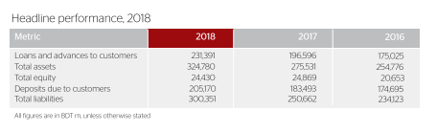
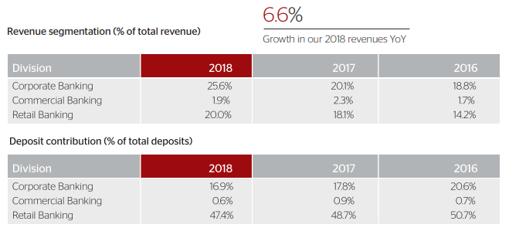

3.10: SWOT Analysis
City Bank introduced a SWOT analysis in their reporting practice with a view to provide their investors, shareholders, customers, and readers an upfront understanding of their core strategic framework under SWOT. It’s an acronym for Strengths, Weaknesses, Opportunities and Threats.

Strengths
- Brand salience: City Bank has created strong Brand salience and City Bank is one of the most valuable financial services brands in the Bangladesh.
Outcome: strong brand goodwill helps increase customer trust and also enables the Bank to achieve good response to its new initiatives.
- Credit and debit card schemes: City Bank's Tie-ups with American Express and various other such establishments to offer a wide scope of advantages to clients and expand trustworthiness have made our cards a popular and sough-after choice.
Outcome: Cards customers have grown acceptably at a 19.7% CAGR over the last five years.
- Digital banking: Citytouch is digital banking platform of City Bank, it has not only introduced digital convergence in banking in Bangladesh, but it has also helped us tackle competition from fintech companies.
Outcome: Day by day Citytouch user has extended since the time of launch of the app.
Weakness
- High cost of funds
Strategic imperative: Diversify fund sources, with an emphasis on CASA.
- High cost-to-income ratio
Strategic imperative: Concentrate on digital technologies to optimize expenses and on improving human resource productivity through performing multiple tasks and just particular recruitment.
- Challenging NPL situation
Strategic imperative: Focus all-out on recovery through balanced efforts and improve competencies in credit checks and underwriting standards
Opportunities
- Changing socio-cultural and demographic factors: Day by day changes family income and consumers will increasingly demand superior institutional capabilities and service levels from banks.
Capturing opportunities: the changes of people income, and customers demand, city bank focus on youth and entrepreneur those who need money to invest their business.
- Convenience-driven innovation: Always customers wants convenience banking services, then consumer demand will increase, there lots of exists opportunity in developing products and solutions that are innovative and help enhance convenience.
Capturing opportunities: City Bank takes several initiatives that add value to the customers. For example, Citygem and Sapphire are prime examples of priority banking platforms that provide discerning services to demanding customers. Besides, also City Bank launches newer features into Citytouch that is digital banking services for the customers.
- Leveraging brand equity: City Bank is a reputed financial brand in the financial services community. The Bank can use this value by developing acknowledgment of more new offering, in this way improving significance in an aggressive business environment.
Capturing opportunities: Our strong and trustworthy support/advertiser base and our profoundly experienced senior supervisory group are our Bank's greatest image envoys. With a notoriety secured on trust, genuineness and trustworthiness, we are certain that our keenly structured new dispatches will be well-acknowledged in our business sectors.
Threats
- Regulatory pressures: Here most important threat is government and Bangladesh Bank regulatory rules and regulation.
- Competition: In Bangladesh’s banking industry is highly competitive market. Because there are around 60 banks in Bangladesh.
- Bad debts: Decayed resource quality and misconduct represent to major threats.

Chapter: 4
Findings & Analysis

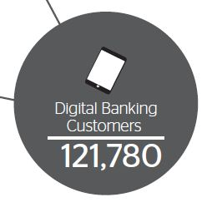
4.1: Findings and Analysis of the Study
Experience Citytouch's best-in-class digital banking services from all City ATMs throughout the nation. City Bank’s online banking application, Citytouch, has reached a user base of 121,780 people, representing a growth of 45.9% as compared to the user base in 2017.

4.2: Digital Banking Transaction
These services greatly help ease the customer’s banking experience, in line with the demand of e-commerce and electronic banking services in the country. Notably, the Citytouch app registered a throughput of 15 lac transactions (51% growth YoY) with a combined volume of BDT25,540 m (75% growth YoY) in 2018, which reflects the increased use of online transactions and services by their customers, thereby paving the way for far-reaching future initiatives in the digital banking space to enhance convenience for customers, optimize costs for the Bank and render an upside in profitability resulting from the increase in transaction fees and fees from value-added services, blended by reduction in costs.

4.3: Impact on mobile financial services & merchants payments
In addition to their general online services, City Bank has also collaborated with the leading mobile financial services company, bKash, to facilitate their customers to transact seamlessly between bKash accounts and City accounts, hence opening doors to greater financial inclusion and extended reach for the Bank.
The branch network of City Bank Limited and other office infrastructure, digital assets, information centers and software applications are a key cause of competitive differentiation. Investing in constructing and maintaining this infrastructure requires significant economic and human and intellectual capital, as we concentrate on leveraging it with a perspective to strengthening our customer service standards.
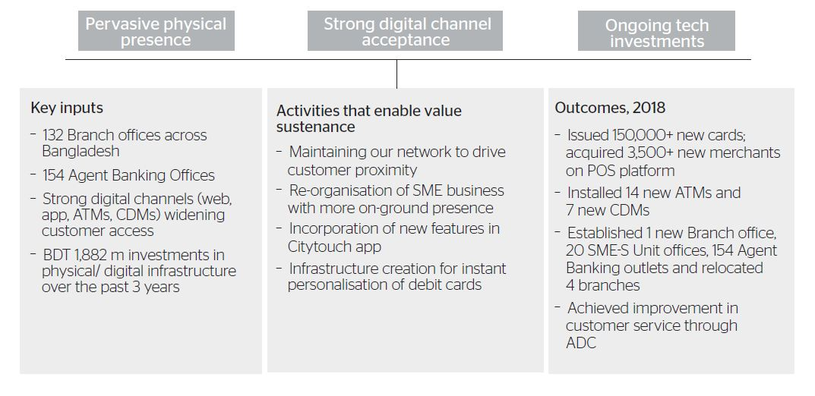
City Bank award-winning Citytouch app, enriched by a number of useful mobile-friendly features, facilitates on-the-go banking and greatly adds to the convenience of our customers. Also, through Citypay, our customers can complete shopping transactions seamlessly and easily by scanning a QR code across thousands of outlets in the country. Besides, our state-of-the-art e-commerce portal permits our customers to make payments instantly and also enables verification of credit card transactions.

4.4: Achievements & Awards
In last three years, City Bank Limited achieved total 19 awards by different awards recognition organizations. Especially they achieved “Best Consumer Digital Bank in Bangladesh” awards continuously in last two years.
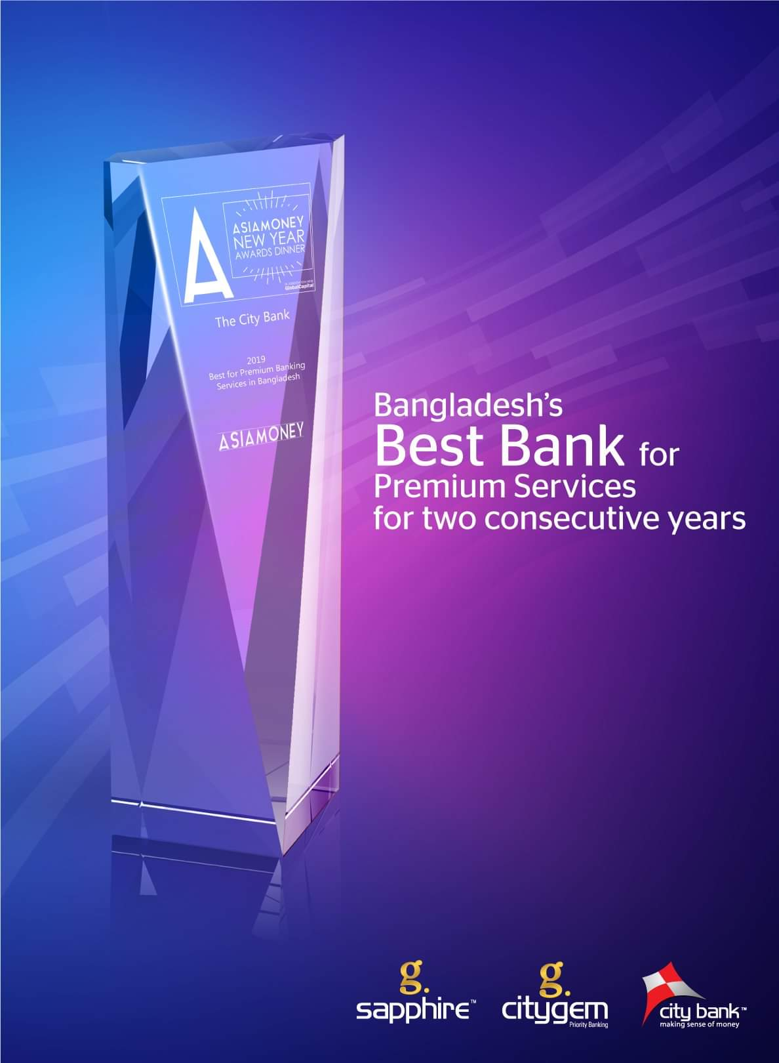
- “Best Consumer Digital Bank In Bangladesh” 2017 & 2018 from Global Finance
- “Best online Bank” 2017from ICT division of the Government of Bangladesh
- “Best investment Bank in Bangladesh” from Finance Asia
- “Best Bank for Premium Services” 2017 & 2018 from Asia Money

4.5: Future target of City Bank Limited Digital Banking
Today, City Bank’s Digital Banking platform has come to be recognized as a cashless, convenient and seamless banking interface that truly unleashes the power of ‘More banking, less bank’. They are also examining the prospects of e-wallet in our Digital Banking journey that will truly revolutionize banking in Bangladesh. Day by day increasing their digital banking “Citytouch” users and City Bank set target 5 lac Citytouch customers within 2021, which is our 50 years of independent day of Bangladesh.

Chapter: 5
Experiences during internship tenure

5.1: Experiences during internship tenure
Internship is perquisite to complete of Bachelor of Business administration program. United international university arranges internship for their all students those are in the last trimesters. UIU wants to develop my practical knowledge by using theoretical knowledge in the organization. I did my internship at legal department of City Bank Ltd at Motijheel, Dhaka. I have lot of practical experience at City Bank in last three months.
I worked at Legal Division of City Bank, then my work was loan defaulter case file input on ULIS (it’s a litigation online server). When I was start this work, I don’t know how much time I need to input one case file on ULIS server? Then after few file input, I knew the file input time that and also I can input 35 files a day. It is really important to recognize the abilities in the organization for a fresh graduate. In last three month at City Bank I learnt my hidden abilities, my weakness, my communication skills, and also increase my computer knowledge. It is the best place where I could clearly find the areas where I need to do better and where I need to improve myself in the future.
City Bank Limited gave me a lot of chance to learn professional skills and they helped me a lot to develop my professional skills. When I was start my internship at City Bank that time I don’t have any practical professional skills, then I got so much help from our seniors brothers and my theoretical knowledge helped meto develop my professional skills, that are:
- Communication skills
- Time Management skills
- Adaptability
- Technological skills
Communication skills: These skills are very important for every person to survive in the organization and for better future. Basically in corporate life we emphasis on written communication system, most of time I saw our seniors brothers communicate with others colleagues by Email in office, and I knew from there, its main communication system for each other’s.
Time management skills: time management skills are mandatory for the jobholders, because office boss always give assignment or project with a deadline. My boss gave me a project 4000 thousand legal file input in online servers within three months, and I did those projects within three month. My senior’s brothers and supervisor were very helpful and gave lot of good advice to manage work within time periods. I learnt time management skills very well from City Bank Ltd.
Adaptability: These skills are necessary for every organization, because every day innovate new ideas, technologies and new things in the world, so if organization wants to survive in the competitive markets then every organization should adopt new technologies and new things. City Bank Ltd always adopts new technologies, and brings new things for giving better services to the customers. I learnt adaptability process from our senior’s brothers. They helped that how to adopt new technologies and new things when City Bank brought.
Technological skills: Basically banking service based on computer, so here first of all every employee need adequate knowledge about their software’s, so City Bank gave me trained about their ULIS software, then I learnt this ULIS software knowledge, that how to operate this software.
As a student it is not possible to gather information about organizational environment, culture, ethics, terms and conditions. City bank gave to chance me to know about the organizational environment, cultures, ethics, terms and conditions by done internship at City Bank. City Bank organizational environment was so much work friendly, and employees are satisfied with the working environment. City Bank always tries to maintain this friendly working environment, and employees are always motivated to do their own responsibility and works. Ethics is part of the organization behaviors that is right or wrong things happened in the organizations. City Bank followed right things that actually accepted in the society, employees are also followed terms and conditions of City Bank.
Before internship I don’t have any experience of all of this, because when I was a student that time I was not practical working experience in organization. But after my internship I achieved lot of practical experiences at City Bank Limited.

Chapter: 6
Conclusion & Recommendations

Chapter: 6
Conclusion & Recommendations

6.1: Conclusion
City Bank’s digital banking platform has achieved considerable sophistication that has helped the Bank meet the banking aspirations of a young and youthful demography that values convenience above anything else. Their Digital Banking platform enables their customers to open accounts with City Bank in a paperless way through tab-based banking, requiring only customer’s thumbprint and national ID as identification. City Bank’s online banking application, Citytouch, has reached a user base of 121,780 people, representing a growth of 45.9% as compared to the user base in 2017. Today, City Bank’s Digital Banking platform has come to be recognized as a cashless, convenient and seamless banking interface that truly unleashes the power of ‘More banking, less bank’. They are also examining the prospects of e-wallet in our Digital Banking journey that will truly revolutionize banking in Bangladesh.

6.2: Recommendations
- Innovate new digital banking services
- Increase promotion & advertising of Citytouch on Social Media, TV, & Newspapers.
- Brings new banking features on Citytouch
- Increase new Merchants payment option by Citytouch
- Implement best security software for safely transaction
- Lucrative offer for transaction of Citytouch users
- Focus on easy & simple registration process

Chapter: 7
Appendix: Reference

7.1: Reference
- Home. (2019). Retrieved 10 September 2019, from https://www.thecitybank.com/home
- Annual Reports. (2019). Retrieved 11 September 2019, from https://www.thecitybank.com/report/annualreports
- Login. (2019). Retrieved 12 September 2019, from https://www.citytouch.com.bd:8443/login

