Comparative review among beauty soaps: in Dhaka city

Internship (INT 4399)



Submitted To
S.M. Asif-Ur-Rahman
Assistant Professor
School of Business and Economics

Submitted By
Shanira Nuzrat
ID- 111 133 013
School of Business and Economics

Date of Submission: 31st May, 2018
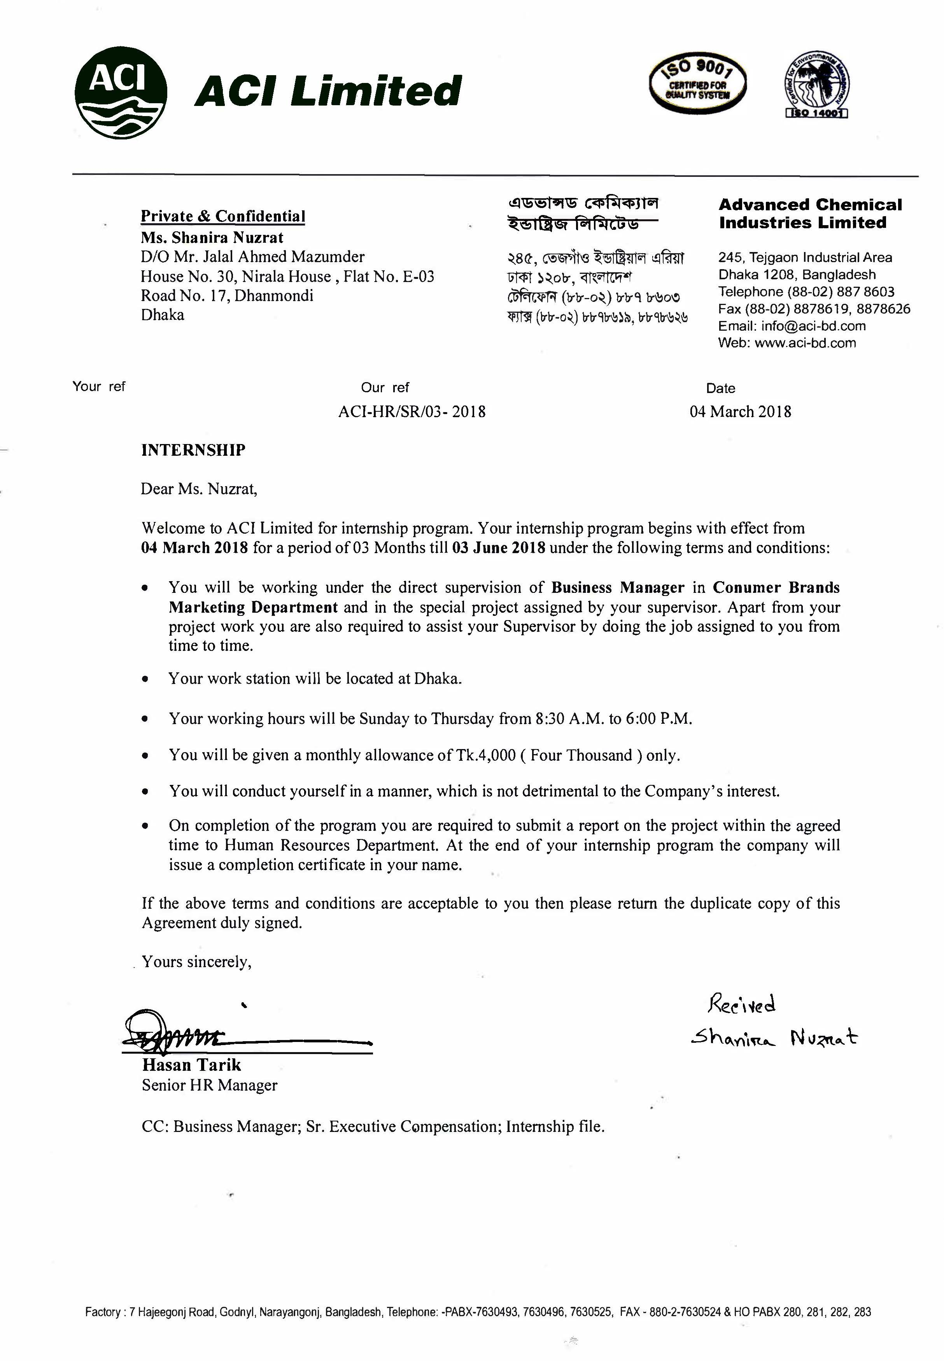
LETTER OF TRANSMITTAL
Date: May 31, 2018
Mr. S.M. Asif-Ur-Rahman
Assistant professor
Department of Marketing
United International University.

I would like to submit my internship report as part of completing a three-month internship period at a renowned FMCG of the country named ACI limited. The report title “Comparative review of beauty soaps in Dhaka city” and contains in-depth research of the Beauty soaps and its comparison with other soaps. Throughout the report I tried to put my best learning and insights which I have gone through at the internship period. I would like to thank my supervisor Mr. S.M Asif-ur-Rahman for supporting me in the whole internship period I also thank Ms. Nithora Rahman, Product Executive, and Consumer Brand for giving me the opportunity to do internship at ACI limited and helping me to learn things.
I have collected as much information as possible from the Advanced Chemical Industries (ACI). Three months effort on this organization was a worthwhile understanding for me as it was in such a reputed business organization. It is a great contentment for me to present you the report as a requirement of the Bachelor of Business Administration. I believe that this internship program has enriched both my knowledge and experience.

Sincerely Yours
Shanira Nuzrat
Id- 111133013
B.B.A
United International University

Acknowledgement
It has been a great opportunity to work on the report under the guidance and supervision of my honorable faculty supervisor, Mr. S.M Asif-Ur-Rahman, Assistant Professor, Department of Marketing. I am greatly indebted to him for having taught me the foundation of business theories.
I would also like to convey my special note of acknowledgement to Ms, Nithora Rahman, Product Executive, ACI Consumer Brands for providing me with guidance on my job responsibility of ACI Sandal Soap.
He enlightened me on the overall situation of the industry and also providing a managerial perspective for a businesslike and marketing.
Finally, I extend my gratitude to all those who helped me in the process of completing this report either by providing me with valuable data and information or merely by their enormous support and encouragement.

TABLE OF CONTENTS
Chapter 01: Introduction 1
1.1. Introduction 2
1.2. Origin of the report 2
1.3. Scope of the report 3
1.4. Objective of the Report 3
1.5. Background and inception 5
1.6. Literature Review 6
1.7. Vision Mission and Values 7
1.8. Purpose of Statement 8
1.9. Organigram: 9
1.10. Recent Developments 10
1.11. Quality Policy 11
1.12. Environmental Policy 12
1.13. Issues 12
1.14. Major Business 13
1.15. Support Functions 16
1.16. Training 17
1.17. Methodology 20
1.18. Scopes and Limitations 21
Chapter 02: Finding and Analysis 22
2.1. Data Analysis: 23
2.2. The researcher has done a qualitative comparison of the products using various criteria: 39
Chapter 03: Comparative Review of beauty soaps: In Dhaka city 42
3.1. Purposed objectives of the topic 43
3.2. The importance of comparative review of beauty soaps considered from different angles. 43
Chapter 04: My Job Responsibility 49
4.1. Nature of the job responsibility: 50
Chapter 05: Analysis Market gaps 54
5.1. Finding Gaps in the Market based on Survey 55
Chapter 06: Recommendation 58
6.1. Recommendation 59
6.2. Additional Recommendations 60
Chapter 07: Conclusion 62
Chapter 08: APPENDIX 64
References A
Questionnaire B

Executive Summery
ACI Limited is one of the most leading FMCG’s of Bangladesh. Besides manufacturing own products, ACI imports many globally acclaimed products. ACI Sandal soap is one of the beauty care products around the world. Though the main leader of beauty care in Bangladesh is Lux from Unilever, the company holds 60.75% share whereas the Government of Peoples Republic of Bangladesh holds 39.25% share moving fast as its current market share is increasing day by day.
This report includes the “Comparative review of beauty soaps in Dhaka city”. Thus it includes all the strategy that ACI follows to promote its brand and distribute it successfully. Beside this, competitors’ strategies are thoroughly analyzed based on retailers’ and condumers’ feedback. ACI conducted this retailer’s survey to analyze market gaps and based on that a fair recommendation has been provided to develop distribution channel.
During the study, Dhaka zone was covered only. First, entire Dhaka zone was divided into territories. Then some areas had been selected within those territories. After that, the shopkeepers and consumers were interviewed and they share their opinions about the product, its system, policy, suggestion and everything.
With all the information and findings from survey, adequate analysis has done in terms of beauty soaps situations. Suggestions are provided at the end of the report for the betterment of the brand in future.



Chapter 01: Introduction

Introduction
ACI is the trusted brand in Bangladesh. To expand its business category ACI imports international products. As a part of this, they import Colgate brand in Bangladesh which is very successful in India and going well in Bangladesh as well. To finish my BBA program, I have to complete internship program and so that joined ACI Sandal Soap Department in ACI Consumer Brand. ACI-Sandal Soap is conducting a survey program on retailers. Here, all the shopkeepers‟ in Dhaka is interviewed about the Beauty soaps. It includes super shop like, Agora, Shwapno or any other branded super shops, retailing shop including pharmacy around Dhaka. All the retailers‟ shops are divided into three categories. They are Category A, B, C that indicates big, medium and small shop respectably. Also, ACI divides the Dhaka into four zones to survey better. Also, within these zones, there are many territories where this survey work was conducted. The main reason is to do this survey to learn about the beauty soaps and how consumers are using it and their viewpoint toward these soaps. During this survey, certain criteria and rules have been followed. Analyzing the survey data, distribution strategy will be developed in future. Moreover, some general gaps and judgment are recommended. Furthermore, this research work will continue time to time as it is the way to develop better distribution strategy.

Origin of the report
This report entitled “Comparative Review of Beauty Soaps in Dhaka City” has been prepared as a requirement for the BBA Internship Program by Shanira Nuzrat, Intern, ACI Consumer Brands. The preparation of the report has served as an induction into the Comparison of all beauty soaps of the company and has also provided a greater understanding of the FMCG and beauty Care industry in Bangladesh. The report has been prepared under the supervision of Ms. Nithora Rahman, Product Executive, ACI Consumer Brands, along with the assistance and instructions of S.M Asif-Ur-Rahman, Assistant Professor, Department of Marketing, United International University.

Scope of the report
The study is based on the activities, analysis and observation as an Intern in ACI Consumer Brands from March 04, 2018 to June 03, 2018. During this 13 weeks’ period, access too many consumers, customers (retailers, hawkers, wholesalers), industry experts and publicly available online data were gained, on which the report is based on. The scope of the report was limited to the soap market of Dhaka, especially its branding practices and prospects.

Objective of the Report
- To Develop a market overview
- To figure out the brand leader in the market place and reason of the customer’s preference
- To evaluate the effectiveness.

Company Overview

Background and inception
ACI was built up as the backup of Royal Substance Ventures (ICI) in the then East Pakistan in 1968. After autonomy the organization has been consolidated in Bangladesh on the 24th of January 1973 as ICI Bangladesh Producers constrained and furthermore as Open Restricted Organization. This Organization likewise acquired posting with Dhaka Stock Trade on 28 December, 1976 and its first exchanging of offers occurred on 9 Walk, 1994. Later on, 5 May, 1992, ICI plc. Stripped 70% of its shareholding to neighborhood administration. Thus, the organization was enrolled for the sake of Cutting edge Synthetic Businesses Restricted. Posting with Chittagong Stock Trade was made on 22 October 1995.


Literature Review
Soap is the assortment of purifying and greasing up items delivered from salt and unsaturated fat. Cleanser can be utilized for washing, showering, and different sorts of housekeeping, where cleansers go about as surfactants, emulsifying. Oils are empowering them to be diverted by water. Then again it can be utilized as improving magnificence. The soonest recorded confirmation of the creation of cleanser like materials goes back to around 2800 BC in old Babylon. (Advertising, C., & Stories, S. (1997)) An equation for cleanser comprising of water, salt, and cassia oil was composed on a Babylonian mud tablet around 2200 BC.
In our nation, there is 100% entrance of cleansers. There are basically three distinct sorts of cleansers & there are-beauty soap, toilet soaps and others (natural). Magnificence cleansers have occurred 70%, beauty soaps in 28% and others are in 2%. Lux is in first position among all magnificence cleansers. It's a result of Unilever. Sandalina sandal soap is in the second position and it's a result of Kohinoor Compound. Keya is the in third position and it's a result of Keya Beautifying agents Ltd. (Bharucha, J. (2015).)
Soaps can tackle issues like squalid face, which settles on the skin because of difficult things discharges that join with earth. This issue looks as appalling as it sounds. In 1989 Lux soap did their advertisement with celebrities which gently cared body, now they’re doing with these days celebrities in 2016/2017. Yet, with some excellence cleansers sleek skin will be a relic of days gone by. In 1959 Dove Cream bar used to say that it was a creamy texture, now Dove does advertisement to remove racism from people. (Fulfilment, P. (n.d.). Meril soap also came in 2012/13 and now it’s a good brand among people. Sandalina Sandal soap also came with its natural ingredients in 2016 and the recent is ACI Sandal soap which is very great for skin & natural. This soap can be utilized on the face as well as on the whole body also. Soaps can keep the skin hydrated. This is can give dampness quick so the skin feels look delicate and supple. Different brands of excellence cleansers mark satisfy its notoriety and are likewise known to be appropriate for those with excessively touchy skin. From the customers point of view beauty soaps can do lots of changes in skin. It can brighten up, can give glow, soften skin, clean dirt from skin etc. customers use different types of soaps and can differentiate the price, quality, types, and fragrance. And marketers bring soaps due to customers’ choice to make customers happy. If the customers are satisfied with things market growth can be raised.

Vision Mission and Values

Mission:
ACI's main goal is to advance the personal satisfaction of individuals through capable use of learning, abilities and innovation. ACI is focused on the quest for greatness through world class items, creative procedures and engaged workers to give the most elevated amount of fulfillment to its clients.

Vision:
To realize the mission ACI will:
- Endeavor to attain a position of leadership in each category of its businesses.
- Attain a high level of productivity in all its operations through effective and efficient use of resources, adoption of appropriate technology and alignment with our core competencies.
- Develop its employees by encouraging empowerment and rewarding innovation.
- Promote an environment for learning and personal growth of its employees.
- Provide products and services of high and consistent quality, ensuring value for money to its customers.
- Encourage and assist in the qualitative improvement of the services of its suppliers and distributors.
- Establish harmonious relationship with the community and promote greater environmental responsibility within its sphere of influence.

Values:
- Quality
- Customer Focus
- Fairness
- Transparency
- Continuous Improvement
- Innovation

Purpose of Statement
- The method was used in this report is quantitative research.
- purpose of this study was to examine the implementation of beauty soaps in Dhaka city. What is the buying behavior, usage, quality etc.
- The non-equivalent pretest posttest method was used in this study.
- Data was collected through a questionnaire.
- The result was shown in the intervention appeared to be one successful on the somatic words.
- The data was collected from customers in shops and the retailers.
- The quality was checked of soaps and those helped to make the survey easier.

Organigram:
The company has diversified into four major Strategic Business Units.
- Pharmaceuticals
- Consumer Brands & Commodity Products
- Retail Chain
- Agribusinesses

ACI Formulation’s Limited
ACI Formulation Ltd is a publicly listed company, separate from ACI Ltd. It manufactures for Agribusiness and Consumer Brands

Shopper Brands division comprises of a couple of classifications. ACI Aerosol, ACI Mosquito coil, ACI Sandal soap, Other-worldly Air Freshener and Vanish Cleaner are the items. Also, in toiletries there are-best cleanser, Savlon, kitchen care, male grooming, Fabric care, Neem original etc.

Recent Developments
ACI has sold a part of its FMCG portfolio namely ACI Aerosol, Mosquito Coil, Cockroach Killer Spray, Angelic Air Freshener and Vanish Toilet Cleaner to US based multinational company SC Johnson & Son. The transaction was valued at Tk 250.54 Crore.
The American company is known for its car care, floor care, household cleaning and scent products. It employs more than 12 thousand people and has operations in more than 70 countries.
Important dates and milestone dates of ACI Limited
1968 | Imperial Chemical Industries Pakistan Manufactures Limited (ICI Pakistan) was established in the then East Pakistan.
24 January, 1973 | Incorporation of ICI Bangladesh Manufacturers Limited.
24 January, 1973 | Commencement of Business.
5 May, 1992 | Imperial Chemical Industries Pakistan Manufactures Limited divested 70% of its shareholding to local management
5 May, 1992 | Name of the company changed to Advanced Chemical Industries Limited from ICI Bangladesh Manufactures Limited
9 March, 1994 | Listed with Dhaka Stock Exchange
22 October, 1995 | Listed with Chittagong Stock Exchange

Company Profile
The Company Profile is mentioned below:
Company Name | Advanced Chemical Industries Limited
Nature of Business | Manufacturing, Processing, Retail, Service
Managing Director | Dr. ArifDowla
Address | ACICenter,245  TejgaonIndustrialArea
Phone | 880 2 887 8603
Fax | 880 2 8878619 & 8878626
Email | info@aci-bd.com

Quality Policy
ACI's central goal is to accomplish business perfection through quality by understanding, tolerating, meeting and surpassing client desires. ACI takes after Worldwide Norms on Quality Administration Framework to guarantee steady nature of items and administrations to accomplish consumer loyalty. ACI additionally meets all national administrative prerequisites identifying with its present organizations and guarantees that present great Assembling Practices (GMP) as suggested by World Wellbeing Association is taken after for its pharmaceutical activities.
The administration of ACI confers itself to quality as the prime thought in all its business choices. All representatives of ACI must take after reported techniques to guarantee consistence with quality guidelines. The pool of HR of the organization will be created to their maximum capacity and tackled through general preparing and their cooperation in looking for ceaseless change of work techniques. ("Welcome to ACI")

Environmental Policy
ACI is committed to maintain the harmonious balance of our eco-system and therefore constantly seeks ways to manufacture and produce products in an eco-friendly manner so that the balance of nature remains undisturbed and the environment remains sustainable.
- In pursuit of this goal, ACI will comply fully with all local and national environmental regulations.
- Ensure appropriate communication and cooperate with internal and external interested parties on environmental issues.
- Create awareness on environmental issues among employees and suppliers.
- Adopt modern waste management technology
- Conserve regular assets like water and vitality for economic improvement, and embrace naturally safe procedures.
- Ensure fitting treatment of all effluents before release, to avoid contamination or corruption of condition.

Issues
The minimized approaches organizations to grasp the ten widespread standards in the key regions of human rights, work guidelines and the earth. These ten standards are:

Human Rights
- To support and respect International Human Rights within the company's sphere of influence.
- To make sure that their own corporations are not complicit with Human Rights Violation.

Labor
- To end discrimination in the workplace.
- Abolition of child labor.
- The right to collective bargaining and recognition of freedom of association.
- To eliminate the use of forced and compulsory labor.

Environment
- To support a precautionary approach to environmental challenges.
- To undertake initiative to promote greater environmental responsibility.
- To encourage the diffusion of environmentally friendly technology.

Anti-Corruption
- To work against all forms of corruption, including extortion and bribery.

Major Business

Pharmaceuticals
ACI figures and markets a far-reaching scope of in excess of 400 items covering all real helpful zones, which come in tablet, container, powder, fluid, cream, balm, gel, ophthalmic and infusion shapes. ACI additionally advertises incredibly famous marked pharmaceutical items imported from world-class multinational organizations like ASTRAZENECA, UK and UCB, BELGIUM. ACI is effectively occupied with presenting more current particles and Novel Medication Conveyance Frameworks (NDDS) to address the issues of present and future.
Lined up with the idea that a pharmaceutical must guarantee compelling administration of condition, ACI agrees to standard condition administration approach, along these lines embellished with EMS 14001 of every 2000. ACI keeps up a suitable and steady association with the human services group of Bangladesh, with the conviction that business brilliance must be accomplished through quest for quality by understanding, tolerating, meeting and surpassing client desires

Consumer Brands
This business segment has three major categories of product range- home care, air care and hygiene care. Products under home care category include ACI Aerosol, ACI Mosquito Coil. ACI Coils enjoys very predominant position and striving to become absolute leader in the market place. ACI has also very attractive product range in this Air Care category with Angelic Fresh Air Freshener. This is the first ever locally manufactured Air Freshener of this country whose fragrances has been applauded by the users and has become market leader in two years. ACI Aerosol is market leader in the mosquito repellent category having market share of 85%. ACI has another very strong range of products in its Hygiene Product category. Savlon Liquid Antiseptic is the highest selling antiseptics in the country. It has more than 75% market share of its category. Products like Savlon Antiseptic cream, Savlon Family Protection Soap and Savlon Femme Sanitary Napkin, Vanish Toilet Cleaner are also under this category. Recently ACI Electronics, a sub unit of ACI Consumer Brands has launched Panasonic Audio visual items in the country.

Agribusiness
ACI Agribusiness is the largest integrator in agricultural sector of Bangladesh. ACI Agribusiness deals with livestock and fisheries, crop protections, seeds, fertilizer and agro-machineries. Under Agribusiness, the following business units are currently operating:

Crop Care & Public Health
Crop care & Public health is dealing with all type of crop protection items. It is providing a complete range of cost effective products which can provide appropriate solutions for the farmers through insecticides, herbicides, and fungicides. This business has been transferred to ACI Formulations Limited form 1st January of this year.

Seeds
Seeds division is dealing with hybrid rice, vegetable and maize seeds. It has partnership with renowned HYV seed companies of the world. ACI started the seed business in 2006. It has its own research and development stations in Gazipur and Bangladesh Agricultural University, Mymensingh.

Cropex
Cropex is dealing with commodity buying, storing, preserving and selling. ACI Cropex is a remarkable addition to the agricultural advancement in the country. The project assists the farmers in various ways - exchanging their crops at the time of their necessity, providing them with technological assistance and advisory services and so on.

Animal Health
This division is dealing with high quality nutritional, veterinary, poultry medicine and vaccines including proposal for pisciculture, cattle rearing and cattle fattening. Integrated fisheries and livestock project will be implemented soon.

Fertilizer
This unit is dealing mainly with micro continent and foliar fertilizer with a focus in basic fertilizer. It launched micronutrient fertilizers like Zinc Sulphate, Magnesium Sulphate, Ammonium Sulphate, Boron, Sulphur 90% and Sulphate of Potash. They are being imported from China, U.S.A, Canada, Taiwan, Argentina, and Turkey etc.

International Alliances
ACI represents to Colgate Palmolive Organization and SC Johnson and Children as selective showcasing accomplice and merchant for the domain of Bangladesh. Colgate is the overall pioneer of the oral care items class. ACI was named as sole wholesaler and advertising accomplice of Beiersdorf AG, Germany; the maker of Nivea mark items. ACI speak to Godrej Shopper Items Restricted. ACI buyer Brand is likewise offering low calorie sweetener results of Merisant for weight cognizant clients and furthermore for them who need to dodge coordinate sugar. In increments to these, ACI speaks to noteworthy number of world’s presumed organizations in Pharma and Agribusiness divisions.

Joint Venture
ACI limited expanded its business joining with following company:
- ACI Godrej Agro vet PVT Ltd.
- Tetley ACI Bangladesh ltd.
- Asian Consumer Care Ltd.

Subsidiary
ACI Formulations  Limited | Manufacturing & marketing of number of agrochemical and  consumer products
ACI Salt Limited | Manufacturing & marketing of edible packed Salt
ACI Pure Flour Limited | Processing, Packing and Marketing of wheat flour products
ACI Foods Limited | Manufacturing & Marketing different types of spices and other  food products
Premiaflex Plastics  Limited | Manufacturing & Marketing of Plastic Products, flexible printing.
ACI Motors Limited | Business of buying, selling, Importing, and assembling of vehicles of both agricultural and nonagricultural use including supplying spare part and providing service facilities for vehicles.
ACI Logistics  Limited | Operating retail chain stores across the country
Agro Chemicals  Limited | Manufacturing, formulating and packaging of pesticides,  fertilizers, plant nutrients, animal food and other nutrients products

Support Functions

Human Resource
ACI HR works with a dream for making a workplace to encourage imagination, advancement and profitability for accomplishing business magnificence through unique and committed individuals. ACI trusts that HR is the most vital resource of the association. ACI recognize the preparation needs and give trainings as needs be to build up the information and aptitudes of their HR. Thought Authority and Group Building gatherings are led all the time. ACI give an empowering working condition to release the maximum capacity of the representatives and an execution-based vocation movement.
ACI have an esteem-based culture where pride of the individual is the most elevated need. ACI put stock in strengthening and designation. ACI sort out various get-togethers like Family Day, Cricket Competition, and Badminton Competition and so forth with a target to reinforce the bond among the workers. ACI rehearse present day HR Arrangements and methods for Enrollment and Choice, Labor Arranging and progression arranging.

Finance and Planning
The major areas of its activities include:
- Corporate Finance
- Treasury
- Insurance and risk management
- Costing
- Credit Management
- Taxation
- New business management
ACI finance is pioneering in introducing and implementing state of the art financial tools like electronic banking, integrated accounting systems, better foreign exchange management through hedging, derivatives etc. To allow us to excel in our performance ACI Finance has strong rapport with all the international and major local banks, non-financial institution including leasing companies. ("Welcome To ACI")
Driving force of Finance is its motto which is "to become most value adding business partner". To drive this vision, ACI Finance proactively helps business in providing right and timely information, analysis, budgetary management and participating in cross-functional team.

Commercial Department
Business Bureau of ACI is a standout amongst the most indispensable useful branches of the organization which manages the production network exercises of ACI. So as to keep every one of the organizations running impeccably, the committed and persevering representatives of this division keep up a decent contact with the clients, both national and universal. The Business Office is reliably accomplishing the best costs for the items that ACI buy, guaranteeing tremendous measure of cost investment funds for the organization. It offers powerful polished skill and aptitude in the whole business exercises of ACI.

MIS Department
MIS bureau of ACI guarantees the general IT related backings for the organization. This office deals with a smooth task of software's, equipment investigating and business databases identified with deals and stock. The MIS division comprises of proficient and gifted software engineers and programming designers.

Training

Distribution Network
- The organization keeps up deliberately found deals focuses in nineteen unique areas the nation over. It has built up a propelled circulation framework through its in excess of 300 gifted and prepared labors.
- ACI are equipped for keeping up a frosty chain for some particular scope of items, for example, immunizations and insulin.
- The Division facilitates and completes on the short and long-haul key arranging and procurement of corporate PC hardware, administrations, and media communications gear and administrations.
- Create appropriate condition for efficient operation of structural subdivisions
- Coordinate construction, maintenance, rent and keeping buildings issues
- Coordinate of issues as logistical support of Bank activities
- Maintain coordinate with Govt. regulatory bodies and supervise all incidents.

Methodology

Methodology
Quantitative method has been used while establishing and doing the analysis part of the report are given below:

Primary Sources
Most of the cases, the information was extracted from primary sources which is from the retailers. The survey was conducted in Dhaka and covered (100) individual shop or retailer. The shops are divided into three categories: The primary source of the information is collected from retailers around Dhaka zones. The survey was conducted during market visit at different marketplace. I have visited around (100) retail and trade shops in Dhaka city. The survey conducted as the shops are divided- These outlets are situated at some main market of the region mainly the grocery shops. They stock products in bulk amounts. Moderate shops situated at the residential area of the region. They generally stock all size of the beauty soaps but at moderate amount.
Institutions like-hotels, hospitals, and pharmaceuticals they take bulk amount of soaps.
I have to report to my supervisor after conducting every market visit and survey. I used excel spreadsheet
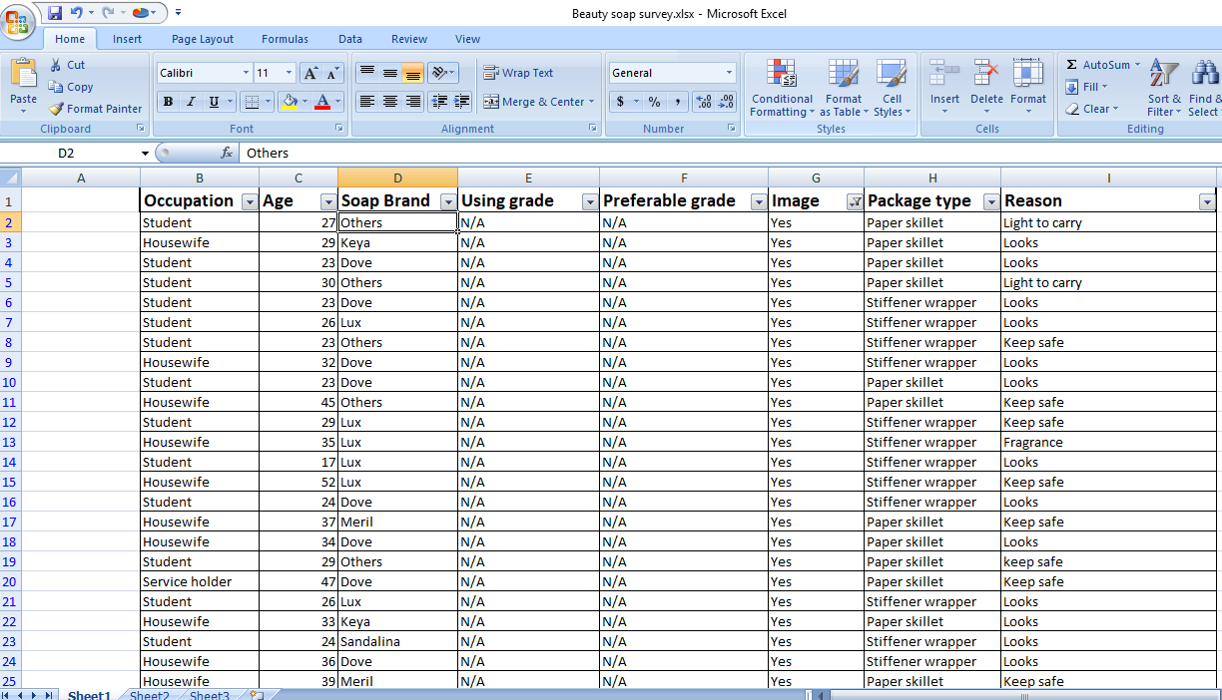

Secondary Sources
I have collected secondary information from following sources:
- Company website.
- Websites of beauty soaps.
- Sales report
- Annual report of ACI.etc.

Sampling Plan
- Population: Retailers and trade shops in Dhaka city.
- Sampling Procedure: Non-probability Convenience sampling technique is used.
- Sampling Size: 100 consumers and shops (retail, trade, Institutions)
Time period and data collection: 4th March- 30th May, 2018.

Scopes and Limitations

Scopes
The reader will easily understand the comparison of beauty soaps. Soap types are- beauty, health and herbal. How beauty soaps are creating a way to take place in consumers mind, how much value is given for these products are also discussed.
Along with this, the reader will observe the market gaps and possibilities of developing the distribution channel.

Limitations
- Confidentiality issues of some information and less information about soaps.
- Reluctant behavior of some consumers when taking interviews.
- Time.

Chapter 02: Finding and Analysis

Data Analysis:
After doing the survey of 100 people in Dhaka city, collected data about customers’ and retailers’ buying behavior of beauty soaps.

Q1. What do you like about Beauty Soap?
Liking about beauty soap is 39.00% people said that they like the moisturizing ability of soap and the age group was in 27-36, 37-50. 38.00% people said that they like the cleaning property all age group and the 51 to 60+ age group, 23.00% people like the germ-free technique.
Like About Beauty soap | Number of people | Frequency | Total
Cleaning Property | 38 | 38.00% | 100
Moisturizing Ability | 39 | 39.00% | 100
Germ Free Technique | 23 | 23.00% | 100

Q2. How many soaps do you buy per month?
43% of people buy 3 to 4 beauty soaps per month. 37% of people buy 5 to 6 and 12% people buy 1 to 2 beauty soaps per month. The age group is maximum 27-36 & 37-50 they prefer more to buy these soaps.
How Many Beauty Soap | Number of people | Frequency | Total
1 to 2 | 12 | 12.00% | 100
3 to 4 | 43 | 43.00% | 100
5 to 6 | 37 | 37.00% | 100
More Than That | 8 | 8.00% | 100

Q3. Which brand do you use? Why?
69.00% people said that they like the Dove cream bar because of its moisturizing ability then 66% people like to use Lux for regular basis. Other people like keya, Sandalina, Meril, Fa etc. for their lower price. The age group was in 18-26, 27-36, and 37-50. People said that they like the cleaning property of beauty soaps and mostly the moisture.
Brand Preference | Number of people | Frequency | Total
Lux | 66 | 66.00% | 100
Dove | 69 | 69.00% | 100
Keya | 11 | 11.00% | 100
Sandalina | 4 | 4.00% | 100
Meril | 8 | 8.00% | 100
Fa | 10 | 10.00% | 100
Santoor | 5 | 5.00% | 100
Others | 0 | 0.00% | 100

Q4. Beauty soaps actually work for enhancing your beauty?
Most of the people said that beauty cream can give a glowing and soft skin but not enhance beauty. Some beauty soaps have the brightening technique.67% of people disagreed because they think beauty soaps can be used by all age and it can keep the skin soft and nourished.
Enhancing Beauty | Number of people | Frequency | Total
Strongly Disagree | 4 | 4.00% | 100
Disagree | 67 | 67.00% | 100
Neutral | 3 | 3.00% | 100
Agree | 22 | 22.00% | 100
Strongly Agree | 4 | 4.00% | 100

Q5. What do you think about the price range of available beauty soaps in Dhaka?
Pricing of beauty soap is 68.00% people said that they like the soaps are reasonable in Dhaka city. Other people think it’s okay or unreasonable. So, from this survey it’s collected that soaps are reasonable.

Price Range | Number of people | Frequency | Total
Very Reasonable | 4 | 4.00% | 100
Reasonable | 68 | 68.00% | 100
Just Okay | 14 | 14.00% | 100
Unreasonable | 12 | 12.00% | 100
Very Unreasonable | 2 | 2.00% | 100

Q6. How often do you use beauty soap?
46.00% people said that they like to use soaps daily once, 24% people use it twice and other people other day or two/three days in a week use it.

Using of Beauty Soap | Number of people | Frequency | Total
Daily Once | 46 | 46.00% | 100
Daily Twice | 24 | 24.00% | 100
Every Other Day | 21 | 21.00% | 100
Others | 9 | 9.00% | 100

Q7. Do you regularly use the same brand/types of use multiple brands?
Using same brand of beauty soap is - 32.00% people said that they like to use same brands for years but 68% people like to change brands in months or years to know more appropriate soaps for their skin.

Regular Use | Number of people | Frequency | Total
Same Brand | 32 | 32.00% | 100
Multiple Brands | 68 | 68.00% | 100

Q8. Where do you normally buy your soap?
32.00% people said that they buy soaps from retail shops and 49% people buy from superstores. Other 12.00% people bring it from abroad and other countries.27-36, 37-50 age group of people said that they like to buy from superstores because they are safe and real products.

Place to Buy | Number of people | Frequency | Total
Retail Shop | 32 | 32.00% | 100
Superstores | 49 | 49.00% | 100
Pharmacy | 7 | 7.00% | 100
Others | 12 | 12.00% | 100

Q9. Do you like- soaps with fragrances /soaps without fragrances?
Liking about beauty soap with fragrance is 97.00% because most of the people like it with good and fresh fragrances. Other 3.00% people like it without fragrance.

Fragrance | Number of people | Frequency | Total
With | 97 | 97.00% | 100
Without | 3 | 3.00% | 100

Q10. If a new brand of pure beauty soap was available, what fragrances would you like?
38.00% people said that they like lime flavor because it can give fresh feelings. 26.00% people like it with normal flavor as it is. 8.00% people like the coconut flavor because it can help skin to glow.

Fragrance Flavor | Number of people | Frequency | Total
Chocolate | 1 | 1.00% | 100
Strawberry | 3 | 3.00% | 100
Vanilla | 3 | 3.00% | 100
Normal | 27 | 27.00% | 100
Coconut | 8 | 0.08% | 100
Blackberry | 0 | 0.00% | 100
Lime | 38 | 38.00% | 100
Other | 20 | 20.00% | 100

Q11. What is the regular size of soap you buy?
54.00% people like to buy the 100 to 150g soaps for regular use and the age group is 37-50 years. 21.00% like to buy 40 to 90g soaps most of them are students who live alone or without family.

Size of Soap | Number of people | Frequency | Total
40 to 90g | 21 | 21.00% | 100
100 to 150g | 54 | 54.00% | 100
200g | 12 | 12.00% | 100
250g | 6 | 6.00% | 100
Above | 7 | 0.07 | 100

Q12. Do you like the packaging of the soap?
Liking about beauty soap packaging is 95.00%. Other 5.00% people said that they don’t like it, it should be changed with other types and safe packaging.

Liking of Package | Number of people | Frequency | Total
Yes | 95 | 95.00% | 100
No | 5 | 5.00% | 100

Q13. What is first thing you notice before buying beauty soap?
39.00% people said that they notice the fragrance of soap before buying it. 32.00% people notice price others are notice pack, origin, contents etc.

First Thing | Number of people | Frequency | Total
Pack | 19 | 19.00% | 100
Origin | 4 | 4.00% | 100
Contents | 2 | 2.00% | 100
Certificates | 1 | 1.00% | 100
Fragrance | 39 | 0.39 | 100
Color | 3 | 3.00% | 100
Price | 32 | 32.00% | 100

Q14. How would you grade the following soap brands? (10= Very good, 1=Very bad)
66.00% people like Lux brand because of the smell and 69.00% people like dove because of the it’s moisturizing ability. Keya and Meril are liked by people who want to spend less amount in soaps, Sandalina can be used who want natural or herbal things and Fa is a good brand so some use it, in others it can be St. Ives, Johnson, Palmolive etc.
Grade soap brands | Number of people | Frequency | Total
Lux | 66 | 66.00% | 100
Dove | 69 | 69.00% | 100
Keya | 11 | 11.00% | 100
Sandalina | 4 | 4.00% | 100
Meril | 8 | 0.08 | 100
Fa | 10 | 10.00% | 100
Santoor | 5 | 5.00% | 100
Others | 2 | 2.00% | 100

Q15. From where you first heard about this brand you use?
47.00% of first watched it from TVC, 21.00% people from social media, 16.00% people heard it from friends and family. Magazines are also focus these brands and 11.00% people read it in magazines. TVC is most effective way.

First Heard | Number of people | Frequency | Total
TVC | 47 | 47.00% | 100
Social media | 21 | 21.00% | 100
Magazines | 11 | 11.00% | 100
Billboard | 3 | 3.00% | 100
Friends & Family | 16 | 0.16 | 100
Others | 2 | 2.00% | 100

Q16. Please put the advertising methods in order based on your opinion from 5 (most effective) to 1(least effective).
Advertising method of beauty soap should be TVC said by 4.46% of people. Social media is an effective way too now-a-days. 3.7% know from radio and 3.03% like it from PVC.

Advertising Method | Range in 5 | Frequency | Total
TVC | 4.46 | 4.46% | 100
Social Media | 3.91 | 3.91% | 100
Magazines/Press | 3.75 | 3.75% | 100
Radio | 3.7 | 3.70% | 100
PVC | 3.03 | 3.03% | 100
Other | 2.18 | 2.18% | 100

The researcher has done a qualitative comparison of the products using various criteria:

Product:
As we can see, Dove is the soap combination of moisturizer and softness so as to satisfy the particular need which was earlier not met thus touching the market which was untouched. Dove products are clinically proven to be one of the mildest moisturizer soap bar which suits all types of skin type and does not irritate the skin. Sensitive skin type can also use this soap bar. Lux is also a mild soap bar but less than dove. Sandal soaps are very good for all types of skin. It can purify and moisturize skin. ACI has recently launched Sandal soap which is very mild and with cocoa and sandal.
Lux | Meril | Tibet | Dove | Fa | Sandalina
75g. =24 BDT. | 100g.=30BDT. | 7g. =23 BDT. | 50g. =75 BDT. | 90g.=120BDT. | 75g. =25 BDT.
100g. =30 BDT. |  | 90g. =25 BDT. | 125g. =120 BDT. | 175g.=125BDT. | 125g.=40 BDT.
150g. =42BDT. |  | 100g. =30 BDT. | 135g. =140 BDT. |  | 150g.=45 BDT.
170g. = 120BDT.

Pricing:
When Dove entered the Bangladeshi market it was priced very high 140BDT. Per135g. Since it was not affordable to many people, Dove then lowered the price 75BDT. Per cream bar, and targeted the upper middle class consumers. Lux 75g is 24 BDT and 170g is 120 BDT. Meril is 100g 30BDT. Tibet is 100g 30 BDT. Sandalina Sandal soap is 75g 25BDT. ACI has also neem and honey soap bars they are 32 BDT 75g.

Grading system:
The grading of the cleanser is dictated by the level of Total Fatty Matter (TFM) in the cleanser. TFM content is the proportion of mass of the greasy substance to the mass of the cleanser. Thus, the higher the TFM the better and purer is the cleanser. The TFM of a Grade 1 soap is least 76% without any fillers (minimum number of added substances), in this manner making it a purer cleanser. The soap with the higher TFM gives more foam, keeps going longer and, all the more significantly, and cleans better.
The goodness of soap lies in the % of TFM contained in it. High quality (Grade 1) soap has to contain 76%TFM. Least quality soap (Grade 3) at least 60%. Some grading of beauty soaps are:
Brand name | Grade
Lux | 2
Dove | 2
Meril | 1
Tibet | 1
Sandalina | 1

Packaging:
packaging of soap bars can create impact on buying habit. Some prefer paper skillet and some prefer wrapper. It can keep soap safe, light to carry, can keep reach out of other germs, etc. it can create differences among beauty soap purchase. Here is a survey I did on packaging types.
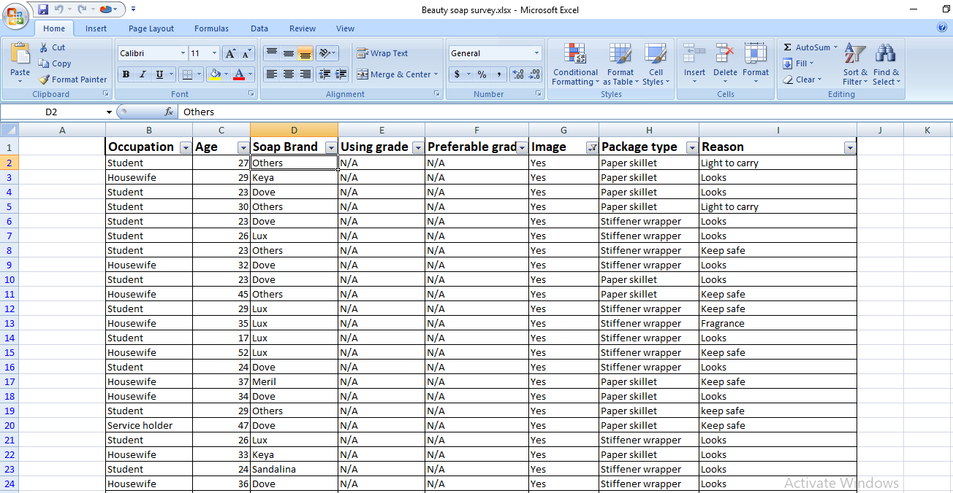

Promotion:
Dove uses societal marketing concept where they educate girls and women on the true definition of beauty. Lux uses brand ambassadors to promote its brand. Meril, Tibet uses rural are people to make their ad, so it indicates this soap is easily affordable in rural areas. Dove has created awareness among the women in the whole of society through social networking websites such as Facebook, twitter, Instagram and Google hangouts. Sandal soaps are from nature so, they use natural beauty to promote themselves. According to surveys conducted, people in Dhaka are most active on social networking sites more than any other country in the whole of globe. They do social networking promotions to attract people.

Public Relations:
The real aim of soap is to bring the inner hidden beauty of women outside glamorously. At first took a survey to understand how women define beauty, how they are satisfied with their beauty etc. The results they came to were very shocking. As a matter of fact only 2% of the women think they are beautiful. Therefore, Dove launched “The Real Beauty Campaign” where they created awareness among the women of what real beauty is and that, women of all shapes, sizes and ages can be beautiful. By doing these campaign they can create a public relation with their brand.

Location strategies:
Dove, Lux products are available in many places, right from super markets to super markets to fair price shops. Due to the recent changes in technology, Soaps are now also available on ecommerce websites that include Daraz.com, Meena Click, and Swapno etc. Meril, Tibet, Sandal soaps etc. use both direct and indirect channel strategies. They are available in every shops of the country. So, people can know more about these.

Chapter 03: Comparative Review of beauty soaps: In Dhaka city
Consumer conduct alludes to the conduct that buyers show in hunting down, acquiring, utilizing, assessing, and discarding items and administrations that they expect will fulfill their necessities.
It can likewise be characterized as those demonstrations of shoppers straightforwardly associated with got utilizing and discarding monetary merchandise and enterprises, including the choice. The investigation of purchaser conduct is the investigation of what they purchase, why they get it, when they get it, where they get it, how regularly they get it and how frequently they utilize it.
To effectively market to various sections the advertising supervisor needs suitable showcasing methodologies which he can plan just when he can comprehend the components which represent these distinctions in customers conduct and quicker.

Purposed objectives of the topic
- To know the perception of customers. What they think about beauty soaps.
- To know the Perception of retailers about beauty soap selling, what type of soaps customers want, what things they prefer in soaps, moisture.
- To know what consumers’ viewpoint towards beauty soaps is, their brand, fragrance, cost, ingredients etc.
- To know which brand, they prefer to use for their skin type.
- To see the awareness level of the consumer in references to soap market.
- To know the reason for a switch over from one brand to another.
- To study the various sources of information on consumers’ buying behavior.
- To check consumer s’ reliability on media habit.

The importance of comparative review of beauty soaps considered from different angles.

For the Specialist:
The examination is essential for the exploration as it less down the hole between hypothetical information and reasonable utilizations of the hypothetical idea picked up amid the reason for administration contemplates.

For The general population/Buyer:
This examination causes the customer to comprehend the trouble of the purchasing conduct.

For the Advertisers:
Better and will empower them to make the item or adjust the item as indicated by the purchasers require fulfillment.
There are various types of soaps in Dhaka city. People love to use them with some qualities, price, availability etc. most of the soaps are from known brands of Bangladesh. Some multinational and some national companies are making beauty soaps in our country. Here are some beauty soaps-
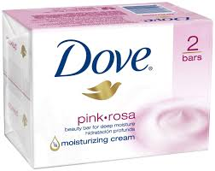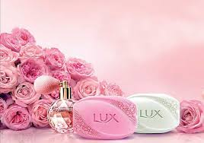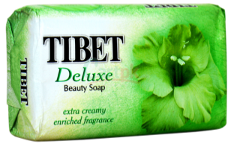
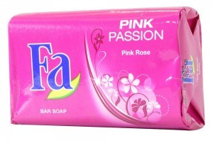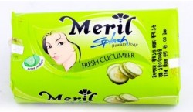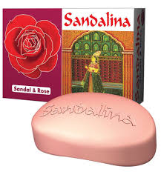

Types and varieties of soaps:
- Lux:
Lux is the soap of Unilever. Today, Lux is the market leader in countries like Bangladesh, Brazil, India, Pakistan, South Africa and Thailand.
- Divided into beauty soap
    - Soft touch Floral fusion oil & French roses
    - Velvet touch Floral Jasmine oil & almond
    - Fresh Splash-refreshing cooling mint and Minerals.
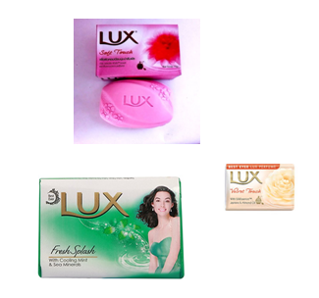
- Divided into perfumed bar-
    - Hypnotic Rose Perfumed Bar
    - Charming Magnolia Perfumed Bar
    - Iconic Iris Perfumed Bar
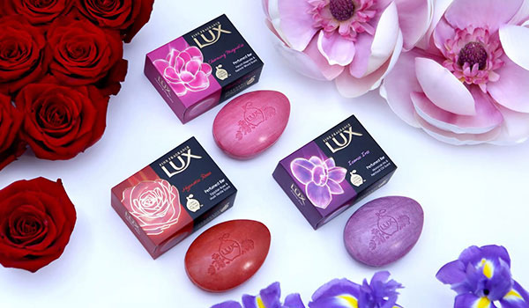

- Dove:
Dove is a personal care brand owned by Unilever originating in the United Kingdom. Dove products are manufactured in Argentina, Australia, Brazil, Canada, China, Egypt, Germany, India, Indonesia, Israel, Ireland, Japan, Mexico, Netherlands, Pakistan, Philippines, Poland, South Africa, Thailand, Turkey, and United States.
- Divided into beauty soap
    - Dove Pink. Rosa Beauty Bar Soap
    - Dove Gentle Exfoliating
    - Dove Pure and Sensitive Bar
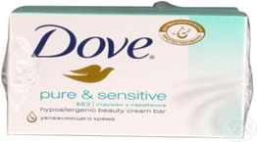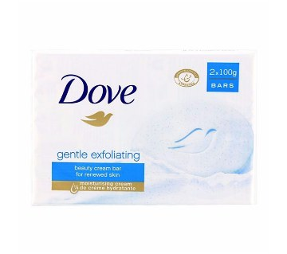
- Some other varieties are-
    - Dove Go Fresh Touch
    - Dove Beauty Bar White
    - Dove Beauty Cream Bar White
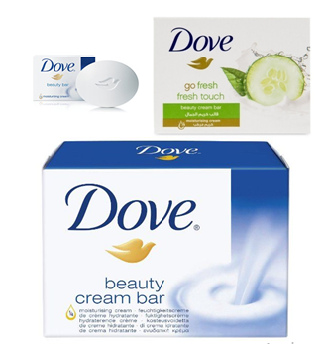
- Meril:
Blending the ancient imperial luxury of milk baths with its 6 times more moisturizing power, Meril Milk Soap will give afresh and soft skin by removing skin roughness and protecting against it. It is a soap of Square-Toiletries Ltd.

There are different types-
    - Natural Milk
    - Milk and kiwi soap
    - Milk and pomegranate
    - Milk And blackberry
    - Milk and beli
    - milk and honey
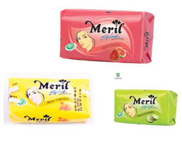
Some other varieties of Meril Splash beauty soaps are-
    - fresh turmeric
    - fresh cucumber
    - fresh melon
    - fresh peach

- Tibet:
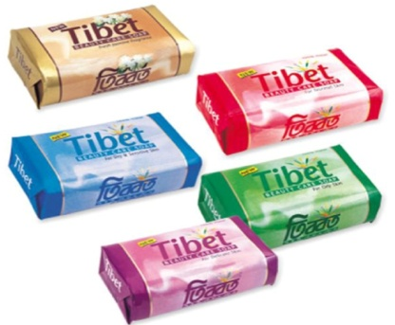
Tibet is a brand of Kohinoor Chemical Co. it’s a high-quality bath soap made from 100% vegetable fat. Some variants of Tibet soaps are-
- Tibet deluxe beauty soap
    - Creamy with fragrance
    - Extra creamy enriched
    - White pink green
- Fa:
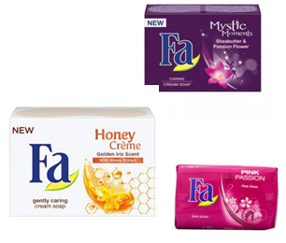
Fa is an international brand for personal care products. It is a subsidiary of German company Henkel AG. Varieties are-
    - Fa Honey Crème
    - Sensual Golden Iris Scent and Honey Extracts
    - Mystic moments
- Mild cleansing and moisturizing
    - Intensively caring Shea butter
    - Fascinating fragrance of the passion flower
- Sandalina Sandal Soap:
SANDALINA offers a world class Grade-1 soap enriched with a unique blend of Sandal Wood Extract. It’s soap of Kohinoor group.
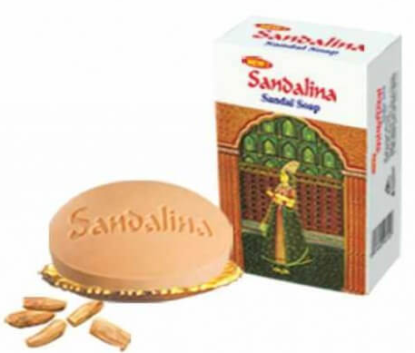
- Aci Sandal soap:
ACI Limited is one of the leading conglomerates of the country. ACI Consumer Brands is stepping into beauty soap category with its Sandalwood soap “ACI Sandal Soap”. ACI Sandal soap is formulated as a Grade-1 soap containing the highest quality of sandalwood oil, cocoa butter, and an invigorating fragrance. The soap is infused with sandal oil which acts as a natural moisturizer and helps to create a glowing effect to skin. It contains cocoa butter which provides balanced moisture, thereby preventing dryness and giving a smooth & supple effect. Its fragrance contains lilac extract that captivates the mind and gives prolonged freshness.
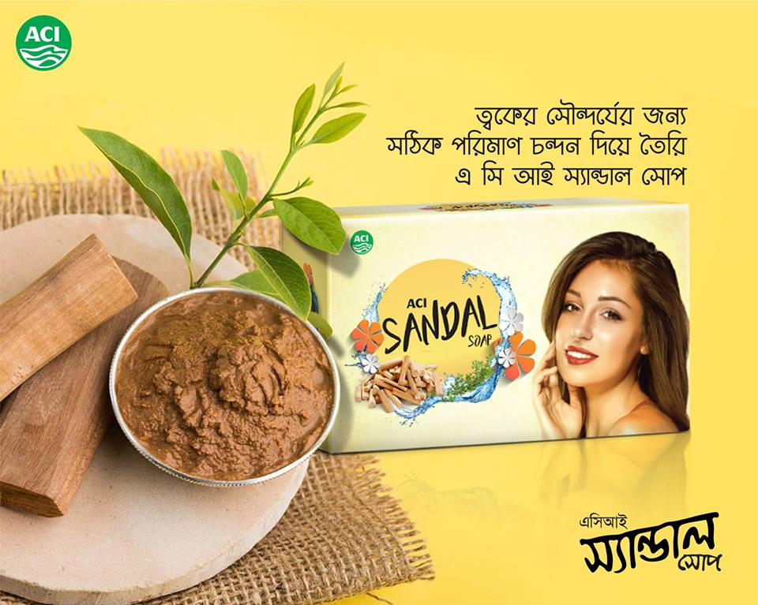
This research analyses the soap industry in the FMCG sector in Dhaka with a special emphasis on two brands Dove and Lux, which are among the trusted and leading soap brands from the same parent company “Unilever”. Unilever is a multinational corporation that owns more than 400 brands in the FMCG sector.

Chapter 04: My Job Responsibility

Nature of the job responsibility:
I joined at ACI Consumer Brand as an intern on 4 March, 2018. I was assigned under the supervision of Ms. Nithora Rahman, Product Executive of Brands like ACI Sandal Soap. My office time was from 8:30 am to 6:00 pm. I have to work 5 days week with Friday and Saturday off day.
At ACI, I gradually learned the office etiquette, and basic official tasks. Within the internship period I learn the corporate culture of ACI. I maintained a good relationship with my supervisor and other employee of the company. My main responsibility is to visit several markets to check the shelf size of ACI personal care products. I also had to check competitor’s product availability and their offers. I got opportunity to work with many awesome personalities there.
My main responsibilities were:
- Making necessary documents before visiting the market.
- Making relationships with sales representative
- Visiting market
- Collecting necessary data
- Inputting the collected data into spreadsheet
- Submitting the report to supervisor.
Here I describe some below:

Making necessary documents:
Before visiting the market, I used to make necessary arrangements like making a format in a note pad to write down the information, collecting SR number of the respective area, Location name, Market addresses.

Making relationship with sales representative:
As the area sub-divided under the sales representatives, they know about all the shop better. So, I have to maintain a good relationship with them so that I can access the information without any disturbance.

Visiting Market:
I have visited all the retail shop at the market. I asked the shoppers about personal care products like- sandal soap, Neem face wash and other beauty soaps.

Collecting the necessary data:
I have to collect all the necessary data regarding ACI Sandal soap. As all the shoppers are not equally amicable, I used different strategy to approach them. An example of how I approached the shoppers is given below:
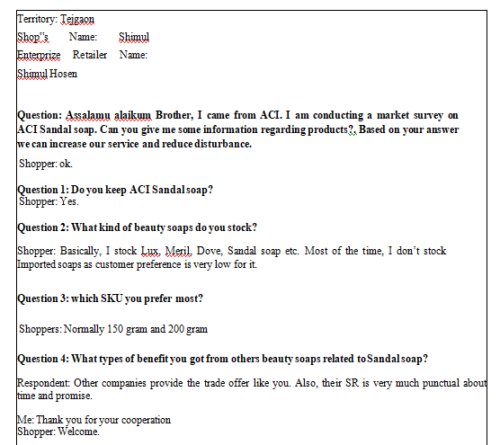

Inputting the collected data into excel and reporting to the supervisor
After my visiting of the market, I come to the office and I input all the data that I gathered. I created a format on my own and my supervisor approved it and wherever the fault is found, my supervisor showed me a way to solve it. I also have to make a summary of the report in excel document to easily understand the report.

Make phone call to retailers
I had to call a list of retailers from different area to know about their opinion about the display program. I told them about the program and the reward and asked them if they want to keep the display at their shop or not. Many of them agreed to keep the display.
I had to contact with 157 shoppers to let them know about the program.

Here I give a photo of the list of retailers:
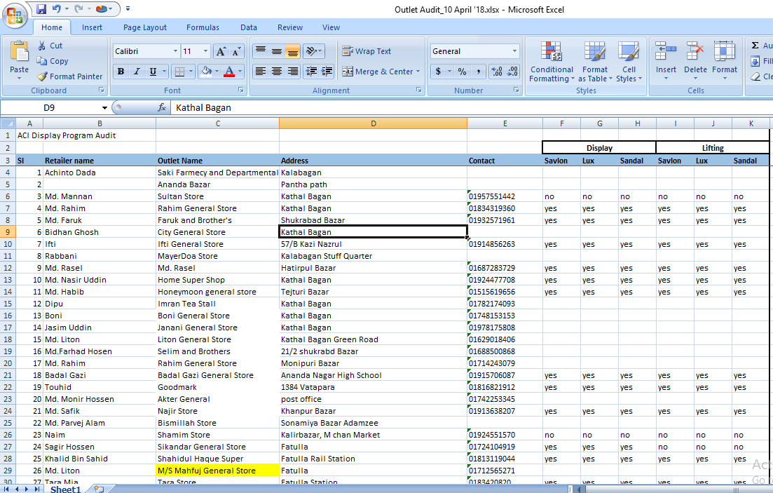

Shoppers | Number
Yes/Interested | 81
No/Not Interested | 12
Number not Reachable | 29
Not Responded | 16
Wrong Number | 10
No Number | 5
Total | 153

Market Visit to check the display:
After the display has been given to the retailers who want it, my responsibilities were to check them if they set the display according to the condition. I have to check all the shop and report to my supervisor about the progress of the program.

Chapter 05: Analysis Market gaps
Beauty soap brands are very much potential about their products. They survey constantly to observe the market, its gaps, and problems lying on retailers and consumer behavior also.
To know the current market situation retailers feedback was taken. Also, the market gaps, reason behind decreasing sales volume and others information related was needed. By conducting retailers‟ survey lots of valuable information extracted from the market as well as retailers’ necessity.

Finding Gaps in the Market based on Survey
After visiting 100 retail shops, so many gaps have been identified in the market that slowing down distribution channel. However, the outcome was more or less positive.
In survey, it is found, almost every outlet stocks of beauty soaps. Also, retailers order soaps regularly. However, almost every shop keeps Lux, Dove, Meril, Tibet. On the other hand, some shops who keep other beauty soap. Moreover, there are some internal issues behind this. As it is confidential those reasons are ignored in this report. Here, every gap and its details are included. However, based on location it may changes as it was mentioned earlier. The main gaps are given below:

Trade offers unavailability:
Most of the retailers want to profit more. Though they have no problem in cash, they can stock more. This type of retailers always seeks trade offer. Basically, offers “Buy 6 get 1 and Buy 12 gets 2”. Unfortunately, they did not get this trade offer often. It causes them turned away from competitor still gives the trade offer.

Not interested in trade offer:
On the other hand, there are some retailers who are not interested in trade offer at all. As, if you want to take the offer, you have to order at least 6. Retailers like small shop do not interested to stock more. Rather they will take 2-3 pieces as they have other soaps in stock to sell.
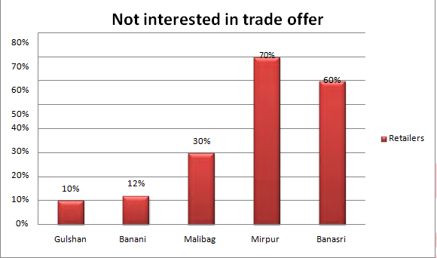
  - Figure: The percentage of retailers not interested in trade offer based on location

Brand ambassadors:
Some beauty soaps are advertised by famous celebrities but some are not like that. So, consumers want to be like those celebrities. As a result, they don’t pay heed to those beauty soaps which are not advertised with celebrities. So, there is a gap in these things.
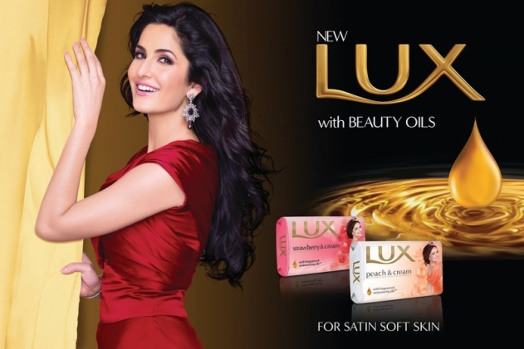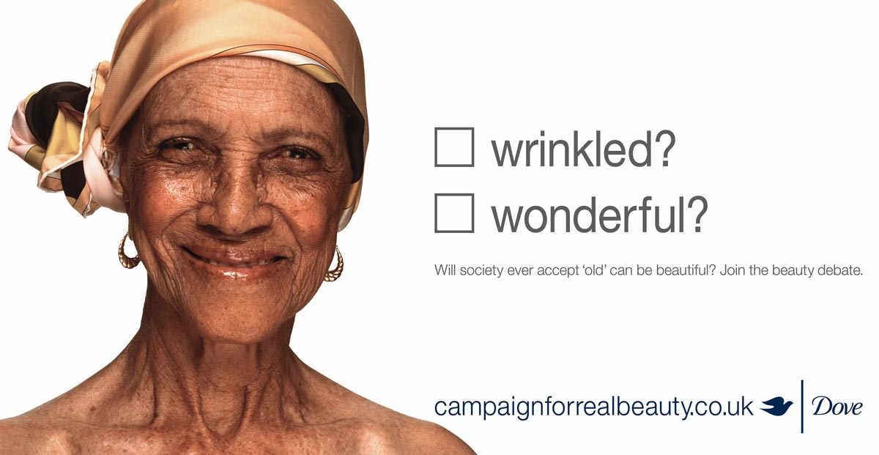

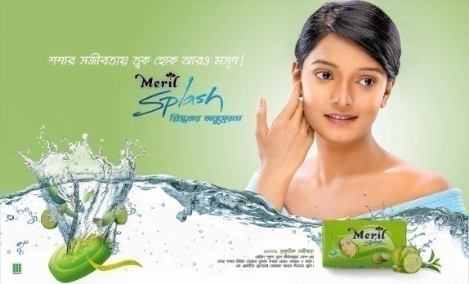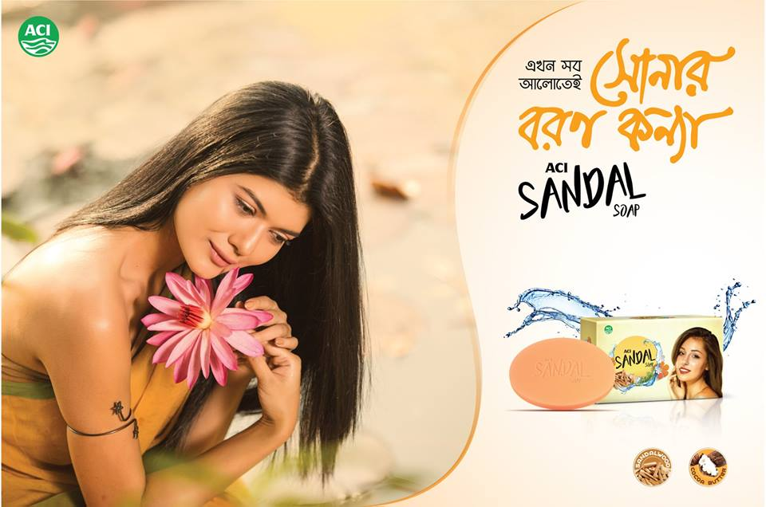

Small market, small sell:
There are some beats (Market or place) where outlets are mostly in C category. These types of markets stock less, even order less than any location. Since their market is small, they do not have enough money to stock or even order more.

Customers’ preference:
Customers’ preference is another issue to stock less or decreasing order of beauty soaps. According to the retailers, customer prefers Dove or Lux first.

Chapter 06: Recommendation

Recommendation
According to Kotler & Keller (2009), a successful marketing channel ensures that a desired product is distributed in a desired amount to a desired channel to satisfy the desired consumer. So, it is the most important element of marketing complex. After conducting retailers’ survey, several things are suggested that can be taken into account.

Lucrative Trade Offer:
As, it was found in the survey that trade offers are mostly accepted in A & B category shops. Since, the retailers have hard cash to order so that ACI should offer something lucrative to them. By doing this, they can increase their sales volume.

Product Display:
According to Abidin & Aziz (2010), window display is one of the methods that sells silently, increase store’s image and assist to make decision. So that product display or window display could be another strategy for ACI to spell.
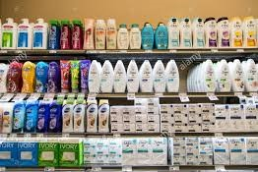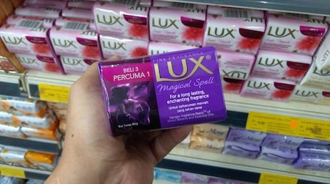

Petty Credit for small shop:
As it was mentioned before, a few retailers cannot order product due to lack of money. So, for this type of retailers if ACI introduced small credit option that could bring significant changes to distribution channel. However, this process should be conducted after consulting financial folk.

Consulting SR regularly:
SR is the person working at the root level and responsible for ultimate processing. Since, ACI has got so many complaints from the retailer; they should be trained properly according to market condition. Also, it can increase their self- efficiency. If ACI wants 100% efficiency from them, they should give adequate training and consultation to them.

Conducting various promotional activities:
ACI should introduce various promotional activities for their customers too. They should give proper advertisement on TV, radio, newspaper etc. The response of consumer is positively related with brand promotional activities. (Cotton and Babb, 1978). Also, they can promote their brand at social network that is the strongest place nowadays. According to Habibi and Richard (2013), brand communities established in social media has positive effects on brand loyalty.

Additional Recommendations

Consulting SR regular basis:
ACI should consult their SR on the regular basis. There will be a fair discussion where SR can speak out about the difficulty facing in the market.

Forming caring image to retailers:
Besides building a fair relationship with them, ACI must create an image that they care about them. Providing necessary help beyond company policy might build a lifetime relationship. Also, it will be a good example of humanity and good promotion too.

Dividing retailers based on the location and their needs:
This is the most important point, ACI should consider. When they divide their retailers based on location, they would know what ways should appropriate. Some of the market is not big and trade offer is not appropriate.

Surveying the market on regular basis:
Last of all, survey work must be going on. This is the only way to know about the market, identify gaps, gain knowledge, analyze strategy, and face competitors. So, they should carry on this sort of research once a year.
Customers’ Brand Choice
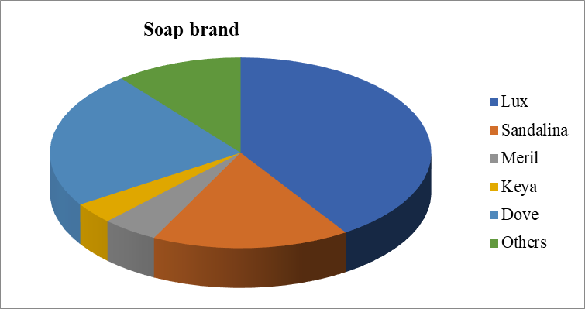
  - Figure: Customers’ Brand choice according to retailers’ feedback
  - Source: Retailer Feedback Survey

Chapter 07: Conclusion
ACI is the most conspicuous and trustable organization in Bangladesh. From 1968, they are satisfying customers' needs and building a sustainable relationship. It produces quality items. Presently, ACI consumer Brands are the most effective name to serve its definitive users. It was started with two noteworthy brands-ACI Aerosol and Savlon in 1995. The division began to take new business through off shoring exchange and additionally neighborhood producing. Likewise, they import global items in Bangladesh. Usage of Beauty soaps in Dhaka city is increasing day by day. So that developing effective product analysis is needed. For this reason, ACI is conducting a survey finding its gaps. Also, this survey helps them to find the problems have in the market. Moreover, it is the only way to identify their market position. According to the consequence of the survey, ACI must take proper action as soon as possible. Furthermore, it will help them to create an effective strategy and fight back to the ground. By doing this kind of research work they will be improved.

Chapter 08: APPENDIX

References

- Research on Personal Care Industry A Comparative Analysis (1).pdf. (n.d.).
- Bharucha, J. (2015). Dove vs Lux : A strong corporate brand or a strong product brand, 1(9), 166–169.
- Fulfilment, P. (n.d.). Project Report on Consumer Behaviour towards Soap Market.
- Ohmann, M. (2014). Internship report. Recruitment and Selection Process of SQUARE Toiletries Ltd. (STL)
- Beauty, N., & Brand, S. (n.d.). ACI Limited.
- http://www.assignmentpoint.com/business/organizational-behavior/internship-report-on-consumer-perception-of-keya-cosmetics-ltd.html
- Female Consumer Beauty Products Perception about Unilever Bangladesh Ltd. (n.d.).
- Advertising, C., & Stories, S. (1997). Canadian Advertising Success Stories.
- www.wikipedia.com

Questionnaire

Comparative Review among Beauty Soaps in Dhaka City

Dear Sir/ Madam,
You will be happy to learn that I am doing a research on the above-mentioned topic as part of a partial requirement for my BBA degree from United International University, Dhaka. To furnish my research, I need to collect some information from you regarding your preference and usage of beauty soaps. Please read the questions and mark your well thought out responses, and thus help me finish my project.
Thank you very much!
Age: 18-26 27-36 37-50 51-60 60+

Gender:
Occupation:

- What do you like about beauty soap?

Cleaning property | Moisturizing ability | Germ free technique

- How many soaps do you buy per month?

1-2 | 3-4 | 5-6 | More than that

- Which brand do you use?

Soap Brand |  |  | Soap Brand
Lux |  |  | Meril
Dove |  |  | Fa
Keya |  |  | Santoor
Sandalina |  |  | Others

- Beauty soaps actually work for enhancing your beauty?

Strongly Disagree | Disagree | Neutral | Agree | Strongly Agree

- What do you think about the price range of available beauty soaps in Dhaka?

Very reasonable | Reasonable | Just okay | Unreasonable | Very unreasonable

- How often do you use beauty soap?

Daily once
Daily twice
Every other day
Others

- Do you regularly use the same brand/types of use multiple brands?
Same brand/type
Multiple brands/types

- Where do you normally buy your soap?
Retail shop | Superstores | Pharmacy | Others

- Do you like- soaps with fragrances / soaps without fragrances?

- If a new brand of pure beauty soap was available, what fragrances would you like?
Chocolate |  |  | Coconut
Strawberry |  |  | Blackberry
Vanilla |  |  | Lime
“Normal” soap fragrance |  |  | Other.

- What is the regular size of soap you buy?

40-90g | 100-150g | 200g | 250g | Above

- Do you like the packaging of the soap?

Yes
No. Why?

- What is first thing you notice before buying beauty soap?

Pack | Origin | Contents | Certificates | Fragrance | Color | Price

- How would you grade the following soap brands? (10= Very good, 1=Very bad)

Lux |  |  | Meril
Dove |  |  | Fa
Keya |  |  | Santoor
Sandalina |  |  | Others

- From where you first heard about this brand you use?
TVC | Social media | Magazines | Billboard | Friends & Family | Other

- Please put the advertising methods in order based on your opinion from 5(most effective) to 1(least effective).

Methods | 1 | 2 | 3 | 4 | 5
TVC
Social Media
Magazines/Press
Radio
PVC
Others

Thank You

