
United International University
Report on

MARKETING STRATEGY OF LEISURE BANGLADESH LIMITED

Submitted To
Dr. Md. Shariful Alam
Associate Professor, UIU
School of Business & Economics
United International University

Submitted By
Prepared by:
Md. Shaharia Kabir
ID: 111 142 317
BBA Program
Major in Marketing
School of Business & Economics
United International University

Submission Date- 07-10-2019
Letter of Acknowledgement
The place chance I had with Leisure Bangladesh Limited was an excellent likelihood for learning and skilled development. Therefore, I consider myself as an awfully lucky individual as I used to be supplied with a chance to be a locality of it. I’m also grateful for having an opportunity to meet fantastic people and professionals who led me although this place amount.
I would prefer to convey my feeling Dr. Md. Shariful Alam, Associate Professor – “Marketing School of Business & Economics United International University” whose direction, steering and support helped me in writing this report and completing my place.
It absolute was an excellent pleasure on behalf of me to work at Leisure Bangladesh Limited as an intern. I convey all of staff for being thus friendly and cooperative. Attributable of their correct attention and co-operation, I actually have learned a lot during this sector through-out my place career.
I would prefer to convey my deepest due to Md. Ashiqul Amin Ashik, Head of Sales & Marketing of Leisure Bangladesh Limited for supporting me to do place in their organization.
Last however not the least my parents and fellow interns, who were also great sources of mental support in completing this report by suggesting me with ideas. Their support was very much significant.

Letter of Submission
7th, October 2019
Dr. Md. Shariful Alam
Associate Professor,
School of Business & Economics,
United International University
Subject: Submission of Internship Report “Marketing Strategy of Leisure Bangladesh Limited”
Dear Sir, this is my pleasure to present my internship report entitled “Advanced Working Report on Leisure Bangladesh Limited.” I have conducted my internship program in Leisure Bangladesh Limited, Head Office, House-10/C, Road-95, Gulshan-2, Dhaka – 1212, under your close supervision.
I believe that knowledge and experience I gathered during the internship period will be helpful in my future professional life. I will be grateful to you if you accept the report. I will be available for defense on this report any time.
Your support in this regard will be highly appreciated.

Md. Shaharia Kabir
ID: 111 142 317
BBA – Marketing
School of Business & Economics

Supervisor’s Certificate
I hereby declare that Md. Shaharia kabir has worked under my supervision, prepared the internship report entitled with “Marketing Strategy of Leisure Bangladesh Limited”. After successfully completed the internship report, submitted in fulfillment of the requirement for the award of degree of Bachelor of Business Administration in the School of Business & Economics, United International University. This report is prepared with sincerity and dedication carried out by Md. Shaharia Kabir alone and to the best of my knowledge.

Table of Contents
Executive Summary 6
1.1 Introduction 7
1.2 Background of the study: 8
1.3 Objectives of the study 9
1.3.1 Broad objective: 9
1.3.2 Specific objective: 9
1.5 Limitations: 9
2.1 Methodology of the study 11
2.2 Data Collection: 11
2.2.1 Primary Sources: 11
2.2.2 Secondary Sources: 11
2.2.3 Methods of Data Collection: 12
3.1 At a look Leisure Bangladesh Limited: 13
3.2 Vision: 14
3.3 Mission: 14
3.4 Core Values: 15
3.5 Board of Directors: 15
3.6 Details of Product line 15
3.7 Operation details 21
3.7.1 Procurement – 21
3.7.2 Development – 21
3.7.3 Production – 21
3.7.4 Marketing – 21
3.7.5 Finance – 21
3.7.6 Civil construction – 22
3.7.7 CSR: 22
3.9 SOWT Analysis 22
3.9.1 Strength: 23
3.9.2 Weakness: 23
3.9.3 Opportunities: 23
3.9.4 Threat: 23
3.10 Products STP: 24
3.10.1 Market segmentation: 24
3.10.2 Leisure Bangladesh Limited- 24
3.10.2.1 Target Market: 24
3.10.2.2 Place: 24
3.10.3 Leisure Innocent- 25
3.10.3.1 Target Market: 25
3.10.3.2 Positioning: 25
3.11.1 Price: 27
3.12 Leisure Innocent Products: 27
3.12.1 Price: 29
3.11.2 Place: 29
3.11.3 Promotion: 30
3.11.4 Promotional strategy: 30
3.13 Internship Experience/Observation Details 30
Job Responsibility 30
3.14 Functions of the Department (Sales & Marketing Department) 32
3.14.1 Preparing Prospect for Leads 32
3.14.2 Generate Leads 32
3.14.3 Getting back and setting an Appointment 32
3.14.4 Qualify the Prospect 32
3.14.5 Follow up and reminder 32
3.14.6 Making the prospect visit our project 32
3.14.7 Address the Prospect's Interest and act accordingly 33
3.14.8 Close the Sale 33
3.15 Other Departments 33
4.1 Findings: 34
4.2 Analyze of the study: 36
5.1 Recommendation 38
5.2 Conclusion: 38
Appendix: 40
References 44

Executive Summary
As per the requirement of the internship program I had to organize a report on Leisure Bangladesh Limited. I had worked with the Admin, Procurement, Legal and Sales & Marketing Department. I was assigned and supervised by the Head of Sales & Marketing Department. I’m glad that I used the chance properly. In each of the division I got the possibility to try and do the desk work and client dealings.
Leisure Bangladesh Limited started its journey on 2012 and now at the present time it has created a milestone in the Real Estate industry. From the first step to the present move Leisure Bangladesh Limited is expanding its business. They have different projects, most of them are unique but they always come up with the changing situation and tough competition. They will prosper that can be seen from their vision which is to be one of the best private own real estate company in Bangladesh in terms of honesty, project quality, client database, asset quality, sound management, and profitability having strong liquidity.
The topic of this report is preparing a marketing plan, aiming at preparing strategy and implementation of strategy to achieve marketing objective. The report starts with identification of Leisure Bangladesh Limited market growth, market share situation in the market. We found some major players in the market who play a leading role and some are falling. Then we do our SWOT analysis and after the SWOT analysis strategies are formulated in order to achieve marketing objective. Then we segment our market, choose target customers and then positioning our product with added value proposition and product features. After that we priced our product, set our promotion strategy and select our distributors.

CHAPTER– ONE

Introduction

1.1 Introduction
Leisure Bangladesh Limited is an internationally acclaimed Real Estate company. Since origin Leisure Bangladesh Limited is providing property comes of various nature creating it popular with customers. Leisure Bangladesh Limited is the first real estate company in Bangladesh to deal with the customers’ must own associate in nursing distant vacation home with world category facilities. It’s stepped into the Bangladeshi real estate arena sort of a breath of fresh air, giving an extraordinary solution once the thought of time was turning into over than an illusion to the busy town dwellers. Leisure Bangladesh is that the pioneer in introducing the primary lifestyle project in Bangladesh, wherever one doesn’t purchased a property only however he also becomes the proud owner of a lifestyle. The Target market of Leisure Bangladesh Ltd. is corporate elite, Non-resident Bangladeshis and knowledgeable affluent professionals. They need to induce faraway from hustle and bustle of the town life to pay quality time with their friends and families while not having to travel abroad. Therefore, leisure has introduced the right merger of Bangladeshi country living with world category amenities. Leisure Bangladesh Limited was incorporated in Bangladesh as Real Estate Company on June 2012 under Companies Act.1994. The Head Office of Leisure Bangladesh Limited is found at Gulshan-2. Leisure Bangladesh Limited commenced its operations on August 2013 with the prime motto of “The Other Side of Life”. The organization offers a good vary of property comes and kind of services to carter property desires for every customer segment. The product basket is wealthy made in content that includes different kinds of land, community and lifestyle projects. Throughout the span of the last five years Leisure Bangladesh Limited has completed and handed over more than 281 plots and villas in Gazipur, establishing itself as an embodiment of quality, competence and potency. Leisure Bangladesh believes that Quality isn’t a priority exclusively of the highest management or the standard management department rather it should be the concern of every single member of the workforce, starting from the Chairman right all the way down to all time of the ladder. Besides, supported the philosophy Quality comes first, Profit is its logical sequence, Leisure Bangladesh Limited is maintaining Quality in the slightest degree stages of development by involving the total workforce. With the dedicated contributions of a full-time workforce together with architects, design engineers, skilled & experienced project personnel and to not mention state-of-the-art in-house architectural & structural design facilities, Leisure Bangladesh Limited has been ready to succeed desirable success within a awfully short time. Leisure Bangladesh Limited believes that a glad client, whether or not a landholder or a client, shall become a supply of their advertisement, making a wider scope for business.
Leisure Bangladesh Limited has been honored by The Asia Pacific Property Awards, world most prestigious London based mostly property award, sponsored by Virgin Atlantics and international Herald Tribune in the Leisure Development class in Asia Pacific Region for give Kaalmegh villas and country club (KVCC).

1.2 Background of the study:
Knowledge and learning become excellent once it's related to theory and apply. For any business student, only information activity isn’t enough for handling the real business situation, therefore, it’s a pre-requisite for the completion of BBA program to involve with a corporation through the internship program.
During my post from May-25, 2019 to this August-31, 2019 I got a chance to know about the real business situation of Leisure Bangladesh Limited. My report is predicated on the title “Marketing Strategy of Leisure Bangladesh Limited” - A Study of Leisure Bangladesh limited that is appointed by my faculty Supervisor, Associate Professor, Dr. Md. Shariful Alam. He formally approved the report and authorized me to prepare it with supportive guidelines. I actually have tried my best to relate the practical situation of Leisure Bangladesh Limited on the premise of operating expertise within the post.

1.3 Objectives of the study

1.3.1 Broad objective:
The fundamental objective of this company is giving highest quality in development work, making a well-established community.

1.3.2 Specific objective:
- Service First: For us ‘Service First’ isn’t associate abstraction; we have a tendency to do mean it. It holds a main and central focus in our operation. We believe, fast & quality service and authentic land for the hallmark of land normal.
- Better Relationship: As we have a tendency to kind bondage with our valued clients, we have a tendency to develop it into a property finish an honest understanding with them.
- Assured Confidentiality: Since we have a tendency to deal in business within the form of land and villa purchase, our solemn promise remains intact with interest of our clients most in order that all purchase are done in a confidential & skilled manner.
- Corporate Citizenship: Leisure Bangladesh Limited could be a compliant organization and pays due taxes. LBL goes green to protect our planet from environmental hazards. LBL is raring to inspire Eco-friendly environment in its project. LBL is an abiding citizen in terms of all laws, rules, norms, sentiments and values of the land.
1.4 Scope of the study: This report has been prepared through extensive discussion with the Md. Ashiqul Amin Ashik, Head of Sales & Marketing of Leisure Bangladesh Limited. At the time of preparing the report, we had a great opportunity to have an in depth knowledge of all the performance appraisal activities practiced by the Leisure Bangladesh Limited.

1.5 Limitations:
From the intention to form the report realistic and properly accepted this report has been conducted. However, several issues appeared within the approach of conducting the study. All the given data isn’t absolutely complete. Some of the data is corporate secret and necessary and only provided to some persons to know about it. However, I strive my best to settle and pass up the Report before the day of the month and hoping it absolutely was satisfied. Although I knew and had access to a lot of data, however there are a unit till some necessary things that I couldn’t get acquire of and that they didn’t like better to disclose. Certain limitations whereas conducting the study are as follows:

- Inadequate information of related field
- Work pressure of executives restricted this report from being additional careful and analytical.
- Lack of integration among all departments
- Time intense as there was less data in net search and therefore the tenure of the internship program was terribly short.
- Competitor’s data could not be gathered due to their privacy policy.

CHAPTER– TWO

Methodology of the study

2.1 Methodology of the study
For accessibility and handiness of data I actually have chosen to figure on the Marketing Strategies of Leisure Bangladesh Limited because the company operates within the market with variety of product in numerous industries, Most of the data utilized in this report is from secondary sources. The most supply of data was the Leisure Bangladesh Limited website. In additionally data are collected from focus cluster discussion, depth interview and survey.

2.2 Data Collection:
The study is exploratory and descriptive in nature. For knowledge assortment it’s used each primary and secondary sources.

2.2.1 Primary Sources:
- Depth interviews were conducted for gathering info from Brand Manager, Assistant brand manager and senior executives.
- Communication with HR people, Media and engineering dept. and supervisor at Leisure Bangladesh Limited.
- Direct Observations of standard activity and cases.

2.2.2 Secondary Sources:
- Information collected from profile of Leisure Bangladesh limited.
- Knowledge from Company Websites
- Data from totally different official sources and records.

2.2.3 Methods of Data Collection:
I have tried my hardest to try to a qualitative analysis wherever it took me one to at least one interview from several higher executives of Leisure Bangladesh limited. I cantered my full study on the most preferred of Leisure Bangladesh limited. I also visited project to come up with important info. The study is increased through survey of 00 respondents. Afterwards, all collected knowledge are summarized, tabulated and eventually ready for report purpose.
I used Microsoft excel to analyze the collected information and acquire the correct which means. I used additionally graph, picture to point out and analyze the info.

Chapter - THREE
Organizational Background and Industry Perspective
Leisure Bangladesh Limited- “The Other Side of Life”

3.1 At a look Leisure Bangladesh Limited:
Leisure Bangladesh is the first real estate company in Bangladesh to handle the customers’ must own an out-of-town holiday home with world category facilities. It has stepped into the Bangladeshi real estate arena sort of a breath of fresh air, providing an extraordinary solution once the construct of leisure time was turning into nothing more than an illusion to the busy town dwellers. Leisure Bangladesh is the pioneer in introducing the first lifestyle project in Bangladesh, where one does not buy a property only, but he also becomes the proud owner of a lifestyle. The Target market of Leisure Bangladesh Ltd. is company elite, Non-resident Bangladeshis and well educated affluent professionals. They want to get away from hustle and bustle of the city life to spend quality time with their friends and families without having to go abroad. Therefore, leisure has introduced the proper merger of Bangladeshi country living with world category amenities. Leisure Bangladesh has following project: Kaalmegh Forest Lodge & Country Club Hidden simply a foot-step far away from the madness of Dhaka City, Kaalmegh, the maiden project of Leisure Bangladesh, gives the chance to explore this distinctive jungle retreat. The project includes 140 superbly designed two-storied personal pool villas, provide the fun of country living whereas providing all modern amenities at the doorstep. Kaalmegh will submerge reality in the lush green depth of this tranquil forest. The project launched in November 2012.
Company Type Privately Held
Founded 2012
Headquarters Gulshan-2, Dhaka Bangladesh
Key people Barrister Omar Sadat
(Chairman)
Key people Omar Shareef
(CEO)
Products See brands listing
Employee’s 51-200 employees
See less
Website http://www.leisurebd.com

3.2 Vision:
At Leisure Bangladesh Limited our goal is to travel higher than associated on the far side and to deliver an expertise that’s fulfilling for our customers. We realize our business is based on relationships which each individual interaction makes a distinction and also creating a haven in the earth far from the madding crowd to rekindle our spirit, rejuvenate our soul and reflect on more important things in life.

3.3 Mission:
We provide the most skilled, informative, loyal and dedicated service within the business. The best interests of our clients will always come first and that we can place the clients’ issues before our own in everyday and each dealing, as we are dedicated to the development of long-term client relationships! Our team-approach philosophy ensures your wants are important to each and every member of our organization.
• Create peaceful places with bit of luxury for living and disbursement leisure.
• Helps folks to mix their mind with beauty and freshness of nature.
• certify our greatest gift for successive generations.
• Best take care of our purchasers, workers and communities.

3.4 Core Values:
- Innovation and Transformation.
- Teamwork and Cooperation.
- Integrity and morality.
- Customer Focus.
- Trust and Respect.

3.5 Board of Directors:

3.6 Details of Product line
- Leisure Kaalmegh Villas & Country Club-
- Leisure Marina Sports Village-
- Leisure Wood Land –
- Leisure Innocent –
Leisure Kaalmegh Villas & Country Club-

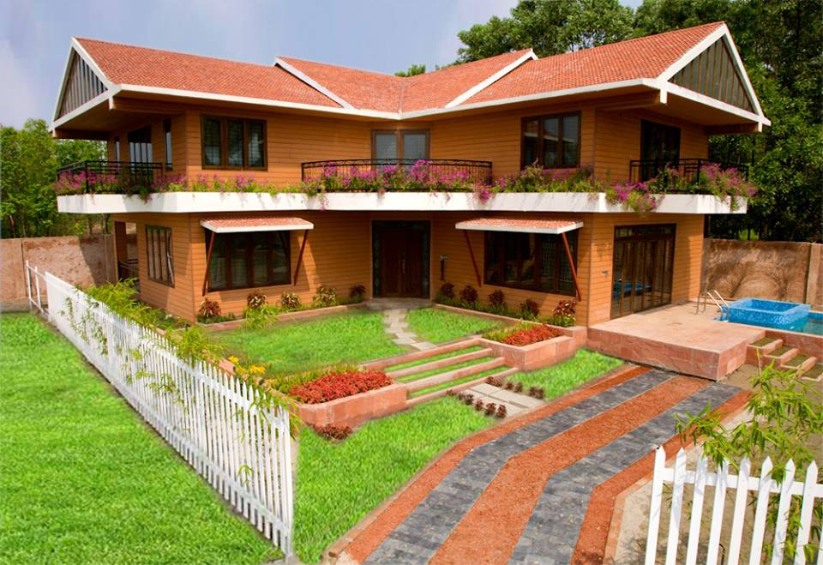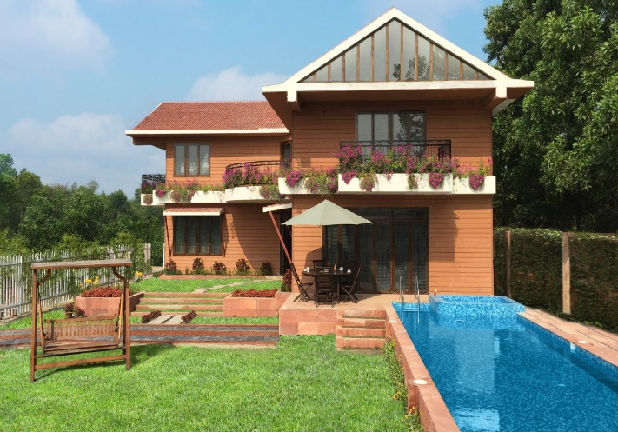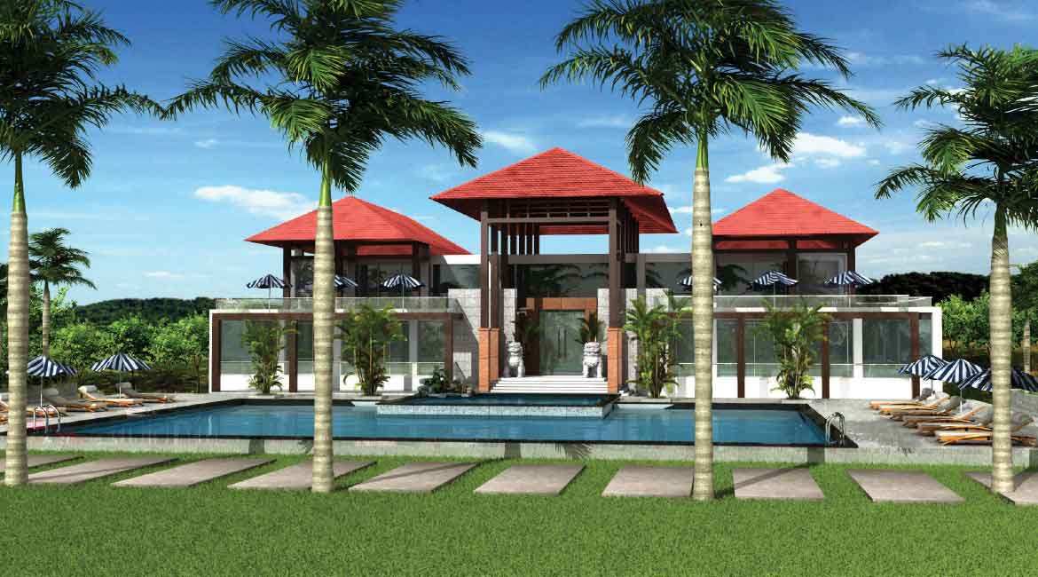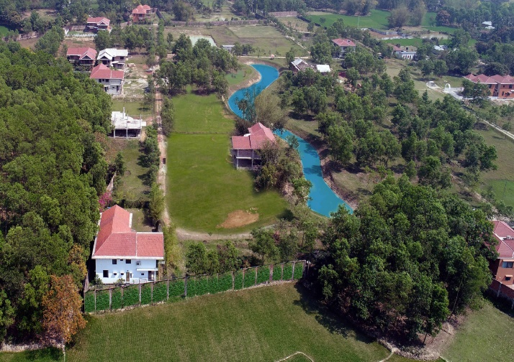

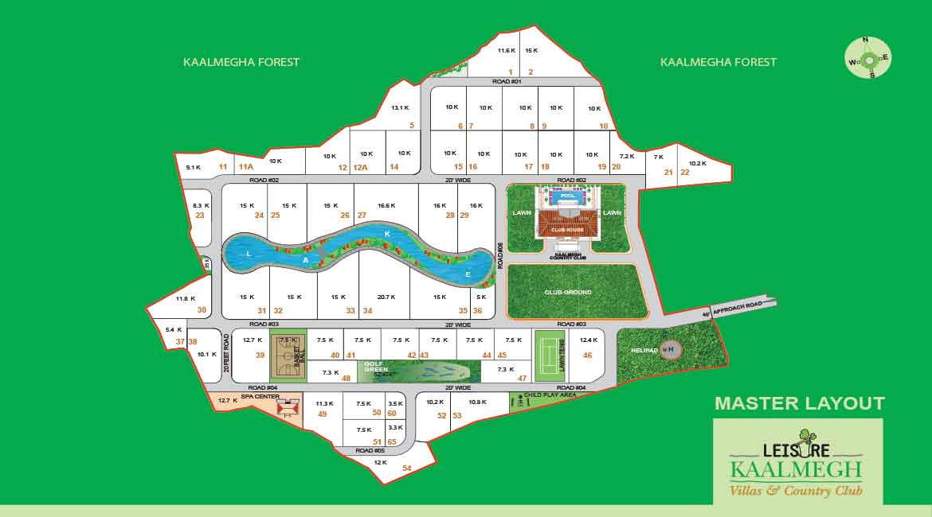Leisure Kaalmegh Villas & Country Club 1

Luxury Redefined in the Lap of Unspoiled Wilderness
Standing majestically on seventeen acres of abundant land, at the sting of Kaalmegha Reserve Forest in Sreepur, Gazipur, 'Kaalmegh Villas and Country Club' may be a masterpiece in each sense of the word. This avant-garde real estate venture offers fifty five luxurious pool villas with a spectacular Country Club at its Centre. While embracing the tranquil countryside, Kaalmegh offers unparalleled modern conveniences. Each villa comes with state-of-the-art amenities, a private swimming pool, raised lawn and manicured garden.
Kaalmegh Country Club, the heart of this one-of-a-kind walled community offers associated array of indoor and out of door facilities for the residents. A number chic restaurant to delight the most discerning palate, associate indulgent spa to rejuvenate the soul, a pleasant restaurant, associate Olympic size swimming pool, an incredible vary of indoor and out of doors sports and activities expect indulgence. Winner of prestigious Asia Pacific Property Awards 2013-14, Kaalmegh is luxury redefined within the lap of unspoiled wilderness.
The name itself defines the Super Luxury Villas at Kaalmegh Villas and Country Club. These impressive villas offer wonderful fusion of country living and foremost amenities geared toward a privileged few.
A sprawling lawn, huge private swimming pool, mirror polish tile, foreign Jacuzzi, private barbecue, 3 spacious balconies make sure that the homeowners of those luxurious villas area unit privileged within the true sense.
Our magnificent two- storied Luxury Villas offer private swimming pool, manicured lawn, and outdoor barbecue grill. These uniquely designed 3 bedroom villas allowing lovely stunning, ample day lightweight and fresh air.

Leisure Marina Sports Village-
Marina is the refreshing escape from the concrete jungle.
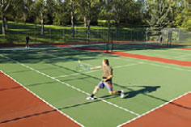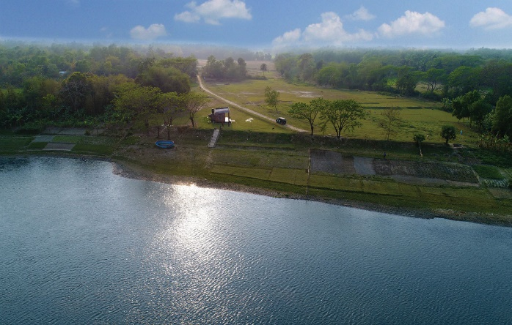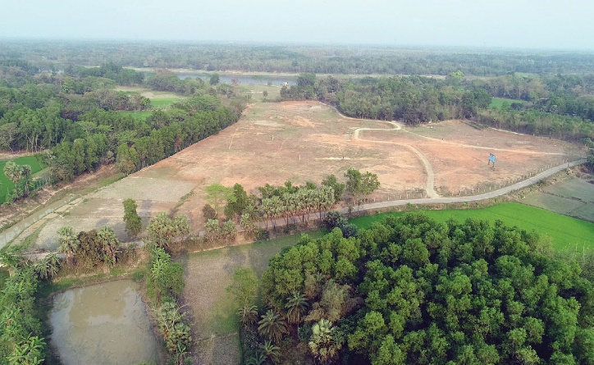
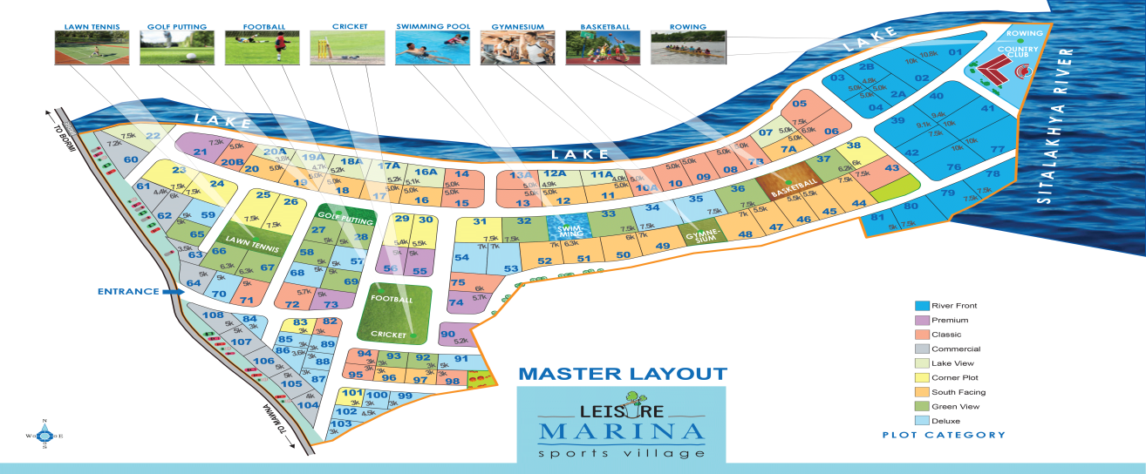
Leisure Marina Sports Village 1
Leisure Marina Sports Village, the first and only Sports Village in Bangladesh. Located on the River bank of Sitalakhya and conveniently connected to the Capital City by road, rail and river, Marina offers spectacular view of the mighty river. Leisure Marina offers an array of indoor and outdoor sports facilities such as Cricket and Football ground, Tennis Court, Golf Putting Green, Swimming Pool, Basketball & Badminton Court. A river-front Boat Club houses the indoor sports facilities such as Pool Table, Table Tennis and Board Games. An Amphitheatre and Gymnasium further add to the numerous facilities at the project.
This unique venture embodies 96 plots in 4 different sizes. A huge swimming pool, well equipped gym, a delightful golf putting green, tennis and basketball court, football field-cum-cricket ground are few of the sports facilities available for the plot owners. An amphitheater and Boat Club with rowing boats build the image complete.
Leisure Wood Land –
Leisure Woodland has revolutionized Bangladesh Real Estate Industry by returning the possession of the plots to their homeowners, even before the installment payments area unit over. The project area consists of 200 big has of undisputed land in Sreepur, Gazipur with 9 categories of plots in 4 different sizes ranging from 4 to 10 Katha’s. Leisure Woodland is designed to supply common facilities like school, lake, park, shops, fishing pond, and mosque and club house for the plot homeowners.
Project has already been handed over in December 2017.
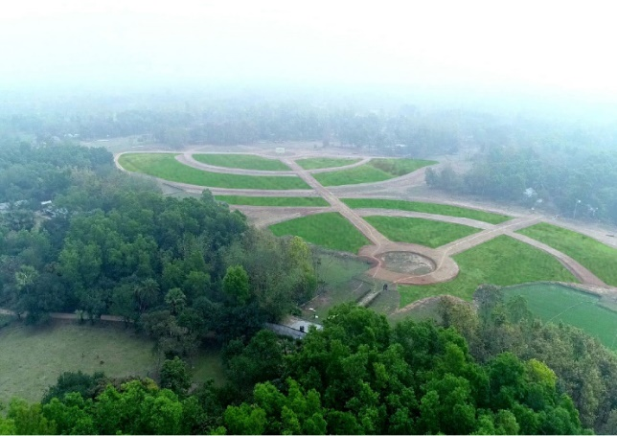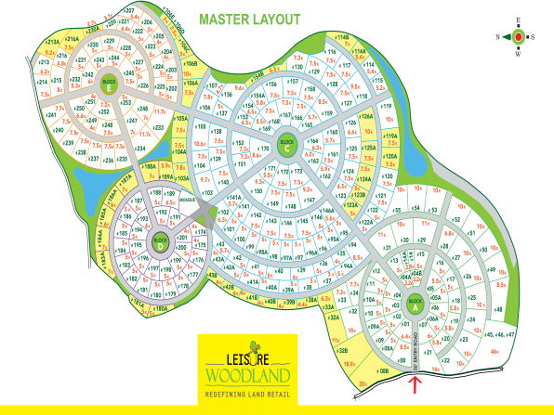
Leisure Innocent –
Leisure Innocent is a Strategic Business Unit of LBL which produce fresh organic food. Now a days in Bangladesh, market food without formalin is inevitable. The main theme of Leisure Innocent is to make sure proper nutrition and healthy food to each home. We are heavily affected by the use of formalin. Leisure Innocent has taken the mission to secure our next generation.
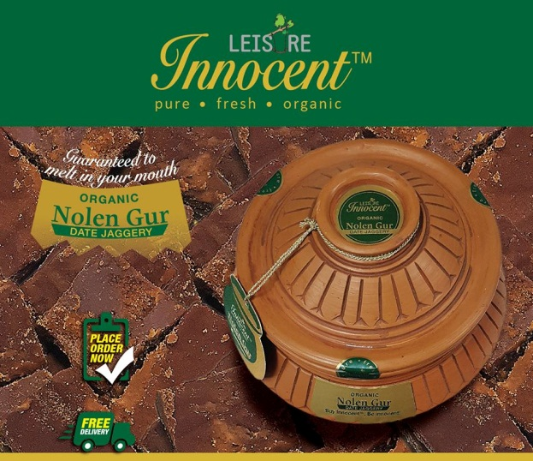
Leisure Bangladesh Limited has already planned about two new business project. These two are the restaurant and hotel. One of them situated in Inani beach in cox’s bazar, where people can enjoy their food and living in beach environment. Other one is an authentic bangle food restaurant which located in Gulshan-2 lawn area of head office.
Just Innocent Food, fresh and natural.
What wouldn't you do for the safety of your love ones, knowing that the food on our table is laced with toxic chemicals and pesticides that are dangerous to our health as well as our Environment?
Leisure Bangladesh is delighted to announce the launch of Leisure Innocent, our sister concern engaged in producing pesticide and preservative; free fresh vegetables in our own farm. No hormones, additives, flavor enhancers or chemical fertilizers have been used in the process of our production. We are also bringing different types of edible oil, organic honey and other fresh produce to the market.
Leisure Bangladesh is the pioneer in Lifestyle projects in Real Estate Arena. Safe, nutritious and tasty foods are essential for a healthy and happy lifestyle. Leisure Innocent has been conceived with this view in mind. It is our promise to deliver fresh and unadulterated food to your table.

3.7 Operation details
Leisure Bangladesh Limited basically operate two types of working process. One is construction for leisure Kaalmegh, Leisure Marina and Leisure woodland. Other one is production for Leisure Innocent.
3.7.1 Procurement – For Leisure Kaalmegh villas, Leisure Marina and woodland LBL first they purchase land. When top management think it needs to expand their project land area they again purchase and acquire new land. This is the part of procurement which they follow first.
3.7.2 Development – After purchasing land, in according to their master plan they start their construction work. They do land leveling, demarcation. Plotting, and road making.
3.7.3 Production – For Leisure Innocent based on season they make the decision which product they will produce and the time period of production. They prepare the land with help of the agriculture officer. They produce fruits, vegetables without harmful pesticide.
3.7.4 Marketing – When development work is running LBL marketing team start to do their job. They first promote those projects through social media with the help of IT department. Then they start to communicate with potential clients. They communicate with clients over phone and meeting with them. And make a site visit. It is a part of their operation policy. For Leisure innocent they promote their product on Facebook and take order through Facebook. There are two delivery boys. As a part of promotion, they do Facebook boosting regularly.
3.7.5 Finance – Leisure Bangladesh Limited run their construction and development work by the help of their own investment, bank loan and the installment which they get after selling plots, villas.
3.7.6 Civil construction – For Leisure Kaalmegh and Leisure Marina Sports City engineers who work in sites they play a role in operation. When a decision from top management is pending, demand and supply of materials does not match, it makes a problem to operate schedule work.
3.7.7 CSR:
A portion of the company’s profits goes towards the development of the society. Leisure Bangladesh Limited believes that if they can work together to make a better society today, tomorrow they will leave behind the best society for the future generations. The company understands that a powerful CSR program is an important part in achieving smart business practices and economical leadership.
Leisure Bangladesh Limited doing their CSR activities by producing pesticide and chemical free pure, fresh, organic food. Moving city people toward rural environment for refreshment.
Some of the formal and clear CSR activities under taken by LBL are:
- Tree Plantation
- Warm Clothing Give Away in Winter Season
3.9 SOWT Analysis:
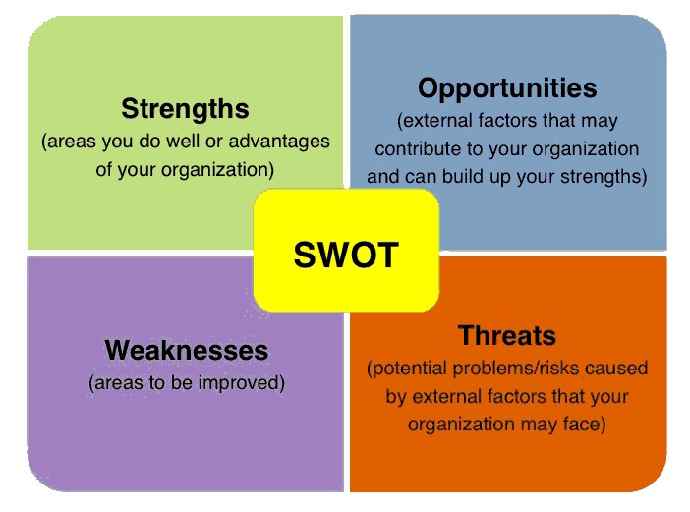

3.9.1 Strength:
- 1. Leisure innocent produce fresh organic foods.
- 2. Their Kaalmegh project plan is totally different than other commercial real estate companies.
- 3. Their Country Club is a master piece in sense of the word.
- 4. Leisure Marina Sports Village is the first and only sports village in Bangladesh.
- Attractive and innovative communication
- Strong advertisement and signature campaign

3.9.2 Weakness:
- Management system isn’t good enough
- Doesn’t follow or maintain the Integrated Marketing Communication (IMC).
- Seven Ps of service marketing are not strictly followed
- Leisure Bangladesh Limited has only one TVC

3.9.3 Opportunities:

- Engagement with Hotel, restaurant, and cafeteria (HORECA)
- Increase brand image through public relation.
- Create demand for higher SKU.
- Consumers are becoming more quality conscious.
- Papaya is another area Leisure innocent can make huge gains.
- Leisure Lifestyle are another area where Leisure Kaalmegh can earn profits.

3.9.4 Threat:
- Political and economic factors.
- Partial government Policies.
- High rate of competition.
- Competitor’s intensive activation with retailer.
- Strategic alliance of competitors with other brands.
- Market leader strong brand image.

3.10 Products STP:

3.10.1 Market segmentation: Marketing department observe and analyze the various factors and or the idea of this data the market is divided. The market analyzed on the idea of external threats and opportunities furthermore because the internal strengths and weakness and relying upon this the market is divided. The market segmentation is two categorized by;

3.10.2 Leisure Bangladesh Limited-
- Real Estate Agent
- Real Estate Company
- Real Estate Title & Development
3.10.2.1 Target Market: Gulshan and Bannani upper class people and middle class are the most important part of Bangladesh population. Leisure Bangladesh Limited reveals that upper class people are more likely to buy foreign and expensive products.
The target purchasers are often divided into broad categories:
A) Individual Prospective Luxury Villa Buyer
B) Lifestyle Projects of Kaalmegh
C) Individual Prospective Land Projects Buyer
3.10.2.2 Place: The Company Leisure Bangladesh Limited is conscious about their placing strategy. Leisure Bangladesh Limited targets a significance customer also target middle upper class purchasers. So these types of people need lifestyle projects in residential area. So think Most of the project of this company’s is, Kaalmegha Reserve Forest in Sreepur, Gazipur, River bank of Sitalakhya Sreepur, Gazipur.

3.10.3 Leisure Innocent-
- Specialty Grocery Store
- Fruit & Vegetable Store
- Organic Grocery Store
3.10.3.1 Target Market: Leisure innocent is targeted at health and concern people. The target market being where people don’t use chemical Hormone, Pesticide, Additives, Preservatives, and Flavor Enhancers. This particular targeting was significant when leisure innocent launched is about guilt free, organic & safe food. Leisure innocent was going for a broad market constituting of all the age groups.
3.10.3.2 Positioning: Leisure Bangladesh is delighted to announce the launch of Leisure Innocent- Organic & Safe food, our sister concern engaged in producing pesticide and preservative free fresh & 100% organic fruits & vegetables in our own farm. We are also bringing different types of edible oil, organic honey, khejurer gur and other fresh produce to the market which are absolutely organic in nature. Organic, safe, nutritious and tasty foods are essential for a healthy and happy lifestyle. Leisure Innocent has been conceived with this view in mind. It is our promise to deliver organic, fresh and unadulterated food to your table.
Geographic

Continent | Asia
Country | Bangladesh
City | Dhaka (Main Focus)
Size/Population | Approximately 16 cores
Demographic
Gender | Male and Female
Age | Basically 15 – 30, below 40
Income | Minimum 20000
Occupation | Mainly Students and other Businessman & Professionals
Psychographic
Social Class | Middle class, Upper middle class
Life style | Preferring Trendy, fusion, Fun, Fashionable, Choosey,
 | Always Foorti, General and tip top
Behavioral
User Status | Potential users, Regular users
Benefits | Better service and quality
Attitude | Positive

MARKETING MIX OF Leisure Bangladesh Limited:
3.11 Lifestyle Projects and Land Projects:
Leisure Bangladesh Limited, the pioneer in providing lifestyle projects in Bangladesh, provide you an chance to get back in touch with yourself and those you love. Leisure Bangladesh isn’t just providing you a property. It’s offering you lifestyle.
Ingredient
Leisure Kaalmegh Villas & Country Club,
Leisure Marina Sports Village,
Leisure Wood Land.

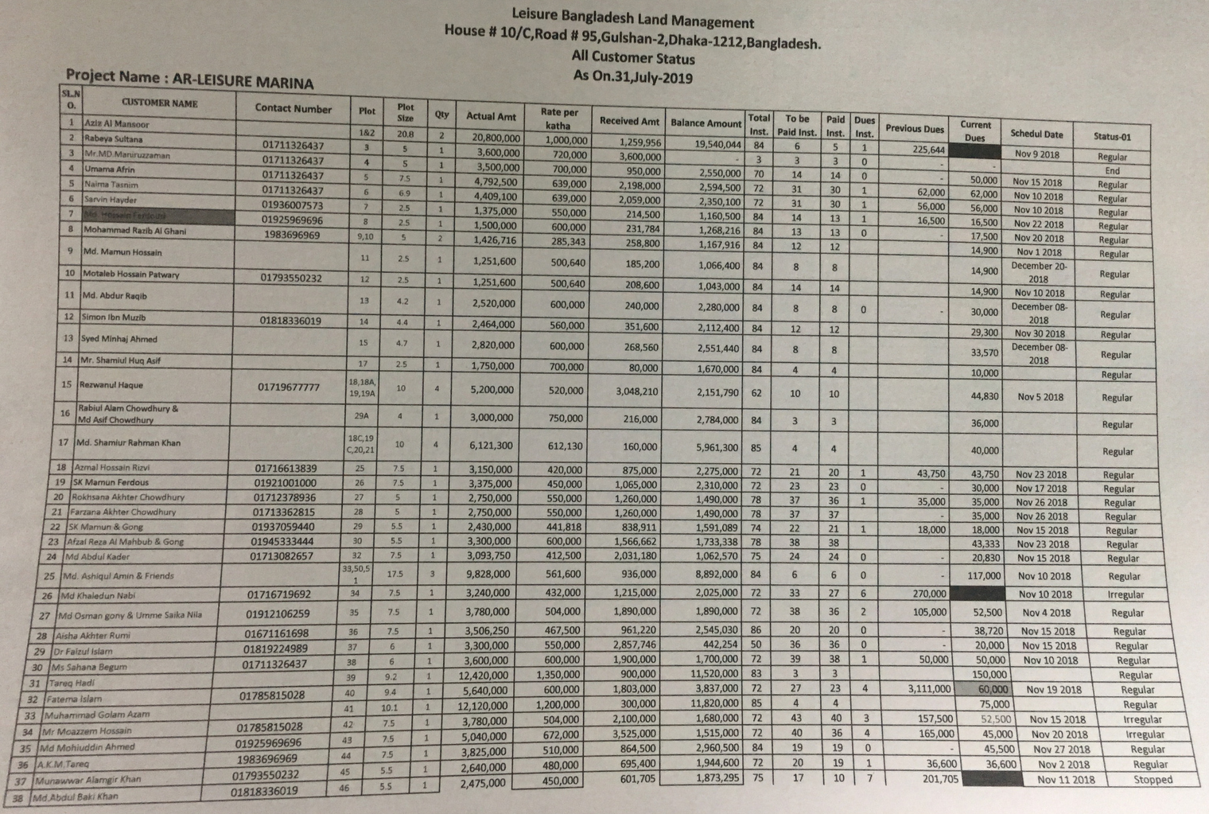
3.11.1 Price: Leisure Bangladesh Limited to practice value-based pricing in which the customers.

3.12 Leisure Innocent Products:
Leisure Innocent is provide 100% organic & safe food.
- Organic Khejurer Gur (DATE JAGGERY).
- Organic Red Lady Papaya.
- Organic Cauliflower
- Organic Long Beans
- Organic Banana
- Organic Lau (Bottle Gourd)
- Organic Cucumber
- Organic Pumpkin
- Organic Broccoli
- Organic Kalai Kumra Bori
- Organic Coconut Oil
- Organic Mustard Oil
- Organic Honey
- Organic Ghee
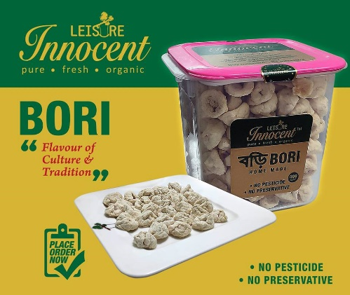

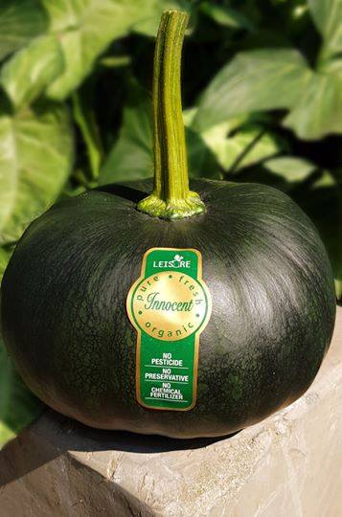



3.12.1 Price:
Some Products Price

Product Name | Weight | Price
Organic Khejurer Gur (DATE JAGGERY). | 2KG Hari | 900.00
Organic Red Lady Papaya | PER KG | 200.00
Organic Lau (Bottle Gourd) | PER PCS | 100.00
Organic Cucumber | PER KG | 100.00
Organic Pumpkin | PER PCS | 100.00
Organic Kalai Kumra Bori | 500gm Box | 480.00
Organic Mustard Oil | 900ml bottle | 470.00
Organic Mustard Oil | 450ml bottle | 270.00
Organic Ghee | 450gm jar | 880.00

3.11.2 Place:
Leisure Innocent system of distribution. That means company wholesaler, retailer consumer.
- It has created his strategy like that in e-commerce information processing system consumer square measure to verify the merchandise.
- Distribution network directly covers Menna bazar, Gourmet bazar, Rahimaafrooz agura and Unimart.
- Supply the products e-commerce site at Cookup.

3.11.3 Promotion:
- Build top of the line consumer’s awareness.
- Creating a personality of the braved.
- To increase the usage.
- Imparts a feeling of freshness
- Effectively communicate brand promise.

3.11.4 Promotional strategy:
- Media platforms used.
- Print media.
- Internet Campaign.
- Interned rural campaign.
- Environment concern ads.
- New product formulations according to changing consumer preferences.
- Advertising.
- Personal Selling
- Event
- TVC

3.13 Internship Experience/Observation Details

Job Responsibility
I started my internship at Leisure Bangladesh Limited on May 25th 2019. In the office, at the beginning I was introduced to the office and very soon I became familiar with the office culture. The first thing I learned was the office Organogram to know and understand how the entire organization, office and the project is run and managed by all the management level employees.
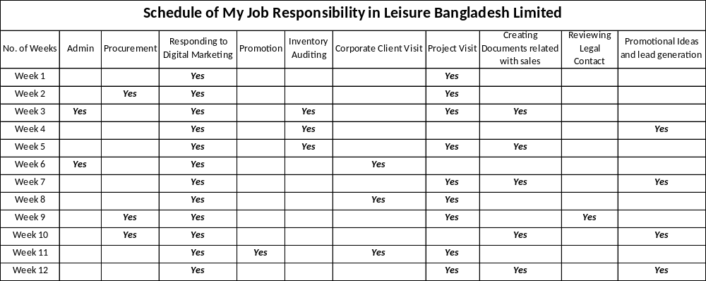
My Job Responsibility Schedule 1
As an intern I was given all the liberty to work freely in Leisure Bangladesh Limited. I was given specific tasks sporadically that were necessary for the department. Though out these twelve weeks I have worked with the Admin, Procurement, Legal and Sales & Marketing Department. I was assigned and supervised by the Head of Sales & Marketing Department.
With the Admin Department I have worked along with the Executive and did the whole stock inventory audit of our Head Office. Where I have recorded and counted all the materials, stationary, equipment’s and etc. Along with that I had supervised the Vehicle Requisition for 2 Days.
With the Procurement Department I worked along with the Procurement Manager and went to several places for rates and purchased different equipment’s needed for our project. I went to the market place, took rates from several stores and justified and sorted the best rate for the desired material.
With the Legal Department I worked with the Lawyer of Leisure Bangladesh Limited and assisted with the legal deed which are made for the clients. I assisted by updating the contact according to the requirement and preference of the clients.
With the Sales & Marketing Department I worked with the Senior Manager and Executive, where I maintained all the queries, replied to comments, promoted and made databases of the clients which came from Digital Marketing. I took clients to project visit and provided all the information need about the project. I have prepared documents needed for sales and gave several ideas for promotion and generating leads. I also went to several Corporate Client visit where I had to inform and make an appointment to project visit according to their preference.

3.14 Functions of the Department (Sales & Marketing Department)

3.14.1 Preparing Prospect for Leads
We cannot prospect effectively without knowing all about our projects and demand of the prospects as we currently have 3 running projects. If we don't understand the product, how could we know who will want to buy it?
3.14.2 Generate Leads
We use digital Marketing and for promotion which includes Google SEO, Facebook Boosting, creating bots and Emailing our prospect.

3.14.3 Getting back and setting an Appointment
We use those leads collected in stage 2, as the interested prospects provide us their contact information or they reach us. We provide them all the information regarding their interest and plan according if they are interested in visits to our project. Sometimes we prefer to cold call over the phone and send email or even mail out sales letters.

3.14.4 Qualify the Prospect
The qualification stage usually takes place at the appointment itself, although we can also qualify briefly during our initial contact. The idea is to confirm that your prospect is both able and potentially willing to buy our product.

3.14.5 Follow up and reminder
We call, remind and inform about the desired date the prospects were interested to visit our project and follow up with their interests.

3.14.6 Making the prospect visit our project
Our sales teams pick the prospect from their location at given desired time and takes them to the project for project visit.

3.14.7 Address the Prospect's Interest and act accordingly
Prospects has their own thoughts and interests, our sales team tries to interpret those thoughts and act according to their needs by providing them the desired land, size, payment flexibility, etc.

3.14.8 Close the Sale
Most of the prospects turn into potential clients after the project visit, therefore our sales team asks the clients to visit our office and go through the paper works and confirm their desired plot.

3.15 Other Departments

Chapter - FOUR
Findings and Analysis of the Study

4.1 Findings:
Personal Problems:
There are problems which should have to hinder me perform my task accordingly, the major problems are summarized as under:
Toward the start of this temporary job, the principal challenge I had was to know the new group. To know colleagues' conduct, their workplace, working condition, and how to deal with each colleagues' conduct. Along these lines, it was difficult to know how to communicate with some colleagues.
On the Sales & Marketing Executive position, all that you do should be performed with greatest speed keeping in mind the end goal to serve numerous clients and working with other clients in background. This makes an Executive not quite the same as others once he/she serves huge number of clients on consistent schedule, at the end of the day the clients don't care for deferring in being conveyed by administrations they have obtained. So subsequent to understanding this is a case I used to recognize the feasible answers for the issues which ought to block me to achieve my assignment in proficient way.

Organization’s Problems:
Leisure Bangladesh Limited does not follow or maintain the Integrated Marketing Communication (IMC) and as a result the customers does not know about their offerings and all other services provided by them. Whenever there is a new client, employees need to make them understand or tell them each and everything to make him/her to know about the organization. It is time consuming and at sometimes irritating too. The big prove of this is that Leisure Bangladesh Limited has only one TVC.
Seven Ps of service marketing are not strictly followed. Seven Ps of marketing are product, price place, promotion, people, process, people, process, physical evidence/environment. To provide service to people, one should strictly follow the seven Ps of service marketing. As a result of not doing that positioning has been hampered and as a result less attracted towards customers.

According to BCG Matrix
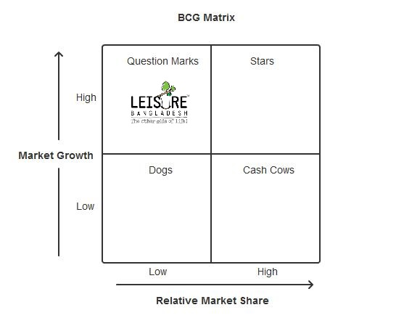
BCG Matrix 1
According to my observation, Leisure Bangladesh Limited should be in Question Mark in BCG Matrix. Question Marks require careful analysis to determine whether or not they are worth the investment required to grow their market share, as the concept of Leisure Bangladesh Limited is different and unique than that of other real estate company of our country.
It is essential to define how much investment the organization is prepared to allocate to a Question Mark product in order to gain market share. This type of decision requires more sophisticated analysis than the Boston Matrix can offer and an organization may need to invest heavily to transform a Question Mark product to Stars or Cash Cows.

4.2 Analyze of the study:
From significant companies to independent companies, bouncing on another pattern without thought for the integrated marketing communication (IMC) technique is a typical event. Each time this happens (Kareh, 2017).
Having an IMC technique is the contrast between publicizing deliberately and lucking out. A compelling IMC will diagram a center message, feature your upper hand, address the proper target market, and tailor the message to fit strong media channels. Basically, the message stays steady, yet the technique for conveyance will change crosswise over stages. (Wertz, 2017)
Having a coordinated showcasing correspondences technique is the way toward opposing a littler yet quick association with a specific end goal to get a more grounded or all the more persevering relationship later. Advertising resembles a session of chess, which isn't won in a solitary move; system and condition likewise add to the result.
The 4 Ps, containing item product, price, place & promotion are the 4 basic mainstays of each promoting technique. Notwithstanding, the unmistakable attributes of administrations requires the expansion of three more Ps – people, process & physical evidence. This is fundamental as administrations contrast unequivocally from items in their inclination: perspectives, for example, client inclusion underway and the significance of the time factor require that extra key components are incorporated to yield a comprehensive promoting blend for administrations.
Each of these three extra Ps is of central importance in services. They all refer to criteria that customers rely on in judging the quality and overall image (Claessens, 2018)
Buyers settle on decisions in the commercial center based on perceptual item properties that can be impacted by different factors under the association's control, for example, item plan and promoting blend of the item. This audit proposes that a firm ought to enhance its objectives concerning item qualities and afterward make an interpretation of these properties into item attributes and levels of promoting blend factors (Kaul & Rao, 1995)
A routine with regards to proactive occupation investigation was firmly identified with hierarchical execution. This relationship was most grounded to the degree that organizations kept up HR data frameworks, concurred HR more prominent inclusion in key arranging and stressed competency-based attributes of workers in the activity investigation approaches they utilized. The discoveries propose that a far-reaching approach of occupation examination is an imperative wellspring of upper hand in its own particular right, and merits due consideration of HR experts, line supervisors and best administration (Siddique, 2007)
The HR Scorecard focused on the long-range outcome of helping each organization to achieve its strategies and objectives in an effective and efficient way. It did this by helping develop a better “fit” between HRM's systems, procedures and practices and what various line departments needed (Cunningham & Kempling, 2011).
Tremendous rivalry and constant increment in cost of generation is driving associations toward cutting back, cutbacks and rebuilding thus representatives need to complete a great deal of work as contrast with before as extra workload is added to their duties. Today to accommodate a business need job enlargement is used to enhance employee's scope and workload. That need can be to increase skills of handling new customer or it can be an industry requirement, or to offset lack of resources due to lack of hiring or high turnover (Hellgren & Sverk, 2011).
Job enrichment is one of the cherished goals to achieve individual performance. It is essential to understand how job enrichment is a valuable tool for managing and fostering the successful employee performance. Enriched job consists of various elements like task significance, task identity and skill variety which improves the performance of employees and motivates them to perform jealously (Vijay & Indradevi, 2015).

Chapter - FIVE
Conclusion and Recommendations

5.1 Recommendation
I realized these problems stated above by seeing the customers and also the employees facing problems while serving or giving service and receiving service. At the first place, Leisure Bangladesh Limited needs to be more active in their marketing policies. Many people are not aware about all the services provided by the organization. Very beginning Leisure Bangladesh Limited needs to follow the principles of IMC as stated above in the report and also think about the positioning of their products and constantly maintain communication with their research and development wing to improve their service line up. It will also increase employee efficiency.
To maintain employee satisfaction, their HR department needs to be more active. To look over constantly about what all the employees want. As the world is moving competition is also increasing and companies also increasing day by day. So, making an acceptable offer towards the employees is the duty of the HR department. Which will bind the employee with organization for a long time and will increase efficiency and as a result the bank will get the competitive advantage.

5.2 Conclusion:
Internship provides a great deal, major advantages to the student or intern in general. It reveals the student’s real standard concerning his/her skills and competence on the intellectuals’ scene. According to considerable tasks that I carried out in Leisure Bangladesh Limited the experience I got, has contributed a lot to the adjustments of theoretical knowledge accumulated all among my academic studies. It is also important to remind that the internship reveals to the students various challenges and realities of the professional work in which he/she will enter in coming days. Therefore, as future managers, they know how to plan for future functioning of the organization. But there are also limitations in internship. At the first-place internship students are not a full-time employee and as a result there are few limitations like access to the organizations network or server, do not having a personal account to use the organizations personal software. At any time if I need to do any kind of work I have to go to someone else’s desk to seek help from them. Another very important thing is the short timing. Three months is not enough to learn an organization’s all the workings and also training is a necessity for all the intern students. Without proper training it is very difficult for someone new like me to keep all the information in memory. And finally, what we had learned throughout our whole under graduation studies in books. It is very difficult to implement them practically.
Organizations need to be more supportive towards their interns to encourage them and help them to improve their skills. To support them an organization should offer flexible work opportunities, create an intern-specific referral program, schedule register check-ins, conduct exit interviews, be selective, communicate beyond the 10-6, hold them accountable and play up the culture.
As mentioned above about some of the organizational problems and their solutions those might create a positive push for the organization but there might be some negative impact too. While implementing those theories LBL might face problem as there are a lot of difference in practical life and book learnings. Implementing these would be a big challenge because LBL needs to reorganize their whole system. And as result it will hamper their work flow and resulting toward facing a downfall in their profit maybe facing loss too. But implementing them might be helpful for LBL as well in the long run too.

Chapter - SIX
Appendix

References
Books:
Claessens, M. (2018). Marketing Mix for Services – 7 Ps of Integrated Service Marketing. Marketing Explained.
Keller Lane Kevin. Strategic Brand Management.4thed. United States: Pearson education, 2013
Kareh, A. (2017). Seven Steps To A Better Integrated Marketing Communications Strategy. Forbes Agency Council.
Kaul, A., & Rao, V. R. (1995). An integrative review. Research for product positioning and design decisions, 293-320.
Article:
https://www.duplichecker.com/article-rewriter.php

Referencing of website:

- https://www.leisurebd.com/
- https://www.linkedin.com/company/leisure-bangladesh-ltd-
- https://www.facebook.com/leisureinnocent/
- https://www.thebalancesmb.com/marketing-strategy-for-home-business-success-1794314

