

Internship Report
“Casting a Digital 'Lighthouse': Revolutionizing Sales Data Management at Nestle Bangladesh PLC for Data-Driven Success”



Submitted to
Dr. Khandoker Mahmudur Rahman (KMR), Ph.D.
Professor & Director
BBA and BBA in AIS Programs
United International University

Submitted by
Muhammad Ullah Sajid
Student ID: 111 192 083

16th September 2023
Letter of Transmittal

16th September 2023
Dr. Khandoker Mahmudur Rahman (KMR), Ph.D.
Professor & Director
BBA and BBA in AIS Programs
United International University
United City, Madani Avenue, Badda, Dhaka 1212.

Dear Sir,

I am writing to formally submit the comprehensive report on "Project Lighthouse" and my role as a Commercial Development Intern at Nestle Bangladesh PLC. This report encompasses detailed insights into the project's objectives, phases, timelines, and benefits, as well as an overview of my role within the organization.

As the sole intern dedicated to "Project Lighthouse," my responsibilities included supervising pilot testing activities, leading and guiding the Digital Image Recognition (DIR) field operators, facilitating communication with the Nestle Global team, and overseeing progress through the backend console. I also actively contributed to cross-functional teams, engaged in focus group discussions for different brands, participated in content creation and ideation, and collaborated with other projects across the organization. Additionally, I played a significant role in making strategic implementations to enhance brand visibility through point of purchase materials.

This report provides a comprehensive account of the project's objectives, phases, and benefits, offering a detailed analysis of each aspect. It also highlights my contributions and the value I have added to Nestle Bangladesh PLC during my internship.

I would like to express my gratitude to the entire team at Nestle for providing me with this invaluable opportunity to contribute to such a groundbreaking project and gain priceless experiences. It has been an enriching and educational journey that has further fueled my passion for pursuing a career in commercial development and marketing.

I am confident that the insights and recommendations outlined in this report will be of great value to the organization.

Sincerely,
Muhammad Ullah Sajid
ID: 111 192 083

Acknowledgements

I would like to express my heartfelt gratitude to the individuals and teams who have supported and guided me throughout my internship at Nestle Bangladesh PLC and the completion of this report.
First and foremost, First and foremost, I would like to express my gratitude to Dr. Khandoker Mahmudur Rahman, honorable supervisor, United International University, I extend my sincere appreciation to Mr. SM Sakibur Rahman, Executive
POP Excellence- CDT at Nestle Bangladesh for providing me the chance to be a part of the team and for providing me with the opportunity to contribute to "Project Lighthouse" and for their continuous guidance and support throughout this endeavor.
I would like to acknowledge the invaluable assistance and mentorship provided by the Nestle Global team, who have been instrumental in addressing the technical aspects of the Digital Image Recognition (DIR) issues.
My sincere thanks go to my colleagues and fellow interns at Nestle for their camaraderie and collaboration. Your insights, feedback, and shared experiences have greatly enriched my learning journey.
I am deeply grateful to the Commercial development team for their support and mentorship during my internship, and for involving me in various projects and activities that have contributed to my professional development.
Special thanks to the field operators and teams involved in the pilot testing of "Project Lighthouse." Your dedication and hard work have been pivotal in the success of this project.
Lastly, I want to express my appreciation to my family and friends for their unwavering support, encouragement, and understanding during this internship journey.
This experience has been both educational and transformative, and I am sincerely thankful to everyone who has played a role in making it possible.

Executive Summary

This report provides a comprehensive overview of "Project Lighthouse" and outlines the role of the Commercial Development Intern at Nestle Bangladesh PLC. "Project Lighthouse" stands as one of Nestle's most revolutionary and impactful initiatives, aimed at digitizing and revolutionizing traditional sales data management through the power of real-time data and digital image recognition (DIR) technology.

Project Lighthouse Overview:
Purpose and Objectives: "Project Lighthouse" seeks to transform sales and marketing by shifting from intuition-based decision-making to data-driven insights. Its primary objectives include enhancing sales and marketing effectiveness and enabling real-time data-driven decision-making.
Phases: The project is organized into six key phases, from master data compilation to a full rollout of dedicated smartphones for distributor sales representatives.
Timeline: "Project Lighthouse" commenced in February 2023 and is scheduled to go live on November 1st, 2023, marking a significant milestone in Nestle Bangladesh PLC's journey towards data-driven excellence.

Commercial Development Intern's Role:
As the sole intern dedicated to the project, the Commercial Development Intern assumes a multifaceted role:
Supervision of Pilot Testing: Responsible for overseeing the pilot testing activities, guiding and leading DIR field operators, and ensuring the smooth execution of data capture processes.
Cross-Functional Collaboration: Actively engages with cross-functional teams, participating in focus group discussions, content creation, ideation, and collaboration with other projects across the organization.
Strategic Brand Visibility: Contributes to strategic implementations aimed at enhancing brand visibility through point of purchase materials.

Benefits and Conclusion:
The report highlights the benefits of "Project Lighthouse," including distributor excellence, new product development, investment efficiency, and customized activities. It emphasizes the project's contribution to Nestle's commitment to data-driven excellence in sales and marketing.
In conclusion, this report not only provides a comprehensive analysis of "Project Lighthouse" but also underscores the pivotal role played by the Commercial Development Intern. It outlines the multifaceted responsibilities, contributions, and the added value to Nestle Bangladesh PLC. This internship has not only been an educational experience but also a journey of personal and professional growth, setting the stage for a promising future in the field of commercial development.
Table of Contents
Chapter 1: Background 6
1.1 Introduction 7
1.2 Rationale of the study 8
1.3 Origin 9
1.4 Objective 9
1.5 Scope of the report 10
1.6 Scope of the report 11
1.7 Limitations 13
Chapter 2: Organizational Overview 14
1.1 History 15
1.2 Nestlé Global 16
1.3 Nestle Bangladesh 16
1.4 Products and Services 17
1.5 Corporate Social Responsibility 18
1.6 Awards and Recognition 18
1.7 Commitment to Quality and Nutrition: 18
Chapter 3: Project Lighthouse 19
1.1 The partner: Exceedra by telus 20
1.2 My role as an intern 21
1.3 About the Project 21
1.4 Where are we? 22
1.5 Digital image recognition 22
1.6 Key benefits if done successfully 24
Chapter 4: The landscape of AI in FMCG 25
4.1 Scope of Artificial intelligence in FMCG 26
How AI is transforming the FMCG sales and distribution landscape 26
4.2 The Future of Ai in FMCG/Retail 27
4.3 Challenges 28
4.4 The AI use cases & Leaders paving the way forward 29
4.5 Unilever 30
Chapter 5: Nestle Bangladesh revolutionizing sales 32
5.1 Digital image recognition (DIR) 33
5.2 Purpose and Objectives 33
5.3 Project Phases 33
5.4 Project Timeline 35
5.5 Project Implementation 35
5.6 Project Benefits 38
Chapter 6: Findings & Observations 39
6.1 Accuracy report 40
6.2 High Accuracy Products (Accuracy > 90%) 42
Moderate Accuracy Products (Accuracy between 70% and 90%) 44
Low Accuracy Products (Accuracy below 70%) 44
6.3 Analysis 45
6.4 Sample photos from which the data is generated 46
Chapter 7: Conclusion & Recommendations 47
7.1 Recommendations 48
References 49

Chapter 1: Background




Click her to skip to Chapter 2: Organizational Overview

1.1 Introduction
The fast-moving consumer goods (FMCG) industry has long been a powerhouse of global commerce, providing essential products to consumers on a daily basis. In recent years, this industry has undergone a profound transformation, driven by the relentless march of technology. One of the most significant technological advancements shaping the FMCG landscape is artificial intelligence (AI). This report delves into the impact and implementation of AI in the fast-moving consumer industry, with a specific focus on Nestlé Bangladesh PLC.
Nestlé, a name synonymous with quality and innovation, has been at the forefront of leveraging AI to enhance its operations, streamline supply chains, and deliver products that meet the evolving preferences of consumers. Nestlé Bangladesh PLC, a subsidiary of the global food and beverage giant, is no exception. As consumers increasingly demand more personalized, sustainable, and convenient products, the adoption of AI technologies has become not just a strategic advantage but a necessity for companies operating in this competitive arena.
This report serves as an exploration of Nestlé Bangladesh PLC's journey into the world of artificial intelligence, shedding light on the strategies, technologies, and outcomes of their AI initiatives. Through an in-depth analysis of Nestlé's AI applications, challenges faced, and the lessons learned, this report aims to provide valuable insights into how AI is reshaping the FMCG industry and driving business success.
By examining the role of AI in optimizing operations, improving product innovation, enhancing customer experiences, and addressing sustainability concerns, this report underscores the significance of AI as a transformative force in the FMCG sector. Additionally, it showcases the potential benefits and challenges faced by companies like Nestlé as they navigate the complex landscape of AI integration.
In an era where data-driven decision-making and automation are paramount, Nestlé Bangladesh PLC's experiences with AI offer valuable lessons for both industry peers and stakeholders seeking to harness the potential of artificial intelligence to thrive in a rapidly evolving market. This report seeks to inform, inspire, and provide a comprehensive understanding of AI's impact on the FMCG industry, with Nestlé Bangladesh PLC serving as a compelling case study in this dynamic and exciting journey of technological advancement.

1.2 Rationale of the study
The fast-moving consumer goods (FMCG) industry is experiencing a profound technological transformation, with artificial intelligence (AI) emerging as a driving force of change. This study is motivated by the need to understand and analyze the impact of AI within this industry, with a specific focus on Nestlé Bangladesh PLC.
Problem Identification: In recent years, the FMCG sector has faced escalating challenges, from consumer demands for personalization and sustainability to heightened competition. To thrive in this dynamic landscape, companies must adapt rapidly and strategically. AI has emerged as a potential solution to address these challenges, yet its implementation and impact require examination.
Relevance: The relevance of this study lies in the crucial role that AI now plays in the FMCG industry. The timeliness of this research is underscored by the increasing importance of AI-driven innovations in optimizing operations, meeting consumer preferences, and fostering sustainability.
Research Questions/Objectives: This study seeks to answer several key questions:
- How is Nestlé Bangladesh PLC leveraging AI technologies in its operations?
- What challenges and opportunities does AI present in the FMCG sector?
- How can the experiences of Nestlé Bangladesh PLC inform broader discussions on AI adoption within this industry?
Gap in the Literature: While there is a growing body of literature on AI in various industries, there is a notable gap regarding its specific applications and impacts within the FMCG sector. This study aims to address this gap by providing a comprehensive analysis centered on Nestlé Bangladesh PLC.
Practical/ Theoretical Significance: Understanding the practical implications of AI adoption by Nestlé Bangladesh PLC and its theoretical contributions to the broader discourse on AI in the FMCG sector are crucial. This research will shed light on how AI technologies can enhance operational efficiency, drive product innovation, improve customer experiences, and address sustainability concerns in the industry.
Expected Outcomes: The anticipated outcomes of this study include valuable insights into the strategies, challenges, and successes of Nestlé Bangladesh PLC in implementing AI solutions. Additionally, it will provide a roadmap for other FMCG companies looking to harness AI's potential for competitive advantage and sustainability.

1.3 Origin
This internship report on the integration of artificial intelligence (AI) within the fast-moving consumer goods (FMCG) sector is born out of a profound curiosity and a deep-seated passion for exploring the transformative potential of cutting-edge technology in one of the world's most dynamic industries.
The journey to conceive and undertake this report began with a recognition of the pivotal role that AI is increasingly playing in shaping the FMCG landscape. The realization that AI has become not merely an option but a strategic necessity for companies like Nestlé Bangladesh PLC and others in the FMCG industry sparked a desire to delve deeper into this evolving paradigm.
As an intern within the FMCG sector, the daily exposure to the industry's challenges and opportunities, coupled with the rapid advancements in AI, provided the impetus for this research endeavor. The desire to bridge the gap between theoretical understanding and practical application of AI within the FMCG realm became the driving force behind this report.

1.4 Objective
General Objective: The general objective of this internship report is to comprehensively examine the role and impact of artificial intelligence (AI) in the FMCG sector, with a focus on Nestlé Bangladesh PLC. It aims to provide a holistic understanding of how AI technologies are shaping the FMCG industry and contributing to operational efficiency, innovation, customer satisfaction, and sustainability.
Broad Objectives:
- To investigate the strategies and approaches employed by Nestlé Bangladesh PLC in integrating AI technologies into its operations.
- To assess the challenges and opportunities presented by AI adoption in the FMCG industry, considering both global trends and local market dynamics.
- To analyze the practical implications of AI in optimizing supply chains, enhancing product innovation, improving customer experiences, and addressing sustainability concerns within the FMCG context.
- To explore the theoretical contributions of AI adoption in the FMCG sector, providing insights into its potential long-term effects on business models and industry dynamics.

Specific Objectives:
- To examine the specific AI applications utilized by Nestlé Bangladesh PLC, including areas such as demand forecasting, inventory management, and customer analytics.
- To identify the key challenges faced by Nestlé Bangladesh PLC during the implementation of AI solutions, such as data privacy concerns, talent acquisition, and integration with existing systems.
- To evaluate the outcomes of AI integration, including improvements in operational efficiency, product development cycles, customer satisfaction metrics, and sustainability practices.
- To provide actionable recommendations based on the experiences of Nestlé Bangladesh PLC and industry best practices for other FMCG companies seeking to harness AI's potential for competitive advantage and sustainability.
These general, broad, and specific objectives collectively guide the research and analysis conducted in this report, aiming to offer a comprehensive exploration of the AI-driven transformation in the FMCG industry, with Nestlé Bangladesh PLC as a central case study.

1.5 Scope of the report
This internship report centers on the pivotal partnership between Nestlé and Exceedra, which harnesses computer vision, machine learning, and artificial intelligence (AI) technologies to revolutionize the fast-moving consumer goods (FMCG) industry, with a primary focus on the Canadian market. The scope of this report encompasses a multifaceted examination of the partnership's implications, applications, and anticipated benefits, both in the context of Nestlé's operations and the broader retail industry landscape.
Key Elements of the Scope:
- Partnership Overview: The report will provide a comprehensive overview of the collaboration between Nestlé and Exceedra, emphasizing the integration of computer vision and machine learning technology to analyze in-store shelf photos. This technology aims to generate data pertaining to product placement, including facings, shelf location, and packaging condition.
- Data Utilization: A critical aspect of the report's scope involves delving into how Nestlé intends to utilize the data generated by Exceedra's AI-driven technology. This includes insights into how Nestlé plans to optimize product placement and enhance marketing campaigns based on the data analysis.
- Benefits for Nestlé: The report will elucidate the specific benefits Nestlé anticipates from this partnership, including but not limited to:
- Enhanced Product Visibility: Nestlé aims to use the data to identify underperforming stores and improve product placement through adjustments in facings and shelf space.
- Increased Sales: By improving product visibility and accessibility, Nestlé expects to drive increased sales, as consumers are more likely to purchase products that are prominently displayed.
- Cost Reduction: Nestlé plans to leverage the data to identify products that aren't performing well and may discontinue them in certain stores, leading to potential savings in inventory and transportation costs.
- Significance in Retail Industry: The scope encompasses an analysis of the broader implications of this partnership, illustrating how it represents a significant development in the use of machine learning and AI in the retail sector. It highlights the evolving recognition among major retailers of the value these technologies bring to their operations.
- Future Adoption: The report will discuss the potential influence of this partnership on the broader retail landscape, paving the way for other retailers to explore similar AI-driven technologies to enhance their own operations.
In sum, this report will serve as a comprehensive exploration of the Nestlé-Exceedra partnership's significance, its applications in improving product placement and marketing, and the potential benefits for Nestlé, all while shedding light on the broader implications for the retail industry.

1.6 Scope of the report
As the author of this internship report, I embarked on a methodical research journey to comprehensively examine the partnership between Nestlé and Exceedra, focusing on the integration of artificial intelligence (AI) technologies within the fast-moving consumer goods (FMCG) industry. The methodology employed for this report encompassed several key steps and approaches:
1. Literature Review:
- Exploration of Relevant Literature: To establish a strong foundation for the research, I conducted an extensive review of academic articles, industry reports, and reputable sources related to AI applications in the FMCG sector, retail industry trends, and case studies on technology-driven partnerships.
- Identification of Key Concepts: This phase involved identifying key concepts, terminologies, and theoretical frameworks relevant to AI in retail and the specific applications explored in the Nestlé-Exceedra partnership.

2. Data Collection:
- Primary Data: While this report is primarily based on secondary research, I gathered primary data through my role of leading the pilot phase of implementing the technology. I have visited the market regularly, consulted and collected data from all the stakeholders, about their perspective on the implementation of technology of such sophistication in context of Bangladesh.
- Secondary Data: A significant portion of the data was collected from secondary sources, including company reports, press releases, academic journals, industry publications, and reputable online platforms. This information formed the basis for the analysis and case study.
3. Case Study Analysis:
- In-Depth Examination of the Partnership: I conducted an in-depth analysis of the Nestlé-Exceedra partnership, examining the specific technologies employed, the objectives of the partnership, and the strategies employed by Nestlé to leverage AI-generated data.
- Data Interpretation: The data generated by Exceedra's technology, as well as related data on product placement and marketing, were interpreted to extract meaningful insights and trends.
4. Conclusion and Recommendations:
- Synthesis of Findings: The methodology culminated in the synthesis of findings from the case study, primary data, and secondary research. These findings were used to draw conclusions about the partnership's impact and significance.
- Recommendations: Based on the analysis, I formulated practical recommendations for Nestlé and other FMCG companies considering similar technology-driven partnerships.
7. Ethical Considerations:
- Data Privacy and Confidentiality: Throughout the research process, ethical considerations were paramount. All data collected were treated with confidentiality and in compliance with applicable data protection regulations.

1.7 Limitations
1. Scope and Generalizability:
- Single-Case Study: The primary case study focused exclusively on Nestlé Bangladesh PLC's implementation of AI technology. This narrow focus limits the generalizability of findings to other FMCG companies with potentially different operational structures and market dynamics.
2. Data Availability:
- Data Collection Challenges: The success of the field pilot testing and data collection was subject to external factors, such as the availability of data gathering tools, technical and confidentiality issues of Nestle, and cooperation from retail stores and distributor partners. Data availability may vary in different settings.
4. Data Quality:
- Data Accuracy: Despite rigorous quality assurance measures, there is a possibility of inaccuracies or discrepancies in the AI-generated data or during manual observations, which may impact the reliability of the findings.
5. External Factors:
- Market Variability: The FMCG industry is influenced by various external factors, such as economic conditions, consumer preferences, and competitive forces. These external factors are beyond the scope of this study but can significantly affect the effectiveness of AI technology in different contexts.
6. Implementation Challenges:
- Organizational Adaptation: The report primarily focuses on the technology itself, but the successful implementation of AI within an organization also depends on factors such as employee training, change management, and cultural adaptation, which are beyond the scope of this study.
7. Short-Term Perspective:
- Limited Timeframe: The study primarily captures short-term impacts and outcomes of the AI technology implementation. Long-term effects and sustainability were not within the scope of this internship report.

Chapter 2: Organizational Overview
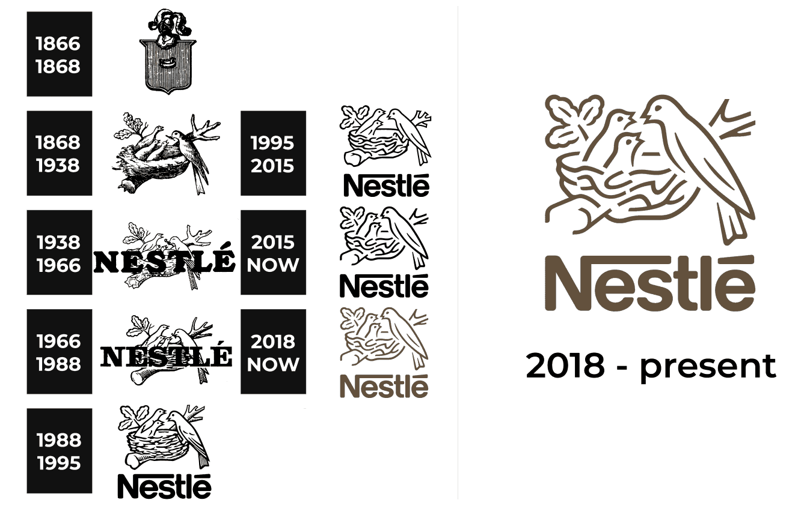



1.1 History
- 1866: The Anglo-Swiss Condensed Milk Company is founded in Cham, Switzerland by brothers George and Charles Page.
- 1867: Henri Nestlé, a German-born pharmacist, develops Farine Lactée Henri Nestlé, a baby food made from cow's milk, wheat flour, and sugar.
- 1905: The Anglo-Swiss Condensed Milk Company and Farine Lactée Henri Nestlé merge to form Nestlé and Anglo-Swiss Condensed Milk Company.
- 1929: Nestlé acquires the Maggi company, a Swiss food company known for its bouillon cubes and seasonings.
- 1938: Nestlé acquires the Carnation Company, a US food company known for its evaporated milk and condensed milk.
- 1947: Nestlé changes its name to Nestlé Alimentana SA.
- 1977: Nestlé acquires the Alcon Laboratories, a Swiss pharmaceutical company.
- 1988: Nestlé acquires the Rowntree Mackintosh company, a British confectionery company known for its Kit Kat and Smarties brands.
- 1998: Nestlé acquires the Gerber Products Company, a US baby food company.
- 2005: Nestlé celebrates its 100th anniversary.
- 2010: Nestlé acquires the DiGiorno Pizza company, a US frozen pizza company.
- 2017: Nestlé acquires the Starbucks Coffee Company's liquid coffee business.
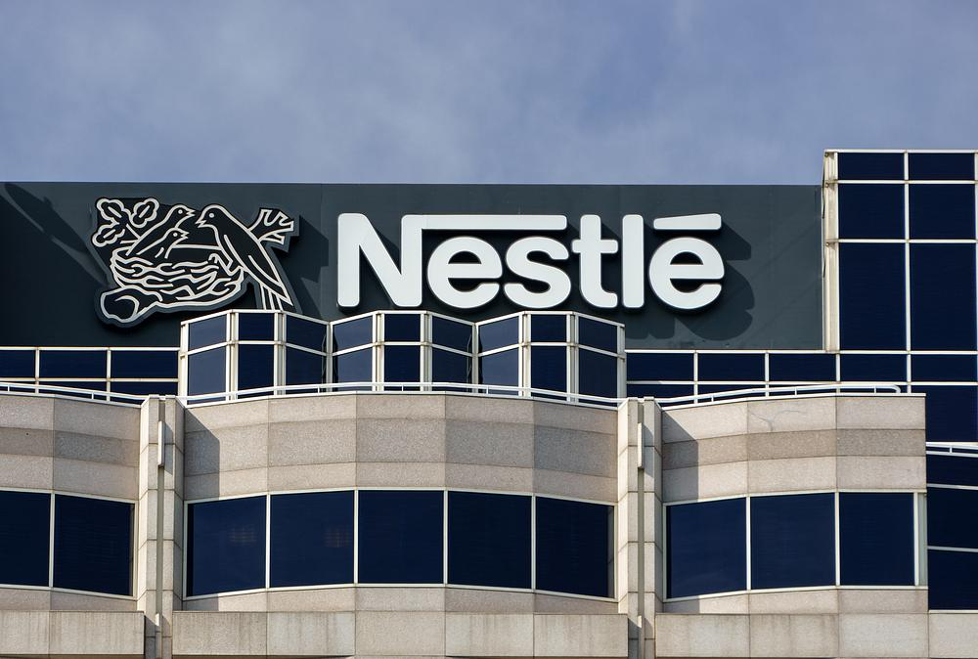
Today, Nestlé is the world's largest food and beverage company, with operations in over 180 countries. It has over 300,000 employees and generates annual sales of over CHF 90 billion. Nestlé's products include baby food, bottled water, coffee, confectionery, dairy products, frozen food, pet food, and snacks.

1.2 Nestlé Global
With a 150-year-plus history, Nestlé is the largest food and beverage manufacturer in the world by sales, generating more than CHF 90 billion in annual revenue. Its diverse product portfolio includes brands such as Nestle, Nescafe, Perrier, Pure Life, and Purina. Nestle also owns just over 20% of French cosmetics firm L'Oreal. The company employs 275,000 people around the world and has a vast portfolio of global products, with more than 30 brands each achieving more than CHF 1 billion in sales annually and a geographic presence that spans almost 190 countries.




1.3 Nestle Bangladesh
Nestlé Bangladesh PLC is a subsidiary of Nestlé S.A., the world's largest food and beverage company. Nestlé Bangladesh was established in 1992 as a joint venture between Transcom Limited and Nestlé S.A., and it became a 100% owned subsidiary of Nestlé S.A. in 1998.
The company's head office is located in Dhaka, Bangladesh, and it has a factory in Sreepur, Gazipur. Nestlé Bangladesh employs over 1,600 people and its products are sold in all over the country.
Nestlé Bangladesh is committed to providing high-quality, nutritious food and beverages to the people of Bangladesh. The company's products are made with locally sourced ingredients, whenever possible, and they are subject to strict quality control standards.

1.4 Products and Services

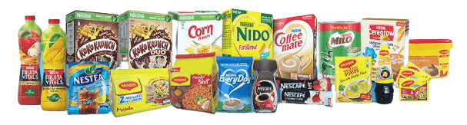

Nestlé Bangladesh offers a wide range of food and beverage product s. Its product portfolio includes milk and dairy products such as powdered milk, condensed milk, and yogurts. The company also provides infant nutrition products, including infant formula and cereals. In addition, Nestlé Bangladesh produces and markets various beverages, such as coffee, tea, and powdered drinks. The culinary products segment includes items like soups, sauces, and cooking aids. Nestlé Bangladesh also offers a range of confectionery products, including chocolates, wafers, and candies.
Nestlé Bangladesh offers a wide range of products and services, including:
- Dairy products: milk, yogurt, cheese, butter, and condensed milk
- Foods: instant noodles, breakfast cereals, soups, sauces, and snacks
- Baby foods: formula milk, cereals, and snacks
- Beverages: coffee, tea, water, and juices
- Pet foods

Nestlé Bangladesh's products are sold under a variety of well-known brands, including:
- Nescafé
- Maggi
- Milo, KitKat, Nido, Cerelac etc

1.5 Corporate Social Responsibility
Nestlé Bangladesh is committed to corporate social responsibility. The company's CSR initiatives focus on the following areas:
- Nutrition: Nestlé Bangladesh supports programs to improve nutrition in Bangladesh, such as the Nestlé Healthy Kids program and the Nestlé Knowledge Sharing program. These programs provide education and support to families on how to improve their children's nutrition.
- Water: Nestlé Bangladesh is committed to water conservation and sustainable water management. The company has implemented a number of water conservation initiatives, such as rainwater harvesting and water recycling. These initiatives have helped to reduce the company's water consumption by 20%.
- Rural development: Nestlé Bangladesh supports programs to improve the lives of people in rural Bangladesh, such as the Nestlé Rural Development program. This program provides training and support to farmers to help them increase their productivity and income.

1.6 Awards and Recognition
Nestlé Bangladesh has been recognized for its corporate social responsibility initiatives. In 2022, the company was awarded the "Best CSR Initiative in the Food and Beverage Industry" by the Bangladesh CSR Awards.
Future Plans
Nestlé Bangladesh is committed to continuing to grow its business and to making a positive impact on the lives of people in Bangladesh. The company plans to expand its product portfolio, invest in new manufacturing facilities, and continue its CSR initiatives.
In addition to the above, Nestlé Bangladesh is also committed to environmental sustainability. The company has set a goal of reducing its greenhouse gas emissions by 20% by 2025. Nestlé Bangladesh is also working to reduce its waste and water consumption.
Nestlé Bangladesh is a responsible corporate citizen that is committed to making a positive impact on the people and the environment of Bangladesh.

1.7 Commitment to Quality and Nutrition:
Nestlé Bangladesh places a strong emphasis on quality, nutrition, and safety across its product range. The company strives to ensure that its products meet high quality and safety standards, adhering to local and international regulations. Nestlé also promotes nutrition education and awareness, emphasizing the importance of balanced diets and healthy lifestyles.

Chapter 3: Project Lighthouse



Go to Chapter 5: Nestle Bangladesh revolutionizing sales.

The partner: Exceedra by telus

Exceedra is a software company that provides solutions to consumer goods manufacturers and distributors. The company's solutions help businesses to optimize their sales and distribution processes, improve their product placement, and reduce their costs.
Exceedra was founded in 1999 and is headquartered in London, UK. The company has offices in North America, Europe, and Asia. Exceedra has over 200 employees and serves over 1,000 customers.
The company's major technological achievements include:
- Developing a computer vision and machine learning-based solution for analyzing shelf photos and generating real-time data about in-store market share, freshness, and other metrics.
- Developing a solution for tracking the freshness of products using computer vision and machine learning.
- Developing a solution for optimizing the planning and execution of trade promotions.
- Developing a solution for managing the supply chain for consumer goods.

Exceedra has notable partnerships with a number of companies, including:




In 2023, Exceedra partnered with Nestlé Bangladesh PLC to use Exceedra Discovery to improve the visibility of Nestlé products on store shelves in Bangladesh. The partnership will initially focus on the Dhaka Metropolitan Area, but it is expected to expand to other parts of Bangladesh in the future.
Under the partnership, Exceedra will provide Nestlé Bangladesh with access to its computer vision and machine learning technology. Nestlé Bangladesh will use this technology to collect data about the in-store placement of its products, such as the number of facings, the location on the shelf, and the condition of the packaging. This data will be used by Nestlé Bangladesh to improve its product placement and marketing campaigns.
The partnership between Exceedra and Nestlé Bangladesh is a significant development in the use of machine learning in the retail industry in Bangladesh. It shows that major retailers in Bangladesh are starting to see the value of using this technology to improve their operations. I believe that this partnership will pave the way for other retailers in Bangladesh to adopt similar technologies in the future.

1.2 My role as an intern
I was hired as the sole intern for Nestle’s one of the most revolutionary and important projects in a very long time, named “Project LightHouse”. My responsibility is to supervise the Pilot testing activities, guide & lead the DIR field operators, communicate with the Nestle Global team for resolving newly raised issues about the “Digital image recognition” (DIR) mobile application, overseeing progress through backend console and reporting to my line manager.
However, despite being an intern dedicated for a particular project, I still had the opportunities of working with cross functional teams and other generic marketing and sales functions such as assisting to conduct focus group discussions for different brands, content creation and ideation collaborating and tagging up with other projects throughout the organization, thus adding value to the organization and in return gaining priceless experiences to excel further into my career.

1.3 About the Project
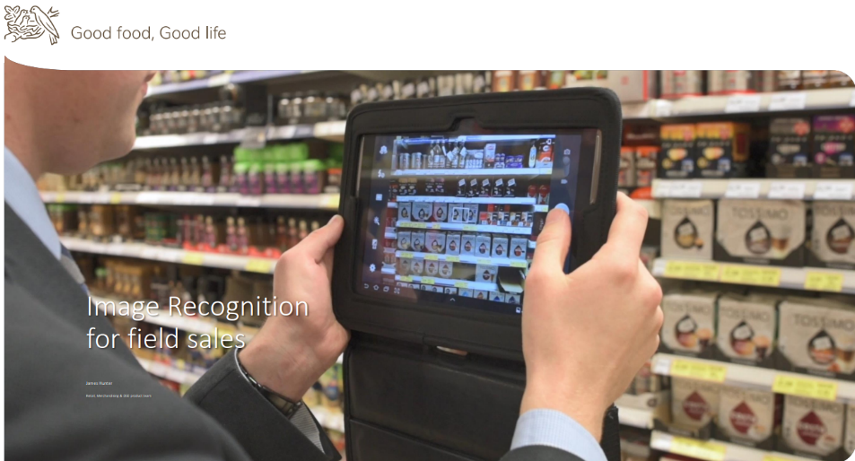
The name is inspired from metaphorical element of emit light from a system of lamps and lenses and to serve as a beacon for navigational aid, for maritime pilots at sea or on inland waterways.
The purpose of the project is to revolutionize and digitalize the traditional methods of sales data management with the motto “Sales and marketing is no more the Arts only but it is now also pure science” and decision-making will not only be based on prediction, past results or gut-feeling but most importantly the real time data. Nestle has partnered with the number one technology support & solution provider (Exceedra by Telus) to proceed with the project.

1.4 Where are we?
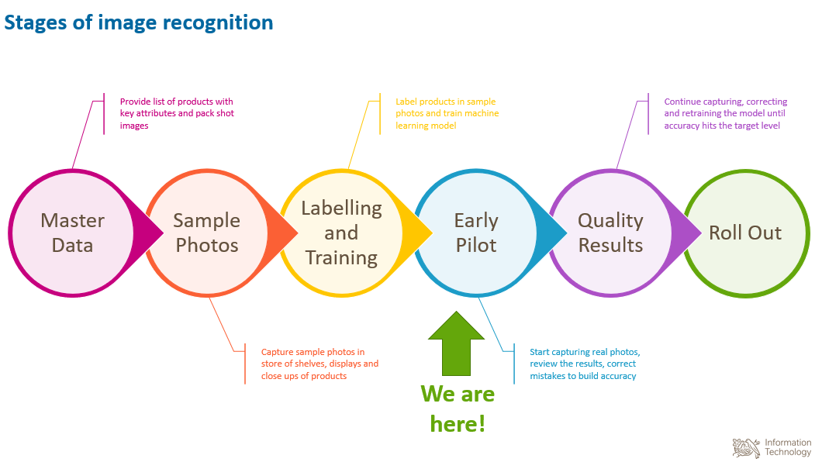
The project is discussed and analyzed in detail in chapter 5: Nestle Bangladesh revolutionizing sales.

1.5 Digital image recognition
Operations: The product pack shots (pictures) are trained in a way; the smartphone camera (The dedicated mobile application) would be able to describe and identify the product just like the human eye does.
We are currently at Early pilot testing phase. Where the process includes the following steps by the field sales representatives on a regular basis. Field operations include:
- Open the app
- Synchronise
- Start the day
- Add shops to visit to the route
- Start each visit
- Take photos in the store shelves
- Complete the form
- Finish the visit
- End the day
After the DSRs (Distributor Sales Representatives) capture photographs, these images are subsequently uploaded to a cloud-based database, where they become available for analysis. This analysis is facilitated through the generation of a comprehensive report utilizing data visualization techniques.
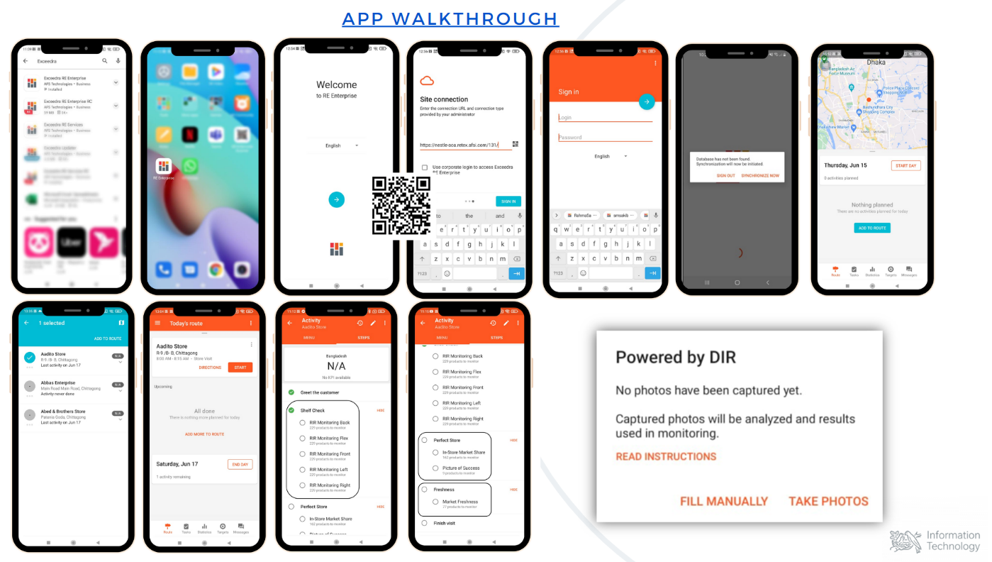
App Walkthrough
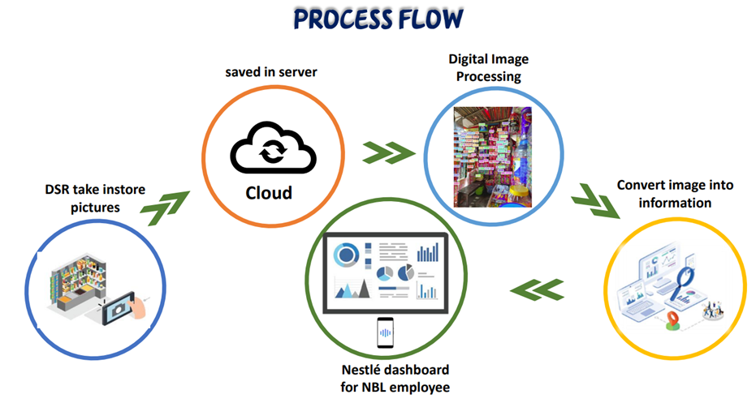
Process flow

1.6 Key benefits if done successfully
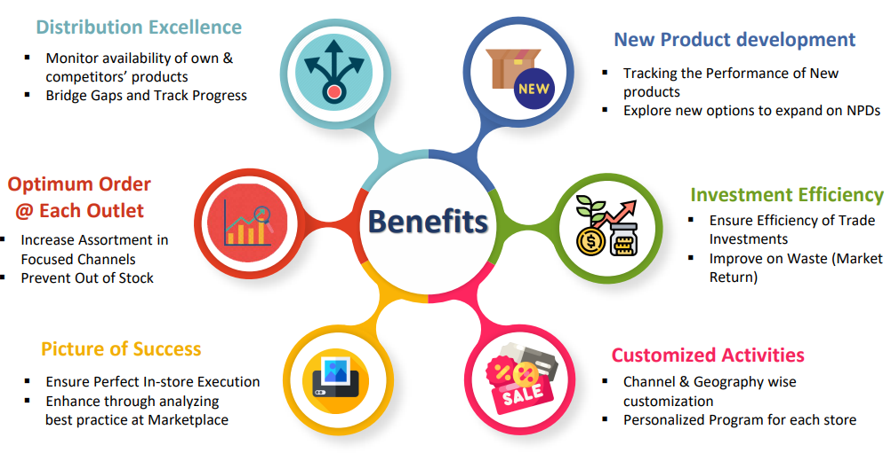
The partnership between Exceedra and Nestlé is a significant development in the use of machine learning in the retail industry. It shows that major retailers are starting to see the value of using this technology to improve their operations. I believe that this partnership will pave the way for other retailers to adopt similar technologies in the future.
- Improved product visibility: Nestlé can use the data generated by Exceedra Discovery to identify stores where its products are not being displayed prominently. Nestlé can then take steps to improve the placement of its products in these stores, such as requesting more facings or better shelf space.
- Increased sales: By improving the visibility of its products, Nestlé can expect to increase sales. This is because customers are more likely to buy products that they can easily see and reach.
- Reduced costs: Nestlé can use the data generated by Exceedra Discovery to identify stores where its products are not being sold well. Nestlé can then discontinue selling these products in these stores, which can save money on inventory and transportation costs.

Chapter 4: The landscape of AI in FMCG

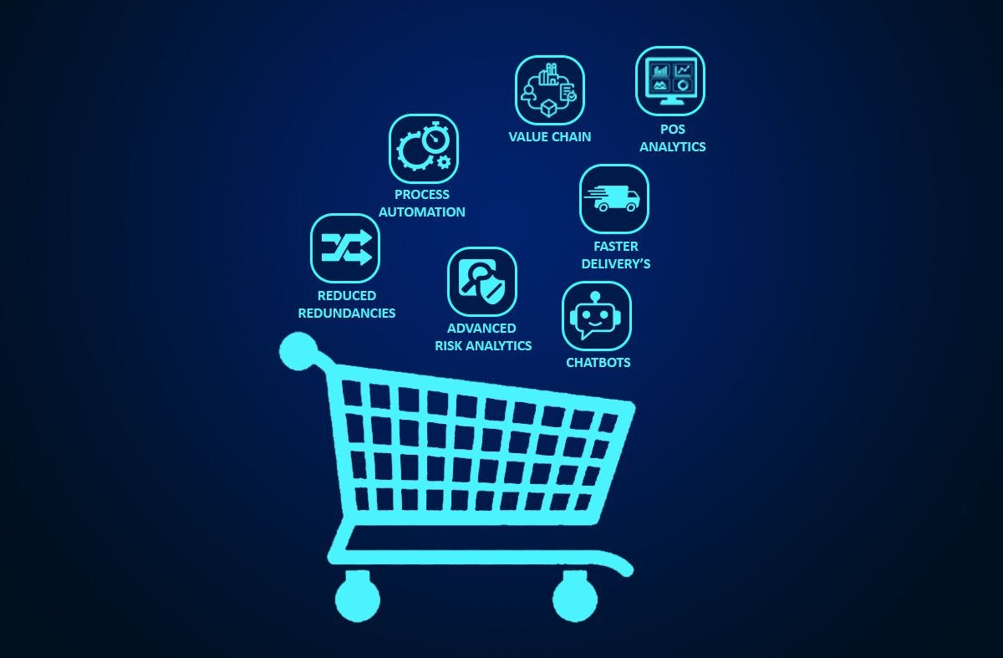

Click here to go to Chapter 6: Findings & Observations

4.1 Scope of Artificial intelligence in FMCG

How AI is transforming the FMCG sales and distribution landscape
The FMCG (Fast-Moving Consumer Goods) sector is in a constant state of evolution, with enterprises perpetually seeking fresh approaches to enhance their sales and distribution mechanisms. Artificial intelligence (AI) stands out as a transformative technology that could revolutionize the modus operandi of FMCG companies.
AI-driven tools for sales forecasting and demand planning hold the promise of enabling FMCG firms to more accurately anticipate future product demand and adjust their inventory management accordingly. By meticulously scrutinizing historical data, consumer behavior trends, and market dynamics, AI algorithms excel in forecasting future demand with precision, thereby diminishing the chances of overstocking or understocking. This proactive approach aids businesses in averting losses due to excess inventory and ensures consistent product availability to meet consumer needs.
Additionally, AI-powered sales automation tools offer an avenue for FMCG enterprises to optimize their sales processes. These tools analyze real-time sales data, identifying potential sales opportunities and suggesting the most effective sales strategies. Through the automation of mundane sales tasks, sales representatives can redirect their efforts toward nurturing robust customer relationships and closing deals, leading to elevated customer satisfaction levels and heightened sales revenues.
The sphere of FMCG distribution and logistics also experiences a substantial AI-driven transformation. AI algorithms are adept at processing extensive datasets related to variables such as traffic patterns, weather conditions, and delivery routes to fine-tune delivery schedules and routing. This optimization endeavor translates into shorter delivery times, enhanced order accuracy, and reduced transportation costs for FMCG companies.
Beyond sales and distribution, AI finds its application in FMCG marketing as well. AI-powered marketing tools analyze consumer behaviors and preferences, facilitating the development of personalized marketing campaigns. By delivering targeted and pertinent marketing messages, FMCG entities enhance the effectiveness of their marketing endeavors, resulting in augmented brand recognition and heightened customer engagement.
In sum, AI holds immense potential to reshape the FMCG industry by providing insights into consumer demand, streamlining sales and distribution processes, and enabling the formulation of more efficacious marketing strategies. As global adoption of AI gains momentum within the FMCG sector, we can anticipate a profusion of innovative solutions poised to further amplify efficiency and propel growth.

4.2 The Future of Ai in FMCG/Retail
The emergence of Artificial Intelligence (AI) presents a multitude of opportunities for businesses operating in the region, particularly within the retail and FMCG (Fast-Moving Consumer Goods) sector. AI has the potential to bring about a transformative impact on various facets of this industry, ranging from customer experience and supply chain optimization to personalized marketing and inventory management. Nonetheless, as is customary with any technological advancement, the integration of AI is not without its set of challenges. This article will delve into the promising prospects that AI introduces to the retail/FMCG sector, explore the hurdles it poses, and propose effective solutions to surmount these obstacles.
Elevated Customer Experience
AI-driven chatbots and virtual assistants can offer tailored and real-time customer support, swiftly addressing queries and thereby elevating the overall customer experience. Moreover, AI algorithms possess the capability to scrutinize customer behavior, facilitating personalized product recommendations that foster heightened customer engagement and satisfaction.
Streamlined Supply Chain Management
AI holds the capacity to optimize the intricacies of supply chain operations through the anticipation of demand, the refinement of logistics, and the trimming of inventory costs. By harnessing AI-driven demand forecasting, retailers can avert both stock shortages and surpluses, ensuring that products remain readily accessible precisely when and where customers require them.
Data-Infused Marketing Strategies
AI empowers retailers to delve deeper into the intricacies of consumer behavior, preferences, and purchasing tendencies. This wealth of data can be effectively harnessed to craft targeted marketing campaigns that resonate with customers, leading to increased conversion rates and improved return on investment (ROI).
Intelligent Pricing Strategies
The implementation of dynamic pricing, driven by AI algorithms, empowers retailers to adapt pricing structures in real-time in response to demand fluctuations, competitor pricing, and other market dynamics. This not only aids retailers in staying competitive but also unlocks the full revenue potential.

4.3 Challenges
Data Privacy and Security Concerns: The utilization of AI systems involves the handling of extensive customer data, necessitating stringent measures for data privacy and security. Managing personal information within AI systems can give rise to legal and ethical dilemmas, underscoring the importance of robust data protection mechanisms for businesses.
Scarcity of Skilled Workforce: Effective adoption of AI technology calls for a proficient workforce capable of developing, implementing, and managing AI systems. A shortage of professionals possessing expertise in AI can pose recruitment and training challenges for businesses.
Initial Capital Investment: The introduction of AI solutions often demands a substantial initial financial investment, which may deter certain businesses from embracing the technology. Small and medium-sized enterprises (SMEs), in particular, may face difficulties in allocating resources for AI implementation.
Integration with Existing Systems: The integration of AI technologies into established retail/FMCG infrastructures can be a complex endeavor. Compatibility issues and potential disruptions during the integration process can impede a seamless implementation.
Investment in Upskilling and Collaboration: Investing in the training and upskilling of current employees can help bridge the skills gap. Furthermore, collaborating with AI service providers or technology partners can provide access to specialized expertise, thereby reducing implementation complexities.
Employing Agile Integration Strategies: Careful planning and rigorous testing are imperative to ensure the seamless integration of AI systems into existing infrastructure. Retailers should embrace agile methodologies and collaborate closely with technology partners throughout this process.
The retail and FMCG industry stand on the brink of a transformative shift with the incorporation of AI technologies. Embracing AI offers substantial prospects for enhancing customer experiences, optimizing supply chains, and refining marketing strategies. Nonetheless, businesses must confront challenges related to data privacy, workforce expertise, financial investments, and integration hurdles. Through the implementation of thoughtful solutions, retailers can fully unlock the potential of AI and gain a competitive edge in the dynamic market landscape. As AI technology continues its evolution, those who embrace and adapt to its capabilities will be best positioned to thrive in the future of retail and FMCG.

4.4 The AI use cases & Leaders paving the way forward
The FMCG (Fast-Moving Consumer Goods) industry, though deeply rooted in history, has seen significant changes in its operational landscape. While the adoption of computerization has enhanced data management and inventory control, the core industry operations have largely remained consistent. A notable shift has been the industry's transition to digital marketing, a global trend necessitated for survival rather than an FMCG-specific innovation.
Here's a glimpse into some FMCG companies harnessing the power of Artificial Intelligence (AI):

Marico Ltd: Marico doesn't just rely on automation; it heavily leverages analytics and AI, particularly machine learning, to advance its own business and that of its distributors. Automation has significantly reduced inventory days, cut sales staff numbers to 20, and eliminated the need for data entry operators. The utilization of geotagging through integrated sales route optimization (ISRO) software has further enhanced efficiency.

AI Palette: AI Palette stands as the world's first AI platform dedicated to FMCG Product Innovation. It crafts winning product concepts aligned with a brand's identity and existing product portfolio. Achieving this by drawing insights from millions of digital conversations and integrating them with company data to create product concepts addressing unmet consumer needs.

Hindustan Unilever: HUL employs the AI software known as Jarvis to extract details like grocery store visits over the past three months and future purchase predictions. Operating across 600,000 villages and 10 million outlets, general trade remains a significant focus for the next decade as part of Project Maxima, aimed at precision marketing at scale.

Colgate-Palmolive: The Colgate Smart Electric Toothbrush E1, enhanced with Artificial Intelligence, collaborates with Apple's Research Kit to crowdsource toothbrushing data for improved and expedited innovation. This toothbrush, designed in consultation with dentists, incorporates real-time sensors and AI algorithms to assess brushing effectiveness across 16 zones of the mouth.

4.5 Unilever
Unilever's AI initiatives in Bangladesh are aimed at digitizing the retail ecosystem and enhancing the experiences of both retailers and shoppers. These initiatives leverage artificial intelligence and technology to streamline processes, improve customer engagement, optimize product displays, and provide financing solutions for micro-entrepreneurs. Here's a deeper dive into each of these initiatives:
- Lever Bazar:
- Description: Lever Bazar is a B2B mobile application designed for retailers. It offers retailers the convenience of ordering Unilever products at any time and from anywhere.
- Benefits for Retailers:
      - Streamlined Ordering: Retailers can easily place orders, reducing time and effort.
      - Inventory Management: It provides retailers with greater control over their inventory, helping to prevent out-of-stock situations.
      - Access to Information: Lever Bazar provides retailers with access to product information and training, enhancing their understanding of Unilever products and their ability to sell them.

- Project Turing:
  - Description: Project Turing is focused on digitizing the shopper's journey using AI.
  - Key Features:
      - OCR Technology: It uses Optical Character Recognition (OCR) technology to convert handwritten data from shopping memos into structured data.
      - Personalized Marketing: This structured data enables Unilever to create more personalized and relevant marketing messages for specific shoppers based on their past purchase habits.

- Project Ray:
  - Description: Project Ray utilizes AI to structure data related to the trade environment.
  - Key Features:
      - Display Checks: The structured data is used to automate display checks, ensuring that Unilever products are prominently and attractively displayed on store shelves.
      - Share of Shelf Measurement: It measures the share of shelf occupied by Unilever products, allowing for data-driven interventions to enhance brand visibility and sales.
- Retail Financing:
  - Description: Unilever has partnered with financial institutions to provide retail financing to micro-entrepreneurs.
  - Key Features:
      - Digital Onboarding: The onboarding process for retailers seeking financing has been digitized for efficiency.
      - Loan Disbursement: The loan disbursement process is streamlined for quicker access to financing.
      - Repayment Process: Digital tools are used to simplify the repayment process.
      - Benefits for Retailers: Retailers can use this financing to purchase inventory and invest in their businesses, helping them grow and remain competitive.
These AI initiatives are not only making retailers more efficient and profitable but also improving the shopping experience for consumers. Lever Bazar enhances product accessibility, Project Turing enables personalized shopping experiences, Project Ray ensures attractive product displays, and retail financing makes products more affordable and keeps prices competitive. As AI continues to evolve, Unilever is likely to explore additional innovative ways to enhance the retail industry further.

Chapter 5: Nestle Bangladesh revolutionizing sales
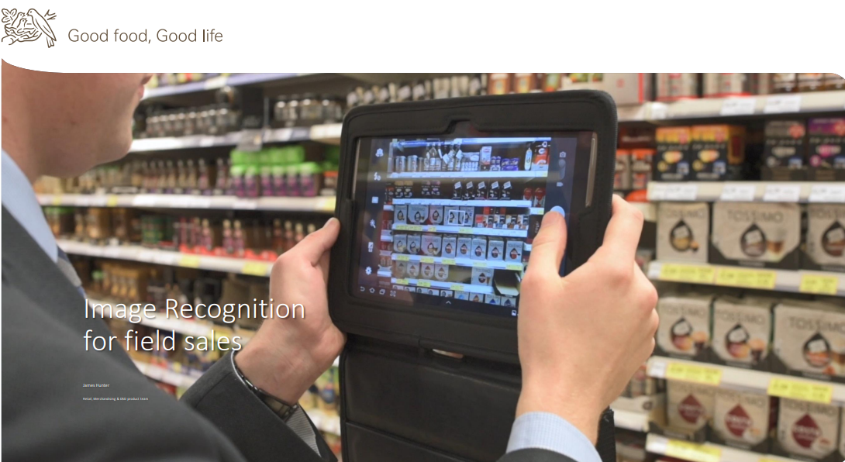

Recap
In Chapter 3: Project Lighthouse, a brief overview of the project and the whole process’s birds eye view is presented. This Chapter will discuss the further details about the project phases and its implementation.

5.1 Digital image recognition (DIR)
Project Lighthouse, a strategic collaboration between Nestle Bangladesh PLC and Exceedra by Telus, aims to revolutionize and digitalize traditional sales data management. The project's core objective is to shift decision-making from being solely reliant on predictions, past results, and gut-feelings to real-time data-driven insights. This part of the report provides a comprehensive overview of the project, its phases, benefits, timelines, current status and success factors.

5.2 Purpose and Objectives
- The primary purpose of Project Lighthouse is to modernize sales data management by embracing data science. Its objectives include:
- Enhancing sales and marketing effectiveness by leveraging real-time data.
- Enabling data-driven decision-making at all levels of the organization.
- Revolutionizing how Nestle interacts with distributors and stores by providing a digital interface for data exchange.
5.3 Project Phases:
The project is divided into six key phases, each serving a specific purpose:
Master Data
- In the Master Data phase, comprehensive product information is gathered. This includes product attributes and high-quality pack shot images. These elements are vital for machine learning model development, ensuring accurate data interpretation and analysis.
Sample Photos
- The Sample Photos phase involves field teams capturing images from store shelves, displays, and individual products. These images serve as a visual dataset for the machine learning algorithms, allowing for the recognition and analysis of products in various store environments.
Labeling and Training Data
- The Labeling and Training Data phase is a crucial step in machine learning model development. Team members label products within the sample photos, providing the necessary ground truth data for training machine learning algorithms. Accurate labeling is essential for achieving high-quality results in later phases.

Early Pilot
- The Early Pilot phase marks a significant step in project execution. Currently underway, it involves pilot testing with 7 distributor sales representatives across diverse store types. These representatives are selected from the top-performing distributors and cover approximately 140 stores across Dhaka metro, Dhaka south, and Chittagong regions. As an intern, your role includes launching, operating, and supervising this pilot program, which commenced in June 2023 and is anticipated to conclude in August 2023. The selected store types include Minimarts, modern trade outlets, and general/grocery stores.
Quality Results
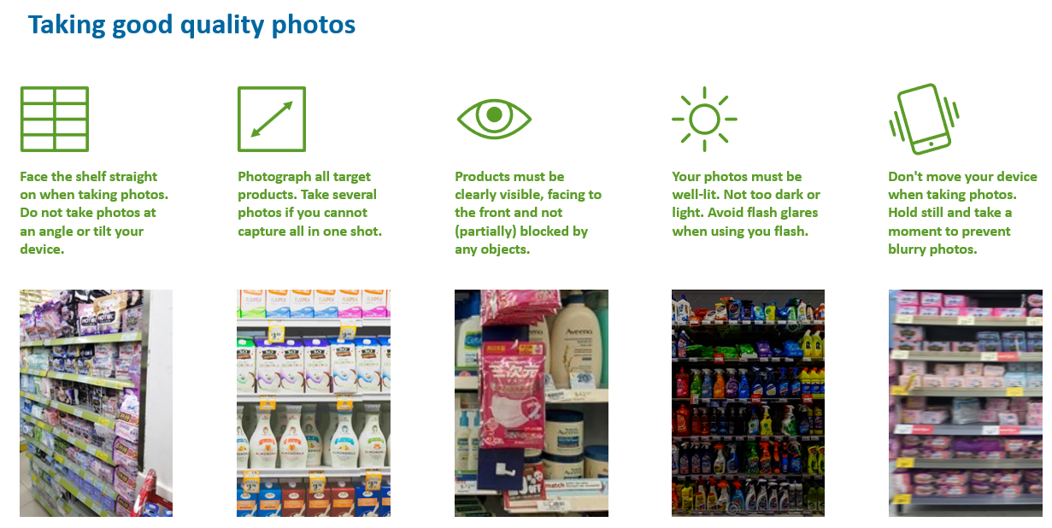
- Maintaining data quality is crucial for the project's success. In the Quality Results phase, efforts are directed toward consistently capturing photos via the Exceedra app, correcting any inaccuracies, and retraining machine learning models. This iterative process ensures that the data remains reliable and valuable for decision-making.
Roll Out
- The Roll Out phase aims to equip all distributor sales representatives with dedicated smartphones meeting specific hardware requirements. These smartphones are essential for the full-time operation of the project, allowing DSRs to capture and upload data efficiently.

5.4 Project Timeline
Key Milestones
- February to June 2023: During this period, the focus was on establishing the project environment and compiling the master data.
- July to September 2023: The Digital Image Recognition (DIR) pilot commenced in this phase, allowing for the testing and validation of data capture processes.
- October 2023: Preparations for the project's full-scale implementation were initiated, including hardware procurement and training.
- November 1st, 2023: The project is scheduled to go live, marking a significant milestone in Nestle Bangladesh PLC's journey toward data-driven excellence in sales and marketing.

5.5 Project Implementation
Field Sales Representatives' Workflow
- Field Sales Representatives, also known as Distributor Sales Representatives (DSRs), play a pivotal role in data capture. Their workflow includes the following steps:
- Open the App: DSRs initiate their workday by opening the Exceedra app on their dedicated smartphones.
- Synchronize: Data synchronization ensures that DSRs have access to the latest information.
- Start the Day: DSRs begin their workday by setting up their route and tasks.
- Add Shops to Visit to the Route: DSRs organize their visits by adding shops to their route.
- Start Each Visit: At each store visit, DSRs commence data capture.
- Take Photos in the Store Shelves: DSRs capture images of store shelves, displays, and products.
- Complete the Form: A comprehensive form is filled out, documenting relevant information.
- Finish the Visit: The visit is completed, and data is submitted.
- End the Day: DSRs conclude their workday, and data is synchronized for analysis.
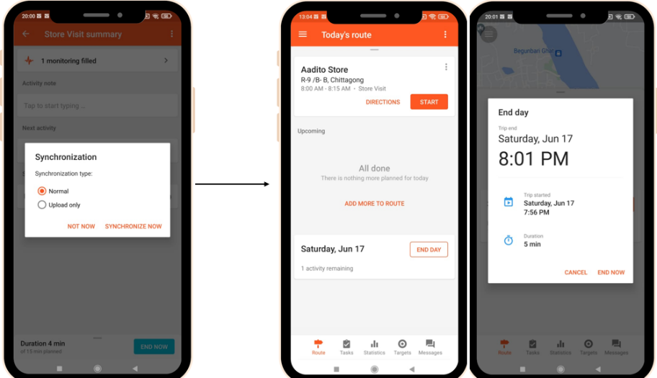

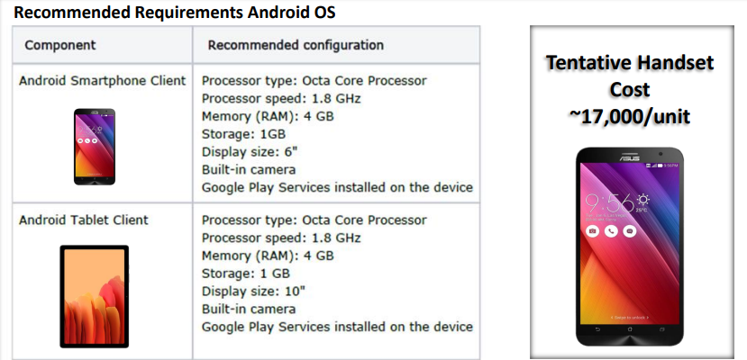
Hardware requirement for implementation:

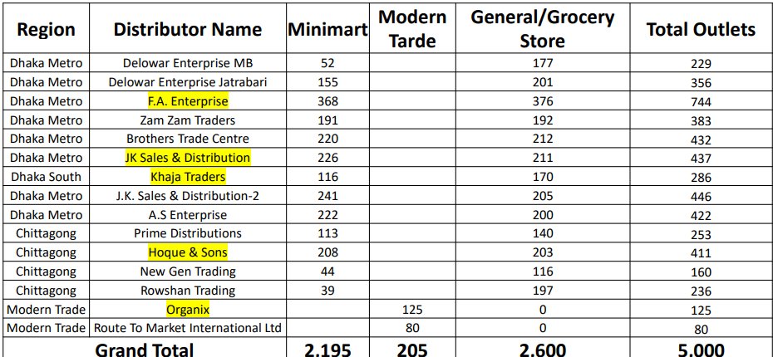
Focus area for DIR Implementation: Distributors marked yellow are chosen for piloting.
Data Processing and Visualization
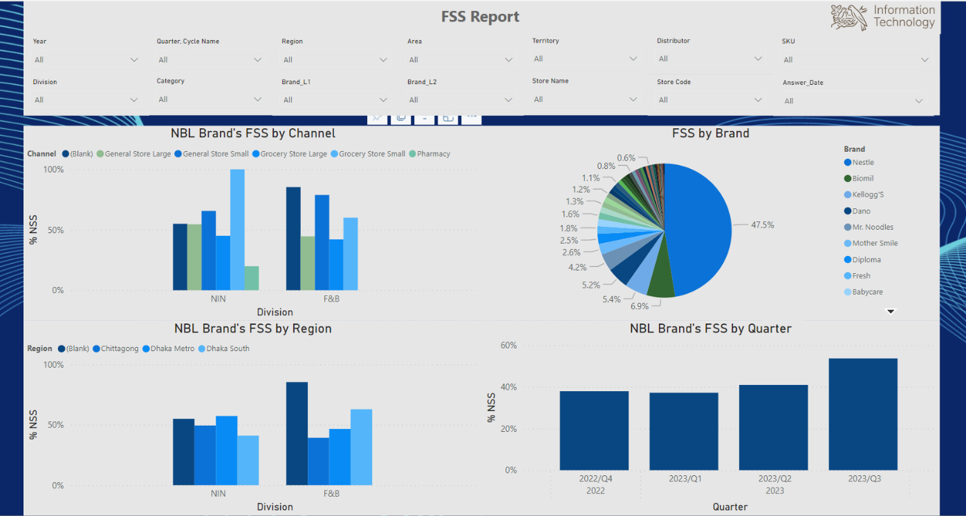
- After DSRs capture photographs, these images are uploaded to a cloud-based database. These images are then processed through digital image processing, converting them into actionable information. The processed data is subsequently presented on a Nestle dashboard, which provides real-time data visualization through pie charts and bar charts.
Photo: Dashboard Snap (real time data)
5.6 Project Benefits
7.1 Distributor Excellence
- Project Lighthouse promises to strengthen Nestle's relationships with distributors. Data-driven insights enable more effective collaboration, ensuring that distributors are well-equipped to meet market demands and optimize their operations.
7.2 New Product Development
- Access to real-time data and insights derived from the project's data analysis capabilities empowers Nestle to make informed decisions regarding new product development. This results in products that are more aligned with market demands and trends.
7.3 Investment Efficiency
- Data-driven resource allocation leads to investment efficiency. Nestle can allocate its resources more effectively based on real-time market conditions, optimizing budgets and investments for maximum returns.
7.4 Customized Activities
- The project enables Nestle to tailor marketing and sales strategies to specific market conditions. This customization ensures that Nestle's activities are precisely aligned with market needs, increasing the likelihood of success.
8. Conclusion
- Project Lighthouse is poised to transform how Nestle Bangladesh PLC manages sales data. By leveraging real-time data and machine learning, the project is set to enhance decision-making and drive operational efficiency. The successful completion of this project represents a significant step toward Nestle's commitment to data-driven excellence.
9. Recommendations
- Continue to monitor and ensure data quality throughout the project, emphasizing the importance of accurate image capture and labeling.
- Establish ongoing training and support mechanisms for DSRs to maximize project success.

Chapter 6: Findings & Observations
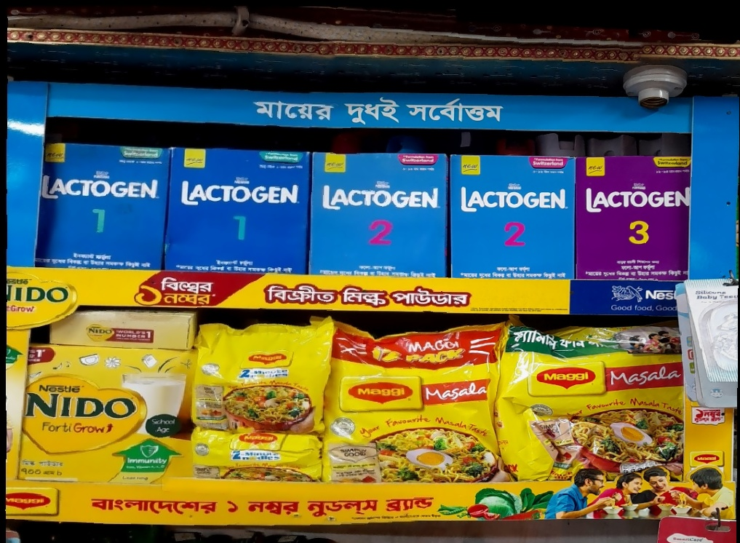

6.1 Accuracy report
Products | EA % | Facings | Actual count | Accuracy
MAGGI 2-MINN Masala DD 16(12x62)g R BD | 94.3% | 10 | 11 | 91%
MAGGI 2-MINN Masala Jumbo 36(4x62)g R BD | 86.3% | 13 | 15 | 87%
MAGGI Healthy Soup Corn Sac 24(4x25g) BD-New Price | 82.3% | 3 | 5
MAGGI Healthy Soup Thai Sachet 96x35g BD-New Price | 86.3%
MAGGI Healthy Soup Veg Sachet 96x25g BD | 66.4% | 1
MAGGI 2-MINN Masala Sumo 18(8x62)g R BD | 92.5% | 15 | 16 | 94%
MAGGI 2-MINN Masala Blast 18(8x63)g R BD | 94.4% | 2 | 2 | 100%
Mr. Noodles Magic Masala 8 Pcs | 68.3% | 2 | 6 | 33%
Mama Instant Noodles 10pcs | - | 2 | 2 | 100%
COFFEE MATE BIB 24x450g BD | 99.2% | 3 | 3 | 100%
NESCAFÉ Classic grey 50g | - | 1 | 1 | 100%
NESCAFE GOLD BLEND Sgnt Jar 12x100g GB | 92.0% | 3 | 4 | 75%
NESCAFE CLASSIC Jar 12x200g N4 BD | 79.0% | _ | _
NESCAFE CLASSIC Jar 18x100g N1 BD | 56.1% | _ | _
NIDO FortiGrow BIB 12x700g BD | 88.9% | 2 | 2 | 100%
NIDO FortiGrow BIB 24x350g BD | 91.5% | 32 | 34 | 94%
NIDO FortiGrow Pouch 18x500g BD | 98.0% | 7 | 7 | 100%
DANO Power 500g | 89.2% | 11 | 11 | 100%
DIPLOMA | - | 1 | 1 | 100%
DIPLOMA 400g | 63.7% | 4 | 6 | 67%
12530429 DIPLOMA 1kg | 62.7% | 0 | 5 | 0%
Fresh | 84.4% | 2 | 2 | 100%
MARKS | 93.8% | 6 | 6 | 100%
NIDO (Nestlé Grey) | 71.5% | 2 | 6 | 33%
NESTLE GOLD CORNFLAKES 18x275g XK | 97.1% | 6 | 6 | 100%
LACTOGEN 2 FLUP Form Tin 24x400g BD | 96.7% | 5 | 5 | 100%
NAN OPTIPRO1 INF Formula HMOTin12x400gBD | 82.6% | 18 | 19 | 95%
NAN OPTIPRO2 F-U Formula HMOTin12x400gBD | 82.3% | 11 | 12 | 92%
NAN OPTIPRO3 F-U Formula HMOBiB20x350gBD | 61.8% | 2 | 4 | 50%
NAN OPTIPRO4 F-U Formula HMOBiB20x350gBD | - | 2 | 2 | 100%
NIDO 1+ PREBIO 1 CL BIB 24x350g BD | 92.3% | 1 | 1 | 100%
NIDO 3+ PREBIO 3 CL BIB 24x350g BD | 97.7% | 2 | 2 | 100%
Babycare 1 TIN 400g | - | 5 | 9 | 56%
Fresh | - | 8 | 8 | 100%
Biomil 1 TIN 400g | 72.7% | 11 | 12 | 92%
Biomil 2 TIN 400g | 84.3% | 13 | 17 | 76%
Biomil 3 BIB 350g | - | 10 | 11 | 91%
Biomil 3 TIN 400g | 90.0% | 17 | 21 | 81%
Biomil 1 BIB 350g |  | 3 | 6 | 50%
Eldobaby 1 TIN 400g | - | 1 | 2 | 50%
Eldobaby 2 TIN 400g | - | 6 | 9 | 67%
Mother Smile Prima-1 TIN 400g | 85.6% | 11 | 16 | 69%
Mother Smile Prima-2 TIN 400g | 85.0% | 7 | 9 | 78%
Fresh | 62.9% | 1 | 1 | 100%
NAN AL 110 DSB085-1 12x400g bd |  | 3 | 3 | 100%
NESTLE GOLD CORNFLAKES 18x275g XK | 97.1% | 9 | 9 | 100%
NESTLE KOKO KRUNCH 18x170g XH | 73.2% | 3 | 4 | 75%
NESTLE KOKO KRUNCH 18x330g XH | 83.6% | 10 | 12 | 83%
Mr. Noodles Family Pack 12 Pcs | - | 4 | 9 | 44%
12451991 Fresh 400g | 84.4% | 17 | 24 | 71%
Mr. Noodles Magic Masala 8 Pcs | 68.3% | 7 | 15 | 47%
Mr. Noodles Masala 16 Pcs | -
Star Ship 500 g | - | 1 | 1 | 100%
- Products: Both Nestle and competitor
- EA%: Estimated or expected accuracy benchmark set during training the data
- Facings: The count of on-shelve product machine could detect
- Actual count: Actual on-shelve SKU number.

By observing 53 products and around 100+- in store retailer photos taken, it can be seen that the actual output has exceeded the estimated outcome and it is likely to increase with time and more training of datasets.
Estimated overall accuracy for the above SKU's | 84.0%
Actual overall accuracy of the above SKU's | 82%

6.2 High Accuracy Products (Accuracy > 90%)
- MAGGI 2-MINN Masala DD 16(12x62)g R BD
  - Estimated Accuracy: 94.3%
  - Facings Detected: 10
  - Actual Count: 11
  - Accuracy Achieved: 91%
- MAGGI 2-MINN Masala Sumo 18(8x62)g R BD
  - Estimated Accuracy: 92.5%
  - Facings Detected: 15
  - Actual Count: 16
  - Accuracy Achieved: 94%
- MAGGI 2-MINN Masala Blast 18(8x63)g R BD
  - Estimated Accuracy: 94.4%
  - Facings Detected: 2
  - Actual Count: 2
  - Accuracy Achieved: 100%
- COFFEE MATE BIB 24x450g BD
  - Estimated Accuracy: 99.2%
  - Facings Detected: 3
  - Actual Count: 3
  - Accuracy Achieved: 100%
- NESCAFE GOLD BLEND Sgnt Jar 12x100g GB
  - Estimated Accuracy: 92.0%
  - Facings Detected: 3
  - Actual Count: 4
  - Accuracy Achieved: 75%
- NIDO FortiGrow BIB 12x700g BD
  - Estimated Accuracy: 88.9%
  - Facings Detected: 2
  - Actual Count: 2
  - Accuracy Achieved: 100%
- NIDO FortiGrow BIB 24x350g BD
  - Estimated Accuracy: 91.5%
  - Facings Detected: 32
  - Actual Count: 34
  - Accuracy Achieved: 94%
- NIDO FortiGrow Pouch 18x500g BD
  - Estimated Accuracy: 98.0%
  - Facings Detected: 7
  - Actual Count: 7
  - Accuracy Achieved: 100%
- DANO Power 500g
  - Estimated Accuracy: 89.2%
  - Facings Detected: 11
  - Actual Count: 11
  - Accuracy Achieved: 100%
- DIPLOMA
  - Estimated Accuracy: N/A
  - Facings Detected: 5
  - Actual Count: 5
  - Accuracy Achieved: 100%

Moderate Accuracy Products (Accuracy between 70% and 90%)
- Mr. Noodles Magic Masala 8 Pcs
  - Estimated Accuracy: 68.3%
  - Facings Detected: 2
  - Actual Count: 6
  - Accuracy Achieved: 33%
- Biomil 2 TIN 400g
  - Estimated Accuracy: 84.3%
  - Facings Detected: 13
  - Actual Count: 17
  - Accuracy Achieved: 76%

Low Accuracy Products (Accuracy below 70%)
- NAN OPTIPRO3 F-U Formula HMOBiB20x350gBD
  - Estimated Accuracy: 61.8%
  - Facings Detected: 2
  - Actual Count: 4
  - Accuracy Achieved: 50%
- Biomil 1 BIB 350g
  - Estimated Accuracy: N/A
  - Facings Detected: 3
  - Actual Count: 6
  - Accuracy Achieved: 50%
- Eldobaby 2 TIN 400g
  - Estimated Accuracy: N/A
  - Facings Detected: 6
  - Actual Count: 9
  - Accuracy Achieved: 67%
- Babycare 1 TIN 400g
  - Estimated Accuracy: N/A
  - Facings Detected: 5
  - Actual Count: 9
  - Accuracy Achieved: 56%
- Mr. Noodles Magic Masala 8 Pcs
  - Estimated Accuracy: 68.3%
  - Facings Detected: 7
  - Actual Count: 15
  - Accuracy Achieved: 47%

6.3 Analysis
- The majority of products in the dataset achieve high accuracy, with accuracy rates exceeding 90% for many SKUs.
- Products with high accuracy are generally well-recognized by the machine learning model, as indicated by minimal discrepancies between estimated and actual counts.
- Some products, especially those with lower accuracy, may require further model training or refinement to improve accuracy levels.
- Incomplete data points should be addressed to provide a more comprehensive analysis of the entire product range.

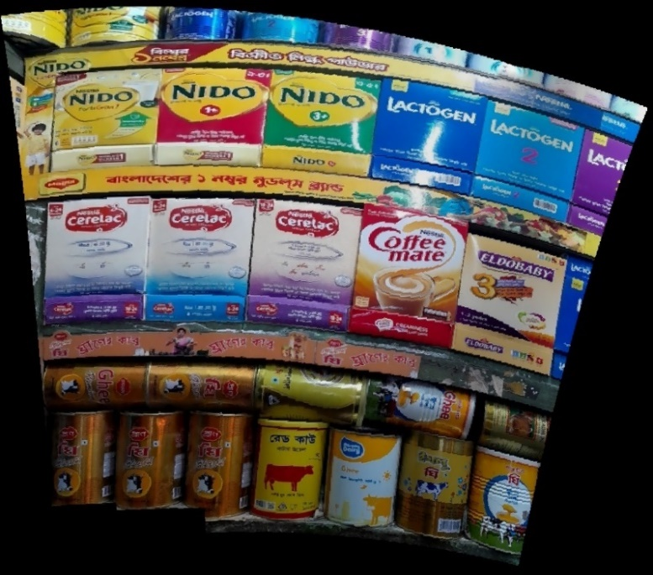
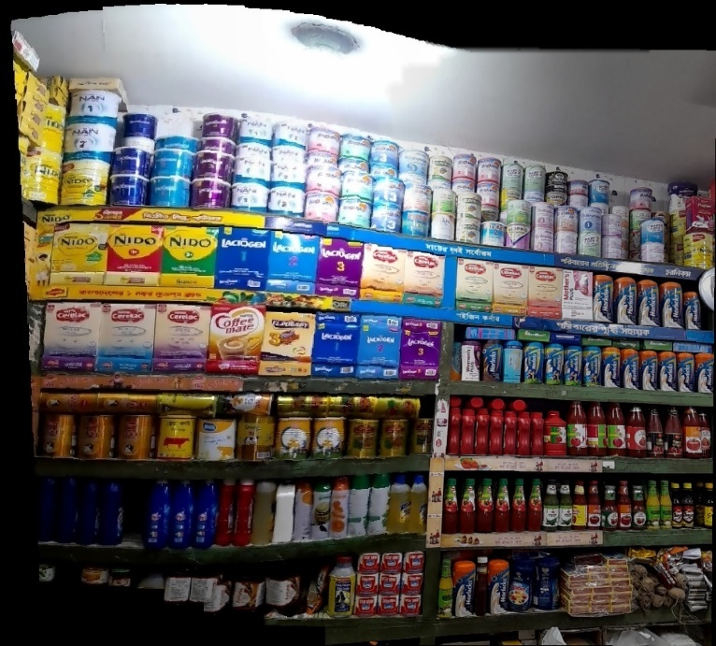
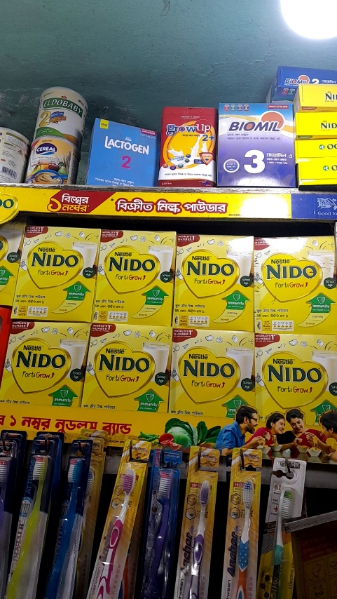
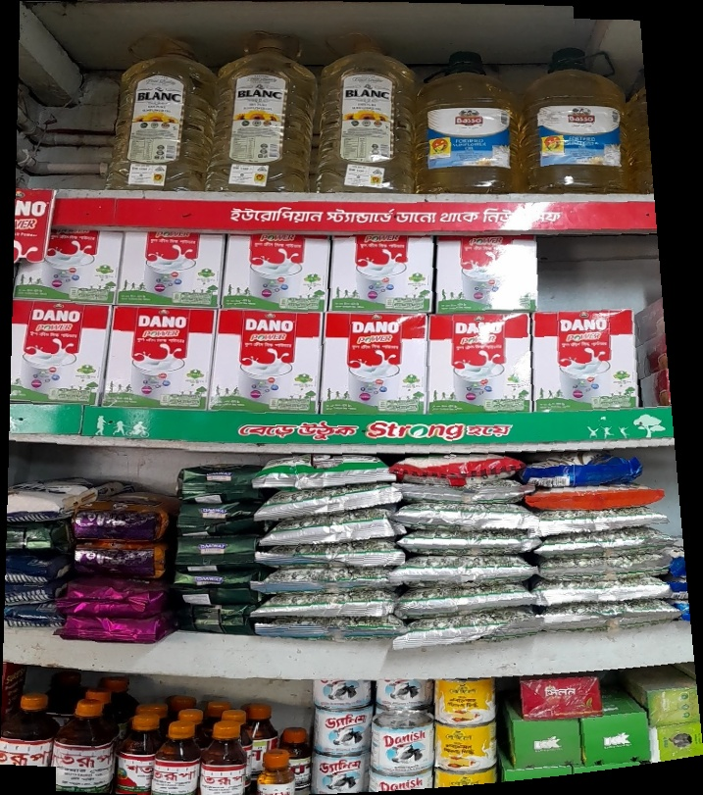
6.4 Sample photos from which the data is generated
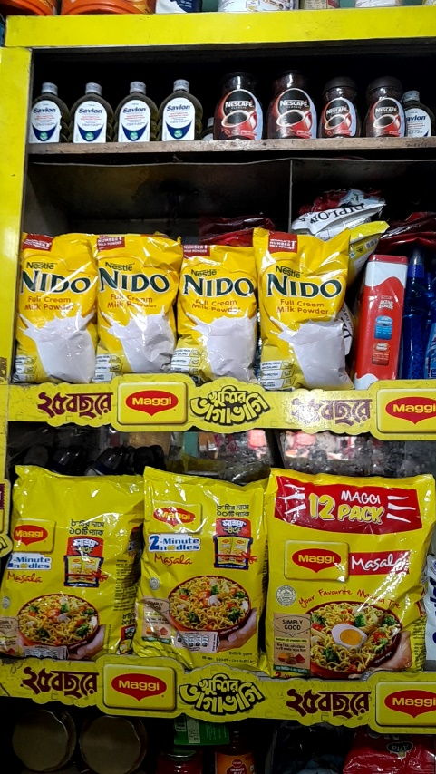

Chapter 7: Conclusion & Recommendations
In conclusion, the "Lighthouse" project at Nestle Bangladesh PLC stands as a testament to the organization's commitment to innovation and adaptability in the ever-evolving landscape of sales and marketing. This transformative initiative, undertaken in partnership with Exceedra by Telus, seeks to redefine conventional sales data management, emphasizing the transition from art to science in decision-making.
Throughout the project's well-structured phases, from master data creation to an early pilot phase, the journey has been marked by significant milestones and promising results. The dedication and hard work of distributor sales representatives (DSRs) during the pilot phase have been pivotal in shaping the project's success.
One of the most valuable aspects of this project has been its impact on my growth and development as an intern. Being dedicated to the "Lighthouse" project has provided me with invaluable hands-on experience in the world of data-driven decision-making and cutting-edge technology implementation. I have had the privilege of overseeing the pilot testing phase, operating the systems, and supervising the DSRs in the field. This immersive experience has not only enriched my technical skills but also honed my project management, leadership, and problem-solving abilities.
Moreover, it has afforded me the opportunity to witness firsthand the positive changes that data-driven strategies can bring to an organization. As the project progresses, I have been able to contribute to its success while also learning from the collective expertise of the Nestle team and our technology partner, Exceedra by Telus.
The "Lighthouse" project has added immeasurable value to my internship experience, equipping me with a unique skill set and a deep understanding of the transformative power of technology and data in the business world. It has been an enriching journey, and I am excited to continue contributing to the project's success as it moves toward full-scale implementation in November 2023.
As Nestle Bangladesh PLC continues its journey toward data-driven excellence, I am confident that the skills and insights gained during my involvement in the "Lighthouse" project will serve as a solid foundation for my future career endeavors. This experience has not only added value to the project but has also been a valuable stepping stone in my professional growth.

7.1 Recommendations
The analysis of the machine learning SKU-wise accuracy data provides valuable insights into the performance of the system and offers guidance on improving the accuracy and effectiveness of the digital image recognition (DIR) model. To maximize the benefits of the "Lighthouse" project, we recommend the following actions:
1. Continuous Model Training and Optimization
- Prioritize continuous model training and optimization efforts, especially for products with accuracy levels below 90%. Regularly updating the model with new data and retraining it will help enhance its accuracy over time.
2. Feedback Loop with Field Operations
- Establish a robust feedback loop with field operations and distributor sales representatives (DSRs). Gather their input on instances where the model may have difficulty accurately detecting product facings. This feedback will be invaluable in identifying specific challenges and areas for improvement.
3. Data Completeness
- Ensure that data completeness is a top priority. Address the missing data points (denoted by dashes) to provide a comprehensive view of all products. Incomplete data can hinder accurate analysis and decision-making.
4. Monitoring Accuracy Trends
- Implement a system for monitoring accuracy trends over time. This will allow for early detection of any significant deviations from expected accuracy levels and facilitate prompt corrective actions.
6. Communication and Training
- Foster clear communication and training between the project team, DSRs, and field operations staff. Ensure that all stakeholders understand the importance of accurate data collection and the role they play in achieving this goal.
8. Quality Assurance Protocols
- Implement quality assurance protocols to validate the accuracy of the data collected by the machine learning model. This could involve occasional manual checks or audits to verify the system's performance.

References
Anastasiya, Z. (2023, June 29). AI in FMCG: Top use cases. Retrieved from InData Labs: https://indatalabs.com/blog/ai-in-fmcg-top-use-cases#:~:text=AI%20can%20assist%20in%20an,up%20with%20a%20personalized%20approach.
Ahmmed, K., Islam, S., Noor, N. A. M., Rahman, K. M., & Ahmed, F. (2019). Toward a theoretical framework of relationship marketing in the business context. Trziste= Market, 31(2), 209-226.
Exceedra by Telus. (2023, May 23). The Exceeedra. Retrieved from Exceedra: https://exceedra.com/centralizing-your-business-intelligence/?utm_content=249822032&utm_medium=social&utm_source=linkedin&hss_channel=lcp-1070003
Innovate for all. (2022, December 12). How Unilever Bangladesh is innovating in the retail ecosystem. Retrieved from a2i Innovate for all: https://a2i.gov.bd/nl/how-unilever-bangladesh-is-innovating-in-the-retail-ecosystem/
Khamis, M. (2023). The Future of AI (Artificial Intelligence) in FMCG & Retail. Imagine Insights.
pati, S. (2021). Top FMCG Companies Who are Using Artificial Intelligence. Analytics Insight.
Rahman, K. M. (2016). Strategic Planning and Marketing Models. In Strategic Marketing Management in Asia (pp. 59-110). Emerald Group Publishing Limited.
Retail.com. (2023). Use of Image Recognition AI will be the game changer for FMCG sales in 2023. The Economic times.
Southey, F. (2023). How Unilever is using AI and big data to transform its food portfolio. FoodNavigator.
Tarai, R. K. (2020). The Implications of Ai In Enhancing Fmcg Industries. 1Symbiosis Centre for Information Technology, Symbiosis International University, Pune, .

