
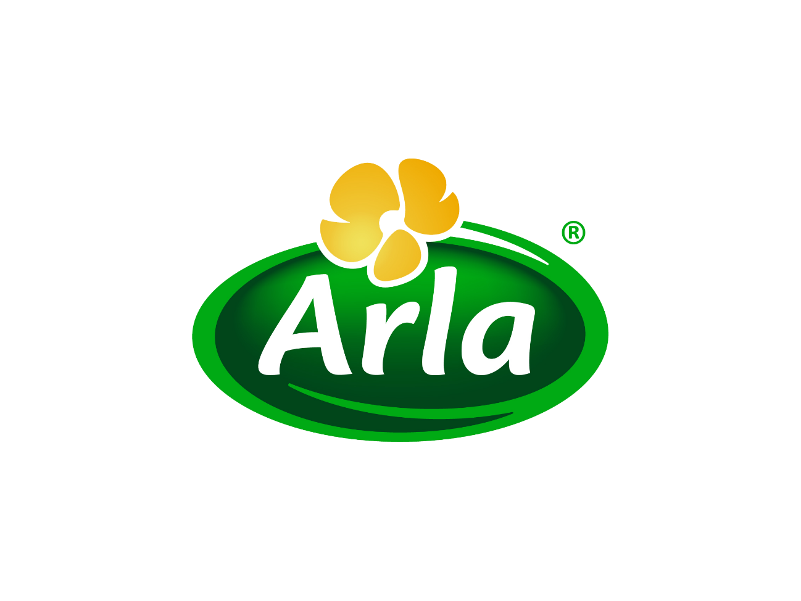

Sadia Jahan Chowdhury
Human Resource Strategies of Arla Foods Bangladesh Limited


Internship Report on
Human Resource Strategies of Arla Foods Bangladesh
Submitted To

Mimnun Sultana
Assistant Professor
School of Business and Economics
United International University

Submitted By

Sadia Jahan Chowdhury
ID: 111152249
Course Code: INT 4399

Date of Submission- 17 August 2020

Date of Submission:

United International University

Letter of Transmittal

14th August, 2020

Mimnun Sultana
Assistant Professor
School of Business and Economics
United International University
Dear Sir,
I am pleased to submit my internship report incompliance with the requirement and your instructions. I worked very diligently and did my best to follow all the guidelines my supervisor provided to meet the course requirements and prepare the report.
The internship report is “Human Resource Strategies and vertual recruitment and activities of Arla Foods Bangladesh”. I would like you to know that working on this project has given us vast experience and knowledge about the topics related to the report, especially about how companies use different practices HR strategies and appraise the performance of the employees. I have found the process of making this report both interesting and challenging.

We hope you find this report satisfactory.

Sincerely yours,
________________________
Sadia Jahan Chowdhury
ID: 111152249

Acknowledgment

At first I would like to start our acknowledgement appreciating the Almighty. I would like to thank the other member for the competition, which made me work harder. Also everyone from my well-wisher who gave me a helping hand whenever I needed help while preparing report. In my 5 month internship period I worked in Human Resource function. Thought my journey I have learned so many HR practices over there. Based on my learning, I prepare my report on Human Resource Strategies of Arla foods Bangladesh.
I want to thank my honorable course Instructor Mimnun Sultana, for her patient guidance and immense support. I want to take this opportunity to express my deep gratitude to her. My internship report is on “Human Resource Strategies of Arla foods Bangladesh” would not have taken the present form in the absence of the invaluable guidance, inspiration and cooperation from her
I would like to thank Mr. Ali Ahsan Khan, Head of Human Resource and Adminstration, for engaging me into several part of the HR practices in Arla. Besides, I would like to thank Mr. Arif Hossain, Assistant Manager, Talent Aqusition and Administration and Ms. Farhin Rahman, Senior Executive, HR Operation and Administration for the guidance and care they have given to sharpen my skills. Their valuable tips and tricks help me to prepare this report. Lastly, I want to thank everyone part of what made my journey with ARLA memorable.

Executive Summary
Arla Foods, world’s fourth largest producer of dairy products which stepped into 131st year in 2019 has been the top manufacturer of dairy goods in Scadinavia. In addition, with a tagline of “close to nature” Arla’s motto is to provide the best quality products to its consumers. 12,700 farmers from the European countries like Denmark, Sweden are the actual owners of this organization. Arla has been remarkably famous to people of Bangladesh for last five decades. Arla’s Dano has been awarded with best Brand Award for consecutively 4 years. Though It has not been on the top of market share. However, it has always been on the top of its consumers mind because of the Quality. Arla has put up with a strong vision of establishing a future of dairy "naturally, to bring health and impulse to the world." With the driving Good Growth Strategy for 2021, company aim to develop our position as a prominent global dairy company and increase our existence in the international growth market. Company goal is to build the highest value for our farmers' milk and the only way we can do that is by expanding value to our customers and our customers by assuring that we do it in a reliable, natural, cooperative and healthy way.
The key objective of this study is to provide a depth analysis of actual tools and techniques of HR functions and how they promote the online office activities, manage the management, employees’ recruitment in this pandemic situation. In this sudden situation how Human Resource function is managing challenges as a FMCG industry. Based on my working experience at Arla Foods as HR Intern, my observations, direct communication with HRs helps me to understand HR policy, matrics, trainings and accomplishing this report.
The whole report includes parts like introduction, objective of study, methodology of study, Company overview, insight of the study, recommendations and conclusion.

Table of Content
Chapter 01 7
1.1 Introduction to the report 7
1.2 Background of the Study 9
1.3 Objective of the Study 9
1.4 Scope 10
1.5 Methodology of the Study 10
1.6 Limitation 11
Chapter 02 13
2.1 Introduction 14
2.2 Overview of FMCG Industry 15
2.3 Overview of Arla Foods 16
2.4 Arla in Bangladesh 17
2.5 The Uniqueness of Arla 21
2.6 Mission, Vision, Strategies 22
2.7 Values 22
2.8 Organogram of Arla Foods Bangladesh 24
Chapter 03 25
3.1 HR Operations 27
Chapter 04 39
4.1 Recruitment 40
Chapter 05 47
5.1 Employee Engagement 47
5.2 Training and Development 51
Chapter 06 57
6.1 Factory HR 58
Chapter 07 62
7.1 Vertual/ e- Recruitment 63
7.1.2 Online activities and Management policies: 65
Chapter 08 67
Findings 68
Recomendations 69
Conclusion 70
Bibliography 71

Chapter 01
(Introduction to the Report)


1.1 Introduction
1.2 Background of the Study
1.3 Objective of the Study
1.4 Scope
1.5 Methodology of the Study
1.6 Limitation


1.1 Introduction to the report

Fast moving consumer goods industry is the competitive industry all over the Bangladesh. Consumer products are the final goods and services that are used daily by common people. Consumption of these products and services are called by private consumption also defined as household consumption. Products are sold at lower cost in short life. Large number of FMCGs were established in Bangladesh locally like Akij Food & Beverage, Pran Group, Kohinoor Chemicals, Square Food & Beverage etc. and large number of FMCGs are establishing now a days like Perfetti Van Melle, Mondalez, Japan Tobacco International, GSK, Emami, Reckitt Benckiser, Sanofi, Beximco and some other pharmaceuticals etc. yet more to register in the list.
It will be a great opportunity for the new generation of people to enrich their career in this sector but only bookish knowledge or theoretical knowledge will not preferable , it will required practical knowledge along with outside knowledge. I have completed internship from Arla Foods Bangladesh Limited from Human Resource and Administration department. I have gained hands-on project knowledge, assigned practical task, directly worked with under the supervision of Talent acquisition and employee engagement, HR policies and metrics and many more. During the three months of internship period, I have sharpen my communication skills, team building and collaboration skills, time management, stress handling skills, people manage skills etc. which will be an enormous learning for me to establish me career in further. As working in Human Resource and Administration function I have got so many chances to work several project on leaning and development, employee engagement activities, arranged Bengali occasion like “International Women’s Day, Pahela Falgun”. If I mention in one sentence anything about my leaning opportunity I would say, working in Arla Foods made my confidence higher and enriched my career.
I could implement my theoretical knowledge which I have learned before and at the Arla Foods I had polished my skills through practical knowledge. It was a great opportunity for me to complete my internship from such a global company and got to know terms, functions and how the business run in the organization.

1.2 Background of the Study

To complete my Bachelor’s degree from United International University, a well-known and accredited private university in Bangladesh is also a great chance for my life. During graduation I have gone through so many lesson of practical knowledge, practice session which is related to the new normal situation in job sector and how to relate this in career. Internship is one of the part of course under bachelor’s degree to showcase the actual learning from my university life as well as my organization which I have work as intern. This internship process helps to work on several task, align with an institution apart from study, prepare projects, handle practical situation related on my major subject. This internship report is one of the part of my internship program conducted by School of Business and Economics, United International University.
I was supervised and monitored by my honorable faculty Mimnun Sultana, Assistant Professor, School of Business and Economics during my internship program. Her guidance was so convenient and helpful to accomplish my report on “Strategies of Human Resource and virtual recruitment and management policies of Arla Foods Bangladesh Limited”. While completing and preparing this report I had to go through a lots of research papers, journals, and online newspapers about fast moving consumer goods, there business policies along with Human Resource responsibilities. The topic of my internship report is well match with current situation of organizations human resource responsibilities.

1.3 Objective of the Study

Broad Objective:
The main purpose of the report is to find out what are the strategies of Human Resource organization follows and compare those strategies with the Arla Foods Bangladesh and worldwide Human Resource departments and follow those strategy to run the business. Another broad objective of this report is research and find out how organization is managing all the human resource management, how they manage employees policies and how they attempt to recruit virtually in this pandemic outbreak. What is the new normal and sudden change occurring while working home office?
It should be compared with the learning of undergraduate BBA program. Also one of the broad objective is to identify how the global HR leaders and Arla manage the HR function in this pandemic situation, how they maintain the recruitment and other administrative work.
Specific Objectives:
Specific objective to analyze the alignment between generic Human Resource strategies and which HR strategies and virtual HR management of Arla Foods Bangladesh use to run their business in market.

1.4 Scope

Arla foods is one of the leading milk brand organization which have position its products all over the Bangladesh and also they have some competitors in market. During preparing this internship report, I was helped by some source, document of Arla Foods. The scopes of the study is to understand,
- The core issues and facts of one organization’s HR function during my internship period like policy, recruitment procedure, employee engagements, training and development, communication and manage externals etc.
- Fully understanding the policy handbook which is recently updated by Arla Bangladesh.
- Facilitate employee on-boarding by required joining documents collection from new joiners and maintain exit interview.
- Find out how Arla global HR/ ‘ONE HR’ and HR of Bangladesh collaborate work together for the betterment of organization.
- Understand how factory HR functions are managed by factory HR professionals.
- Researched mostly used software in Arla like Policy Portal, Power BI, payroll software etc.
- Develop LinkedIn learning contents and teasers aligning with ‘LinkedIn Learning Project’.

1.5 Methodology of the Study

In order to complete this study, I had to follow two source of information and data collection. I had to come up with lots of documents, data finding to match industry HR. The nature of the study is qualitative rather than quantitative so the study needs to face to face interaction with the supervisor and employee of organization.
Primary Data:
- One to one communication with Arla employees
- Personal observations while working
- Collect data from various reports, policy handbook
- Observation from my Internship supervisor Mr. Arif Hossain, Assistant Manager, Talent Acquisition and Administration of Arla Foods Bangladesh Limited
- Experience from 5 months internship period in Arla Foods Bangladesh Limited in Human Resource and Administration department.
Secondary data:
- Arla Foods Bangladesh Official website
- Internal Website of Arla Foods Bangladesh (Arla.net, HR Policy, Success factor, Policy Portal)
- Manage files of Arla Foods Bangladesh
- Documentary of dairy industry papers, journals from internet and web visit
- Official documents

1.6 Limitation

There is some limitation I faced while preparing the report. As Human Resource activities and responsibilities are quite confidential for any organization, so I have to face some limitations while managing data.
- Time: In this pandemic situation, it was quite tough for me to prepare this report. I can't collect more relevant data so I have to depend on only pervious data, over the phone discussions and previous experiences.
- Data: Arla provides lots of data for this report but in some case they were not let me use because of the company policy. Some confidential data cannot be shared with others. Arla also have some other Policy Portal, internal websites like Arla.net, share point which are completely confidential to share. That’s why I couldn’t elaborate those data sites also I had intended to be kept secret while using information.
- Face challenges to analysis the data

Job Description of Arla Foods Bangladesh:
Administration-
- Handle ad hoc administration activities assigned by the HR team.
- Prepare Arla’s Annual News letter article
- Purchase office materials for employee engagement activities.
- Develop contents about occation and communicate with employees
HR Business Partner-
- Potential resume sourcing, initial screening and update recruitment database.
- Scheduling interviews, prepare viva call list of selected candidates and make phone calls.
- Facilitate employee on-boarding by required joining documents collection from new joiners and maintain exit interview.
- Update HRIS system and personal confidential files including all HR paper works.
- Update different excel database continuously to prepare different HR reports and dashboards.
- Support in different employee engagement and employer branding activities as a core team member. (Arla Family Day 2020, Falgun Celebration 2020, Woman's Day 2020 and UIU National Career Fair 2020).
- Maintain communication with all functions of the company regarding HR issues.
Factory HR-
- Prepare and launch training and development project, titled as ‘Online Learning Program’ by internal and external experts.
- Develop LinkedIn learning contents and teasers aligning with ‘LinkedIn Learning Project’.
- Develop Annual recognition documents and match with the internal criteria of HR department.

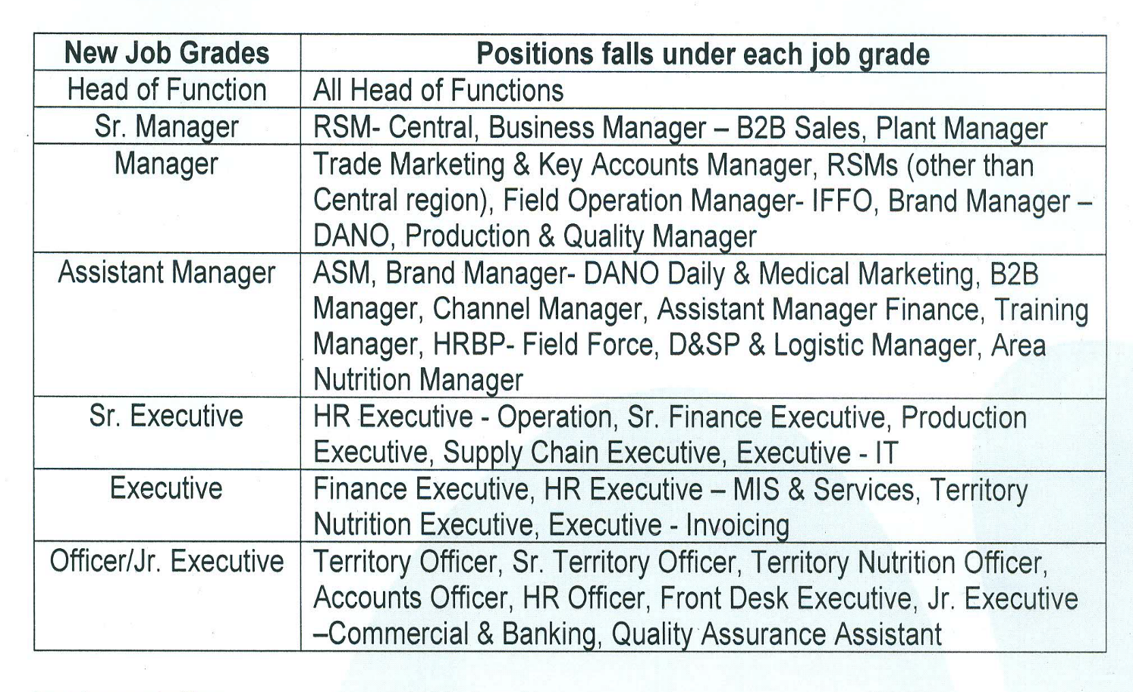
Management grade structure of Arla Foods:

Chapter 02
(Industry Overview)
2.1 Introduction
2.2 Overview of FMCG Industry
2.3 Overview of Arla Foods
2.4 Arla in Bangladesh
2.5 The Uniqueness of Arla
2.6 Mission, Vision, Strategies
2.7 Values
2.8 Organogram of Arla Foods

2.1 Introduction

Fast Moving Consumer Goods (FMCG) company is the product based organization which sell high volume of necessary goods to consumer at comparatively lower cost. These types of goods are also named as “Consumer Packaged Goods”. The common fast moving consumer goods include: foods and beverages, confectionary, toiletries (e.g. hygiene goods), fruits and vegetables, dairy products etc. Frequent purchases, low engagement (little effort to choose product), low prices, short shelf life, rapid consumption, price comparison are some characteristics of FMCG from the perspective of consumer.
High volumes, low contribution margins, extensive distribution, high inventory turnover are the perspective of marketers. FMCG industries play a great role to develop our economy, because of dealing with inelastic goods they can reach to every part of consumer life. FMCGs contribute employment opportunities all over the world due to having a large business in both urban and rural community. (KENTON, 2020) There are four major types of FMCG in all over the world, these are- home and personal Care, food and beverage, Cigarettes, Alcohol.
Characteristics of FMCG:
Consumer’s View | Marketer’s Perception
Fast consumption | Wider distribution network
Shorter product life | High stock turnover
Low price | Low contribution margin
Low involvement | Low brand loyalty
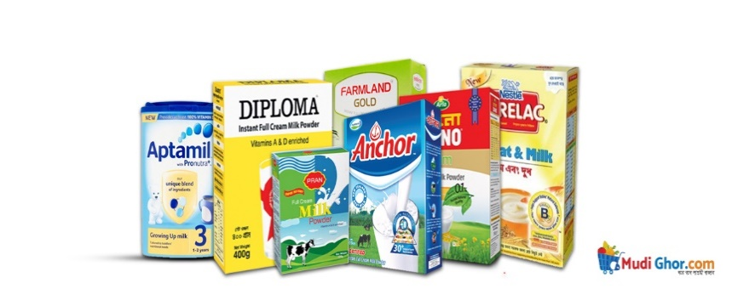
Discussion about dairy products in FMCG market:
Population of Asian cluster have the most diversified concepts of health and energy, so market of dairy or health products are emerging. Dairy sector in India is the number 1 industry and the output from dairy industry was 1.215 billion rupees (US$39 million) in 2018. In India, they have approximately 1000 milk processing plant all over the country. In Bangladesh we also have a competitive market along with local dairy brands as well as multinational brands. Both local and foreign industry are running their business competitively. (reddy, November 2018)

2.2 Overview of FMCG Industry

Previously the FMCG industry was unestablished and insignificant before 1950’s to the 70’s around the world. Fast-moving consumer industry began to shape from more than 50 years in the Indian community. In that time industry was undeveloped form the point of view of in-vestors and economists due to favoring of Governments small-sized sector and small purchas-ing power of people. With less capital and less investment some new brands started to set up their business domestically and FDI condition was relaxed to set global business in the seg-ment. In the middle of nineties all the global players were rapidly spread their ventures all over the world. These rapid-growing economy started to rule in mid-nineties, increasing ur-banization and increasing per capital income is expected to expand $100 billion in 2025 from FMCG industry. Gradually global brands like Unilever, Nestle, GlaxoSmithKline (GSK), Reckitt Benckiser, Arla Foods, Marico, Transcom and some local FMCG like Akij Food and Beverage, ACI, ACME, Square Food and Beverage, Bashundhara Food and Beverage became the dominant force in Bangladesh. (Asaduzzaman Ashik, 21st June, 2018).
Global FMCG | Local FMCG
 | 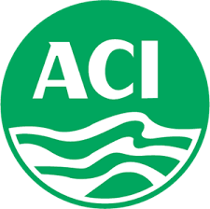
 | 
 | 
 | 
 | 


In recent pandemic situation FMCG industry and their supply chain become time-bound. Organization are getting more focused on digital platform to sell products and embracing new normal, we can say FMCG industries are facing some challenges in this new situation and virtual working process. Professionals is saying that online platform for selling and promoting are increasing than customer. Some are introducing in-house home delivery services and some are changing the market strategies. (Sadman Sakib Pantho, 2020)

2.3 Overview of Arla Foods

Arla foods is one of the global dairy cooperation, which is also known as Arla Foods Amba or Puck internationally. This largest Dairy products manufacturer completed its journey of 131 years and competitive. Arla Foods is a competitive dairy company which was established in 1880 and it can be said that company earned revenue more than 12 Billion Dollar (Approx.). More than 10,300 farmers are working in seven European countries of Arla’s Firm and pro-duce and deliver natural and solid dairy products for the customers. In the 1880s, the farmer from Sweden and Denmark combined and produce the best quality milk product. That time income came from the organization goes legitimately to the proprietors.






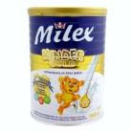




13.0% (Butter and spreads)
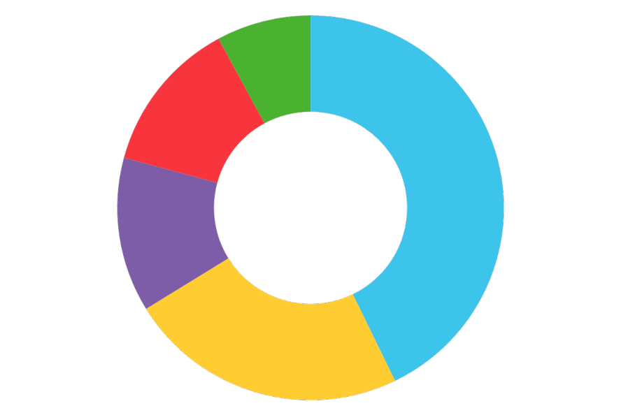



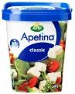
12.9% (Milk powder and Whey proteins)
42.8% (Fresh dairy)

23.4%(Cheese)
Arla’s products split by categories

The company guarantees the quality of every liter of milk. The technique was made by Arla Foods and it became well-known between European countries in the early period. As a composer possessed venture Arla emphasizes on their item and focused on the creature welfare and sanitation. Global company of Arla Foods was situated in Denmark and it is the biggest milk producer in Scan Davian. Arls’s operations were affected by long time blockade on products of Danish in the Middle East before 2006. Anger among Muslims on making cartoons of Hazarat Muhammad (PUBH) was made in Denmark was the underlying reason. That time Arla’s biggest market outside was Middle East. In 3rd February 2006, organization declared to dissolve the deals with the Middle East totally and it was cost total US$2 million of the organization in each day.
On 17 April 2000, Arla Foods was formed and merged between Swedish dairy Arla and Danish dairy organization MD foods. Arla secure its forum with client. Company started to run the business an undoubtedly flawless scenario. Arla Foods’ brands include Lurpak , Anchor, Arla Cravendale ®, Castello®, Apetina ®, Arla Buko , Arla BabyandMe , Arla Cheasy ®, Arla Lactofree , Arla Organic, Arla Natura, Arla®Skyr , Arla Yoggi , Cochio ®. In 2018 they made a pledge to minimize food waste in their production by 50% by 2030. Presently Arla foods is operating in 30 nations. Being one of the biggest companies in the Dairy Sector, 19000 employees is working with Arla Foods. The family is getting bigger and better. Presently the organization is included 12700 Dairy Farmers who are the real Owners of the organization. (Arla Foods amba, n.d.)

2.4 Arla in Bangladesh

Arla’s Product was first introduced in early 60’s in Bangladesh. In 1962, Dano Milk Powder was first Imported in Bangladesh. From 2014, Arla Foods Bangladesh started to its journey under Danish administration. From then Arla Foods is achiving top notch achievement in Bangladesh consistently. Before that Arla has been present in Bangladesh since 1961 through the most renowned milk powder brand Dano, which is now manufacturing a variety of product line with the different taste, packaging and quality by maintaining European quality standards. This large company created more than 1600 direct and indirect job with its operation in Bangladesh. At the very beginng, Arla Foods was run their business through their powerful brand ‘DANO’ when MD Foods was handled Dano. MD Foods made the dairy product market profitable, after the successful achievement Alra Foods Amba approved to setup a local office in Bangladesh in 2014.
1995: MD Foods and Arla decided to collaborate
1999: MD Foods and Arla announced merger plans
2000: Arla Foods Amba was build on April 17
2013: Arla Foods was entered in Bangladesh and create a joint venture with Mutual Milk products Ltd.
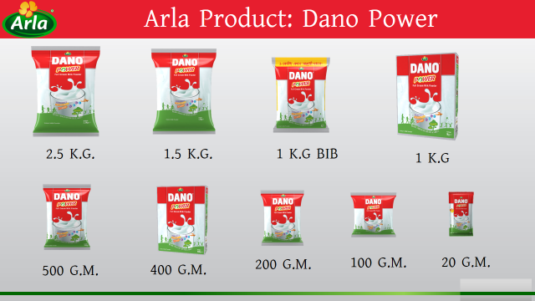
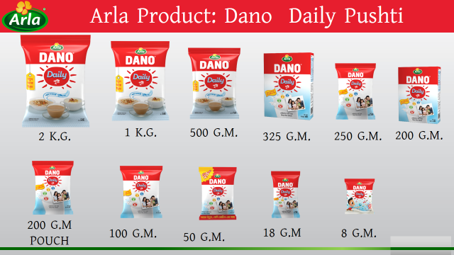
Along these lines, they began their contact office to follow advertise movement of Bangladesh Market, in the long run prompting a letter of credit being approved from Bangladesh to Denmark. To fortify neighborhood nearness in Bangladesh, as a feature of Good Growth Strategy 2020, through expanded the executive control, Arla marked a joint endeavor with Mutual Foods in 2014. Mutual Foods has been bundling the Dano® milk powder brand since the 1960s in Bangladesh. Arla has a 51% offer and gives the mass items, runs the repackaging manufacturing plant with around 130 representatives, and does the item advertising; Mutual Foods claim 49%, and runs a system to disseminate Arla's milk powder items in Bangladesh. Arla was compensated as the "Best Employer Brand 2017" in the nation. In addition, mutual trading was given the full expert to import fueled Dano in 1995. In 1998, they began the manufacturing facility in Bangladesh to satisfy worldwide guideline. Moreover, presently it's under Danish administration and, controlled internationally. Furthermore, Arla is expanding the product offering quickly to guarantee the present of each dairy item. Mr. Peter Hallberg is currently the managing director of Arla Foods Bangladesh Limited and Mr. Azim Uddin Ahmed is the chairman of Arla Foods Bangladesh Limited. Moreover, Arla Foods Bangladesh has 115 Distributors and 70+ Sub-Distributors in Bangladesh. More than 350 Employees directly working for the organization and there are 600+ sales representatives working for the company. Worldwide dairy goliath Arla Foods intends to additionally reinforce its impression in Bangladesh contacting revealed section of the populace while supporting them with moderate and better nourishment. With the target, the world's fourth-biggest dairy maker through its image, Dano, needs to put Tk 9.0 billion in the coming time in Bangladesh, where 51 percent day by day shortage in the utilization of milk was recorded by the World Health Organization (WHO). VP and head of Southeast Asia Arla Foods Ltd, Mark Boot shared the organization's future venture plan and prospects of dairy industry in the nation in a selective meeting with The Financial Express (FE) in September 2018. Overseeing chief of Arla Bangladesh Peter Hallberg was likewise present there at the meeting. Naming Bangladesh a key market for the Scandinavian organization, he said Arla has been working its business in this nation throughout the previous 57 years and built up an extraordinary appropriation connect with a solid group of individuals. (Arla Foods, n.d.)
Arla Products
A prerequisite for a successful company is the ability to attract the right talent. Just as we in Arla brand our products to the consumers, we also need to brand our company as an attractive employer to the talent we need. Once recruited, our employees need to support them in embracing our culture. This is called Employer Branding.
Dano Full Cream Milk Powder: Dano Full Cream Milk Powder gives your family the essential vitality and sustenance they require with Dano full cream milk powder. This is the most sold and nurtured product of the company. Arla sees this as their mother product though they also concentrate on the product as well. It can be established in both regular and instant forms. This highly famous product has a similar composition of cow’s milk-not to remember the creamy flavor. FCMP is also rich in vitamin A and d3 which include a high level of Calcium which is required for growth, development, and maintenance of human bone and teeth.
Dano Daily Pushti (DDP): Dano Daily Pushti (DDP) is a reasonable nutrition answer, vital families. It includes Calcium, Protein, and vital vitamins, and minerals which are essential for family health. It’s more reasonable for tea and milk-based products. One glass of nutrition cost 10 Taka.

Brands | SKU Name | MRP / SKU
Dano | Dano Power - 2.5 Kg | 1,600.00
Dano | Dano Power - 1.5 Kg | 950.00
Dano | Dano Power - 1 Kg | 650.00
Dano | Dano Power 1 Kg Pillow Pack | 630.00
Dano | Dano Power - 500 Gm | 320.00
Dano | Dano Power Classic - 400 Gm | 275.00
Dano | Dano Power - 400 Gm | 275.00
Dano | Dano Power - 200 Gm | 140.00
Dano | Dano Power - 100 Gm | 70.00
Dano | Dano Power - 20 Gm | 15.00
ST. Cream | 170gm St. Cream | 95.00
Daily Pushti | Dano Daily Pushti - 2 Kg | 800.00
Daily Pushti | Dano Daily Pushti - 1 Kg | 410.00
Daily Pushti | Dano Daily Pushti - 550 Gm | 240.00
Daily Pushti | Dano Daily Pushti - 500 Gm | 220.00
Daily Pushti | Dano Daily Pushti - 325 Gm | 160.00
Daily Pushti | Dano Daily Pushti - 200 Gm Pouch | 100.00
Daily Pushti | Dano Daily Pushti - 100 Gm | 50.00
Daily Pushti | Dano Daily Pushti - 50 Gm | 30.00
Daily Pushti | Dano Daily Pushti - 20 Gm V | 10.00
Daily Pushti | Dano Daily Pushti - 8 Gm | 5.00
Daily Pushti | Dano Daily Pushti - 7 Gm | 5.00
Dano Captain | Dano Captain Choco 500 Gm | 250.00
Dano Captain | DANO Captain Choco 150gm | 75.00
Dano Captain | DANO Captain Choco 30gm | 15.00
Dano Captain | DANO Captain Choco 12gm | 8.00
Dano Captain | Dano Captain Choco 500 Gm FS | 223.20
Choice | Dano Slim 350 Gm | 295.00
Choice | Dano Mom 360 Gm | 450.00
Deelac | Deelac 1 BIB - 180 Gm | 220.00
Deelac | Deelac 1- 400 Gms | 530.00
Deelac | Deelac 2- 400 Gms | 530.00
UHT | Full Cream UHT Milk 3.5% | 198.00
UHT | Low-Fat UHT Milk 1.5% | 198.00
UHT | Skimmed UHT Milk 0.3% | 198.00
UHT | Lactofree UHT Milk 3.5% | 248.00
UHT | Organic UHT Milk 3.5% | 248.00

Dano Captain: This is the new addition to Arla foods in Bangladesh. A chocolate milk powder specially prepared for growing kids. These are the first of its type in Arla history. It’s a combination of sugar and chocolate milk.
Dano MOM: Dano mom for women who are readying to be a mother, who is pregnant and who is still breastfeeding a baby. It is a milk supplement that if a pregnant woman consumes 2 glasses / 1 gram daily, 5% iron, vitamin D and folic acid are consumed daily. The product must be completed within 20 days after opening the tin.
Dilac 1, Dilac 2: If a baby does not get breast milk, Deilak will substantiate the proper nutrition of the baby so that it can get out properly. For children under 6 months - Dilac 1, 6 months to 2-year-olds - Dilac 2. It contains PREBIOTIC, which is not available in any other infant formula in the market. It increases the number of PROBIOTIC in the body, which helps enhance the body's immunity. Dilla has 5 types of vitamins and 5 types of minerals It is the most affordable of the formulas available in the market. Delac comes directly from Denmark.
Dano Fit:
- Dano Fit contains only 0% fat.
- Fats are high in calcium, vitamin A and high levels of vitamin D.
- Dano fit helps keep the body fit.
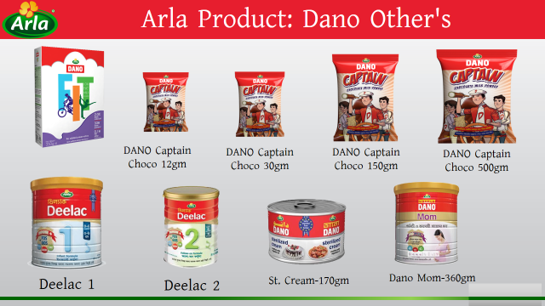
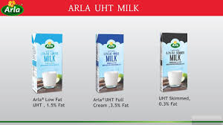
Dano Sterilized Cream: Dano Sterilized Cream is made from beef fresh milk and vegetable oil.In addition to the power production of the company, Arla also sells cream which names Dano sterilized cream. It’s a regular product with rich flavor. This cream can be used to make cakes, faluda, kormaand all kinds of sweets that Bangladeshis love very much.

2.5 The Uniqueness of Arla

We have extracted what is truly unique about Arla as a workplace, and this should always be reflected in our employer branding communication and activities. It is called the Employer Value Proposition, and it is in fact Arla's unique selling points, our characteristics.
We have compiled our characteristics under the umbrella of "Create the future – Grow with Arla" to illustrate how closely this is tied to our vision of creating the future of dairy and to Good Growth. This is split into four pillars, each representing important attributes defining why Arla is a great company with a great culture offering great jobs with a great purpose.

2.6 Mission, Vision, Strategies

Mission: Arla's Mission is to,
verify the highest worth, service & value for their farmers' milk while making open doors for their development - As a helpful organization claimed by milk makers, Arla's undertaking is to guarantee that they can make however much incentive as could reasonably be expected from the milk makers' milk - and subsequently accomplish a Competitive milk price for both owners and different providers. For the owners, it is significant that they are certain that their milk can be sold - today, yet additionally later on. Without a safe future standpoint, they would not have the capacity to build up their very own homesteads.
Vision:
The vision is to be on the top of all the dairy organizations in the planet by making impressive esteem and proactive market authority to acquire the most astounding accessible milk cost. The goal is to amplify the cost which will get into Owner's hand. For satisfying the target, they resolved to make the additional esteem and exhibit the proactive market authority. The vision is to,
Become the most attractive and comfortable dairy company for both the owners and the beloved consumers.
Strategies:
- Ensuring high quality of the products
- Advancement and Renovation
- Great Bonding with Customers & Farm Owners
- Research, Exploration & Analysis
- Product availability
- Strong relationships with consumers [Source: Arla Amba Website]

2.7 Values

Arla Foods values is built on an ambition which is to create global Arla Foods. A central part of values are, Our Character: Lead – Sense ‐Create.
Lead – Sense – Create define us what we actually and what we say. This is why we have incorporated them into our daily work. With a common character, we can achieve the targets set out in our mission, vision and strategy.
LEAD is about taking the lead, being in the driver’s seat in all our actions. It is about being passionate, striving for leadership and identifying the highest potential in our people, business and relationships.

SENSE is about perceiving our people, consumers and the world around Arla. It is about augmenting integrity, an open mind culture, seeing different scopes of skills, high potential in people attributes, business and relationships.
CREATE is about modifying and being devising in embracing expertise, brands and market relationships. Hiring strong potential talent in Arla’s business and partnerships.
Department Chart:
This is the actual senerio and the hierarchy of Arla HR department. Three employees and an intern work under Head of Human Resource and Administration. Collaborately they work together in this industry for making organized and smooth growing.

2.8 Organogram of Arla Foods Bangladesh

Managing Director
Ranks | Departments
Head of Departments | Head of Human  Resource | - Human Resource
Head of Departments |  | - Admin
Head of Departments | Head of Sales | - East & West Sales Operations
Head of Departments | Head of Sales | - Central
Head of Departments | Head of Finance | - Corporate Finance
Head of Departments | Head of Finance | - Financial Reporting
Head of Departments | Head of Finance | - Factory Finance
Head of Departments | Head of Finance | - IT
Head of Departments | Head of Supply Chain | - Inbound Logistics
Head of Departments | Head of Supply Chain | - Outbound Logistics
Head of Departments | Head of Supply Chain | - Factory Inventory
Head of Departments | Head of Corporate Affairs & PR | - Alternative Channel Management
Head of Departments | Head of Corporate Affairs & PR | - Corporate Affairs
Head of Departments | Head of Marketing | - Brand Management
Head of Departments | Head of Marketing | - Activation
Head of Departments | Head of Marketing | - Trade Marketing
Senior Manager
Manager
Assistant Manager
Senior Executive
Executive
Junior Executive
Blue Collar

Chapter 03
(Human Resource Strategies of Arla Foods Bangladesh Limited)

3.1 HR Operations
- Equal Employment Opportunity policies
- Employee classifications
- Workdays, paydays, and pay advances
- Overtime compensation
- Vacation policies
- Holidays
- Sick days and personal leave
- Performance improvement

Human Resources is a function of an organization that monitor the people issues related to organization to run a balanced business both field and office such as HR policy, recordkeeping, compensation and benefits, maintain corporate culture, recruiting and hiring employees, performance management, personnel administration and organization law. In the past scenario, people used to think HR role was fixed with “Hire and Fire” but those traditional thought and belief were gone. Today HR functions are not only liable for recruiting and onboarding new hires but also spreading in responsibilities towards creating positive culture and leaning culture in the workplace. Human Resource function is the heart of an organization, the more efficiently one manage the employee, culture the more organization will spread positive word of mouth to external people.
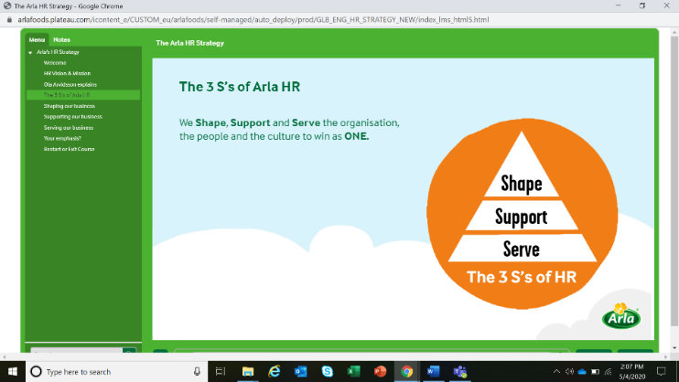
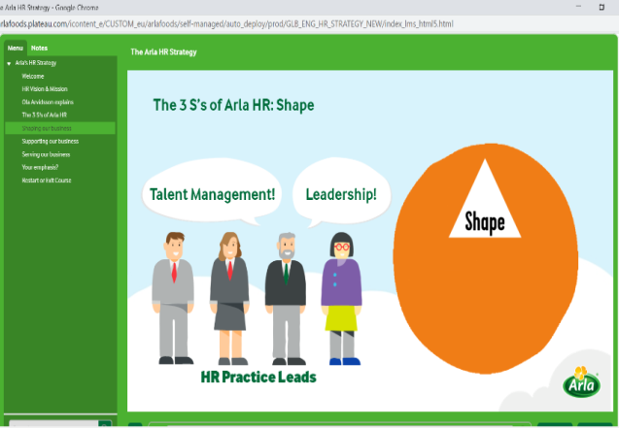
Arla Foods follows “The 3 S’s” in worldwide while running its business. These are:
Shape, Support and Serve.
To avoid negative thoughts and bring positivity in organization HR employees need to emphasize strategies in the workplace. Strategies of Human Resource mainly stands by five pillars: (Smyth, 2019), (LaMarco, 2019)
- HR Operations
- Recruitment
- Training and Development
- Employee Engagement
- Factory HR

3.1 HR Operations

3.1.1 HR Policy:
HR policies deals with a formal rules and guidelines and bunch of activities which solved the business purpose and solve the misunderstanding between employees and their obligation in the workplace. Written HR policies will help to avoid unavoidable circumstances. The key benefit of human resource policies are communication between people in organization, helps to maintain the situation through conveys guidelines which need to be followed, establish fair and equal treatment, help management to take better decision, building transparent culture and risk reduction, prevent misunderstanding in the organization. A written document of HR policy is must for an organization to manage the business in smooth way. Most of FMCG industry follow their written rules for employee benefits, compensation, pay scale, recognition, administration, leave policy, insurance etc. (BY INC. EDITORIAL, INC. STAFF, n.d.)
Arla Foods follow these HR policies while maintain the business:
- Equal Employment Opportunity policies
- Employee classifications
- Workdays, paydays, and pay advances
- Overtime compensation
- Meal periods and break periods
- Vacation policies
- Holidays
- Sick days and personal leave
- Performance improvement
- Transfer policies (Arla Policy handbook, 2020)
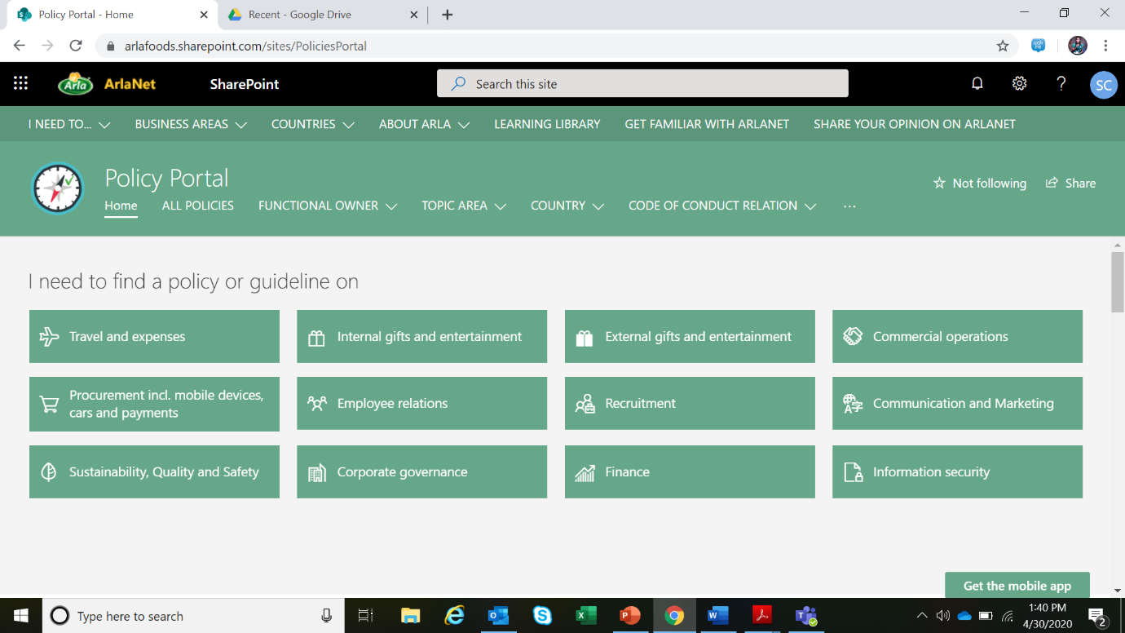

a. Equal Employment Opportunity policies: Today every organization around the world are popular based on their opportunity policies and advantage there are provided. Arla Foods is kind of organization who ensure the top priority of workers, employees and staffs that’s why people are willingly work together collaborately.
Arla Foods provides equal opportunities to all employees to remove discrimination and harassment of color, race, origin, gender identity by local laws. This equal employment opportunity includes all terms and conditions of recruiting and hiring, employee engagement program, layoff, and leave of absence, necessary needs for employees. All kinds of discrimination are prohibited under the office environment and human resource department is closely monitor all sort of well-being, and advantage.
b. Employee classifications: Arla Foods is strictly follow the employees’ chain of command and the classification of the position. From the bottom organization have blue collar employee who are office stuffs and used to work at factory, white collar employees classification start from Junior Executive who are the bottom line in the mainstream organogram/ classification, then comes to Executive, Senior Executive, Assistant Manager, Manager, Senior Manager, Head of Department, Managing Director of the organization. Chain of command is maintained according to written HR policy.
Employees from Head of Departments to Executive are usually work as a team and producing quality of work in a same struggle and dedication but everybody needs to be careful about the reporting employee.
c. Workdays, paydays, and pay advances:
Workdays-
Corporate Office: Sunday to Thursday; (In: 8:30 am to 9:30 am, out: 5:30 pm to 6:30pm)
Packaging Plant: Saturday to Thursday; (In: 8:00 am to 9:00 am, out: 5:00 pm to 6:00 pm)
Sales Force Employee: Saturday to Thursday; 8:30 am to 6:00 pm
This official timing is applicable for white collar employee only not for factory worker and head office stuffs but this time is also flexible for employee. For official requirement, employee may need to be present on holiday also for urgency. Packaging Plant/ factory employees and Sales force employees are eligible for alternative holiday on Saturday. This office timing could be change as per management discretion.
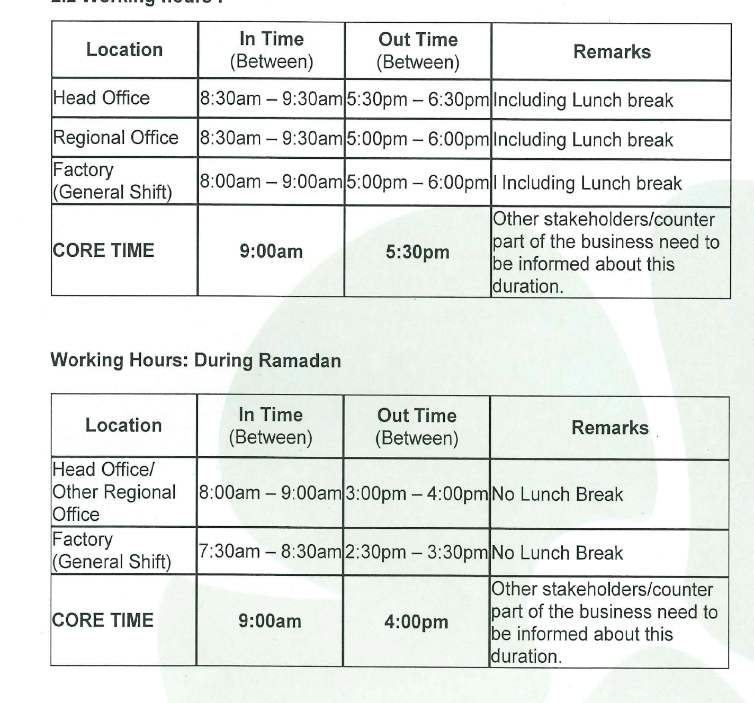

Pay Day- Salary pay date is 25th day of each month. If 25th is holiday of off day salary paid to next immediate opening day. Arla Foods Bangladesh is always attentive and stirring about the salary and other monetary benefits to the employees. Recently Arla foods has comeup with the solution that every internal and external employee will get their salary with 25th day of each month.
Advance Payment- Company provide advance payment when business required. Any business which is immediate to happen employee can withdraw the advance for the purpose of the event and need to settle the amount within 15 working days after completion of the event. There is celling for the advance, employee cannot take advance more that than.

Arla Foods BD also provide advance to employee for their personal purpose if there is necessary. Process of advance payment-
- Employee need to apply for advance payment with mentioning the reason of taking the advance along with proper justification
- Employee need to take the recommendation from line manager and function head.
- Department of HR justify the reason and
- If the reason is considerable then took approval from Managing Director and employee got the advance.
The installment amount and payback tenure also determined by human resource function. And a specific amount of money an employee can withdraw from organization for personal purpose.
d. Overtime compensation:
Overtime is when an employee or worker works more than scheduling working hours and give extra effort in the organization and overtime compensation refers to the remuneration of the extra effort outside of the schedule working hour. Arla Foods always consider the employee and staffs overtime compensation at the end of the month. Overtime compensation may varies between companies to companies which calculated the number of over working hours.
Calculation of overtime pay:
-Hourly pay rate x 1.5 x overtime hours worked.
This is how standard overtime pay is calculated.
Arla foods Bangladesh also follow this calculating method to calculate the compensation of overtime of employees and workers. Here is an example how Arla Foods calculate the overtime pay who worked 42 hours (2 hours overtime),
-Pay rate (Regular) x 40 hours = Regular pay + Pay rate (Regular) x 1.5 x 2 hours = Overtime pay = Total pay in one week
e. Meal periods and break periods:
In in the head office and factory employee can take lunch break 1-hour break between 12.00 noon - 3.00 pm.

f. Vacation policies/ Holidays:
In Arla Foods, employee will be granted paid holidays on the public holidays gazetted by the
Govt Republic of Bangladesh which shall be:

International Mother Language Day
Father of Nation’s Birthday
Independence Day
Shab E-Barat
Bengali New Year
International Labor Day
Buddha Purnima
Night of Destiny
Eid-Ul-Fitr Holiday
Eid-Ul-Azha Holiday
Janmashtami
National Mourning Day
Ashura
Durga Puja
Eid-e-Milad-un Nabi
Victory Day
Christmas Day

Employee who absents from work without prior consent of the Company or without reasonable excuse on the working day immediately preceding or immediately succeeding the gazetted public holiday, shall not be entitled to paid holiday. Any special holidays if declared by Govt. Republic of Bangladesh at any one time which are in addition to those gazette public holidays will be observed by the Company unless announced by the Company indicating otherwise through written memo/notification.
g. Sick days and personal leave:

The following categories of leave shall be applicable to Arla Foods Management Staff:

- Annual leave : 20 days
- Casual Leave : 10 Days
- Sick leave : 14 days
- Maternity leave : 180 Days
- Paternity Leave : 5 Days
- Unpaid Leave : Management Discretion
- Special leave : Management Discretion

Sick Leave:
- An employee shall be entitled to fourteen (14) working days Medical Leave on pro-rata basis with full pay and other admissible benefits (if any) in a calendar year from the day of joining. Medical Leave cannot be carried forward.
- Sick leave exceeding three (03) days needs to be supported by medical certificate.
- Medical Leave may be granted on the same day for which it is required. Leave application needs to be done immediately or within 03 days (maximum) after joining office. Failure to do so will result in the appropriate disciplinary action being taken against the employee.
- The employee must inform their line manager or HR before/within the first hour of the expected start of work or earlier if possible.
- Medical Leave over and above the entitled days will be adjusted from the Annual Leave first and then Casual leave and rest of the leaves will be leave without pay or at the management discretion. In case of serious illness, it will depend on the discretion of the management completely.

h. Performance Improvement and promotion:
- The Company may consider internal employee for promotion to higher Job Band as and when vacancy arises.
- The selection of suitable candidates will be at the absolute discretion of the Company.
- When there are vacancies, the Company may, if it thinks fit, advertise on
- Company’s website and/or the mass media, and the Company will consider applications accordingly.
- The Company reserves the right to fill vacancies from outside the company if no existing employees have been found suitable to fill such vacancies.

i. Transfer policies:
- Arla encourage mobility within the organization, both nationally and internationally, and we aim to enhance career opportunities within the organization by having an open, internal job market.
- If the employee wishes to apply for a job within Arla, he/ she shall:
- Check out vacant positions within Arla at https://hr.arla.com/vacancies/
- Write an application
- Interview and assessment
- References from former employers will be taken in accordance with country specific employment legislation but only with employee’s permission.
- If the employee has been employed in his current position for less than 12 months, he must inform his Line Manager before sending his job application.
- If the employee has been employed in his current position for more than 12 months, he must inform his Line Manager when the recruiter is contacting references.
- When an employee is required to be transferred, the Human Resources Department shall issue such the employee with a written notice employment letter stipulating the effective date, reporting line, job title/designation, and other relevant terms and conditions.

3.1.2 Salary Administration:
- Employee’s monthly salaries will be paid on the 25th day of the each month. If 25th day is weekend/holiday, salary will be disbursed on next immediate working day.
- Where necessary, salary proportionate amount due in respect of the month shall be calculated as follows :
Monthly Gross Salary
--------------------------------- X No of calendar Days from date of joining to end of the month
No. of Calendar Days in a month including public holidays

Salary Review:
- The annual salary review process is one of our annual People Processes in Arla. The salary review takes place in February / March every year, and builds on the principles of pay for performance.
- Line Managers use the outcome of the individual Dialogue meetings, combined with the core principles of paying a fair and competitive salary, as input to their proposals.
- New salaries will be effective with the April salary.

3.1.3 Benefits:
a. Festival Bonus:
Arla Foods provide annual festival bonus like in Eid-ul-Fitr, Eid-Ul-Adha according to policy. This policy is intended to provide a clear guidance on company festival bonus and distribution. This policy applies for festival bonus distribution of employee(s) of Arla Foods Bangladesh Limited at all levels. This policy will be applicable for all Blue Collar and White Collar and HR contractual employees like external IT employee and staffs.
b. Reimbursement of Annual Membership Fees:
Regarding the company policy of Arla, the Company would reimburse ‘Annual Membership Fees’ of Recognized Professional Institutions to the employees who are member of such institutes. The cost of annual membership fees will depreciate in one (01) year. If an employee leaves the company before that period, the employee shall have to reimburse/compensate the cost/expenses on a proportionate basis.
c. Mobile phone and allowances:
Every organization provides allowances and mobile phone bill to employees because it is very necessary to communicate with clients, regular managing tasks. Employees of Arla Foods Bangladesh limited is eligible for mobile phone and allowance based on usages and requirement. Mobile phone eligibility and allowance will be as per mobile allowances policy. Also mobile phone is provided to the manager and senior employees in Arla Foods.
d. Special Leave
Based on special consideration Arla withhold these special leave regulations for employees,
- Special Leave may be granted by the Board or management to an employee on accidental/health/ religious ground.
- Based on medical report and doctor’s advice, special leave may be granted however, period of special leave shall not be extended more than 180 days.
- Special leave may be combined with any other kind of leave.
- Special leave shall be counted as duty in calculating service for gratuity.
- Leave salary during special leave shall be equal to:
  - Full pay for the first three months of any period of such leave.
  - Half pay, for the remaining period of any such leave.
- Management can approve any other leave as deemed fit under this leave type.

e. Hospitalization Benefits (IPD):
Criteria | Plan | Amount
Max. Payable Benefit Per Confinement | 200K | 200,000.00
Max. Payable Benefit Per Confinement | 100K | 100,000.00
Room Limit | 200K | 6,000.00
Room Limit | 100K | 4,000.00
All other in-patient treatment expenses Includes- surgical expenses, consultation fees, medicines, medical appliances, relevant investigation and other ancillary services (excluding Room and ICU charges at actual up to a maximum per Hospitalization) | 200K | 120,000.00
 | 100K | 60,000.00
ICU | Both | 80,000.00/14 Days

Below facilities is included with hospitalization benefit:
- Post Hospitalization Physiotherapy.
- Ambulance service to & from hospital.
- Overseas Treatment.
- On spot bill adjustment.
- Post hospitalization medicine up to 10 days.

f. Maternity Benefits:
Plan | Plan | Cesarean | Normal Delivery | Miscarriage/Legal Abortion
200K | Maternity C/S 60K | 60,000.00 | 40,000.00 | 30,000.00
100K | Maternity C/S 40K | 40,000.00 | 25,000.00 | 20,000.00

- Female employee and spouse of legally married male employee is entitled for maternity benefit.
- Maximum age limit is 45 years.
- For the new joiner, pregnancy commencing before the member is not entitled for benefit.

3.1.4 Performance Appraisal:

Performance appraisal, also known as annual review is the review of individual employee for certain time period about his/her job performance, contribution to the organization, enhance changes, achieve growth according to those performance company awarded to the employee for better performance. Evaluation is done by the head of human resource and functional head and based on employee’s skills, value adding achievements and growth they apprise an employee.
In Arla BD the process of performance appraisal is called calibration. Employee set their objective at the very beginning of each year with the discussion with line manager which is directly aligned with broad organizational objective. Calibration is done end of the year based on performance of the whole year. Arla Foods BD used Nine Grid Matrix for Calibration the performance. Besides, Mid-year Review also happened at the middle of each year to understand the progress of the performance objective. Managers also can sit with employee anytime for feedback session and can take note for further reference.

Performance Appraisal Types:
Most of the performance appraisals are meant to be top-down. But there are other types:
Self- assessment- Individual employee rate their performance of tasks, responsibilities and behavior. Employees of Arla Foods can use this appraisal.
Peer assessment- Team member of individual's rates his performance, for example; supervisor, functional head apprise individual’s appraisal.
360-degree feedback assessment- In this assessment case employee, his/ her supervisor and peers altogather give feedback of individual employee.

3.1.5 Guidelines:
For the purpose of calculation, a period of more than six months will be considered as a full year.
The Gratuity shall be paid to the concerned employee.
In case of death, the Gratuity shall be payable to:
  - The person(s) nominated by him/her before his/her death
  - His/her legal heirs in the absence of any nomination
Other details guideline will be followed by Deed of Trust “Arla Foods Bangladesh Limited Employees Gratuity Fund”
Anti-bribery
- The Company is committed to conducting the business with honesty and integrity, and expects all employees to maintain high standards. A culture of openness and reliability is mandatory in order to erase illegal or unethical conduct occurring and addressing them when they do this.
- Employee is encouraged to report suspected corruption as soon as possible, in the knowledge that his concerns will be taken seriously and investigated as appropriate, and that his confidentiality will be respected.

Anti-harassment
Arla Foods is proud of its policy of maintaining a work environment that encourages respect for the dignity of each individual. The Company, therefore, endeavours to maintain a work environment free from unlawful harassment and bullying based on sex, sexual orientation, race, colour, religious creed, national origin, ancestry, age and disability. The Company prohibits such Harassment, whether at the office premises or at Company-sponsored social or non-social functions, events or programs. If such Harassment occur; Arla would take necessary action to prevent its continuation or recurrence. In addition, the Company will endeavour to prevent the harassment of its employees by persons who are not Company employees, but who are on Company premises or who have a business or other enrollment with the Company.
Harassment is unlawful, and any individual found to have engaged in Harassment will be subject to disciplinary action, up to and including termination of employment. If it is found that an individual’s conduct at work or work related events adversely affects their performance, that of other employees, or the Company’s legitimate business interests, they will be subject to disciplinary measures, which may also include dismissal.
If Arla Foods discover the false allegation against people in organization regarding harassment or bullying, necessary steps will be taken to the allegation raiser. Employee may ask questions or raise concerns regarding harassment/ discrimination, potential and actual adverse human rights impacts to his Line Manager or HR Business Partner.

Grievances Procedures
1) The purpose is to resolve any grievances or problems that an employee may have as quickly and fairly as possible.
2) Where a grievance relates solely to concerns of harassment or discrimination by a colleague, Anti- harassment will normally be used in preference to the Grievance Procedure.
3) An employee having a grievance should first approach the Line Manager, unless the grievance relates to the Line Manager, in which case the matter should be raised at the next level of management.
4) If the employee has difficulty at any stage of the Grievance Procedure because of disability or any other reason, the employee should inform the person to whom he is raising his grievance.
5) This Procedure is non-contractual. It may be amended at any time and the company may depart from it depending on the circumstances of the case.
Place your grievance to your
supervisor
Place your grievance to Function Head
Place your grievance to HR

UNRESOLVED

UNRESOLVED

General Guideline:
- Considering cost and future implications, academic certificate verification is applicable for only white-Collar employees of the organization. Academic certificates of existing White-Collar employees will be also verified under a project within a stipulated timeframe agreed by the management.
- Only bachelor’s degree or equivalent Degree Certificate to be verified to ensure genuineness of the certificate.
- An employee’s certificate has to be verified within six (06) months from the date of joining in Arla Foods Bangladesh Limited. Human Resource Division will be responsible to complete the verification within the stipulated time.
- Organization will bear the relevant cost applicable to verify academic certificates from the appropriate authority.
- The following acts and omissions shall be treated as misconduct:
- Financial misappropriation
- Wilful insubordination or disobedience
- Theft, fraud or dishonesty in connection with the Company’s or counterpart's business or property
- Taking or giving bribes to anybody at workplace or any illegal misconduct in his/her work
- Habitual "Absence without Leave" or absence without authorised leave
- Habitual breach of any regulatory guidelines, office rules or regulations
- Disorderly or indecent behaviour
- Habitual negligence in performance of duties
- Taking up employment elsewhere while absent from work or on leave or dual employment without informing and approval from Arla BD management.
- Falsifying, tampering with, damaging or causing loss of the Company’s or a counterpart's official records
- In case of Criminal Offence committed by an employee action will be taken by the Company in accordance with the provisions of the prevailing laws of the land.
- Racial/caste abuse
- Sexual harassment.

Chapter 04

4.1 Recruitment
- Recruitment Process
- Generic on-boarding checklist
- First 90 days of on-boarding

4.1 Recruitment

Recruitment is the process of identify the talent for organization who will take the company in higher stage in a certain procedure like interviewing, selecting, hiring and onboarding employees. This is a complete cycle of onboarding new employee in the organization. An efficient recruitment turns to sourcing right candidate in right job at a right time. There are some steps to bring a talent employee who can partake the growth of the organization. 5 mandatory key phases of recruitment should follow a recruiter in all organizations. Sometimes it can vary by the size of industry, structure, organizations culture and the organizations policy.

Arla Foods follows the phases of recruitment under the talent acquisition policy. These phases are-
- Identifying the Hiring Needs
- Preparing the Job Description
- Talent Search
- Screening and Shortlisting
- Interviewing
- Onboarding Selected Candidate
a. Identifying the Hiring Needs:

If organization has a job opening or newly formed vacancy, recruiter have to identify what actual talent required from that particular job post. Without knowing any need or purpose of recruitment hiring will not successful. So, the process of recruitment in Arla start with identifying skills, experience which will be needed for particular job. So the job specification will be needed for the post. In Arla determine hiring needs refers to:
- Figure out the current gaps in particular team.
- What is required from the new talent like abilities, personality, experiences, qualities etc.
- Make a list of missing qualifications, attributes and productivity in team

b. Preparing the Job Description:

After identifying the actual requirement (knowledge, skills and experience), the recruitment needs to prepare job description including duties and responsibilities, requirements etc. Preparing a job description (JD) will help to understand exact job fit talent also it will meet the meet the demands of the job post.





Arla Foods prepare a job description for per employment vacancy through this checklist recruiter search for candidates or employer can compare before applying. JD is the tool to get the right candidates in a right time. Job description includes-

Title
Duties &
Responsibilities
Qualifications & Skills
Location
Compensation, Perks & Benefits

c. Talent Search:

To attracting right talent people and encourage them to apply the current job post are the most important fact of recruitment process. Organization can spread the opening information by advertisement, create activities through social media, generate referrals, job website etc. Organizations attract the new talent and encourage to apply particular job.
Arla Foods recruiters attend different job fair, publish job post on job portal like BDJobs.com, internal referrals to search talent employee. Basically, Arla focuses on two sources of recruitment that helps to tap talent:
- Internal Sources of Recruitment
- External Sources of Recruitment
Internal Sources of Recruitment-
Arla foods sometimes internal source of recruitment, this process motivate employee to involve more in organization development, encourage to be productive. Hiring from internal source also deduction of the rate of attrition. Existing employee of the organization will spread the word of mouth about the job vacancy and create a buzz on LinkedIn/ Facebook.
External Sources of Recruitment-
Arla Foods collect select employee from internal resource, it is a wider resource to maintain a big number of candidates. This organization follows some external sources to collect resume/ CVs:
- Online job portals
- LinkedIn
- Job fair
These are externals source to avoid biasness and partiality.

d. Screening and Shortlisting: (Compensation, Perks & Benefits)

After collecting resource from external or internal source for recruitment, HR department needs to shortlist and screen the applicants accurately and effectively. The most crucial and challenging part of recruitment because if you choose or select wrong person for organization your organization will suffer.
These are steps Arla Foods effectively follow while screening and shortlisting employee-
- Focus on the match of basic requirements and qualifications.
- Next, experts sort the resumes who fulfill the criteria of the job along with relevant experiences, technical competencies, interpersonal skills and expertise related to job.
- Then, shortlist and finalize the candidates who have fulfilled the requirements.
- Finally, call for interview
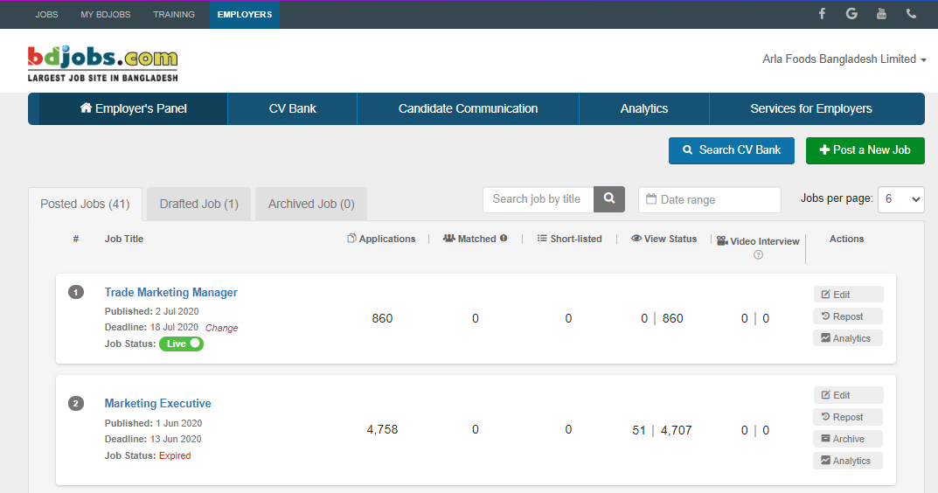

e. Interviewing:
Candidates who had shortlisted earlier will have to go through the interview as well as other assessments. This process of assessment is gateway of a candidate in the organization.
In Arla Foods, they follow three assessments while selecting the candidate for onboarding-
- Initial interview
- Predictive Index (Cognitive resonance and Behavioral test)
- Final Interview

Telephonic Screening/Video Interviewing:
In the digitalized era, video interviewing is the new normal to the all types of industry. Arla Foods also following the trend of digitalization and whenever there is any recruitment the use the online platform called ‘Zoom’ and ‘Microsoft Teams’.

f. Onboarding Selected Candidate:
After selecting and accepting offer by the candidate, he has to go through the onboarding process. It’s the final stage of recruitment process. In this stage, organization has to provide individual proper training and orientation. This will help him to understand the culture, job responsibilities, whom to report etc.
New hires always feels awkward at the first day at office, instead of showing him around the workplace make him feel comfortable, provide necessary devices in organization which is required. In the onboarding day Human Resource department of Arla complete some onboarding paper works. (Recruitment Process, n.d.)
Generic Onboarding Checklist-
- Went through all steps on the Onboarding Page.
- Completed all pre-assigned learning activities in SuccessFactors
- New joiner have to signed up their local induction
- He/she go through the induction quiz
- Keep evidence of the topics.
That is the program of Arla to the new colleague. Use it to set short-term objectives and create a structured plan with main activities for the first 90 days in his or her new job.


First day:
Activity | Responsible | Comments (can be deleted before sharing)
Introduction to Buddy and Team | Manager | Informally by their desks, or schedule breakfast or team meeting.
Introduction meeting between manager and employee  - Relevant paper work  - Intro to Function/Department/Business plan  - Employee's role and Position Description  - Personal On-boarding Program and short-term objectives | Manager
Lunch with colleagues and manager | Manager/  Buddy | Make sure most of the team is available for lunch.
Guided tour of the building | Buddy | A guided tour could include conference rooms, printers, toilets, wardrobe, entrances and exits, and parking areas. Intro to alarm systems and time registration systems.
Equipment set-up and work station  - Show desk/work station  - Make employee access card  - Set up computer  - Set up phone (Sim, mail)  - Set up print | Buddy | - Fill out access card form from Reception  - Provide password for computer.

First week:
Activity | Responsible | Comments (can be deleted before sharing)
Introduction to relevant stakeholders | Manager/  Buddy | Go for a walk in the building and make introductions.
Introduction to systems and programs  - Navigation of Arlanet  - Onboarding page for New Employees  - Self-paced learning (IT Academy/Learning Library)  - Applications (Concur, Ariba, SAP, Skype, Outlook)  - File sharing (team sites and drives) | Buddy | If relevant – show functional service portal (HR, M&I, Finance etc). Show how to use phone book, book a meeting room etc.
Self-study time  - Read provided material  - Go through onboarding page on Arlanet  - Complete assigned e-learning | New  colleague
Short introduction to Arla Foods  - Introduction to Arla Culture & Business  - Inform about health, safety, sickness, vacation and other policies | Manager | Briefly explain our mission, vision, Good Growth etc. The new colleague will be exposed to this on CheckIn and on Welcome to Arla course, but it is important that the manager explains it as well.
Role-specific on-the-job training | Colleague
Local induction course/Welcome to Arla or other training | HR

First 90 days:
Date xx/xx | Activity | Responsible | Comments/links
 | Self-study time  - Read provided material  - Go through on boarding page  - Complete assigned e-learning | New  colleague
30 days | 1 month: First Dialogue meeting (mandatory)  - Status on short-term objectives  - Create long-term objectives  - Fill out Dialogue Contract  - Assign additional training | Manager | Mandatory  - Use the position description and business plan to create long-term objectives.  - Fill out online Dialogue and upload the Position Description in Success factors.  - Assign training in Success Factors.
90 days | 90 days: Onboarding Review Meeting (mandatory)  - Evaluate on boarding experience  - Review Dialogue and short-term objectives  - Feedback | Manager | Mandatory  The formal on boarding period is over after this meeting.

Chapter 05

5.1 Employee Engagement
5.2 Training and Development

5.1 Employee Engagement

Employee engagement is the process and tools of Human Resource to engage them in success of organization as well of employees. Employee engagement gives an employee good feeling for organization and employee became committed to the workplace, they will thing about the growth and success of the organization.

Engagement in a workplace is based on collaborative environment, two way communication, trust and loyalty in the workplace and its employees. Without employee engagement activities employee will not feel motivate towards organization that’s why Arla Foods always encourage the employee engagement activities, events, recognition for employees motivation because these engagement activities are the chances to increase motivation, organization success, partake in the growth of own organization. (Engage For Success)
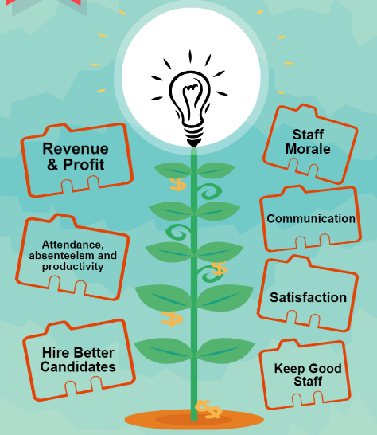
The Benefits of Employee Engagement-
- Increases Productivity and improves Retention Rates
- Increases Revenue and lowers Absenteeism
- Make employees happy, Happier Customers and Cost saving
- Makes them Loyal and produce better Quality of work
- Employees Work Harder and spread positive Vibes
- Employees are Innovative, drives Employee Advocacy
- Employees Offer positive suggestions and intrinsically Motivated
(14 Benefits of Employee Engagement that Work, 2020)
Some of employee engagement activities of Arla Foods Bangladesh are;
- Employee Recognition Award
- Family Day
- Sales 360
- Learning Projects
Arla’s Employee Recognition Award:
Recognizing the extra ordinary efforts & celebrating the success are key positive contributors towards achieving a performance driven culture within the organization. The employee/s contribution should be over and above his/her/their usual expectations of the role. This could be a one-off incident or it might be a reflection of excellent contribution over a period of time.
Recognition categories of Arla Foods Bangladesh are;
Monthly- Recognition program on ‘Employee of the month’ will be introduced for field sales up to Territory Officer level under Sales Function. Each month ‘Employee of the month’ will be selected from each sales Region based on defined parameter. Awardee will be nominated by Sales leadership team in a prescribed form and finalized by Head of Sales and Head of HR.
Quarterly- Recognition program on ‘Employee of the Quarter’ will be introduced for the field people up to Territory Nutrition Executive level under Medical Marketing Function. Each Quarter ‘Employee of the Quarter’ will be selected based on defined parameter. Awardee will be finalized by Head of Medical Marketing and Head of HR.
Annual- The proposal for the nomination of annual recognition scheme can be made either by the Heads of Functions or the Line Managers. This is applicable for all employees (Specially Parmanent) of the organization, they can be same functions or diversify functions. Opportunities for recognition may include the following, however are not limited to:
- MD’s Award: Under this category, individual/team is being awarded for the outstanding contribution. The nomination/s for this category will be made by anybody in the organization but final choice will be under the sole discretion of the Managing Director.
- Best Speed to Execution: Under this category, individual/team will be awarded for the quick execution of the project or any activity, which has a significant business impact.
The nomination will be made based on the remarkable demonstration of velocity & agility while achieving the task.
- Best Initiative: A spontaneous contribution to business beyond usual expectation. The initiative which impacts the business over a bigger horizon. This may be sighted as an example for a long time.
- Best Process Improvement: Any creative ideas or act may come under the preview of this category which improves the current process/procedure & ease up the existing process in a big way.
- Best in Customer Service: The recognition for Customer Service Excellence can be given to a team or individual who has done extremely well in serving customers in a manner that exceeds all expectations. It can be applicable to any function considering all customers including internal and external.
- Best Teamwork: Teams/departments outperforming their overall KPI with significant business impact will come under the preview of this category.
Arla’s Family Day:
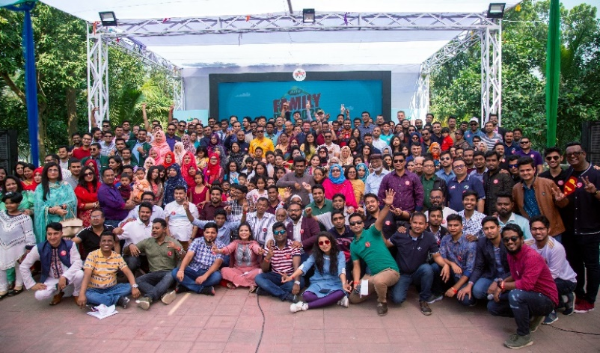
In every year Arla Foods Bangladesh organize Family day which is the biggest event in the organization. From 2015 Arla foods is organizing this event for the betterment and motivate the employee of the organization. Organization believes that this type of employee engagement events and activations will help to level up the employees productivities. The event always coordinated by cross functional team members and make the event successful and flawless. There were lots of fun activities for male, female and kids to increase the involvement, bonding, relationship between the families.
Arla’s Sales 360:
This program is also one of the annual program for sales people in Arla on to increate motivation and employee satisfaction. Through is initiative sales professionals will get awarded for achieving sales target, increase the distributions, widen the channel of sales. This employee engagement activities is arranged by Human Resource function of Arla.

5.2 Training and Development


Training and development is very important for an organization to motivate employees, this is one of the tools of Human resource function in organization. This essential tools usually focus to nurture skills and abilities of employees, raising their work performance in existing roles. Organization provides these learning opportunities to further growth of individual. Training implies to upgrade an employee’s knowledge, abilities and competencies. (Training and Development, n.d.)
When an employee starts his/her journey at Arla, organization provides job-related training to assure optimal performance of the responsibilities he/she will be maintained, so that the individual can take part in the growth more to the organization. Training in Arla Foods aims to ensure that the group always has a workforce of qualified and properly trained employees at its disposal, and that qualified employees are always identified to potentially substitute others on all levels of the company. Thus, training is relevant for all parts of Arla Foods. The company has decided to adapt its offering of internal training courses to match its global catalogue of skills and competencies. The training courses are categorized under the following headings:
- General skills
- Personal skills
- Functional skills
Any manager is responsible for regularly assessing his/her employees, partly to be aware of their skills, and partly to ensure that these match Arla Foods' catalogue of skills and competencies.

Following this seven simple but effective steps which is followed by Arla to establish successful training and development programs-
a. Assess Organizational Training & Development Needs:
Whenever there is lack of employee skills in organization, they arrange training session through in-house and external trainings. Also if an organization launch a new product they need their employee to understand and adopt the new product and increase in-line efficiency, that’s why organization spend huge amount of money to train the employees.
Arla Foods always search which is talent required to perform his/her task, they assess the talent need according to organization. Then they fix out which employee needs training on which area.
b. Define Your Training Objective:
Training goal had been defined in this stage and identifying training objective is the most crucial aspect of arranging a training. Finding objective and talent need gives the program path which training to provide for betterment and bring success. Arla Food invest on employee training and development, like if HR professionals need trainings they provide- Management Skill for HR and Administrative Professionals, HR Audit Master Class, Effective Employee Counseling and Grievance Handing Mechanism and Certified Human Resource Associate [CHRA] Program. All sort of trainings are provided in some popular training institutions in Bangladesh which is usually focused by Arla. Some of these institutions are;
- Bangladesh Foreign Trade Institute (BFTI)

- DCCI Business Institute (DBI)
- LCBS Dhaka
- BD Jobs Training
- Institute of Professional Development Programs (IPDP)
- Omnisource Bangladesh
c. Training Program Design:
After finding the core objective of training of the employees, organization need to have a roadmap or design their plans before jump into action. An effective plan includes learning and developing methods as well as instructional content flow and other such practice test.
Arla Foods training design is formulated based on Sales, Marketing, Human Resource, Supply Chain, B2B functions whenever it’s required.
- They keep in mind the needs of employees and create content of training around the objective
- Formulate the training principles for internal employees
- Employees are sent to training center like BFTI, DCCI, LCBS, BD Jobs Training, IPDP etc.
- Set up an interactive training program along with Q & A sessions
- Training segments should keep into short and effective.
- Daylong session can be formulated
- Ensure effective connection between segments
d. Training Program Development
After preparing the design organization need to develop training program internally or externally by trainers. Also training materials like training manuals, practice notes, prepare feedback material for instructor, required PPT and other practice materials for sessions need to create for employees.
Usually when Arla face any training they focus on external training institute to train their talents, those institute develop that session, prepare materials for employee and give feedback.
e. Training Program Implementation
This is the step where all preparation you have taken so far will rolled out. There are some few points to make sure while implement effective training program-
- Training activities should well in advance and sessions should be mobilize with current situation
- Decide the suitable organization and location for employee training based on group size.
f. Evaluate Your Training Program
After completing an effective training and developing program, follow-up should be kept for understanding the effectiveness of employee training. It is necessary to track an employee as soon as complete the training and developing program, this tracking helps to understand training objective and implement on daily basis of work in organization.
Arla foods always track the progress and effectiveness on the existing employee of the training program who go through program just after accomplishing the training and development if necessary. This training and developing of workers and employees can increase the productivity, motivation and reduce increase turnover. Get feedback from employees who had rolled out. Was it helpful for current responsibilities and imformative? Collect the suggetion from employees and make a dashboard of effectiveness of training program it will help to understand the new and updated program versions. (7 STEPS TO CREATE SUCCESSFUL TRAINING AND DEVELOPMENT PROGRAMS, n.d.)
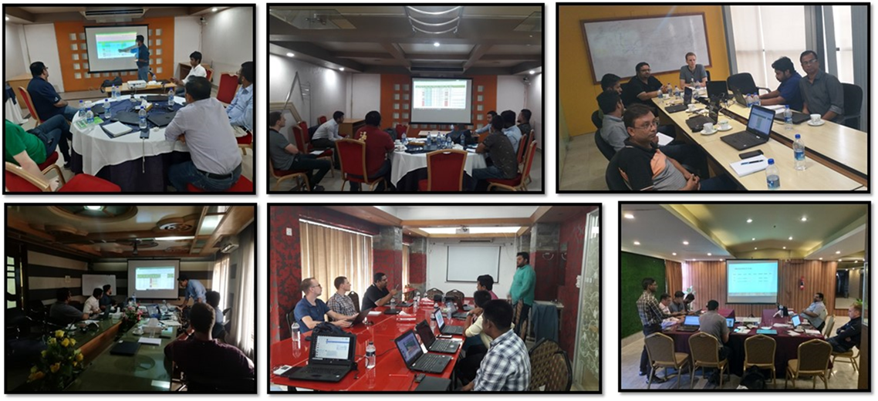
Arla’s Sales Training Session

In house Learning and Development:
Below is a brief description of what the employee will need to understand what development is available within his/her function in Arla Foods.
Success Factors
This is the online tool for booking learning activities. Employee can search by subject and then select the date and time that suits him. Any fees are shown next to the selected course.
Learning Library
This is Arla self-service learning library. The employee can find a number of different learning activities under some core subjects which are common to all colleagues in the business. These are accessible to all employees and are designed to be self-paced so the employee can develop himself at a time that is convenient to the employee.
IT Academy
The IT Academy concept is an in-house development where we record typical software situations, introducing and teaching use and best practices of our most important software systems. The interactive lessons from IT Academy are available to view by everyone within Arla, on-site or through VPN remote connection.

ARLA FOODS TRAINING EVALUATION FORM

Name: Training Attended:

Institution: Resource Person:
Duration:
CURRICULUM High Low
1. | The training met my expectations. | 5 | 4 | 3 | 2 | 1
2. | Knowledge learned on training will increase my job efficiency. | 5 | 4 | 3 | 2 | 1
3. | Training objectives for each topic were followed. | 5 | 4 | 3 | 2 | 1
4. | The curriculum content was well organized and easy to go through. | 5 | 4 | 3 | 2 | 1
5. | The materials distributed were pertinent and useful. | 5 | 4 | 3 | 2 | 1
RESOURCES PERSON / INSTRUCTOR
1. | The presenters were knowledgeable | 5 | 4 | 3 | 2 | 1
2. | The quality of instruction was good. | 5 | 4 | 3 | 2 | 1
3. | Good training aids and audio-visual aids were used. | 5 | 4 | 3 | 2 | 1
4. | Class participation and interaction were encouraged. | 5 | 4 | 3 | 2 | 1
5. | Adequate time was provided for attendee questions. | 5 | 4 | 3 | 2 | 1
OVERALL
1. | How do you rate the training overall? | 5 | 4 | 3 | 2 | 1
2. | This training was effective to do my job better. | 5 | 4 | 3 | 2 | 1
3. | This training is worthwhile and should be conducted on a  regular basis. | 5 | 4 | 3 | 2 | 1
ADDITIONAL COMMENTS:
1. | Which of the trainings presentations or topics were the most useful to you?
2. | What items or activities would you like to see added to this training to make it more useful?
3 | Other Comments:

Signature: ______________________ Date: _____________
Benifits of HRD:
Most precious campital for an organization is human capital that plays a crucial role of running business successfully , contribute for the betterment of organization with the help of their capabilities. Successful organizations always work behind every employee, they motivate them, guide them, train them according to their job role and make strong backbone amoung organizations. HRD or human resource development is training system of an organization where individuals are provided development training by experts to gain and involve with new competencies which will take the workforce or human capital self-reliant.
There some benifits the workforce of employee aquire while training-
People Commitment- New generation employees are use to feel motivated if organization provide them training about basic learning about job. Workforce whose basic development need from organization are met they are committed and loyal to organization and keep impact on development of their workforce. Prople of Arla foods are so committed for their workplace and resistant to switch another better oppourtunity because organization provide them training and invest on their learning.
Improved Employee Performance and Learning Capacity- The main purpose of human resource development is improving employee performance and improve effectiveness. Arla Foods always guide the talented employee for retaining and utilise their full caliber and benifit of the organization and they take measures the workforce by giving training to enrich skills, values, attitudes.
Improved Organizational Effectiveness- Human resource improve development of organization and produce quality of work with collaborative environment if they give proper training to workforce. Trained employees can

Informed and talented employees avail directly to the benifit and growth of an organization. HR Development focuses on continuous mitigrating and dveloping the competencies, dynamism and effectiveness of its employees; helps to develop positive attitude and problem solving skills; upgrading individual and collective experience, knowledge and perceptions; and enhancing their competitive skills. These and similar activities fine-tune employees to align and integrate their personal goals with organizational goals. (A.Noe)

Chapter 06

6.1 Factory HR
- Responsibilities of factory HR
- Factory HR Operations

6.1 Factory HR

Factory HR or plant HR is refers to maintain factory related rules and regulation and ensure the positive work environment according to Government policy for the employees and workers, find out the right number of talent employee and productive worker to execute production strategy and assists and implement the global HR-related legal and regulatory guidelines in production house.
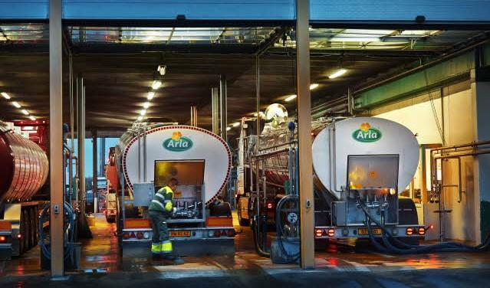
Factory of Arla Foods is located at Konabari, Gazipur.
Responsibilities of factory HR-
- Establish the rules of presence in each floor to monitor the production flow and process. It will helps to keep record and maintain balance on each floor.
- Proactively solve the employee relation with fair and unfair issue factory HR implied the rules to protect the need of worker so that they can work effective. Ensure the disturbance free area while production is processing.
- Factory HR should manage employee grievances and impose the grievance procedure rules of organization, in this case HR could set up an open forum to resolution of all issues regarding factory.
- After every quarter factory HR can provide all the employees and workers some training regarding operations and engineering to better productivity, agile and prompt working environment.
- Factory HR have to take initiative of other ad hoc activities that save time and energy. Other ad hoc HR activities can be tracking of production, quick attendance taking, less stoppage of machine, extra support for production, communication etc.
- Keep evidence of employment documents and other factory related agreements also keep on eye about workers needs and wants.
- Monitor all sort of safety training after each quarter, focus on employee turnover and productivity, labor shortage.
- One of the core responsibilities of plant HR is to stay updated himself/ herself in current labor law, implement laws according to those rules. (Kumar, n.d.)
Most crucial HR operation is maintained by factory HR in all over the world. There are six HR functions in Factory/ Plant that can drive efficient results while product manufacturing in the organization.

a. Compensation management

Compensation management is one of the largest expense apart from purchasing raw materials and other necessary goods for production house in an organization because workers and employees efficiency depends on handsome compensation. So factory HR should focus on cost effective wages to manpower.
Arla’s factory Human Resource team always focus on on-time salaries and wages disbursement within 25th in each month so HRs always keep an eye on right mix of wages and their base and variable pay, other benefits to motivate them, entertain high performers, invest on their trainings and safety.
b. Benefits evaluation and administration
Human resources are the most important resource of manufacturing organization so they need to provide all sort of benifits. Factory HR should manage and controll the expense which is invested on employees and workers. As the factory workers face couple of risky jobs, ensuring their health benifit is sencitive issue. According to labour law of Bangladesh, organization must have ensured the regulation of safety in workplace.
Arla Foods Bangladesh ensure the health insurance for employee and strictly maintain the safety benefits by organization. There is a survey for the factory human resource regarding their job satisfaction, worker retention, benefit plan, employee contributions, based on the survey factory HR evaluate their benefit plan and other administration. All the benefits like first-aid appliances, medical care, interval for rest or meal, weekly holiday, extra allowance for overtime, annual leave and wages, protection from inflammable machines and administration curriculum are setup by the instructions of global Arla Foods.
Recruitment/ Talent acquisition

Recruiting the true talent for manufacturing industry is the important but the younger generation feels less interest. So HR should encourage the manpower about the benefits of working such manufacturing organization. That’s why factory HR need to plan and prepare module of recruitment process and attract talent employee.
There is a team in Arla Foods Bangladesh who basically maintain the curriculum of recruitment to hire person job fit in Arla. In the factory of Arla Bangladesh, we have approximately one thousand blue collar worker along with employees like Engineer, Quality Assurance Officers, Supervisors and Floor Inspector etc. These are the scopes for HR to recruit employee.

Training and development

Providing training and giving enough leaning about the building machinery, automatic machines, cranes, hoists and lifts, pressure plant, dangerous fumes, explosive or inflammable gas, dust and personal safety is main responsibilities for factory HR leaders so that employee get attach with the organization with safety. These types of training has a direct impact on productivity. By hiring outside consultants, trainers’ trainings can be done.
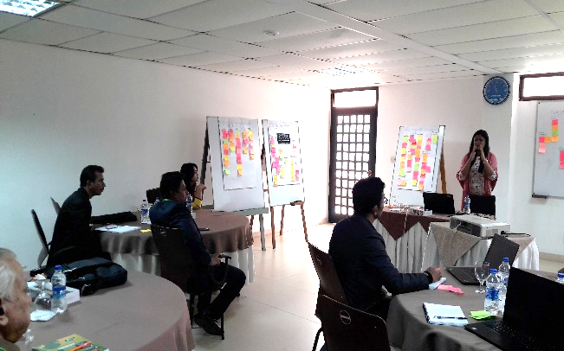
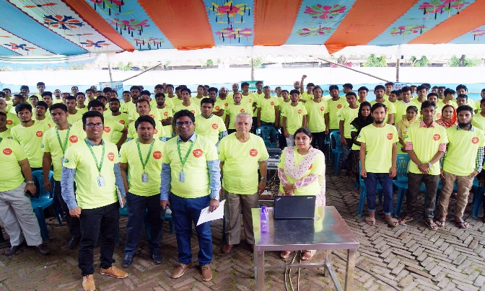
Arla Foods factory which is located in Gazipur strictly follow these tanning and development procedures which is provided by third party institutions for workers. HR employee in factory thoroughly examined by an inspector every 12 months or less than that which ensure that all the hoists, lifts, lifting machineries, cranes, striking gear, pits and tunnel are safe to work.
Arla’s Safety Training by Externals

Performance appraisal and management

HR professionals design and implement the method of performance management internally or the help of third party institutions. Big organization used to do this performance appraisal internally but some organization is assisted by outside consultants. Effective Performance appraisal and management helps to get an idea to HR function the productivity of individual employee, target achievement, meet deadline in time.
Arla Foods Bangladesh has a strong performance appraisal procedure through this process HR function measure the employee activities, performance, effort for organization. Organization recently focus on ‘Power BI’ (Power BI is a tool to provide business analytics service under Microsoft and it helps to create the business performance, report and HR dashboards) to complete the performance appraisal of the employee. Organize use the Power BI to measure the appraisal for white collar employee this is not applicable for workers and stuffs.

Employee and labor relations

HR leaders in manufacturing organization like Arla Foods have to have clear knowledge about the county’s labor relations. Every organization tries to follow individual county’s law for worker like conditions of employment, payment of wages, maternity benefit, health and hygiene, welfare measures, working hour and leave etc. If any unwanted occurrence happened HR leaders have to deal with it according to government rules and procedures. (HR Functions That Drive Results in Manufacturing), (Khan, 2013)

Chapter 07

4.1 Online Recruitment
4.2 Online Activity and Management

7.1 Vertual/ e- Recruitment

Vertual recruitment is the recruitment method for the organization to hire and sourcing employee through internet. e-recruitment is the new normal in now a days for all of the organization around the world. Online recruitment process is becomming most using process for recruiter to hire talented candidates and by this time internet platform is quickly become primary recruitment matric. Some organization follow this online recruitment process internally by the HR Business Partner or some organization take help from third-party institutions for talent search. Arla Foods Bangladesh conduct this online talent acquisition by HRBP of the organization with readily available job portals, social media specially LinkedIn, Bdjobs.com and other business networking sites.
e-recruitment or internet recruiting is same as normal in-house recruitment process but FMCG industry are not actively focusing on this recruitment tool which is new normal a developing country like Bangladesh. While working at Arla Bangladesh, I have been realized some benifits of vertual recruitment than traditional recruiting, like-
- To find suitable candidate in the short period of time.
- Process is time saving for both the recruiters and candidates.
- Emerging the organization with new normal is the best way to stay updated.
- Balance of cost per hire and selection ratio


7.1.1 Vertual recruitment for employers
Vertual recruitment create awareness of a organization abour a vacancy, it allows you to get a clear idea about the organization, their culture etc from internet. As the idea of vertual interview is new to people of Bangladesh, knowing some information and tools as an employer and utilize while recruitment. Arla Foods HR professionals use some software which is licenced for organization ( Software: Microsoft Teams, Zoom, GoToMeeting) online employment testing.
There are four way to conduct or arrange an online recruitment-

Professional Associate Websites:
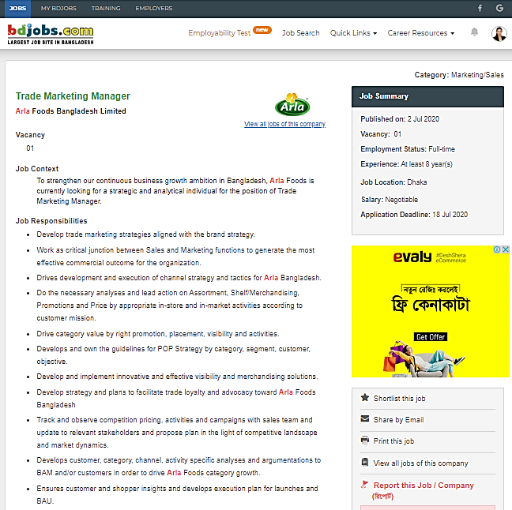
To maintain a websiteis mendatory for any organization to collect perfect candidate when nececessary and provide necessary information about organization so that candidated can reach to organization when there is any opening. Now a days responsible candidate always visit organizations frequently to get updated. One organization can take advantage from job posting site like Monster, Glassdoor and these source automaticallu create database of resumes according to organizations criteria.
In this case Arla Foods always souce employee through website and email. There is an official email to sourcing porential resume.
Professional Associate Website
College and Alumni Organizations:
Nows a days universities are allowing the organizations in their campus portals, official website to advertise for free. This allows an organization to source more candidates who are freshly graduated or high professional. United International University always embrace and welcome other MNC, FMCG, Banks other colsultancy agencies to promote, engagement which necessary, sometime UIU give them oppurtunity of publishing post jobs to their websites.
As Arla Foods has other sourcing tools so they do not permit campus activities and do not let using the organization name with other institutions.
Social Media resources:
Some social media websites have high volume number of candidates within 18-34 age group so it is very easy to reach with them through a single social media post on the websites. Posting job oppourtinities on the social media helps to growing company presence in upcoming new generation. One can use LinkedIn, Twitter and Facebook while posting new job so that employee can share with their other contacts. LinkedIn and Facebook allows candidate list who have applied that shows in company account. These are the best choice for vertual recruitment and reach out to potential resource.
In this situation, Arla Foods source potential candidates through social media page like Facebook, LinkedIn.
Complany Website:
Every organization tries to create a career site over their website and also that career site can create a job portal. If organization has any opening company website works as funnel for candidates. Capitalize in company website traffic by adding a call to action for job applicants which will add extra value to organizations website. For vertual recruitment and sorting resumes from the website it hate to make sure to createan easy process. (Donohoe, 2019)
Above mentioning tasks are ways to vertual recruitment which cannot increase the efficiency of an organization recruitment process. There are some best tools for online recruitment-
Programmatic job advertising: Arla Foods allow programmatic job advertising by the Human Resource hiring team to posting vacancy to different talent pools which I was easy way to source vertually. This adversiting ensure the top notch recruitment advertising provoding insights of data of current recruitment.
Candidate testing: Candidate screening test is important for employers to understand whether candicate is perfect fit for the organization. If the employee do not fit in the workplace it won’t be worthy to investing lots of time for vertual recruitment. Online test shows a path to find out the candidates soft skills, job fit atributes, personality etc.
(Recruitment Online: Tips & Tools, n.d.)

7.1.2 Online activities and Management policies:
After 20th century, departments of human resource were became important function and established for organization betterement and sustainability. Gradually Human Resource departments started their function with maintaining organizational documentation, formulated rules and regulations, forms, preparing performance apprisal for employees, recruiting and selection, payroll etc. It had became now most lucrative job all over the world and helped to meet the government laws and regulations, keep an eye on employment oppourtunities, compensation and benifits, provide learning culture to employyes. For maintaining data, information, integrating performance Human Resource Information Systems (HRIS) create vast impact on workflows and daily basis work for professionals of Human Resource. But Human Resource workflows and administrative tasks is moving towards vertual platform where every organization is focusing on online software like Microsoft Teams, Google Meet, Zoom etc. (Suen, 2017)
Organizations all over the world is focusing new normal vertual office activites and maintain the management policies. Currently Arla Foods Bangladesh also managing activities and other working procedure by vertual platform like HR administrative tasks, salary disbursement, employee engagement, providing benifits to factory workers.

Vertual quarterly sales incentive scheme:
This incentive is be called ‘Quarterly Sales Incentive’ in Arla which used to conducted in the period of quaterly and the quarterly sales target will be fixed for all distributor level. All types of sales incentives are measured by Human rource business partner and head of sales in Arla foods vertually through Microsoft Teams.
- Incentive will be start from 90% achievement level.
- At 100% achievement, individual’s earning will be double of his current earnings and it can be more.
- Some KPIs (Key Performance Indicator) have been defined for the incentive
- If an individual achieve his/her target at least 2 months in the quarter than he/she will eligible for receiving the incentive.
- 25% of incentive amount will be disburse after the end of month and remaining amount will be disburse after end of each quarter.
- Pay out will be calculated based on monthly gross Salary
- Quarterly cumulative amount will be considered as quarterly sales incentive
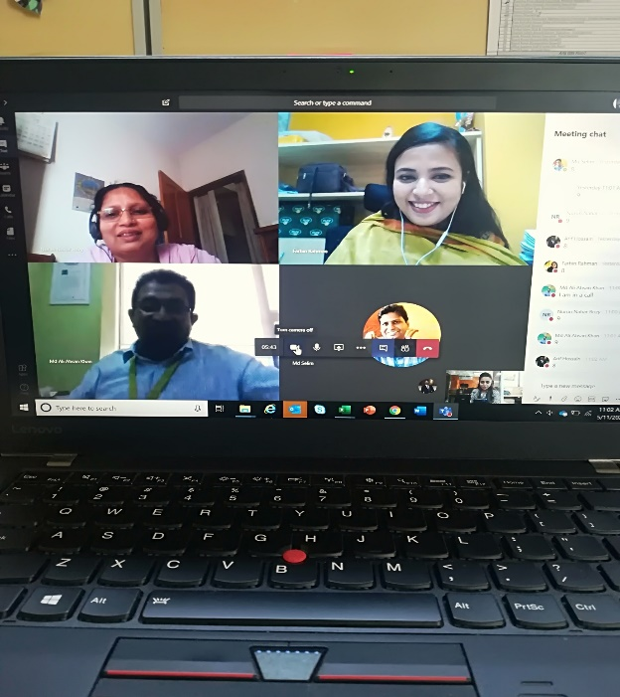

Example of Incentive calculation:
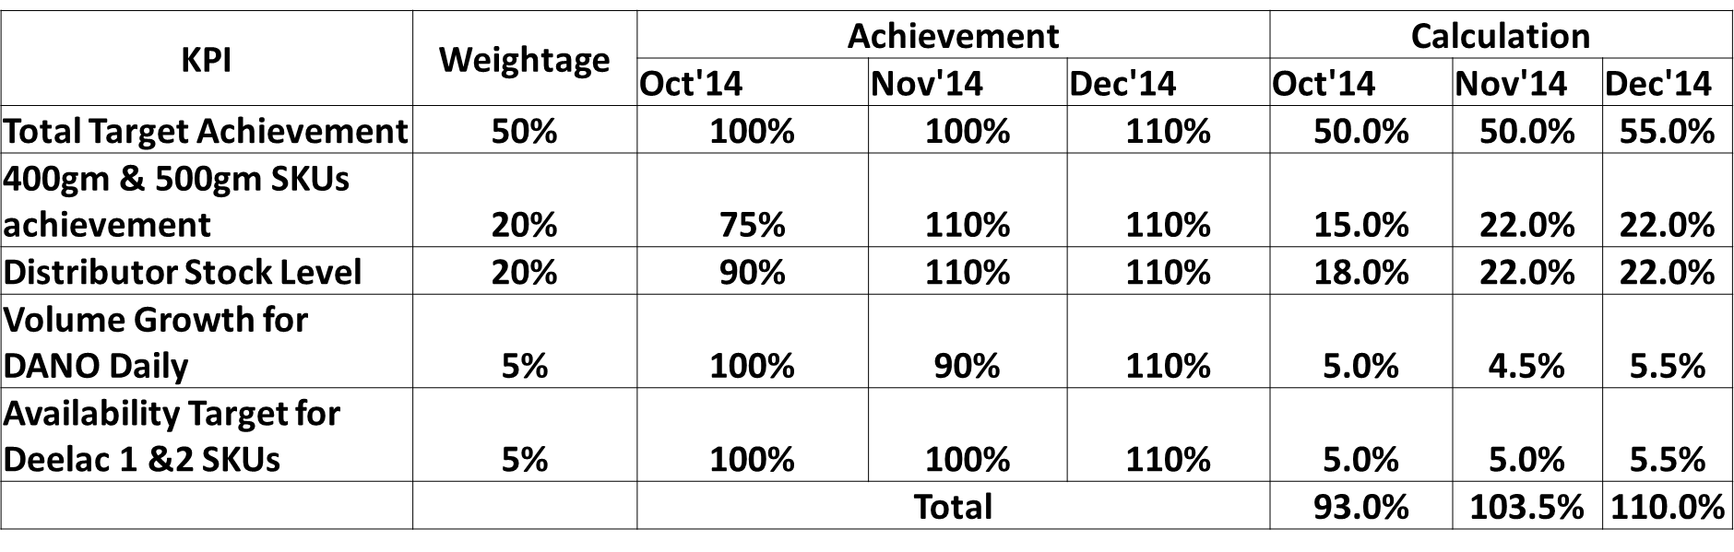
Monthly Gross Salary – BDT.10,000
Incentive Earning
Quarterly Incentive
7,000
Nil
Nil
Nil

Vertual training and development:
It is very important for employee to perform well and achive sales target in fast moving consumer industry and to achive target employee needs to have continuous training training and development allingned with job responsibilities. Now a days organizations are allowing their employee in the vertual training by the help of exterts of different sector and thus they will be benifited in new technology, new normal.
Previously Arla Foods do not focus on this sort of vertual training but they will surely organize this type of vertual training session to cumminicate and create engagement with employees.

Chapter 08

8.1 Findings
8.2 Recomendations
8.3 Conclusion

Findings

Human Resource department is one of the key functions for Arla Foods Bangladesh Limited. Since the organizations culture, values, policies makers are maintaning by the professionals of this department so it is highly needed proper nourishment of the organization. After analyzing organizations HR activities, I have identified some findings,
- Arla Foods is a flat organizational hierarchy and emplyee get chances to work closely with managers, HOD which is rarely find any other organization.
- Employees are satisfied of the payscale and at the end of the day they show loyalty to company and working several years long.
- Department wise responsibilities and working stratucture is smooth and transparent in Arla Foods.
- HR department egerly embrace and grab the change the new ideas and thoughts any of the employee.
- Sometimes work should have approved from global team which is really time consuming
- Organization do not count employees performance as seniority.
- Individual can work independently
- One of the negative facts I have notice that male female ratio is quite discriminative. Only few females are working in the company. But now Arla Foods is increasing their female ratio in workplace.
- While recruiting employee Arla shows equal priority to private, public and national universities students, human resource function looks for skilled and energetic employees only.

Recommendations

Being an Intern for last 5 months, I have been able to get many insights from the organization and learned many valuable things. Though 5 months are a very short period to understand ins and outs of an organization. Based on the short-term experience, I would like to draw some recommendations for the organization,
Training and Development: More acute and profound training programs should conduct to increase performance of the employyes. In very optimum level different on the job and off the job training courses could be provided because these some sort of learning culture needed for some employee. Organization should focus on training about new thing to some aged employee and they should have up-to-date about the recent technologies.
HR policy of Arla could include some arrangement regarding to a reutilized and modern training.
HR counseling cell: There should have HR councelling and ensure amoung the employee maintain the good bonding with others. Encourage the employees that they egerly share about the problems in professional life. Whole process have to have full confedentiality to HRs.
Continuous modernization and revision: At Arla there are some individual who have less mindset to embrace Modernization and revision and less likely encourage changes. HR functions should continuously monitor on new changes happening and introduce new normal subject to employees amtch them with Arla policy.
More social engagement: Arla Foods always work accordingly with Global Arla Foods Amba, since starting they are following the traditional engagement. But now a days other organizations are coparatively more focusd on social media platform. That is how other FMCG are spreding positive word of mouth about their industry where Arla has some lacking in this case due to the policy so they need more employee engagement in social media and that’s how employee get satisfy about his/her job.

Conclusion

Arla Foods Bangladesh has created a very strong and solid impression in Bangladesh. Arla is stepping ahead in Bangladesh with full steam. It’s guaranteeing the dedication of selling most elevated quality dairy products to its customers. Arla is well positioned organization and going ahead with consistent development, focusing on its key abilities and dutie for the quality. Individuals in Bangladesh embraced Dano as a standout amongst the most dependable brands. The company is continuously growing with evolving policies of innovation and consumer satisfaction. Its commitment to producing high quality food products and providing them at affordable prices has kept them in high regards amongst its consumers. As one of the largest producers of dairy products in the world, it is sure to become a leader in setting standards for international business and food production on a global scale. Throughout internship period, I got a friendly and team working environment and had a amazing bonding with all the departments of Arla Foods.

Bibliography

- (u.d.). Hentet fra Arla Foods amba: https://www.arlafoods.com.bd/
- 14 Benefits of Employee Engagement that Work. (2. February 2020). Hentet fra Vintage Circle: https://blog.vantagecircle.com/benefits-of-employee-engagement/
- 7 STEPS TO CREATE SUCCESSFUL TRAINING AND DEVELOPMENT PROGRAMS. (u.d.). Hentet fra Evoma: https://evoma.com/business-centre/7-steps-to-create-successful-training-and-development-programs/
- A.Noe, R. (u.d.). Employee Trainingand Development. McGraw-Hill/Irwin.
- Arla Foods. (u.d.). Hentet fra Wikipedia: https://en.wikipedia.org/wiki/Arla_Foods#History
- (2020). Arla Policy handbook. Human Resource & Administration. Bangladesh: Arla Foods.
- Asaduzzaman Ashik. (21st June, 2018). FMCG Industry Review of Bangladesh. Bangladesh: EBL Securities Limited Research.
- BY INC. EDITORIAL, INC. STAFF. (u.d.). Human Resource Policies. Hentet fra Inc.com: https://www.inc.com/encyclopedia/human-resource-policies.html
- Donohoe, A. (02. August 2019). Definition of Online Recruitment. Hentet fra Bizfluent: https://bizfluent.com/about-6319257-definition-online-recruitment.html
- Engage For Success. (u.d.). What is Employee Engagement.
- HR Functions That Drive Results in Manufacturing. (u.d.). Hentet fra Overture Institute: https://www.theoverturegroup.com/blog/6-hr-functions-that-drive-results-in-manufacturing/
- KENTON, W. (12. Mar 2020). Fast-Moving Consumer Goods. Hentet fra Investopedia: https://www.investopedia.com/terms/f/fastmoving-consumer-goods-fmcg.asp
- Khan, P. A. (2013). Bangladesh Labour & Industrial Law. Dhaka: Shirazul Islam.
- Kumar, Y. K. (u.d.). Sr Role - Plant HR Generalist. Hentet fra iimjobs.com: https://www.iimjobs.com/j/sr-role-plant-hr-generalist-mfg-10-15-yrs-85517.html
- LaMarco, N. (25. January 2019). What Are HRM Strategies? Hentet fra Chron: https://smallbusiness.chron.com/hrm-strategies-59260.html
- Recruitment Online: Tips & Tools. (u.d.). Hentet fra Smart Recruiters: https://www.smartrecruiters.com/resources/glossary/recruitment-online/
- Recruitment Process. (u.d.). Hentet fra Jobsoid: https://www.jobsoid.com/recruitment-process/
- reddy, V. b. (November 2018). A STUDY ON FAST MOVING CONSUMER GOODS SECTOR-A COMPARITIVE STUDY ON DAIRY AND SOFT DRINK PRODUCTS, 159.
- Sadman Sakib Pantho. (22. May 2020). FMCG industry in Bangladesh is coping with lockdown. Hentet fra The Daily Star: https://www.thedailystar.net/next-step/news/how-fmcg-industry-bangladesh-coping-lockdown-1904839
- Smyth, D. (13. June 2019). What Are HRM Strategies? Hentet fra Bizfluent: https://bizfluent.com/about-5529235-hrm-strategies.html
- Suen, H.-Y. (2017). Toward Multi-Stakeholder Value: Virtual Human Resource Management.
- Training and Development. (u.d.). Hentet fra Business Jargons: https://businessjargons.com/training-and-development.html

