An Internship Report
Prioritizing Consumer Needs and Wants of Bangladesh Steel & Engineering Corporation


Supervised By
Dr. Md. Shariful Alam
Associate Professor
School of business and economics
United International University

Prepared By
Name: Nahid Hossain Ghalib
ID: 111 123 238
BBA Program
United International University (UIU)

Date of Submission: 10th April, 2019


Acknowledgement

At the beginning of the report, I want to thank Allah for making me able to complete my BBA internship at Bangladesh Steel Engineering Corporation Limited as well as to prepare my internship report.

I want to thank my honourable course faculty and internship supervisor Dr. Md. Shariful Alam, Associate Professor, School of business and economics, United International University for all the guidance and direction during last three months of internship period. It was very hard for me without the format of the report and the suggestions of preparing my report well. Thank you sir for sharing your valuable time from your busy schedule. All of your effort was highly appreciable

I want to show my gratitude to Md. Nur Alam, Senior Marketing Executive of Bangladesh Steel & Engineering Corporation Limited (BSECL) for helping me to perform several technical responsibilities inside the organization. . I felt a lot of difficulties at first as an intern to perform my responsibilities, where I found him as a supporting hand and he guided and supported me to accomplish the work objectives. He also shared a lot of information that were proved very important resource for preparing my report.

Moreover, I want to thank all the colleagues and fellow members for sharing the time and information to complete my report. The office environment and employee engagement was very good and because of these two factor, I feel an affection inside me for the office. I wish, I could work there once more.

Letter of Transmittal

10th April, 2019

To
Dr. Md. Shariful Alam
Associate Professor
School of business and economics
United International University

Subject: Submission of Internship Report.

Dear Sir,
It is my pleasure to let you know that I have recently finished my three months long internship program from Bangladesh Steel Engineering Corporation Limited (BSECL). During performing my responsibilities as an intern, I have prepared my internship report on “Prioritizing Consumer Needs and Wants of Bangladesh Steel Engineering Corporation Limited”.
As a marketing concentrated student, the topic of the report was very relevant to my field of study and preparing the report was very interesting to me. The application of different methods make me able to acknowledge the marketing application of prioritizing needs and wants of consumer. I have learnt to apply my educational learnings in the practical scenario.
All the guidelines and supports that you provided to me, was very helpful for the preparation of the report. I have got all the basic ideas of how ro make an internship report from the format, you had given to me. All these helped me a lot to enrich my report with valuable information on Bangladesh Steel Engineering Corporation Limited (BSECL).
I want to add that I have followed all the steps you had suggested me to include in the report. All the data, used in the report, are relevant and taken from valid sources as well as from my internship experiences.
I would be highly grateful if you accept my internship report and oblige thereby.

Yours obediently,
Nahid Hossain Ghalib
ID: 111 123 238
BBA Program
United International University (UIU)

Executive Summary

Bangladesh Steel & Engineering Corporation Limited was created with the aim of contributing to the development of the country's infrastructure, creating the basis for industrial growth, making human and material movements faster and easier, and helping in the use of the system.
I am lucky to get the opportunity to work here. Each day I passed very challenging time and learnt a lot of lessons. The report title is also very friendly to me as I’m going to be a graduate of marketing major. So, understanding the prioritization of consumer needs and wants and know how to apply the learning knowledge into my practical knowledge seems to be very helpful to me in my upcoming future.
Basically, a need is a conscious sense of deprivation in a person. In other words, customer needs is something that requires to be fulfilled to make consumer satisfied. For example, in the case of Steel business, speed of service, quality of steel is a good example of what is needed to the consumer (Peterson, Neels, Barczi and Graham, 2013). A steel company that does not maintain a high level of trustworthiness and durability of their products will lose business relationships with its competitors. So, prioritizing the needs would be an effective strategy to sustain the business in such competitive market.
The report is started with the general discussion on why and for what are the reasons the report is created for from the first chapter. The following 2nd chapter shares the methods used to prepare the report. Then, the third chapter discusses the overview of the company so that a reader of this report can get a broad idea on the Bangladesh Steel & Engineering Limited. The later and the main chapter is chapter 4th that is going to share how the company is prioritizing the needs and wants of its consumer to satisfy them. In the end of the report, few recommendations have been shared for the betterment of Bangladesh Steel & Engineering Limited.
Subject Keywords: Need, Want, Customer satisfaction, SWOT Analysis, Bangladesh Steel & Engineering Corporation
Table of Contents

Chapter One: Introduction
1.1 Introduction: 1
1.2 Objectives of the study: 1
1.3 Rational of the study: 2
1.2 Scope of the study: 2
1.4 Limitations of the study: 2

Chapter Two: Methodology of the study
2. Methodology of the study 4
2.1 Data design: 4
2.2 Data Analysis: 4
2.3 Analytical tools: 4
2.4 Model Specification: 4

Chapter Three: Organizational Overview of Bangladesh Steel & Engineering Corporation Limited
3.1 Background of the Steel Industry in Bangladesh 6
3.2 Organizational Background of BSECL 7
3.3 Vision of BSECL 7
3.4 Mission of BSECL 8
3.5 Values of BSECL 8
3.6 Security policies of BSECL 8
3.7 Safety policies of BSECL 8
3.8 Business policies of BSECL 8
3.9 Products and services of BSECL 9
3.10 Target Market of BSECL 10
3.11 SWOT Analysis of BSECL 10
I. Strength of Bangladesh Steel & Engineering Corporation Limited 11
II. Weakness of Bangladesh Steel & Engineering Corporation Limited 12
III. Opportunity of Bangladesh Steel & Engineering Corporation Limited 12
IV. The Threats of Bangladesh Steel & Engineering Corporation Limited 12

Chapter Four: Prioritizing Consumer Needs and Wants of Bangladesh Steel & Engineering Corporation Limited
4.1 Identifying consumer needs and wants. 15
4.2 Prioritization of needs and wants. 20
a. Price Policy: 20
b. Improve the creation of value for the product and the customers: 20
c. Powerful distribution network: 21
d. Improvement in Steel Product Development: 21
e. Changes in Source of economic supply (raw materials): 22
f. Greater interaction and evaluation with final consumer: 22
g. Improvement in customer service and relationship service: 22
h. Regular incentives and rewards for retailers: 23
i. Focus more on adaptation than on standardization: 24
j. Organization of trainings and seminars: 24
k. Highlight other promotional and advertising initiatives: 25
Chapter Five: Recommendations and Conclusion
5.1 Recommendation 27
5.2 Conclusion 28
Reference 30

Acronyms
BSECL | Bangladesh Steel & Engineering Corporation Limited
SWOT | Strength, Weakness, Opportunities, Threats
BSRM | Bangladesh Steel Re-rolling Mills
RRM | Rani Rolling Mills LTD
KSRM | Kabir Steel Rolling Mills
BBFL | Bangladesh Blade Factory Ltd.
OHS | Occupational Health and Safety
List of Acronyms

Chapter one: Introduction

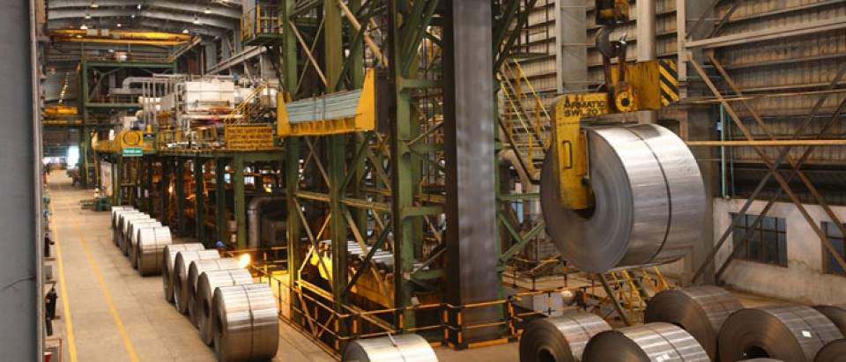

1.1 Introduction:
Bangladesh Steel & Engineering Corporation Limited (BSECL) was created with the aim of contributing to the development of the country's infrastructure, creating the basis for industrial growth, making human and material movements faster and easier, and helping in the use of the system. Maritime and fluvial transport. Currently, BSECL has only 9 (nine) active industrial companies, of which 49% are owned by three (3) companies, namely Atlas Bangladesh Ltd., National Tubes Ltd. and Eastern Cables Ltd. respective companies. The companies of Bangladesh Steel & Engineering Corporation have played an important role in the economic development of the country by producing electric cables, domestic cables, transformers, lightning rods, automatic circuit breakers and circuit breakers, LT and HV insulators. , PFI installations, light tubes, CFL lamps and super enameled copper wires, etc., contributing substantially to the electrification of the country. BSEC also contributes to the road transport sector by assembling buses, trucks, jeeps, motorcycles, mishuk, etc. The companies in these cities also produce the MS / GI / API type and safety razor blades. During the 2017-2018 fiscal year, companies in the Black Sea region produced goods for 6,672.40 billion crowns and sold goods for 864.13 million crowns. Crowns while allowing a net profit (before taxes) of 73.67 billion crowns. The BSEC also paid 2777.67 billion crowns to the National Treasury as VAT and taxes.

  - Objectives of the study: The objectives are the goals for what the report has been prepared. The objectives are:
- Primary objectives: The primary object is to complete the internship program and achieve the BBA degree from the United International University.
- Secondary objective: This objectives are more specific and relevant to the report.
- To Analyse the business of Bangladesh Steel & Engineering Corporation Limited
- To identify the needs and wants of consumer
- To analyse the procedures of service to measure the prioritization of need and wants of consumer.
- To recommend several suggestions in favour of the company.

1.3 Rational of the study:
The report is going to analyse the prioritization of consumer need and wants by Bangladesh Steel Engineering Corporation Limited. A need is a conscious sense of deprivation in a person. In other words, customer needs is something that requires to be fulfil to feel consumer satisfied, later the need converted into wants and to the desire the demand creates. So, the topic “Prioritizing Consumer Needs and Wants of Bangladesh Steel Engineering Limited” is very crucial as the consumers are the variable for whom the business is running for. Moreover, there are a lot of competitor who can take the position by offering better services and fulfilling the consumers’ needs and wants.

1.2 Scope of the study:
The report search for the needs and wants that consumers might hope from the Bangladesh Steel Engineering Corporation Limited. The marketing manager can find the report very informative. There were rarely any report also made on this company. So, obviously the company overview can help any buyer to know about the company and how the company facilitates consumer through its products and services. Other companies can learn the consumer prioritization criteria. The report will help any reader to know how to sense the need and wants of consumer and how to concentrate on those needs and wants. Faculties and university students will also be benefitted from the practical experience oo mine.

1.4 Limitations of the study:
The limitation I have passed while preparing these report are:
- Limited duration: The internship program is for three months in duration. In this short period of time, it was very hard to prepare the full report.
- Strict policies: The Company follows strict policies and rules on sharing company’s inner information to the outside. Few information were very important for my report but I am not permitted to share.
- High work pressures: An intern has to perform a lots of responsibilities all the day long in the organization. It was difficult to manage all those responsibilities and prepare the report.

Chapter Two: Methodology of the study

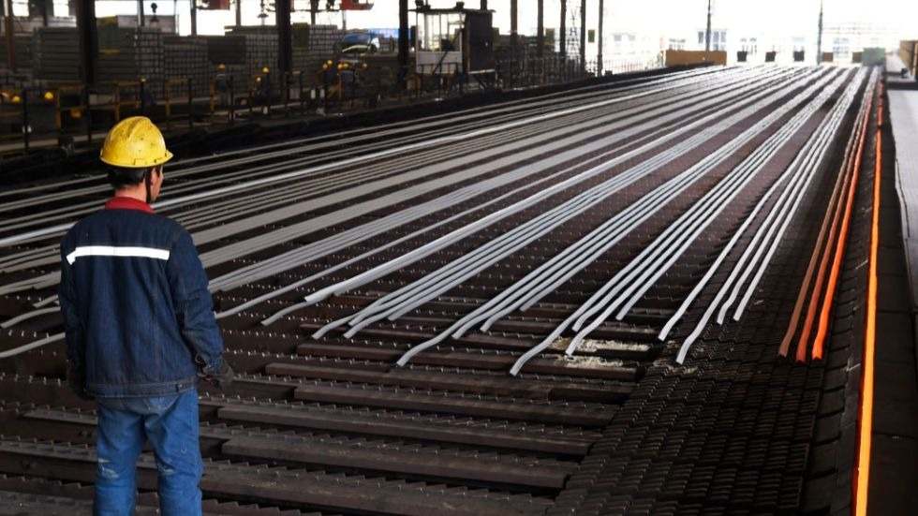

2. Methodology of the study
This chapter is going to discuss all the methods the report is about to follow in the later. This Methodology is separated into four parts discussed below:

2.1 Data design:
The study is designed based on exploratory descriptive research using several famous marketing model. Exploratory research is research conducted for a problem that has not been studied with greater clarity, whose objective is to establish priorities, develop operational definitions and improve the final design of the research. Exploratory research helps determine the best research design, the method of data collection and the selection of subjects.

2.2 Data Analysis:
Both quantitative and qualitative data and several marketing concepts are followed to show how the company is prioritising the consumer’s needs and wants.

2.3 Analytical tools:
The study is conducted through Microsoft Word and Microsoft Excel. A survey questionnaire is designed using Google forms and 6 random consumers of BSECL had been chosen to share their needs and wants. This survey is used to measure the basic idea of what the consumer are expecting from the steel company and later shown how the company is improving their service to meet the needs of their consumer.

2.4 Model Specification:
The report consists of popular marketing theories and models. For instance:
a. Swot Analysis: To identify BSECL internal environmental factors such as the strengths weaknesses, opportunities and threats. The SWOT analysis provides useful information for linking enterprise resources and capabilities to a competitive environment in a managed environment.
b. Survey Questionnaire: It’s a popular marketing method to collect information and it consists of a set of questions that used to collect, analyse and interpret the different views of a group of people from a particular population. The questionnaire is created by Google forms and delivered to 6 real buyers of BSECL to get an idea of the different need of the consumers and to identify their perceptions of the Bangladesh Steel and Engineering Corporation Limited (BSECL).

Chapter Three: Organization Overview of Bangladesh Steel & Engineering Corporation Limited (BSECL)

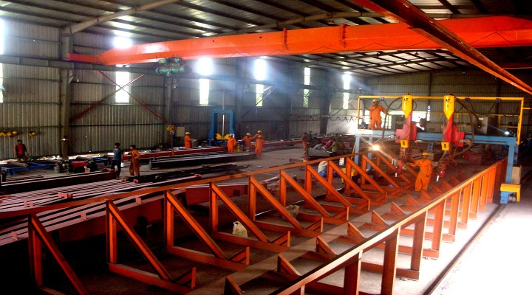

3.1 Background of the Steel Industry in Bangladesh
The first steel plant was founded in 1952 by the industrial group named, H Akberali under the name of "Bangladesh Steel Re-rolling Mills (BSRM)". Located in Nasirabad, Chittagong, the plant has formed reinforcing bars and structural sections. The plant has expanded gradually, adopting new technological knowledge, creating in 1987 a European transnational plant that incorporates a machine mill. The BSRM group added a billet production facility in 1996 to ensure a stable distribution of billets from its mills. In 2006, the company installed a cold pilot mill for the production of high strength ribbed yarns.
At that time KSRM Steel Plant Ltd. emerged. More recently, they established a billet factory in Chittagong. Its factory is located in Ghoramara, Sitakunda in Chittagong. KSRM is a steel production organization that belongs to the Kabir group of industries. One of the largest mills in Bangladesh. In addition, several other steel companies have sprung up in the country, including GPH Ispat, (RRM) Rani Rolling Mills LTD, (KSRM) Kabir Steel Rolling Mills, AKS, Anwar Ispat, HKG Steelworks Ltd., Rahim Steel Mills LTD, Seema LTD, Steelworks, Steel Steels Bashundhara, etc.
Bangladesh The steel industry is emerging as one of the largest industrial sectors in the country. These are small and large mills and rolling mills throughout the country, producing mainly deformed bars of different qualities (40, 60, 500), angels, channels and coils for the construction industry. Although the history of the steel industry is not the oldest. But this can make a glorious future. Before 1971, Bangladesh did not have a steel factory and even after liberation there were only a few steel mills in the country. In the 1990s, the current development of this sector began with a revolution. During this period, construction agencies or developers volunteered to build a modern infrastructure. Thus, with the increase in demand, new investors have begun to invest in the production of steel or bars. In 2012, we have almost 400 factories throughout the country, including Dhaka, Chittagong. Although most of them are manual mills, 30 factories are automated.
Many steel companies have acquired a reputation as a brand. These include GPH Ispat, BSRM, RSRM, KSRM, RRML, Anwar Steel, HKG Steel, AK Steel, Rahim Steel and Abul Khair Group. Today, the largest steel producer is BSRM. They have been doing business for 60 years. Its production is almost six and a half million tons per year, which corresponds to a demand of 26% of the local market. Now, the barrels of class 60 are slowly replaced by g500 bars, which now produce many mills in our country. With g500, builders and property developers can also save at least 15% more steel than the G60.

3.2 Organizational Background of BSECL
Bangladesh Steel & Engineering Corporation Limited (BSECL) was formed by the merger of Bangladesh, then Steel Mills Corporation Limited and Bangladesh Engineering & Shipbuilding Corporation, by order of Bangladesh Industrial (Nationalization, 2nd Amendment), 1976. Bangladesh Steel & Engineering Company started operating with 62 companies. Subsequently, BSECL created a sector called Bangladesh Blade Factory Ltd. (BBFL) in 1984. At present, it has only 9 industrial enterprises in operation, of which 49% out of the 3, Atlas Bangladesh Ltd, National Tubes Ltd. and Eastern Cables Ltd. have been uploaded by the public and employees of their respective companies. Bangladesh Steel & Engineering Corporation has played an important role in the country's economic development by producing power cables, internal cables, transformers, unloaders, cut-off fuses (DOFCs), switches, LT switches, HT switching devices, PFI installation, light tubes, CFL bulb and enamelled copper cable, etc. and therefore contribute substantially to the electrification of the country. BSECL contributed to the road transport sector and assembled buses, trucks, all-terrain vehicles, motorcycles, Mishuk, etc. BSECL companies also produce MS / GI / API with safety blade / razor. During the fiscal year 2017-2018, the BSECS member companies produced goods worth CZK 672.40 and sold for a value of TK 864.13 while allowing a net profit ( before tax) of 73.67 million crore. BSEC also paid TK 2,377,000 to the State Treasury in respect of VAT and taxes.
Bangladesh Steel and Engineering Corporation Limited (BSECL) was founded on July 1, 1976. It is run by Pragoti, a company that collects Mahindra cars in Bangladesh. In 2016, it signed an agreement with Honda to drive motorcycles in Bangladesh. The company delivered his shipyard and engineering work to Narayanganj to the Bangladeshi Navy. The company has the Chittagong dry dock in Chittagong, Bangladesh. In 2016, the government announced plans to build military vessels in the Chittagong dry dock. A parade of six openings is built at Sylhet. He is also the owner of GEMCO, a producer of cables and National Tubes in Gazipur. Its main office is the BSECL building in Kawran Bazar, which also houses the offices of RTV, NTV and Amar Desh.
Creation of innovative products and processes in steel.

3.3 Vision of BSECL
Create innovative steel products and processes that exceed the current and future needs of our customers.

3.4 Mission of BSECL
The BSECL team will always create high quality innovative steel solutions for its customers in a safe, responsible and economical way.

3.5 Values of BSECL
At BSECL, the fundamental values ​​of safety, quality, productivity and innovation are the basis of our company, since the company is committed to fulfilling its mission to operate safely, responsibly and profitably.

3.6 Security policies of BSECL
In BSECL, safety is first and foremost. Our cutting-edge approach to security is more than a goal of the company. It is part of BSECL culture, it is the basis of everything the company do and what matters most to them.

3.7 Safety policies of BSECL
a. Develop, implement and maintain occupational health and safety (OHS) procedures;
b. Reduce and eliminate risks through safety and health procedures and emergency preparedness programs;
c. Commit the necessary resources to comply with all applicable legal and other requirements, as well as the prevention of accidents and the necessary continuous improvement;
d. Strive to continually improve the effectiveness of your health and safety management activities.
e. Regularly assess compliance with all applicable OHS procedures;

3.8 Business policies of BSECL
a. Innovation
BSECL is the engine of innovation in all our processes and products. BSECL is based on a long-standing legacy of innovation to create high-quality steel solutions that exceed the needs of current and future customers.3.6 Products and services of BSECL.
b. Productivity
As a manufacturer of stainless steel, carbon and steel products, BSECL manages flexible structures that allow it to adapt to changing market conditions and customer needs.
c. Quality
BSECL is committed to the continuous improvement of its products, processes and services to meet and exceed the expectations of its customers.

3.9 Products and services of BSECL

Chart 1: Product and services of BSECL

3.10 Target Market of BSECL
Chart 2: Target Market of BSECL

3.11 SWOT Analysis of BSECL
Internal and external environment investigation strategies are an important part of strategic planning process. The company's internal environmental factors can be classified as Strength (S) or Weakness (W) and Opportunities (O) or Threats (T) of enterprises strategic environment. This analysis is called SWOT Analysis. The SWOT analysis provides useful information for linking enterprise resources and capabilities to a competitive environment in a managed environment. For example, it is a mechanical instrument for formation and selection. The following figure shows how a SWOT analysis fits into an environmental scan:
Chart 3: SWOT ANALYSIS

Strength of Bangladesh Steel & Engineering Corporation Limited
- Excellent competitive power:
BSECL has been working continuously in steel production. As a result, the company gained great competitive power. It has the ability to face terrific competition.

- Reliability:
Be the preferred business partner of customers and suppliers to supply quality products; Provide best service on a timely and after-time commercial transaction.

- Strong marketing alignment:
BSECL has developed a powerful and effective marketing policy to share designs with the designers of its products, which make customers more aware of the mind.

- Strong Links and Employees Composition:
BSECL employees are one of the company's main strengths. BSECL employees have a strong commitment to the organization. The main reason behind this energy is the strong culture of BSECL.

- Strong product distribution line:
BSECL has employed more than 100 distributors across the country so that people can get BSECL products in reasonable time. They also have a number of sales and supply depots in Dhaka, Comilla, Borga, Shyamlat and Khulna.

Weakness of Bangladesh Steel & Engineering Corporation Limited
- Power crisis:
Everyday energy crisis is increasing in Bangladesh. As a heavy industry, BSECL requires a lot of energy and gas for its daily production. Since the government has not provided uninterrupted supply of fuel and gas, production is declining.

- Profit reducing for high interest rate:
BSECL has taken a lot of loan from several banking and financial institutions in Bangladesh. Interest rates reduce corporate profits so.

Opportunity of Bangladesh Steel & Engineering Corporation Limited
- Organizational purpose
Providing quality products at low prices to the company and making life of the people safer by becoming partners in the country's construction activities.
- Increased demand for products:
There is more scope for profit in the BSECL because the demand for 500 degree auctions daily in the local market is increasing.

- International goals:
Since BSECL is a nationally recognized company, it has a great opportunity to export steel products in the near future.

The Threats of Bangladesh Steel & Engineering Corporation Limited

- Economic crisis
Global recession and the existing socio-political situation prevailed in Bangladesh in 2008 in any developmental work. Secondly, due to the recession, steel sales have declined.

- Growing competition:
All major steel producers in Bangladesh want to increase their production capacity. Production capacity increases, production costs will be reduced to them. As a result, the competition in the steel market will increase.

- New Contest:
In recent times, the new company has started production of steel. One of them, AKS (Abul Khair Steel) is one of them. Its goal is to produce 800,000 tonnes of steel a year. But now they only produce 200,000 tons.

Chapter 4: Prioritizing Consumer Needs and Wants of Bangladesh Steel & Engineering Corporation Limited (BSECL)
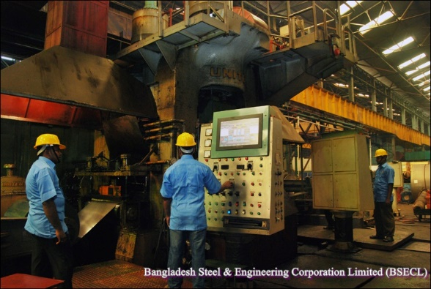

4.1 Identifying consumer needs and wants.
Delivering better customer service means providing products and services or providing effective solutions to the problems, satisfying customer needs. To do this, the representatives of customer service, customer service and call centres must be able to accurately and completely identify the needs of the customers. The objective of identifying consumers need and want is to identify and meet the needs of the customers. It’s an essential and highly an important step to create reliable clients. At the end of this BSECL will be able to correctly identify the importance of identifying customer requests; Ask the right questions to accurately identify the needs; Identify and accept the benefits of cross-selling opportunities; And meet the needs of current customers, products, services and solutions.

To identify the consumer need and want of BSECL products and services, I have carried out a survey through Google forms and found several opinion on the needs and wants of 6 real buyers of Bangladesh Steel & Engineering Corporation Limited (BSECL). The questions are given below and some additional needs that are observed by me during my internship also included later to identify all the needs and wants of BSECL buyers’.
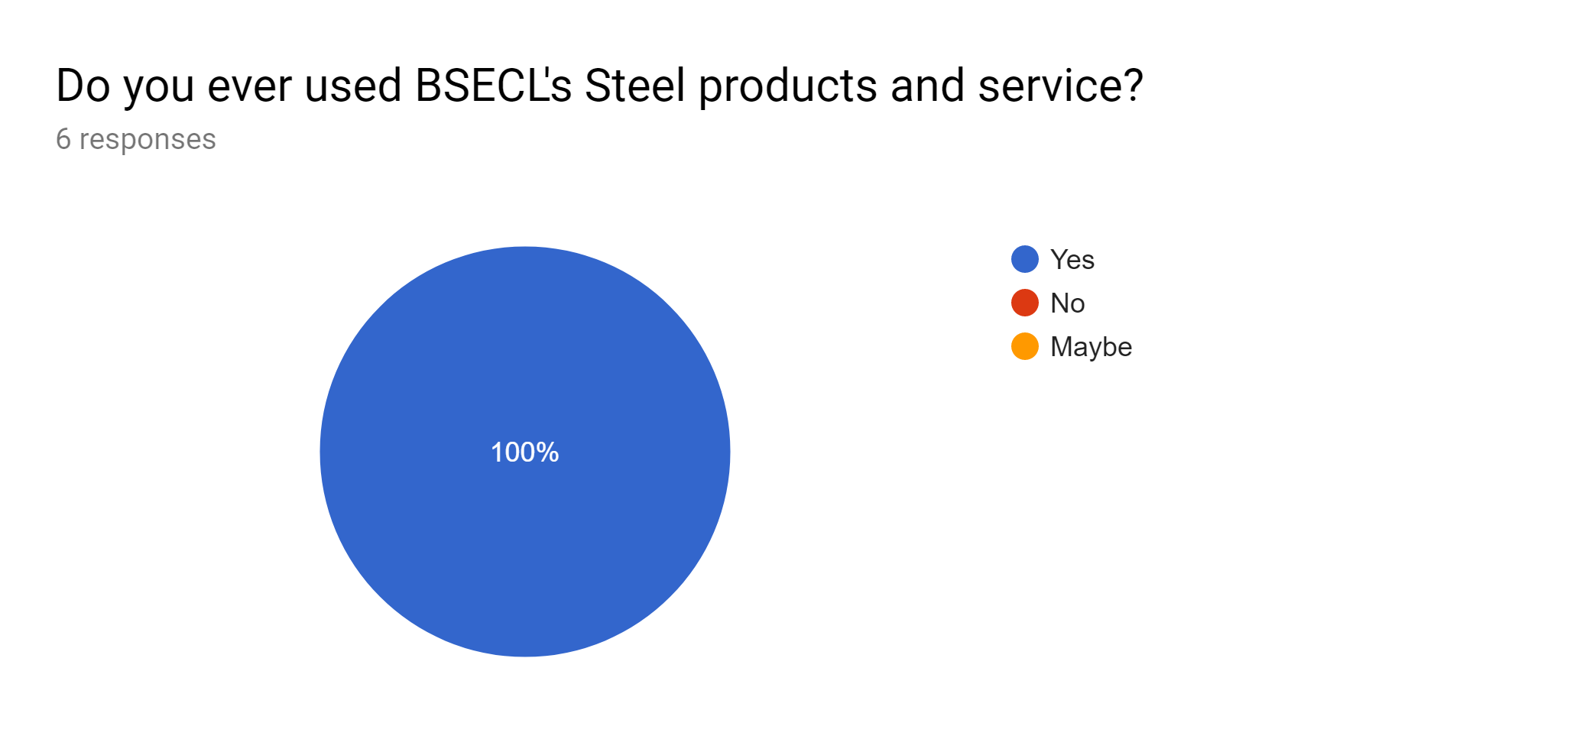
Interpretation:
All the six respondents were selected who had at least purchased once from the Bangladesh Steel & Engineering Corporation Limited (BSECL).

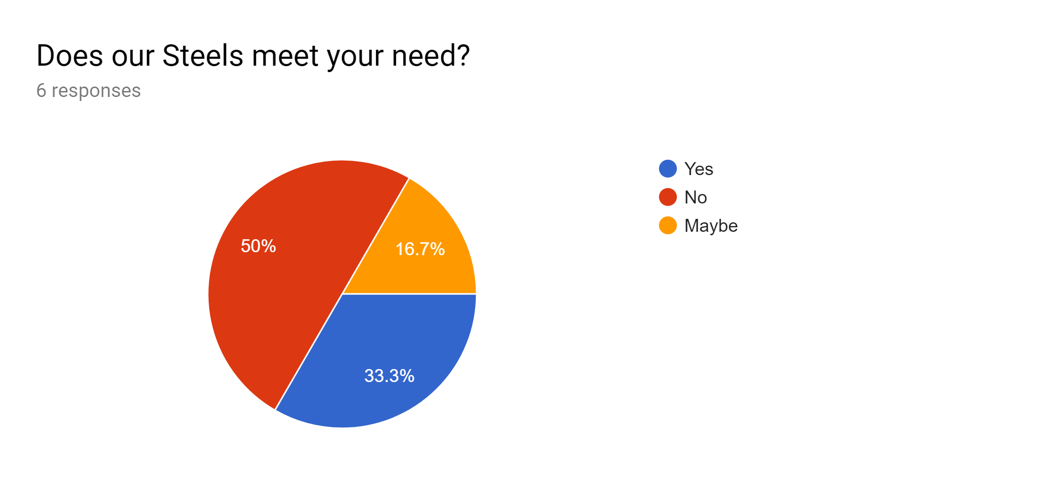
Interpretation:
From the 6 buyers of BSECL, 50% means 3 consumer replied that the products didn’t meet their need. Though there are 2 buyers who were satisfied.

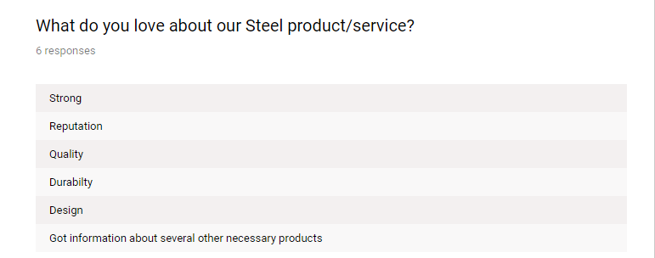
Interpretation:
The features of a product that the consumers like most means that in terms of these for these features the consumer is satisfied and there is less need to be an improvement. Most of the buyers replied that the design and durability of BSECL’s steel are good means in terms of quality the consumers are satisfied.

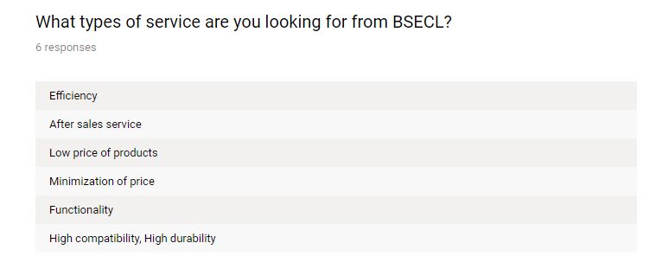
Interpretation:
Through this question, the needs of consumers are identified. Bangladesh Steel & Engineering Corporation Limited (BSECL) should prioritize these needs to compete in the market. The needs can be listed as functionality, price penetration, compatibility with necessary products, and the steels need to be durable and long lasting. Most of the consumer demanded for the after sales service and the reduction of prices of different steels of BSECL.
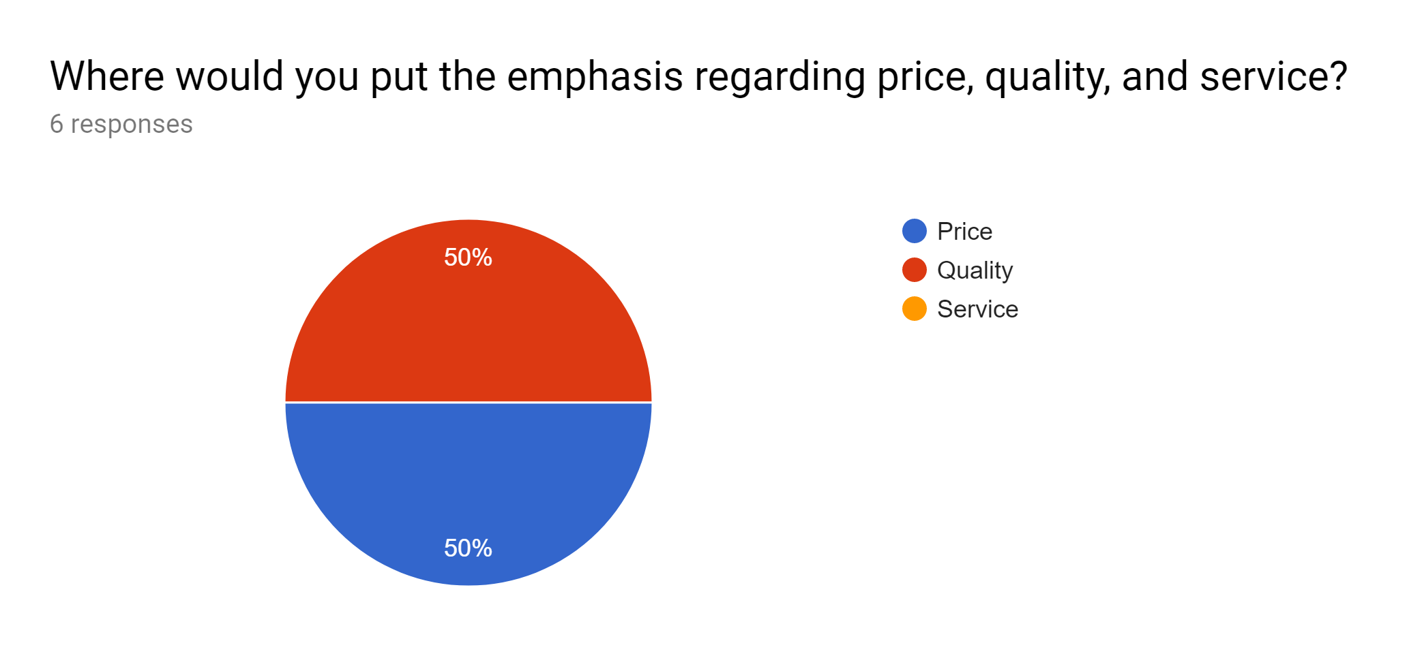
Interpretation:
Among the 6 buyers of BSECL, Most of them emphasize the price and quality of the product. In terms service, consumer asked for post purchase services and in time delivery of steels from the company.

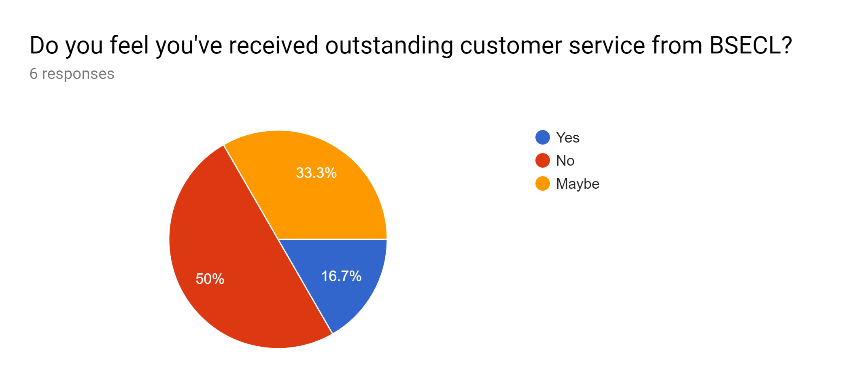
Interpretation:
Most of the consumer (6) replied they didn’t received any outstanding services from the company

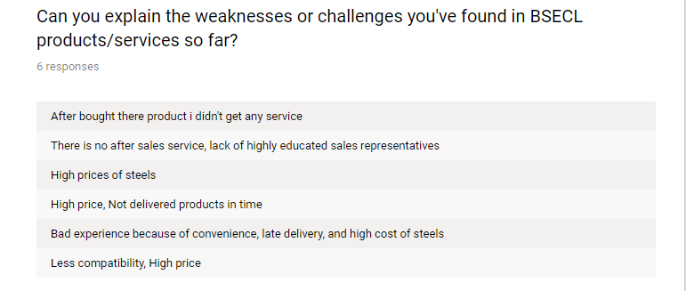
Interpretation:
The weakness of the steel of BSECL are the after sales services the company. For instance: steels didn’t reach to the destination in time, steels price are so high compare to other steel companies, steels are less convenient and compatible to use.

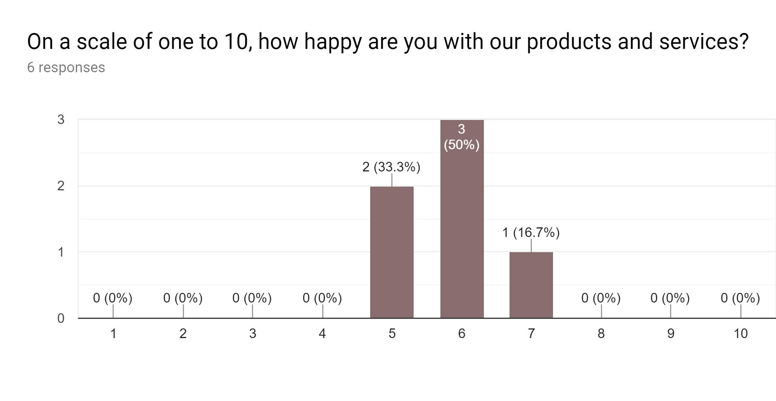
Interpretation:
Most consumers are happy buying steel products from Bangladesh Steel & Engineering Corporation Limited (BSECL).

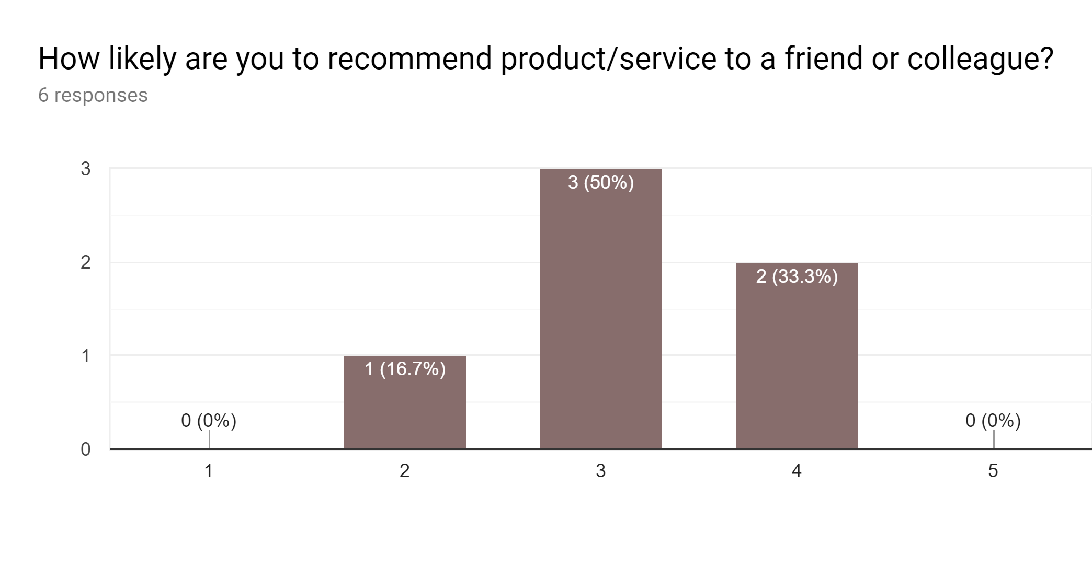
Interpretation:
Mostly consumers are likely to recommend the products and services of Bangladesh Steel & Engineering Corporation Limited (BSECL) to their friends and colleagues.

4.2 Prioritization of needs and wants.
The current steel market is experiencing a very complex environment. Most often, it is performed for mass market operations. And in most cases, high skills are growing in the market. Bangladesh Steel & Engineering Corporation Limited (BSECL) regularly search to find out the consumers’ needs and wants so that the company can compete in the market and carry a good product or service reputation among its buyers and consumer by fulfilling their need. At the same time, there are still some important opportunities that can play a very important role in the improvisation of sales and marketing operations. Some of the goals of the improvements can generate long-term results in other business operations. The most improvised areas through what BSECL can prioritize its consumers need are suggested below:
- Price Policy:
In this case, the prices of the steel products that BSECL rationally established at 30% of the profit margin. On the other hand, competitors play an advanced game that keeps the profit margin at an average of 10%. Even in some cases, they offer less than 10%. This situation creates a stimulating platform to provide a high urgency in the market. Along with this BSECL, they have clear goals that can be achieved by implementing tactical marketing strategies. In addition, the company can offer additional service initiatives that will bring greater value to the customer. This will convey the message that he admits that a quality product and additional services are available at a standard price. In a moment, the price system will have a different perception of the perception that at this moment our customer is taking into account price sensitivity. Therefore, the decision-maker must put in place an alternative pricing system that at least ensures that price differences are reduced with competitors. This will certainly minimize the impact of aggressive market behaviour. Since the market is more price-sensitive than when considering other issues, the initiations should focus solely on the priority of how the market operates.

- Improve the creation of value for the product and the customers:
The customer is only interested in products that create value. This only occurs when the customer receives a better service within the appropriate price limits. Since Bangladesh Steel & Engineering Corporation Limited (BSECL) faces a different scenario, it now offers more services to generate value for its customers. In our case, prices can be a factor, but if you lead the market by providing more valuable services and responding to user requests, this will surely have a lasting impact on your operations. The main reason for its current scenario is the unmodified target market of the product. If brand awareness and service can be guaranteed quickly, they can gain market loyalty. Trademark recognition usually occurs when each group of customers has a high participation in the purchase and use of the product. These must be unique approaches for customers who not only cover sales, but also create value. The concepts were adaptable to push the customer groups to remember the product and to express their interest in the problem. Ultimately, Bangladesh Steel & Engineering Corporation Limited (BSECL) must develop policies that promote value creation for customers rather than business results.

- Powerful distribution network:
The powerful distribution network plays a very important role in these commercial operations. Based on this market scenario, the company involves direct and indirect factors to make the channel stronger and more proactive. For example, Bangladesh Steel & Engineering Corporation Limited (BSECL) places the products according to the use of the main product. As an Steel Electrode for Steel Pipe and the Instrument Retailer improve the sales plan for the company and the dealers. In addition, the product brand will ensure that distributors will give credibility to the particular electrodes. Currently, this process is being carried out by the rival Goodweld Group with stainless steel tube distributors. Although they are not yet in an alarming position, these strategies are relocating the market for us. The instant security and market regulation of BSECLs must specify the implications of the alternative trade process. In addition, the distribution channels of our competitors are more or less of concern for the importers of Nawabpur. From there, the products are segmented according to the needs of the wholesaler and the retailer. But the process translates into lower brand awareness by demographic factors (price and less brand recognition). As a result, our best competitive advantage would be to dominate the market by letting the customer group know the value of the brand and the important factors in the supply chain. Finally, it could be argued that more related factors within the distribution line and greater involvement in service delivery will yield positive results.

- Improvement in Steel Product Development:
Bangladesh Steel & Engineering Corporation Limited (BSECL) has already segmented its product according to the needs of its customers. This helped them to classify the client's needs. These products differ in size, use and price. At the same time, the company could offer packaging systems that will present new offers to the customer to make them happy with the products. Most likely, this time, the package will be distinguished by large quantity quantities with significant price reductions. In the case of a moderately priced product, our goal would be to develop a very small product base so that customers can derive value and make better use of it. Regardless of this, it is necessary to provide instructions on the packaging of each product to help users know how to participate and take precautionary measures to avoid accidents. Along with this developed product, it is necessary to follow the market test proposal before marketing it. Furthermore, it must be placed in segments where customers have only a specific indulgence to use the products.

- Changes in Source of economic supply (raw materials):
The manufacturing and product prices of BSECL are extremely reliable for the supply of articles or raw materials. If the goods provided are available and effective, BSECL can save time. To create a clearer market coverage, BSECL provides solutions to identify supplies at an affordable price. This could also be done by changing the business model of the business. As if the alignment with the foreign company produced the product at low prices. Furthermore, it is possible to show the customer the desired product at an economical price.

- Greater interaction and evaluation with final consumer:
Each company considers its main users or consumers as its main resources. Because the global market persists. If this turns against fire, society will undoubtedly find recessions. On the other hand, business can gain a reputation if customers are satisfied. But this intention of the end users creates complexity because their perception never remains static. In dealing with the client group, our main effort would be to involve more interactions with them. After that, the important information must be evaluated to see if any feasible change can be implemented or not. If they update their policies and draw attention to what our customer’s want, we are confident that we can create more value among them. This type of size in the service offering of the product will help to capture the market in a very important way. Therefore, it is essential to interact regularly with customers and evaluate the data they have acquired.

- Improvement in customer service and relationship service:

BSECL has a customer relationship service that tracks all activities related to customer concerns. But due to the facts, services are not provided as needed. In the case of our market for stainless steel and cast iron electrodes, BSECL is adopting different strategies. First, BSECL classifies the customer groups necessary to provide high-level facilities. Most of BSECL activities are carried out on a B2B basis. The main customers are, therefore, the industry and the construction company that must be concerned about decisions about the use of the product. Therefore, to have greater perspective and value in the client's mind, BSECL maintains tactical supervision and field sessions. The representative physically visits the respective client of the respective sales areas. Subsequently, the customer relations representatives are motivated and proactive to dealing with customers. In addition, sales and after sales services must have an effect on the customer so that the transaction can continue in the context of long-term relationships and be used for value improvement purposes.

- Regular incentives and rewards for retailers: As Bangladesh Steel & Engineering Corporation Limited (BSECL) knows that retail groups are our main representatives in the mass market because most of the transactions of our products are through the retail process. For this reason in particular, BSECL must play a very close and influential role vis-à-vis the groups of distributors. If they are able to provide maximum facilitation to their distributors, they will undoubtedly succeed in reducing many in the price-sensitive market. To maintain close and operational relationships, they must adopt an effective management process that motivates them and helps them to work positively for the company's operations. Distributor groups will undoubtedly be motivated if periodic incentives and sales incentives are provided from time to time. The rewards will encourage them to get more word-of-mouth marketing results if BSECL adopts the incentives and rewards. Although sales add value to the company, some things deserve more attention. Sales are mostly different depending on the sales area. As a result, sales results are not the same in the concept. For an informational overview, the organization must evaluate all sales activities and the key performance index of sales personnel. This process is more useful because it plays a coordinating role within the sales department. Most likely, if an industry increases sales, you can suggest advice and instructions to others to get good results in their respective fields. Further evaluation would then result in dynamic implementation and changes necessary to achieve the appropriate results. Furthermore, it will show the failures and challenges that will play a very important role in forecasting sales decisions. At the same time, it also reserves the authority to customize the actions relating to sales transactions. Finally, the continuous assessment of the key indicator of sales performance is essential to stimulate market activity and improve another factor.

- Focus more on adaptation than on standardization: The steel market shows us the diversified commercial policy of BSECL competitors. Therefore, it is quite certain that the needs of the market exceed the objectives of the variety of products. The market itself offers a great opportunity for different products depending on use. Highlights critical customer approaches where priority comes with consumers selections. There is no doubt that there is a market that is only suitable for the adaptation process. The purpose of the adaptation process is the personalization approach of the business in which they establish their operations and strategies, based exclusively on the needs, desires and demands of the customers. Unless the result is much more productive. On the other hand, the standardization process sets a standard for the customer market that the user has to adapt for future use. Most standardization markets are based on brand awareness and the concerns customers consider when they are part of it. These markets often have powerful, high-quality target groups to carry out their business activities. But in our case, we have to reach the adaptation process because our customer groups are homeless. If, by any means, the standard process introduces a basic collision term, the market will certainly choose alternative options. Therefore, for SS and CI, adaptation to the market would be the most important process.

- Organization of trainings and seminars: to create a buzz and send a message about security issues, BSECL must aim to organize several training programs and seminars. This will encourage our customers to learn more about the advantages and disadvantages of using the product. In addition, it will also show how to use the product in a very economical and perfect way. In this type of product, customers are always ready to know new things to measure and perform operations to use the product. Subsequently, these initiatives could also be considered corporate social responsibilities to ensure the presence of agriculture in the market. Not only will you be aware of this, but you will also create price initiatives that generate concerns about security and security measures. At the same time, the company should organize more meetings and seminars with its stakeholders to make productive decisions. This approach would be more enlightening if experts from both countries and abroad organized these events. Undoubtedly, this will create a platform for the client and the organization to evaluate each other and create a constructive market for the management of the company.

- Highlight other promotional and advertising initiatives: Bangladesh Steel & Engineering Corporation Limited (BSECL) has very limited marketing and promotion activities. For these particular reasons, their activities are diversified. These problems often lead to the dilemma of the lack of understanding of the brand, the dispersion of the customer market, the alternative perceptions and the reasons of the personal spirits (customers). The most robust products of the company are used for industrial purposes (B2B operation). For this reason, the company applies a very reserved and limited marketing policy to this respective populated market. At the same time, we have a large number of end customers. They buy directly from us and use them. For this particular group, traditional marketing policies are less appropriate. This often results in a massive product and a lack of functionality for the end customers. To obtain more information about the existing market, BSECL must present regular initiatives to reduce the confusions related to our market.

Chapter 5: Recommendations and Conclusion

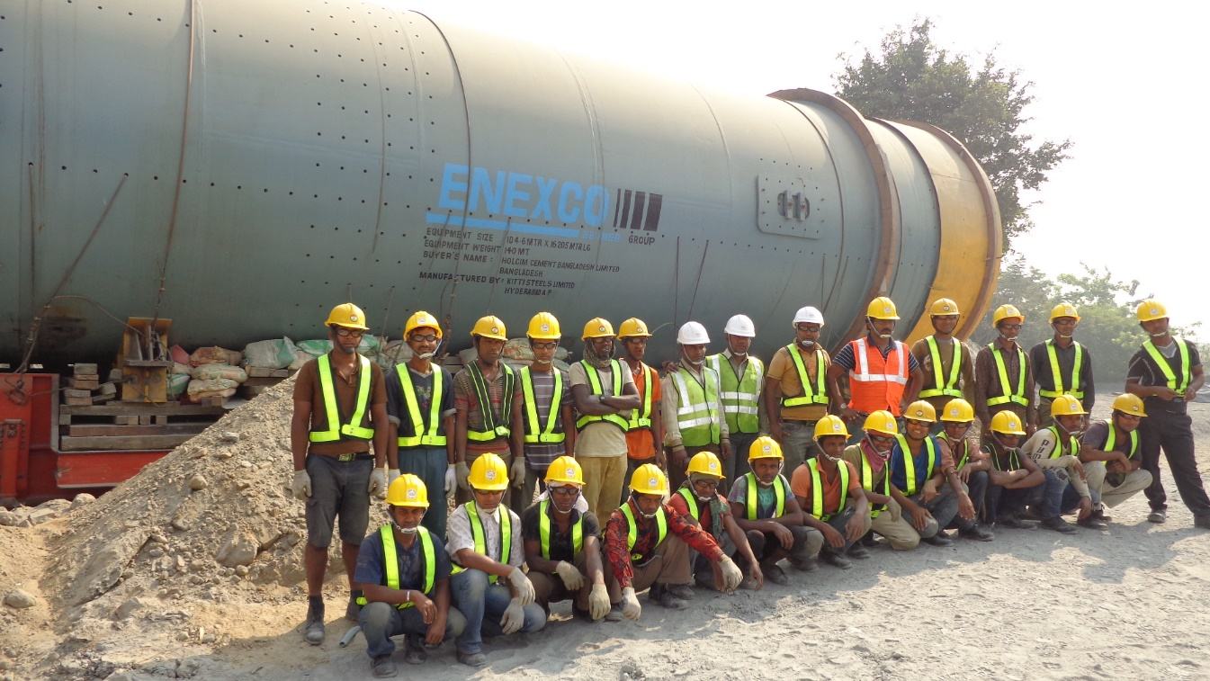

5.1 Recommendation
After analysing how Bangladesh Steel & Engineering Corporation Limited is meeting the needs of their respected consumers, it might be clear that the consumers willing to buy steels and wants to recommend the company with others. On the other hand efforts provided by the company to meet the demand is also appreciable. If few services are conducted carefully, the company can fulfil the consumer needs properly. Few suggestions are provided below from my academic knowledge for the betterment of the BSECL.
  - The market is more price-sensitive than when considering other issues, the initiations should focus solely on the priority of how the market operates.
  - Bangladesh Steel & Engineering Corporation Limited should establish a standard for the customer market that the user has to adapt for future use. Most standardization markets are based on brand awareness and the concerns customers consider when they are part of it.
  - The product such as steel, rods, stainless steel, steel pipe need to compatible with the final products.
  - If brand awareness and service can be guaranteed quickly, they can gain market loyalty. Trademark recognition usually occurs when each group of customers has a high participation in the purchase and use of the product.
  - The decision-maker must put in place an alternative pricing system that at least ensures that price differences are reduced with competitors. This will certainly minimize the impact of aggressive market behaviour.
  - BSECL need to concentrate on the after sales service so that they can satisfy their consumers well.
  - Though consumers are satisfied in the durability, reliability, and quality features of the steel, BSECL should not degrade the features while improving the other features.

5.2 Conclusion
Bangladesh Steel & Engineering Corporation Limited (BSECL) was created with the aim of contributing to the development of the country's infrastructure, creating the basis for industrial growth, making human and material movements faster and easier, and helping in the use of the system. The company faces several challenges due to lack of service and the high cost of manufacture in a recent couple of years back. It has established several policies to tackle the situation and enlist in the Bangladesh market as a reputed one. A lot of improvement is yet to be accomplished so that consumers can be satisfied using BSECL products to their own purpose.
The study of this internship report was conducted to find out the consumers current need and compare the consumers need into the current improvement so that the company can prioritize and meet the needs. Few lacking are found that need to be taken into consideration immediately. Consumers are happy for the quality of steel that BSECL are providing but not happy with the higher price of the products, late delivery service, less priority on aftersales service, incompatibility of steels with the final products, less promotion and awareness activities of the steel brand and so on. The suggestions provided in the end can be used to reduce the dissatisfaction if possible. A quick improvement of these problems can help Bangladesh Steel & Engineering Corporation Limited (BSECL) to prioritize the consumer needs and wants.
Chapter 6: Appendix

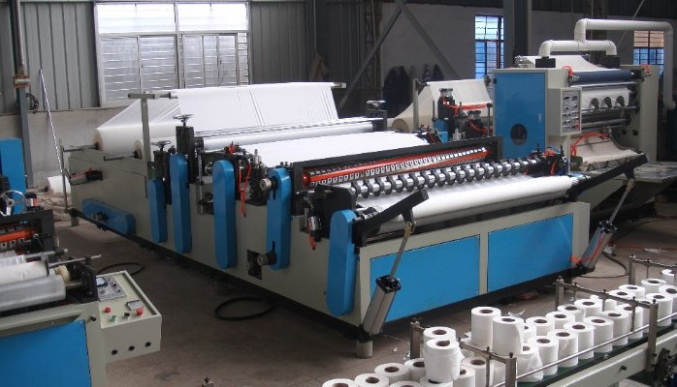

Reference
(1)Paul N. Bloom, 2009, A Decision Model for Prioritizing and Addressing Consumer Problems, Journal of Public Policy & Marketing Availavle at: https://doi.org/10.1177/0743 91568900800112.
(2)Jai-Ok Kim Sandra Forsythe, Qingliang Gu, Sook Jae Moon, (2002) "Cross‐cultural consumer values, needs and purchase behavior", Journal of Consumer Marketing, Vol.19Issue:6, pp.481502, https://doi.org/10.1108/07363760210444869
(3)Kenneth David Strang (2012) Prioritization and Supply Chain Logistics as a Marketing Function in a Mining Company, Journal of Marketing Channels, 19:2, 141-155, DOI: 10.1080/1046669X.2012.667763.
(4)Mehrparvar, A Shahin - Article name: Prioritizing internal service quality dimensions Published in an International Journal, 2012.
(5)Sime Curkovic, Robert Sroufe, Steve Melnyk, juune 2005, identifying the factors which affect the decision to attain consumer need, Available at: https://doi.org/10.1016/j.energy. 2004.02.016

