Internship Report On
“General Banking Activities

of Sonali Bank PLC Lalmatia Branch”

Tabassum Islam
This report is submitted to the School of Business and Economics, United International University as a partial requirement for the degree fulfillment of Bachelor of Business Administration.

Internship Report On “General Banking Activities of
Sonali Bank PLC Lalmatia Branch”

Submitted to:
Dr. Md. Shariful Alam
Professor
School of Business & Economics (SoBE)
United International University
Submitted by
Tabassum Islam
111 193 049
BBA in Marketing

School of Business & Economics
United International University
Date of Submission: 4th August, 2025
Letter of transmittal
Dr. Md. Shariful Alam
Professor
School of Business & Economics (SoBE)
United International University
Dear Sir,
It is an honor to prepare and submit this report titled “Internship Report On General Banking Activities of Sonali Bank PLC Lalmatia Branch,” Which is fully based on my internship experience at Sonali Bank. To the best of my knowledge, and as accurately as possible, I have included all relevant data and related propositions in this report. I'm certain that this report will meet your expectations, and I'd be pleased to answer any questions you might have.

Sincerely yours,
Tabassum Islam
111 193 049
BBA in Marketing
School of Business & Economics
United International University

Certification
This certifies that, in order to fulfill the requirements for a BBA degree, Tabassum Islam, a student enrolled in the School of Business and Economics at United International University (UIU) with ID number 111 193 049, has finished the internship report titled “Internship Report On General Banking Activities of Sonali Bank PLC Lalmatia Branch” She did her best to finish the report. I hope her future days are filled with success.
Supervisor,

Dr. Md. Shariful Alam
Professor
School of Business & Economics (SoBE)
United International University

Declaration of the Student
Myself Tabassum Islam, a BBA Marketing major with the bearing ID 111 193 049 at United International University, I so certify that all of the information in this Internship Report On General Banking Activities of Sonali Bank PLC Lalmatia Branch” is entirely based on what I have learned and experienced at work. The report was prepared with the kind guidance of my esteemed internship supervisor, Dr. Md. Shariful Alam Sir, a professor at United International University. I further declare that the information in this report is original and legitimate, having not been lifted from any published or unpublished source, except where this is appropriately cited through full and accurate referencing. I have acknowledged all main sources of help.
Tabassm Islam
111 193 049
BBA in Marketing
SoBE, UIU

Acknowledgement
I want to start by sincerely thanking Almighty Allah for giving me the courage to stand where I am at this moment. Additionally, I want to express my sincere gratitude to my academic supervisor Professor Dr. Md. Shariful Alam for his guidance, support and for being inspiring figure to me. I am grateful to my onsite office supervisor, Mahbuba Hossain, Relationship Manager, Co-Supervisors Suraiya Parveen, Principal Officer and Sharmin Sultana, Principal Officer Sonali Bank PLC, Lalmatia Branch. Despite their hectic schedule and several responsibilities, they provided excellent mentorship and guidance during my internship experience. they guided me in creating the report with ease and assisted me in reaching my objectives. I would also like to thank all my friends and classmates at UIU for being there whenever I needed help throughout my entire undergraduate journey.
Executive Summary
Based on my three-month academic internship, this report provides a detailed summary of the general banking operations performed at Sonali Bank PLC, Lalmatia Branch. This internship gave me hands-on experience in the workings of one of Bangladesh's biggest and oldest state-owned commercial banks as part of my Bachelor of Business Administration (BBA) curriculum. The report's primary goal is to understand and learn about Sonali Bank's daily operations and general banking practices, with a particular focus on the Lalmatia Branch. The Lalmatia Branch serves a wide customer base, including individual clients, small businesses, students, senior citizens, and government employees. Account opening, cash transactions like cash deposits and withdrawals, local remittance, cheque clearing, deposit schemes information, customer service, and associated front-desk operations are all included in general banking, which is a bank's main operational department. My goal in writing this report is to fill the gap between academic and practical knowledge. I had the chance to experience and help with many important tasks during my internship, such as cash deposit forms, processing cheques, client inquiries, account opening procedures, and opening accounts as well (current, savings, and FDR), data entry in the bank's core banking system (CBS). Additionally, I gained knowledge of compliance protocols like KYC (Know Your Customer). In conclusion, this internship has significantly contributed to my understanding of the banking sector and enriched my theoretical knowledge with hands-on experience at Sonali Bank PLC, through its Lalmatia Branch. The branch maintains a strong public presence and plays a pivotal role in delivering essential banking services.
Table of Contents

CHAPTER I: INTRODUCTION 1
1.1 Background of the report 1
1.2 Objectives of the report 1
1.4 Scope 2
1.5 Limitations 2
CHAPTER II: COMPANY AND INDUSTRY PREVIEW 3
2.1 Company Analysis, Overview and History 3
2.1.1 A brief overview of the banking operations in Bangladesh 3
2.1.2 Sonali Bank PLC 3
2.1.3 Corporate Profile 5
2.1.4 Organizational Structure 7
2.1.5 Board of Directors 8
2.1.6 Vision 8
2.1.7 Mission 8
2.1.8 Slogan 9
2.1.9 Overview of the Bank 9
2.2.0 Some notable features of the Bank are as follows: 9
2.2.1 Services of SBPLC 10
2.2.2 Trend and Growth 31
2.2.3 Customer Mix 31
2.2.4 Marketing Mix/Marketing Practices 32
2.2.5 General Banking Operations 33
2.2.6 SWOT Analysis 34
2.2.7 Threat of Substitutes & Rivalry 35
CHAPTER Ill: INTERNSHIP EXPERIENCE 36
3.1 Student Information 36
3.2 Internship Overview 36
3.3 Training 37
3.4 Contribution to Departmental Function 38
3.5 Student’s Learning and Benefits 38
3.6 Evaluation 38
3.7 Skills Applied During my internship 39
3.8 New Skills Developed 39
3.9 Application of Academic Knowledge 39
3.10 Challenges Faced 40
CHAPTER lV: CONCLUSIONS AND KEY FACTS 40
4.1 Recommendations 40
4.2 Conclusion 41
References 42
Appendix A: 43

List of Abbreviation/Acronyms
SBPLC | Sonali Bank PLC
CBS | Central Banking System
LC | Letter of Credit
FDR | Fixed Deposit Receipt
TT | Telegraphic Transfer
DD | Demand Draft
PO | Pay Order
EFT | Electronic Fund Transfer
RTGS | Real Time Gross Settlement
NID | National Identity Document
NRB | Non-Resident Bangladeshi
NFCD | Non-Resident Foreign Currency Deposit
RFCD | Resident Foreign Currency Deposit
SND | Short Notice Deposit
SME | Small and Medium Enterprise
NGO | Non-Governmental Organization
SMS | Short Message Service
IB | Internet Banking
ATM | Automated Teller Machine
KYC | Know Your Customer
AML | Anti-Money Laundering
CRM | Customer Relationship Management

CHAPTER I: INTRODUCTION
Sonali Bank PLC is the biggest state-owned leading public commercial bank in Bangladesh. It was founded in 1972 and has its headquarters in Motijheel, Dhaka. With a domestic network of more than 1,230 branches and a global presence through its subsidiaries and representative offices, being a fully government-owned public limited company since 2007, It provides a broad range of retail, corporate, and international banking services. The Lalmatia Branch is a full-service bank offering cash management, remittance, general banking, customer service and what not.

1.1 Background of the report
This report is prepared based on my recent internship at Sonali Bank PLC, Lalmatia Branch. Its goal is to describe and look at how the branch runs its general banking services, especially in light of the bank’s good performance. Recently in 2024, Sonali Bank made a record operating profit of Tk 5,634 crore, which is Tk 1,788 crore more than the previous year. This growth came from more deposits, which reached Tk 1. 65 trillion, and higher net interest income. This report builds upon documented evidence and firsthand experience to examine how these macro achievements manifest at the Lalmatia Branch.

1.2 Objectives of the report
- General ideas of the general banking services and how they are handled at the Lalmatia Branch.
- Look at how the branch helps the bank reach its goals, especially in growing deposits, using digital services, and focusing on small and medium businesses (SMEs).
- To find out where the branch is doing well and where it might be struggling.
- Suggest ways to improve how the branch works, make customers happier, and better match the bank’s overall goals.
1.3 Motivation of the report
- The primary motivation is twofold:
Educational: To connect academic banking theory with real-world practices by documenting general banking processes such as account opening, clearing, remittance, and cash handling and so on.
- Practical: To contribute constructive insights to the Lalmatia Branch and Sonali Bank, enhancing service delivery, digitization strategies, and operational alignment with the bank’s focus on SMEs, cost-effective digital services, and customer-centric improvements.

1.4 Scope
- This report looks at the everyday banking activities at the Lalmatia Branch, such as handling cash, managing accounts, issuing cards and ATMs, doing money transfers, and clearing cheques and so on.
- It also includes the bank’s recent financial results and its main goals for 2024–2025.

1.5 Limitations
- The report is based mostly on what I experienced and observed during my three-month internship, so basically it is qualitative and descriptive rather than quantitative. So, it lacks extensive quantitative customer surveys. Also, I couldn’t access detailed internal data because of confidentiality, privacy and regulatory constraints.

CHAPTER II: COMPANY AND INDUSTRY PREVIEW

2.1 Company Analysis, Overview and History

2.1.1 A brief overview of the banking operations in Bangladesh
The economic growth of a country is closely tied to its financial system, and in Bangladesh, banks play a major role in driving that progress. They help keep the economy running smoothly and support the country’s overall development. Over time, the role of banks has become more complex and diverse. While giving loans is still a key function, banks now offer a wide range of services to meet the growing needs of customers. In Bangladesh, banks serve a variety of clients, including individuals, small businesses, government offices, and even international organizations. As people’s financial needs have grown, banks have adapted by offering more personalized services. They now provide different types of accounts, such as savings, current, FDR (Fixed Deposit Receipt), and even specialized accounts like money market accounts or retirement savings plans, based on a customer’s profession or financial goals. The banking system in Bangladesh is overseen by Bangladesh Bank, the country’s central bank, which manages the overall monetary policy and regulates all other banks and financial institutions. There are different types of banks operating in the country, such as government-owned banks, private commercial banks, Islamic banks, foreign banks, specialized banks, and non-scheduled banks. Among them, Sonali Bank stands out as one of the most trusted and customer-focused state-owned banks. It has built a strong reputation for offering reliable and helpful service. Compared to many other government banks, Sonali Bank is already earning good feedback from customers for the quality and efficiency of its services.

2.1.2 Sonali Bank PLC
Sonali Bank PLC is Bangladesh’s largest state-owned commercial bank. It was formed in 1972 by merging three banks that used to operate under Pakistan, National Bank of Pakistan, Bank of Bahawalpur, and Premier Bank, right after the country gained independence. To modernize its operations, Sonali Bank became a registered company called Sonali Bank Limited on June 3, 2007. A few days later, on June 5, 2007, Bangladesh Bank gave it the license to operate as a commercial bank. From November 15, 2007, it officially began operating as a company after signing an agreement with the Government. As the bank grew, it launched a subsidiary company named Sonali Investment Limited on September 14, 2009, to provide merchant banking services. Later, on June 29, 2010, the bank also introduced Islamic banking options based on Shariah law in five major cities. To fulfill its social responsibilities, it created the Sonali Foundation, which supports various community-based initiatives. Currently, Sonali Bank has 1,234 branches, with 1,232 inside Bangladesh (mostly in rural areas) and 2 overseas branches in Kolkata and Siliguri, India. Among all these branches, 48 are authorized to handle foreign trade transactions.
To manage all its operations smoothly, the bank has:
- 18 General Manager offices,
- 69 Principal offices, and
- 47 departments at its Head Office.
Sonali Bank serves over 24.7 million customers, and its massive workforce of 18,115 employees includes both officers and staff. The bank puts great emphasis on employee training. It has a main training college in Dhaka named “Sonali Bank Staff College”, plus additional institutes in Chattogram, Rajshahi, Khulna, Bogura, and Mymensingh. Globally, Sonali Bank has been expanding its presence too. It set up a fully-owned exchange company in the United States in 1994, called Sonali Exchange Company Inc., which now runs 9 branches. In the UK, it operates as Sonali Bank (UK) Ltd., a joint venture with the Bangladesh government, and currently has 6 branches. It also has representative offices in Saudi Arabia (Riyadh and Jeddah) and Kuwait, and provides remittance services in Malaysia through partnerships with Maybank and IME (M), SDN, BHD. Even people without a bank account can send or receive money through Sonali Bank thanks to services like Western Union, IME, Transfast, Express Money, and many others. Sonali Bank partners with 80+ global banks and exchange houses to handle international remittances and 617 foreign correspondent banks for trade finance. The bank offers a variety of deposit and loan products aimed at helping both individuals and businesses. These include agricultural loans, SME loans, export-import finance, consumer loans, and more catering to people from all walks of life. Besides regular banking, Sonali Bank handles many government services in places where the Bangladesh Bank doesn’t have a branch. These include:
- Paying government and private employee pensions
- Disbursing school and madrasa staff salaries
- Providing student scholarships
- Managing social safety net allowances
- Handling government savings certificates
- Collecting utility bills and taxes
- Managing Hajj and Zakat funds
In short, Sonali Bank is more than just a bank. it’s a lifeline for millions of people across Bangladesh and abroad, committed to driving the country’s economy forward while supporting the community at every step.

2.1.3 Corporate Profile
Field | Information
Name of the Company | Sonali Bank PLC
Chairman | Mohammad Muslim Chowdhury
Managing Director & CEO | Md. Shawkat Ali Khan
Company Secretary | Md. Mahboob Hossain
Legal Status | Public Limited Company
Genesis | Emerged as a nationalized commercial bank in 1972, following the Bangladesh Bank (Nationalization) Order 1972
Date of Incorporation | 03 June, 2007
Date of Vendor's Agreement | 15 November, 2007
Registered Office | 35-42, 44 Motijheel Commercial Area, Dhaka, Bangladesh
Authorized Capital | Taka 6000.00 Crore
Paid-up Capital | Taka 4530.00 Crore
Number of Employees | 18,187
Number of Branches | 1234
Phone-PABX | 0257161008-88
FAX | 88-02-9561410, 9552007
SWIFT | BSONBDDH
Website | www.sonalibank.com.bd
E-mail | info@sonalibank.com.bd

2.1.4 Organizational Structure
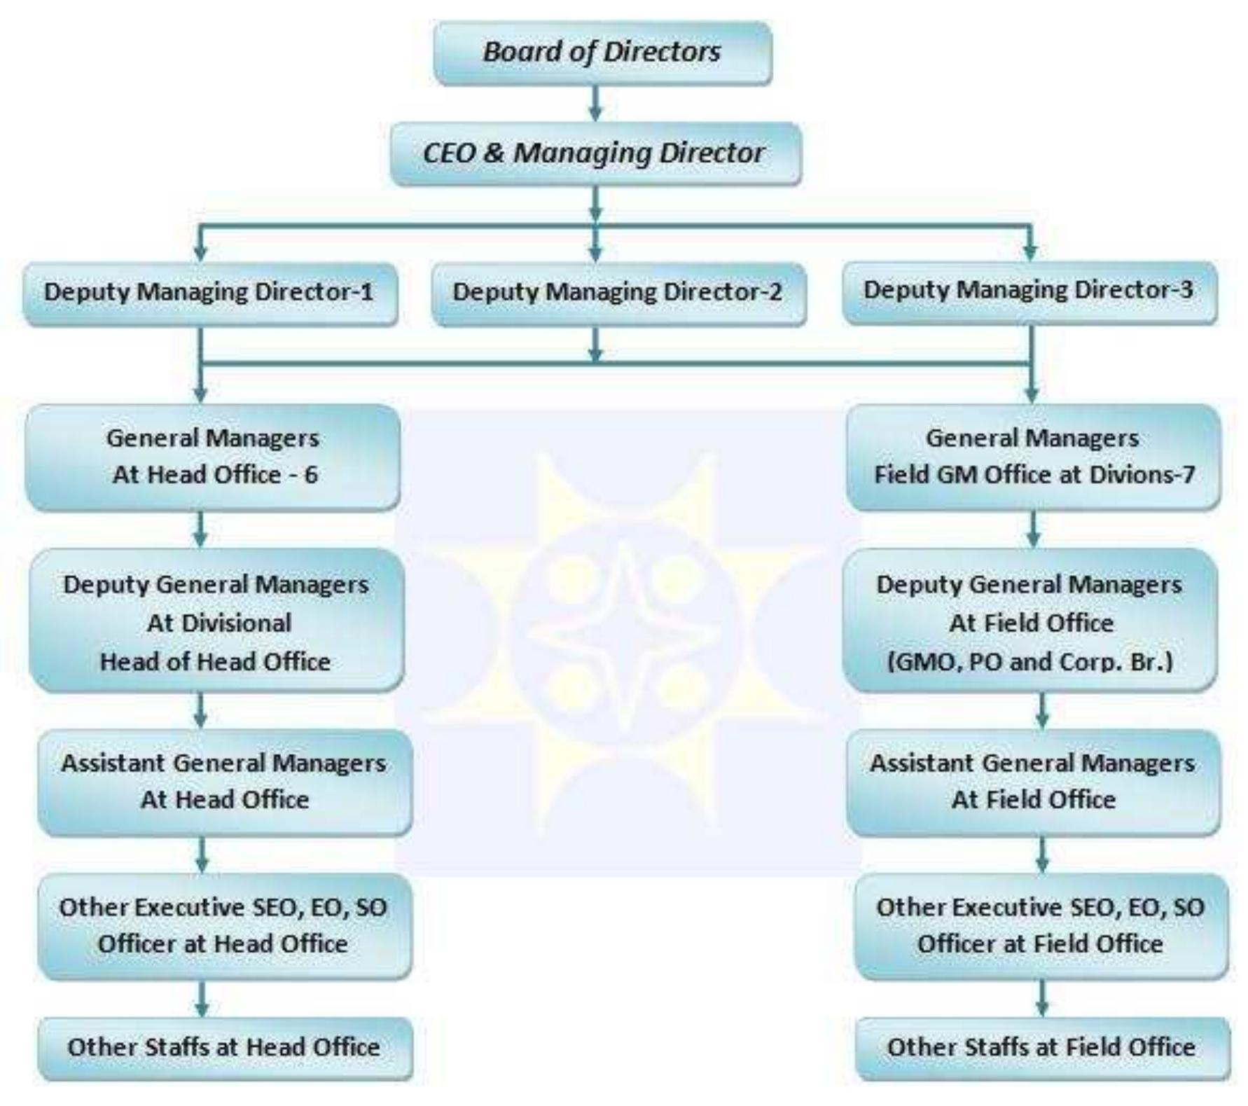

2.1.5 Board of Directors
SL No. | Name | Designation
1. | Mohammad Muslim Chowdhury | Chairman
2. | Muhammed Mahbubur Rahman | Director
3. | Dr. Mohammad Abu Yusuf | Director
4. | Md. Azimuddin Biswas ndc | Director
5. | Mr. Molla Abdul Wadud | Director
6. | Dr. Asif Naimur Rashid | Director
7. | Mohammed Jahangir Alam | Director
8. | Md. Mofazzal Husain | Director
9. | Muhammad Masrurul Islam | Director
10. | Laila Bilkis Ara | Director
11. | Tariqul Islam Chowdhury | Director
12. | Md. Shawkat Ali Khan | Managing Director & CEO

2.1.6 Vision
Sonali Bank wants to be a reliable leader in the banking sector by offering smart, inclusive, and tech-based services that help improve the lives of people and support the country’s development. Their goal is to make banking easier, faster, and more responsible for everyone.

2.1.7 Mission
The bank is working to make people’s lives better by becoming more efficient, transparent, and responsible in its work. It wants to follow ethical rules, make the best use of its resources, and promote good governance so that it can truly support the growth of the country and its people.

2.1.8 Slogan
Credible and smart

2.1.9 Overview of the Bank
Shortly after Bangladesh gained independence, Sonali Bank was established as the country’s largest nationalized commercial bank under the Banks' Nationalization Order of 1972 (Presidential Order-26). It was formed by merging and liquidating three banks that had operated during the Pakistan period, National Bank of Pakistan, Premier Bank, and Bank of Bahawalpur. As a fully government-owned bank, Sonali Bank took on a vital role in rebuilding the country. It handled various financial programs assigned by the government and also carried out its own banking operations to support different areas of the economy. On November 15, 2007, the bank was officially turned into a Public Limited Company (PLC) with full government ownership and renamed Sonali Bank Limited. After this transformation, the bank received greater independence in decision-making to help it run more efficiently and compete better in the financial sector. Today, the bank is known as Sonali Bank PLC. It is overseen by a Board of Directors with 11 members, and its operations are led by a Managing Director and CEO, who is a highly experienced and respected banker. The bank’s head office is located in Motijheel, Dhaka, the main business district of Bangladesh’s capital city.

2.2.0 Some notable features of the Bank are as follows:
Capital Structure:
Authorised Capital | Tk. 6000.00 Crore
Paid up Capital | 4530.00 Crore
Total No of Branches | 1234
No of Foreign branches | 2
No of Local branches | 1232
No of Rural Branches | 696
No of Urban Branches | 536
No of G.M. Offices | 18
No of Principal Offices | 69
No of Regional Offices | 0

Overview: Sonali Bank PLC has an authorized capital of Tk. 6000.00 Crore and a paid-up capital of Tk. 4530.00 Crore. The bank operates a total of 1234 branches, with 2 located abroad and 1232 within the country. Of the local branches, 696 are in rural areas and 536 are in urban regions. Additionally, the bank has 18 General Manager Offices, 69 Principal Offices, and no Regional Offices. These figures reflect the bank’s extensive network and its strategic presence in both local and international markets.
Subsidiaries: Sonali Exchange Company Incorporated (SECI) having 10 (Ten) branches in USA. Sonali Investment Limited (Merchant Banking) having 4 (Four) branches at Motijheel, Paltan, Uttara, Mirpur in Dhaka and 1 (One) branch in Khulna, Bangladesh.
Associates: Sonali Bank (UK) Limited having 2 (Two) branches in UK.
Sonali Polaris FT Limited
Representative Offices: 3 1(One) in Jeddah, KSA; 1 (One) in Riyadh, KSA and 1 (One) in Kuwait.
Correspondence: 639

2.2.1 Services of SBPLC
- Personal Banking
- International Banking
- Industrial Financing
- Deposit and credit schemes
- SME Banking
- Foreign Currency A/C
- Investment Bond
- Offshore Banking
- Card Services
- Agent Banking
- Ancillary Services
- Locker Service
- SMS Service
- Digital Banking
- Islamic Banking
Personal Banking
Sonali Bank provides a range of everyday banking services for individual customers. You can open savings, current, or fixed deposit accounts and enjoy services like cheque books, fund transfers, remittances, and access to locker facilities. It’s designed to meet the daily banking needs of regular people. This is one of the largest and most accessible banks in Bangladesh, with around 1,232 branches covering both city areas and remote villages. It offers a wide variety of personal banking services through skilled staff and strong infrastructure. From basic savings accounts to locker facilities and remittances, Sonali Bank is committed to serving individual customers with care and efficiency. Sonali Bank helps customers send and receive money both locally and internationally in the fastest time possible. It offers services such as:
- Demand Draft (DD), Mail Transfer (MT), and Telegraphic Transfer (TT) for fund transfers between branches.
- Standing Instructions to automatically transfer funds on specific dates.
- Cheque Collection through clearing houses or even beyond clearing areas.
- Payment Orders and Call Deposits for business and personal use.
- Locker Services for safe storage of valuables
Savings Account
Any Bangladeshi citizen, living at home or abroad, can open a savings account either individually or jointly.
Key Features:
- Minimum deposit to open: Tk. 1,000
- Free cheque book
- Quick handling of foreign remittances
- Easy fund transfers between branches
- Option to set up Standing Instructions
Required Documents:
- Filled account opening form & signature card (attested if abroad)
- Two passport-size photos of the account holder and one of the nominee
- Nominee photo signed by the account holder
- For NRBs: Copy of first 7 passport pages attested by the Bangladesh Embassy
- Copy of NID, birth certificate, or citizenship certificate
- Utility bill for address proof
Daily Profit Account (SBDP)
This is a special deposit scheme designed to offer daily interest earnings to individual account holders.
Key Features:
- Minimum balance: Tk. 20,000
- Daily transactions allowed via cheque
- Must maintain Tk. 20,000 daily to earn interest
- Interest Rate: 5% per annum (only if balance stays above Tk. 20,000 daily)
- Interest calculated and added every six months
- 6-month minimum account duration required for earning interest
Eligibility:
Only Bangladeshi individuals aged 18 or older can open this account. It is not available to companies or organizations.
Fixed Deposit Receipt (FDR)
The FDR account allows to deposit a lump sum of money for a fixed period in exchange for higher interest rates. Duration Options (Interest rates vary):
- 3 to 6 months: 8.25%
- 6 months to 1 year: 8.50%
- 1 year to 2 years: 8.75%
- 2 to 3 years: 8.75%
Trade Finance & Credit Facilities
Sonali Bank provides a wide range of loans to support trade, business, and individuals. These include: Types of Loans Offered:
- Business and commercial loans
- Overdraft facilities
- Home loans (both residential and commercial)
- Transport loans
- Loans against brick fields or gold
- Loans backed by wage earner’s bonds, insurance policies, or shares
- Loans for work orders, FDRs, DPS, and other savings instruments
International Banking
For customers involved in foreign trade or working abroad, Sonali Bank makes it easy to send and receive money internationally. They offer services like demand drafts, telegraphic transfers, and support for import/export transactions. They also have partnerships with global banks to make overseas transactions smoother. SBPLC has been a pioneer in international banking for over 50 years. Even before Bangladesh gained independence, the bank was known for its expertise in handling foreign exchange and international trade. Today, it still holds a leading position in managing the country’s export-import business and processing inward remittances from across the globe. With a strong network of domestic branches and partnerships with numerous correspondent banks worldwide, Sonali Bank handles a significant portion of the country’s foreign trade activities. Whether it’s helping businesses with global transactions or assisting individuals with foreign remittances, the bank provides trusted, reliable services backed by decades of experience.
Key International Banking Products & Services
- Export Credit - Provides financial support before and after shipment to help exporters manage their cash flow.
- Supplier’s Credit Assistance - Helps importers arrange financing for purchases from foreign suppliers.
- Letters of Credit (LCs) - Offers secure payment solutions to ensure smooth international transactions between buyers and sellers.
- Foreign Currency Guarantees - Includes Bid Bonds, Performance Guarantees, and Advance Payment Guarantees to support clients in international bidding and project execution. Bill
- Purchasing & Discounting - Allows exporters to receive early payments on export documents.
Foreign Currency Services - Buy/sell foreign currencies and Traveler’s Cheques, including remittance services.
- Account Facilities - NRAT (Non-Resident Taka Account) – for Bangladeshis living abroad.
- NFCD Account – foreign currency account for non-residents
- RFCD Account – foreign currency account for residents with income earned abroad.
- Convertible/Non-convertible Taka Accounts – flexible account types for international use.
- Forward Contracts - Allows businesses to lock in future exchange rates to avoid losses from currency fluctuations.
- Correspondent Banking - Extensive network of partner banks around the world, allowing secure and smooth global transactions.

Import Finance Services
Sonali Bank supports importers by offering a complete package to make the importing process easier and more secure. Services include:
- Opening Letters of Credit (LCs)
- Post-import financing through facilities like LIM (Loan against Imported Merchandise) and LTR (Loan against Trust Receipt)
- Shipping Guarantees and Import Collection Services for smooth goods clearance and payments
Export Finance Services
- Advising Export LCs
- Pre-shipment finance to prepare goods for export
- Negotiating export documents to collect payment from foreign buyers
- Confirming Letters of Credit for extra assurance in high-risk markets
In summary, Sonali Bank PLC’s international banking division plays a crucial role in connecting Bangladesh with the global economy. Its long-standing experience, strong global ties, and client-focused services make it a trusted partner for businesses and individuals engaged in cross-border financial activities.
Industrial Financing
Sonali Bank supports large and small industries by offering loans for business growth and factory setup. These loans help industrial companies get the capital they need to run or expand their operations. SBPLC plays an important role in supporting industrial growth and job creation across Bangladesh. The bank offers a variety of loan schemes to help set up new businesses or expand existing ones, whether small cottage industries or large-scale factories. These credit facilities are also available to self-employed individuals, with the goal of boosting productivity, creating employment, and contributing to the country’s overall economic development. The bank’s loans cover both long-term investments (such as building new factories or upgrading machinery) and short-term working capital needs (like purchasing raw materials or paying staff). These initiatives help drive GDP growth and support Bangladesh’s industrialization.

Major Credit Schemes Offered by Sonali Bank:
- Industrial Financing for Thrust Sectors - Focused loans for industries identified as high-potential by the government.
Sonali Bank Industrial Credit Scheme - General industrial loans for a range of businesses.
- Special Investment Scheme for Cottage and Small Industries - Targeted support for small businesses and entrepreneurs.
- Consortium Financing for Large Industries - Big loans for large-scale industries, funded through joint efforts with other banks.
Financing for Software Development & Data Processing – Loans to support the IT and tech sectors.
To promote growth in key areas of the economy, Sonali Bank offers loans at very low interest rates for businesses in the following government-identified sectors:
- Software development & IT services
- Agro-based industries (excluding potato cold storage)
- Artificial flower production
- Frozen food processing
- Gift and craft items (especially for export)
- 100% export-oriented leather goods
- 100% export-oriented jute products
- Jewelry making, diamond cutting & polishing
- Oil & gas industry
- Sericulture (silk farming) and silk production
- Stuffed toy production (export-focused)
- Export-focused textile manufacturing (excluding garment factories)
In addition to the thrust sectors, Sonali Bank also supports a wide range of viable industries, including:
- Composite textile industries (woven and knit)
- Spinning mills (textile/acrylic)
- Sweater and garment accessory production
- Washing plants and denim factories
- Hotels, tourism, and resorts
- Hospitals and clinics
- Power generation projects
- LPG/CNG filling stations and conversion centers
- Pharmaceuticals and healthcare manufacturing
- Plastic and rubber industries
- Tannery and footwear manufacturing
High-tech and innovative industrial projects
Sonali Bank PLC’s wide range of credit schemes reflects its strong commitment to driving industrial growth and economic development in Bangladesh. Whether you’re a small business owner, an industrialist, or a tech entrepreneur, the bank offers flexible financing options tailored to your needs.
Deposit and Credit Schemes
The bank offers a variety of deposit and loan options. From savings and fixed deposits to small personal loans, especially for government workers and teachers. There’s a scheme for everyone. Loan amounts are flexible, and repayment terms are easy to manage.
Sl. No. | Scheme Name | Profit Rate | Monthly Installment / Deposit | Tenure
01 | Sonali Savings Scheme | 6.50% (Compound) | Tk. 500 or its multiples (max Tk. 10,000) | 5 years
02 | Education Savings Scheme | 6.50% (Compound) | Tk. 500 or its multiples (max Tk. 10,000) | 10 years
03 | Medical Savings Scheme | 6.50% (Compound) | Tk. 500 or its multiples (max Tk. 10,000) | 10 years
04 | Rural Savings Scheme | 6.50% (Simple) | Tk. 100, 200, 300, 400, 500, or 1000 | 7 years
05 | Marriage Savings Scheme | 6.50% (Compound) | Tk. 100 to Tk. 10,000 (in increments of Tk. 1000) | 10 years
06 | Non-Resident Deposit Scheme | 7.00% (Simple) | Tk. 5,000 to Tk. 15,000 (in increments of Tk. 1,000) | 5 years
07 | Sonali Bank Retirement Savings Scheme | 10.00% (Simple) (Effective from April 1, 2025) | As per policy | 3–15 years
08 | Sonali Millionaire Scheme | 6.00% (3–8 yrs), 6.50% (9–14 yrs), 7.00% (15–20 yrs) – Compound Interest | As per scheme | 3–20 years
09 | Swadhin Savings Scheme | 3% more than current savings account rate | Minimum opening deposit: Tk. 1,000 | 5 or 10 years
10 | Annoya Sonali Savings Scheme | 9.25% (3 yrs), 9.50% (5 yrs) – Simple Interest (Effective from 13-11-2024) | Tk. 1,000–10,000 (in multiples of Tk. 1,000) | 3 or 5 years
11 | Sonali Lakhpoti Scheme | 5.00% or 5.50% (Compound Annual Interest) | Tk. 4,000 or Tk. 2,600 | 2 or 3 years
12 | Sonali Monthly Profit Scheme | 8.25% (Simple Profit) | Tk. 1,00,000 or its multiples | 3 years
13 | Sonali Expat Monthly Profit Scheme | 8.50% (Simple Profit) | Tk. 2,00,000 and above, in multiples of Tk. 1,00,000 | Not specified

SME Banking
Sonali Bank supports small businesses and entrepreneurs through specialized SME (Small and Medium Enterprise) loans. These are designed to be simple and flexible so that new or growing businesses can get the funding they need. SBPLC places strong emphasis on Small and Medium Enterprise (SME) financing as a tool to fight poverty and empower economically disadvantaged communities. By offering easy access to finance, especially in rural or underdeveloped areas, the bank is helping people improve their livelihoods, create jobs, and contribute to economic growth. It particularly encourages women and underprivileged entrepreneurs by offering them priority access and more flexible terms under its SME credit policies.
Key Features of the SME Lending Policy
- Loan Amount - Loans range from a minimum of Tk. 50,000 to a maximum of Tk. 5 crore (50 million). This wide range makes it suitable for both small startups and growing businesses.
- Criteria of Borrower
i. Must be a Bangladeshi citizen aged 18 or older.
ii. Applicants cannot be loan defaulters, declared bankrupt, or mentally unfit.
iii. Women entrepreneurs are especially encouraged to apply.
Type of Business Allowed
Sonali Bank offers loans to different types of business entities, including:
- Sole proprietorships
- Registered partnerships
- Private limited companies
- Joint ventures (except public limited companies)
Security Requirements
- Men entrepreneurs can borrow up to Tk. 5 lakh without providing collateral.
- Women entrepreneurs can borrow up to Tk. 10 lakh without needing collateral, this is part of the bank’s commitment to gender inclusivity.
Loan Tenure
- Project or Term Loans: Maximum up to 5 years, with flexibility depending on the nature of the project.
- Working Capital or Trading Loans: Typically for 1 year, and can be renewed after the term ends.
Loan-to-Equity Ratio
- For Project or Term Loans, the ratio is 70% loan and 30% equity (borrower’s own investment).
- For Working Capital Loans, the ratio is 75% loan and 25% equity.
Repayment Terms
- Term Loans: Repayments are made on a monthly or quarterly basis within the agreed loan period.
- Working Capital Loans: Can be repaid either daily or in full before the loan period ends.

Foreign Currency Accounts
If you earn or receive money in foreign currency, you can open a special account in USD, GBP, or EUR. These accounts are useful for expatriates, travelers, and businesses dealing in foreign currency. You can also earn interest if your balance meets a minimum level. SBPLC offers Foreign Currency Accounts (FC Accounts) to support individuals, businesses, and organizations that earn income in foreign currencies. This type of account provides the flexibility to save, transfer, or convert foreign currency into local currency (Bangladeshi Taka), based on the account holder’s needs.
Key Features of the Foreign Currency Account
Eligibility:
- Any individual, company, or organization earning foreign currency (e.g., through remittance, exports, overseas jobs, etc.) can open an FC account.
- Free Transfer or Conversion: The full balance in the account can be transferred abroad without restrictions or converted into Bangladeshi Taka at any time.
- Nominee Option: Account holders can assign a nominee to operate the account on their behalf, adding flexibility and security.
- Interest Earnings: Interest is paid in foreign currency if the deposit term is at least one month, the balance is minimum USD 1,000, GBP 500, or equivalent in another currency
Deposits: Any foreign currency amount brought into Bangladesh with proper customs declaration (Form FMJ) can be deposited. Additionally, up to USD 5,000 may be deposited without any declaration.
No Minimum Deposit Required: You can open an FC account without any initial deposit, making it accessible and easy to start.
- Travel Entitlement : Account holders can withdraw funds from their FC account for overseas travel according to their allowable limit, following regular banking procedures.

Required Documents for Account Opening
To open a Foreign Currency Account with Sonali Bank, the following documents are necessary:
- Duly filled account opening form (as per the bank’s prescribed format)
- Signature card, completed and verified by the Bangladesh Embassy (if abroad)
- Two passport-sized photos of the account holder
- Two passport-sized photos of each nominee
- Nominee's photo must be signed and attested by the account holder
- For non-resident Bangladeshis (NRBs): A photocopy of the first 7 pages of the passport,
- attested by the Bangladesh Embassy
- Signature on the form must match the signature on the passport
- A copy of the employer’s certificate or valid work permit (for NRBs)
Investment Bonds
The bank sells various government bonds like US Dollar Premium Bonds and Wage Earner Development Bonds. These are safe investment options for people who want to grow their money over time.
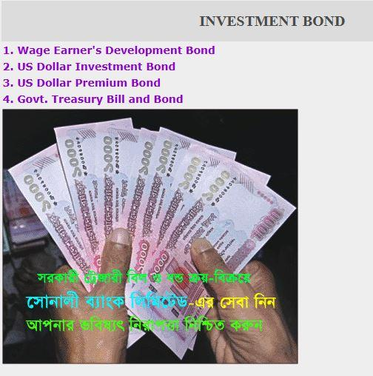
Offshore Banking
Sonali Bank PLC recently received official approval from the Foreign Exchange Policy Department of Bangladesh Bank to start Offshore Banking operations, with the license granted on June 10, 2024. The bank has already developed its offshore banking operational guidelines and finalized the organizational structure, which have been approved by its Board of Directors. Other preparations, such as infrastructure, staffing, and system readiness, are nearly complete. As everything is falling into place, Sonali Bank is expected to launch its offshore banking services very soon, offering international-standard facilities to foreign investors and corporate clients looking to conduct banking outside regular domestic regulations.
Card Services
They offer debit and credit cards, including Visa Silver and Gold. These cards can be used in Bangladesh or internationally for shopping, withdrawing money, or paying bills. Some cards support both BDT and USD, and all come with modern features like QR code payments.
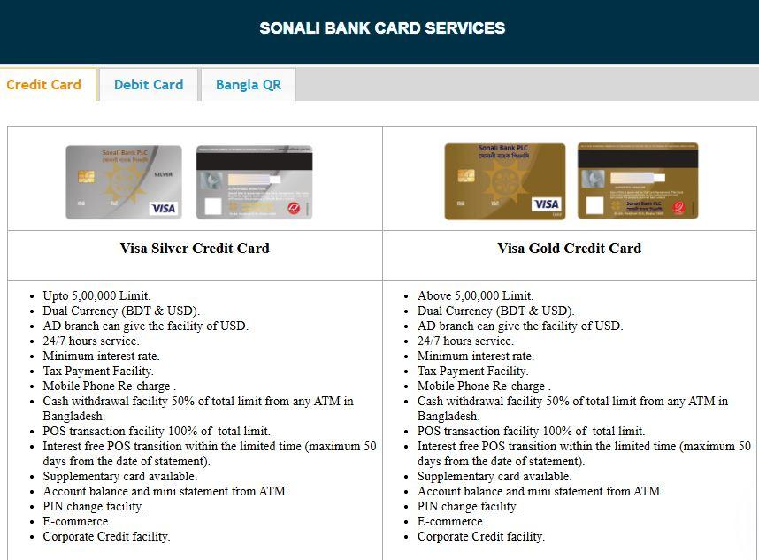
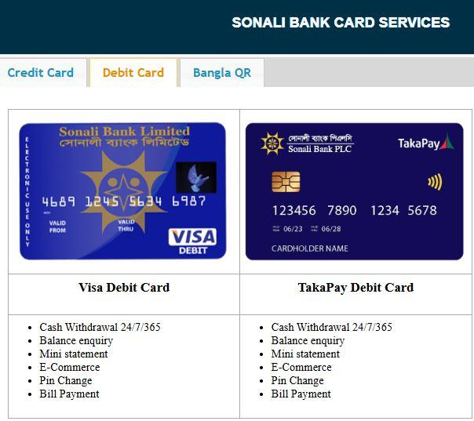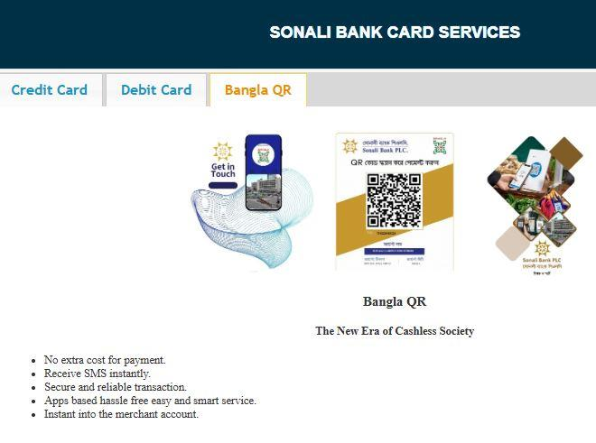

Agent Banking
In rural or remote areas where branches are hard to find, Sonali Bank has agents who offer basic banking services. This helps people in villages access banking without having to travel far. SBPLC’s Agent Banking Outlets are designed to bring essential banking services closer to rural and underserved communities. These outlets offer a wide range of services that allow customers to manage their accounts, make deposits, receive remittances, and more, without needing to visit a main branch.
Key Services Available
- Savings Accounts (Individual) - Open a savings account, Deposit and withdraw cash, transfer funds in and out.
- Current Accounts (Individual) - Account opening, Cash deposit and withdrawal, Fund transfer
- SND Accounts (Special Notice Deposit) - Open and manage SND accounts, Cash transactions and fund transfers
- School Banking Accounts - Special savings account for students, Cash deposit/withdrawal and transfers
- Sonali Savings Scheme Accounts - Open scheme accounts, Deposit installments via cash or transfer
- Fixed Deposit Accounts - Open FDR accounts, Deposit through bank transfer
- Cash and Fund Transfers to Main Branches- Deposit cash or transfer funds into any existing Sonali Bank account (Savings, Current, SND, SDS) at regular branches through agent outlets
- Foreign Remittance (EFT) Deposit Services - Deposit foreign remittances directly into agent banking accounts using Electronic Fund Transfer (EFT)
- Foreign Remittance Cash Withdrawal - Withdraw remittance received through web-based or PIN-based systems from agent outlets
- BEFTN & RTGS Transactions - Inward and outward transactions through BEFTN (Bangladesh Electronic Funds Transfer Network) and RTGS (Real Time Gross Settlement)
- Digital Banking Access - Sonali Bank’s digital platforms like Sonali e-Wallet and Sonali e-Sheba for secure and convenient transactions
- Cheque Services - Issue cheques and use them for transactions at any Sonali Bank branch
- Debit Card Issuance - Debit cards issued by the linked branch can be used for transactions on behalf of account holders
- Extended Banking Hours - Agent outlets remain open 7 days a week, from 8:00 AM to 8:00 PM, allowing customers to deposit or withdraw cash at their convenience

Ancillary Services
Sonali Bank also handles many public services, like pension payments, stipends for students, and freedom fighter allowances. You can also pay utility bills, taxes, passport fees, or buy government savings certificates through the bank. SBPLC goes beyond regular banking by offering a wide range of ancillary services that support both individual and national needs. Through its extensive branch network across Bangladesh, the bank plays an active role in public service delivery, bill collection, and social welfare. As part of its collection services, Sonali Bank accepts payments for a variety of government-related fees and utility bills. These include income tax (source tax), VAT, customs and excise duties, and municipal holding taxes. Customers can also conveniently pay their gas, electricity, telephone, and WASA bills through the bank. Additionally, it collects passport and visa fees, travel taxes, zakat fund contributions, hajj deposits, and land development taxes, making it a one-stop solution for essential public transactions. On the payment side, the bank handles disbursement of pensions to retired employees of the government, corporate bodies, Bangladesh Bank, the armed forces, and even British pensioners. It also facilitates the distribution of stipends and scholarships to students, salaries for teachers (both government and non-government), and food procurement payments on behalf of the government. It also contributes significantly to social services by distributing government allowances to widows, divorcees, destitute women, freedom fighters, and women who have survived acid attacks. These efforts reflect the bank’s commitment to social inclusion and support for vulnerable communities. Moreover, the bank handles sales and encashment of various financial instruments such as savings certificates, ICB unit certificates, prize bonds, wage earners’ development bonds, and US dollar premium bonds. Customers can also purchase lottery tickets of semi-government and autonomous organizations, Sanchayapatra, and application forms for public service and judicial commissions. The bank also assists with the exchange of damaged or torn currency notes. Under miscellaneous services,It provides account information to the National Board of Revenue (NBR) when required, supports the Local Governance Support Project, and facilitates the enlistment of private insurance companies. All these additional services make Sonali Bank a vital institution in Bangladesh's financial and administrative ecosystem, offering convenience and trust to both citizens and the state.
Locker Service
If you need a safe place to store important documents, jewelry, or valuables, Sonali Bank provides locker facilities in many of its branches.
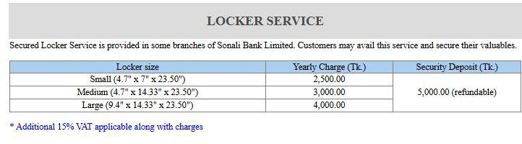
SMS Banking Service
With Sonali Bank’s SMS service, you can get instant alerts about your account activities or check your balance and mini statements anytime using your phone. Just register once at your branch to get started. SBPLC offers a 24/7 SMS Banking service to ensure customers can stay connected to their accounts at all times, no matter where they are. This service includes two main features: Transaction Alert and Push-Pull SMS Service.
With the Transaction Alert Service, customers receive an instant SMS notification every time a transaction is made in their account. Whether it's a deposit, withdrawal, fund transfer, or any other movement, the bank immediately sends a message to keep the account holder informed. This service is available for a small fee of BDT 50 plus VAT, charged on a half-yearly basis. The Push-Pull Service allows customers to actively check their account information by sending a simple SMS. Through this feature, users can request their current account balance, a mini statement showing recent transactions, or details about their account number sequence. Like the alert service, this also comes at a cost of BDT 50 plus VAT for every six months. To use the Push-Pull service, customers just need to send a specific SMS to the number 26969. For example, typing "SBL BAL" will return the balance of a single account, while "SBL BAL1", "SBL BAL2", etc., can be used for multiple accounts. Similarly, "SBL STM" provides a short statement for a single account, and "SBL STM 1", "SBL STM 2", etc., work for multiple ones. To find out the account sequence, the keyword "SBL SEQ" can be sent. If a customer needs help or wants more information about the service, they can simply text "SBL HELP". This SMS service is designed to give customers quick, reliable, and round-the-clock access to their account information, adding a layer of convenience and security to their banking experience.

Digital Banking
Sonali Bank PLC’s Digital Banking segment is designed to provide fast, secure, and convenient banking services through digital platforms. It includes the following services:
- Sonali Corporate i-Banking: Tailored internet banking for corporate clients, enabling bulk transactions, salary disbursements, and more.
- Sonali Bank Payment Gateway: Supports secure online transactions for e-commerce businesses and merchants.
- Online Bill Payment System: Allows customers to pay utility bills, tuition fees, and other charges online, avoiding long queues.
- Sonali Bank Mobile Apps: Offers mobile-based banking features like balance inquiry, fund transfer, utility bill payment, and more.
- Sonali eSheba: A digital customer service platform that enables online service requests, application tracking, and updates.
- Sonali eWallet: A mobile wallet solution for cashless transactions, online shopping, and digital fund transfers.
- Binimoy Service: A digital interoperability platform that facilitates smooth fund transfer between different banks and MFS (Mobile Financial Services) providers under the Bangladesh Bank’s digital transaction network.
Islamic Banking
Sonali Bank PLC also offers Islamic Banking, adhering strictly to Shariah-compliant financial principles. This segment is ideal for customers who prefer interest-free, ethical banking solutions. The features include:
- Overview of Islamic Banking: Gives detailed information about how Islamic banking functions within the bank, following Islamic laws and avoiding interest (riba).
- Hajj Savings: A special account designed to help customers save gradually for performing Hajj, with Shariah-compliant terms.

2.2.2 Trend and Growth
Sonali Bank PLC demonstrated notable financial improvement in 2024, achieving a record operating profit of Tk 5,634 crore, which marked an increase of Tk 1,788 crore from the previous year. This growth was primarily driven by a significant rise in deposit inflow, totaling approximately Tk 1.65 trillion, and a sharp surge in net interest income (NII), which reached Tk 1,425 crore, nearly triple that of the previous year. Although the loan portfolio experienced a slight decline, mainly due to adjustments in government-related disbursements, the bank maintained a healthy advance-to-deposit ratio of around 60%. Furthermore, its recovery from non-performing loans (NPLs) amounted to Tk 1,170 crore, reflecting a focused effort to reduce bad debts. These indicators suggest strong institutional momentum as the bank strengthens its position within Bangladesh’s financial sector.

2.2.3 Customer Mix
Sonali Bank PLC caters to a diverse clientele, including individual customers, government employees, pensioners, students, small and medium-sized enterprises (SMEs), and public institutions. The bank's role as the leading state-owned financial institution makes it a central platform for handling government transactions, scholarship payments, remittances, and public payroll services. In recent years, the bank has shifted more focus towards CMSMEs and export-oriented enterprises, aligning with national economic priorities. As a result, the bank's customer base reflects a blend of mass-market retail users and institutional/government-linked entities, providing it with stability and volume-driven service demand.

2.2.4 Marketing Mix/Marketing Practices
Sonali Bank PLC uses a thoughtful combination of the 4Ps of marketing, to effectively reach and serve its customers across Bangladesh and beyond.

- Product
- Price
- Place
- Promotion
Product
Sonali Bank offers a broad variety of financial products and services tailored to meet the diverse needs of its customers. These include personal banking, international banking, SME banking, Islamic banking, and social welfare services, among others. The bank also facilitates services like sales and encashment of bonds and certificates. All of these are designed to fulfill essential banking needs through a customer-focused and innovative approach.
Price
When it comes to pricing, Sonali Bank remains competitive. The bank aims to keep interest rates on loans and deposits attractive enough to benefit customers while remaining sustainable. This helps them maintain trust and long-term relationships with clients across different economic backgrounds.
Place
Sonali Bank has a vast network of branches spread throughout all seven divisions of Bangladesh, ensuring wide physical reach. It also has two overseas branches in India and several affiliated foreign exchange houses to cater to expatriates and global clients. Additionally, with the launch of online and mobile banking services, the bank has extended its presence into the digital space, making banking easier and more convenient for everyone.
Promotion
To bring in new customers and retain existing ones, Sonali Bank engages in various promotional efforts, such as advertising campaigns, special offers, and community outreach programs. Each branch also appoints a SPO (Senior Principal Officer) who often serves as a relationship manager, ensuring personalized support and maintaining strong client connections.

In short, by strategically combining product offerings, competitive pricing, widespread reach, and smart promotions, Sonali Bank PLC successfully positions itself as a trusted and accessible financial institution for millions.

2.2.5 General Banking Operations
At the branch level, particularly at Lalmatia, general banking functions form the foundation of daily operations. These include opening and maintaining accounts, processing cash deposits and withdrawals, issuing cheque books and debit cards, and conducting local remittance activities. The branch also handles inward and outward cheque clearing and provides front-line customer service for transaction support and problem resolution. Operational workflows are carried out using the bank’s core banking software, ensuring real-time data entry and service accuracy. Recent digitalization efforts have led to increased use of QR-based withdrawals, mobile apps, and online inquiries, reducing the dependency on manual procedures and improving customer service efficiency. Staff members play a key role in bridging the digital divide by assisting customers, especially older clients or those unfamiliar with tech-based banking.

2.2.6 SWOT Analysis
- Strengths
Sonali Bank’s vast branch network (over 1,230 locations) and government ownership ensure trust and reach across all parts of the country. Its established brand and strong customer loyalty, particularly among government employees and pensioners, offer stable business.
- Record profit, strong deposit base, and improved loan recovery performance reflect sound financial management.
- Weaknesses
Bureaucratic processes often slow down services and decision-making.
- The bank still lags behind many private banks in terms of technological innovation and customer-centric digital solutions.
- A heavy reliance on government deposits may restrict operational flexibility.
Opportunities:
- With increased focus on digital transformation, the bank can expand its reach and reduce overhead through mobile apps and online services.
- Growth in SME financing and remittance channels offers scope for higher profit margins and broader economic impact.
- The introduction of its payment switch and digital service expansion creates competitive leverage in the retail segment.
Threats
- Rising competition from agile private banks and fintech companies could erode Sonali Bank’s market share.
- Economic instability and regulatory constraints could affect future profitability and lending capacity.
- Persistent exposure to non-performing loans and public scrutiny may limit operational freedom.

2.2.7 Threat of Substitutes & Rivalry
Threat of Substitutes – High
Sonali Bank PLC, like other traditional banks, faces growing challenges from alternative financial services such as mobile banking platforms, microcredit institutions, non-governmental organizations (NGOs), and internal informal financial markets. These alternatives offer many of the same services, like lending, saving, and money transfers, often with greater flexibility and accessibility. As a result, customers are no longer limited to conventional banks like Sonali Bank for their financial needs. This shift gives people more options, reducing their dependency on banks and increasing the overall threat of substitutes in the industry.

Rivalry Among Competitors – Low
While Sonali Bank competes with other banks for deposits and market share, the level of competition is relatively low due to its unique status as a government-owned bank. It offers services and advantages that private banks can’t easily match. For example, opening a student account at Sonali Bank costs just Tk 150, whereas private banks often charge much more. Additionally, Sonali Bank plays a key role in handling government transactions, such as collecting payments and providing services to public sector employees. In times of liquidity issues, it also has the privilege of borrowing from the Bangladesh Bank, something not all banks can do as easily. These benefits give Sonali Bank a distinct competitive edge, reducing the intensity of rivalry with other banks.

CHAPTER Ill: INTERNSHIP EXPERIENCE

3.1 Student Information
Name: Tabassum Islam
ID: 111 193 049
Program: Bachelor of Business Administration (BBA)
Major: Marketing

3.2 Internship Overview
I began my internship at Sonali Bank PLC on March 16, 2025, at their Lalmatia Branch, located at 4/1/A Navana New Burry Palace (1st Floor), Sobhanbag, Dhaka-1207. During my time there, I was placed in the General Banking Department, where I got hands-on experience in core banking operations. My onsite supervisors were Mahbuba Hossain, Suraiya Parvin, Sharmin Sultana, a highly experienced professionals at the Lalmatia branch. Under their guidance, I was able to learn and perform a range of daily banking tasks and processes. In short, during my internship at Sonali Bank PLC, Lalmatia Branch, I worked as an intern in the General Banking Division. Although I was not assigned an official job title, I was entrusted with various roles and tasks that gave me insight into the daily workings of the bank. My responsibilities primarily included assisting with customer service, observing transaction processes, helping with account opening procedures, handling documentation, and supporting various clerical tasks. I also maintained communication with customers, helped them fill out forms, guided them through bank services, and ensured that all documentation was properly organized and filed. I was responsible for checking the accuracy of deposit and withdrawal slips, managing account opening forms, verifying national ID and passport copies, and maintaining compliance with bank policies. At times, I was also asked to support the IT section by checking database entries and updating information. These tasks allowed me to witness how front-desk and back-office operations work hand-in-hand.
As an intern, my key responsibilities included:
- Account Opening at Central Banking System (CBS)
- Carefully reviewing and verifying the details provided in Savings Account, FDR Account, and Schemes Account forms to ensure accuracy.
- Digitally updating signature cards of newly opened accounts into the Central Banking System (CBS).
- Assisting in the preparation of cheques and vouchers, making sure all information was accurate.
- Verifying National ID (NID) documents of account holders to confirm authenticity.
- Verifying all the documents of the customers
- Uploading and updating vouchers and invoices on designated portals.
- Matching and cross-checking cheques, vouchers, and invoices with the branch daybook for reconciliation.
This internship gave me a solid understanding of how general banking operations are managed on a daily basis and how attention to detail and accuracy are critical in this sector.

3.3 Training
As part of the onboarding process, I received hands-on training from my on-site supervisors. This training was both formal and informal. I was taught how to manage the account opening procedure, understand different types of accounts (savings, current, fixed deposit, etc.), and operate the bank’s internal software system. I was guided on regulatory compliance measures such as KYC (Know Your Customer), anti-money laundering protocols, and transaction reporting procedures. The training also included lessons on handling customer complaints, communication etiquette, how to verify documents, and how to ensure error-free transactions. They were very supportive, patiently explaining their tasks and demonstrating procedures whenever I had questions. Through real-life observation and direct mentorship, I gained practical knowledge that textbooks could not provide.

3.4 Contribution to Departmental Function
As an intern, I was actively involved in the day-to-day activities of the general banking department. By helping the officers manage workloads, I contributed to smoother operations. My assistance in preparing forms, organizing files, and updating account records helped reduce the burden on the bank staffs. I also played a role in improving customer satisfaction by guiding them through processes, answering their queries, and ensuring their needs were met in a timely manner. Though my role was limited compared to that of full-time employees, the support I provided allowed others to focus on more complex tasks. My supervisors often acknowledged that my attention to detail and willingness to assist helped in maintaining order during busy banking hours. My careful attention to detail helped the department maintain accuracy and avoid audit issues.

3.5 Student’s Learning and Benefits
General banking is the core of all banking functions. It includes routine services such as account opening, fund transfers, issuing cheques, and creating pay orders. During my internship, I gained a solid understanding of how these basic but essential services are handled in real time. By observing and interacting with bank officials from different sections, I learned how the cash section, account section, clearing section, bill collection, account opening, and FDR management operate. This experience not only broadened my understanding of banking practices but also gave me a clear view of the work culture and professional environment in Bangladesh’s banking sector.

3.6 Evaluation
Overall, my performance during the internship was appreciated by my supervisors & the AGM. I was regularly given constructive feedback, which helped me improve and learn. My punctuality, eagerness to learn, and ability to adapt were acknowledged. I took every task seriously, no matter how small it was. The officers often mentioned my ability to quickly grasp new information and take initiative. By the end of the internship, I had earned their trust to handle more complex tasks with minimal supervision. I believe my willingness to learn and my respect for professionalism contributed to a positive evaluation.

3.7 Skills Applied During my internship
I applied several skills I had previously acquired through my academic coursework. These included:
- Basic accounting knowledge to understand transaction processes.
- Marketing & Communication skills for customer interaction.
- Time management and multitasking.
- Data entry and documentation handling.
- Teamwork and interpersonal skills in a professional setting.
- These abilities helped me adjust to the bank's fast-paced environment and made my contributions more effective.

3.8 New Skills Developed
One of the most valuable aspects of my internship was the new skills I developed:
- Professional communication: I learned how to interact with customers, superiors, and colleagues with proper etiquette.
- Technical skills: I gained familiarity with banking software, digital record systems, and internal security protocols.
- Problem-solving: I learned to handle minor customer issues and find solutions by coordinating with officers.
- Regulatory understanding: I now understand the importance of compliance, audit trails, and legal verification procedures.
These skills will be highly beneficial in my future career, especially in the banking sector.

3.9 Application of Academic Knowledge
My academic background in BBA (Marketing) from United International University helped me understand customer behavior, service quality, and strategic communication. The marketing concepts I studied, such as customer relationship management and service delivery, were directly applicable in the banking environment. I could relate theoretical frameworks to real-world banking scenarios, such as how customer loyalty is built through consistent service quality and transparency.

3.10 Challenges Faced
Thankfully, I did not encounter major problems during my internship at Sonali Bank PLC’s Lalmatia Branch. The staffs were cooperative, welcoming, and always ready to assist me whenever I had questions. The only minor challenge I faced was related to gathering specific internal information for this report, as certain data was confidential and not accessible to interns.

CHAPTER lV: CONCLUSIONS AND KEY FACTS

4.1 Recommendations
Based on my experience during the internship, I would like to offer a few suggestions for Sonali Bank PLC to enhance their internship program in the future:
- Firstly, each branch could benefit from having more interns at a time. This would help distribute the workload more evenly, preventing individual interns from becoming overwhelmed. As a result, interns would be able to work more effectively and maintain better focus on their tasks.
- Secondly, to keep the internship engaging and to avoid repetitive tasks, it would be helpful to assign interns a variety of responsibilities that challenge their interpersonal and professional skills. Rotating interns across different departments occasionally can also provide them with broader exposure to the bank’s operations. This would not only make the experience more enriching but also help interns feel more involved, valued, and motivated throughout their internship.
- Lastly, based on my internship experience at Sonali Bank PLC, I have observed some areas where improvements could enhance overall efficiency. For example, the use of more advanced digital tools in the general banking department could significantly reduce manual errors and save time. Introducing training programs for staff to better use updated banking software would also increase productivity. Additionally, making certain forms and processes more user-friendly for customers, especially for senior citizens and those with limited digital literacy, would improve service quality and customer satisfaction. Ensuring better coordination between different departments through regular internal meetings can also reduce delays and miscommunication.

4.2 Conclusion
My internship at Sonali Bank PLC, Lalmatia Branch, has been a rewarding and transformative experience. Throughout this program, I had the opportunity to observe and actively participate in the day-to-day operations of one of Bangladesh’s largest and most respected government-owned banks. Being assigned to the general banking department allowed me to witness the core functions that keep a branch running smoothly. One of the most valuable takeaways from this experience was learning how different banking functions are interconnected. This taught me the importance of precision, responsibility, and integrity in banking activities. I also realized how crucial the general banking department is, as it serves as the foundation for all other banking services. Moreover, this internship provided me with the chance to apply the academic knowledge I gained from my university courses into real-world practices. The work culture at Sonali Bank was supportive, and my colleagues, especially my supervisors, helped me learn by giving constructive feedback and guidance. Their encouragement boosted my confidence and allowed me to take ownership of my tasks.

To sum up, my internship at Sonali Bank PLC was a valuable learning journey. It gave me a glimpse into real-world banking operations and allowed me to apply some of my academic knowledge in a practical setting. I not only learned technical skills but also soft skills such as communication and attention to detail. This experience has helped me grow both personally and professionally and has given me a clearer view of what a career in banking might look like. this internship helped me understand the expectations of a professional workplace, which will definitely benefit me in my future career. In conclusion, my internship at Sonali Bank PLC was more than just a short-term experience.

References
      - Bangladesh Bank. (n.d.). Bangladesh Bank official website. https://www.bb.org.bd/en/
      - Sonali Bank PLC. (n.d.). Sonali Bank official website. https://www.sonalibank.com.bd/
      - Sonali Bank PLC. (n.d.). About us. https://www.sonalibank.com.bd/aboutus.php
      - Sonali Bank PLC. (2024). Annual report 2023–2024. https://www.sonalibank.com.bd/PDF_file/annualreport/2024/Sonali_Bank_Annual_Report_2023.pdf
      - Investopedia. (n.d.). Marketing mix: The 4 Ps of marketing.
      - Kotler, P. (2003). Marketing management (11th ed.). Pearson Education.
      - Ahmed, S. U. (2017). Banking in Bangladesh: Evolution and performance. University Press Limited.
      - Rahman, M. M. (2020). Banking sector reforms in Bangladesh: An analytical review. Journal of Business and Economics, 12(2), 45–57.
      - Rose, P. S., & Hudgins, S. C. (2013). Bank management & financial services (9th ed.). McGraw-Hill Education.
      - BRAC University. (n.d.). BRACU institutional repository. https://dspace.bracu.ac.bd/
      - United International University. (n.d.). UIU institutional repository. https://dspace.uiu.ac.bd/
      - Daffodil International University. (n.d.). DIU institutional repository. http://dspace.daffodilvarsity.edu.bd

Appendix A:
