
Developing a Marketing Plan for Diamond Insulation Products

Intern Supervisor:
Md. Shariful Alam, PhD
Associate Professor
School of Business and Economics

Submitted By:
Fazle Rabbi
ID: 111131077

Date of Submission: July 22, 2019



Developing a Marketing plan for Diamond Insulation Products

Letter of Transmittal

July 22, 2019
Md. Shariful Alam,PhD
Associate Professor,
School of Business and Economics,
United International University.

Subject: Submission of the intern report on “Developing a Marketing Plan for Diamond Insulation Products.”
Dear Sir,
With due honor, It is a great opportunity for me to submit the intern report on “A marketing plan for Diamond Insulation Products.” As part of our BBA course requirement, I have prepared this report on the basis of the knowledge I have gathered from my related courses and I would like to express my sincere gratitude to you for your continuous support and guidance.
Though I have put my best efforts to achieve the objectives yet it is likely that the report may have some mistakes and hope that our endeavor will serve the purpose. So, I hope that the report will worthy of your consideration and I will always be ready to provide any further clarification that you may require.

Yours sincerely
…………………
Fazle Rabbi
ID:111 131 077

CERTIFICATION
This is to certify that Fazle Rabbi, a student of BBA, ID – 111 131 077, under School of Business and Economics, United International University (UIU) has completed the internship report titled “Marketing Plan of Diamond Insulation Products’ as a part of requirement for obtaining BBA degree. He has given his best efforts to complete this report. I wish him all the success in his life.

Supervisor

_________________________________________
Md. Shariful Alam, PhD
Assistant Professor
School of Business and Economics
United International University

Honesty Statement

I have prepared a internship report on “Developing a Marketing plan for Diamond Insulation Products” which is a compulsory course for the completion of Bachelors of Business Administration. (BBA), through this honesty statement I would like to inform you that I have not taken any help from illegal sources. This report is a result of my hard work, All the information in this report has been collected from primary and secondary sources. I did not use any copyright protected information here.

Best regards,
Fazle Rabbi
ID- 111 131 077

Acknowledgement

I would like to thank Almighty Allah for giving me strength, patience and virtue to complete this report.

I would like thank my intern supervisor MD. Shariful Alam PhD for giving me the opportunity to work with him during this internship period. With his proper guiding, continuous support and counseling I have been able to complete this report comprehensively. I have tried my best to reflect his guidance in this report.

I would also convey my sincere gratitude to the Managing Director of Diamond Insulation Product, Mr. Mobarak Islam for his sincere support and guidance throughout the internship report.

I would also like to take the opportunity to acknowledge the help provided by the entire marketing team of Diamond Insulation Production. They have provided me their valuable time from their busy schedule and given me enough guidance, support and information which was required to complete this report.

Finally I would like to thank each and every one who was involved in different stages during this period of internship.

Office  Tel  Mob  E-mail  Web | :  :  :  :  : | West Brammankitta, Kalindi,  Keranigonj, Dhaka- 1310  02-7761632  01711-568726, 01713-518971  diamond_mobarak@yahoo.com  www.diamondeps.com | Importer, Manufacturer, Suppliers Insulation Board  (Cork sheet), Pipes& Packaging

Ref: Date:

Factory : Khagail,Kalindi, Keranigonj, Dhaka-1310
Tel : 02-7763396,02-7763945
Mob : 01715390507, 01716788586

TO WHOM IT MAY CONCERN

This is to certify that MD Fazle Rabbi, Student of United International University, ID no.111 131 077 has successfully completed the internship program at this company. During this period of internship he had been exposed to different activities And was found punctual, hardworking and inquisitive. We wish him success and bright future in his life.

For Diamond Insulation Products

———————————
MD Mobarak Islam
Managing Director
Diamond Insulation Products
List of Acronyms
Factory : Khagail,Kalindi, Keranigonj, Dhaka-1310
Tel : 02-7763396,02-7763945
Mob : 01715390507, 01716788586

EPS- Expandable polystyrene Styrofoam
DIP- Diamond insulation products
B2B- Business to Business
GI- Galvanized Iron
GM- General Manager
AGM- Assistant General Manager
MD- Managing Director
PE- Polyethylene
DMD- Deputy managing Director
GPS- Global positioning Systems

Table of Contents
Executive Summary 1
Introduction 2
History of DIP 3
Company Profile 4
Clients of DIP 5
Company Vision 7
Company Mission 7
Purpose of the report 7
Objective of the Study 7
Rationale of the study 8
Scope of the study 8
Limitations of this report 9
Methodology of the Report 9
Marketing Plan for Diamond Insulation Products 11
Current Marketing Situation 11
Market Description 12
Product review 13
Competitive Review 16
Marketing organization 18
Channels and Logistics review 19
SWOT Analysis 20
Objectives and Issues 22
Marketing Strategy 24
Action Program 32
Budgeting 33
Controls 35
Conclusion and Recommendations 36
References 37

Executive Summary
This internship report is prepared for the accomplishment of a bachelor degree as required by the School of Business and Economics, United International University. This report consists of three main chapters, Chapter 1 contains Company overview, purpose and objective, Chapter 2 contains methodology and Chapter 3 contains Marketing plan.
The study is based on the company named Diamond Insulation Product. Diamond Insulation Products is an expandable polystyrene (EPS) products manufacturing industry. It has started its production in March 2008. Initially, there are several products in its production line, such as Insulation Board, Box, Packaging, and Pipe Insulation which is widely used for Insulation purpose.
Internships provide students numerous perks: They gain experience, develop skills, make connections, strengthen their resumes, learn about a field, and assess their interests and abilities. Internship also provides training and experiential learning opportunities for the development of skills in assessment, counseling, crisis intervention, consultation, outreach, and supervision.
The main part of the report is the Marketing plan of Diamond Insulation Products. The major parts of the marketing plan for Diamond Insulation Products are Product review, Competitive review, SWOT analysis, Product strategy, Competitive strategy, pricing strategy, Distribution strategy, Marketing communication strategy, Action Program, and Budgeting. All of these parts are described briefly in this report.
This report contains both primary and secondary data. The primary data was collected simply by observing and asking questions about different aspects of marketing plan to the marketing team. Secondary data was collected from the journal, book, and website.

Introduction

EPS stands for Expandable Polystyrene Styrofoam. Expanded Polystyrene insulation is lightweight, rigid, closed cell insulation. It is lightweight, durable, moisture resistant, thermally efficient, Shock absorber. Moreover it can be used for versatile purpose and easy to use. In Bangladesh the demand of EPS products getting popular day by day. But only a limited number of businesses have been set up here to cover the whole fast growing demand. So opportunities to be successful in this business are significant. A marketing plan can take many different forms. It can be formal or informal; highly detailed, or more general. At a minimum, the purpose of a marketing plan is this: it will describe who your clients are and where they are, and how you can reach them. Getting more clients means more business, and more business means greater profits. For the relatively minimal time and effort required to create a marketing plan, the pay-off can be huge. It’s an excellent investment for any small business. The importance of marketing plan is significant. A good marketing plan helps to give required direction to product, brand or company. With a marketing plan a company is better prepared to launch its product or service and promote sales percentage to the existing products. A marketing plan differs from an business plan in terms of scope. A marketing plan is very limited in scope compared to a business plan which is broad. It provides documentation how the organization’s strategic objectives will be gained. The marketing plan provides direction how the company will create and sustain profitable relationships. It also forms a number of internal and external relationships. It affects how marketers work with each other and other parts of the company to deliver superior value hence satisfy the needs of customers. It also affects company’s relationship with supplier, distributors and strategic alliance partners. It also influences relationship with the stakeholders significantly for example government regulations maker, media and the community. All of these above mentioned relationships play a vital role in a company’s success. So every organization should consider it while constructing a marketing plan.

History of DIP
During early 80’s there was no concept of EPS based products in Bangladesh. At that time to conserve crops, foods and vegetables the importance of cold storage emerged. As a core part of cold storage the concept of EPS emerged too. At that time only former president of Bangladesh Mr AQM Badruddoza Chowdhury established first ever EPS factory in Bangladesh. His company was only the sole player in this field. At that time the demand for EPS only existed during winter season, and all the needs were fulfilled by that particular company, and the scope was very limited. During 90’s businesses in Bangladesh moved to the path of export and import. In order to safeguard the products the demand of EPS based products increased significantly. DIP started their business 1995 as a merchandiser and following year marked its introduction in the market. During 2006, the demand which was limited to three months in a year, turned out to be 12 months. Also many multinational companies constructed their own manufacturing plant in Bangladesh. The existing companies were unable to fulfill the huge demand required by these companies. So DIP started thinking about establishing their own industry in order to capitalize this opportunity. DIP established their factory in 2008 aiming to fulfill the huge market demand. With modern automated machineries, skilled employees and leadership they have been able to fulfill market demands and consequently established them as a market leader. At 2016 they replaced all their old manual and semi-automatic machineries with fully automated machineries to ramp up their production. As of 2019 in order to fulfill increasing demands they are thinking of setting up more technologically advanced machineries.

Company Profile
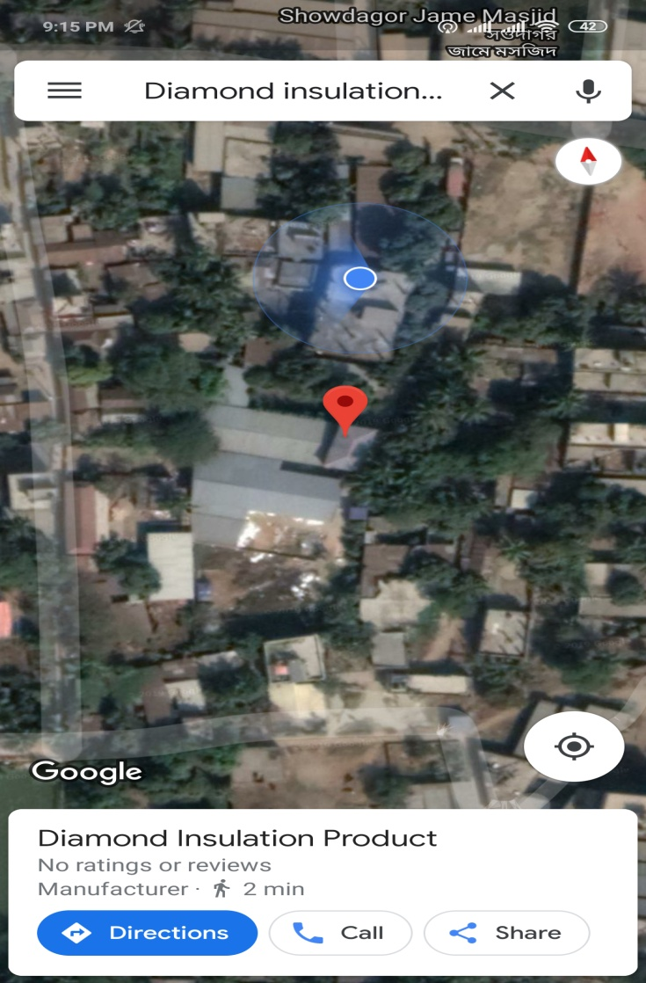
Diamond Insulation products specialize in manufacturing EPS based products. The company started its journey in 2009. Mr Mobarak Islam is the founder and also the managing director of the company. Now Diamond Insulation Product is one of the most leading manufacturers in Bangladesh. In Bangladesh 2/3rd of the total production of EPS based products are manufactured by Diamond Insulation Products. Now the company has two factories equipped with modern machineries. DIP uses latest German technology to produce EPS based products. The company imports high quality raw materials to produce its products and supplies all over Bangladesh. Their clients include some of the leading firms across the world. The notable clients includes Samsung, LG, Bengal meat, Vision, Sony etc. Their products include EPS sheet, EPS fish box, EPS insulation pipe, Jumbo EPS, and Electronics EPS packaging etc. The vision of the company is to become the global supplier of EPS based products. Currently the company is satisfying the need of local markets. In future they want to announce their global presence.
Figure 1: GPS location of Diamond Insulation Products Head office and factory

Clients of DIP
. DIP has over 250 clients. Some of the notable clients of DIP are
- LG
- Samsung
- Dong Zing
- Singer
- Hamko batteries
- Volvo batteries
- Kazi Farms
- Bengal meat
- Partex
- Asia tech
- Excellence ceramics
- RAK ceramics
- Abul Khayer
- Chan Sarder cold storage
- BM cold storage
- Modhu uzala cold storage
- Tamanna cold storage
- Maxwell
- Nasir group
- RK export import

Organogram
Here is the DIP’s organogram where we can see the hierarchical structure of the company.

Organization Organogram
Account Dept.
HR & Admin Dept
DMD
Party / Clients
Distribution/Delivery
Organization Organogram
Production Dept.
Sales & Marketing
Director
Managing Director

Managing Director ghug

Account Dept.
DMD
HR & Admin Dept
Party / Clients
Distribution/Delivery
Production Dept.
Sales & Marketing
Director

Company Vision
DIP wants to become a global EPS supplier after meeting domestic demand.

Company Mission
Meeting domestic demand by providing high quality EPS at optimum cost and retain the position of being a market leader.

Purpose of the report
The main purpose of this report is to make a “Marketing Plan” for Diamond Insulation Products which is required for BBA degree accomplishment. In his current marketing situation, this marketing plan will benefit the company and I am honored to work with a industry leader in developing their own marketing plan.

Objective of the Study
Broad Objective

The Board objective of this study is to develop the marketing plan of Diamond Insulation Products.

Specific Objective

Market segmentation of EPS based products.
- To learn about the pricing, distribution, budgeting, communication strategy of DIP
- To gain practical knowledge about the EPS based products.
- To learn about the sales promotional activities of EPS based products.
- To review current marketing strategies and action plan
- Future opportunities of EPS based products.

Rationale of the study
I am Fazle Rabbi Id 111 131 077, the student of Business Administration. For the completion of BBA degree I have to prepare an internship report. My honorable supervisor Md. Shariful Alam, PhD had assigned me to prepare this report on “Developing a Marketing Plan for Diamond Insulation Products". It had the formal approval of my supervisor of School of Business and Economics. The report is coordinated by the marketing division of DIP. The reason of the study is to construct a marketing plan for DIP.

Scope of the study

The scope of this report was limited to the overall description of the company organizational structure, management policies and marketing policy. The report aims to construct an effective marketing plan for DIP. The main focus of this plan is to develop a competitive strategy in this challenging market.

Limitations of this report

The project report was not free from limitations. I faced some problems during the study, which I am mentioning them as below:

Time constraint: The report had to be completed within a limited amount of time.

Lack of Supervision: I had to work within the busy working schedule of the marketing team members.

Other limitation: As I am an intern, so I faced lack of experience problem. I had to write many aspects from my own observation which may vary person to person.

Methodology of the Report
The methodology of the report consists of methodology of the study, exploratory study, target population, sample size and technique, sampling technique, sources of data, primary sources and secondary sources. The chapter ends with the data collection instrument.
Methodology of the Study
Both primary and secondary data is used to prepare this report. Primary data was derived from the conversation with the marketing team members and observation of the type of work. Secondary data was derived from journal, books and website.
Exploratory Study
A study design gives us proper guideline and systematic approach for the study. It forms the blueprint for collecting measuring and analyzing data.
Target Population
Cold Storage owner, Electronics manufacturers, Meat and vegetables exporters, Frozen food exporters, RMG exporters, ornaments maker, Tiles manufacturers.
Sample Size and Technique
For this study, the sample size that I have taken consists of 21 industries.
Sampling Technique
I have used convenient sampling method among the Diamond Insulation products customers.
Sources of Data
Data was collected from i. Primary Sources, ii. Secondary Sources
Primary Sources
- Direct conversation with customers and marketing team members.
- Observation and deskwork.
- Work process of marketing team.

Secondary Sources
- Web site
- Textbooks and professional journal.
- Annual report of Diamond Insulation Products

Data Collection Instrument
Different types of computer software are used for reporting the gathered information from analysis, such as Microsoft Word, Microsoft Excel and Data are analyzed using my own judgment.

Marketing Plan for Diamond Insulation Products
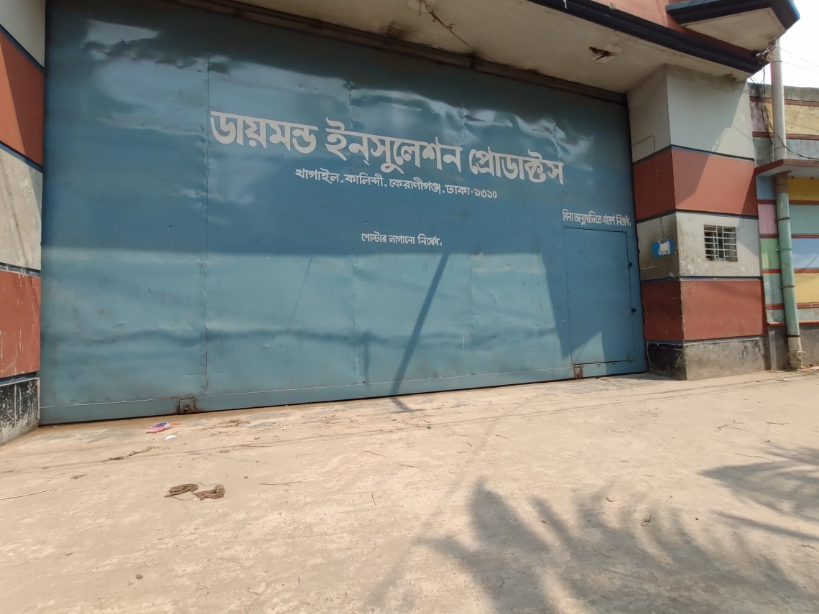
Picture 1: Factory entrance of Diamond Insulation Products

Current Marketing Situation
DIP founded in 2013 with experience in EPS based products is about to construct a marketing plan in a market that is slowly getting matured day by day. Rising demand for the packaging industry in Bangladesh as a result of increasing manufacturing output on a domestic level is a driving force. Rising importance of insulation property in the building sector is expected to promote the usage of high-quality polymers. Furthermore, increasing spending toward enhancing the durability of commercial complexes and residential buildings during extreme external environmental factors is expected to over the next eight years. Growing demand for cold chain packaging solutions in the pharmaceutical sector as a tool for improving product safety and keeping the freshness of packaged food fresh during transportation is a key driving factor. Furthermore, improvement in the frozen food industry is also a major sector for EPS based product. Also growing use of Electronics products and their safety during transportation is also a important sector for EPS based products. All of these factors indicate that the current marketing situation is very promising. Unlike other sectors numbers of competitors in this sector are very low. DIP itself is the current market leader, Advance technology holds the runner up position and 3rd position goes to RFL. Other players include Saudia insulation, Three Brothers and Bangladesh insulation. As the market is slowly maturing day by day so the market is going to be saturated soon. Our marketing plan will also focus on this.

Market Description
DIP is basically a Business to Business (B2B) company. It sells its product to other large and small businesses. Its market consists of businesses that prefer EPS based product for packaging and safety of their products. Its targeted segments are Cold storage ( BM Cold storage), Electronics manufacturers (Samsung), Meat exporters (Bengal meat), Garments. Customers can choose between wide variety of models such as EPS block Bangladesh insulation, Electronics packaging pads from Fars, Fish box from Saudia. But Diamond insulation Products specializes in manufacturing all of the above mentioned variants plus Jumbo EPS, helmet insulation, Crockeries packaging box and so on. Auto machines of German technology are used to make products which are of very high quality and high quality finish with competitive price to appeal buyers. Also for some specific customers DIP offers credit facility which put them to the leading position.
Prior to starting sales and marketing activities a solid knowledge regarding market is essential. It can be achieved by marketing description. The first step is to identify the customer and then how to approach them. There are some crucial questions that needs to be answered otherwise it’s difficult to approach them. Those quick are:
How many customers can there be?
What are their locations? Neighborhood/Province/Asia/World?
What is the maximum amount they are ready to pay?
A company should now as much as possible regarding their customers, their preferred

Product review

Dip has different types of EPS based products.
EPS fish box with different size like DBX 4,DBX 3,DBX2, box24 , box 20,Box18,box15 e.t.
Product is something that is offered in a market for the attention, acquisition, use market consumption that might fulfill a want or need. Products can be tangible or intangible such as cars, table, chairs etc. Products are substantial element in forming a marketing plan. It starts with offering something that offers value to the customers. These offerings build foundation for profitable customer relationship. A company’s offering may include both tangible goods and services, for example pure tangible goods such as toothpaste, salt. Others may include pure services for example insurance services. Even goods and services can be combined in a company’s offerings. First step of creating a product strategy is to pinpoint the market problems. One way of doing this is to interview the target market. It helps to understand the competitive landscape and shows the path to differentiate. The product strategy is pretty much dynamic, it has to change overtime. Listening to customer problems and develop product strategy is a circular process. After learning more and more about the market it will evolve as per market situation. The product strategy of DIP includes:

- They build EPS based product for electronics manufacturers, fish and meat exporters and cold storages.
- Their main customers are mainly electronic manufacturers, cold storage, fish meat and vegetable exporters And packaging industries
- They sell their product via direct selling, retail channel, websites and selling through agents
- Their products are priced based on weight.

Power of product strategy indicates what you include as well as what you exclude. By selecting a particular target market one also excludes other market.

EPS block with different density like 24kg density, 20kg density, 18kg density etc. customer can customize any size in this sector.

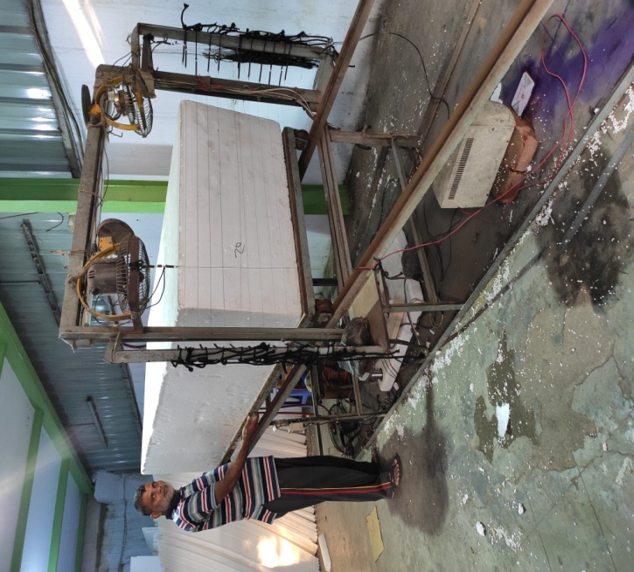

Picture 2: EPS block processing and EPS fish box
EPS electronics packaging like for a refrigerator door pad, front pad, corner pad, etc.
EPS grooving for any battery packaging
Jumbo EPS ball uses in garments sector in Bangladesh
EPS for crockeries packaging like soup set, tea set, glass set etc.

Picture 3: EPS grooving unit

Competitive Review
Advance EPS Technologies Ltd
They use Holland based technology and machineries from Italian company Hirsch. They produce high quality EPS blocks. The company currently owns Pre expander of various density, block molding machines and also electronic cutting machines with a view to cutting the products according to desired size and thickness. They use raw materials ‘Styropor’ from BASF, Malaysia and from Ming Dih, Tiwan.
Three Brothers Insulation
A leading distributor of insulation and sealing products, they produce high quality products and sell them at a competitive price. They specialize in insulation structural material, thermal, cold and acoustic. They have also wide product range in textile sector. They also can supply various accessories as per client requirement
Shimu EPS
They specialize in packaging sector. They started their journey in November 2017.Their main product portfolio includes Fish box, vegetable box, Medicine box, helmet liner, TV packer, Fridge packer, VCD maker, blender buffer, Pipe insulation. Now they have about 35 products in their product line
FARS insulation
It started its business in 2015.they are quite well established in market. Their main target is Electronics manufacture. Currently they are one of the best in this sector. They source their raw materials from Saudi Arabia which are high quality in nature. They have business in Tiles sector. After meeting in house demand they sell the products in outside market.

Marketing organization
DIP’s marketing team is led by Syed Ahad general manger marketing with the assistance of MR. Reyaz Islam and five more junior marketing managers. They efficiently handle the process of marketing for the organization.

Marketing Organization

G.M. Marketing

A.G.M. Marketing

Marketing Executive- 4
Marketing Executive- 2
Marketing Executive- 5
Marketing Executive- 3
Marketing Executive- 1

Channels and Logistics review


Picture 4: Channels and Logistics department
Direct sales via marketing team to the target companies.
Five showrooms across the countries
Online sales via website
40 authorized agents across the country

Initially they plan to sell their products to all over Bangladesh. In future they are planning to expand their business to India, Nepal and Sri-Lanka.

SWOT Analysis
A business' strategy and decision-making process is influenced greatly by marketing department. Understanding the environment that a business will operate in is one of the first steps marketers should initiate in their research. SWOT -- strengths, weaknesses, opportunities and threats -- analysis is a simple but powerful tool that marketers can use to have better understandings regarding the environment. Through findings made in SWOT, a business can effectively judge the marketplace and quickly capitalize on opportunities. Highly useful for ac your organizational goal, attainment of the four categories provides specific insights that can be used to formulate a successful marketing plan, including:
Strengths - Positive attributes internal to your organization and within your control. Strengths can be resources, competitive advantages, the positive aspects of those within the workforce and the aspects related to business that you do particularly brings positive effect to the organization, It also involves focusing on all the internal components that add value or offer a competitive edge. DIP possess the following strength in current marketplace

Full automatic production process, so enough supply according to demand
- Competitive pricing
- Own van, truck, pick up so they can deliver within 24 hours in any part of the countr
- Most advanced human resources in the industry

Weaknesses - Factors that are within your control yet confine ability to obtain or maintain a competitive edge such as limited expertise, lack of resources, limited access to skills or technology, substandard services or poor physical location. Weaknesses encapsulate the negative factors within a business that reduces the overall value of a products or services. This category can be used to have organizational assessment, provided that a company focuses on an accurate identification of its weaknesses. DIP possess following weaknesses:
- Lack of brand awareness : Brand is not well established yet because company didn’t make investment on branding
- Electricity problem: In factory location electricity supply isn’t adequate so secondary source must be used which increases cost
- Gas Problem: Lack of gas supply which hampers production and increases cost.

Opportunities – It is the combination of all the external factors that act as the motivation for the business to exist and shine within the marketplace. These factors include the specific opportunities existing within your market that provide a benefit, including market growth, lifestyle changes, resolution of current problems or the basic ability to offer a higher degree of value in comparison to your competitors to promote an increase in demand for your products or services. . The companies that can capitalize on its opportunities have higher chance to succeed in a marketplace. DIP possess following opportunities:
- Demand of EPS is rising as it is low cost and environment friendly
- EPS bricks: it will replace the traditional brick as it is more efficient and environment friendly. It has the potential to become next booming industry
- A worldwide famous company is establishing their manufacturing plants in Bangladesh. They prefer sourcing EPS products from local companies. It also may open the door for taking this sector to international level.

Threats - External factors beyond the control of the organization that have the potential to restrain the marketing strategy, or put the entire business, at risk. The primary threat in any business is the emergence of Competitors. It can be arrival of new competitor, lethal strategy executed by competitor. However, other threats can include rapid price increases by suppliers, increased government regulation, economic downturns, negative press coverage, shifts in consumer behavior or the introduction of revolutionary technology that leaves existing products or services obsolete. Though these forces are external and cannot be controlled. The threats of DIP in the current scenario are;

- Government tax policies
- Environmental issue is a huge threat
- Due to recent fire incidents government is very strict on petrochemicals

SWOT analysis may also aid in the creation of a contingency plan that will enable you to adapt in the changing marketplace quickly.

Objectives and Issues
Objectives
- Construct an effective marketing plan
- Reaching to more and more via marketing campaigns
Issues
- No formal marketing plan was constructed before, so it must be started from scratch.
- Marketing plan requires huge costing but success is not guaranteed.
- Industry information is very limited and confidential.

Buyers need and Corresponding features/Benefits of DIP
Targeted Segment | Buyers Need | Corresponding features/Benefit
Cold Storage owners | Accurate Density board  Accurate sized board | Specially trained operators to control density  Regular maintenance of machines to maintain accurate size.
Meat exporters | Lightweight and strong box  Good insulation property.  Structurally rigid box | Specialized box that minimizes transportation cost and allow to carry more meat in a single box  Strong and rigid box  Superior insulation property  Fully Automated machines to maintain lightweight and rigidity of boxes
Electronics Manufacturers | Total set of EPS should provide security to the main product.  Maintain stability and balance during transportation  Avoid damage | Structurally rigid top pads, bottom pads and side pads  Automated machines to maintain superior quality to support electronics products

Fish Exporters | Highly insulated box  Lightweight but rigid  Strong insulation property to avoid rotten fish | Specialized box that minimizes transportation cost and allow to carry more fishes in a single box  Strong and rigid box Superior insulation property  Maintain optimum insulation for fish boxes.

Marketing Strategy
A marketing strategy refers to the activities a business undertakes to reach its target customer and turning them into customers of the product or service that the business provides. The marketing strategy of a company includes value proposition offered by a company, key marketing messages, information on the target customer and other high-level elements. The marketing strategy informs the marketing plan, which is a document that tells the timing and type of marketing activities. A company’s marketing strategy should have a longer lifespan than any individual marketing plan as the strategy is where the value proposition and the key elements of a company’s brand reside. These strategies don’t change much overtime. Marketing strategies are often confused with marketing plans. Because they do feed off one another, it is not unusual to mix up the marketing strategy with marketing plan. It is significant that the transition between these two is not smooth, a marketing strategy represents the big picture of what the business offers: the value proposition and related brand messaging. The marketing plan is how the business will deliver the key message: the platforms, the creative, the timing and so on.

DIP’s marketing strategy is based on offering high quality product at competitive price point. Their primary target is Electronics manufacturers like Samsung, LG who need EPS products for packaging and safeguarding their own products. Their secondary target is fish, meat and vegetables exporters of Bangladesh who needs EPS boxes to be reminiscent of meat, fish and vegetables. Their primary business target is large to mid-sized businesses that want to safeguard and package their own products. They are also targeting EPS bricks manufacturers, Event management organizations due to the growing demand of EPS in those sectors.

Positioning
Market Positioning refers to the ability to influence consumer perception regarding a brand or product relative to competitors. The objective of market positioning is the image establishment or brand identification so that consumers perceive it in a certain way. For example a smartphone manufacturer can position itself with distinctive feature; a car manufacturer can position itself with luxury, comfort and long longevity. DIP positions itself by providing high quality product at competitive price. DIP uses raw materials from BASF best EPS raw materials manufacturers in the world that helps to maintain light weight and rigidity of EPS based products. One of the best features of DIP is the delivery of the product on promised time that helps them to differentiate among the market.
Product Strategy
DIP includes all the products described earlier in the product review section. In future they are thinking of introducing EPS bricks, substitute of traditional bricks in Bangladesh market which has a huge potential. Establishing Diamond brand is a compulsory part of product strategy The brand and logo will be displayed on its product and its packaging reinforced by its prominence in the introductory marketing campaign.
Pricing Strategy
Pricing is an important part of marketing plan, the decision on price and its pricing strategy impacts the customer’s decision on purchasing of that particular firms product. The pricing strategy of DIP depends on cost of imported goods, tax rate of government, dollar exchange rate, and pricing of competitors. The base price of each gm. of EPS is 20 paisa which is competitive enough in the current scenario. Although price may vary because of customization of customer. Although DIP is market leader in this sector and their quality is industry best, their pricing is always competitive. For example, a typical 9*14*20 EPS box sold at 140 taka which is lowest in the industry. The goal of this competitive pricing strategy are 1. To attract more customers, 2. To gain more market share.
Pricing strategy refers to method companies use to charge for their products or services. Most of the company set the price of their products and services based on production, labor and advertising expenses and then add on a amount so that they can make a profit. There are several different pricing strategies, such as penetration pricing, price skimming, discount pricing, product life cycle pricing and even competitive pricing. There is several pricing strategy available:

1. Penetration pricing strategy: It is suitable for small companies. This type of company generally sets lower price for their product on order to gain market share. The prime objective of this type of strategy is to attract large number of customers with low price and use various marketing strategies to retain them

2. Price skimming strategy: This type of company charge premium for their product to gain quick profit. Companies that lack financial resources to produce product in high volume uses this type of strategy.

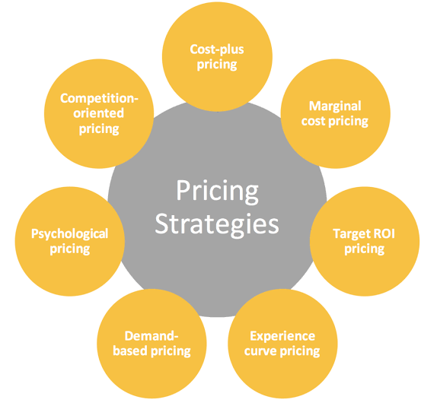
3. Product life cycle pricing: A product has definite life cycle i.e. introduction, growth, maturity, and decline. This strategy refers to setting different prices during different cycle. During growth stage price is generally higher.

4. Competitive based pricing: It is deployed when there is a little difference in price in the market. There comes a time when a company has to keep its price low to match competitors.

5. Temporary discount pricing: The main objective of this type of pricing strategy is to increase sales. The discounts are given in the form of coupon, seasonal price cut, price cut on volume purchase.
Distribution Strategy

DIP follows several strategies to distribute their products. They have showrooms located at the heart of the Dhaka City where customers can come and choose their products. Outside Dhaka they have designated agents who sell their product and get attractive commission. Also customers can visit to the factory directly to place their orders, DIP itself takes transportation responsibility and delivers the product to the doorstep of the customer through truck or pick up. Recently they have added online order facility from their website. In future they are planning to build strong ecommerce platform to distribute their product more efficiently.
Distribution strategy should be in line with company’s overall mission and vision. Developing a coherent distribution strategy is a key element of marketing mix. Distribution refers to making the product or service available to customers. Distribution is done by selling directly by manufacturers, selling via intermediaries or selling by agent.
Plan is a core component of marketing plan. At the strategic level, there are three broad approaches to distribution; they are selective, mass and exclusive distribution. The overall distribution should be customer centric and it should add value to the customers.
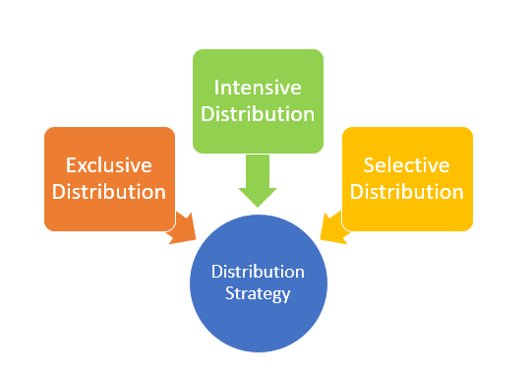

In a marketing plan, distribution strategy should be such that it can reach to maximum number of customers at a minimum or optimal cost. A good distribution strategy can maximize revenue while a bad distribution strategy can destroy a marketing plan. Distribution strategy should be updated time to time through demand analysis and supply analysis so that it can adapt to the current marketing situation.

Marketing Communication Strategy

Picture 5: Head office of Diamond Insulation Products
Marketing communications strategy defines the entire range of activities you will do to market your products. This includes everything from paid marketing to media relations (PR). Any large company’s marketing plan will have several campaigns on multiple channels simultaneously. DIP has some Unique Selling Propositions (USP) for example their imported raw materials are industry best, their products have accurate size and weight and more importantly their pricing is very competitive.
It is the strategy used by a firm to reach its target customer through various communication methods. Message (what is to be said), medium (where it is to be said) and target (to whom the message is reaching) are the 3 core parts of communication. Marketing communication strategy consists of three guiding principles
Brand alignment: it refers to marketing channel should have same perception as company. For example the seller of luxury watches should build relationships with journalists from time magazine.
Customer alignment: It refers to following the rule, be there where customers already are. A company should select channels where customers are active.
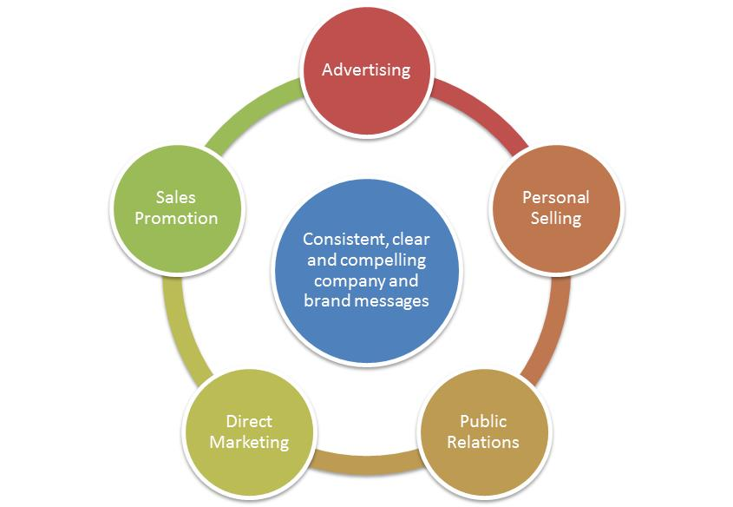
Budget alignment: it refers to selecting channels that support our budget.
A large company like DIP has several channels and multiple campaigns simultaneously. Combination of all these channels formulates marketing mix. Channels are PPC, Social media, TV, advertising, print, radio etc.

Their marketing mix include
Online advertising on Facebook, Google etc.
Offline advertising on print media, billboards or TV,
Direct marketing,
Personal selling,
Sponsorships,
DIP brands their product in following ways
Website
Business Card
Participating business fair
Advertising campaign
Direct marketing campaigns
Social platforms

Marketing Research
Most organization will benefit from basic level of marketing research. Even if it doesn’t provide new information it will tell what’s exists.
Market research refers way of gaining information about current market. Preferably, this is precise information regarding target market and the key points that influence customers buying decisions. It can be casual and limited in scope and, although it may not be “statistically significant” research, it can still be valuable. The value and “degree of fit” may be based on the quality, cost, or the amount of time to acquire the information using these practical market research tools. Determine what form of market research is going to work best for you. Make that decision based on the value you will receive, versus the time and other resources you need to invest to gain access to that information.
Market research is often confused with an elaborate process conducted by a third party that takes a tremendous amount of time and money. It may be report to take a different perspective on what market research is and how it is conducted.

Primary Market Research
Primary market research is research that you conduct yourself, rather than information that you find already published. Primary market research may result from you having direct contact with your customers or the public. This may be through the following types of information gathering.
- Focus groups gather a small group of people together for a discussion with an assigned leader.
- Customer surveys
  - Existing customers
  - Potential customers
- Your competition
  - Solutions
  - Technologies
  - Niches

Secondary Market Research
Market research may also come from secondary sources. This is information others have acquired and already published which you may find relevant. Access to this secondary market research data may be yours for the asking and cost you only an email, letter, phone call, or perhaps a nominal fee for copying and postage. Much of it is entirely free. Much of it is available to search on the Internet.

Using research, they are identifying the specific features and benefits of the target market segment values. Feedback from the market tests, surveys, and focus groups is helping them to develop its products. They are also measuring and analyzing customer’s attitude towards competing brands and products. Brand awareness research will help them to determine the effectiveness and efficiency of their messages and media. In future they will use customer satisfaction studies to gauge market reaction.

Action Program
In Bangladesh January, February, March and April are considered as the peak season for farmers. Because crops are cut down. Also vegetables and fruits are grown in large quantity. So Cold storage is needed to store this vast amount of Crops, Vegetables and fruits. EPS is one of the major component in a cold storage because EPS seals the cold storage and make it air tight. There is thousands of cold storage in Bangladesh. So being a market leader, their first priority is to fulfill the huge demand of this cold storage and also provide them products in time. Their marketing teams will various cold storages throughout the country showcase their products and features and bring orders.
The 2nd quarter i.e. May, June, July; August is regarded as summer season in Bangladesh. In this time of the year the demand of Electronics based products particularly AC and Refrigerator increases. For packaging purpose EPS based products are needed in high quantity. So DIP will focus on fulfilling the demands of these Electronics manufacturers. Their marketing team will focus on Local and Global electronics manufacturers and bring orders from them.
The 3rd quarter of the year the demand of the EPS products rises because of fish export and battery packaging. Already there are lot of fish export companies use DIP’s fish box. The focus of the marketing team will be bringing in more and more new companies.

Budgeting
It’s a difficult process. Most of the companies estimate, base their budget in terms of last year expense. If any company can clearly define their major campaigns and needs they can have q better outcome. Using ROI can also help appropriate budget for marketing plan. Lack of proper budgeting and cost may cause failure to marketing plan. While insufficient funding for such items as equipment or staffing may immediately come to mind when budgeting for the whole business, it’s the lack of a properly constructed marketing budget that creates problems in many marketing plans and campaigns. A marketing budget is the marketing plan based on cost. It confirmes that your marketing plan or campaign is realistic not unrealistic. Some pre-budget research into existing industry and market, competitors and business’s historical marketing activities and statistical data helps marketing managers make a more proper marketing budget. A company should cost out all general marketing and marketing communications expenses you. Marketing department should work in line with accounting department to create a realistic and competitive marketing budget.

Estimated budget- $17,155
Estimated spending on different aspects:
National marketing (Banner ads)- $4000 (23%)
Local Marketing (Newspaper and in store marketing)- $2000(12%)
Public Relations (Sponsorship and Client events)-$2300(13%)
Social Media (Twetter,Facebook and Instagram)-$1825(11%)
Online (Website and Mobile App)-$1300(8%)
Advertising (Online and Print)-$1800(10%)
Market Research (Surveys)-$1800(10%)
Sales Campaigns (Campaign A, Campaign B)-$1000(6%)
Other (Corporate Branding and Business Cards)-$1230(7%)

Controls
To capitalize the maximum profit on a marketing plan, there need to be strict controls in every step. As a marketing plan moves along, the controls are constantly examined to determine how the plan's actual performance compares to the projections. Any changes that need to be made done in accordance with the current marketing situation. Understanding what the control is in a marketing plan is will help to formulate effective performance measurement indicators. Control involves t measurement, evaluation, and monitoring. Resources are limited and costly so it is important to control marketing plans. Setting standards is mandatory in control process. Then actual performance is compared against the standard performance. It is generally done by marketing manager. Corrective action (if any) is then taken.

In DIP’s marketing plan all of the marketing activities will be controlled tightly. The activities will be checked each month to see if it’s complementing the Company’s actual objective. If any adjustment is required it will be done accordingly. As there are some vulnerable facts for example tax policies of government, if there is sudden increase in costing they have to inform the customers about re-quotation.

Picture 6: Arial view of Diamond Insulation Products factory

Conclusion and Recommendations
Marketing plan aims to develop products and services required by target customers. A good marketing plan helps to create customer understandings, why someone product is superior than others.it also helps to reach target audience, boost customer base and ultimately enhance sell and profits. The marketing plan of Diamond Insulation Product is top notch. My recommendation would be set up diverse and skilled marketing teams to implement this plan perfectly.

References
Website
- http://www.diamondeps.com/
- http://advanced-bd.com/company-profile/
- https://www.bdtradeinfo.com/yellowpages/des_data.php?subcategory_id=931
- https://insulationcorp.com/eps/
- http://www.fairinsulationtechnology.com/
- http://shimueps.com/
Books
- Principles Of Marketing,13th Edition ,Kotlar-Armstrong
- International Marketing,15th Edition, Philip R. Cateora-Mary C. Gilly-John L. Graham
- Strategic Marketing,10th Edition, David W. Cravens-Nigel F. piercy

