Internship Report
On
HR Activities of City Bank Ltd

Submitted To
Farhana Rashid
Assistant Professor
School of Business and Economics
United International University

Submitted By
Afrina Haque
ID-111 131 113
BBA Program, School of Business and Economics
United International University


UNITED INTERNATIONAL UNIVERSITY

Date of Submission: 21th October, 2018

Letter of Transmittal

Date: 21th October, 2018
To
Farhana Rashid
Assistant Professor
School of Business and Economics
United International University
Subject: Submission of Internship Report on HR Activities of City Bank Ltd.
Dear Madam,
Here is my internship report on HR Activities of City Bank Ltd. It gives me enormous pleasure to submit my internship report title as “HR Activities on City Bank Ltd.”, that is required for graduation from the BBA program of United International University. I have thoroughly enjoyed in preparing this internship report which has contributed significantly to my understanding on the essentials and importance of practical knowledge. I have tried to follow your guidelines to complete this report with my practical experience. Also, thanks to my organizational supervisor Mr. Saiful Islam (Deputy Manager, City Bank Ltd.) for cooperating and suggesting to make this comprehensive report.
Thanking for your time and kind consideration. If you have any further query I would be very pleased to clarify that.
Sincerely yours,
.......................
Afrina Haque
ID-111 131 113
BBA Program, School of Business and Economics
United International University

Acknowledgement

At first, I like to thank Almighty Allah the supreme ruler of the universe, who created me and making me able to complete my internship and graduation. Then I also thanks to my University supervisor Ms. Farhana Rashid, Assistant Professor of the United International University for her valued guidance and suggestions for finishing the internship program successfully. I would also thank the Human Resource Department of the City Bank Limited for giving me the opportunity to complete the internship with them.
My heartfelt thanks to my supervisor Mr. Saiful Alam, Deputy Manager, The City Bank Limited for his guidance and inspiration for this report and he also helped me to learn so may new things. Without his support I was unable to prepare the report.

Lastly, I would also like to thank to my co-workers Mr. Mahbub Alam, Ms. Nusrat Nipa, Ms. Ayesha Humaira Ahmed, Ms. Narija Khaled for supporting me, helped me to learn official procedures and making my internship life more enjoying and memorable.

Abstract

This report is based on internship program. The main objective of this report is human resource activities of the City Bank Limited (CBL). City Bank is one of the fastest growing commercial banks in Bangladesh. I had a great experience working with them. They are established a central banking system. Recently they are updating their mission, vision, goals and values. The report is discussed human resource activities of City Bank Limited. The report is categorized in 7 (seven) sections. First section is about objective, scope, mission, vision, methodology and limitations. The second section is discussed about company profile of CBL. The third section is discussed about theoretical practices of human resource management. The forth section is discussed about the human resource practices in City Bank Limited. The fifth section is discussed about the experiences and skills that I have gained through the whole internship program. The sixth section is discussed about the findings and analysis and the seventh section is discussed about recommendation and conclusion.

Keyword: Discussed, Limitations, Discussed, Experiences.

Table of Contents
Title | Page No
CHAPTER – 01
Introduction | 1
1.1 Introduction | 2
1.2 Origin of the Report | 2
1.3 Interpretation of the Study | 2
1.4 Background of the Study | 3
1.5 Problem that I Find | 3
1.6 Objectives of The Report | 3
1.7 Methodology | 3
1.8 Types of Research | 4
1.9 Research Design | 4
1.10 Data Collection | 4
1.11 Data Analysis and Presentation | 4
1.12 Limitation of the Study | 5
1.13 Limitation of time | 5-6
CHAPTER – 02
Overview of the City Bank Limited | 7
2.1 Overview of the City Bank Limited | 8
2.2 The Vision of the Bank | 15
2.3 The Mission of the Bank | 15
2.4 Motive and target of CBL | 15
2.5 City Bank Limited associated culture | 16
2.6 Standard of City Bank Limited | 16
2.7 Organizational Structure | 16
2.8 Board of Directors | 17
2.9 Executive Committee | 18
2.10 Departments of the City Bank Limited | 19
2.11 Employee of the City Bank Limited | 19
2.12 Job Grads of the City Bank Limited | 120
2.13 Management Team | 21
2.14 Products and services of City Bank Limited | 22
2.15 Loan Section | 22
2.16 Card Section | 27
2.17 Islamic Banking | 28
2.18 Digital Banking | 28
2.19 Awsards and Achievements | 29-30
CHAPTER – 03
Theoretical Analysis of City Bank Limited | 31
3.1 Theoretical Analysis of Human Resource Management | 32
3.1.1 Definition of Human Resource Practices | 32
3.1.2 Recruitment | 32
3.1.3 Selection | 33
3.1.4 Training | 34
3.1.5 Development | 34
3.1.6 Performance Appraisal | 35
3.1.7 Compensation management | 36
3.1.8 Change management | 37
3.1.9 Human Resource Planning | 37
3.1.10 Reward System | 38
CHAPTER – 04
Human Resource Practices in City Bank Limited | 39
4.1 Human Resource Practices in City Bank Limited | 40
4.2 Recruitment and Selection Process of City Bank Limited | 40
4.3 Factors and Ways of Recruitment and Selection Procedure | 43
4.4 The Procedure of Selection | 44
4.5 Recruitment Policy | 48
4.6 Administration | 50
4.7 Promotion | 51
4.8 The Probation and Confirmation Terms | 52
4.9 Resignation and Termination | 52
4.10 Pay and Benefits Package | 53
4.11 Performance Appraisal System at City Bank Limited | 54
4.12 Performance Appraisal Process | 54
4.13 Purposes of Performance Appraisal | 54
4.14 Methods of Measuring Employee Performance | 55
4.15 Compensation Management | 55
4.16 Employee Relation | 56
4.17 Incentive | 56
4.18 SWAT Analysis | 57-58
CHAPTER – 5
Internship Experience | 59
5.1 Internship Experience | 60
5.1.1 My Contribution | 60
5.1.2 Efficiency I have gained | 60
5.1.3 Interaction with supervisor and co-worker | 61
5.1.4 Acceptations versus reality | 61
5.1.5 Part of my future career | 62
5.1.6 Fellows | 62
5.1.7 Atmosphere of the bank | 62-63
CHAPTER- 6
Findings and Analysis | 64
6.1 Findings and Analysis | 65
6.1.1 Positive findings | 65
6.1.2 Negative findings | 65
CHAPTER - 7
Recommendation and Conclusion | 66
7.1 Recommendation and Conclusion | 67
7.1.1 Recommendation | 67
7.1.2 Conclusion | 68
References | 69
Appendix | 71-78

CHAPTER – 01
Introduction

1.1 Introduction
An Internship is an essential part of BBA program. It helps to gain our practical working experiences. It is an effective component to apply the academic knowledge in a real working environment. It also helps the fresh graduates to achieve little experiences and that helps in the permanent job. I as an about to graduate was fortunate to work at City Bank Limited in the HR department which is the area of concentration. This internship gave me an opportunity to work with the HR department of City Bank Limited and also gave an idea about HR activities. My organizational supervisor Mr. Mahmud un Nabi who is the deputy manager of HR department help me a lot to know about the recruitment and selection process of City Bank Limited. I have learned how to arrange the interview session, how to keep records of the interviewee, coordinate the interview programs and choose the best candidates along with the applicants.

1.2 Origin of the Report
I have conducted the report to fulfill the partial requirement of BBA program. And also give an overview of City Bank Limited based on my work experience. The origins of the reports are:
- To analyze the human resource activities of City Bank Limited
- To understand the recruitment, training, and selection process of City Bank Limited
- To make the recommendation to solve the problems faced by City Bank Limited on its overall activities.

1.3 Interpretation of the Study
Knowledge and learning become perfect when it is associated with theory and practice. A Practical application makes theoretical knowledge more perfect. As our system is text-based so internship plays an important role because it makes a bridge between theoretical knowledge and practical experience. So, universities arrange internship programs. United International University is one of the universities who arrange internship programs for students. By this programs universities, students and also the organization gets benefits. So, internship programs play an important role in BBA program.

1.4 Background of the Study
I worked as an intern at city bank limited. I have made a report on the selection and recruitment process of City Bank Limited. This report explains about the objective and nature of City Bank Limited. Recruitment and selection process is successfully managed and maintained the Human Resource Management division of City Bank Limited. I have the report by visiting the HR department and also with the help of available information.

1.5 Problem that I Find
A good HR practice could bring a healthy environment because it is a backbone of an organization. Without a HR practice a company cannot become successful in the industry. With the help of HR employee would positively express their affection towards the company.HR brings a healthy environment in the company. So, HR policy becomes a strategy for every company.
1.6 Objectives of The Report
The broad objective of the report is to provide overall Human Resource Management Practices of the City Bank Limited and also doing a comparative analysis about the recruiting and selection process of City Bank Limited. And also want to know about how they focusing on fresh employee and job training. The objectives of the report are:
- Provide a company overview.
- To highlight the organizations recruiting training and selection process.
- To find-out strong points and flaws involved in HRM Practices of the City Bank Limited.
- To analyze the market overview where I tried to find out the turnover situation and actual growth of City Bank Limited.
- To recommend the necessary steps to overcome the Problems and make possible solutions in the future.

1.7 Methodology
Research is an organized method of the finding solutions to problems. According to Woody- research comprises of defining and redefining the problem, formulating hypothesis or suggested solutions, collecting data, reaching conclusion, testing conclusion to determine whether they fit the formulated hypothesis. The type of method used in this report is mainly of an expressive nature. To meet the objectives of the study, I realized that a single method would not be effective for preparing the report. Formal & oral discussion, direct observation, and printed papers of the Bank were found useful for preparing the report. Both primary and secondary sources played an effective role for preparing the report.

1.8 Types of Research
The report was prepared on human resource practices of City Bank Limited. I have followed two methodologies. I have collected information in two ways. This report is prepared with qualitative data.

1.9 Research Design
The report is an exploratory research about recruitment and selection process of City Bank Limited. I have gathered information by personal interview and also verbally discussed with them. I have collected information through the annual report of 2017, bank article, journal, manuals etc.

1.10 Data Collection
Data collected through face to face interview with the employees of HR department of City Bank Limited. I also collected information from the interviewee for in-depth analysis. Of information. They share their thoughts and ideas which helped me a lot. I faced some drawbacks when certain executives are reluctant to disclose specific information due to their confidentiality.
The sources of data collection:
- Practical experience while working in the bank.
- Gathered information through discussion with the employees of the City Bank limited.
- Personal Observation in the bank.
- Through the annual report, publications and training materials.
- Through checking periodical statements of the bank, brochures, journals, booklets etc.
- Visiting official Website of the City Bank Ltd.
- Analyzing documentary file of the City Bank Ltd.
- File study in the Human Resource Division

1.11 Data Analysis and Presentation
- Collected information has processed through data processing software.
- Thorough analysis, working variable future projection and working definitions are combined in the report.
- Presented information are the existing practices of human resource management of City Bank Limited.

1.12 Limitation of the Study
Human Resource Department is the most confidential & trustworthy department for any organization in the City Bank Limited. Here as an intern, I was allowed to get limited information for my study because the executives are reluctant to give information. I am not allowed to get the information which are too much confidential for the Bank. So I get all the information I have learned from my Work and that’s the way I prepared the report. The limitations are given below:

1.13 Limitation of time
Because there are lots of working pressure in the branch so that. I faced problems due to collecting information.

1.13.1 Data insufficiency
Because of the shortage of time, all information is not possible to collect.

1.13.2 Lack of records
Insufficient books, publications, facts, and figures narrowed the scope of analysis.



CHAPTER – 02
Overview of the City Bank Limited

2.1 Overview of the City Bank Limited
2.1.1 Historical Background of City Bank Limited
The city bank is known as full scheduled commercial bank and it has local as well as an international share holder. City Bank started its journey on the 4th of July 2001 with a vision to be the absolute market leader. The City Bank is a commercial bank extending a full range of banking facilities. It intends to set standards as the absolute market leader by providing efficient, friendly and modern fully automated online service which is on a profitable basis. The City Bank is reputed through its unique and competitive products and it also become famous for its online banking facilities.
The bank is mainly maintained by privatize bank in Bangladesh-The City Bank ltd. The city Bank is currently looking for impressive goal oriented and individuals for various business operation. It has positioned itself as a new generation Bank with a focus to meet diverse financial need a growing and developing economy.
City Bank wants to build a profitable and socially responsible financial institution. The bank has assigned with a stated policy to promote broad-based participation in the exile economy all the way through the provision of high-quality banking service based on information technology. The bank will ensure this by increasing access to economic opportunities for all individuals and businesses in Bangladesh with a special focus on currently under served enterprises and households across the rural-urban area. We believe that growing the ability of underserved individuals and enterprises to build their asset will increase the economic well-being for all Bangladesh.
The City bank focus on under-served enterprises across the urban area. The bank focused on association-based Banking, as it considers that the quest of profit and developmental goals are mutually reinforcing. This focus makes the bank to emphasize more on to explore and access market opportunities as well as build an asset base to its Bank clients and that brings profit for them.

2.1.2 Organizational Overview of City Bank Limited
City Bank is one of the oldest private commercial banks operating in Bangladesh The City Bank Limited, with institutional shareholdings by International Finance Corporation (IFC) and Shore cap International, has been the fastest growing Bank in 2016and 2017.sponsored directors commenced the journey with 3.4 crore worth of capital which has now bring 330.77 crore as capital and reserve. And at the year-end of 2017, The City Bank ltd .had recorded a 204 percent growth in assets, and a 67 percent growth in liabilities, and has made operating profit of 130 percent.
A fully active profitmaking bank, The City Bank ltd emphases on pursuing unexplored market niches in the Small and Medium Enterprise Business. In the last four years of operation, the Bank has disbursed over BDT 1300 crore in loans to nearly 32,000 small and medium entrepreneurs which brought a huge profit for them. The management of the Bank believes that this sector of the economy can contribute the most to the rapid generation of employment in our Bangladesh. City Bank is among the very few local banks which do not follow the traditional, decentralized, geographically managed and branch-based business or profit.

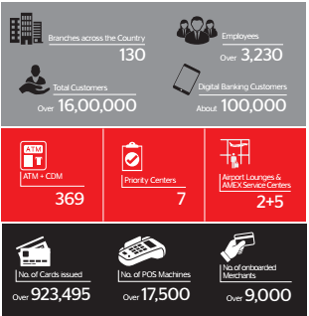

At a glance the financial condition of City Bank Limited.

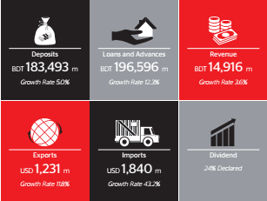

At a glance the financial condition of City Bank Limited

2.1.3 Company Profile

The City Bank is a Bangladeshi private commercial bank which is operating throughout Bangladesh. The City Bank Limited, has institutional shareholdings by International Finance Corporation (IFC) and Shore cap International, has been the fastest growing Bank in Bangladesh. The Bank operates under a “double bottom line” agenda where profit and social responsibility are the main mottoes. The services provided by city bank are customer service, loans, credit cards, debit cards, LC, dollar endorse, money link, account opening, cash withdraw and deposit, foreign currency etc. A fully operational Moneymaking Bank, The City Bank ltd efforts on pursuing new market niches in the Small and Medium Enterprise Business. In the last six years of operation, the Bank has expended over BDT 7500 crore in loans to approximately 200,000 small and medium entrepreneurs. The management of the Bank believes that this sector of the economy can contribute the most to the rapid generation of employment in Bangladesh and it will solve our unemployment problem as well. The Bank’s footprint has grown to 83 branches, 40 SME Service Centers, 429 SME unit offices and 132 ATM sites across the country, and the customer base has expanded to 465,000 deposit and 187,000 advance accounts. In the years ahead, The City Bank ltdanticipates to familiarize many more services and products as well as add a broader network of SME unit offices, Retail Branches and ATMs across the country.
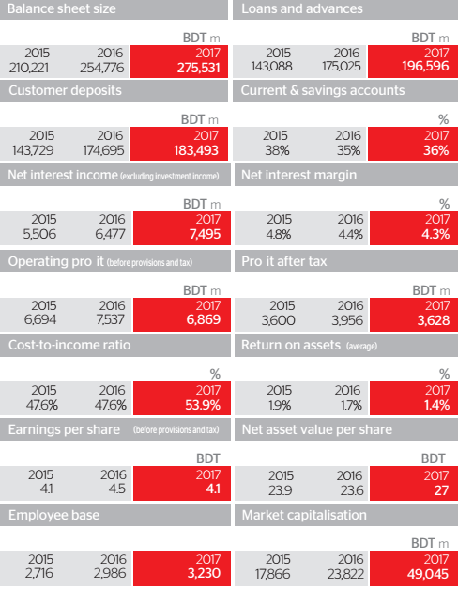

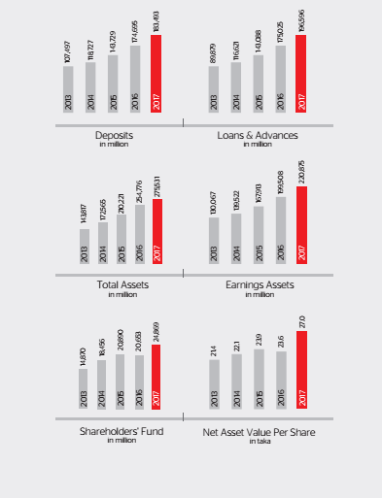

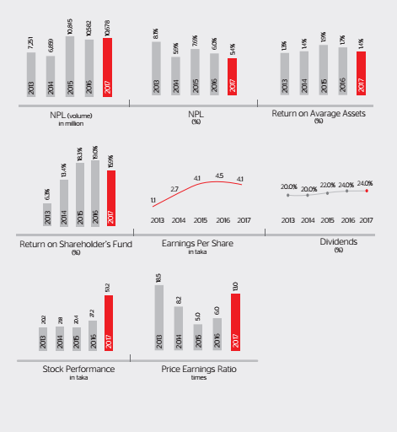

2.2 The Vision of the Bank
To be the top Bank in the country with the best performs and highest social commitment.

2.3 The Mission of the Bank
- To grab the position of the second largest bank in Bangladesh.
- Recruit the best from the applicants who can be a good resource for the bank
- Motivate the employees by giving attractive salary and wages payments.
- Controlling and monitoring the employees by using both X & Y motivation theories.
- Continuous progression in ‘Small & Medium Enterprise’ sector.
- Manage and regulator the organizational interactions and responsibilities.

2.4 Motive and target of CBL
City Bank Limited not only focusing on making money but also keep the social commitments. They strongly make cooperation’s with businessmen, industrialists, and others. The motives of CBL are given below:
- On an average achieve 20% return on shareholders’ equity
- To become the market leader in product improvement.
- To be one of the three financial institutions in Bangladesh.
- To achieve positive economic added value each year.

SLOGAN OF THE BANK
“MAKING SENSE OF MONEY”

2.5 City Bank Limited associated culture
In City Bank Limited they have some corporate cultures:
- Clients come first
- Rapid decision making
- Encourage creativity of employees
- Search for professional experience
- To maintain professional ethics
- To create flexibility and prompt response

2.6 Standard of City Bank Limited
- Accountable and transparent
- Focused on customer delight
- Engaged and inspired

2.7 Organizational Structure
The Managing Director is also a member of the board of City Bank Limited. The board of directors is the top management and policy-making committee of The City Bank Limited. Presently the board consists of a chairman and board of directors.
The directors who have shown their capacity in the field of finance and banking, trade, commerce, industry is appointed for board of directors.
The chief operations officer executes all the banking activities under the directions of the board. Recruitment committee of Human resource Division appoints the officer and other line and staff personnel.

Organogram
Shareholders

Board of Directors
Chief
Advisor
Audit
Committee
Executive
Committee
Managing Directors

Company
Secretary
Deputy Managing Directors

Marketing, Developing & General Banking
General Services
Credit
Audit & Inspection
Central Accounts

Human Resources
Research & Planning
IT
International
Treasury & Money Market

Board Secretariat & Share
Cost Control
Law & Recovery
Card Cell

2.8 Board of Directors
NAME | POSITION
Mr. Mohammed Shoeb | Chairman
Mrs. Tabassum Kaiser | Vice-Chairperson
Mr. Deen Mohammad | Director
Mr. Aziz Al Kaiser | Director
Mr. Rubel Aziz | Director
Mr. Hossain Mehmood | Nominated Director
Mr. Hossain Khaled | Director
Mr. Rajibul Huq Chowdhury | Director
Mrs. SyedaShaireen Aziz | Director
Mr. Rafiqul Islam Khan | Director
Mrs. Savera H. Mahmood | Nominated Director
Mr. K.M. Tanjib-Ul Alam | Independent Director
Mr. Farooq Sobhan | Independent Director
Mr. Md. Kafi Khan | Secretary

2.9 Executive Committee

NAME | POSITION
Mr. Deen Mohammad | Director
Mr. Aziz Al Kaiser | Director
Mr. Rubel Aziz | Director
Mr. Hossain Mehmood | Nominated Director
Mr. Hossain Khaled | Director
Mr. Rajibul Huq Chowdhury | Director

2.10 Departments of the City Bank Limited
In three different criteria City Bank has 26 departments:
The Departments are-
- Business
- Support
- Operations

2.11 Employee of the City Bank Limited
The city bank has a huge number of employees working all over the branches of Bangladesh. There are different types of employees working at City Bank Limited.

2.11.1 Management Trainee Officer
Highly qualified students are selected as management trainee officer. The MTO’s are a permanent employee but they have to study as a student inside BRAB Bank for the period of one year. They have to also give exams, give presentation. After one year if they can complete their learning period efficaciously, then they will become a senior officer directly from the MTO. And their job will be fixed in the City Bank Limited.

2.11.2 Regular Employee
The regular employees are known as permanent staff. The regular employees are allowed to get the bonus, incentives, rewards, festive bonus and other allowances with their basic salaries. They also get extra facilities giving by the City Bank Limited.

2.11.3 HR Stuff
HR stuff are those employees who have to work under the direct supervision of the Bank’s authority, whose performance is monitored by the Bank Management. Of City Bank Limited. They look after the overall employee of City Bank Limited.

2.11.4 Outsource Stuff
The employees who recruit through outsource agencies is known as outsourcing staff. Other contractual employees are not permitted to any service contract. The requirement of any support staff through outsource agency must come through HR signed by the Division Head of human resource will send the requirement to provide staff by the Outsource Agency.
2.11.5 Intern
Interns are one kind of employee in City Bank Limited. To boost and help human resource development in the financial industry, the Bank may decide to offer internship programs to individuals or educational institutions. Interns learn a lot of banking activities. Their internship period is 3 months. They hire by the MD& CEO of the Department Head.

2.12 Job Grads of the City Bank Limited
The Job Grades of regular employee of The City Bank Limited are as follows:
- Deputy Managing Director (DMD)
- Executive Vice President (EVP)
- Senior Vice President (SVP)
- Vice President (VP)
- Senior Assistant Vice President(SAVP)
- First Assistant Vice President
- Assistant Vice President
- Senior Principal Officer (SPO)
- Principal Officer (PO)
- Senior Officer (SO)
- Management Trainee Officer (Direct Recruit)
- Officer Grade II
- Officer Grade I

2.13 Management Team
Management team of the City Bank includes the following positions and each position contains one member.
Managing Director & CEO

Chief Information Officer

Head of Credit

Company Secretary & Head of Regulatory & Internal Control

Head of Credit

Head of Probashi Banking

Head of Human Resource Management

Head of Treasury & Financial Institution

Chief Financial Officer

Head of Retail Banking

Head of Enterprise Risk Management

Head of Corporate Banking

2.14 Products and services of City Bank Limited
2.14.1 Retail Banking
Current Account
Eligibility: At least 18 years old
Nationality: Bangladeshi
Features: City touch, SMS alert, call center facility.
Locker facility
Debit card facility
City max card for easy shopping
Fund transfer facilities
Online banking service
General Savings Account
Each and every individual maintains a personal savings personal savings account for the purpose of maintaining financial needs.
Eligibility: At least 18 years old
Nationality: Bangladeshi
Features:
Cheque book facility
Online banking facility
Debit card facility
Utility payment service through cards
City touch, SMS alert, call center service
High-value Savings Account
Eligibility: At least 18 years old
Nationality: Bangladeshi
Interest rate:3.75%
Features:
Interest on daily balance
Cheque book facility
Safe deposit locker facility
Online banking service
Collection of cheques through the clearing house

Newborn Deposit Account
The Deposit account is the account whose parents wish to deposit money for the safety of their children.
Features:
Age: from the day of birth until the baby turns six
Nationality: Bangladeshi
Interest rate:2.50%
Features:
Half yearly interest payment
Insurance coverage
Auto installment transfer facility to the DPS account
Flexibility to choose the installment date

Student’s Savings Account
City Bank Limited has introduced student’s savings account for students who are below 18 years old. They arrange it for the development of their career.
Eligibility: Below 18 years old
Birth certificate
Nationality: Bangladeshi
Interest rate:4.50%
Features:
No maintenance fees
Free passport Endorsement
Free SMS alert
Term deposit account

2.14.2 General DPS Account
General DPS account is a product in small installments that secures individuals financial future.
Eligibility: At least 18 years old
Nationality: Bangladeshi
Features:
No initial deposit required
Installment range 500 to 50000 per month
Loan facility on deposited account
Choosing of installment date

2.14.3 Fixed Deposit Account
Individuals who believe in long-term investments and want a higher interest they purchase the fixed deposit account.
Eligibility: At least 18 years old
Nationality: Bangladeshi
Features:
They get the loan facility
Encashment facility
Opportunity for choosing the duration
Foreign currency account

2.14.4 FCY Account
This account is a non-interest account has an attractive feature to make the foreign transaction more convenient.
Eligibility: At least 18 years old
The people who are non-resident Bangladeshi or the Bangladeshi nationals working with foreign companies whose salary comes as foreign currency.
Features:
Credit salaries paid in foreign currency
Open in the form of USD, GBP,EURO
Checking regular transactional account
Disburse salary in foreign currency

2.14.5 RFCD Account
Resident Bangladeshi nationals open this account with foreign currency brought in at the time of return from travel.
Eligibility: At least 18 years old
Nationality: Bangladeshi
Features:
Convertible to local currency
Purchase airline tickets
Purchase books from abroad
2.15 Loan Section
Personal Loan
City Bank gives personal loans to solve all requirement of an individual and to fulfill their dream.
Eligibility: Age: 22 to 60 years
A salaried executive must get 15,000 taka salary
Professional must get 30,000 taka salary
A Businessman must have 30000 taka each month
Features:
Loan tenor 12 to 60 month
No hidden charges
The Interest rate is favorable.
Home Loan
This loan is given for home purpose and by getting this loan their wish to have an own home come true.
Eligibility: Age: 22 to 65 years old
Salaried would have a minimum income of 40000
Features:
Loan range 5 lac to 1.2 crore
Settlement facility
No hidden charge
Loan against property
Tenor 1 year to 25 years

There are some other products like:
- City Foreign Exchange
- Non-funded business like-
- Medical file
- Student file

Here is the online City touch Application Form, the customers can operate their accounts online.



2.16 CARD SECTION
VISA DEBIT CARD
It is a hassle-free and safe card.
Eligibility:
Individual must have to maintain an account with CBL. There is a form which will the individual have to fill up. Then with the shortest period of time, the individual will get the visa card.

Features:
Pin change
Mini statement
Balance inquiry
Hassle free shopping
Get discounts

THE CITY MAX CARD
It is a very popular card of CBL. By this card, the individuals get 5% cashback in shopping. It is a unique card. Some super shops offer buy one get one opportunity. This opportunity is only applicable for citymax card user. And also using citymax individuals get the opportunity to use the free lounge in airports.

There are some term and conditions
Cash back facility is not applicable for ATM transactions and using the card in abroad.
Cashback shall be credited to individual’s bank account every quarter.
Credit cards are:

American Express Cards
Visa Platinum card
Visa Gold Local
Visa Classic Local
Credit Card Customer Service

Different Cards of City Bank Limited




2.17 Islamic Banking
There are some products that offer by CBL for Islamic purpose
- Manarah current account
- Manarah savings account
- Manarah monthly deposit scheme
- Manarah hajj deposit scheme
- Manarah auto loan and finance

2.18 Digital Banking
- City Touch
- I Banking

2.19 Awards and Achievements
City Bank had awards for its available service to customers. It has attained lots of awards for its products. Also. It has reached “THE ASIAN BANKER STRONGEST BANK IN BANGLADESH.”

It has also owned “ASIAN BANKER LEADERSHIP ACHIEVEMENT”.

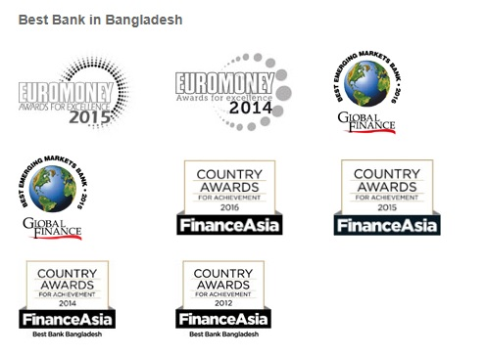

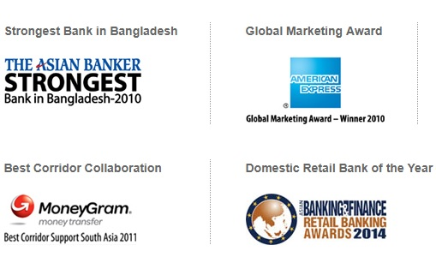

CHAPTER – 03
Theoretical Analysis of City Bank Limited

3.1 Theoretical Analysis of Human Resource Management
3.1.1 Definition of Human Resource Practices
Human resource management: human resource management is a critical component of employee well-being in any business. HR functions are payroll, benefits, hiring, firing and keeping the employee. Human resource management is a function of management concerned with hiring, motivating, and maintaining people in an organization. According to Edwin Flippo “human resource management is the planning, creating, directing, regulatory of the procurement, development, compensation, combination, maintenance, and separation of human resources to the end that individual, organizational, and social objectives are accomplished. According to DeCenzo and Stephen P. Robbins “human resource management is thoughtful with the people dimension in management”
According to Mathis and Jacsion “human resource management is the strategic and operational management of activities focusing on the human resources in an organization.” HRM can be defined as consisting of the following elements of traditional personnel administration personnel development, a specific management philosophy that values labor as a major asset of an organization and that regards strategic management. Human resource management is a staff management system in which workers are seen as a resource that needs to be controlled to achieve the highest profit and a competitive advantage.

3.1.2 Recruitment
According to Edwin Flippo” it is a process of probing for prospective employee and motivating and inspiring them to apply for jobs in an organization.” He says, Recruitment is often termed positive in that it stimulates people to apply for jobs, to increase the hiring ratio the number of applicants for a job. Recruitment is the activity that links the employers and job seekers. A process of discovery and attracting capable applicants for employment. Recruitment is searching and obtaining applicants for jobs from among available recruits. Recruitment involves attracting and finding as many applicants as possible from qualified job seekers. Recruitment means a process of finding and attracting skilled applicants for employment. The process begins when new recruits and sought and ends when their applicants are submitted. The result is a pool of applicants from which new employees are carefully chosen. It is the process of discovering sources of manpower to meet the recruitment of manpower to meet the recruitment of staffing schedule and to employ the effective measures and the effective selection of an efficient working force.

3.1.3 Selection
The process of interviewing and assessing candidates for a specific job and choosing an individual for employment based on certain criteria. Employee selection can range from a very simple process to a very intricate process depending on the firm hiring and the position. The process of making a hire or no hire decision regarding each applicant for a job and selection can be defined as the process of selecting the exact person for the right job. The process of interviewing and assessing the candidates for a specific job and picking an individual for employment based on certain criteria.
The Selection process is a series of definite steps used to select which recruits should be hired. Selection is a process by which an organization chooses from a list of applicants the person or persons who best meet the selection criteria for the positions available considering the current environmental condition.

Selection Tests

Personality Tests
Ability Tests

- Interest Tests
- Personality Tests
- Projective Tests
- Attitude Tests
- Aptitude Tests
- Achievement Tests
- Intelligence Tests
- Judgment Tests

3.1.4 Training
Training is a method of learning a sequence of programmed behavior. It helps to bring positive changes to employees, they change their skills and attitude of employees. It is an application of knowledge and gives an awareness of rules and procedure to guide their behavior. Training means any attempt to improve employee performance on a currently held job or one related to it. Training refers to the method used to give new or present employees the skills they need to perform their jobs, it is the act of increasing the knowledge and skills of an employee for a particular job. Training is an organization planned effort to facilitate employees learning of job-related competencies. Training is the process of planned programs and actions undertaken for the improvement of employee’s performance in terms of his approach, skills, knowledge, and conduct. And training is a systematic process through which an organization’s human resources gain knowledge, develop skill through practical activities that improve corporate performance.

Methods of Training

On-the-Job Training Methods
- Job rotation
- Coaching
- Job instruction
- Committee assignments
- Internship training

On-the-Job Training Methods
- Case study method
- Incident method
- Role play
- In basket method
- Business game
- Grid training
- Lectures
- Simulation
- Management education
- Conferences
o

3.1.5 Development
Development means formal education, job experience, relationships, assessments, of personality and abilities that help employees to prepare for their future. Conferring to Griffin “Development denotes to teaching managers and professionals the skill needed for both current and future jobs.
Employee developments methods are
- Job rotation
- Committee assignment
- Lecture courses and seminar

Importance of Training
- Maintains qualified products/services
- Achieves high service standards
- Provides information for newcomers
- Refreshes the memory of old employees
- Achieves learning about new things; technology, product/service delivery
- Reduces mistakes – minimizing costs
- Opportunity for staff to feedback/suggest improvements
- Improves communication & relationships – better teamwork.

3.1.6 Performance Appraisal
A performance appraisal is a systematic, general, and periodic process that monitors an individual’s job performance and productivity in relation to certain pre-established culture and organizational objective. According to Newstrom “it is a process of assessing the performance of employees sharing that information with them and examining for ways to develop their performance.” Performance appraisal is that system in which management finds out how effective it has been at hiring and placing employees. The performance is a process of evaluating employees’ performance. Performance management is a process that effects organizational success by having managers and employees work together to achieve the goal of an organization. Performance appraisal is a goal to provide an accurate picture of past and present employee performance.

Methods of Performance Appraisal

Traditional Methods | Modern Methods
- Ranking method  - Paired comparison  - Grading  - Forced distribution method  - Forced choice method  - Checklist method  - Critical incidents method  - Graphic scale method  - Essay method  - Field review method  - Confidential report | - Management by Objectives (MBO)  - Behaviorally anchored rating scales  - Assessment centers  - 360-degree appraisal  - Cost accounting method

3.1.7 Compensation management
Compensation management is the process of giving monetary value to an employee for the work they do by means of a company process or policy. Compensation is a systematic approach by providing monetary and non-monetary value to employees. Compensation refers to money received in the performance of work and many kinds of opportunities that an organization provide to their employees. Compensation provides to employees directly by monetary benefit and indirectly by non-monetary benefit. Compensation is only about money but also rewards and allowance in return for their service. Compensation is a central part of human resource management.

Different types of compensation are
- Overtime pays
- Base pay
- Travel allowance
- Meal allowance
- Housing allowance
- Bonus
- Profit sharing
- Gives benefit like- dental, insurance, medical, vacation, leaves, retirement etc.

3.1.8 Change management
Change management is the process of developing a planned approach to change in an organization and it is a structured approach to transitioning individuals, teams, and organizations from a current state to a desired. It is used for technical implementation. Change management is used to achieve required outcomes and also realize the change effectively whining the functional domains and enterprise-wide system.
Change management refers-
- Strategy
- Measure
- Organize
- Motive
- Team work
- Improve

3.1.9 Human Resource Planning
Human resource planning is a program that identifies current and future human resources imperative for an organization for achieving goals. Human resource management works with the human resource management and overall strategies of the organization. Human resource planning is used for systematic planning to achieve optimum use of an organization’s human resources of an organization. The organization strongly need human resource planning so that they can meet the business objective and gain a competitive advantage over competitors. Human resource planning compares the present objective with a future goal. They also identify the changes to meet goals.

There is some importance to human resource planning
- It provides equal opportunities
- It helps to the shortage of qualified resources to fill job.
- It is imperative for lifelong learning
- It is used for a wider span of recruitment option
- It provides an informed base for planning employee development

3.1.10 Reward System
Reward management is concerned with the preparation and execution of strategies and policies that aim to reward people fairly, equally and inconsistently in accordance with their value to the organization. Reward includes all types of intrinsic and extrinsic reward that are received as a result of employment by the organization. The success and advantage received by employees for their job performance in an organization. Employees in the organization join for rewards. And reward is an intensive plan to reinforce the desirable behavior of workers or employers and return in they receive the reward. The Reward is also defined as a payoff for efficient and effective performance regarded as rewards. Reward means a thing given to anyone because of his contribution to the organization.
Types of Rewards
- Monetary  - Salaries  - Bonus  - Stock options  - Healthcare  - Tuition reimbursement  - Professional development  - Professional involvement | - Non-monetary  - Office furnishing  - Parking space  - Laptop/tools for job  - Title  - Exec restrooms  - Corner office

CHAPTER – 04
Human Resource Practices in City Bank Limited

4.1 Human Resource Practices in City Bank Limited
City Bank Limited is one of the fastest growing commercial bank. Human resource practices are the means through which human resource personnel can develop the leadership of staff. Human resource practices is a planned a process of recruiting, selecting, inducting employees, providing orientation, imparting training and development, appraising the performance of employees deciding compensation and giving benefits motivating employees etc. human resource is a process of managing people for performance. Its aim is to establish a more open flexible and caring management style so that staff will be motivated, developed, and managed in a way that they can give of their best to support. Human resource practices are defined as the practices, policies, and the system that influence employees’ behavior, attitude, and performance. City Bank limited strongly believes in human resource practices. They have a recruitment process, they train their employees, they maintain an appraisal system, and they have a compensation program.
Operation of human resource division
- Selection and recruitment
- Training
- Compensation and benefit package
- Promotion
- Reward system
- Policies for resignation or termination of services
- Policies of leave

4.2 Recruitment and Selection Process of City Bank Limited
A Recruitment process is the process of searching for and obtaining applicants for jobs from among whom the right people can be selected. Recruitment and selection process refers to finding and attracting capable applicants for employment. This process begins when new recruits are sought and ends when their applicants are submitted. Selection is the process of choosing individuals with required qualification and aptitude to fill jobs in the organization. Selection is the process of differentiating between applicants in order to identify and hire those with a greater opportunity in a job. Selection is a process in which candidate for employment are divided into two classes those who are to be offer employment and who are not selected. There are 5 ways for searching applicants:

Job
Posting

CV Sourcing
and
Shortlisting
Appointment
Letter

Medical
Test
Written
Test

Interview
Job
Offer

The HR Department will communicate with shortlisted candidates only
4.2.1 Direct Interview
The City Bank Limited maintains a CV Bank in human resource department. The human resource department shortlists the CVs and call for a direct interview for the specific post.

4.2.2 Through Advertisement
Sometimes the human resource department of City Bank Limited is unable to shortlist the CVs. So they give advertisement in newspaper mentioning the job description with the minimum requirement that the applicant should have for the post. Then the human resource department shortlists the CVs and follow their own procedure.

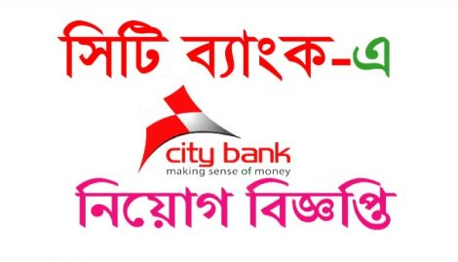


4.2.3 Internal Job Posting
The City Bank Limited gives circular through board notice. Permanent staff and outsource staff can apply for the internal job posting. But for this, the permanent staff had to work for minimum 1 year and outsource staff had to work for 3 years. But with special consideration, the employee can make an exception. In that circular job description is clearly clarified and candidates can apply with the help of respective line manager.

4.2.4 Contractual Hiring
This person is directly appointed by the MD with the reference of chairman or board of directors or the management committee. It is not a post of a regular employee that why it is called as a contractual job.

4.2.5 Transfer
Bank adopts the policy after taking the approval from MDs offices.

4.2.6 Promotion
Promotion is used for the internal purpose of recruitment, promotion used as an effective tool for recruitment. Promotion takes place if the job is increased and the management committee upgrades the job upon recommendation of the respective department. The line manager must clear the requirements of job content, responsibilities, dimensions, change in the organization structure etc.

4.2.7 Budget of Recruitment
The human resource department fixed a budget every year. They make the budget through the concern of other departments. It is the responsibility of a human resource department to looking for requirement of employees and to look after the vacancies. Board of directors are the main person who decides about the recruitment. They can also create new positions. City Bank makes an organ gram for each division and branch. The organ gram should not be rigid, it should be reviewed and revised time to time.

4.3 Factors and Ways of Recruitment and Selection Procedure
Board of directors has the supreme authority to recruit employees. City Bank Limited maintains some ways to perform the recruitment process. They hire employees by online database, through advertisement, by the CV bank of human resource division and by participating in job fairs. There are some factors that City Bank Limited considers – technological and administrative changes of employees, financial condition of candidate, resignation and termination and quality insurance of the employee.

4.4 The Procedure of Selection
City Bank limited has some comprehensive procedure for choosing the right procedure. It has extensive selection procedure and competent professionals for the selection process.

4.4.1 Screening
The departments confirms the human resource division that there is a vacant position so that the HR department can hire employees for that particular division. Firstly the human resource department thought that if there is any suitable candidate for the post, I mean to say that they search the candidates internally or prospective external candidates already identified earlier. Sometimes to make a quick decision the head of the human resource propose suitable staff within the City Bank for the position to the respective department head.

4.4.2 Job Representation
Job representation refers to City Banks recruitment, selection, training, performance appraisal, salary administration, promotion, and other personnel activities. It should be ensure that the employee has a clear knowledge about job context, purpose, organ gram, duties and responsibilities. When the employee appointed promoted for a post that time job description will be provided to that employee.

4.4.3 Recruitment Sources
Recruitment sources are for a place the right people in the right position so that appropriate person can be nominated for the post. The appropriate recruitment always demands the correct selection of human resource. An unskilled employee should be a burden for an organization. As a result, there will be an impact on the overall performance of an organization. There are some sources that are followed by the City Bank for the purpose of recruiting.

4.4.4 Internal Sources
If there are suitable candidates internally presented then the HR department hire them for the vacancy post. There is an advantage in that case, the employee which is internally appointed then he or she knows the terms and condition, duties and responsibilities, pay range etc. appointments are made by the way of promotion, up gradation or transfer with the approval of the authority. In this case, the vacancy is announced by internal advertisement in concerned departments.

4.4.5 External Sources
Whenever job vacancies circulated outside the main objective is to attract the qualified candidates for their vacancy position. They expect in this way they can have the right person for the right post. An advertisement is given by newspaper, articles and magazines. Sometimes the job seekers feel interested to work in City Bank Limited so they drop their CVs in the human resource department. In the human resource department, there is a CV bank so that the interested people drop their CVs. Whenever there is a vacancy then the human resource department check the CVs and choose the suitable, CV and call them. Their information is always kept in the database software. The Website is also used for vacancy announcement in modern science. Sometimes employment agencies technical institutions and journals help a lot in the recruitment process through the selection of candidates.

4.4.6 Accept of Application
Human resource department collects the job application against each vacancy announcement. They maintain a specific time period for receiving the application and that is minimum 10 days. There is a rule that no person cannot send the application after the deadline. If any candidate sends the CV after the deadline, in that case, they need a written authorization by the concerned manager. The human resource department sequentially name the candidates and made a list.
City Bank has a policy that all candidates should meet the prerequisite of that job. The candidates who are rejected within six months cannot apply any post in City Bank limited. Within a one year, a candidate cannot sit for more than two test or interviews.

4.4.7 Shortlisting
The shortlisting method is known as a qualitative method, managerial judgment plays an important role in this method.
Shortlisting is done on the basis of job specification of a position. The job criteria are reviewed during the short listing. Before shortlisting job criteria are set by HR and line manager. There are two types of criteria- general and technical. HR determines the general criteria and line manager determines the technical criteria. Both criteria are important. The criteria selection mostly depends on job nature.

4.4.8 Assessment of Criteria
In the shortlisting, they focus on the educational qualification. Whether the candidate has the required educational qualification. City Bank maintains a policy in case of shortlisting. The candidates who have relevant job experience will be selected for shortlisting. If the candidate has irrelevant job experience and skill that are not considered during the shortlisting. After shortlisting of prospective candidate’s appropriate employment test are there such as written test, oral test and any other test are arranged for assessing the candidate’s suitability. There aresome psychological test are like intelligence, aptitude, temperament and attitude of the candidates are measured and observed.
The main focuses of the employment test are-
- Assessment of mental ability, memory, reasoning
- Proficiency in performing a task
- Assessment of job analysis
- Assessment of potentiality and ability to learn

The selection process is done on the basis of hurdle the approach. The candidates are rejected following each of the stage or test are being administered by the candidates.

4.4.9 Conducting a Written Test
HR makes a questionnaire. A set of questions are draft by line manager and sent to the human resource department. Human resource select some question as a random basis. Then when finalizing the question, the human resource department made a relevant, consistent, and standard of the pattern of the question. Questions are made according to the job requirement and position. Usually, the question pattern is in multiple-choice and narrative in nature. HR checks all the multiple types and narrative type of answers where the line manager checks the narrative type of technical part. HR compiles the score of the written test. It is the responsibility of the human resource department to call the candidates who passed in the written test. The minimum qualifying score is 45%. Candidates who have qualified in the written test are call for the next session.

4.4.10 Checking the Presentation Skill
It is one kind of policy of City Bank Limited. Before appearing the written test, the human resource department arrange half an hour presentation program on the following topic-
- The City Bank profile
- The goals, values and targets of City Bank Limited
- The growth of the City Bank Limited
- The brief job description of the position
- Types of written test, discuss the about the question and evaluation of the result

4.4.11 Interview Steps
After the selection, there will be an in-depth discussion between the interviewee and interviewer. The interview is formed as-
- Head of the human resource department
- Departmental head
- Line manager
Generally, the human resource department conducts all the process of recruitment and selection. In case of hiring senior management level position, they hire some outside firm to recruit. The interview board members ask various questions about relevant skill, the question types are open- ended, behavior-oriented, competency based and stress type questions. The interview board members rank all the candidates and mark them. The basis of the preliminary section is marks obtained in oral test and their judgments about the candidate’s fitness. The passing score of the oral test is 4. The recommendation to be made does not necessarily in favor of the top-ranked candidate because the board member may be convinced in evaluating overall performance.

4.4.12 Medical Examination
The candidates have to pass in the medical examination. They have to do it by any diagnostic center. The medical examination is conducted once the preliminary decision for recruitment is made but the employment agreement has not yet given. A Medical test is required because the authority wants to know if the candidate is physically and mentally fit or not for the post. The Medical exam is bear by the company.

4.4.13 Checking the Information and Reference
The human resource department verifies certain information as provided in the job application such as educational degree, work experience, last employment status. The purpose of reference a book is to obtain factual information confidentially about a prospective employee and seeking options from professional referees. And collect information from the previous employer that the employee has a bad record or not.

4.4.14 Final Selection and Giving Appointment Letter
A Positive reference book, passing in the medical exam successfully, collected satisfactory information from the previous employer the candidate is selected for appointment. The authority of City Bank Limited gives an appointment letter to the selected candidates. The appointment letter includes-
- Job title and salary
- Place of posting
- Name of department
- Nature of appointment
- Joining date
- Terms and conditions
- Probationary period
- Conditions of confirmation
- Notice period
- Ending date of employment
With the appointment letter, job description is also attached. Thenthe human resource director signs the appointment letter and the candidate will start his job in the City Bank Limited.

4.5 Recruitment Policy
City Bank maintains some policy in respect of the recruitment process. Managing director is the main person in case of recruitment. He has the supreme authority. All regular employees will be appointed by the managing director and all human resource contract employees will be appointed by the head of the human resource division. The recruitment schedule will be created according to the service level agreement and the interview board will with the head of the department of that post.

4.5.1 Training and Development Program of City Bank Limited
City Bank Limited established a training institute. The experienced workers of City Bank become the faculty members and give training to the employees. Through this training process, the regular employees become proficient and skilled. Training is a learning experience and it seeks a relatively permanent change in an individual that will improve his or her ability to perform. Training can promote the changing of skill, knowledge, attitude and social behavior. Development is a related process and it not only improve the job performance but also bring growth to the personality. Training helps the individuals to progress toward maturity and actualization of their potential capabilities so that they become not only good employees but also good man and women. City Bank Limited arrange two types of training.

4.5.2 On-the-Job-Training
City Bank arranges on the job training. It is a very popular program in City Bank Limited. on the job training places, the employees in an actual work situation and makes them productive. There is a drawback in the training that is sometimes it hampers the productivity.
The training which offers the employees a separate training session that is called off the job training. Off job training is arranged by City Bank in order to make the employees skilled. Off the job training covers classroom lectures, films demonstrations, case studies, and other exercise and programmed instruction.

4.5.3 Coaching
Coaching is a one to one training process. City Bank Limited gives training through coaching. They identify the quick areas and try to focus on them as early as possible. They also grant the benefit of transferring theory learning to practice.

4.5.4 Committee Assignment
City Bank Limited must be conduct project-based training program. They trained up their employees to cross-functional training process so that the employees can do various kinds of work.

4.5.5 Mentoring
City Bank Limited focuses on their training programs the development of the employee’s attitude. Mentoring is always done by a high-ranking inside person. Mentoring is one to one training process. They do it so that the employees can behave gently to their customers.

There are some other training programs
- Orientation training
- Job specific training
- Foreign training
- Supervisors coaching
- E-learning online training and evaluation

After recruiting a candidate, the City Bank arrange training programs for that employee so that the employee can do his work effectively. They think that this training program works effectively the employee become more proficient in this area. They consider it as an investment, not an expense.

4.6 Administration
The Administration is the division where the employees are maintained and controlled. If any employee need leave and face any kind of problem the administration looks after it.

4.6.1 Maternity Leave
The City Bank gives all the women employees to enjoy 4-month maternity leave. Women employee can enjoy 2 times maternity leave in her whole work life at City Bank Limited.

4.6.2 Study Leave
City Bank gives minimum 2 years of study leave without pay and allowance. But there is a condition the employee who needs study leave have to work minimum 3 years in City Bank Limited.

4.6.3 Annual Leave
All the regular employees of City Bank enjoy 24 days leave in a year. Any pending leave can be carried forward to the next year. In this 24 day leave 15 days considered as consecutive leave.

4.6.4 Casual/Sick Leave
Bank will consider up to 14 days of absence for an employee who may be unable to attend due to sudden illness or urgent private affairs. In a month an employee cannot absent more than 2 days at a time.

4.6.5 Leave without Pay
City Bank gives leave without pay due to a certain circumstance. But it must not exceed 60 days.

4.6.6 Leave During Probation Period
Sometimes the employees need to leave in during the probation period. The leave has to be specially declared by the department. Bank gives casual leave after completing 6 months of the probationary period. If an employee needs a leave not completing 6 months it will be adjusted against the casual leave.

4.6.7 Annual Leave Encashment Facility
Annual leave encashment facilities may be allowed to the employee for a maximum period of 90 days at the time of living off that employee.

4.7 Promotion
Promotion is a continuous process by which the employee feels motivated for working in the bank. They feel encouraged to do better work, give excellent service. City Bank gives two types of promotion.

4.7.1 Regular Promotion
Regular promotion is giving on regular performance. Supervisor observes the whole bank and the employee. When an employee gives excellent performance, the employee becomes an asset to the bank. The supervisor notices it and take a promotion appraisal form from the human resource department and suggested the employee for promotion.

4.7.2 Performance Matter Promotion
Performance matter promotion is given by the bank according to the job grade in the bank. It is given annually. The promotion is dependent on the whole performance of an employee in a year. The fulfillment of target a of the employee is also a big issue in performance matter promotion.

4.8 The Probation and Confirmation Terms
If an employee has less than 3 years of job experience than that employee gets a 1-year probation period. In another side the employee who has more than 3 years of job experience will have a probation period of 6 months. If any employee unable to show satisfactory progress and acquire required efficiency during employee’s probationary period the appointing authority extend his probationary period for additional 6 months or other cases the appointing authority give one month notice and pay a one-month salary without assigning that person. If an employee successfully completes the probation period then he will be confirmed for the post.

4.9 Resignation and Termination
City bank limited has some policies and procedure in accordance with the termination and resignation of the employees. There is some situation when this termination and resignation happens-
- When a regular employee resigns
- When a regular employee terminated
- When a temporary employee resigns
- When a temporary employee terminated

4.9.1 Resignation of a regular employee
A regular employee can leave the service by giving one month notice and have to compensation an amount equal to the employee’s total pay for one month.

4.9.2 Resignation of a temporary employee
A temporary employee can leave the service by giving 15 days prior notice in the writing of employee’s intention to do so or pay to the compensation an amount equal to employee’s total pay for 15 days.

4.9.3 Termination of a regular employee
The authority may terminate a regular employee by giving him one month notice in writing or on payment of one-month substantive pay in lieu of such notice and the employee shall not be entitled to any form of compensation for termination of service.

4.9.4 Termination of temporary employee
The termination of temporary employee happens when the authority without assigning any reason without giving him or her any notice and the employee shall not be entitled to any compensation for termination of service.

4.10 Pay and Benefits Package
Pay and benefit are the motivational factors for employees. City Bank Limited designs compensation program for employees for getting better motivated, efficient employees in the organization. The bank follows a fair, competitive and flexible remuneration policy. The board approves this policy for the betterment of the employee. The remuneration of employee consists in 3 way.

4.10.1 Basic Salary
Basic salary is the main margin of the salary range. The city bank gives basic salary without any other allowance. City bank has 30 slabs of the salary range for every job grade where basic salaries are in flexible amount.

4.10.2 House Rent
Competent authority sometimes allows house rent allowance to be paid as such rates and such condition.

4.10.3 Medical Allowance
Competent authority considers medical allowance in accordance with the job grades and on certain condition.
There are also more employee benefits:
- Family benefit
- Retirement plan
- Educational program
- Insurance policy
There are Some Objectives of Pay and Benefits
- Satisfy the employees
- Reduce turnover
- Minimize the overtime cost
- Reduce fatigue

4.11 Performance Appraisal System at City Bank Limited
Performance appraisal is a process of evaluating employees past performance, rewards, records, promotion, and staff development purposes. Performance appraisal is the system that is used for identifies, evaluates and develops employee performance.

4.12 Performance Appraisal Process
Performance appraisal process are done by following characters-
- Supervisors
- Subordinates
- Peers
- Customers
- Self-appraisal
- 360-degree approach

4.13 Purposes of Performance Appraisal
There are many purposes that city bank follows a performance appraisal system.
- To evaluate training needs
- To overview past performance
- To develop individuals
- To set targets for future
- To identify promotion
- To solve the hidden problems of an organization.

4.14 Methods of Measuring Employee Performance
There is various kind of method that city bank limited follows for measuring performance appraisal. Two types of method are significantly used in city bank ltd.
- 360-degree feedback
- Experience-based

360-degree feedback: 360-degree feedback is a popular performance method in city bank limited. With this method employees are measured by peers, managers, subordinates, customers and many other people.
Experience-based: The city bank limited measures the employee performances. City bank valued that employee who is more experience than others.

4.15 Compensation Management
Employee benefit and services were formerly known as benefit and these benefits were in-kind payments employees receive in addition to payments in the form of money. An employee works for rewards, and the most important reward is money. There are some benefits that are non-compensation in nature. That is-
- Protection in the case of health and accident
- Retirement and termination package

4.15.1 Goals of Compensation
Compensation administration is design in the form of the lowest cost pay structure. It is an agreement between employer and employee that defines the working relationship. This agreement with or without care of a formal collective negotiating agreement influence the outcome achieved.
There are some government rules that influence the compensation administration:
- The Government has fixed minimum standard of wage and the organization must follow it.
- Collective bargaining and selection process is constructed by government rules and regulations.

4.16 Employee Relation
There must be a balance between employer and employee relation. Employer and employees have their own set of needs and values. City Bank maintains 3 categories employee relationship.

4.16.1 Employee Working Condition
City Bank limited maintains a hygienic working condition for the employee because they believe in “right work for the right person”

4.16.2 Employee Health
City bank provides health care, free medical checkup, and necessary medical facilities for each employee.

4.16.3 Employee Safety Issue
City bank always concerns about their employees. They provide all kinds of job safety such as insurance and other facilities.

4.17 Incentive
Incentives control cost because the employee is being paid for her extra effort and for the benefits brought to the organization. Incentives add to base pay. The incentive plans are given below:

4.17.1 Individual Incentive Plan
- Employee performance vs. company standards
- Quantity and quality of the goal
- Quantity of work
- Number of monthly sales
- Work attendance measurement
- Work safety record

4.17.2 Group Incentives
There are various group incentives
- Customer satisfaction
- Official cost savings
- Reduction in accident
- Service cost savings

4.17.3 Company Wise Incentive
- Company profits
- Wide incentive plan
- Cost prevention

4.18 SWAT Analysis
SWAT analysis are in two ways-
Internal -
- Strength
- Weakness
External –
- Opportunity
- Threat

4.18.1 Strength
- Extremely rapid growth
- Employees become satisfied with their job
- Keeping records in an appropriate method
- Employees perform very well
- Making good profit
- Employees do their work effectively
- A well-decorated office

4.18.2 Weakness
- There isa centralized power
- Lack of negotiation
- Promotion system is not adequate
- Lack of workforce and team
- Deficiency of business communication
- Recruitment policy is manual
- Deficiency of administrative performance

4.18.3 Opportunity
- Avail in the national growth rate
- Well serve in the society
- Chance to get a huge amount of money
- Destination to introduce a new sector
- Orientation in the private sector

4.18.4 Threats
- Foreign banks are entering in Bangladesh
- Bangladesh bank impose rules and regulation which interrupts in the development
- Political factors of Bangladesh

CHAPTER – 5
Internship Experience

5.1 Internship Experience
5.1.1 My Contribution
As an intern, I enjoyed a lot working with them. I worked in the human resource department but also, I worked also worked in the general section. I made a group and it was a great experience for me. Since from the beginning of my internship, I worked in the human resources division, then I worked with recruitment team, CV sorting, interview phone call, and coordinate interview session.
I am also worked in training process and processed the information like-number of training occurred in a month, number of participants, their attendance rate, the total cost of the training. I also processed the employee profile update. The profiles updated in the system.
I also worked in the general section. I worked on fill up the current savings account, general savings account, and fill up the MX card form. I helped a lot to Mr. Mahbub Alam (customer service officer) in checkbook issue. I opened student accounts. I create the CB number into their system. Their software name is finacle. I posted the checks into their system.
I worked under BOM (board of management). I helped a lot to Mr. Samad (board of management) in audit issues. I destroyed the checkbooks from their system. I sent emails to those persons whose checkbooks are going to be destroyed. I delivered the checkbooks to customers. I handle lots of arrogant customers. Sometimes customer made problems, they didn’t maintain the queue. I handled them in a soft manner. I also worked on loan files.

5.1.2 Efficiency I have gained
For the first time in my life, I worked on corporate culture. It teaches how to talk in a formal way, how to dress up in a formal way, how to work under pressure. It was my first working experience at the office. I worked on their finacle system. And it was a great experience for me. I created CB numbers. I also worked on tracking the CB numbers into their system.
I also worked on the checkbook destroy system. In that system, the work is in two layers. Firstly, it should be destroyed in the system. Then you have to cut the checkbook or torn it. Firstly, I sent the emails to the customers that your checkbooks are going to be destroyed. Then I listed the account number, name, their address, and series of the checkbook.
I also worked on employee profile updating and keep the records of the training process. I also worked on shortlisting the candidates, call some of the candidates and supported the interview process.
I also learned how the new employees go through a process while joining and the things that they need to submit and file them properly. I also became very skilled in photocopying and scanning documents. I also knew that scanned document separately and send the mail.

5.1.3 Interaction with supervisor and co-worker
The working environment of City Bank is very pleasant. People are very hardworking and friendly. They are very helpful. I have worked closely with the Customer Service Officer. I learned lots of things from them. They taught me how to behave in a formal way. Dealing with the customers. They gave me lots of instructions about their finacle system. The other people in our office are also very helpful and polite. It was a small team but a very strong team, whoever asked me to do any task they first gave me an idea and instruct me to do that work. Sometimes I made mistakes but they have very appreciated me and instruct me to do that task correctly.
My Deputy Manager Mr. Saiful Alam was a very good man. He guided me in a good way. He always came to me and asked my progress. He also encourages me to give suggestions.

5.1.4 Acceptations versus reality
Some people shared their bad experiences with me that City Bank Limited not take the interns seriously. They only asked to do the clerical works by the interns. Some previous interns also told me that the culture of the office is rigid. They badly behaved with interns and they do not cooperate at all. They only order the interns but not give any brief explanation of the job.
Honestly speaking I had enjoyed the whole internship program. They treated me as an officer. The working environment of the City Bank Limited was very friendly and even I worked on their customized banking software. They taught me their banking software with great pleasure. I made a wonderful team with them even they always shared their lunch with me. On the last day of my internship, they celebrated the day with a big cake.

5.1.5 Part of my future career
I felt really proud that I have done my internship at City Bank Limited. I was a great opportunity to work with them. When my internship started the first few weeks I worked in the Human Resource Department. Then the rest of the internship period I worked in the general section. I have learned a lot of thing about the banking process it was a great experience for me which will take part in my future career.
I have learned so many things that I feel interested to work in the banking sector. I have the knowledge of whom to deal with the customers. I strongly believe in cross-functional work so I worked with various departments. City Bank limited and the officers shared with me their lots of experience in their job life. I feel interested to build up my career in the banking side. I know most of the banking process now like the general banking and the human resource practices of the bank. The officers as my coworkers helped me, guided me, taught me about the banking procedure, guided me how to work with formal way, how to dress up, how to handle the problem customer, how the audit session happens. In this way I have learned a lot of things about the banking sector, I enjoyed a lot. So, I am now interested to work in banks and started my career as a banker.

5.1.6 Fellows
My fellows are also very cooperative. On the first day of my bank, I feel very shy. But Nusrath Nipa (Customer Service Officer) introduced me to all the officers. They well come to me warmly. I made a family with them. They treated me as their coworker. They made me relax when I do any job directed by them. I had a great relationship with Md. Mahbub Alam, Nusrath Nipa, Sharmin Ahmed, Muhitur Rahman. I also made a relationship with the foreman also. The officers of the bank guided me in a right way, solve my problems doing any work if I asked any question about the bank related issues they will give me an answer.

5.1.7 Atmosphere of the bank
The working environment of City bank limited are very nice. The whole office itself is a family. When I join the bank as an intern they made me as a member of that family. The officers and the senior level employees behaved with me so nicely that I am really surprised. They are so supportive that they willingly taught me about the banking procedure, the banking behaves, the banking culture etc. I made a friendly relationship with my deputy manager Mr. Saiful Islam. He encouraged me a lot to learn new processes, he also told the officers to teach me about their FINACLE system. He observed me as I am learning or not. He took a great care of me. I am so proud that I have worked with such a nice team. When I joined the bank, I feel fear to talk because it was my first corporate job. But they gave me their ideas, and thoughts, their shared experience and so on. I am such a lucky guy that I get an opportunity to work with them.
It was a great experience for me. I used to call them Apu and Bhaiya. They create a culture like that. They internally talk like that. So, I am used to this behavior. They told me to not call them as sir and madam.

CHAPTER- 6
Findings and Analysis

6.1 Findings and Analysis
6.1.1 Positive findings
- They strongly maintain the recruitment process.
- They use modern technology for banking activities.
- They are very much cooperative with other every personnel.
- They maintain a standard behavior with their customer.
- They maintain a sharp cleanliness in their office surroundings.
- They have embraced the concept of Green Banking.
- They have introduced e-statements for their customers.
- They have provided services for the holistic development of the children with special educational needs (Autistic children) through multidimensional programs.
- They have supported to promote art, culture, and science in our school and colleges.
- They have supported to promote community development and disaster management.

6.1.2 Negative findings
- Pay packages system of the bank differs comparing to another bank in Bangladesh.
- Sometimes employees feel extra work pressure.
- Training programs are not sufficient for the employees.
- Shortage of employees.
- Employee absenteeism rate is very high.
- Canteen facilities for employees are not moderate.
- Shortage of various types of form (savings, current etc.).
- ATM booth is not sufficient for their customer.
- Employees deposit target is high.

CHAPTER - 7
Recommendation and Conclusion

7.1 Recommendation and Conclusion
7.1.1 Recommendation
I have the practical experience of the city bank for only three months, so, it is very difficult for me to recommend with my little experience in the bank. I have found some limitations regarding operational and HR activities of the bank. Based on my observation I would like to recommend the following suggestions:
- Their performance appraisal system is not standard enough. So, the human resources department should seriously concentrate on it. Because the success and failure of the organization are highly dependent on the proper human resources performance.
- The employees are given a deposit target, which creates extra pressure on them for this reason they cannot freely provide customer service. They had to expend most of their valuable time on marketing to fill up their target. If the bank can reduce the pressure, then they could be able to provide better service than the present situation.
- The pay structure systems are differing from the other bank, so they should work on it to reduce the high turnover of employees.
- To provide quality service to the customer, it needs to a trained team of an organization. That’s why the bank should recruit fresher and also bright energetic persons such as MBA, BBA etc.
- The Bank should offer more services to the customers such as Credit card, Visa card, Master card, ATM machine etc.
- Their canteen facility is not moderate for their employees, they should think seriously about it.
- Their training is not structured and effective for them. So, they should arrange a proper training program.
- As the clients are not in favor of the introducing system, if possible the rule of introducing to open an account should be changed. Because many customers faced in the problem to arrange an introducer at the time of opening accounts.

7.1.2 Conclusion
The City Bank Limited is one of the fastest growing banks in Bangladesh. City bank has a reputation for giving quality service to customers. It was a great experience for me to work in the City Bank Limited. It is my first job experience in corporate level. I have learned the bookish knowledge with the practical experience. People are heading towards the banking sector nowadays. They find it really an exciting job. So, it has become a challenge to select the right candidate that is being done successfully by the human resource division. Every organization nowadays maintains a human resource department. They do the critical works for the organization. City Banks human resource department is very strong. I have discussed it through the whole report. A strong human resource department can change the whole condition of the organization. City Bank is nowadays a very popular bank among the middle-class people. Their Citymax card has become very popular among the customers. They give extra features in it. City bank is using modern technology in their banking process. So, the customers are attracted to the City Bank for a modern and customized service.

References

Books & Journal

Aswathappa, K. and Dash, S. (2008). International human resource management. New Delhi: Tata McGraw-Hill Pub.

Bae, J. and Rowley, C. (2001). The impact of globalization on HRM: the case of South Korea. Journal of World Business, 36(4), pp.402-428.

Ajzen, I. and Fishbein, M. (2002). Understanding attitudes and predicting social behavior. Englewood Cliffs, NJ: Prentice-Hall.

Tayeb, M. (2005). International human resource management. Oxford: Oxford University Press, pp.70,72,77,99-102.

Akinci, S., Aksoy, Ş. and Atilgan, E. (2004). Adoption of Internet banking among sophisticated consumer segments in an advanced developing country. International Journal of Bank Marketing, 22(3), pp.212-232.

Aladwani, A. (2001). Online banking: a field study of drivers, development challenges, and expectations. International Journal of Information Management, 21(3), pp.213-225.

Balasubramanian, S., Raghunathan, R. and Mahajan, V. (2005). Consumers in a multichannel environment: Product utility, process utility, and channel choice. Journal of Interactive Marketing, 19(2), pp.12-30.

Barczak, G., Ellen, P. and Pilling, B. (1997). Developing typologies of consumer motives for use of technologically based banking services. Journal of Business Research, 38(2), pp.131-139.

Bauer, H., Grether, M. and Leach, M. (2002). Building customer relations over the Internet. Industrial Marketing Management, 31(2), pp.155-163.
Jo Black, N., Lockett, A., Ennew, C., Winklhofer, H. and McKechnie, S. (2002). Modelling consumer choice of distribution channels: an illustration from financial services. International Journal of Bank Marketing, 20(4), pp.161-173.

Maniraj Singh, A. (2004). Trends in South African Internet banking. Aslib Proceedings, 56(3), pp.187-196.

Pikkarainen, T., Pikkarainen, K., Karjaluoto, H. and Pahnila, S. (2004). Consumer acceptance of online banking: an extension of the technology acceptance model. Internet Research, 14(3), pp.224-235.

Skogland, I. and Siguaw, J. (2004). Are Your Satisfied Customers Loyal? Cornell Hotel and Restaurant Administration Quarterly, 45(3), pp.221-234.

Suh, B. and Han, I. (2002). Effect of trust on customer acceptance of Internet banking. Electronic Commerce Research and Applications, 1(3-4), pp.247-263.

Swinyard, W. and Ger Ghee, L. (1987). Adoption Patterns of New BankingTechnology in Southeast Asia. International Journal of Bank Marketing, 5(4), pp.35-48.

Websites:
https://www.thecitybank.com/Current-Account.php
https://www.thecitybank.com/General-Savings-Account.php
https://www.thecitybank.com/Personal_Loan.php
https://www.thecitybank.com/home_loan.php
https://www.thecitybank.com/city_maxx.php
https://www.thecitybank.com/city_Debit-Card.php
https://www.thecitybank.com/new_born_deposit_account.php
https://www.thecitybank.com/high_value_savings_account.php
https://www.thecitybank.com/vision.php
https://www.thecitybank.com/annual_reports.php

Appendix

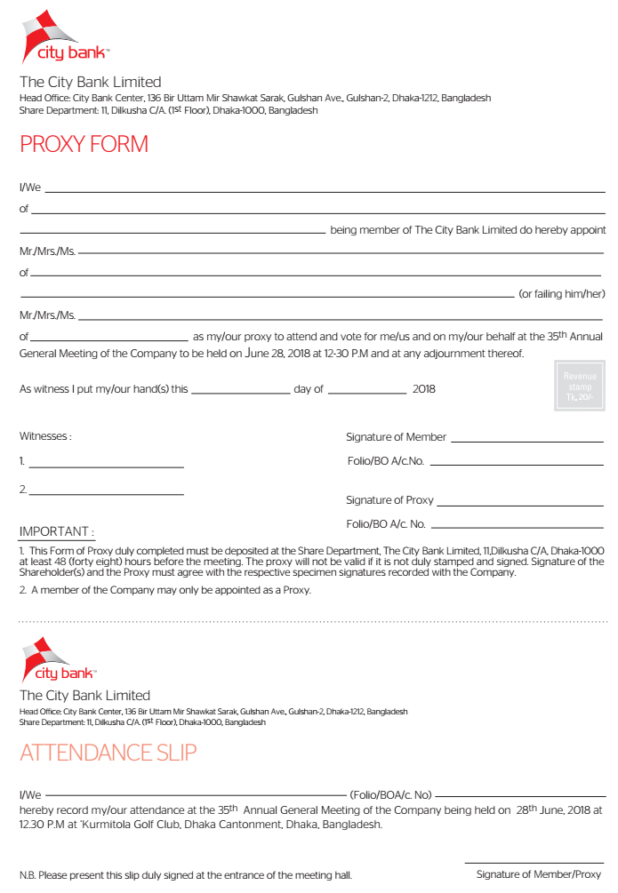

Performance At a Glance of City Bank Limited 2017
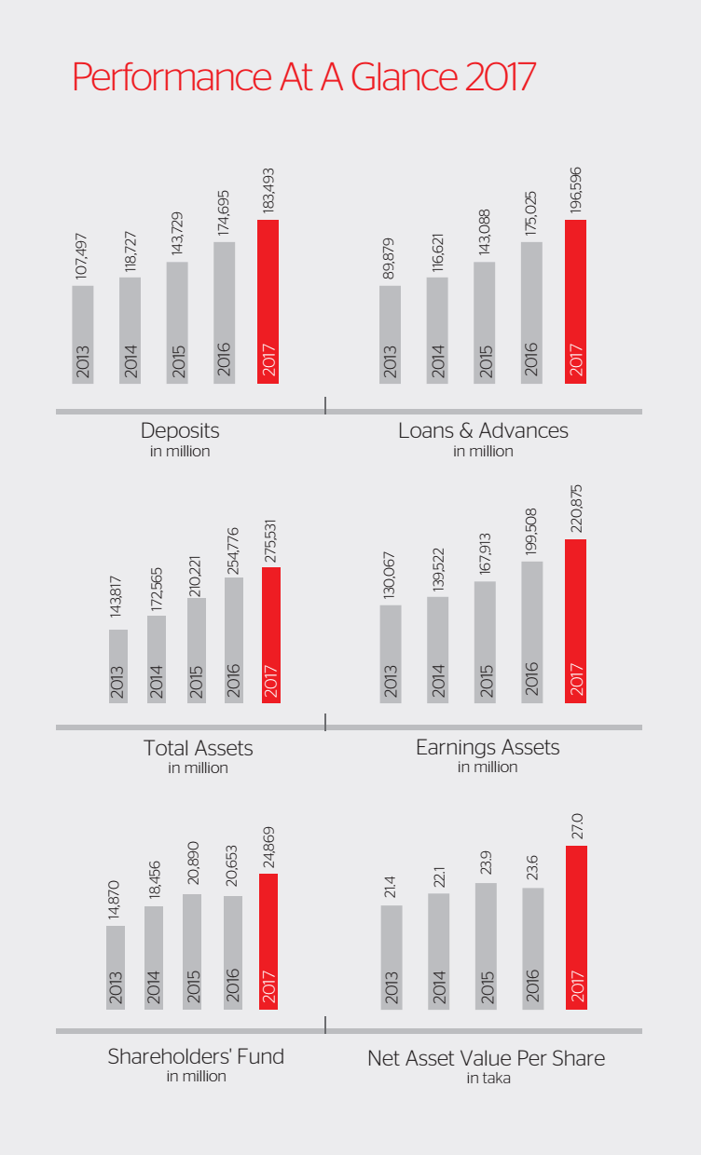

City Bank Footprint
