Audit Procedure:
A Practical learning of Consumer Knitex Limited

S.K Abdullah Al Mamun

This report is submitted to the school of Business and Economics, United International University as a partial requirement for the degree fulfillment of Bachelor of Business Administration

Internship Report on
Audit Procedure:
A Practical learning of Consumer Knitex Limited

Submitted to:
Mr. Mohammad Tariq Hasan
Assistant Professor,
School of Business & Economics
United International University

Submitted by:
S.K Abdullah Al Mamun
111 151 550
BBA. (Accounting)
Trimester: Summer
School of Business & Economics

 United International University

Date of submission: 20 August, 2020

Letter of Transmittal

Date: 20th AUGUST, 2020
Mr. Mohammad Tariq Hasan
School of Business & Economics
United International University

Subject: Submission of Internship Report on “Audit Procedure: A Practical learning of Consumer Knitex Limited”.
Dear Sir,
With due respect, I would like to submit the “Internship Report” for your kind Suggestion. This report is a summary and analysis of three months of internship experience by which I gather practical knowledge from Consumer Knitex Ltd. The topic of this report is “Audit Procedure: A Practical learning of Consumer Knitex Limited”.
I have tried my best effort to work sincerely to cover all issues regarding the topics. To learn valuable information I worked hard and tried my best to prepare this report correctly. However, if you have any consecration, advice or recommendations for further progress regarding the report, I will be obligate to provide further explanation.
Hence, I wish that you would be kind enough to accept this report for analysis.

Thank You,
Sincerely,
S.K Abdullah AL Mamun
111 151 550
School of Business & Economics
United International University

DECLARATION

I am, S.k Abdullah AL Mamun, declaring that the internship report of titled “Audit Procedure: A Practical learning of Consumer Knitex Limited” is uniquely prepared by me after the completion of three months’ work experience of Consumer Knitex Ltd.
I am also confirming that the report is prepared only for my academic requirement. It might not be used with the interest of the opposite party of the corporation by which they can collect any information of the organization.

________________
S.k Abdullah Al Mamun
ID No: 111 151 550
School of Business and Economics
United International University

ACKNOWLEDGEMENT

The internship program is beneficial because we can learn a practical knowledge with relaying theoretical knowledge as part of the Bachelor of Business Administration (BBA) program. It’s a great opportunity for me to do internship in Compagnie Mauricienne de Textile Ltee (CMT-BD), a multi-national ready-made textile company.

With a respective mind, I would like to Thanks to Almighty who Always with me, then I would like to remember Mr. Mohammad Tariq Hasan who have helped me during every step of my internship program. With respect I would like to remember Md. Sadiqur Rahman, Md. Zaber Tauhid Abir, and Ms. Zabin Tasnim Oni to give me the opportunity to complete my internship at Consumer Knitex Ltd.

I also want to thank Mr. Francois Gilles Tam Fat Woo (Managing Director) and Mr. Sanjay Kumar Chooromoney (Country Director) and all employees of the Consumer Knitex Limited, for their co-operation it’s become easier for me to prepare the report. I am sure that their strong managerial activities will influence anybody to build one’s career properly.
I prepared this report from my own perspective and overview. Then at last, I shall be grateful to those people who read this report and who shall get benefit from this report at present and in future.

Scope & Limitations
Scope:
Bangladesh's has huge opportunity because of its high population and low-cost labor is widely available. If we can control some major problems like political violence and corruption then many foreign investors may interest to invest in our country. BY using this internal source with the help of a stronger internal control system we can increase our GDP and archive huge revenue to support our self.

Limitations:
There are some limitations while doing this report such as:
- I could not able to collect enough data due to the company's privacy policy
- Unable to understand the company’s slang term.
- Due to short time within just three month unable to collect enormous amount of information among huge data.
- Budget is low.
- Unable to understand to company’s external business policy.

Executive Summary
Consumer Knitex is a garments factory one of the sister concern of Compagnie Mauricienne de Textile Ltée. They started their journey in Bangladesh in 2011. At present they have three factories in Bangladesh. This internship report is made on titled “Audit Procedure: A Practical learning of Consumer Knitex Limited”– the report is consisting of the important things of assessing the organization's case. This topic is chosen by consulting with my academic honorable faculty. I want to describe the temporary position within the Finance and Audit department of Consumer Knitex limited. By holding this position I get a prime opportunity to conduct a close examination and improve better understanding of the current situation of internal control of the organization & clothes sectors in Bangladesh. In this report I would like to discuss about my given responsibility on the organization, Control activity and Risk allocation, evaluation of risk, Information, communication and monitoring. I also collect information from BGMEA to discuss about RMG sector situation of Bangladesh. Major information collect from CONSUMER KNITEX LIMITED to know about internal control and external control of the organization. SWAT analysis of the organization. The terms and condition of the consumer knitex limited is more clear and specific getter than some local companies. They are very strict about their rules. In some case we found that the multination organizations management is more decorated then local companies. Their internal control is automatic. They use face scan machine to maintain attendance. On the other hand our Bangladeshi garments companies found in poor internal control, number of reason found behind this. Because of poor administration and late salary payment creates worker dissatisfaction, Worker violence are making narrow their business. Lack of internal control and implementation is main responsible for this negative effect. In Bangladesh government is trying to developing this sector for this reason government implementing rules, imposing law and regulation to protect employee’s right. Consumer Knitex LTD is more careful about using more standard technology for approval, Train up their workers and employees regular, Increase their salary according time. Regular evaluate their work and it will help them to develop the organization and also the employee this way their profit is increasing.
Keyword: Audit procedure, RMG sector, planning, technology

Table of Contents
Internship Report on i
Letter of Transmittal ii
DECLARATION iii
ACKNOWLEDGEMENT iv
Scope & Limitations iv
Executive Summary vi
List of Tables xiii
List of Figures xiii
CHAPTER 1: Introduction 2
1.1 Origin of the report 2
1.2 Background of the report 2
1.3 Objective of the Report 3
1.4 Literature Review 4
CHAPTER 2: Business Background 6
2.1 Company Background 6
2.2 Overview of Organization: 7
2.3 Vision 7
2.4 Mission 7
2.5 Organizational Structure of Consumer Knitex Limited 8
2.6 The Head Office of Consumer Knitex Limited: 9
2.7 Operations and expansion of operations 10
2.8 Industry background 13
CHAPTER 3: My internship at Consumer Knitex Ltd. 17
3.1 Bills Check: 18
3.2 Market Evaluation for audit purpose: 19
3.3 Communicate with suppliers: 19
3.4 Maintain stationary items and prepare purchase order: 19
3.5 Licensing purpose: 20
3.6 Check Maintains: 20
3.7 Attach money Receipt: 20
3.8 Filing Purchase order copy: 20
3.9 Check maternity leave signature, Face matching with the person 20
3.10 Check Attendance sheet for all Intern 21
Chapter4: Theoretical Part of Internal Control System 23
4.1 Purpose 23
4.2 Objective 23
4.3 Implementing Law and Regulations: 23
4.4 Reliable Financial Reporting: 24
4.5 Efficiency & Effectiveness of Operation: 24
Chapter: 5 Management and Auditor Responsibilities for Internal Control 26
5.1 Reasonable Assurance: 26
5.2 Inherent Limitations: 26
Chapter: 6 COSO Components of Internal Control 27
Chapter 7: Control Environment 29
7.1 Integrity and Ethical Value: 29
7.2 Board of Director or Audit Committee Participation: 29
7.3 The Control Environment Management Philosophy & Operating Style: 30
7.4 Human Resource Polices & Practices: 30
7.5 Organizational Structure: 30
Chapter: 8 Risk Assessment 32
8.1 Financial Risk 32
8.2 Credit Risk: 33
8.3 Non Financial Risks 33
8.4 Social Risk 34
8.5 Risk of Unforeseen Events: 34
8.6 Country Risk 34
8.7 Political Risk 35
8.8 Economic Risk: 35
Chapter: 9 SWOT Analyses on Internal Control of Consumer Knitex Ltd. 37
9.1 Strength 38
9.2 Weakness 38
9.3 Opportunities 38
9.4 Threats xii
Chapter: 10 Findings & Recommendation xiv
Chapter: 10 Recommendations xiv
Chapter: 11 Conclusion xv
Internship Completion Certificate xvi
Bibliography xvii

CHAPTER 1

Introduction

  - Origin of the report

1.2 Background of the report

1.3 Objective of the Report

1.4 Literature Review

1.1 Origin of the report
In BBA program an internship report is very necessary part for a student. For the internship report purpose a student need to go an organization and have to work for a certain period of time. From this internship a student get an opportunity to learn real world job life experience and get a chance to relay practical and knowledge with theatrical knowledge. In summary, I like to say that this report is an evidence of my practical capability to use my theatrical learned knowledge in real-life business knowledge. My internship report topics assist me to know the system of RMG sector in Bangladesh. My report is titled “Audit procedure of consumer knitex LTD" and is done on the basis of my practical working experience I have learned and under the supervision and guidance Mr. Mohammad Tariq Hasan, Assistant Professor, School of Business and Economics, United International University.

1.2 Background of the report
Internship report is the last course of my undergraduate program. After completing all theoretical courses I found many smellier topics with practical business world. Practical business sector is more challenging getter than assumption. This report will reflect my ability to use my educational knowledge in corporate world. It is a great privilege for me to work in audit department in consumer knitex LTD. I observe many departments file very closely and learn various system of different department. This internship report is base of my three month of working experience. I communicate with every department as my designation purpose and as a part of my given responsibility purpose. This report is based on audit procedure of the organization. So I try my best to learn the procedure from the organization.

1.3 Objective of the Report
Internship is totally practical knowledge to understand the organizational environment properly. It assists a student to make their career because internship program is a carrier developing activities. According to me this internship report helps me regarding some specific issue. Now I like to discuss those points.
General Objective: For the purpose of Internship program I learn a big deal about audit procedure from consumer knitex LTD and Readymade Garments sector of Bangladesh. So, we must have objectives of our own accomplish this report properly. Some general objectives are:
- This report will provide me some general information of the organization.
- It’s a matter of regard that only for political hazer garments loss huge foreign investment.
- Our country has cheap labor and government provides huge facilities to develop and sustain this sector for the entrepreneur.
- For new entrepreneur government provide high tax exemption in this sector.
- Government should involve with international markets as a assistant of our seller
So this sector will get better opportunity to export more.
Broad Objective:
- By using the experience at consumer Knitex LTD archive a good position in our country.
- To fulfill Undergraduate requirement.
- To satisfy the requirement of internship report .
Specific Objective:
- To learn their internal control system of the organization.
- To use the theatrical knowledge with practical job sector, how to face practical situation and control the situation, how to consider the company policy and take action.

1.4 Literature Review
In this report I like to focus the present condition of the RMG sector of Bangladesh and audit procedure of consumer knitex LTD and short description about the sector in our country. Since 1980 garments sector started in Bangladesh. We may found huge report about this sector by focusing various issues. So audit procedure is not a new issue in this sector but in this report I would like to describe the issue which has very few reports. Now I like to discuss some finding that are below.
Proper accounting system is assisted an organization to take any decision and provide operational information of the organization. According to ( Anup Kumar 2012) Many garments do not follow proper accounting method also there are no correct separation programs for workers who leave the firm, also employees are not secured and their internal control system is very poor and needs to improve this system.

CHAPTER 2

Business Background

2.1 Company Background
2.2 Overview of Organization:
2.3 Vision
2.4 Mission
2.5 Organizational Structure of Consumer Knitex Limited
2.6 The Head Office of Consumer Knitex Limited:
2.7 Operations and expansion of operations
2.8 Industry background

2.1 Company Background

Compagnie Mauricienne de Textile Ltée (CMT ) is the mother company which sitiated in Mauritius. Consumer Knitex ltd was established in 1986 which located in Mymanshing Valuka. Francois Woo and Louis Lai Fat Fur is the owner of the business. CMT began its operation with new production system humble though in 1986. That became one of the largest shirts Industry among global market. After starting their journey they were very conscious to implement their dream. They were very much conscious and sincere about their quality and production. They didn’t compromise about the product quality. They choose the best suppliers to ensure the raw material. After satisfying that market they decided to increase the market and expand their business. As a result of their plane they establish Consumer Knitex as a sister concern of CMT. Consumer Knitex then did the tremendous result and become the biggest Shirt were maker among CMT group.
Compagnie Mauricienne de Textile Ltée (CMT) has become a worldwide shirt wear clothing industry . They also supply the product in UK, France. Compagnie Mauricienne de Textile Ltée (CMT) has 6500 above labor and official respective Clark, consumer knitex ltd is known as their Bangladeshi business company name. They are increasing their production level by appointing new employee.
Their mission statement for the organization is "From wherever we have a tendency to come… to where we're going". They say that they want to be the best maker with highest quality manufacturer of clothing wear and alternative clothing in this industry, by using effective resources with correct innovation and advancement with their every individual.
CMT has one sewing production line in Bangladesh which located in Mymensingh Trishal. They use more sophisticated new technology in production. They have good environment and wonderful decotation. Etch day more than 4000 worker with representative serve there. Their target is to achieve more than 6000 skilled man. Another factory is located in Valuka in Mymanshing is called Consumer Knited Ltd. CMT group established this Garments factory in 2011 and stated their operatin in October 2011. During that time it has 1500 above worker and Staff.
Dignity Textile Mills Limited (DTML) located at Shreepur, Gazipur which is their third factory in Bangladesh. This factory is used as a unit for their dying purpose. Their next plan is to open another unit as savar or Manikgonj. (Not decided yet). Their head office is located at UTC Building, Panthapath Dhaka.

2.2 Overview of Organization:
Mission Vision is one of the most important parts of the organization. Without mission and vision no organization can sustain and without it an organization is like a boat without a rudder so it is necessary to show the mission vision and chart of the organization.


2.3 Vision
Vision is consisting of futuristic Imagination where their last goal is. Their vision is to becoming the market pioneers among the shirt wear industry.

2.4 Mission

Mission statement is mainly explained how we could perform regularly to achieve our vision. They have a regular plane to achieve their regular performance as to achieve their final goal or destination.
“From wherever we have a tendency to come… to where we're going”
They highly try to produce high quality clothes, jersey Shirt their entire product. To ensure quality they never compromise to add high technology in production, they train their employees regularly and develop them and making them more efficient.

2.5 Organizational Structure of Consumer Knitex Limited

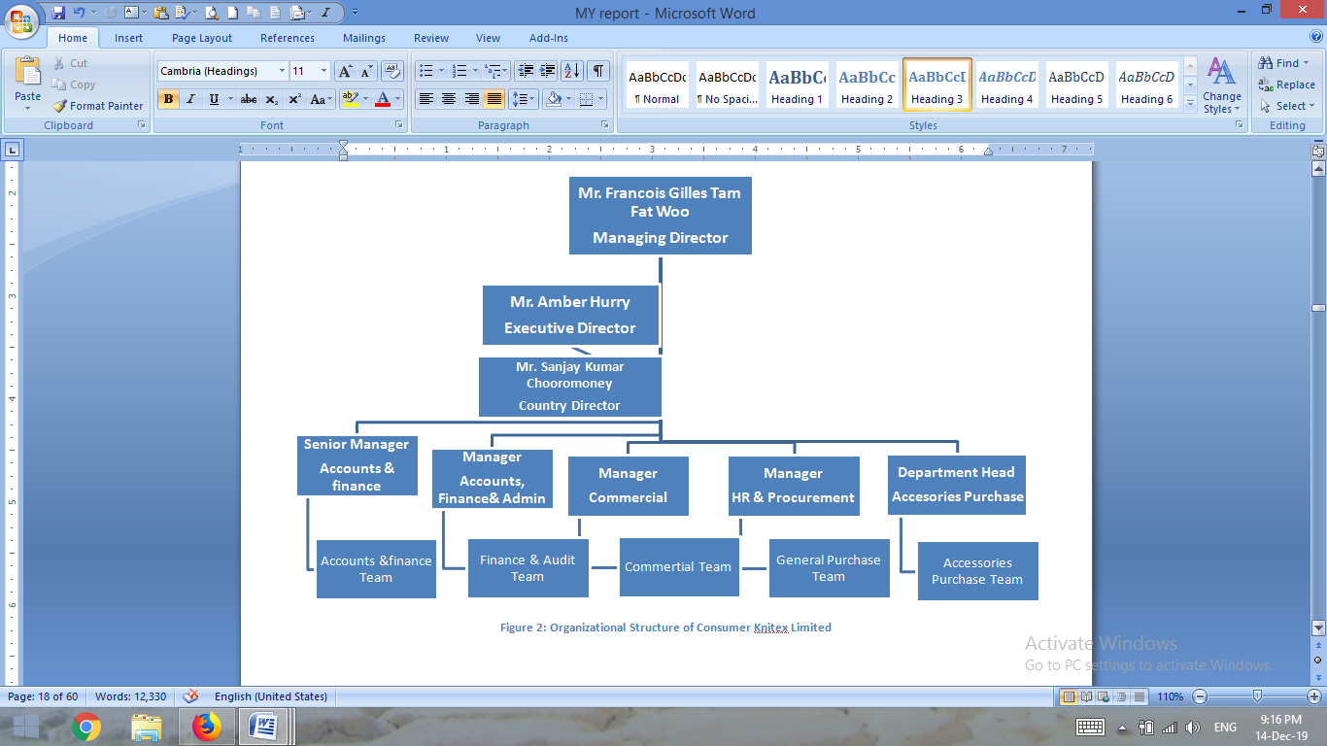

Figure 2: Organizational Structure of Consumer Knitex Limited

2.6 The Head Office of Consumer Knitex Limited:

- The head office consists of Accounts, Audit, Commercial, Accessories, HR-Admin and General Purchase.
- General Purchase: This department is responsible of office stationary, machine accessories and all other general purchase.
- Finance Accounts & Audit: This department is responsible for all file checked and payment. More over Audit department is take care of every licensing update renew, vat Tax and Visa passport work for the organization.
- HR-Admin: This department is implementing rules provide administrative service human resources collecting, payroll and communicate with each and every employee..
- Commercial: Commercial department is responsible for every export and import service of the organization. Form the store to shipment of the product they observe every steps of the product.
- Accessories Purchase: They actually purchase all the required accessories what actually the factory give requisition.


Head Office, UTC Building, Panthapath, Dhaka

2.7 Operations and expansion of operations

- They have strong administration for each department separately in developing purpose.
- New sewing plant to complete the target and complete more capacity.
- Has Separate Research and Development sector for developing purpose.
- Very soon they are opening High-Tech coloring factory in Africa.
- To create various demand and satisfy new customer need they has creative and item plan center.
- To avoid shortage of supply they have spinning mills.
- They are opening biggest sewing plant in Mauritius.
- They are implementing value adding forms
- They have 6 sewing plants and two fabric plants also management buildings.





Consumer Knitex Limited ( Valuka)
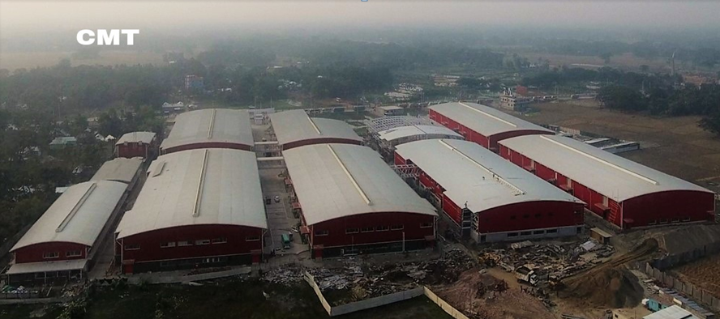
Consumer Knitex Limited ( Trishal)

Dignity Textile Mills Limited (Shreepur)

TO satisfy their dream they are always appointing expert worker who has better skills and they careful to their responsible employees. They are highly caring about the quality of the product so they never compromise to ensure it. From the beginning of the organization they are continuously developing it. They are importing high quality machine from foreign country to ensure quality purpose. With the shirt item they are trying to develop Giants Textile Company also in Bangladesh.



This is an image of Spinning Mill of Consumer Knitex Ltd.

2.8 Industry background

Among the developing world Bangladesh is known as developing country. Once upon a time just was our main cash crop. But in accordance of time it took place of another industry and that is RMG sector of Bangladesh. The journey was started for the sector in our country during Mughal period when Muslim and Jamdani cloth has great goodwill. In the early 1960 2nd large production and 1st garments is known as Reaz store. After our liberation war few entrepreneurs are decided to establish this sector and promise to make it more strong sector.
During that time our woman entrepreneur creates garments named Boishakhi Garments. We stated to export our product since 1977. Then Nurool Quader khan was the pioneer of readymade garment industry in Bangladesh. Since that time still today this sector is developing everyday. At present we achieve the second largest position for exporting readymade garments.
This graph is representing the number garments industry exists in Bangladesh and actual countable condition of RMG sector.

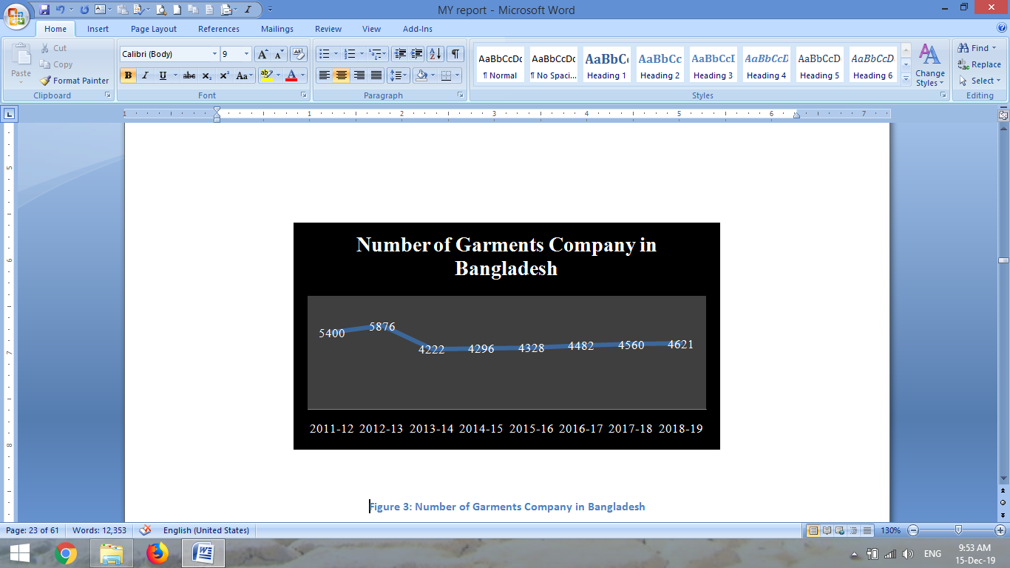

Figure 3: Number of Garments Company in Bangladesh

From BGMEA we let the information which actually showing us that from 2011 to 2012 the number of garments was 5400 which has been increased 5876 on 2013. The owner from that time established more garments because of the high profit they able to earn from that sector.
From 2013 to 2014 number of garments industry has decreased due to some phenomena and some unpredicted digester harm that sector. Rana plaza Collapse more than 2000 people died and thousands of family has lose their main earning source , Tazreen garments phenomena died more than thousands of people by the burn on fire. It was really crewel event for us and also a harming situation for this sector. Many foreign Investor refuse to invest in our country cancel their shipment. For this reason many garments industry had to close their operation.
In 2014 to 2015 foreign buyer again fell interested to invest in this sector although they provide some condition for the safety of the workers. All the garments are agreed to obey the condition. BGMEA and BKMEA play an important role on that situation they ensure the investor to fulfill the basic safety need for the workers. After that 2015, 2016, 2017, 2018 to 2019 number of garments industry increasing. Because of high quality of the product and cheap labor again foreign coming for investment.

This chart is showing the export data which has been increasing day by day.
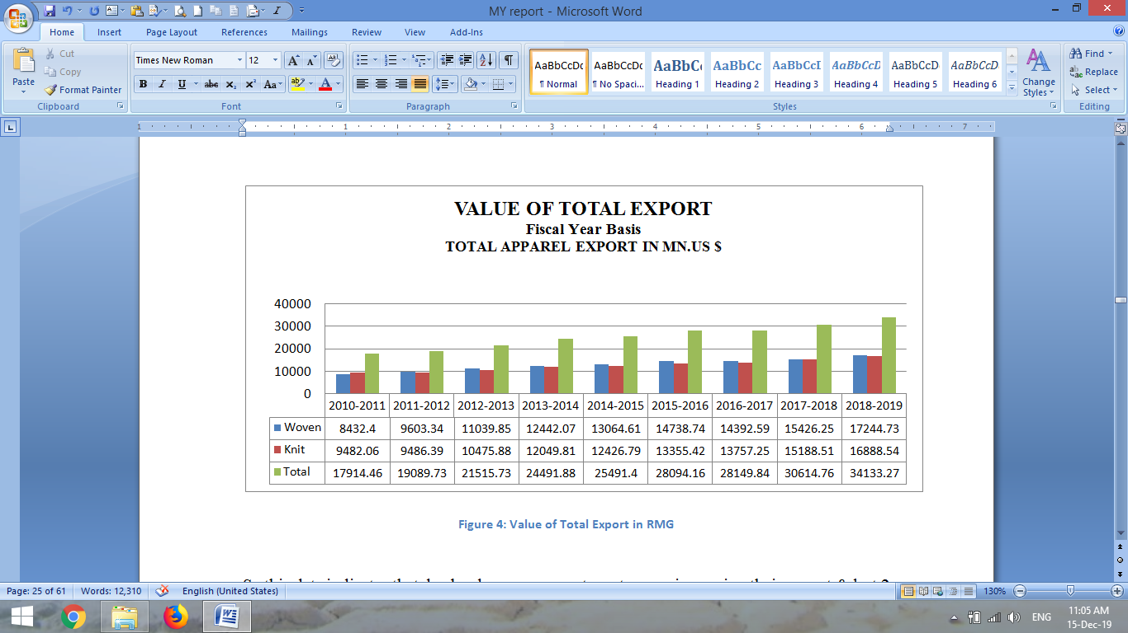
Figure 4: Value of Total Export in RMG

From this chart we may know that this sector is developing day by day. Though in 2012 we observe a very dangerous event on that time but after that this sector was careful about that harmful event. By using new technology all owners are trying to protect that danger. So on new way we are able to increase our production. As new garments are growing number of employment are also increasing. Our exporting product is taking place on Europe and American markets. Our GDP is growing because of this sector.

CHAPTER 3

My internship at Consumer Knitex Ltd.

- Bill check of Purchase, Commercial and Accessories department.
- Market evaluation for audit purpose.
- Communicate with suppliers for their payment purpose.
- Maintain Stationary; prepare Purchase Indent to purchase stationary.
- Licensing and visa passport work.
- Check maintains.
- Attach Money Receipt
- Filing Purchase order copy for purchase department purpose and find it.
- Check maternity leave signature, Face matching with the person.
10. Check Attendance sheet for all Intern.
11. Submission of document to CID office.

My internship at Consumer Knitex Ltd.

I started my internship from 7 September to 8 December at consumer knitex ltd. I was selected for audit department. From the first day my supervisor taught me what will be my major responsibility and how to complete the work. He introduces me with every department and gives me a short brief about their job responsibility. Which department is responsible for what type of work. How a transaction start a process and how to finish the work. One of my major responsibilities was check every department file and the actual process. If the department didn’t complete all the procedure properly I give the file back to that department.

My Supervisor gives me that training that which things I need to follow for which department because each department has separate and different rules. Then I have to check stationary item, before shortage of any stock I need to inform my supervisor so that he may purchase the product. After that my supervisor gave me a short brief about the organization what actually Bangladeshi department does.

Finally they give me some more responsibility to as a part of my internship purpose. I always believes without hard working no one able to learn high quality value. I may able to add some extra benefit and value as my skill development for their given work. My major responsibility for the internship purpose was.
- Bill check of Purchase, Commercial and Accessories department.
- Market evaluation for audit purpose.
- Communicate with suppliers for their payment purpose.
- Maintain Stationary; prepare Purchase Indent to purchase stationary.
- Licensing and visa passport work.
- Check maintains.
- Attach Money Receipt
- Filing Purchase order copy for purchase department purpose and find it.
- Check maternity leave signature, Face matching with the person.
- Check Attendance sheet for all Intern.
- Submission of document to CID office.
3.1 Bills Check:

On the first day of my office my supervisor shows me a General purchase bill. The bill contains authorize signature and authority signature. At first he asked to check all necessary the signature to approve the bill, he also introduce me the whole procedure from where to began a purchase procedure how to purchase who sign for which approve of a bill. If anything was missed he asked me to inform him. Though first week I did some mistake to check some bills but after the month it becomes very easy for me. I could check many bills with in very short time getter than previous time.
After first week another supervisor from the same department asked to check accessories bill. The system for the bill was little bit different from purchase bill. There was no quotation for checking the bill but has some approval from the higher authority. Then the bill contains assurance that the good safely reached on store or not.
After the month my supervisor asked to check commercial bill. Commercial bills contain a quotation by which every amount is checked. For every amount of bill there has a money receipt. Commission was fixed for the freight forwarder. The bill was more sensitive but system is easy. Within very short time I memorize the process.
After the first month I was skilled enough to check every department bills. Sometime I don’t need to ask my supervisor that I am doing the right way nor not. And some time he can keep trust that I am able to check the bill correctly.
There I actually checked three departments’ bills. Those departments are:

- General purchase
- Accessories
- Commercial

3.2 Market Evaluation for audit purpose:
With paper work doesn’t make a learning student proper productive. With paper work when he physically go to market and use his personal experience and common sense with paper work that will make him perfect as he learn when to use which word to talk some one. My supervisor teaches me how to audit on market and how to communicate with whose seller. My job was to evaluate actual price of the product. I physically go to a shop, I told them I come from a company for corporate purchase.
I just hide my company name just to ensure the real price of the product. I told them to give the price quotation. After visiting few shops I just collect the price from them and after the market audit I just make a report on it. I found difference between the many items of exit light. I report it to my supervisor; he finally checked the report and said I did well.

3.3 Communicate with suppliers:

From the second day of my office my second supervisor asked me to communicate with suppliers among those whose check is ready for payment. My supervisor first gives me a hard copy of check list and a hard copy of suppliers list. From the suppliers list find out the suppliers contract number. Then I inform them by SMS. If any suppliers called me to know the amount I told them the amount of their check contains.

3.4 Maintain stationary items and prepare purchase order:
It was not an easy task for me. After every month I have to collect each and every member’s stationary requisition. Then I have to count physical stock. In the store there were more than 170 above item. Many of the item was not familiar to me because in office their needs many type of file like office file, index file, management file box file ETC. So as a student I don’t know the entire item mane. My second supervisor helps me to memorize the name.
After counting the entire item and balancing physical stock I prepare purchase order how many Pecs we need to purchase. My supervisor mainly checked every step with me. Advise me how to I do every step correctly. Then the purchase order was signed by the country director or authorizes officer of the office then purchase department will purchase it.
3.5 Licensing purpose:
During my internship period my supervisor was very busy to turn our organization into multinational organization. I often use to go Office of the Chief controller of Imports and Exports office. Then I have to go ACCORD office. Sometime my supervisor used to take me with him and sometime I go alone. Then I go to BIDA office for documentation purpose.
3.6 Check Maintains:
When accounts issue any check our responsibility was to scan the check copy mail it to my supervisor and print a hard copy of the check. Then I attach the hard copy with the check. My supervisor gives me two hard copy of the same check list. Then I give the check list to the reception and take a received copy of check list. After the day reception gives us back the check if any supplier didn’t received the check. We issue the check next day with new issuing check list.

3.7 Attach money Receipt:

After receiving the check supplier provide signature on the photocopy of the check and provide a money receipt from his organization. We take the receipt and add this receipt with the bill copy before the file was going to store.

3.8 Filing Purchase order copy:

Purchase department gives us purchase order copy we called it PO yellow copy. They make a short list of this copy. After purchase of the product purchase department provide this copy for audit and accounts department for payment order. I received the yellow copy checked it and give to accounts department. Accounts department take the PO number and provides Purchase Indent number. After that they give it back to audit department. I arrange the PO date by date. Make filing and after a certain period of time we give it back to purchase department.

3.9 Check maternity leave signature, Face matching with the person

For internal controlling process an auditor need to check every necessary document. As a part of audit my supervisor gives the responsibility to check the document of maternity leave. The signature is proving that actually the right person take the money. In case of worker sometime their signature does not match with their previous signature on that case the organization take their photograph. I have to check their face match with their id card or not. I learn from my supervisor that how to check the pattern of signature. I can implement this value to other organization. Personally I learn a great deal from consumer knitex limited.

3.10 Check Attendance sheet for all Intern

Form my personal feeling I feel little bit happy when I check others interns attendance sheet. If they were not present the office right time I have the authority to give them absence. Before salary time I check the attendance sheet, scan the sheet make a copy mail it to my supervisor and finally give the attendance sheet to accounts department. After few days accounts give us salary.

Chapter: 4
Theoretical Part of Internal Control System

4.1 Purpose
4.2 Objective
4.3 Implementing Law and Regulation
4.4 Reliable Financial Reporting:
4.5 Efficiency & Effectiveness of Operation:

4.1 Purpose

Internal control is a vital element for the organization. For effectiveness of the organization and to achieve organizations goal internal audit is very necessary. Internal Audit department evaluate all the procedure paper work. Internal audit implement company law and rules. So without this rules company will not achieve its mission.
To sustain in competitive market implement discipline is very necessary. Many of organization gain huge profit because of their effective internal control system, strong management. When an organization is able to gain control over the organization they can able to expand their business on market. On the reverse lack of control can be responsible for huge losses.

4.2 Objective

Without objective no target is become able to face what actually they want to accomplish. Management basically has few objectives to achieve internal control of the organization. Those objectives are
- Implementing Law and Regulation
- Financial report is done without material misleading.
- Organization operating with efficiency and effectively

4.3 Implementing Law and Regulations:
One of the major objectives is implementation of law and regulation properly. By obeying rules and regulation properly company can avoid financial losses and able to increase productivity. According to Section 404 company act every public company must submit a report base on its law and regulation.
Public, Nonpublic and Non-profit organizations need to obey law and regulation of government to Control the internal environment of the organization . Law also protect the right of the employees also.

4.4 Reliable Financial Reporting:
Financial report should be always irrespective. Financial report use owner creditor investor or authorizes third party. To make reliable financial report a company generally uses International Accounting Standard system. In case of Bangladeshi company use Bangladesh Accounting Standard System. (BFRS).

4.5 Efficiency & Effectiveness of Operation:
Efficiency and effectiveness of organization indicates the proper control over the organization. The resources organization is using are properly utilizing to achieve organization goal or not mainly ensure it. Proper controlling ensure financial and non financial information by with company take decision.

Chapter: 5
Management and Auditor Responsibilities for Internal Control

- Inherent Limitations
- Reasonable assurance

Management and Auditor responsibility are not the same works both are related but each one are individual. Management has to establish the rules and maintain the internal control of the organization. Audit department has checked the implementation of rules. According to section 404 companies has to publish a public report on the basis of company rules and law.
In that case auditor main responsibility is to check financial report, evaluate it observe the process properly happening or not.
Auditor has to follow a frame work which actually control by management.
Mainly two key concepts management mainly focus such as:
- Reasonable Assurance
- Inherent Limitations

5.1 Reasonable Assurance:
To provide reliable data and financial statement fairly management should develop their internal control properly. Proper calculation before any physical operation makes the word less costlier and beneficial. Material misstatement can be preventing by using reasonable assurance. For every operation management has to think about the cost and benefits.

5.2 Inherent Limitations:

If auditor wants he can provide reasonable assurance but he cannot provide absolute assurance. Auditor has to follow the core rules, provide statement on the basis of financial statement. To detection of fraud auditor has some restriction for that reason auditor cannot provide absolute assurance. This is called inherent limitation. Auditor may not able to make audit risk zero.
Auditor has to consider financial statement and management is responsible for financial statement so there was some limitation. Sometime auditor doesn’t get proper information as management control it. So intentionally or unintentionally auditor cannot check all the documents properly. That’s why it is not easy to find fraud.

Chapter: 6 COSO Components of Internal Control

COSO’s Components of internal control is more successful internal control framework which use in USA, UK and other developing countries. Auditors mainly focus on these areas. There are five components (Alvin A. Arens, 2018-2019) . COSO’s Components of internal control include five components such as:
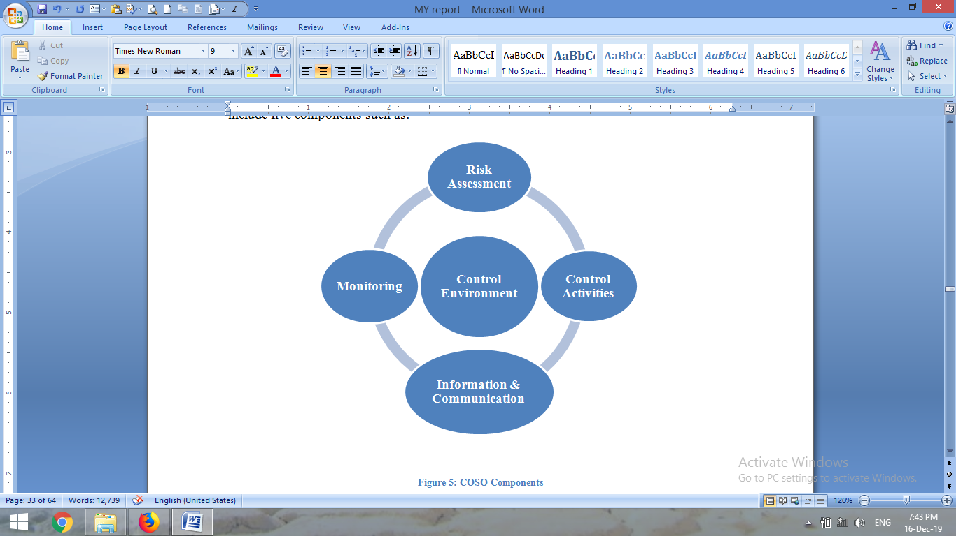

Figure 5: COSO Components
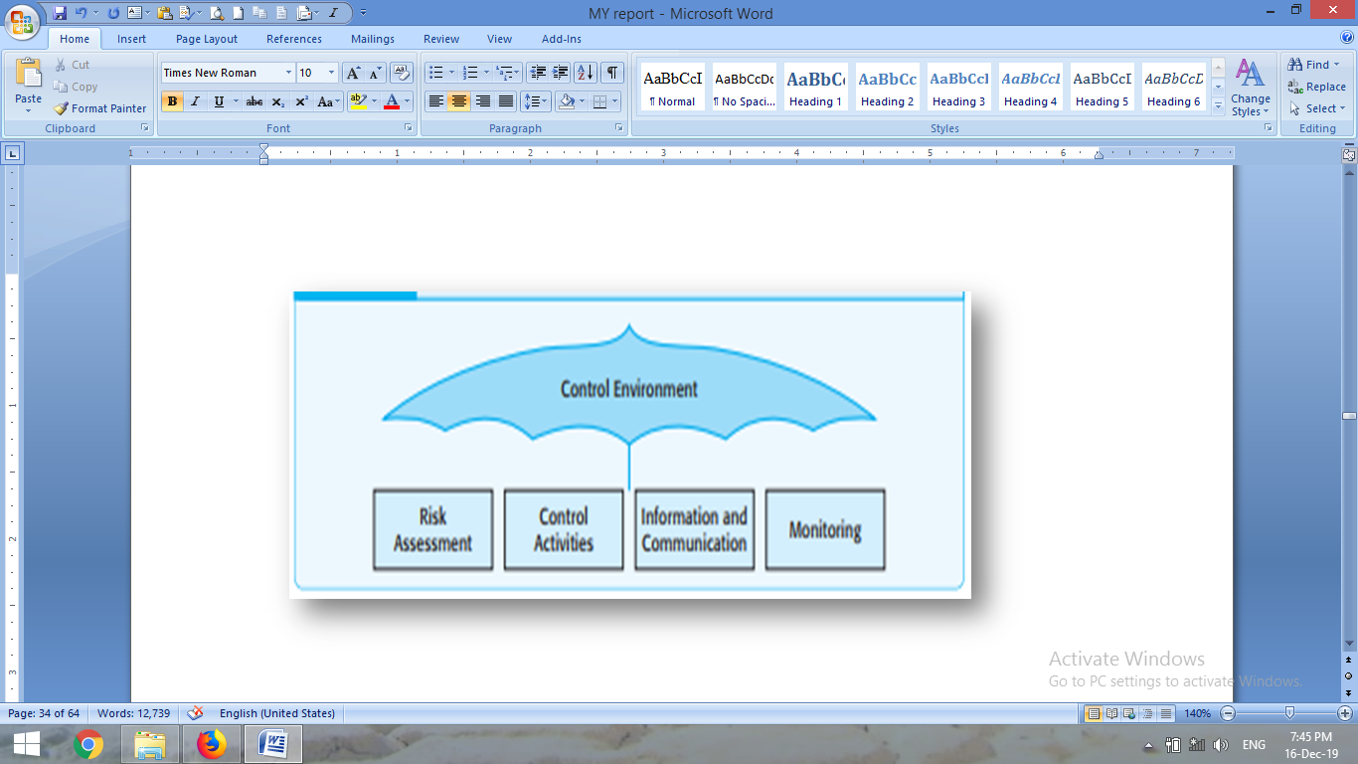
Five Components of Internal Control

Chapter: 7
Control Environment
7.1 Integrity and Ethical Value
7.2 Board of Director or Audit Committee Participation
7.3 The Control Environment Management Philosophy & Operating Style
7.4 Human Resource & Practices
7.5 Organizational Structure

Business environment is consisting of both internal and external environment. External environment consist of Political and economical condition of economy. Political environment is handling by Owner, director and prime management. They know how to deal with them. In this case auditor just focus about some vital Sub- Components.
7.1 Integrity and Ethical Value:
Integrity and ethical values allude ethical and behavioral standards based on situation it is the abbreviation of 4 things such as

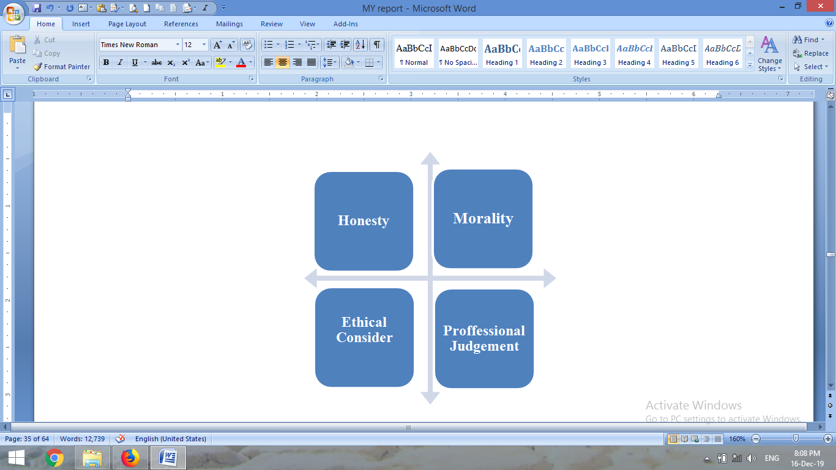

Figure 6: Integrity and Ethical Value

To control environment those 4 things are very important. Company can earn more by using the 4 things and also catch fraud. Internal auditor should consider that element to judge and establish those rules properly. Auditor has to judge their decision along with their professional judgment. Practicing of those four things in organization may reduce illegal or unethical practice.
7.2 Board of Director or Audit Committee Participation:
The board of directors is the essential part of the company. To conduct the company they implement every decision and check every system and also financial decision also. They actually responsible for every decision because have to obey their command. They have to consider major issues of external or internal environment. From the purchase procedure to licensing everything they have to check final result. As they have to observe everything it is very critical for them to observe each and every issue timely but their contribution is necessary equally for everywhere. To solve this problem they create this audit department and make a strong team. By this effective audit team they make full control all other department and on the basis of their contribution board of director can observe each and every issue within very short time.

7.3 The Control Environment Management Philosophy & Operating Style:
We can segment it into 2 Areas such as :

Figure 7: The Control Environment Management Philosophy & Operating Style

7.4 Human Resource Polices & Practices:
Auditors can understand the company policy condition and internal control system properly. Auditor has to check the employee’s salary sheet promotional file very carefully. Auditor has to check the company policy in case of promotion.
7.5 Organizational Structure: From the organizational structure Client can easily understand the company’s system is centralized or decentralize. It is an easy term for other user to easily understand the stature.
Chapter: 8
Risk Assessment
8.1 Financial Risk.
8.2 Credit Risk
8.3 Non Financial Risks
8.4 Social Risk
8.5 Risk of Unforeseen Events:
8.6 Country Risk
8.7 Political Risk
8.8 Economic Risk:

For risk assessment auditors give impasses on financial reporting on the basis of management analysis of risk relevant financial statement with accounting standard or not. Risk can be two types such as.
- Financial Risk.
- Non- Financial Risk

8.1 Financial Risk is a kind of risk where company face liquid money problem when they are unable to pay their payment and can pay their debts. Financial risk is very important for government and also for private organization. It is a burning issue for every organization. For this financial risk company can lose for their potential investor. Any third party, shareholders and stockholder everyone considers this issue before invest money.

Figure 8: Financial risk.

These are all common forms of financial risk.

8.2 Credit Risk:

Credit Risk taking loans from investors or bank and pay back their loan on time. It is a consideration the ability that they can back it on time or not.



8.3 Non Financial Risks

Non-Financial Risks also part of Risk. Basically, Non-financial risk is related to the environment also some of the man-made risks depends on situation. Non-Financial risk is not related to the financial transaction but this kind of risks my responsible for huge financial loss because it is related to the organization.

Figure 11: Non Financial Risks

8.4 Social Risk
The social risk is an external risk of business. This type of risk influence business directly and indirectly. For communication purpose organization has to communicate with human rights violations in workforce. Company has to deal with various labor functions and many corrupted situation which actually create by company officers. .

8.5 Risk of Unforeseen Events:
Any unforeseen event can damage the whole organization. Affect the organization structure, security or entire industry. Unforeseen events may have positive or negative impact on market, price of share or stock

8.6 Country Risk
Country risk is considered one of the critical risks. For organization it is almost impossible to control this situation. Before starting any business company should consider about the fact. Political issue, climate change, Geographical condition change are the main concerning issue for country risk. Organization should consider government economic condition like high tax rate. Before entering any country or expanding business any organization should consider the facts.

8.7 Political Risk
Political risk is another uncontrollable risk for business. Because of Political violence strike or affects that affect the business profitability. Political decision affects the economy directly. For political decision organization investor government buyers sellers and finally consumer could suffer. On the other hand the government whish are less politically stable business is growing on that country. Political instability is essential for business. Only for political instability and politically sober environment many investor come to invest in the country. Before invest any national and multinational country they consider the political risk fact.

8.8 Economic Risk:
Organization investor’s financial bank all are largely affected by economic risk. Government rules, regulations policy and exchange rates all are directly influenced by economic risk.

There are two component of economic risk such as
1. Micro Economic Risk
Micro economic risk refers a micro component of economy to a country such as political condition or action in a host country. Government sometime may or may not able to be take control over it.

2. Macro Economic Risk
Macroeconomic risks are the type of risk by which every business will be affected by it inside the country or sometime may outside of the country. Macro Economy can be threat of foreign exchange rate. Macroeconomic risk may contain government monetary policy, tax policy , government monetary policy , political and civil trouble.

Chapter: 9

SWOT Analyses on Internal Control of Consumer Knitex Ltd.

9.1 Strength
9.2 Weakness
9.3 Opportunities
9.4 Threats

SWOT analysis or matrix analysis is a framework which is developed for the company’s strategic planning also evaluates the company’s competitive position. (Grant, 2019)
Actually SWOT analysis has four components. Those four components are Strength, Opportunity, Weakness, and Threats. To run an organization properly and become successful business they should regular observe carefully and update this process to ensure their business is running effectively. Base on SWOT Analysis Company could run their business on efficiently. For internal and external control SWAT analysis provides a strong graph.
A SWOT executes this in four basic steps that even new business owners can understand and find opportunities. (Schooley, 2019)

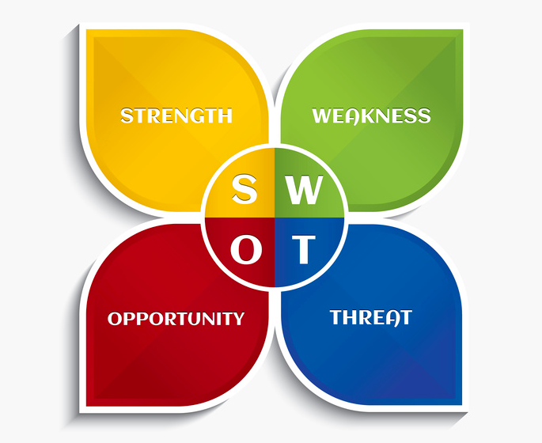
SWOT analysis on Internal Control of Consumer Knitex Ltd.

9.1 Strength: SOWT analysis is examination of a company about four distinct variables. To analysis strength on the basis of CKL we find some points. Few points of Strength are :
- Consumer knitex has strong internal control management.
- Their financial condition is strong.
- Their working environment is more sober and good.
- Their management is skilled enough.
- Their payment system is advance, after month they pay their wages during the first week.
Basically this thing indicates that they have efficient internal control system also their managers and authority control their environment properly. Their efficient management makes it stronger.
9.2 Weakness: If we compare with other company’s consumer knitex is comparatively new in our country so they have some weakness. Now I like to discuss about those weakness.
- Organization has shortage of local engineers so they have to hire from foreign country.
- They have very high turnover ratio. Other organization offer more benefits.
- Their production cost is higher getter than competitor.
- They are unable to create enough training opportunity for their labor.
- They have high cost of storage to stock more Raw Materials.
- For every operational activity they have take approval from higher authority though they live in foreign country. It is more time consuming and delay to take decision.
- They don’t arrange any program to motivate their employees or workers.
- Their salary is poor getter than other organization.
9.3 Opportunities: As our country is a developing country Bangladesh has huge opportunity. As we have low labor cost and huge natural resources like natural gas and water. Consumer knitex limited also find some great opportunity in Bangladesh. Such as :

- They get the opportunity to expand their business in Bangladesh. It’s a great opportunity for them that they get some free space in our country that’s why they can easily ale to establish a new firm in our county.
- Bangladesh has huge natural gas field that’s why they can easily use it and continue their production.
- Their product demand has been increasing for that reason they are getting more orders from their customer.
- To increase their market they are trying to export their product in Japan. If they can create the market they will able to increase their market.
- To earn more profit they will invest more in Bangladesh.

9.4 Threats: To conduct proper operation every company face some problem. Among those problems some problems are major among them and some are minor. Consumer knitex LTD also face some problems. In future upcoming problems are known as threat.
- Money inflation and unstable economic condition may be a big threat for consumer knitex limited.
- Political issues are major issue and big threat for the organization. For any political hazard raw material and other suppliers product can create prevent for shipment.
- In competitive market high raw material prices is a big threat for them.
- Increasing export and import cost is a big problem for the organization and a big threat.
- Competitors are increasing day by day so it’s a big problem for the organization.
Consumer knitex has much better strength getter then many other garments factories in Bangladesh. Threat is much almost similar as like other organization. Consumer knitex has good internal control system for that reason they has much strong strength. If our government assists them with easy term and condition they produce more and will able to export more product from Bangladesh.

Chapter: 10

Findings & Recommendation

Findings: In this report my experience is about Inter audit procedure of consumer knitex Limited. After four month of my internship I notice that they have strong and efficient management. They are very serious and sincere about their internal control system. For their internal control system they have lot of opportunity in future in these sectors.
- Assignment & Task: They Regular meet up their assignments evaluate their work properly. On the other hand if consider about hole industry then I think it should improve more.
- Goal: Almost all the garments are concern to full fill their short term goal as they are less concern to focus long term goal for that reason they don’t full fill their target properly. They sometime don’t abide by government rules properly for that reason they are losing foreign order.

- Accounting System: Many of the garments fail lose because they don’t maintain their accounting system properly but consumer knitex is very efficient because they are concern about proper accounting behind every transaction.

- Salary Structure: Foreign investors are choosing Bangladesh because of low production cost and cheap labor cost. Consumer knitex has the same condition they provide low salary in corporate sectore also.

Recommendation: Consumer knitex has strong internal control system though they have some weakness also. They have lack of local engineer to operate their machines and maintained also. I think this is the right time of consumer knitex to take help of higher authority of IT technology to approve any IT related requisition. For stationary management audit department is maintaining it but it is actually worked of HR department according to my perception because only audit department has the right to ask anyone for their personal use of official stationary.

Chapter: 11 Conclusion

Conclusion: At long last I found the moral internal control, discover The RMG sector and actually a office may continue its operation. An institutor is not only a analyst but also a consultant of the organization. I am lucky enough that I may found a good institutor, with his help I may able to find out how actually relay practical knowledge with theatrical knowledge. In this report I conduct research and collect data to know the outside garments factory and their environment. Economic fact of a country also influenced the production of garments.
For this internship program purpose I have to relay my entire BBA program all theoretical knowledge and help me to realize me with practical knowledge which I actually acquire from the book. This internship program also helps me to adopt with corporate culture. Is is one of the worth experience in my life with a valuable journey in my life with Consumer knitex Limited.
In Bangladesh RMG sector is very important sector with social, economic and environmental code of conduct. Many of the private welfare organization, NGO and also government are always monitor this sector. Government imposes law to protect everyone’s right. The Bangladesh Labor law (2006) which is meets with the international standards. Compliance could be a key demand for all international buyers so Bangladeshi manufacturers can maintain the quality and maintain the law.
At the end of my internship, I have to say that Consumer Knitex Ltd is one of the Bangladesh's top leading clothing organizations. In Mauritius, It is the best because of its good internal control. I can say in the end that the analysis of internal control of Consumer Knitex Ltd. is admittedly sensible and it will be able to maintain its position in the RMG section in Bangladesh.

Internship Completion Certificate
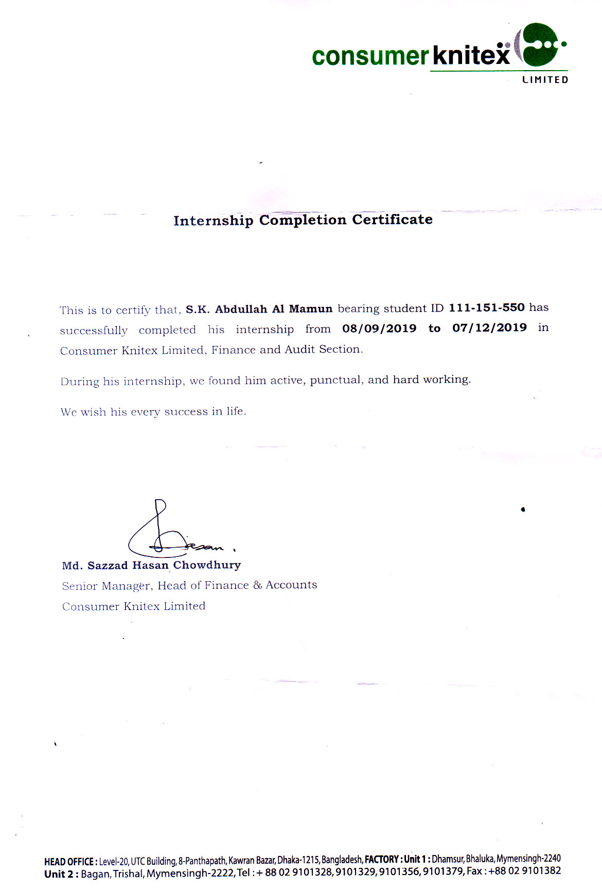

Bibliography
InvestorWords.com. (n.d.). Monitoring. Retrieved December 19, 2019, from InvestorWords.com: http://www.investorwords.com/19314/monitoring.html
Alvin A. Arens, R. J. (2018-2019). Auditing & Assurance Services (15th ed.). United States of America: Pearson Education, Inc.
Anisul M. Islam, F. M. (2011, March 1). Internal Control Policy in the RMG Sector of Bangladesh. Retrieved October 14, 2019, from ACADEMIA: https://www.academia.edu/6523762/Internal_Control_Policy_in_the_RMG_Sector_of_Bangladesh
Anup Kumar Saha, K. C. (2012 ). Internal Control Practices of Readymade Garments Sector(Textile Industry) in Bangladesh , 1,70.
Association, B. G. (2019, May 1). BGMEA. Retrieved October 10, 2019, from About Garment Industry of Bangladesh: http://www.bgmea.com.bd/home/pages/AboutGarmentsIndustry
BGMEA. (2019, September 11). Trade Information . Retrieved September 9, 2019, from Bangladesh Garments Manufactures & Exporters Association : https://www.bgmea.com.bd/home/pages/tradeinformation
BGMEA, E. P. (2019, September 11). Trade Information . Retrieved September 25, 2019, from BGMEA : http://www.bgmea.com.bd/home/pages/TradeInformation
Carolyn Dittmeier CIA, C. P. (2014). Evaluating Internal. 247 Maitland Avenue, Altamonte: The Institute of Internal Auditors Research Foundation.
CFA, I. (n.d.). Risk Management- An Introduction. Retrieved August 8, 2019, from IFT: https://ift.world/booklets/4-2-non-financial-risks/
CHEN, J. (2019, June 25). Corporate Finance & Accounting . Retrieved from INVESTOPEDIA: https://www.investopedia.com/terms/f/financialrisk.asp
CHEN, J. (2019, June 25). Financial Risk. Retrieved 10 23, 2019, from Investopedia: https://www.investopedia.com/terms/f/financialrisk.asp
Deloitte. (2019, 10 23). COSO – Control Environment.

