Crime Sentiment Through Social Media
(Safety Perspective)

Submitted To
Ahmed Imran Kabir
Adjunct Lecturer
School of Business & Economics

Submitted by
Shahrin Sultana
Id: 111 152 084
Major: MIS
Department of School of business & Economic

United International University
Submission Date:June 09,2021
Letter of transmittal

June 09,2021
Ahmed Imran Kabir
Adjunct Lecturer
School of Business & Economics
United International University

Subject - Project paper on “Crime Sentiment Through Social Media’ .

Dear sir,
With all due respect,I would like to introduce my project "Crime Sentiment Through Social Media", which was created as a prerequisite course for completing the BBA. When working on this project, I tried to follow every suggestion recommended to me.
While I was in the learning process, this report gave me some insights into the basic facts of the SPSS. Therefore, it will be a very challenging and interesting experience. Thank you for helping to develop this idea. Without your inspiration, this report would not be complete.
If you can provide some educated hints on the work involved, I will be grateful again.
Sincerely
Shahrin Sultana
Id: 111 152 084

Declaration

I am Shahrin Sultana,hereby declare that the project work titled "Crime Sentiment Through Social Media" is a record of my original work under the guidance of Ahmed Imran Kabir.
It has been proven to be sufficient to partially meet the requirements of the Bachelor of Business Administration.

Shahrin Sultana
Acknowledgement
I want to thank Allah Almighty, because his divine blessings have enabled me to successfully complete last year’s project. I want to thank my superior Ahmed Imran Kabir for my BBA program. I am grateful for his guidance, advice, and support. His positive and calm attitude is very valuable. Unconditional love and support. Without his continued support, I cannot achieve anything. I would also like to thank everyone who participated in the survey of this research project. Without their enthusiastic participation and input, the test may not be successful.

Summery

Social networking sites allow users to share ideas, pictures, messages, actions. Although It has a broad privacy policy, for many reasons, it allows third parties to access a large amount of information about each user which has caused many privacy issues in recent years. The first part of this work is based on bibliographic search, describing social media risks over the past ten years, and analyzing its possible impact on social network users. In the second part of this work, based on a survey of respondents, I tried to find out how users understand the privacy policy and what measures they have taken to protect their privacy. I used SPSS to analyze the results. I tried to show measurements of frequencies, percentages, means, and widespread deviations.

Table Of Content

Letter of transmittal……………………………………………………………………………....……..2
Declaration………………………………………………………………………………………....……3
Acknowledgement……………………………………………………………………………………....4
Summery………………………………………………………………………………………………...5
Chapter 1
Background of the study……………………………………………………………………….1
Statement of the Problem………………………………………………………………..…….2
Objectives of the study……………………………………………………………………...…2
Scope & limitations………………………………………………………………………….…2
Methodology………………………………………………………………………………….…2
Chapter 2 (Review of the Literature)
Introduction…………………………………………………………………………………...…3
Aggressive risk………………………………………………………………………………....5
Sexual risk………………………………………………………………………....……………6
Value related risk………………………………………………………………………...……..7
Commercial risk……………………………………………………………………………..…8
Intervention……………………………………………………………………………………...9
chapter 3 (Research Method)
Research Design……………………………………………………………………………..10
Sample Size…………………………………………………………………………………...10
Data collection………………………………………………………………………………...11
Data collection plan………………………...…………………………………………………11
Chapter 4 (Finding & Analysis) ..............................................................................................12-53
Chapter 5(Conclusion)...................................................................................................................54
Appendix……………………………………………………………………………………………..…5
Chapter 1
Background Of The Study

The main task of Internet users today is to use social networks. Most users use the Internet for entertainment and social purposes. Therefore, there are new social networking sites streaming media every day. Every day, millions of users actively use social media sites such as Facebook, Twitter, YouTube, Instagram, LinkedIn, and Google+. Users upload a variety of data to the Internet, including personal information such as text, images, video, and audio.
The topic of data protection and social media has received great attention from several researchers, because some information transmitted through social media during online activities may have negative effects and adverse events. When various social networks launched social media platforms that allowed third-party developers to provide applications and widgets as additional features, privacy issues also emerged. Online media and third-party developers have commercial advantages. If personal information is leaked, users are still at risk. In addition, users receive a lot of information about online activities through these social networks. Some users may also post information about confidential and private topics. This is because they do not know or deliberately underestimate the security risks on social media. This article examines the relationship between explanatory variables, including: privacy and data security, privacy issues and dependent variable perception privacy control, and personal privacy management. All these relationships are explained in detail in the research methods section.

Statement of the Problem
In addition to the benefits of the Internet, the lack of privacy on social networks is an evolving issue that is not limited to commercial intrusions. The main problem for users is that the government may access users' private information, including their identity , friends, and comments Connect to the Internet without realizing that their online activities are transparent to everyone. Even in open companies beyond Internet control, the disclosure of users personal information can cause great difficulties, including emotional, honour, and other professional or political issues. For example, a person may be unemployed due to an undesired disclosure of undeclared health information. Uploading embarrassing photos without her knowledge or consent may sexually harass women. It is not clear how Internet users in "open" and "closed" societies understand these issues, how they perceive them, and how they can react to them by changing their online behavior.

Objectives of the Study
1) Understand the Internet and some good and bad things on social media.
2) Understand what personal information is and how to protect personal information online.
3) Understand why it is important to be helpful and friendly to other people on the Internet, and how they can be helpful and friendly to other people on social media.
4)Understand online bullying and strategies to combat online bullying and stay online without compromising security or privacy.
Scope and limitations of the Study
Any research always has limitations. In particular, this study has two limitations. First, the easy-to-use sample limits the generality of research results and conclusions. In addition, due to the lack of random selection, boundary analysis cannot be performed.

Methodology:
The questionnaire is used as a tool for collecting data. Use the Social Science Statistics Package (SPSS) to analyze the data. Descriptive measures such as mean and standard deviation were used to check social media usage behavior and crosstab, chi-square analysis was performed to determine the difference between the survey groups.
Chapter 2

REVIEW OF THE LITERATURE

Introduction

The term "Internet security" covers a series of issues directly or indirectly related to the physical and mental health of Internet users. Also called online security, digital security or electronic security. This concept applies not only to the risks people face online, but also to how to protect themselves from these risks. Many studies in this field are related to the safety of internet users. One of the reasons for this particular concern is that young people are the most active users on the Internet. Being online gives them many opportunities, but it may also expose them to different risks. Compared with adults, young people are particularly at risk of facing such risks online, because short-term rewards, especially long-term rewards, can stimulate their interest more than long-term rewards. They are also long-term because they are more prone to dangerous behaviors than adults. Another problem is that their way of accessing the Internet is different from previous generations. They spend more time on laptops, smartphones and tablets, for example in the bedroom. As a result, children’s Internet use is usually carried out without parental supervision. Not affected by online risks. Just like children and teenagers, they are also connected to the Internet. They may be less susceptible to certain risks and are generally reluctant to avoid risks, but they cannot avoid potential negative consequences. Related to dangerous use of the Internet, reputation damage or monetary loss due to online fraud. In addition, some studies have shown that older Internet users (65-90 years old) tend to be inexperienced with different types and functions of technology, which suggests that older users may just be doing so, in some cases, as vulnerable online as younger peers.
Over the years, educational researchers from different disciplines, educators, media outlets, and governmental establishments have voiced worries about the dangers humans face on-line on a day by day foundation and feature expressed the need for suitable interventions in order to minimize the harm some on-line activities may cause, especially to children. More recently, however, a few teachers have begun to label this expanded fear as ethical panic. They claim that the Internet isn't as risky as normally assumed via means of public opinion, seeing that now no longer each hazard Internet customers face will necessarily bring about terrible final results. Nonetheless, they no longer deny that a few Internet customers have terrible stories which bring about harm. Therefore, it is vital to deal with those problems so the dangers Internet customers come upon are minimized without prescribing the possibilities the World Wide Web has to offer. In a 2nd categorization, a difference can be made among dangers associated with on-line content material and people associated with on-line contact (Youth Protection Roundtable, 2009). Contact dangers anticipate an immediate connection or interaction among perpetrator and victim, even as this sort of connection is absent or much less visible whilst dealing with content material dangers. Moreover, a few risks may co-arise in particular on-line contexts (e.g., hate speech ought to result in cyber bullying). As such, it isn't the scope of this access to give an exhaustive review of all dangers Internet customers may also come upon.

Aggressive risk:
The freedom and anonymity provided by the Internet can harm others by spreading pictures or videos. There are many types of cyber bullying. Cyber bullying is the most common term used to widely evaluate this form of online bullying. There is no consensus on the definition of this term, but it can be understood as a competitive or reckless behavior against victims through the Internet or various virtual technologies with the help of individuals or organizations. Although anyone can be a victim of cyberbullying, the research is mainly conducted among young people and teenagers. With definitions and metrics, it is difficult to assess the advantages of cyber bullying in this age group. On average, 20% to 40% of young people have experienced cyber security at least once (Tokunaga, 2010).In the past decade, the number of victims of cyberbullying has even increased (Jones, Mitchell, and Finkelhor, 2012). As young people become active customers of social media and the Internet, this is not always surprising. As a result, a large part of your social activities are now online.
Therefore, the victims of cyberbullying should be seen as the context for changing or expanding the bullying behavior, rather than as an increase in the number of children being bullied. Most victims of cyberbullying are disappointed with this experience. In terms of the frequency, duration and severity of competitions, cyberbullying is associated with mental health problems and educational issues (e.g. depression, social anxiety)., Reduce the score, increase the number of passes). In addition, cyberbullying is related to the bad university atmosphere. It should be noted that, compared with cyberbullying, the damage caused by cyberbullying may be more serious because it can appear anonymously without difficulty. That day. However, it should be noted that apart from the latter, these skills are not specific to the context of cyberbullying. A unique form of cyberbullying is cyberbullying, or repetitive and harmful harassment of people using digital devices. Stalkers can use this virtual technology to obtain data about the victim and obtain results. The difference between cyberbullying and cyberbullying is that by using this definition, bullies no longer want to cause harm, even though they usually cause harm.Often want to provoke an advertisement or friendship with the victim. The analysis confirmed that 6.3% of people have suffered cyberbullying in at least two weeks (Dreβing, Bailer, Anders, Wagner & Gallas, 2014).

Sexual risk:
The Internet has also served as a platform for disseminating pornographic content. If (young) Internet users are faced with such inappropriate content, this may cause concern.One study found that this proportion was 23% ( 10-17 years old) has been reluctant to watch pornography in the past year. When sending these gender-specific texts, photos or videos created by yourself through your mobile phone or mobile phone,On the Internet, this is called pornography. Because there are many definitions and standards for gender identification, the prevalence estimates vary widely.The normal part of the sexual experience, personal. People involved in pornographic text messages should be aware of the risks associated with specific online contacts. After sending a sex message or picture, it is difficult to control what is happening and who can see it. This content may damage your reputation or be used by (online) bullies. In addition, texting will increase the risk of texting. This is a form of blackmail, in which the offender receives explicit pornographic material created by the victim and uses it to exert pressure. Or they engage in sexual intercourse or pay a certain fee.By threatening to disclose this intimate content to friends or family, the bully tries to achieve their goals. Since it is believed that many cases of sexual torture have not been reported, it is difficult to estimate its incidence. The sexual assault on her is also called online nursing. Social media platforms and mobile applications provide a wide range of new tools for sexual predators to reach young people.Although this risk should be seriously considered, the moral panic surrounding this issue may be disproportionate to the loss of online care. In addition, young people do not always know who they communicate with online.

Value related risk:
Although the risks associated with digital attacks and sexual risks have become the subject of extensive research, little is known about the risks associated with securities. These risks are associated with malicious content and unreliable information, which are easy to find on the Internet and may have a negative impact on the value held by individuals. About yourself, a group of people or the whole society. For example, there are many suicide and non-suicide self-harm units (NSSI) that describe and discuss different types of suicide and self-harm. However, most of them specifically advise against harmful behaviors. Some people even ask for help. Processing information about suicide or self-harm may put people in need at risk. Some findings may mean that dealing with suicide and NSSI advice and recommendations can actually lead to an increase in destructive thinking. Suicide sites and NSSI's interactive features can provide seekers with a virtual space in which they can emotionally support each other.Further research is needed to fully understand the motivations of Internet users to visit these types of websites. The Pro-ana website describes anorexia as a lifestyle rather than a disease, with the same duality. Eating disorders, but this does not mean that these places are completely useful and will not cause potential harm to users. For example, a study on places that promote anorexia (Bardone-Cone & Cass, 2007) found that respondents saw anorexia Websites find themselves more difficult than websites opened on other websites. Few studies have investigated security risks. Therefore, it is difficult to estimate how many people will visit a website with such content. Little is known about other ways of disseminating unhealthy information through social media sites. Radical ideological groups also use the Internet to spread hatred and even radical messages. These groups shared many beliefs related to violence.As a reasonable way to achieve group goals, their hatred is usually directed at people of different races, religions, or sexual orientations. Because of their ideology, these groups provide a clear structure that can gain insight into the world, reduce ambiguity, and make membership very attractive to them. It is believed that young people are particularly vulnerable to this type of reasoning when seeking identity and belonging. Depending on the frequency and time of viewing certain messages exposure to hateful or racist content can affect belief systems. In addition, there is concern that exposure in some cases will cause subscribers to mobilize online or even offline for extreme activities. Among young people between the ages of 36, 65.4% are exposed to radiation. Hate the content on the Internet in the past 3 months. To the office,one fifth of the latter even encountered violent content.

Commercial Risk
Businesses and other business participants have developed various methods of collecting personal information from Internet users.On the other hand, the collection of this data is usually opaque. Although it is sometimes possible to refuse cookies, this may make it impossible to use website content. The same goes for social networking sites (SNS). It is impossible to take advantage of SNS-related benefits without disclosing certain personal information.In addition, people often do not understand how to use the collected data. They are an attractive crowd to attract advertisers, and young people are active Internet users, which makes it easier for sales representatives to contact them online and collect their personal information.However, the question is how far young people can judge whether they consume advertising and whether they have collected their personal data. This can be problematic, especially when faced with a mix of marketing and entertainment content . Because the credibility of these games is not obvious, compared with other forms of advertising, games can make it easier for young people to accept advertising messages.It may also affect your decision to disclose personal information. If people are not careful about their personal information, unintended consequences may occur. For example, you may receive spam, which can be defined as unsolicited email, starting with unsolicited advertisements. Inappropriate content, or even fraudulent messages, can be part of a phishing attack, in which criminals or fraudulent organizations try to collect personal financial information. Credit, usually disguised asIf Internet users fall into such scams, it can lead to identity theft and large amounts of money loss. Finally, there are some commercial risks directly related to the behavior of Internet users. One of them is the use of illegal copies. Copyright infringements affect the financial situation of individual creators and the entire creative industry, some people thinkIllegal downloading, sharing and transmission are acceptable practices. In addition, gambling sites may have a negative impact on users. It turns out that this is a relatively new branch of the gambling industry that covers all forms of online gambling and gambling, so it is difficult to study. Because it is not easy to access online game players, most studies use targeted sampling strategies to collect information.Therefore, it is difficult to assess the popularity of online gambling. Research also shows that gambling problems are on the rise.In practice, gambling addiction can have a variety of negative consequences.It obviously causes financial problems, but it can also cause psychological and interpersonal health problems such as stress, anxiety.

Intervention:
Although more and more literature focuses on specific cybersecurity issues, there is still a lack of evidence-based interventions to successfully reduce cyber risks and damage. Sports are opportunities to reach out to minors and adults, stimulate public debate and raise awareness of online safety. At the same time, it is unclear to what extent these sports have also contributed to behavior change. Legislative measures have been taken in the past to mitigate online risks. An important part of these initiatives involves data collection and confidentiality monitoring. In addition, filter software cannot replace teaching young people how to use the Internet responsibly. Survival strategies specifically target children who feel disadvantaged due to online experiences. It is interesting that they suggest a more general approach rather than specific cybersecurity training. They believe that emphasizing general life skills such as empathy, emotional intelligence, and conflict management may be helpful. An example of this approach is the fourth R program, which aims to develop healthy friendships and romantic relationships. Facts have proved that the program can effectively reduce dangerous behaviors in offline mode. This may also apply to online contexts. There are two main types of parental mediation: restrictive mediation and active mediation. The first is when parents try to control or limit the time they spend online, the content they view (for example, using blocking or filtering software), and the online activities of their children.People are critical of this approach, because restrictions can motivate young people to use avoidance techniques. In addition, some people believe that this form of mediation is related to risk reduction, but at the same time limits the possibilities of the Internet.

Chapter 3
RESEARCH METHODS

Research Design

The main challenge of this project is to find information from social media regarding feeling secure.
This research paper is divided into five chapters.
They are: introduction, literature review, proposed methods, results and visualization of results, conclusions and future scope.
Chapter 1: Introduction, goals and specifications, motivation, expected results, report design.
Chapter 2: Literature Review.
Chapter 3: Suggested Methods, Data collection, Sample Size, Data Analysis plan, Questionnaire development.
Chapter 4: Results and Visualization of Results.
Chapter 5: Conclusions and future prospects.

Sample Length
Sample length refers back to the number of contributors or observations protected in a study. The study’s findings should describe from a sample of forty-eight students.

Questionnaire development
The records which may be used with nominal scales are with inside the non-parametric group. The maximum in all likelihood ones could be cross tabulation with chi-square There also are surprisingly state of the art modeling strategies to be had for nominal records.
This study is a YES/NO scale which is nominal. It has no order and there may be no distance between Agree and Disagree.

Data collection
After resuming the break, I explained the nature of the investigation and how to use the results. Invite participants to participate in the survey and inform them that it only takes 10 to 15 minutes to complete the questionnaire. I emphasized that my participation is voluntary and their responses will be consistent and confidential. Before the participants were provided with the informed consent form and questionnaire, they were told that if they did not want to participate in the survey, they did not have or did not need to participate in the consent form.
Data Analysis plan
IBM SPSS Statistics 26 is a software that performs statistical analysis of data. I use this data editor to complete this project. Data analyses protected descriptive records. Descriptive records protected measurements of frequencies, percentages, means, and widespread deviations.
I used grouping methods to analyze nominal data. Variables are grouped into categories, and frequency or percentage can be calculated for each category. The data is also presented visually, for example using a bar chart.One way to analyze data is to test hypotheses. For nominal data, nonparametric tests such as chi-square tests are used to perform hypothesis tests.
- Open the Frequencies window (Analyze> Descriptive Statistics> Frequencies) and double-click the Range variable.
- To get statistics for a mode, click Statistics.
- Check the Mode box and click Next.
- To activate the histogram option, click on the chart. Set the radio button for the histogram.
- Then click "Next". When finished, click "OK".
Calculate Cross tabulation and Chi-square:
- Click Analysis -> Descriptive Statistics -> Cross Tabulation.
- Drag (at least) one variable into the row field, and drag one (at least) one variable into the column field.
- Click Statistics and select Chi-square.
- Click Next, and then. The chi-square test can be performed. The results are displayed on the SPSS output screen.

Chapter- 4
Finding and Analysis

Here the table indicates there are 47 valid and 1 missing value.
 |  | Frequency | Percent | Valid Percent | Cumulative Percent
Valid | Male | 23 | 47.9 | 48.9 | 48.9
Valid | Female | 21 | 43.8 | 44.7 | 93.6
Valid | Non-binary | 2 | 4.2 | 4.3 | 97.9
Valid | Prefer not to answer | 1 | 2.1 | 2.1 | 100.0
Valid | Total | 47 | 97.9 | 100.0
Missing | System | 1 | 2.1
Total |  | 48 | 100.0

This table contains a total of 48 students and a student response did not specify.
The percent column measured out of a total 48 observations. The respondent’s rates are male 47.9%, female 43.8% and others (4.2+2.1) =6.3%.

The valid percent column measured out of 1 non-missing response. The respondent’s rates are male 48.9%, female 44.7%, and others (4.3+2.1) =6.4%.

The cumulative percent column computed by adding the valid percent column up to the row. The first row indicates the valid percentage 48.9% are male 2nd row (48.9+44.7) = 93.6% are female and the rest so on.
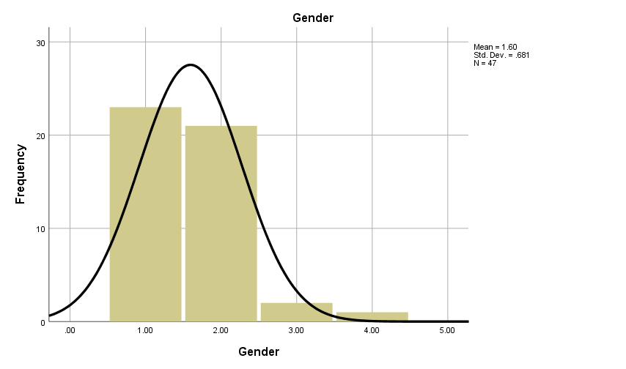

Here, Mean = 1.60 and standard deviation =.681.

Question wise Frequency

- Did you experience bullying on social media?

CSQ1
 |  | Frequency | Percent | Valid Percent | Cumulative Percent
Valid | Disagree | 15 | 31.3 | 31.9 | 31.9
Valid | Agree | 32 | 66.7 | 68.1 | 100.0
Valid | Total | 47 | 97.9 | 100.0
Missing | System | 1 | 2.1
Total |  | 48 | 100.0

In this sample question 15 respondents disagreed and 32 respondents agreed with this question. And the valid percentage observed that 31.9% disagreed and 68.1% agreed.

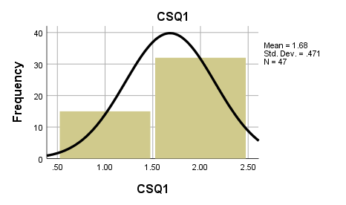
Here,
Mean = 1.68 and standard deviation =.471.

.

2.Are you satisfied with the amount of post engagement or relationships on social media?

CSQ2
 |  | Frequency | Percent | Valid Percent | Cumulative Percent
Valid | Disagree | 16 | 33.3 | 34.0 | 34.0
Valid | Agree | 31 | 64.6 | 66.0 | 100.0
Valid | Total | 47 | 97.9 | 100.0
Missing | System | 1 | 2.1
Total |  | 48 | 100.0

In this sample question 16 respondents disagreed and 31 respondents agreed with this question. And the valid percentage observed that 34.0% disagreed and 66.0% agreed.

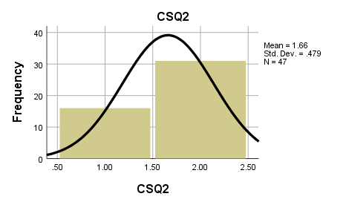

Mean = 1.66 and standard deviation =.479.

3.Did you send your private picture to your partner?

CSQ3
 |  | Frequency | Percent | Valid Percent | Cumulative Percent
Valid | Disagree | 22 | 45.8 | 46.8 | 46.8
Valid | Agree | 25 | 52.1 | 53.2 | 100.0
Valid | Total | 47 | 97.9 | 100.0
Missing | System | 1 | 2.1
Total |  | 48 | 100.0

In this sample question 22 respondents disagreed and 25 respondents agreed with this question. And the valid percentage observed that 46.8% disagreed and 53.2% agreed.

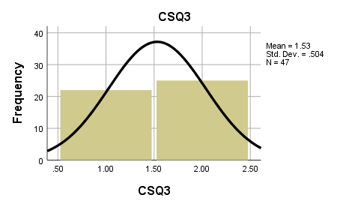

Mean = 1.53 and standard deviation =.504

4.Do you face any problem or harassment about it?

CSQ4
 |  | Frequency | Percent | Valid Percent | Cumulative Percent
Valid | Disagree | 25 | 52.1 | 53.2 | 53.2
Valid | Agree | 22 | 45.8 | 46.8 | 100.0
Valid | Total | 47 | 97.9 | 100.0
Missing | System | 1 | 2.1
Total |  | 48 | 100.0

In this sample question 25 respondents disagreed and 22 respondents agreed with this question. And the valid percentage observed that 53.2% disagreed and 46.8% agreed.

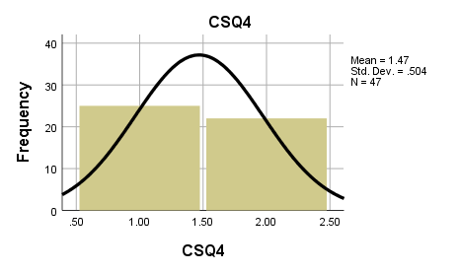

Mean = 1.47 and standard deviation =.504

5. Have you felt free to share your own thoughts?
CSQ5
 |  | Frequency | Percent | Valid Percent | Cumulative Percent
Valid | Disagree | 25 | 52.1 | 53.2 | 53.2
Valid | Agree | 22 | 45.8 | 46.8 | 100.0
Valid | Total | 47 | 97.9 | 100.0
Missing | System | 1 | 2.1
Total |  | 48 | 100.0

In this sample question 25 respondents disagreed and 22 respondents agreed with this question. And the valid percentage observed that 53.2% disagreed and 46.8% agreed.

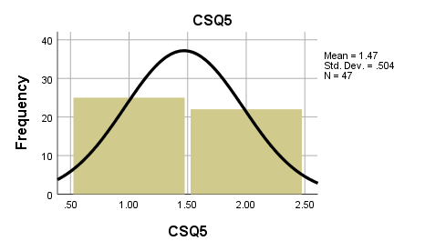

Mean = 1.47 and standard deviation =.504

6.Do you think the government ensures proper safety on social media?

CSQ6
 |  | Frequency | Percent | Valid Percent | Cumulative Percent
Valid | Disagree | 33 | 68.8 | 70.2 | 70.2
Valid | Agree | 14 | 29.2 | 29.8 | 100.0
Valid | Total | 47 | 97.9 | 100.0
Missing | System | 1 | 2.1
Total |  | 48 | 100.0

In this sample question 33 respondents disagreed and 14 respondents agreed with this question. And the valid percentage observed that 70.2% disagreed and 29.8% agreed.
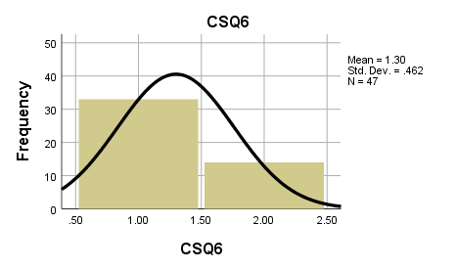
Mean = 1.30 and standard deviation =.462

7.Have you any fake account?

CSQ7
 |  | Frequency | Percent | Valid Percent | Cumulative Percent
Valid | Disagree | 33 | 68.8 | 70.2 | 70.2
Valid | Agree | 14 | 29.2 | 29.8 | 100.0
Valid | Total | 47 | 97.9 | 100.0
Missing | System | 1 | 2.1
Total |  | 48 | 100.0

In this sample question 33 respondents disagreed and 14 respondents agreed with this question. And the valid percentage observed that 70.2% disagreed and 29.8% agreed.

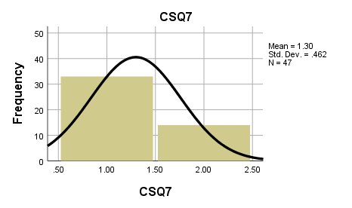

Mean = 1.30 and standard deviation =.462

8.Do you react to it?

CSQ8
 |  | Frequency | Percent | Valid Percent | Cumulative Percent
Valid | Disagree | 33 | 68.8 | 71.7 | 71.7
Valid | Agree | 13 | 27.1 | 28.3 | 100.0
Valid | Total | 46 | 95.8 | 100.0
Missing | System | 2 | 4.2
Total |  | 48 | 100.0

In this sample question 33 respondents disagreed and 13 respondents agreed with this question. And the valid percentage observed that 71.7% disagreed and 28.3% agreed.
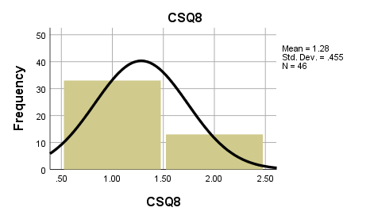

Mean = 1.28 and standard deviation =.455

9. Does social media affect mental health?

CSQ9
 |  | Frequency | Percent | Valid Percent | Cumulative Percent
Valid | Disagree | 3 | 6.3 | 6.4 | 6.4
Valid | Agree | 44 | 91.7 | 93.6 | 100.0
Valid | Total | 47 | 97.9 | 100.0
Missing | System | 1 | 2.1
Total |  | 48 | 100.0

In this sample question 3 respondents disagreed and 44 respondents agreed with this question. And the valid percentage observed that 6.4% disagreed and 93.6% agreed.

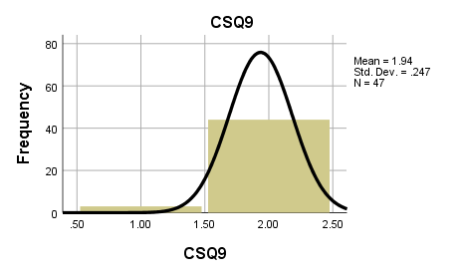

Mean = 1.94 and standard deviation =.247

10.Did you have a negative experience with a virtual site where you give your identical information?

CSQ10
 |  | Frequency | Percent | Valid Percent | Cumulative Percent
Valid | Disagree | 20 | 41.7 | 42.6 | 42.6
Valid | Agree | 27 | 56.3 | 57.4 | 100.0
Valid | Total | 47 | 97.9 | 100.0
Missing | System | 1 | 2.1
Total |  | 48 | 100.0

In this sample question 20 respondents disagreed and 27 respondents agreed with this question. And the valid percentage observed that 42.6% disagreed and 57.4% agreed.

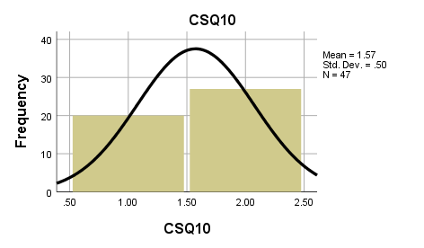

Mean = 1.57 and standard deviation =.50

12.Do you feel safe online?

CSQ11
 |  | Frequency | Percent | Valid Percent | Cumulative Percent
Valid | Disagree | 27 | 56.3 | 57.4 | 57.4
Valid | Agree | 20 | 41.7 | 42.6 | 100.0
Valid | Total | 47 | 97.9 | 100.0
Missing | System | 1 | 2.1
Total |  | 48 | 100.0

In this sample question 27 respondents disagreed and 20 respondents agreed with this question. And the valid percentage observed that 57.4% disagreed and 42.6% agreed.

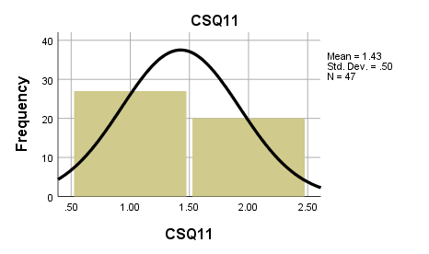

Mean = 1.43 and standard deviation =.50

12. Have you ever shared your password with someone?

CSQ12
 |  | Frequency | Percent | Valid Percent | Cumulative Percent
Valid | Disagree | 32 | 66.7 | 68.1 | 68.1
Valid | Agree | 15 | 31.3 | 31.9 | 100.0
Valid | Total | 47 | 97.9 | 100.0
Missing | System | 1 | 2.1
Total |  | 48 | 100.0

In this sample question 32 respondents disagreed and 15 respondents agreed with this question. And the valid percentage observed that 68.1% disagreed and 31.9% agreed.

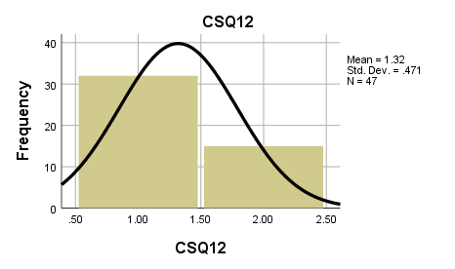
Mean = 1.32 and standard deviation =.471

13.Have you opened emails from total strangers?

CSQ13
 |  | Frequency | Percent | Valid Percent | Cumulative Percent
Valid | Disagree | 30 | 62.5 | 63.8 | 63.8
Valid | Agree | 17 | 35.4 | 36.2 | 100.0
Valid | Total | 47 | 97.9 | 100.0
Missing | System | 1 | 2.1
Total |  | 48 | 100.0

In this sample question 30 respondents disagreed and 17 respondents agreed with this question. And the valid percentage observed that 63.8% disagreed and 36.2% agreed.

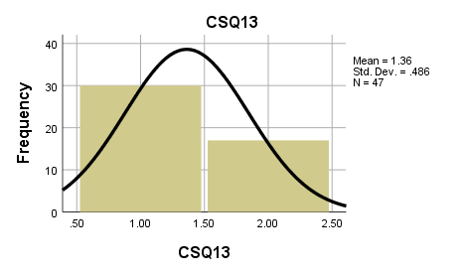
Mean = 1.36 and standard deviation =.486

14.Have you ever purchased anything online without permission?

CSQ14
 |  | Frequency | Percent | Valid Percent | Cumulative Percent
Valid | Disagree | 32 | 66.7 | 68.1 | 68.1
Valid | Agree | 15 | 31.3 | 31.9 | 100.0
Valid | Total | 47 | 97.9 | 100.0
Missing | System | 1 | 2.1
Total |  | 48 | 100.0

In this sample question 32 respondents disagreed and 15 respondents agreed with this question. And the valid percentage observed that 68.1% disagreed and 31.9% agreed.

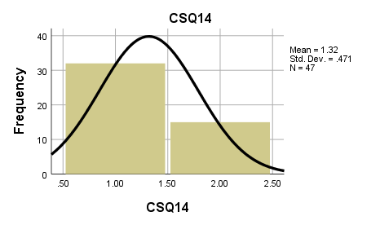

Mean = 1.32 and standard deviation =.471

15.Have you ever been involved in chat sessions with people using vulgar expressions or sexually explicit language?

CSQ15
 |  | Frequency | Percent | Valid Percent | Cumulative Percent
Valid | Disagree | 28 | 58.3 | 59.6 | 59.6
Valid | Agree | 19 | 39.6 | 40.4 | 100.0
Valid | Total | 47 | 97.9 | 100.0
Missing | System | 1 | 2.1
Total |  | 48 | 100.0

In this sample question 28 respondents disagreed and 19 respondents agreed with this question. And the valid percentage observed that 59.6% disagreed and 40.4% agreed.

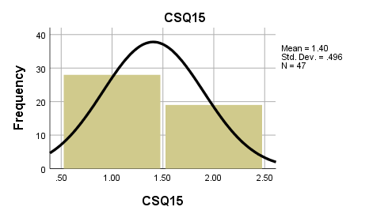

Mean = 1.40 and standard deviation =.496

Crosstabs Analysis

Case Processing Summary
 | Cases
 | Valid |  | Missing |  | Total
 | N | Percent | N | Percent | N | Percent
Gender * CSQ1 | 47 | 97.9% | 1 | 2.1% | 48 | 100.0%
Gender * CSQ2 | 47 | 97.9% | 1 | 2.1% | 48 | 100.0%
Gender * CSQ3 | 47 | 97.9% | 1 | 2.1% | 48 | 100.0%
Gender * CSQ4 | 47 | 97.9% | 1 | 2.1% | 48 | 100.0%
Gender * CSQ5 | 47 | 97.9% | 1 | 2.1% | 48 | 100.0%
Gender * CSQ6 | 47 | 97.9% | 1 | 2.1% | 48 | 100.0%
Gender * CSQ7 | 47 | 97.9% | 1 | 2.1% | 48 | 100.0%
Gender * CSQ8 | 46 | 95.8% | 2 | 4.2% | 48 | 100.0%
Gender * CSQ9 | 47 | 97.9% | 1 | 2.1% | 48 | 100.0%
Gender * CSQ10 | 47 | 97.9% | 1 | 2.1% | 48 | 100.0%
Gender * CSQ11 | 47 | 97.9% | 1 | 2.1% | 48 | 100.0%
Gender * CSQ12 | 47 | 97.9% | 1 | 2.1% | 48 | 100.0%
Gender * CSQ13 | 47 | 97.9% | 1 | 2.1% | 48 | 100.0%
Gender * CSQ14 | 47 | 97.9% | 1 | 2.1% | 48 | 100.0%
Gender * CSQ15 | 47 | 97.9% | 1 | 2.1% | 48 | 100.0%

This table shows the Case Processing summary, which discloses the number of valid cases used for the analysis.

Gender * CSQ1
Count Table
 |  | CSQ1 |  | Total
 |  | Disagree | Agree | Total
Gender | Male | 9 | 14 | 23
Gender | Female | 6 | 15 | 21
Gender | Non-binary | 0 | 2 | 2
Gender | Prefer not to answer | 0 | 1 | 1
Total |  | 15 | 32 | 47

This count table shows ,15 respondents disagreed and 32 respondents agreed with this question.

Chi-Square Tests
 | Value | df | Asymptotic Significance (2-sided)
Pearson Chi-Square | 2.065ª | 3 | .559
Likelihood Ratio | 2.949 | 3 | .400
Linear-by-Linear Association | 1.821 | 1 | .177
N of Valid Cases | 47
a. 4 cells (50.0%) have expected count less than 5. The minimum expected count is .32.
$H_{0}:Experienced bullying on social media$
$H_{1}:Not experienced bullying on social media$

With the level of significant .05,
The value of test statistic is 2.065 and p = .559

In this case the p-value is greater than the significance level (α = 0.05), so that I do not reject the null hypothesis. That means the highest number of people are experiencing bullying on social media.

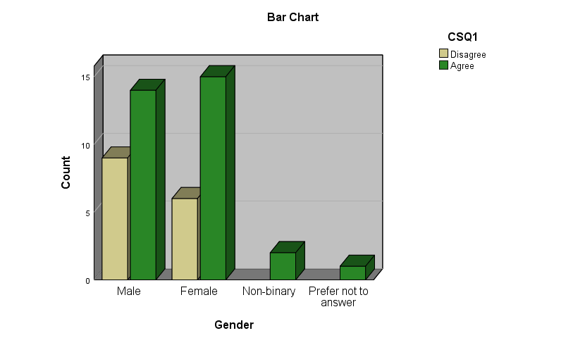

The green bars represent the respondents who agree that they are experiencing bullying on social media and the brown bars represent the respondents who disagree with the question.

Gender * CSQ2
 |  | CSQ2 |  | Total
 |  | Disagree | Agree | Total
Gender | Male | 11 | 12 | 23
Gender | Female | 5 | 16 | 21
Gender | Non-binary | 0 | 2 | 2
Gender | Prefer not to answer | 0 | 1 | 1
Total |  | 16 | 31 | 47

This count table shows ,16 respondents disagreed and 31 respondents agreed with this question.
Chi-Square Tests
 | Value | df | Asymptotic Significance (2-sided)
Pearson Chi-Square | 4.474ª | 3 | .215
Likelihood Ratio | 5.390 | 3 | .145
Linear-by-Linear Association | 4.199 | 1 | .040
N of Valid Cases | 47
a. 4 cells (50.0%) have expected count less than 5. The minimum expected count is .34.

$$H_{0}:Satisfied the amount of post engagement or relationship on social media$$
$$H_{1}:Not Satisfied the amount of post engagement or relationship on social media$$

With the level of significant .05,
The value of test statistic is 4.474 and p = .215
In this case the p-value is greater than the significance level (α = 0.05), so that I do not reject the null hypothesis. People are satisfied with the amount of post engagement or relationships on social media.
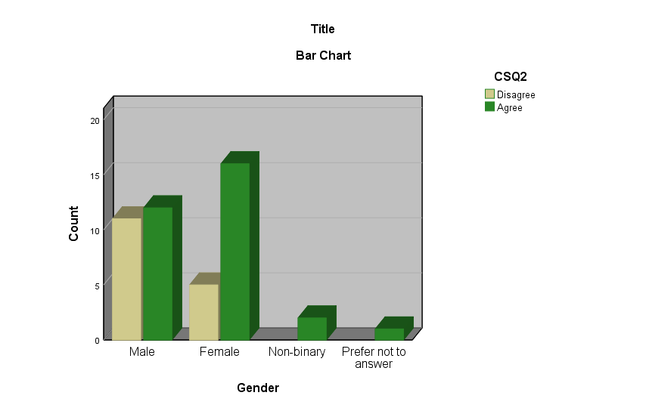
The green bars represent the respondents who agree that they are satisfied to post engagement on social media and the brown bars represent the respondents who disagree with the question.

Gender * CSQ3

Crosstab
Count
 |  | CSQ3 |  | Total
 |  | Disagree | Agree | Total
Gender | Male | 10 | 13 | 23
Gender | Female | 11 | 10 | 21
Gender | Non-binary | 1 | 1 | 2
Gender | Prefer not to answer | 0 | 1 | 1
Total |  | 22 | 25 | 47

This count table shows ,22 respondents disagreed and 25 respondents agreed with this question.

Chi-Square Tests
 | Value | df | Asymptotic Significance (2-sided)
Pearson Chi-Square | 1.253ª | 3 | .740
Likelihood Ratio | 1.635 | 3 | .652
Linear-by-Linear Association | .002 | 1 | .964
N of Valid Cases | 47
a. 4 cells (50.0%) have expected count less than 5. The minimum expected count is .47.

$$H_{0}: Share personal information on social media$$
$$H_{1}:Do not share personal information on social media$$

With the level of significant .05,
The value of test statistic is 1.253 and p = .740

In this case the p-value is greater than the significance level (α = 0.05), so that I do not reject the null hypothesis. That means the highest number of people are comfortable to share their personal information on social media.

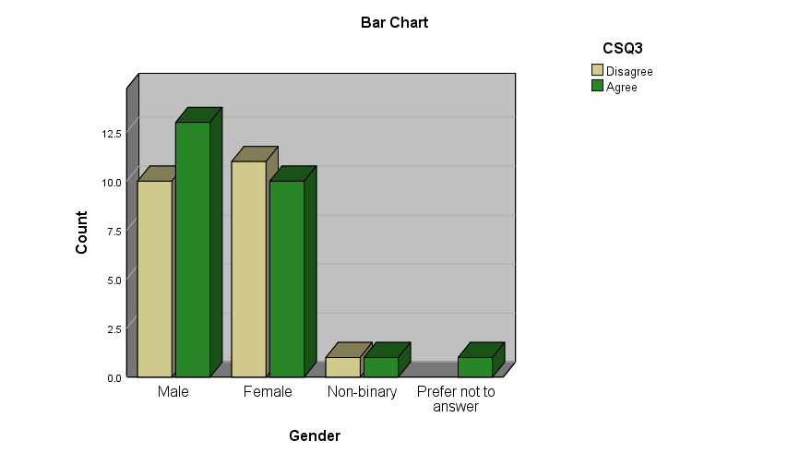

The green bars represent the respondents who agree that they send personal information on social media and the brown bars represent the respondents who disagree with the question.

Gender * CSQ4

Crosstab
Count
 |  | CSQ4 |  | Total
 |  | Disagree | Agree | Total
Gender | Male | 13 | 10 | 23
Gender | Female | 11 | 10 | 21
Gender | Non-binary | 1 | 1 | 2
Gender | Prefer not to answer | 0 | 1 | 1
Total |  | 25 | 22 | 47

This count table shows 25 respondents disagreed and 22 respondents agreed with this question.

Chi-Square Tests
 | Value | df | Asymptotic Significance (2-sided)
Pearson Chi-Square | 1.253ª | 3 | .740
Likelihood Ratio | 1.635 | 3 | .652
Linear-by-Linear Association | .661 | 1 | .416
N of Valid Cases | 47
a. 4 cells (50.0%) have expected count less than 5. The minimum expected count is .47.

$$H_{0}:Not Faces any problem or harassment about share information$$
$$H_{1}:Faces any problem or harassment about share information$$

With the level of significant .05,
The value of test statistic is 1.253 and p = .740

In this case the p-value is greater than the significance level (α = 0.05), so that I do not reject the null hypothesis. Respondents face problems sharing information.
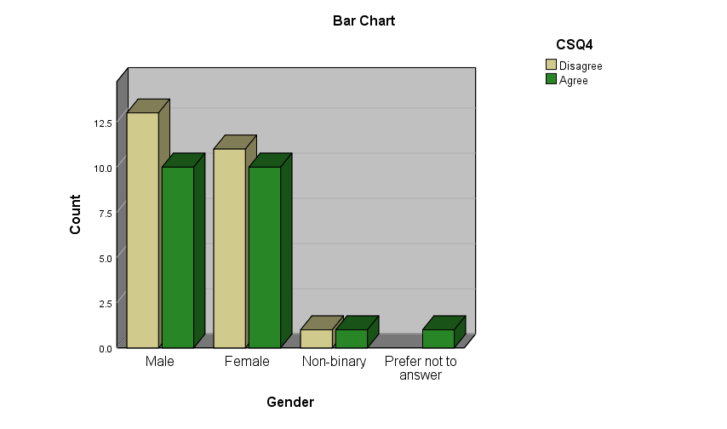

The green bars represent the respondents and the brown bars represent the respondents who disagree with the question.

Gender * CSQ5
Crosstab
Count
 |  | CSQ5 |  | Total
 |  | Disagree | Agree | Total
Gender | Male | 13 | 10 | 23
Gender | Female | 10 | 11 | 21
Gender | Non-binary | 2 | 0 | 2
Gender | Prefer not to answer | 0 | 1 | 1
Total |  | 25 | 22 | 47

This count table shows ,25 respondents disagreed and 22 respondents agreed with this question.

Chi-Square Tests
 | Value | df | Asymptotic Significance (2-sided)
Pearson Chi-Square | 3.261ª | 3 | .353
Likelihood Ratio | 4.407 | 3 | .221
Linear-by-Linear Association | .147 | 1 | .701
N of Valid Cases | 47
a. 4 cells (50.0%) have expected count less than 5. The minimum expected count is .47.

$$H_{0}:Do not felt free to share own thoughts$$
$$H_{1}: Felt free to share own thoughts$$

With the level of significant .05,
The value of test statistic is 3.261 and p = .353

In this case the p-value is greater than the significance level (α = 0.05), so that I do not reject the null hypothesis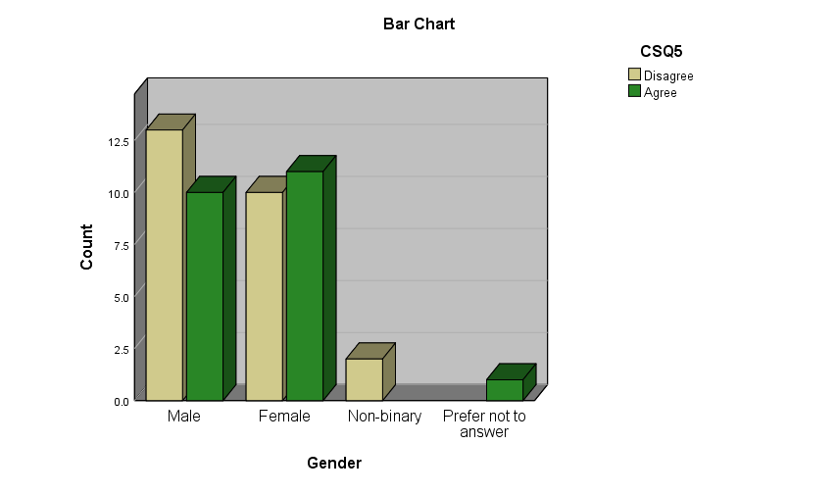
The green bars represent the respondents who agree that they feel free to share their own thoughts on social media and the brown bars represent the respondents who disagree with the question.
Gender * CSQ6

Crosstab
Count
 |  | CSQ6 |  | Total
 |  | Disagree | Agree | Total
Gender | Male | 18 | 5 | 23
Gender | Female | 12 | 9 | 21
Gender | Non-binary | 2 | 0 | 2
Gender | Prefer not to answer | 1 | 0 | 1
Total |  | 33 | 14 | 47

This count table shows,33 respondents disagreed and 14 respondents agreed with this question.

Chi-Square Tests
 | Value | df | Asymptotic Significance (2-sided)
Pearson Chi-Square | 3.700ª | 3 | .296
Likelihood Ratio | 4.484 | 3 | .214
Linear-by-Linear Association | .095 | 1 | .757
N of Valid Cases | 47
a. 4 cells (50.0%) have expected count less than 5. The minimum expected count is .30.

$$H_{0}:Government do not ensure proper safety on social media$$
$$H_{1}:Government ensure proper safety on social media$$

With the level of significant .05,
The value of test statistic is 3.700 and p = .296
In this case the p-value is greater than the significance level (α = 0.05), so that I do not reject the null hypothesis. Respondents think that the Government does not take proper safety measures to ensure social media.
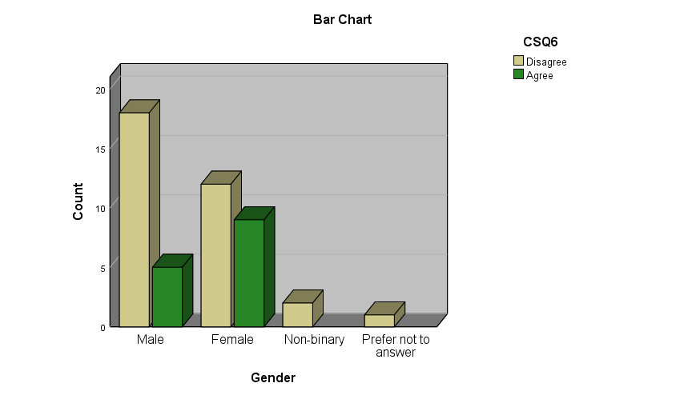
The green bars represent the respondents who agreed and the brown bars represent the respondents who disagree with the question.

Gender * CSQ7

Crosstab
Count
 |  | CSQ7 |  | Total
 |  | Disagree | Agree | Total
Gender | Male | 19 | 4 | 23
Gender | Female | 11 | 10 | 21
Gender | Non-binary | 2 | 0 | 2
Gender | Prefer not to answer | 1 | 0 | 1
Total |  | 33 | 14 | 47

This count table shows ,33 respondents disagreed and 14 respondents agreed with this question.

Chi-Square Tests
 | Value | df | Asymptotic Significance (2-sided)
Pearson Chi-Square | 6.155ª | 3 | .104
Likelihood Ratio | 6.933 | 3 | .074
Linear-by-Linear Association | .605 | 1 | .437
N of Valid Cases | 47
a. 4 cells (50.0%) have expected count less than 5. The minimum expected count is .30.

$$H_{0}: Not experienced on fake account$$
$$H_{1}: experienced on fake account$$

With the level of significant .05,
The value of test statistic is 6.155 and p = .104
In this case the p-value is greater than the significance level (α = 0.05), so that I do not reject the null hypothesis.

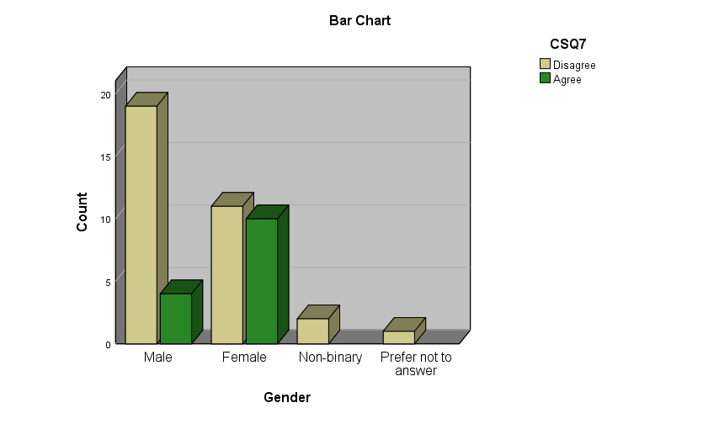

The green bars represent the respondents agree and the brown bars represent the respondents who disagree with the question.

Gender * CSQ8

Crosstab
Count
 |  | CSQ8 |  | Total
 |  | Disagree | Agree | Total
Gender | Male | 17 | 6 | 23
Gender | Female | 14 | 7 | 21
Gender | Non-binary | 2 | 0 | 2
Total |  | 33 | 13 | 46

This count table shows ,33 respondents disagreed and 13 respondents agreed with this question.

Chi-Square Tests
 | Value | df | Asymptotic Significance (2-sided)
Pearson Chi-Square | 1.108ª | 2 | .575
Likelihood Ratio | 1.641 | 2 | .440
Linear-by-Linear Association | .001 | 1 | .971
N of Valid Cases | 46
a. 2 cells (33.3%) have expected count less than 5. The minimum expected count is .57.

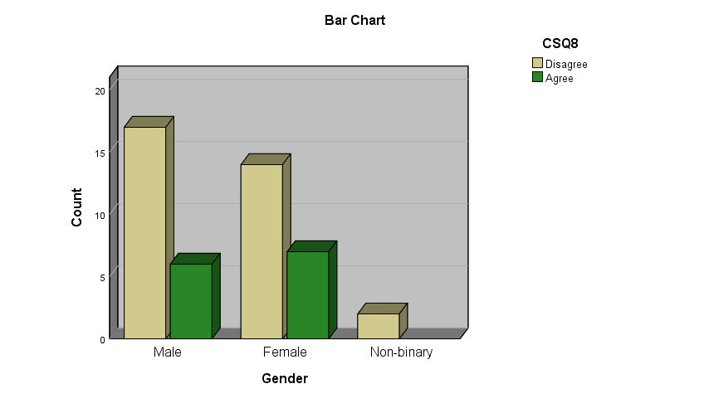

The green bars represent the respondents who agree that they will react if they have any fake account and the brown bars represent the respondents who disagree with the question.

Gender * CSQ9

Crosstab
Count
 |  | CSQ9 |  | Total
 |  | Disagree | Agree | Total
Gender | Male | 2 | 21 | 23
Gender | Female | 1 | 20 | 21
Gender | Non-binary | 0 | 2 | 2
Gender | Prefer not to answer | 0 | 1 | 1
Total |  | 3 | 44 | 47
This count table shows ,3 respondents disagreed and 44 respondents agreed with this question.

Chi-Square Tests
 | Value | df | Asymptotic Significance (2-sided)
Pearson Chi-Square | .503ª | 3 | .918
Likelihood Ratio | .683 | 3 | .877
Linear-by-Linear Association | .476 | 1 | .490
N of Valid Cases | 47
a. 6 cells (75.0%) have expected count less than 5. The minimum expected count is .06.

$$H_{0}:Social media affect mental health$$
$$H_{1}:Social does not media affect mental health$$

With the level of significant .05,
The value of test statistic is .503 and p = .918

In this case the p-value is greater than the significance level (α = 0.05), so that I do not reject the null hypothesis. That means the highest number of people think that social media affects mental health.

Gender * 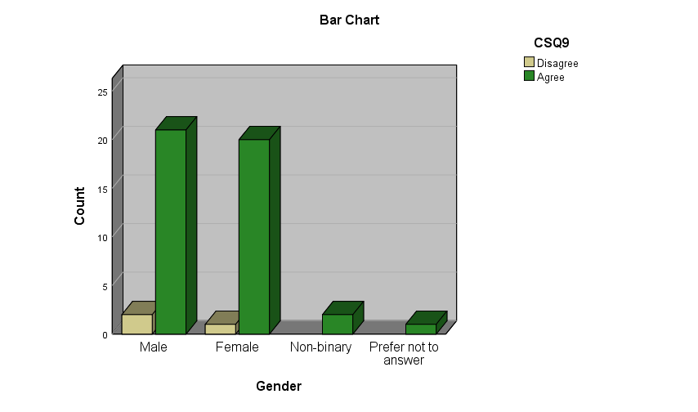

The green bars represent the respondents who agreed that social media affects mental health and the brown bars represent the respondents who disagreed with the question.
CSQ10

Crosstab
Count
 |  | CSQ10 |  | Total
 |  | Disagree | Agree | Total
Gender | Male | 8 | 15 | 23
Gender | Female | 11 | 10 | 21
Gender | Non-binary | 0 | 2 | 2
Gender | Prefer not to answer | 1 | 0 | 1
Total |  | 20 | 27 | 47

This count table shows ,20 respondents disagreed and 27 respondents agreed with this question.

Chi-Square Tests
 | Value | df | Asymptotic Significance (2-sided)
Pearson Chi-Square | 4.229ª | 3 | .238
Likelihood Ratio | 5.325 | 3 | .150
Linear-by-Linear Association | .816 | 1 | .366
N of Valid Cases | 47
a. 4 cells (50.0%) have expected count less than 5. The minimum expected count is .43.

$$H_{0}:Have a negative experience with a virtual site where give identical information$$
$H_{1}:Have not a negative experience with a virtual site where give identical information$

With the level of significant .05,
The value of test statistic is 4.229 and p = .238
In this case the p-value is greater than the significance level (α = 0.05), so that I do not reject the null hypothesis. That means the highest number of people have a negative experience with a virtual site where they give identical information.
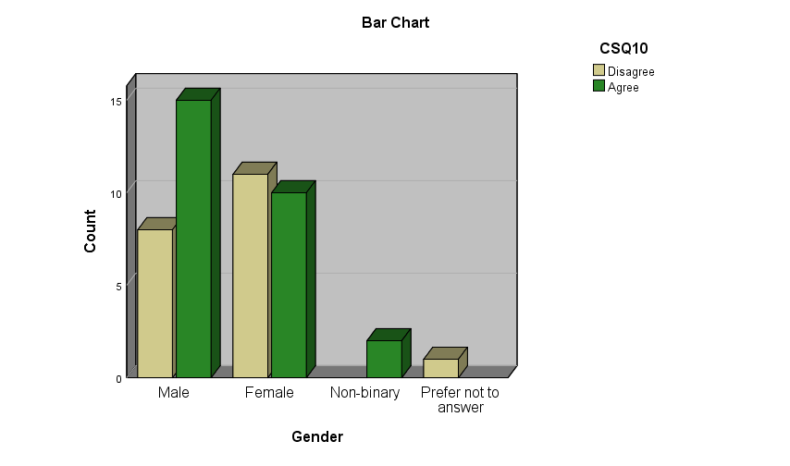
The green bars represent the respondents who agree that they have a negative experience with a virtual site where they give identical information and the brown bars represent the respondents who disagree with the question.

Gender * CSQ11

Crosstab
Count
 |  | CSQ11 |  | Total
 |  | Disagree | Agree | Total
Gender | Male | 13 | 10 | 23
Gender | Female | 12 | 9 | 21
Gender | Non-binary | 2 | 0 | 2
Gender | Prefer not to answer | 0 | 1 | 1
Total |  | 27 | 20 | 47

This count table shows ,27 respondents disagreed and 20 respondents agreed with this question.

Chi-Square Tests
 | Value | df | Asymptotic Significance (2-sided)
Pearson Chi-Square | 2.840ª | 3 | .417
Likelihood Ratio | 3.935 | 3 | .269
Linear-by-Linear Association | .001 | 1 | .971
N of Valid Cases | 47
a. 4 cells (50.0%) have expected count less than 5. The minimum expected count is .43.

$$H_{0}: Not feeling safe online$$
$$H_{1}:feeling safe online$$
With the level of significant .05,
The value of test statistic is 2.840 and p = .417

In this case the p-value is greater than the significance level (α = 0.05), so that I do not reject the null hypothesis. That means the highest number of people are not feeling safe online.
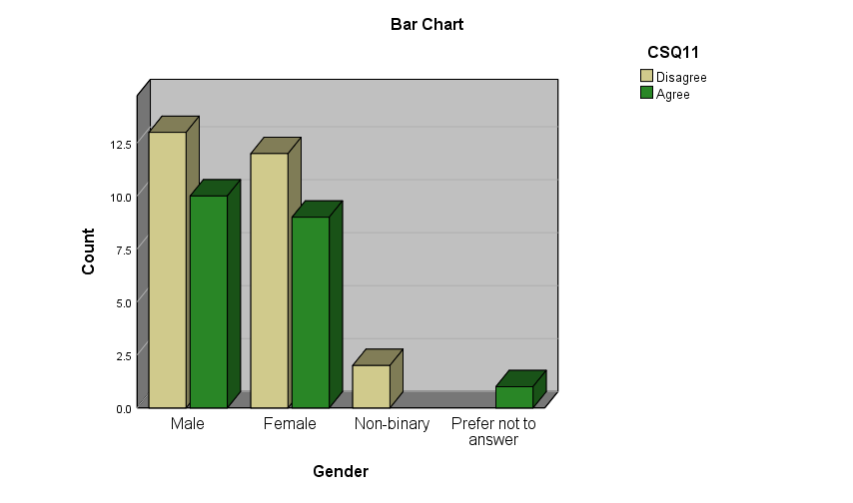
The green bars represent the respondents who agree that they are not feeling safe on social media and the brown bars represent the respondents who disagree with the question.

Gender * CSQ12

Crosstab
 |  | CSQ12 |  | Total
 |  | Disagree | Agree | Total
Gender | Male | 19 | 4 | 23
Gender | Female | 12 | 9 | 21
Gender | Non-binary | 1 | 1 | 2
Gender | Prefer not to answer | 0 | 1 | 1
Total |  | 32 | 15 | 47

This count table shows ,32 respondents disagreed and 15 respondents agreed with this question.

Chi-Square Tests
 | Value | df | Asymptotic Significance (2-sided)
Pearson Chi-Square | 5.824ª | 3 | .120
Likelihood Ratio | 6.157 | 3 | .104
Linear-by-Linear Association | 5.418 | 1 | .020
N of Valid Cases | 47
a. 4 cells (50.0%) have expected count less than 5. The minimum expected count is .32.

$$H_{0}:Disagreed to shared password with someone$$
$$H_{1}:Agreed to shared password with someone$$
With the level of significant .05,
The value of test statistic is 5.824 and p = .120

In this case the p-value is greater than the significance level (α = 0.05), so that I do not reject the null hypothesis.
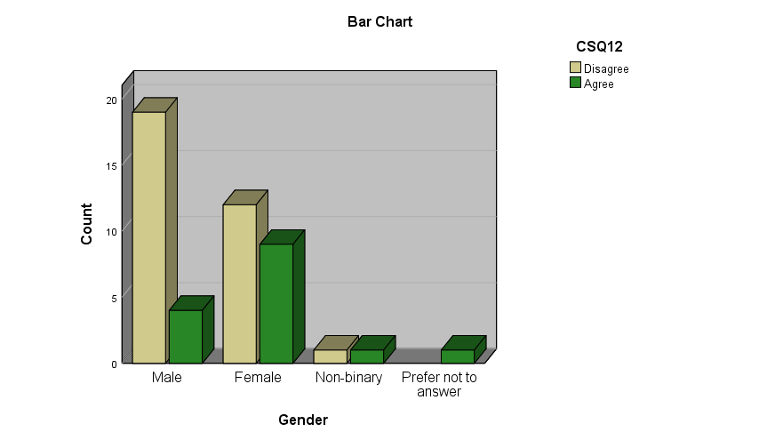

The green bars represent the respondents agree and the brown bars represent the respondents disagree that they do not share passwords with others.

Gender * CSQ13

Crosstab
Count
 |  | CSQ13 |  | Total
 |  | Disagree | Agree | Total
Gender | Male | 14 | 9 | 23
Gender | Female | 15 | 6 | 21
Gender | Non-binary | 1 | 1 | 2
Gender | Prefer not to answer | 0 | 1 | 1
Total |  | 30 | 17 | 47

This count table shows ,30 respondents disagreed and 17 respondents agreed with this question.

Chi-Square Tests
 | Value | df | Asymptotic Significance (2-sided)
Pearson Chi-Square | 2.543ª | 3 | .468
Likelihood Ratio | 2.824 | 3 | .420
Linear-by-Linear Association | .151 | 1 | .697
N of Valid Cases | 47
a. 4 cells (50.0%) have expected count less than 5. The minimum expected count is .36.

$$H_{0}:Not opened emails from total strangers:$$
$$H_{1}:opened emails from total strangers$$

With the level of significant .05,
The value of test statistic is 2.543 and p = .468
In this case the p-value is greater than the significance level (α = 0.05), so that I do not reject the null hypothesis. That means the highest number of people have not opened emails from total strangers.

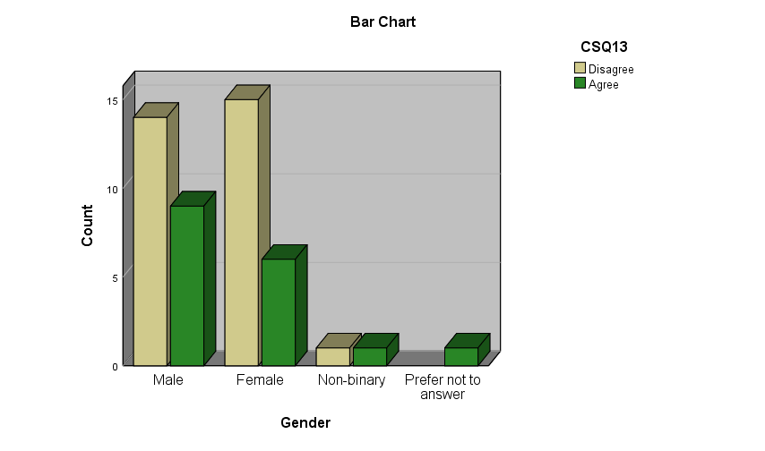

The green bars represent the respondents who agree and the brown bars represent the respondents who disagree with the question. They have not opened emails from total strangers.

Gender * CSQ14

Crosstab
Count
 |  | CSQ14 |  | Total
 |  | Disagree | Agree | Total
Gender | Male | 18 | 5 | 23
Gender | Female | 12 | 9 | 21
Gender | Non-binary | 2 | 0 | 2
Gender | Prefer not to answer | 0 | 1 | 1
Total |  | 32 | 15 | 47

This count table shows ,32 respondents disagreed and 15 respondents agreed with this question.

Chi-Square Tests
 | Value | df | Asymptotic Significance (2-sided)
Pearson Chi-Square | 5.324ª | 3 | .150
Likelihood Ratio | 6.098 | 3 | .107
Linear-by-Linear Association | 1.983 | 1 | .159
N of Valid Cases | 47
a. 4 cells (50.0%) have expected count less than 5. The minimum expected count is .32.

$$H_{0}:Disagreed to purchase anything online without permission$$
$$H_{1}:Agreed to purchase anything online without permission$$

With the level of significant .05,
The value of test statistic is 5.324 and p = .150

In this case the p-value is greater than the significance level (α = 0.05), so that I do not reject the null hypothesis. Max respondents disagreed to purchase anything online without permission.
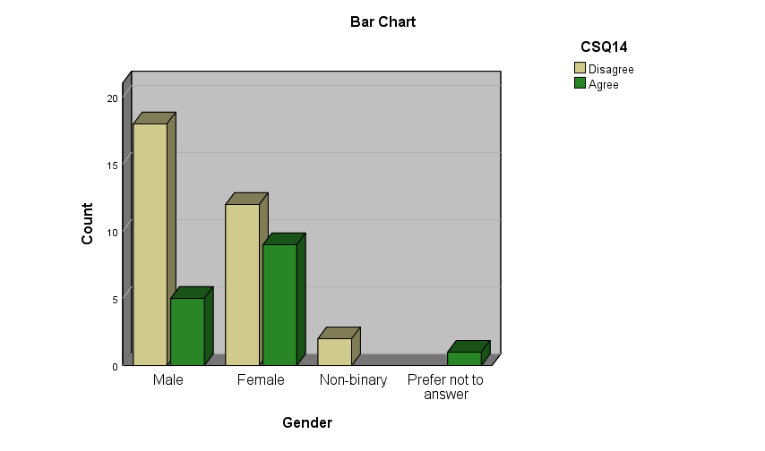

The green bars represent the respondents who agree and the brown bars represent the respondents who disagree with the question.

Gender * CSQ15

Crosstab
Count
 |  | CSQ15 |  | Total
 |  | Disagree | Agree | Total
Gender | Male | 13 | 10 | 23
Gender | Female | 15 | 6 | 21
Gender | Non-binary | 0 | 2 | 2
Gender | Prefer not to answer | 0 | 1 | 1
Total |  | 28 | 19 | 47

This count table shows ,28 respondents disagreed and 19 respondents agreed with this question.
Chi-Square Tests
 | Value | df | Asymptotic Significance (2-sided)
Pearson Chi-Square | 5.735ª | 3 | .125
Likelihood Ratio | 6.802 | 3 | .078
Linear-by-Linear Association | .539 | 1 | .463
N of Valid Cases | 47
a. 4 cells (50.0%) have expected count less than 5. The minimum expected count is .40.

$$H_{0}:Not involved in chat sessions with people using vulgar expressions$$
$$H_{1}:involved in chat sessions with people using vulgar expressions.$$

With the level of significant .05,
The value of test statistic is 5.735 and p = .125
In this case the p-value is greater than the significance level (α = 0.05), so that I do not reject the null hypothesis.

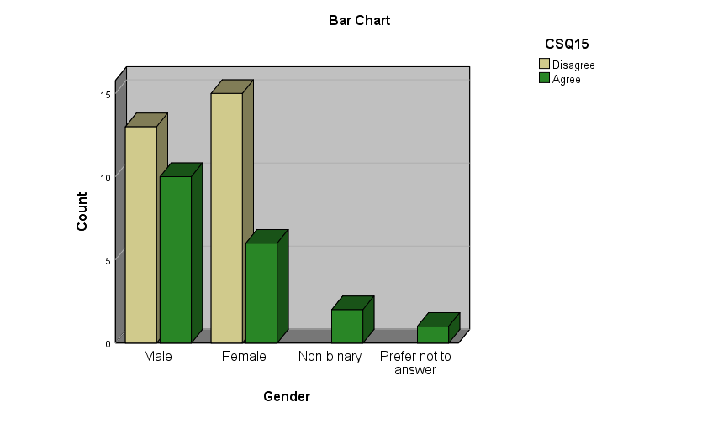
The green bars represent the respondents who agree that they are involved in chat sessions with people using vulgar expressions or sexually explicit language and the brown bars represent the respondents who disagree with the question.

Chapter 5

Conclusion

Sharing information on social media can be as simple as revealing demographic data, updating status, sharing emotions and thoughts, posting photos and videos, sharing personal interests, and commenting on the history of friends. For those who use the Internet, governance becomes crucial.Users are currently being screened for their privacy awareness, and it has been found that there is no difference between gender and people who know the privacy settings. This study examines three independent variables that are expected to affect the management of personal data protection.However, it must be communicated correctly There is still a lot of work to be done on the importance of managing social media privacy settings. The results indicate that the respondents’ knowledge of the confidential environment does not affect their perception of any of the variables used in this research. It is expected that users will become more aware of the importance of privacy, especially when sharing information. Therefore, this research is of great significance to the existing literature on undergraduate data protection, data security, data protection control, and management. It clarifies the exploration of applicable social media awareness mechanisms. Users who need to actively manage their private information.This study has some limitations because the respondents were young people between the ages of 20 and 21. For more colors in the results, future research should consider a wider age range of respondents. Therefore, one person can influence the size of the result. Future research may examine the same number of interviewees of different genders to obtain the same results. In addition, the sample is based on a university, so the results may not be suitable for counting all users in other universities. To make up for this shortcoming, the researchers plan to expand the broadened results. Copy this research to several other universities to include larger samples and different demographic data.

References

Sarah A. Downey ―The 5 biggest changes to Facebook‘s privacy policies‖, November26th,2012,URLhttps://www.abine.com/blog/2012/facebook-privacy-policy-changes/(accessed June 2015)

https://libguides.library.kent.edu/spss/chisquare

https://libguides.library.kent.edu/SPSS/FrequenciesCategorical
https://www.statista.com/statistics/274829/age-distribution-of-active-social-media-users-worldwide-by-platform/

https://www.surveyking.com/help/cross-tabulation-analysis

https://www.spss-tutorials.com/frequency-distribution-what-is-it/

Appendix

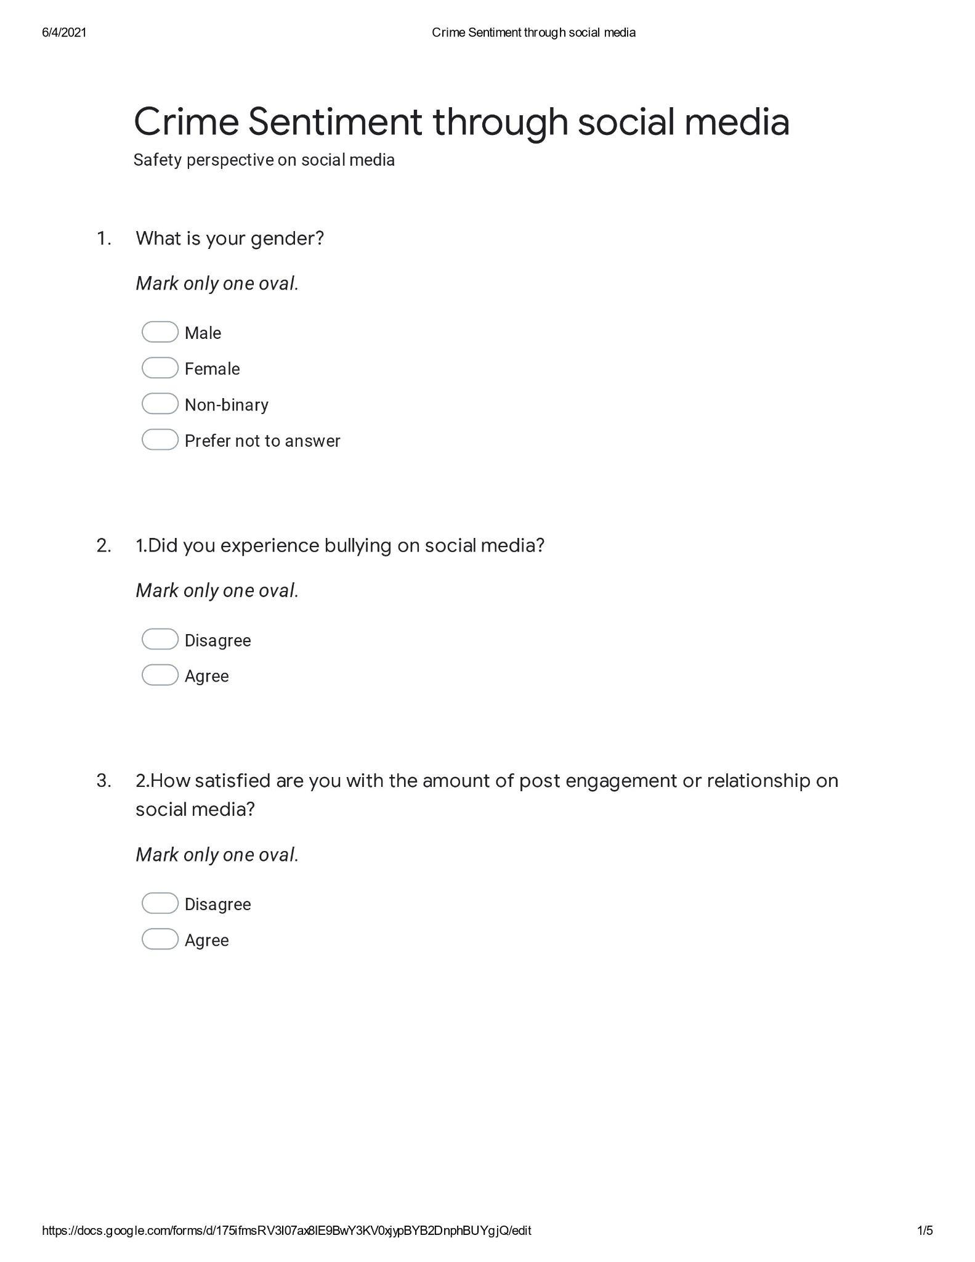
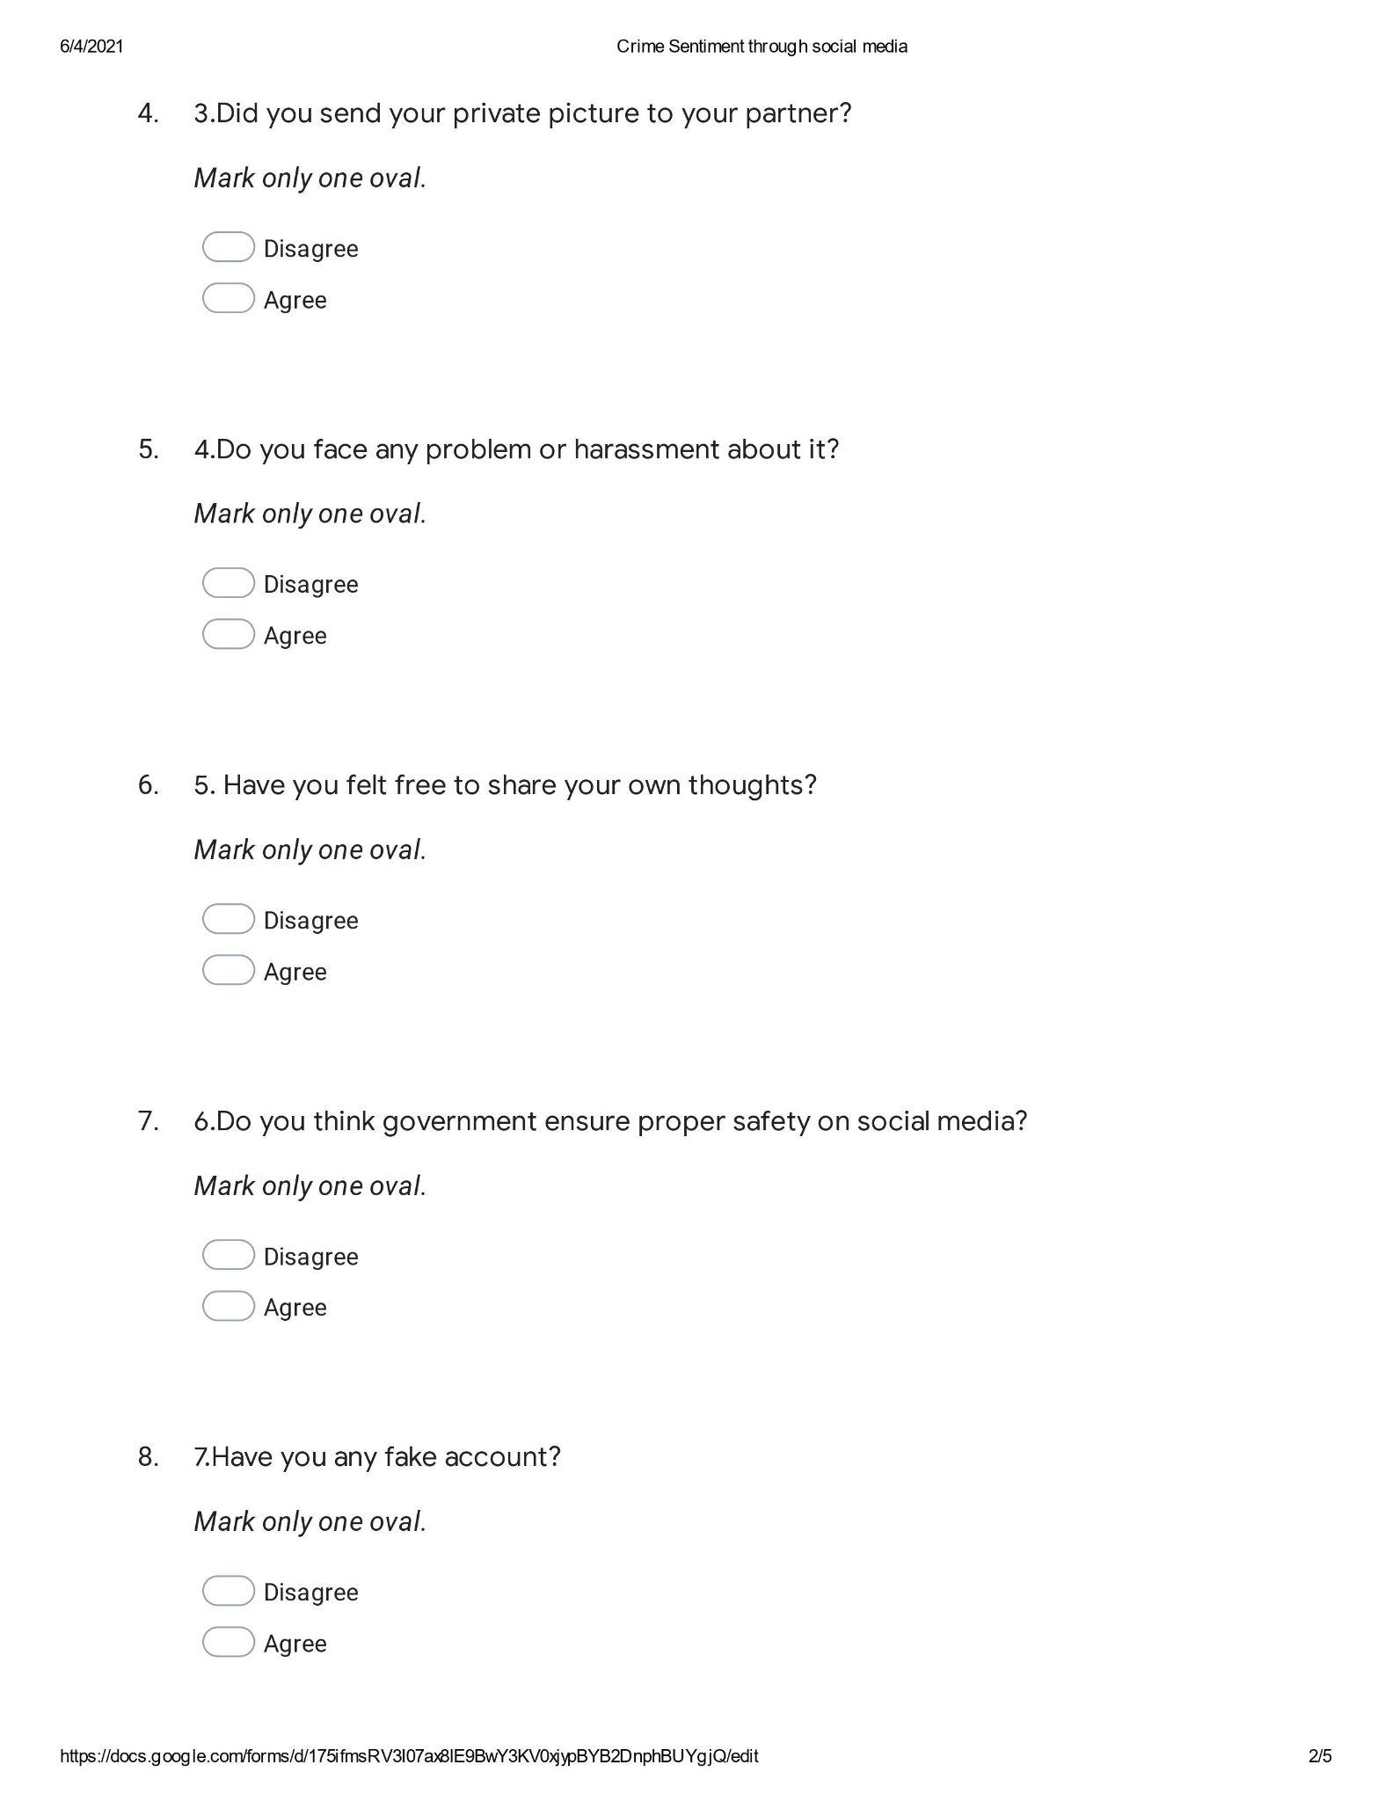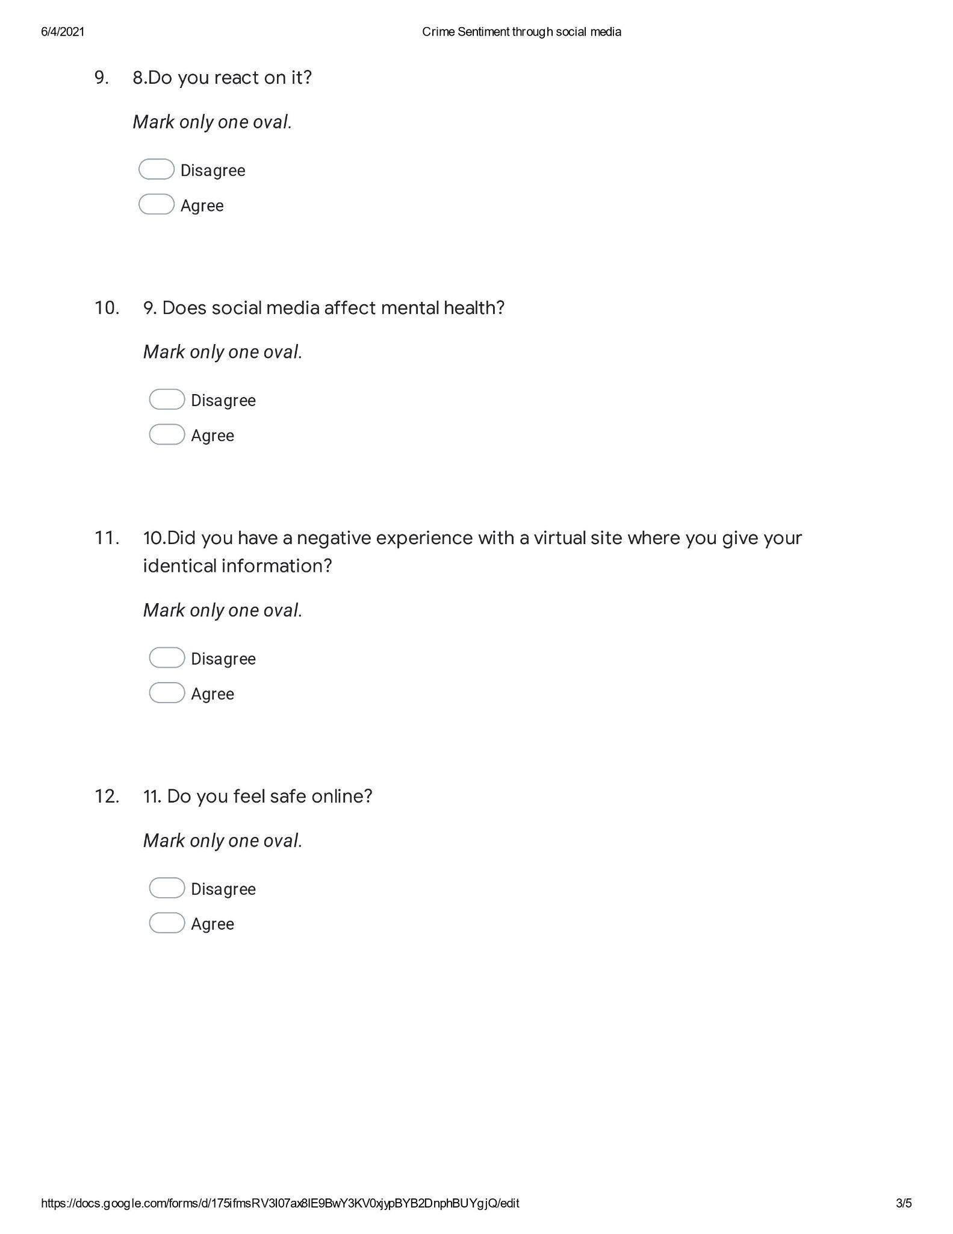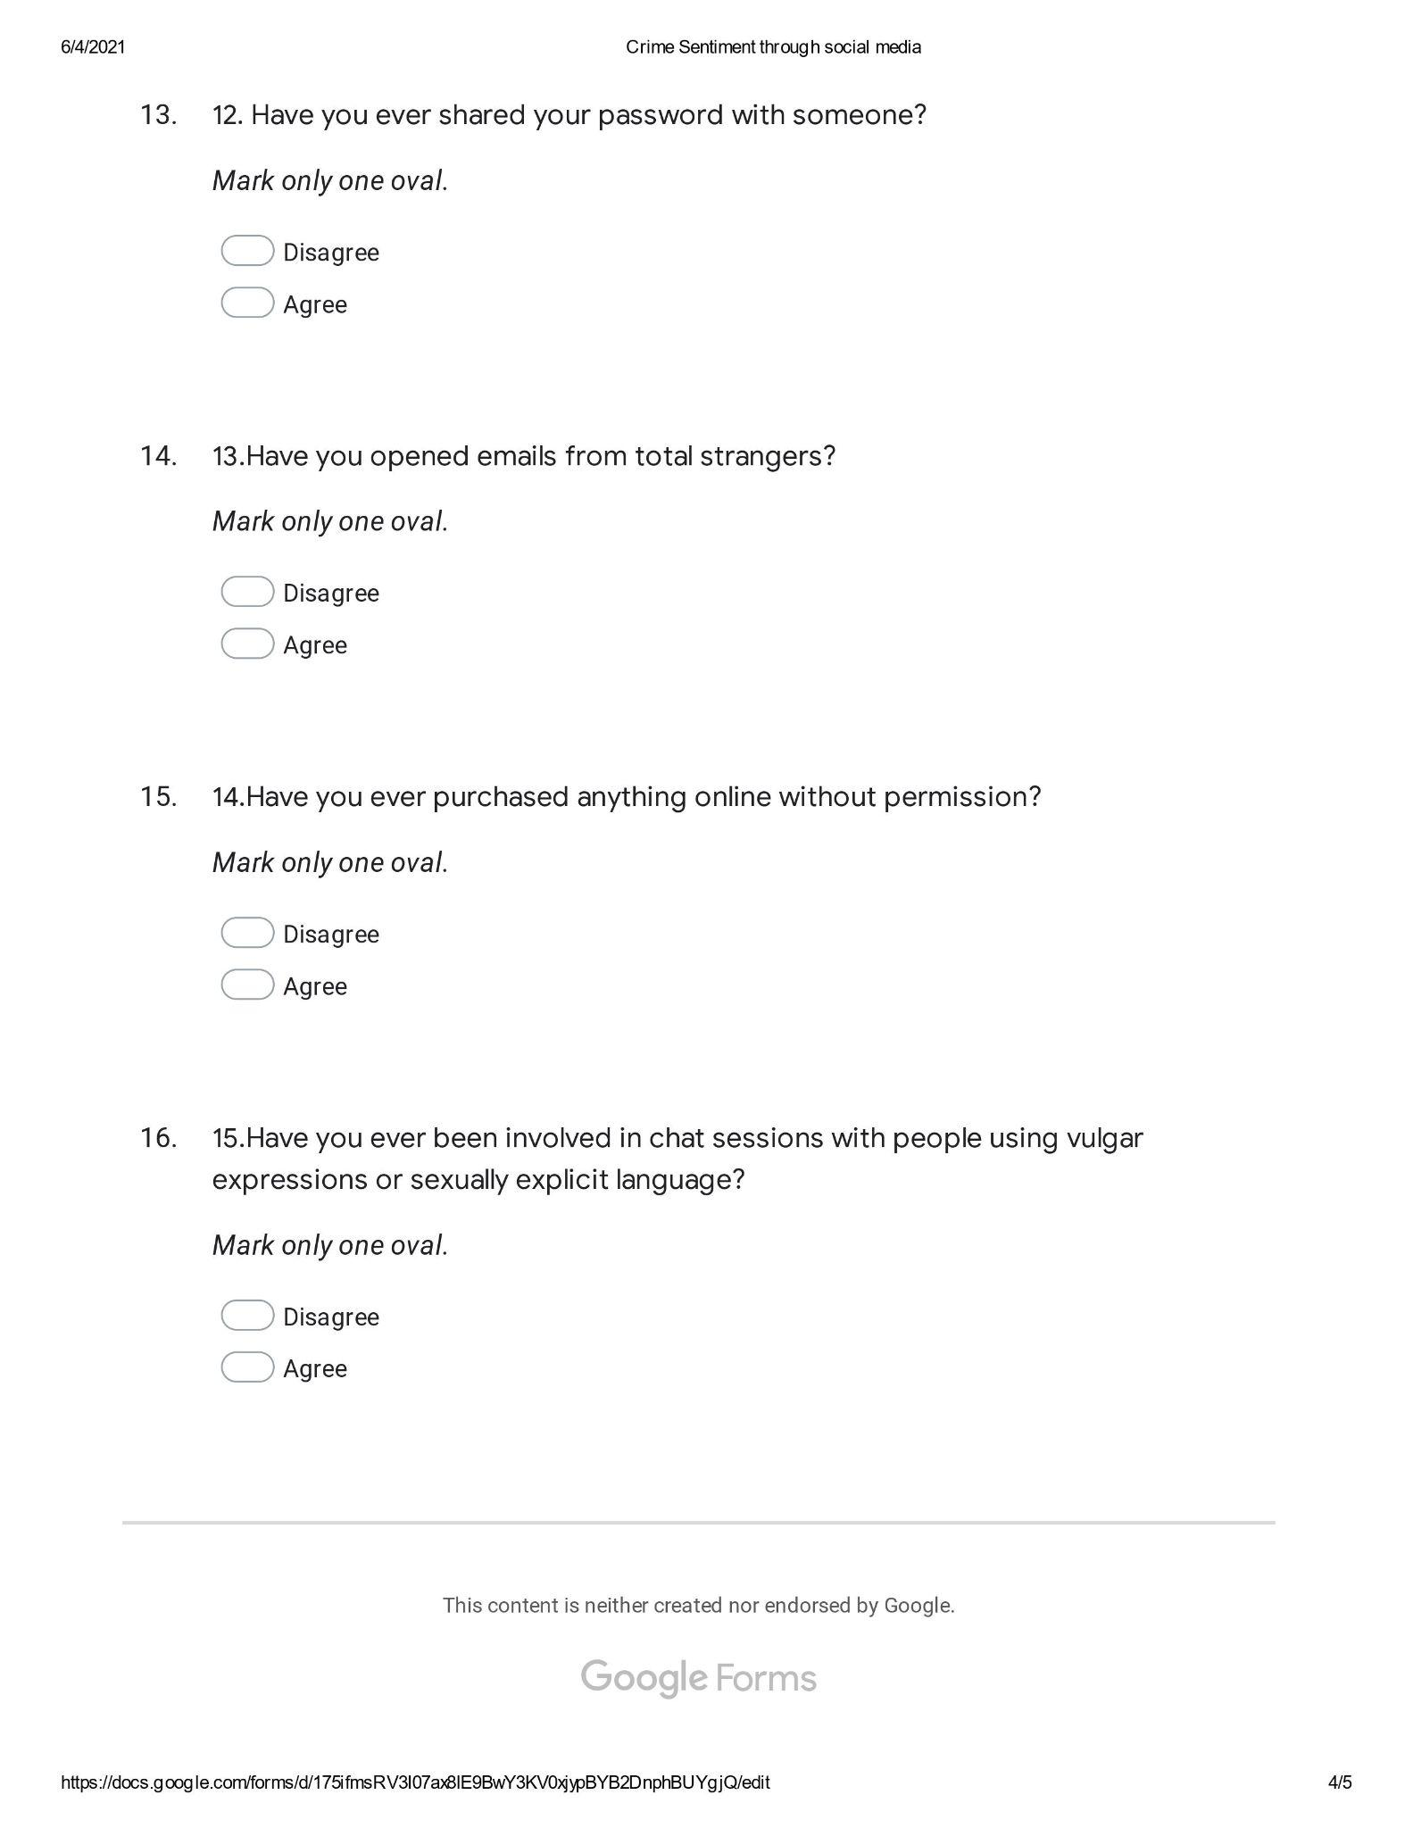
CROSSTABS
/TABLES=Gender BY CSQ1 CSQ2 CSQ3 CSQ4 CSQ5 CSQ6 CSQ7 CSQ8 CSQ9 CSQ10 CSQ11 CSQ12 CSQ13 CSQ14 CSQ15
/FORMAT=NOTABLES
/STATISTICS=CHISQ
/COUNT ROUND CELL
/BARCHART.

FREQUENCIES VARIABLES=Gender CSQ1 CSQ2 CSQ3 CSQ4 CSQ5 CSQ6 CSQ7 CSQ8 CSQ9 CSQ10 CSQ11 CSQ12 CSQ13
CSQ14 CSQ15
/HISTOGRAM NORMAL
/ORDER=ANALYSIS.
