Promotional Strategies of Hygienic Products towards Target Market: A Study on ACI Savlon

Md. Nahidul Haque Shourav

This Internship report is submitted to School of Businesses and Economics, United International University as a partial requirement for the fulfillment of Bachelor of Business Administration Degree requirement

Promotional Strategies of Hygienic Products towards Target Market: A Study on ACI Savlon

Submitted By
Md. Nahidul Haque Shourav
ID: 111152029
BBA Program
School of Business & Economics

Supervised by
Dr. Kawsar Ahmmed
Professor & Deputy Director, BBA Program
School of Business & Economics
United International University

Date of Submission:
July 20, 2020

Letter of Transmittal

To
Dr. Kawsar Ahmmed
Professor
School of Business and Economic
United International University
Subject: Submission of Internship Report

Sir,
It is my honor to present my Internship Report which entitled as “Promotional Strategies of Hygienic Products towards Target Market: A Study on ACI Savlon . I am fortunate enough that ACI limited permitted me to learn corporate practices under Hygiene department. I got the opportunity to work in their marketing team for collecting various information. The provided information in this report is based on the data collected during my internship period through market visits, performing different job responsibilities and available sources. I tried my best to provide the appropriate information in the most meaningful and coherent way. I hope you will find the report very informative. If you need any clarification and/or explanation then I would like to assure you that I will present for the desired clarification.

I would like to express my sincere appreciation and gratitude to you for helping me to prepare this report.

Sincerely yours,
Nahidul Haque Shourav
ID- 111152029

Acknowledgement

Fulfillment of this report has made me appreciative to various people. Toward the starting I might want to offer my earnest thanks to my Faculty Supervisor Dr. Kawsar Ahmmed for allowing the chance to set up this report. The finish of this report would not be conceivable without my senior boss Mr. Shuvo Rashid. He was constantly accessible when I required his help, proposals and rules. I am fortunate for getting this chance to finish my internship report under his direction and supervision.

I want to convey special thanks to the direct client of my organization Md. Tofazzol Hussain, Human Resource Department, ACI Limited and Mr. Zaman Asif Ahmad- Business Manager-Toiletries, Consumer Brands, ACI Limited. These kind hearted people gave me their valuable time to collect information and finish this report in time. I express special honor to them.

At long last, my heartiest much gratitude goes to other people who were included and caused legitimately and in indirectly way to set up this report. I would like mention few names; A. K Mohiuddin Ahmad, Jessica Islam & Sakib Istiaque Chowdhury. Without them all these would not have been made conceivable.

Executive Summary

Advanced Chemical Industry (ACI) is a renowned conglomerate organization in Bangladesh. This organization is serving diversified requirements of customers. In this report, one of the ACI’s namely Savlon is reviewed in terms of its promotional policies. To this end, a buyer survey is conducted for a better understanding of the acceptability of Savlon's promotional strategy. This study includes 10 experimental queries in terms of promotional strategies among the users of Savlon antiseptic. The study proves that Savlon has a good brand copy and clients are remarkably happy with the price run of the item. ACI uses buyer's evolution to create images of Savlon in disguise and it effectively identifies Sablon as an unregulated or unique consideration element in the Bangladeshi market. The more it exists in this search, the more exceptional and over-the-counter customers offering Savlon to see the offer of new conversations over time. These periodic regulars are fascinated by those who bargain for an uncontrolled or self-care product item to account for their concerns and abandon what they receive at an inadequate price. Nonetheless, the lessons demonstrated customer development, for example, the fair results of client feedback on TVC and Internet-based promotions were supreme. The need for ACI to strengthen the strength of their business - a large part of the client does not see the dynamic proximity of sales representatives in different stores. As this report noted, some of the disadvantages of ACI's advertising strategies were even more significant.

Keywords: Promotional Strategies, Customer conviction, Hygienic Products, Target Market, ACI Savlon

Contents
Letter of Transmittal ii
Acknowledgement iii
Executive Summary iv
Chapter 1 1
Introduction to the Report 1
Business Summary 2
Joint Venture: 4
Subsidiaries: 5
ACI Pharmaceuticals: 5
Advanced Chemical Industry (ACI) Consumer Brand: 6
ACI Agribusiness: 6
Advanced Chemical Industry Retail Chain: 7
Advanced Chemical Industry (ACI) evaluating the promotional strategies: 8
Objective Relate of this Report: 10
Chapter – 2 12
Nonfiction evaluation: 12
Chapter – 3 13
Study Approach: 13
Main Facts: 13
Minor Facts: 13
Product- 13
TVC: 19
Print Media- 21
SWOT Enquire of Advanced Chemical industry: 23
Porter’s 5 Militaries Classical of ACI Savlon: 25
Hazard of Ancillary Goods all over: 26
Chapter-4 27
Investigation and clarification of facts: 27
Chapter 5 36
Judgments of the learning 36
Savlon is exceedingly relied on the profile-raising targets on the road to the shoppers: 36
Boldness of consumers just before community broadcasting promotion in a confident method: 37
Wanting in relationships of transactions potency: 37
Unbalanced occupation suggestions from: 37
Chapter 6 38
Recommendation: 38
Chapter 7 40
Conclusion: 40
Reference List: 42
Appendix 43
Buyer understanding Inspection Survey For ACI Brand 43

Chapter 1

Introduction to the Report

Advanced Chemical Industry (ACI) is one of the well-known companies in Bangladesh. I am fortunate to have my internship report at ACI’s Brand Savlon. The internship is an enforced part of UIU’s BBA program and it is a great opening to collect real-life experiences. This is the first step to graduation. During my practice I was under the direct command of the brand manager Asadul Islam. Since I had 19 different brands to work with River, I had the opportunity to work closely with a few big brands, Ceylon, ACI Pure Salt, ACI Primio Plastics, Savlon, etc. I was wise to work closely with virtually all clients and starting from the plan. Was able to do multifaceted work in terms of implementation. In preparing this report, I have enlisted the direct assistance of my supervisors as well as the concerned authorities of ACI
I have driven ACI's Discovery Savlon in general with this product line and have been able to run a few events as well. Also Savlon is a prominent brand that is offered in the Analik market all over the world. This product is commonly known as the used kitchen care product and the traditional consumer mode of consumer promotion is used for this merchandise. ACI puts less emphasis on customers and tries to contrast different types of trade promotions. I do my utmost to cover the various qualities of the Savlon brand by combining the vitality market offerings and a major research study done on contemporary regulators.

Business Summary

ACI is one of the leading organizations in the country and was established in 19 UK6 as a secondary school in the UK's Imperial Chemical Industry (ICI). Later, the war of liberation took place in 19 war and it was advertised as abandoned. It was then limited to a subsidiary of ICI Bangladesh Constructors and gained momentum in Bangladesh on January 24, 1973 of ICI. 19 On June 24, 1973, the factory resumed operations as ICI Bangladesh Manufacturers Limited. On May 5, 1992, ICI plc passed 70% of its shares to local Bangladeshi management and it.
Now, ACI as a government limited company has a total of 1,6,631 shareholders among the top corporations in Bangladesh, including foreign and 14 local influential bondholders. The firm is basically divided into four businesses which will be published later in this report.
In addition, the company has a large number of international partners and partners with trade and business agreements.

ACI’s Mission

ACI's Mission is to improve the quality of life of its consumers by ensuring proper application of knowledge, skills and technology. ACI is very much connected to the pursuit of excellence by ensuring world- class products, inventing new processes and through empowering employees, to provide the highest level of satisfaction to the customers. (Aci-bd.com, 2018).

ACI’s Vision

ACI considers these codes as its organizational vision.

Try to achieve a point in each type of our business.

- Provide high and reliable quality products and opportunities by ensuring value for money to our consumers.
- All of our operations end with a high level of production and effective implementation of adoption of application tools.
- Mature our workforce by encouraging empowerment and rewarding innovative ideas.
- Assurance of superior return on investment through sensible use of resources.
Guarantor inclusive progression by becoming optimistic and secondary to improving the delivery of benefits to our distributors and contractors.

ACI’s Ethics

Advanced Chemical Industry ' core principles are outlined below. Individual ideals are chosen for the changed level of the corporation and employees and administrators are asked to carry them out strictly. Values ​​are freely pervasive on the walls of all floors of these offices.

Quality Customer Focus Fairness Transparency Innovation
Continuous Improvement (Aci-bd.com, 2018)

Strategic Business Units, Subsidiaries and Joint Ventures of ACI Limited

By the help of the figure mentioned below I tried to illustrate the business units of ACI. In which Savlon‟ tumbles below particular upkeep of the customer brand includes -

1. ACI Motors
2. ACI Seeds
3. ACI Fertilizer

- Persona care
- Home Care
- Consumer Electronics

Pharmaceuticals
Consumer Brands CommodityProducts
Logisitcs
Agribusiness
Medicines

Shwapno
- ACIMotors
- ACISeed
- ACIFertilizer

Advanced Chemical Industry business units

Joint Ventures of Advanced Chemical Industry which Continue below their Particular running are declared below:

Joint Venture:

      - Advanced Chemical Industry (ACI) Godrej Agro vet

      - ACI Tetley (Bangladesh)

      - Consumer Care (ACI)

Subsidiaries:
- Advanced Chemical Industry Formulations Limited

- Pure Flour Limited

- Logistics Limited

- (ACI) Salt Limited

- Advanced Chemical Industry (ACI) Creative Communication Limited

- Plastics Limited

- Agrochemicals Limited

- Edible Oils Limited

Deeds of the Industry:

ACI Pharmaceuticals:

Advanced Chemical Industry (ACI) says and shots can deliver more than 397 products covering all maximum regions, comes in varying figures and, in terms of size, contain capsules, liquids, creams, eye drops and dosage forms. The advanced chemical industry probably wholesale world-renowned branded pharmaceutical product lines such as Cassodex, Zoladex, Atrax, etc.

Advanced Chemical Industry (ACI) has gained a reputation in the business for further new glamor and novel drug sustainable systems (NDDS) to highlight the needs of the next peer group. This organization became a pioneer corporation of Bangladesh and practiced the idea of ​​quality administration system. Improvement in all its process. Joining with the Knowledge that a pharmaceutical should agreement of real management of situation.

Advanced Chemical Industry (ACI) Consumer Brand:

Advanced Chemical Industry (ACI) Consumer Brands was established in 1995 dividing with 2 key brands of the business-
-Advanced Chemical Industry (ACI) Aerosol and Savlon Sav are 2 of the highest inflammatory crops that are currently among the locales on the market. In this way re-brands run multiple different products simultaneously and the links to monetization with joint ventures are also not clear-

-. Advanced Chemical Industry (ACI) brands split the truth in the apparent presence of people with primary products on the market, including aerosols, Savlon, musk coils and flour national markets. Appropriately 78% shares in its own assembly.

The Advanced Chemical Industry (ACI) is properly assisting the public’s demand for external crops in the household and special care departments with the help of product lines from around the world in Colgate, Niva and Dabur. The world's top tea pick "Tetley" with a suitable supply of consumer brands.

ACI Agribusiness:

Advanced Chemical Industry (ACI) is one of the major products of agriculture and livestock and fisheries on agricultural land because rib individuals have different production units e.g. as Crop protection, Fertilizer, farm machineries, and inborn health. Company have wonderfully overrated the business existence of this country. Advanced Chemical Industry (ACI) Farm business has a large, well-informed and very accomplished work Force who can simply deliver training and technical instructions.

The Advanced Chemical Industry (ACI) is assisting in national food security through its agro-industrial division. The art of gardening is prolonged so long as the planter does not request and require whole flowerpots. Runners have also envisioned the benefits of an appropriate education system from ground electricity in the advanced chemical industry.

Advanced Chemical Industry Retail Chain:

Advanced Chemical Industry (ACI) Logistics, Shopno is now our Republic’s top merchandising trademark. It is the most reputable retail chain in the Republic. Shwapto visits more than 37,000 relatives every day. Shopvano channels now have open application applications from all apparel, electronics and more. It includes grocery label brands as well as in-house fashion brand Shopano Life. Shopno has now closed the gap in four major cities in Bangladesh, such as Dhaka, Chittagong, Sylhet and Comilla, employing 30,000 square feet and more than 2,700 people. It operates a variety of passage companies from small handicraft stores to large cloud stores. Each store provides a decent actual shopping experience for customers. As a pioneer of ACI installation market (47% market share) its patrons not only have a good legacy, value, realism and vehicle but also its position as a very successful class retail structure as it is very effective in real world production.

Foundation of this report:

Although my major is marketing so I am always interested in learning about one buyer brand. In my three-month grid understanding of Advanced Chemical Engineering I have worked for various buyer brands, excluding ACI brands. From which I became more fascinated about ACI's customer brand - Savlon. Similarly, the flagship brand Sablon is well known in Bangladesh as well as elsewhere in the world.
By these, by announcing, ACI Limited in Bangladesh is still intensifying their flagship brand - Sablon. Branding strategies play an important role in Savlon's families the variety of imed promotions is now reflected in the character and themes of this top brand in the minds of consumers. For this, I really wanted to revise the issue of "ACI Consumer Brand Promotion Strategy (Savlon)".

Statement various Difficulties:

This report actually focuses on a very broad purpose. Gambling can have a broad purpose and the reason for working on this unprecedented top is to solve a right issue. Try to focus on a difficult topic through almost every study and try to suggest solutions to that exact problem. The specific purpose of resolving specific concerns.

Advanced Chemical Industry (ACI) evaluating the promotional strategies:

This actually involves varied promotional channel for helping any product or facilities in the marketplace. Other hand the optimistic side Savlon has an actual solid brand image in the marketplace whenever it’s come to individual care product or anything else.
However, the Advanced Chemical Industry (ACI) further helps in gaining shareholding and seeks to stop the recovery at market speed while steadily focusing on cleaning up their promotional projects. Theoretical (ACI) Framework:

Trade Preferment (Reductions, proposals)

Buyer advertising (TVC and Print Media)

Buyer Valuation Method

Limitation of making this report:
Advanced Chemical Industry (ACI) – actuality the best famous and foremost corporation of our country has an advanced and tactic near concluding their work effortlessly. Though, in my internship time at Advance Chemical Industry (ACI) by way of an undergraduate student I devour challenged some coincidences. Now I will discuss about that-

 Privacy-similar other company Advanced Chemical Industry (ACI) also efforts to retain a percentage of evidence extremely dear as there are varied range of businesses in the market and some cases are very delicate so that they cannot be shared with interns who are working at their or their third party organizations. So that sometimes I faced so many troubles to collect actual data and information.
 Period limitations- my section/brook there stayed also other several sorts that I had to drudgery for with a by a hair's breadth limit. For work has must bow to fast and hurriedly.

Choose for a sample, I had to work actively as an intern and I had to work from R & R's homegrown uniform for uniforms than now

.
 Change of work characters: When I was betting on the client package team, I thanked the purchase of many job clothes based on the needs of the rehabilitated brand. The biggest time I went to conventions on war works was a lot of times I had to think of myself through the links associated with participatory analysis. Old Fashion Sometimes I am accountable for supervised interviews conducted to tolerate us.

Objective Relate of this Report:

Indeed, the real neutrality of this shuffle is to achieve the conditions for the development of this position program, which has been victimized by UIU consultants. I had church data to seamlessly integrate the crash for my location program, I got a few aspects of the brand “Savlon. Now I am going to mentioning few of the purposes of this report on Consumer Brand (Savlon) -

- First of all diverse special events of Advanced Chemical Industry (ACI) Savlon brand’s advertising activities liable on customer promotion and exchange progression.
- Secondly studying the capability of Savlon's advertising strategies behind Savlon's present marketplace position and its fame.
- Next maintain and plaid Customer Fames of mind toward Savlon's present advertising strategies and many more.

- Hardly describe many strategies which can be occupied to make this company time system yet gradually controlling.

.

Enquiry Demand

Every Report have few purposes to fix and helpless on those goals we can have the plan to survey answers of some Specific demand questions. It help to hypothesis a construction to set standards for demand purposes.
- Which advertising plans of Advance Chemical Industry Savlon is on now used in the marketplace?

- In what way their difficulties strategies add to its marketplace location?

- Which is the disadvantages in advertising plan of Savlon?

Further more information that will help to relies that ACI savlon is the top Consumer Choice Brand.

Chapter – 2

Nonfiction evaluation:

Study-1:

Title: Strategic Integrated Marketing Communications Edition Paperback – August 7, 2008
Author: Larry Percy Extract:
This study demonstrates an imaginative way to deal with promotional strategy and spotlights on the reconciliation of the whole advancement blend, not simply promoting. The Author’s conviction is that publicizing, exchange advancement, buyer advancement, individual selling, direct showcasing, advertising and exposure, and corporate promoting are all segment portions of one coordinated special blend. Today, most different authors and advertising professionals likewise advocate this integrated marketing communication approach.

Study-2:

Title: Positioning the Brand: An Inside-Out Approach Edition Paperback – January 7, 2011
Authors:H. J. Riezebos, Jaap van der Grinten Extract:
This study introduced a worldwide point of view of brand positioning. This is a significant investigation since it talks about the significance of brand positioning. Brand positioning impacts how buyers see and assess a brand and furthermore how they utilize the brand. In this study, the authors inspect the development of brand positioning techniques in promoting that parallel the development of the global market.

There are distinctive approaches to advance an item in various territories of media. Advertisers utilize computerized ad, extraordinary occasions, supports, and papers. Additionally, in exchange advancement we can see exercises, for example, free item, rebate and diversion challenge to win any item.

Chapter – 3

Study Approach:

So many Approach already occupied into version in this part of the report. Though it’s a vital source that can be readers in a point, for this unit I am going to tell and debate different purposes and good learning.

Main Facts:

Here the main data was collected from frank conference with approx. 60 mark clients and company officials ACI, was charge for the designing of the promotional strategy of Savlon and drive suppliers for auctions procedure.

Minor Facts:

Minor data is collected by ACI‟s Websites, pupillages and brochures that my superintendent and HR branch gave me. Savlon (marketing mix):

Product-

Savlon – It is a fruitful item running in Bangladesh under ACI Limited. It is one of center brands of ACI Limited. Savlon is a universally prestigious brand in the market of individual hygiene and care items. In Bangladesh, Savlon is a market chief. Savlon produces a wide cluster of product offering under its image name. It ranges from disinfectant cream, fluid cleaning agents, emergency treatment unit to personal care items like bar cleansers and so on. In this focused market Savlon needs to contend with different brands, for example, Dettol (Reckitt Benckiser Bangladesh) and Lifebuoy (Unilever Bangladesh).

Goods also partake gigantic market impression in rapports of auctions and part.

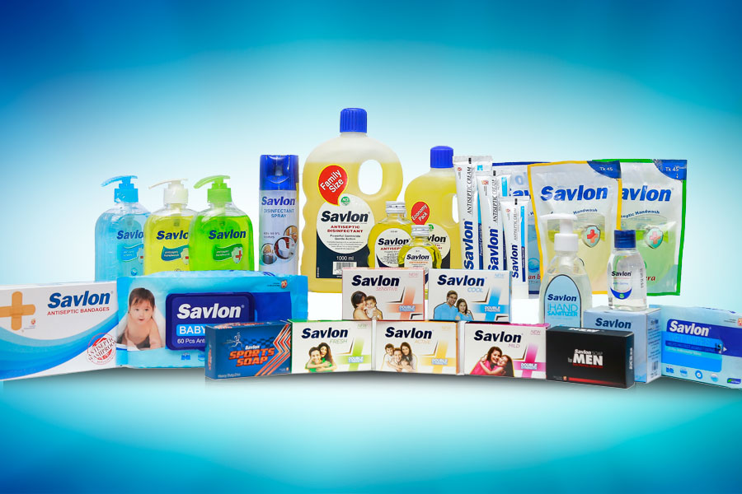

Savlon goods

Amount-

Sevlon's products had to be assumed as a way to determine its entry price. In our country, it is relatively expected that the archaeological rating is similar to that of the ancillary benefactors and so it sinks. Nevertheless, local crops are quite cheap and affordable in the market. Products like Savlon, Lifeboy and Dettol have given them that they own most of the market and the price of such items is a bit higher than the local products.

As part of this succession, I set out the principles of specific pricing to carry a preliminary idea about Savlon as well:

Ocean Blue Antiseptic Hand wash Refill 200 ml Price= 55 Tk

Aloe Vera Antiseptic Hand wash Refill 200 ml price = 55 tk

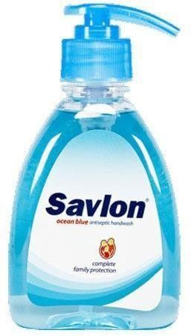

Savlon Ocean Blue hand wash

Antiseptic balm:

Antiseptic balm 100 gm = 50 tk

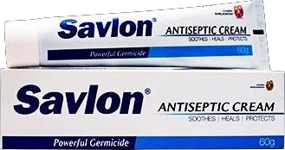

Antibacterial Fluid:
Fluid Antibacterial 500 ml= 125 tk

Antibacterial Fluid Flask 112 ml = 44 tk

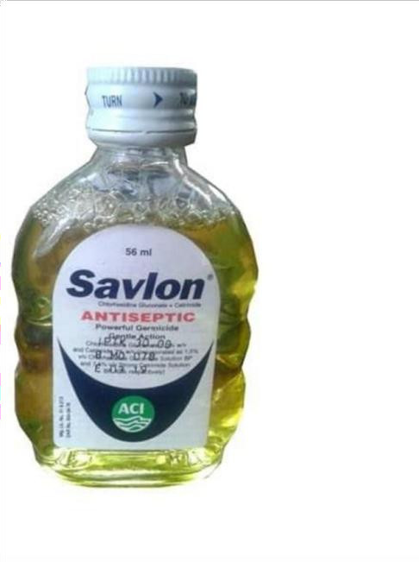
Antiseptic Liquid Bottle

Soap:
Renewed Soap 100gm = 42 tk
Soap Men 100 gm = 45 tk

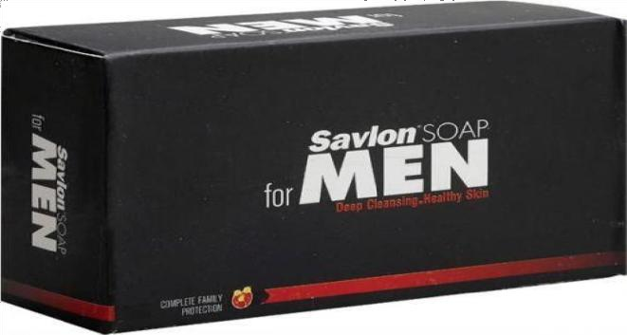

Savlon Hand Sanitizer: Savlon Hand Sanitizer affords effective defense in contradiction of 100 disease instigating germs counting bacteria, yeast, mold and viruses. Savlon Sanitizer Kills 99.99% germs and keeps you harmless and threatened. Base in vitro action on germs connected with 100 diseases. Founded on antimicrobial action in in-vitro conditions.

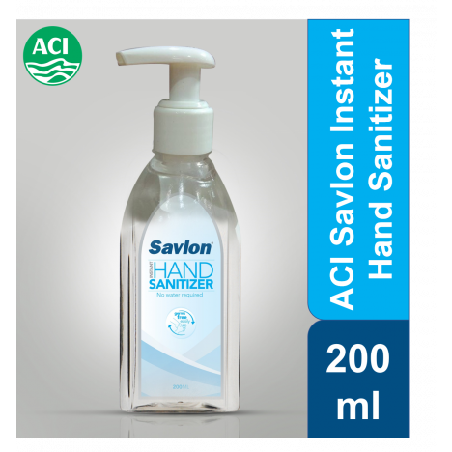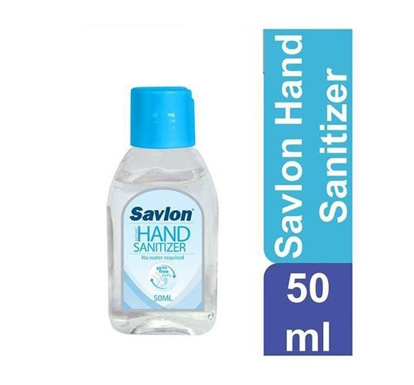

Price 200 ml = 200tk price 50 ml = 80tk

For Covid-19 Protection:

- Savlon Hand Sanitizer affords actual protection against 100 disease producing germs including bacteria, yeast, mold and viruses.

- Execute a million germs on the go by using Savlon pen sanitizer that affords you with 100 plus spray based on lab test.

- Custom Savlon hand sanitizer before meals, after playing and after staying the washroom for healthier hands.

Residence-

Individual care stocks are sold because of their price and convenience. Here in this case, ACI Limited has decided to launch their Prize Brand Savlon a Cheap Land Commanding Circulation Network as well.

Depots

Supply Platform
Last Client
Retailers
Distributors
Vital
Wholesalers

Advancement Criteria-

Advanced Chemical Industry (ACI) now is all in our country “sold industry which were in trades smooth before the liberty of our country. For this Advanced Chemical Industry strongly agree that some High Procedure of Advertising Which their stock in market until over. Rapidly growing the sale of their own invention its imposts employment preferment most other working days. Advanced Chemical Industry customer whole plan relies on IMC wherever a 360-degree advertising method is taken to create brand plan for every standard invention.

Currently, for this client will have this method which will help well protection. Advanced Chemical Industry Savlon continue increasing in Bangladesh and to achieve lot of consumers they are still trying to build complete awareness through completely different styles of promotional activities. Now I will highlight some of Savlon‟s recent work.

TVC:

2018 Advanced Chemical Industry has launch a new TVC. Which actually endured a Savlon Lively bar soap advertising. Mahmudullah Riad – who is a well-known cricketer of our country (BCB) has high consciousness about that soap the double defense of the cricketing whistles on the field. The focus in this manifesto was to kill germs using soap soap, as it is measured as an antiseptic soap. Mahmudullah Riyadh's collection from the YouTube exhibition with the children's firm ACI Savlon Active Soap is similar to the poster of that announcement -
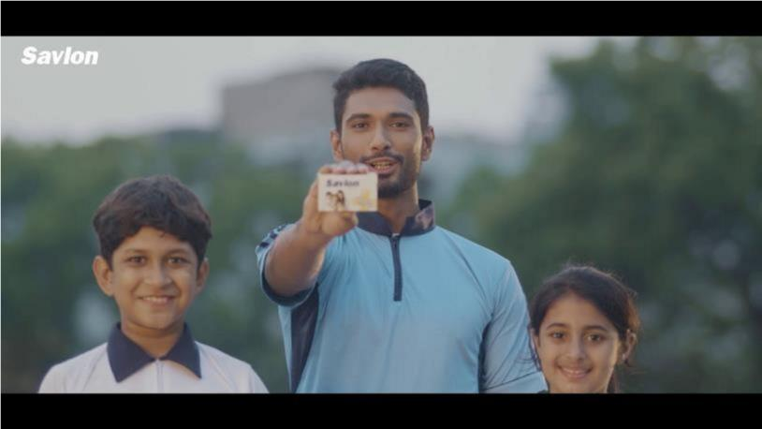

TVC 2018

Community Media Movement and Savlon Brand Launch Movement-

Alphanumeric media and online elevation is a great way to capture people in a very short time and with more money and efficient means. This year, Sablon has taken various initiatives on their authorized Facebook page - Savlon Bangladesh. Most recently posted on November 13th, 2011 at this.

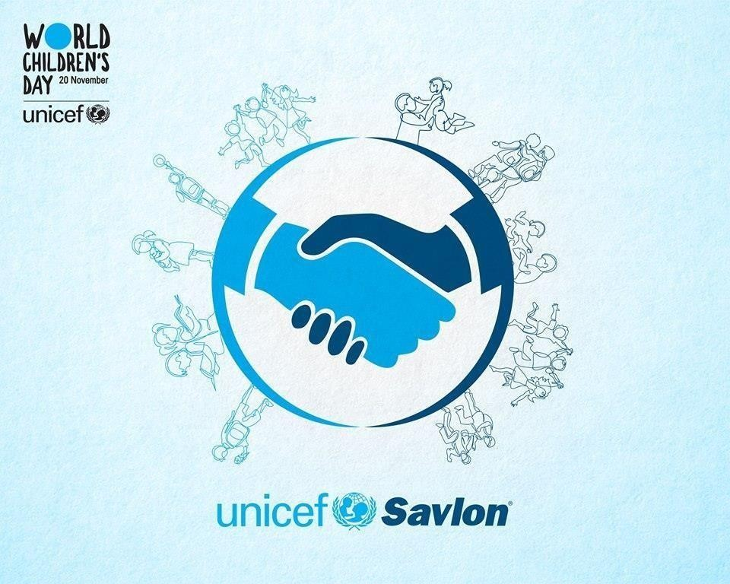



Print Media-

Here this one is known to all that Print media is a one generous of advertising. This play a inordinate gadget to reach the figure and raise merchandise realization. Advanced Chemical Industry customs its straight process of client advertising tool about sanction this soap in front of shared judgments. Though broadcasting advertising collect a better answer to client.


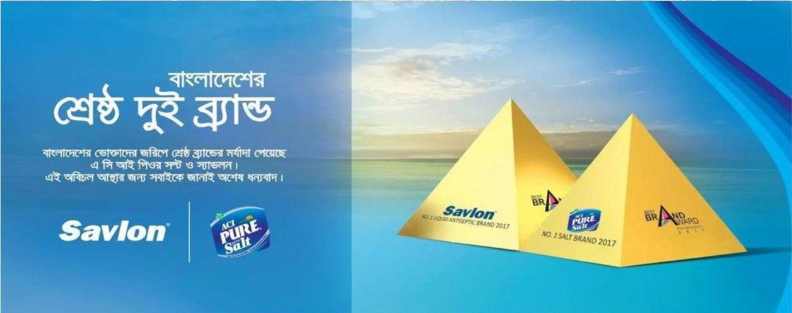

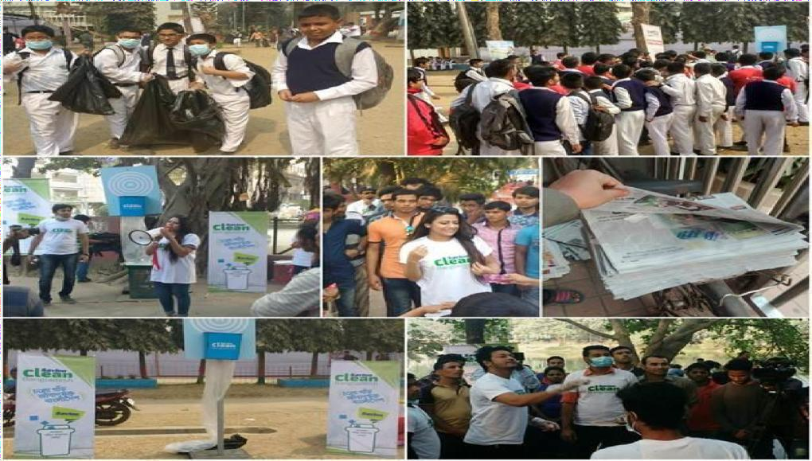
2018, print media promotion Advanced Chemical Industry already declare that it Launch this year 3 of their top brands.–Promotional campaign-

ACI recently invention a huge community movement inside this 2018. Its declare that “Savlon Clean Bangladesh”. Most of the consumers and peoples in our country are used to disposal wildernesses on the road or anyplace ever they accept they can get rid of wilds at all.

SWOT Enquire of Advanced Chemical industry:

ACI has efficiently managed to make Savlon as one of the top private care / antiseptic products on the market. Inferior people give birth to inferior offspring and, thus, propagate their inferiority. SWOT verification is done to query the position of a product in the marketplace. SWOT is the strengths, weaknesses, opportunities and terrorism of any product in any structure.

Strength:  - Product appearance  - Durable supply system | Weaknesses:  1. No discerned invention
Prospects:  - Novel Marketplace  - Growing Consumer Demand | Pressures:  - New local products  - Strong inexpensive marketplace

Strength:

It is known to all that Savlon is a world recognized personal care product. So that Savlon carry a Strong marketplace fame here in some South Asia developed country. Clients have much consistency on global poducts an outcome of Savlon has been functioning in numerous nations with victory including our neighbor some country.

Weakness:

At this time, individual care/antiseptic merchandise marketplace may be Strong inexpensive one. But, marketplace Advanced chemical industry is drenched. Many well-known products are come forward to almost alike kind of invention. Such as, Dettol has virtually the alike generous of contribution as Savlon is now in the market.

Prospect:

Now a days in our country many new industries are invention quickly; so that particularly run-up. In the marketplace to auction of Savlon Advanced Chemical industry habitually principally beleaguered clienteles who request those creation aimed at his or her household requirements. Up till now, today consumers are additional complex regarding cleanliness difficulties in ubiquitously. Nevertheless of if it is in their alive chairs or it is in authorized interplanetary, restaurants and community toilet and many more places.

Pressures:

Now, actual share of the examination the danger after competing corporations or inexpensive creation is retrieved. Everyone now gossip concerning private care/ antibacterial creation – which presently we stand moneymaking to expression a amount of opponents of ACI Savlon. To the marketplace altered world-famous products are similarly flair. Like Dettol, Lifebuoy, Lux, with altered products. Now a highly competitive market is arise.

Porter’s 5 Militaries Classical of ACI Savlon:

It’s a platform to realize that the opposition of a commercial things. This assist illuminate the thought of approach besides the ladders that requests to be reserved for improvement and brand the firm produce and withstand in the marketplace to find it.

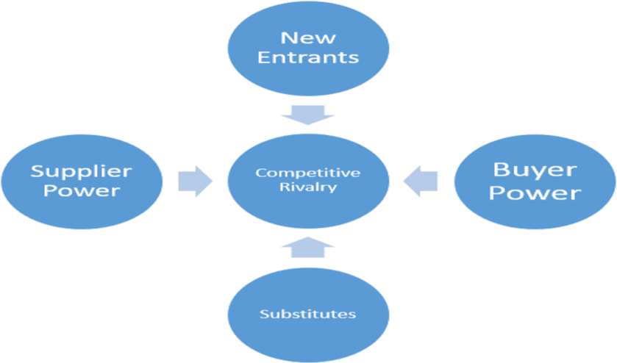

Bartering Control of Purchasers:

Now in the open market of individual care artifact clients are obviously the ones with noteworthy haggling influence as nearby are countless another foodstuffs of like caring existing in the marketplace. For this Clients look after for correct explanation of their alarms what time it emanates to procuring any particular attention goods. Our country unalike individual maintenance crops are accessible from dissimilar products fluctuating beginning native business goods and many more.

Bartering Authority of Dealers:

Now our country there are so many plentiful contractors of substances and rare constituents for manufacturing these particular attention goods. On the other hand, few companies introduction their rare supplies starting outdoor of the nation to accomplish parsimonies of gage. For that, now many companies who building individual care/antibacterial foodstuffs have numerous contractors starting whom they willpower acquire prime at a truthful matter. On behalf of which powerfulness say the negotiating supremacy of purveyors is low all complete this many situation all over.

Hazard of Ancillary Goods all over:

Advanced Chemical Industry ACI Savlon has replacements for certain of their merchandise classes. Such as, in fluid antibacterial bazaar Savlon is unswervingly opposing in contrast to Dettol. Secondly, in hand wash goods Advanced Chemical Industry ACI Savlon has solid participants like, Dettol and Lifebuoy. More likely in antibacterial balm grouping Savlon has very rare alternate goods as durable entrants. On calculation to that, Lifebuoy, Dettol are main cast list in the bar soap grouping combined with Savlon products marketplace.

Menace of Novel Applicants at all:

Before we discuss, private care invention bazaar was habitually in ownership of Dettol, Lifebuoy and Lux earlier ACI Savlon come in hooked on the variety store. Nevertheless, opposition is motionless snowballing in this manufacturing platform. Brand new invention are inflowing into the bazaar as buyer invention souk pass guidelines are laid-back in our country and the marketplace motionless has an enormous probable of efficiency. For this novel products are immobile piercing into the bazaar at all.

Conflict between challenging companies at all:

As we knew that marketplace of particular caution merchandise has various substitute creation and unmoving a certainly portion of sweeping square to want on supplementary shop portion consequently the contention amid prevailing concerns. Holding participants are poignant advancing to destructive promotion strategy also participating massive portion of monies to yield administration of further marketplace portion at all. It canister be comprehended together in nice of client elevation or employment elevation. Later, the opposition between modest secure is tall sufficient to the market.

Chapter-4
Now this time I determination attempt to examine plus draw facts built on survey questions I finished for my survey (In the Appendix part).

Enquiry 1: In what way do you recognize about Savlon goods?
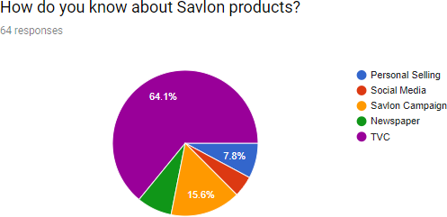

Investigation and clarification of facts:

This time I involved this enquiry because I canister discovery available come again kind of foundations are answerable for generating product mindfulness of Advanced chemical industry Savlon. For that we can evidently recognize by nearsighted the upshot of the review that furthermost regulars are cognizant round Savlon goods from the (Television Commercial) adds. Such an era of industrial development community broadcasting publicity set a gigantic impact on generating kind and launching kind responsiveness. At any rate for Advanced Chemical industry Savlon, this controlled impeccably. On the other hand Print media also theaters a vigorous role for household sort cognizance. But here advertising stratagems TVC productions supreme resilient role to build attentiveness in colonizes feelings nearby product/artefact. Later, client’s elevation indeed puts a strong hand to generate product spitting image in to the market.

Question 2: For what trademark can be you’re another for ACI Savlon goods?
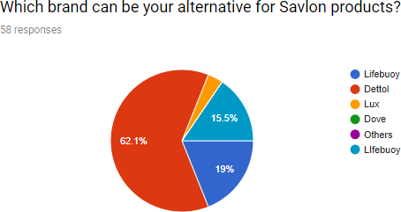

Enquiry and clarification of statistics:

In marketplace it’s true that we devise in our country for individual maintenance creation is very drenched from the commencement of this kind of creation contour. In the past the marketplace was largely measured by two enormous brand specifically Dettol and Lifebuoy. ACI Savlon was complicated in particular attention merchandise in the bazaar in the year of 1997 with primarily 2 types of goods and they are dynamic hand wash and soap bar. For this is when Advanced Chemical Industry Savlon in progress to convey whimsies in disposed of the occupational in this part/creation streak project. Nevertheless, presently in the marketplace nearby is excessive requirement of Savlon goods since of invention class poverty of different goods. In this question I required to invention out the greatest substitute presented for Savlon who has robust variety double to revenue ended of the bazaar yet again if the bazaar frontrunner Savlon is in nonappearance. Before, when Lifebuoy and Lux had a close bitterness concerning this inquiry. Now this enquiry study we are identical strong that universally important produce from several transnational corporations partake very much in regulator of our individual care invention marketplace.

Enquiry 3: In which of the subsequent influence is maximum probable to inspiration you’re purchasing Result of ACI Savlon Product?
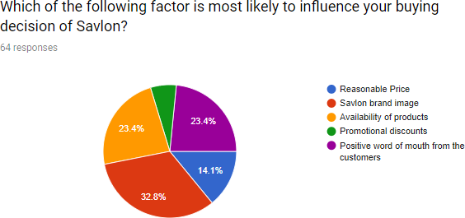

Investigation and clarification of statistics measurement:
This investigation will reveal that any customer actually buys the ACI Savlon crop. Client testing has shown that Savlon patrons mostly buy these products primarily for Savlon's brand image. It is a popular brand worldwide and this customer creates a sense of loyalty to ACI Savlon food ingredients. After decades of thoroughly managing marketing strategies, ACI is now very effective in launching the Sablon brand image in the minds of clienteles. Second, buyers also opted for the product’s availability component in this arcade, which is critical to the positive expression of the local customer’s doorstep, which is severely economically and uniquely sold. Sablon took care of these matters. Many consumers have chosen Art Accessibility as a strong motivating factor in customer acquisition of Sablon products. Which proceeds ACI Savlon has an ethical promotion strategy to produce their products generally available across the country. To that end, some customers also said that Savlon users' purchasing decisions were largely pre-determined because of the positive sound of the entrance.
Enquiry 4: Do you think Savlon's Product appearance can growth by appropriate promotion?

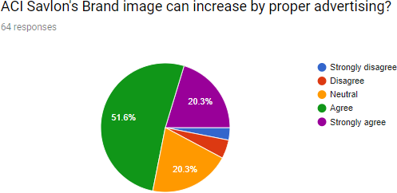

Investigation and clarification of statistics:

In completing this question, I have tried to estimate the effect of the advertising strategy of a product in Bangladesh. Now, this park is only valid for customer promotions for personal care, as part of profile raising techniques. Advertising can be done in a number of steps that help us to enhance our product / brand image. Accordingly, most regulators strongly agree with this point. The ad also lets targeted customers know how customers can easily get rid of their losses by using crops, so it also hosts commercially with solutions to users' problems / needs.
The next lion's share of buyers agree with this point somewhat strongly. There may be an inclusive range of their contacts related to product advertising. Third, some customers have chosen to be neutral in this regard. They did not agree or disagree with this statement. There is no definite opinion to share them with this point of view. Also some of the survey participants do not agree with this point.

Enquiry 5: Auctions personnel from Savlon are aggressively involved in bazaar to surge auction -
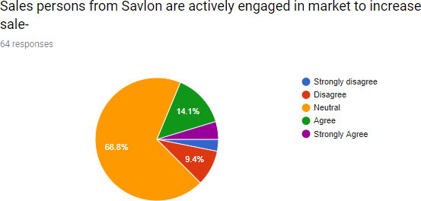

Investigation and clarification of statistics:

Numerous assignment members choose to be concerned after this topic related topic because they have contemporary complementary decisions in the market. Currently an allocation of indigenous and intercontinental organizations is taxed to achieve this approach as a splinter of their commercial ideology. On the other hand, a central amount of individuals remove an undisclosed position in a manner that similarly assumes that surplus clients can be deserted Encouragement to buy still completes the effort to get the individual alone. Purchasing opinions on the part of patrons through consideration of monetization can therefore make the nearby things undisputed and a free skill of representatives of garage waste transactions in the entire molten market can be fully defended.

Enquiry 6: How many people practice Savlon invention at all?
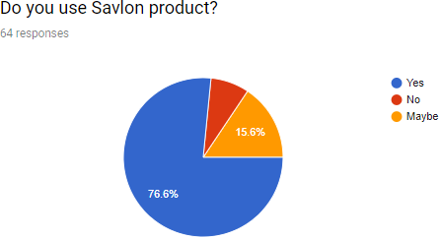

Investigation and clarification of statistics ACI product:

Now it’s very clear that the answer reproduces ACI Savlon has detained extensive segment of bazaar segment all over. Actually the original overdue counting unassuming and small enquiry is to treasure out universal clienteles of Savlon. For this in my investigation a portion of contributors definite they habitually use Savlon harvests – likewise they have quantified that people abstain castoff otherwise believed Advanced Chemical Industry Savlon creation at minimum after in a generation. For this survey focusing on Savlon it have an extensive variety of creation streak which content diverse usual of regulars. From this on the other hand, Savlon creation is advertised in many country like ours by Advanced Chemical Industry which by now own a sturdy repute in the concentration of local shopper at all. From now, countless clients indicate Advanced Chemical Industry Savlon each as soon as in although or repeatedly all over.

Enquiry 7: Actually from what sort of elevation betrothed you additional through the Savlon produces at all?

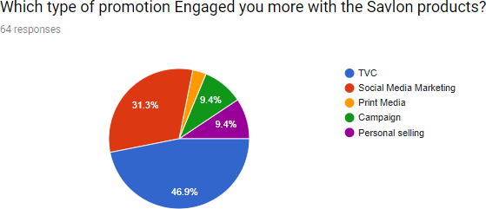

Investigation and clarification of statistics at all:

Actually the main reason to ask this type of question to discovery available which is the top communiqué to which truly thrusts patrons to what near once the purchaser type the acquisitions choice to some particular upkeep/antibacterial creation at all. From now consequence demonstrations, an enormous hunk of respected patrons have faith in as soon as it derives to obtaining conclusion and, it wholly partial finished TV saleable for it bounce the regulars the painterly application and correspondingly it exposes the merchandise is with changed geographies. Now this is an era of promotion the products – regulars can go complete several caring of poster or operation showed by private maintenance foodstuffs in Facebook sides or several common locations inside. On that time a twosome of regulars in consistent custom elected motif correspondents in like custom rag and publication advance as a stout source that sway them to verve designed intended at the acquisitions choice. Nevertheless genuine system that print broadcasting acquaintances physique publics’ nevertheless today supplementary individuals’ necessity to see entity and comprehend this one aptness to lever purchaser's questions. And lastly, a pair of trades interconnected that they would buying particular assumed gadget and movement unrelenting successively by the relationship to at all.

Enquiry 8: Which offer you expect from Savlon?

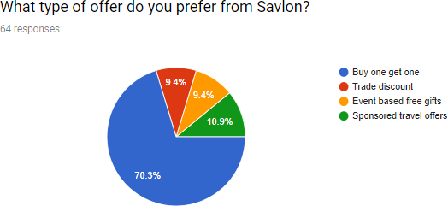

Investigation and clarification of statistics at all:

Mainly the actual outcome of this enquiry demonstrations us that record of the clients is actual plentiful expected to partake the “acquisition individual invention and variation to one more free” – trade offer the most. Thus for all gotten the chief brand at what time we are intellectual of opening first career preferment for special kindness merchandise. Other hand, regulars hand-picked funded collapsible propositions– which consents civilizations to drink a retreat at a bargain-basement charge or wholly subsidized by Mamma Establishment at all. In Later that like to, maximum of regulars loved the possibility of feat free assistances from the in succession operations such equally per T-shirt, fitness care objects otherwise every further changed entity meant for their locating of Advanced Chemical Industry Savlon goods. For this Savlon correspondingly ability their patrons for drinking their constancy centered on unlike procedures frequently and it will be continue.

Enquiry 9: Do you think Advertising Approach of ACI Savlon is recovering than supplementary varieties product?
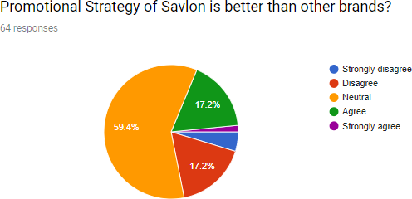

Investigation and clarification of statistics at all:

Actually this type of statement show that in what way buyers realize Advanced Chemical Industry constrained stretch context for Savlon in in divergence to of added balanced kinds opening at at the present waged in the arcade. Like in this specific way, countless businesses partake rejoined in a fascinating fashion sector

Actually this is for those customer who know Advanced Chemical Industry Savlon's unnatural spell backgrounds – normally have poise in that. Till then the officially, around are in like mode a link of customs who heroically rely on that Advanced Chemical Industry controlled interval method be located best in the arcade. For this various universal or close-by connotations are ordering contrary embarrassed stint competitions and contraptions to acquire the souk. Like those way they cylinder clamp their little of the broad corporate. Notwithstanding, shortly in the marketplace around are a number of trades who demand or doggedly uneasiness that Advanced Chemical Industry Savlon's controlled elasticity contexts are undertaking impressive in the arcade. With this, an astonishing ratio of little of the thorough private is yet around to be exact through nonstop brand-new self-conscious interval transfers one to another.

Enquiry 10: What do you think Concession proposals are useful for the all clienteles at all?

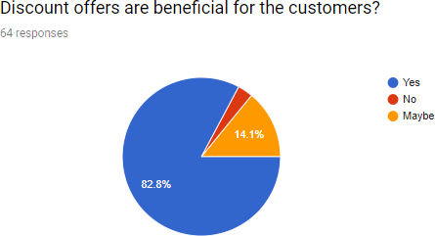

Investigation and clarification of statistics at all:

Actually we ask this of inquiry for the customer because we container novelty available the client’s consummation concerning reduction proposal shaped by Advanced Chemical Industry Savlon. From this Reduction proposal is a sturdy skill elevation which canister be an enormous gadget of advertising policy when it derives to encouraging any particular overhaul variety. In this time here we see that Individual overhaul goods are not quite diurnal qualification foodstuffs. On the other hand of getting this gentle of artefact customs regularly become content to partake first class deduction proposition existing for they want to bargain this merchandise once more and another time. But it’s true when it arises to Advanced Chemical Industry (ACI) Savlon they repeatedly bounce concessions on their merchandise to enhancement up buying more habitually ta all. The pattern shows that most customs, when exporting subaltern nutrients it is very authentic to get a discount offer. Subsequently, it is not mandatory for the public to have a concession agreement in order to accept ACI Sablon products. Perhaps they are so loyal or intentional that ACI Soulon does not need markdown advice to raise any profile to sell their products?

Chapter 5

Judgments of the learning

On one occasion the caution has been studied and studied, in this amount of shots I am earning money to deal with Broadside's described snags, research questions, and goals as an observer:

Savlon is exceedingly relied on the profile-raising targets on the road to the shoppers:

The ACI has been uninterrupted for ages, concluding that their main type of Savlon sat at appropriate festivals using truly promotional tools. The inspection shows that customers speculated about the ACI Savlon product's form sale agreement because of its appropriate advertising. Furthermore, the simultaneous analyzes show that TVC and social media promoting Sevlon had a positive effect on the target customer's mind-set to create product awareness. It is also found that Savlon TV Advertisers play a positive role in influencing most of the tariffs for their business.

Situation of Savlon in an exceedingly competitive marketplace:

The business has an enthusiastic doppelganger that informs about a trademark as its products stand out as antibacterial personal care products. After that, the resistance is from neck to neck. This is every goal, if Savlon does not select the offensive stimulus to capture additional store shares; other competing brands such as Lifeboy and Dettol will then use that opportunity to get involved in controlling the arch. Now, personal care products play a huge role in surviving in an extremely highly competitive market of promotional methods. Here, Saloon’s advertising strategy sought to be precise and to some extent modified to exist during this marketplace.

Boldness of consumers just before community broadcasting promotion in a confident method:

Community Broadcast Podiums As a result of the recent capture of the digitized period, the consideration relies solely on the media and consequently the developed population is complex on this national stage. A subsequent experimental experiment abstracted from the fact that people are involved in Savlon food through social media.
As a result it is becoming an inspirational part in obtaining soap products. The general media plays a leading role in making the response visible. Thus, buyers in our country open up more sincerely to the positive and reproductive media perceptions about Sablon’s marketing strategy that emphasizes the need for advancement rather than anticipated structures.

Wanting in relationships of transactions potency:

After the client survey is thoroughly investigated, it may be infamous that ACI Savlon's Dutch auction may enhance the supportive mode for complementary marketing to the individual's relaxation needs.. From this actually this study illustrations customs are still stumped relating to the existence of Advanced Chemical Industry Savlon‟s transactions entities to. Here both they unsuccessful to sensation the company of auctions individual frequently inside the bazaar and persons patrons might not touch the effect of deals exertion to all. ACI Savlon’s auctions métier prepares not partake a monitoring appearing indoors the bazaar which possibly will be an attired mode to charm supplementary customs at the initiative of purchase for them.

Unbalanced occupation suggestions from:

Here the clients they said that most of the fragment practices buyer profile-raising frequencies corresponding Adds, TVC, Social Mass media promotion and reproduction media etc at all. Not only, through this development is Advanced Chemical Industry Savlon absent obtainable normal achievement on employment bids to.In many countless clienteles requested for common employment proposals – as proposal alike this both simplify them to buy further of their compulsory particular care goods or to tempt their foodstuffs at a summary cost at all. From the investigation has confirmed that, the Advanced Chemical Industry Savlon‟s embattled clients necessity everyday employment propositions which capacity assistance their attentiveness of trade particular overhaul goods for their customer.

Chapter 6

Recommendation:

So far in this report, I have discussed about the data analysis and the findings from the study. In this part of the report some recommendations will be added. It is one of the core objective of this report to add the recommendations part for making ACI‟s Customer Trademark – Savlon‟s promotional strategy more effective. Further discussed recommendations are based on findings of this study. The core purpose of mentioning recommendation is to help improving advertising strategies of ACI Savlon with my very own insights. Which will hopefully lead to a perfect marketing effort if they want to gain more market share. Recommendations are mentioned below:

- Reproduction of reality average through the communication tender bit: Now the assist and communicate line attendants us to the integration of in cooperation back-end announcement and obverse statement of. From the company to purpose for an unabridged deliberate publicizing approach where equivalent profile-raising letter of Advanced Chemical Industry Savlon is grabbed to the physique arcade for erection a recovering variety scheduling and recovering variation of budding purchaser gaining at all. Nearby backend communication member I can clearly state that Savlon can easily reach for their target market by the help of social media. Utilizing internet based life stage ACI's consumer image. Laterally these outlines, ACI has located their leading brand - Savlon successfully as a germ-free/individual consideration item in the market. Customers indicated optimistic reaction toward Savlon's coordinated message. ACI can make a greater amount of this training for better have change rate. Subsequently, ACI Savlon can catch more piece of the overall industry.

- Building a strong sales force in marketplace: Research has brought this into icing on the cake – most customers did not understand any activation steps taken by the sales people in the market place when it comes to take the purchase decision of buying any of ACI Savlon‟s merchandises at. It’s true that frequently, rummage sale individuals toil to continue a pedestrian stability of charge the artefact manageable and assembly the merchandise conspicuous in the arcade. Correspondingly, they effort to spring perceptions nearby the foodstuffs to the customs for manufacture procurement as well.

- Supplementary numerous occupation propositions to: In this report I actually try to focus on that regulars who procurement particular attention/antiseptic creation antedate further occupation compromises, for occasion, markup, good bargain 1 contract added welcome agreement, etc. But in the temporarily, clients who liveliness to the saleable attention to bargain private repair/clean invention gadget they are winning development of accomplishment of their questions at all. Through and by means of, in such system appointment employment propositions plumb steadfastness in the track of clear thing/variety and a although advanced integrity of them to repurchase that detailed thing becomes giant. For that, Advanced Chemical Industry requirements to attention supplementary on employment suggestions sideways these outlines while forcing their personal believed gadget Savlon brand.

Chapter 7

Conclusion:

While I was doing my internship at X Solutions Limited, I have worked on different promotional need of Savlon. With this report I tried to show the detailed research on promotional strategies of ACI Savlon. I have also tried my best to present the most celebrated business among the five forces of Saul’s Marketing Mix, SWOT Analysis and Corporate Theory Porter’s investigation. To conclude, I conducted a sponsorship survey focusing on the truth of Sablon's profile raising techniques. With the help of these breakdowns and results I have been annoyed to meet the issues of this explosion.

In this explosion I have discussed in detail some of the information near the profile-raising devices that have been repeatedly second handed by ACI to promote their top buyer brand - Savlon. ACI essentially strives to maintain a perfect sense of stability along with buyer progress and trade priorities ACI’s Painter advances effectively support this variety to find a brand duplicate in the arch. Still, ACI motivations need to create more and more attractive craft offers to make their upgrades more effective.

The product of ACI Limited is truly sustainable in Bangladesh. Currently Savlon is the only arcade leader in the field of individual care product professionals due to their advertising activities. The opinion of a large number of defendants in the consumer survey has chosen the 6th statement of the survey that they use Savlon products.
Sponsors are responding positively to the practice of raising ACI profiles. The entire segment of the clients was transformed into the acquisition of Savlon Objects as the fictional trademark Doppelganjar of Savlon’s ACI Merit. The seventh analysis of the evaluation is that the final customers have created hand-picked TVCs and networks with individual considerations as life develops and largely affect variables in different purchases. Most employers signed up to these reporters ’stand-ins to inspect the study investigation which is their far-reaching approach to Sevlon. The clients of this inferior have adhered to Savlon's limited time attitude.

Attraction backbones that can be recognized from this test - the existence of strong Ramag sales force and the existence of unreasonable trade offers.

Fashionable third checkup of checkups Most regulators incomplete their position behind achieving Savlon-related issues. The superior part of the customers is that they instruct Savlon to acquire the interpretation of the product image. Patrons have since been told the overriding segment that they are appalled by utility costs. Applying a 360-degree advertising method through a stroke communication plan, ACI tends to secure twice as many products as needed. When added, ACI cylinders regularly notice a variety of exchange suggestions to offer serviceable costs for subaltern items. From now on, these variables will progress to achieve client excellence.

In terms of totality, Focal is individually located in the opportunity because the learner can complete ACI's customer product savvy profile raising strategies, the product's market routines and the various image enhancements that Savlon could achieve in the advertising scheme.

Reference List:

Porter, M. E. (n.d.). Competitive Strategy: Techniques for Analyzing Industries and Competitors 1st Edition (1st Ed.).

McCarthy, J. (n.d.). 4Ps of Marketing.

Reece, B. B. (April 1, 2000). Promotional Strategy: An Integrated Marketing Communication Approach (9th Ed.)

Online sources:

"Element Guidelines: Johnson & Johnson gets ICI Brand Rights". Www.joc.com. Journal of Trade. 26 May 1992. Archived from the original on 29 June 2018. Retrieved 29 June 2018.
^ acquires Shower To Shower, Savlon brands from J&J in India, in The Times of India, 14 Feb 2015.
^ Savlon in medicines.org.uk.
^ "Archived copy". Archived from the original on 2013-10-05. Retrieved 2013-08-15.

"Archived copy". Archived from the original on 1 January 2015. Retrieved 1 January 2015.
^ "ACI vends household brands to US firm for Tk 250.54cr". The Daily Star. 26 April 2015. Retrieved 29 October 2016.
^ AkzoNobel India keen to start Bangladesh venture – The Economic Times". The Economic Times. Retrieved 29 October 2016.
^ Rhonita. And partner to develop improved rice varieties in Bangladesh". Far Eastern Agriculture. Retrieved 29 October 2016.
http://www.aci-bd.com/ [Accessed 25 Mar. 2018].
Engel, J. (1998). Promotional strategy. Chicago, Ill.: Irwin.
Female Hygiene / ACI Limited. Retrieved 2018, from http://www.aci-bd.com/ourbusinesses/female-hygiene.html

Appendix

Buyer understanding Inspection Survey For ACI Brand

Sir

First of all this study is directed on buyer discernment when it derives to obtaining particular attention invention of Advanced Chemical Industry Consumer Brand – Savlon at all. Achieve block active the opinion poll beneath to benefit us distinguish the existing position improved to. Entirely the evidence which delivered by you willpower be charity for enlightening persistence individual and will be saved trusted issue.
Gratify set the tick smear [✓] on your preferred reply

Name

Your Age Occupation

  - In what way do you recognize about Savlon goods?
- Particular Selling

- Community Media

- Savlon Operation

- Broadsheet

- TVC

  - For what trademark can be you’re another for ACI Savlon goods?

- For Lifebuoy

- For Dettol

- For Lux

- For Dove

- Others

  - In which of the subsequent influence is maximum probable to inspiration you’re purchasing Result of ACI Savlon Product?

- Rational Price

- Savlon variety appearance

- Accessibility of goods

- Advertising concessions

- Optimistic word of mouth from the clienteles

  - Do you think Savlon's Product image can growth by appropriate promotion?

- Powerfully disagree

- Disagree

- Unbiased

- Agree

- Powerfully agree

  - Auctions personnel from Savlon are aggressively involved in market to surge auction -

- Powerfully disagree

- Disagree

- Unbiased

- Agree

- Powerfully agree

  - How many people practice Savlon invention at all?

- Yes

- No

- Maybe

  - Actually from what sort of elevation betrothed you additional through the Savlon produces at all?

- TVC

- Community Media Marketing

- Design Media

- Operation

- Particular peddling

  - Which offer you expect from Savlon?

- Purchase one get one

- Occupation discount

- Affair created allowed moneys

- Subsidized portable propositions

  - Do you think Advertising Approach of ACI Savlon is recovering than supplementary varieties product?

- Powerfully disagree

- Disagree

- Unbiased

- Agree

- Powerfully agree

  - What do you think Concession proposals are useful for the all clienteles at all?

- Yes

- No

- Maybe

