
Sales & Marketing in Global Brand Pvt. Limited: The Way It Works

Submitted to
Md. Shariful Alam, PhD
Associate Professor
School of Business and Economics
United International University

Submitted by:
Sadman Sakib
ID: 111133069
School of Business and Economics
United International University

Date of Submission: 18th March, 2019

Sales & Marketing in Global Brand Pvt. Limited: The Way It Works

Letter of Transmittal

18th March, 2019

Md. Shariful Alam, PhD
Associate Professor,
School of Business and Economics,
United International University.

Subject: Submission of the project report on “Sales & Marketing in Global Brand Pvt. Limited: The Way It Works

Dear Sir,
With due respect, I would like to inform you that, it is a great pleasure for me to submit the intern report on “Sales & Marketing in Global Brand Pvt. Limited: The Way It Works” as it is a fulfillment of partial requirement to achieve BBA degree under the curriculum of United International University, Bangladesh.
I have worked hard preparing this report and I hope that it will fulfill my degree requirement. I will be always available for answering any query on this report.

So, I fervent requesting and hope that you would be kind enough to accept my report and oblige thereby.

Sincerely yours,



-----------------------------------------------

Sadman Sakib
ID: 111133069
BBA Program
School of Business & Economics
United International University

Acknowledgement
First of all, I express my deep gratitude to the Almighty Allah who created and nurture us in this transitory world. I also have to put my heartfelt respect and gratitude for His kindness and help that were provided to me to complete my report. This study is the outcome of the report writing program undertaken by the course and instructed by Md. Shariful Alam, PhD, Associate Professor, SOBE, and United International University for summer 2018 student to supplement the experience and communication skills. I am indebted to them who have directly and indirectly assisted me in conducting the study. Specially, I am thankful to my honorable supervisor because of his assistance gives us the opportunity to start our report promptly.

Table of Contents

Executive Summary ------------------------------------------------------------------------------------ II
CHAPTER 01: INTRODUCTION OF THE REPORT 3
1.1 Rationale 3
1.2 Objectives 4
1.3 COMPANY BACKGROUND 4
1.3.1 Vision Statement 7
1.3.2 Mission Statement 7
1.3.3 Values 7
1.3.4 Uniqueness 7
1.3.5 Corporate Profile of the Company 10
Chapter 2: Activities undertaken 11
2.1 Work Related Activities 11
2.1.1 Check current stock report 12
2.1.2 Buyer setup 13
2.1.3 Sales Setup 14
2.1.4 Serial number entry: 15
2.1.5 Confirm and Collect Bill 16
2.2 Other Relevant activities: 17
2.2.1 Check Email: 17
2.2.2: Receive phone call 18
2.2.3: Staple Invoice with Challan: 18
2.2.4: Visit the market: 18
2.2.5: Scan Different Documents: 18
2.2.6: Prepare quotation for Tender: 18
CHAPTER 3: CONSTRAINTS/ CHALLENGES 19
3.1 Limitations of the Organization /limitations faced by me 19
3.2 Problems due to Lack of Adequate and Appropriate Academic Preparation 20
3.2.1. Mismatches with my Academic Preparation 20
3.2.2 Relevance of the Academic Preparation or Major to the present assignment and future job requirement of the organization 20
4.3 Missing knowledge and skills that to be learned in the university 21
CHAPTER 4: LESSONS LEARNED FROM THE INTERNSHIP PROGRAM 22
4.1 Implications to the organization/company: 22
4.2 Implication’s to Universities Internship Program 23
CHAPTER 5: CONCLUDING STATEMENT 24
5.1 Recapitulation 24
5.2 Suggestions addressing the challenges 24
CHAPTER 6: REFERENCES 26

List of Figures | Page Numbers
Figure 1: Milestone of GBPL | 06
Figure 2: GBPL Organizational chart 2015 | 08
Figure 3: ORGANOGRAM GPBL (IDB BRANCH) | 09
Figure 4: Screen shot 1 | 11
Figure 5: Flow Chart 1 | 11
Figure 6: Screen Shot 2 | 12
Figure 7: Flow Chart 2 | 13
Figure 8: Screen Shot 3 | 13
Figure 9: Flow Chart 3 | 14
Figure 10: Screen Shot 4 | 14
Figure 11: Flow Chart 4 | 15
Figure 12: Screen Shot 5 | 15
Figure 13: Screen Shot 6 | 16
Figure 14: Flow Chart 5 | 16
Figure 15: Screen Shot 7 | 17

Executive Summary
This internship report is based on the three month long internship program that I had successfully completed in Global Brand PVT Limited under marketing and ecommerce Division from 12.08.2018 to 15.11.2018 as a requirement of the BBA program, United International University. As being completely new to practical, corporate world setting, every hour spent in the GBPL gave me some amount of experience all the time all of which cannot be explained in words. But nevertheless, they were all useful for my career.
This report includes the company profile, which includes their competencies and their focus on the business concentrated customers, their strategies and planning regarding the customers and how they deal with them. Then it says about “my job responsibilities” that I used to do during my internship in Global Brand Pvt. Ltd. as an intern. The report includes the way of approach to the individual customers, how the company retains the customers` attention from time to time and the operations regarding sales. The lists of attained operations and its flow charts are shown in the report. In the work flows it is shown how some activities are done and how I was able to do my work through proper guidance.
The Marketing and Sales department of Global Brand Pvt. Ltd. and my responsibilities, which mostly resolves around the product presentations to clients at it`s IDB Branch. The information portrayed in this document has been collected mainly from primary sources and some secondary sources such as reports with the approval from the Global Pvt. Ltd. upon the disclosure of the sources. Global Brand Pvt. Ltd. follows strict code of conduct for which it has to maintain a level of confidentiality.
Subject Keywords: Marketing, sales, customer retention, organizational behavior.

CHAPTER 01: INTRODUCTION OF THE REPORT

Theoretical knowledge never equips with all the skills he/she requires in the practical field, and therefore practical real world experience is required. Internships provide an opportunity for students to relate theory with practice and further serve as a temporary labor pool for those organization that have committed to participate in the internship program. The internship program fulfills its mission of preparing students for significant professional and managerial positions in the public and private sector. This program and final report will enable the student to compare theoretical ideas taught in the classrooms and relate this with the real business environment.
The following report describes the activities carried out during fulltime internship at Global Brand Pvt. Ltd .The document contains information about the organization and the responsibilities performed by me through the whole period.
The first part of the report offers an overview of the organization. Following, it proceeds to describe in some detail, which is relevant to the project, carried out by my respective analysis.

Rationale

The organization I have selected for internship is very much sound in modern technology and have a great organization culture overall. There is a lot of scope to learn and have practical experience regarding the value chain, distribution process, sales and mainly the overall operations of the Global Brand Pvt. Ltd. It is one of the biggest and consistent developing organization in the country.
I have chosen Retail Sales and Operations of Global Brand Pvt. Ltd to work on. It is known that company`s turnover depends on sales and in order do sales many operations are required to be done. As an apprentice I am receiving retail sales training and the included operations in order to develop skills which will help me to get a job according to my desire expectation.

Not but the least, the more important point is to be noted that this practical knowledge is directly involved with my educational background. This is enhancing my theoretical knowledge. This report is done to fulfill my BBA program relating my major Marketing.

1.2 Objectives

The objective is to gain valuable knowledge in real life situation and make a relation between theoretical learning and practical findings. The various concepts learnt throughout the BBA curriculum from Operations Management, Services Marketing, Strategic Marketing, Marketing Management etc. will be a great influence in the study.

The major purpose of this report is to focus light on the operational process of one of the biggest ICT solution company of Bangladesh. The underlying objectives of the report are:

- To know about the origin of the enterprise.
- To know the operations and the distribution structure of GPBL.
- To learn the marketing process.
- Build up an effective communication skill.
- To learn the organizational behavior.
- To learn time management.
- Build up critical thinking skills.

1.3 COMPANY BACKGROUND

Global Brand Pvt. Ltd registered with the Register of the Joint Stock Companies and firms of Bangladesh under the companies Act 1994.Since 1996, global Brand Private limited has been supporting clients national wide in managing the evolving role of information communication technology in business. As a strategic business partner, GPBL provide diversified ICT solutions and service that support attainment of their clients` business objectives. Their service and solution include distribution industries of hardware systems, networking products, network infrastructure building, and delivery, installation of PCs` Servers, Printers, Projectors and POS.

- 18 years of Management experience.
- Sound Financial Background.
- An ISO 9001:2008 certified company
- 150+ IT Professionals
- 500+ Employees
- One corporate Head Office; Branch Offices in district level Dedicated Service Center.
- Distribution Channel all over in Bangladesh
- Operates Domestic and International Market
- Authorized Distributor for 30+ reputed Brand
- Have an Excellent Client base to reference
- Best Certified and Quality Engineers in the Business

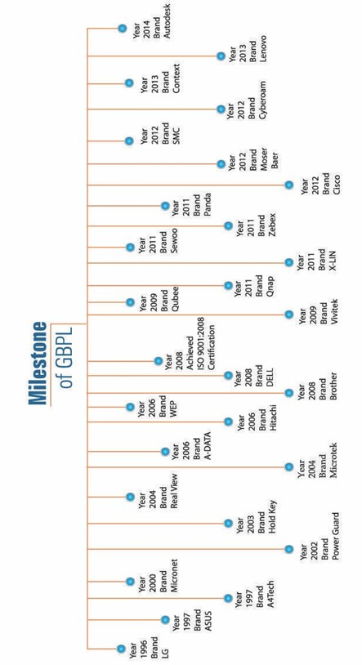
Figure 1: Milestone of GBPL

1.3.1 Vision Statement

To build a beautiful tomorrow, keeping in mind the frequent changes in taste and needs of a modern lifestyle in touch of ICT.

1.3.2 Mission Statement

- To create value for valuable customer.
- To become market leader by consistently exceeding the customer`s expectations and satisfactions.
- To touch the sign of digital Bangladesh.

1.3.3 Values

- Being consistently honest and trustworthy.
- The quality of Being Excellent.
- An economic state of growth with rising prosperity and full employment

1.3.4 Uniqueness

- Dynamic Management team
- Young, energetic, well trained and proactive Marketing, Sales, Support and service team
- Strong moral commitment to the customers.
- Structured and automated supply chain management.
- World best Multi-brands alliance.
- National wide dealers and Retail coverage.

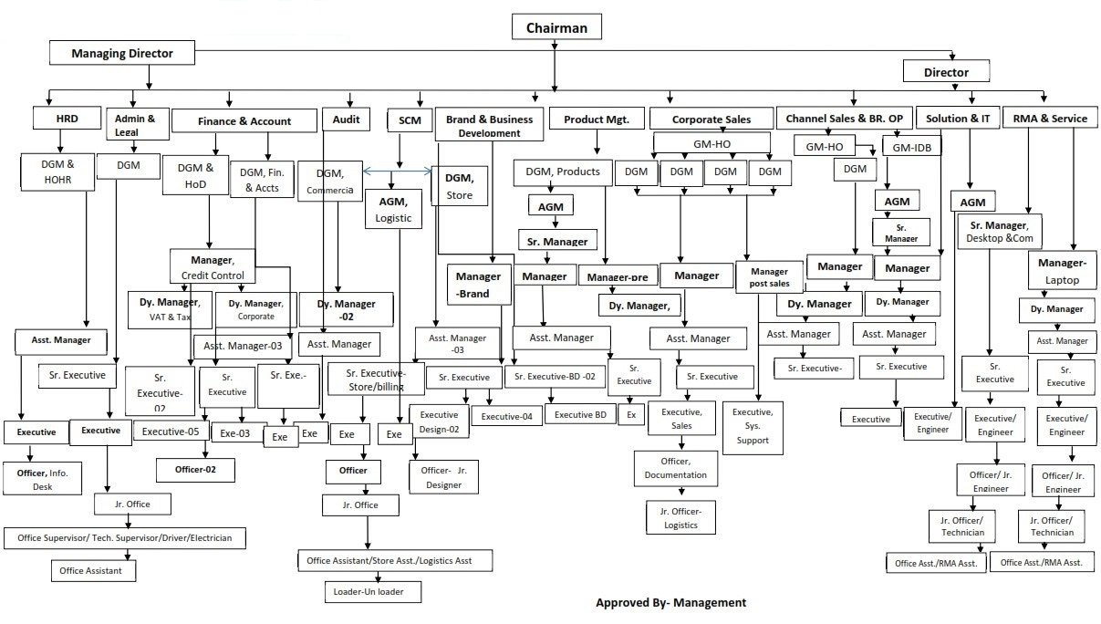
Figure 2: GPBL Organizational Chart 2018

ORGANOGRAM GPBL (IDB BRANCH)

Figure 3: ORGANOGRAM GPBL (IDB BRANCH)

1.3.5 Corporate Profile of the Company

Name of the Company: GLOBAL BRAND PVT. LTD

Year of Establishment: 1996

Status of the Company: Private Limited Company

Country of Registration: Registered under Registrar of joint Stock Companies, under the companies act 1994

Number of Employees: 500+

Corporate Head Quarters: Salim Center, 19/2, West Panthapath, Dhanmondi, Dhaka- 1205

Telephone: 8123284, 9136316, 9136420, 9111200, 9133460

Fax: (88-02) 9145687

E-mail: office@globalbrand.com.bd & info@globalbrand.com.bd

Website: www.globalbrand.com.bd

Chapter 2: Activities undertaken

2.1 Work Related Activities

According to meet the customers` demand we have to face many queries about availability of our product. In order to reply them we use software named Paperless Office, which helps us to find out all our sales data, even we can do other operations related to sales.

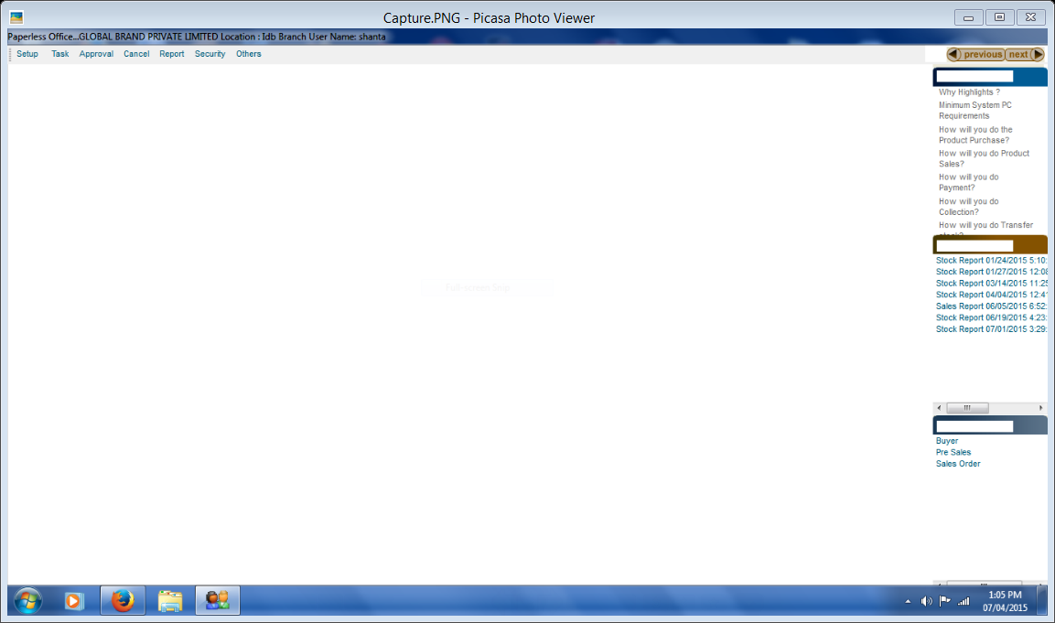
Figure 4: Screen shot 1
START
Open Paperless Office
Give password
Select Paperless Office

END

Figure 5: Flow Chart 1

2.1.1 Check current stock report

While customers look for any product, I check out our current stock report in order to provide them the correct information. First of all I check the stock list by putting the particular product name with its model into the information box, search the product if it’s available or not then I give the feedback to the customer.

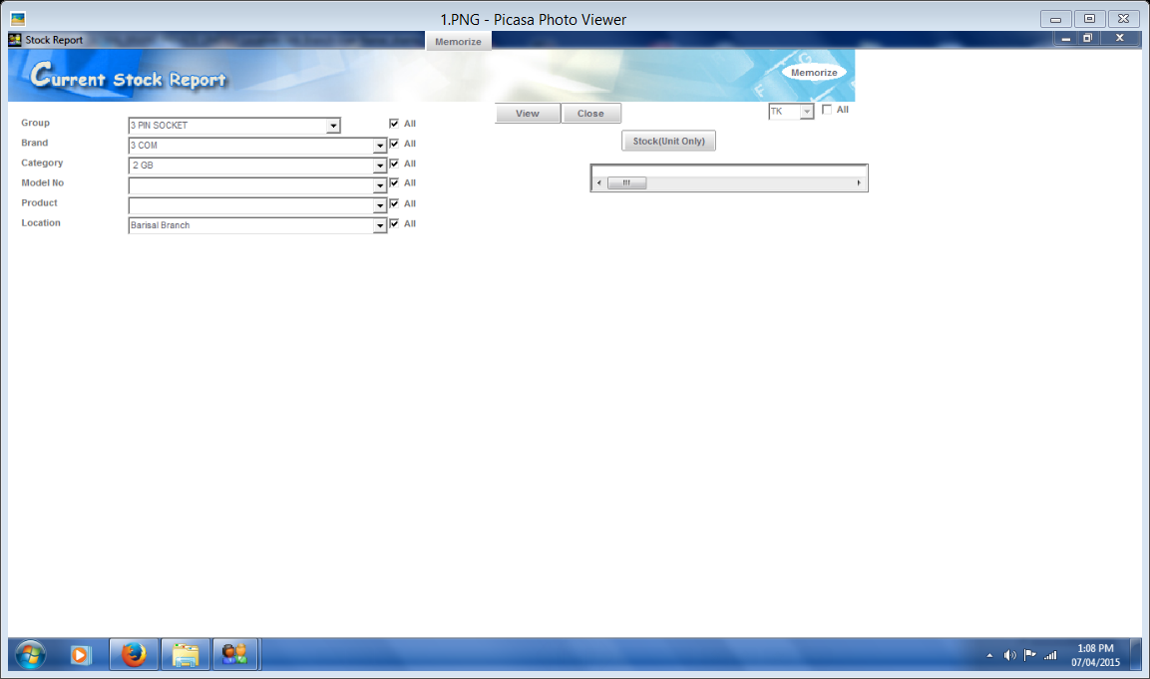
Figure 6: Screen Shot 2
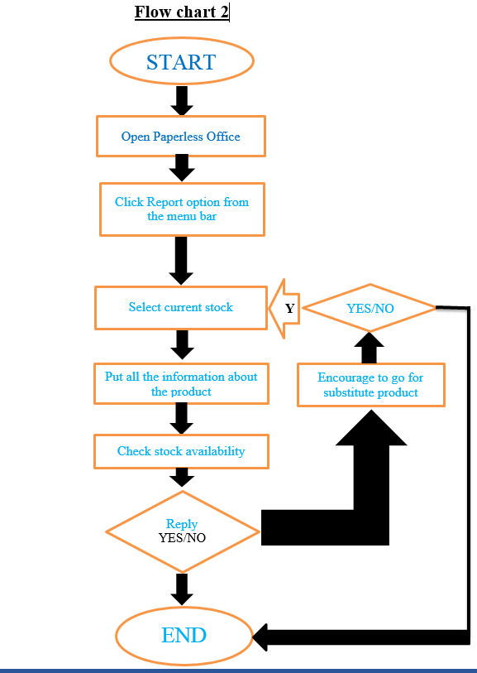
Figure 7: Flow: Chart 2
2.1.2 Buyer setup
After checking the current stock we offer our product to the customer. If the customer accepts our offer we go for preparing a buyer setup. Opening the Paperless Office I select buyer setup option from the task menu then put the required information of the buyer and save it.
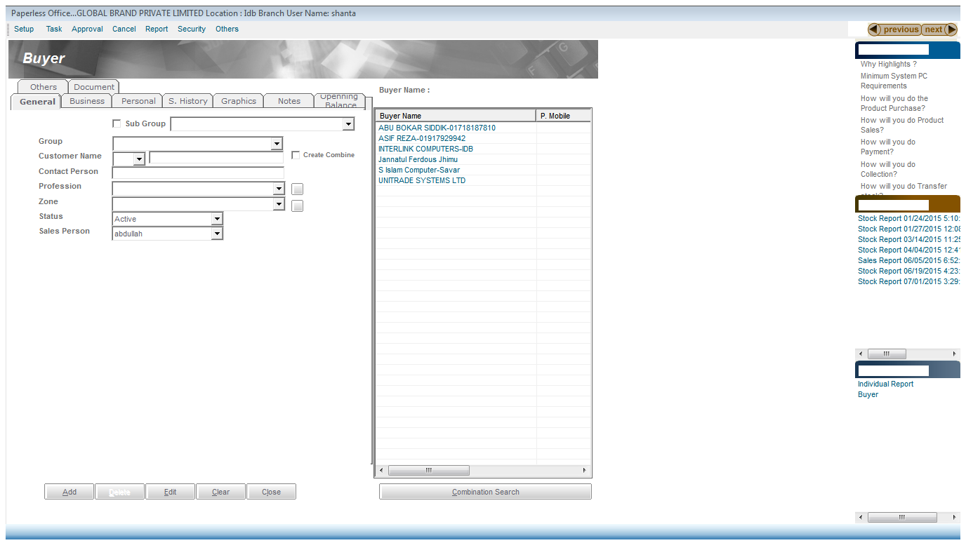
Figure 8: Screen Shot 3
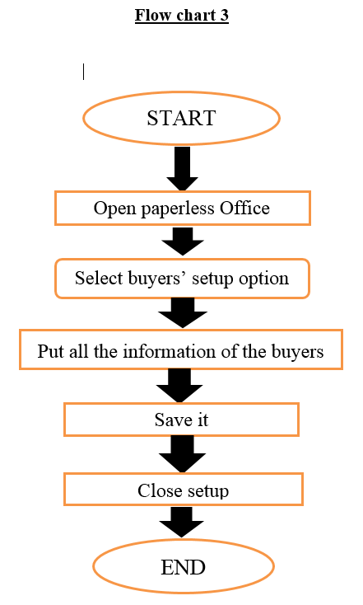
Figure 9: Flow: Chart 3

2.1.3 Sales Setup
After inputting the buyer setup, we close that screen and open Pre-sales order option. Then I put product details, buyer’s name by which his data has been saved, product price and quantity. After that clicking the add button we input the sales order report, then we close that screen and wait for approval.
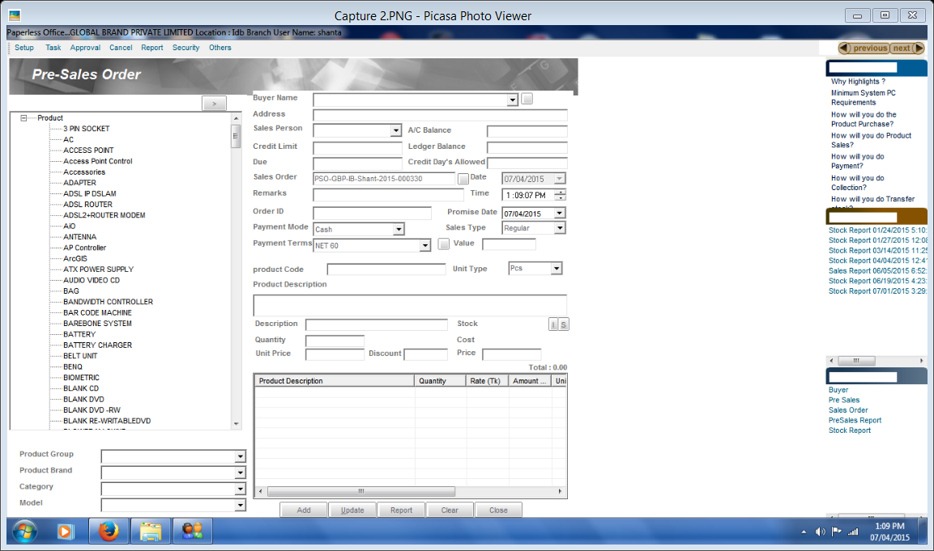
Figure 10: Screen Shot 4

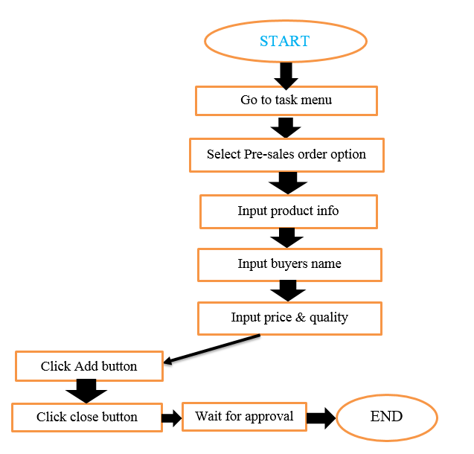
Figure 11: Flow chart 4

2.1.4 Serial number entry: After getting the approval I entry serial number of the products. I open the task menu then select Sales Order Finalize option. A new window pops up, I put the serial numbers of the product, view report to check weather I put the serial number correctly or not.
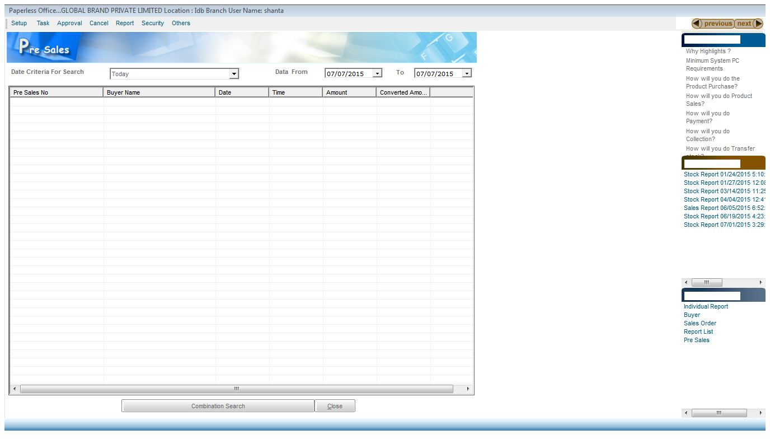
Figure 12: Screen Shot 5
2.1.5 Confirm and Collect Bill
After finishing the entire task above, it’s time to finalize report and collect the bill. I select Report from the menu bar then click finalize report, after the click the print button and take out a print out, give it to the customer and collect the bill.

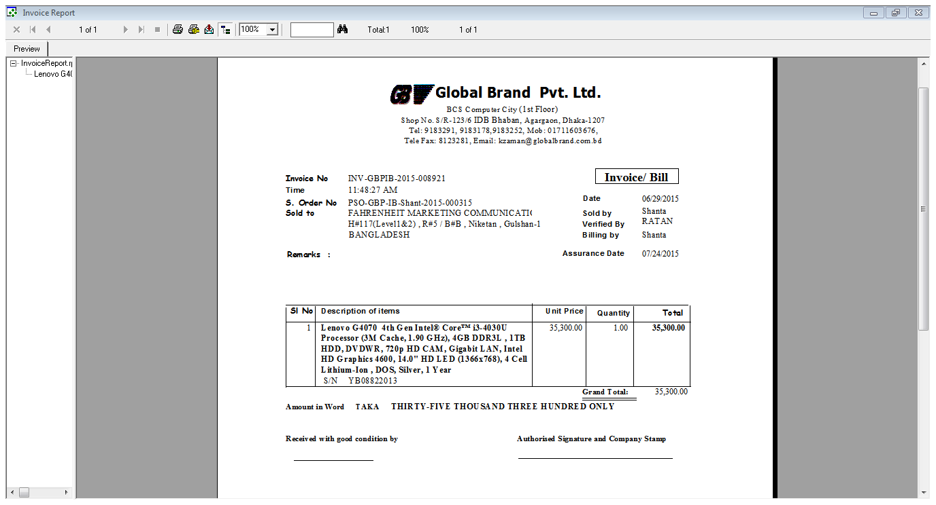
Figure 13: Screen Shot 6

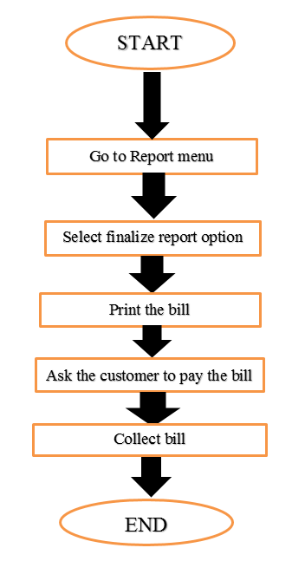
Figure 14: Flow chart 5
2.2 Other Relevant activities: Besides my assigned job relate activities I do many other relevant activities which are not must to do but to enhance my experience.
2.2.1 Check Email: Checking email daily is a kind of important issue for us. Many clients send us email in order to know the recent price of any product or ask for any quotation. Besides we receive and send mail to product manager to know the recent price of the product if there is any change in the price or informed about the upcoming product and its price.

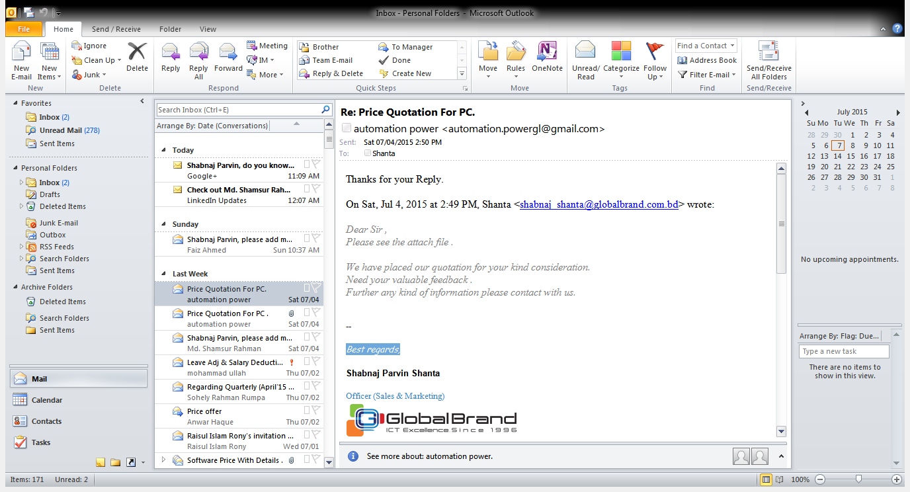
Figure 15: Screen Shot 7
2.2.2: Receive phone call: Besides sales sometimes I attain phone call from the customers. Customers call to know much information about our product and out service. It’s my partial duty to receive the calls and provide the information required.

2.2.3: Staple Invoice with Challan: It is another duty of mine to staple the invoice with the challan of each sale. By matching the code number of invoice and challan I staple them and hand those to my supervisor.

2.2.4: Visit the market: Global Brand Pvt. Ltd is one of the biggest distributors in IT sector. Most of the existing shop in the market buys products from us at retail price. We provide them a selling price at which they should sell their product. It is my supervisor`s duty to inspect the market besides his job duty. I go along with him and inspect as well if our customers doing their job properly or not.

2.2.5: Scan Different Documents: When I get foreign delicate, I need to collect different documents from customers. Ex- national ID card, passport, driving license, commissioner certificate etc. So I need to scan those documents for banking purpose. After scanning those documents I print it and return the original copy to the customers.

2.2.6: Prepare quotation for Tender: Many organization release tender in order to buy product in minimum price by maintaining all their requirements. I prepared a quotation for Women and Children Ministry, Bangladesh.

CHAPTER 3: CONSTRAINTS/ CHALLENGES

Every affiliation work has to face some limitations while conducting various activities in various extents. There was no exception in the case of mine while I was pursuing my internship program. I had to come across many challenges to acquire the exact outcome from my activities. Basically the challenges I have faced can be categorized into 2 types:
- Problems identified in the organization.
- Problems due to lack of adequate and appropriate academic preparation.

3.1 Limitations of the Organization /limitations faced by me

- Global Brand Pvt. Ltd. Use “Paperless Office” software to do their academic work is such a slow process to do any kind of activities. Even they don’t go for any modification.
- In spite of being a big organization, Retail customer services are not to the expected level yet.
- Lack of customer feedback, survey, research and proper maintenance may lose their potential customers.
- Inventory management system is not up to date and don’t go for proper forecast for the near future.
- Stock arrangement system is poor, it takes time to find a product.
- Employee satisfaction is most crucial factor in any organization. However, it has been observed that the work time was not to satisfactory level after interviewing some staffs.
- Regular interactions with the officials were the pre-condition of getting information about products and its’ price. As the officials were busy in their own role, it was difficult for me to bring out information and discuss various important things with them.
- A company should follow and obey its policy and therefore, GBPL has to maintain the secure and restricted internal environment for the safety of the company. Getting access to the people is a matter of maintaining great precaution for the safety, and hence, there will be many restrictions for a student or intern as an outsider. So, some important information was totally restricted due to the suspicion of security breach. Hence, getting access to limited people and limited information were some challenges for me.
- A study on sales and operational activities may take significant amount of time to understand better where this internship had to be accomplished within limited 3 months of time as required by the university. It was really a challenge for me to work within limited period.

3.2 Problems due to Lack of Adequate and Appropriate Academic Preparation

3.2.1. Mismatches with my Academic Preparation
In many areas I have experienced mismatches with my academic preparation while I was doing my internship. This is because university does not provide all the theoretical knowledge and I found few courses which solely match with operational activities. In my BBA course I had to gain various aspects including inventory management, managerial forecasting, operational research, quality control, where very few of them deeply focuses on sales and operational activities. As university always focuses on gaining theoretical knowledge I had a little scope to gain practical knowledge related to sales and operational activities.

3.2.2 Relevance of the Academic Preparation or Major to the present assignment and future job requirement of the organization

Despite many mismatches with my academic preparation, I found some courses those were really useful as I needed the theoretical knowledge of those course while I was doing the internship program on sales and operation of GBPL. From all the courses few could be mentioned. And they are:

- Organizational Behavior:
This course was basically about many aspects of organizational functions, aspects. I found similarity of this course with my internship program. I have gained knowledge about organizational behavior that helps me to work in organization properly.

- Marketing Management:
This course goes with various characteristics of selling policy and marketing the products. I found this course useful for my internship program as I have learned knowledge about how to sell a product though it’s a slow moving product or back dated product.

- Supply Chain Management:
This course provided me with the knowledge on the supply chain management of a company to operate the product life cycle. While I was doing my internship program I had the chance to work with their logistics management system and the knowledge I gained from the course assisted me to evaluating their supply chain management activities.

- Managerial Decision Analysis :
A company always focuses on the decisions to derive the maximum benefit from it. I gain not only the knowledge about making decisions of a company but also studied on market settings, Industry analysis, company and technical analysis. It was useful in a sense that I had to analyze the selling and marketing policy and that include various analysis of this company upon which their current and future strategies to be set.

4.3 Missing knowledge and skills that to be learned in the university
- University should offer a subject which has deeper knowledge about total Microsoft Office.
- University should offer some practical workshop for students about overall sales and marketing activities.
- University should offer to visit different manufacturing, financial and service institution to the student in order to gain some practical knowledge which will also help them to be practical in future life.
- University should arrange more seminar on sales and marketing.
- University should pressure the students to do field work rather than googling it.

CHAPTER 4: LESSONS LEARNED FROM THE INTERNSHIP PROGRAM

4.1 Implications to the organization/company:

From my experience I have learned so valuable knowledge which helped me a lot to understand the sales and its operations and as well as to prepare this report. Through this internship affiliation report I got a chance to have a very close observation about all the sales activities of Global Brand Pvt. Ltd. Followings are my understanding from this internship program:

- First of all, I have learnt about the organizational behavior, how individuals and groups act in the organization, what is the people-organization relationships in terms of the whole person, whole group, whole organization etc.
- I have learned about the compensation management practice. Here I have learned about different form of direct-indirect, financial-non financial benefits and rewards that has been provided to the employee in exchange for their work. The most important lessons from this part is that before making compensation policy for the employees, the policy maker must be keep in mind about the Management Philosophy.
- I learned the fact of using reference power in the compensation factor affects the equal employment opportunity. It means, sometimes employees are directly appointed through reference and because of their strong reference they got some extra benefit which other employee at the same rank doesn’t get.
- I have learned mostly about the leave management system. Here I have learned about the category of leave, leave entitlement, how to process a leave application, how to calculate earned leave etc.
- I have gathered knowledge how to communicate with the people, how to convince the customers, understand the customers demand, how to face the communication error. I have realized that great customer service in a proper way is the fundamental of great customer satisfaction
- Through writing different type of letters, quotation and notices my writing skill has been developed along with Microsoft Office.
- It is required that intern will deal with various sector and departments of an organization. I felt that I have achieved some more dimensions while I was studying on the various sector of the organization and working on different tasks. These multi -dimensional work could be valuable for my career ahead of me.
- During my internship I got sufficient assistance from the staffs which helped me a lot to enhance my knowledge, skill and the power to implement my academic knowledge in a working place. In my upcoming life on the way to my career it will help me a lot to start a better professional life responsibility, commitment, regularity in workplace and worthiness to interact with different sorts of people.

4.2 Implication to Universities Internship Program

This internship has improved my skills a ton, both off paper and on paper. I didn’t realize it all of this time, but this position served not only as a positive learning experience but a resume builder as well. I came into this with a resume that was basically nothing, now I’m leaving and I have lots of update to do. My resume doesn’t need a makeover, it needs to be restarted from the scratch and that’s a good thing.
University’s internship is helpful for my future academic career, now I am much more conscious about at what kind of job can be much more fruitful, how I am supposed to manage my whole career and of course how I am supposed to communicate with other employees and many other additional affairs required for a job. I have learned formal report format. Acquisition of academic information and practical job information from different sources help me sufficiently to prepare the report. I have also learned few more things through this internship program like-
- It has improved my trust, confidence, and professionalism.
- Developed my skill and competencies.
- It has increased my timeliness, regularity and sophistication in work.

CHAPTER 5: CONCLUDING THOUGHT

5.1 Recapitulation

Internship report is really essential for every student of business studies to get idea practically. By completing this report I have got overall idea of retail sales and also other general activities of a distribution and retail sales company and these may be helpful to know about the technical and management knowledge of modern sales. This is a huge sector and yet to discover the whole.

The experience and learning I have gathered during my long three months program with GBPL was really important for me and this assisted me a lot to realize my further career for upcoming future. In these 3 months most of the sections and departments have been observed by me and I have acquired plenty of things from those. Global Brand Pvt. Ltd always concern for countries economy as well as countries people. GPBL is thinking to introduce new product and service and more advanced “online shopping” for better customer satisfaction.

From my point of view about sales and marketing department, I can include several activities of a Wholesaler and Retailer Company such as retail sales, corporate sales, distribution, market analysis, tendering, billing, marketing, making equation, cash receipt and payment and so on. It has been also observed that GBPL is the largest ICT importer of Bangladesh provides EMI scheme to general people.
From my experience during 3 months I can say that GBPL branch office is really a nice place to work as it has good management and strong team members. It can be added that Global Brand Pvt. Ltd. is playing a vital role in computer sourcing as well for the country’s economy as well.

5.2 Suggestions addressing the challenges

- Although I faced lot of problems during my internship inside the organization, I can suggest some views to overcome this. There should be a different section of research that will help interns to understand their work properly. This division will co-operate with newly interns and researchers to improve their skill which will motivate them inside the organization during their internship.

- Engaged employees are innovative. They’re always looking for a better way.

- Non-work activities that foster relationships increase employee engagement.

- Global Brand Pvt. Ltd. should increase their product facility or scheme more rapidly for, greater customer satisfaction. In addition, they must be efficient in E-commerce.

- Global Brand Pvt. Ltd. should come out with more customer feedback, research and survey to know what their clients actually think about their service. To compete with other leading company, they should increase their customer satisfaction too.

- Organization facility such as technology, equipment should be more advanced. Overall working environment should be well equipped and better for more employee satisfaction.

- The entire employee should be well treated, the incentives should also need to increase and company should ensure motivation to employees.

CHAPTER 6: REFERENCES

Corporate Profile (Global Brand Pvt. Ltd.) 2018.
Kazi Fayaz Hossain, Business Development Manager at GPBL LTD.
Email: Kazi_fayaz@globalbrand.com.bd
Contact: +8801969633000)
Info@globalbrand.com.bd
office@globalbrand.com.bd
www.globalbrand.com.bd
Kotler & Armstrong - Principles of Marketing 17th GLOBAL Edition 2018.
Marketing Management, Global Edition by Philip Kotler.
https://www.torbenrick.eu/blog/performance-management/20-tips-to-improve-employee-engagement-and-performance/

