Enhancing Employee Motivation through Performance Evaluation



This report is submitted to the school of Business and Economics, United International University as a partial requirement of the degree fulfillment of
Bachelor of Business Administration.

Submitted to:
Name: Prof. Dr. Abu Saleh Md Sohel-Uz-Zaman
Designation: Professor

Submitted By:
Name: Maliha Ahmed Mumu
ID: 111 161 086
Major: Human Resource Management

School of Business and Economics

United International University

Date of Submission: 15.06.2020

Letter of Transmittal

Date:
Dr. Abu Saleh Md. Sohel-Uz-Zaman
Professor
School of Business and Economics
United International University

Subject: Submission of Internship Report.
Dear Sir,
I would like to submit my report titled “Enhancing Employee Motivation Through Performance Evaluation” prepared as a part of the requirement for BBA Program of United International University.
I have completed my internship program in The United Commercial Bank Limited and I worked there as an intern for three months. Working on this report was a great learning experience for me as I got to learn the differences between practical and theoretical work. I hope you will find the report to be a systematic and reliable.
I would like to take this opportunity to thank you for all the support and guidelines that you have provided which I hope to continue getting in the future.

Sincerely yours,
Maliha Ahmed Mumu
ID: 111 161 086
School of Business and Economics
United International University

Declaration

I, Maliha Ahmed Mumu, hereby declare that the presented report of internship titled “Enhancing Employee Motivation through Performance Evaluation” is uniquely prepared by me after completion of three months’ work at North Brook Hall Road Branch of United Commercial Bank Limited. This report is only prepared for my academic purpose which has not been previously submitted for any degree, diploma etc.

Acknowledgment

First, I would like to thanking the Almighty Allah for qualifying me to prepare the report and performing the duties and responsibilities with cordiality as an intern.
I would like to express my special gratitude to my academic supervisor Dr. Abu Saleh Md. Sohel-Uz-Zaman Sir for encourage me with inspiring suggestions, guidance and instructions for completing the report. This report would not have been completed without his help.
I am grateful to Mr. Anisur Rahman (SVP & Head of Branch), North Brook Hall Road Branch, United Commercial Bank limited for his cooperation and necessary support. I also want to thank Mr. Jashim Uddin Ahmed (Operation Manager) sir for permitted me to use the necessary equipment, documents and all my colleagues and staff members for providing me good working environment.
Lastly, I want to thank my University “United International University” for making me enough capable to take all duties and responsibilities and trying to perform on it. This report might have never been completed without the necessary theoretical and practical knowledge which I received through different courses from my respected faculties.

Table of Contents

Chapter 1: Introduction and Background of The Case Study 1
1.1 Background of The Research 1
1.1.1 HR and Organizations 1
1.1.2 Performance evaluations and appraisals of the employees 4
1.2 Objective 10
Primary Objective 10
Secondary Objective 10
1.3 Significance 11
1.4 Limitation 11
1.5 Methodology 12
DATA COLLECTION 12
PRIMARY SOURCES: 12
SECONDARY SOURCES: 12
1.6 Literature Review 13
Chapter 2: About UCBL and NBHR Branch 24
2.1 Company Profile 24
2.2 Vision 24
2.3 Mission 25
2.4 Values 25
2.5 Goals and Objectives 25
2.6 SWOT and PESTLE Analysis of UCBL 26
2.6.1 SWOT 26
2.6.2 PESTEL Analysis on UCBL 29
2.8 Brief of UCBL, N.B.H.R Branch 33
2.9 BRANCH MANAGEMENT ORGANOGRAM AND UCBL ORGANOGRAM 33
2.9.1UCBL Organogram 33
2.9.2NBHR Branch Organogram 34
2.10 UCBL Performance Evaluation Form 35
2.11 Description and the Performance evaluation 40
Chapter 3: Data Findings & Analysis 42
3.1 Data Findings 42
3.2 Data Analysis 43
3.2.1 How Performance Evaluation Directs Employee Motivation Error! Bookmark not defined.
Chapter 4: Conclusion, Lessons Learned & Future Career 44
4.1 Differences between Expectation & Experience during internship 44
4.2 Influence on Career Plan 45
4.3 Conclusion 46
References 47

Executive Summary
The case study named “Enhancing Employee Motivation through Performance Evaluation” is based upon the multiple chapters that captures the current scenario of North Brook Hall Road Branch of United Commercial Bank Ltd. here there are four chapters and they are: introduction and background, About UCBL, Data Findings and Analysis and Conclusion and lessons learned and future career.

On the first chapter, there is an elaborate explanation of all the terms and analogies related to HR, Performance evaluations, Appraisals and Literature review of the case study. I have given elaborations of Management by Objectives (MBO), 360-Degree Feedback, Assessment Centre Method, Behaviorally Anchored Rating Scale (BARS) and Psychological appraisals. I have also incorporated all the information from various journal articles from both Emerald and Wiley in the literature review. I have also mentioned the data collection method, methodology and the primary and secondary research of the case study in the first chapter

On the second chapter, I have given various information regarding UCBL from company profile, vision, mission, values, objectives, organogram of both the company and the branch of UCBL.

On the third chapter I have mentioned the thematic analysis of the case study along with the details of the semi structured interview of my supervisor, Mr. Mr. Anisur Rahman (SVP & Head of Branch), North Brook Hall Road Branch, United Commercial Bank limited. I have also given the data analysis and findings of the case study.
In the fourth chapter, I have given my experience of the internship and what I have learned form the three months of internship and about my future plan for my career. And lastly, I have provided the conclusion of the study.

Chapter 1: Introduction and Background of The Case Study

1.1 Background of The Research

HR and Organizations

HR are basic to relationship in crowd domains, going from imperative proposing to association picture. HR experts in a privately owned business who have adjusted authority give different organizations to laborers. The domains where HR keeps up control can redesign an agents' seeing all through the workforce while strengthening business exercises.

HR improves the association's essential worry with its data on how human capital impacts definitive accomplishment. Pioneers with capacity in HR fundamental organization check out corporate powerful that underlies current staffing evaluations and projections for future workforce needs subject to business demand.

HR pay specialists make reasonable compensation structures that set association remuneration genuine with various associations in the zone, in a comparable industry or associations competing for agents with relative aptitudes. They lead expansive compensation and pay reviews to keep up pay costs as per the affiliation's current cash related status and foreseen salary.

Points of interest specialists can reduce the association's costs related with turnover, trimming down and selecting replacement workers. They are basic to the relationship since they have the secret sauce and authority imperative to orchestrate pack advantage groups for laborers, inside the affiliation's budgetary arrangement and solid with financial conditions. They in like manner think about agent favorable circumstances well while in transit to pull in and hold workers. This can diminish the association's costs related with turnover, trimming down and enrolling replacement workers.

Directors have a promise to give safe working conditions. Working condition prosperity and danger the administrator’s experts from the HR area manage consistence with U.S. Word related Safety and Health Administration rules through keeping up exact work logs and records, and making programs that reduce the amount of workplace wounds and fatalities. Working condition prosperity experts in like manner attract delegates in propelling care and safe treatment of hazardous equipment and dangerous manufactured mixtures.

HR laborer relations specialists limit the affiliation's introduction and hazard related to cases of inappropriate business practices. They perceive, investigate and resolve working condition gives that, left unattended, could winding insane and entrap the relationship in real issues identifying with government and state threatening to division and incitement laws.

HR getting ready and progression specialists’ sort out new delegate heading, a central development in forming a strong supervisor laborer relationship. The readiness and headway zone of HR in like manner gives setting up that supports the association's sensible work practices and specialist improvement to design confident pioneers for regulatory and the administrators occupations.

Agent relations experts in HR help the affiliation achieve first class, resolve and satisfaction levels all through the workforce, by making ways to deal with strengthen the business specialist relationship. They administer specialist evaluation reviews, lead focus social occasions and search for delegate data as for work satisfaction and ways the business can proceed with extraordinary working associations.
HR enlistment experts manage the business methodology from screening resumes to arranging gatherings to getting ready new delegates. Normally, they choose the best methodologies for enrolling applicants, including assessing which up-and-comer following structures are generally fitting for the affiliation's needs.

HR specialists work personally with utilizing chiefs to affect extraordinary selecting decisions, according to the affiliation's workforce needs. They provide guidance to boss who aren't familiar with HR or standard enrolling methodology to ensure that the association loosens up proposition to proper contenders.

HR workers ensure that the affiliation adheres to government state business laws. They complete authoritative work indispensable for recording that the association's delegates are able to work in the U.S. They furthermore screen consistence with material laws for affiliations that get regulatory or state government contracts, through keeping up competitor stream logs, made legislative arrangement in regards to minorities in the public arena plans and one of a kind impact assessment.

1.1.2 Performance evaluations and appraisals of the employees
Management by Objectives (MBO)
In the wake of defining clear objectives, managers and subordinates occasionally examine the advancement made to control and discussion on the plausibility of accomplishing those set targets. MBO is the valuation approach where managers and admin representatives together distinguish, plan, sort out, and bear goalmouths to concentrate on during a particular appraisals period.
According to P. Christopher Early, “One of the most fundamental aspects of the management process is called management by objectives, or MBO. This technique refers to the establishment of specific targets or goals for work activities in a variety of work contexts. MBO incorporates many important aspects of effective management, including co-ordination of strategic with tactical and operational goals, individual accountability, clear and straight forward work objectives, and superior–subordinate interaction. The concept of MBO is most often credited to Peter Drucker in his management classic The Practice of Management published in 1954, based on his extensive work with General Electric Company as well as industrialist Alfred Sloan.” (Earley, 2014)

while approving goals utilizing the SMART strategy to check whether the set target is explicit, quantifiable, feasible, practical, and time-delicate, this presentation appraisals technique is utilized to coordinate the larger authoritative objectives with destinations of workers successfully.

Attainment is compensated with progress and a pay ascent while disappointment is managed move or further preparing. This procedure as a rule lays more weight on substantial objectives and impalpable perspectives like relational aptitudes, responsibility, and so on are frequently brushed under the carpet.

360-Degree Feedback
360-degree criticism is a multidimensional exhibition appraisal technique that assesses a worker utilizing input gathered from the representative's hover of impact in particular directors, companions, clients, and direct reports. This strategy won't just take out inclination in execution audits yet in addition offer an away from of a person's capability. The idea of including esteem is a significant worry from an association's point of view and should be tended to before current use of 360-degree frameworks is talked about. By including esteem, we mean contributing moderately legitimately to an association's upper hand, where upper hand is characterized as giving an item or administration for each received by its clients as including esteem and doing as such in a manner that is one of a kind and hard for a contender to promptly copy. (Beatty, 1993)

This evaluation strategy has five vital parts like:
Self-evaluations
To glance back at their presentation and comprehend their qualities and shortcomings, Self-evaluations offer workers an opportunity Be that as it may, if self-appraisals are performed without organized structures or formal techniques, it can become permissive, unusual, and one-sided.

Administrative surveys

surveys done by administrators are a piece of the conventional and essential type of appraisals is called administrative surveys. These audits must incorporate individual worker appraisals granted by chiefs just as the assessment of a group or program done by ranking directors.

Associate audits

As chains of command move out of the hierarchical picture, associates get a one of a kind points of view on the representative's presentation making them the most pertinent evaluator. These surveys help decide a worker's capacity to function admirably with the group, take up activities, and be a solid supporter. Be that as it may, companionship or ill will between friends may wind up contorting the last assessment results.

Subordinates Appraising manager (SAM)

This upward evaluation segment of the 360-degree criticism is a sensitive and noteworthy advance. Repartees will in general have the most one of a kind view-point from an administrative perspective. Be that as it may, hesitance or dread of requital can slant evaluation results.

Client or customer audits

The customer segment of this stage can incorporate either inside clients, for example, clients of item inside the association or outer clients who are not a piece of the organization but rather communicate with this particular worker all the time.

The fundamental reason for reviews is routinely depicted as the age of trust in ﬁnancial articulations by clients, which thus will improve the efﬁciency of capital markets. Proprietors are viewed as those essentially requesting reviews for taking care of office related issues and to reimburse themselves against ﬁnancial misfortune. Practically speaking, in any case, the customer organization pays for the review, and friends the board has significant inﬂuence over the arrangement and compensation of inspectors. This implies, notwithstanding the fulﬁlment of the administrative necessities of a free review for the proprietors, the review additionally must be seen as helpful by the customer. (Hellman, 2006)
Client audits can assess the yield of a representative better, be that as it may, these outside clients regularly don't see the effect of procedures or strategies on a worker's yield.
Assessment Centre Method

The idea of appraisal focus was presented path in 1930 by the German Army yet it has been cleaned and custom fitted to accommodate the present condition. The appraisal community strategy empowers representatives to get an away from of how others watch them and the effect it has on their exhibition. The primary bit of leeway of this strategy is that it won't just survey the current execution of an individual yet in addition foresee future occupation execution. Alan Jones said, “The assessment centre method has become increasingly popular for management selection and appraisal in North America; Finkle (1976) estimated that over 1000 organizations were using the method by the mid-1970s.” (JONES, 1981)

Behaviorally Anchored Rating Scale (BARS)

Typically, secured rating scales (BARS) bring out both the subjective and quantitative advantages in a presentation evaluation process. BARS contrasts worker execution and explicit social models that are tied down to numerical evaluations. Kingstrom & Bass said “The present paper reviews BARS comparative research in terms of five psychometric characteristics: (1) leniency effects; (2) dimension interdependence; (3) interrater agreement; (4) discriminability; and (5) rating validity and accuracy. The appropriateness of focusing on these psychometric characteristics is discussed, and studies comparing BARS and alternative scale formats on other characteristics are also reviewed and evaluated. Finally, a number of serious methodological problems plaguing the BARS comparative studies are pointed out and the implications of these problems for BARS comparative research is discussed. (PAUL O. KINGSTROM, 1981)

Every presentation level on a BAR scale is moored by various BARS proclamations which portray regular practices that a worker routinely displays. To quantify a person's presentation against foreordained principles, that are material to their job and employment level. These announcements go about as a measuring stick

The first step in Quite a while creation is age of basic episodes that delineate common work environment conduct. The subsequent stage is altering these basic episodes into a typical organization and evacuating any excess. After standardization, the basic cases are randomized and evaluated for viability. Staying basic episodes are utilized to make BARS and assess representative execution.

Psychological appraisals

Mental evaluations prove to be useful to decide the shrouded capability of workers. This technique centers around breaking down a worker's future execution as opposed to their past work. These appraisals are utilized to break down seven significant parts of a worker's presentation, for example, relational aptitudes, subjective capacities, scholarly characteristics, initiative abilities, character qualities, passionate remainder, and other related aptitudes.

The connection between social critical thinking evaluations, work (authoritative and episode related) stress and mental pain was surveyed in 78 ﬁreﬁghters from three divisions of a UK territorial Fire Service utilizing an unknown self-report poll. The consequences of a progressive relapse investigation demonstrated that work pressure and critical thinking evaluation represented a signiﬁcant measure of the fluctuation (49percent) in mental pain scores. A little yet signiﬁcant measure of extra fluctuation was represented by the associations among hierarchical and episode related pressure and critical thinking evaluations.

More speciﬁc investigation showed that of the six critical thinking examination measurements, the methodology factor was the main signiﬁcant indicator of mental trouble, after work feelings of anxiety were controlled. People in various ﬁre administration positions announced comparative degrees of hierarchical pressure, self-evaluated critical thinking and mental pain, in spite of the fact that watch individuals had higher occurrence related feelings of anxiety than senior ofﬁcers.
There were additionally contrasts in the example of hierarchical and episode related stressors between ﬁre administration positions. Results are talked about as far as the inﬂuence of critical thinking evaluations on work pressure and mental trouble, and the possible significance of such examinations in mediation systems for stress the executives in the ﬁre administration. (Williams, 2001)

1.2 Objective of the Case Study

In this internship report, there are two types of objectives.

Primary Objective

The primary objectives the case study is to find out how appraisal or performance evaluation assists in employee motivation and how the theoretical knowledge of human resource management implements in real life scenario.

Secondary Objective

- To recognise the general HR exercises of UCBL.
- By UCBL, what sort of HR appraisal are given.
- To verify how UCBL manages their tasks by appraisals.
- To break down the development of advancement in the bank.
- To know the inward working relationship among the employees of UCBL.

1.3 Significance

The essentialness of this case study is, anybody can get the possibility of the accessible administrations and exercises of UCBL by this report are unmistakably referenced here. It will give the away from of workplace and inward exercises of UCBL as this report is made dependent on my entire temporary job understanding.

1.4 Limitation

In each report, there may be a few impediments. The significant impediments that the investigation looked during study period is highlighting underneath:
- Only three months isn't adequate to assemble ideal information on the all-out zone of banking exercises for UCBL.
- Inability of state-of-the-art data now and again.
- There isn't any rule about representative's exhibition assessment.
- Allocation of time for giving utilize point by point.

1.5 Methodology

To collect the proper information, it is very important to select the proper methodology. The main methodology of this case study based. The details of the data collection and the methodology is given below:

DATA COLLECTION: Data have been collected from both primary and secondary sources.

PRIMARY SOURCES:

- Face to face conversation with the bank officers and staffs.
- By practical deskwork.
- Relevant files and documents as provided by the concerned officer.
- Through semi-structured interview upon the employees of UCBL.

SECONDARY SOURCES:

- Website of UCBL.
- News, journals, articles and manuals.
- Annual report of UCBL- 2018.
- Previous research book and journal.

1.6 Literature Review

According to Teresa et al, Advancement is a key component for authoritative separation and achievement. In this sense, there is expanding enthusiasm for breaking down how to advance advancement in associations and in examining the instruments or factors that lead to the improvement of development limit. A few past works have managed this issue at authoritative level. In any case, we might want to feature the ongoing examination that has risen at person. Investigation from the individual outlook centers around representatives, believing them to be a key component in the advancement of development limit in associations. In such manner, underlined that representative imagination contributes generously to authoritative advancement and upper hand. In like manner, the writing features the effect that HR arrangements and practices (HRP) can have on advancing workers' imaginative conduct (IB).

The idea of HR framework quality is contended to be identified with the observations that workers have of how HRP are actualized. A HR framework ought to be seen as particular, steady and ready to make agreement (human asset the board (HRM) framework quality) among representatives so as to support the appropriation of the normal mentalities and practices for the satisfaction of the association's goals. These three highlights have been characterized as the center elements of the HR framework quality idea. In any case, the writing has not set up definitive outcomes about the impact that HRM framework quality has one discernment and therefore on singular conduct.

Thusly, we discovered works that highlighted a potential direct impact on conduct while others featured a directing impact of this variable and other examination placed an intervening impact. However, there are as yet different issues to be replied and it is brought up that, maybe the effect of the three measurements that make up HRM framework quality (peculiarity, consistency and accord) ought to be broke down from an individual and not joint point of view. This implies concentrating how every one of these measurements' persuasions representatives' recognitions and their conduct independently. (Teresa Canet-Giner, 2019)

Human Resource Management (HRM), for its legitimacy and achievement, should envelop human instinct. It needs to provide food for essential standards characterizing alluring behavior of people inside and outside an association. In spite of the fact that the standards are all inclusive, reception and utilization of those contrast in associations relying upon explicit religion, culture and conventions. Religion assumes significant job in forming just as coordinating individual conduct

There has been expanding accentuation on innovative work identified with HRM in formed nations coming about into their headway in comprehension of the subject just as progress in utilization of the ideas. Their accepted procedures can give rules to the creating nations. In any case, it has been felt that the appropriation of western HRM rehearses by the business associations of creating nations, without fitting those to neighborhood condition, doesn't bear wanted organic product. It typically results into scaling down, heightening of work, and expanded administrative control.

There are social obstructions because of which soul behind specific practices isn't effectively seen. For instance, execution-based compensation is suspiciously seen in specific nations imagining that it breeds foul play and permits certain people to exceed expectations at the expense of others. Another perspective introduced by is that Western HRM rehearses regularly advantage ranking staff with cutting edge instructive capabilities and conflicts with the enthusiasm of junior staff with less or no proper training.

It is relevant to explain here that Western and Islamic lessons are commonly comparative with the exception of an inconspicuous variety; the prior being benefit driven and the last human driven. Consequently, a need is felt to discover presence and viability of essential standards which could go about as reference and guide for various gatherings of people. Religion is a strong source in such manner which shape personal conduct standard of individuals. Islam gives far reaching rules on all parts of human life and that legitimate use of those rules can decidedly affect HRM.

Significance given to religion in business is expanding with expanded consideration being offered to the ideas of inspiration and motivation of representatives just as social obligation. The ongoing past has seen expanding enthusiasm among Western countries concerning Islam and the Islamic world. Researchers from Muslim nations have additionally shown a recharging of enthusiasm for business and the board forms in Islamic nations in their strict, political and social settings. Be that as it may, the greater part of the consideration has been given to Islamic financial aspects and Islamic banking. (Muhammad Habib Rana, 2017)

the significance of HR execution assessment frameworks to associations in and TQM-based organizations specifically, has been featured by numerous quality and HR scientists. contends that in contrast with other HRM capacities, there have been increasingly precise, longitudinal overviews on its utilization. Despite the fact that the job of assessment might be awkward for some, states that decisions of execution are required if execution unexpected choices, going from end to pay increment and advancement, are to have any kind of judicious premise.

Likewise, in a nitty gritty assessment of the presentation the board issue in quality-centered associations found that an unseemly exhibition estimation could be a significant reason for disappointment in the usage of TQM. Further, in an ongoing investigation of superior association, the act of utilizing a worth included exhibition assessment process was referred to as one of top ten vehicles for inventive upper hand. A ﬁrm's HRM exercises must ﬁt with one another and bolster other administration modified if top authoritative execution is to be accomplished.

Supporting the HR rehearses and inner ﬁt perspectives, HR rehearses concentrated on improving worker responsibility, were identified with better. there is no uncertainty that the examination and HR execution evaluation can be difﬁcult and mistake ridden. Notwithstanding, it is imperative to both the hierarchical and individual points of view that the undertaking despite everything be done as viably as could be expected under the circumstances. Maybe as well as can be expected be expressed is that, a developing number of associations are receiving TQM, however most, rather than taking out execution examination, have endeavored to make it progressively good with quality administration. In doing as such, this paper examines the principle issues of the HR execution assessment frameworks as of now leading in more than 150 UK-based quality-driven associations as the ﬁrst step towards recognizing the primary measures of a quality-driven HR execution assessment framework.

This examination starts with a concise review of the proﬁle and appropriation of the studied associations. Next, the fundamental acts of HR execution assessment frameworks are talked about, trailed by an assessment of the adequacy of the current execution assessment frameworks in improving and accomplishing TQM goals. At last, ramifications of these ﬁndings for HR execution assessment framework by and large, and a quality-driven HR execution assessment specifically, are likewise talked about. (Soltani, 2002)

Fathi Mohammed et al. said that, this is consistent with a huge degree as whatever a representative brings to the association is regarded to be special and individual to that person. Clearly HR factors, for example, authoritative arranging, staffing, preparing and advancement, execution evaluation and pay and prize are imperative and vital to an association's prosperity or disappointment. Accordingly, the basic commitment of HRM, for example, the HR results to hierarchical execution, has been perceived to the degree that it has gotten one of the key exploration regions in the field of HRM. HRM rehearses can improve authoritative execution just as HR results.

Nonetheless, the majority of these examinations have created different positive and negative discoveries which have made specialists in the HRM area to recommend that increasingly future experimental examinations should be completed to learn and approve these discoveries. It has likewise been uncovered that HRM rehearses fluctuate as per nations, with these varieties being related to both size of the associations; and the natural contrasts regarding social qualities. HRM rehearses HR results ought to be directed dependent on different social settings. This is valid for Libya with its one of a kind social quality, combined with a clashing hierarchical atmosphere or condition that could impede a powerful HR result.

Exploration in the zone of HRM rehearses is currently getting progressively increasingly famous, especially in the non-Western condition, for example, in nations like Hong Kong, Israel, Korea, Russia, Taiwan, New Zealand, including Libya. However, the majority of these investigations appear to give more consideration to huge private associations, in this manner ignoring the open area associations which assume a similarly urgent job in the economy. In this manner, given this situation of contrasts in HRM rehearses in various nations and the hypothetical holes, an investigation to look at the impact of HRM rehearses on the HR results inside the Libyan setting is considered essential. HR results are named: representative fulfillment, worker relations, representative maintenance and worker allure. What's more, in spite of the fact that it is commonly concurred that HRM rehearses are emphatically connected with HR results, there is as yet the requirement for extra examination to be attempted to give more proof that underpins the HRM rehearses HR results relationship from various settings. In like manner, since the rise of the idea of key HR in the mid-1970s, there has been a great deal of progressing banter with respect to which of the various HRM approaches or practices that have been advanced, really encourages predominant HR results. In spite of the quantity of studies on the HRM rehearses HR results relationship, still more examinations are required so as to more readily comprehend the connection between HRM practices and HR.

Past examinations have called attention to that the connection between HRM practices and HR result would require an extra factor as an arbiter, and authoritative atmosphere has been recognized as a potential middle person in the HRM rehearses HR results relationship. It likewise is by all accounts affirmed that the most recent writing surveys rotate around the way that the association among HRM and authoritative execution takes after a 'black box'. At the end of the day, there is an absence of straightforwardness on what precisely prompts what. Considering this turn of events, different researchers have placed that it is pivotal to look at the mediating or mediator steps in the HRM-execution interface, for example, the components intervening or directing the end point factors.

Appropriately, most examinations on HRM rehearses HR result relationship have utilized factors, for example, representative abilities, worker mentalities and worker conduct as interceding factors absent a lot of thoughtfulness regarding significant factors, for example, authoritative atmosphere which can assume a critical job in the HRM rehearses HR results relationship. A hierarchical atmosphere can expand representative occupation fulfillment in different manners. Sadly, past examinations in the HRM field have neglected to incorporate the critical job of this promising go between (authoritative atmosphere). HRM strategies in a roundabout way influence firm execution by encouraging the production of hierarchical situations that empower unrivaled execution. Along these lines, this examination explores whether hierarchical atmosphere intervenes the impact of HRM rehearses on the HR results, explicitly in associations in Libya. (Fathi Mohamed Al Damoe, 2017)

It's not working well indeed and despite the fact that we have likely known this for quite a while it creates the impression that now we may be increasingly genuine about attempting to ﬁx it. Spoiler alert: the ﬁx isn't to aimlessly dispose of evaluations. In this section we spread out numerous recommendations that originate from professionals and analysts about how to improve PM and, while, it might be that for a specific association in a specific setting disposing of evaluations bodes well, we think this is likely an uncommon association and an extremely strange setting that generally, there are better and more powerful procedures to improve PM than tossing out the child with the bathwater. Execution the board is a "nonstop procedure of distinguishing, estimating, and building up the presentation of people and groups and adjusting execution to the key objectives of the association (Performance examination (PA) is a little bit of this and is typically centered around the methodical survey and assessment of occupation execution.

PM fills numerous needs in associations which can incorporate technique (connecting individual and hierarchical objectives), faculty choices (e.g., remuneration, advancement), worker improvement (e.g., training), workforce arranging (e.g., distinguishing qualities/shortcomings and connecting them to employing plans), and documentation (e.g., approval for determination, lawful veriﬁcation of legitimate methods) In this part, we consider (a) the degree to which PM is broken why it is broken, what associations are doing or proposing ought to be done to ﬁx the brokenness, and what the surviving writing says about the brokenness and proposals for ﬁxing it. In case you feel that PM does not merit the difficulty or that the enthusiasm for it has blurred as of late, here are a couple of things to note. From 2003 to 2007 "PM" positioned as the third most well-known theme concentrated in every one of those top-level grant outlets.

In a substance examination of Industrial and Organizational Psychology expositions from 2003 through 2013, just Leadership appeared as a more continuous subject than PA. Throughout the previous 4 years the Society for Industrial and Organizational Psychology (SIOP) has reviewed enrollment to find out what individuals see as the main 10 working environment patterns. In 2015, PM was not on the rundown, in 2016 the changing idea of PM was #4, and in 2017 it was identiﬁed by SIOP individuals as the most significant work environment pattern. As expressed in the SIOP report, "How to assess and oversee execution has been one of the key issues associations have looked as of late. News features have concentrated on enormous enterprises finishing yearly execution surveys and evaluations, yet what will have their spot?
As associations keep on confronting issues like conventional PM frameworks demonstrating ineffectual or negatively affecting commitment and culture, they can anticipate that a more prominent need should think outside the customary presentation survey box and spotlight more on developing and updating PM frameworks, reevaluating yearly audits and appraisals, and assessing objective setting". Each following segment of this section will address one significant issue with customary PM as oftentimes identiﬁed by experts. To begin with, we investigate the basic conviction that PM is lumbering and tedious, which takes away from the viability of the PM procedure in different manners.

Second, many contend that they ﬁnd the evaluations that are regularly a piece of PM frameworks to be off base and, in this manner, not especially helpful for overseeing execution. Third, maybe the evaluate that has gotten the frequently voiced as of late is that the PM procedure, which is normally focused on a yearly survey process, is excessively static for the dynamic, constant associations of the 21st century. At long last, somehow or another, every one of the three of these scrutinizes lead to the last issue we examine, which is that raters and ratees reliably react firmly to the PM procedure as negative intellectual, full of feeling, and conduct responses. In the rest of the areas of this section we will accomplish more than toss stones by exploring what specialists are stating and feeling about PM frameworks and potential ﬁxes, however we will likewise connect the current PM exploration to these worries and recommended upgrades.

This linkage of the issues and likely arrangements with what we know from the set-up research is what is most woefully ailing in the ﬁeld. The absence of linkage is indicative of the science-practice hole in IO/Organizational Behavior (OB)/Human Resource (HR), and PM specifically, that has been expounded on so regularly. We want to not simply help close this hole by getting professionals and analysts discussing very similar things, however to likewise assist associations with improving their PM rehearses through a careful conversation of observationally based methodologies. (Paul E. Levy, 2017)
Associations are re-appropriating a wide scope of exercises changing from structure, gathering, item advancement, advertising, and item conveyance to end clients. The act of redistributing empowers a firm to focus on its center business exercises just as, improving its exhibition. Re-appropriating implies setting up a legally binding relationship with the outer accomplice who can give products and enterprises that coordinate the necessities of the assembling firm. The exchange of tasks to an outside gathering which were recently led inside. Albeit, the vast majority of the organizations consider re-appropriating as a system for limiting expense and expanding market esteem, just a couple of perspectives it as a transformational procedure.

Notwithstanding the developing pattern towards re-appropriating Prior exploration uncovers a developing stream of distributions on different exercises and tasks which might be re-appropriated by a firm. There are notable articles on redistributing of data innovation, data frameworks and security, client care, producing tasks, design industry, and coordination, just to give some examples. In addition, re-appropriating should be possible locally just as universally, where worldwide re-appropriating is regularly named as seaward. Subsequently, aside from re-appropriating different exercises, the organizations are likewise disposed towards re-appropriating of human asset (HR) exercises.

According to the examination led by Global Industry Analyst in 2011, the HR re-appropriating market is developing consistently and will reach $162 billion by 2015. Furthermore, the positive development in 2014 is probably going to proceed in 2015. Practically all the organizations are occupied with HR redistributing as it benefits a firm in a few different ways that by re-appropriating preparing and finance exercises, firms can improve their exhibition. HR re-appropriating additionally prompts cost investment funds, improved effectiveness and adaptability. (Deepa Mishra, 2017)

The Strategic Human Resource Management (SHRM) writing has looked to describe the Employment relationship, in as target a path as conceivable so as to think of prescriptive typologies of blueprints that the HR division must take so as to interface up to firm level technique from one viewpoint and connection down to wanted worker conduct on the other. However, over and over, fitment issues have tormented experimental endeavors at demonstrating these unpredictable connections. Exact settings thus, for example, suggestions for and by different partners, moral issues for society everywhere and results for explicit assortments of work, vocations, mental agreements and business connections have remained unaccounted for. 'Slick models' that typify procedure typologies into SHRM assortment of information have been the thing to take care of with little respect to relevant subtleties.

The nonappearance of setting mindfulness thusly makes troublesome the operationalization of SHRM hypothesis into HRM practice and execution results. This article subsequently audits the pertinent writing that lies in these fitment issues and offers to connect this reasonable hole by proposing a 'Force' hypothesis based nomothetic, typological union for making the business-confronting Human Resource (HR) work. The strategy utilized is that of topical audit, content investigation, and inductive estimating. (Roshni Das, 2018)
PA research has been on distinguishing the conditions which influence the legitimacy, unwavering quality and different attributes of worker execution estimation. This center has brought about an absence of thoughtfulness regarding what have been depicted as response standards, however all together for examination frameworks to be powerful they should be 'acknowledged and upheld by its representatives'. The estimation of such a methodology is reflected by late discoveries that PA responses sway on representative mentalities, for example, work fulfillment and hierarchical.

One worker response to PA that has been the focal point of various examinations is that of saw decency of the PA. Worker convictions about the reasonableness of a PA framework were a significant effect on a definitive accomplishment of any PA framework in light of the fact that apparent decency was connected to trust in and thus, acknowledgment of the PA framework. Notwithstanding the significance of PA reasonableness and the consideration given to it in the writing, there have been not many endeavors to create and test a scope of PA process factors that influence a worker's impression of execution examination decency. (Peter Kavanagh, 2007)
A significant exploration enthusiasm for vital human asset the executives (SHRM) is the relationship between superior work frameworks (HPWS) and business execution, and the connection between them has been accounted for to be factually signiﬁcant in numerous examinations. As of late, the focal point of SHRM has developed to look at the inner instruments in the HR–execution interface. For instance, social procedures (for example worry for representative atmosphere) intercede the connection among HPWS and worker mentalities.

Further the impact of hierarchical individuals' discernments toward HR rehearses, with certain investigations demonstrating that worker observations inﬂuence the connection between HR rehearses and ﬁrm execution. An audit of the rundown of HR rehearses estimated in past examinations uncovers irregularities. For instance, a few researchers chose the nearness of HR rehearses, while others picked the adequacy of HR practices to quantify the autonomous variable. Nonetheless, no exact investigation of HR rehearses has looked at the prescient forces of various measures. The apparent viability measure could have more proximal impacts on ﬁrm execution than the nearness measure does. Gathering data with respect to the nearness of HR practices might be deluding a direct result of the hazard that directors may neglect to execute such practices as proposed. In like manner, this investigation inspects the relative prescient forces of these two measures.This examination explores South Korean ﬁrms to look at the connection between the two diversely estimated HR practices and two distinctive execution results: ﬁnancial execution and occupation fulfillment of workers. (Choi, 2014)

Chapter 2: About UCBL and NBHR Branch

2.1 Company Profile

UNITED COMMERCIAL BANK LIMITED (UCB), Since its initiation, it has resolved to give top notch money related administrations to the individuals of the nation to quicken financial improvement of the country. Along these lines adding to the maintainable improvement of the nation In that capacity, it has been working for animating exchange and trade quickening the pace of industrialization, boosting send out, making business opportunity, lightening neediness, increasing expectation of living of the individuals and so on. It is probably the biggest system of 187 branches among the original banks in the private division. It is supported by some unique and rumored business visionaries and famous industrialists of the nation and furthermore took an interest by the Government, began its unassuming excursion in mid-1983 with a solid responsibility of the financial and social advancement of Bangladesh and has had the option to build up itself as one of the biggest private business banks in Bangladesh today.
The Bank is solidly occupied with the improvement of exchange, trade and industry through an inventive credit strategy, planning to assume a main job in the financial exercises of the nation, The bank has just made an unmistakable imprint in the domain of Private Sector Banking through customized administration, imaginative practices, dynamic methodology and effective administration with its solid duty to the monetary advancement of the nation,

2.2 Vision

To the bank of first choice through maximizing value for our clients, shareholders & employees and contributing to the national economy with social commitments

2.3 Mission

To offer financial solution that creates, manage and increase our clients’ wealth while improving the quality of life in the communities we serve.

2.4 Values

- We put our customers first
- We emphasize on professional ethics
- We maintain quality at all levels
- We believe in being a responsible corporate citizen
- We say what we believe in
- We foster participative management

2.5 Goals and Objectives

- Utilize every single accessible asset to create different arrangement, strategies and techniques in every one of the targets and objective territories.
- Utilize group of expert workers.
- Search for an absolute tweaked answer for by building up full robotization step.
- Develop a sensible store assembly plan.
- Build up proper loaning hazard evaluation framework.
- Develop a structure to make sound advance and advances.
- Develop orderly techniques and approaches by improving administration productivity.
- Ensure a sound pace of recuperation everything being equal, advances and different credits.
- Build up a minimal effort support base.
- Meet capital ampleness enlistment at untouched.

2.6 SWOT and PESTLE Analysis of UCBL

2.6.1 SWOT
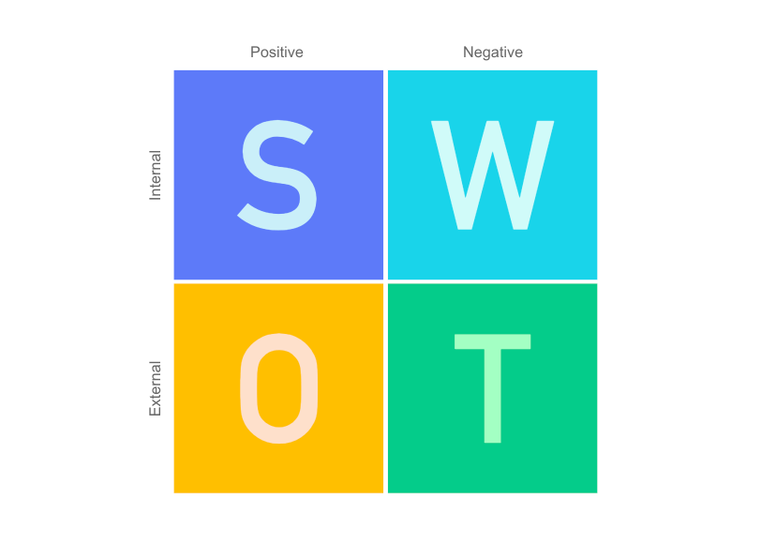

Strengths
- The Relationship between business and worker is a lot of apparent, which expanded the efficiency of representative.
- Supervisory group is solid.
- Profoundly geographic zone.
- Generally excellent net revenue accomplished by the most recent couple of years.
- Solid capital back to bring accessible liquidity.
- Productive and experienced supervisory group.
- Sound Import and Export activity.
- Officials are profoundly qualified and experienced.
- Staffs are quick in their Activities.

Weaknesses

- Absence of appropriate Info in due time.
- There is no client grumble work area thus it at some point makes bothering.
- Client care isn't up to the norm and adequate.
- Despite the fact that the bank has propelled internet banking framework, the workers are not adapted to this framework.
- Inaccessibility of cutting-edge electronic apparatus.

Opportunities

- Customer dependability on UCBL is developing step by step on the bank
- UCBL offers numerous well-known plans for exchange administration and these plans of UCBL advance the dealers of the nation.
- Branches are expanding step by step since individuals are intrigued to do the business.
- Remote settlement is incredibly expanded.
- Import and fare are expanding continuously, so bank can appropriately abuse this chance.
- On the web, SMS Banking Services now accessible in the bank.
- ATM card and ATM Booth office additionally accessible at this point.

Threats

- Extremely competitive market.
- Passage of new plug bank, renting organizations, and trader bank and so on, they all are contenders.
- Contenders are offering imaginative new items and administrations consistently.
- Political emergency and absence of trust to the remote financial specialists.
- Government forces assessment and VAT on benefit.
- National Bank's approaches a few times are not for the private bank's arrangements. Frequent fluctuation of domestic currency with US dollar.
- Uncertain market conditions.

2.6.2 PESTEL Analysis on UCBL
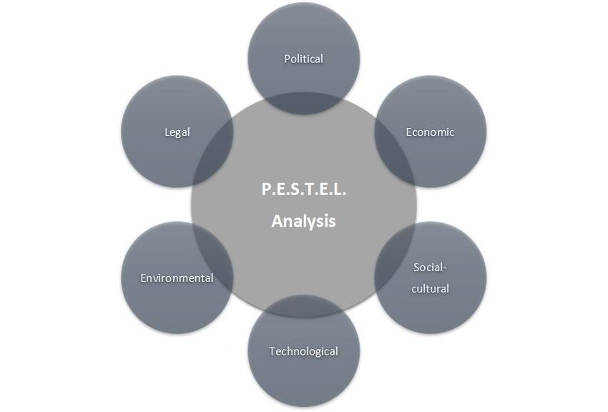Political factor

The political unsteadiness that the nation has endured since the beginning and still has influenced the general states of Bangladesh as well as the remote financial specialists and worldwide nations. In spite of the fact that UCBL is a remote bank and the detailing line is in Middle East and London however the political conditions in the nation influences its exercises to a significant degree as eventually the Central bank of Bangladesh manages all the exercises of all nearby and outside banks. Because of the political precariousness, the worldwide speculators falter keeping their cash as they fear cheats (for example late defilement exercises in SONALI Bank which is nationalized bank) and the way of life of Bangladesh as it is well known for its awful and disorderly patterns. Additionally, other political viciousness', for example, "HORTAAL" likewise hampers UCBL banking movement.

Economical factor

In Bangladesh national reserve funds rose just marginally, demonstrating the moderate development in bank stores and is low by International gauges. The reasons for low reserve funds have been the low per capita salary, high reliance proportion, urbanization, absence of appropriate framework in provincial regions and expansion prompting ascend in costs. Swelling is high because of high food costs which balance the interest the executive’s approaches. Bangladesh is no special case to the financial unsteadiness and vulnerability and UCBL needs to work inside such monetary condition. Since the world economy is moving towards a downturn, so the cash gracefully and the total interest of the economy are extraordinary impacts that influence the financial area. Because of high expansion, neediness is high and the beneficial limit is focused. Thus, UCBL is influenced by this reality identified with Bangladesh economy as it is playing out its business in this nation.

Social factor

Since the ascent in costs, the overall population has gotten cognizant towards their spending and is confronting a decline in their extra cash. They are sparing less and therefore the development in the bank stores has eased back down. Due to the political, monetary and law and request circumstance being dubious, there is absence of trust found in the individuals of Bangladesh on the money related organizations. Another perspective that adds to it is that individuals are less taught and uninformed of how framework functions so bits of gossip make extraordinary frenzy that bring about issues in budgetary area, thus influences UCBL moreover.

Technological factor

There are presently robotized teller machines that have supplant the regular tellers, the entire financial frameworks have been computerized guaranteeing straightforwardness in the framework because of which the trust of the buyer has been picked up. With the expansion of its utilization as well as the evolution in innovation, it has made numerous chances to a wide range of businesses. The web innovation has given new roads to fill in as internet banking framework is a typical marvel in the west and is picking up prevalence in Bangladesh as well. Numerous versatile and telecom organizations are working together with the bank to connect with the clients considerably more productively and advantageously. This has raised the degree of the opposition along these lines raising the weights to contend in interesting manners to include esteem.

Environmental factor

A few ecological antagonistic conditions, for example, cataclysmic event and the likelihood of tropical storms, floods, quakes, tidal wave and so forth make it more hazardous for UCBL to put resources into certain territories of Bangladesh. In expansion, the covid 19 pandemic is likewise hampering the financial activities of UCBL.

Legal factor

The precariousness of the lawful outline and absenteeism of opportunity of the authorized executive has disabled the development of the economy as speculations have eased back down. The peace circumstance has become from terrible to more terrible. The potential remote financial specialists have retreated and the entities who have just underwroted face dangers and uncertainty. The ongoing past is loaded up with the bomb impacts and assaults on outsiders and since UCBL is a remote bank, it also has been compromised and still faces fears.

2.8 Brief of UCBL, N.B.H.R Branch

North Brook Hall Road branch is the 75th branch of United Commercial Bank Ltd. The interior & exterior decoration of N.B.H branch is simply wonderful. Branch premise is well furnished and centrally air-conditioned. An automatic generator is in place to ensure uninterrupted power supply. There are some efficient & effective bankers working in this branch. The management of the branch always tries to provide better service to its customers and behave well with them. As a result, they have gotten a huge number of accounts in this branch.

2.9 BRANCH MANAGEMENT ORGANOGRAM AND UCBL ORGANOGRAM

2.9.1UCBL Organogram
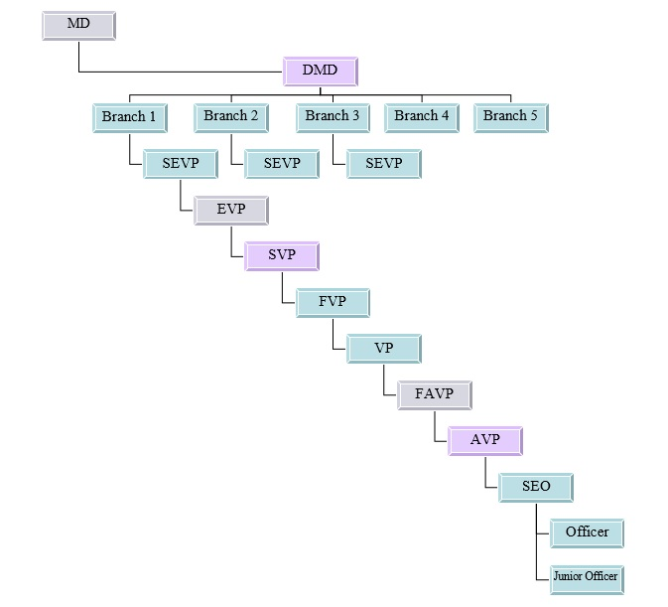

2.9.2NBHR Branch Organogram
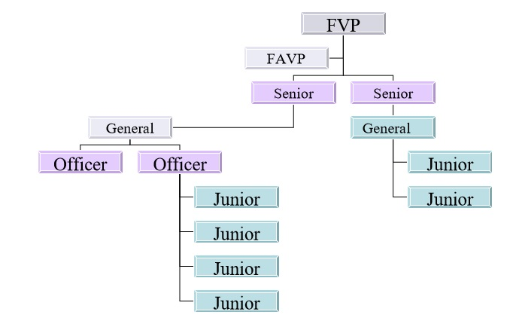

2.10 UCBL Performance Evaluation Form
The pictorial presentation of the Performance Evaluation Form of UCBL is given below:
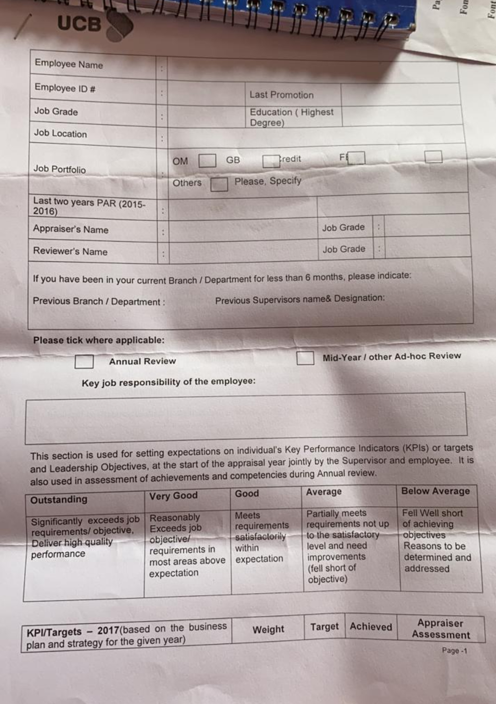
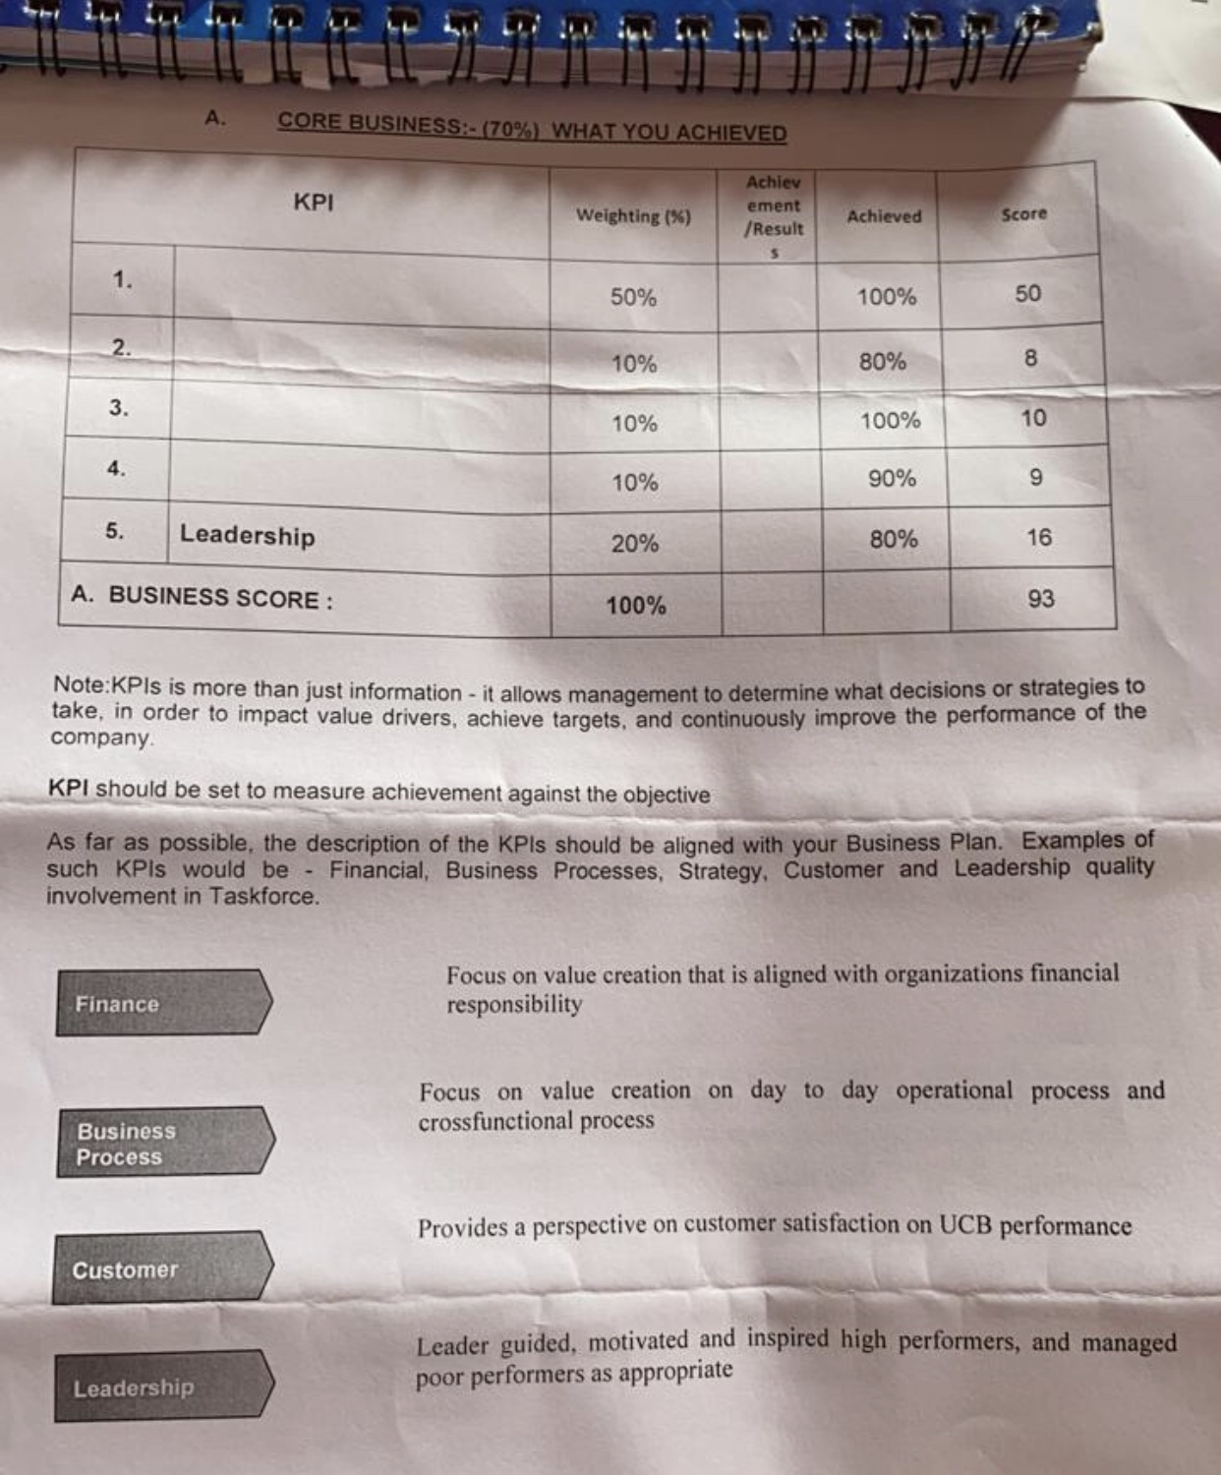
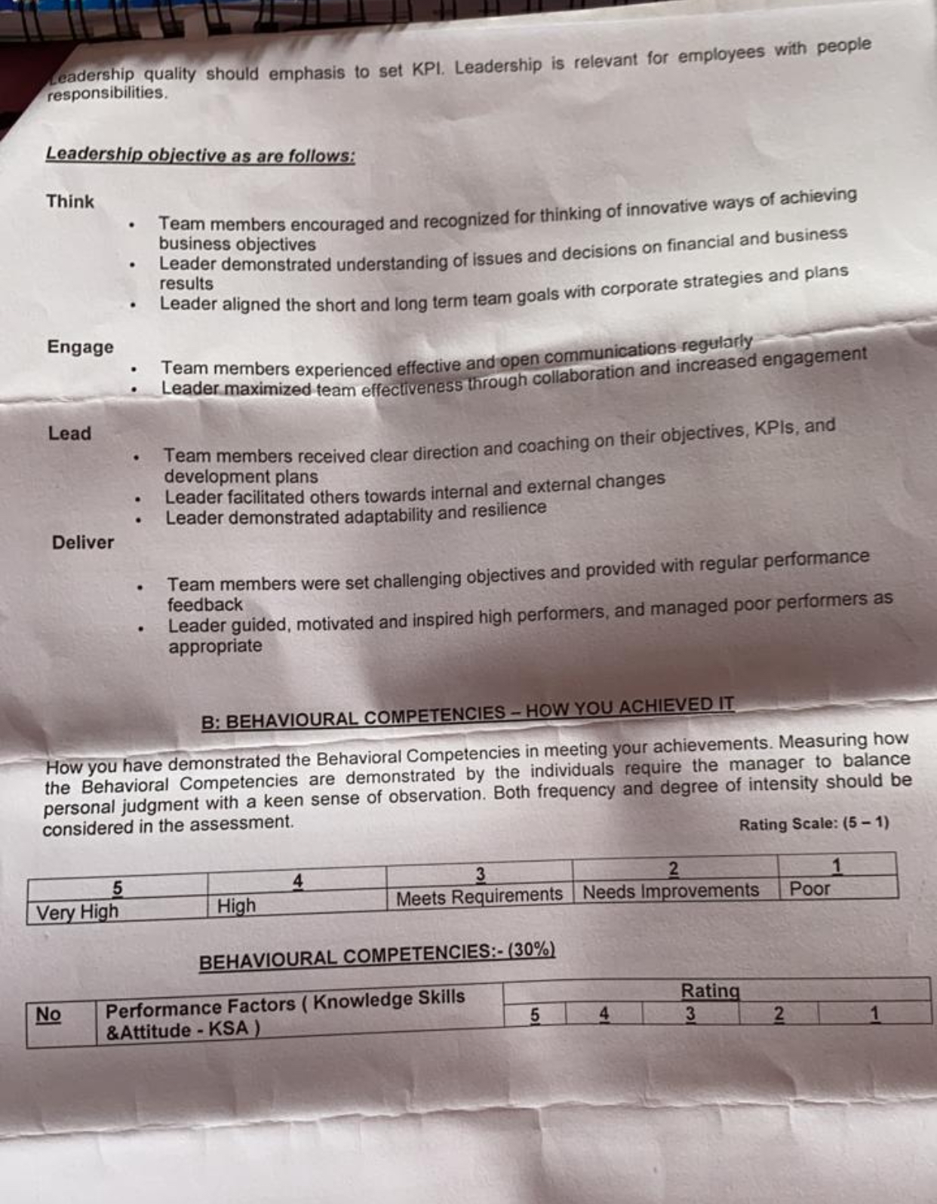


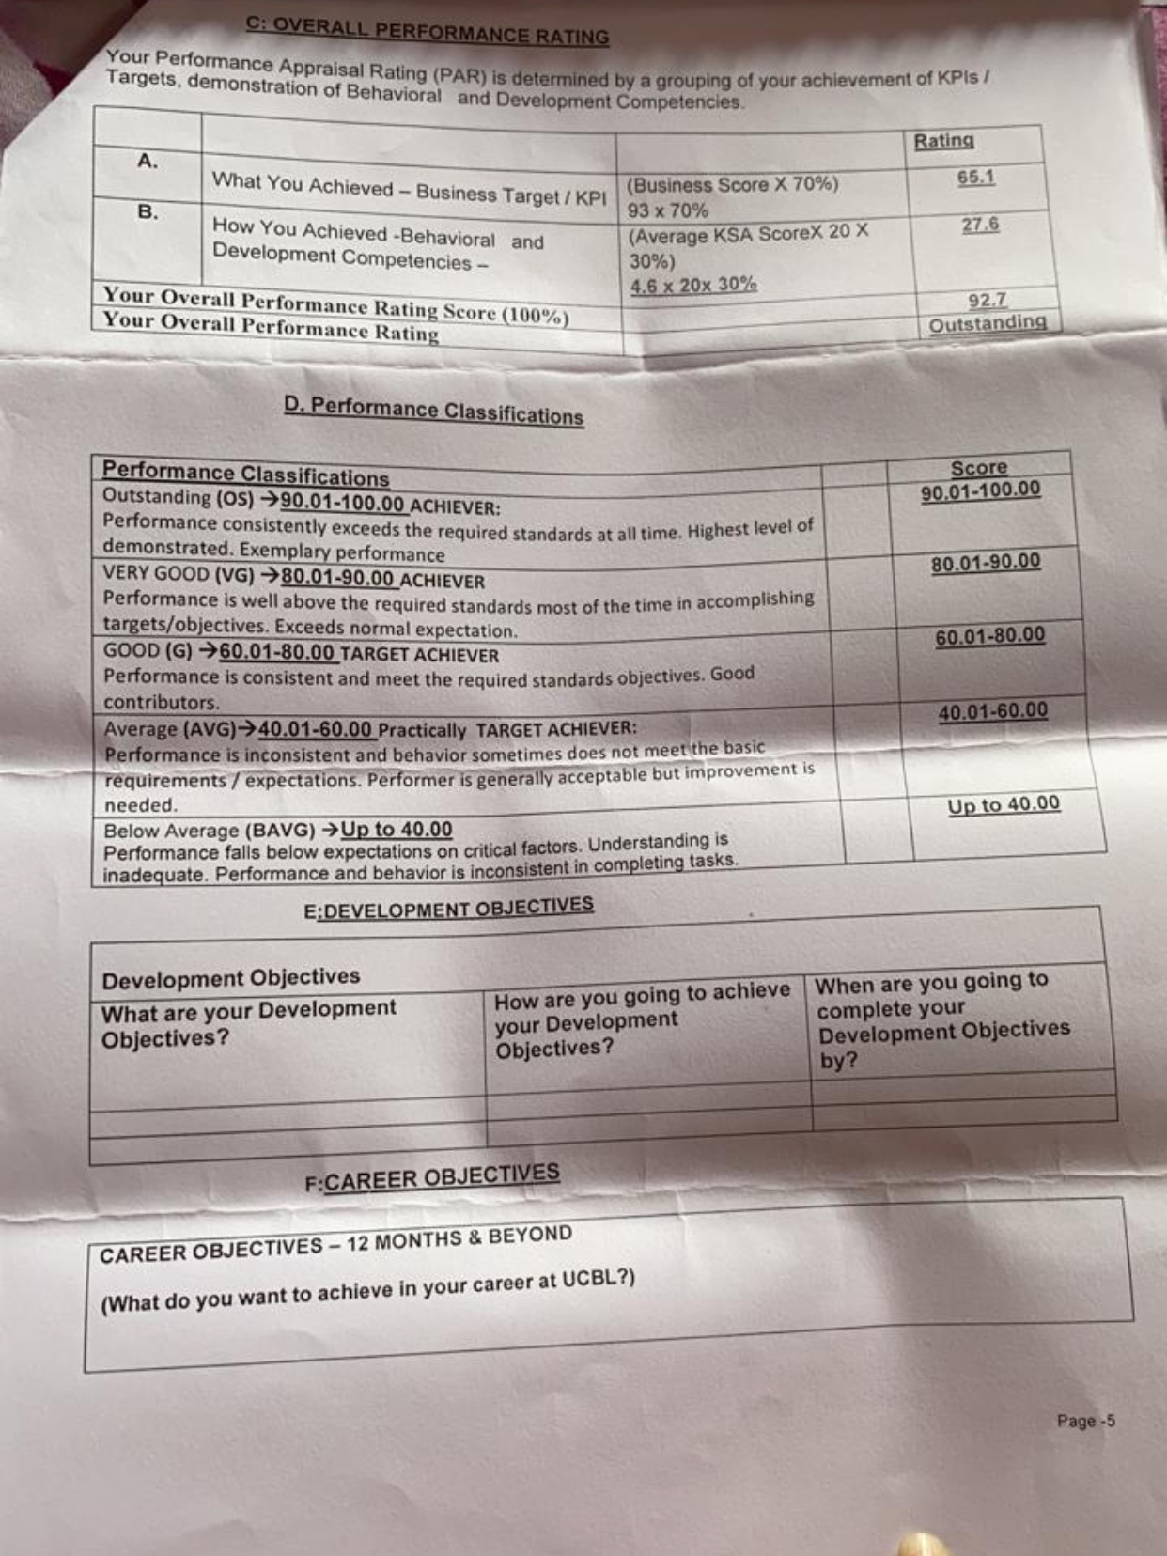

2.11 Description and the Performance evaluation

The evaluation of the employee performance is based on scaling of employee performance in some scores through various questions. The whole appraisal system two portions, one is quarterly evaluations and another is yearly evaluations. The quarterly evaluation happens four times in a year. Each 3 months after, quarterly evaluations occur. Here all the performance within short period of time is recorded and evaluated by the extent of performance is given. On the other hand, the yearly evaluation happens each year and the evaluation is based on the performance of the employees within the year.

In the evaluation form the whole appraisal of the employee is founded upon some important criteria which are the key performance indicator (KPI) of an employee. The criteria of KPI are Financial Process, Business Process, Strategy, Customer’s perspective and Leadership. All of this information is gathered thorough various of questions answered by the team members as well as the team leaders. All the questions from the KPI are classified in scalar form. The scale is from point 1 to point 5. The higher points in the KSA factors signifies higher performance. These appraisals of the employees happen both quarterly and yearly.

Performance classifications are objectified through the KPI indicators. There are separate weightages of each of the KPI indicators. 50% of the whole business score is from Financial process. The weightage of business process, strategy, customer’s perspective and leadership are 10%, 10%, 10% and 20% respectively.

Now the performance classifications are divided in to 4 criteria and which are Outstanding (OS), Very Good (VG), Good (G), Average (AVG) and Below Average. If any employee gets above 90 % of the total business score, they achieve Outstanding (OS). Similarly, any employee acquires 80%-90%, 60%-80%, 40%-60% and up to 40% will get Very Good (VG), Good (G), Average (AVG) and Below Average respectively.

There are some additional points in the business scores for the employees. If an employee can secure more current and savings account from the potential customers will have the chance to secure more KPI percentage. In addition, if the employees can able to get more non-performing loans from the potential consumer will get supplementary 1 percent of the KPI from each sales of non-performing loans because these loans generate more capital for the branch of UCBL.

2.12 How Performance Evaluation Motivates Employees of UCBL

In the description of the performance evaluation of UCBL, it is clearly visible that there are mainly two ways to evaluate the employee’s performance. One is yearly appraisal and another is quarterly appraisal. Now how this evaluation helps to get motivations to the employees is the main theme of the case study. Here in the quarterly evaluation, the employees get to know how they are performing and how they are keeping up to the task for the shorter period of time. This helps the employees that how much they have accomplished in their designated field of expertise. And this sense of accomplishment creates psychological motivation for the job. Subsequently, this psychological motivation is encouraging the employees to do job more effectively and efficiently.

On the other side, the yearly evaluation is enabled on the basis of the four quarterly evaluations. And on those evaluations’ employees are characterized by their performance of the whole year long. Moreover, these appraisal marks help to increase more salary by giving bonus, increment and other financial rewards. As the employee is getting more salary each year by providing superior performance to their field of work, the employees are getting financial motivations. And by correlation evaluations and motivations, the employees are giving their best performance and thus making UCBL much more successful in the Banking Sector of Bangladesh.

Chapter 3: Data Findings & Analysis

3.1 Data Findings

The data analysis of this case study is completely based on thematic analysis. For that we have to know the semi structured interview. The interview I have taken for this case study is the supervisor of mine, Mr. Anisur Rahman, SVP & Head of Branch of North Brook Hall Road Branch. On the interview I have asked 3 questions, which are:

- How effective the current performance evaluation system is for UCBL NBHR branch?
- Do you think there is any problem regarding the appraisal system?
- Is the evaluation form correctly objectifying the actual performance scenario?

According to Mr. Rahman, the evaluation system is very successful as the form is very detailed, well elaborated and precise to objectify the whole scenario, on the other hand Mr. Rahman also mentioned that there is not any problems regarding the current appraisal system but if there is any, the head office and the HR heads will get to know if there is any problems or not. Lastly, Mr. Rahman said that for the North Brook Hall Branch of UCBL, there has not been any problems that has put this branch into jeopardy or there are not any problems that have portrayed unseemly performance appraisals for employees. And according to these words, there are no such problems because the managers of the branch are giving their all to maintain superior performance of the officer.

3.2 Data Analysis

According to archival research and semi structured interview, we get to know that, according to Shaun Pichler, “Four constructs regularly measured as correlates of employee reactions: (1) rater-ratee relationship quality, (2) supervisor trust, (3) social support, and (4) supervisor satisfaction” (PICHLER, 2012). In NBHR branch of UCBL and their appraisal system strictly follows these rules.

According to the scholars, Gary P. Latham, Marie-Helene Budworth, Basak Yanar and Glen Whyte, “A manager who receives a favorable performance appraisal subsequently evaluates the performance of another signiﬁcantly more positively than a manager who receives an unfavorable performance appraisal.” (Gary P. Latham, 2008) Here in interview, we get to know the exact thing about the treatment of managers that they always positively encourage the employees and that results to superior performance records of employees in the evaluation.

According to the thematic analysis and archival research we get to sure that Enhancing Employee Motivation through Performance Evaluation is very much effective through proper appraisal policy and positive influence by the managers over the employees. According to Dirk De Clercq, Inam Ul Haq & Muhammad Umer Azeem that “The positive relationship between role ambiguity and perceptions of unfair performance appraisals is mitigated by employees’ organization-speciﬁc experience though.”.

Chapter 4: Conclusion, Lessons Learned & Future Career

4.1 Differences between Expectation & Experience during internship

As an intern, my desires and encounters were two finished totally various viewpoints, as my encounters ordinarily outperformed my desires. A few models are given underneath: Since I worked in UCBL, that could be an assistance essentially based organization and conveying the palatable help is that the fundamental objective, I took in an approach to bargain the different buyers of different demeanor, classification and group. The customer dealing with skill was completely absent in room setting.
They were amazingly able and incredibly planned to serve the customers. all through my case, I expected to be told a great deal of concerning exchange and credit division. I found that doing work wasn't as exhausting as I accepted anyway to an unequivocal living I may in any case say it had been exhausting. strength of the laborers of UCBL was on the far side any inquiry. In actuality, time was awfully short to know it all of those divisions. in any case, I adapted bounty concerning those divisions work with the help of a senior authority.
I recognized that hypothetical data and reasonable data were appallingly totally extraordinary. certifiable things were significantly more reasonable and touchier to different factors, and individuals’ things were customarily alterable. I used to be locked in with incredibly hypothetical course work. Internship program gave a stage to coordinate or relate the instructive learning in genuine world. As an understudy of BBA program, I expected to relate some of my hypothetical data with reasonable work. notwithstanding,
Thus, it had been not unendingly direct to check between instructive data and reasonable data. all things being equal, instructive data will be horrendously helpful in overseeing certifiable issues and may give us a right rule.

4.2 Influence on Career Plan
As an understudy, my desires and encounters were two finished totally various perspectives, as my encounters regularly outperformed my desires. A few models are given beneath:
Since I worked in UCBL, that could be an assistance principally based organization and conveying the palatable help is that the fundamental objective, I took in an approach to bargain the different buyers of different personality, class and group. The customer dealing with skill was completely absent in room setting.
I found that doing work wasn't as exhausting as I accepted anyway to an express living I may in any case say it had been exhausting. intensity of the laborers of UCBL was on the far side any inquiry. They were very skilled and amazingly expected to serve the customers. all through my spot program, I expected to be told a ton of concerning trade and credit division. Truly, time was horribly short to know it all of those divisions. by the by, I adapted bounty concerning those divisions work with the help of a senior authority.
Internship program gave a stage to coordinate or relate the instructive learning in genuine world. As an understudy of BBA program, I used to be locked in with significantly hypothetical course work. I expected to relate some of my hypothetical data with reasonable work. in any case, I recognized that hypothetical data and reasonable data were horrendously totally extraordinary. genuine things were significantly more reasonable and delicate to different factors, and individuals’ things were frequently alterable.
Subsequently, it had been not interminably direct to check between instructive data and reasonable data. all things considered, instructive data will be frightfully helpful in overseeing genuine issues and may give us a right rule.

4.3 Conclusion

Internship is a scaffold between hypothetical information and functional information. Since I have finished my Internship, I accept the experience I have accumulated working in the official condition will be demonstrated essential for me to proceed in my expert life To work well for clients, organizations should be capable in numerous territories quicker advancement of new business techniques, contracting organization conventions, lessening methodology times, improving client care and expanding and keeping up information for achieving every one of these objectives. As an internee of UCBL, I have genuinely made the most of my temporary job from the learning and experience perspective.
I am certain that this three-month entry-level position program at UCBL will assist me with realizing my further transporter in the activity showcase. As there are heaps of nearby and foreign banks in Bangladesh the UCBL is promising business among them. In this serious market UCBL needs to contend the others business banks as well as with the open Bank. UCBL is progressively equipped for contributing towards monetary improvement as contrasted and another bank of UCBL. UCBL Invested more assets in fare and import business. Clearly the correct thinking about this bank including building up a fruitful system over the nation and expanding assets will have the option to assume a significant job in the arrangement of improvement.
During my temporary position Information Technology have been contributing increasingly more to the improvement of operational and the board procedure I have acknowledged how current Science and Achievement in the financial business to a great extent relies upon powerful loaning. Less the measure of advance misfortunes, the more the salary will be from Credit activities the more will be the benefit of the UCBL Limited and here lays the achievement of Credit Financing. Throughout my useful direction I have attempted to become familiar with the pragmatic financial exercises to acknowledge it with my hypothetical information, which I have greathearted and going to obtain from different courses of my BBA program.

References
Beatty, M. L. (1993). 360-Degree Feedback as a Competitive Advantage. Human Resource Management, 253-272.
Choi, J.-H. (2014). The HR–performance link using two differently measured HR practices. Asia Paciﬁc Journal of Human Resources , 370-387.
Deepa Mishra, S. K. (2017). Outsourcing decision: do strategy and structure really matter? . Journal of Organizational Change Management , 1-31.
Earley, P. (2014). management by objectives (MBO). Wiley Encyclopedia of Management, 1.
Fathi Mohamed Al Damoe, k. H. (2017). The mediating effect of organizational climate on the relationship between HRM practices and HR outcomes in the Libyan public sector. Journal of Management Development , 1-24.
Gary P. Latham, M.-H. B. (2008). The Inﬂuence of a Manager’s Own Performance Appraisal on the Evaluation of Others. International Journal of Selection and Assessment, 220-228.
Hellman, N. (2006). Auditor–client Interaction and Client Usefulness – A Swedish Case Study. International Journal of Auditing , 99-124.
JONES, A. (1981). Journal of Occupational Psychology. Inter-rater reliability in the assessment of group exercises at a UK assessment centre , 79-86.
Muhammad Habib Rana, M. S. (2017). Impact of HR practices on organizational performance: moderating role of Islamic principles. International Journal of Islamic and Middle Eastern Finance and Management .
PAUL 0. KINGSTROM, A. R. (1981). A CRITICAL ANALYSIS OF STUDIES COMPARING BEHAVIORALLY ANCHORED RATING SCALES (BARS) AND OTHER RATING FORMATS. PERSONNELP SYCHOLO, 263-288.
Paul E. Levy, S. T. (2017). Performance Management: A Marriage between Practice and Science – Just Say “I do” . Research in Personnel and Human Resources Management, 155-213.
Peter Kavanagh, J. B. (2007). Understanding performance appraisal fairness. Asia Pacific Journal of Human Resources , 132-150.
PICHLER, S. (2012). THE SOCIAL CONTEXT OF PERFORMANCE APPRAISAL AND APPRAISAL REACTIONS: A META-ANALYSIS. Human Resource Management, 709-732.
Roshni Das, A. D. (2018). Strategic human rescource management: a power based critique . Benchmarking: An International Journal , 1-43.
Soltani, E. (2002). Towards a TQM-driven HR performance evaluation: an empirical study . YOUNG RESEARCHER , 347-370 .
Teresa Canet-Giner, A. R.-C.-I.-C. (2019). Impact of the perception of performance appraisal practices on individual innovative behavior . European Journal of Management , 1-20.
Williams, S. R. (2001). Short Communication: Relation between social problem-solving appraisals, work stress and psychological distress in male firefighters. Stress and Health, 219-229.

