Internship Report
On
Maintenance of Health, Hygiene and Safety Facilities at Babylon Group

Name of the student
Raihan Ahmed

A Report Submitted to the School of Business and Economics in Partial Fulfillment of the Requirements for the Degree of Bachelor of Business Administration

Internship Report
On
Maintenance of Health, Hygiene and Safety Facilities at Babylon Group Limited
Course code: INT 4399
Submitted To
Nasrin Akter
Assistant Professor
School of Business and Economics
United International University
Submitted By
Raihan Ahmed
ID: 111 161 315
Bachelor of Business Administration
Human Resource Management Department
United International University

Date of Submission

November 21, 2021

Letter of Transmittal
November 21, 2021
Nasrin Akter
Assistant Professor,
School of Business and Economics
United International University
Subject: Submission of Internship Report.
Dear Faculty,
I am submitting my internship report on “Maintenance of Health, Hygiene and Safety facilities in at Babylon Group Limited” which is a requirement of BBA program. On the other side, it is a delightful source of learning about Industrial Law practices in the garments industry of Bangladesh.
I am very thankful for your invaluable assistance, cooperation, and directions in preparing this report. This internship report was successfully completed due to my best efforts and hard work. If you could please accept this report, I would be grateful to you. I hope you found this internship report paper to be satisfactory.
Sincerely,

Raihan Ahmed
ID: 111 161 315
BBA, Major in Human Resource Management
United International University

Declaration of the Student
I am Raihan Ahmed, student of Bachelor of Business Administration at United International University with major in Human Resource Management. I hereby declare that the Internship Report on “Maintenance of Health, Hygiene and Safety facilities in at Babylon Group Limited " is original work which has never been submitted for a certification or degree.
I also thus certify that this internship report work was completed entirely by me under the supervision of my supervisor, Nasrin Akter, Assistant professor, School of Business & Economics at United International University. This report was written to meet the requirements for my undergrad degree from United International University, BBA Major in Human Resource Management.
Raihan Ahmed
ID: 111 161 315
BBA, Major in Human Resource Management
United International University

Acknowledgment
First and foremost, I would like to want to thank Allah for providing me with the strength to carry out my tasks and obligations throughout my internship and to complete my report on time.
My internship supervisor is Nasrin Akter, Assistant Professor of School of Business and Economics at United International University and I am grateful for her consistent instructions, observations and support during my internship time.
From September, 2021, Working as an Intern was a great honor for me on the Human Resource Department of Babylon Group Limited (Head Office). Arif Hossain, Junior Manager of HRD at Babylon Group Limited assisted me with departmental operations by training me and providing hands-on experience. I owe them a debt of gratitude.
I am thankful to Babylon Group Limited, its management, and especially the colleagues in the HR departments for their help in compiling this difficult research with crucial facts and data.
Table of Content

Executive Summary vii
Chapter 01: Introduction
1.1 Introduction of the report 2
1.2 Scope of the report 2
1.3 Objective of the study 2
1.3.1 Primary Objective 2
1.3.2 Specific Objective 2
1.4 Methodology of the study 3
1.4.1 Sources of Data Collection 3
1.4.2 Conducting Survey and Descriptive Analysis Technique 3
1.5 Limitation of the study 4
Chapter 02: Literature Review
2.1 Concept of Human Resource Management 6
2.2 Functions of Human Resource Management 6
2.3 Industrial Relations in HRM 7
2.4 Objectives of Industrial Relations and Labor Law Practices 8
2.5 The Ministry of Labor Law of Bangladesh on maintenance of helath, hygiene and safety workplace 9
2.6 The Role of HR on Health, Hygiene and Safety Workplace 10
Chapter 03: Overview of the organization
3.1 Overview and History of the organization 13
3.2 Mission 13
3.3 Vision 14
3.4 Strength 14
3.5 Products and Services 14
3.6 Clients 15
3.7 Organizational Chart 15
3.8 Ethical Trading and Labor Law Practices 15
3.9 HR Department of Babylon Group 16
Chapter 04: Analysis and Findings
4.1 Analysis 19
4.1.1 Maintenance of Health and Hygiene Measures 19
1. Statement: The workplace of the organization is maintained clean and tidy regularly. 19
4. Statement: Proper ventilation is arranged in every working room of the organization. 20
5. Statement: The Organization does not have an internal combustion engine that is operated. …………………………………………………………………………………………….21
6. Statement: The Organization has effective measures in place for disposing of trash generated by production. 21
7. Statement: The Organization does not have any artificial humidification functions. 22
8. Statement: Organization has been arranged a system to avoid crowds at your workplace. …………………………………………………………………………………………….22
9. Statement: Pure drinking water facilities have been arranged for all workers at every workplace. 23
10. Statement: There are sufficient numbers of sanitary available in the organization. 24
11. Statement: Every washroom is marked with “male” “female” in Bangla. 24
12. Statement: There are enough bins for depositing garbage and spit in specified places across the organization. 25
4.1.2 Maintenance of Safety Measures 26
13. Statement: In the organization, as emergency exist at the time of fire, there is alternative staircase connecting with every floor at the time of fire. 26
14. Statement: Several numbers of firefighting equipment have been placed and providing training to workers in the organization according to the license given by the Fire Service Department. 26
15. Statement: The organization have the practice wearing something to protect their eyes while working anything dangerous which may cause problem in eyesight. 27
16. Statement: First aid and immediate treatment has been arranged for all workers and labors……………..........................................................................................................................27
17. Statement: Sufficient supervisors, inspectors and field staffs have been appointed to ensure the health and safety protection and awareness to all the workers. 28
18. Statement: Supervisors, Inspectors and Officers has organized training sessions for all employees, labors and workers on maintaining and ensuring health, hygiene and safety procedure at their workplace. 29
4.2 Findings 30
Chapter 05: Recommendation and Conclusion
5.1 Recommendation 33
5.2 Conclusion 33
References 35
Questionnaire and Data of the Survey 36

Executive Summary
Workforce development and proper utilization of manpower through human resource management is an important part of the company or industry that contributes to the key of business success. Therefore, the main objective of every organization or business is to enhance the performance and productivity of employees or workers through utilization of human resource management and to incorporate various principles and guidelines of industrial law and labor practices in a garment industry by human resource management as well as to bring business success, it is very important for companies or organizations or the garment industry to properly implement and follow the rules of health, hygiene and safety industry relations. The readymade garments industry of Bangladesh ranks 2nd position in the world and this success is due to the contribution of thousands of workers of garments industry of Bangladesh. Therefore, considering the health, hygiene and safety workplace of the all workers of garments industry, a number of policies have been formulated under the supervision of the Ministry of Industry and Labor Law of Bangladesh (2006), which are being practiced by the human resource management department of each garments industry of Bangladesh as well as are being monitored by the BGMEA and BKMEA of Bangladesh.
In this report, the various practices of ensuring the health, hygiene and Safety facilities for workers of Babylon Group Limited have been highlighted as well as the challenges faced by the HR department of various have been disused.
The HRD of Babylon Group Ltd. emphasizes the interdependence of the employer and the employees and thinks that both parties should be treated fairly. Government and business regulations on workplace safety, health, and cleanliness are rigorously followed by the HRD of Babylon Group Limited. Their organization is now considerably cleaner, and the HR department is in management of Occupational Safety and Health act in their workplaces. Some challenges have been mentioned in this report according to the results of the survey and analysis. And, based on the data analysis and findings, some recommendations are provided to assist the HRD of Babylon Group Limited in meeting the issues of preserving health, hygiene, and safety facilities at their workplace for all workers and industrial workers.

CHAPTER 01
INTRODUCTION

Introduction of the report
For development and success, good labor relations are essential. In the case of an epidemic, organizations or the garment industry must be attentive so that unanticipated occurrences or external crises do not influence their employees and generate instant uncertainty, posing a direct danger to the organization's entire work efficiency and effectiveness. Furthermore, when firms or the garment industry adjust to any pandemic condition, issues in a variety of areas of their operations, as well as new solutions, must be identified. Therefore, an internship report has been prepared by studying Bangladesh's garment factories and their management systems for health, hygiene, and safety policies at their workplace. This internship report must be submitted to UIU's esteemed faculty and my internship course supervisor in order to receive a Bachelor of Business Administration degree from United International University.

Scope of the report
Maintenance of Health, Hygiene and Safety policies at Babylon Group Limited is the primary focus of this research and the internship report. This research will shed light on the hurdles that HR departments face, as well as the issues that each Garment Industry has faced. Also, how they're dealing with the new obstacles and adjustments that have arisen for their employees and labors on maintenance health, hygiene and safety facilities at the workplace of the organization.

Objective of the study

Primary Objective
The main & primary objective of this project is to analyze on Maintenance of Health, Hygiene and Safety policies at Babylon Group Limited.

Specific Objective
- To get and overview of the Babylon Group Limited and the activities of HRD.
- To know and get a clear understand about the policy of the Ministry of Labor Law regarding the health, hygiene, and safety facilities on garments industry of Bangladesh.
- To find out the challenges of HRD on maintenance of Health, Hygiene and Safety policies at Babylon Group Limited.
- To provide recommendations to the HRD of Babylon Group Limited to help them in protecting their workers, laborers, and employees by maintaining safe working conditions.

Methodology of the study

Sources of Data Collection
All of the data for this study and analysis took place in different independent sources. These are the details:
- Primary Sources of Data
The primary data was gathered from the following sources:
- Conducting survey on the ready-made garments industry (Babylon Group Limited).
- Interacting with HR coworkers, supervisors, and faculty members who are involved in the HR department and having discussions with them.
- Observing and experiencing the scenario in the garment industry with regard to ensuring safe workplaces.

- Secondary Sources of Data
The secondary data was gathered from the following sources:
- Babylon Group Limited’s official website.
- Relevant articles, newspapers, reports from online platforms and website.
- HR reports and various types of public documents of garments industry.
- Industrial Law & Labor Relationship and HR related articles, books.

Conducting Survey and Descriptive Analysis Technique
In the report the topic is “Maintenance of Health, Hygiene and Safety Facilities at Babylon Group Limited”. A survey questionnaire has been prepared for analyzing the study of the topic in where 18 statements are included and these have been divided into two sections:
- Maintenance of Health and Hygiene Measures
- Maintenance of Safety Measures
“Five Likert Scale” Technique has been used for conducting the survey and the scale range is 1 to 5. Some of the diagrams and pie charts have been used for analyzing the data and the study of the topic.
Sample Size (n): The numbers of 30 respondents have been participated on conducting the survey who works in the Head Office of Babylon Group Limited (Darus Salam Road Mirpur, Dhaka). Most of the respondents’ age is around 30 to 45years and 17 participates were in the HR department and the remaining of 13 participates were in the officers ranking on various department.

Limitation of the study
Despite the fact that my internship experiences at Babylon Group Limited introduced me with a great opportunity to adapt what I've learned in school to real-life situations, however, there were a few issues that should be regarded obstacles in the completion of this analysis. Among them are the following:
- a) Due to the pandemic situation, it was difficult to conduct fast & efficient interviews and consult with senior staff, since the responses were supplied in a limited amount of time, and there may have been errors throughout their activities.
- Some statements may not conform to specific industry rules and processes due to confidentiality.

CHAPTER 02
LITERATURE REVIEW

Concept of Human Resource Management
In enterprises, the word human resource management (HRM) has been advocated as a substitute for the word personnel administration. In this viewpoint, expert like Armstrong (1987) saw HRM as "elderly wine in new bottles," but Guest (1987) asserted that HRM is not a substitute for people administration, but to a certain extent differ in a number of aspects. In fact, this means that HR's tasks are mostly management in nature, such as recruiting, incentive systems, and promotion, with additional things. This is not to say that HR administrators don't have a "seat at the table," or that they aren't recognized as strategic business partners, and hence don't contribute to the organization's success.
Byars & Rue (2004) define HRM as "activities designed to provide for and coordinate an organization's human resources."
Storey (1995) defines HRM as “a different theory of management that attempts to stay ahead of the competition through the deliberate deployment of a highly motivated and competent workforce by the use of a comprehensive set of cultural, organizational, and personnel strategies."
Furthermore, according to Boxall & Purcell (2000), "HRM encompasses everything involved with the management of employee relationships in the company."
The terms "anything" and "everything" in the definition include a larger variety of themes, such as employment agreements plus ways on behalf of workers to be engaged in addition to participating in sectors not directly addressed by their employment agreements, ensuring a appropriate work life. Also it extends beyond employment and labor relations, which people management in businesses cannot provide.
Reference: (Ph.D), O. 2012 (1st Edition). Human Resource Management: Theory and Practices. Ota Ogun State, Nigeria: Eduactional Publishers.

Functions of Human Resource Management
HR tasks are described in a variety of ways; Purcell and Ahlstrand (1994) proposed nine (9) functionalities that HRM departments should pursue. They suggested that, these activities should be applicable for most medium and large businesses, depending on the nature of their operations.
The HR department's job is defined by seven (7) actions in relation to external factors such as legal, global, environmental, cultural, economic, political, technical, and social forces, as well as how they interact with HR operations, according to Mathis and Jackson (2006). As shown in figure 2.1, the HR activities model is divided into four (4) categories.
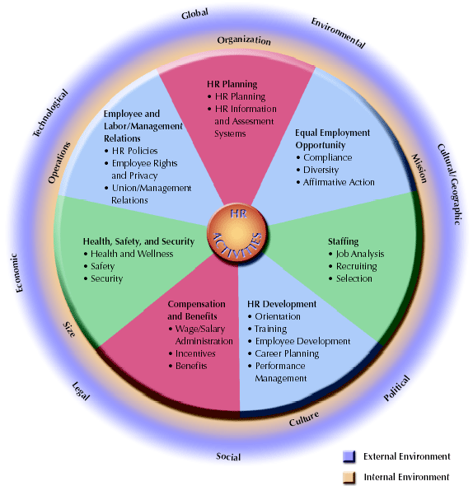
Figure 2.1: Functions of Human Resource Management
(Source: Adapted from Mathis & Jackson, 2006)

Industrial Relations in HRM
Industrial relations is a field of study that examines the relationship between a company's management and its employees at work and provides a framework for resolving various labour disputes. Because of the industrial revolutions in the late 1800s, this paradigm arose. It consists of the following two terms:
- 'Industry' may be defined as an economic activity conducted by a group of people (i.e., producing, manufacturing, or processing commodities or services).
- The term ‘Relations' refers to the connection and communication that exists between an employer and his or her employees in the workplace.
The many individuals holding unique roles within the business, as well as the external or internal affiliations engaged in the process of developing strong industrial connections, may be divided into two categories
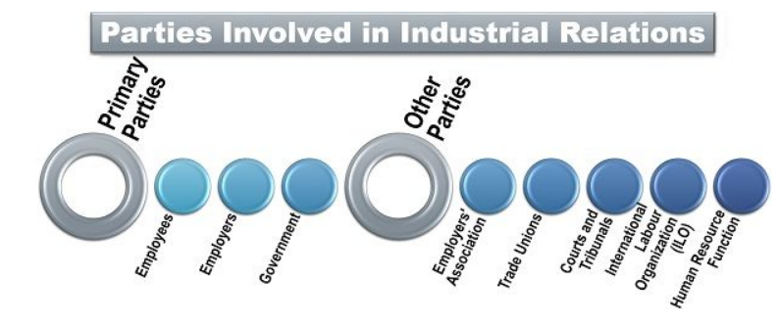
Source: https://theinvestorsbook.com/industrial-relations.html
Reference: Solanki, D. S. (2018). Concept of Industrial Relation. Industrial relations (HRM), p. 04.

Objectives of Industrial Relations and Labor Law Practices
Whenever we discuss about industrial relations, we're talking about a wide range of formal ties that exist within a company. For development and success, good labor relations are essential. The following are some of the reasons for their significance:
- Dealing with Complaints: By resolving disagreements and establishing a process to resolve both sides' concerns, industrial relations aim to preserve a pleasant connection between management and employees.
- Mental Revolution: It places a strong emphasis on both management and people changing their mindsets. The employer must regard the employee's contribution to the firm, but the employees must also respect the management's authority.
- Employees’ Rights Protection: Various statutes (such as the National Labor Relations Act in Bangladesh) and organizations were founded under industrial relations to protect the rights and interests of employees (irrespective of their membership of the labor union).
- Interpreting Contracts: Industrial relations focuses on giving supervisors and managers with sufficient training on labor law contracts in order to clear up any misunderstandings.
- Boosting Employee Morale: The most efficient resource of the business is a motivated staff. As a result, industrial relations focus on increasing employee confidence and morale in order for them to work better than previously.
- Collective Bargaining: The laborer's representative and management offer their recommendations to each other and then bargain over them. This is done in order to obtain a mutual agreement that is documented in a collective bargaining agreement.
- Increasing Productivity: Industrial relations work to raise an organization's efficiency and production by assuring long-term employee retention and lowering absence rates.
Reference: Solanki, D. S. (2018). Concept of Industrial Relation. Industrial relations (HRM), p. 04.

The Ministry of Labor Law of Bangladesh on maintenance of health, hygiene and safety workplace
The Bangladesh Ministry of Labor has provided a range of regulations on industry compliance with particular health, cleanliness, and security laws, which will be regulated by the BGMEA and BKMEA, as well as 23 Ministry of Labor Crisis Management Communities. The factory will face legal action under labor law if the health, hygiene, and safety rules are not followed.
Every worker has a legitimate and legal entitlement to work-related health, hygiene and safety benefits. All workers must have a healthy, sanitary, and safe working environment, and most favorable workplace health and safety must be accomplished all the way through improved place of work practices. The Bangladesh Labor Law Act 2006 - ILO (International Labor Organization) addresses the following workplace health and safety issues:
- Health & Hygiene,
- HVAC (heating, ventilation, and air conditioning) systems,
- Artificial humidity,
- Overcrowding,
- Lighting systems,
- Fire incidents,
- Overweight,
- Safety of the structure and equipment,
- Mechanical enclosures,
- Working on or around moving machinery,
- Gases that are explosive or combustible, as well as dust,
- Warnings against hazardous washing,
- Personal protective equipment,
- Risk assessment
- And Prevention measure. (Section 51-99 of Labor Act 2006, amended 2013)
Reference: Khan, P. A. (Modified 2013). Bangladesh Labour & Industrial Law. Bangladesh: Uddoyon Publication.

The Role of HR on Health, Hygiene and Safety Workplace
HR staff members are responsible mostly for finding top talent, recruiting, and hiring. They also play a significant role in maintaining employee safety and well-being. The human resources department of a firm is important in implementing and advocating health and safety requirements throughout the workplace. More extensive health standards in the workplace should be developed as the globe continues to fight the epidemic and individuals return to work. A safe and active workforce is often seen as a productive workforce. Employees are more satisfied at work when health and safety rules and regulation are adopted and followed uniformly across the firm. As a result, by enforcing safety procedures and health rules, HR teams may raise employee morale in the middle of the global health crisis while also assisting new employees in settling in. As a result, the organization's quality, efficiency, and profitability improve. Moreover, HR departments should concentrate on wellness programs, workers' healthcare, and other projects that improve employee health and well-being.
The HR department is involving on undertaking the following Work Health & Safety duties at their workplaces:
- Assigning one or more management members being in responsibility of health and safety operations and technical aspects
- Establishing effective policies on occupational Health and Safety compliance with the Bangladesh Labor Law Act 2006 - ILO.
- Keeping in touch to ensure that everyone is doing their share to preserve health and safety.
- As required by law, an Occupational Health and Safety Committee will be formed, which will comprise fire marshals and first responders.
- Putting Together a Safety Committee.
- Defining the responsibility of supervisors in terms of health and safety.
- Identifying dangers on a regular basis, evaluating them, and taking steps to mitigate the risks.
- Diseases and Accidents: investigate them and take appropriate preventative measures.
- Providing frequent training and information.
- Management of certificates, licenses, tests & other documents of ILO and OHS records.
- Creating an emergency response mechanism in the event that something goes wrong.
- Top management evaluates the system's performance.
Reference: Anangwe, M. R. (2018, September 06). The Role of HR in Workplace Health and Safety. Retrieved from Linked In (Safety First)

CHAPTER 03
OVERVIEW OF THE ORGANIZATION

Overview and History of the organization
Babylon Group is a manufacturer of knit and woven items. It manufactures woven and casual clothing, washes, dyes, and finishes knitted textiles, converts and packages paper, embroiders and screen prints, transports, and trades garments. Various divisions of the organization are committed to producing high-quality goods for customers all around the world. The organization is self-sufficient and engages in knit wear manufacturing, woven wear manufacturing, washing plants, printing houses, knitting units, dyeing and finishing of knitted textiles, embroidery, trimmings manufacture, paper converting and packaging, garment trading, and so on. To meet the expanding local demand, it also features fashion wear selling establishments.
Babylon Group's adventure began in 1986 with a few of sewing machines to make woven textiles on a relatively small scale. The firm now employs over 11,500 skilled people and will have turnover revenue of more than $128 million in 2020, representing a 472 percent increase over the previous year. (Source: Annual Revenue Report of Babylon Group, 2020). Workers in all types of production need to go through a process of constant and rigorous training in order to maintain the management's high quality of output. This driving force is also provided for by the group, which ensures facilities that surpass the minimum required by international regulations. It has a fair pricing store, healthcare and day care services, financial assistance, and other charitable activities for employees and their families. As part of their societal commitment, the organization has constructed a free medical care station for everybody. During natural disasters, Babylon delivers relief goods, including cash, to victims in any area of the country.

Mission
- To have the greatest infrastructure in order to choose and suit any feasible change in the corporate environment as quickly as possible.
- To build and develop a sustainable business model having the right peoples & processes.
- To concentrate on continual improvement via the use of cutting-edge industrial engineering methods and models in production.
- To concentrate on continual capacity enhancement through the development and engagement of people, the implementation of good business processes, and the use of technology and automation.

Vision
To develop the capacity and resources to generate at least $500 million to national GDP while evolving with diverse business sectors and providing benefits to clients, as one of the greatest responsible business organizations and valued employers.

Strength
Babylon Group's strength resides in its facilities, competent people resources, and management. Some of the highlights are as follows:
- Every production facility has adequate storage and a computerized inventory and supply chain management system.
- Every factory has its own power production and distribution model.
- Babylon's quality is recognized by worldwide standardization organizations such as ISO International Organization for Standardization) and WRAP (Waste Reduction Award Program).
- The availability of contemporary gear and equipment capable of meeting the different needs of clients.
- Within its concerns, the business has a variety of support facilities that directly contribute to the easier execution of orders and cost savings.

Products and Services
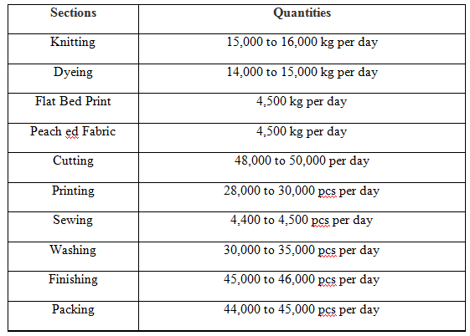

Clients


Organizational Chart
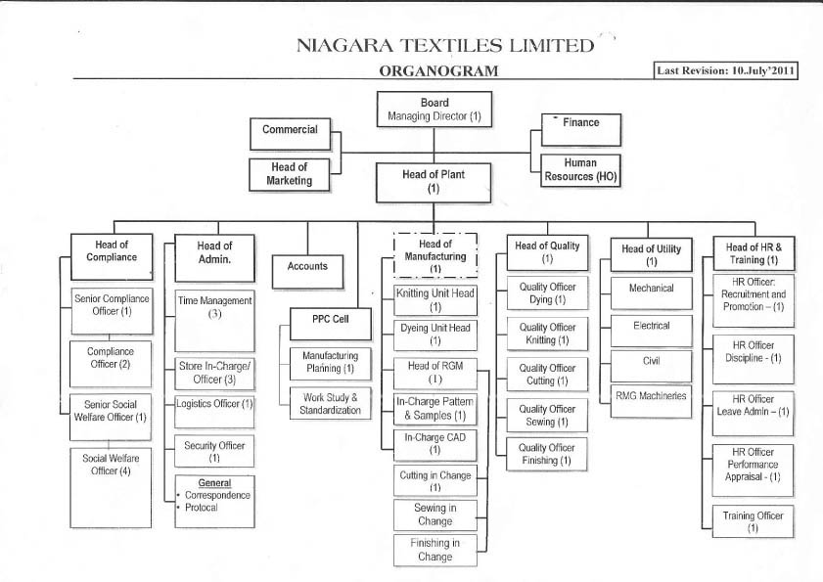
Figure: Organization Chart of Babylon Group
(Source: Internal Report of Babylon Group Limited)

Ethical Trading and Labor Law Practices
- Increase in special wages on the basis of efficiency.
- Provide incentive for additional production.
- Monthly attendance bonus.
- Annual two festival bonuses.
- Provide financial benefits for education, medical treatment and marriage.
- Provide interest free loan facility for working employees.
- Scholarship facilities for meritorious children of workers and employees.
- Providing low cost "soft sanitary napkins" to women workers.
- For entertainment, workers can watch television and VCD in the dining hall.
- Annual picnic and cultural events.
- Published by the annual magazine "Babylon Kathakatha" written by workers and employees.
- Scholarship facilities for poor meritorious students across the country.
- Distribution winter clothes to the people affected by winter.
- Relief assistance to people affected by natural disasters.

HR Department of Babylon Group
The HRD of Babylon Group Ltd. emphasizes the interdependence of the employer and the employees and thinks that both parties should be treated fairly. To that goal, the HRD of Babylon expects to be able to undertake the following:
- To formulate and maintain policies that allow Babylon to develop and implement opportunities for recruitment, hiring, promotion, pay benefits, transfers, and training and development without regard to gender, age, nationality, color, ethnicity, religion, or political beliefs.
- To foster a culture of support and trust inside the industry that encourages workers to work effectively together as a team while also encouraging them to be flexible, skillful, and dynamic.
- To ensure that there will be enough workers with the required knowledge and skills to satisfy the industry’s immediate and long term demands.
- To ensure that moderate systems for recruitment, training and development, evaluation and performance management are in place.
- To coordinate the industry's succession planning for all top management roles.
- To ensure that government and business regulations on workplace safety, health, and cleanliness are rigorously followed.
- To prohibit all types of forced labor those violate fundamental human rights.

CHAPTER 04
ANALYSIS AND FINDINGS

Analysis

Maintenance of Health and Hygiene Measures

Statement: The workplace of the organization is maintained clean and tidy regularly.

Figure 01
60% of respondents are strongly agreed and 40% of respondents are agreed on this statement.
- Statement: Organization keeps its premises clean and free from harmful odor, drain, privy or any other nuisance.

Figure 02
On this statement, 63% of respondents are agreed and 37% of respondents are strongly agreed.
- Statement: All walls, partitions, ceilings of the organization are to be repainted at least once in every 3 years.

Figure 03
On this statement, 64% respondents are agreed. But remaining 13% respondents are neutral and 23% respondents are disagreed because they said that only special cases some of the partitions, ceilings of the organization are to be repainted.

Statement: Proper ventilation is arranged in every working room of the organization.

Figure 04
On this statement, 77% of respondents are agreed and 23% of respondents are strongly agreed.

Statement: The Organization does not have an internal combustion engine that is operated.

Figure 05
100% of respondents are agreed on this statement.

Statement: The Organization has effective measures in place for disposing of trash generated by production.

Figure 06
On this statement, 87% of respondents are agreed, but 13% of the respondents said that, due to lack of maintenance, sometimes effective arrangements do not work properly on every production units.

Statement: The Organization does not have any artificial humidification functions.

Figure 07
100% of respondents are disagreed on this statement that they have not any artificial humidification functions.

Statement: Organization has been arranged a system to avoid crowds at your workplace.

Figure 08
47% and 20% respondents are agreed and strongly agreed on this statement. But remaining 33% respondents claimed that, In Babylon Group, they do not follow this rule “By written order, the chief inspector issues a notice to any employer, which is then placed in each workroom and specifies the maximum number of employees”. And also some of the workplaces workers do not follow the avoiding overcrowding rules.

Statement: Pure drinking water facilities have been arranged for all workers at every workplace.

Figure 09
57% respondents are agreed on this statement but remaining 43% respondents claimed that, all water supply points are not marked with “pure drinking water” in Bangla and for all the workers facilities of cold water are not available during summer.

Statement: There are sufficient numbers of sanitary available in the organization.

Figure 10
100% respondents are agreed on this statement.

Statement: Every washroom is marked with “male” “female” in Bangla.

Figure 11
77% respondents disagreed with statement and they claimed that, every washroom is not marked with male and female in Bangla.

Statement: There are enough bins for depositing garbage and spit in specified places across the organization.

Figure 12
30% respondents claimed that, even if there are sufficient bins & spit boxes but at the same time, a specific emphasis should be placed on the regular cleaning system, which is frequently neglected.

Maintenance of Safety Measures

Statement: In the organization, as emergency exist at the time of fire, there is alternative staircase connecting with every floor at the time of fire.

Figure 13
100% respondents agreed on this statement.

Statement: Several numbers of firefighting equipment have been placed and providing training to workers in the organization according to the license given by the Fire Service Department.

Figure 14
77% respondents agreed on this statement. But remaining 23% respondents claimed that, the management do not training to their new workers to ensure that what they should do at the time fire.

Statement: The organization have the practice wearing something to protect their eyes while working anything dangerous which may cause problem in eyesight.

Figure 15
100% respondents agreed on this statement.

Statement: First aid and immediate treatment has been arranged for all workers and labors.

Figure 16
All the respondents agreed on this statement.

Statement: Sufficient supervisors, inspectors and field staffs have been appointed to ensure the health and safety protection and awareness to all the workers.

Figure 17
90% of respondents agreed on this statement. But remaining 10% respondents claimed, even if sufficient officers, supervisor and filled staffs are available in the organization but they have shortage of cleaning staffs and there is lack of monitoring on field staffs’ activities.

Statement: Supervisors, Inspectors and Officers has organized training sessions for all employees, labors and workers on maintaining and ensuring health, hygiene and safety procedure at their workplace.

Figure 18
90% of respondents agreed on this statement. But remaining 10% respondents claimed, even if sufficient officers, supervisor and filled staffs are available in the organization but they have shortage of cleaning staffs and there is lack of monitoring on field staffs’ activities.

Findings
In the case of maintaining health, hygiene, safety facilities at Babylon Group Limited,
- Every level and place in their industry is cleaned on a daily basis, including stairs, working areas, outside gardens, and roadways, as well as garbage clearance, and Disinfectant Spray is used on a regular basis.
- Effective arrangements are available in Babylon Group Limited for disposing wastes due to manufacturing purpose. But sometime due to the lack of maintenance it, the arrangements do not work properly in every production units.
- In the case of avoiding overcrowd at the work places, Babylon Group Limited follows the rules about numbers in work-room or work-place limitations. Every worker has 9.5 cubic meters of space in the work room. But sometimes at some of the workplaces, workers do not follow the avoiding overcrowding rules.
- In Babylon Group Limited suitable supply of sufficient drinking water is provided. But all points of water supply stations are not marked with “pure drinking water” in Bangla. And for all the workers facilities of cold water are not available during summer.
- There are sufficient numbers of sanitary available in Babylon Group Limited. Adequate light and ventilation are there in the toilet. Toilets are kept clean with detergent in Babylon Group Limited. Separate washrooms are there for both male and female. But every washroom is not marked with “male” “female” in Bangla.
- In Babylon, sufficient number of spittoons and dustbins are provided in convenient places along with notes. However, several officers and workers remarked that extra consideration should be given to the regular cleaning system on these bins and spit boxes, which are frequently neglected.
- They have the practice wearing something to protect their eyes while working anything dangerous which may cause problem in eyesight. Even they try to protect their worker’s eyes from any excessive light or heat.
- Babylon Group Limited has put in place first-aid and treatment facilities for all of its workers and labors. And they also get free medical facilities, medicines from the medical care. As well as If a worker falls ill at his/her workplace, an ambulance is available for his/her immediate hospitalization.
- Organization hires new staffs, officers and field staffs keeping in the mind the health of the worker. But some of the respondents claimed that, organization has shortage of cleaning staffs and also there is lack of monitoring on field staffs’ activities.
- HR teams, medical staffs, and field staffs have been training workers and labors on maintaining hygiene, health, and safety requirements on a weekly basis. In addition, training sessions are done on open land in workplaces.

CHAPTER 05
RECOMMENDATION AND CONCLUSION

Recommendation
Babylon Group Limited's HRD should also compile a list of practical, inventive ideas and improvements for ensuring the health, cleanliness, and safety of all workers in their workplace. Based on the job life experiences, study of the topic and findings, some recommendations are provided below to aid HR teams in helping to protect their workers, employees, and industrial workers by maintaining safe working conditions.
- Babylon Group Limited should set up a Compliance Department and Trade Union Community in order to ensure safe working conditions and sufficient health, hygiene, and safety facilities to all employees and industrial workers. Constitute a factory cooperative and inform one another about the help of government.
- In order to reduce risks and maintain amount of coverage, the Compliance Department, HR teams, Inspectors, and Trade Union community should assist workers and ensure a healthy and safe working environment.
- The HRD needs to provide training facilities to all existing and new hiring workers about using of fire workings’ equipment to ensure that what they should do at the time fire.
- All water supply points and washrooms should be marked with “pure drinking water” and Male and Female Washroom in Bangla rather than English.
- In the case of shortage of cleaning staffs, the HR department should hire more workers for doing it properly.

Conclusion
Since the RMG division of Bangladesh is in the 2nd position in the world. The Bangladesh Labor Service has defined a number of measures related to industry compliance with specific health, hygiene, safety controls that may be operated by BGMEA and BKMEA. Bangladesh Labor Law is a clear code for ensuring the rights of Bangladeshis working in various production lines and businesses while maintaining the requirements of the ILO's universal heritage. From the outset, Babylon Group Limited has been devoted to developing and executing all forms of health, hygiene, and safety regulations, as well as maintaining a clean and tidy environment while considering practical occupational safety and health. The Babylon Group Limited has built a medical service station that is available to the public as part of their societal responsibility. During natural disasters, Babylon delivers relief goods, including cash, to victims in any area of the country. Babylon adheres to strict quality standards in order to provide perfect output, which is incredibly beneficial to their success. Babylon Group Limited's health, hygiene, and safety rules are strictly enforced.

References

(Ph.D), O. 2012 (1st Edition). Human Resource Management: Theory and Practices. Ota Ogun State, Nigeria: Eduactional Publishers.
Anangwe, M. R. (2018, September 06). The Role of HR in Workplace Health and Safety. Retrieved from Linked In (Safety First): https://www.linkedin.com/pulse/role-hr-workplace-health-safety-martin-rodgers-anangwe
Khan, P. A. (Modified 2013). Bangladesh Labour & Industrial Law. Bangladesh: Uddoyon Publication.
Overview of the organization. (n.d.). Retrieved from Babylon Group Limited: https://www.babylongroup.com/
Solanki, D. S. (2018). Concept of Industrial Relation. Industrial relations (HRM), p. 04. Retrieved from Industrial Relations (HRM): https://www.cvs.edu.in/upload/IR_Concept.pdf
Workplace Health and Safety. (n.d.). Retrieved from Worker Insight Consortium: https://www.workersrights.org/issues/workplace-health-and-safety/
Yoder, J. D. (n.d.). Importance of Industrial Relations. Retrieved from Human Resource Management: https://www.whatishumanresource.com/industrial-relations

Questionnaire and Data of the Survey

Maintenance of Health, Hygiene and safety Facilities of Babylon Group
Dear respected respondent,
The following questionnaire is to collect information from the HRD of Babylon Group. It’s about the challenges of HR department of the garments industry where they are facing on maintaining health, hygiene, and safety policies at their workplace. The information will be kept confidential and be used only for research purposes.
Name:

Age: | 25-35 | 35-45 | 45+
Position: | HR Manager | Officer | Trade Union

 | Particulars | Strongly  Disagree | Disagree | Neutral | Agree | Strongly  Agree
 | Maintenance of Health and Hygiene Measures
1 | The workplace of the organization is maintained clean and tidy regularly. | 0 | 0 | 0 | 12  (40%) | 18  60%
2 | Organization keeps its premises clean and free from harmful odor, drain, privy or any other nuisance. | 0 | 0 | 0 | 19  (63%) | 11  (37%)
3 | All walls, partitions, ceilings of the organization are to be repainted at least once in every 3 years. | 0% | 07  (23%) | 04  (13%) | 19  (64%) | 0%
4 | Proper ventilation is arranged in every working room of the organization. | 0% | 0% | 0% | 23  (77%) | 07  (23%)
5 | The Organization does not have an internal combustion engine that is operated. | 0% | 0% | 0% | 30  (100%) | 0%
6 | The Organization has effective measures in place for disposing of trash generated by production. | 0% | 04  13%) | 0% | 26  (87%) | 0
7 | The Organization does not have any artificial humidification functions. | 0% | 0% | 0% | 30  (100%) | 0
8 | Organization has been arranged a system to avoid crowds at your workplace | 0% | 07  (23%) | 03  (10%) | 14  (47%) | 06  (20%)
9 | Pure drinking water facilities have been arranged for all workers at every workplace. | 0% | 13  (43%) | 0% | 17  (57%) | 0%
10 | There are sufficient numbers of sanitary available in the organization. | 0% | 0% | 0% | 30  (100%) | 0%
11 | Every washroom is marked with “male” “female” in Bangla. | 0% | 23  (77%) | 0% | 07  (23%) | 0%
12 | There are enough bins for depositing garbage and spit in specified places across the organization. | 0% | 04  (13%) | 05  17% | 21  (70%) | 0%
Maintenance of Safety Measures
13 | In the organization, as emergency exist at the time of fire, there is alternative staircase connecting with every floor at the time of fire. | 0% | 0% | 0% | 30  (100%) | 0%
14 | Several numbers of firefighting equipment have been placed in the organization according to the license given by the Fire Service Department. | 0% | 04  (13%) | 03  (10%) | 23  (77%) | 0%
15 | The organization have the practice wearing something to protect their eyes while working anything dangerous which may cause problem in eyesight. | 0% | 0% | 0% | 23  (77%) | 07  (23%)
16 | First aid and immediate treatment has been arranged for all workers and labors. | 0% | 0% | 0% | 27  (90%) | 03  (10%)
17 | Sufficient supervisors, inspectors and field staffs have been appointed to ensure the health and safety protection and awareness to all the workers. | 0% | 03  (10%) | 0% | 24  (80%) | 0%
18 | Supervisors, Inspectors and Officers has organized training sessions for all employees, labors and workers on maintaining and ensuring health, hygiene and safety procedure at their workplace. | 0% | 0% | 0% | 24  (80%) | 06  (20%)

