
INTERNSHIP REPORT
Comparison Between rules & regulations of Shahjalal Islamic Bank Limited & City Bank Limited 
VS

Supervised By Ms. Shakila Aziz
Assistant Professor
School of Business & Economics United International University (UIU) Prepared By Tahsin Khandakar
ID: 111 173 057 Department : BBA
Date of Submission : 02nd October, 2024
Letter of Testimonial
2nd October, 2024

Ms. Shakila Aziz Assistant Professor United International University (UIU) Subject: Submission of Internship repot.

Dear Miss,
Respectfully, it has been an absolute pleasure & privilege to be your student and have the chance to present the report on “Comparison between rules & regulations of Shajalal Islamic Bank (SJIBL) & City bank” and for your kind consideration. This job is assigned to me to fulfil the partial requirement of BBA program. The report contains a comprehensive study on the difference between Islamic and Conventional bank in different spare of works. I focused intently and to the best of my ability when writing the report on the subject of this project. I have done my best to collect the information needed for the report when pulling it together. I extremely thank for you for your guidance during the preparation of this report. Any sort of suggestions regarding this report will be greatly acknowledged and I will be gratified if my report serves its purpose.
Would you please kindly accept my paper and oblige me thereby. Thank you very much for your kind cooperation. Sincerely yours, Tahsin Khandakar ID : 111 173 057 Department : BBA
Declaration
I, Tahsin Khandakar, completed this internship report titled “Comparison between Rules & Regulations of Shahjalal Islami Bank Limited (SJIBL) & City Bank Limited (CBL)” under the guidance of Ms. Shakila Aziz, Assistant Professor at United International University. This report was submitted as a mandatory requirement for obtaining my Bachelor of Business Administration (BBA) degree from United International University, marking a key milestone toward my graduation. Signature of the student Tahsin Khandakar ID: 111 173 057 Department :BBA

Acknowledgement
‘In the name of ALLAH, the Most Gracious and Merciful.”
I am pleased to present this report. First and foremost, I extend my heartfelt gratitude to Almighty ALLAH for granting me the strength, perseverance, and guidance needed to successfully complete this report within the designated time.

I would like to express my sincere appreciation to my mentor and supervisor, Assistant Professor Ms. Shakila Aziz of United International University, for her invaluable support, encouragement, and guidance throughout the process of this report.

I am also deeply thankful to the team at Shahjalal Islami Bank Limited (SJIBL) for granting me the opportunity to complete my internship and for providing me with the necessary assistance and information. Their continuous support made the completion of this report much smoother, and I am truly grateful for their cooperation.

Thank you. Executive Summary
This report has been prepared as part of the requirements for completing the BBA program. Throughout the report, I have strived to offer a clear and detailed comparative analysis of the rules and regulations between Shahjalal Islami Bank Limited (SJIBL) and City Bank Limited. Shahjalal Islami Bank operates with the mission of establishing an equitable society grounded in the principles of social justice, closely adhering to its rules and regulatory policies when managing customer accounts. On the other hand, City Bank follows a more customer-centric approach, shaping its policies according to the guidelines set forth by the regulatory framework in Bangladesh.
Islamic banks, including Shahjalal Islami Bank, are governed by a set of financial practices aligned with the principles of "Islamic Shariah," which prohibits interest-based transactions. In my study, I focused on the regulatory issues faced by customers of both Shahjalal Islami Bank and City Bank. A significant challenge for SJIBL is the absence of a comprehensive regulatory and supervisory framework that fully supports its adherence to Shariah principles. Additionally, the absence of an interbank Islamic money market, coupled with the uniform policies applied to both conventional banks like City Bank and Islamic banks like SJIBL, presents challenges. Further issues include a discriminatory legal reserve requirement, a restrictive sales environment for customers, and the lack of adequate legal protection and support from Bangladesh Bank, which increases the risks associated with Islamic banking.
To address these concerns, it is recommended that Bangladesh establish an independent banking act specifically designed for Islamic banks. This act would oversee, guide, and supervise their operations, ensuring adequate legal protection and support for all stakeholders involved.
The report is divided into several chapters. The first chapter provides an introduction to the study, while the second chapter & the third chapter gives an overview of Shahjalal Islami Bank Limited & City Bank Limited, including its corporate profile and organizational structure. The fourth chapter gives an overview of principles of Shahjalal Islamic Bank Limited and City Bank Limited. The fifth chapter focuses on comparing the rules and regulations between Shahjalal Islami Bank Limited and City Bank Limited. In the Sixth chapter I present the ratio analysis of Shahjalal Islami bank Limited of Five (05) Years. In the Seventh chapter, I present my findings and recommendations based on the analysis, and concludes the report. Throughout this report, I have highlighted the key differences in the regulatory frameworks of the two banks, and in the final section, I offer insights into consumer investment in Shahjalal Islami Bank Limited and evaluate the overall performance of my study.
Table of contents
Chapter 1: | Introduction
 | 1.1 | Background of The Study. |  | ………………….. |  | 08-08
 | 1.2 | Origin of The Report. |  | ………………….. |  | 08-08
 | 1.3 | Objective of The Study. |  | ………………….. |  | 09-09
 | 1.4 | Methodology |  | ………………….. |  | 09-09
 | 1.5 | Scope of The Study |  | ………………….. |  | 10-10
 | 1.6 | Limitation of The Study |  | ………………….. |  | 10-10
Chapter 2: | Company Profile of Shahjalal Islamic Bank Limited
 | 2.1 | Overview of Shahjalal Islamic Bank Limited. |  | ………………….. |  | 11-11
 | 2.2 | Mission of Shahjalal Islamic Bank Limited. |  | ………………….. |  | 11-11
 | 2.3 | Vision of Shahjalal Islamic Bank Limited. |  | ………………….. |  | 11-11
 | 2.4 | Management Policy of Shahjalal Islamic Bank Limited. |  | ………………….. |  | 12-12
 | 2.5 | Marketing Strategy of Shahjalal Islamic Bank Limited. |  | ………………….. |  | 12-12
Chapter 3: | Company Profile of City Bank Limited.
 | 3.1 | Overview of City Bank Limited. |  | ………………….. |  | 13-13
 | 3.2 | Mission of City Bank Limited. |  | ………………….. |  | 13-13
 | 3.3 | Vision of City Bank Limited. |  | ………………….. |  | 13-13
 | 3.4 | Management Policy of City Bank Limited. |  | ………………….. |  | 14-14
 | 3.5 | Marketing Strategy of City Bank Limited. |  | ………………….. |  | 14-14
Chapter 4: | Principles of Islamic Bank and Cnventional Bank.
 | 4.1 | Principles of Islamic Bank. |  | ………………….. |  | 15-16
 | 4.2 | Principles of Conventional Bank. |  | ………………….. |  | 17-19
Chapter 5: | Conceptual Difference
 | 5.1 | Conceptual Difference Between Shahjalal Islamic Bank Limited and City Bank Limited. |  | ………………….. |  | 20-25
 | 5.2 | Comparison of Foreign Exchange Operation Between Shahjalal Islamic Bank Limited and City Bank Limited |  | ………………….. |  | 25-26
 | 5.3 | Shariah Compliance Practice at Shahjalal Islamic Bank Limited and City Bank Limited. |  | ………………….. |  | 26-27
Chapter 6: | Ratio Analysis of Shahjalal Islami Bank Limited.  6.1 Five Years Financial Analysis …………………………… 28-28  of Shahjalal Islamic Bank Limited.  6.2 Ratio Analysis of Shahjalal Islamic Bank Limited………….... 28-37  Chapter 7: Findings, Recommendation and Conclusion.  7.1 Findings and Recommendation ……………………………… 38-38  7.2 Conclusion. ……………………………………………… 39-39  Reference ……………………………………………………. 40-41
Chapter 1:
Introduction
1.1 Background of the study Every undergraduate business student is required to participate in an internship program to acquire practical experience within an organization. This part of the curriculum provides students with the opportunity to witness first-hand how theoretical knowledge is applied in real-world business settings. It is an invaluable chance for students to bridge the gap between academic concepts learned over four years and their practical application in the professional sphere. As part of this program, I have undertaken an internship at Shahjalal Islami Bank Limited, where I aim to develop and refine my skills through hands-on experience. After gaining insight into the workings of the bank, I have chosen to focus my internship report on analysing the rules and regulations implemented by Shahjalal Islami Bank Limited over the past five years. This report will offer a detailed exploration of the regulatory framework that governs the bank’s operations, with guidance and support provided by both my organizational supervisor at the bank and my academic supervisor at my institution.
1.2 Origin of the report The internship report is an essential component for completing the undergraduate program at UIU Business School. This experience allows students to bridge the gap between academic knowledge and practical application, helping them develop essential professional skills that are invaluable for entering the competitive job market. Internships offer students the opportunity to apply their theoretical understanding in real-world settings, while benefiting from the guidance and mentorship of seasoned professionals. During my internship at Shahjalal Islami Bank Limited, I encountered a key challenge in aligning conceptual knowledge with practical scenarios.
This report aims to reflect on the learning outcomes and analyses gained throughout the internship, with the following objectives:
a) To acquire valuable knowledge, expertise, and professional skills, such as time management, communication, and teamwork.
b) To examine the operational guidelines of a real business environment.
c) To identify the differences between academic knowledge and the professional workplace.
I was assigned to the Motijheel Foreign Exchange Branch of Shahjalal Islami Bank Limited, where my supervisor approved the topic I selected for my report. The report will focus on an analysis of the bank’s financial performance over the last five years, along with an organizational overview and a study of its policies. 1.3 Objective of the report The primary objective of preparing this report is to fulfil the requirements for completing a Bachelor of Business Administration (BBA) degree. It is a vital prerequisite for graduation and serves as an opportunity to critically assess the rules and regulations of Shahjalal Islami Bank Limited.

This report aims to provide an in-depth analysis of the regulatory framework governing the bank's operations, with a focus on its practices over the last five years. To further refine the scope of this analysis, the following key objectives have been outlined:

a. To examine and compare the rules and regulations of both Shahjalal Islami Bank Limited and City Bank, identifying any similarities or differences between the two.
b. To conduct a comparative analysis of the regulatory practices of Shahjalal Islami Bank Limited and City Bank, focusing on areas such as compliance, governance, and operational guidelines.
c. To identify any challenges or issues arising from the implementation of these rules and regulations, particularly those that may impact the banks' efficiency or compliance with national and international standards.
d. To propose recommendations for addressing the identified problems, providing practical solutions to enhance the regulatory framework and improve overall performance.

By focusing on these objectives, this report will offer valuable insights into the strengths and weaknesses of the regulatory structures of both banks, while also suggesting ways to overcome any issues that may arise.
1.4 Methodology The report is based on both primary and secondary data. Primary data were collected through self-observation, surveys, and interviews with bank officials to gain first-hand insights. Secondary data were sourced from various materials, including financial statements, online resources, the bank's annual reports, and its prospectus. Together, these data sources provided a comprehensive understanding of Shahjalal Islami Bank Limited.

1.5 Scope of the study This study seeks to explore both the efficiency and limitations of Shahjalal Islami Bank Limited by analysing financial data obtained during my internship through direct interaction with organizational employees. The insights gained from this hands-on experience provided a deeper understanding of the bank’s operational strengths and challenges. To strengthen the analysis and ensure comprehensive coverage, I also incorporated secondary data, which was instrumental in comparing the bank’s financial performance over time. By combining practical experience with research-based information, this report aims to provide a well-rounded evaluation of Shahjalal Islami Bank Limited’s overall effectiveness. 1.6 Limitations of the study During my internship at Shahjalal Islami Bank Limited, I was fortunate to gain a wealth of valuable experience. However, there were certain challenges that I faced while conducting my research. The three-month period, though productive, proved to be relatively short for such a comprehensive study, making it difficult to acquire all the necessary data and information. Additionally, due to the bank’s confidentiality policies, access to some crucial data was restricted, limiting the depth of my analysis. Despite these constraints, working closely with experienced professionals in a supportive and comfortable environment was an exceptional opportunity. It not only enhanced my understanding of the banking sector but also contributed significantly to my personal and professional development.

Chapter 2
Company profile of Shahjalal Islamic bank limited



2.1 Overview of Shahjalal Islamic Bank Limited Shahjalal Islami Bank Limited (SJIBL), established on May 10, 2001, is a leading Shariah-compliant commercial bank in Bangladesh. The bank adheres to Islamic banking principles, which prohibit interest-based transactions, focusing instead on profit-sharing, ethical investments, and risk-sharing mechanisms. SJIBL offers a comprehensive range of financial services, including deposit accounts, investment solutions, foreign trade services, and remittance facilities. Over the years, the bank has experienced consistent growth and has built a strong presence in retail, corporate, and SME banking sectors. SJIBL is recognized for its innovative financial products, customer-centric approach, and strict adherence to Islamic financial laws. The bank places a strong emphasis on corporate social responsibility (CSR), contributing to various community welfare initiatives such as education, healthcare, and disaster relief programs. With an extensive branch network across Bangladesh and a growing customer base, SJIBL continues to play a crucial role in the country’s banking industry. 2.2 Mission of SJIBL The mission of Shahjalal Islami Bank Limited is to provide high-quality financial services through Islamic principles, ensuring transparency, accountability, and fairness. They aim to contribute to the socio-economic development of the country by promoting inclusive growth, innovation, and superior customer service.
2.3 Vision of SJIBL The vision of Shahjalal Islami Bank Limited is to become a modern, technology-driven, profitable bank with strong foundations in Shariah principles, contributing to the socio-economic development of the country. 2.4 Management policy of SJIBL Shahjalal Islami Bank Limited’s management policy is centred around several core principles. The bank is committed to ensuring that all its operations align with Islamic principles, maintaining Shariah compliance at every level. It prioritizes delivering high-quality, customer-focused services to enhance the banking experience. A strong emphasis is placed on risk management, with the bank adopting comprehensive frameworks to address and mitigate potential financial risks. Corporate governance is key, with a focus on transparency, accountability, and ethical practices. The bank also fosters growth and innovation, continually seeking to improve and implement new banking solutions. Additionally, there is a strong commitment to employee development, investing in the training and skills enhancement of its staff to drive performance and effectiveness. These guiding principles collectively support the bank’s goal of achieving sustainable growth and high customer satisfaction.
2.5 Marketing Strategy of SJIBL Shahjalal Islami Bank Limited employs a multifaceted marketing strategy aimed at bolstering its presence and appeal in the competitive financial sector. The bank's approach is centred on cultivating a strong brand identity through consistent and effective communication. By leveraging a blend of traditional and digital media, Shahjalal Islami Bank ensures its message reaches a broad audience, highlighting its commitment to Islamic banking principles and customer-centric services. Strategic partnerships and community engagement further enhance its market positioning, while innovative product offerings and personalized services cater to the diverse needs of its clientele. This holistic strategy not only reinforces the bank's reputation but also drives customer loyalty and growth.

Chapter 3: Company Profile of City Bank

3.1 Overview of City Bank City Bank is one of Bangladesh's leading private commercial banks, recognized for its innovative banking services and strong commitment to modern financial solutions. Established in 1983, the bank has grown into a dynamic institution, offering a wide range of products, including corporate banking, retail banking, SME services, and digital financial solutions. City Bank stands out for its pioneering efforts in digital banking, launching the first American Express card in Bangladesh and developing cutting-edge digital platforms like Citytouch. With a focus on customer satisfaction and technological advancement, City Bank has cemented its reputation as a forward-thinking institution in the country's banking sector. 3.2 Mission of City Bank: City Bank Limited is dedicated to delivering financial services that cultivate lasting relationships with its customers by prioritizing trust, innovation, and tailored solutions. The bank is committed to addressing the diverse needs of its clients while maintaining exceptional standards of professionalism and integrity. By doing so, City Bank seeks to improve the financial prosperity of individuals, businesses, and the broader community. With a focus on ethical practices and a promise of excellence, the bank continues to offer cutting-edge banking solutions that promote sustainable economic development.
3.3 Vision of City Bank City Bank envisions becoming the top financial institution in the country, renowned for its banking excellence, innovative customer-focused solutions, and commitment to sustainable growth. The bank is dedicated to delivering lasting value to its stakeholders, building trust, and upholding integrity and transparency through cutting-edge banking services. 3.4 Management policy of City Bank City Bank's management policy is anchored in promoting sustainable growth, fostering innovation, and delivering exceptional customer service. The bank is dedicated to upholding robust governance standards, ensuring transparency and accountability throughout its operations. Its leadership is focused on cultivating a progressive work culture that supports employee growth and boosts operational effectiveness. A strong emphasis is placed on leveraging technology to optimize services and enhance digital banking solutions. By implementing customer-driven strategies and sound risk management practices, City Bank secures financial stability and strengthens its competitive edge in the industry. The bank's ethical approach to banking, adherence to regulatory standards, and commitment to social responsibility are key components of its management philosophy, fostering trust among both internal and external stakeholders. 3.5 Marketing Strategy of City Bank City Bank’s marketing strategy revolves around cultivating strong customer relationships and boosting brand visibility through innovative and well-targeted initiatives. The bank places a significant emphasis on understanding its customers’ needs, allowing it to deliver tailored products and services that resonate with their preferences. By leveraging digital platforms and modern marketing methods, City Bank not only broadens its audience reach but also maintains solid engagement with its existing customers. The strategy is designed to offer a seamless banking experience, prioritizing convenience, accessibility, and trust. Furthermore, City Bank builds its brand through strategic partnerships and sponsorships, enhancing its visibility in key markets and ensuring a consistent and positive public image. Customer feedback plays a pivotal role in refining the bank’s offerings, fostering long-term loyalty. With a mix of traditional and digital marketing approaches, City Bank remains agile in responding to shifting market trends, securing its position as a leader in the financial sector.

Chapter 4
Principles of Islamic Bank Limited (SJIBL) & Conventional Bank (City Bank Limited)

4.1 Principles of Islamic Bank Islamic banking operates on a distinct set of principles derived from Shariah law, emphasizing ethics, fairness, and social responsibility in financial activities. These principles reflect the Islamic worldview that finance should contribute to the well-being of individuals and society rather than focusing solely on profit maximization. Broadly, the principles of Islamic banking are as follows: a) Prohibition of Interest (RIBA): In Islamic finance, the prohibition of interest, known as Riba, is a cornerstone of Sharia law. Riba encompasses any assured gain on capital without a corresponding return in value, typically arising from loans or financial arrangements. This practice is considered exploitative and unfair within Islam, as it allows lenders to gain profit while borrowers bear the financial burden, regardless of the actual economic outcome or risk involved. To uphold ethical financial practices, Riba is banned, fostering fairness, justice, and equity in economic transactions. This prohibition has paved the way for alternative financial approaches, such as profit-sharing and equity-based models, that adhere to Islamic principles and values. b) Risk sharing (Mudaraba & Musharakah): Islamic banking encourages partnerships between financial intuitions and clients. Mudaraba: Mudarabah represents a risk-sharing arrangement in Islamic finance where one party supplies the capital, while the other contributes their expertise and manages the investment. In this partnership, profits are distributed according to a mutually agreed-upon ratio, reflecting each party's contribution and involvement. However, financial losses are solely absorbed by the capital provider, as the managing partner's risk is limited to their time and effort. This structure aligns with Islamic principles by promoting fairness and equity, ensuring that profits are earned through shared success rather than unearned gain. Musharakah: Musharakah, a foundational principle in Islamic finance, represents a collaborative business model where all partners contribute capital and share in both the profits and losses proportionate to their investment. This approach encourages a shared responsibility among participants, fostering a sense of teamwork and mutual advantage. Unlike traditional financial arrangements, where risk may be disproportionately shouldered by one party, Musharakah distributes financial exposure evenly among all partners. This fair and transparent risk-sharing mechanism upholds the values of equity and openness, ensuring that each participant’s financial input—whether in cash or in kind—directly affects their share of both gains and losses. By converting business ventures into cooperative efforts, Musharakah promotes a collective approach to success and adversity, underscoring a commitment to joint growth and responsibility. c) Ethical Investments and Avoidance of Haram Activities Islamic banks ensure that investments align with Islamic values, which means avoiding sectors considered harmful or unethical, such as alcohol, gambling, and speculative trading. The focus is on supporting industries that contribute to the real economy, such as manufacturing, healthcare, and education. d) Social responsibility and Charity (Zakat & Sadaqah) In Islamic banking, the principles of social responsibility and charitable giving are foundational to its operations. At the core of this framework are Zakat and Sadaqah, two key practices that underscore the sector’s dedication to societal welfare. Zakat is an obligatory charitable act requiring Muslims to dedicate a specified portion of their wealth to those in need, thus facilitating a redistribution of resources and fostering economic fairness. Meanwhile, Sadaqah represents voluntary charity, which individuals provide beyond their Zakat duties, embodying a personal commitment to helping others and strengthening community bonds. Collectively, these practices ensure that Islamic banking not only upholds ethical norms but also plays a proactive role in promoting social equity and community well-being. e) Focus on Long-Term Sustainability: The sustainability of an Islamic bank over the long term depends on its consistent adherence to Shariah principles, while also ensuring financial competitiveness and social accountability. Unlike conventional banks, Islamic banks follow a distinct model that emphasizes profit-sharing, risk-sharing, and ethical finance instead of relying on interest-based practices. For sustained growth, these institutions must innovate within Shariah guidelines and implement strong risk management strategies to stay resilient in an evolving global economy. Expanding the range of products and services that attract ethically minded customers is crucial for growth. Additionally, Islamic banks must strike a balance between profit maximization and their responsibility to promote socio-economic fairness, ensuring that their investments have a positive impact on communities and contribute to equitable development. By prioritizing transparency, sound governance, and strict regulatory adherence, Islamic banks can foster trust and loyalty among their stakeholders, a key factor in ensuring longevity. Moreover, incorporating sustainability initiatives—such as green finance and supporting SMEs into their core mission enables Islamic banks to emerge as pioneers in ethical banking while contributing to long-term global sustainability efforts. In essence, Islamic banking is centred on promoting a fair and ethical financial system that serves both individuals and society, guided by the principles of Islamic values. These principles strive to create a more just and equitable economy by emphasizing shared risks, responsible investments, and a focus on social well-being.
4.2 Principles of conventional banking (City Bank) Conventional banking, the backbone of global financial systems, operates on a set of guiding principles that have remained largely consistent over time, yet evolve to meet the changing needs of economies and individuals. These principles form the foundation of how banks manage risks, serve customers, and contribute to economic growth. Below is a distinct exploration of the key principles that define conventional banking: a) Interest based Financial Model: Conventional banking operates on the core principle of interest-based financing, where banks earn revenue by extending loans and charging interest. The profit margin arises from the difference between the interest collected on loans and the interest paid to depositors. This model maintains a balance between savers, who receive returns on their deposits, and borrowers, who obtain funds for personal or business needs. In this system, the bank serves as an essential intermediary, facilitating the flow of capital and promoting economic activity. b) Risk management & mitigation: Conventional banking revolves around interest-based financing, where banks generate income by providing loans and charging interest on them. The profit for banks emerges from the disparity between the interest they charge on loans and the interest they offer to depositors. This system effectively balances the interests of savers, who earn returns on their deposits, and borrowers, who gain access to funds for various needs. As intermediaries, banks play a crucial role in channelling capital and driving economic growth. To safeguard financial stability, banks implement advanced models and techniques for risk management. These include measures like collateral requirements, credit scoring, and asset diversification to minimize potential losses. This careful approach enables banks to lend responsibly while maintaining the trust of both depositors and investors.

c) Liquidity and Capital Adequacy
In the realm of traditional banking, maintaining liquidity and capital adequacy is essential for ensuring both stability and effective operation. Liquidity denotes a bank’s readiness to fulfil short-term liabilities promptly and efficiently, ensuring it has ample cash or assets that can be quickly converted to cash to handle customer withdrawals and urgent financial demands. Conversely, capital adequacy reflects the bank's ability to withstand financial shocks and sustain its activities through a robust capital foundation. This concept is assessed through specific ratios and regulatory standards, designed to protect the bank from economic turbulence and to uphold overall financial system stability. Together, these elements play a crucial role in supporting the robust and enduring health of conventional banks. d) Profit Maximization with Prudence
Conventional banks seek to maximize profits, but their approach is rooted in responsibility and caution. They achieve profit growth by carefully managing loans, investments, and fee-generating services, while ensuring that risks associated with these areas are effectively controlled. While banks focus on generating returns for shareholders and stakeholders, they place equal importance on long-term stability rather than short-term profits. Regulatory oversight and strong internal governance help prevent the adoption of risky strategies, preserving the financial health and sustainability of the institution. e) Trust and Customer Confidence
Conventional banks are built on a foundation of trust, which is crucial for sustaining strong customer relationships. Customers entrust their money to banks with the expectation that their funds will be securely managed and accessible when needed. The bank's reputation for reliability and security plays a key role in shaping customer confidence. To uphold this trust, conventional banks maintain transparency in their operations and follow strict ethical standards and regulations. They also offer services such as deposit insurance and maintain a consistent track record of strong performance, further reinforcing the confidence that customers place in them. f) Ethical Responsibility and Social Impact
Although profit remains the central focus for conventional banks, many are beginning to recognize their expanding social obligations. This evolution includes encouraging responsible lending, actively engaging in corporate social responsibility (CSR) efforts, and prioritizing environmentally sustainable actions. Additionally, banks are weaving environmental, social, and governance (ESG) principles into their business models, ensuring their practices reflect societal values. By embracing ethical banking standards, these institutions not only strengthen their public image but also secure long-term viability, blending financial success with meaningful social progress.
Conventional banking operates on key principles that balance risk management, profitability, customer confidence, and adherence to regulatory standards. These foundational elements are essential for the stability of banks, ensuring they can sustain operations while supporting the wider economic system. While the industry continually adapts to changes, the core values of conventional banking remain crucial in promoting economic growth, financial stability, and societal progress.

Chapter 5
Conceptual Difference

 VS
5.1 Conceptual difference between Shahjalal Islamic Bank Limited & City Bank Limited Shahjalal Islami Bank Limited (SJIBL) and City Bank Limited (CBL) are two prominent private commercial banks in Bangladesh, but they operate based on fundamentally different banking models. The differences stem from their underlying principles, operational methods, target markets, and financial instruments. Below is a detailed discussion of the conceptual differences between the two:
a) Banking model & Principles: Shahjalal Islamic Bank Limited (SJIBL) Islamic Banking Model: Shahjalal Islami Bank Limited (SJIBL) operates in accordance with Islamic banking principles, which are often referred to as Shariah-compliant banking. A key distinction of this model is the strict prohibition of interest (riba), which is viewed as exploitative under Islamic law. Instead of employing interest-based transactions for loans or deposits, SJIBL utilizes profit-sharing arrangements and risk-sharing contracts.
#Shariah Oversight: The bank’s activities are regulated by a “Shariah Supervisory Board” tasked with ensuring that all financial products and services adhere to Islamic guidelines. The bank avoids involvement in industries considered haram (prohibited), such as those related to alcohol, gambling, or other unethical business practices.
#Principles of Risk & Profit sharing: SJIBL applies the principles of “Mudarabah” (profit-sharing) and “Musharakah” (joint ventures), which entail sharing profits between the bank and its customers. By embracing this approach, the bank assumes a portion of the risks alongside its clients, rather than earning fixed interest.
City Bank Limited (CBL) Conventional banking Model: The conventional banking model employed by CBL is built on an interest-based framework, where interest serves as a key driver of revenue. The bank provides loans with a fixed interest rate and accepts deposits that accumulate interest for customers.
#Absence of Shariah Compliance: CBL does not adhere to religious guidelines, focusing instead on standard market principles, such as interest rates and conventional financial strategies. Its main objective is profit maximization, achieved through the interest spread—the difference between what it charges borrowers and what it pays depositors.
#Risk Transfer Mechanism: In this system, the burden of risk largely falls on the borrower, while the bank shields itself through interest-bearing agreements, ensuring repayment regardless of the borrower’s financial success or failure. b) Financial Products & Services: Shahjalal Islamic Bank Limited (SJIBL) # Profit & Loss sharing products: SJIBL offers various Islamic financial products that avoid interest, such as:
*Mudarabah (profit-sharing) for deposit accounts, where customers are considered investors and share profits according to a pre-agreed ratio.
*Musharakah (joint venture financing), where the bank and client jointly invest in a business and share profits and losses.
*Murabaha (cost-plus-profit), a common financing mechanism where the bank purchases an asset on behalf of the customer and sells it at a marked-up price, agreeing on a repayment schedule.
*Ijara (leasing), where the bank buys an asset and leases it to the customer.
#Ethical and Social Responsibility: The bank does not engage in industries or activities prohibited by Shariah, such as alcohol, gambling, or speculative financial products. Its operations are aligned with ethical investing, focusing on social welfare and economic justice. City Bank Limited (CBL) # Interest based products: CBL offers a variety of conventional banking services, including: Interest-earning savings accounts and fixed deposits, which provide customers with a predetermined return on their savings.
Loans with interest, such as personal, home, and auto loans, where borrowers repay the loan amount with an added interest fee.
Credit card services, where interest is applied on any unpaid balances.
#Comprehensive Financial Offerings: CBL also provides an extensive array of financial services, not bound by religious restrictions, encompassing corporate banking, trade finance, wealth management, and investment banking. c)Revenue generation mechanism: Shahjalal Islamic Bank Limited(SJIBL): #Profit-Sharing Model, Not Interest-Based: Shahjalal Islami Bank Limited (SJIBL) generates income through trade, investments, and leasing activities, emphasizing profit-sharing and equity participation. Instead of earning predetermined interest from loans or paying fixed interest rates to depositors, SJIBL’s returns are tied directly to the success of its investments. Consequently, depositors do not receive a guaranteed return; instead, their earnings fluctuate based on the actual profits generated from the bank’s business ventures. City Bank Limited (CBL):
#Interest based earnings:
CBL primarily generates revenue through its interest margin, earning income from loans and advances extended to clients while offering lower interest rates on deposits.
*Assured Returns for Depositors: CBL customers receive a predetermined interest on savings accounts, term deposits, and other fixed-income products, ensuring a steady return on their savings, independent of the bank’s financial performance.
d) Target market:
Shahjalal Islamic Bank Limited (SJIBL):
Shahjalal Islami Bank Limited (SJIBL) primarily serves individuals and businesses seeking “Shariah-compliant banking solutions”. Its customer base consists of those who prefer ethical and interest-free financial services in accordance with Islamic principles.
*Commitment to Ethical Finance: SJIBL prioritizes responsible banking by supporting industries that promote societal well-being and steering clear of speculative or harmful sectors. The bank's operations are rooted in ethical values, ensuring compliance with Islamic law while fostering community development.
City Bank Limited(CBL):
CBL caters to a wide range of customers, including individuals, businesses, and corporations looking for traditional banking services. It provides greater flexibility in its offerings and collaborates with various sectors of the economy.
*Emphasis on Profit Maximization: As a conventional bank, CBL prioritizes maximizing profits by offering a variety of competitive financial products like loans, credit cards, and wealth management solutions.
e) Risk management and Financing approach:
Shahjalal Islamic Bank Limited (SJIBL):
*Risk sharing: A core principle of Islamic banking is the joint sharing of risks between the bank and its customers. Through contracts like “Mudarabah” and “Musharakah”, both parties are involved in the profits and potential losses, promoting a fairer approach to financial risk distribution.
*Asset-based Financing: Islamic banking emphasizes asset-backed transactions, requiring tangible assets or services to support financial dealings. For instance, in a “Murabaha” arrangement, the bank purchases an asset and then resells it to the client with an agreed-upon profit margin.
City Bank Limited(CBL):
*Risk Transfer: In traditional banking systems, the risk typically shifts to the borrower, ensuring that the bank's profits remain protected through the interest applied to loans. Regardless of the outcome of the borrower's investment or business, the bank secures its earnings from the interest charged.
*Credit-Based Financing: Conventional banks follow a credit-based model, where they provide loans with the aim of generating income from interest. Their profitability is not tied to the success of the borrower's project but hinges solely on the borrower’s capacity to repay the loan along with the accrued interest.
f) Social responsibility and ethical investment :
Shahjalal Islamic Bank Limited (SJIBL)
*Islamic social responsibility:
Shahjalal Islami Bank Limited (SJIBL) operates with a focus on promoting societal welfare in alignment with Islamic values. The bank ensures that its financial activities and investment products strictly adhere to Shariah principles, avoiding involvement in sectors that could harm society, such as alcohol, tobacco, gambling, and speculative ventures. Additionally, SJIBL actively engages in social responsibility initiatives, including the distribution of Zakat, which is dedicated to aiding the less fortunate and supporting various charitable causes.
City bank Limited(CBL)
Corporate Social Responsibility :
Like other conventional banks, CBL participates in CSR initiatives. Unlike banks that adhere to religious guidelines, CBL has the flexibility to invest in any industry that offers profitability. Its CSR programs are primarily driven by corporate policies rather than religious considerations. g) Customer Relationships:
Shahjalal Islamic Bank Limited (SJIBL)
In Islamic banks such as SJIBL, customer relationships are founded on “partnerships”. The bank collaborates closely with its clients, ensuring that both parties share in the benefits of the transaction. This risk-sharing model promotes a more cooperative and mutually beneficial approach to banking.
City Bank Limited(CBL) In traditional banking, the relationship tends to be more “transaction-focused”, emphasizing interest-driven agreements. The bank offers financial services for a set charge, and the borrower is obligated to repay loans with interest, irrespective of whether their business ventures succeed or fail. h) Purpose and Vision:
Shahjalal Islamic Bank Limited(SJIBL):
Shahjalal Islami Bank Limited aims to establish a financial system rooted in Islamic principles, designed to promote social justice, equity, and ethical investment practices. Its vision centres on ensuring financial inclusion while remaining committed to Shariah-compliant values. Through this approach, SJIBL seeks to foster fairness and integrity within the banking sector.
City Bank Limited(CBL):
CBL aims to provide “profit-oriented” banking services tailored to individuals, businesses, and corporations. Its vision emphasizes “financial expansion”, market leadership, and enhancing shareholder value, all within the scope of traditional banking practices. In essence, the key conceptual difference between Shahjalal Islami Bank Limited (SJIBL) and City Bank Limited (CBL) is their “banking frameworks”. SJIBL operates under Islamic banking principles, emphasizing profit-sharing, Shariah compliance, and ethical investment practices. On the other hand, CBL adheres to a traditional, interest-based banking approach. These foundational differences shape their financial products, revenue models, risk management strategies, and overall banking philosophy and social responsibility.
5.2 Comparison of Foreign Exchange Operations Between Shahjalal Islami Bank Limited and City Bank Limited
To analyse the foreign exchange activities of Shahjalal Islami Bank Limited (SJIBL) in comparison with City Bank Limited, you might focus on the following aspects: 1. Products and Services: - SJIBL: Delivers a variety of foreign exchange services, such as foreign currency accounts, remittance solutions, export and import financing, and currency exchange.
- City Bank: Provides comparable services, but with an expanded selection of forex products, including tailored services for corporate clients and sophisticated forex trading options.
2.Technology and Innovation:
- SJIBL: Relies on traditional banking technologies for forex transactions, which may not be as cutting-edge.
- City Bank: Probably invests significantly in technology, providing online forex services, mobile apps, and advanced trading platforms. 3. Exchange Rate Mechanisms:
- SJIBL: Typically follows the exchange rates established by Bangladesh Bank but allows for some flexibility based on market conditions.
- City Bank: May offer more competitive rates and sophisticated hedging options for businesses due to its larger scale and advanced foreign exchange capabilities. 4.Regulatory Adherence:
Both Shahjalal Islami Bank Limited and City Bank follow the regulations set by Bangladesh Bank concerning foreign exchange. However, City Bank may face additional compliance demands due to its international operations. 5.Fees and Charges:
- SJIBL: Typically, SJIBL maintains more affordable fees for routine transactions.
- City Bank: On the other hand, City Bank may impose higher fees, but these often come with premium services and additional benefits that can make the expense worthwhile. 6.Customer Base and Reach:
-SJIBL: Primarily targets individuals and small to medium-sized enterprises, tailoring its services to meet their needs.
-City Bank: Caters to a broader clientele, encompassing large corporations as well, which allows for more specialized and customized forex solutions. Evaluating these factors will offer a thorough analysis of the foreign exchange activities conducted by both banks, allowing for a detailed comparison between them.
5.3 "Shariah Compliance Practices at Shahjalal Islami Bank Limited"
Shahjalal Islami Bank Limited (SJIBL) upholds Shariah compliance through both its financial dealings and its workplace culture, ensuring that all aspects of its operations are consistent with Islamic principles. Here’s how SJIBL integrates Shariah adherence into its daily operations and workplace environment: 1. Ethical Business Conduct: SJIBL is committed to fostering honesty, transparency, and fairness in every aspect of its business operations and workplace environment. Employees are required to uphold Islamic ethical principles, ensuring that their conduct reflects integrity and respect for others, while avoiding any form of deceit or exploitation. 2. Shariah Governance Framework: Shahjalal Islami Bank Limited (SJIBL) adheres to a “Shariah Governance Framework” designed to align its operations with Islamic principles. This framework is managed by the “Shariah Supervisory Board (SSB)”, which conducts regular oversight and audits to ensure that all activities, processes, and interactions comply with these principles. 3. Interest free salary accounts: Employee salary accounts at the bank are designed in accordance with Shariah principles, meaning they do not accrue interest. Instead, the bank promotes profit-sharing methods such as “Mudaraba” for savings accounts, aligning with its commitment to Islamic finance practices. 4. Workplace Environment and Dress Code: Shahjalal Islami Bank Limited cultivates a professional atmosphere that aligns with Islamic principles. The dress code emphasizes modesty, reflecting Islamic values, while gender interactions are managed with professionalism and respect. The bank upholds gender segregation practices, ensuring that all interactions adhere to Islamic guidelines of modesty and appropriate behaviour. 5. Restrictions on Interest-Based Financing for Employees: SJIBL provides a range of financing options for its employees, all designed to comply with Shariah principles. Rather than applying interest charges, the bank uses Islamic financial contracts such as “Murabaha” (cost-plus financing) and “Ijarah” (leasing) for needs like housing, vehicles, or personal expenses. 6. Corporate social responsibility: SJIBL integrates Corporate Social Responsibility into its operations by focusing on Zakat, which is obligatory charity, and Sadaqah, which is voluntary charity. This approach underscores the bank's commitment to community welfare and aligns with Islamic values of generosity. SJIBL not only contributes to social causes but also actively engages its employees in charitable activities, fostering a culture of compassion and support for those in need. 7. Shariah training for employees: SJIBL conducts “Shariah training sessions” and workshops for its employees to deepen their understanding of Islamic banking principles and the significance of upholding Shariah standards in both their personal and professional lives. These initiatives are crucial in fostering a culture of Shariah adherence within the organization. 8. Refraining from Haram Practices: It is essential to steer clear of engaging in or endorsing transactions related to alcohol, gambling, or other activities deemed haram (forbidden) within the workplace. 9. Fair treatment of employees: SJIBL adheres to Islamic principles in employee practices by providing fair wages and benefits, ensuring prompt compensation. It also upholds employee rights, emphasizing justice in resolving workplace disputes and ethical management practices. 10.Corruption: SJIBL adopts a firm policy against bribery, corruption, and unethical practices, reflecting the Islamic principles that denounce such behaviours. Shahjalal Islami Bank Limited upholds Shariah compliance by cultivating an organizational culture deeply grounded in Islamic principles. The bank ensures that all financial services offered are in line with Shariah law, while also fostering a work environment that emphasizes fairness, modesty, and social responsibility.
Chapter 6: Ratio Analysis of Shahjalal Islami Bank Limited:
6.1 Five Years Financial Performance at a Glance of Analysis Shahjalal Islami Bank Limited: 
6.2 Ratio analysis of Shahjalal Islamic Bank Limited:
Ratio analysis helps evaluate a company's liquidity, efficiency, and profitability by comparing financial statement items. It's particularly useful for external parties who only have access to these statements, as it provides insight into the company's financial health. Financial statement analysis uses various accounting techniques to assess a firm's risk and profitability, aiding in decision-making. Although financial statements alone may not provide all the answers, they offer valuable data for making informed decisions through proper analysis. This section evaluates Shahjalal Islami Bank Limited using financial ratios, with a strong emphasis on investment performance while covering other key areas to assess overall bank performance. 6.2.1 Current ratio: The current ratio is a liquidity measure that evaluates a company's ability to meet short-term obligations within a year. It shows how well current assets are used to cover debts, helping depositors, investorsand stakeholders assess financial health. Current ratio = (Current asset / Current liabilities) Table 1: Current ratio 
Figure 1 : Line Graph of Current Ratio over time 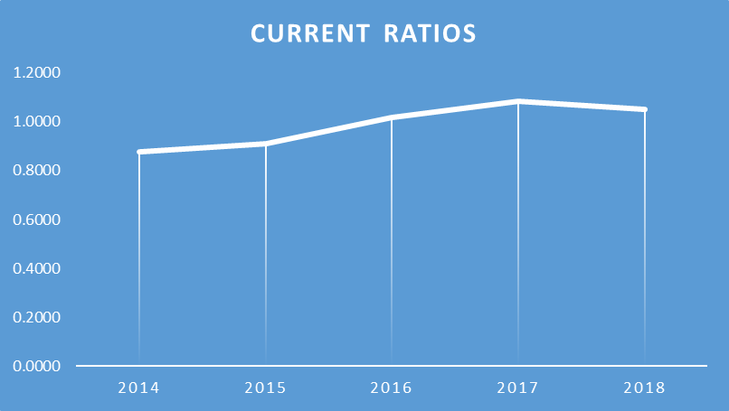 Interpretation : The current ratios of Shahjalal Islami Bank Limited from 2014 to 2018 were 0.87, 0.90, 1.01, 1.08, and 1.05, showing a steady increase until a slight decline in 2018. However, most investors seek a 2:1 ratio, where assets are double the liabilities. Shahjalal Islami Bank’s ratios fall below this benchmark, indicating a substandard liquidity position. 6.2.2 Net Working Capital: Net working capital is the difference between a company's current assets and liabilities. An increase in net working capital indicates that the company has sufficient resources to meet its financial obligations and invest in other activities. Net working capital = (Current asset – Current liabilities) Table 2 : Net working capital 

Figure 2: Line Graph of Net Working Capital Over Time  Interpretations: The net working capital of Shahjalal Islami Bank Limited reflects its liquidity position. During 2014 and 2015, the bank recorded negative net working capital of BDT (12,072,729,957) and BDT (9,917,507,643) respectively. However, from 2016 onwards, there was a notable improvement with figures rising to BDT 2,063,069,508 in 2016, BDT 12,319,931,132 in 2017, and BDT 9,228,521,284 in 2018. This upward trend, starting in 2016, signifies a positive shift for the bank's financial health. 6.2.3 Debt Ratio: The debt ratio shows how much of a company's assets are financed by debt, calculated by dividing total liabilities by total assets. A higher ratio indicates more financial risk, while a lower ratio suggests less reliance on debt. Debt ratio = Total Liabilities/ Total Assets. Table 3: Debt ratio 
Figure 3: Line Graph of Debt Ratio Over Time 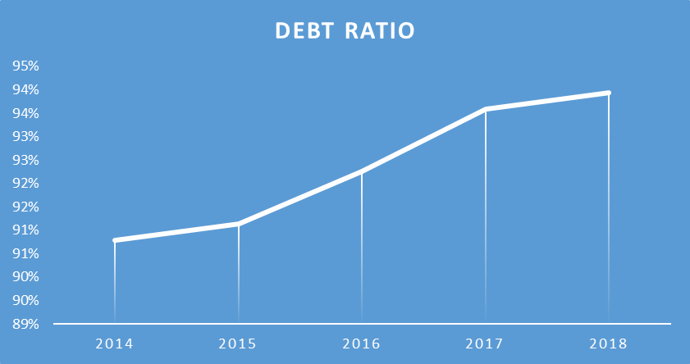
Interpretation: A lower debt ratio is generally favourable for the bank from a creditor's point of view. However, an analysis of the debt ratios from 2014 to 2018 shows a notable upward trend, with the figures rising from 91% in 2014 to 94% in 2018. Specifically, the ratios were 91% in 2015, 92% in 2016, and 94% in 2017. This increasing debt load could pose potential risks to the company’s financial health. 6.2.4 Debt to Equity Ratio: The Debt-to-Equity Ratio measures a company's capital structure by comparing creditor and investor funds. A higher debt percentage indicates greater risk and reliance on borrowing. Debt to Equity Ratio =Total Liability/Equity Capital Table 4: Debt to equity ratio 

Figure 4: Line Graph of Debt to Equity Over Time 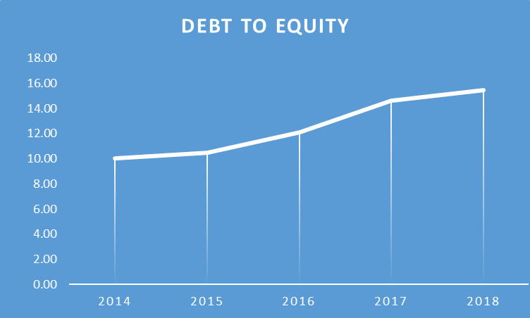 Interpretation: The Debt to Equity Ratio of Shahjalal Islami Bank Limited showed a consistent rise over the years, standing at 10.04 times in 2014, 10.47 times in 2015, 12.13 times in 2016, 14.61 times in 2017, and reaching 15.48 times in 2018. This upward trend indicates an increasing reliance on debt compared to equity. A high Debt to Equity Ratio such as this suggests that the bank may face challenges in generating enough cash flow to meet its debt obligations effectively. 6.2.5 Return on Assets: Return on Assets (ROA) is a key profitability metric that measures how effectively a company utilizes its assets to generate profit. A higher ROA percentage indicates better efficiency and is generally seen as a positive indicator of performance. Return on Asset (ROA)=Net Profit after Taxes/Total Assets Table 5: Return on assets 

Figure 5 : Line Graph of Return on Assets Over Time 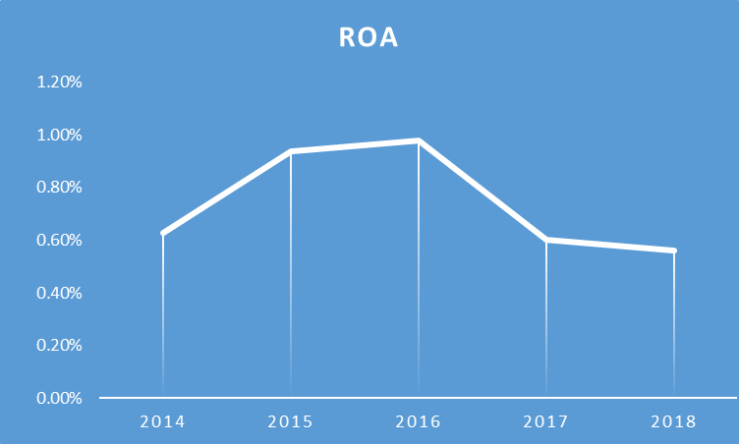 Interpretation: The Return on Assets (ROA) for Shahjalal Islami Bank Limited was recorded at 0.62%, 0.93%, 0.97%, 0.60%, and 0.56% for the years 2014, 2015, 2016, 2017, and 2018, respectively. The highest ROA figures were observed between 2015 and 2016, reaching 0.93% and 0.97%. However, a noticeable decline followed in 2017 and 2018, dropping to 0.60% and 0.56%, which signals a negative trend for the bank. To improve performance, the bank needs to focus more on maximizing the effective use of its assets in order to boost returns. 6.2.6 Return on Equity: Return on Equity measures the profitability generated from the investment made by the shareholders, including both preferred and common stockholders. A higher return typically indicates a stronger financial performance, reflecting how well the company is maximizing the value for its owners. ROE =Net profit after Taxes/Shareholder's Equity

Table 6- Return on Equity


Figure 6: Line Graph of Return on Equity over time 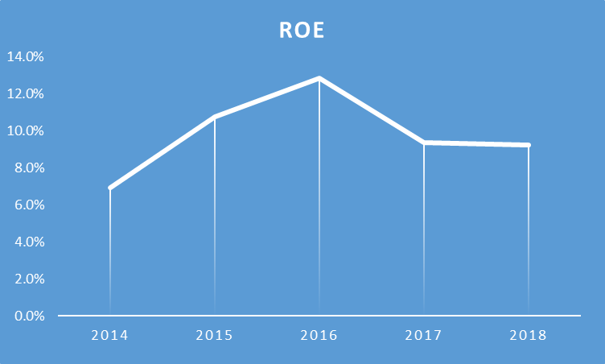 Interpretation: The Return on Equity (ROE) for Shahjalal Islami Bank Limited over the years 2014 to 2018 shows a fluctuating trend, with the figures being 6.94%, 10.74%, 12.83%, 9.37%, and 9.24% respectively. Notably, the ROE peaked in 2015 and 2016 at 10.74% and 12.83%, indicating strong financial performance during these years. However, from 2017 onward, a downward trend is observed, with the percentage declining to 9.37% in 2017 and 9.24% in 2018. The lower ROE in 2014 (6.94%) and the decline in recent years reflect a concerning trend for the bank’s financial health. 6.2.7 Non-Performing Investment: A Non-Performing Investment (NPI) occurs when the principal or interest payments are overdue by 90 days or more. Alternatively, if interest expenses have been capitalized, refinanced, or are past due by less than 90 days, it may still be classified as an NPI if there are concerns about the full repayment of the amount owed. NPI= Non-Performing Investment / total Investment Table 7: Non- Performing Investment 

Figure 7: Line Graph of Non performing Investment over time 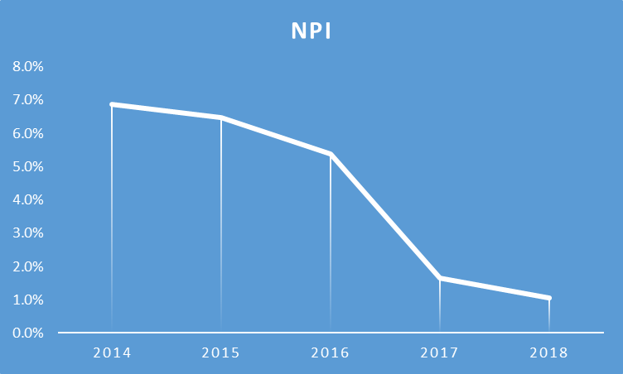 Interpretation: The Non-Performing Investment (NPI) ratio of Shahjalal Islami Bank Limited showed a notable shift over the years. In 2014, 2015, and 2016, the NPI ratios were relatively high at 6.87%, 6.46%, and 5.37%, respectively. However, the situation improved significantly in 2017 and 2018, with the ratios dropping to 1.64% and 1.05%. This downward trend in non-performing investments marks a commendable achievement for the bank, showcasing its improved asset quality and management. 6.2.8 Investment to Deposit Ratio: The overall performance of investments and deposits is evaluated using the Investment to Deposit Ratio (IDR), which provides insight into how effectively a bank is utilizing its deposits to generate returns through investments. This ratio is a key indicator of the bank's financial health and operational efficiency, reflecting the balance between the funds available for lending and the investments made. IDR= Total Investment/Total Deposit Table 8: Investment to Deposit Ratio  Figure 8: : Line Graph of Investment to Deposit Ratio over time 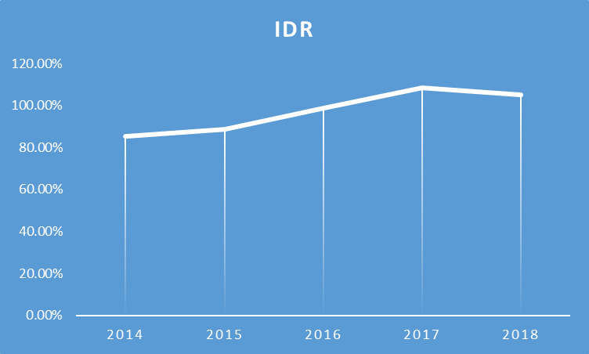 Interpretation: The Investment to Deposit Ratio for Shahjalal Islami Bank Limited from 2014 to 2018 showed figures of 85.25%, 88.62%, 98.86%, 108.41%, and 105.21%, respectively. This indicates a general upward trend over these years, despite a slight decline in 2018. It is essential for Shahjalal Islami Bank Limited to make efforts to utilize the deposited funds effectively. 6.2.9 Earnings Per Share: Earnings per share (EPS) are typically of significant interest to both existing and potential shareholders, as well as to the company's management. EPS = Earnings available for common stockholders / No of Share Outstanding Table 9 : Earnings Per Share  Figure 9: Line Graph of Earning Per Share over time 
Interpretation: Shahjalal Islami Bank Limited reported earnings per share (EPS) of Tk 1.10 in 2014, Tk 1.79 in 2015, Tk 2.27 in 2016, and Tk 1.61 in both 2017 and 2018. The highest EPS was recorded in 2016, after which there was a decline. The consistent EPS of Tk 1.61 in both 2017 and 2018 suggests a concerning trend for the bank, indicating potential challenges ahead. 6.2.10 Earnings Ratio: The price-to-earnings (P/E) ratio of a stock evaluates the compensation received for each share in relation to the company's earnings or profit per share. Earnings Ratio (P/E Ratio) = Price per share/ Earnings per share Table 10: Earnings Ratio:  Figure 10: Line Graph of Price Earning Ratio Over time 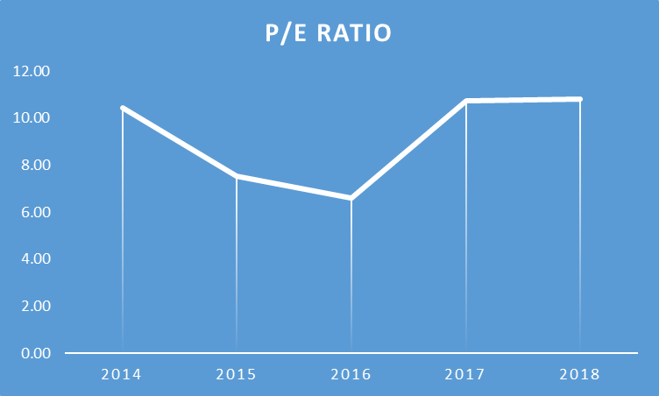 Interpretation: The data presented indicates that the Price/Earnings (P/E) ratio of Shahjalal Islami Bank Limited was 10.45x in 2014, 7.54x in 2015, 6.60x in 2016, 10.72x in 2017, and 10.81x in 2018. Notably, the current P/E ratio surpasses those of previous years, signaling positive growth and prospects for the bank.

Chapter 7:
Findings, Recommendation and Conclusion

7.1 Findings and Recommendation When comparing Shahjalal Islami Bank Limited (SJIBL) with City Bank Limited (CBL), several significant differences are evident in their operational philosophies, financial offerings, and customer engagement approaches. SJIBL adheres to Shariah law, which prohibits interest-based transactions, focusing on profit-sharing and asset-backed financing models. This framework influences its product range, including Murabaha, Ijarah, and Mudaraba, distinguishing it from CBL’s conventional interest-bearing products. In contrast, City Bank operates under a traditional banking model, providing a variety of financial services such as personal loans, credit cards, and fixed deposits, all based on interest rates.
Another major distinction is in financial inclusivity. SJIBL primarily serves customers who prefer Shariah-compliant banking solutions, drawing a more niche group that seeks ethical, interest-free banking. CBL, on the other hand, targets a broader demographic, ranging from individual clients to businesses and SMEs, offering greater flexibility in its services.
When it comes to digital banking, CBL leads with advanced technological infrastructure, offering robust mobile banking, online banking platforms, and other digital solutions that cater to tech-savvy users. While SJIBL has also ventured into digital services, its offerings are still developing and not as comprehensive as CBL’s technology-driven solutions.
Findings: The main differences lie in their banking approaches (Islamic vs. conventional), the scope of financial products, and their technological advancements. SJIBL appeals to a specialized market seeking Shariah-compliant banking, while CBL serves a more diverse audience with its varied offerings.
Recommendations: SJIBL should focus on expanding its digital banking capabilities to match the convenience and ease provided by CBL’s advanced platforms. Conversely, CBL could consider introducing Islamic banking products to cater to customers interested in Shariah-compliant services. Both institutions would benefit from enhancing customer service and engagement to boost satisfaction and loyalty within their respective markets. 7.2 Conclusion In conclusion, the disparity between Shahjalal Islamic Bank Limited and City Bank Limited lies in their fundamental banking philosophies and service structures. The differences between Shahjalal Islami Bank Limited (SJIBL) and City Bank Limited (CBL) arise from their differing banking models, goals, and operational methods. SJIBL operates as a Shariah-compliant Islamic bank, strictly adhering to Islamic finance principles, such as the prohibition of interest (Riba) and employing risk-sharing mechanisms like Mudarabah, Musharakah, and Ijara. This model ensures all financial transactions align with Islamic law. In contrast, CBL functions as a conventional commercial bank, focusing on interest-based services such as loans, credits, and deposits, and aims to maximize shareholder value through traditional banking practices. SJIBL primarily serves customers seeking Islamic financial products, while CBL caters to a wider audience with modern financial solutions including credit cards, retail banking, and corporate services. CBL has made significant investments in digital banking and technological innovation, enhancing its competitive edge in the retail sector. Although SJIBL has also begun incorporating digital technologies, its primary emphasis remains on upholding Islamic values.
Furthermore, their regulatory frameworks differ: SJIBL is governed by a Shariah Supervisory Board that ensures compliance with Islamic principles, whereas CBL adheres to the conventional regulatory standards set by the Bangladesh Bank. These foundational differences influence their strategic directions, target markets, and service offerings, contributing to a diverse banking environment in Bangladesh that supports both conventional and Islamic banking needs.

Reference
Ahmad, A.U.F. and Hassan, M.K. (2007). Regulation and performance of Islamic banking in
Bangladesh. Thunderbird International Business Review, [online] 49(2), pp.251–277.
doi:https://doi.org/10.1002/tie.20142.
Assignment Point (2023). Overview of Shahjalal Islami Bank Limited. [online] Assignment Point.
Available at: https://assignmentpoint.com/overview-shahjalal-islami-bank-
limited/?fbclid=IwAR09m80w_YTBZBFINW8zKGKE2XACu55siQd6pDtltN-
Q2MsyTo7xU1VrV9E [Accessed 2 Oct. 2023].
Bangladesh Bank (2009). Guidelines For Islamic Banking. [online] Bangladesh Bank. Available
at:
https://www.bb.org.bd/aboutus/regulationguideline/islamicbanking/guideislamicbnk_intro.pdf?fb
clid=IwAR12Q28X-05eAtWcwRDoUyzxRQpeLSU3vccTCziz0SW_IibpFfFgea7NG4E
[Accessed 2 Oct. 2023].
Bank Info Beta (2023). City Bank - Bangladesh» BankInfoBD. [online] bankinfobd.com. Available
at:
http://bankinfobd.com/banks/46/City_Bank?fbclid=IwAR2cByvLNKrtLouLQPIUVISaQ3nNRc
ZNfisVc5r9UyH3pC1iKgjFq72U8tA [Accessed 2 Oct. 2023].
City Bank (2023). Citytouch. [online] www.thecitybank.com. Available at:
https://www.thecitybank.com/citytouch?utm_source=google&utm_medium=cpc&utm_campaig
n=citytouch_sem&gclid=CjwKCAjwseSoBhBXEiwA9iZtxhEGLe8jkOxKyTSBiNqUg0zVmF4
2bNtmjiDe9wx_0k6bbmc6hPNAuBoCFyYQAvD_BwE&fbclid=IwAR3CMO_ZCS_IVjok4C0
mtZjhdhddwDjCs6NEUID0Kqy-2zw33FrOIuXBckM [Accessed 2 Oct. 2023].
M. Kabir Hassan, Muhammed Tarık İSLAM, Ahmed, Z. and Jahidul Islam SARKER (2023).
Islamic banking in Bangladesh: a literature review and future research agenda. International
Journal of Islamic and Middle Eastern Finance and Management, 16(5), pp.1030–1054.
doi:https://doi.org/10.1108/imefm-05-2022-0185.
Shahjalal Islami Bank Limited (2023a). Shahjalal Islami Bank. [online] sjiblbd.com. Available at:
https://sjiblbd.com/investment.php?fbclid=IwAR2xdy_Zdj3_1oEvKzDWs1CpV6pTmvBe9BglK
Di1G5ftgPYNfYAzxHTZaN8 [Accessed 2 Oct. 2023].
Shahjalal Islami Bank Limited (2023b). Terms & Conditions for SJIBL Internet Banking and
Mobile App Services . [online] Shahjalal Islami Bank Limited. Available at:
https://sjiblbd.com/download/terms_300920.pdf?fbclid=IwAR1vOA7QfNUZzV9dygQfbE5yvV
-Dy-MgQdpiGgmjblMVz8pHXU_oMJoawGE [Accessed 2 Oct. 2023].
The Financial Express (2019). The current state of the banking industry in Bangladesh. [online]
The Financial Express. Available at: https://thefinancialexpress.com.bd/views/views/the-current-
state-of-the-banking-industry-in-bangladesh-1556380055.
The Lawyers of Jurists (2023). BANKING SYSTEM OF THE CITY BANK LIMITED. [online] The
Lawyers & Jurists. Available at: https://www.lawyersnjurists.com/article/banking-system-of-the-
city-bank-limited/?fbclid=IwAR3CMO_ZCS_IVjok4C0mtZjhdhddwDjCs6NEUID0Kqy-
2zw33FrOIuXBckM [Accessed 2 Oct. 2023].

