Analysis of Dhaka Bank PLC and the Private Commercial Banking Industry in Bangladesh: An Internship Experience Perspective

Mahiya Islam

This report is submitted to the school of Business and Economics, United International University as a partial requirement for the degree fulfillment of Bachelor of Business Administration
Analysis of Dhaka Bank PLC and the Private Commercial Banking Industry in Bangladesh: An Internship Experience Perspective
Submitted to:
Name: Dr. Md. Mohan Uddin
Designation: Professor
Major: Finance & Fintech
Submitted By:
Name: Mahiya Islam
ID: 111 221 154
Major: Finance & Fintech
Registration Trimester: Spring 2026

School of Business and Economics
United International University
Date of Submission: 17-07-2026

Letter of Transmittal

July 17, 2026
Dr. Md. Mohan Uddin
Professor
School of Business & Economics
United International University
United City, Madani Avenue, Dhaka 1212
Subject: Submission of Internship Report entitled “Analysis of Dhaka Bank PLC and the Private Commercial Banking Industry in Bangladesh: An Internship Experience Perspective”
Dear Sir,
With due respect, it is with great pleasure that I submit the report of my Internship entitled “Analysis of Dhaka Bank PLC and the Private Commercial Banking Industry in Bangladesh: An Internship Experience Perspective” for the partial fulfillment of the requirement of the Bachelor of Business Administration (BBA) majoring in Finance & FinTech at United International University.
The report is an outcome of my internship experience with Dhaka Bank PLC at its General Banking Department. The internship gave me the opportunity to bring my theoretical learning in banking into practice and gave me a good insight into the banking world, and also improved my skills in banking. I have written this report with sincerity and care in accordance with your directions, and I have met academic requirements by means of practical learning. I would love you to check this out and be open to any questions you may have. Finally, I would like to express my gratitude to you for your continuous support and encouragement during the internship and the preparation of the report.
Sincerely,
Mahiya Islam
ID: 111 221 154
Bachelor of Business Administration (Finance & Fintech)
United International University

Certification of Summary Index

Declaration of the Student

I, Mahiya Islam, a student of the Bachelor of Business Administration (BBA) program of the United International University (UIU), Finance & FinTech major, hereby declare that this Internship Report is a part of the completion of the BBA degree program entitled “Analysis of Dhaka Bank PLC and the Private Commercial Banking Industry in Bangladesh: An Internship Experience Perspective”.
I hereby certify that this is my internship report on Dhaka Bank PLC based on my observation, learning, and gathering information from the bank. This report has not been submitted, either in whole or in part, to any other educational institution for any academic purpose. I have given proper credit to all sources of information that I have used in preparing this report.


Mahiya Islam
ID: 111 221 154
Bachelor of Business Administration (Finance & Fintech)
School of Business & Economics
United International University

Corporate Evidence

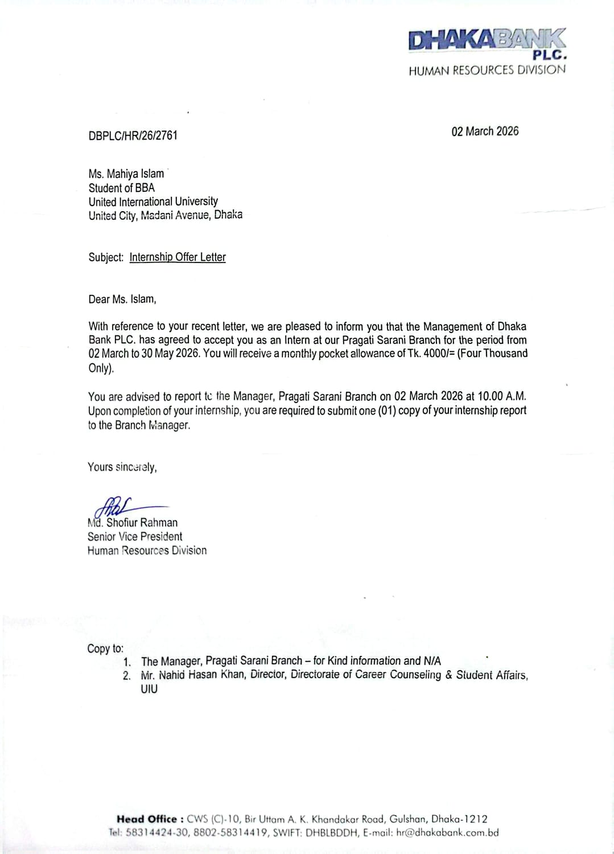

Figure I: Internship Placement Letter
Source: Dhaka Bank PLC, Pragati Sarani Branch

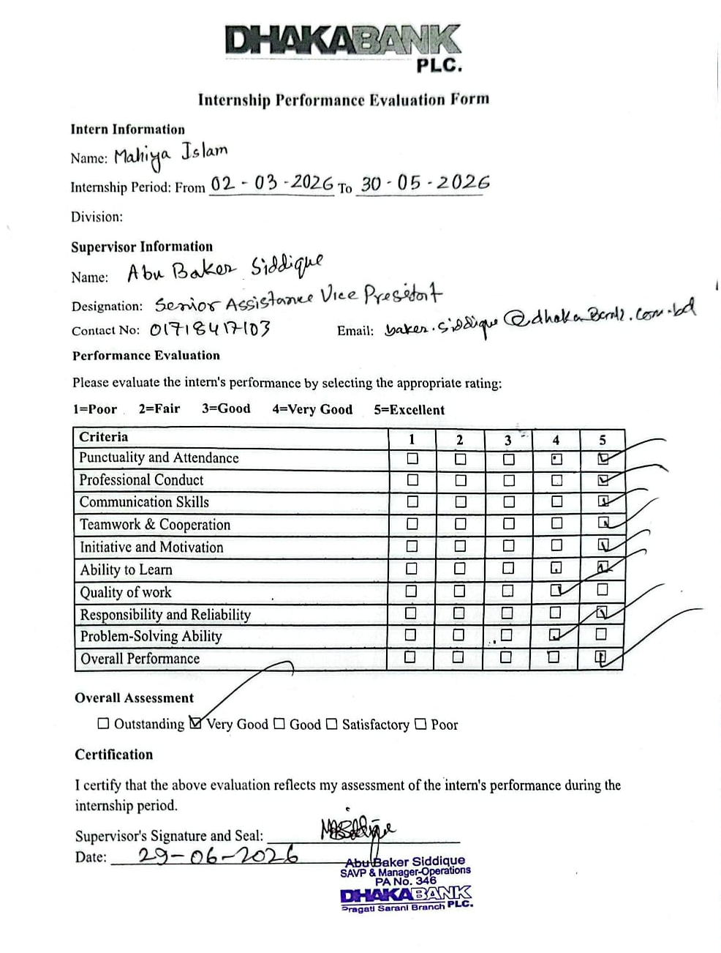
Figure II: Internship Evaluation Form
Source: Dhaka Bank PLC, Pragati Sarani Branch

Acknowledgement

First and foremost, I express my sincere gratitude to Almighty Allah for giving me the strength and ability to successfully complete my internship and this report.
I would like to thank Dr. Md. Mohan Uddin, Professor, School of Business & Economics (SoBE), United International University for providing invaluable guidance, on-going support and constructive suggestions provided during the preparation of this report.
I am also deeply grateful to the management and employees of Dhaka Bank PLC. I would like to express my special gratitude to Ashiqur Rahman, SVP & Manager, Dhaka Bank PLC, and Abu Baker Siddique, SAVP & Manager Operation, Dhaka Bank PLC, for giving me the opportunity to complete my internship and for their guidance, cooperation, and support throughout this internship period.
Last but not least, I would like to express my sincere gratitude to my parents and family for their unconditional love, encouragement, and constant support throughout my academic career.

Executive Summary

One of the most significant sectors to contribute to the economic development of Bangladesh is the banking sector. Private commercial banks have a major role to play in savings promotion, providing credit, assisting the businesses, facilitating international trade and promoting financial inclusion. Over the past few years, banking has grown by a factor of many digital transformations, technological innovations, and customer-centric financial services. But the industry has a number of problems as well, such as growing non-performing loans (NPLs), competition, changing regulations, and economic uncertainty.
This internship report has been prepared based on my three-month internship at Dhaka Bank PLC, one of the leading private commercial banks in Bangladesh. The primary aim of my internship was to acquire practical experience in the Banking sector to put theoretical knowledge into practice, which I had gained throughout my Bachelor of Business Administration (BBA) program. My internship was in the General Banking Department, where I was engaged in account opening, customer service, document verification, transaction processing, etc. My work helped me to appreciate the practical side of banking and also develop my communication, analytical, and problem-solving skills.
The report has three main components. The first section documents gives an introduction to the background, vision, mission, products, and services of Dhaka Bank PLC. To analyze the financial position and performance of the bank, the other half of the first part is based on financial statement analysis, ratio analysis, trend and growth analysis, DuPont analysis, and SWOT analysis of Dhaka Bank PLC. The second part introduces the private commercial banking industry in Bangladesh, covering its size, trends, and maturity, as well as a SWOT analysis of the industry. The last part is based on the internship experience, the organization's profile, and the intern's daily tasks during the internship.
According to the financial analysis, Dhaka Bank PLC sustained a healthy growth trajectory in its assets, deposits, loans, operating profit and digital banking services in 2024. The Bank also continued to enhance customer-friendly services and expand banking activities. The profitability, however, has reduced because of higher loan loss provisions and increased pressure of non-performing loans (NPLs) on important performance indicators, Return on Assets (ROA) and Return on Equity (ROE). These difficulties did not dampen the Bank's financial health, which was bolstered by sound risk management, operational efficiency, and the drive to sustainable business expansion.
In conclusion, the internship was a valuable experience that allowed students to apply theoretical knowledge and skills to gain practical experience. It helped me in the better understanding of the working of the banking industries, overall banking activities, financial analysis and functioning of the private commercial banking industry in Bangladesh. The internship will give me the knowledge, skills, and experience that will support my future career in the banking and financial sector.

Contents

Letter of Transmittal i
Certification of Summary Index ii
Declaration of the Student iii
Corporate Evidence iv
Acknowledgement vi
Executive Summary vii
CHAPTER 1: INTRODUCTION 1
1.1 Background of the Report 1
1.2 Objectives of the Report 3
1.3 Rationale of the Report 3
1.4 Scope and Limitations of the Report 4
1.5 Definition of Key Terms 5
CHAPTER 2: COMPANY AND INDUSTRY PROFILE 8
2.1 Company Analysis 8
2.1.1 Overview and History 8
2.1.2 Trend and Growth 9
2.1.3 Product/Service/Customer Mix of Dhaka Bank PLC 13
2.1.4 Company Operations/Activities 15
2.1.5 Company SWOT Analysis 19
2.2 Industry Analysis 24
2.2.1 Specification of the industry 24
2.2.2 Size, Trend, and Maturity of the Industry 25
2.2.3 Industry Swot Analysis 26
CHAPTER 3: INTERNSHIP EXPERIENCE 32
3.1 Positioning, Duties, and Responsibilities 32
3.1.1 Position 32
3.1.2 Duties and Responsibilities 32
3.2 Training & Development 35
3.3 Contribution to Organization 36
3.4 Evaluation 37
3.5 Skills Applied 37
CHAPTER 4: RECOMMENDATIONS AND CONCLUSION 40
4.1 Recommendations 40
4.1.1 Recommendations for Dhaka Bank PLC 40
4.1.2 Recommendations for the General Banking Department 40
4.1.3 Recommendations for Self-Development 41
4.2 Conclusion 41
REFERENCE 43
APPENDIX-A: Internship Placement Letter 44
APPENDIX-B: Internship Evaluation Form 45

List of Figures

Figure I: Internship Placement Letter iv
Figure II: Internship Evaluation Form v
Figure 1.1: Market Share of the Banking Sector in Bangladesh 2
Figure 2.1: Financial Inclusion Growth Analysis of Dhaka Bank PLC 11
Figure 2.2: SWOT Analysis of Dhaka Bank PLC 19
Figure 2.3: SWOT Analysis of the Private Commercial Banking Industry 27
Figure 3.1: Account Opening Process Using EzyBank 33
Figure 3.2: Sample of Account Opening Using EzyBank 33

List of Tables

Table 2.1: Core Business Growth Analysis of Dhaka Bank PLC 9
Table 2.2: DuPont Analysis of Dhaka Bank PLC 12

CHAPTER 1: INTRODUCTION

1.1 Background of the Report
Banking is one of the key pillars in the economic development of any country. It is a key financial intermediary that helps to channel savings into the economy, lends to companies and individuals, helps to conduct international trade, and supports overall economic development. Banks are not just about debt protection and deposit insurance; they are also instruments for development, through enabling entrepreneurship, home ownership, education, and infrastructure development.
The banking sector has undergone a massive change in the 21st century at a global level. Brick-and-mortar banks are now smart digital platforms with AI, blockchain, and mobile technology. But it has also created new challenges like cyber threats, regulatory complications, and sustainable and inclusive financing.
In the past 30 years, the banking sector in Bangladesh has seen tremendous growth and transformation. After the economic liberalization in the 1990s, the sector grew at a tremendous pace after many private commercial banks joined the banking sector. In the present scenario, 62 banks are functioning in the country, of which 43 are Private Commercial Banks, six are State-Owned Commercial Banks, and some are specialized and foreign banks.
Private Commercial Banks have taken the lead in the industry. By 2024, they hold around 70-75% of banking assets and deposits. These banks are known for their efficiency, innovation, customer-centric approach, and rapid adoption of technology. They have been instrumental in achieving financial inclusion, in supporting small and medium enterprises (SMEs), in enabling export-import businesses, and have been contributing to the government's revenue by paying taxes and treasury operations.
The significance of the banking system is higher in Bangladesh than in any other country. With a population of over 170 million and one of the fastest-growing economies in South Asia, the country relies on banks for the mobilization of savings, the provision of credit to businesses, exports, and the financial inclusion of the non-banked population. Private Commercial Banks (PCBs) have been the most dynamic in the banking sector among all types of banks.

Figure 1.1: Market Share of the Banking Sector in Bangladesh
Source: Bangladesh Bank Financial Stability Report 24 (Financial Stability Report, n.d.)
Modern technology, quick services, innovative products, and a customer-first approach are leading the way for private banks. One among these progressive institutions is Dhaka Bank PLC, one of the most trusted and progressive private commercial banks of the country.
Dhaka Bank PLC was founded on 5 July 1995 with a definite mission to be “Excellence in Banking”. It has expanded from its initial base in Motijheel to become a robust financial institution with 114 branches, 26 sub-branches, 87 ATMs, 3 SME Centers, and 2 Offshore Banking Units throughout the country of Bangladesh. Through the subsidiary Dhaka Bank Securities Limited, the bank has successfully provided capital market and brokerage services. It has also launched digital solutions, Islamic banking, SME financing, and capital market services.
What makes Dhaka Bank PLC special is its balanced approach — combining traditional banking strengths with modern digital innovation. The bank has heavily invested in technology, launched the popular “Dhaka Bank Go Plus” mobile app, and shown strong commitment toward Green Banking and sustainable finance. At the same time, it continues to focus on customer service excellence and financial inclusion.
However, the journey has not been without challenges. Like other banks, Dhaka Bank PLC faces issues such as rising Non-Performing Loans (NPLs), intense competition from both traditional banks and fintech companies (such as bKash and Nagad), and pressure on profitability.
This internship report is the outcome of my three-month internship at the Pragati Sarani Branch of Dhaka Bank PLC in the General Banking Department. It represents my sincere effort to connect classroom theories with real-world banking practices. Through this report, I explore Dhaka Bank PLC’s background, operational activities, financial performance, industry position, and, most importantly, the practical lessons I learned as an intern.
The banking sector in Bangladesh is currently undergoing a significant transformation, where traditional banking practices are increasingly integrating with modern technology and digital solutions. This report looks at this changing picture in the light of one of the prominent actors in the private commercial banking industry, Dhaka Bank PLC. (Dhaka Bank PLC Annual Report 24, n.d.) (Dhaka Bank PLC | Excellence in Banking, n.d.-a)

1.2 Objectives of the Report
This report sets out to achieve the following key objectives:
- Analyze the performance of Dhaka Bank PLC.
- Analyze the status of the private commercial banking industry.
- Describe the internship experience at Dhaka Bank PLC.

1.3 Rationale of the Report
The Bangladeshi economy has undergone tremendous development over the last few decades, and the banking sector is among the most important drivers of this growth. Economies are advanced by both government-owned and private banks. The industry is continuing to evolve due to new regulations, political and economic factors, and emerging technologies. Private commercial banks are particularly dynamic and competitive in the sector.
Both academic and theoretical learning were important in paving the way for a successful career, while practical experience refined skills and helped bring a clearer understanding of the real world of work. The main aim of this report is to illustrate the application of knowledge acquired in financial courses in real-life situations.
This report provides an account of Dhaka Bank PLC's performance in the banking industry, its daily operations, and the quality of service it provides to customers, in competition with other banks. It also discusses the opportunities and challenges presented to the private commercial banking industry. Further, the report notes that I have developed skills in observation and analysis, critical thinking, and professional report writing, which will help me in my profession. Hence, this report is of great importance for many reasons.
This report has the following objectives:
- To get hands-on experience with opening accounts and working directly with customers.
- To explore the organizational structure, division of the departments, and business units of Dhaka Bank PLC.
- To examine the conversion of Dhaka Bank PLC from traditional banking methods to modern banking methods.
- To have an overall background of Dhaka Bank PLC and the private commercial banking industry.
- To define bank strengths, weaknesses, opportunities, and threats for growth and risk areas for the bank and the private commercial banking industry.
- To make classroom theories come alive by using them in the actual operation of banking.
This internship report is not only part of my B.B.A. program, but also reflects the hard work and learning I gained from this 3-month experience. In the past 3 months, I have learned about the banking industry and have been inspired to pursue a career in finance.

1.4 Scope and Limitations of the Report
I have prepared this report by integrating my experience at Dhaka Bank PLC, secondary data from authentic sources, and Dhaka Bank PLC's 2024 annual report. Additionally, I have connected my academic knowledge with real-life experience throughout the report. The following section outlines both the scope and limitations of this study.
This report has the following scope:
- An overview and analysis of Dhaka Bank PLC, including its financial performance.
- An analysis of the private commercial banking industry.
- A closer look at the products and services I encountered throughout my internship journey.
- An assessment of technological adaptation and digital banking transformation.
The report has the following limitations:
- The internship duration was too brief to observe all aspects.
- Confidentiality restrictions prevent the inclusion of internal data.
- This report focuses on the Pragati Sarani Branch; activities from other branches may not be fully represented.
- Information was collected from annual reports and secondary sources, which may be limited by time constraints.
- There was limited opportunity to interact with upper management and executives for in-depth analysis.
Despite certain limitations, I have made every effort to present accurate and relevant information using the available resources.

1.5 Definition of Key Terms
- Private Commercial Banks: Private commercial banks are financial institutions owned by private persons or institutions which offers banking services, including acceptance of deposits, extension of loans and credit, payment services, and other financial services to individuals and businesses for profit.
- Non-Performing Loan (NPL): A loan that has not been paid on time over a certain period, typically 90 days or more, is called a Non-Performing Loan (NPL). Such loans reduce a bank's profitability and increase financial risk.
- Return on Assets (ROA): Return on Assets (ROA) is a profitability ratio that indicates how effectively a bank uses its total assets to generate net profit. It is determined by dividing the net profit after tax by the average total assets.
- Return on Equity (ROE): Return on Equity (ROE) is a profitability ratio that measures how effectively a bank generates profit from shareholders' equity. It is the ratio of net profit after tax to the average shareholders' equity.
- DuPont Analysis: DuPont Analysis can be used as a financial performance evaluation method that decomposes Return on Equity (ROE) into its various parts, which can then be used to evaluate the profitability, asset usage, and financial leverage of a company.
- SME Banking: SME Banking is the banking service for Small and Medium Enterprises (SMEs). It comprises loans, deposits, trade finance, and other financial products for the growth and development of small and medium enterprises.
- General Banking: General Banking is the day-to-day banking services such as opening an account, making deposits and withdrawals, cheque clearing, fund transfers, customer service, etc.
- Islamic Banking: Islamic Banking is a banking system which functions based on Islamic Shariah. It forbids the taking and giving of interest (Riba) and makes its financial transactions based on profit-sharing and asset-based financing.
- Digital Banking: Digital Banking is the offering of banking services via digital mediums like mobile banking apps, internet banking, ATMs, and online platforms that enable customers to conduct banking activities with them at anytime and anywhere.
- Financial Inclusion: Financial Inclusion is the way of making financial services available in an affordable, useful and safe manner to every individual and enterprise, including the provision of savings, credit, payments and insurance.
- Green Banking: Green Banking is the banking service which is environmentally friendly, minimizes the environmental footprint of banking activities, and encourages financing for environmentally friendly and sustainable development projects.
- Agent Banking: Agent Banking is a banking service in which authorized agents deliver simple banking services for a bank in regions where there are no physical branches. Examples of these services are deposits, withdrawals, opening accounts, and transferring funds.
- SWOT Analysis: The SWOT Analysis is a strategic planning tool that analyses four factors: Strengths, Weaknesses, Opportunities, and Threats that can affect a business or a company and help them develop their business plan and decision-making.
- Earnings Per Share (EPS): Earnings Per Share (EPS) is a financial ratio that indicates the amount of profit earned for each outstanding ordinary share of a company. The net profit available to ordinary shareholders divided by the weighted average number of ordinary shares outstanding.
- Classified Loans: Classified Loans are loans that are classified as substandard, doubtful, or bad/loss because the borrower has not paid as agreed. These advances show the risk of credit, and banks have to keep provisions for losses if they are to be issued.

CHAPTER 2: COMPANY AND INDUSTRY PROFILE

2.1 Company Analysis

2.1.1 Overview and History
Overview: Dhaka Bank PLC is one of the best, fastest-growing, and most well-known private banks in our country. Dhaka Bank PLC has a large and growing network of 114 branches and 26 sub-branches, 87 ATM booths, 20 ADMs, 2 Islamic banking branches, 2 offshore banking units, and 3 SME centers across Bangladesh. Dhaka Bank PLC got listed on the Dhaka and Chittagong Stock Exchanges in 2000. Dhaka Bank PLC has a subsidiary company named “Dhaka Bank Securities Limited” to serve in the capital market, which has 6 branches across Bangladesh. (“About Us,” n.d.)
It is renowned because of its excellence in banking operations, client-focused services, innovative approaches to finance, and product variety. It offers a range of services for individuals, businesses, and companies, including digital banking, trade finance, and personal banking, among many others. It is achieving customer trust by improving technology and customer care.
Vision of Dhaka Bank: “At Dhaka Bank Limited, we draw our inspiration from the distant stars. Our team is committed to assuring a standard that makes every banking transaction a pleasurable experience. Our endeavor is to deliver razor-sharp sparkle through accuracy, reliability, timely delivery, cutting-edge technology, tailored solutions, global reach, and high investment yields. Our goal is to achieve distinction like the luminaries in the skies — Excellence in Banking.”
Mission of Dhaka Bank: “To be the premier financial institution in the country, providing high-quality products and services backed by the latest technology and a team of highly motivated personnel to deliver Excellence in Banking.”
Corporate Values of Dhaka Bank: Dhaka Bank PLC's corporate values indicate that its activities are customer-oriented. Their core values are customer focus, integrity, teamwork, respect for individuals, and responsible citizenship. (“Vision, Mission And Values,” n.d.)
History: Dhaka Bank PLC was established under the Companies Act, 1994, on April 06, 1995, and commenced its commercial banking operations on July 05, 1995. It was founded by a well-known Bangladeshi businessman and politician, Mirza Abbas Uddin Ahmed, after the 1990s liberalization.
Mr. Abdul Hai Sarker, the Founder Chairman, has an important role in building the institution. The former President of the Bangladesh Textile Mills Association (BTMA) provided strong leadership, quickly earning the trust of customers and the business community.
Over the past thirty years, Dhaka Bank LTD has become an important part of Bangladesh’s banking industry with its excellence. It has rapidly expanded its business by opening new branches, adopting new digital services, and expanding its operations to include companies such as Dhaka Bank Securities Limited.
From 2003 to 2005, it introduced its retail, internet, and Islamic banking. In 2004, it established its subsidiary, Dhaka Bank Securities Limited. In 2007, it launched its credit card service and offshore banking. Now, after 30 years, it has grown so much and plays a vital role in Bangladesh's economy. It is improving further through the adoption of new technologies and trends. It has won many awards, including “Branding Award”, “The Banker Award”, “Best Corporate Bank-Bangladesh 2023”, and many more. (“CORPORATE BANKING,” n.d.; Dhaka Bank PLC | Excellence in Banking, n.d.-a)

2.1.2 Trend and Growth
The bank's performance in 2024 indicates it continued to expand across most of its core businesses. Assets, deposits, loans, operating profit, export business, import business, and inward remittances have increased at the bank compared to 2023. This means the bank expanded its operations during the year.
Table 2.1: Core Business Growth Analysis of Dhaka Bank PLC
Core Business Growth Analysis
Indicators | 2024 | 2023 | Growth%
Assets | 431,459 M | 378,639M | 14%
Deposits | 299,531M | 282,079M | 6%
Loans & Advance | 268,985 M | 256,187 M | 5%
Earnings Per Share | TK 1.24 | TK 1.72 | (28%)
Import | 279,718M | 223,512M | 25%
Export | 201,606M | 171,695M | 17%
Inward Remittance | 88,431 M | 77,563 M | 14%
Operating profit | 10,606M | 8,152M | 30%
NPL Ratio% | 5.33 | 4.88 | (9%)
Classified Loans | 14,341 M | 12,514 M | 15%
ROA | 0.31 | 0.48 | (35%)
ROE | 5.71 | 8.41 | (30%)
Shareholders’ Equity | 22,038M | 21,786M | 1%
Source: Annual Report 2024 of Dhaka Bank PLC
The bank's assets went up by Tk. 378,639 million in 2023 to Tk. 431,459 million in 2024, showing a 14% growth. This implies that the bank's size and strength increased based on the aggregate of its resources.
This was followed by a growth in customer deposits from Tk. 282,079 million to Tk. 299,531 million, with a 6% growth. This indicates that the bank gained more customers' trust and kept their money with it.
Loans and advances grew by Tk. 256,187 million to Tk. 268,985 million, showing a 5% increase. This translates into an increase in the number of loans the bank awards to businesses and customers.
The operating profit increased significantly by Tk. 8,152 million. 10,606 million. This indicates increased business activity and banking income.
The bank's overseas business was also good. Exports grew by 17%, imports grew by 25%, and inward remittances grew by 14%. From these findings, it is evident that Dhaka Bank has enhanced its position in international trade and foreign remittance services. But some financial indicators declined during the year. Earnings per Share (EPS) decreased from Tk. 1.72 to Tk. 1.24, a 28% decline. Return on Assets (ROA) fell from 0.48% to 0.31%, and Return on Equity (ROE) declined from 8.14% to 5.71%. The declines indicate that the bank's profit margins dropped as it grew its business. Both the Non-Performing Loan (NPL) ratio and the classified loan ratio rose to 9% and 15%, respectively. This means the bank's credit risk increased in 2024.

Figure 2.1: Financial Inclusion Growth Analysis of Dhaka Bank PLC
Source: Annual Report of Dhaka Bank PLC 2024
The bank also continued to grow its financial inclusion opportunities. SME financing grew by 2%, agricultural loan disbursements grew by 23%, and the bank's contribution to the national exchequer grew by 19%. The upgrades symbolize the Bank's commitment to expanding businesses, agriculture, and the country's economy
Digital banking continued to grow during the year. Internet Banking transactions rose by 8%, ATM transactions rose by 22%, and Transactions through the Dhaka Bank Go Plus App rose by 27%. The number of deposit accounts has also risen by 68%, and Nano Savings DPS has risen by 639%. The figures show that the bank's digital banking is gaining ground with its customers.
Overall, the trend showed that Dhaka Bank PLC experienced strong business expansion across asset growth, deposit growth, loan growth, operating profit, digital banking, and international business. The bank's profitability ratios and loan quality fell slightly, but the bank's operations continued to grow, and its position in the banking industry was enhanced.
DUPONT Analysis
DuPont Analysis is a financial performance evaluation technique which illustrates the source of a company's Return on Equity (ROE). It looks at ROE, but decomposes the ROE into two important ratios: Return on Assets (ROA) and Equity Multiplier (EM). This assists in determining that any shift in shareholders’ returns can be attributed to changes in return on capital, asset efficiency or financial leverage.
The correlation between these components is:
ROE = ROA × Equity Multiplier (EM)
= (Net Income/Total Assets) x (Total assets/Total equity)
The overall financial performance of Dhaka Bank PLC and the key factors influencing the bank's returns to shareholders can be understood through this analysis. The DuPont Analysis of Dhaka Bank PLC is given below:
Table 2.2: DuPont Analysis of Dhaka Bank PLC
DU PONT Analysis
Year | ROA | Equity Multiplier (EM) | ROE
2024 | 0.31% | 18.49 | 5.71%
2023 | 0.48% | 17.04 | 8.14%
2022 | 0.49% | 16.63 | 8.09%
2021 | 0.65% | 16.16 | 10.53%
Source: Annual Report of Dhaka Bank PLC 2024
Analysis of Return on Assets (ROA): Return on Assets (ROA) is a ratio that indicates how effectively the bank is utilizing its overall assets to make a profit. The higher the ROA, the more efficient the use of assets and the more profitable the organization is.
From the table, Dhaka Bank PLC's ROA declined from 0.65% in 2021 to 0.49% in 2022, then slightly decreased to 0.48% in 2023, and further fell to 0.31% in 2024. This indicates that the bank was less profitable of its assets during the 4-year period.
The decrease in ROA is primarily due to the decrease in net profit in 2024. The bank held higher loan loss provisions in order to safeguard against potential credit risks, according to the annual report. This meant that the bank was taking a risk management approach, being careful about its profits in the short term, but for the long term, the bank was becoming more financially stable.
Analysis of Equity Multiplier (EM): The Equity Multiplier (EM) is a ratio that reflects the amount of financial leverage that is applied by the bank. It reveals the proportion of the bank's assets that is funded by equity funds.
Dhaka Bank PLC's EM increased steadily from 16.16 times in 2021 to 16.63 times in 2022, 17.04 times in 2023, and 18.49 times in 2024. These figures show that the bank was more dependent on borrowing to finance its assets, and that this ratio increased.
An expansion of the EM allows for more returns when profits are high. It also raises the financial risk as the bank is more relying on external financing. Thus, a sustainable financial leverage ratio is crucial for financial sustainability.
Analysis of Return on Equity (ROE): The Return on Equity (ROE) is used to assess the return earned by the bank on the shareholders' investment. One of the most significant measures of the overall financial performance.
The ROE of Dhaka Bank PLC fell from 10.53% in 2021 to 8.09% in 2022, and stayed nearly the same in 2023 at 8.14%, but dropped drastically to 5.71% in 2024. This means that the bank's return on its equity was not as high as it was the previous year.
Despite the rise in the Equity Multiplier in 2024, the lower ROA affected ROE's level much more. The overall return to shareholders was lower due to lower profitability, and the resulting rise in financial leverage failed to compensate for this. This indicates that lower ROE was due to lower profit, not because of inefficiency of the use of shareholders' equity.
Overall, according to the DuPont Analysis, Dhaka Bank PLC's financial performance declined in 2024 as compared to the earlier years. The decline in the ROA is a reflection of the bank's decreasing earnings from its assets, and the rise in the Equity Multiplier reflects financial leverage that the bank applied. The leverage, however, was not enough to make up for the lowered profitability, which led to a lower ROE. (Dhaka Bank PLC Annual Report 24, n.d.)

2.1.3 Product/Service/Customer Mix of Dhaka Bank PLC
Dhaka Bank PLC offers a variety of products and services to meet its customers' needs. For different customers, they offer different services. Dhaka Bank PLC has earned a strong position in customers' minds because of its customer-focused approach. Products and services of Dhaka Bank PLC for different customers are:
- Personal Banking-Based Products: This is for people like housewives, students, and workers who want to save their money. For these customers, they offer deposit products including savings account, current account, fixed deposit, DPS (Deposit Pension Scheme), salary account, bundle savings account, and RFCD account. Loan products include personal loans, home loans, car loans, salary loans, consumer credit schemes, and other retail loans. Card services include credit cards, debit cards, and Master cards. Other services include lockers and remittance services.
- Corporate Banking Customers: These products and services are for big companies and businesses. They offer short-, medium-, and long-term project finance, working capital finance, syndicated loans, import & export trade finance, Letters of Credit (L/C), Bank Guarantees, cash management solutions, term loans, and leasing.
- Small and Medium Enterprises: SMEs need specialized support to grow. As they are very important to the economy, Dhaka Bank PLC places strong emphasis on them. Dhaka Bank PLC provides SME Loans for expanding businesses and working capital, cluster-based financing, and women entrepreneur financing, supply chain finance and distributorship finance, agri & micro-enterprise loans, and refinance facilities from Bangladesh Bank & SME Foundation.
- Shariah-Based Products: Given that Bangladesh is a Muslim-majority country and not all customers want interest-bearing products, Dhaka Bank PLC has introduced Shariah-compliant products for its muslim customers. They offer interest-free deposit products, including the Mudaraba Hajj Savings Scheme, Tawfeer Mudaraba Savings Bond Account, Tawfeer Mudaraba Deposit Pension Scheme, Foreign Remittance Account, Mudaraba Value Max Savings Account, Tawfeer Mudaraba, Mudaraba Deposit Double Scheme, Mudaraba Bundle Savings Account, Mudaraba Marriage Deposit Scheme, Tayyebah Lakhpoti Deposit Scheme, Tayyebah Kotipoti Deposit Scheme. They also offer investment products, including the Tayyebah MasterCard Titanium Credit Card, the Tayyebah Islamic Credit Card, and many more.
- Digital Banking Products: Dhaka Bank PLC is introducing its digital banking products day by day. For digital banking, they offer Dhaka Bank Go Plus, Bangladesh Bank APP, EzyBank, Nano Savings DPS, e-Rin, MFS Fund Transfer, Self-Banking, ATM (Automated Teller Machine), ADM (Automated Deposit Machine), and CRM (Cash Recycling Machine)
- Web-Based Products: Dhaka Bank PLC also has some web-based products. They are: Dhaka Bank PLC.C-Solutions, Dhaka Bank PLC. Direct, Tuition Fee Solution, Interactive Banking, Credit Card from Home, Account from Home and many more.
Dhaka Bank PLC also offers other services, including payroll banking, sustainable finance products, premium services, and many more. They have personalized products for every type of customer. They listen to their customers, understand them, and design products and services accordingly. (Dhaka Bank PLC Annual Report 24, n.d.) (Dhaka Bank PLC | Excellence in Banking, n.d.-a)

2.1.4 Company Operations/Activities
Dhaka Bank PLC is one of the largest private commercial banks, with a large network of branches, sub-branches, ATMs, and digital channels. It has designed its daily operations clearly so that all departments and business units can work efficiently. Dhaka Bank PLC focuses strictly on organizational structure to ensure the output is reliable, high-quality, and effective for the customer. They operate their day-to-day activities through different departments and divisions. They are:
- Credit Division: The Credit Division is in charge of the bank's credit operations. It reviews loan applications, reviews the financial health and loan payment ability of borrowers, approves loans in accordance with the credit policies of the bank and monitors loan repayments. The division also manages credit risk by reducing non-performing loans (NPLs) and ensuring compliance with Bangladesh Bank's guidelines.
- Information Technology (IT) Division: The Information Technology (IT) Division is responsible for the bank's technological infrastructure and digital banking services. Its roles include internet banking, mobile banking, ATM services, cyber security, maintenance of systems, and software support. Dhaka Bank PLC provides digital platforms such as Dhaka Bank Go Plus and Ezy Dhaka, while Oracle FLEXCUBE is used as the core banking system to ensure secure, fast, and efficient banking operations.
- Human Resources Division: All the activities pertaining to the employees of the bank are handled by the Human Resources Division. Its role is to carry out recruitment, training and development, performance management, compensation and benefits management, employee welfare, and career development. The division also aims to provide a positive working environment and a skilled, motivated, and productive workforce of the bank.
- Finance & Accounts Division: The Finance & Accounts Division handles the financial operations of Dhaka Bank PLC. It prepares Financial statements, prepares Budgets, accounting and records, keeping a check on income and expenditure, and adhering to Accounting standards and Bangladesh Bank regulations. The division also gives financial reports to assist management in making decisions regarding strategic business planning.
- Treasury Division: The Treasury Division is responsible for liquidity, investment portfolio, and foreign exchange activities. It balances the funds necessary for the day-to-day operations of a business and the most effective use of excess funds. The division also controls interest rate risk, performs money market transactions, government securities, and foreign currency operations, which help ensure the bank's financial stability.
- Global Trade Services Division: The Global Trade Services Division is responsible for all banking and trade financing operations of Dhaka Bank PLC at the international level. It offers import and export finance services, letters of credit (L/C), bank guarantees, foreign remittance services, and other international trade services. The division ensures that all the foreign trade operations are in compliance with the Bangladesh Bank regulations and international banking practices.
- Audit & Risk Management Division: The Audit & Risk Management Division ensures that all banking operations are carried out in accordance with the internal banking policies, the Bangladesh Bank policies, and other legal requirements. It periodically reviews branches and divisions, assesses the credit risk, financial risk, and internal control systems, and makes recommendations for corrective action. The division is vital to the bank's asset protection, corporate governance, and financial stability.
- Dhaka Bank Training Institute (DBTI): The Dhaka Bank Training Institute (DBTI) is responsible for developing the professional knowledge and skills of the bank's employees. It conducts training courses, workshops, seminars, and development courses on banking operations, compliance, customer service, leadership, and digital banking regularly. These initiatives provide support for employees for their growth and to adjust to the changing banking industry.
- SME Banking Division: The SME Banking Division offers financial solutions to Small and Medium Enterprises (SMEs). It provides business loans, working capital financing, trade finance, and advisory services for promoting business growth and entrepreneurship. The division also plays a role in the employment generation and economic development of Bangladesh by providing financing to SMEs.
- Islamic Banking Division: The Islamic Banking Division offers Islamic banking products and services. It works on the principles of Islamic finance, which does not include interest (Riba), and profit-sharing and asset-based financing. The division offers Islamic banking deposit accounts, Islamic investment services, trade finance, and other Islamic banking financial services to serve the needs of Islamic banking customers.
- General Banking Department: The General Banking Department of a bank is one of the most significant departments because of the daily operational activities and direct customer service that is provided. The officers in this department are engaged in the opening of new accounts, verification of customer documents, processing of cash deposits, cash withdrawals, issuance of pay orders, and conducting electronic fund transfers through the RTGS and EFT systems. They also provide cheque books, debit cards, and activate internet and mobile banking services as per the need of the customers.
Cheque clearing is another big task assigned to the General Banking Department. The clearing of cheques process is the method of transferring money from the bank where the cheque is issued to the bank where the cheque is deposited. Banks share cheque details in the Bangladesh Automated Clearing House (BACH) run by Bangladesh Bank, and banks do not directly collect money from customers. This system facilitates quicker, secure, and efficient funds transfers. There are two types of cheque clearing:
- Outward Clearing: The customer deposits a cheque of another bank at Dhaka Bank for collection; the cheque will be picked by the bank through the clearing system. This is called “outward clearing.”
- Inward Clearing: When the other bank sends a cheque issued by the account holder of the other bank (Dhaka Bank), Dhaka bank verifies the cheque, and if all is correct, it releases the cheque. This is called "inward clearing".
A cheque can be dishonored if the bank account has inadequate funds, the drawer's name is not on the cheque, the cheque is outdated or post-dated, the drawer has stopped payment on the cheque, or if there is incorrect or incomplete information on the cheque.
Clearing of cheques is an important work of General Banking Department as it facilitates the transfer of funds from one bank to the other bank in a safe and proper manner and also helps in reducing the customer's visit to the bank of origin.
The department also handles utility bills, municipal taxes and other government fees, keeps customer records, settles any account related issues and offers various banking information and services. These activities help the General Banking Department to perform the smooth running of the banking activities every day and provides efficient services to the customers.
Apart from its major departments and divisions, Dhaka Bank PLC. also runs some specialized business units such as Account Service Unit, Cash Unit, SME Banking, Corporate Banking, Personal/Retail Banking, Islamic Banking, International Trade and Foreign Exchange and Capital Market Services. These business units enable the Bank to provide a wide range of financial products and services to meet the diverse needs of individual and corporate customers.
Dhaka Bank PLC has also expanded its branch and sub-branch network and ATM outlets in Bangladesh and introduced a wide range of digital banking channels, making it easy and accessible for customers to avail banking facilities. The Bank uses innovative digital solutions, including internet and mobile banking, to offer round-the-clock, secure, and efficient services. The Bank will continue to strive for excellence in customer service and adhere to the rules and regulations laid down by Bangladesh Bank. Moreover, Dhaka Bank PLC is proactively involved in many Corporate Social Responsibility (CSR) activities in the field of Education, Healthcare, Environmental Sustainability, and Welfare of the community. All these activities reflect the Bank's dedication to financial excellence as well as to the creation of lasting value for the society and contributing towards the sustainable development of Bangladesh.(Dhaka Bank PLC | Excellence in Banking, n.d.-b) (Dhaka Bank PLC Annual Report 24, n.d.)

2.1.5 Company SWOT Analysis
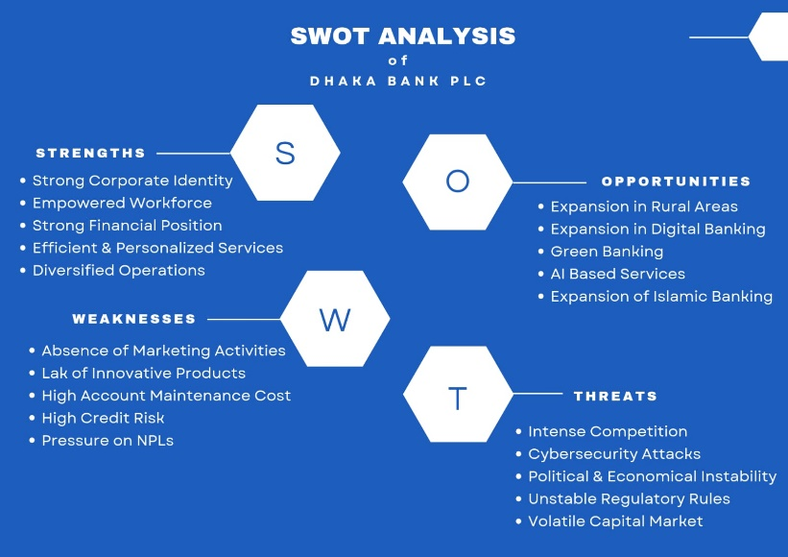
SWOT analysis is a tool that helps identify a company's overall strengths, weaknesses, threats, and opportunities, thereby gauging the company's competitive potential. It helps a company to recognize its market position and the strategies it should adopt accordingly. Here, a SWOT analysis of Dhaka Bank PLC is conducted to understand the bank's positioning better:

Figure 2.2: SWOT Analysis of Dhaka Bank PLC
Source: Created by Author using Canva
- Strengths of Dhaka Bank PLC:
In the banking sector, Dhaka Bank PLC has emerged as one of the leading private commercial banks in Bangladesh with its progressive business expansion and customer-centric banking approach. Its ability to deliver quality banking services, experienced staff, diversified business and sound financial position have fortified the bank's banking industry position. The internal capacity allows the Bank to be competitive, build confidence among customers, and foster its long-term business goals. The strengths of Dhaka Bank PLC are highlighted below.
- Strong corporate identity: To customers, Dhaka Bank PLC is the leading and trusted bank for providing financial services countrywide. Its strong corporate image and identity help it gain a stronger position in customers' minds. This strong brand image has helped Dhaka Bank PLC rapidly capture the personal banking sector in Bangladesh, which has become its strongest strength.
- Empowered Workforce: The Department of Human Resources of Dhaka Bank PLC perfectly manages its employees. The top management believed in empowering employees and didn’t control them through their boss. Employees can make their own decisions, which makes it a better place for them. Because of this trust and freedom, employees become loyal and motivated, providing their best performance, which helps Dhaka Bank PLC to grow faster in the banking industry.
- Strong Financial Position: Dhaka Bank PLC has a good financial status as its assets, deposits, loans, and operating profit are continuously growing. The Bank's total assets grew to Tk. in 2024. The operating profit increased by 30 percent from the previous year to 431,459 million. This is indicative of the stability and effective financial management of the Bank and its capacity to support sustainable business growth.
- Efficient and Personalized Services: Customer feedback indicates that Dhaka Bank PLC strives to provide hassle-free, fast, and friendly service. Customers get personalized services based on their needs. Customers feel comfortable with this bank and become loyal, which is an advantage for Dhaka Bank PLC over other banks in the country.
- Diversified Operations: Dhaka Bank PLC offers a wide range of banking services, including retail banking, corporate banking, SME financing, Islamic banking, treasury services, and international trade finance. This multi-generational business model provides the bank with income from multiple sources, lowers business risk, and satisfies the financial requirements of a broad range of customer segments.
- Weaknesses of Dhaka Bank PLC:
However, Dhaka Bank PLC has several internal issues that could impact its operational efficiency and financial performance, given its strong market position. There is a concern about rising credit risk, growing delinquent loans, relatively high account maintenance fees, and lack of growth in select markets. Solving these problems by improved risk management, and continuous operating process improvement will enhance the competitiveness of the bank. The key weaknesses of Dhaka Bank PLC are presented below.
- Absence of strong marketing activities: Dhaka Bank PLC doesn’t focus strongly on its marketing activities. They do not use mass media, e.g., television, for advertising, which is why they cannot attract many customers. TV ads and campaigns could play a vital role in marketing, helping everyone know about their good performance. Though it focuses on CSR activities compared to other banks, good marketing can bring more customers.
- Lack of innovative products: Nowadays, other banks are introducing more innovative products to their customers. Compared to that, Dhaka Bank PLC needs to introduce more innovative products for its customers, such as green banking activities. Dhaka Bank PLC offers stable services to its customers, but to compete in the industry, it should work on this more.
- High cost of maintaining the account: The costs of maintaining your account and the service fees may be fairly high for some customers. This can be a deterrent for new customers from opening and keeping an account, and could lower customer satisfaction from competing banks that charge fewer fees.
- High credit risk: Dhaka Bank's credit risk is high due to the possibility of borrowers not paying back on time. This puts the bank in a position to keep its loan loss provisions high and thus makes it less profitable. It is important to manage credit risk in order to safeguard the bank's financial health.
- Pressure on Non-Performing Loans (NPLs): Over the year 2024, Non-Performing Loans (NPLs) were rising in Dhaka Bank PLC. The NPL ratio of the Bank has also worsened from 4.88% in 2023 to 5.33% in 2024, and this has increased the need to set aside provisions for loan losses due to possible credit risks. This sensible solution has a positive impact on the financial stability of the Bank, but it also has a negative impact on profitability and overall financial performance.
- Opportunities of Dhaka Bank PLC:
In the modern era, the banking landscape in Bangladesh is undergoing rapid transformation attributed to the adoption of technology, escalating digital transactions, evolving customer expectations, and more Technological advancements, rising digital transactions, customer expectations, and more have made the banking market in Bangladesh fast transform. The changes present a great opportunity for Dhaka Bank PLC to grow its business through digital banking, Islamic banking, green banking, Artificial Intelligence, and expansion of geographical reach. This will help the bank to gain customer base, increase the quality of service and ensure sustainable growth. The following are the main opportunities for Dhaka Bank PLC. Some of the key opportunities that are available for Dhaka Bank PLC are discussed below.
- Expansion in Rural Areas: Dhaka Bank PLC can expand its operations beyond a city-focused model by introducing banking agents and city people to village people. That’s how they will grow across the country and attract more customers easily. If they can reach the village people, the deposit base will also increase.
- Expansion in Digital Banking: Dhaka Bank PLC already offers a range of online banking products and mobile apps. But smartphone and internet users in Bangladesh are also increasing gradually. Dhaka Bank PLC may improve its apps and software to make them more user-friendly to attract more people, especially young and rural users. As it has already invested in advanced software, it has strong potential to grow further, helping it provide faster, more efficient services at a lower cost.
- Green Banking: Green, eco-friendly banking is in demand nationwide. Green Banking includes waste management, environmentally friendly businesses, green financing, loans for solar energy, and more. If Dhaka Bank PLC can grab market share by expanding its green financing, this will help it to update its image and grow as a socially conscious institution.
- AI-Based Services: The new key in modern technology is Artificial Intelligence. Dhaka Bank PLC can implement it across its apps and software to provide 24-hour services, including chatbots, customer service, advisory services, AI-based credit scoring, and more. This will help to offer a better customer experience.
- Expansion of Islamic Banking: Dhaka Bank PLC has 2 Islamic banking branches and many Islamic products. Dhaka Bank PLC should launch more Islamic branches as interest in Islamic banking is growing. Dhaka Bank PLC should focus on marketing to help customers learn more about its Islamic products. There is a high growth potential here if Dhaka Bank PLC can capture this segment.
- Threats of Dhaka Bank PLC:
Dhaka Bank PLC also faces a tough business climate with a number of factors that can impact its functioning. Strong competition among banks, changing economic conditions, cybersecurity risks, regulatory changes, and fluctuations in the capital market continue to create uncertainty for the banking sector. Accordingly, the bank should be flexible, enhance its risk management mechanism, and quickly adjust to market dynamics so as to be secure in the long-term. The following are the major threats faced by Dhaka Bank PLC. The following are the major threats that Dhaka Bank PLC faces with.
- Intense Competition: There are already so many well-established private banks in the industry. On top of that, they offer almost the same type of products and hold the same idea. Dhaka Bank PLC competes strongly with these banks. Some of them are City Bank, Prime Bank, Premier Bank, and BRAC Bank. Fintech companies such as bKash, Nagad, and Rocket are also among its strong competitors. This intense competition can confuse customers and affect profit margins.
- Cybersecurity Attacks: Dhaka Bank PLC has high potential to grow its digital banking. It has already launched apps for its customers. It holds so much information about those customers online. So, cyber-attacks and hacking risks arise here. Online fraud is also increasing. This can hamper the customers' trust. They will also face a financial loss.
- Political and Economic Instability: Bangladesh has a very unstable political and economic environment. It constantly faces political unrest, inflation, global economic crises, and natural disasters. This negatively affects both customers and banks. Regulations from the Bangladesh Bank also suddenly changed. Dhaka Bank PLC may be aware of this situation; otherwise, it will face a loss.
- Frequently Changing Regulatory Rules: Due to adverse situations, the Bangladesh Bank frequently changes its rules. It introduces new rules on interest rates, capital, loan governance, and related areas. To lower the inflation rate, the Central Bank is also increasing policy rates. These sudden changes hamper the company's operation and hinder its ability to reach its goals.
- Volatile Capital Market: The banking sector can also be adversely impacted by the volatility of the capital market, which may decrease investment opportunities, diminish investor confidence, and cause uncertainty in the financial market. This volatility could be an indirect effect on Dhaka Bank's investment income and overall business performance. (Dhaka Bank PLC Annual Report 24, n.d.)

2.2 Industry Analysis

2.2.1 Specification of the industry
Public Commercial Banks are owned by the Government of a country. On the other hand, Private Commercial Banks are owned by private companies or individuals. Public Commercial Banks mainly focus on economic development, public welfare, and the country's financial condition. Besides, Private commercial Banks mainly focus on profit enhancement, technological development, customer satisfaction, and efficiency.
The primary services of the private banking sector include current and savings accounts, digital banking, loans, and trade finance. They play a vital role in Bangladesh's economy. They are not only improving the financial condition but also helping reduce unemployment, supporting the growth of small and medium businesses, boosting this country's imports and exports, and much more.
The financial system of Bangladesh runs mainly through its banking system. And this private commercial banking sector is very important for this country. They are naturally very competitive and customer-oriented. They are regulated by the central bank of this country, the Bangladesh Bank. Private Commercial Banks of Bangladesh must comply with the Bank Companies Act 1991 and other rules issued by the central bank and the government regarding loans, liquidity, capital, and related matters. This industry can be categorized into two parts. They are –
- Traditional Banking: These banks, such as Dhaka Bank PLC, charge interest on all their products. and services
- Islamic Banking: Islamic Banks like Shahjalal Islamic Bank PLC follow Shariah law, avoiding interest rates in their products and services
But nowadays, traditional private banks are also focusing on their Muslim customers and personalizing products for them, as Dhaka Bank PLC offers the Mudaraba Bundle Savings Account, Tawfeer Mudaraba Savings Bond Account, Tayyebah Islamic Credit Card, Tayyebah Car Finance, and many more.

2.2.2 Size, Trend, and Maturity of the Industry
- Size: Right now, in Bangladesh, there are almost 43 private commercial banks among 61-62 scheduled banks, and they hold 65-75% of bank assets. The banking sector in this country is very large, with US$212 billion in assets. Here, private commercial banks hold the most.
Because of these banks, loans and deposits are growing gradually, but issues like non-performing loans are also arising. (World Bank Open Data, n.d.)
- Major Trends: The major trends of the private commercial banking industry are given below:
- Deposit Growth: Deposit growth in the banking sector has been steady and strong. Total deposits grew by 11.51% to end December 2025 as private commercial banks made a substantial contribution to this growth; the growth rate is the highest in the last five years. In addition, private banks seem to have the edge over public banks in terms of customer service and competitive interest rates, which makes their services more appealing to customers. This customer preference is one of the key drivers of the high level of customer deposits mobilized by PCBs relative to other bank categories. (Bank Deposit Growth Hits Five-Year High in 2025 | The Daily Star, n.d.)
- Digital Banking: Private commercial banks are very focused on adopting innovative and modern technology. They are the pioneers of the e-banking system in Bangladesh, providing a range of sophisticated services like mobile banking, hassle-free electronic transactions, internet banking, and easy-to-use apps. This tech-centric approach is beneficial for their attraction of tech-savvy customers, as well as their enhancement of operational efficiency.
- High Competition: In Bangladesh, there is high competition among private commercial banks. Now, there are 43 private commercial banks in the market, and disruptive fintech companies like bKash. The level of competition puts pressure on margins, and the maximization of profits is rather difficult for individual banks.
- Islamic Banking: Bangladesh is a Muslim majority country and it has a high demand for Islamic banking products. Thus, all private commercial banks provide Islamic banking facilities without the use of interest (riba). For instance, Dhaka Bank offers special products such as “Mudaraba Bundle Savings Accounts” which are specially created for those who are interested in Sharia-compliant savings products.
- Loan Growth: Private commercial banks mainly emphasize on providing service in a customer friendly and hassle-free manner. Such a strategy helps them to extend loans more efficiently, earn higher profits, and keep their Non-Performing Loan (NPL) ratios lower than those of public commercial banks.
- Recent Trends: Private commercial banks in Bangladesh are aware and responsive towards the new trends in the financial sector. Recently, the green banking, financing of Small and Medium Enterprises (SMEs), integration of contemporary technologies and growth of retail banking are becoming more prominent. PCBs are therefore increasingly focusing on green projects, green loan tranches for SMEs, and further improvement of retail banking services to better meet market needs. Maturity of the Industry
- Maturity of the Industry:
The industry maturity stages help to determine whether a business is developing over time. It has five stages: start, growth, shakeout, maturity, and decline. The PCB industry is in its growth-to-maturity stage, which means it is highly competitive and not new. Although there are many private commercial banks, there are significant opportunities for growth in rural areas. Small banks are planning to merge with stronger banks to survive in the market. For example, Padma Bank tried to merge with Exim Bank, but the plan didn’t work out.
Private banks are more effective and efficient nowadays. They are more customer-oriented and technically improved. But they need to improve more in NPLs, complete digital transformation, risk management, and related areas. But this industry is likely to grow further. (Bangladesh Bank, n.d.)

2.2.3 Industry Swot Analysis
There are many advantages and disadvantages to the Private Commercial Banking sector in Bangladesh. They often compete with public banks and other financial institutions to survive in the industry. The SWOT analysis helps determine how the private banking sector is stronger and weaker than the public banking sector and other financial institutions.
A SWOT analysis can provide a better understanding of why PCBs are perceived as more agile and innovative than public sector banks, and pinpoint areas in which they need to grow to ensure they remain sustainable in the changing financial landscape in Bangladesh.
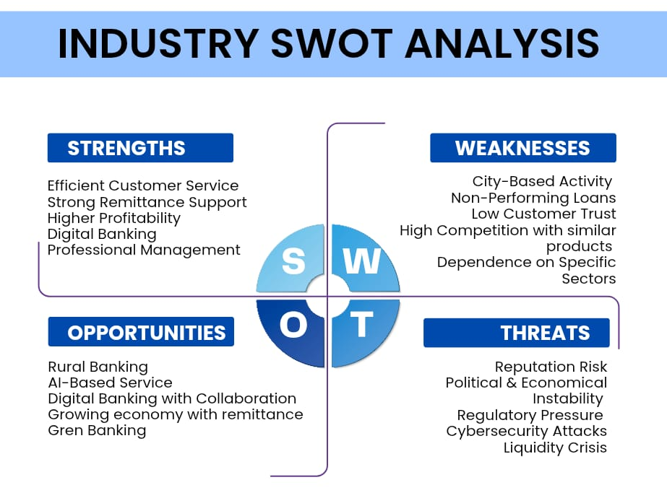

Figure 2.3: SWOT Analysis of the Private Commercial Banking Industry
Source: Created by Author Using Canva
- Strengths of the Private Commercial Banking Industry:
The private banking sector's strength lies in its market uniqueness, which helps it survive among so many financial institutions. The strong performance of PCB is because of its technological development and customer-oriented approach. Strengths are the main reason for customers' trust in private banks in Bangladesh.
- Efficient Customer Service: PCBs have made a place in customers' hearts because of their customer-oriented approach. They offer friendly, hassle-free services and are friendlier than public commercial banks. They solve their customers' problems very quickly and use up-to-date technology. That is why customers feel more comfortable with private banks rather than public banks. The swot analysis is given below:
- Strong Remittance Support: As remittances are very important to our economy, PCBs strongly support them. The remittance process is very quick; they offer digital remittance services and strong partnerships with other banks to support customers sending money from abroad. Remittance is a strength because it helps attract more deposits and fosters strong communication with those customers' family members.
- Higher Profitability: The private commercial banking sector focuses on profit maximization and is more profitable than the private commercial banking sector. This is because of their higher Return on Assets (ROA) and Return on Equity (ROE). Their cost management is very effective. They manage their costs in line with their earnings and carefully mitigate every risk. Because of their high profitability, they can invest in additional banking assets, open new branches, and adopt new technology. That’s how the private banking sector is growing more than the public banking sector.
- Digital banking and technological adaptation: Private banks in Bangladesh consistently adopt new technologies to provide hassle-free services. Most of these banks offer online banking, ATMs, mobile apps, and card services, allowing customers to access services from anywhere. Because of technological improvements, they can cut costs more than public banks can.
- Professional Management: Every staff member at private commercial banks is highly skilled and well-educated. They provide enough training to be perfect for their workplace. The managers are also highly skilled and experienced. There is no political pressure in the workplace. The managers handle all situations professionally and make decisions very quickly. This is the reason for the strong growth of these banks.
- Weaknesses of the Private Commercial Banking Industry:
There are also a variety of weaknesses in this industry. But if they handle them efficiently, they will grow more in the industry. Otherwise, these weaknesses can be the reason for their profit reduction.
- City-Based Activities: Most private commercial banks run their offices in cities, not in rural areas. Because of their city-focused customer approach, they are losing many customers in villages. There are fewer branches of private banks than of public banks. If they can reach the village people, they will receive many deposits and further expand their business.
- Non-Performing Loans: Non-performing loans are loans that customers take out but are unable to repay. The number of NPLs is increasing day by day among public banks. The reason behind this is economic instability, a poor recovery system, and poor credit assessment. Because of NPLs, some private banks are incurring losses, facing financial risk, and seeing profits decline.
- Low customer trust: Due to political issues, an unstable economy, liquidity issues, and other factors, clients are losing trust in banks. The general public does not fully trust private banks to keep their money. So, they are taking services from public banks. Because of these, private banks are slowly losing customers.
- High competition among similar products: Private banks in Bangladesh operate with similar ideas and mottos. They offer almost the same products and services. Still, the competition is high due to varying interest rates and fees. But the profit margin can be reduced as a result.
- Dependence on specific sectors: Some private banks focus on sectors such as trade, small and medium-sized businesses, garments, and real estate. But all public banks focus on the whole country. So, if any specific sector faces any problems, those private banks will suffer a lot. They may decrease this risk through diversification.
- Opportunities of the Private Commercial Banking Industry
Opportunities are areas in the external environment that can help to grow in the industry. There are many opportunities to maximize profit in this industry. PCBs should focus on and grab these opportunities to improve themselves.
- Rural Banking through agents: Banking agents could be a new trend in the private banking sector. To reduce reliance on a city-focused approach and reach more rural areas, private banks can introduce banking agents, an agent network, and mobile banking at low cost. This is how they can grab more customers and more deposits from villages.
- AI-Based Service: Artificial intelligence is a new technological trend. Banks can use these in their day-to-day operation. Using AI, they can provide chatbots and financial advice, detect fraud and bad customers, and provide credit scores. They can provide quicker and more efficient services through AI.
- Digital Banking with Fintech Collaboration: Private banks can strengthen their capabilities by partnering with fintech companies in Bangladesh. The performance of Fintech companies is very strong. Because of the partnership, they will gain access to innovative ideas and products, a quick payment system, and a fast transaction system in their digital banking system. Also, they will be able to compete with mobile banking services such as bKash.
- Growing Economy with Remittances: Remittances play a significant role in the Bangladeshi economy. Many people in Bangladesh send money to their families through banks. So private banks can provide better, easier services to attract those customers. Because of this, they attract more customers by maintaining good communication with those customers' family members.
- Green Banking and Sustainable Finance: The new focus in Bangladesh is green banking. The demand for green loans and eco-friendly projects is rising gradually. Private banks can seize this opportunity by focusing on green banking, reducing waste, operating eco-friendly businesses, using solar energy, and more. This will help to create a good image and gain new customers in the market.
- Threats to the Private Commercial Banking Industry
Threats also come from the external environment, but that creates risks. So private banks need to be aware, as this situation can arise suddenly. If they are not prepared to handle them, they will incur significant losses.
- Reputation Risk: Any adverse situation, such as service failures, fraud, or political issues, damages the image of the private banking sector. Even a failure at any public bank can harm the image of private banks. Customers lose trust in every bank and start to move money.
- Political and Economic Instability: Political and economic instability are the biggest threats to banking sectors in any country. Bangladesh frequently faces problems, including political instability, inflation, and economic crises. This creates difficulties for both customers and banks. Banks face difficulties running their businesses, and customers face difficulties repaying their loans. Private banks face greater challenges because they don’t receive the same government support as public banks.
- Regulatory Pressure: All banks in Bangladesh are regulated by the Bangladesh Bank. Bangladesh Bank brings new rules for loans, interest rates, governance, capital requirements, and more. This sudden pressure from the central bank causes difficulties for private banks.
- Cybersecurity Attack: As private banks expand their digital banking operations, cybersecurity is their biggest concern. Cybersecurity problems arise from hacking, malicious employees, data leakage, and similar incidents. These online frauds are increasing day by day. If any cyberattacks occur, private banks will face immense losses in financial and customer trust.
- Liquidity: A liquidity crisis in any bank can create panic among customers. They start to lose their trust and withdraw their money from all banks. Recently, Islami Bank in Bangladesh faced this situation, and it struggled to meet the sudden surge in withdrawal requests.

CHAPTER 3: INTERNSHIP EXPERIENCE

3.1 Position, Duties, and Responsibilities

3.1.1 Position
The Bachelor of Business Administration (BBA) is a four-year degree that includes an internship to provide students with practical experience and real-world applications of their studies. I was appointed as an Intern in the Pragati Sarani Branch of Dhaka Bank Limited, one of the top private commercial banks of Bangladesh. The first day of my internship was March 02, 2026 and it lasted a total of three months. I was part of the general Banking department and was closely supervised by the GB officers which directly influenced my daily experience.
As an intern, I performed various roles and provided support in customer service, account opening, document verification, and other daily banking activities. I also gained insight into bank practices, record-keeping, and keeping good records following bank policies. This experience gave me good insight into the work of a bank and how to manage in a professional setting.

3.1.2 Duties and Responsibilities
At Dhaka Bank PLC, I gained a lot of knowledge about banking and office operations, as well as the work environment. I gained insight into the interdependencies of all departments and how they provide the most effective service to the customers. My internship at Dhaka Bank PLC was very helpful in improving my soft skills, including communication, teamwork, and professionalism, through completing various tasks and responsibilities. Some of my responsibilities at Dhaka Bank PLC are-
- Account Opening Support: Have opened multiple savings accounts for individual customers at Dhaka Bank PLC. This was one of my primary duties. Dhaka Bank PLC has an app named “Ezy Bank,” and I opened accounts using this app. Ensured that customers carried all necessary documents (2 copies of the account holder's photo, 1 copy of the nominee's photograph, 1 copy of each customer's NID, and 1 copy of the utility bill). These are the fundamental papers used for these accounts.
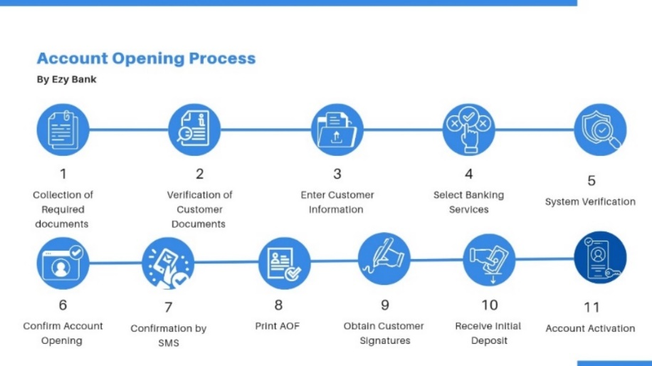
First, I gathered all of the required documents to establish the bank accounts. Then I reviewed the documents myself, entered all customer data into the app, and added services based on customer preferences, such as debit cards, checkbooks, and internet banking. It is after the app has completed all checks that I confirm the account opening. The customer received a message on their cell phone that the bank account was opened successfully.
Figure 3.1: Account Opening Process Using EzyBank
Source: Created by Author Using Canva
I then printed out the forms and gathered customer signatures at the proper locations. Customers were required to make a 1000 TK deposit at the time of account opening to activate their accounts. That's how I opened accounts with Ezy Bank at Dhaka Bank PLC.
I set up several accounts and processed numerous AOFs in compliance with office rules and customer information requirements. I also gathered and pasted all the clients' documents into their forms. I have set up several accounts like this – savings, payroll, current, DPS, FDR, SDS, corporate. Once all the AOFs are prepared, these are sent to ASU (Account Service Unit).
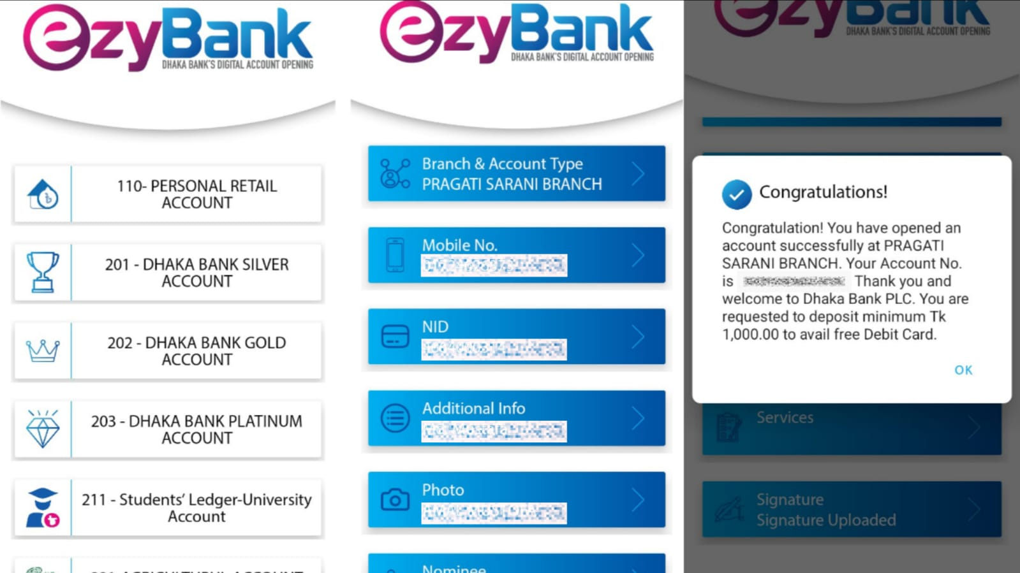

Figure 3.2: Sample of Account Opening Using EzyBank
Source: Dhaka Bank PLC, Pragati Sarani Branch
- Supporting Transactions: Helped customers with various transactions. Assisted in completing deposit slips, cheques, RTGS, ETFs, and payout forms. Once the forms were prepared, I went to the managers, obtained their consent, and then gave them to the officers.
- Customer Document Management: Implementing the Know Your Customer (KYC) guidelines and our office's internal rules, I maintained sensitive customer information and kept it confidential. Thoroughly identified new accounts, followed up on missing documents, and handled a variety of paperwork. I organized the vouchers and paperwork every day, leaving a neat filing system. It was a great learning experience in terms of organization and documentation.
- Bank Statements and Solvency Delivery: Customers frequently request bank statements and solvency documents. Each time someone came in for these, I would give them the forms they needed and show them how to fill in their account number, account title, and the statement date. Upon completion, I ensured that the requested documents were provided to me efficiently, including the statements and solvency documents.
- Cheques and RTGS: When a customer came in with cheques or RTGS forms, I thoroughly checked every detail. In RTGS, I checked the account title, account number, bank and branch names, routing number, and that it was not marked or blemished. When it came to cheques, I made sure the payee was correct, the date was within 5 months, and the amounts in words and numbers matched exactly. I also ensured that the signature was legible and written in black ink; no signatures were overwritten or scratched. When everything was ready, I stamped the copy as received, returned it to the customer, and handed the copy to the officers. RTGS transactions could only be received until 2:50 pm. Once this period ended, RTGS was no longer available.
- Deliveries of Debit Cards or Mastercard: Delivery of debit or Mastercard takes, on average, 1-2 weeks after the account is activated. I assisted with arranging those cards by date. I called customers and directed them to pick up their cards. Upon customers' arrival for their debit card, I verified that the name on the card and the phone number were correct. Once confirmed, I signed the customer's registration and activation card. I handed out their cards, and they had to retrieve their PINs from the cash register area. I gave the officers my card activation. I also assisted customers with replacing, activating, issuing, blocking, and captured cards.
- Cheque Books Delivery: The cheque books are delivered to the Branch within a week of the account's opening and activation. I fill in the registration book with all the information for each customer and personally telephone them to inform them that their cheque books are ready. When customers come in, I double-check their account numbers, get their signatures, and then hand their cheque books back to them with a sense of pride.
When the account holder is unavailable, I give them an authorization letter. When the authorized person presented this letter, I handed over the cheque books to ensure the process was smooth and secure.
- Office phone contacts with Customers: Contacted Customers on the office cellphone for various purposes. As their debit cards and cheque books arrived, I invited them to come into the office to collect them. If they did not complete all the information on their account-opening application, I reminded them to submit the required paperwork. If a cheque was returned, I explained the reasons on the phone and arranged for them to come in the following day. Here are some of the ways that I continue to maintain contact with our customers.
- Customer service in account opening form: Apart from assisting customers with filling out the account opening form, I have helped them complete various payment and transaction forms. I have helped in making deposit slips, cheques, RTGS forms, pay order forms, account update forms, and even debit card forms. I was able to support my customers with the different forms with the help of my seniors.

3.2 Training & Development
Passive training is a learning method in which an individual listens, observes, or reads without taking any action. I gained knowledge through both passive and active training approaches at the beginning of my internship at Dhaka Bank PLC, where I observed, listened, and gained hands-on experience. During my internship, the training was not very formal. The informal training was effective, however, in three forms. They are the practical instructions provided at the start of the internship, on-the-job learning, learning from errors, and training.
My training at Dhaka Bank PLC was more practical and hands-on than passive. Instructions were not particularly structured. On the first day, I observed the activities of the officers and the environment of the office, as well as other banking activities. This was much more helpful for me to get a clear understanding of what was important in my responsibilities.
I started to get minimal tasks and responsibilities on the second day. I learned the tasks the way that people learned them: through practice. If I had any problems or was unsure, I sought advice from my supervisor. She explained the procedure and how to do the tasks properly. This facilitated my learning and understanding of tasks.
My teammates helped me correct my mistakes and gave me feedback when I was doing new tasks. This boosted my self-confidence and made me perform better. To conclude, Dhaka Bank PLC offered training based on observation and practice, and the on-the-job learning approach was more emphasized. It proved to be very useful for enhancing my abilities in practice, problem-solving, and knowledge of the real-world working environment in the banking sector.

3.3 Contribution to Organization
As an intern, I helped with the day-to-day operations of the General Banking Division with my supervisors and co-workers. My job was to help with the opening of accounts. Assisted with opening and processing multiple current accounts and savings accounts by gathering, verifying, and organizing necessary documents and ensuring adherence to the policies of the financial institution.
Moreover, I helped to get customer information and documents as needed, and this enhanced the efficiency of the workday. I also set up and managed customer information and records, allowing easy access to critical documents and documents quickly.
Additionally, I helped with the management and issuance of cheque books and Debit cards, ensuring that the customers' requests were carried out accurately and on time. I also assisted customers by giving them basic information about the various banking services and referred them to the proper officers as required.
I was always assigned tasks within a proper scope; however, I always attempted to complete the work assigned to me in a sincere, accurate, and professional manner. My work assisted the officers in easing their workload and, as it relates to the operation of the General Banking Department, assisted in its efficient operation.

3.4 Evaluation

The performance of my internship has been evaluated through both formal and informal evaluations at the end of the internship period by my organizational supervisor at Dhaka Bank PLC, Pragati Sarani Branch. A formal evaluation took place at the end of the internship period, and was carried out on an official internship evaluation form provided by the supervisor. This framework assessment measured me against various performance indicators: punctuality, professionalism, communication skills, willingness to learn, quality of work, management of time, team working, initiative, customer service orientation, and problem-solving. I received excellent ratings in almost all the categories, which I think is a reflection of my consistent efforts, discipline, and positive attitude during the internship.

With the exception of the formal evaluation, my supervisor and senior officers at the General Banking Department provided me with informal feedback regularly. They carefully monitored my day-to-day activities, including account opening with EzyBank, document verification, customer queries, cheque clearing, cash transactions, and more, and gave me tips as they went along. This ongoing feedback enabled me to recognize my strengths and weaknesses as I learned and improved.

This assessment process has not only tested my technical abilities, but also my capacity to function in a professional banking environment, work under pressure, and also be able to collaborate with the team. It reaffirmed my dedication to learning, my active participation in the activities of the branch, and my service to the department. This experience has helped me build my confidence and get ready for my next job with the banking sector.

3.5 Skills Applied
This internship experience at Dhaka Bank PLC has been very enriching, helping me acquire and refine skills that will guide my professional future. Here are some of the skills I practiced and learned are given below:
- Communication skills: Communication is very important in the corporate world. I have to deal with many officers and customers, and my communication skills have improved significantly. I assisted customers in opening accounts, completing various forms, grasping a lot of information, and determining their wants. I had to come to their aid when my senior officers were not at their desks. I needed to see what my senior officers needed and when, as well as what customers needed.
- Professionalism Skill: I have improved my communication skills and professionalism. Demonstrated good manners, followed the organization's formal dress code, and had high standards of discipline, respect, and punctuality. I was courteous and professional in all my interactions with seniors, coworkers, and customers.
- Documentation and Record-Keeping: I had to document and maintain records every day. Always adhered to organizational procedures in completing forms, kept good records, and handled sensitive paperwork appropriately. All documents are listed in an organized manner to make it easy to find later. This was a reinforcement of focus on documentation and organizational skills.
- Teamwork and Cooperation: Dhaka Bank PLC is committed to working as a team to achieve the best results. I have acquired knowledge of how to work with my teammates and upper management every day. All tasks were open, trustworthy, and responsible, with clear goals. Senior officers' instructions and advice were very helpful for completing these tasks successfully.
- Problem-Solving Skills: It was always my goal to put the customer first. Under the guidance of my seniors, I helped many clients set up their accounts, address account problems, and provided a variety of services. Every challenge furthered my problem-solving abilities and spurred growth.
- Detailing and Accuracy: Both detailing and accuracy were important in my work. I handled multiple AOFs and other documents containing important information, such as NID, TIN certificates, and Birth Certificates, where errors could lead to serious problems. I always ensured to strengthen my attention to detail.
- Ethical Compliance: During my internship, I have been working with the team to ensure confidentiality, resolve conflicts of interest, and apply know-your-customer regulations. I was inspired to continue working hard and taking responsibility by observing the team's ethical conduct.
- Time Management: My seniors gave me great tips for efficient time management and timely completion of assignments, particularly in the busiest times at the branch. Timely delivery of work, e.g., RTGS, was mandatory. Therefore, it was essential that all tasks be completed by their deadlines.
Other than these skills, I have applied my academic knowledge and learnings in these three months.
The knowledge I gained from my finance and banking courses helped me a lot to conduct my daily tasks.

CHAPTER 4: RECOMMENDATIONS AND CONCLUSION

4.1 Recommendations
Dhaka Bank PLC is among the fastest-growing banks in the country and is already taking proactive steps to remain competitive. Based on my internship experience and analysis, I have several recommendations to further enhance the operations of Dhaka Bank PLC and its general banking department. These suggestions will also support my own professional development as I prepare for a future career in banking.

4.1.1 Recommendations for Dhaka Bank PLC
Dhaka Bank PLC has proven to be effective at delivering customer service and driving business growth. To achieve further growth in the banking industry, it should consider the following steps:
- Dhaka Bank PLC can enhance its online and digital banking. With the help of AI, the bank can optimize its software and make its mobile apps easy and intuitive for Gen Z and millennials.
- The annual report for 2024 of Dhaka Bank PLC indicates risks related to non-performing loans, according to an analysis. The bank could respond to these promptly by beefing up its credit assessment and taking additional steps to mitigate NPLs.
- Dhaka Bank PLC has expanded by providing several city-based branches and sub-branches. The bank can now concentrate on rural areas and use agent banking to expand its customer base there.
- One of the new trends in the banking industry is green banking and sustainable projects. Dhaka Bank PLC may actively explore the possibilities in these areas.
- Dhaka Bank PLC can consider establishing additional Islamic branches in different parts of the country to better serve its Muslim customers.
- To reach both Gen Z and millennials, Dhaka Bank PLC should focus more on marketing through billboards and digital ads, sponsoring more programs, and running campaigns at universities.

4.1.2 Recommendations for the General Banking Department
The General Banking Department is essential to every bank, serving many customers daily. To strengthen this department, Dhaka Bank PLC should consider the following recommendations:
- Due to high customer volume, the account-opening process should be simplified to reduce wait times.
- Implementing a queue management system will help manage customer flow during peak hours.
- Improving documentation and record-keeping will help prevent delays and errors.
- They can implement an effective feedback system so that upper management can directly monitor customer complaints and suggestions.
- Regular staff training in customer service, product knowledge, communication, and digital banking will improve service quality.

4.1.3 Recommendations for Self-Development
Internship at Dhaka Bank PLC was not only a mandatory part of my BBA studies but also a great way to gain practical experience in the job market. It was helpful to me as I prepared to enter the professional world and to prepare for a future career in the finance sector. During this 3-month journey, I realized several aspects of myself I can improve to move forward in my career.
- I need to improve my communication skills to deliver better customer service and problem-solving.
- I'm keen to build my knowledge of the latest banking software and learn how to use Excel for analysis. As digital banking tools are changing so quickly, I want to keep up with them.
- I am committed to improving my analytical abilities in financial reporting, financial statement analysis, banking performance analysis, and analysis of complex financial cases.
- I will continue to gain knowledge in banking activities, risk management, loan processing, credit analysis, and other relevant areas.

4.2 Conclusion
The private commercial banking industry plays a significant role in the economic development of Bangladesh by promoting savings, providing loans, supporting businesses, facilitating trade, and contributing to financial inclusion. The private commercial banks are constantly upgrading their services to meet the demand of the customers and to stay competitive, especially with the rapid technological advancement, digital transformation, and the rising customer expectations. Meanwhile, several industry issues are creating hurdles, such as an increase in non-performing loans (NPLs), regulatory updates, cybersecurity threats, and economic uncertainty. To achieve sustainable growth, banks need to constantly innovate, reinforce risk management, and improve customer service.
In terms of the customer approach, diversified banking function, and good financial management, Dhaka Bank PLC has a good position among the leading private commercial banks. The financial analysis in this report indicates that the Bank has continued to grow its assets, deposits, loans and operating profit in 2024. But, it suffered from higher lending loss provision and pressure from non-performing loans, which impacted its profitability. Nevertheless, the Bank's financial stability ensured it continued to prioritize sound risk management practices, digital banking, and business sustainability.
I had a great opportunity to put my classroom learning into practice in the banking sector through my three-month internship at Dhaka Bank PLC. I had the opportunity to learn some very useful basic banking skills and account opening procedures, as well as handle customer telephone calls, verify documents, process transactions, and other general banking duties, through my participation in this work. I was able to build communication, teamwork, problem solving, and time management skills all while learning valuable basic banking skills.
Overall, this internship program has enhanced my knowledge on finance, banking, banking operations, financial analysis and Private commercial banking sector in Bangladesh. It has also boosted my confidence and set me up for the banking and financial career. Overall, I believe that, by continuing to enhance its customer services, digital banking, and risk management, Dhaka Bank PLC. will be in a good position to sustain their growth and remain competitive in the coming years.

REFERENCE

About Us. (n.d.). Dhaka Bank | Excellence in Banking. Retrieved June 17, 2026, from https://dhakabank.com.bd/about-us/
Bangladesh Bank. (n.d.). Retrieved July 10, 2026, from https://www.bb.org.bd/en/index.php
Bank deposit growth hits five-year high in 2025 | The Daily Star. (n.d.). Retrieved July 10, 2026, from https://www.thedailystar.net/business/economy/news/bank-deposit-growth-hits-five-year-high-2025-4123076
CORPORATE BANKING. (n.d.). Dhaka Bank | Excellence in Banking. Retrieved June 17, 2026, from https://dhakabank.com.bd/corporate-banking-2-2/
Dbl Annual Report 24. (n.d.).
Dhaka Bank PLC | Excellence in Banking. (n.d.-a). Dhaka Bank | Excellence in Banking. Retrieved June 17, 2026, from https://dhakabank.com.bd/
Dhaka Bank PLC | Excellence in Banking. (n.d.-b). Retrieved June 17, 2026, from https://dhakabank.com.bd/
Financial Stability Report. (n.d.).
Vision, Mission And Values. (n.d.). Dhaka Bank | Excellence in Banking. Retrieved June 17, 2026, from https://dhakabank.com.bd/mission-vision-and-values/
World Bank Open Data. (n.d.). World Bank Open Data. Retrieved July 10, 2026, from https://data.worldbank.org

APPENDIX-A: Internship Placement Letter
Source: Dhaka Bank PLC, Pragati Sarani Branch

APPENDIX-B: Internship Evaluation Form

Source: Dhaka Bank PLC, Pragati Sarani Branch

