A Project
On
Determining the success factors of international marketing of RMG: A case study of 4 RMG's in Bangladesh
Submitted To
Dr. Seyama Sultana
Assistant Professor
School of Business & Economics
Submitted By
Syeda Afrose Ria
111 142 242
BBA Program
United International University

Date of submission:
05th May, 2019

05th May , 2019
Dr. Seyama Sultana
Assistant Professor
School of Business & Economics
Subject: Submission of project report on “Determining the success factors of international marketing of RMG: A case study of 4 RMG's in Bangladesh”
Dear mam,
Glad to submit my project on “Determining the success factors of international marketing of RMG: A case study of 4 RMG's in Bangladesh”. I have conducted my project on4 RMG's in Bangladesh. This is a part of the entire requirements to complete BBA program.
While preparing this report, I have followed all the instructions that you have given to me. I tried my best to prepare this report and believe that all the ideas from this report will help me in my future practical life. I will be grateful to you if you accept this report.
I hope that you will find this paper worthy of my labor.

Sincerely yours,
Syeda Afrose Ria
111 142 242
BBA Program
United International University

Abstract
RMG’s of Bangladesh have expanded their operation and business in the different markets. The international marketing strategy carries the different elements where the organization prefers to determine the success factors for the strategy. 4 top RMG in Bangladesh such as Al-Muslim Group, Ha-meem Group, Beximco Fashion Group and Square fashions Ltd have been working internationally while creating the value to the economy and the monetary policy of Bangladesh. The researcher has focused on the success factors of the international marketing strategies of RMG in Bangladesh for the development of the reputation and profitability. The aim of the paper was to investigate the factors that contribute to the success of developing an effective international marketing strategy of RMG’s. The researcher has searched for the primary data while accepting the positivism and deductive research approach. The survey research strategy has been used to apply the questionnaire method to collect data from 20 respondents of RMG’s of Bangladesh including Al-Muslim Group, Ha-meem Group, Beximco Fashion Group and Square fashions Ltd. The analyzed data has represented that the communication, usages of technology, culture of the global market, adaptability and flexibility of the marketing strategy and employee engagement have been the success factors of international marketing strategies of RMG’s in Bangladesh.

Table of Contents
Abstract ii
List of Figures iv
Chapter 1: Introduction 1
1.1 Introduction 1
1.2 Background of the study 1
1.3 Problem statement 1
1.4 Research Aim 2
1.5 Rationale of the Study 2
Chapter 2: Literature Review 3
2.1 Factors Contributing to International Marketing strategy 3
2.2 Factors contributing to Success of marketing strategy 4
2.3 Impacts of Success factors on International marketing strategy 5
2.4 Research Conceptual Framework 6
Chapter 3: Research Methodology 7
3.1 Research philosophy 7
3.2 Research approaches 7
3.3 Research Strategy 8
3.4 Data collection methods and Data analysis 8
3.5 Sampling Method 9
3.6 Ethical consideration 9
Chapter 4 Analysis and Discussion 10
4.1 Data Findings and discussion 10
Chapter 5 Conclusion 23
5.1 Conclusion 23
5.2 Recommendation 23
Reference 25
Appendix: 27
Survey Form 27
Questionnaire 28

List of Figures
Figure 1: The online service develops the communication with the customers 11
Figure 2 The international market prefers a better marketing strategy from the industries 12
Figure 3 Technology has been used for the promotion and marketing activities by RMG 13
Figure 4 The expansion under the global business creates the need for the high quality full international marketing strategy. 14
Figure 5 The global business prefers certain elements from the marketing strategy of RMG 15
Figure 6 The international marketing strategies create challenges for the RMG 16
Figure 7 The brand reputation of RMG affects the success of the International marketing strategy 17
Figure 8 The quality customer’s service from RMG have impacts on the success of the marketing strategy 18
Figure 9 RMG prefers to engage employees for managing the marketing strategy 19
Figure 10 The communication plays the role of success in improving the international marketing strategy. 20
Figure 11 The success factors of international marketing strategy relate to the internal environment 21
Figure 12 The expansion of the company succeeds based on the international marketing strategy 22
Figure 13 International marketing mix 31
Figure 14 Factors influencing international marketing strategy of RMG 31
Figure 15 International marketing strategies 32
Figure 16 Factors affecting IMS 32
Figure 17 RMG growth trends in Bangladesh 33
Figure 18 Research Conceptual Framework 34

Chapter 1: Introduction

1.1 Introduction
Bangladesh has gained its popularity while being the second largest exporter of the ready -made garment products and clothes in the world exposing around 132 countries in the world. The exports had doubled from 2010 to 2015. RMG sectors of Bangladesh have increased the growth in the fiscal year. Basically, the top RMG sector has been able to provide the direct and indirect employment to the individual around 4.4 million where 80% of the employments are for women (Gough and Laudon, 2017). Readymade garment sector in Bangladesh offers mostly the low competitive cost for the production and best quality raw materials and the products for the high-end garment products. They provide the products to the global brands including Adidas, Calvin Klein, Diesel, Hugo Boss, Nike, Puma, and Ralph Lauren. This paper will discuss the success factors of the internal marketing of 4 top RMG in Bangladesh such as Al-Muslim Group, Ha-meem Group, Beximco Fashion Group and Square fashions Ltd.

1.2 Background of the study
Every country manages the GDP with the help of agriculture and service industries (Collis & Hussey, 2013). Bangladesh has created the markets in the internationally with the help of RMG sector. Bangladesh RMG Sector has created the value to the economy and the monetary policy. RMG in Bangladesh has duty-free market access to the international markets and the developed countries including Japan, EU, UK, Norway, Switzerland and Canada. The international market demands the right products with the right quality and the promotional mix and activity (Dawson, 2017). Bangladesh Garment Manufacturer and Exporters Association (BGMEA) has been managing the project for the safe and sustainable garment industry where the top RMG industries have been contributing own for the international market. The researcher will search for the primary data from 4 top RMG industries in Bangladesh to demonstrate the success factors of each for the international marketing.

1.3 Problem statement
Problem statement reflects the concept of the concise description that is the issue to be addressed. In RMG sector of Bangladesh has been developing the profitability and the employment for the individual. But, their success factors do not affect exactly on their international marketing and the operations in the different markets. Most of the top industries of RMG in Bangladesh have not been established their name and the reputation in the international market. This report will discuss the facts and success factors of the internal marketing of the selected RMG groups in Bangladesh.

1.4 Research Aim
The research aims at investigating the factors that contribute to the success of developing an effective international marketing strategy of RMG’s.

1.5 Rationale of the Study
Globalization has changed the market and the customers of the market, so have the social media and technology (Coombes and Millett, 2011). The companies and the industries push their marketing activities to the international area to improve the brand image and to bring the positivity towards profitability. The improvement and success factors of the industries often relate to the international marketing activities of the company. Over the period, the sectors of RMG in the market have identified the need for the expansion and the global entry in the new market (Easterby-Smith, 2012). But the existing markets and the competitors often create the hazards and the barriers for the companies. Thus, the marketing factors globally and internationally of the industry and the RMG sectors of the country should be maintained with the right techniques in the new market. Bangladesh has developed its market for RMG internationally and locally. The RMG sectors have been able to develop the GDP and the profitability for the country. The employment opportunities in the country have increased due to RMG and its operations in the country. The success factors of international marketing often reflect the success of the industries and the expectation of RMG (Jankowicz, 2011). Based on the researches, garments industry in Bangladesh practices the waste management, waste heat recovery, energy efficient technology, and environmental management system to improve the image and the reputation of the sectors. These steps can be evaluated and accepted in the industry as the success factors and criteria or affect the success factors of the RMG in Bangladesh. The researcher will focus on the primary data collection through the questionnaire method while selecting around 20 respondents from 4 RMG groups in Bangladesh to determine the success factors of international marketing in the world.

Chapter 2: Literature Review

2.1 Factors Contributing to International Marketing strategy
Global marketing is a key issue for the different industries and multinational business firms. Most of the industries and companies prefer to expand for profitability and sustainability (Viardot and Dessler, 2011). Markets happen to bring lots of options and the risks for the new entry in the area pushing the company for a better strategy for survival. According to Blair and Hitchcock (2011), the competitions from the existing competitors in the global markets affect the business and profitability. Most of the industries prefer to maintain their reputation while managing a strong establishment. It is hard enough to maintain a better establishment with the marketing strategy in the international markets while the company faces huge competitions from the industries. Thus, competition may appear to affect the development of the international marketing strategy the most. But, Bharwani and Bhutt, (2012) argued to the statement of Blair and Hitchcock (2011) and referred that marketing of the global products around the world affects the operations and the strategy where the company has to carefully look for opportunities. Globalization of markets has encouraged the initiative of different organizations where trading of the global products need to be promoted and represented towards the customers. Supporting to the statement of Bharwani and Bhutt, (2012), Hoffman & Woody (2013) extended, the existence of that new product needs to be established in the new market to remind the customers and to manage own establishment. The international marketing strategies of the company help to develop a competitive advantage among its competitors which pushes the company to develop more effective marketing strategies while promoting own products globally. Going opposite to the statement, Lientz and Larssen (2014) stated global marketing strategy and globalization are interrelated and the company under the global market needs to maintain the global marketing strategy is needed in order to improve the market position and the efficiency of operations while managing the homogeneity of demand across cultures for the customers as well. Supporting to the statement of Lientz and Larssen (2014), Buckley & Ghauri (2015) mentioned that the due to the raise in globalization, the companies are surrounded by foreign consumers and the different competitors and suppliers. The company has identified that the different countries have the limitation (Palmer and Hartley, 2016). Thus engaging in international business, the company must bring the promotional and marketing strategies and activities to shape the international business.
Not every time, the competitors or the customers affect the company to maintain the international marketing strategy. According to Blair and Hitchcock (2011), the need for the new marketing strategy often affects the environment and the resources of the company. The internal resources and the ability of the industry affect the development of the company’s marketing and promotional strategy for the market. Supporting the statement of Blair and Hitchcock (2011), Hoffman & Woody (2013) extended that the development of the international marketing strategy could be profitability and sustainability in the market. The development of the international marketing strategy and the activities may get pushed by various factors and elements. But at the end of the day, the necessity of the establishment in the new market would influence the company to represent own products and own service more efficiently.

2.2 Factors contributing to Success of marketing strategy
Development of the marketing strategies is not right enough to develop the profitability for the company. The international marketing strategies of the multinational business firms would not be successful unless they are able to manage the activities and the promotion. According to Blair and Hitchcock (2011), the development of the related marketing activities that are related enough to the market and customers are more successful those are not. The marketing functions of the company should be able to get the idea of the competitions from the existing competitors and the global markets to improve the success of the marketing strategy and the activities for the business (Viardot and Dessler, 2011). But, Bharwani and Bhutt, (2012) argued to the statement of Blair and Hitchcock (2011) and referred that proper establishment of the marketing depends on the project and the efficiency of the commercialization. While managing the marketing strategy for the market, the company has to carefully manage the message and the customers from different cultures. Supporting to the statement of Bharwani and Bhutt, (2012), Hoffman & Woody (2013) extended that the company should be more aware of the demands for the customers and the strategy of the competition to develop the acceptance of the international marketing strategies. Most of the garments and the other industries prefer to research the competitors and the competitive advantage among its competitors to develop more effective marketing strategies which have been a contribution to their productivity and the success in the market. Going opposite to the statement of both Bharwani and Bhutt, (2012) and Hoffman & Woody (2013), Lientz and Larssen (2014) stated that the company must get to develop the global marketing strategy to improve the market position and to offer the homogeneity of demand. Under the globalization, those companies get the success and more foreign consumers which are more sufficient to offer the products representing the quality and the culture (Palmer and Hartley, 2016). The company must manage the quality and the attractiveness of the international business to develop promotional and marketing strategies.

2.3 Impacts of Success factors on International marketing strategy
International or the global marketing trends in the organization help the company to manage the marketing and other promotional strategies and activities. Most of the industries integrate the success factors to the international marketing strategy only to input the right elements for a better strategy. According to Bharwani and Bhutt, (2012), market research and the current market data of the new area would help the company to manage the authentic and accurate marketing strategy despite having the existing competitors in the global markets. Even the flexible business environment for the industries and garment sectors to maintain an effective marketing strategy for the customers. But, Hoffman & Woody (2013) argued and referred that the brand reputation of the company is one of the greatest success factors for the international marketing strategy. The company must manage the reputation and the brand image while working on international marketing strategy to promote global products around the world. Supporting to the statement of Hoffman & Woody (2013), Lientz and Larssen (2014) added that the flexible business culture and the renowned global product in the new market would help the company to manage the international marketing strategy to remind the customers. The international marketing strategies would help the company to develop and use own competitive advantage for promoting own products. Going opposite to the statement, Buckley & Ghauri (2015) stated that not every time, every success factors of the company helps the organization to manage the international marketing strategy or the global marketing strategy. The global market prefers the accurate and higher international marketing strategy as existing competitors are already in the market and to be trustworthy, the RMG or the other sector must maintain the position to improve the international marketing strategy and market position while managing the cultures for the customers. Supporting the statement Buttle and Maklan (2015) mentioned that the globalization and the existing competitors may change the success factors for companies. The company has to manage flexible business and international marketing strategy for different countries (Viardot and Dessler, 2011). Engaging the customers to the business with the communication would bring the positivity towards the company and their promotional and marketing strategies for the international business. Thus, most of the company would prefer to manage the flexible international marketing strategy to maintain the flexibility.

2.4 Research Conceptual Framework
Research conceptual framework may appear to represent the tools for identifying the scope for the data to represent the concept of the research. The research conceptual framework of any particular research represents the systematic ways of results and the activities. The research conceptual framework for this paper has been attached in the appendix. The researcher has searched for data representing the strategies most of the RMG use for the global market. The researchers have analyzed the data related to the RMG and its marketing strategy for the international market which would reflect the success factors and the determinants of the success factors of the international marketing strategy. At the same time, the researcher has identified that macro environment of the markets and the cross-culture factors of the market affect the international marketing strategy and the promotional activities for the company. Thus the researcher has evaluated how the RMG has been able to established and sustained in the global markets with their international marketing strategies. Based on this concept, the researcher can distinguish the different success factors for international marketing strategies to manage the data collection and to accomplish the expected outcome.

Chapter 3: Research Methodology

3.1 Research philosophy
Research methodologies are the process used by the researcher to collect information for the development of the expected outcome to make decisions (Bryman and Bell, 2011). Under the research methodologies, the researcher must manage the tools and process for the data collection. The research philosophy represents the belief to the researcher to collect, gather analyze and use the data for the paper (Collis and Hussey, 2012). The epistemology research philosophy and the doxology research philosophy have been used by the researcher based on the situation. In this paper, the researcher has been searching for the primary data from the general sources and human participants.
The epistemology research philosophy in the research philosophy that appears to be true for the researcher while working on the data (Gill and Johnson, 2012). On the other hand, the doxology appears the belief of the researcher to be true. In this paper, the researcher has chosen the true data from the sources. Under the epistemology research philosophy, the positive research philosophy allows the researcher to invite human participants to collect the raw and primary data from the sources (Thornhill et al., 2013). The interpretivism research philosophy under epistemology research philosophy allows the researcher to collect secondary and factual data. On the other hand, the ontological research philosophy allows the researcher to collect the social and factual data where the primary or the human participants are not allowed (Ketchen and Bergh, 2016). In this paper, the researcher has selected the positivism research philosophy as the researcher has chosen to collect raw data from the human participants which cannot be supported either ontological or interpretivism research philosophy

3.2 Research approaches
The research approach is a systematic plan consisting of the steps to a detailed method of data collection, selection, analysis, and interpretation. Under the classifications of the research approaches, the researcher has chosen the right one.
The deductive research approach is concerned with managing the concept or developing a hypothesis based on existing theory (Bryman and Bell, 2011). Deductive research approach has been selected by the researcher to maintain the data collection. The Inductive research approach helps the researcher to collect the secondary and facts data from the sources (Collis and Hussey, 2012). In this paper, the qualitative and secondary data cannot be suitable for the research paper. For the suitability, thus the researcher has selected the deductive research approach.

3.3 Research Strategy
The research strategy is the process of the step to step actions for the researcher to accomplish the data collection and to conduct the research systematically for the expected results (Gill and Johnson, 2012). The different research strategies help the researcher to collect data. The researcher has chosen a suitable research strategy for the paper.
The survey research strategy helps the researcher to work on the various quantitative sources while using the interview methods, questionnaire or the poll system to collect data from the human participants (Thornhill et al., 2013). The observational or experimental research strategy helps the researcher to identify the variables while evaluating their relationship to identify the causes and the facts. The case research strategy allows the researcher to identify similar cases while collecting the relevant facts (Ketchen and Bergh, 2016). In this paper, the researcher has chosen to work with the raw data from the human participants. Only the survey research strategy has features that can be selected in this paper. Thus, the researcher has selected the survey research strategy for data collection. Under the survey research strategy, the researcher has used the questionnaire method. The sample questionnaire is presented in the appendix.

3.4 Data collection methods and Data analysis
Data collection method helps the researcher to work on the selected method either to identify the causal relation or the relationship of the variables (Bryman and Bell, 2011). The researcher has been looking for the right data collection methods for getting the data from the specific sources. Primary research is the method of research encouraging the researcher to collect basically the raw and generic data from the primary sources (Collis and Hussey, 2012). Secondary research is the method of encouraging the researcher to collect the facts from the less relevant or the used sources for the research paper. Under the qualitative data collection method, the researcher is able to collect the descriptive and causal data whereas the quantitative data collection methods help the researcher to use the questionnaire method, structured interview, poll and other sources of collecting statistical data (Gill and Johnson, 2012). The researcher has already chosen the questionnaire method to choose the primary data. Thus, only quantitative data collection method has been suitable for this paper.
Data analysis tools represent the system for collecting data in different circumstances (Thornhill et al., 2013). Among the SPSS, MS Excel and other analysis tools, the researcher has selected the MS Excel for the completion of the data analysis.

3.5 Sampling Method
Population for the researching is hard enough to be conducted (Bryman and Bell, 2011). The researcher has chosen the sample from the population to conduct the primary research for reliable and valid data from the sources. In this paper, the researcher has chosen the purposive sampling method which is the non-probability sampling method. The researcher has chosen this purposive sampling as this method focuses on particular characteristics of the selected population which will help the researcher to get the research questions. In this paper, the researcher has selected 20 employees from top RMG in Bangladesh such as Al-Muslim Group, Ha-meem Group, Beximco Fashion Group, and Square fashions Ltd. The questionnaire method has been used for the research paper.

3.6 Ethical consideration
Every researcher must focus on the relevant ethical issues and ethical consideration to manage any unethical behaviors towards others through the research paper. The researcher of this paper has managed the ethics. The researcher has selected the right sources for data collection. The sources, data collection tools, and the data evaluation tools have been evaluated for its clarity, authenticity and effectiveness.
The researcher has not manipulated, alter or change the research data for own expectation. The proper data collection tools have been used for the collection of the data. The researcher has not influenced, altered or manipulate the respondents for the particular data.
The updated data will be stored in the data for 3 years. The data of the paper will not be used for other paper. The information of the respondents will be protected.

Chapter 4 Analysis and Discussion

4.1 Data Findings and discussion
Total respondents for this paper were 20 from 4 popular and large RMG’s including Al-Muslim Group, Ha-meem Group, Beximco Fashion Group, and Square fashions Ltd. The demographic profile of the respondents is:
Demographic profile |  | Frequency | Percentage
Gender | Male | 12 | .60
Gender | Female | 8 | .40
Gender | Total | 20 | 1
Age | 1-5 | 4 | .20
Age | 6-10 | 13 | .65
Age | More than 10 Years | 3 | .15
Age | Total | 20 | 1
Organisation | Al-Muslim Group | 5 | .25
Organisation | Ha-meem Group | 5 | .25
Organisation | Beximco Fashion Group | 5 | .25
Organisation | Square fashions Ltd | 5 | .25
Organisation | Total | 20 | 1

The online service develops the communication with the customers.
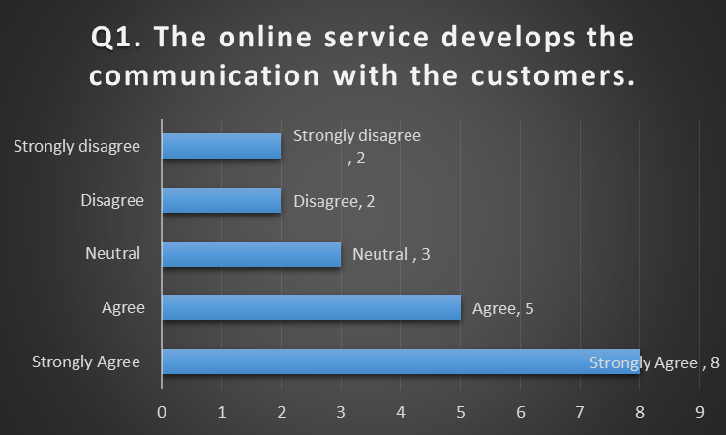
Figure 1: The online service develops the communication with the customers
Around 13 respondents from RMG group have agreed to the fact that the online service of the RMG has developed the communication and interaction programs with the potential customers. Around 3 respondents were confused and stayed neutral and 4 respondents disagreed of the facts that online service manages the communication with the customers. Over the period, the modern era demands for the communication and services related to technology and the internet. In Al-Muslim Group, the online services have increased the motivation for the employees to work on their communication skills and interaction for the customer’s service. Most of the industries prefer to develop the online services for the operation and the customer’s satisfaction in the market (Blair and Hitchcock, 2011). Ha-meem Group, Beximco Fashion Group, and Square fashions Ltd have developed their online service most probably to survive in the market where the employees have agreed that their ways of interaction with the customers have changed. The similar discussion of Palmer and Hartley (2016) stated that the large industries prefer to use online service and online place to maintain the network and connection for the development of the image and communication.

The international market prefers a better marketing strategy from the industries
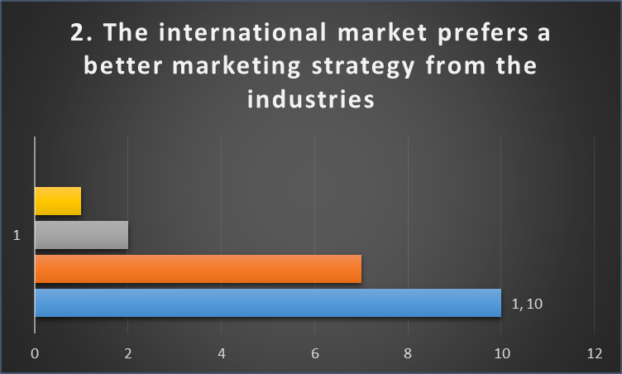
Figure 2 The international market prefers a better marketing strategy from the industries
Around 17 respondents of the survey have agreed that the international markets for the organization or RMG group prefer or demand the high-quality full marketing strategy. 2 respondents stayed neutral and most of them agreed without having any confusion or doubt about this fact. RMG in Bangladesh has been expanding in the international market for the development of the profitability and brand image (Coombes and Millett, 2011). The global market has different elements require the different strategies with high-quality marketing strategy. Al-Muslim Group, Ha-meem Group, Beximco Fashion Group, and Square fashions Ltd have been developing their marketing strategy according to the culture and expectations of the international markets to survive in the market. The opposite discussion of Lientz and Larssen (2014) referred that the markets of local or global would prefer the adaptive marketing strategy from the industries. The quality full strategy may not provide a better outcome based on the macro environment and the changing demands of the customers.

The Technology has been used for the promotion and marketing activities by RMG.
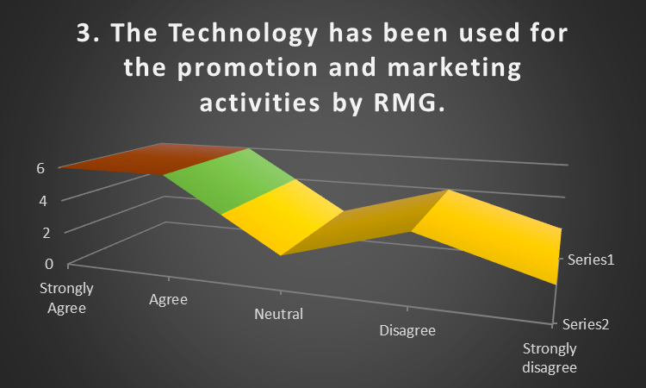
Figure 3 Technology has been used for the promotion and marketing activities by RMG
Technology has changed the perception of the RMG while working for the promotional activities for the international markets. Around 12 respondents have agreed that the RMG has been using technology for the promotional and marketing strategy. Around 2 respondents of the survey stayed neutral and 6 of them disagreed about this fact of technology. Beximco Fashion Group and Square fashions Ltd have changed their market view and adopted technologies for the development of the brand image and promotional strategy. Al-Muslim Group and Ha-meem Group have different strategies and marketing strategy while using technology in the market. The similar discussion of Buckley & Ghauri (2015) identified and they referred that the large industries in the market prefer to adopt a cost-effective strategy for the promotional and marketing strategy in the international market. Technology is the best of them selected by RMG. Technologies have been used by the large industries to maintain the employee’s performance and the marketing operations while targeting both local and global customers (Viardot and Dessler, 2011). Even technology-based service and marketing activities relate to the high profitability with low-cost service.

The expansion under the global business creates the need for the high quality full international marketing strategy.
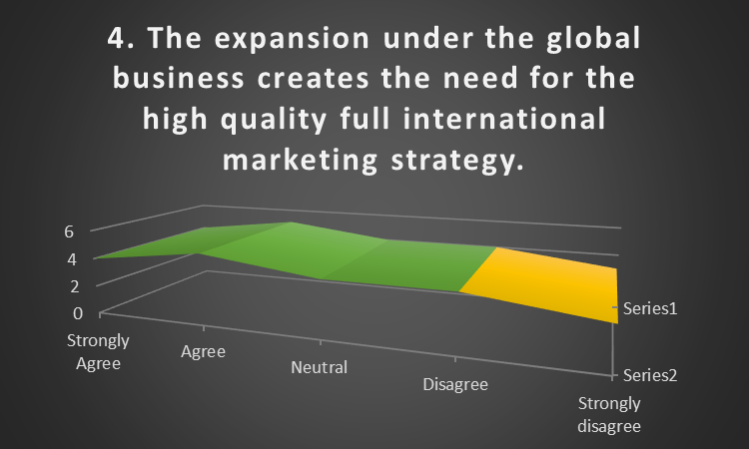
Figure 4 The expansion under the global business creates the need for the high quality full international marketing strategy.
9 respondents have agreed that the expansion under the global business prefers the international marketing strategy from the business organization. 4 respondents have not been agreed or disagreed and 4 of them disagreed that the organization needs the international marketing strategy for the expansion in the global market. As the global market demands the different cultures and the participation, expansion under the global business prefers the right and adaptive international marketing strategy from RMG (Blair and Hitchcock, 2011). Beximco Fashion Group and Square fashions Ltd have faced a high amount of competition from the international market which pushed them to improve their international marketing strategy based on the environment and global business factors. The similar discussion of Palmer and Hartley (2016) referred that the expansion in the global market carries the elements which cannot be managed under local marketing strategy resulting in the quality full international marketing strategy for the customers.

The global business prefers certain elements from the marketing strategy of RMG.
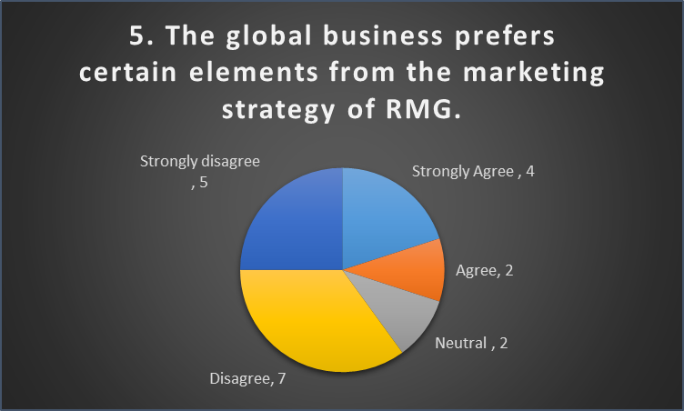
Figure 5 The global business prefers certain elements from the marketing strategy of RMG
Globalization has carried the different cultures and competition for the new entry. Most of the elements of the global business should be attached to the strategy for the development of the profitability and sustainability (Blair and Hitchcock, 2011). Around 6 respondents have agreed that the organization must contain the certain adaptive elements while developing the international marketing strategy for the market. 2 respondents stayed neutral and 12 of them disagreed that the global business affects the organization or RMG to carry the elements for the success. However, the discussion of Buckley & Ghauri (2015) stated that the expansion in the global market affects the business and marketing strategy of the organizations where the flexibility and adaptability in the new marketing strategy should be established. Al-Muslim Group and Ha-meem Group have carried the culture and name of them for developing the brand image and marketing strategy in the global market. Beximco Fashion Group and Square fashions Ltd have worked with the motivations for the new customers with different elements for the marketing strategies in the global market.

The international marketing strategies create challenges for RMG.
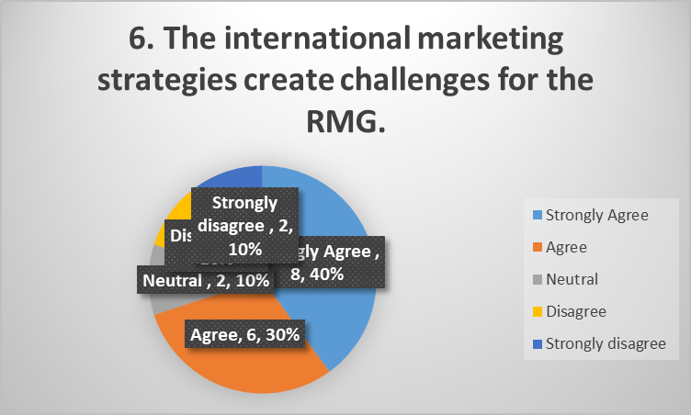
Figure 6 The international marketing strategies create challenges for the RMG
More than 14 respondents have agreed that the barriers and challenges have been increased due to the development of the international marketing strategic created by RMG. 20% of the respondents have disagreed that the international marketing strategies did not create the barriers or challenges for RMG group. RMG in Bangladesh has been focusing on the development of the market image while expanding in the international market (Coombes and Millett, 2011). The brand image has been developed with challenges and barriers for the industries. Ha-meem Group and Square fashions Ltd often faced rumours and bad reputation due to the development of the different elements related to the international marketing strategies in the market. The similar discussion of Lientz and Larssen (2014) stated that the international marketing strategies would demand the high economic shift and corporate culture different from the local cultures creating the challenges and barriers for the industries to maintain the service and image in the market.

The brand reputation of RMG affects the success of the International marketing strategy.
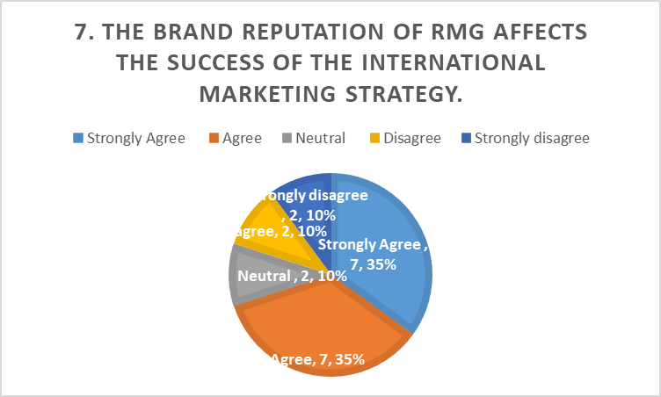
Figure 7 The brand reputation of RMG affects the success of the International marketing strategy
The brand image of the organization affects the operation, perception towards the customers and environment for the industry. Around 70% of the respondents of Al-Muslim Group, Ha-meem Group, Beximco Fashion Group, and Square fashions Ltd have agreed that their brand reputation affects the success factors and motivation for the international marketing strategy. Around 20% of the respondents in the survey have not been agreed to the link-up of the brand reputation. The opposite discussion of Palmer and Hartley (2016) referred that the success and potentiality of the international marketing strategy have not been affected by the brand reputation or the brand image of the organization under the international market environment. Other elements including the motivation, quality and customer’s service often affect the success of the marketing strategy. Basically, the brand reputation of the organization encourages them to develop the powerful and attractive international marketing strategy for the customers (Buttle and Maklan, 2015). On the other hand, the brand reputation of RMG attracts the customers towards the purchase of the products which provides the success to the marketing strategy as well.

The quality customer’s service from RMG have impacts on the success of the marketing strategy
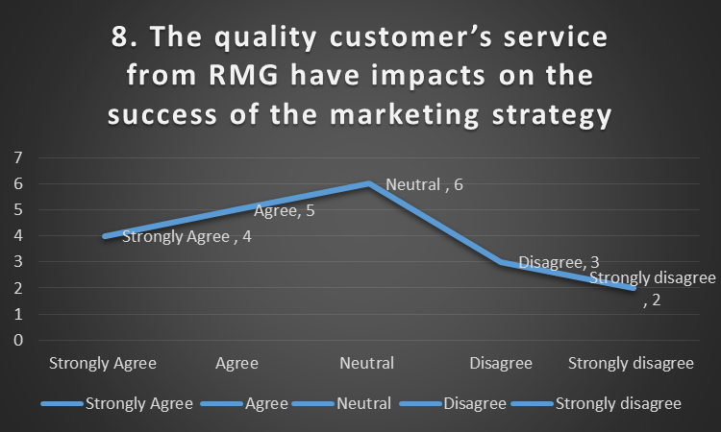
Figure 8 The quality customer’s service from RMG have impacts on the success of the marketing strategy
Around 9 respondents have agreed that the quality full customer’s service would affect the success of the marketing strategy. Around 6 respondents have been stayed confused and neutral as they did not find any linkup of the customer’s service and success of the international marketing strategy. The similar discussion of Buckley & Ghauri (2015) referred that the quality full customer’s service push the RMG to give efforts to the marketing strategy and the customers would have the better perception of the industries which will be the part of the success of the marketing strategy in the market. Based on the quality service for the customers, the organization prefers to maintain the brand image towards their loyal customers and potential customers (Viardot and Dessler, 2011). Thus, the quality customer’s service from RMG have impacts on the success of the marketing strategy.

RMG prefers to engage employees for managing the marketing strategy.
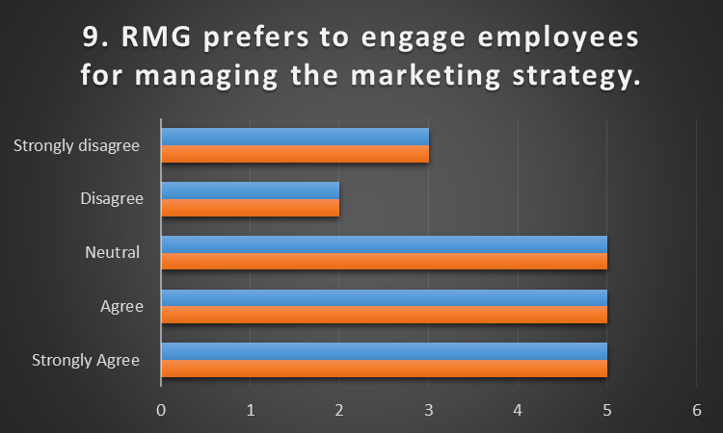
Figure 9 RMG prefers to engage employees for managing the marketing strategy
Most of the respondents of Al-Muslim Group, Ha-meem Group, Beximco Fashion Group, and Square fashions Ltd have agreed that the industries prefer to engage the employees for managing and implementing the international marketing strategy in the different markets. But around 5 respondents from RMG have disagreed as they did not feel the employee engagement works for managing the international marketing strategies. The opposite discussion of Coombes and Millett (2011) referred that the development or management of the international marketing strategy would not be connected with the employee engagement for the success in the market. However, engaging the employees for managing the marketing strategy for the international market would benefit RMG and industries.

The communication plays the role of success in improving the international marketing strategy.
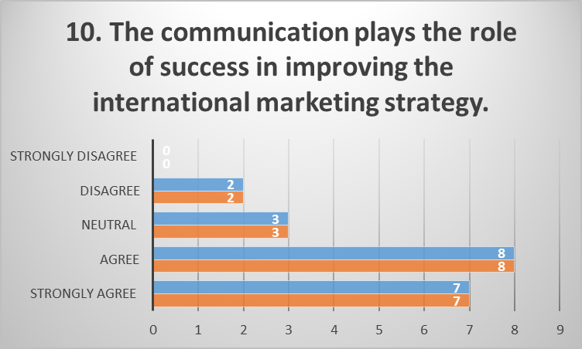
Figure 10 The communication plays the role of success in improving the international marketing strategy.
15 respondents in RMG agreed that communication with the customers and employees help the organization to develop the international marketing strategy in the market. The biggest RMG in Bangladesh including Al-Muslim Group, Ha-meem Group, Beximco Fashion Group, and Square fashions Ltd have developed the communication with the customers and employees for the development of the marketing strategy. International marketing strategy has been developed due to the communication and interaction in most of the industries. The similar discussion of Coombes and Millett (2011) stated that the proper communication and interaction with the customers and employees help the organization to get the feedback and to be more flexible towards the service and marketing strategy resulting to the effective and attractive promotional mix for the customers.

The success factors of international marketing strategy relate to the internal environment.
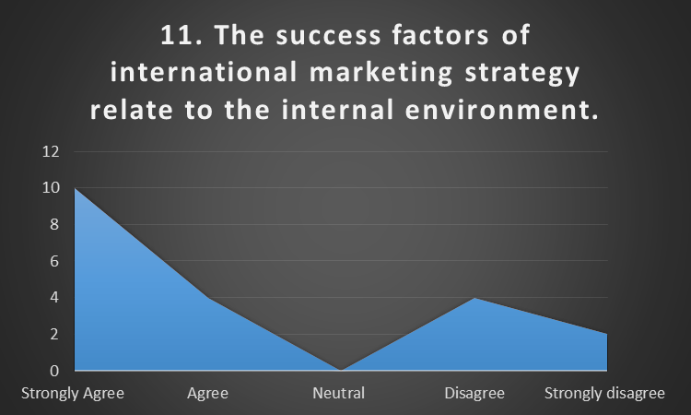
Figure 11 The success factors of international marketing strategy relate to the internal environment
14 respondents have agreed that the internal factors and environment of the company would affect the success factors of international marketing strategy. 6 respondents have disagreed that the connection of the success factors to the internal environment. The similar discussion of Lientz and Larssen (2014) stated that the internal environment of the organization will affect the communication, motivation, funds, strategy, and operation of the organization. These factors related to the success elements in international marketing strategy for the development of the profitability and brand image.

The expansion of the company succeeds based on the international marketing strategy.
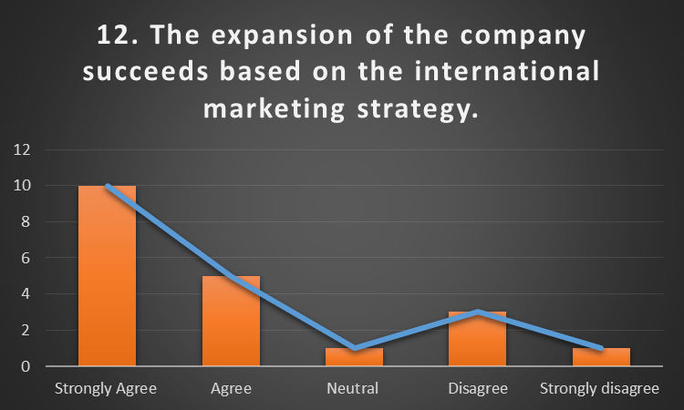
Figure 12 The expansion of the company succeeds based on the international marketing strategy
Expansion of the organization and the success would depend on the international marketing strategy. The strategy should be related to the expansion and operation for managing the reputation of the organization (Viardot and Dessler, 2011). More than 15 respondents of the RMG survey agreed that the expansion of business highly depends on the international marketing strategy which should be developed for the better success. 4 respondents disagreed the fact that the expansion depends on the international marketing strategy. Over the period, Al-Muslim Group, Ha-meem Group, Beximco Fashion Group, and Square fashions Ltd have been working for the development of the different strategies to improve the success for the expansion in the international markets. The opposite discussion of Buckley & Ghauri (2015) referred that the success of the company while expanding does not depend on the international marketing strategy only. Various factors and elements are attached to the expansion of RMG for their success in the market.

Chapter 5 Conclusion

5.1 Conclusion
Investigating the factors that contribute to the success of developing an effective international marketing strategy of RMG’s, the researcher has collected and analyzed the data properly. Global marketing for the different industries requires the proper strategy as the options and the risks for the new entry are tremendous. Al-Muslim Group has seen that the development of the international marketing strategies would not be successful unless they are able to manage promotion related enough to the market and customers they are targeting. Square fashions Ltd has believed that the proper establishment of the marketing strategy and the success depends on the project and the efficiency of the commercialization while managing the customers from different cultures. The international marketing strategies of the garments industries would be effective where the RMG is able to improve the market position while working on the homogeneity demands. Al-Muslim Group and Ha-meem Group have seen the global marketing trends while developing the marketing and other promotional strategies and activities. Beximco Fashion Group has focused on the market research and the current market data to manage the accurate marketing strategy under the flexible business environment. The greatest success factors for the international marketing strategies of these RMG’s in Bangladesh are related to the brand image and the flexible business culture while promoting the global product for the new customers. Success factors of the international marketing strategies of RMG’s help the organizations to develop competitive advantage compared to the existing competitors in the market. The RMG in Bangladesh preferred to maintain the position for accepting the cultures of the customers and the globalization to manage flexible business and international marketing strategy with the communication and coordination inside of the workplace. The motivation and employee engagement were the necessary parts for motivating the employees for the development of the effectiveness of the marketing strategies as well. The motivation for the different types of employees would encourage them for the development of the marketing and promotional strategy for the international branches of RMG. Thus, RMG should focus on the employee’s empowerment while thinking about developing the success of the marketing strategy.

5.2 Recommendation
For the development of the success factors in the international marketing strategy, there are certain techniques and methods should be used by the RMG in Bangladesh. Al-Muslim Group, Ha-meem Group, Beximco Fashion Group, and Square fashions Ltd have been working with their own traditions and marketing strategy. Certain recommendations are given below:
- Technology and the internet have represented themselves as the ways of communication and promotional tools for the business. From communicating with the customers to the development of the brand image, technology and usages of the video campaign and social media are used by the organizations. RMG in Bangladesh should focus on using technology for the operation, communication, and production where the social media and other media and platform should be used for the promotional and marketing activities for the success in the international markets.
- Strategy in the organization needs to be flexible and adaptable enough to cope with the changes and competition from both local and global market. Compiling with the business strategy, RMG’s should focus on the development of the flexible marketing strategy while managing the traditions and perception of the customers in the different markets.
- Employees of the organizations in the different branches play a major role in direct marketing and communication with the customers. Under the international marketing strategy, cross culture management should be adopted for the development of the cross-culture communication and diversity in the workplace. Diversified marketing and promotional mix definitely will help RMG to develop the successful market image while working for the development of the profitability and sustainability in the market.

Reference
Bharwani, S. and Bhutt, N., (2012). Challenges for the global hospitality industry: an HR perspective. Worldwide hospitality and tourism themes, 4(2), pp.150-162.
Blair, A. and Hitchcock, D. (2011). Environment and business. London: Routledge.
Bryman, A and Bell, E (2011), 2nd edition Business Research Methods, Oxford: Oxford University Press.
Buckley, P. J., & Ghauri, P. N. (2015). International Business Strategy: Theory and Practice. Routledge.
Buttle, F. and Maklan, S. (2015). Customer relationship management. London: Routledge.
Collis, J & Hussey, R (2013), 2nd Edn, Business Research. New York, Palgrave Macmillan.
Coombes, H and Millett, R. (2011) Ready-made Garment industry. New York, Palgrave.
Dawson. C., (2017), 3rd Edn, Garment Sectors and Market, Oxford, How To Books Ltd.
Easterby-Smith, M, (2012), 2nd Edn, Management Research –An introduction
Gill, J and Johnson, P (2012), 3rd Edition Research Methods for Managers, London: Sage.
Gough, O. and Laudon, C. (2017). Small business driving record employment levels. [online]. Available at: http:// smes-driving-employment-levels-2539643/ [Accessed 24 February 2018].
Hoffman, A. J., & Woody, J. G. (2013). Climate change: What's your business strategy? Harvard Business Press.
Jankowicz, A (2011) Ready-made Garment, St. Edmunds, St. Edmundsbury Press Ltd.
Ketchen, D. and Bergh, D., (2016). Research methodology in strategy and management. Amsterdam: Elsevier JAI.
Lientz, B. and Larssen, L. (2014). Manage IT as a business. Amsterdam: Elsevier Butterworth Heinemann.
Palmer, A. and Hartley, B. (2016). The business environment. Maidenhead: McGraw-Hill Education.
Saunders, M, Lewis, P. and Thornhill, A. (2013), 4th Edition Research Methods for Business Students, New Jersey: Financial Times/Prentice Hall.
Viardot, E. and Dessler, G. (2011). The timeless principles of successful business strategy. New York: Springer

Appendix:
Serial Number:

Survey Form

TITLE OF THE RESEARCH: “Determining the success factors of international marketing of RMG: A case study of 4 RMG's in Bangladesh”
Dear participant,
This is an academic research project which is based on the success factors of international marketing of RMG of Bangladesh. The researcher has used Al-Muslim Group, Ha-meem Group, Beximco Fashion Group, and Square fashions Ltd for the investigation. The information of yours will be protected from the third parties.
Thank You
Socio-Demographic Profile of the survey
1. What is your gender?
- Male
- Female
2. How many years are you working for your organisation?
- 1-5 Years
- 6-10 Years
- More than 10 Years
3. In which organisation are you working?
- Al-Muslim Group
- Ha-meem Group
- Beximco Fashion Group
- Square Fashions Ltd.

Questionnaire
Close Ended Questions: Please mark the correct answer,
1. The online service develops the communication with the customers.
- Strongly Agree
- Agree
- Neutral
- Disagree
- Strongly Disagree
2. The international market prefers a better marketing strategy from the industries.
- Strongly Agree
- Agree
- Neutral
- Disagree
- Strongly Disagree
3. The Technology has been used for the promotion and marketing activities by RMG.
- Strongly Agree
- Agree
- Neutral
- Disagree
- Strongly Disagree
4. The expansion under the global business creates the need for the high quality full international marketing strategy.
- Strongly Agree
- Agree
- Neutral
- Disagree
- Strongly Disagree
5. The global business prefers certain elements from the marketing strategy of RMG.
- Strongly Agree
- Agree
- Neutral
- Disagree
- Strongly Disagree
6. The international marketing strategies create challenges for the RMG.
- Strongly Agree
- Agree
- Neutral
- Disagree
- Strongly Disagree
7. The brand reputation of RMG affects the success of the International marketing strategy.
- Strongly Agree
- Agree
- Neutral
- Disagree
- Strongly Disagree
8. The quality customer’s service from RMG have impacts on the success of the marketing strategy.
- Strongly Agree
- Agree
- Neutral
- Disagree
- Strongly Disagree
9. RMG prefers to engage employees for managing the marketing strategy.
- Strongly Agree
- Agree
- Neutral
- Disagree
- Strongly Disagree
10. The communication plays the role of success in improving the international marketing strategy.
- Strongly Agree
- Agree
- Neutral
- Disagree
- Strongly Disagree
11. The success factors of international marketing strategy relate to the internal environment.
- Strongly Agree
- Agree
- Neutral
- Disagree
- Strongly Disagree
12. The expansion of the company succeeds based on the international marketing strategy.
- Strongly Agree
- Agree
- Neutral
- Disagree
- Strongly Disagree

Researched Literature:
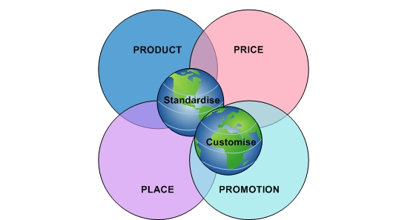
Figure 13 International marketing mix
Source: (Lientz and Larssen, 2014)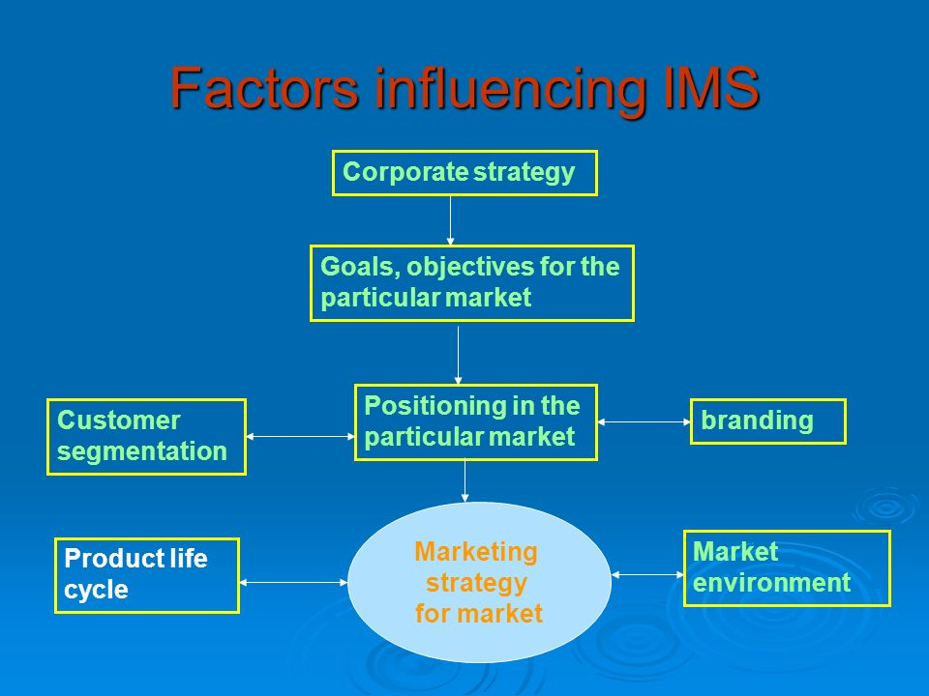
Figure 14 Factors influencing international marketing strategy of RMG
Source: (Hoffman & Woody, 2013)
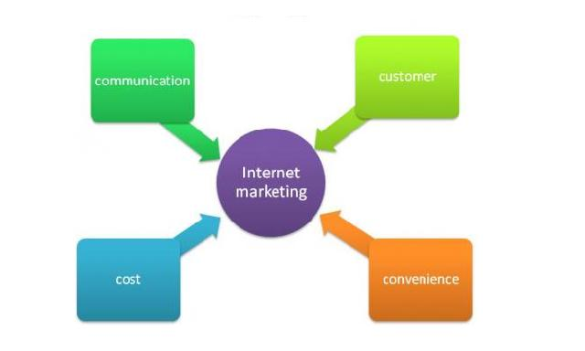
Figure 15 International marketing strategies
Source: (Jankowicz, 2011)
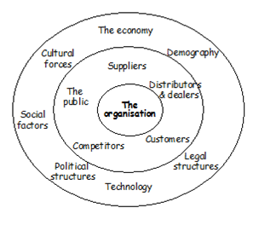
Figure 16 Factors affecting IMS
Source: (Lientz and Larssen, 2014)
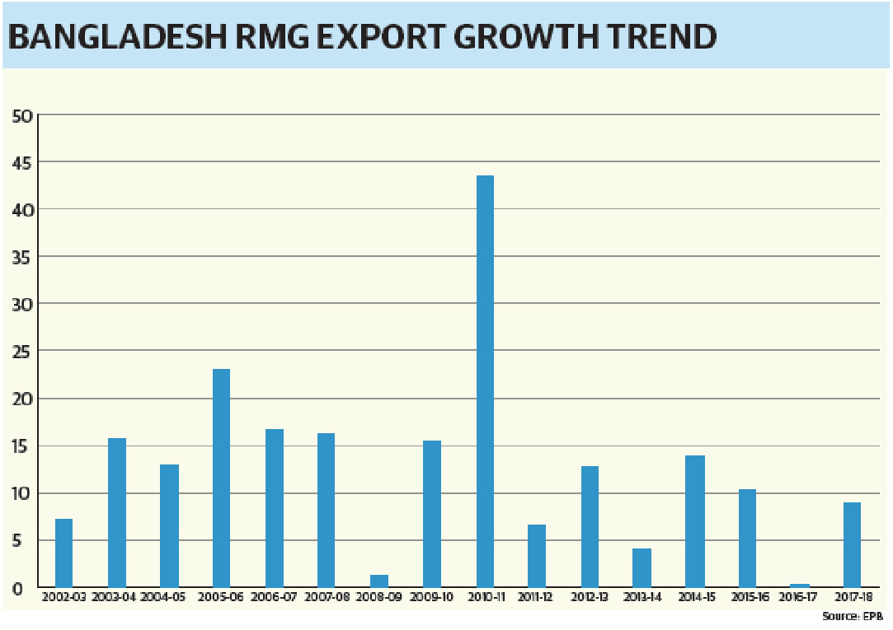
Figure 17 RMG growth trends in Bangladesh
Source: (Gough and Laudon, 2017)

Figure 18 Research Conceptual Framework
Source: Own
Recording data:
Question | Strongly agree | agree | Neutral | Disagree | Strongly disagree
1. The online service develops the communication with the customers. | 8 | 5 | 3 | 2 | 2
2. The international market prefers a better marketing strategy from the industries. | 10 | 7 | 2 | 1 | 0
3. Technology has been used for the promotion and marketing activities by RMG. | 6 | 6 | 2 | 4 | 2
4. The expansion under the global business creates the need for the high quality full international marketing strategy. | 4 | 5 | 4 | 4 | 3
5. The global business prefers certain elements from the marketing strategy of RMG. | 4 | 2 | 2 | 7 | 5
6. The international marketing strategies create challenges for the RMG. | 8 | 6 | 2 | 2 | 2
7. The brand reputation of RMG affects the success of the International marketing strategy. | 7 | 7 | 2 | 2 | 2
8. The quality customer’s service from RMG have impacts on the success of the marketing strategy | 4 | 5 | 6 | 3 | 2
9. RMG prefers to engage employees for managing the marketing strategy. | 5 | 5 | 5 | 2 | 3
10. Communication plays the role of success in improving the international marketing strategy. | 7 | 8 | 3 | 2 | 0
11. The success factors of international marketing strategy relate to the internal environment. | 10 | 4 | 0 | 4 | 2
12. The expansion of the company succeeds based on the international marketing strategy. | 10 | 5 | 1 | 3 | 1

