IDLC

Internship Report
On

“Portfolio Management system of IDLC Investments Limited”

Internship Report
On
‘Portfolio Management system of IDLC Investments Limited’

Submitted To:

Shakila Aziz
Assistant Professor
School of Business & Economics
United International University

Submitted By:
Md. Saiful Islam Sarker
ID: - 111 141 318
School of Business & Economics
United International University

Date of Submission: 28th September, 2018

Letter of Transmittal
To
Shakila Aziz
Assistant Professor
School of Business & Economics
United International University

Subject: Submission of the Internship Report

Dear Madam,
I would like to submit the report on “portfolio management system of IDLC Investment Ltd” which is the topic of my internship program. I would like to say that this report is prepared by me under the supervision of my internship instructor.

I trust that this internship program has given me an opportunity to gain both of my knowledge and experience. I made my best effort to fulfill the measurable of the report and trust that it will fulfill your expectation.

By preparing this report I have tried to include all the relevant information to ensure the report sweeping as well as workable one.

I therefore, hope that you will grant this report.

Yours ever,
Md. Saiful Islam sarker
ID: 111 141 318

Acknowledgement:

First, all praises go to the Almighty Allah, the most precious, the most grateful, the most kind and generous to man and his action. This internship report is on portfolio management system of IDLC Investment Ltd., Dhaka.
For preparing this report I am grateful to my organizations instructor Nayeem Chowdhury Manager, Department of DPM. He always tries to support my work and helped me at any time.

I would like to convey my sincere gratitude to my university instructor, Shakila Aziz, Assistant Professor of school of business and economics, United International University. Without her guidance and assistance the report would not have been seen and light of day.
Finally, my deep gratitude goes in favor of my university for getting library, lab facilities and my teachers to enrich my knowledge, which support me in different stages to complete this report.

Executive Summary:

IDLC Investments Limited (IDLCIL) has started its operations from August 16, 2011 to offer merchant banking services to both individual and institutional clients. As per requirement of the Bangladesh Securities & Exchange Commission (BSEC), IDLC formed a separate subsidiary on May 19, 2010 in the name of “IDLC Investments Limited”, to transfer its existing merchant banking activities to the newly formed existence.
The main aim of this report is to portfolio management systems of IDLC Investment Ltd.
First of all, in this report I provide a background of the IDLC Investment Ltd. Next, I have given a short description of IDLC Investment Ltd. These descriptions are mostly focuses on this company’s actual running situation and past background.
Then next part is project part. Through the challenges and practical learning, I have been able to discover my capabilities and lacking. It was a very important part to provide my best effort to that organization.
Next, I have recommended new product & services and the financial highlights of IDLC Investment Ltd in the analysis part. It is the most critical part of this report and mainly it is the main part to focuses on the DPM products and clients satisfaction.
Finally my overall view if the organization controls and takes proper steps to overcome its limitations; it will become a heart -trusted non financial bank of People.

Table of Contents:

Title: | Page no:
- Chapter-01: Introduction | 08
1.1 Back ground of the study: | 09
1.2 Origin of the report: | 09
1.3 Objectives of the report: | 09
1.4Methodology: | 10
1.5 Limitations of the study: | 10
- Chapter-02: company profile | 11
2.1 Background of IDLC Finance Limited: | 12
2.2 Vision statement: | 12
2.3 Mission statement: | 12
2.5 Hierarchy of the organization: | 14
2.6 Overview of IDLC Investment Ltd: | 14
2.7 Products & services: | 15
- Chapter-03: Internship experience | 16
3.1 My contribution Of IDLC Investment Limited: | 17
3.2 Training program: | 17
3.3 Exam session: | 17
3.4 work under instructor: | 17
3.5 work separately: | 17
3.7 Learning: | 18
3.8 Observation: | 18
3.9 Recommendation: | 18
- Chapter-04: value added service & finding | 19
4.1 Portfolio management: | 20
4.3 Discretionary Portfolio Management (DPM): | 22
4.3.1 MAXCAP: | 22
4.3.2 Easy Invest: | 24
4.3.3 Profit–Loss Sharing Scheme: | 26
4.3.4 Portfolio Advisory Service: | 28
4.3.5 Capital protected scheme: | 30
4.4 Components of Tax Certificate: | 32
4.5 SWOT Analysis of IDLC: | 33
4.6 Financial Highlights of IDLC Investment Ltd. | 35
4.7 Findings: | 39
- Chapter-05: Recommendation & conclusion | 41
5.1 Recommendation: | 42
5.2 Conclusion: | 43
References: | 44

Chapter-01-Introduction

1.1 Back ground of the study:
Internship is the most critical part and the ending part for a student. Every student effort to complete this part and they can do it. In this part students will faces the actual working environment and learn official and practical discipline. Students should amenable to learn new things and official works. A student can earn academic learning in their Four years study life but he can’t gain any practical knowledge. In the internship program he should gain actual practical knowledge. In the entire internship training program, a student can learn the practical way to use his academic knowledge.
I had done my internship program at IDLC Investments Limited under Discretionary portfolio management department. I will give the importance in corporate sales to their different products and portfolio services, that’s why the name of the topic for my report is “portfolio management system of IDLC Investment Limited”. My organization instructor Nayeem Chowdhury, Manager of DPM departments and my institutional instructor Shakila Aziz madam accepted it.

1.2 Origin of the report:
Students have a great opportunity to successfully complete the program and important reason is to face the real life working experience in the corporate world. Students should gain knowledge to working practically by following four years academic knowledge. It is an important part of all graduate students. I also completed my internship program on the ‘IDLC Investments Limited’ and also completing my report based on this organization. The guideline and preparation of the report was supervised and directed by Shakila Aziz, assistant professor, school of business and economics, UIU and I am thankful to her for appoint this project.

1.3 Objectives of the report:
1.3.1 Main objectives:
To evaluate an overall idea of portfolio management system of IDLC investments ltd.
1.3.2 Board objectives:
- To understand the portfolio management services
- To focuses on the companies effectiveness and weakness
- To identify the performance of investment
- To make recommendations to prove their portfolio services
- To evaluate present and growth of the company

1.4 Methodology:
There are two types of data is use to complete the report, like:
- Primary data: primary data collected by DPM department’s executives, both of the executives are helpful to provide me the proper information. No formal questionnaire was used by this collecting data.

- Secondary data: this data is collect by official website of IDLC and their annual report of 2013 to 2017 and relevant websites.

1.5 Limitations of the study:
I was working in the IDLCIL for three months as an intern. It was very short time courses but it was a great opportunity for me to working this environment and both of the employees are friendly. But I had to face some limitations to collect the information, which is-
- Employees are not allowed to provide delicate and depth information
- The main obstacle of the study was insufficient access to information which was limits
- As the employees were busy with their own duty, they could give me little time for deliberation.
- Time bondage is another limitation of the study.
- As my duty was totally in field job, that’s why I can’t gather proper information of internal organization.

2. Chapter-02-Company Profile

2.1 Background of IDLC Finance Limited:
IDLC Finance Ltd. (IDLCFL) has opened as a number of leasing company back in 1985 with 5 members and this company has 33 years down the track. And it is the largest Non Banking Financial organization in the country. It is also a reputed financial brand in the financial industry.
Now a day’s IDLC have performed 20 cities and they also have 38 branches. IDLC has 1400 employees always serving 45000 clients. IDLC has creating to say that, ‘we are merely in the financial business, as we try to do something more. We strive to help people achieve their dreams’.
IDLC always try to provide better customer satisfaction services while profits are more important to market survival.

IDLC creates three supplementary companies, which are:
- IDLC Investments Ltd.
- IDLC Securities Ltd &
- IDLC Asset Management Ltd.

2.2 Vision statement:
‘We will be the best financial brand in the country’

2.3 Mission statement:
‘We will focus on quality growth, superior customer experience and sustainable business practices’.

2.4 IDLC believes:
- Completeness
- Customer Focus
- Equal Opportunity
- Trust and Respect
- affection
- Simplicity
- Eco-Friendly

2.5 Hierarchy of the organization:
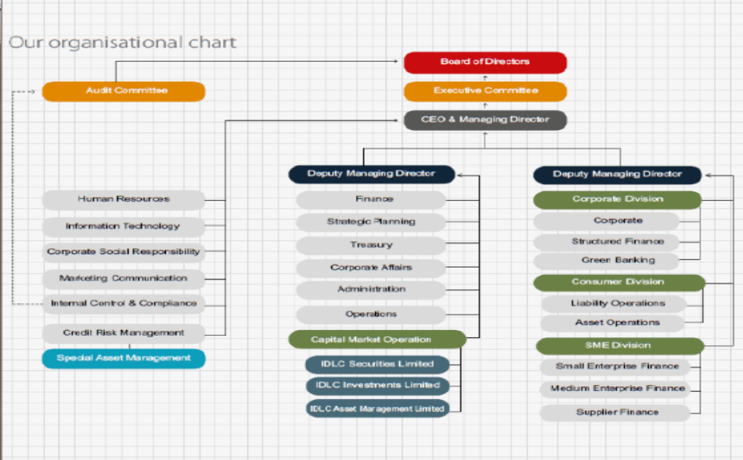

2.6 Overview of IDLC Investment Ltd:
IDLC investments Limited are a merchant bank. It is fully sister concerns of IDLC Finance Limited. IDLC is one of the largest non-banking financial companies in Bangladesh. It was mainly created by International finance corporation, German Investment Corporation, Korea development bank, Aga khan fund for economic development etc.
IDLC investments ltd mainly started their merchant banking in 1999. In 2010, IDLCIL started as a separate company as the rules of BSEC. This company provides investment banking, portfolio management, margin loans and securities research services to their clients, both individuals and corporations.

2.6.1 USP of IDLCIL:
- IDLCIL has their own proficient research team
- It has also a good 11 years track record of average return
- It has also good experiment traders
- IDLCIL has also a good number of CFA holders
- Over performed market in bearish & bullish spell

2.6.2 Most target clients of IDLC investment Ltd:
- Who has no enough money to invest
- Who don’t have enough time to invest in the right time
- Who want to take tax benefit

2.7 Products & services:

2.7.1 DPM departments offer these products:
- Easy Invest
- Maxcap
- Profit loss sharing scheme
- Portfolio advisory services
- Capital protected scheme

2.7.2 DPM provides some Services:
- Initial public offering
- Repeat public offering
- Underwriting
- Mergers
- Acquisitions
- Capital raising under IPO

Chapter-03-Internship Experience

3.1 My contribution Of IDLC Investment Limited:
In January 2018, I joined in IDLC investment limited by the department of Discretionary portfolio management. I also perform several works in this department. By the short time training, I was starting my internship program in this company. My performance under this department given below:

3.2 Training program:
I was joining IDLC investment limited at 15th January 2018. When I was joining this company, it was a great happiness to me to join a new experience; previously I have no experience in this sector. It was a great opportunity for me.
They assigned me to promote their product at corporate sectors and they also provide me 3 days training. In this training they focus many terms and problems to promote their products.
The whole internship program they provide different training session. The most one training session is held on BSEC which is situated in Agargaon. The training was focuses on ‘capital market investment’.

3.3 Exam session:
After providing their successful training session, DPM departments arranged an exam session. This question paper also created these departments. And also got a good mark.

3.4 work under instructor:
After 4th days, our actual work was started. First of all my supervisor creates a group and every group have also a trainer, who support our job and if I faces any problems they solve it. In first day I visited Motijheel area, which area was full of corporate offices. Every time I noticed my trainer how he cooperates and talks to corporate persons.

3.5 work separately:
When I work with my trainer I was facing many problems and he solved it. But in 2 days later I was starting individually. My supervisor also selected different area which I should visit. In these different areas, I was visited different corporate office and talk to the corporate persons.
I always discuss this corporate person to my products and services. In this work many corporate person appreciate my work. I mainly focus our new value added service, which is ‘Easy invest’. It was a great experience for me.

3.6 Learning:
In this DPM departments, I worked a under a project, which was ‘Learn & Earn”. I have learned many things in this project. Like-
- I must learn about capital market
- How to remove shyness
- I also know the tax benefits, and tax related tasks
- I also know the perfect invest time of capital market
- I also know how to sell any product in different situation
- Also know the target oriented work
- Also know how to work in a pressure
Finally I was gather perfect practical knowledge in this department

3.7 Observation:
IDLC provide a great working environment. Every stuffs are really helpful. They also consider interns as an employee. Everyday supervisor assign many works to the interns. In regular basis interns also more dedicated to their work. They are really helpful when I prepare this project.

3.8 Recommendation:
DPM Supervisor should assign intern in various works that why every intern learn more.

Chapter-04-Value added service & Findings

4.1 Portfolio management:
In IDLCIL portfolio management is their initial basic or primary work. Other departments are also as supporting wings of portfolio management. Like, IDLCIL has a strong research department who perform as a portfolio manager and these departments also provide many decisions where you invest or when you buy or sell.

4.2 Duty under Clients:
- IDLCIL always provides portfolio statements by RM or E-mail
- Stock sell and buy
- Proactive communication
- Company supply tax certificate
- Company always change their investments policy if necessary
- If any clients have any queries company should answer

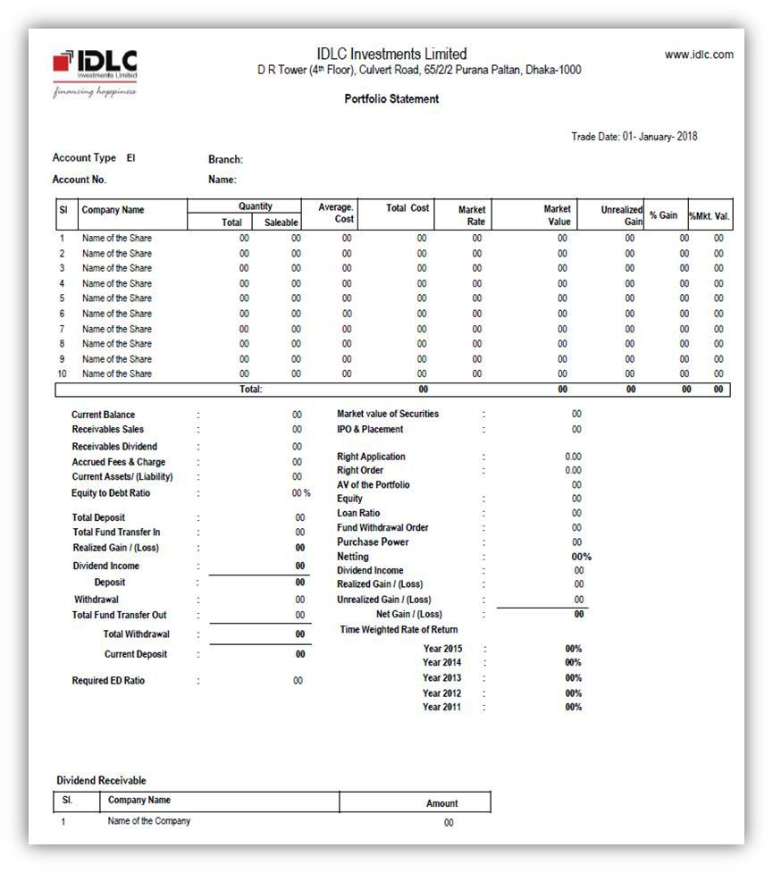
Here is the format of portfolio which is maintaining by IDLC Investments Limited.

4.3 Discretionary Portfolio Management (DPM):
Discretionary portfolio management of IDLC Investments Ltd was created in 2007 as like “Cap Invest”, which was modified by as like “MAXCAP” in 2010. It has a strong experienced team; this team always manages their valuable clients’ funds. IDLCIL provides their clients to good activity and a good business model. IDLCIL have also different kinds of products like Maxcap, Easy Invest, Profit-loss sharing, Capital-protected scheme & Portfolio Advisory service.
IDLC Investments Ltd is the greatest merchant bank in Bangladesh. They have 3500 clients. They create monthly investment scheme which is Easy Invest in August 2016. They also gain better response around the country and also providing good return of 29% in year 2017.
IDLC’s DPM departments have 11 years strong track record and also generating 22% average return.

Discretionary portfolio management has 5 products, like-

4.3.1 MAXCAP:
Maxcap is the 1st product of DPM Department and it also planned for individuals & companies clients. IDLCIL perform as a portfolio manager will maintain a organized investment process and planned approach to increase portfolio.

4.3.1.1 Key components of Maxcap:
- Lowest investment money: Five Lacs taka
- At least investment period: 2 years
- Margin Loan provided by financier needs.

4.3.1.2 Investment procedures:
Portfolio manager should affirm a clear and valuable investment process in conditions of portfolio proportion, maintaining, selecting best stock etc.
The investment procedure has been carefully composed to ensure:
- Separate professional appraisal and responsibility in each area of resolving
- Eliminating for all contest of interest
- Fair exchange and objectivity in every negotiation
- Corresponding of law and other critical works

4.3.1.3 Investment approach:
IDLCIL or DPM departments always determine to appropriate sectors differentiate and safety selection to manage clients portfolio. And they also use both basic and quantitative analysis for guiding the investment.

4.3.1.4 Investment design:
Portfolio manger always focuses on gaining future returns at an equitable risk through proper management of companies’ portfolio.

4.3.1.5 Where to invest?
Portfolio manager should invest only in share market stock designed by BSEC.
Portfolio manager would keep on the following obstacles when taking investments decisions:
- Every funds will not invested in different securities having in period of more than one year
- Funds are not invested in private capital
- Funds are more than 30% & 60% of whole amount of total assets would not be in single security.

4.3.1.6 Who will carry the risk?
Individuals or companies are the clients of Maxcap that’s why as a portfolio manager will always be responsible for taking high risk control measures.

4.3.1.7 Risk control measures:
Portfolio Manager will sensibly apply different risk control measures. Some are:
- First, Portfolio Manager will provide appropriate limits of stocks, industry and portfolio levels
- Second, Portfolio Manager always try to reduce risk by selecting good and potential stocks and achieving ample diversification

4.3.1.8 Reporting:
Portfolio and transaction statements will be given quarterly

4.3.1.9 Fees and charges:
- Account creating Fee: 500 taka
- Management Fees: 2.50% on market value
- Confirmation Fee: 0.35%
- Early leaving Fee: 0.50%

4.3.2 Easy Invest:
The most popular DPM product is Easy Invest. It will always grow up your portfolio. It is a small investments process. Portfolio manager always follow a good disciplined investment process and minimize risk of market impulsiveness.

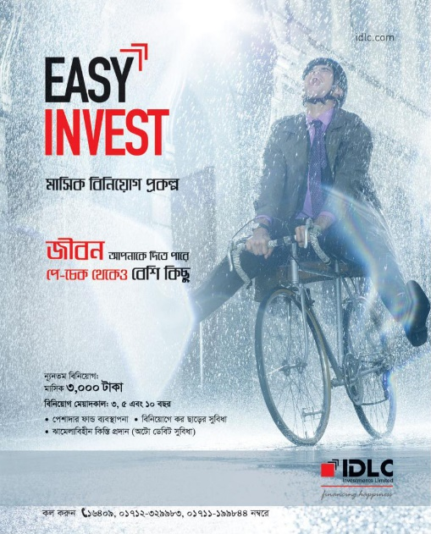

4.3.2.1 Components of easy invest:
- It can be opened as a small amount of money,
- It is easily affordable
- Long term solutions for children’s, marriage etc
- It is also follow auto debit system
- It has also provide a insurance coverage up to 1 lac per year
- It also provide a great opportunity to get rebate on income tax

4.3.2.2 Key information:
- Monthly investment amount: 3,000 taka and in multiple of BDT 1,000
- Investment period: 3, 5 and 10 years
4.3.2.3 Fees & charges:
- Account creating Fee: 500 taka
- Management Fee: 3% on market value
- Confirmation Fee: 0.50%
- CDBL charges: 450 taka
- Insurance Premium: 74 taka per year (optional)
- Early leaving Fee: 3% within 6 months and 1% is before infancy

4.3.3 Profit–Loss Sharing:
Profit loss sharing is a one kind of DPM services where IDLCIL would manage every client’s funds and will take investments decision. Its limited share is 30% and the ratio is 70:30 of total investments. Where, IDLCIL bares 30% and clients is 70% to invest.

4.3.3.1 Components of PLS:
- lowest Investment Amount: 10 Lacs taka
- at least Investment period: Two Years
- Investment and Profit-Loss sharing: 70:30 Ratio

4.3.3.2 Investment procedures:
Portfolio manager should affirm a clear and valuable investment process in conditions of portfolio proportion, maintaining, selecting best stock etc.
The investment procedure has been carefully composed to ensure:
- Separate professional appraisal and responsibility in each area of resolving
- Eliminating for all contest of interest
- Fair exchange and objectivity in every negotiation
- Corresponding of law and other critical works

4.3.3.3 Investment approach:
IDLCIL or DPM departments always determine to appropriate sectors differentiate and safety selection to manage clients portfolio. And they also use both basic and quantitative analysis for guiding the investment.

4.3.3.4 Investment design:
Portfolio manger always focuses on gaining future returns at a equitable risk through proper management of companies portfolio.

4.3.3.5 Where to invest?
Portfolio manager should invest only in share market stock designed by BSEC.
Portfolio manager would keep on the following obstacles when taking investments decisions:
- Every funds will not invested in different securities having in period of more than one year
- Funds are not invested in private capital
- Funds are more than 30% & 60% of whole amount of total assets would not be in single security.

4.3.3.6 What is guaranteed?
In market condition capital protected scheme is 100% secured.

4.3.3.7 Risk control measures:
Portfolio Manager will sensibly apply different risk control measures. Some are:
- First, Portfolio Manager will provide appropriate limits of stocks, industry and portfolio levels
- Second, Portfolio Manager always try to reduce risk by selecting good and potential stocks and achieving ample diversification

4.3.3.8 Reporting:
Portfolio and transaction statements would be given by semi annually.

4.3.3.9 Fees and charges:
- Account creating Fee: 500 taka
- Management Fee: 1.50% per annul on market value
- Confirmation Fee: 0.35%
- Early leaving Fee : 2%

4.3.4 Portfolio Advisory Service:
Portfolio Advisory Service is the important experienced investment wings of IDLCIL. It is a wealth maximization service provide to our good number of clients. Every clients are gained high quality research support. They should be more analyzing good performance to the trend of capital market. IDLC investments ltd also offer a best expert services of capital market investments advisor.

4.3.4.1 Elements of PAS:
- lowest Investment Amount: 10 Lacs taka
- at least Investment period : Two Years
- Margin Loan system : N/A

4.3.4.2 Investment process:
Portfolio manager should affirm a clear and valuable investment process in conditions of portfolio proportion, maintaining, selecting best stock etc.
The investment procedure has been carefully composed to ensure:
- Separate professional appraisal and responsibility in each area of resolving
- Eliminating for all contest of interest
- Fair exchange and objectivity in every negotiation
- Corresponding of law and other critical works

4.3.4.3 Investment approach:
IDLCIL or DPM departments always determine to appropriate sectors differentiate and safety selection to manage clients portfolio. And they also use both basic and quantitative analysis for guiding the investment.

4.3.4.4 Investment design:
Portfolio manger always focuses on gaining future returns at a equitable risk through proper management of companies portfolio.

4.3.4.5 Where to invest?
Portfolio manager should invest only in share market stock designed by BSEC.
Portfolio manager would keep on the following obstacles when taking investments decisions:
- Every funds will not invested in different securities having in period of more than one year
- Funds are not invested in private capital
- Funds are more than 30% & 60% of whole amount of total assets would not be in single security.

4.3.4.6 Who will carry the risk?
Individuals or companies are the clients of portfolio advisory services that’s why as a portfolio manager will always be responsible for taking high risk control measures.

4.3.4.7 Risk control measures:
Portfolio Manager will sensibly apply different risk control measures. Some are:
- First, Portfolio Manager will provide appropriate limits of stocks, industry and portfolio levels
- Second, Portfolio Manager always try to reduce risk by selecting good and potential stocks and achieving ample diversification

4.3.4.8 Reporting:
Portfolio statement would be given by daily basis.

4.3.4.9 Fees & charges:
- Account creating Fee: 500 taka
- Management Fee: 5,000 taka (monthly)
- Equity Incremental Fee: 10%
- Confirmation Fee: 0.40%
- Early leaving Fee: 0.50%

4.3.5 Capital Protected Scheme:
The final DPM service is capital protected scheme where IDLCIL always manage every clients fund and took investments decision.

4.3.5.1 Elements of CPS:
- Lowest Investment: 10 Lacs taka
- At least Investment period: Four Years and Three Months
- Margin Loan system: N/A

4.3.5.2 Investment process:
Portfolio manager should affirm a clear and valuable investment process in conditions of portfolio proportion, maintaining, selecting best stock etc.
The investment procedure has been carefully composed to ensure:
- Separate professional appraisal and responsibility in each area of resolving
- Eliminating for all contest of interest
- Fair exchange and objectivity in every negotiation
- Corresponding of law and other critical works

4.3.5.3 Investment approach:
IDLCIL or DPM departments always determine to appropriate sectors differentiate and safety selection to manage clients portfolio. And they also use both basic and quantitative analysis for guiding the investment.

4.3.5.4 Investment design:
Portfolio manger always focuses on gaining future returns at a equitable risk through proper management of companies portfolio.

4.3.5.5 Risk control measures:
Portfolio Manager will sensibly apply different risk control measures. Some are:
- First, Portfolio Manager will provide appropriate limits of stocks, industry and portfolio levels
- Second, Portfolio Manager always try to reduce risk by selecting good and potential stocks and achieving ample diversification

4.3.5.6 Reporting:
Portfolio and transaction procedures will be given semi annually

4.3.5.7 Fees and charges:
- Account creating Fee: 500 taka
- Management Fee: 1.50% per annual on market value
- Confirmation Fee: 0.35%
- Early leaving Fee: 2%

4.4 Components of Tax Certificate:
IDLCIL always provide tax certificate to their clients in July 1st. In this certificate some things are important like:
- Income tax
- Dividend income
- Loan amount
- Unrealized gain
- Deposit during this period
Here is a format of tax certificate which is providing by IDLC:
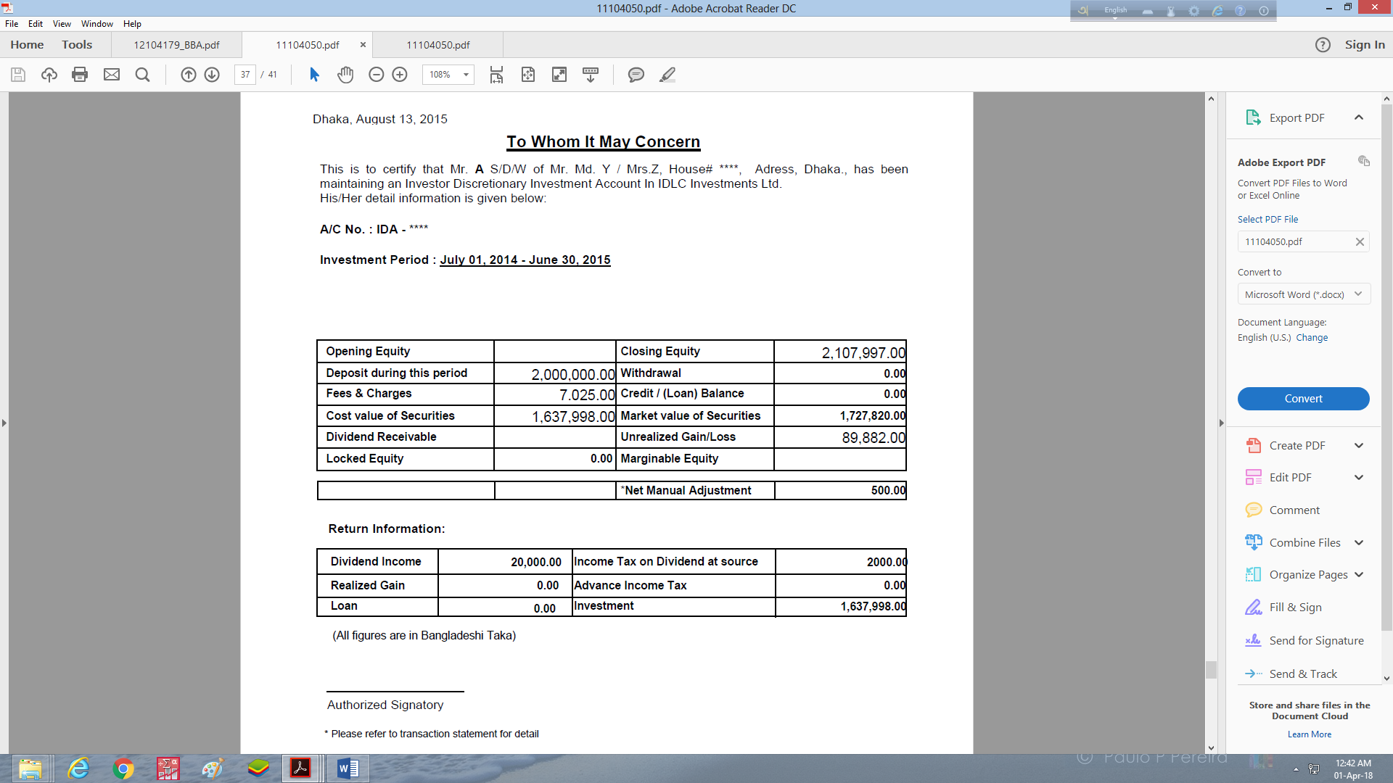

4.5 SWOT Analysis of IDLC:
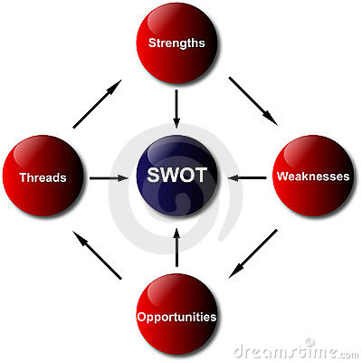

4.5.1 strength:
•Contract on Investment.
• Company position and goodwill
• Expanding market, raising sales & profitability
• A profitable industrial sectors with fruitful business
• Good motivation ability of target clients group

4.5.2 Weakness:
• Lack of enough marketing (advertising and promotion) trail
• Lack of training period in their employs.
• Strong contest among the existing performers of the industry.

4.5.3 Opportunities:
• Regulatory environment forming private sector enlargement
• Value accession in product and services
• Enlarging the community of Bangladesh
• A very broad scope is superior for foreign capitalist also.

4.5.4 Threats:
• Market constrain for menacing of guidance rate
• National and planetary political disquiet
• Political instability
• Conflicting market

4.6 Financial Highlights of IDLCIL:
The year of 2017 IDLC investments ltd. performed a good net operating income of 450 million. This was notable improvement from 2016. In 2016 net operating income was 243 million. By the following table describe the focusing of revenue issue from different products.

4.6.1 Portfolio operations:

Operational Income | 2013 | 2014 | 2015 | 2016 | 2017
Net interest income | (160.88) | (46.92) | 149.69 | 140.22 | 102.59
Portfolio management services | 60.25 | 75.44 | 67.78 | 44.56 | 46.61
Settlement and transaction fees | 22.09 | 26.25 | 21.66 | 20.02 | 58.63
Documentation fees | 0.03 | 0.05 | 0.07 | 0.75 | 0.95
Total operational revenue | (78.51) | 54.82 | 239.19 | 205.55 | 208.79

In 2017, net interest income is 102.59 on the other hand 2016, net interest income is 140.22, which is more then 2017. Next portfolio management services are higher than previous year and transaction fees also be higher.

4.6.2 Financial Performance:

Financial performance | 2013 | 2014 | 2015 | 2016 | 2017 | growth
Total Assets | 3829.30 | 2553.18 | 2081.17 | 2705.36 | 5039.47 | 23.34%
Total Liabilities | 2539.38 | 1210.18 | 618.85 | 1072.96 | 2319.00 | 12.46%
Net Income | (213.26) | 53.07 | 119.32 | 170.08 | 276.52 | 1.06%

Analysis by financial performance, in 2013 company faces net loss, but in 2014 to 2017 company’s net income increases. And growth rate is 1.06%.

4.6.3 Investment Banking:

Investment banking | 2013 | 2014 | 2015 | 2016 | 2017
Issue management fees | 3.50 | 9.50 | 4.61 | 11.00 | 2.50
Underwriting | 0.92 | 2.76 | 1.28 | 0.20 | 0
Corporate advisory fees | 13.52 | 10.50 | 1.27 | 17.21 | 44.06
Total revenue from investment banking | 17.95 | 22.76 | 18.06 | 28.42 | 46.56

In 2017 revenue from investment banking is 46.56 million, where 90% contribution from corporate advisory fees. But some contribution from issue management fees. Company should focuses on advisory services, and also generates some revenues in future.

4.6.4 Investment income:

Investment income | 2015 | 2016 | 2017
Capital gain | 41.75 | 50.98 | 209.43
Dividend income | 5.80 | 17.38 | 48.42
Income from Zero Coupon Bond | 0 | 10.80 | 18.51
Total Investment income | 47.55 | 79.17 | 276.37

In 2017, Investment income was BDT 276.37 million, where major contribution came from Capital gain 75%. This was a higher investment size from another year good returns from the capital market investments.

4.6.5 Operational expenses:
Operational expense | 2013 | 2014 | 2015 | 2016 | 2017
Salary & allowances | 43.29 | 45.96 | 55.09 | 49.42 | 58.10
General & administrative expense | 29.49 | 26.02 | 25.60 | 29.76 | 30.93
Total operational expense | 72.78 | 71.98 | 80.69 | 79.18 | 89.03

The Company has total cost of 89.04 million in 2017, out of 65% was incurred for salary and allowances and another was for general and administrative purposes. The company attained the cost income ratio at 16.5% in 2017; it was significantly higher income generation.

4.7 Findings:
I was performing three months as an intern in IDLC Investment Ltd. In that three months I was working with a particular product named Easy Invest. Where easy invest begin in August 2016 but in 2017 they ran some campaigns which increases their number of clients.
Easy Invest is a capital market product of Discretionary Portfolio Management (DPM) department that will build their portfolios over time, with small investments at regular spans. In this department there are also 4 products. Like-
- Maxcap
- Profit loss sharing
- Capital protected scheme
- Portfolio advisory services
And I also try to highlight the financial performance and current situation of IDLC Investment Ltd. I found that-
- In 2013, IDLC investment limited faces net loss 213.26 million taka.
- In 2014 to 2017 net income increases.
- IDLCIL always provide quarterly portfolio statement by their clients.
- They also provide tax certificate by their clients.
- Their 5 years income performance is good and they also improve day by day.
There is no doubt that IDLC Investment Ltd is one of the top leading investment companies in Bangladesh, but I have some findings. Which are:
- For the 1st time they promote their product but day by day they don’t promote different channel.
- They don’t provide details information by portfolio statements.
- Tax certificate doesn’t show how much rebate they get.
- Management fees are high.
- By internship program, training session are too short.

5. Chapter-05-Recommendation & conclusion

5.1 Recommendation:

- IDLCIL should promote their product by social media, TV etc. Digital marketing should decorate their product promotion.
- IDLCIL is the sister concern of IDLC Finance Ltd. If they create an individual brand, their product should be promoted better.
- If they provide better training programs to the intern students, they should get better performance.
- Management fees are too much high, if IDLCIL should reduce their management fees, they much get more clients.
- Tax rebate should be included by tax certificate.

I trust that, IDLC will follow all the directions of laws, rules and regulations which will make possible the organization to reach its goal and consummate its vision.

5.2 Conclusion:

In Financial business is very profitable. This business is flourishing day by day. Although apartment living is a modern social appearance people are developing prosperous attitudes towards apartments living which is gaining flourishing cultural adoption and These are, Company must keep up their commitment and give precedence to their customer. Increase in the number of companies will also increase competition and gain market by providing better services with affordable and reasonable rate. So that IDLCIL also be a good merchant bank. IDLC also a good leading non banking financial organization in the country.

References:

Primary derivations:
- Nayeem Chowdhury, Manager, department of DPM

Secondary derivations:
- http://www.idlc.com/idlc-investments-ltd.php
- https://en.wikipedia.org/wiki/IDLC_Investments_Limited
- IDLC Annual Report at 2013 to 2017
- http://www.idlc.com/

