
Report On
“ Prospective Investment practices of Banking Companies Of Bangladesh”

“A Study On The Modhumoti Bank Limited”

Sinfotech



United International University

Submitted By

Ismail Hossain
ID: 111 151 474
Major In Accounting

Submitted To

Rana Mazumder (ACMA)
Assistant Professor
School of Business Economics
United International University

Date of Submission: 15-09-2019

Letter of Transmittal

15 September, 2019

Rana Mazumder (ACMA)
Assistant Professor
School of Business & Economics
United International University

Subject: Submission A Report On “Prospective Investment practices of Banking Companies of Bangladesh”

Dear Sir,
I am very glad to inform you that I have successfully completed My Internship Report On “prospective investment practices of Banking companies of Bangladesh” A study on the Modhumoti Bank Limited.
In preparing this report I was committed to enrich by giving my sincere effort & including authentic facts and figure. This report was imposed to me for the imperfect fulfillment of the requirement under BBA program of United International University.

This report analysis I steered growth my knowledge to make an exclusive report. and this report has given me an amazing experience that might have massive uses in the future activities.

I sincerely hope that it would be efficient to satisfy your expectation. I am very grateful to you for giving me the chance to finish this internship report. If you call me for any explanation or inquiry about this report, I would be very grateful.

Sincerely Yours,

Ismail Hossain

ID: 111 151 474

Acknowledgement

First of all would like to thanks to my supervisor Rana Mazumder ACMAsir for his guidance and constant supervision as well as for his support in completing this report I would like to thanks to him for supporting me and giving me the right direction. I am extremely honored to have this up and completion of my report. All that I have done is only owing to such management and collaboration and I would not overlook to express gratefulness toward him.

Also I am very thanks full to my Bank “Modhumoti Bank Limited” for permitting my internship on Common Service Division (CSD). This Bank there are important person that they helped me a Lot. Mr. S.M Shahin Iqbal (AVP), Bahadur Miah (FAVP), Affan Khan (Assistant Officer) and Zahid Ahmed (Officer) and all the other employee. And I am also thank full to the other Division.

Finally, I would like to give a special thanks to The United International University authority for putting this of content which will help us to fight the real world.

Executive Summary

This report we worked for the prospective investment practices of Banking companies of Bangladesh. We collected the data for Two Industries Engineering and another one is Fuel. And also we did analysis some specific topic. This report helped me to the Engineering and Fuel company’s impression on prospective investment practices of banking companies of Bangladesh. The primary aim of this report is essentially collecting the data and analyzing the prospective investment practices. In this report also I include the company’s overview and Banking Industry profile. Then for Analyzing we selected the listed Engineering and fuel company Under Dhaka Stock Exchange. In this report I Collected the data for two years for Engineering and Fuel company. For the purpose of the preparing the report I collected the data from their Annual report in the year of 2015 and 2016. From the Annual report I tried to find some information of company’s like Board of director ownership, public ownership, govt ownership, Net profit, Audit firm, Total Asset, Total Debt, operating profit, CFF Financial Activities, CFF Operating Activities and and financial expense etc. and lastly I analyze the data for both of the Engineering and Fuel Companies of some specific topic and there is operating profit, Financial expense, Total Asset, Total Debt, and CFF Financial Activities. so in this report these are the main factor of this whole report.

Contents
Letter of Transmittal ii
Acknowledgement iii
Executive Summary iv
Chapter-01 1
Introduction 1
1.0 Introduction 2
Chapter-02 3
Research Methodology 3
Chapter- 03 5
Company Overview 5
3.0 Moduhumoti Bank Limited 6
3.1 Vision of Modhumoti Bank 7
3.2 Mission of Modhumoti Bank: 7
3.3 Objective of MMBL: 7
3.4 Board of Directors 8
3.5 Organogram 9
3.6 The Other Divisions are given below: 10
Chapter - 04 12
4.1 Banking Sector in Bangladesh: 13
4.2 Functional Banks 15
4.2.1 Central Bank: 15
4.2.2 Commercial Banks: 17
4.2.3 List of Commercial Banks: 19
4.3 New Bank In Bangladesh: 20
4.4 Problem of the Banking Sector In Bangladesh: 21
4.5 Possibilities in the Banking Sector in Bangladesh: 21
4.6 Banking Sector of Sustainable Growth: 21
Chapter -05 23
Findings & Analysis 23
5.1 Comparison of Average operating Profit 24
5.2 Comparison of Average Total Asset 25
5.3 Comparison of Average Total Debt 26
5.4 Comparison of Average Financial Expense 27
5.5 Average of Cash Flow from Financial Activities 28
Recommendation 29
Conclusion 30
Reference 31

Chapter-01

Introduction

1.0 Introduction
In this report basically we connecting the both industries with bank. Engineering Industry and Fuel Industry are one of the biggest industry in Bangladesh. These two industries now try to satisfy local demand with self-reliance. In Engineering sector, the light Engineering Sectors considered the “mother of all sectors”. This Sector now contributes 2 percent of the gross domestic products (GDP) and can play significant role in the company. It meets about 30% of the total domestic demand act as a backward linkage for the food processing, railway, shipping, garments and sugar industries. In Engineering sector light engineering is an important industry in terms of its contribution to growth and poverty reduction.
On the other side another Industry is Fuel& Power industry. In Fuel industry petrol and Diesel are the major fuel for the transportation, Power and agriculture sector are the main fuel demand driver of Bangladesh. According to BPC the demand of the petroleum Products in our country stood at 5.26 million MT in year 2015-16. Basically, Bangladesh's primary purpose is Asia's nineteenth largest natural gas producer. Gas supplies fulfill 56% of household demand for electricity. Bangladesh is a net importer of petroleum and crude oil goods.
All Major Fuel Deports as well as one refinery in located in the port city of Chittagong:
- 88% of fuel Transportation is undertaken by river mode of transport.
- 7% by railways.
- 5% by roads.
Capacity of a shallow Draft is 500 MT maximum whereas that of a coastal tanker is 1.000 to 1.500 MT

  - Objective of the Study
Primary objective

- To accomplish the partial requirements of BBA Program School of business Economics, United International University

Secondary Objectives:
- To recognize the Prospective investment practices of Banking Companies of Bangladesh.

- To Identify How the company, appraise their performance.

- To Identify the Analysis Between the both industries and connecting with Bank.

Chapter-02

Research Methodology

2.0 Research Methodology:
Basically Research methodology is the specific or technique used to identify, select, process and analyze information about a topic. So our research methodology is what type of data we collected for purpose of this study that are given below.

2.1 Types of Data
In this Methodology we are using secondary data. And main source of our data is company’s website. Our another source of collect the data is Dhaka stock Exchange (DSE) and Lanka Bangla Financial portal website. And some published articles are using for this study.

Collection Process:
Basically we collected our data from company’s website and their annual report from 2015 and 2016. From the annual report we collected our data from Auditors report and their financial statement. For the information about scrip code, we collected listing & financial end data and we visit Dhaka Stock Exchange (DSE) website.

2 Types of industries:
Here, we selected 2 types of industries in Bangladesh that is Engineering industry and Fuel industry for purpose of this study. We selected the listed company from Engineering industry and from Fuel industry. And we also have used two years of data for each companies.

Chapter- 03

Company Overview

3.0 Moduhumoti Bank Limited

Modhumoti Bank Limited is a limited public corporation that stared its journey on September 19, 2013.The bank's first branch is Motijheel Branch. The goal is to facilitate economic growth for individuals and businesses through modern and innovative banking system. People were not that aware back in 2013 and used to digital banking. Modhumoti Bank LTD has therefore introduced a very client Friendly digital banking system environment and still help their clients in every step of the banking process. MMBL believes in financial inclusion and would take banking services to people regardless of society's class. They therefore approached the market with the slogan ‘Your Access to Success’ targeting business people.
MMBL faced challenges at the inauguration due to the slowdown of economic activity and the country's political unrest. Despite the challenge it faced, it made operating profit and net profit after tax to the tune of BDT 113.10 million and BDT 56.91 million during its 3 (three) months operation in 2013 respectively. The bank operates its business carefully and steadily and believes in sustainable growth. The bank's total assets were BDT 7,874.92 million at 31 December 2013. The Bank opened two branches in 2013 and four additional branches by the end of March 2014 within this short period. With remarkable growth as a goal, the bank will consolidate its position to introduce financial discipline in order to create a market ethos that the bank is committed to performing and maintaining excellence of quality assets. In 2016, the Bank's total deposits were BDT 23,303.74 million from BDT 16,903.42 million in 2015. On the other hand, total loans and advances in 2015 increased substantially to BDT 17,138.60 million compared to BDT 9,983.04 million. With a firm business motto, the Bank's business continued to grow slowly but steadily. Bank achieved BDT 886.76 million operating profit in 2016.

Modhumoti Bank Limited seeks to continue to move forward in all fields of its operation with good development. It also continually attempts to solve compliance problems. All main areas of capital adequacy, excellent asset quality, sound management, adequate earnings and powerful liquidity are focused.

3.1 Vision of Modhumoti Bank: Their vision is to lead the fresh generation of local commercial banks by excelling in client service through insight, empowering staff, intelligent technology use and a complete range of products and services of the greatest quality.

3.2 Mission of Modhumoti Bank:
- Fast customer service.
- Maintain Sustainable Growth
- Offer Quality Financial Services with Latest Technology
- Provide smooth return on shareholder’s equity
- Attract & Retain Qualified Human Resource
- Maintain Corporate Social responsibility
- Explore Un-Banked areas.

3.3 Objective of MMBL:

- To conduct business operations in a transparent manner based on market mechanism within the legal and social framework as focused in our mission towards vision of the organization.
- To provide customer efficient, innovative and quality products and services with excellent delivery system in such manner where we shall compete with ourselves every moment.
- To attract and retain good employees as well as enhancing their career through training.

3.4 Board of Directors


Chairman

•
Humaiyan Kabir

EC
Chairman

•
Barrister Sheikh Fazle Noor Taposh, MP

Director

•

•
Md. Ismail Hossain

•
Nemai Kumer Saha

•
Salahuddin Alamgir

•
Mostafa Kamal

•
Tanjima Binthe Mostafa

•
Shahana Yasmin

•
Sultana Jahan

•
A Mannan Khan

•
Ferdousi Islam

•
Manwar Hossain

•
Rezin Ahmmad Talukder

•
Yusuf Ali

•
Md. Mahbubur Rahman

•
Md. Didarul Alam MP

•
Syeda Sharmin Hossain

Managing
Director &
CEO

•
Md. Shafiul Azam

3.5 Organogram

Managing Director (MD)

Deputy Managing Director (DMD

Senior Executive Vice President (SEVP)

Executive Vice President (EVP)

Senior Vice President (SVP)

Vice President (VP)

First Vice President (FVP)

Assistant Vice President ( AVP)

First Assistant Vice President (FAVP)

Principle Officer (PO)

Senior Executive Officer (SEO)

Executive Officer (EO)

Senior Officer (SO)

Officer (Off)

Assistant Officer (AO)

Trainee Assistant Officer (TAO)AS

3.6 The Other Divisions are given below:
►Retail Banking Division

►Corporate Banking Division-
●Short term finance
●Long term finance
●Real State Finance
●Project finance
●Working order financing/ Supply Financing

►Agent Banking-
● Modhumoti Agent Bankin
● Modhumoti Agent Point Details

►International Division-
● Correspondence Banking
● FATCA
● Account Opening from FATCA
●Exchange Rate
● Offshore Banking

►SME Service-
Since inception, the Modhumoti Bank Ltd has held socio economic development in high esteem and was among the first to recognize the potentials of SME’s.

►Trade Service Division-
● Trade Service

►NRB Division-
● ModhumotiProbash Ca
● List of Exchange Houses

►Retail Banking Division ►ICT Division ►Credit Risk Division
►Corporate Banking Division ►Operations Division ►Risk Management
►SME Division ►Treasury Back Office ►AML & CFT Division
►Agent Banking Division ► Credit administration Division ► Treasury Mid Office
►International Division ►Common Service Division
►Mobile Finance Service Division ► Trade Service Division
►Loan Recovery Division
►RPD & MIS Division
►All Manager operations

Chapter- 04
Banking Industry Profile

Banking Industry Profile

4.1 Banking Sector in Bangladesh:
Bangladesh has been going through fragile stages of growth in the banking sector since the liberation. Bank nationalization in the post-liberation era was designed to safeguard the depositors ' institution and interest. Those in charge of the banking sector bore the burden of placing banks and credible foundations. Despite everything that had been accomplished, there emerged some aspects of irregularities. With the statement of the central bank roll, Bangladesh bank began to take steps to get banking institutions on the correct track, yet the preponderance of banks ' public sector leadership left some adverse impacts on the money market in specific, and the economy in general manipulated the banking sector as a whole by agility among borrowers. In effect, culture by default, among others effects, appeared on the scene.
The aim of the opening to the banking sector of private and international respondents was to achieve descriptive results for the banking sector. Private bank authorization aimed at creating competition between banks and competition within the forms of effectiveness and productivity of bank-funded enterprises. Unfortunately, individuals still need to acquire credit for efficiency in the big banking sector, credibility & growth.
Management & banks have affected the smart use of banking facilities to obtain short-term & long-term loans. They sometime showed inflated equity to get money for investment for business & Industry. Few have diverted their loan money to a different purpose from the loan proposal and have failed to repay their loan to the banks in non-profitable units. For this reasons new entrepreneur are not getting capital while defaulting entrepreneur have started obtaining either relief in the form of rescheduling for the repayment program or additional for inevitable for diversified units.
But the situation is changing day after day. Bangladesh Bank is taking more initiative to reduce bad loans. Banks are also taking smart technology & decision to reduce bad loans and invest in a more secure location. This is also not good for the bank, but also good for the Bangladesh economy, because investors are trying to improve their business decisions and to innovate more constructively.
In order to improve the banking sector, Bangladesh Bank has undergone some changes in the AD banking company in latest years and some modifications are also underway. Which are as follows:
● Every bank has to increase their paid up capital and reserve for 10 million to 20 million.
●There should not be more than 13 directors in a bank (except the investors).
● If any family holds more than 5% of the share, at best two managers of that family may be appointed.
● If any family holds less than 5% of the share, that family may appoint at best one director.
● Accepts the managing director, other managers should not be continually holding his post twice.
● Accepts these laws, Bangladesh bank has increased penalties that are more suitable for these act's misusers
Bangladesh bank is attempting to enhance Bangladesh's banking sector, which is why it intends to boost banks from 20 million to 40 million paid-up capital reserves in India between a few years now 30 million and 50 million in Pakistan. If any bank faces trouble improving their paid-up capital and reserve, then the recommendation from Bangladesh bank is to merge with another bank.
In such circumstances, it becomes essential to find out what function the nation is now planning and evaluate its operational elements to ascertain the significance and sensitivity of the economic industry and its general effect on our domestic economy. A thorough review of the role of banks and their analysis in operational elements and their general impact on the domestic economy, Expansion & contribution is crucial in order to understand its previous, present and future impact on the country's banking sector's growth & development. In the worldwide context, the role of the bank is far-reaching and more penetrating in the financial and fiscal discipline of trade, trade, business, export and import.
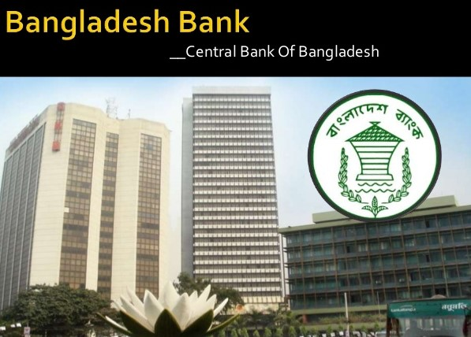

\

4.2 Functional Banks

4.2.1 Central Bank:
The central bank holds many responsibilities& authorities which defines its function. These are as follows.
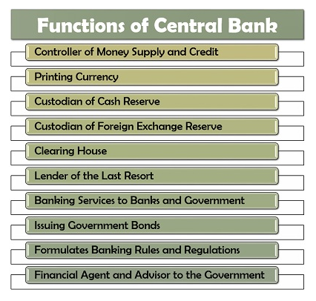

Figure: Functions of central Bank

The controller of money supply & credit: The central bank's main role is to monitor money supply and market loan flow using quantitative tools (bank rates, cash reserve ratio, statutory liquidity ratio and open transactions). And qualitative tools, i.e. the interest rate for loans fluctuates.
Printing currency: The central bank has the specialist of printing the summaries of all denominations excepts for TK. 1 notes & coins.
Custodian of cash reserve: All banks have central bank accounts where they can hold some money reserve for future requirements.
Custodian of Foreign exchange reserve: This bank is accountable for managing, controlling and exchanging a country's foreign currency & gold by keeping the foreign reserve and stabilizing the exchange rates.
Clearing House: The central bank functions as a mediator between the two or more commercial banks in order to settle their accounts at the moment of failure and handle the business banks ' transaction.

Lander of the last resort: One of the most important function central bank is to provides loans to commercial banks at the time of emergency, loss & insolvency.

Banking service to banks &governments: This bank provides all the general banking service & accepting deposit & sanctioning loans to the other banks & the government.

Issuing Government Bonds: The central bank issue various government bonds to generate funds, encourage public deposit & investments in the country.

Formulates Banking rules & regulation: This bank conducts multiple regulatory tasks such as licensing banks, framing banking standards and policies that prepare a mechanism for bank debt recovery, monitoring banking activities, etc. Even the central bank exercises moral suasion to make commercial banks adhere to so farmed strategies.

Financial Agent & Advisor to the Government: At the moment of economic crisis, fiscal deficit, and promoting loans to other nations, the central bank functions as a financial advisor to the state by the expert opinion supplier. Simultaneously, it also functions as an agent by representing the nation and government at global conferences and meetings, along with issuing government bonds and securities on behalf of public.

4.2.2 Commercial Banks:
The commercial banks have multiple function to perform. These are bifurcated into the following two heads each including multiple activities:

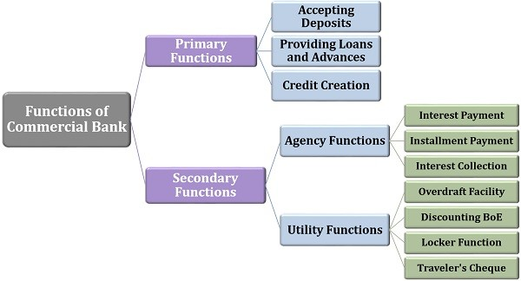
Figure: Functions of commercial Banks

Primary Functions: The commercial banks carry out different functions, the essentials one other as follows-

● Accepting Deposit: The banks received deposit from its customer by initiating them open current accounts, savings accounts, fixed accounts etc.
● Providing loans and advances: They also offer long term loan, demand loan, short term loan many other to fulfill the customer’s financial needs.
● Credit Creation: Investing the collected sum in the profitable ventures, equities, advancing loans to the business entities, etc. leads to a generation of profits for the banks.

Secondary Functions: Apart from the fundamental activities of commercial banks listed above, there are many secondary functions conducted by these banks in the following classifications.

● Agency Functions: Commercial banks act as agents to the public or the client by offering multiple payment and collection services on a weekly, monthly or annual basis by charging certain commissions.

● Commercial banks act as an agent by paying on behalf of their customers for different interests.

● They also pay the installments on loans borrowed from clients on a monthly, quarterly or annual basis, such as home loans, car loans or personal loans.

● They also make it easier for clients to pay taxes, mutual funds instalments and insurance premiums.

● The banks on behalf of their customers, collect their checks, interest rents, dividends etc.

Utility Functions: Other than the agency functions, the bank also provides other facilities to the public. Some of these are mentioned below:

● Commercial banks provide bank overdraft facilities to attract cash even in holders ' accounts ' zero balance condition.

● By discounting their bills of exchange and promissory notes, the banks provide cash to clients.

● The banks provide clients with lockers to maintain their jewelry and valuables with the banks in secure custody.

● Travel checks are also issued by commercial banks to perform during the clients ' trip to prevent loss or theft or cash.

4.2.3 List of Commercial Banks:

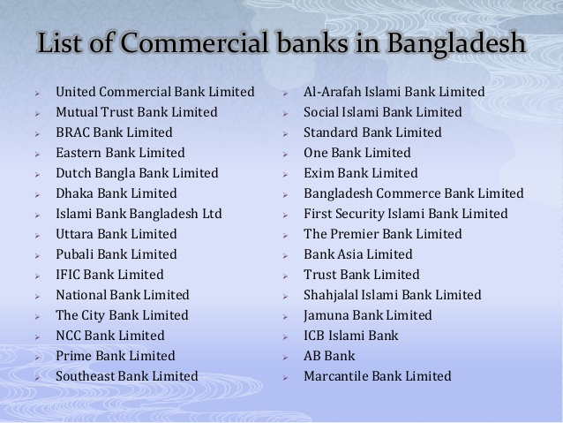

4.3 New Bank in Bangladesh:

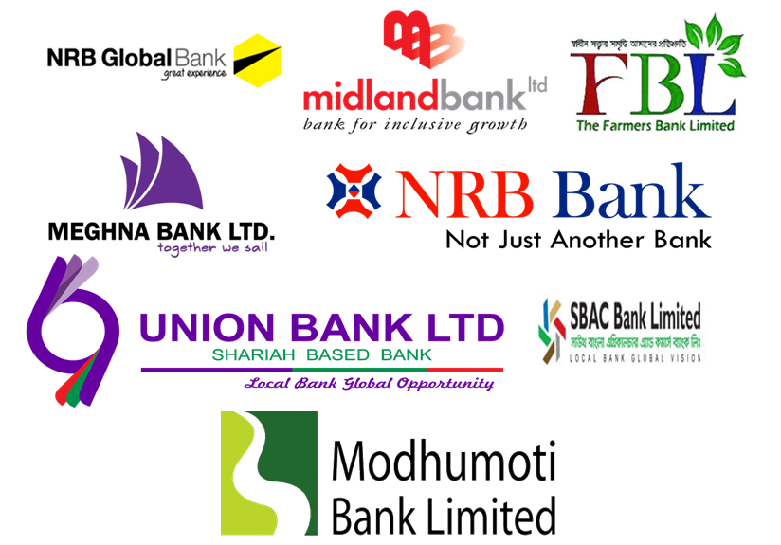

4.4 Problem of the Banking Sector in Bangladesh:
The banking sector problem is common and is not solely linked to the banking system. It should be autonomous but responsible to the regulatory entity. Prudential regulation should be restricted to institution-taking deposit and obviously separated from non-prudential regulation. The issue with the bank's reduced profitability is that it could lower the tax and thus trace the tax scheme where bank is the number one source of tax under NBR's big tax unit. In addition, the income goal may face another side's obstacle where reduced loan growth can influence investment & development, and hence tax collection.

4.5 Possibilities in the Banking Sector in Bangladesh:
Bangladesh's banking sector has enormous opportunities, so the following are provided:

● Bangladesh's banking sector has an excellent chance to become a significant domestic economy industry.

● There is an enormous population in Bangladesh. This benefit can accelerate the development and development of the banking sector in Bangladesh.

● The banking sector in Bangladesh is highly capable of ensuring the correct quality of the product service in line with the worldwide market requirements.

● In Bangladesh, there are ten overseas banks active, but no Japanese bank yet. So the Japanese bank has an enormous prospect of opening its branch in Bangladesh.

4.6 Banking Sector of Sustainable Growth:
The banking sector dominates the economic industry of Bangladesh. On the one side, the banking sector's dominance makes the financial industry vulnerable, but on the other, it emphasizes the resource sector's vital significance in mobilization and economic growth. The banking sector's function in accelerating development depends on the sector's soundness and depth. The banking sector in Bangladesh has traveled through a trip where several ups and downs have been encountered by the industry. In an effort to enhance the sector's structural limitations, reform measures were conducted.
Such steps were motivated by goals such as enhancing banks ' capital adequacy, streamlining rules for rescheduling multiple kinds of loans, tightening non-performing loan provision, enhancing discloser criteria, and enhancing the accounting system. Without a doubt, these have enhanced the sector's soundness over the years. However, the banking sector's performance It was not satisfactory in the latest past. Currently, key performance indicators of the country's commercial banks reflect banks ' poor health. Most banks were unable to demonstrate important improvements in indicators such as capital to risk-weighted assets, non-performing loans, expense revenue ratio, return on assets, return on equity, liquid assets and access liquidity despite several liquidities al measures taken by the central banks.

Increased such big economic irregularities in Sonali & core banks tracking Bangladesh Bank inspection. The also designated central bank observes 14 banks and economic functions, both state-owned and private, to monitor these banks ' further deterioration and carefully monitor their governance to enhance. However, the outcome remains to be seen in these banks ' performance indices.

For the state-owned banks (SOBs), profitability, measured by return on assets and return on equity, was negative. Though these indicators are positive for private commercial banks, they are very small. Similar performance is noted for non-performing loans (NPL). Although NPL's share of full loans in SCBs decreased significantly from June 2018 in September 2017, the rate remains as high as 21.82%. On the other side, NPL has risen in private business banks (PCBs) and foreign commercial banks (FCBs). Because of elevated NPL, bigger provisions must be made by state-owned banks.

These banks must be kept going by the government to inject funds. Clearly implementing BASEL 3 demands requiring an increase in the capital adequacy ratio to 12.5 percent of their risk-weighted assets by 2020 will be challenging for the SCBs. The capital adequacy ratio of SCBs as of September 2018 was only 6.2 percent.

Lower SCB earnings are primarily owing to poor assets, effectiveness, and interference with politics. In the case of PCBs, more stringent central bank compliance requirements and low private sector loan appetite owing to sluggish company setting are the main factors for the reduced profit. This is expressed in banks ' elevated liquidity quantity. The advance deposit ratio was just over 70%. in November 2018 even though banks are allowed to lend up to their 80% of their total deposit

Because of the 1990s, 2000s and later, the banking industry experienced significant success. In the coming days, the banking sector will have archived the capacity to absorb financial and economic stress shocks, enhance risk management & governance, and enhance transparency & disclosures for banks.

Chapter-05

Findings & Analysis

5.1 Comparison of Average operating Profit

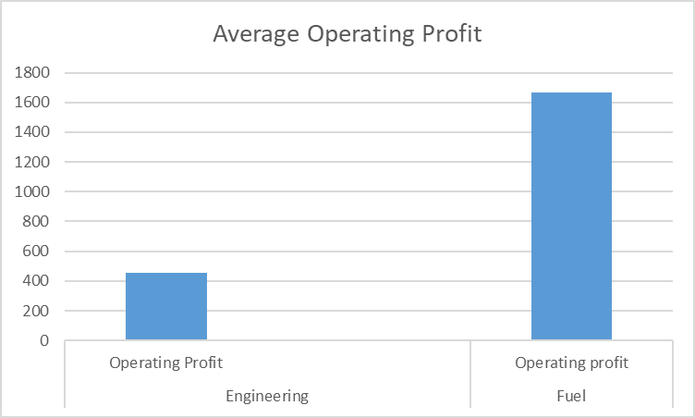
Figure:01 Average Operating profit

A profit from business operations before deduction interest and taxes. Operating profit serves as an indicator of the businesses potential profitability with all extraneous factors removed from the calculation. Operating profit is important because it is an indirect measured of efficiency. Operating Profit is an accounting figure that measured the profit earned from a company’s business operations, thus excluding deduction of interest and taxes. Here we can see that average operating profit of the both Engineering and Fuel Industry. Here we can also see that Fuel Industry has more average operating profit than Engineering industry. So Bank will more invest in the Fuel industry because of their average operating Profit has more than Engineering Industry.

5.2 Comparison of Average Total Asset

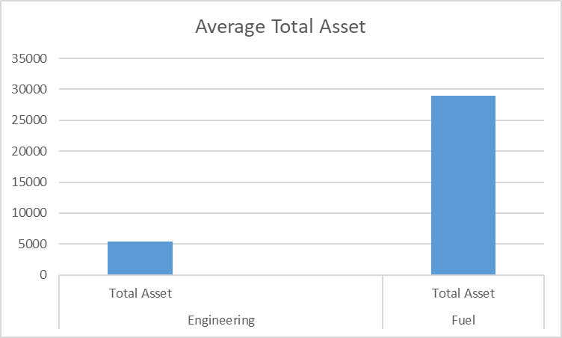

Figure-02 Average Total Asset

Total Assets Refers to the total amounts of assets owned by a person or entity. Total Assets relates to the complete quantity of resources held by an individual organization. Assets are also classified on the balance sheet as either current asset or long-term assets. A current asset such as account receivable and long-term assets such as fixed assets. Here Above the chart we can see that there are two industries Engineering and fuel and their average total assets so above this chart we can see that Fuel industries total assets has more average total assets than engineering industries company’s. so Bank will more loan or invest in Fuel industries because their average Total assets has more than engineering industries.

5.3 Comparison of Average Total Debt

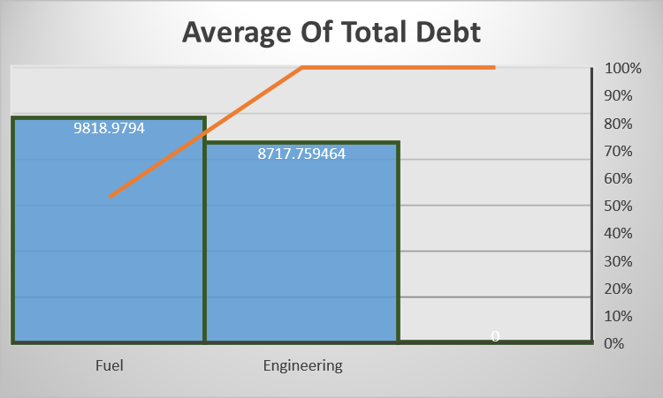

Figure-03 Average of Total Debt

Total Debt is the sum of all long-term liabilities is recognized on the company’s balance sheet. Total Debt is a term used most often when discussing organizational finance from the macro perspective and Total debt is combination both short term and long term debt. If we can see above that chart we can see that Fuel Industries average total debt is high and engineering industries average total debt has lower than fuel, in that case Bank will give the loan Bank will more invest in the Engineering industries cause their average total debt has low Bank could be think that engineering industries are not liable to others that’s why bank will more invest in engineering industryonly because of their low average total debt other than fuel industry. And Bank will not invest in the Fuel Industry the reason is their average total debt are higher than engineering industry so Bank will invest more in the engineering industry.

5.4 Comparison of Average Financial Expense

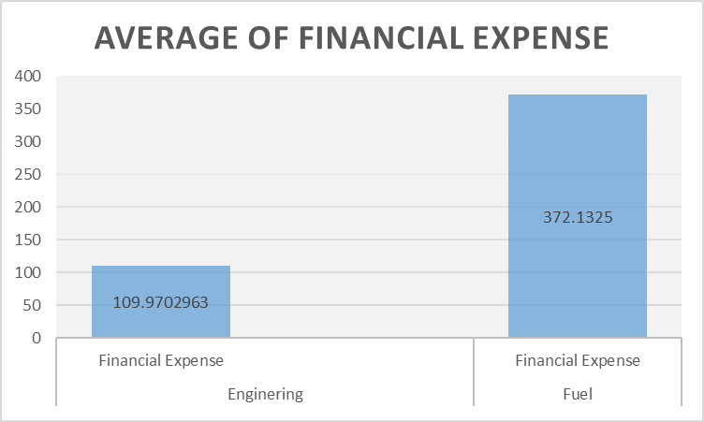

Figure-04 Average Financial Expense

Financial expense is any cost that happens when owing or renting an asset or property. Financial expense can mean a generally interest expense on long term debt it includes interest and related charges. Financial expense mainly refers as cost of financing and cost of borrowing money. If we see that figure-04 there are two companies’ here engineering and fuel and there average financial expense are given there. Here we can see engineering average financial expense and fuel average financial expense if we look at that graph or chart Fuel average of financial expense has higher than engineering average of financial expense. In that case Bank will give loan and more invest in the Fuel Industries Company only because of their financial expense is high. Bank will give more loan Fuel industry because if Bank will more invest in this company than this company will more Interest pay to the Bank. So above this chart we can say that Bank will more invest in the Fuel Industry.

5.5 Average of Cash Flow from Financial Activities

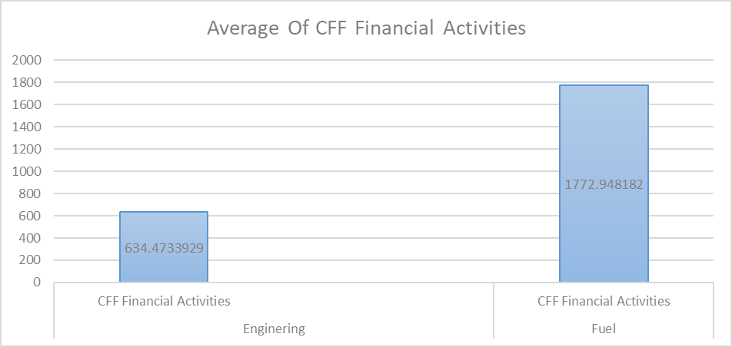

Figure-05 Average of CFF Financial Activities

Cash Flow from Financing activities is a segment of companies’ cash flow statement. Cash flow from Financing activities illustrations the net flow of cash that are used to fund the company. Financing activities includes the transaction involving debt, equity and dividends. Debt and equity financing are reflected in the cash flow from financing section which varies with the different capital structure, dividend policies or debt term that company’s may have. Cash flow from financing activities affords investor with into a company’s financial profession and how well a company’s capital structure managed. Above that chart here we can see Fuel industry has more CFF financing activities than engineering industry. So Bank will more invest in Fuel industry. Because Fuel financing activities are healthier than engineering financing activities.

Recommendations

In This Report we have two industries one is Engineering industry and another one is Fuel industry. Here given some suggestion for both of this industries that may help to reduce the problem in different areas that are given below:
In Case of Engineering Industry
- In the case of prospective investment practices Engineering companies need to increase and generate higher operating profit that will be more helpful and good portfolio of company to investors.

- Engineering industry also need to increase their Total asset if their assets increase for sure the company’s liabilities and equity by the same amount.

- For Better performance of the company engineering industry also need to find a way to generate increase financial expense because higher financial is better for the companies most of the company’s expense fall only because of sales, general and administrative expense, cost of goods sold and interest expense. So Engineering companies also need to increase their financial expense.

In case of Fuel Industry
- In case of prospective investment practices Fuel industry needs to reduce their Total debt because their total debt is higher than the engineering industry in that case Bank will not give the loan fuel industry so Fuel industry need to reduce their Total debt. High total debt is not good for any companies.

- They also need to reduce their financial expense as much as possible because high amount of financial expense could be the reason of net loss.

Conclusion

One of the biggest industry in our country is Engineering and Fuel industry. The growth of Engineering companies and Fuel companies is very impressive. Bangladesh has built a solid reference line and going to concerning self-reliant for the production of engineering machine and fuel power. Our Engineering companies and Fuel companies are successful in the domestic market. Basically in This Report we completed some task that are Data collection for both of these industries and we also analyzed some specific topic for both of these industries. For analyzing sector, we calculate the average of Total Assets, total Debt, Operating Profit etc. we showed our analysis from the graph and we also discussed about the banking industry profile in our country.

On The Other Side Modhumoti Bank Limited isthe public limited company which started their journey 19th September 2013. First customer service maintains sustainable growth and maintain corporate social responsibility is the main mission of the modhumoti bank.Modhumoti Bank limited introduced a very client friendly environment for digital banking system. They approach the market targeting the business people with the slogan “Your Access to Success”.

The Achievement section of Bangladesh Engineering & Fuel Sector is very pleasurable. It Had to collapsible a long tactic to succeed the current significant place in Domestic & International markets.

References

- Company overview: https://www.modhumotibankltd.com/
- Banking Industry Profile: https://www.bb.org.bd/
- Data Collection for Both Industries: https://lankabd.com/and Annual report both industries

