A Report
on
“The Financial Counterparty Credit Risk Management Process of Banglalink Digital Communications Limited.”
BANGLALINK
INTERNSHIP
REPORT ON





INT 4399 (SEC-A)

UNITED INTERNATIONAL UNIVERSITY

Internship Report
On

Financial Counterparty Credit Risk Management Process of Banglalink Digital Communications Limited

Submitted To
Muhammad Enamul Haque (MEH)
Assistant Professor
School of Business and Economics
United International University

Submitted by
Munira Akter
ID:111 152 108
Program BBA

Submission Date: 18th January, 2020

Letter of Transmittal

18th January, 2019
Muhammad Enamul Haque
Assistant Professor
School of Business and Economics
United International University.

Subject: Submission of Internship Report.

Dear Sir,
With due honor and respect I am pleased to submit my internship report on “Financial Counterparty Credit Risk Management Process of Banglalink Digital Communications Limited” as part of my BBA program requirement. While preparing this report, I tried my level best to follow your instructions and guidelines as per program requirement.

Throughout my working experience at Banglalink Digital Communications Limited, I have discovered and gained a lot of new and practical knowledge. By using my experience, skill and knowledge while working at Banglalink, I have prepared the report with full determination and sincerity to make it a success.

I shall be highly encouraged if you are kind enough to receive this report. If you have any further enquiry concerning any information, I would be pleased to answer any clarification.

Yours sincerely,
Munira Akter
ID: 111 152 108


Acknowledgement

First of all I would like to thank almighty Allah for giving me courage and patience to successfully complete my internship report I would like to thank my instructor Mr. Muhammad Enamul Haque, for being extremely supportive and considerate throughout my internship period. Due to his kind cooperation I was able to complete my internship smoothly.
I would also like to convey my deepest appreciation and gratitude to my supervisor Fahmida Rahman (Associate Finance Business Partner, Treasury Department) for being an very emphatic mentor in guiding me throughout the whole course of Internship project and her contribution in guiding, suggestions and encouragement have helped me to successfully complete my work and groomed me in writing this report.
Furthermore, I would like to show gratitude to all the colleagues working in the treasury department of Banglalink for being helpful to me during my entire internship period and providing me with the necessary information required to prepare my report. I would also like to thank all the employees of Banglalink Digital Communications Limited for helping me in the workplace. I am very grateful to everyone who helped me during my internship period and made my experience a memorable one.

Executive Summary

The objective of the report is to analyze the financial counterparty credit risk management process of Banglalink Digital Communications Limited. This study is the reflection of my learning from my responsibilities and experiences from doing my internship at Banglalink. To prepare this report, the required information was collected from both primary sources and secondary sources. I did my internship at the treasury department of Banglalink Digital Communications limited.
In this report it was studied how the credit risk of the financial counter parties of Banglalink are evaluated using seven factors. Each factor has a standard that the financial counter parties have to maintain. By checking these factors we can get idea about the credit risk of the financial counterparties of Banglalink.
By analyzing all the financial counterparties of Banglalink Digital Communications limited based on each of the seven factors we came to the conclusion that Brac Bank, Standard Chartered Bank and Pubali Bank Limited show the least credit risk, and Mutual Trust Bank and Islami Bank Bangladesh Limited have the highest credit risk among the financial counterparties. The rest of the financial counterparties of Banglalink seems to have low credit risk. And Banglalink is recommended to increase their credit limit for Brac Bank, Standard Bank and Pubali Bank as they carry the least credit risk among all the financial counterparties of Banglalink. And as Mutual Trust Bank and Islami Bank Bangladesh Limited shows the highest credit risk among its financial counterparties Banglalink should reduce credit limits for these banks. If these banks continue to show higher credit risk in the future Banglalink should close accounts with these banks and shift to other banks with lower credit risks if possible.

Table of Content

Chapter One: Introduction | 1
Company Profile | 2
Vision of Banglalink | 3
Values of Banglalink | 3
Purpose of the Study | 6
Objective of the Study | 6
Data Collection Sources | 6
Limitation Of The Study | 7
Chapter Two: Financial Counterparty Credit Risk Management Policy | 8
Financial Counterparty Credit Risk Management Policy of Banglalink | 9
Responsibility of Organizational Units | 15
Chapter Three: Financial Counterparty Credit Risk Management | 18
Financial Counterparties of Banglalink | 19
Credit Risk Analysis of The Counterparties of Banglalink | 20
1% of Total Asset | 21
Liquidity Coverage Ratio | 23
Loan to Deposit Ratio | 25
Tier 1 Capital Ratio | 27
Capital Adequacy Ratio | 29
NPL Ratio | 31
Allowance on loan losses Ratio | 33
Conclusion | 35
Reference: | 36
Appendix | 37



Introduction

Chapter One
Introduction to Banglalink

Banglalink Digital Communications limited started its operation in Bangladesh in February 2005. Currently Banglalink is the third largest telecom network of Bangladesh with 33.69 million active subscribers. Banglalink Sims represent almost 22 percent of the market. Banglalink was one of the pioneers in the telecom industry of Bangladesh to make mobile telephones cheap and affordable. The mission of Banglalink was “Bringing mobile telephones to the masses” persuaded Banglalink to find ways to offer quality services in the cheapest rates possible. This was one of the main reason of Banglalink being a success with in a very short time of its starting operations in Bangladesh. 
Its strong core values also facilitated the success of Banglalink. These core values are Customer-obsessed, Entrepreneurial, Innovative, and Collaborative & Truthful. As Banglalink has already reached is goal of making mobile phone services affordable it currently is working on introducing the digital world to its customers. It is currently transitioning from being a traditional mobile operator to a tech company. For the recent years it is working closely with tech startups by providing them funds and other technical supports.
To ensure that the customer get the best experience Banglalink has heavily focused on digitalizing and updating the way the they engage, interact, operate and provide services to their customers. The present mission of Banglalink is to enable its customers to enjoy the perks of an updated digital future. To ensure this Banglalink is heavily investing their efforts and funds in creating a strong digital ecosystem by providing innovative products and services.

Banglalink is not only dedicated to its customers, rather it is also a great place for employees as it provides equal opportunity to its employees and is very strict against any non-compliance activity. The head quarter of Banglalink, known as Tigers Den is the first certified Green Office by World Wide Fund for Nature also known as WWF in Bangladesh. The organization structure of the company is relatively flat allowing more connection and interaction between employees from all levels of the management.
Banglalink is a fully owned company of Telecom Ventures Ltd. The major shareholder of this company is VEON, which is a NASDAQ and Euronext Amsterdam Listed telecom connectivity provider company. It is currently serving more than 235 million customers with a global presence in Algeria, Armenia, Bangladesh, Georgia, Italy, Kazakhstan, Kyrgyzstan, Laos, Pakistan, Russia, Tajikistan, Ukraine and Uzbekistan. (Banglalink.net, 2019)
Vision of Banglalink



Values of Banglalink

Collaborative

Innovative



Truthful



Entrepreneurial

Customer-Obsessed

(Annual Report 2015, 2015)

PURPOSE OF THE STUDY
The purpose of the study is to analyze and reflect on the experiences and learning achieved of a subject while working on it in the internship program.

ORIGIN OF THE STUDY
This project has been prepared as a requirement for my Internship course. The study is to focus on one of the processes I was involved working while doing my internship at Banglalink Digital Communications Limited. In this study I have analyzed the process through which Banglalink manages the credit risks of its financial counter parties.

OBJECTIVE OF THE STUDY
The main objective of this project is analyze the financial counterparty credit risk management process of Banglalink Digital Communications Limited.

DATA COLLECTION SOURCES
To prepare this report, the required information was collected from primary sources and secondary sources. The policy and practices of Credit Risk Management of Banglalink was mainly collected from primary sources. The data used to analyze the credit risk of the counterparty financial institute of Banglalink has been collected from the annual reports of the each banks respectively.
Primary Source of Data:
- Experience gained from completing tasks at internship
- Direct Interactions with Supervisor and Coworkers
Secondary Sources of Data:
- Website of Banglalink Digital Communications Ltd.
- Annual Reports of Banglalink Digital Communications Ltd.
- Policy handout notes of Banglalink Digital Communications Ltd.
- Annual Reports of the Banks analyzed in the report.
LIMITATIONS OF THE STUDY
Although utmost dedication was given in the preparation of this report, the report may not be perfect as there were some limitation that was faced while making this report. They are as follows:
Time constraint: Although I was able to learn a lot during my three month period of internship, it was not enough to achieve in depth knowledge about the credit risk management process as I was not involved in all the steps of the process. Hence I was unable to conduct more in- depth and detail oriented analysis and include that in my report.
Confidential information: Every organization maintains its own secrecy. Banglalink Digital communications limited was no exception to this. Some of my colleagues did not disclose enough information for the sake of confidentiality of the organization.

Chapter Two
Financial Counterparty Credit Risk Management Policy
Financial Counterparty Credit Risk
Management Policy of Banglalink

1. Policy Definition
Counterparty Credit Risk Management is defined as the process of managing the credit risk towards VEON Group’s (Parent company of Banglalink Digital Communications Limited) financial counterparties and involves identifying, measuring, managing, monitoring and reporting of counterparty credit risk. The Counterparty Credit Risk Management Policy provides the objectives, policy statements and responsibilities with regard to counterparty credit risk management.

Counterparty credit risk applies whenever Banglalink Digital Communications Limited is exposed to non-performance by a counterparty. It therefore includes the risk of a customer failing to pay for goods or services or a supplier failing to provide goods or services which are already committed to/paid for. However, for the purpose of this policy, counterparty credit risk management shall be limited to financial counterparties only, i.e. financial institutions which are conducting financial transactions with Banglalink Digital Communications Limited. Financial transactions at Banglalink Digital Communications Limited currently include bank deposits, funding, money market fund investments, FX and interest rate derivatives, guarantees and letters of credit, cash management, supply chain finance and trade credit insurance.

2. Objectives
  - To safeguard the current and future fair value of the assets of the Banglalink Digital Communications Limited;

  - To identify, measure, analyze and manage counterparty credit risks, against approved counterparty credit limits, in a systematic manner;

  - To minimize Banglalink Digital Communications Limited’s potential losses from counterparty defaults.

3. Risk Assessment
Counterparty credit risk is the risk that Banglalink Digital Communications Limited’s financial counterparty fails to meet its obligations in accordance with agreed terms. The potential credit exposure with financial counterparties is determined. The credit risk of the financial counter parties of Banglalink Digital Communications Limited are evaluated based of a total of seven categories. Each category has a standard that the financial counter parties has to maintain. Banglalink checks how well its financial counterparties are maintaining the standards of each category to analyze their performance. Based on the analysis of the credit risk decisions about the financial counter parties are taken. The seven categories used for the credit risk analysis by Banglalink are,

4. Policy Statements
This section describes the various policy statements on counterparty credit risk management. The Standard Operating Procedures (SOP) describe in further detail the process and execution of this policy.

4.1 General principles
The counterparty credit risk management policy is based on the following principles:
- To do business with financially sound counterparties only;
- To limit the concentration of exposure (diversification);
- To limit the tenor of investments to 3 months (92 days);
- To put in place legally enforceable offset arrangements with counterparties;
- To make use of legally enforceable collateral in specific cases.

Banglalink Digital Communications Limited’s HQ Treasury, IHB and OpCo Treasury are jointly responsible to make sure the above mentioned principles are followed at all times and shall fulfil their responsibilities by closely working together.

4.2.1 Limit Setting and Exposure Determination
- HQ Treasury is responsible for maintaining a list of approved financial counterparties and maintaining the corresponding credit limits on a total and country-level (see Appendix).

- Counterparties are classified per Credit Risk Class (CRC). As a rule, Banglalink Digital Communications Limited would only deal with CRC 1 and CRC 2 counterparties.

- CRC 3 and CRC 4 counterparties are dealt with only if there are no CRC 1 and 2 alternatives and the general rule is to keep the exposure to these counterparties at a minimum.

- The list of approved financial counterparties and credit limits are determined by Group Director Corporate Finance or Group Treasurer with input from OpCo Treasury, IHB and HQ Treasury and ultimately approved by Group CFO.

- Credit limit setting will be done by applying appropriate credit risk measurement methodologies based on calculation of an “Expected Loss” determined by “Probability of Default", “Exposure at Default” (i.e. NFA) and Loss Given Default.

- The Probability of Default and “Loss Given Default” will be estimated on a qualitative credit assessment of financial counterparties incorporating the following criteria:

- Based on this credit assessment a maximum “Exposure at Default”/NFA position will be derived representing the credit limit for a specific counterparty.

- OpCo Treasury shall perform an annual review of all Tier 3 financial counterparties (see Bank Relationship Management Policy) and corresponding limits and report this information, including proposed new/changes limits to IHB.

- IHB shall perform an annual review of all Tier 1 and Tier 2 financial counterparties and corresponding limits.

- IHB shall propose new/changed limits for review by Group Director Corporate Finance or Group Treasurer and ultimate approval by Group CFO. OpCo Treasury is responsible to monitor OpCo country level credit exposures on a daily basis. IHB is responsible to monitor global/total credit exposures for financial counterparties on a daily basis.

- The exact approach to determine and monitor credit exposures is detailed in the SOP document for Counterparty Credit Risk Management.

4.2.2 Early warning monitoring and reporting
- Early warning indicators related to a specific counterparty include any market intelligence or indicators with potentially negative outcomes (e.g. credit rating downgrade, change of CDS spread). The types of possible early warnings are further detailed in the SOP.
- OpCo Treasury shall monitor and report early warning signals for OpCo financial counterparties to IHB. IHB and HQ Treasury who shall determine required actions.
- IHB shall monitor and report early warning signals for HQ level financial counterparties to HQ Treasury who shall determine required actions.

4.3 Credit risk mitigation
- It is required to manage cash balances close to zero by (a combination of) repayment of debt, making use of flexible funding arrangements to cover operational cash requirements (rather than cash buffers) and/or up-streaming of excess cash (e.g. through dividend payments or intercompany loans).
- HQ Treasury must approve the level of local cash buffers/excess cash per OpCo in the case that (committed) credit lines for this purpose are not available.
- In the event of a (foreseen) credit limit breach, OpCo Treasury and IHB shall determine mitigating actions to resolve the situation within 2 business days in consultation with HQ Treasury.
- If a limit is breached, one or more of the following actions shall be considered:

- No new transactions to be conducted with the counterparty;
- Reverse or unwind any transactions with the counterparty (including transfer of cash elsewhere);
- Enter into hedging transactions to limit the exposure to an acceptable level;
- Enter into a collateral agreement with the counterparty;
- Request a higher credit limit or temporary exception via HQ Treasury which will coordinate necessary approval from Group Director, Corporate Finance or Group Treasurer and Group CFO.

4.4 Approved Instruments
Credit Default Swaps (CDS) for risk mitigation are allowed with approval required from Group Director Corporate Finance or Group Treasurer, Group CFO or Supervisory Board in accordance with the Group Authority Matrix.

4.5 Miscellaneous
All situations/processes not explicitly covered by the Counterparty Credit Risk Policy or related procedures shall be aligned with HQ Treasury prior to undertaking any actions.
Any exception to or deviation from this policy, structural or on a one-off basis, must receive prior approval from HQ Treasury which will coordinate any additional necessary approvals from Group Director, Corporate Finance or Group Treasurer and Group CFO.

5. Control and Reporting
- OpCo Treasury monitors OpCo country level credit exposures on a daily basis and reports early warning signals to HQ Treasury and IHB as they are identified.

- IHB monitors global/total credit exposures for financial counterparties on a daily basis and reports early warning signals to HQ Treasury as they are identified.

- IHB reports the consolidated group credit exposure to financial counterparties on a monthly basis in the monthly Treasury Management Report.

- OpCo Treasury and IHB perform an annual review of all financial counterparties and corresponding limits.

Policy review and control:
On an annual basis, Group Director, Corporate Finance or Group Treasurer shall assess the effectiveness and efficiency of the current Counterparty Credit Risk Management Policy and credit limits and adjust it to reflect changes in exposures, Group priorities and/or market developments.

Policy compliance:
Monitoring of the Counterparty Credit Risk Management Policy compliance is executed by the Manager – Treasury Back Office. Any breaches of the policy shall be reported to the Group Treasurer, Group Director Corporate Finance and Group CFO and in the Treasury Management Report. (Banglalink , 2018)

6. Responsibilities of Organizational Units
The diagram in the next page summarizes the primary responsibilities of different organizational units regarding the Counterparty Credit Risk Management;

Responsibilities of Organizational Units
Supervisory Board
- Approve CDS transactions in accordance with Group Authority Matrix.
Group Director Corporate Finance
- Review and pre-approve all items which are provided to Group CFO and Supervisory Board for approval.
Group CFO
- Review and pre-approve all items which are provided to Supervisory Board for approval.
- Approve the Counterparty Credit Risk Management Policy.
- Approve new/changed/temporary counterparty credit limits for all financial counterparties.
- Approve CDS transactions in accordance with Group Authority Matrix.
- Authorize specific exceptions to Counterparty Credit Risk Management Policy.
Responsibilities of Organizational Units (continued)

Group Treasurer
- Review and pre-approve all items which are provided to Group CFO and Supervisory Board for approval.
- Review Counterparty Credit Risk Management Policy.
- Determine new/changed/temporary credit limits for all financial counterparties.
- Approve CDS transactions in accordance with Group Authority Matrix.
- Authorize specific exceptions to Counterparty Credit Risk Management Policy.
HQ Treasury
- Monitor the Group’s overall counterparty risk management process.
- Assign new counterparty credit limits and update policy.
- Monitor and report early warning signals.
- Review and adjust the Counterparty Credit Risk Management Policy.
Responsibilities of Organizational Units (continued)

IHB (In House Bank)
- Perform (annual) review of counterparties.

- Monitor and report early warning signals for HQ level financial counterparties.

- Monitor global/total exposure per counterparty.

- Propose new counterparty limits.

- Resolve limit breach when identified.

- Report consolidated group credit exposure and limit breaches to CFO and update limits in TMS.

OpCo Treasury
- Monitor and report counterparty risk for local counterparties.
- Resolve limit breach when identified.
- Request new limits.
- Monitor and report early warning signals for local financial counterparties.
- Ensure alignment with other departments.
- Support assessment of counterparty creditworthiness.

Financial Counterparty Credit Risk Management of Banglalink

Chapter Three
Financial Counterparties of Banglalink
The treasury department of Banglalink Digital Communications Limited manages the credit risk of its financial counterparties. As I was an intern working in the treasury department I also got the opportunity to provide input in the process of credit risk management. For managing the credit risk Banglalink Digital Communications Limited sets credit limits for each of its financial counterparties based on their previous year’s performances. In my internship I was given the responsibility to prepare the credit limit setting form for each of the financial counterparties of the Banglalink Digital Communications Limited this forms helps the CFO to finalize the credit limits. Banglalink Digital Communications Limited mainly has 12 (twelve) financial counter parties, these are:













Credit Risk Analysis of the Counterparties of Banglalink
The credit risk of the financial counter parties are evaluated based of the following seven factors. Each factors has a standard that the financial counter parties have to maintain. By checking these factors we can get idea about the credit risk of the financial counterparties of Banglalink. If the counterparties are maintaining all of the standards successfully then we can say that counterparty is very safe and has minimal credit risk and if any counterparty fails to meet more than 3 standards the responsible department will try to reduce its deposits and lower the credit limits in those counterparties as the analysis indicates higher credit risks for those counterparties. The seven categories and their standards used for the credit risk analysis by Banglalink are as followed;
- 1% of Total Asset
(Standard: >2,000,000,000 BDT)
- Tier 1 Capital Ratio
(Standard: >6%)
- Capital Adequacy Ratio
(Standard: >10%)
- Liquidity Coverage Ratio
(Standard: >100%)
- Non-Performing Loan Ratio
(Standard: <5%)
- Allowances on Loan Losses Ratio
(Standard: 3% to 10%)
- Loan to Deposit Ratio
(Standard: >80% to 95%)

In the next part of this report we are going to check each of these factors for the 12 previously mentioned Bank which are the financial counterparties of Banglalink Digital communications limited and analyze their credit risk by glancing whether they are being able to maintain the standards or not.
1% of Total Asset
The initial factor that is checked of the financial counterparties of Banglialink Digital Communications Limited is the 1% of total assets. It is used for checking the size of the financial counterparty or the bank. Banks that are bigger in size are usually more stable in events of economic uncertainties. This is why Banglialink Digital Communications Limited considers financial counter parties or banks of bigger size to have less credit risk.
Standard: 1% of the total asset of the counterparty should be minimum 2,000,000,000 BDT
Bank | 1% of Total Asset | Maintained Standard in 2019
Brac Bank | 3,580,046,261 (BDT) | YES
Bank of Ceylon | 609,771,800 (BDT) | NO
Eastern Bank | 2,855,000,699 (BDT) | YES
City Bank | 3,269,404,388 (BDT) | YES
Citi NA | 458,516,784 (BDT) | NO
MTB | 2,224,448,979 (BDT) | YES
Primier Bank | 2,168,098,811 (BDT) | YES
Pubali Bank | 4,102,256,931 (BDT) | YES
South East Bank | 3,815,756,789 (BDT) | YES
Dutch Bangla Bank Limited | 3,464,687,910 (BDT) | YES
Islami Bank Bangladesh Limited | 9,979,593,031 (BDT) | YES
Standard Chartered Bank | 3,794,992,424 (BDT) | YES

Banglialink Digital Communications Limited has set the standard for 1% of total assets of its financial counterparty or bank to be a minimum of 2,000,000,000 taka. If the 1% of the total asset of the financial counter party or bank is higher than 2,000,000,000 taka it is considered to be a comparatively bigger bank and considered to have lower credit risk, where as if a financial counterparty’s 1% of total asset is lower than 2,000,000,000 taka it is considered to be somewhat riskier than the bigger banks.

Standard
>2,000,000,000
Among the twelve financial counterparties of Banglalink Digital Communications Limited ten of the financial counterparties are maintaining the standard of 2,000,000,000 taka. Among them Islami Bank Bangladesh has the highest, its 1% of total asset is almost 5 times higher than the standard set by Banglalink’s finance department. The two financial counterparties or banks that are failing to maintain the standard are Commercial Bank of Ceylon and Citi NA. The 1% of their total asset are respectively 609,771,800 taka and 458,516,784 taka. But it should be noted here that this factor is insignificant for both this banks as both of these are international banks, and here only their local assets have been considered. Other than these two banks Mutual Trust Bank and Premier bank are almost equal to the standard so considering the 1% of total asset factor Islami Bank Bangladesh Limited has the lowest credit risk and MTB and Premier Bank Limited has higher credit risk than the other counterparties of Banglialink Digital Communications Limited
Liquidity Coverage Ratio
The liquidity coverage ratio is used to evaluate whether a financial institution has sufficient capital during short-term liquidity disruptions in the economy. It basically shows how much of its 30 days cash-flows can be funded by its high quality liquid assets. High quality liquid assets include cash, central bank reserves, government securities, corporate debt securities etc. (Investopedia.com, 2019)
Standard: Liquidity coverage ratio of the counterparty should be minimum 100%
Bank | Liquidity Coverage Ratio | Maintained Standard in 2019
Brac Bank | 143.54% | YES
Bank of Ceylon | 278.38% | YES
Eastern Bank | 127.67% | YES
City Bank | 115.33% | YES
Citi NA | 153.00% | YES
MTB | 110.62% | YES
Primier Bank | 114.07% | YES
Pubali Bank | 264.48% | YES
South East Bank | 123.37% | YES
Dutch Bangla Bank Limited | 144.33% | YES
Islami Bank Bangladesh Limited | 169.05% | YES
Standard Chartered Bank | 341% | YES

The Basel Committee on Banking Supervision (BCBS), under the BASEL III regulatory has made it mandatory for the banks to maintain a minimum of 100% of Liquidity coverage ratio (James Chen, 2019). In this factor Banglalink Digital Communications limited set the standard same to be same at 100%. But higher liquidity coverage ratio indicates that the financial counterparty has more capability to ride out any short-term liquidity disruptions. So financial counterparties that have higher liquidity coverage ratio is considered to have lower credit risk.

Standard
>100%
All the financial counterparties or banks of Banglalink Digital Communications limited can be observed maintaining the standard of liquidity coverage ratio. Among all the financial counterparties Standard chartered bank has the highest liquidity coverage ratio of 341%. Commercial Bank of Ceylon and Pubali Bank also has impressive liquidity coverage ratio, the ratio of these two banks are 278.38% and 264.48% respectively. This means these banks have higher capability to sustain a short term liquidity crisis compared to the other counterparties, so this means they have lower risk to become default thus low credit risk. Although Mutual trust bank, Premier Bank and City Bank are maintaining standard they are almost equal to the standard are lower than most of the other financial counter parties in terms of liquidity coverage ratio so among the counterparties of Banglalink Digital Communications Limited, considering the LCR factor Banglalink faces higher credit risk from these three banks as these banks will face trouble if the liquidity disruption continues more than 30 days.
Loan to Deposit Ratio
Another important factor evaluated by Banglalink is the LDR or loan to deposit ratio of its financial counterparties. The Loan to deposit ratio shows how much a bank has loaned to its customers against every taka of deposit it received. (Chris B Murphy, 2019). Banglalink uses this factor to measure whether the bank will have significant reserves available for expected or unexpected contingencies.
Standard: Loan to deposit ratio of the counterparty should be between 80-95%
Bank | Loan to Deposit Ratio | Maintained Standard in 2019
Brac Bank | 104% | NO
Bank of Ceylon | 110.70% | NO
Eastern Bank | 109.20% | NO
City Bank | 113.00% | NO
Citi NA | 55.40% | NO
MTB | 100.00% | NO
Primier Bank | 92.60% | YES
Pubali Bank | 88.10% | YES
South East Bank | 89.70% | YES
Dutch Bangla Bank Limited | 83.10% | YES
Islami Bank Bangladesh Limited | 104% | NO
Standard Chartered Bank | 110.70% | NO

Banglalink Digital Communications Limited consider the ideal loan-to-deposit ratio to be 80% to 95%. If a financial counterparty has higher loan to deposit ratio than this standard Banglalink considers it to be risky as it is loaning out almost equal or more than its deposit thus stands in a higher risk if any negative financial contingencies occur. Also if a financial counterparty has lower than the standard it indicates that the financial counterparty may be failing to use its deposits efficiently and effectively to generate profit.
Standard
80% - 95%

}
It can be realized that most of the financial counterparties are failing to maintain the standard loan to deposit ratio set by Banglalink. Brac Bank, Commercial Bank of Ceylon, Eastern Bank and City Bank has loan to deposit ratio higher than 100% this means they lending more money to their customers as loans than what they are receiving as deposits. Among all the financial counterparties of Banglalink, City Bank has the highest loan to deposit ratio, its LDR is 113%. This means for every 100 taka deposit City Bank is lending 113 taka as loan to its customers. This puts them in high risk if any financial downturn occurs or unexpected fund is required by the banks. On the other hand, Citi NA and Standard Chartered bank has very low loan to deposit ratio. This indicates they are not utilizing their deposits enough to generate revenue. Premier Bank, Pubali Bank, South east Bank and Dutch Bangla Bank is maintaining the standard loan to deposit ratios, so considering the LDR factor Banglalink perceives these banks to be less risky as they will be less affected in case of any financial downturn, unexpected fund requirement or increase in loan default.
Tier 1 Capital Ratio
The tier 1 capital ratio is calculated by a bank’s core tier 1 capital by its total risk weighted assets. The tier 1 capital ratio measures the financial strength of a bank, this ratio is so significant in measuring the financial strength of a bank that it has been adopted as a part of the Basel III Accord on bank regulation. (Will Kenton, 2019)
Standard: Tier 1 Capital ratio of the counterparty should be above 6%
Bank | Tier 1 Capital Ratio | Maintained Standard in 2019
Brac Bank | 12.31% | YES
Bank of Ceylon | 11.34% | YES
Eastern Bank | 9.26% | YES
City Bank | 8.29% | YES
Citi NA | 12.54% | YES
MTB | 6.38% | YES
Primier Bank | 7.92% | YES
Pubali Bank | 8.57% | YES
South East Bank | 7.54% | YES
Dutch Bangla Bank Limited | 9.30% | YES
Islami Bank Bangladesh Limited | 8.51% | YES
Standard Chartered Bank | 17.61% | YES

The BASEL Accord makes it mandatory for the banks to maintain a minimum tier 1 capital ratio of 4.5%. Banglalink has set the standard a little higher than that at 6%, the reason being it measures the core financial strength of the financial counterparties. Tier 1 capital include bank's common stock, retained earnings, accumulated other comprehensive income (AOCI), noncumulative perpetual preferred stock and any regulatory adjustments to those accounts. It represents the amount of capital that allows a bank to absorb losses without affecting interests of depositors. So financial counterparty with higher tier 1 capital ratio is considered to be less risky by Banglalink.
Standard
> 6%

All the financial counterparties of Banglalink Digital Communications Limited can be seen maintaining higher than the standard tier 1 capital ratio. The higher the tier 1 capital ratio the lower risk the financial counterparty opposes. Among all the financial counterparties of Banglalink, Standard Chartered Bank has the highest tier 1 capital ratio. The ratio of Standard Chartered is almost 3 times the standard ratio, its tier 1 capital ratio is 17.61%. Brac Bank and Citi NA can be seen maintaining a tier 1 capital ratio that is 2 times higher than the standard. Considering the tier 1 capital ratio factor Standard Chartered, Brac Bank and Citi NA are the safest financial counterparties of Banglalink. Among all the financial counterparties Mutual trust bank has the lowest tier 1 capital ratio. Its tier 1 capital ratio is 6.38%. Although this doesn’t mean Mutual Trust Bank has high credit risk, this indicates that among the current financial counterparties of Banglalink, mutual trust bank has higher credit risk compared to the financial counterparties considering the tier 1 capital ratio factor.

Capital Adequacy Ratio
Capital adequacy ratio is measured to see if the bank has enough cushion to absorb a fair amount of losses before it becomes insolvent. (Adam Hayes, 2019) According to the Basel III accord a bank has to maintain a minimum Capital Adequacy Ratio or CAR of 8%. This is maintained to ensure stability of a nation’s financial system.
Standard: Capital Adequacy Ratio of the counterparty should be above 10%

Bank | Capital Adequacy Ratio | Maintained Standard in 2019
Brac Bank | 13.67% | YES
Bank of Ceylon | 12.88% | YES
Eastern Bank | 12.02% | YES
City Bank | 12.19% | YES
Citi NA | 20.00% | YES
MTB | 12.86% | YES
Primier Bank | 12.27% | YES
Pubali Bank | 12.17% | YES
South East Bank | 12.38% | YES
Dutch Bangla Bank Limited | 15.60% | YES
Islami Bank Bangladesh Limited | 11.97% | YES
Standard Chartered Bank | 19.23% | YES

Banglalink set the standard for its financial counterparties to be 10% which is higher than the Basel requirement. Banglalink prefers banks with high capital adequacy ratio as financial counterparties as they have less risk of becoming insolvent. If any financial counterparty has higher capital adequacy ratio Banglalink considers it to be safe and likely to meet its financial obligations without difficulties.
Standard
> 10%

All the financial counterparties of Banglalink seems to be maintaining higher than the standard capital adequacy ratio. This means all the financial counterparties have enough cushion to absorb a fair amount of losses before becoming insolvent and lose depositors funds. Among all the financial counterparties of Banglalink Citi NA has the highest capital adequacy ratio of 20% which double of the standard set by Banglalink. Standard Chartered bank also has almost the double of the standard, a capital adequacy ratio of 19.23%, Dutch Bangla Bank Limited also has an impressive capital adequacy ratio of 15.60%. These are the safest financial counterparties of Banglalink considering capital adequacy ratio as they have very low possibility to become insolvent if any financial disruption occurs. Consider this factor these financial counterparties of Banglalink has the lowest credit risk.

NPL Ratio
NPL or Non-Performing loan refer to those loans which has not received any payment for the period of last 120 days. Non-Performing loan are considered default or almost default loans. (Troy Segal, 2019) NPL ratio indicates how much of the total loans of a bank are non-performing loans. It basically how well the banks are managing its loan.
Standard: Non-performing loan ratio of the counterparty should be lower than 4%
Bank | NPL Ratio | Maintained Standard in 2019
Brac Bank | 4% | YES
Bank of Ceylon | 0.80% | YES
Eastern Bank | 2.30% | YES
City Bank | 5.30% | NO
Citi NA | 5.90% | NO
MTB | 5.40% | NO
Primier Bank | 4.00% | YES
Pubali Bank | 8.70% | NO
South East Bank | 5.60% | NO
Dutch Bangla Bank Limited | 6.20% | NO
Islami Bank Bangladesh Limited | 8.51% | NO
Standard Chartered Bank | 3.10% | YES

Higher Nonperforming loan ratio means the bank is failing to effectively collect loan repayments, so always lower nonperforming loan ratio is preferred. Banglalink has set the standard of NPL ratio to be lower than 5% for its financial counterparties. If the financial counterparties have higher nonperforming loan ratio Banglalink considers them to be risky as they are failing to maintain high quality loan portfolio and seems to be engaging in high risk loans which can eventually lead to bank failure.
Standard
<5%

It can be seen than almost half of the financial counterparties of Banglalink are failing to maintain the NPL ratio standard set by Banglalink. Among them Pubali bank and Islami bank have very high nonperforming loans ration, their NPL ratio are 8.70% and 8.51% respectively. This could be because they are not being able to screen their customers effectively before lending loans or lending in high risk loans. Both this can be risky as they can cause bank failures. Along with them City Bank, Citi Na, MTB, South east Bank and Dutch Bangla Bank Limited have higher Nonperforming loans ratio which indicates they are less effective in collecting loan repayment from their customers. The reason because of so many financial counterparties failing to keep their nonperforming loan ratio low could be because of the nationwide rise in non-performing loans due to changes in policies by Bangladesh Bank. Considering the NPL ratio factor Commercial Bank of Ceylon, Eastern Bank and Standard Chartered Bank show least credit risk for Banglalink as they have a very low NPL ratio which indicates they are managing their loans effectively.
Allowance on loan losses Ratio
Banks cannot recover all of its lending’s, many customers fail to pay their loans also banks sometimes lend loans to risky customers in expectations of high interest rates. To recover from these loan losses banks estimate the loans that might not be paid and reserve a portion of money to recover from that loss. This is called the allowance on loan losses. (Giulio Rocca, 2019) The allowance on loan losses ratio is calculated by dividing allowance on loan losses by total loans of the bank. This ratio indicates how much of the total loan is covered for expected loan losses.
Standard: Allowance on loan losses ratio of the counterparty should be between 3% to 10%
Bank | Allowance on loan losses Ratio | Maintained Standard in 2019
Brac Bank | 3% | YES
Bank of Ceylon | 0.30% | NO
Eastern Bank | 7.20% | YES
City Bank | 3.40% | YES
Citi NA | 0.90% | NO
MTB | 3.10% | YES
Primier Bank | 5.20% | YES
Pubali Bank | 5.20% | YES
South East Bank | 5.00% | YES
Dutch Bangla Bank Limited | 3.40% | YES
Islami Bank Bangladesh Limited | 11.97% | NO
Standard Chartered Bank | 4.40% | YES

Banglalink has set the standard of allowance on loan losses ratio to be between 3% to 10%. A higher allowance on loan losses ratio indicates the bank can survive future losses better, including unexpected losses beyond the loan loss provision.
So if the allowance on loan losses ratio is too low it is risky as it might not have enough reserve to withstand its future loan losses, but also if the allowance on loan loss ratio is too high it means that the expected loan loss of the bank is significantly high and the bank might be facing difficulties in managing its loans this expecting high loan losses.
Standard
3% - 10%

}

We can observe that most of the financial counterparties are maintaining their allowance on loan losses ratio within the standards. But the ratio seems to be very high for Islami Bank Bangladesh Limited as the ratio is 11.97%. This indicates Islami Bank Bangladesh Limited might expect higher loan losses or loan default. On the other hand the allowance on loan losses ratio is too low for Commercial Bank of Ceylon and Citi NA, as their ratios are 0.30% and .90% respectively. This could be because they are managing loans very effectively but they have very high risk to face difficulties to absorb losses in case of sudden increase in bad debts. So Islami Bank Bangladesh Limited, Commercial Bank of Ceylon and Citi NA has high credit risk for Banglalink considering the allowance on loan losses ratio.
Conclusion & Recommendation
By analyzing all the financial counterparties of Banglalink Digital Communications limited based on each of the seven factors we can come to the conclusion that Brac Bank, Standard Chartered Bank and Pubali Bank Limited show the least credit risk among all the other financial counterparties of Banglalink as these banks are maintaining standards in almost all the factors used by Banglalink to analyze credit risk. One the other hand Mutual Trust Bank and Islami Bank Bangladesh Limited seems to have the highest credit risk among the financial counterparties of Baglalink as they failed to maintain standards for 2 or more than 2 factors analyzed by Banglalink. The rest of the financial counterparties of Banglalink seems to have low credit risk as they failed to maintain in less than 2 factors.
So Banglalink should increase their credit limit for Brac Bank, Standard Bank and Pubali Bank as they carry the least credit risk among all the financial counterparties of Banglalink. And as Mutual Trust Bank and Islami Bank Bangladesh Limited shows the highest credit risk among its financial counterparties Banglalink should reduce credit limits for these banks. If these banks continue to show higher credit risk in the future Banglalink should close accounts with these banks and shift to other banks with lower credit risks if possible.

Reference:
Adam Hayes. (2019, May 19). Capital Adequacy Ratio – CAR. Retrieved from Investopedia.com: https://www.investopedia.com/terms/c/capitaladequacyratio.asp

Annual Report 2015. (2015). Annual Report. Banglalink. Retrieved from https://www.banglalink.net/sites/default/files/cms-resource/files-media-center/annual_report_2015.pdf

Banglalink . (2018). Banglalink Counterparty Credit Risk Management Policy. VEON Ltd.

Banglalink.net. (2019). Retrieved from About Us: https://www.banglalink.net/en/about-us/about-banglalink

Chris B Murphy. (2019, July 11). Loan-to-Deposit Ratio (LDR). Retrieved from Investopedia.com: https://www.investopedia.com/terms/l/loan-to-deposit-ratio.asp

Giulio Rocca. (2019, April 10). Allowance on loan losses. Retrieved from smallbusiness.com: https://smallbusiness.chron.com/calculate-loan-loss-provision-coverage-ratio-75569.html

Investopedia.com. (2019, May 19). Liquidity Coverage Ratio. Retrieved from Investopedia.com: https://www.investopedia.com/terms/l/liquidity-coverage-ratio.asp

James Chen. (2019, July 15). BASEL III. Retrieved from Investopedia.com: https://www.investopedia.com/terms/b/basell-iii.asp

Troy Segal. (2019, August 11). Nonperforming Loan (NPL). Retrieved from Investopedia.com: https://www.investopedia.com/terms/n/nonperformingloan.asp

Will Kenton. (2019, August 29). Tier 1 Capital Ratio Definition. Retrieved from Investopedia.com: https://www.investopedia.com/terms/t/tier-1-capital-ratio.asp

APPENDIX



Credit rating 2018 2019
Moody's (long term / short term) |  | Ba3
Standard & Poor's (long term / short term)  Fitch (long term / short term) |  | B+
Dagong Rating (long term / short term) |  | CRISL-AA+/ST-1
Local Rating (Agency Name + long term / short term) | AA1, ST-1 (CRAB) | CRISL-AA+/ST-1
Size check
Total Assets | 289,501,416,927 | 358,004,626,083
Total Liabilities | 263,510,610,952 | 316,304,440,781
Total Equity | 25,990,805,975 | 41,700,185,302
1% of Total Assets | 2,895,014,169 | 3580046261
Financial indicators
Tier 1 Capital Ratio | 11.24% | 12.31%
Capital Adequacy Ratio | 12.72% | 13.67%
Liquidity Coverage Ratio | 125.51% | 143.54%
Total loans | 202,559,380,746 | 238,008,103,268
Non-performing loans | 8,434,924,403 | 8,599,965,740
Allowance on loans losses  Change in allowance on loans losses  Total deposits | 7,989,495,186  1,033,465,587 196,224,439,257 | 7,570,512,834
 | 7,989,495,186  1,033,465,587 196,224,439,257 | -418,982,352
 | 7,989,495,186  1,033,465,587 196,224,439,257 | 228,622,409,702
Net result | 5,250,120,046 | 5,547,303,999
Non-performing loans / Total loans | 4.2% | 4%
Allowances on loans losses / Total loans | 3.9% | 3%
Deposits / Total liabilities | 74.5% | 72%
Total loans / Total deposits | 103.2% | 104%
Net result / change in Allowances | 20% | -8%
Credit Limit | 30,000,000 | 30,000,000

*amounts in Taka

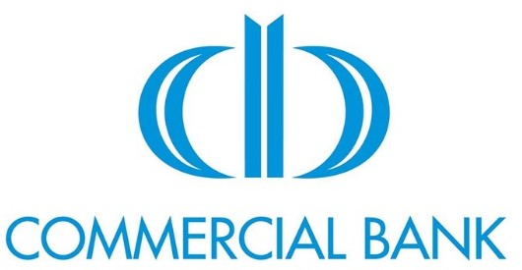

Credit rating 2018 2019
Moody's (long term / short term)
Standard & Poor's (long term / short term)
Fitch (long term / short term)  Dagong Rating (long term / short term) |  | AA-(IKA)
Local Rating (Agency Name + long term / short term) | CRISL(AAA) | CRISL-AAA
Size check
Total Assets | 49,848,044,694 | 60,977,180,045
Total Liabilities | 41,106,039,695 | 51,144,985,392
Total Equity | 8,742,004,999 | 9,832,194,653
1% of Total Assets | 498,480,447 | 609,771,800
Financial indicators
Tier 1 Capital Ratio | 12.11% | 11.34%
Capital Adequacy Ratio | 11.75% | 12.88%
Liquidity Coverage Ratio | 209.17% | 278.38%
Total loans | 32,568,452,654 | 39,008,280,027
Non-performing loans | 324,724,521 | 328,338,404
Allowance on loans losses | 165,733,103 | 125,289,343
Change in allowance on loans losses  Total deposits | 27,105  28,815,424,409 | -40,443,760
Change in allowance on loans losses  Total deposits | 27,105  28,815,424,409 | 35,228,595,047
Net result | 914,355,247 | 1,307,002,445
Non-performing loans / Total loans | 1.0% | 0.8%
Allowances on loans losses / Total loans  Deposits / Total liabilities | 0.5% | 0.3%
 | 70.1% | 68.9%
Total loans / Total deposits | 113.0% | 110.7%
Net result / change in Allowances | 0.003% | -3.1%
 | 10,000,000 | 15,000,000
Credit | 10,000,000 | 15,000,000
*amounts in Taka


Credit rating 2018 2019
Moody's (long term / short term) | B1 | Ba3
Standard & Poor's (long term / short term)
Fitch (long term / short term)
Dagong Rating (long term / short term)
 | CRISL (AA+,ST-2)
Local Rating (Agency Name + long term / short term) | CRISL (AA+,ST-2) | CRISL ‘AA+’/ ‘ST-  2’
Size check
Total Assets | 253,365,303,480.00 | 285,500,069,947
Total Liabilities | 231,779,737,881.00 | 262,124,609,863
Total Equity | 21,585,565,599.00 | 23,375,460,084
1% of Total Assets | 2,533,653,035 | 2855000699
Financial indicators
Tier 1 Capital Ratio | 10.09% | 9.26%
Capital Adequacy Ratio | 13.82%  113.35% | 12.02%  127.67%
Liquidity Coverage Ratio | 13.82%  113.35% | 12.02%  127.67%
Total loans | 184,027,300,831 | 217,380,258,429
Non-performing loans | 4,627,158,710 | 5,003,101,115
Allowance on loans losses | 11,501,561,018 | 15,618,345,039
Change in allowance on loans losses | 2,104,616,163 | 4,116,784,021
Total deposits | 167,348,195,022 | 199,155,588,070
Net result | 2,404,823,295 | 3,110,776,907
Non-performing loans / Total loans | 2.5% | 2.3%
Allowances on loans losses / Total loans | 6.2% | 7.2%
Deposits / Total liabilities  Total loans / Total deposits | 72.2% | 76.0%
Deposits / Total liabilities  Total loans / Total deposits | 110.0% 87.5% | 109.2%  132.3%
Net result / change in Allowances | 110.0% 87.5% | 109.2%  132.3%
 | 30,000,000 | 30,000,000
Credit | 30,000,000 | 30,000,000
*amounts in Taka

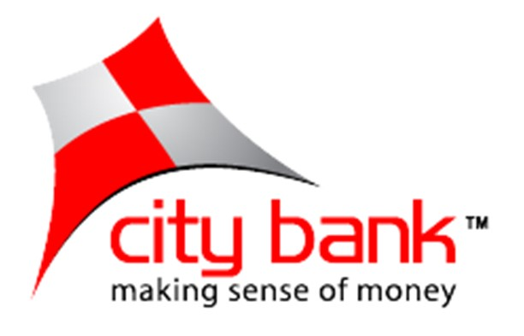
*amounts in Taka
Credit rating 2018 2019
Moody's (long term / short term) | BA3 | Ba3
Standard & Poor's (long term / short term)
Fitch (long term / short term)
Dagong Rating (long term / short term) | AA2, ST-2
Local Rating (Agency Name + long term / short term) | AA2, ST-2 | CRAB-AA2/ST-2
Size check
Total Assets | 278,067,080,739 | 326,940,438,782
Total Liabilities | 251,887,994,727 | 302,023,153,874
Total Equity | 26,179,086,012 | 24,917,284,908
1% of Total Assets | 2,780,670,807 | 3269404388
Financial indicators
Tier 1 Capital Ratio | 10.15%  12.46% | 8.29%
Capital Adequacy Ratio | 10.15%  12.46% | 12.19%  115.33%
Liquidity Coverage Ratio | 131.90% | 12.19%  115.33%
Total loans | 196,595,859,784  10,677,894,989  6,047,157,044 | 231,391,469,451 12,325,502,447
Non-performing loans | 196,595,859,784  10,677,894,989  6,047,157,044 | 231,391,469,451 12,325,502,447
Allowance on loans losses | 196,595,859,784  10,677,894,989  6,047,157,044 | 7,973,811,689
Change in allowance on loans losses | (255,854,817)  182,902,922,173 | 1,926,654,645
Total deposits | (255,854,817)  182,902,922,173 | 204,860,462,516
Net result | 3,458,678,453 | 2,224,726,816
Non-performing loans / Total loans | 5.4% | 5.3%
Allowances on loans losses / Total loans | 3.1% | 3.4%
Deposits / Total liabilities | 72.6% | 67.8%
Total loans / Total deposits  Net result / change in Allowances | 107.5% | 113.0% 86.6%
 | -7.4% | 113.0% 86.6%
 | 30,000,000 | 30,000,000
Credit | 30,000,000 | 30,000,000


Credit rating 2018 2019
Moody's (long term / short term) | A1, | A1,
Standard & Poor's (long term / short term) | A+ | A+
Fitch (long term / short term)  Dagong Rating (long term / short term)  Local Rating (Agency Name + long term / short term) | AA- | AA-
Size check
Total Assets | 37,911,694,081 | 45,851,678,410
Total Liabilities | 27,991,139,104 | 34,913,155,444
Total Equity | 9,920,554,977 | 10,938,522,967
1% of Total Assets | 379,116,941 | 458,516,784
Financial indicators
Tier 1 Capital Ratio | 12.01% | 12.54%
Capital Adequacy Ratio | 39.32% | 20.00%
Liquidity Coverage Ratio | 124.25% | 153.00%
Total loans | 16,341,521,278 | 17,311,932,778
Non-performing loans | 220,340,191 | 1,013,000,000
Allowance on loans losses | 162,113,674 | 162,203,174
Change in allowance on loans losses | 52,500 | 89,500
Total deposits | 25,640,188,410 | 31,260,876,650
Net result | 510,866,038 | 960,200,717
Non-performing loans / Total loans | 1.3% | 5.9%
Allowances on loans losses / Total loans  Deposits / Total liabilities | 1.0% | 0.9%
 | 91.6% | 89.5%
Total loans / Total deposits  Net result / change in Allowances | 63.7% | 55.4%
 | 0.01% | 0.01%
 | 40,000,000 | 35,000,000
Credit | 40,000,000 | 35,000,000
*amounts in Taka



Credit rating 2018 2019
Moody's (long term / short term) |  | ‘negative watch’
Standard & Poor's (long term / short term)
Fitch (long term / short term)
Dagong Rating (long term / short term)
Local Rating (Agency Name + long term / short term) | CRISL(AA,ST-2) | AA ST-2
Size check
Total Assets | 201,753,934,194 | 222,444,897,850
Total Liabilities | 189,991,847,439 | 209,165,941,427
Total Equity | 11,761,962,068 | 13,278,827,972
1% of Total Assets | 2,017,539,342 | 2224448979
Financial indicators
Tier 1 Capital Ratio | 7.30% | 6.98%
Capital Adequacy Ratio | 13.76%  107.05% | 12.86%  110.62%
Liquidity Coverage Ratio | 13.76%  107.05% | 12.86%  110.62%
Total loans | 145,606,993,782 6,268,357,000 | 166,145,119,129
Non-performing loans  Allowance on loans losses | 145,606,993,782 6,268,357,000 | 8,951,400,745  5,200,397,350
Non-performing loans  Allowance on loans losses | 4,414,765,000 | 8,951,400,745  5,200,397,350
Change in allowance on loans losses | 1,256,230,472 | 785,632,350
Total deposits | 151,776,065,501 | 166,160,290,425
Net result | 1,980,337,805 | 1,734,449,551
Non-performing loans / Total loans | 4.3% | 5.4%
Allowances on loans losses / Total loans | 3.0% | 3.1%
Deposits / Total liabilities | 79.9% | 79.4%
Total loans / Total deposits | 95.9% | 100.0%
Net result / change in Allowances | 63.4% | 45.3%
 | 3,000,000 | 2,000,000
Credit | 3,000,000 | 2,000,000
*amounts in Taka


Credit rating 2018 2019
Moody's (long term / short term)
Standard & Poor's (long term / short term)
Fitch (long term / short term)
Dagong Rating (long term / short term)
Local Rating (Agency Name + long term / short term) | CRSIL(AA+, ST-1) | CRSIL(AA+, ST-1)
Size check
Total Assets | 182,537,051,926 | 216,809,881,060
Total Liabilities | 169,378,032,978 | 201,392,920,792
Total Equity | 13,159,018,948 | 216809881060
1% of Total Assets | 1,825,370,519 | 2168098811
Financial indicators
Tier 1 Capital Ratio | 7.85% | 7.92%
Capital Adequacy Ratio  Liquidity Coverage Ratio | 12.12% | 12.27%  114.07%
Capital Adequacy Ratio  Liquidity Coverage Ratio | 90.18% | 12.27%  114.07%
Total loans | 135,891,061,280 | 156,960,037,516
Non-performing loans | 6,373,639,000 | 6,266,984,000
Allowance on loans losses | 8,330,026,000 | 8190633273
Change in allowance on loans losses  Total deposits | 379,463,000  140,644,053,680 | 139,392,727
Change in allowance on loans losses  Total deposits | 379,463,000  140,644,053,680 | 169,439,776,036
Net result | 1,969,338,840 | 2,268,937,264
Non-performing loans / Total loans | 4.7% | 4.0%
Allowances on loans losses / Total loans | 6.1% | 5.2%
Deposits / Total liabilities | 83.0% | 84.1%
Total loans / Total deposits | 96.6% | 92.6%
Net result / change in Allowances | 19.3% | -6.1%
 | 3,000,000 | 3,000,000
Credit | 3,000,000 | 3,000,000
*amounts in Taka


Credit rating 2018 2019
Moody's (long term / short term)
Standard & Poor's (long term / short term)
Fitch (long term / short term)
Dagong Rating (long term / short term)
Local Rating (Agency Name + long term / short term) | NCR (AA, ST-1) | NCR ( AA,ST-1)
Size check
Total Assets | 368,184,268,814 | 410,225,693,149
Total Liabilities | 344,137,163,440 | 383,018,823,767
Total Equity | 24,047,104,573 | 27,206,869,382
1% of Total Assets | 3,681,842,688 | 4,102,256,931
Financial indicators
Tier 1 Capital Ratio | 8.76%  12.34%  204.02% | 8.57%
Capital Adequacy Ratio | 8.76%  12.34%  204.02% | 12.17%
Liquidity Coverage Ratio | 8.76%  12.34%  204.02% | 264.48%
Total loans | 239,539,597,542 | 271,494,626,288
Non-performing loans | 20,786,943,558 | 23,559,960,570
Allowance on loans losses | 12,396,234,798 | 14,049,915,623
Change in allowance on loans losses | 4,716,681,791 | 1,653,680,825
Total deposits | 270,603,690,454 | 308,003,414,028
Net result | 1,797,145,783 | 3,627,028,560
Non-performing loans / Total loans | 8.7% | 8.7%
Allowances on loans losses / Total loans | 5.2% | 5.2%
Deposits / Total liabilities | 78.6% | 80.4%
Total loans / Total deposits | 88.5% | 88.1%
Net result / change in Allowances | 262.5% | 45.6%
 | 10,000,000 | 10,000,000
Credit | 10,000,000 | 10,000,000
*amounts in Taka



Credit rating 2018 2019
Moody's (long term / short term)
Standard & Poor's (long term / short term)
Fitch (long term / short term)
Dagong Rating (long term / short term)
Local Rating (Agency Name + long term / short term) | CRISL (AA, ST-2) | CRISL-AA2/ST-2
Size check
Total Assets | 339,288,054,190 | 381,575,678,880
Total Liabilities | 313,454,356,626 | 353,448,950,650
Total Equity | 25,823,646,761 | 28,116,657,718
1% of Total Assets | 3,392,880,542 | 3815756789
Financial indicators
Tier 1 Capital Ratio | 6.79% | 7.54%
Capital Adequacy Ratio | 10.84%  102.81% | 12.38%  123.37%
Liquidity Coverage Ratio | 10.84%  102.81% | 12.38%  123.37%
Total loans | 234,316,716,329 | 267,671,627,805
Non-performing loans | 13,878,533,441 | 15,027,998,959
Allowance on loans losses | 10,069,290,980 | 13,283,300,001
Change in allowance on loans losses | 3,911,006,674 | 3,214,009,021
Total deposits | 269,828,075,048 | 298,334,794,587
Net result | 1,168,628,781 | 2,473,208,844
Non-performing loans / Total loans | 5.9% | 5.6%
Allowances on loans losses / Total loans | 4.3% | 5.0%
Deposits / Total liabilities | 86.1% | 84.4%
Total loans / Total deposits | 86.8% | 89.7%
Net result / change in Allowances | 334.7% | 130.0%
 | 3,000,000 | 3,000,000
Credit | 3,000,000 | 3,000,000
*amounts in Taka


Credit rating 2018 2019
Moody's (long term / short term)
Standard & Poor's (long term / short term)
Fitch (long term / short term)
Dagong Rating (long term / short term)
Local Rating (Agency Name + long term / short term) | CRAB: AA+, ST-1 | CRSIL(AA+, ST-1)
Size check
Total Assets | 308,623,005,232 | 346,468,790,969
Total Liabilities | 289,377,846,655 | 323,382,820,737
Total Equity | 19,245,158,577 | 23,085,970,232
1% of Total Assets | 3,086,230,052 | 3464687910
Financial indicators
Tier 1 Capital Ratio | 9.20% | 9.30%
Capital Adequacy Ratio | 11.35% | 15.60%
Liquidity Coverage Ratio | 125.10% | 144.33%
Total loans | 197,705,187,268 | 218,037,368,120
Non-performing loans | 9,644,519,611 | 13,516,572,219
Allowance on loans losses | 7,072,213,981 | 7,435,718,457
Change in allowance on loans losses | 654,072,116 | 363,504,476
Total deposits | 233,796,357,368 | 262,467,721,796
Net result | 2,287,581,069 | 3,998,968,383
Non-performing loans / Total loans | 4.9% | 6.2%
Allowances on loans losses / Total loans | 3.6% | 3.4%
Deposits / Total liabilities | 80.8% | 81.2%
Total loans / Total deposits | 84.6% | 83.1%
Net result / change in Allowances | 28.6% | 9.1%
 | 15,000,000 | 10,000,000
Credit | 15,000,000 | 10,000,000
*amounts in Taka



Credit rating 2018 2019
Moody's (long term / short term)
Standard & Poor's (long term / short term)
Fitch (long term / short term)
Dagong Rating (long term / short term)  Local Rating (Agency Name + long term / short term) | CRISL (AA+, ST-1)
 | CRISL (AA+, ST-1) | CRISL AAA (Triple A),ST-1
Size check
Total Assets | 899,599,143,024 | 997,959,303,050
Total Liabilities  Total Equity  1% of Total Assets | 848,935,014,010  50,664,129,014  8,995,991,430 | 942,492,696,349
Total Liabilities  Total Equity  1% of Total Assets | 848,935,014,010  50,664,129,014  8,995,991,430 | 55,466,606,701
Total Liabilities  Total Equity  1% of Total Assets | 848,935,014,010  50,664,129,014  8,995,991,430 | 9979593031
Financial indicators
Tier 1 Capital Ratio | 8.58% | 8.51
Capital Adequacy Ratio | 11.50%  127.49% | 11.97%  169.05%
Liquidity Coverage Ratio | 11.50%  127.49% | 11.97%  169.05%
Total loans | 710,728,930,368 | 800,969,926,216
Non-performing loans | 25,518,608,827 | 26,182,498,156
Allowance on loans losses | 4,918,370,000 | 4,929,708,576
Change in allowance on loans losses | 76,960,000 | 11,338,576
Total deposits | 753,913,987,322 | 822,200,715,600
Net result | 4,920,606,745 | 6,310,300,055
Non-performing loans / Total loans | 3.6% | 3%
Allowances on loans losses / Total loans  Deposits / Total liabilities | 0.7% | 1%
 | 88.8% | 87%
Total loans / Total deposits | 94.3% | 97%
Net result / change in Allowances | 1.6% | 0.18%
 | 5,000,000 | 5,000,000
Credit | 5,000,000 | 5,000,000
*amounts in Taka

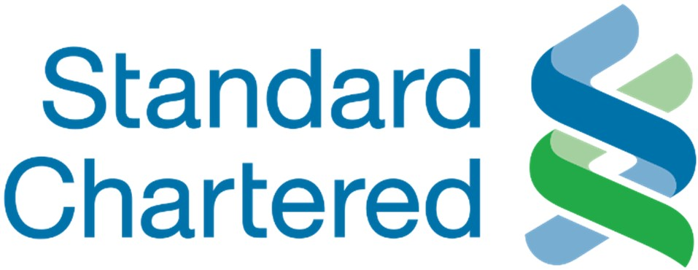
Credit rating 2018 2019
Moody's (long term / short term) |  | A1
Standard & Poor's (long term / short term) |  | A
Fitch (long term / short term)  Dagong Rating (long term / short term) |  | A+
Local Rating (Agency Name + long term / short |  | A+
term) | CRISL (AAA,ST-1)
Size check
Total Assets | 283,578,315,863 | 379,499,242,374
Total Liabilities | 242,489,754,426 | 328,444,959,061
Total Equity | 41,088,561,436 | 51,054,283,312
1% of Total Assets | 2,835,783,159 | 3794992424
Financial indicators
Tier 1 Capital Ratio | 14.24% | 17.61%
Capital Adequacy Ratio | 15.93% | 19.23%
Liquidity Coverage Ratio | 123.11% | 341%
Total loans | 160,771,327,960 | 186,382,670,247
Non-performing loans | 4,746,691,594 | 5,774,659,637
Allowance on loans losses  Change in allowance on loans losses  Total deposits | 7,902,962,171  507,968,122 203,659,648,459 | 8,267,396,364
 | 7,902,962,171  507,968,122 203,659,648,459 | 364,434,193
 | 7,902,962,171  507,968,122 203,659,648,459 | 290,722,556,387
Net result | 7,474,218,650 | 9,843,163,059
Non-performing loans / Total loans | 3.0% | 3.1%
Allowances on loans losses / Total loans | 4.9% | 4.4%
Deposits / Total liabilities | 84.0% | 88.5%
Total loans / Total deposits | 78.9% | 64.1%
Net result / change in Allowances | 6.8% | 3.7%
 | 20,000,000 | 30,000,000
Credit | 20,000,000 | 30,000,000

Recent Two Years Credit Limits
Bank | 2018 | 2019 | Change in Credit Limit
BRAC Bank Ltd. | 30,000,000 | 30,000,000 | 0
Citibank NA | 40,000,000 | 35,000,000 | (5,000,000)
Commercial Bank of Ceylon | 10,000,000 | 15,000,000 | 5,000,000
Dutch-Bangla Bank Ltd. | 15,000,000 | 10,000,000 | (5,000,000)
Eastern Bank Ltd. | 30,000,000 | 30,000,000 | 0
Islamic Bank Bangladesh Ltd. | 5,000,000 | 5,000,000 | 0
Mutual Trust Bank Ltd. | 3,000,000 | 2,000,000 | (1,000,000)
Premier Bank Ltd. | 3,000,000 | 3,000,000 | 0
Pubali Bank Ltd. | 10,000,000 | 10,000,000 | 0
Southeast Bank Ltd. | 3,000,000 | 3,000,000 | 0
Standard Chartered Bank | 20,000,000 | 30,000,000 | 10,000,000
The City Bank Ltd. | 30,000,000 | 30,000,000 | 0
Trust Bank Ltd. | 700,000 | - | (700,000)
*amounts in Taka

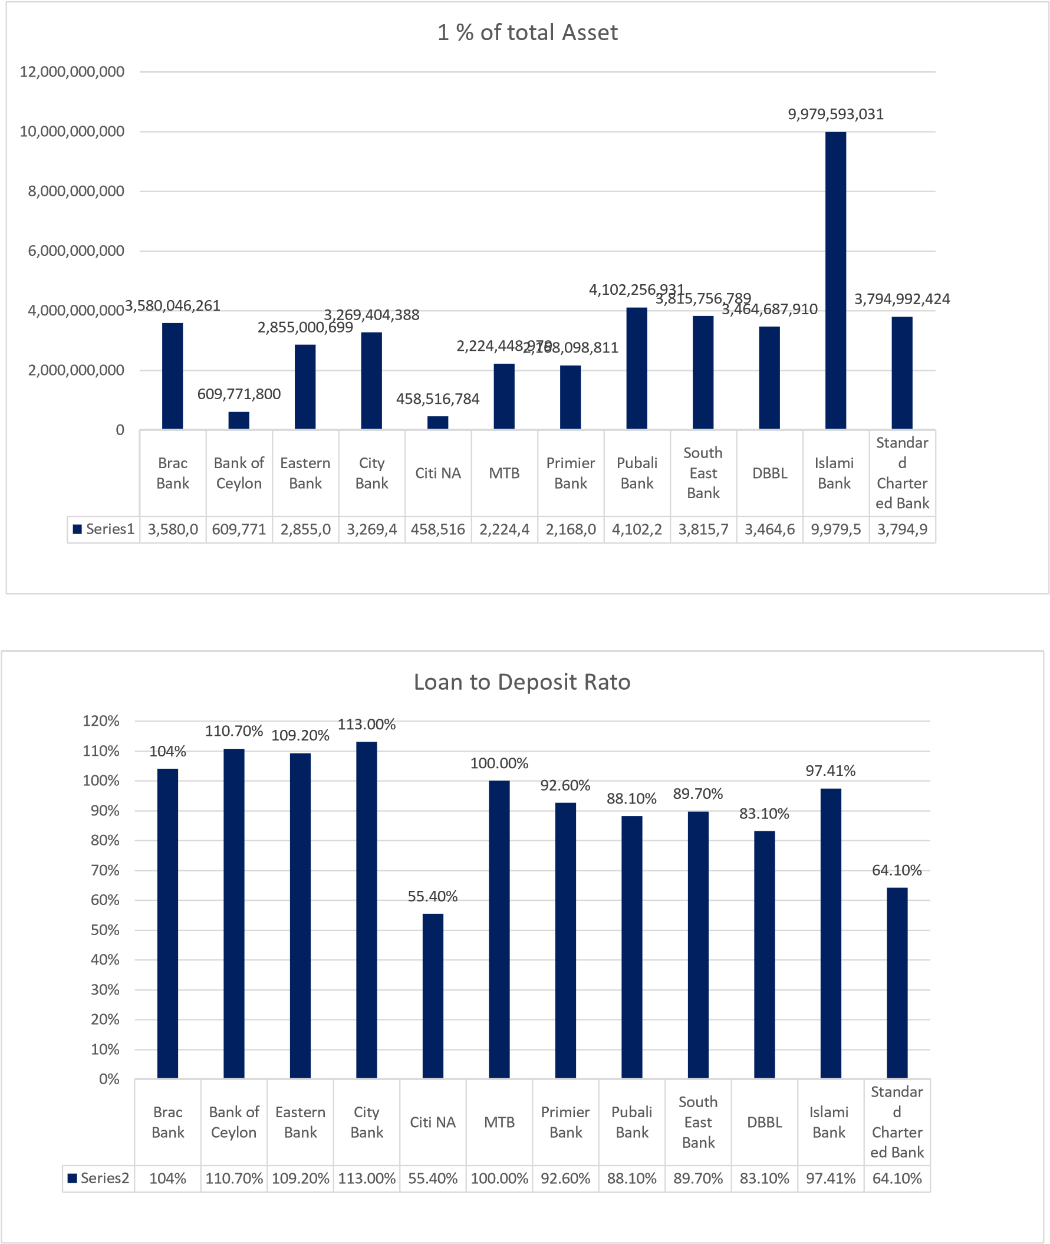
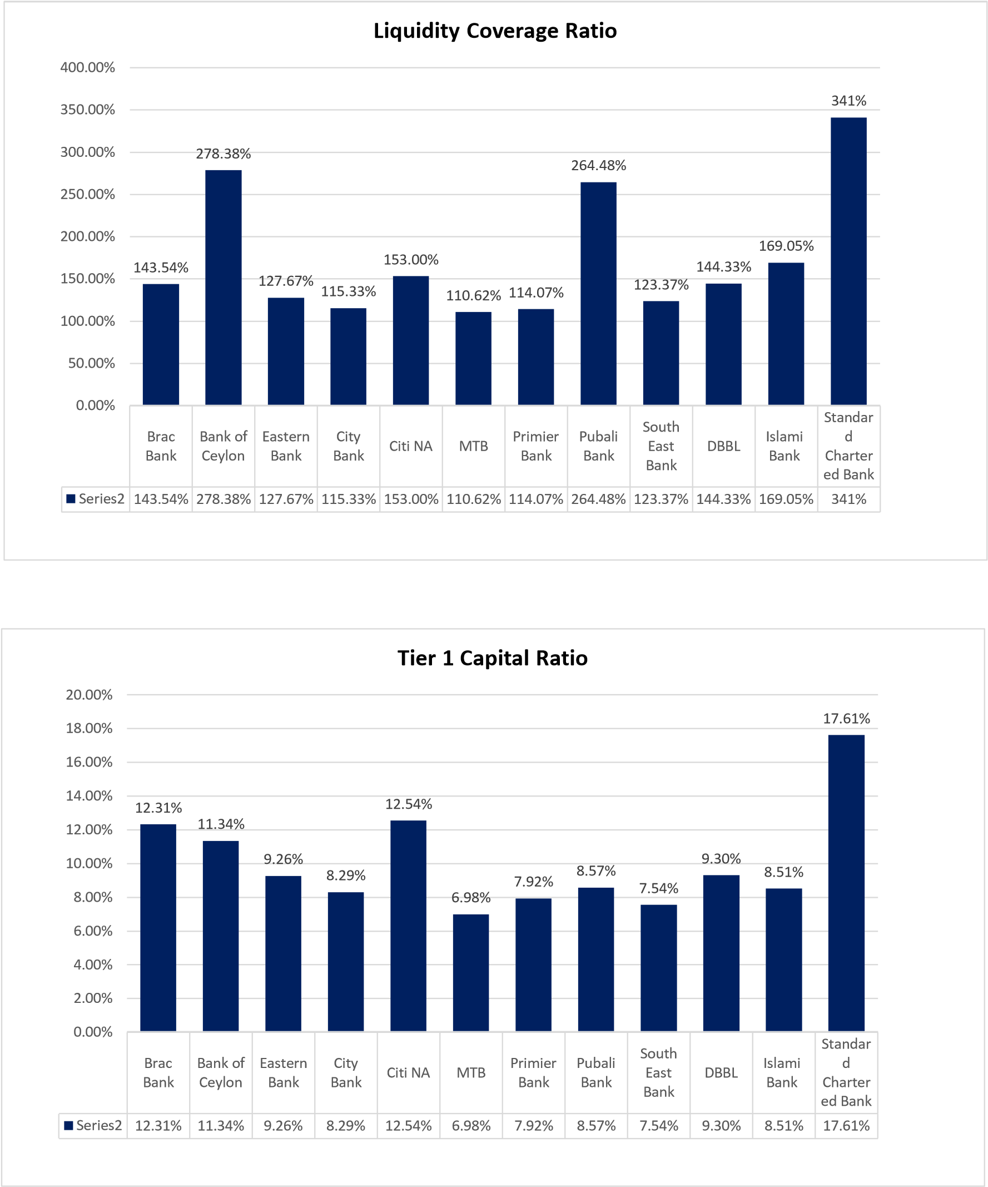
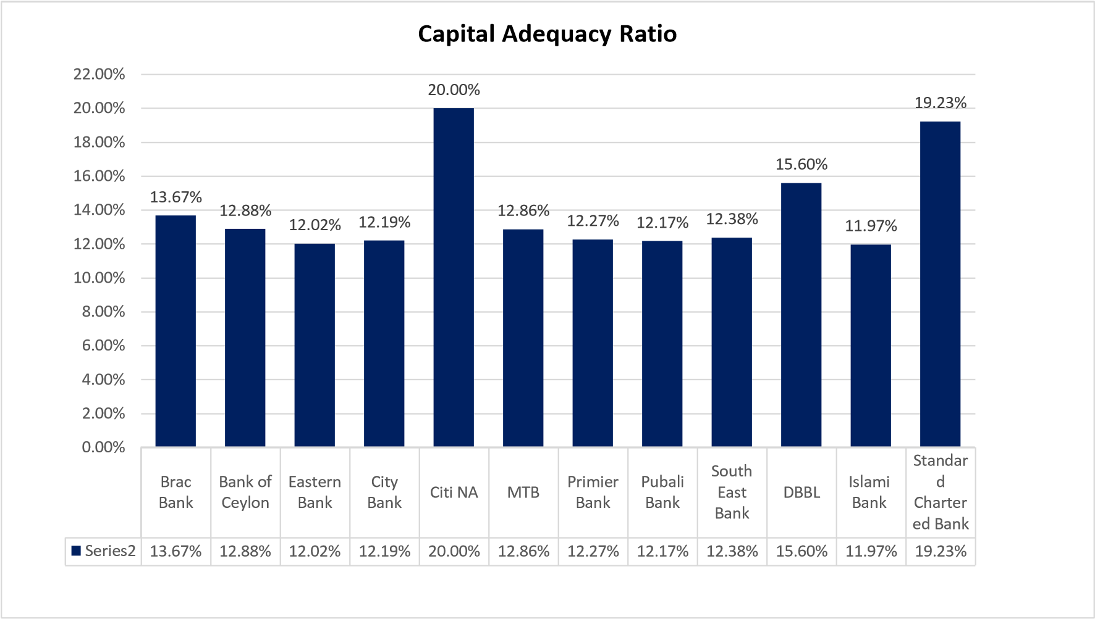
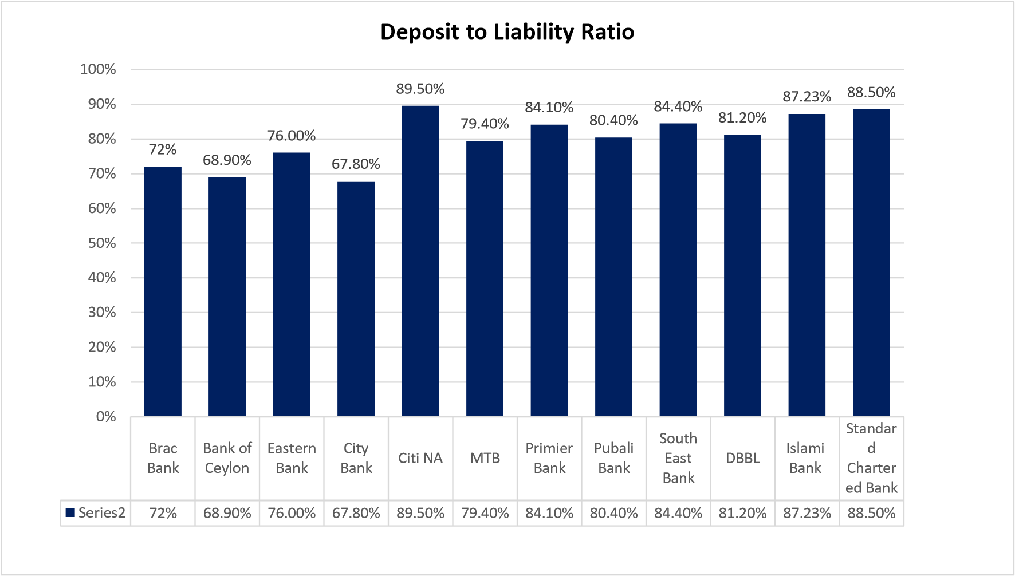
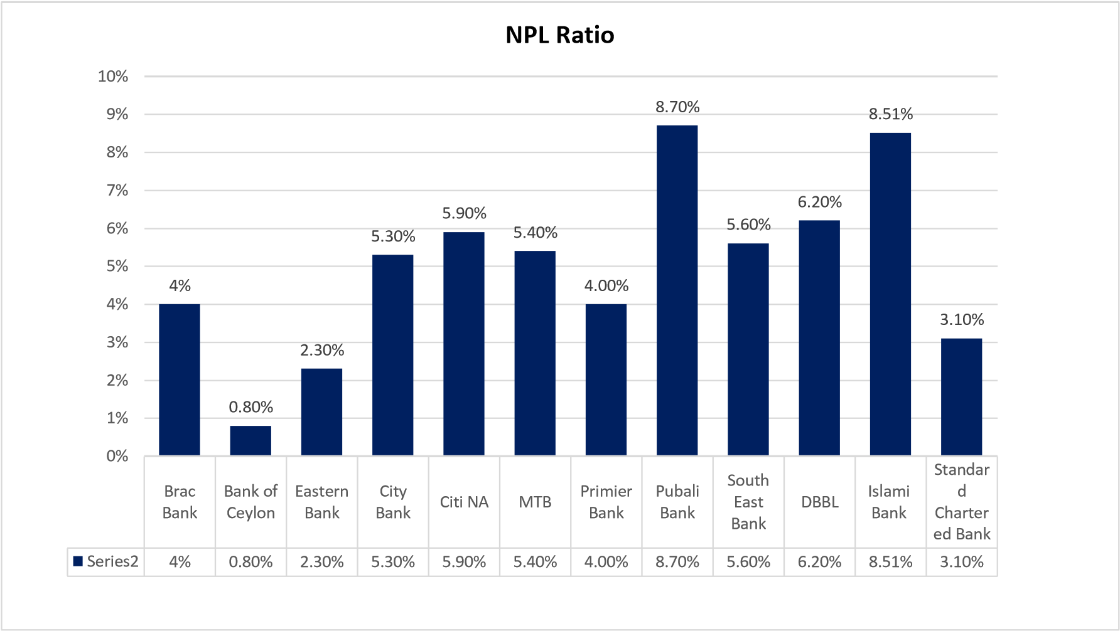
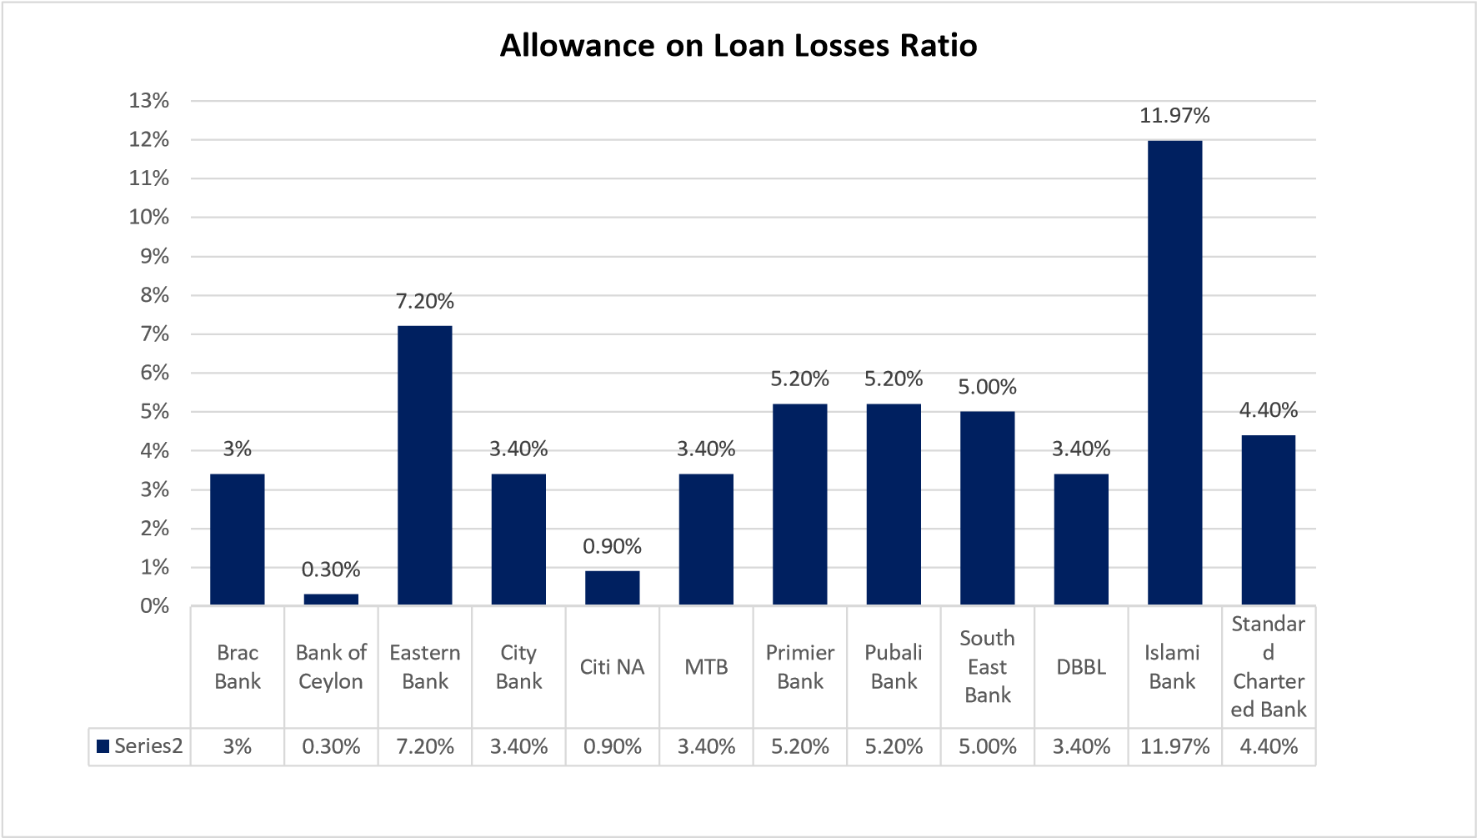

1% of total asset
Standard | more than 2000000000
Brac Bank | 3,580,046,261 | TRUE
Bank of Ceylon | 609,771,800 | FALSE
Eastern Bank | 2,855,000,699 | TRUE
City Bank | 3,269,404,388 | TRUE
Citi NA | 458,516,784 | FALSE
MTB | 2,224,448,979 | TRUE
Primier Bank | 2,168,098,811 | TRUE
Pubali Bank | 4,102,256,931 | TRUE
South East Bank | 3,815,756,789 | TRUE
DBBL | 3,464,687,910 | TRUE
Islami Bank | 9,979,593,031 | TRUE
Standard Chartered Bank | 3,794,992,424 | TRUE

Tier 1 Capital Ratio
Standard | more t | han 6%
Brac Bank | 12.31% | TRUE
Bank of Ceylon | 11.34% | TRUE
Eastern Bank | 9.26% | TRUE
City Bank | 8.29% | TRUE
Citi NA | 12.54% | TRUE
MTB | 6.98% | TRUE
Primier Bank | 7.92% | TRUE
Pubali Bank | 8.57% | TRUE
South East Bank | 7.54% | TRUE
DBBL | 9.30% | TRUE
Islami Bank | 8.51% | TRUE
Standard Chartered Bank | 17.61% | TRUE

Capital Adequacy Ratio
Standard | more th | an 10%
Brac Bank | 13.67% | TRUE
Bank of Ceylon | 12.88% | TRUE
Eastern Bank | 12.02% | TRUE
City Bank | 12.19% | TRUE
Citi NA | 20.00% | TRUE
MTB | 12.86% | TRUE
Primier Bank | 12.27% | TRUE
Pubali Bank | 12.17% | TRUE
South East Bank | 12.38% | TRUE
DBBL | 15.60% | TRUE
Islami Bank | 11.97% | TRUE
Standard Chartered Bank | 19.23% | TRUE

Liquidity Coverage Ratio
Standard | More than 100%
Brac Bank | 143.54% | TRUE
Bank of Ceylon | 278.38% | TRUE
Eastern Bank | 127.67% | TRUE
City Bank | 115.33% | TRUE
Citi NA | 153.00% | TRUE
MTB | 110.62% | TRUE
Primier Bank | 114.07% | TRUE
Pubali Bank | 264.48% | TRUE
South East Bank | 123.37% | TRUE
DBBL | 144.33% | TRUE
Islami Bank | 169.05% | TRUE
Standard Chartered Bank | 341% | TRUE

Non-performing loans / Total loans
Standard | lower than 5%
Brac Bank | 0.04 | TRUE
Bank of Ceylon | 0.008 | TRUE
Eastern Bank | 0.023 | TRUE
City Bank | 0.053 | FALSE
Citi NA | 0.059 | FALSE
MTB | 0.054 | FALSE
Primier Bank | 0.04 | TRUE
Pubali Bank | 0.087 | FALSE
South East Bank | 0.056 | FALSE
DBBL | 0.062 | FALSE
Islami Bank | 0.0851 | FALSE
Standard Chartered Bank | 0.031 | TRUE

Allowances on loans losses / Total loans
Standard | between 3% to 10%
Brac Bank | 3% | TRUE
Bank of Ceylon | 0.30% | FALSE
Eastern Bank | 7.20% | TRUE
City Bank | 3.40% | TRUE
Citi NA | 0.90% | FALSE
MTB | 3.40% | TRUE
Primier Bank | 5.20% | TRUE
Pubali Bank | 5.20% | TRUE
South East Bank | 5.00% | TRUE
DBBL | 3.40% | TRUE
Islami Bank | 11.97% | FALSE
Standard Chartered Bank | 4.40% | TRUE

Deposits / Total liabilities
Standard | Higher than 70%
Brac Bank | 72% | TRUE
Bank of Ceylon | 68.90% | FALSE
Eastern Bank | 76.00% | TRUE
City Bank | 67.80% | FALSE
Citi NA | 89.50% | TRUE
MTB | 79.40% | TRUE
Primier Bank | 84.10% | TRUE
Pubali Bank | 80.40% | TRUE
South East Bank | 84.40% | TRUE
DBBL | 81.20% | TRUE
Islami Bank | 87.23% | TRUE
Standard Chartered Bank | 88.50% | TRUE

Total loans / Total deposits
Standard | Between 80%-95%
Brac Bank | 104% | high
Bank of Ceylon | 110.70% | high
Eastern Bank | 109.20% | high
City Bank | 113.00% | high
Citi NA | 55.40% | low
MTB | 100.00% | high
Primier Bank | 92.60% | standard
Pubali Bank | 88.10% | standard
South East Bank | 89.70% | standard
DBBL | 83.10% | standard
Islami Bank | 97.41% | high
Standard Chartered Bank | 64.10% | low

Summary of credit analysis
 | Brac | Ceylon | Eastern | City
1% of Total Asset | 3,580,046,261 | 609,771,800 | 2,855,000,699 | 3,269,404,388
Tier 1 Capital Ratio | 12.31% | 11.34% | 9.26% | 8.29%
Capital Adequacy Ratio | 13.67% | 12.88% | 12.02% | 12.19%
Liquidity Coverage Ratio | 143.54% | 278.38% | 127.67% | 115.33%
Non-performing loans / Total loans | 4% | 0.80% | 2.30% | 5.30%
Allowances on loans losses /  Total loans | 3% | 0.30% | 7.20% | 3.40%
Deposits / Total liabilities | 72% | 68.90% | 76.00% | 67.80%
Total loans / Total deposits | 104% | 110.70% | 109.20% | 113.00%
 | Citi | MTB | Primer | Pubali
1% of Total Asset | 458,516,784 | 2,224,448,979 | 2,168,098,811 | 4,102,256,931
Tier 1 Capital Ratio | 12.54% | 6.98% | 7.92% | 8.57%
Capital Adequacy Ratio | 20.00% | 12.86% | 12.27% | 12.17%
Liquidity Coverage Ratio | 153.00% | 110.62% | 114.07% | 264.48%
Non-performing loans / Total loans | 5.90% | 5.40% | 4.00% | 8.70%
Allowances on loans losses /  Total loans | 0.90% | 3.10% | 5.20% | 5.20%
Deposits / Total liabilities | 89.50% | 79.40% | 84.10% | 80.40%
Total loans / Total deposits | 55.40% | 100.00% | 92.60% | 88.10%
 | South | DBBL | Islami | Standard
1% of Total Asset | 3,815,756,789 | 3,464,687,910 | 9,979,593,031 | 3,794,992,424
Tier 1 Capital Ratio | 7.54% | 9.30% | 8.51 | 17.61%
Capital Adequacy Ratio | 12.38% | 15.60% | 11.97% | 19.23%
Liquidity Coverage Ratio | 123.37% | 144.33% | 169.05% | 341%
Non-performing loans / Total loans | 5.60% | 6.20% | 8.51 | 3.10%
Allowances on loans losses /  Total loans | 5.00% | 3.40% | 11.97% | 4.40%
Deposits / Total liabilities | 84.40% | 81.20% | 87.23% | 88.50%
Total loans / Total deposits | 89.70% | 83.10% | 97.41% | 64.10%

