`



"Navigating the compensation and benefit structure to comprehend the influence on the performance of the employees: An overview of the reward practices at Nestlé Bangladesh PLC"



"Navigating the compensation and benefit structure to comprehend the influence on the performance of the employees: An overview of the reward practices at Nestlé Bangladesh PLC"

An Internship report submitted to the UIU School of Business & Economics for the partial fulfilment of the requirements for the degree of Bachelor of Business Administration


Course Code: INT4399
Submitted to:
Ms. Nasrin Akter
Assistant Professor - HRM/Management
School of Business & Economics (SoBE)
United International University
Submitted by:
Nafisa Murshed
ID: 111 182 129
School of Business & Economics (SoBE)
United International University
Date of submission:
08th June, 2024


Letter of Transmittal
Date: 08th June, 2024
Nasrin Akter, Assistant Professor, HRM/Management, SoBE
United International University
United City, Madani Avenue, Badda
Dhaka - 1212, Bangladesh.
Subject: Submission of Internship Report

Dear miss,
With due respect, I am very pleased to announce that, after completing my 3-month internship from Nestlé Bangladesh PLC’s HR function, I have written my internship report titled “Navigating the compensation and benefit structure to comprehend the influence on the performance of the employees: An overview of the reward practices at Nestlé Bangladesh PLC”. I have conscientiously adhered to the valuable directions and guidelines provided by you and my organisational supervisor. This report is an illustration of the practical knowledge and skills acquired while interning at Nestlé. On this note, I would like to thank you for sparing your time to go through the paper, along with advising and supporting me. With the report in mind, I have gathered what I deemed to be the most significant data so that the resulting report would be as meaningful, relevant, and credible as possible. To conclude, I found this study to be very compelling and educational which I believe will aid me in the foreseeable future.
I would also like to extend my appreciation to you for having accorded me an opportunity to write and present this report on the subject in question as well as your constant support during the preparation of this report. For any queries, I will be more than delighted to provide you with any clarifications regarding the report.

Yours Sincerely,

Nafisa Murshed
ID - 111 182 129
United International University, SoBE

Declaration of Studentship

I am Nafisa Murshed, bearing ID - 111 182 129, a student under the Bachelor of Business Administration program with a major in Human Resource Management and Supply Chain Management. I hereby certify that the internship report titled “Navigating the compensation and benefit structure to comprehend the influence on the performance of the employees: An overview of the reward practices at Nestlé Bangladesh PLC” is prepared on the basis of my 3 months internship tenure at Nestlé and is an original work done by me under my supervisor Ms. Nasrin Akter, Assistant Professor (HRM/Management), School of Business and Economics as a partial requirement of the prerequisites for the degree fulfilment of the Bachelor of Business Administration.

It is imperative that the reader be distinctly informed that this report constitutes the author’s original work and has not been previously submitted for credit or accreditation purposes. The data and information presented in this paper have been exclusively collected and written by me in accordance with the responsibilities of my internship. As for the sections of the report that may have violated the issue of copyright, I would like to accept any penal consequences for the misleading data or unconfirmed information which may have been delivered.

Nafisa Murshed
ID - 111 182 129
United International University, SoBE



Acknowledgement

In the name of ALLAH, The most Gracious, The most Merciful. Praise be to The Almighty, The One who has answered our prayers in a variety of ways and blessed us throughout this journey with patience, courage, and fortitude in particular. My sincere gratitude to The Almighty ALLAH for enabling me to study, comprehend, and complete this report.

Secondly, I am obligated to my course instructor, Ms. Nasrin Akter, for providing me with the chance to do this internship report on a topic that has the potential to be very useful to me in the foreseeable future and also for consistently and patiently guiding me throughout my journey. The epitome of synergy in compiling the components of this project resulted from her steadfast assistance, confidence in me, inspiration along with an endless reservoir of motivation and consolation.

I would like to send forth my earnest gratitude to Nestlé Bangladesh PLC for according me the invaluable opportunity to pursue an internship with their esteemed organization. The degree of concern, empathy, and warm care that I gained from the Nestlé HR department during my time in the organisation was delightful at its optimum. My gratitude goes out to my organizational supervisors, Ms. Zarin Subah Faizah (Sr. Officer - Payroll, Ops and MIS) and Mr. Prince Joy Rozario (Manager - Rewards, PD & Ops) for instructing me and also for showering their unwavering support and patience towards me.
In addition, I would like to acknowledge my family for being supportive all throughout the years, without whom I would not have been able to gain the achievements that I have.

Table of Contents

Letter of Transmittal 3
Declaration of Studentship 4
Acknowledgement 5
1. Introduction 9
1.1 Origin 9
1.2 Background 10
1.3 Objectives 10
1.4 Methodology 11
1.4.1 Data collection 12
1.5 Scope 12
1.6 Limitations 13
2. Literature Review 14
3. Organizational Overview 23
3.1 About Nestlé Bangladesh PLC: 23
3.2 Brief History: 25
Nestlé S.A 25
Nestlé Bangladesh PLC 25
3.3 Categories offered by Nestlé Bangladesh PLC: 27
Product offerings: 27
3.4 Mission, vision and values: 28
3.5 Market Segmentation: 31
4. Analysis 33
4.1 Internship overview: 33
4.1.1 Specific Responsibilities of the Job 33
4.1.2 Leaning aspects of the internship journey: 35
4.2 Project: 36
4.2.1 Human Resource Management of Nestlé Bangladesh PLC 36
4.2.2 Nestlé Bangladesh PLC Compensation and Benefits 37
4.2.3 Nestlé Bangladesh PLC Rewards 42
4.2.4 Nestlé People Development: 45
5. Findings, Recommendations and Conclusion: 48
5.1 Findings: 48
5.2 Recommendations: 58
5.3 Conclusion: 60
5.4 Bibliography: 61

Executive Summary

The report is precisely organised, assuring a logical and cohesive progression. After the prefatory section, the report's major content begins with an organizational overview including the history, mission, vision, values and activities. The report then further encompasses the internship description, data analysis, findings, recommendations and a conclusion.
In the elaboration of the report, the various facets of the payment, reward and benefits system offered by the organisation are closely examined. The report sheds light on the crucial component of the compensation and reward system with thorough feedback from management personnel and the regular employees. Moreover, the report incorporates opinions from relevant studies; hence, it also builds a well structured view of the concerns underpinning the topic.
I have learned the significance of meticulous record-keeping and great attention to detail in HR procedures from my internship at Nestlé Bangladesh PLC. My responsibilities included assisting my superiors with the compensation & reward structure and people development, as well as ensuring the accuracy and completeness of employment records by identifying missing data in the files of regular, contractual, and temporary employees and promptly notifying them to request the necessary documents. Furthermore, the exposure provided to me by NBL has endowed me with a multidimensional outlook that will undeniably influence my forthcoming professional pursuits.

CHAPTER -1

INTRODUCTION

Introduction

1.1 Origin

“Navigating the compensation and benefit structure to comprehend the influence on the performance of the employees: An overview of the reward practices at Nestlé Bangladesh PLC” is the title of the report which I have meticulously prepared in order to fulfill the requirements of the Bachelor of Business Administration degree from United International University. The report is compiled utilising the three-month internship I completed at the HR department of Nestlé Bangladesh PLC. The internship experience at Nestlé Bangladesh PLC and the commendable mentorship I received from both my academic and organisational supervisors influenced my decision to compose this report.

1.2 Background
Human resource management (HRM) refers to the structured processes and procedures for the effective management and coordination of employees and other stakeholders in an organization. Human Resource Management (HRM) focuses on the personnel aspect of management. It encompasses the organisation, coordination, and administration of the workforce to accomplish the mission, vision, goals, and strategic objectives of the organisation. Compensation and benefits are essential components of human resource management. An incentive-rich remuneration and benefits package serves to entice high-performing candidates and promotes employee retention, motivation, and a favourable work environment. Compensation refers to the monetary remuneration which a team member receives in return for their services. The monetary value can encompass several forms of compensation, such as wages, salary, commissions, and bonuses. Benefits refer to nonmonetary incentives or awards that a firm offers to its employees. Some benefits may possess a monetary worth, despite the absence of cash compensation for a team member. Examples of monetizable advantages include equity, stock options, health insurance, and retirement savings plans. Compensation and benefits are integral components of the employment package provided by an organization to a potential applicant. The primary distinction between the two lies in whether they are monetary or non-monetary kinds of compensation.

1.3 Objectives
The predominant goal of this report is to provide detailed discussion of the effect of the compensation and reward system on the performance of an entity’s employees. The basis of this evaluation therefore lies in the survey responses received, and the data that the respective stakeholder provided. The objectives may be subdivided further as follows:
- Broad objective: To assess the overall compensation and reward policies, which are put forward by the management of Nestle Bangladesh PLC for making all its operational areas effective. Also, the research seeks to establish findings pertaining to the relationship between employee performance and the compensation, reward, and benefits package.
- Specific objectives:
- Evaluate each aspect of the compensation system, including salary, bonuses, and other financial perks, in order to comprehend its structure and execution.
- Determine the company's performance evaluation criteria used to assess employee productivity, efficiency, and work satisfaction in connection to the compensation and benefit system.
- Enumerate the external and internal factors that impact the design and efficacy of the compensation and benefit framework, including industry benchmarks, organisational culture, and employee preferences.
- Determine the compensation-related motivational elements that stimulate employees to actively engage in developmental opportunities and strive for continuous learning.
- Evaluate the non-financial advantages, such as healthcare benefits, maternity and childcare policies and incentive to assess their influence on employee motivation and retention.
- Examine the influence of remuneration systems on employee performance and productivity, specifically in terms of employee development and competency improvement.

1.4 Methodology
This study seeks to acquire a more comprehensive understanding of the subject matter by focusing on both quantitative and qualitative data. The majority of the information in this report comes from primary sources.

In order to obtain a comprehensive understanding of the tasks they undertake; primary data were gathered via an extensive series of in-depth interviews with the relevant supervisors of the HR
department at Nestlé Bangladesh, as well as the responses of the employees to a survey regarding the correlation between employee performance and compensation/reward structure. Secondary information was obtained from sources such as the Nestlé website, intranets, and other pertinent academic journals and websites which were deemed relevant to the study.

1.4.1 Data collection
The data collection sources are described below -
- Feedback form: Questions concerning the compensation and reward structure, as well as its influence on employee development and performance, were distributed in the form of a survey. Quantitative data has been collected through the responses provided in the survey by the employees of the company.
- Personal work experience: Diverse facets of the study were recognised with the assistance of personal observations and insights gained on the job.
- Face-to-face interview with the supervisors: In this instance, I utilised a pre-designed questionnaire to periodically enquire during work breaks in order to gain a deeper understanding of the employees' work, culture, practices, limitations, and recommendations. Qualitative data was obtained from the discussions and subsequently restructured for use in this research endeavour. I devised a questionnaire comprising both open-ended and close-ended enquiries which sufficiently gathered data from various viewpoints. Due to the challenge of scheduling dedicated interview hours, I have made use of three months of my internship period at Nestle Bangladesh PLC. I have solicited many perspectives by posing varied enquiries at different time periods, according to the specific circumstances and subject matter.
- Utilising secondary sources: The evaluation comprises a variety of resources, including internal documents and Nestlé-supplied HR policies, in addition to external sources including the Nestlé website, industry reports, scholarly articles, and academic textbooks that centre on performance appraisal and compensation management.
The utilisation of information obtained from these sources is crucial for comparing Nestlé's operations to those of the industry and pinpointing potential avenues for refinement or innovation. The aforementioned information serves as the foundation for the following sections of the report, which

put forth precise recommendations and approaches to further augment the Compensation and reward practices of Nestlé Bangladesh.

1.5 Scope
The report predominantly emphasises the impact of the compensation and reward structure on the performance of the employees through the conducted interview sessions with the relevant supervisors
and the feedback responses from the employees, analysing their overall satisfaction and enthusiasm with respect to performance and productivity, learning, development, satisfaction, career growth, retention etc. along with understanding the significant impact of rewards on their performance.

1.6 Limitations
- Certain feedback may not conform with particular business standards and procedures owing to confidentiality.
- The subjective nature of participant feedback, which is susceptible to individual biases and perspectives, can complicate the derivation of objective conclusions regarding the effect of compensation and reward on employee performance.
- Insufficient in-depth understanding of the intricacies of the corporate industry.

CHAPTER - 2

LITERATURE REVIEW

Literature Review

Sirait (2006) defines compensation as a monetary or non-monetary recompense that is accepted by employees in exchange for their service to the organization. The effective management of compensation is a critical undertaking in ensuring that employees are highly content with their jobs. Productivity can be acquired, generated, or maintained through compensation. Insufficient compensation often results in employee attrition, thereby impeding organizational succession efforts, particularly in the realm of recruitment.
(Darma, P. S., & Supriyanto, A. S. (2017). "THE EFFECT OF COMPENSATION ON SATISFACTION AND EMPLOYEE PERFORMANCE" in Management and Economics Journal, Volume 1(1), December 2017. E-ISSN: 2598-9537, P-ISSN: 2599-3402. Retrieved from http://ejournal.uin-malang.ac.id/index.php/mec)

Benefits generally comprise the obligatory or legally mandated elements of an employee's compensation package. Perquisites, on the other hand, are supplementary benefits that an employer may elect to offer. Rewards, on the other hand, are distributed in accordance with employee and team performance as an element of initiatives aimed at recognizing and expressing appreciation to employees. In accordance with the terms of the employment contract, employee benefits are supplementary forms of compensation. Although some of these benefits are voluntary, others are mandated by law for a business to offer. For example: paid leave, stock options, medical insurance, healthcare insurance, pension plan etc.
Jathanna, P. (2023) Difference between benefits, perks and rewards. Available at: https://www.sorryonmute.com/difference-between-benefits-perks-and-rewards/

The interest in a rewarding system and policy implemented in public administration institutions is based on the fact that the system and the policies are able to grab the employees attention and increase their interest, not only pertaining to achievements in individual performances but particularly for their
contribution in increasing global productivity of these enterprises in the near future.
De Freitas Bradley C. (2017) Human Resource Reforms in Public Administration: The Importance of the Reward System. HOLISTICA – Journal of Business and Public Administration, Vol.8 (Issue 2), pp. 49-58. https://doi.org/10.1515/hjbpa-2017-0012

A reward system is beneficial not only to the employee but also to the organisation. The employee will feel more motivated to work harder by having a reward system in place.

The employee will feel more committed to their work and their productivity will increase. An increase
in productivity will then benefit the organisation. Therefore, a reward system is mutually beneficial to the employee and the organisation.
Francis, A. (2018) The importance of reward management, MBA Knowledge Base. Available at: https://www.mbaknol.com/human-resource-management/the-importance-of-reward-management/ (Accessed: 02 January 2024).

According to Aslam A., Ghaffar A. and Talha T., Mushtaq H., The significance of employee motivation within an organisation stems from the direct and substantial impacts that the attitudes and actions of employees have on the organization's overall productivity. In order to remain competitive, organisations must attract talented individuals who possess the necessary skills to join their ranks. Moreover, in order to increase the commitment of current employees to remain with the organisation, it is critical to implement a suitable incentive-based compensation system which will work as a stimulus for the employees.
Aslam A., Ghaffar A., Talha T., Mushtaq H. (2015). Impact of compensation and reward system on the performance of an organization: An empirical study on banking sector of Pakistan. European Journal of Business and Social Sciences,4(08), 319–325.

In a research, Madhani P. M. suggested that the compensation practices implemented in the sales division had a major effect on employee motivation and enhanced productivity and performance.
Madhani P. M. (2009). Sales employees compensation: An optimal balance between fixed and variable pay. Compensation & Benefits Review,41(4), 44–51.

According to Forbes (2023), compensation has a big impact on worker satisfaction and retention. Retaining employees necessitates offering attractive base salary or hourly payments since it demonstrates that the company values their time and effort.
Sorn, M.K. et al. (2023) The effectiveness of compensation in maintaining employee retention, SCIRP. Available at: https://www.scirp.org/journal/paperinformation?paperid=126223 (Accessed: 06 January 2024).

According to a study conducted by Dina et al., the impact of compensation on employee retention and performance in the hospitality sector in Medan City, North Sumatra, is notably favourable. Furthermore, it was discovered that retention acts as a mediator in the connection between compensation and performance, implying that a portion of the explanation for the influence of compensation on performance can be attributed to its effect on retention. The research underscored the significance of ensuring that employees receive sufficient remuneration. Organizations ought to
contemplate providing competitive remuneration and incentives to exceptional personnel. This can contribute to the attraction and retention of exceptional personnel, which will ultimately improve

employee performance.
The provision of adequate compensation significantly influences employee retention rates within an organization, as it conveys to employees that the company genuinely values and addresses their welfare. The level of employee retention or presence at the organization will serve as an indicator of employee satisfaction.
According to Murty and Hudiwinarsih (2012), an employee who is motivated will approach the tasks assigned by the company with enthusiasm and vigour. Conversely, an employee who lacks motivation is prone to exhibiting discomfort and discontentment with their work, which ultimately leads to subpar performance and hinders the attainment of organizational objectives.
Therefore, according to (Grabara, 2013), it can be asserted that effective compensation management will have an impact on employee performance.
Conversely, inadequate administration of compensation will lead to employee demotivation, which will ultimately have an impact on the deteriorating performance of the workforce. The foundation of the argument is Maslow's motivational theory (1943).
In accordance with Maslow’s motivational theory, Employee satisfaction is positively correlated with the fulfilment of their basic requirements, which motivates them to remain with the organization in pursuit of additional benefits, social recognition, and self-development opportunities. Further support for this notion can be found in prior studies that establish a substantial correlation between compensation and employee retention (Warner, 1981; Terera and Ngirande, 2014; Hong et al., 2012; Astuti, 2014; Thalassinos et al., 2012; Kossova et al., 2014).
Dina et al. (2017) ‘Compensation, employee performance, and mediating role of retention: A study of differential semantic scales’, EUROPEAN RESEARCH STUDIES JOURNAL, XX(Issue 4A), pp. 151–159. doi:10.35808/ersj/825.

Wilson (2004) contends that an effectively managed rewards system has the potential to enhance the calibre of employee performance. Absence of an appropriate reward system within an organization may result in issues such as low employee morale, unproductive employee performance, or a high employee attrition rate. As stated by Barber and Bretz (2000), when employees are motivated, they are more likely to deliver satisfactory performance. This is because they anticipate receiving compensation at the end of each month. Reward systems exert a significant influence on organizational retention and motivation, ultimately leading to the attainment of elevated levels of performance. According to a study conducted by Edirisooriya (2014), a robust positive correlation exists between employee performance and monetary compensation, including salaries and wages.

Bonus schemes constitute a critical component of reward systems. This is due to the fact that the incentive distribution to employees will be contingent upon their present performance within the organization. The impact of rewards, such as bonuses, on employee performance was found to be both
positive and statistically significant, according to research conducted by Hameed et al. (2014) and
Sajuyigbe (2014). According to Porath, Gerbasi, and Schorach (2015), an employer's genuine expression of gratitude fosters a positive work environment, which in turn increases employee productivity and strengthens the employer-employee social network. The transformation of negative
feedback into constructive criticism is essential for the growth and progress of employees. It is crucial to establish a positive culture in the workplace.
Noorazem, N.A., Md Sabri, S. and Mat Nazir, E.N. (2021) ‘The effects of reward system on employee performance’, Jurnal Intelek, 16(1), pp. 40–51. doi:10.24191/ji.v16i1.362.

As stated by Kerry and Oliver (2002), it is critical to comprehend that the performance and engagement levels of both individuals and teams in the workplace will be significantly influenced by the reward system. Consequently, it is critical to implement an effective and efficient reward system tailored to the specific requirements of each organization.
As per the assertion made by Mottaz (1985), intrinsic rewards for an individual can be obtained by
means of engaging in demanding tasks, receiving constructive criticism and recognition, and being provided prospects for professional advancement and progress. These employees will possess the capacity to generate outcomes while concurrently maintaining their enthusiasm, contentment, and sense of pride regarding their achievements. Opportunities for advancement, a feeling of fulfilment, recognition, endorsement, self-worth, difficulty, independence, and accountability are all intrinsic rewards. (Mahaney & Lederer, 2006). Compensation, employment stability, benefits, advancements in rank, bonus payments, and salary increases are examples of extrinsic rewards (Mahaney & Lederer 2006; Mottaz 1985).
According to the study by Goldsmith et al. (2000), it is well-known that extrinsic rewards increase employee commitment to objectives, reduce employee turnover, and attract top talent. Consequently, compensation may be the only factor attracting individuals to their employment (Stajkovic & Luthans, 2001).
Hoole, C. and Hotz, G. (2016) ‘The impact of a total reward system of work engagement’, SA Journal of Industrial Psychology, 42(1). doi:10.4102/sajip.v42i1.1317.

Palmer (2012) provides a definition of incentives as external motivating factors and temptations that stimulate an individual to exert greater effort. These incentives are granted in recognition of the individual's outstanding performance, as it is anticipated that greater effort and output will result from

a sense of satisfaction with the organization. Furthermore, incentives may be conceptualised as recognition for outstanding performance, provided that the remuneration is sufficient to inspire the employee to recognize the significance of the occupation while simultaneously fulfilling his
fundamental necessities.
Alfandi, Dr.A. and Alkahsawneh, Dr.M. (2014) ‘The role of the incentives and reward system in enhancing employee’s performance â€a case of Jordanian travel and Tourism Institutions"’, International Journal of Academic Research in Business and Social Sciences, 4(4). doi:10.6007/ijarbss/v4-i4/788.

According to an article by Varuni Gupta published in ET HRWORLD, as demonstrated by the psychology of compensation, the manner in which rewards are organised and delivered can have a substantial impact on employee engagement, motivation, and performance. Motivated personnel take pride in their organizational roles. They function as fervent advocates who actively participate in furthering the organization's goals. By performing duties beyond the scope of their employment, these employees promote a healthful work environment.
Organisations must recognise that in this competitive business environment where competitors are keen to recognise their potential, highly skilled employees are discerning of their worth and will not tolerate mediocrity in terms of compensation or job satisfaction. In the realm of employee rewards, monetary compensation is frequently the most prominent component. Although undeniably imperative for both talent attraction and retention, its influence on motivation transcends mere financial compensation. offering a competitive salary establishes the groundwork for employees' financial stability and satisfies their desires and requirements, thus alleviating concerns associated with personal finances. The provision of financial stability and a sense of security fosters intrinsic motivation among employees, as it enables them to concentrate on their tasks without perpetual concern for their expenditures.
Gupta, V. (2023) The psychology behind how compensation impacts employee motivation - ethrworldme, ETHRWorld.com. https://hrme.economictimes.indiatimes.com/news/workplace/the-psychology-behind-how-compensation-impacts-employee-motivation/103368656 (Accessed: 06 January 2024).

The objective of the reward strategy, as stated by (Güngor, 2011), is to consistently, honestly, and equitably compensate individuals/employees in accordance with their contributions, so that they will continue to support and achieve the organization's strategic objectives. Armstrong (2007) states that numerous organizations employ incentive strategies as a crucial instrument to develop efficient reward systems that increase employee commitment and productivity, motivate middle-level employees, and facilitate the retention of high-quality employees.
Komolafe, D. (2021) (PDF) reward systems: Impacts of reward systems on employee performance ... Available at: https://www.researchgate.net/publication/354689901_REWARD_SYSTEMS_IMPACTS_OF_REWARD_SYSTEMS_ON_EMPLOYEE_PERFORMANCE_AND_DEVELOPMENT (Accessed: 07 January 2024).

According to an article published by Indeed Career Guide, reward and benefits/incentive structure is important because:
- Rewards function as a means of motivating employees. An environment in which employees are aware that high performance will earn them an incentive to work harder may increase their commitment to their position. When an employer implements a fixed reward system, employees are motivated to execute allotted tasks with efficiency in order to gain recognition from their managers and earn rewards.
- An additional effect of an employer rewarding an outstanding employee for a successful year or project is that it inspires and motivates other personnel to strive for the same reward or incentive. This may exert a favourable impact on the organization's productivity. Efficient personnel make every effort to achieve and transcend the objectives established. Consequently, motivational rewards, whether financial or non-financial in nature, stimulate employee productivity.
- A successful reward scheme can facilitate the infusion of a culture of healthy competition within an organization by means of an employer. Incentives may be granted in accordance with either individual or team performance, or both. Competition often serves as a substantial catalyst for enhancements in performance, productivity, and progress. Employers can further foster innovation and creativity by promoting a constructive spirit of competition.
- Employers foster an environment that promotes collaboration and collective effort in pursuit of shared objectives by bestowing rewards upon exceptional teams of employees.
- An employer can foster a more robust employee-employer relationship by acknowledging and rewarding the diligent employees. Incentives and rewards serve to demonstrate to individuals their value to the organization, which can increase their allegiance. Generally, loyal employees exert greater effort toward the expansion and development of the company.
- Reward and incentive programs can be utilised by employers to establish and foster a culture of accountability. By knowing that the performance of the team will determine the reward at the conclusion of the project, the team members can be held accountable.
Editorial Team, I. (2022) What are reward systems? (including benefits and examples). Available at: https://ca.indeed.com/career-advice/career-development/reward-systems (Accessed: 07 January 2024).
The significance of rewards lies in the fact that they incentivize and reward performance, promote employee well-being, encourage, and retain talent through their competitive and equitable nature, and boost the employer brand. Employees are inclined to exert greater effort and accomplish their objectives

when they perceive that their compensation and benefits adequately compensate for their contributions. Moreover, employees improve in health, happiness, and productivity when they are provided with benefits that address their mental, physical, and social requirements. Furthermore, those who are content with their remuneration and benefits are inclined to endorse their employer to others.
Consulting, H. (2023) How do compensation and benefits impact employee engagement and retention?, How to Boost Employee Engagement and Retention with Compensation and Benefits. Available at: https://www.linkedin.com/advice/1/how-do-compensation-benefits-impact-employee-engagement#the-importance-of-compensation-and-benefits
Agustiningsih et al. (2016) demonstrate the importance of a reward system by asserting that the implementation of a remuneration reward system serves to incentivize employees, leading to improved performance, increased productivity, reduced employee turnover, the cultivation of service-oriented behaviour, and the prevention of corruption. Remuneration may consist of monetary compensation, such as a salary, as well as set and variable allowances, incentives, and additional benefits. Remuneration refers to the complete pay that employees receive in exchange for the services they have provided.
Pay difference within organizations serves to recognize and reward an individual's contributions to the organization. When compensation is dependent on performance, the various facets of its significance may become more prominent. When rewards are of minimal value, they may lose their significance. When they reach a significant size, they can potentially inspire actions that are harmful to the organization, as seen by the notorious case of the rogue trader Nick Leeson. Inter-organizational compensation can serve as a means to compete with other organizations in order to recruit and keep individuals with the necessary skills and knowledge required by an organization, as long as it is perceived as being more valuable than what other organizations supply. The phenomenon described here is known as the sorting effect, which posits that businesses tend to attract specific individuals, with the most skilled individuals being drawn to the organizations that offer the highest salaries.
Compensation possesses significance beyond its instrumental purpose of facilitating the purchase of goods. This suggests that in addition to the straightforward principle of "more is better," the perception of compensation as rewarding or not depends on its psychological interpretation or significance.
van Eerde, W. (2015) ‘Motivation and reward systems’, Wiley Encyclopedia of Management, pp. 1–4. doi:10.1002/9781118785317.weom060146.
The significance of compensation in relation to employee development is illustrated by Ali (2009), who asserts that compensation reflects not only the return of benefits but also the capabilities or
accomplishments of the individual.
As an illustration of the impact that reward systems have on employee performance, Lin (2000) defines a compensation system as an incentive structure in which employees' contributions are reciprocated. An incentive-driven workforce can be encouraged to exert greater effort through the use of an efficient compensation system, thereby augmenting job performance.
Hsin-Hsi Lai (2011) The influence of compensation system design on employee satisfaction. Available at: https://academicjournals.org/article/article1380532520_Lai.pdf
Inés and Pedro (2015) discovered that the sales organization's efficacy and the performance of individual salespeople are significantly impacted by the sales compensation system. Hence, amidst a perpetually competitive business landscape, numerous organizations globally, in Africa on a regional, and local scale are presently striving to discern inventive remuneration approaches that are explicitly associated with enhancing employee productivity (Denis and Michel, 2011).
Kimani N. Jean; Thomas Katua Ngui & Arasa Robert (2017) Effect of compensation strategies on employee performance: A case study ... Available at: https://www.semanticscholar.org/paper/Effect-of-Compensation-Strategies-on-Employee-A-of-Jean-Ngui/a5a99cfee986ef79176e792d12d7f225c2a4ac63
According to an article written by Hitesh Bhasin, reward management strategies are implemented by an organization in order to motivate employees, contributing to the firm's strategic objectives, external and internal equity assurance, retention and recruitment, reinforcing psychological contract, preserving sustainable financial health, adherence to legal requirements and managing productive and efficient administration.
Bhasin, H. (2021) Reward management - definition, types and benefits, Marketing91. Available at: https://www.marketing91.com/reward-management/

CHAPTER - 3

ORGANISATIONAL OVERVIEW

Organizational Overview

3.1 About Nestlé Bangladesh PLC:

Nestlé S.A., headquartered in Vevey, Vaud, Switzerland, is a Swiss multinational food and beverage processing conglomerate. Since 2014, by various metrics including revenue, it has held the distinction of being the largest publicly traded food corporation globally.

Nestlé, an international conglomerate with operations in 191 countries, expanded its commercial operations into Bangladesh in conjunction with Transcom Beverage Limited. Although Nestlé Bangladesh PLC officially started operations in 1994, the organization's inception can be traced back to 1992. Situated in Gazipur, precisely 55 kilometres to the north of Dhaka, Sreepur is the designated location for the production facility of Nestlé Bangladesh PLC. In 1992, Nestlé S.A. and Transcom Ltd. purchased all the shares of Vita Rich Foods Ltd. Nestlé S. A. obtained a majority stake of 60 percent, while Transcom Ltd. purchased a minority stake of 40 percent. In 1998, Nestlé S.A. acquired the remaining 40% stake from our local partner, resulting in Nestlé Bangladesh being a wholly-owned subsidiary of Nestlé S.A. The company has offered a wide range of products and services aimed at helping them in managing their personal and familial well-being over the last 25 years.

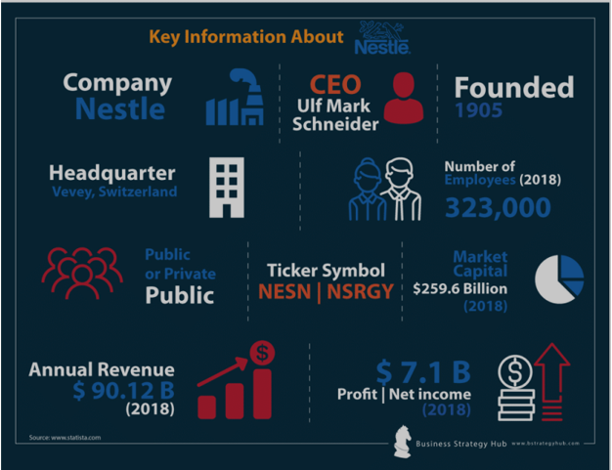

Source: Nestle – Dr. Myles Bassell, Official Website (professorbassell.com)

Nestlé Bangladesh PLC has been supplying nourishing and gratifying products for all life stages in an effort to facilitate Bangladesh's transition to a society where health, nutrition, and general well-being are prioritised for the past two decades. Because of the wide variety of consumers it serves, the organization is committed to providing outstanding value in its products. By means of community engagement, employee training, enhancement of local livelihoods, promotion of healthy dietary practices, and public education on nutrient assimilation, Nestlé Bangladesh PLC guarantees the quality of its products.

As the preeminent nutrition, health, and wellness corporation on a global scale, Nestlé dominates product categories including infant nutrition, bottled water, condensed and evaporated milk, ice cream, chocolate and malt beverages in addition to soluble coffee and culinary products.

3.2 Brief History:

Nestlé S.A
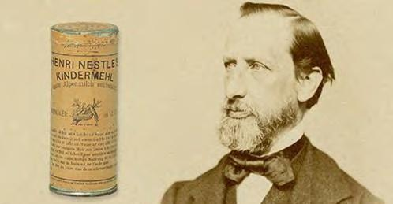
A premature infant in Switzerland in 1867 was unable to lactate, which was concerning in an era when inadequate alternatives to effective breast milk caused malnutrition and killed many infants. Henri Nestlé, upon becoming aware of the situation, administered his newly developed "farinelactée" infant formula to the child which was made from cow milk, wheat flour, and sugar. It was the sole product that the child was able to digest which ensured his survival. The fact that his life-saving innovation serves as a blueprint for every subsequent one in Nestlé's 150-year history demonstrates the company's ability to anticipate and meet the evolving requirements of consumers.
The narrative of Nestlé officially commenced in 1866, when the Anglo-Swiss Condensed Milk Company (established by George and Charles Page) introduced condensed milk to Europe as a substitute to fresh milk. In exchange for boosting sales and production, Henry Nestlé delegated control of his company to three Vevey-based local entrepreneurs. Nestlé and Anglo-Swiss encountered fierce

competition when they began offering identical variants of one another's core products, including infant cereal and condensed milk. Both corporations were expanding their global
markets and production. In 1882, Anglo-Swiss commenced operations in the United States; however, its aspirations were impeded by the untimely demise of George Page. As a result, they ceased operations in the United States in 1902, thereby setting the stage for a future merger with Nestlé. The Anglo Swiss and Henri Nestle’s company merged in 1905 to establish the Nestlé & Anglo-Swiss Milk Company, an entity that underwent a transformation into Nestlé in 1977.

Nestlé Bangladesh PLC

Nestlé Bangladesh PLC’s headquarters is located in Dhaka. The office is located in the Tejgaon industrial area and is named NINAKABBO. The headquarters features a modern and elegant interior design. From levels 4 through 6, three distinct colour schemes were implemented to represent three
Nestlé values: nutrition (depicted by green), rural development (portrayed by yellow), and water (represented by blue).

The following is a chronology of the events:

- Nestlé Bangladesh commenced its commercial operations in 1992.
- In 1994, the company began producing sweetened condensed milk. The repackaging of infant nutrition, infant cereal, and milk powder also was initiated during this period.
- In 1997, the process of forming the initial Noodle queue was initiated.
- Nestlé Bangladesh experienced a transformation in 1998, assuming the status of a wholly owned subsidiary of Nestlé SA. The manufacturing of breakfast cereal commenced, and the Distribution Centre was inaugurated.
- In 2002, the inception of a domestically produced infant cereal commenced.
- In 2004, the production of Breakfast cereal ceased. It was decided to switch from the practice of locally repackaging infant nutrition items to the importation of finished goods (FG).
- In 2007, the Distribution facility experienced an expansion and effectively obtained ISO 14001 and OHSAS 18001 certifications. The NQMS and ISO 22000 certifications were obtained by the organization in 2008.
- Nestlé Bangladesh commissioned its second Noodle line in the year 2009.
- In 2010, the Nestlé Healthy Kids (NHK) program was launched.
- In 2012, a third Noodle line was initiated. A mechanised system was implemented at the distribution centre. The company achieved the Standard Chartered-Financial Express CSR

award for the year 2010-11.
- The initiation of confectionery production occurred in the year 2013. The Warehouse Monitoring System underwent a transition to digitalisation. The efficiency of warehouse
management and surveillance is enhanced through the implementation of digital techniques via the Digitalized Warehouse Monitoring System (WMS). An experimental knowledge-sharing initiative was implemented.
- The company commenced a partnership with 2030 Water Resource Group (WRG) in the year 2014.
- In 2016, the company launched the manufacturing of dairy products as well as the repackaging of bulk tea enhancers.
- Fruit Drinks and Nectars were introduced to the marketplace in the year 2017.

3.3 Categories offered by Nestlé Bangladesh PLC:
Nestlé, an established multinational corporation with a substantial global footprint of over 150 years and a presence in Bangladesh spanning over 27 years, offers an extensive range of products that effectively cater to the nutritional requirements of a considerable portion of the world's population. At present, the corporation operates in a business sector that comprises seven overarching categories, each of which is delineated by its product portfolio. The following elements are included:

- NP (Nestlé Professionals)
- BFC (Breakfast Food Cereal)
- IC (Infant Cereal)
- Culinary
- IC (Infant Cereal)
- IF (Infant Formula)
- Beverage
- Dairy

Product offerings:
NBL's product portfolio can be categorised into two broad divisions:
    - Food & Beverage
    - Nutrition

The market-renowned Nestlé products are enumerated in the following order:
- Confectionary: Nestlé KitKat ● Nestlé Classic ● Nestlé Truffle ● Nestlé Munch ● Nestlé Munch Rolls ● Nestlé Milky bar ● Nestlé Caramel Crisp ● Nestlé Chunky Chocolate Bar
- Culinary: Maggi Noodles ● Maggi Soup ● Maggi Shad E Magic
- Dairy: Nido Forti Grow ● Nido Full Cream Milk Powder ● Nestlé Milo
- Everyday Breakfast & Cereals: Nestlé Koko Crunch ● Nestlé Koko Crunch Duo ● Nestlé Corn Flakes ● Nestlé Milo Cereal
- Nescafe: Nescafe Coffeemate ● Nestea ● NesFrappe ● Nescafe Classic ● Nescafe 3 in 1 ● Nescafe Gold
- Baby Cereals: Nestlé CereGrow ● Lactogen ● NAN 1 ● NAN 2


Figure: Brand categories of Nestlé Bangladesh
Source: https://www.nestle.com.bd/ask-nestle/products-brands

3.4 Mission, vision and values:

The primary goal of Nestlé is "to unlock the power of food to enhance quality of life for everyone, today and for generations to come" which encapsulates the company's mission and vision. This purpose highlights the organization's dedication to capitalising on the capacity of food to enhance the
standard of living, not only for the current generation but also for subsequent ones. (Nestlé Global, 2023). This philosophy demonstrates a comprehensive approach that takes into account the effects on
stakeholders, pets, the environment, and human beings. Additionally, the multidimensional implementation of the notion of respect within Nestlé constitutes a cornerstone of the organization's values. Respect is not merely a conceptual value for Nestlé; rather, it is a fundamental aspect of their business operations and methodologies. Respect at Nestlé is defined by four fundamental domains: self-respect, which signifies integrity, fairness, and genuineness; regard for others, which entails keeping commitments and guaranteeing the quality of offerings; regard for diversity, which underscores inclusivity, transparency, and diverse viewpoints; and regard for the future, which signifies a dedication to conscientious and valiant measures for the environment and subsequent generations. Nestlé's business strategy is guided by these values, which place a strong emphasis on innovation, enthusiasm, long-term growth, and a constant pursuit of improvement.

The mission of the company is “The world's premier nutrition, health, and wellbeing corporation. From dawn to dusk, our objective of "Good Food, Good Life" is to provide customers with the greatest quality, most nutritional options across a wide range of food and beverage categories and eating circumstances."

(Reference: https://www.edrawmind.com/article/nestle-mission-and-vision-statement-analysis.html)

The vision of the company is “To be a growing, dynamic company focused on nutrition, health, and wellness which increases shareholder equity by becoming an increasingly favoured employer, preferred supplier, and persistent seller of desired goods.” (Nestlé, n.d.).

The values of the company incorporate Enhancing the quality of life ▏ Inspiring and delighting the senses ▏ Contributing to a more sustainable and healthy global environment ▏ Upholding principles of integrity, fairness, and honesty ▏ Adhering to ethical corporate standards ▏ Preserving the
integrity of information ▏ Ensuring transparency ▏ Preserving the trust of consumers

The tagline of the company is “Good Food, Good Life.”
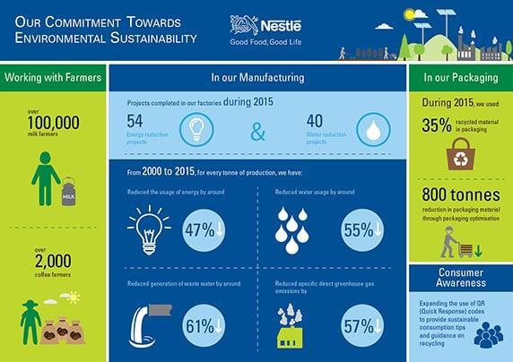
Source : https://www.nestle.in/media/news-feed/world-environment-day

To put it simply, Nestlé's mission, vision, and values are unified in their commitment to improving quality of life through food. This commitment is founded upon a profound regard for the well-being
of individuals, society, and the environment. As a result, Nestlé adopts a holistic business strategy that goes beyond mere financial achievement.
(Reference: Nestlé Global. (2023). Nestlé purpose and values. Retrieved from Nestlé website.)
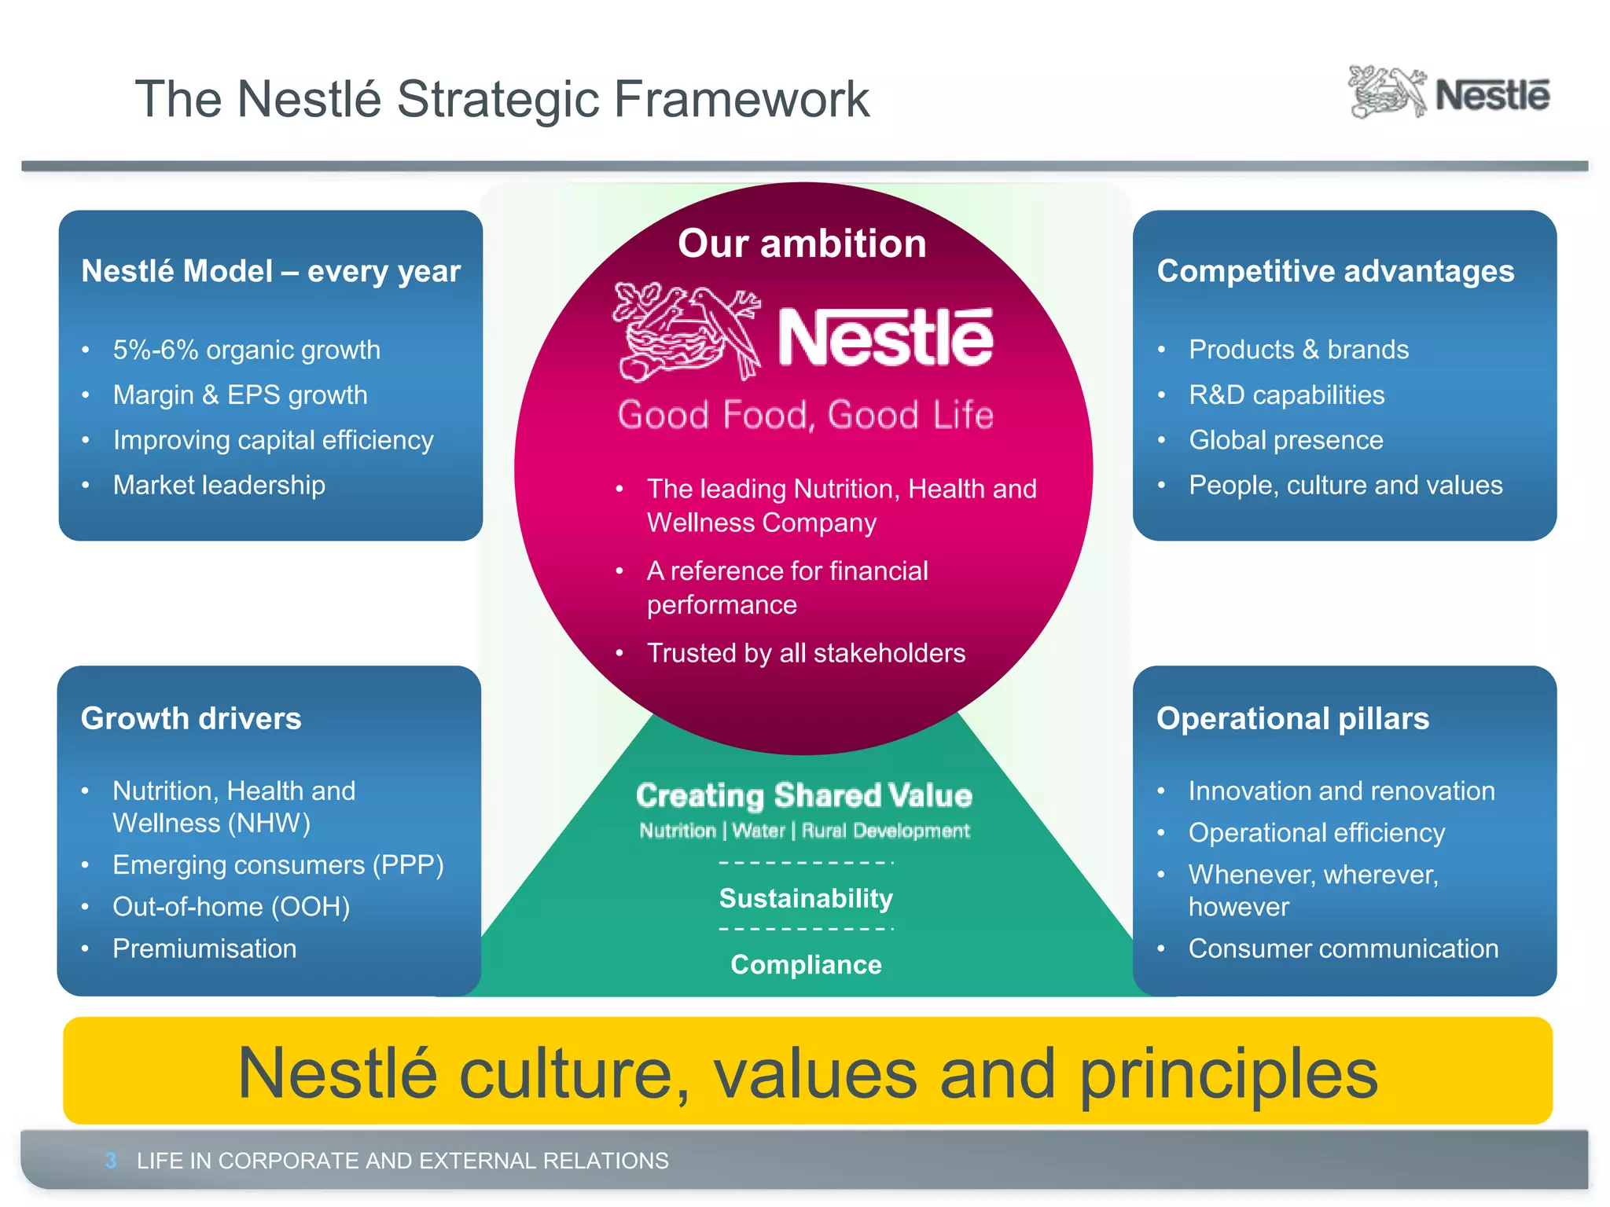
Figure 1: Nestle Culture, Values and Principle [Source:MAPexpo 2012 - Margaret Stuart (Corporate and External Relations Manager, Nestle) | PPT (slideshare.net)]

3.5 Market Segmentation:
- Geographic characteristics: Nestlé Bangladesh introduced Nescafé ice in response to the prevailing perception of Bangladesh's hot climate. Customers prefer to consume this coffee with hot or cold water and an ice crystal during the warmer months in order to refresh their bodies and minds.
- Demographic characteristics:
- Age : Consumers’ age was utilised by Nestlé to segment the demand for its leading brands. Examples include NIDO, Nesquick, KOKO Krunch, and Lactogen.
- Income : Nestle effectively implemented market segmentation based on consumer expenditure. For instance, KitKat Chocolate and Cornflakes are specifically marketed towards individuals who possess a moderately high income bracket (Business Strategy Hub, 2021). Others, including Maggie Shaad-E Magic, are designed with low-income individuals in mind.

- Psychographic characteristics:
- Lifestyle and individuality: Nestlé introduced 2-minute Maggi noodles targeting time-crunched mothers. It will aid mothers in efficiently preparing a dinner or refreshment for the evening in less than two minutes. Nescafe 3 in 1 is specifically formulated for individuals with demanding schedules who lack the time to brew their own coffee (Business Strategy Hub, 2021). By consuming ‘Nescafe 3 in 1’ in one sitting, they will effectively conserve time. There has been a combination of sugar, coffee, and tea.
- Behavioural characteristics:
- Advantages/benefits: Nestlé Bangladesh's operations were effectively segmented according to benefits. Consequently, Cerelac is made available to clients desiring to maximise the performance of their products. Cerelac is a nutrient-dense infant formula designed for children younger than one year.

CHAPTER - 4

ANALYSIS

Analysis

4.1 Internship overview:

4.1.1 Specific Responsibilities of the Job

Throughout the duration of this three-months internship, I have been affiliated with the Human Resource Department's Rewards and Operations Team. The primary responsibility of the Human Resource Department at Nestlé Bangladesh PLC is to administer rewards.
The internship program provided me practical work experience and has delegated the subsequent duties to me:
- Monthly processing of medical schemes: This is a significant monthly task that I undertake. Annually, Nestlé Bangladesh Limited allocates a specific monetary value to each employee, encompassing both management and non-management personnel. They are able to utilise this sum for medical purposes, for which they are eligible to submit a monthly claim. Thus, we receive a substantial volume of medical claims that require processing each month. I have been allocated the task for processing these bills which includes recording them into Excel and then transferring them to the relevant party who further sends them to the Finance department for disbursement with the current month’s salary.
- Onboarding formalities: Additionally, I am responsible for overseeing the onboarding process for both permanent employees and interns. I am tasked with ensuring that they furnish us with all the necessary documentation prior to their enlisting.
- Exit Procedures: Similar to the onboarding process, I am responsible for the exit procedures, but exclusively for the interns. I oversee the exit-related paperwork and ensure that it is distributed appropriately and accompanied by a comprehensive explanation. I also compose the letter of experience for the departing interns and the employees.
- Maintaining and updating personal files: Nestlé ensures the maintenance and updating of personal files by allocating distinct folders for each employee, containing all pertinent documents spanning from the employee's induction to the present. Everything must be in order, beginning with the curriculum vitae, academic papers, medical records, performance evaluation form, and culminating in the salary statement. My contribution was pivotal in guaranteeing the comprehensiveness and precision of employee records. I ascertained the availability of all mandatory documents and inserted any generated additional papers into their corresponding files by promptly contacting employees to ask for the required documentation if any information was absent.
- Reorganised and Updated the HR Policies Folder: I worked independently on this project and reorganised and serial-number coded all the current Nestlé Bangladesh HR policies that are in effect so that they can be located with ease whenever required.
- Preparing analytical data: I aided the Rewards team in conducting analysis of data through creation of dashboard reports in order to extract meaningful insights such as calculating attrition rate, performing people analytics based on factors such as region, grade, location, and age etc., determining headcount percentages etc. by utilising the medium of Excel, Canva, Power Bi and so forth.
- Organising: I also substantially assisted in the organising of events and business meetings such as Nestlé Annual Excellence Award, Pitha Utshob, Town Hall etc. through idea generation, assisting with the organisation of games/recreational activities, vendor handling, designing, check listing etc.
- Communication: Additionally, I provided support to the Rewards and People Development team by creating communication posters pertaining to policies, as well as composing communication emails, letters, and inspirational quotes.

4.1.2 Leaning aspects of the internship journey:

During my internship at Nestlé Bangladesh PLC, I was afforded the opportunity to explore a multitude of human resources facets, including employee file administration, adherence to policies, laws, and regulations, communication aspects, employee recruiting and onboarding, data analytics and so forth. This practical experience yielded me with significant knowledge regarding human resources procedures and activities.
Gaining knowledge of the organization's policies, employment laws, and regulations in the various jurisdictions in which it operates, as well as understanding the collection, analysis, and utilisation of HR data to inform decision-making pertaining to diverse management activities, will undoubtedly be crucial as I advance in my professional trajectory in the near future.
Acknowledging the critical nature of safeguarding the privacy of employees' personal information is an indispensable element of human resources and this is another significant learning which I will be
taking from my internship journey. The internship facilitated my understanding of the importance of this facet.
Proficiency in the domains of collaboration and corporate behaviour is of immense value for fostering professional growth. My comprehensive exposure to the corporate culture during my tenure at Nestlé

Bangladesh PLC has equipped me with this knowledge, which I am certain will prove invaluable as I advance in my career in human resources or related professional trajectory.
A central focus of the human resources discipline is recognising the significance of a meticulous onboarding procedure in facilitating the rapid adaptation of new employees into the organizational
mindset. My internship journey aided me to gain important insights into the significance of this aspect and gather knowledge of the minor to major factors that require meticulous attention to detail during the employee onboarding process.
Achieving proficiency in managing employee complaints, disputes, and issues while simultaneously fostering a harmonious workplace atmosphere has proven to be an enormous learning curve as well.
By engaging with employees from various cultural backgrounds and gaining experience adapting to the HR practices of different cultures, this journey facilitated the development of my global perspective. Additionally, it equipped me with project management and communication skills through my involvement in the coordination of employee engagement activities, implementation of new HR systems, administration of communication posters/mails and collaboration with vendors for company and industry events.
Last but not the least, this comprehensive experience has served as nothing but the stepping stone to my professional and personal growth which I am certain will be of immense value as I advance in my career within the realm of human resources.

4.2 Project:

4.2.1 Human Resource Management of Nestlé Bangladesh PLC

Nestlé acknowledges that the engagement of their employees is crucial to their success and that no accomplishments can be made without it. Nestlé Human Resource Managers at all levels prioritise the task of guiding and motivating individuals to contribute value to both the Company and society. This necessitates a significant individual dedication from every employee and a shared mentality focused on achieving outcomes. The team is efficient, captivating, and motivating. They firmly believe in practising what they preach and setting a positive example via their everyday work. In this regard, their actions carry more weight than their words. Thus, at Nestlé, the primary criteria for advancing within the organization are the ability and willingness to adhere to the Nestlé Culture and Human
Resource principles, regardless of one's background, nationality, religion, race, gender, sexual
orientation, or age.

Line managers bear the primary duty of creating and maintaining a work environment in which individuals feel personally dedicated to their tasks and strive to achieve optimal results for the success
of the Company. The HR structure facilitates and empowers individuals in determining the company
needs and the related personnel requirements. Thus, the objective of HR managers and their teams is to offer expert advice to line managers with the goal of achieving exceptional business outcomes
through the optimization of employee performance, while also providing superb working conditions. Nestlé recognizes the utmost importance of establishing a rapport founded on trust and respect with workers and employees across all hierarchical levels. They have zero tolerance for any type of harassment or discrimination. The HR department ensures the establishment of a courteous and constructive conversation environment, where the employees' perspectives are acknowledged and taken into consideration. Nestlé prioritises the preservation of its employees' freedom to associate and their ability to engage in collective bargaining. Additionally, Nestlé guarantees the establishment of regular and direct contact within the workplace. Although engaging in communication with trade unions is crucial, it does not serve as a substitute for the intimate connection that the management upholds with all employees. To foster ongoing improvement, they promote open communication with their employees that extend beyond the conventional aspects of collective bargaining. This allows them to exchange knowledge and collaboratively identify opportunities pertaining to significant issues such as Creating Shared Value, workplace health and safety, and environmental concerns.
Nestlé is dedicated to advancing the process of building streamlined and adaptable organizational frameworks with limited managerial levels and extensive spans of control. These structures facilitate personal growth, enhance efficiency, and facilitate the implementation of the "Nestlé Management and Leadership Principles" program. Reduced hierarchical levels necessitate heightened collaboration among employees. This will enhance the organization's flexibility and accountability. It effectively meets the current and future needs of a dynamic and inventive organization operating in a highly competitive environment. These fundamental convictions have motivated them to establish a setting that prioritises not only personal accountability and independence, but also a robust inclination to assist others, collaborate in diverse teams, and foster internal cooperation rather than competition.

4.2.2 Nestlé Bangladesh PLC Compensation and Benefits
Nestlé, a prominent company in the field of nutrition, health, and wellness, enjoys global recognition.
However, what entices new recruits and maintains the interest of existing employees is not solely the compensation and incentives tied to exceptional performance. Furthermore, it encompasses the
esteemed value and reliance that their reputation instils in individuals who collaborate with them; the connections with supervisors and colleagues; acknowledgment and gratifying encounters throughout

employment with a multinational corporation; and opportunities for personal development and
advancement. Nestlé prioritises Fixed Pay, Variable Pay in the form of compensation along with benefits like Insurance, Medical, LFA, Personal Growth and Development, Work Life Environment etc. as the fundamental components that determine Total Compensation and Benefit Package. Nestlé possesses a competitive advantage over all other multinational corporations (MNCs) due to its
diversified workforce and culture, comprehensive benefits across the grades, automated employee learning systems, substantial investments in systems and processes, and effective and influential mentoring programmes. Nestlé’s compensation package includes the following:

- Fixed Pay: The Base Salary forms the fundamental component of the overall remuneration package. Typically, the other components of compensation are based on or connected to it. Periodic surveys are employed as a reference point to ascertain the company's competitive standing in the market. Base salaries and wages can be determined within the range of the
market median and the third quartile of competitive competitor levels, as gathered from trustworthy survey providers. The fixed pay of Nestlé Bangladesh PLC’s compensation package incorporates gross salary, lunch allowance, festival bonus, and travel allowance among others. Base salaries undergo periodic reviews, typically on an annual basis which is termed as ASR (Annual Salary Review). Nevertheless, in exceptional situations, it may be possible to contemplate a supplementary evaluation. Salary evaluations should be based on both individual performance and considerations of internal fairness and external competitiveness. Furthermore, while determining a compensation rise, it is important to consider the employee's overall status, including their potential, future development goals, the rate at which their salary has increased in the past, and any recent adjustments made to their salary.
- Variable pay: The primary objective of variable pay schemes is to incentivize the entrepreneurial spirit of personnel involved and guarantee their motivation to exceed anticipated performance levels. The aim is to facilitate employees' engagement in the company's achievements. Nestlé's variable compensation is contingent upon the gross
salary of its employees. Employees are eligible for two types of bonuses depending on their workstation. The first is a periodic Performance Bonus, which is given to non-field employees based on their annual gross compensation. The second is the Short-Term Bonus (STB), which is granted to field personnel on a monthly basis, also based on their gross salary. The Short-Term Bonus (STB) programme allows for the acknowledgment of employees who achieve measurable outcomes for the company, in alignment with predetermined objectives. The alignment of objectives and the delivery of short-term bonuses are determined by the extent to

which expected collective and/or individual variables are achieved throughout the performance period, usually spanning a calendar year. It is generally advisable to strive for a harmonious blend of collective and individual goals. In order to effectively implement the business plan and foster the Performance Culture, it is essential that the objectives are derived from the Business Unit's strategy, which is in line with the Nestlé Strategic Performance Framework.

As part of the Total Rewards programme, Nestlé, as an Employer of Choice, intends to offer competitive and all-encompassing employee benefits. Benefit program provided may consist of some or all of the subsequent, contingent upon the particularities of each market:

- Insurance benefits: These benefits are intended to safeguard employees against potential hazards such as accidents, illnesses, disabilities, and fatalities while they are on duty. These programmes are frequently offered to employees voluntarily, alongside occupational and mandatory/social security workers' compensation payments for work-related disability, accidents, or illnesses, depending on market legislation and norms. Nestlé offers its employees, their spouses, and their first four dependent children access to health insurance and life insurance which is referred to as group life insurance.
- Provident fund: Nestlé provides the employees to be admitted to the membership of Nestlé Bangladesh PLC's Provident Fund in which each employee must contribute to the Fund on a monthly basis in an amount equal to 10% of their base pay, which will be paid to them upon termination of employment. The percentage is withheld from the employee's remuneration during each periodic payment and is remitted to the Trustees by the Company.
- Medical benefits: Hospitalisation, or IPD (in-patient), and routine doctor visits, or OPD (out-patient), constitute the two categories into which the medical benefits can be classified. Additionally, maternity benefits for specific grounds (female employee or male employee’s
spouse) and immunisation facilities against common diseases are included. This policy also provides coverage for prescription medications, dental care, diagnostic examinations, spectacles, along with routine checkups. Employees, their spouses, and their initial four children are granted access to the aforementioned amenities. This scheme is designed to provide employees with immediate access to top-tier healthcare and health insurance coverage in the event of an injury or illness. They are expected to cover the whole expenses of treatments and hospitalisation for themselves and their family.
- Executive Health Checkup: This policy will apply to all permanent management employees. It is mandatory for employees of the organisation to consistently uphold good health. Hence,

employees aged 40 and above will have the right to have an Executive Health Check-up once a year, while those under 40 years old would have the right to undergo an Executive Health
Check-up once every two years, in addition to the existing company medical programme policy. All permanent management employees shall be bound by this policy. Constant
adherence to excellent health is mandatory for all employees of the organisation. Hence, employees aged 40 years and above shall receive an Executive Health Checkup annually, while those aged below 40 years shall be eligible for one every two years, in conjunction with the company's up-to-date medical scheme policy.
- Staff Quarterly Gift Vouchers: The objective of this policy is to institute a structure in which employees will receive four vouchers on a quarterly basis, each with a value of BDT 1,000. The coupons are intended for the acquisition of items from the Staff Sales Shop. Each coupon must be utilised by the conclusion of the respective quarters within the same year.
- Gift vouchers: The company provides the employees with gift vouchers from Aarong in 4 quarters throughout the year. These vouchers are redeemable for discounts on Aarong product purchases.
- Infant Feeding Scheme: The company promotes and supports extended breastfeeding for all female employees and the spouses of male employees. In the event of insufficiency of breastfeeding, the employee may enrol in the Infant Feeding Scheme, contingent upon a medical recommendation. Employees are eligible to receive Infant Feeding items for their children up to the age of 1. The policy shall solely apply to the initial two offspring.
- Leave Fare Assistance: This benefit is valid for all permanent local management employees of Nestlé Bangladesh PLC. Leave fare aid, also referred to as LFA, is equivalent
to one month's gross salary every year. This allowance is given to employees to help cover the necessary expenses incurred during their vacation.
- Marriage Gift Policy: Nestlé Bangladesh PLC presents its employees with a memento of appreciation to commemorate their wedding. This gift is valid for all the local permanent employees of Nestlé Bangladesh PLC who will get a specific monetary gift in honour of their matrimonial union. This policy is exclusively relevant to the employee's sole marriage which takes place throughout their tenure at the organisation.
- Gratuity Scheme: This scheme is applicable for all the local permanent employees who have been with Nestlé Bangladesh PLC for 5 years and above. The eligibility for the gratuity scheme is determined by multiplying the number of years of service by the last drawn gross salary.
- Management leave policy: Employees are granted annual or yearly leave for 20, 24, or 21 working days per calendar year, depending on their location in the head office/distribution centre, regional offices, or factory, respectively. Upon a physician's certification, employees are granted sick leave for absences exceeding two days. In addition, employees are eligible for a special leave of absence in the following circumstances: unanticipated death of a parent, in-laws, child, spouse, or close relative; employee marriage; or child's wedding. Maternity leave is available to female employees and entitles them to receive their complete pay for a duration of 24 weeks, with prenatal leave being limited to a maximum of 8 weeks. It is worth noting, however, that the maternity benefit is applicable solely to the initial two dependents. Unused leaves are carried forward in full from January to March, with a maximum of 5 days carried forward from April.
- Recognition Scheme: Nestlé acknowledges that recognizing exceptional efforts and celebrating success are crucial factors in fostering a performance-oriented culture inside the firm. In order to be profoundly recognised, the employee's contribution should exceed their typical performance standards for the role. The situation could either be a single occurrence or it could perhaps be indicative of a consistent and outstanding contribution over a prolonged duration. This scheme applies to all of the permanent management employees of Nestlé Bangladesh PLC. Recognitions can be classified as instant recognition, quarterly recognition, annual recognition, or Long Service recognition - which is awarded for completing extended service to the organisation.
- Staff Sales Policy: All permanent local personnel of Nestlé Bangladesh PLC are granted access to this scheme for their personal use only. Monthly, employees are permitted to purchase items valued at a maximum of 20% of their aggregate monthly gross salary. Employees without

- children under the age of five are not permitted to purchase any product that substitutes for breast milk.
- Childcare Benefit Policy: Provision of childcare reimbursement will be extended to all permanent female employees up to 2 years of age. This benefit is restricted to two children at most, and only if the child is enrolled in a registered daycare or creche.
- Work Life Environment: An inspirational work environment at Nestlé is essential for attracting, keeping, and engaging high-performing employees. In order to foster a positive and health-conscious environment both in and out of the workplace, Nestlé is dedicated to offering the following within the cultural and social context of each market:
- An encouraging and motivating workplace that fosters a harmonious integration of professional and personal spheres.
- Prospects to engage and make contributions to volunteer initiatives, when suitable, that capitalise on the Creating Shared Value (CSV) principles that hold significance for the company.
- A flexible work environment or work-from-home policy which offers a rejuvenating perspective on the concept of work.

4.2.3 Nestlé Bangladesh PLC Rewards
Nestlé Rewards programmes are implemented in accordance with the social and legal context of each nation, taking into consideration relevant collective agreements. Nestlé has a strategic objective of achieving competitiveness in the marketplace over the long term. Within this particular framework, it is imperative to consider the comprehensive "employee package". Rewards should align with employees' marketplace preferences and adhere to Nestlé’s guidelines. It is essential that total rewards align with the company governance framework and are implemented within the local, legal and socioeconomic context. Some discretion may be allowed, but it must comply with relevant legislation. The "Total Rewards" should be straightforward and rational for analysis. Consequently, all the elements of Rewards are set in a state of concordance with one another.
There are 3 types of performance bonuses provided to the employees namely:
- STB (Short-Term Bonus) : The Short-Term Bonus (STB) is pertinent to all other functions and its evaluation is based on a 9-box matrix. This matrix incorporates 2 types of criteria; one end of the spectrum evaluates the ‘what’ part and another end of the spectrum evaluates the ‘how’ part. A high-performing employee must possess proficiency not only in the what aspect but also in the how aspect; even if one executes tasks proficiently, they must exhibit proficiency in how they are doing it which includes their behaviour, communication skills, team work etc. Teamwork is crucial since individual success might be compromised if the team as a whole is not performing well because Nestlé appreciates an end-to-end culture where you work in a way that helps others to work as well. Consequently, the rating system operates according to two criteria. A score of 3/3 signifies exceptional/exceptional indicating that the employee has excelled in both the ‘what’ and how aspects. 3/2 refers to exceptional/successful which means exceptional performance in one aspect and satisfactory in the other but there is still room for improvement and lastly 3/1 refers to exceptional/improvement implying the employee performed exceptionally well in one area and quite poorly in another. The Line Manager assesses the employee using the 9-box matrix and assigns a rating that determines the performance bonus which is provided to the employees from other functions apart from Sales and Nutrition. Employees are rewarded by the rating system, with bonuses ranging from 125-135% for a 3/3 rating, 115-125% for a 3/2 rating, and 90-110% for a 2/2 rating. The targets are given in such a way that on the basis of it the employees get their annual performance bonus.
- Sales incentive: This is basically offered to the Sales team and it works as an incentive for the employees to work harder towards their targets because the closer they are towards their targets the more their performance bonus will increase. This is directly linked to the employees’ gross salary as for example an employee reached 100% of the target they were assigned to so in this event he/she will be able to achieve a bonus equivalent to 100% of his/her gross salary. However, there are certain other factors at play like for instance if the employee is able to reach 110% then he/she will be getting an additional 15% along with the bonus equivalent to 110% of their gross salary. Hence, the incentive escalates in proportion to each successive slab, motivating employees to improve their performance and achieve higher targets, demonstrating the direct correlation between performance and reward.
- Performance Merit Scheme: This scheme is exclusively relevant to the Nutrition team. The employees must pass four distinct types of evaluations. Due to the fact that they are nutritionists and communicate directly with physicians, they must undergo a stringent process to ensure their competence. The initial assessment is a quiz that assesses if the nutritionists are recommending the correctly prescribed products to doctors, whether or if they can effectively communicate the proper usage, benefits, and nutritional value of the products etc. For instance, Cerelac has 3 stages, and administering stage 2 to a 3-month-old baby could be very harmful as the ingredients are designed for older children. Nutritionists must be well-versed in these technical details and are required to take a quiz on the subject matter in each quarter. After they are done with the quiz, they have 3 types of achievement targets which includes targets related to doctors, area-wise targets and their own performance targets. Based on the quiz and the 3 achievement targets, they receive an accumulated percentage coupled with their gross salary in each quarter. This basically works as an indicator to work harder and perform better thus showcasing a direct correlation between performance and reward.

After achieving high performance for a consecutive period of 2.5-3 years, an employee is positioned to receive a promotion. For instance, in the event that an employee maintains exceptional performance
for a consecutive two years, a check-in meeting will be held with the line manager in the subsequent year and if the employee continues to demonstrate exceptional performance, he/she will be scheduled
for a promotion in conjunction with the performance incentive. Consequently, the salary will
ultimately increase and a rise in the gross salary will inevitably result in a corresponding increase in the incentive associated with the gross salary. This essentially equates to a doubling of profits; thus,
employees strive to consecutively maintain outstanding performance. Employee morale and satisfaction on the job may be enhanced by recognising and appreciating the extraordinary endeavours and commitment of employees through the provision of monetary rewards, or salary increases in exchange for their outstanding work of nature. The implementation of incentive and compensation policies has the potential to inspire both field and non-field personnel to strive for higher levels of
productivity and foster extraordinary performance. To ensure the long-term viability of incentive programmes and employee engagement, Nestlé implements transparent communication regarding bonus eligibility requirements, consistent feedback from employees, and transparent evaluation processes to optimise the effectiveness of such schemes. By implementing this practice, the organisation effectively sustains motivation and guarantees that incentives remain consistent with its strategic objectives and key values.

Nestlé does not have a culture of terminating employees or a sacking policy unless the employee does something which has a legal impact like if they indulge themselves in any sort of illegal activity or if
they sexually harass someone or participate in any other intolerable misconduct with legal ramifications. Nevertheless, in the event that an employee fails to meet expectations, they receive a
warning in the initial year and are enrolled in a performance-improvement plan (PIP) the following year. The PIP procedure entails issuing the employee a letter informing him/her that their performance
has been consistently subpar for a period of time and that he/she will be assigned under the supervision of two to three trainees. The employee will be paired with two to three high-performing members of their team and will be expected to emulate their effective work methodology in order to strive to enhance their own performance. Furthermore, the employees are assigned with trainings
associated with the subject-matter like for example innovative worker, high-performing mindset, skills
required for presentation, Excel etc based on the specifications of your job. Following a comprehensive grooming process, the employee will be re-evaluated to determine whether or not they
have made any progress. Nevertheless, in the event that the employee's performance fails to improve despite this, their gross compensation will be significantly affected; for instance, they may only be eligible to receive their gross salary and will be ineligible for any performance bonuses or STBs for the following years. Finally, in the event that the employee continues to perform poorly, an internal discussion ensues to determine the necessary next steps, such as whether the employee should be
transferred to a different job shift or movement, or whether they should engage in a more substantial discussion regarding termination in accordance with labour legislation, contingent upon mutual agreement. Nevertheless, the final stage represents an exceedingly rare possibility, as employees typically exhibit signs of progress as soon as they are enrolled in a performance improvement plan.
Additionally, an annual salary review is conducted each year during which an employee's performance is evaluated and subsequently subjected to an increment so if an employee consistently underperforms, their increment may be withheld. This could demotivate the employee and encourage them to exert greater effort, as they would observe that other employees are receiving salary increases while their own remains unchanged.

Thus, we can come to the conclusion that there’s no separation policy based on performance and also how the reward and compensation structure impacts the performance level. Employees, in coordination with their Line Managers, begin the year by planning and selecting specific Key Performance Indicators (KPIs) to achieve during the year. Once the KPIs have been drafted, they commence their implementation by devising an action plan and systematically executing it. At the conclusion of the year, employees undergo a comprehensive performance evaluation using the 9-box matrix where they are assessed and graded while strictly adhering to the pay-for-performance principle. However, if any employee experiences demotivation due to which they are exhibiting poor performance, the assistance of Business Partners and Line Managers are sought to identify potential opportunities, reevaluate compensation and rewards, determine whether the demotivation stems from an organisational or individual level, and examine industry benchmarks with the intention of devising the most effective solution for the employee.

4.2.4 Nestlé People Development:
In conjunction with a distinct incentives and development system, a high-performance culture is required at Nestlé in order to achieve both individual and organisational objectives. This can be accomplished by assigning each employee complex and specific responsibilities and by ensuring they comprehend how their efforts impact the organisation as a whole. Line managers and employees collaborate across the organisation to ensure that stringent standards are established and consistently achieved on an annual basis. Over time, this enables management to discern and incentivize employees who exhibit exceptional performance, while simultaneously providing constructive
criticism of low-performing individuals. Employees receive consistent feedback on their performance
and career objectives using a specific set of tools and procedures, such as the Performance Evaluation

Process (PE), the Progress and Development Guide (PDG), and 360° assessments. Each year, every manager dedicates the optimal time to focus on monitoring and mentoring employees. Employees are accountable for their own progress under the guidance of their line supervisors, and they can express their professional goals and ambitions through mutual dialogue. The organisation aims to attract and choose employees by offering appealing yet logical professional prospects. Nestlé highly values cultural diversity and provides professional possibilities for immigrants. At Nestlé, individuals are evaluated based on their sustained performance and achievements, as well as their potential for advancement. The Company engages in an active and rigorous succession planning process at all levels to ensure a steady pipeline of successors prepared to meet future needs. Nestlé strives to
eliminate obstacles for both women and men in advancing their careers by creating a flexible work environment, implementing mentoring programmes and providing flexible career paths. The HR team implements efficient tools and provides line managers with essential information to support the ongoing development of employees and the firm.

CHAPTER - 5

FINDINGS, RECOMMENDATIONS & CONCLUSION

5. Findings, Recommendations and Conclusion:

5.1 Findings:

As it was already mentioned that a survey was conducted to gain responses from the employees regarding their view of the correlation between employee performance and compensation/reward structure, hence the statistical analysis are being provided below:

1.
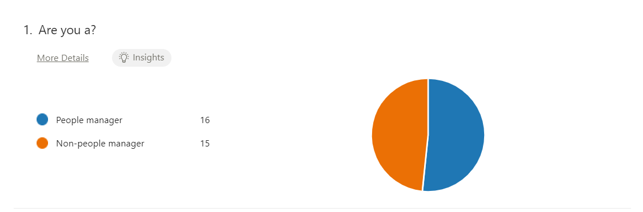Among the 31 respondents, 51% were people managers and the remaining 49% were non-people managers.

2.
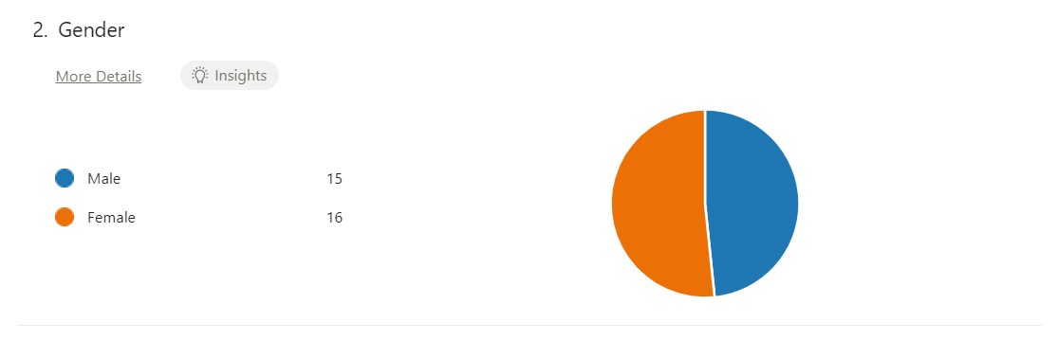
In terms of gender, 16 respondents were female and the other 15 respondents were male.

3.

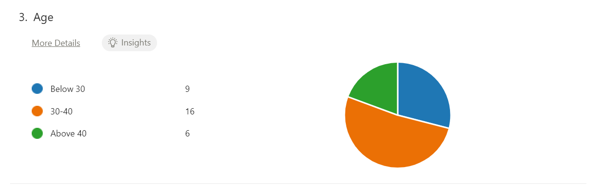
As per the survey, the company is dealing with mostly young adults in the sense that 52% can be placed under the age category of 30-40 while 30% are found to be below the age category of 30 and 19% were found to be above 40.

4.

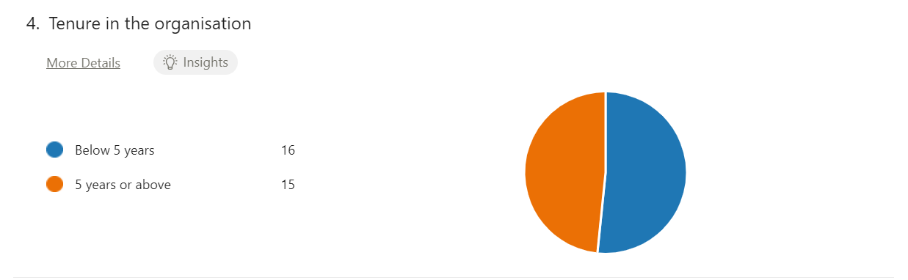
Among the 31 respondents, 48% were found to be extremely committed with the workplace as they have been with the organization for a tenure of 5 years and above while the remaining 52% has been working for a tenure of below 5 years.

5.

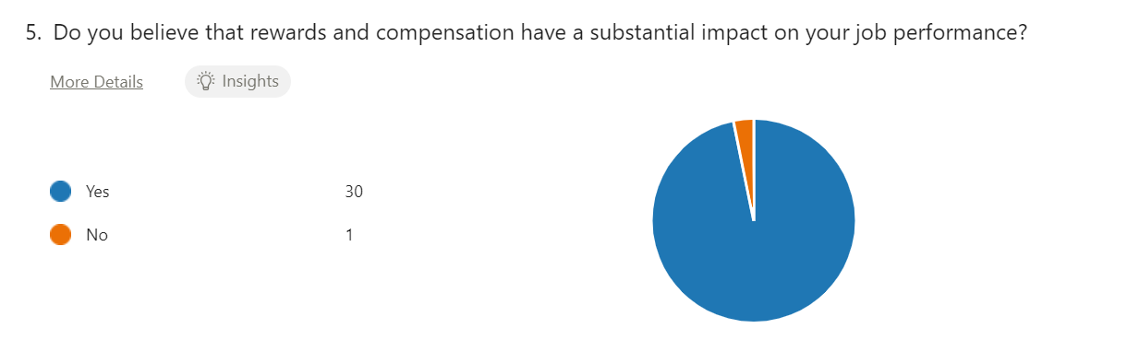
Majority of the respondents are extremely satisfied with the rewards and compensation system of the organization, and they believe that the system has a substantial impact on their job performance given by the response in the survey where 97% are affirmative and only 3% have a different perspective.

6.
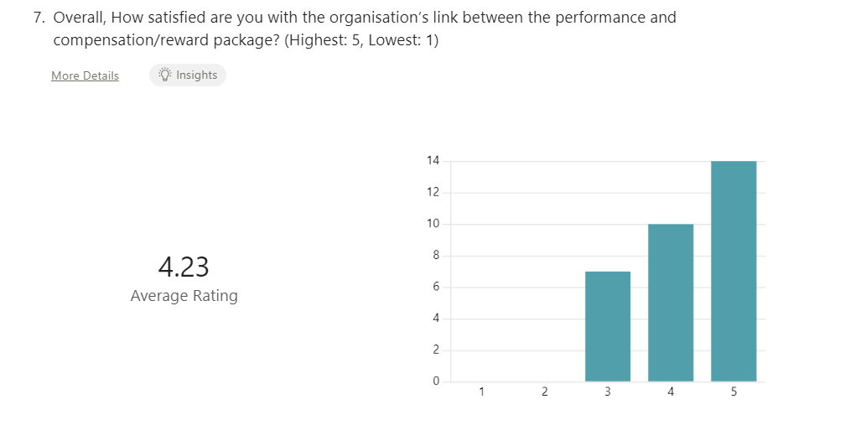

Among the 31 respondents, 23% rated the organization’s link between the performance and compensation/reward package on a scale of 5 to be 3 while 32% rated it on the level of 4 and the majority which is 45% rated it to be 5 out of 5.

7.
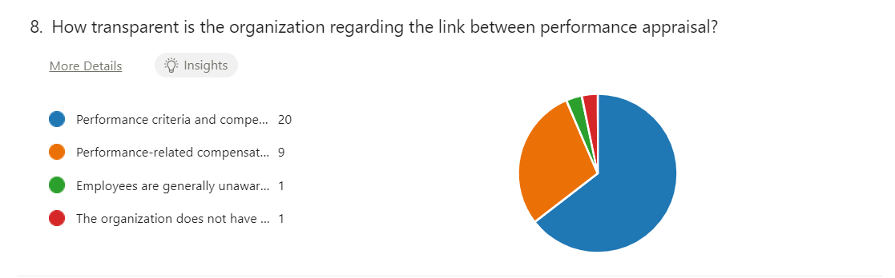
65% of the respondents are sure about the organization’s transparency regarding performance appraisal and 29% gave a moderate response while 3% affirmed that employees are generally unaware of how performance affects compensation and the remaining 3% do not think that the organization has a clear policy which links performance to compensation.

8.
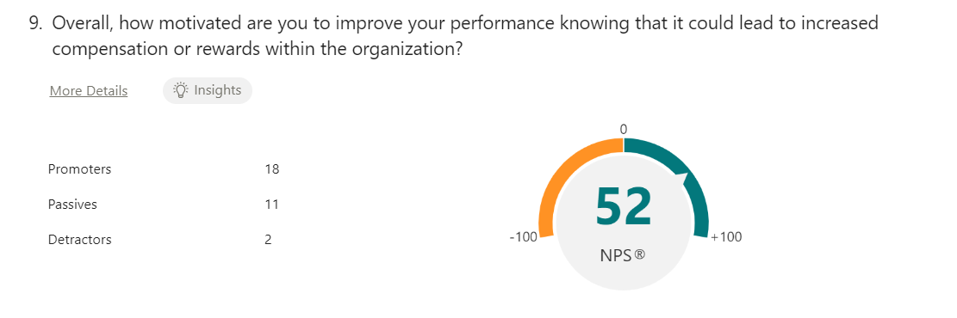
[N.B: The rating for promoters ranges from 9-10 on a scale of 1 to 10 while the rating for the passive audience ranges from 7-8 and the detractors have their rating ranging from 1-6.]

58% of the 31 respondents are motivated to improve their performance knowing that it could lead to an increment of compensation or rewards within the organization. However, 35% are the passive audience while 6% were found to be detractors.
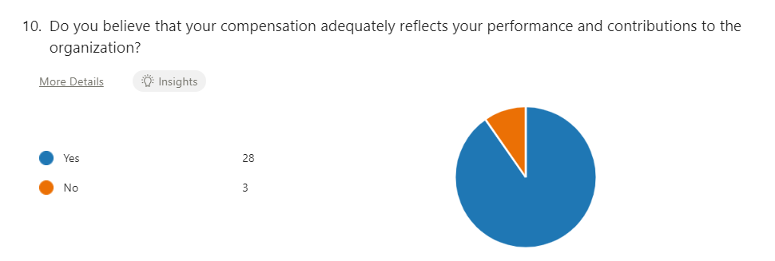
9.

90% of the surveyed employees responded positively to the fact that the compensation system adequately reflects their performance and contributions to the organization while the remaining 10% harboured an alternative point of view.

10.
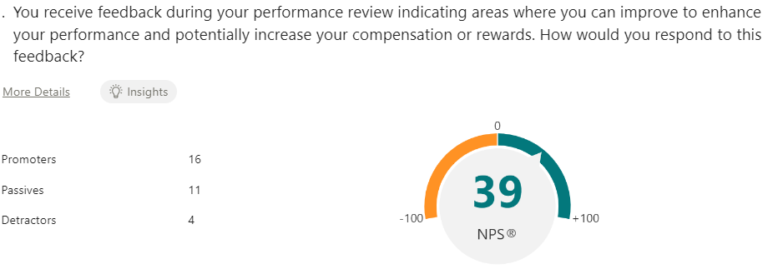

Among the 31 respondents, 52% are the promoters of being motivated by getting feedback regarding the gaps in their performance and how they can potentially get an increment by improving the deficiency in their work. However, 35% are the passive audience while 13% were found to be detractors who provided the votes ranging from 4-6.

11.
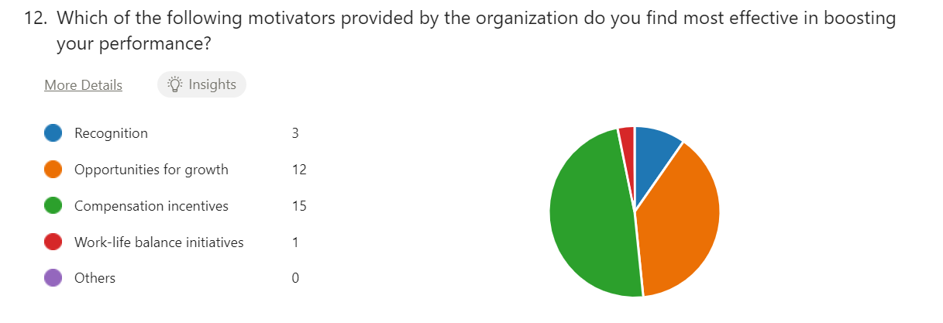

Based on the respondents’ prevailing opinion, the majority of the employees agree with the idea that compensation incentive is the most influential tool in increasing their performance. This can be evidenced from the fact that 48% of the employees who were surveyed endorsed this concept as a motivating factor, and 39% for the prospect of growth. On the same note, while 10% of the respondents consider recognition as an important consideration in this regard and a mere 3% consider schemes towards work-life balance as the significant facet.

12.

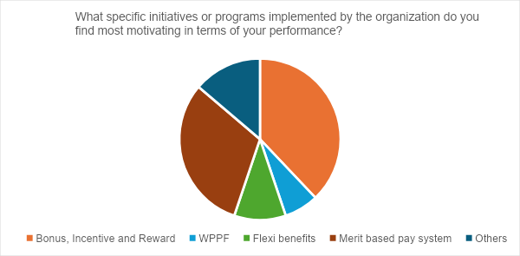

According to the survey, 42% were in favour of extrinsic factors like monetary incentives and rewards package along with WPPF while 29% voted that they find the merit-based pay system to be the most motivating factor in terms of their performance. On the other hand, 23% were found to be significantly motivated by intrinsic motivating factors like flexible benefits, recognition, training modules, mentorship sessions and so forth.

13.

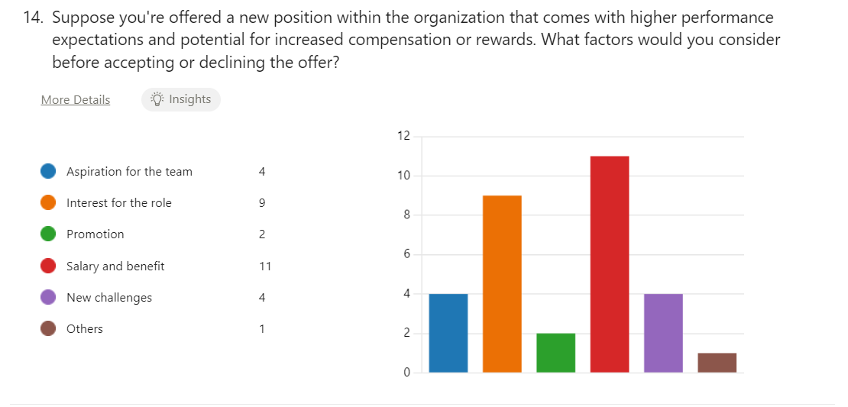
35% of the 31 respondents voted for salary and benefit when asked about a new position within the organization that comes with higher performance expectations and potential for increased compensation or rewards, while 29% went with interest for the role. On the other hand, 13% agreed with aspiration for the team while 13% gave affirmation to new challenges. Lastly, 6% voted in favour of promotion and the remaining 3% chose other considerations.

14.

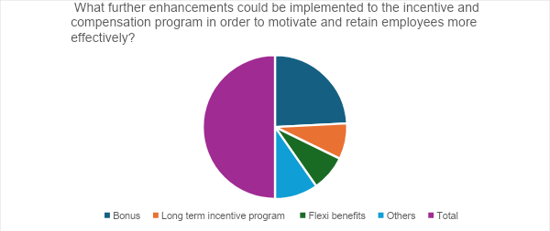

In accordance with the findings of the survey, 48% of the respondents indicated more lucrative bonuses to be the primary driver for motivating and retaining employees more effectively. Additionally, 16% of the respondents believed that a long-term incentive program would serve as a motivating factor, particularly among those who have been with the organization for 5 years and above. Conversely, 16% of the participants are in favour of flexible benefits as a means of motivation, while the remaining 19% suggested incorporating other factors into the incentive and compensation program to enhance employee motivation and retention.

15.

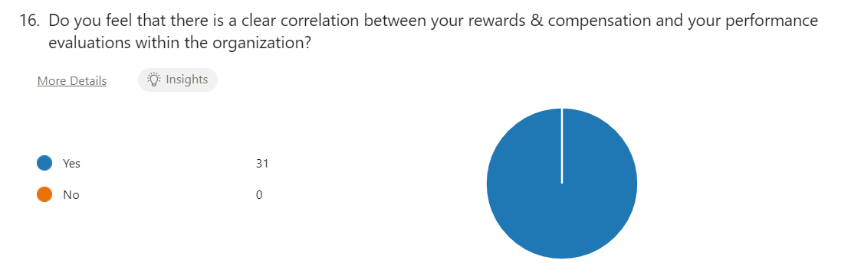

100% of the respondents affirmed the fact that there is a correlation between their rewards and compensation package with their performance evaluations within the organization thus confirming the impact of the relationship between rewards/compensation and the individual’s performance level.

16.

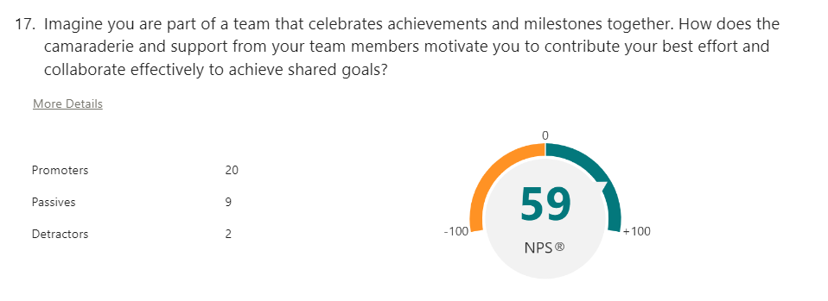

[N.B: The rating for promoters ranges from 9-10 on a scale of 1 to 10 while the rating for the passive audience ranges from 7-8 and the detractors have their rating ranging from 1-6.]
Among the 31 respondents, 65% are the promoters of being motivated by the camaraderie and support of the team members to contribute their best efforts and to collaborate effectively to achieve the shared goals. However, 29% are the passive audience while 6% were found to be detractors who provided the votes ranging from 3-6.

17.
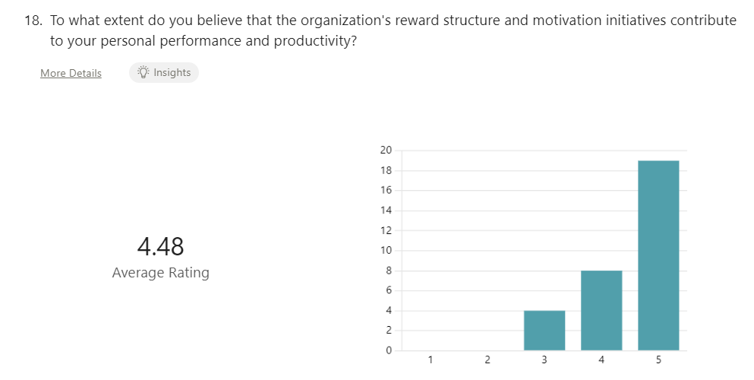

61% of the 31 respondents provided a rating of 5 to the fact that the organization's reward structure and motivation initiatives contribute to their personal performance and productivity while 26% voted for it to be 4 and the remaining 13% opted for a rating of 3.

5.2 Recommendations:
As per the analysis and from my own perspective, there might be a few aspects that the company should predominantly focus on in order to have a seamless management system. The recommendations are being provided below:
- The conclusions derived from the analysis of the local concerns acknowledged by the answers to the questions 11, 13 and 14 of the conducted survey reveal a potential major suggestion to pay more emphasis on factors like compensation incentives and opportunities for growth; salary and benefit, the interest for the role, lucrative bonuses along with long term incentive program as these were the choices most preferred by the employees. The company should opt for experimenting with these options to evaluate the impact on the employee performance and comprehend its relationship with the reward and compensation structure. If the results are quite effective, then they should sustain the activities that are most effectual and dispel the

ones which are non-effective as per their anticipated results. However, this should be tested within the organization for effectiveness at the lowest cost to the organization.
- They should adopt digitalisation of the onboarding process rather than physical documentation unless it’s absolutely necessary. This will save time and increase effectiveness as well as lower down the costs.
- They could incorporate modernised technologies like AI which can be utilised to filter the CVs at the preliminary stage which eases down the process and make it more efficient to accommodate a large pool of applicants seamlessly. They could also consider including a fun aspect to their recruitment process, such as the gamification tests that are formulated to engage the candidates more, add engagement into it and at the same time sharpen their problem solving and skill building.
- They could consider using Power BI and additional SQL queries to create dashboards that will be useful to extract more insight from the data hence assisting in the decision-making process.

- They could launch a retirement plan for employees who have served them over an extended period of time like 30 years and above.

- The organization should arrange a daycare within the premises for the employees of the organization so that women with young children are able to work without any worries.

- There should be a provision for anonymous complaints so that the employees can seek assistance for any sort of problems effortlessly.

- The employees should be yielded with the opportunity to provide feedback regarding their departments and management without revealing their identity.

5.3 Conclusion:
To sum up, in this report, we have examined the compensation and benefits system of Nestlé Bangladesh PLC and how it has greatly contributed to the employees’ performance.
The analysis of the compensation and benefit structure at Nestlé Bangladesh PLC discloses an eclectic approach to employee rewards which predominantly influences performance. The commitment of the company to align compensation with the market reference point and flexibility in implementing a diverse range of benefits fosters motivation among the employees and boosts the level of satisfaction towards the job. Thus, Nestlé Bangladesh effectively synchronises monetary and non-monetary rewards not only for the purpose of attracting talent but also for the purpose of retaining the employees and fostering their growth, thereby enhancing both the employee and the overall organizational performance. The findings of this study establish that employees who are fairly remunerated and those who are appreciated feel motivated to work in ways and increase their performance levels that are likely to enhance the corporate objectives henceforth promoting organizational sustainability.
The information derived from this synopsis underlined by the significance of the well- rationalised reward platform helps to manage employee performance and productivity. Thus, Nestlé Bangladesh’s action indicates that a sound and respectable reward and compensation strategy for the employees is imperative for the development of a solid team of employees who will help the organization build a competitive edge and achieve its objectives. Nestlé can sustain its stance as an employer of choice in the perpetually evolving business landscape by ongoing evaluation and adaptation of these practices through the fine-tuning of the company’s compensation and benefits strategy along with keeping the welfare of the employees in mind.

5.4 Bibliography:
Nestlé Bangladesh: Home | Nestlé Bangladesh | Nestlé (nestle.com.bd)
Home | Nestlé Bangladesh (no date b). https://www.nestle.com.bd/

Wikipedia contributors (2024) Nestlé. https://en.wikipedia.org/wiki/Nestl%C3%A9

'The Emerald Handbook of Work, Workplaces and Disruptive Issues in HRM' (2022) The Emerald Handbook of Work, Workplaces and Disruptive Issues in HRM [Preprint].
https://www.researchgate.net/publication/363311869_Human_Resource_Management_in_Multinational_Corporations.

Staff, C. (2024) What is Human resource Management? Definition + career guide. https://www.coursera.org/articles/human-resource-management.

Nestlé history timeline (no date) Nestlé Global. https://www.nestle.com/sites/default/files/2022-12/nestle-company-history-timeline.pdf.

Nestlé Market segmentation, targeting, and positioning (no date). https://www.edrawmind.com/article/nestle-segmentation-targeting-and-positioning.html.

Parker, B. (2024) Nestle SWOT 2024 | SWOT Analysis of Nestle. https://bstrategyhub.com/nestle-swot-analysis-2019-swot-analysis-of-nestle/.
Nestlé Bangladesh Limited (no date). https://assignmentpoint.com/nestle-bangladesh-limited/.

Kabir, S. (no date) HR-Practice-of-Nestlé-Bangladesh. https://www.scribd.com/document/487014454/HR-practice-of-Nestle-Bangladesh.

Compensation Report 2020 (2021). https://www.nestle.com/sites/default/files/2021-03/nestle-corporate-governance-compensation-report-2020-en.pdf.

Fulmer, I.S., Gerhart, B. and Kim, J.H. (2023) 'Compensation and performance: A review and recommendations for the future,' Personnel Psychology, 76(2), pp. 687–718. https://doi.org/10.1111/peps.12583.

Julie (2020) The Relationship between Performance and Compensation: Does Better Performance Follow the Money? - HRProfessionalsMagazine. https://hrprofessionalsmagazine.com/2020/11/30/the-relationship-between-performance-and-compensation-does-better-performance-follow-the-money/

Compport | Blogs | The Power of Strategic Compensation: A In-Depth Guide (no date). https://www.compport.com/blog/the-power-of-strategic-compensation-a-guide#:~:text=Pay-for-Performance%20Models%3A%20Compensation%20managers%20develop%20and%20implement%20pay-for-performance,that%20motivate%20employees%20to%20excel%20in%20their%20roles.

.

