SUCCESSION PLANNING: A STUDY ON CITY
GROUP, BANGLADESH

This report is submitted as a partial fulfillment of the degree of
Masters in International Human Resource Management

Name: Behejat Fatima Chowdhury

ID No:115203002
Program: MIHRM



School of Business &amp; Economics
United International University
23 February, 2021
Letter of Transmittal

March 1, 2022
Prof. Dr. F. A. Sobhani
Director, MBA, EMBA & MIHRM Programs
United International University

Dear Sir,
With due respect, it gives me great pleasure to submit my project report titled "Succession planning management” - A Study on City Group " in partial fulfillment of the requirements for the MIHRM program under your supervision. It was a valuable real-world experience, and I made every effort to meet the academic requirements.
I have worked diligently to prepare this report and have attempted to make it as clear and comprehensive as possible within the limits. I am confident that it will accomplish the task at hand.

I will always be willing to provide clarifications regarding this report, if necessary.
Sincerely Yours,
________________
Behejat Fatima Chowdhury
Student ID: 115 203002
Program: MIHRM
School of Business and Economics
United International University

Student’s Declaration

I, the undersigned, certify that I completed my project under the supervision of Prof. Dr. F. A. Sobhani, Director, MBA, EMBA, and MIHRM Programs, United International University (UIU), Dhaka, Bangladesh. I wrote a report titled "a research on the training and growth of a city group," which is entirely my own work. Neither a portion of this report has been plagiarized nor has it been submitted before to any other university for any academic qualification, certification, diploma, or degree.

________________
Behejat Fatima Chowdhury
Student ID: 115 203002
Program: MIHRM
School of Business and Economics
United International University
March 1, 2022

Acknowledgement

"Gratitude is the most difficult emotion to explain, and it frequently fails to reflect the full extent of one's feelings."
MIHRM program has aided me in gaining a lot of valuable experience that will help me in future in my profession. I take this opportunity to convey my heartfelt gratitude for this with an incredible sense of thankfulness. The success and completion of this project required guidance and assistance from many people, and I feel myself fortunate to have it during my project's. Everything I've accomplished has only been possible due of their direction and assistance, and I'd like to thank them for that. working under Prof. Dr. F.A Sobhani’s inspired supervision has been a huge honor for me. I'd also like to express my heartfelt gratitude for his invaluable advice, recommendations, and amazing mentorship.
I owe a lot of gratitude to The Director- Mr. Mohammad Hassan, Mr. M. Shabbir Ali, SHRM-SCP, Director- Group HR, Talent management Head, Md. Tabsir Rajib, Senior Manager, group HR Director of HR in City Group. who has given me the opportunity to learn about business management and research at the same time, I'd like to express my gratitude to all of my professors.
I am blessed to receive regular encouragement, support, and guidance from all employees in Human Resources Development, Customer Care, Technology, Finance, and Supply Chain department, which aided me in finishing my assignment successfully
Behejat Fatima Chowdhury
Student ID: 115 203002
Program: MIHRM
School of Business and Economics
United International University
March 1, 2022
Executive Summary

The study was devoted to succession planning management in one of the leading privately owned conglomerate. This report covered succession planning management at City group and overview of current strategy of succession planning, and the effectiveness of succession planning. I got opportunity to discuss openly with the different senior level personnel of city group to gather practical information regarding succession planning background, management. I have included Five chapter which are divided according to their relatedness with the chapter caption where I tried to covered all area related with my topic.
My First chapter is introductory chapter where I have mentioned the background of the report, scope of my study, objective of the study including broad objective and specific objective.
The Second Chapter of my study is methodology where I have discussed nature of my study, described the procedure I followed to sourced, collect and analyze the data,
The Third Chapter of my report was company background which was started with the company information with their organogram and SWOAT, people and HR information and the structure of management level, roles of City group. It also included an overview of succession planning mechanism.
The Fourth chapter of my report will represent the discussion to relate my main objective of the report. interview data findings and analysis show the employees view towards strategy of succession planning, effectiveness of the practice, how it relates to the overall organization structure, culture, development strategy to groom up successors to establish the talent pipeline against key position and role of City group.
The fifth chapter of my report represented where key findings, effective recommendations and added some concluding word was added to end my chapter.

Tentative of contents
PREPARATORY PART
Letter of transmittal ………………………………………………………….
Student’s Declaration…………………………………………………………
Acknowledgement…………………………………………………………….
Executive Summary…………………………………………………………..

CHAPTER 1: INTRODUCTION……………………………………………..
Background of the study……………………………………………………....
Objective of the study………………………………………………………….
Broad objective
Specific objective
Methodology………………………………………………………………
Primary data
Secondary data
Sampling
Data collection process………………………………………………
Data analysis process…………………………………………………

Scope and limitations ………………………………………………………………
Significance of the study……………………………………………………………

CHAPTER 2: CORPORATE PROFILE……………………………………..
Company background and history………………………………………………………….
Mission, vision and value statements………………………………………….
Product and service…………………………………………………………….
SWOT Analysis…………………………………………………………………
Organogram…………………………………………………………………….
City Group HR…………………………………………………………………
Employee Information…………………………………………………………
Number of employees ……………………………..
Employee type …………………………………………………………….
Overview of the management at City group………………………………….
Overview of succession planning at City Group………………………
Objective of succession planning………………………………………..
Procedure of Succession Planning………………………………………
Tool for Succession planning……………………………………………
Training and Development ………………………………………………

CHAPTER 3
Discussion and Analysis

3.1 Understanding succession planning strategies at City Group
3.1(a) Key role consideration
3.1(b) Acknowledging Critical Role
3.1(c) Strategic Alignment
3.1(d) Giving opportunity to right potential candidate
3.1(e) Grooming strategies of successors

3.2 Effectiveness of succession planning at City group
3.2(a) Culture of appreciation and feedback further reinforced
3.1(b) Better managing of changing business dynamics
3.2 (c) Greater opportunity for carrier growth
3.2 (d) Ensure more room for strategic thinking

CHAPTER 4
Conclusion and Recommendations
4.1. Major Findings of the Study
4.2. Recommendations for improvements
4.3. Concluding Remarks

List of Figure…………………………………………………………………….
Figure 2.1 SWOAT Analysis……………………………………………………
Figure 2.2 Organogram…………………………………………………………
Figure 2.3 Numbers of employees at different management level…………….
Figure 2.4 Level of management ………………………………….
Figure 2.5 Role of management
Figure 3.1 Succession planning Matrix of City group
Figure 3.2 customized succession evaluation

Appendices ………………………………………………………………………
Appendix 1: Interviewee question………………………………………………
Appendix 2: Interviewee Information…………………………………………
Appendix 3: performance appraisal…………………………………………
Appendix 4: Job Nomenclature………………………………………………
Appendix 5: Abbreviation………………………………………………………

CHAPTER 1
1.0 Introduction

  - Background of the Study:

succession planning is a topic that is rarely discussed in many organizations because of its sensitivity. One of the most difficult issues facing today's firms, is ignoring open dialogues. Whereas by building a long-term succession plan can save business. Over the last decade, succession planning has become more sophisticated because of more global competition, post pandemic challenge, and huge changes in worker demographics and mobility. Business executives desire skilled future leaders to fill empty leadership jobs in order to deal with market challenges and address changes in workforce demographics. Formalizing succession planning aids company executives in finding, keeping, and cultivating high-potential employees so that they can gain the essential skills and competencies to take on leadership roles. My focused was particularly on City group, I choose City group because I came to know that City Group has currently transformed their business strategies where they have enriched their HR with lots of departments, new policies and they have redesigned it have a succession planning whereas City group is maintaining more integrated succession planning which created interest to choose this company for my study and as a part of my MIHRM program at UIU, I was required to write a project report where I chose this topic to do on City Group. I was connected to the Human Resources Division at City Group. My project report is titled "Succession planning: A study on City group” which I chose and was authorized by Prof. Dr. F.A Sobhani, Director MBA, EMBA, MIHRM, United International University.

1.2 Objective of the study:
Objectives of this study can be described as what was expected to achieve by this study. The study's goals are divided into two categories:
- Broad Objective
- Specific Objective

1.2 (a) Broad Objective:
The purpose of this study was to look into the succession planning, with a particular focus on City Group. It is a wide range of topic, where this study will explore and gain a better understanding of the succession planning objective, strategy, effectiveness, process, evaluation and policies of City group.
1.2 (b) Specific Objective:
This study objective was worked as a statement purpose as this study does not linked with any hypothesis or research question. The specific objective of this study are as follows
- To understand Succession planning strategies at City group
- To Identify effectiveness of succession planning management of city group
- To make recommendations to management to improve

1.3 Methodology:
This study required a systematic approach for retaining reach meaning from collected data where it followed qualitative approach as they are flexible for focusing reach meaning from data. To understand the organization’s perspectives towards succession planning and to know about their culture, a lot of time needed to spend with the selected organization’s group of people in an ethnography manner. To perform the study, data source was identified in order to classified, interpreted and analyzed in an organized way. Two sources of data were identified to collect informative data to make the report more understandable and effective. The sources are:
1.3 (a) Primary Data: Here, the researcher is directly involved in the data collection process. The data type is primary data where it acquired first-hand information that serves as the basis for the systematic examination. The data was gathered and evaluated using focused group and one to one employee interview.
1.3 (b) Secondary Data: Secondary data was also used in this study which are-HR departments documents includes talent management charts, appraisal forms, assessment guidelines for managers, succession planning chart, evaluation forms. Different types of journal, articles and website.
1.3 (c) Sampling
In order to collect primary data, it required sampling from a big population of City group because the study needed to look at a wide range of cases that are all connected to a single phenomenon or event. Purposive sampling was seeming appropriate because the topic of this study is wide, and needed information as many as possible to stand up their strategy, culture towards succession planning. Purposive sampling was seeming appropriate for this study to collect data where the sample size was 8 employees of only management level. The criteria for selecting Individual employee were chosen based on their tenure, job grade, managerial level, as well as stream. For criteria selection tenure is used to refer to an employees working period at City group.
Job grade refers to the degree of authority in management level. Each participant employee in interview and group discussion are considered and will be mentioned as respondent in this study. Respondent are chosen from different management levels, job grade and tenure to understand the organizations succession planning practice and effectiveness. who are working in different departments under different stream.
1.3 (d) Data Collection Process:
Data collection process was significant in this study to gather meaningful information on the topic, succession planning. In collecting data from the primary source, the process can be described in two sessions. in first session, the purpose of collecting data from the focused group was to know what management is thinking, what are the policies they are following to maintain succession planning and how they have designed their succession planning management framework to identi1fy the strategy they are practicing. Open ended question was asked in both terms. Scheduled meeting was organized on February4, 2022 at 11:00 to 12:05 am which included an explanation of the organization's overview, current HR practices and strategies regarding succession planning. The interview was around 60 minutes long and recorded in personal cell phone. The HR Director was in charge of this coordination. It was a group discussion which was conducted at City Group office. It was also helpful to familiarize with their environment and conducting the second session of one to one interview. To conduct the second interview session, the HR provided a list of names, contact information of different employees matching with my respondents’ criteria. one to one interview conducted by communicating with each employee over phone. Here each employee will be considered as respondent in this study. The respondent was whole conversation of each respondent was around 35 minutes. The researcher interacted with each of the respondent. Each employee was interviewed for on average 5 to 10 minutes for each question. In addition to writing down some notes I explained and asked permission for it. One to one interview duration was February to 6th to February 11th of 2022.
I tried to collect as much data as I could from recent journals, articles and some website to enrich my knowledge to correlate my findings and discussion of the study. In this qualitative study, the researcher was the main tool for collecting data. During the process of collecting and organizing data of interviews, looking at organizational documents, and looking at visual data was all ways to get information that were seen and heard related to succession planning. In this qualitative study one to one interviews and focused group were a good way to get necessary data where semi structured open-ended questions was effective to obtain data.
1.3 (e) Data Analysis process:
It is significant to analyze the data properly since it enables to construct a fact based findings and demonstrates the exist deficit and acute to assess obtained data to create necessary recommendation and concluding marks. The focused group’s conversation and each interview on phone was recorded on researcher’s personal device and it was in bilingual language (Bangla and English). The researcher needed to translate the conversation in English to interpret the data, which was typed into Microsoft word. Each interview was recorded to keep track of the information, the respondents gave. For the second phase of the interview respondent was connected by phone and was recorded accordingly by their permission. The first interview was transcribed and analyzed right away using the comparison method. Data from interviews and documents were looked at and compared. A group of data is considered as a set in this study. After giving the dimension an initial name, it was then defined under a group name to answer the research question. The main goal of this analysis is to look for patterns in the data to identify and relate them to the objective of the study. Each interview was recorded to keep track of the information the respondents gave. The record for each person was on average 5 to 10 minutes long for each question. First session interview was recorded and noted in personal notebook. It was then typed into Microsoft word as translation was needed.
second session interview was also recorded and then form record, typed in Microsoft word to analyzed accurately by using the comparative method. For assuring accuracy interviews record and word documents were looked at and compared again. For second phase of the study the data analysis was comparative method comparing one piece of data to another to see if there are any similarities and differences. The group of data was organized together as a set as they are on the same level then after giving the dimension and initial name of each group the analysis found a patterns on the data.
1.4 Scope and limitations:
This study was created after thorough discussions with City Group's HR, Talent Management, and Management teams, as well as interviews with employees at various levels of management in various departments at City Group's head office, House: NW(J) 06, Road: 51, Gulshan-2, Bangladesh. To complete the Project report of my MIHRM program and to explore the real-life exposure of the organization, it was a great opportunity to gather hands-on knowledge with Human Resource Department of a leading FMCG company in Bangladesh. The duration of the study was December 1 to February 15 of the year 2022. At the time of writing the report, I had a fantastic opportunity to gain a thorough understanding of succession planning, including the process of succession planning, appraisal, the role of management at all levels, and the City group's talent-related strategies. Limitations was delay on getting appointment, for scheduled interview was created time limitation for this study. As the topic is quite sensitive and confidential for organization, I had to be careful while interpreting data and writing the discussion. Sometimes the respondents took long time to answer one of the open ended question which was difficult to relate with the main objective

1.5 Significance of the Study
The study's qualitative design provided a distinctive viewpoint on “City Group” through the interviews with employees and examination of employee records in order to provide more evidence of succession planning. This study will provide recommendation on how the existing system of succession planning will be more effective and this study will provide an ideal platform for gaining a better understanding on the employees of City groups views towards succession planning of the organization.

CHAPTER 2
2.0 Company Profile

2.1 Company Background
City Group is a well-known consumer goods manufacturer and a large Bangladeshi corporation. The organization has a 50-year history and has experienced great growth in terms of value creation and productivity. Fazlur Rahman, a well-known business magnet in Bangladesh's private sector, founded City Group. On February 6, 1972, City Group was founded as a mustard oil company. City Group has evolved to become one of Bangladesh's top corporations, with a four-decade history as one of the country's leading industrial and commercial icons, thanks to the success of its first project. City Group has expanded in several industries, including manufacturing, industry, and trading. The early 1990s saw the birth of consumer goods, foods, steel, printing and packaging, transportation, electricity and energy, stocks and securities, insurance, media, and health care. City Group has a long record of achievements to its credit. There are currently 25 businesses, each specializing in a distinct product or service. One of the group's most valuable advantages is that they regularly keep their promises, do not skimp on quality, and maintain excellent connections with customers, employees, and society. City Group is currently working to meet and respond to the needs of people in the United States and around the world. The employees of the City Group are all working hard to respect the company's founder's principles. They were successful due to their unwavering commitment, unwavering business ideals, and pioneering mindset. The firm, the client, and society are the three main focuses of City Group's activities. They've been serving the country for more than four decades and have been active in the social arena to improve our country's living standards. They consistently make positive contributions to community and environmental quality. City Group's charitable efforts include providing financial aid to poor students completing their studies at Dhaka University and supporting medical institutions in need. Every job at City Group provides a chance for personal development. Employees devote themselves to the different business concerns of the corporation based on their areas of passion or interest. Individuals with varied industry experiences make up the management team, which adds value through the process of continuous improvement and change management. Years of painstaking planning planning and hard work have paid off, now City Group is on its way to becoming a business conglomerate of the 21st Century. Our Contact Info. (n.d.)

2.2 Mission, vision and value statements:
2.2 (a) Vision
"To become leading Bangladeshi conglomerate in global arena operating responsibly and sustainably for making a better society" Our Contact Info. (n.d.)
2.2 (b) Mission
"Blending world class technology, innovation and local entrepreneurship to provide hygiene, health and excellence to consumers " Our Contact Info. (n.d.)
2.2 (c) Core values: The core six principles and values guide people of City Group focus and feel more connected to their work and with the company's bigger goals. It also helps City group people make better decisions and work more efficiently. These values are one of the building blocks of City Group’s organizational culture which also represent the hexagon logo of City Group. These core six values, Our Contact Info. (n.d.) are as follows:
- Innovation
- Quality
- Productivity
- Accountability
- Integrity
- Teamwork
2.3 Product and Services:
City group is engaged in business with Consumer goods, Foods, Steel, Printing & Packaging, Shipping, Power & Energy, Shares and Securities, Insurance, Media, Healthcare etc Our Contact Info. (n.d.) City group is engaged in variety of businesses but they are well-known for some of the promising brand which are, Teer, Jibon, Sun, natural, Bengal. Our Contact Info. (n.d.). With a presence in edible oil, Atta, flour, semolina, rice, lentil, and sugar, animal feed, Tea, pure drinking water and a diverse category of products at an enticing price-quality ratio to meet the aspirations of the masses.
2.4 SWOT Analysis:
Here this SWOT analysis represents an accurate detail look of City Group’ s strengths, weaknesses, opportunity and threat.

2Strengths | Weakness | Opportunities | Threats
Brand Value | Inadequate Classroom Training | Building a continuous L & D culture
Diversified Products & Services portfolio | Formal Onboarding Process | Creating a Knowledge Management Center | Arrival of new competitor and introduction of products
Quality of Products & Services | Participative Decision making | Coming up with Innovative Products & Services focusing on health issues. | Aggressive marketing strategies of competitors
Strong Leadership Line up | Digital Marketing | Expand into International markets | Government Policies & Regulations
Culture of Automation |  | End of Service focused C & B Philosophy.
Core Values |  | Partnering with Online influencers
Financial stability
Integrated Business Unit Models

Figure 1.1 Source: HCM, City Group

2.5 Organogram:
City group corporate structure is represented by this organization structure below
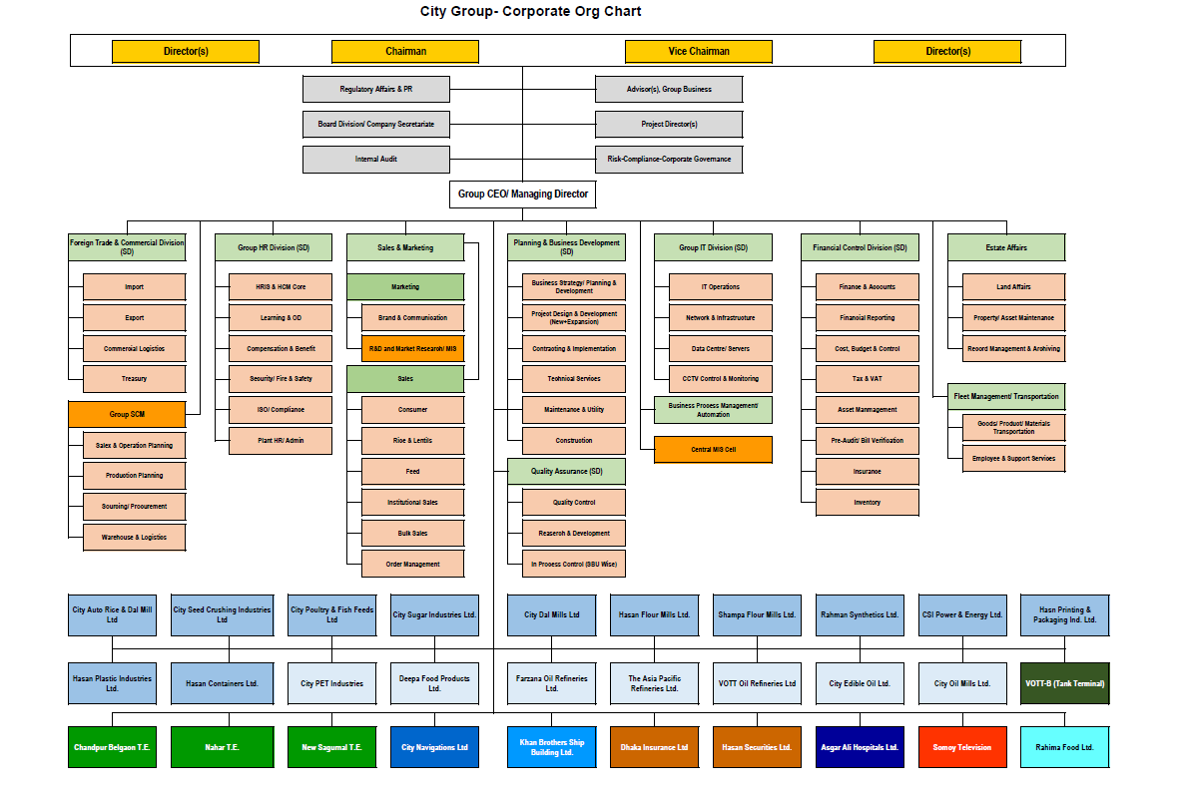
Figure: 1.2 Source: HCM, City Group

2.6 City Group HR
The HR goal of City group is ensuring business continuity and sustainability through robust talent pipeline, performance management & development culture and employee Well-being. Group HR of City group is responsible to initiate strategies which can help people be happier, by integrating the right environment for businesses to build competitive advantages, build core skills, and make business more sustainable. Group HR of City group is in charge of All human resource activities. According to their role in business the department is divided under six units. HR strives to acquire a competitive advantage by strategically placing a highly motivated and capable workforce, utilizing a variety of cultural, structural, and people strategies of human resources operations to propel the firm forward. The practices are as follows:
- Planning for human resources
- Recruitment and selection
- Performance appraisal
- Learning and growth
- Carrier planning and development
- Talent management
- Rewards
- Maintain workplace Relationships
- Safety and health
- Employee wellbeing
- Administrative duties

2.7 Employee Information:
People of City group are the main asset who derives the business goal of the organization to accomplish the vision. City Group has dedicated employees who actively accept challenges and eager to continually learn something new. Roles and tasks are distributed depending on the individuals' interest and specializations. All employees are devoted to their work and follow the corporate standards. In every unit functional leaders, team leaders are there to oversee their performance and motivate them to achieve the business goal. The number of employees in total City group is around 15000. Our Contact Info. (n.d.). In city group workforce, there are two types of employees’ management level employees and non-management level. The employee numbers of management level are approximately as follows:

Top Management | 12
Senior Management | 42
Mid-Level Management: | 180
First Level Management | 510

Source: HCM, City group

It's critical for HR to understand their alternatives when it comes to different types of workers when it comes to employing a workforce. Recognizing the need of cost-cutting, City Group is hiring two sorts of staff. Employee benefit structures, payment scales, and other related concerns fluctuate depending on management level.

  - (a) Permanent employee: City group is hiring regular employees who are working permanent basis for different position in the organization in management and non-management level. For permanent employees, City group has different pay level and benefit structure. City group reviewing the employee’s performance during their probation period for permanent positions and after finishing the probation period they are confirming the positon. Permanent employees have more flexibility, opportunity for skill development and promotional opportunity in their work field.

  - (b) Casual: City Group is mainly hiring casual employee for non-management level. basically in factory, production plant, they are engaging with daily basis contract within these time employees are getting paid and benefitted based on policy.

2.8 Overview of Management structure at City Group
The starting point for any organizational design is a realistic company structure that is based on a well-thought-out strategy. If the management team develops a clearly understood strategy and a company structure to accommodate it, the management system has a better chance of being effective. Mary M. Crossan, J. N. (2005) before presenting the discussion and findings of the study it is needed to present the structure and management level in City group to get familiar with the positions of different management. A committed, capable, and distinguished leaders are engaged as management team to take on crucial responsibilities within the organization. These persons make up the top tiers of management inside City group where each specializes in a distinct area of operating a business and they are the functional Leaders who created the organization's structure and determine how different components of the organization will interact by planning, organizing, staffing, leading, controlling, and inspired the employees of City group. Leaders have created their organization’s management level at 4 layer to create a line to separate different managerial jobs.
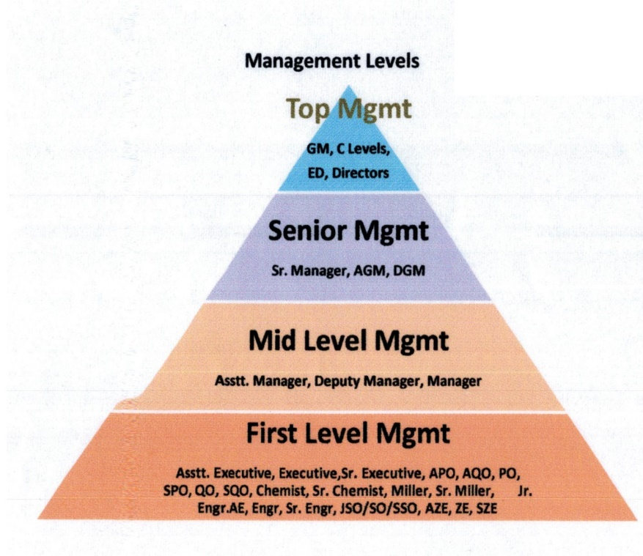

Figure: 1.1 level of management hierarchy at City Group, source: City group

A vital characteristic requisite for success is an efficient management system. A company must plan, discuss, and assign roles to provide fluid leadership, embodied in the management system, during the course of doing business. The operation and use of the management system also have to be documented and broadcast throughout the company so that all employees know what part they have in its implementation. Mary M. Crossan, J. N. (2005) City group has classified their critical roles according to the different job grade, across the management level because city group focused on role not for the position so in order to create successors and make succession planning fruitful they have established criteria of role for each level. they have position wise JD but they are on the way to development for competency framework. which are as follows:
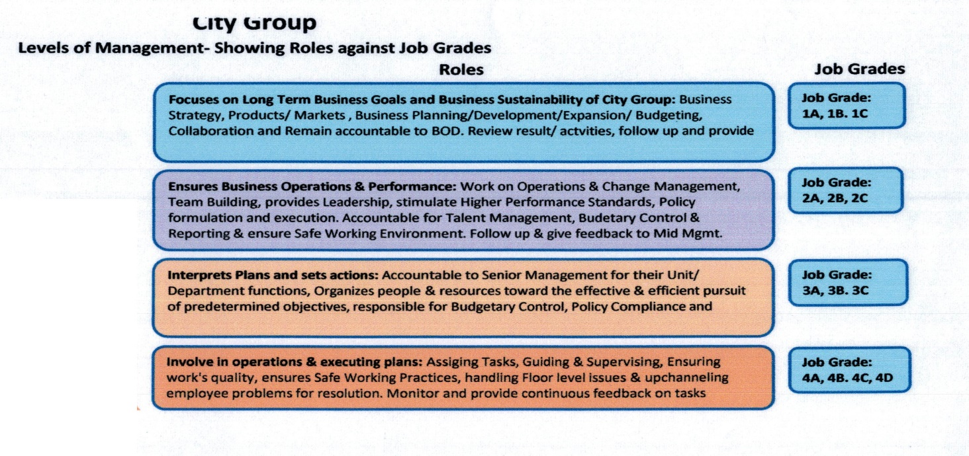

Figure 1.2 role against different level, Source: City group, HR

2.9 Overview of Succession planning at City group:
Organizations are rebuilding and getting ready for the new way of life. The people, processes, and systems are also getting a close look. It even more important to have a well thought out plan for when someone leaves. The process will become even more important as more baby boomers retire. There will be a lot more gaps in skills and knowledge succession planning will be more effective to enrich the knowledge, prepare successors for the future in post pandemic world, where Succession planning effect on shaping up future leaders’ role and solid ground for the organization to survive. Ugoani, J. (2020, June 5).
City Group initiated the practice of succession planning programs to build a high performance culture by ensuring a talent friendly environment to make successors ready to utilize their skills, expertise, and knowledge so that they can take on leadership roles in the event of organizational growth, talent loss, or management turnover. Most importantly this plan will build up a strong talent pool who will get opportunity to explore real life experience, will be engage in learning and bring innovation to the company.

2.10 Objective of Succession Planning at City Group:
City group is following a modern approach where each individual’s performance and potential is noted and they are given opportunity to enroll into succession planning program. The broad objective of succession planning at City group is aiming to provide a suitable supply of successors for present and future prospective senior roles coming from the business strategy in order to plan and manage individual careers in the best interests of the organization and the individual. The specific objective of succession planning are as follows:
- To create data to use in making organizational personnel decisions.
- To discover high-potential employees to take on increased responsibility
- To provide carrier opportunity for potential employees
- Assign functional leaders and expertise to transfer Knowledge and skill
- To empower employee and increase engagement.
- Ensure business continuity through retaining high expertize knowledge and skill.

2.11 Procedure of Succession planning at City Group:
To make a systematic growth experiences for people who are aspiring to key roles, a formal data driven plan is followed by City group to initiate the actions, policies, and processes for the next-in-line leader's appointment. There are consecutive steps of succession planning process of to make the plan effective which are:
- Identify key roles
- Define the competencies and requirement for each job role
- Establish criteria to assess talent
- Form a talent pool for successors
- Develop successors to take up leadership role at right time

2.12 Tool for succession planning:
Having a deep understanding of someone’s career development to date in conjunction with an honest appraisal of that person’s leadership potential and job performance through a “Nine-Box” assessment can provide much needed insight into the present level of developmental readiness for a stretch experience. Patrick M. Wright, P. (n.d.). City Group HR uses the 9-Box Grid to examine and map their talent pool based on two factors: performance and potential. Performance reviews are used to track performance on the horizontal axis. The vertical axis denotes potential, which refers to a successor's ability and competence to carry out the task. To make succession planning more effective, HR released a new talent management tool in 2018, the box grid matrix, which is a customized version for evaluating and recognizing successors. Their succession plan ensures that there are enough skilled personnel on hand to fill any key vacancies as soon as they happen, as well as preparing them to transition to any new position as swiftly as possible.

2.13 Training and Development at City Group:
The philosophy at Goldman Sachs, however, is more balanced in terms of making use of all three ways of learning: (1) learning from formal classes; (2) learning from other people (mentoring); and (3) learning on the job (experiential learning). Regardless of the respective percentages, the state of the practice is to emphasize developing leaders in the context of ongoing work rather than taking leaders from their work to develop. Patrick M. Wright, P. (n.d.). To build their successors, City Group use the 70:20:10 model, which they believe is the most efficient method to improve the efficacy of their learning and development initiatives. Hands-on experience is the most helpful for employees, according to the city group HR, because it helps them find and perfect job-related abilities, make decisions, handle problems, and engage with influential individuals such as managers and mentors inside work settings. Employees learn from one another in a variety of ways, such as through social learning, coaching, mentorship, collaborative learning, and other forms of peer involvement. Encouragement and feedback are two of the most important aspects of any effective learning technique. Only 10% of professional development should be spent on traditional courseware training and other educational events

Chapter 3.0
3.0 Findings & Discussion

3.1 Understanding Succession planning strategies at city group

Organizations face constant pressure to build a strong, effective, and sustainable leadership pipeline. But like most strategic planning, this is easier said than done. When it comes to the succession planning process, many HR managers are challenged to ensure their succession strategy is flexible enough to meet the needs of the organization and the employee, as well as shifting dynamics within their industry. Proper succession planning instills confidence across the organization that selection of future leaders is strategic, comprehensive, and fair. 6 Foundations for Effective Succession Planning. (2018, August 21).
To make the succession planning successful it is very important to place the strategies correctly and in place. Compared to the global average of 65%, Bangladeshi FBs have more next-gen family members working in the business. In addition, 63% of the next gen working for the business are in leadership teams, which again is higher than the global average (43%). On the other hand, about 34% of the next gen do not work for the company but own shares. Based on our experience of working with the FBs in Bangladesh, we see more and more next gens are joining their FBs, learning about how the businesses are run and taking new initiatives to add to the company portfolio. Thus, the structuring of a succession plan is an extremely important consideration for FBs. Business owners must decide whether they will groom their next gens to run the business or professionalize the business and pass on only ownership to the future generation. Rashid, M. (2019) Analyzing respondent’s views towards succession strategies of City group it can be discussed as follows:

3.1 (a) Key Role Consideration:
The foundation for coping successfully with staffing surprises is succession planning. Organizational survival in a globally competitive environment depends in part on having identified and developed replacements (i.e., successors) for key positions. This is the essence of succession planning. A more formal definition of succession planning is the process of identifying one or more successors for key positions and preparing them for expanded organizational responsibilities through job assignments and other developmental activities. The part of this definition regarding preparing individuals for expanded responsibilities overlaps with what is typically considered as leadership development—broadening the capacity of an individual to be effective in leadership roles and processes. Patrick M. Wright, P. (n.d.). In order to make business more agile when any type of change occurs, City group think that job description is not important rather talent ability to perform the job role is significance to sustain in the market when change occurs. In order to plan for that, they have been following an effective succession plan to maintain a strong pipeline by developing them to ready for present and future roles.
" Succession planning enables businesses to maintain continuity. Without a good succession plan, businesses can be disrupted”-R1

All Respondents said that, without a well-crafted succession plan Business survival is difficult in today’s market. City Group understand the need of succession plan; City Group is looking forward make uninterrupted business as numerous benefits are associated with this practice. Management is willing to be on board to utilize each employees’ skill and prepare them to handle critical roles. The term succession planning refers to a business strategy companies use to pass leadership roles down to another employee or group of employees and succession planning ensures that businesses continue to run smoothly and without interruption. KENTON, W. (2020, December 06)
Succession planning usually looks at the most important roles in the company, as well as short and long-term successors for these jobs. Despite the fact that reviewing small numbers can make the process easier, larger organizations may want to run succession planning models at a directorate/divisional/service/area level to make sure that other business-critical, technical, or hard-to-fill roles are taken care of as well. Progressive businesses that are inclusive when it comes to managing and developing their employees will look to find critical roles at all levels of the company. City group is using best possible succession plans look at candidates from all parts of the company. Now the question is what are the key role in City group.in organization chart, the most highly authorized person is the Managing director of the company who is coming from the Board of the directors.
“The next managing director of the company is The son of Chairman sir who is an active member of the board.”-R2

As City group is privately owned company but a backup plan should include many capable successors who possess the necessary competences to occupy the post at any moment. The founder of a family business is primarily accountable for developing such plans which can be used in the event of an unexpected, scheduled, or unscheduled vacancy. Business owners must decide whether they will groom their next gens to run the business or professionalism the business and pass on only ownership to the future generation, it is essential that the choice the FB makes is clearly thought out and communicated and that next gens are adequately trained to take up the ownership of or manage the business. Rashid, M. (2019). Like other privately owned company in Bangladesh, City group the owner’s son is the successor of managing director of the company who is already an active member of the board and holding vice chairman position currently. The Managing Director is the current Chairman and owner.
The family business succession procedure begins with the preparation of children’s to be successors. Here one thing need to be mentioned that the current Managing director is in place and the would be managing director is taking additional responsibilities. The would be managing director is involved in the business around 20 years and he is grooming up and familiarize with his business from his 8th grade. After completing the education when he chose to join the business he got extensive training to ensure He is getting close mentoring and coaching from his father and also from the experts of the management team to ensure that he understand the company's corporate concept, it functions, have the integration, alignment, and collaboration with all stakeholders. It also strengthens the interpersonal skills, leadership skills, technical knowledge about business concern to proceed. Now he is the member of the board and after the current chairman/ Managing director he will be the managing director of the company. Here the Managing director is the top most position and the succession of this position is very important for future sustainability. One of the main jobs of the board is to keep an eye on how the company is running and make sure it's running in line with the rules of the company and what the shareholders want. As the CEO or managing director and the chair person is the same person, this combined role means that they are going to be watching themselves. A board led by an independent chair is more likely to find and keep track of areas of the company that aren't following its goals and to put in place corrective measures to get it back on track. The succession of Managing Director role is predetermined because the board and owners’ strategy is to involving the family member in management team rather holding only ownership. It is their strategy like other private business in Bangladesh. Currently they have enriched their management team as it was over burdened. In city group, every level of management role is defined and outlined. Earlier it has been discussed that there are 4 levels in management and roles have been created accordingly. Key role does not mean the managing directors position only it means the various roles of different management level which need succession to maintain the organization's operations and long-term goals. The organization can continue to grow and achieve other objectives because it has a constant flow of people to fill important roles. city group consider that top level to mid-level are the most important area in their structure and the role and responsibility of this positions are most critical to fill up. These are the positions that are critical both strategically and operationally. The goal of city groups' succession planning is to create successors for their top level of the management which are 1 tire positions. accomplish the most critical role who focus the strategy, long term business goal to maintain business sustainability, responsible for product expansion, budgeting and most importantly accountable to board of the directors. Top- Management, which are 1 tire positon who are designated as - GM/ COO, COO (group), CFO, Director (SBU). Secondly Midlevel positions are also key position who are Manager, Deputy manager and Assistant manager who are playing critical role for executing all strategies. City Group always try to ensure a strong talent pipeline specially for these two but sometimes other roles in senior management may also found critical depending on the situation. The main focus is on continuity and constancy.

3.1(b) Acknowledging critical roles
You’ve worked hard to build your business, make sure you’re protected. As you well know, being in business is inherently risky. And as companies grow, so do the risks of losing company value. You should have a plan to minimize and mitigate both your personal risk and business risk in order to protect everything you’ve worked so hard to achieve. Ugoani, J. (2020, June 5). In planning for succession it is urgent to identify critical responsibilities inside the organization for which potential successors are required. While all tasks within City Group are critical in some way but it is beneficial to prioritize them wherever possible. In major companies such as Nike and IBM, succession planning is identified as part of an ongoing talent management program to groom future executives. In addition to annual performance evaluations, senior executives engage in a series of discussions about employees who’ve shown readiness to take on more significant roles, especially when there are anticipated vacancies Ugoani, J. (2020, June 5). City group is considering succession plan for top level to midlevel whereas currently the position of Managing Director it is not considered inside talents for succession. In each unit of City group their unit head is responsible to create and identify the role that is needed to run the business and gain competency through successors development into that role. For mid-level the successors identified from junior level and from mid- level successors are identified as successors for senior and top levels.
“Functional leaders are the creators of unique job roles in the unit.”- R5
In each unit their unit head is responsible to create and identify the role that is needed to run the business and gain competency through successors development into that role. Mostly mid and top level holds most of the important roles in the business. It may find it advantageous to base this on succession challenges identified in a broader talent context, such as recruitment, development, or retention, or to apply criteria such as the following: The strategic or operational impact on the organization/service/team of a vacant position. Unique skill sets or knowledge repositories External employment market availability or internal pipeline capacity. It is critical to approach succession planning objectively, weighing the individual's impact against that of the role. In terms of positions, this could allude to the effect of a vacancy or recruiting difficulty. Individually, this may mean possessing highly specialized knowledge or abilities that are difficult to replicate in determining organizations criticality of positions – they divided it in three categories. which can be referred like- indicating that the position is not critical, roles which are partially crucial, and some can be indicated that it is in high priority. Whereas an example has come that
“A junior executive can be quickly replaced who does not need any successors. But a top or mid position cannot be out for very long so they need successors.”
This indicates that most of the time they identified roles which are mostly in top and senior level positions. For determining the roles here two things are needed to consider.
- Position Role
- Job role
It can be explained like for example an AGM in HR is responsible for recruitment and Selection whereas the position role is recruitment and selection but there are many job roles required to that position like posting advertisement, conducting interviews, these sub roles enables a more complete and in-depth assessment of succession when a successor become ready to play the 70 to 80 percent of these role they can be considered as successors and plugged in if the AGM left but in that case the position role cannot be offered because the successor is currently holding the position of Deputy managers post so he need to be fulfill the experience of required position so in that case a promotion may offered as senior manager and he may entitled as recruitment specialist and after competition of required experience in job grade he will be eligible to become an AGM.
Here another thing is important that along with the structure, size, and maturity can affect how they try to find and keep good employees because talent Pipelines may vary in different business as many businesses are new in the market.
“A structured talent pool will be set up as business grows.”- R6
So in matured businesses they have already a strong talent pipeline. So they need to planning succession over their differently and in many businesses they are new so in that case they need to be plan more strategic to find out which role is important in that business units. 21 “growth strategies without a reliable succession plan would require a lot of outside hiring and training, which could cost a lot of money. One respondent said that they should keep track of the financial impact of succession planning” City group is looking for successors to figure out who will succeed in the most important roles in business and will be ready for future leadership according to their capacity. City group wants to maintain a strong talent pipeline to meet the business need and secure every position’s essential roles.
3.1(c) Strategic alignment:

In City Group Succession plans are reviewed and developed on a regular basis to ensure they continue to satisfy current and future skill, capacity, and behavioral demands and are closely connected with developing organizational priorities. Here the decisions about succession are based on measuring the potential and performance where there is no place of presumptions about an individual's objectives and readiness. They are not include/discuss only those who are favored/deemed ready today rather selective plans are made by including the potential and readiness of everyone, City group can have diversified talent pool in the organization's talent profile as a result of succession decisions. By focusing exclusively on the short or long term, rather than on both, some persons may be unable to take advantage of future chances. To minimize the risk of over or under supply in the pipeline — having an excess of qualified personnel with no open positions, or a lack of appetite/preparedness for particular responsibilities, succession plans are reviewed and modified yearly to account for changes in performance. Possible, readiness, and aspirations of potential successors, as well as ensuring that previously indicated actions and/or hazards have been implemented and/or handled effectively. But the most important thing is appraisal meeting which is once in a year.

“We make our successors ready not only to take over the position rather to play the role of his seniors.”-R2
Readiness means the capacity to take the responsibility of senior’s role. City Group develop their successors ready not only when someone leave, fired, retired, not present along with that they can be there when any critical role emerged. City group create opportunity to involves in various leadership role throughout the different level. It means city group maintain their succession plan and understand development need of their successors. There succession plan is designed according different level of management. they do not just identify some top tire positions for top management in their structure rather they have built up a leadership plan throughout different levels of the management. position. Here another thing is important that along with the structure, size, and maturity can affect how they try to find and keep good employees because talent Pipelines may vary in different business as many businesses are new in the market.
“A structured talent pool will be set up as business grows.”- R6

In matured businesses they have already a strong talent pipeline. So they need to planning succession over their differently and in many businesses they are new so in that case they need to be plan more strategic to find out which role is important in that business units. broadening it to critical jobs at all levels. These can be located in a variety of ways.

“growth strategies without a reliable succession plan would require a lot of outside hiring and training, which could cost a lot of money. One respondent said that they should keep track of the financial impact of succession planning” –R3

They use succession planning role assessment template to identify which role is more critical either strategically or operationally. Functional leaders also provide additional information/observations regarding the profile of the current team. Here some major issues should be handled like- Over or under supply in the pipeline –which means an excess of qualified employees with no vacant positions, or a lack of appetite/readiness for specific duties, internal fill vs external fill, this should be completed upon the completion of the succession plan and should be evaluated on a regular basis to ensure that appropriate actions are taken. Readiness means the capacity to take the responsibility of senior’s role. City group create opportunity to involves in various leadership role throughout the different level at different business unit. They do not just identify some top tire positions for top management in their structure rather they have built up a leadership plan throughout different levels. succession planning strategy is aligned with business strategy. HR strategy of talent development, succession plan all are initiated according to the business requirement. Like their sugar mill and oil mill both have different needs. For making succession plan they have flexibility to create plan according to the business unit’s needs. The norm in contemporary management practice is for organizations to adopt a computerized human resource information system which stores inventories of the skills, competencies and experiences of individual employees along with other performance records and potentialities for effective management succession planning and implementation. Ugoani, J. (2020, June 5)
In City Group Succession planning is not a stand-alone process it is integrated with other activities such as individual development plans, career goal mapping, and manpower forecasting. This type of connection helps them to make succession planning more comprehensive and efficient. HR maintain recorded chart which includes every year’s termination possibility, list of current important leader’s retirement date, assessment of organizational leadership needs and current, competency role and possible competency role for future. They maintain the chart to indicates a description of their potential successors of each unit according to their performance. In their performance appraisal they measure their alignment of organizational competencies in terms of team behavior and KPI/result/delivery so that the PDP can focus on desired areas. According to data of performance, matching requirement of competency, fixed tenure a successor may eligible to enroll to succession planning program.

3.1 (d) Giving opportunity to right potential candidate:
Understanding the difference between high potential vs. high performer employees can make a huge difference to your bottom line. A high potential employee provides nearly double the value to an organization, and they’re three times more likely to be successful leaders in the future. Hedges, L. (2021, May 27) In city group potential means who has a strong performance history and a strong team behavior (appendix-3). The performance appraisal plays an important role to identify the right potential candidate. People who meet expectation or exceed expectation both can be eligible to enroll into succession planning program. City group is considering team behavior as a very important criterion for assessing talent. To assess talent, performance is considered as the result delivery and KPI. whereas team behavior is a set of guideline. Team behavior is a set of guided behavior approach which is measured by self-rating and supervisor rating. These attitude, Management, leadership, technical or operational competency, team work. Where they are generalizing the behavior through different attributes. City group understand that a succession plan will be only possible when the performance and potential to play the role of a successors can be identified accurately. Most importantly a high performer is not always a good candidate for succession. A person who has performance along with team behavior will be able to play the role along with performance are considered as successor. City Group is maintaining post popular tool and using The succession planning matrix which is easier and helpful to picturized essential roles competency inside the organization. Successors are measured and identified by their potential and performance. Where potential indicate the successors ability to perform the role and performance is how they are performing at their current role and their readiness.

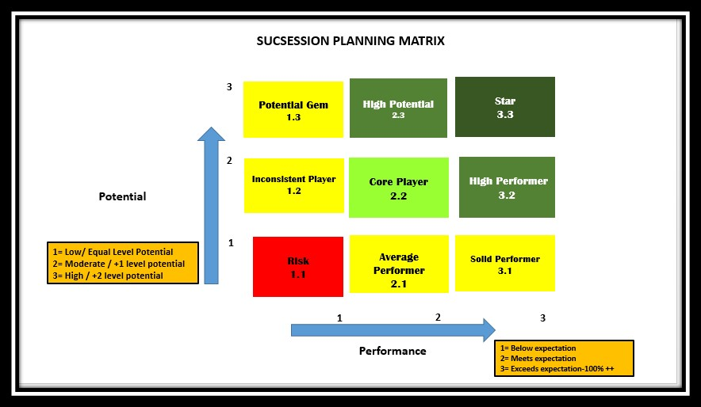Figure 3.1: Succession planning matrix, HR City Group.

“we use the succession matrix to map the successors according their readiness in terms of performance and potential”. -

It can be easy to find out how well successors are doing and how well they could be. So it will help to figure out the development need and planning for succession planning program in order to identify gap. Here the Rating distribution is 1, 2, 3 which are- for performance axes below expectation, meets expectation and exceeds expectation and for potential axes- 1,2,3 which are measured as performance and team behavior equal level potential is measured according to performance and team behavior that means performer can only perform his level jobs then moderate level where he is eligible to perform one level upper from his job grade then high potential means he has potential to perform 2 grade upper from his level. And the measure of this potential is the performance and team behavior. Team behavior is a set of established guideline which is clearly mentioned in their performance appraisal guideline (appendix 3). 9 different talent pool can be created to make development plan according to their performance or potential gap. There are 9 types of talent with different rating which are as follows:
- Star: whose performance exceeds expectation and who has high potential
- High potential: who meets expectation in performance and has high potential to grow.
- High performer: performers who has high performance which is exceeding expectation and in potential they meet expectation.
- Core player: who meet expectation in performance and moderate level of potential
- Potential Gem: who has high potential but performance is below expectation.
- Inconsistent player: who has moderate level potential and low performance
- Average performer: whose performance is meeting expectation but potential is low.
- Risk: whose performance in not meeting expectation and potential is low.
Every year, the functional leaders update their succession matrix where they put for the essential role at least 2 successors. The successors are categorized to ready for now, for 6 month or ready for 1 year the successors for each position may be have 2 successors. The functional leader need to present the management committee the successors profile and criteria to confirm him as the successors. According to the analysis successors possibility to become successors, grooming strategies are initiated to give them necessary support. In each appraisal meeting they communicate the possibilities, solutions, personalized program to help the successors. It also helps to map out the training budget for each pool. It is easy to set up a talent pool, which can put the successors in a job that is best for them. it was easier to see where they were going in the future when their predecessors helped them learn about business philosophy and some project background. Most certainly it ensures a clearer career direction.

3.1 (e) Grooming strategies of Successors:
The design of a leadership development initiative should be grounded in succession management, anchored in the organization’s strategy and feasible given the organization’s size and resources. Specifically, the who and what of leadership development are ultimately based in the foundation set by succession management. Johnson, J. (2020, December 10) City Group tries to arrange best possible way within their limits. In order to developing successors, City group has designed their development strategy according to their capacity. they use 4C as an effective tool which considered like:
- Cross functional assignments
- Coaching & mentoring
- Critical assignment
- Classroom training
It is critical to equip talents with skill sets and to be mentally strong, city group designed the coaching so strategically and structurally by establishing,
- Behavioral consultation, instructional coaching
- Provides direct observation and feed back
- Provides modeling with practice opportunity
- Uses problem solving, goal setting, and data based decision making.

Estimates from those who have worked extensively in the field of leadership development indicate that as much as 80 percent of the learning and development of those who eventually move into senior management stems from experience, 10 percent from classroom education and training and the other 10 percent from coaching and mentoring. Patrick M. Wright, P. (n.d.).
All of the respondent who were interviewed had experience of many tools for development, however, there was no one tool that was found effective alone, above all the rest. Where Coaching considered as highly effective method for talent development at City Group.

"Coaching is no more a talent development tool, if you master coaching, it will never appear as a tool, but will become your leadership style R3”.
internal coaches are there and provide them with the fundamental coaching tools and abilities necessary to develop different talent pool. Mentoring and Coaching are the two most important tools they experienced to get better at their jobs and in meeting the needs of their company's succession plan. Internal coaching, on the other hand, has a better awareness of the coaching areas since the coaches have greater experience knowing the coaches' and organizations' goals. They also offered and experienced external coaching, which is an independent procedure that can bring a new business viewpoint and modify the status quo. internal coaches are there and provide them with the fundamental coaching tools and abilities necessary to develop different talent pool. Mentoring and Coaching are the two most important tools they experienced to get better at their jobs and in meeting the needs of their company's succession plan. On the other hand, internal coaching has a better understanding of the coaching areas because the coaches have more experience understanding of the goals of the coaches and their organizations. External coaching is also a good thing they offered and experienced, because it's an independent process that can bring a new business perspective and change the status quo Collaboration initiatives are taken to develop successors spontaneously where Unit heads take the initiative to seek out to collaborate with one another or it can be a result of a planned project where the firm is aiming to use the capabilities of successors from other departments. Combining skill sets and expertise from cross team individuals allows the business to harness multiple ideas, techniques and problem solving talents that are valuable. a real-world assessment tool like critical assignments, cross functional for future successors is very important. Mentoring is more about giving advice and sharing own experiences. Mentoring aid high-potential individuals in enhance their self-esteem, develop their abilities, and prepare them mentally to take on leadership roles successfully. For example, they decode and pass on implied knowledge from business experts as part of a knowledge management program.
“mentoring can help people from different generations work together at the same place”-R7. Choosing the most suited successors involves hard thought, planning, and time. To succeed in their new roles, the successors will require hands-on mentoring and training to guarantee a smooth, seamless transition that, if done successfully, will benefit the business for many years.They are engaged in a variety of coaching techniques depending on the situation. To groom successors, development techniques not only expertise in skills rather psychologically prepare them for the huge duties which are waiting for them in future and these actually help to develop competency. In terms of class room training they have less experience with it.
“It was necessary to had a separate department as L&D to build our own capacity.”
A dedicated learning and development (L&D) department has just been formed to construct a team capable of conceiving, producing, directing, and delivering training programs for their company. This looks to be their enthusiasm to learn, which is a great starting point for creating a learning culture. The Organization's rules supported the 70-20-10 learning model, in which 70% of training is done on the job, 20% is done one-on-one with feedback, and 10% is for outside and formal training. It is the responsibility of functional leaders to determine whether or not successors are ready. Successors' ability to manage projects in complex environments, as well as their ability to make sound judgments and effective planning capacities, is developed through difficult projects, so that the skills and talents can benefit the firm. In order to encourage alignment, the city group designed evaluations to assure perfect alignment with succession plan needs, notably for the majority of critical roles.

“We do a tailored assessment, and then customized development plans on our needs.”-R2

They are doing a unique evaluation, followed by tailored development plans. Successors are given hard and demanding jobs which will push their competencies and provide rich experience and mentors and coaches could guide the bright folks.
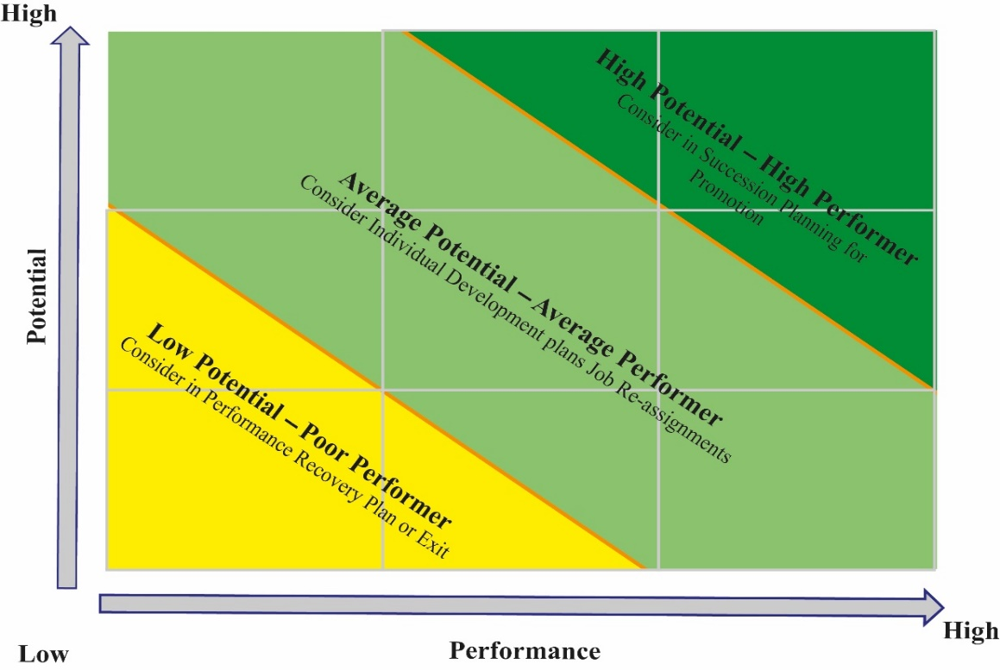
Figure 3.2: customized evaluation with permission of R2
To achieve better alignment, and in particular, for most complicated roles, they ensure customized evaluations to assure full alignment to the SPP. Here from the succession matrix people who are in greener box are entitled as high potential and high performer who are eligible for exclusive development plan. Average performer and average potential are considered for development plan according to their gap. Poor performer and poor potential may have selected for recovery plan or can exit from existing succession plan. They use the bell curve to make a distribution curve to see how each person's performance compares to the group's performance. Where for example 20 percent of them can come up with their next senior leadership succession plans. The rest of the people is either taking part in performance-improvement programs.

3.2 Effectiveness of succession planning:
organizations that had early management succession plan are more successful than those who waited for too long to introduce one. Ugoani, J. (2020, June 5) Leadership bench strength, the leadership pipeline and leadership capacity are popular metaphors for the underlying issue of ensuring that an organization’s leadership is adequately developed to face current and future challenges. Patrick M. Wright, P. (n.d.). The effectiveness of succession planning has been discussed, and the outcomes have been divided into five categories. This study may help to positive social change by supporting talent development and improving the standard of living in local communities by creating solid work opportunities and job stability. For company leaders, talent management is a primary priority. Strategies aid in the collaboration of an organization's increased performance and qualified staff. To groom high-potential individuals for future leadership roles, business executives can use increased synergy and reorganize the firm to be more talent-centric to help their people progress. Succession planning assists a business in responding to market concerns such as staff changes and demography, as well as preparing for future growth.

3.2 (a) Culture of Appreciation & Feedback further reinforced

It is vital to keep in mind that the aim of leadership development is not to establish programs. Instead, it should be about building and executing practices and procedures developmental systems that capitalize on work-related experiences to assist achieve the organization’s strategy. At City Group, Line managers are mostly responsible to communicate their overall succession plans to their team members in every unit. They always create a clear sharing about succession planning process with juniors in their appraisal meeting to understand each employees goal and expectation. To make succession planning as a part of business goal, City group was looking forward to have a talent friendly environment where succession planning created the path. It is already becoming a part of their culture to ensure supportive environment where every leader is guiding his juniors and motivate them for grooming others, guiding others, and created a culture in helping others grow.
“in appraisal meeting it is a common question that who is your next.” R2
It seems that they hold strong belief of helping their own employees grow. It is seen as a good thing. Because in an organization good succession planning strategies aren't enough to make succession plan effective. Everyone from employees, supervisors, leaders, management need to be involved. leaders at different levels are willing and eager to have a well-designed and effective training plan to make succession planning more effective It is very important for succession planning programs, especially for the people who are eligible. As line managers have worked for the company for a long time so they are the best people to guide the people who want to move up in the company. Their Succession planning including the higher level is open and honest about identifying talent, because it is a part of grooming and grouping them in a talent pool it is important. Because it is a time consuming, expensive process.
“There should be no personal reasons for not including someone in the talent pool, but there is some preference which are set into the guideline and everything is recorded and monitored directly by each unit leader and management team” –R7
The management wants to become transparent and leaders are open to discuss the carrier ladder in appraisal meetings to make selection fair. The performance are the main criteria to heading into the succession planning program. The preference for choosing successors are dependent on the records of each individual’s performance. Every unit maintain the performance records to match up in order to offer the succession planning program. As everything is recorded and evaluated by HR and respected department, there is less chance of unfairness. At their performance appraisal it is declared that who It should be clear to the direction where the successors are heading towards but in order to disclose the rating, some respondents think it's ok to talk about their rating on succession plan openly and with full transparency to all their employees, but some thinks that sharing the rating openly is not the best way to go about it because that some employees might be stressed out by having full information about how their jobs are going to be passed down because this could make them to dissatisfied because everyone can not feel in same way. It depends on leaders to think about all of their options when they decide what and how to share their successors rating.
3.2 (b) Better managing of changing business dynamics

To improve their own and their company's performance, employees always look for, share, and apply new knowledge and skills. Most people don't like change. The same is true in business. The economy is always changing, and customers' preferences and attitudes change all the time. Technology, distribution, markets, and industries are all changing, too. A lot of people are competing with each other. Marketing that worked yesterday may not work today. Some people don't like change. Routine is a good thing because it makes it easier to get things done in life. A lot of people find it hard to adapt to changes, and it's usually a lot of work. Most people like things the way they are. Many things can go wrong when one has to deal with changes in business, it might be helpful to know what people think about when they face change. There is some usual change when people are going through development programs which can help successors to deal with changes in business better, for example cross functional assignments or project work. whether one may work alone or have a team. Where one respondent made a direct link between effective training and succession planning, as well as learning and development activities that are linked to qualifying successors in managing of changing business dynamics. During periods of transition within an organization, new leaders and team members may suffer feelings of insecurity. When changes are approaching, workers want to know how they will be affected. The greatest way for a manager to inspire confidence during these times is to be as open and approachable as possible. Organizational changes, whether planned or unplanned, can be difficult. Employees become concerned when they are unsure how their responsibilities inside the organization will be affected. People starting new employment in a new organization also require guidance and support. Managing people across the succession plan needs thought and skill to maintain corporate continuity and performance during periods of transition.

3.2 (c) Greater opportunity for Career Growth
Organizations are now moving away from the once-confidential process of hand-picking successors to a more transparent process of identifying high-performance leaders and preparing them for top leadership positions. Ugoani, J. (2020, June 5). There are high passionate employees who are thrive to do challenging work and expect carrier ladder. Succession plan help to identify the similarities between employee expectations and aligning roles to become a successor by tracking his self-rating, carrier path goal to make the opportunities available to him so that successors can look this as his desire. Newer generation are more willing to have development plan and carrier growth Sometimes development programs are more important than money. Many companies can always pay more, but not all can easily compete in the field of talent development easily where city group is offering high level of development strategy. Even, City group can use their succession planning strategy to attracts and retain top talent from the market. As the ability of individuals for change jobs or advancing need of their careers are evaluated through a systematic process, so employees’ abilities, values, talents, interests, behaviors, goals can be compared through assessment tool that help to matches each personnel potential to organizational requirements, expectations, and culture which was a more critical process before for successor identification and selection. Now, it is necessary to nurture and maintain identified talent and high potentials in order to fill future key/leadership positions when they become available. Succession doesn’t mean promotion it will make them ready first for the role. It assists potential managers in preparing for their roles, ensuring they arrive in post with the necessary skills and expertise.
“successors can help senior leaders when they are overburdened”
Employees with a higher potential level may be assigned more complex and challenging assignments. Managers can utilize these assignments to assist lower-level employees evolve into higher-level employees. As a mid-level employee approaches the highest career ladder step, a manager can assign that person to a project or job similar to those that higher-level employees will receive. This will be proven the successors how they deal with higher-level assignments. The readier they are in succession matrix the chance increases to get the higher opportunity. Respondents said that their succession planning will help their company to be seen, as a good place to work as they have carrier development opportunities because talented employees value development programs so strong talent development programs with good succession planning are able to bring in the right people. Improved employer branding can also attract new talent to join and make internal employees more willing to help with Succession planning program. Focusing on succession will be a good way to get and keep people.
3.2 (d) More room for Strategic thinking and Knowledge sharing:
Successors must be involved in additional tasks to support development programs and contribute to the development of a succession planning pipeline. Involving employees in new roles helps to recognize their potential and sharpens their abilities beyond routine tasks. Moreover, he added that
"You have to offer successors an opportunity to open up and contribute" –R2
When successors are encouraged to take risks and make their own decisions, in addition to being helpful. Empowering employees these means allowing them to succeed on their own and trusting them to make the best decisions. Additional assignments in succession planning program could enhance an employee learning culture by exposing talented people to new abilities that make them qualified and individuals Those who are enthusiastic about their personal growth and transformation are more likely to participate in development programs and take full responsibility for the succession planning options available to them. While empowerment and engagement of employees can be used interchangeably with a characteristic of organizational cultures which is practiced at various levels and in a variety of applications. sometimes many teams or team leaders want to collaborate with one another, they can do so on their own or as part of a formal project where the company wants to work with people from different departments. People who work on different teams can bring their skills and experience together to help the company reach its goals and objectives. According to one respondent,
“one of the challenge with Project is that some of the project members ask to take a decision even though they knew it was bad.” -R8
This type of activities helps the project leader to test the decision making capability of successors. These type of projects can help people to talk about things that might go wrong, and they need to be able to talk about problems outside the comfort zone. This type of project allows the successors to get new ideas about how to solve problems and it can also be an opportunity to prove one’s potential in front of the supervisors and management. By bringing them into these different project is truly encouraging. New innovation can be emerged into business by those who have potential enough so they can brainstorm new ideas and improve the way things are done which directly effect on enhancement of business efficiency and profitability. Demographic shifts will certainly result in fierce competition for talent, possibly more quickly or slowly than expected. Candidates in the labor pool are unlikely to have the necessary experience and key skill sets for critical positions. It will be vital to collect critical organizational knowledge so that it may be shared with future generations or successors. They think that people are becoming more skilled, and future leaders can be developed from them. Here mentoring and coaching successfully help to transfer knowledge and skill to the young generation. respondent directly connected to his own experience and mentioned that
"Nine out of 10 times, because of training and practice, I'm better at what I do." –R7
It is up to new leaders to seize the reins and steer the organization in the right direction once managers and team members have supplied them with the tools and information they require. Their encouragement and empowerment help in fostering creativity and these support helps successors to play an active role in keeping the company on track to meet its objectives.

Chapter 4
4.0 Summary & Conclusion

Key Findings
Maintain the consequence of succession planning for an organization's continuity for critical roles are challenging. After analyzing interview data, viewing companies overall approach the key findings are:
- All Management level positions are evaluated by potential and performance where each and every potential employee is counted but most important position in management level is implemented only for the position under managing director because the family member are the successor of this position. Currently the owner is holding the position as well as chairman position of the board like other Bangladeshi private company. The owner is not comfortable to hold the ownership only rather he wants to ensure the management team’s authority and guide the team towards long term strategy.
- City Group is giving emphasize on practicing strategic human resource to makes sure that the whole company is working together to reach its goal and securing the talent pipeline from director to midlevel position and it indicates the board ’s training willingness to prepare the workforce for future roles.
- The main strategy behind succession planning was to create a supportive culture which is talent centric. The systematic approach of succession planning is helping them to enrich their work culture where team behavior guideline is maintained by all of the employees.
- By launching succession plan they are more prepared to face future challenges and they are preparing their talent to contribute more with innovation.
- Preserving organization culture and existing knowledge is another cause and effect of succession plan.

4.2 Recommendation for Improvements:
For this study, the in depth interview was conducted where their ability to share a lot of important information in limited time frame and open sharing of organizational documents helped to find identifiable problems and according to my observation, I have come up with some, against recommendation.
4.2(a) effective corporate management:
The concept of succession planning is realized by the board and they have approved a very methodical plan for preparing successors for the most critical roles according to their performance and potential. Whereas the owner, chairperson, is considering that owners talented son or daughter as the successor of the managing director positon. The owner should understand who is more capable to take the CEOs position and which will be more profitable because It will create more accountability when the CEO and Chairperson position will be separated and if it is not separated then the capability should be measured to ensure the capacity of holding that position. Transferring power does not mean transferring ownership. In public companies, for example, usually have board of directors that selects the management team to successfully and efficiently handle many duties of the organization. The board of directors does not get involved in the day-to-day operations of the business. The various management positions are assigned to a certain group of people, each of whom is in charge of accomplishing specific tasks assigned to her division. City groups management team is now enriched with functional head who are assigned as directors but they are all under supervision of the managing director.
4.2 (b) Appraisal meeting should be more than once in a year:
City group is maintaining their appraisal meeting yearly but this should be at least twice in a year. Every month is important in the business, it will help to grab the Newest data of performance if it is more than once in a year. Formal appraisal should be 1/2 yearly at least. reviews are essential to find out if an employee has a lot of potential. Leaders have the chance to sit down and talk with successors one-on-one during a performance review to find out where they are and where they want to be in the future. Successors PDP, evaluation data can be updated accordingly by this information. Though City group do the reviews frequently but the process should be formal to make the HRIS information updated.
4.2 (b) 360-degree assessment only in terms of team behavior:
To be a potential candidate one must ensure team behavior. There is specific assessment guideline to measure team behavior which are attitude, Management control, leadership, operational capacity and team work. Under each segment there are clear behavioral indicator for instance, attitude towards team members, guiding others, empowerment, feedback and so many behavioral aspects which should not be based on only supervisor. Today’s successor will be next leader so he should be appreciated by his team, juniors, peers to be an effective leader. A customized 360-degree feedback can be a good option to assess “team behavior” only which can be like as follows:
- It should be for training purpose and voluntary because forcing employees to participate, and making them to do so can obtain low-quality data. As this feedback is part of personal and professional development, the data should be helpful to fulfill the purpose.
- Make sure that the feedback is kept confidential Employees may not give their feedback because they don't believe it will be kept private.
- To get the most from 360degree process and to ensure high participation, it is best to separate this from performance appraisal and design for development purpose only.
- Should carefully design the process to get the clear feedback like- need to set up with useful and valid questions for your employees and raters.
- Should be communicated clearly with participants so that they understand the process clearly.

4.2 (c) E-learning: in post pandemic world it is proven that e-learning is a strong platform for creating a long term learning and it is possible to make personal learning program easier and cost effective and in time consuming way. an help you make important decisions about how to prepare for the future. Train, test, and do other things to measure skills and find people who want to learn. This can also be used to send content to your prospects all the time. Making the best e-Learning experience can be possible by looking for courses and other resources that can be used in the system. It is more beneficial because some people might need to learn new skills that don't yet exist. This process should last a long time because it should be able to change. L& D department have plan on it but it should be implement as soon as possible.
4.3 Concluding marks:
City Group HR is maintaining Succession plan to makes sure that there is already a way to substitute a high-ranking person, senior level employees and in addition they are making their talent ready for future positions for business continuation and sustainability. Whereas the main position of management the CEO is not including into this succession planning, the succession planning is more like a talent management strategy where they are following more methodical planning for mapping and grooming talented individuals as successors for specific roles which the management team consider appropriate. they get support, evaluated and get transition preparation aid to perform the unique role. Basically they come up with this program to enrich the culture, more supportive organizational culture for talent development This culture should be continued to make succession planning effective and develop the talent purposely to align the business changing needs. By embracing succession planning can generate stronger and more diverse talent pools which will help bring innovation form new generation. When a set of role employ this strategy, they can develop deep and lasting bonds. At City group successful continuity strategy is needed to anticipates the difficulties. Their strategy is to consider the top and mid level maangement should be developed successors. Whereas the managing director position will be holded by the familiy member and decesion will be taken by board but the other similar top positions in management team they are establishing the framework to identify right potential candidate.

References
6 Foundations for Effective Succession Planning. (2018, August 21). Retrieved from peoplefluent.com:https://www.peoplefluent.com/blog/succession/6-foundations-effective-succession-planning/
Definition of 'Succession Planning. (2022, February 22). Retrieved from The Economic Times : https://economictimes.indiatimes.com/definition/succession-planning
Hedges, L. (2021, May 27). High Potentials vs. High Performers: A Manager’s Guide to Identify, Assess and Develop. Retrieved from softwareadvice.com: https://www.softwareadvice.com/resources/high-potentials-vs-high-performers-a-managers-guide/
It’s Urgent – Succession Planning In A Post-COVID World. (2021, May 10). Retrieved from IMSA Search : https://www.imsa-search.com/articles/its-urgent-succession-planning-in-a-post-covid-world/

Johnson, J. (2020, December 10). GROOM YOUR SUCCESSORS, PROTECT YOUR WEALTH, AND DETERMINE YOUR OPTIONS – 3 MORE BENEFITS OF PLANNING FOR YOUR EXIT. Retrieved from businesstransitionacademy.com: https://www.businesstransitionacademy.com/strategic-business-planning-blog/groom-your-successors-protect-your-wealth-and-determine-your-options-3-more-benefits-of-planning-for-your-exit
KENTON, W. (2020, December 06). Succession Planning. Retrieved from Investopedia.com: https://www.investopedia.com/terms/s/succession-planning.asp
Mary M. Crossan, J. N. (2005). Strategic Analysis and Action, 6th Edition. Retrieved from pearson.com: https://www.pearson.com/us/higher-education/program/Crossan-Strategic-Analysis-and-Action-6th-Edition/PGM175672.html
Our Contact Info. (n.d.). Retrieved from city group.com. bd : https://www.citygroup.com.bd/contact-us
Patrick M. Wright, P. (n.d.). Human Resource Strategy . 1-38.
Rashid, M. (2019). Fuelling business growth. Dhaka: PwC Bangladesh .

Tiller, s. (2011, December 15). Organizational Structure and Management Systems. Retrieved from ascelibrary.org: https://ascelibrary.org/doi/10.1061/%28ASCE%29LM.1943-5630.0000160
Ugoani, J. (2020, June 5). Management Succession Planning and Its Effect on Organizational Sustainability. Retrieved from SSRN: https://papers.ssrn.com/sol3/papers.cfm?abstract_id=3598097
What is Succession Planning? (n.d.). Retrieved from corporatefinanceinstitute.com: https://corporatefinanceinstitute.com/resources/knowledge/strategy/succession-planning/
White, s. K. (2018, August 29). What is succession planning? A key talent strategy for business. Retrieved from cio.com: https://www.cio.com/article/222187/what-is-succession-planning-a-key-talent-strategy-for-business.html

Appendices
Appendix 1
Interview question
1. What is your understanding on the Succession Management process?
2.What strategies have you used to have a good succession?
3. How do you find high-potential employees who are entitled to raise?
4. How have you designed development program for planning your successors future4
5. How do you evaluate your successors and make them ready?
Interview question to identify effectiveness of succession planning management at city group
6. What changes have you observed in the work/business environment as part of Succession Management process

Appendix 2
List of Interviewees
Duration: 4 February – 11 February 2021.

SL | Position | Job Grade | Department /stream | Interview Dates and times | Pin
1. | Director, | 1A | Group HR | 4 February  11:00 am-12:30 pm | R1
2 | DGM | 2C | Engineering Stream | 4 February  11:00 am-12:30 pm | R2
3. | Senior manager | 3A | Talent Management  Group HR | 4 February  11:00 am-12: 30 pm | R3
4. | Assistant Manager | 3C | Sales  Consumer | 6 February  11:30 am-12:05 pm | R4
5. | Assistant Manager | 3C | Production | 6 February  5:00 pm- 5: 25 pm | R5
6. | Senior executive | 4A | Marketing  Branding | 9 February  3:30pm -4:00pm | R6
7. | Senior executive | 4B | Quality | 10 February 5:30pm-6:00pm | R7
8. | Manager | 3B |  | 11 February  11:30am-12:12 pm | R8

Appendix 3
Performance appraisal of City Group
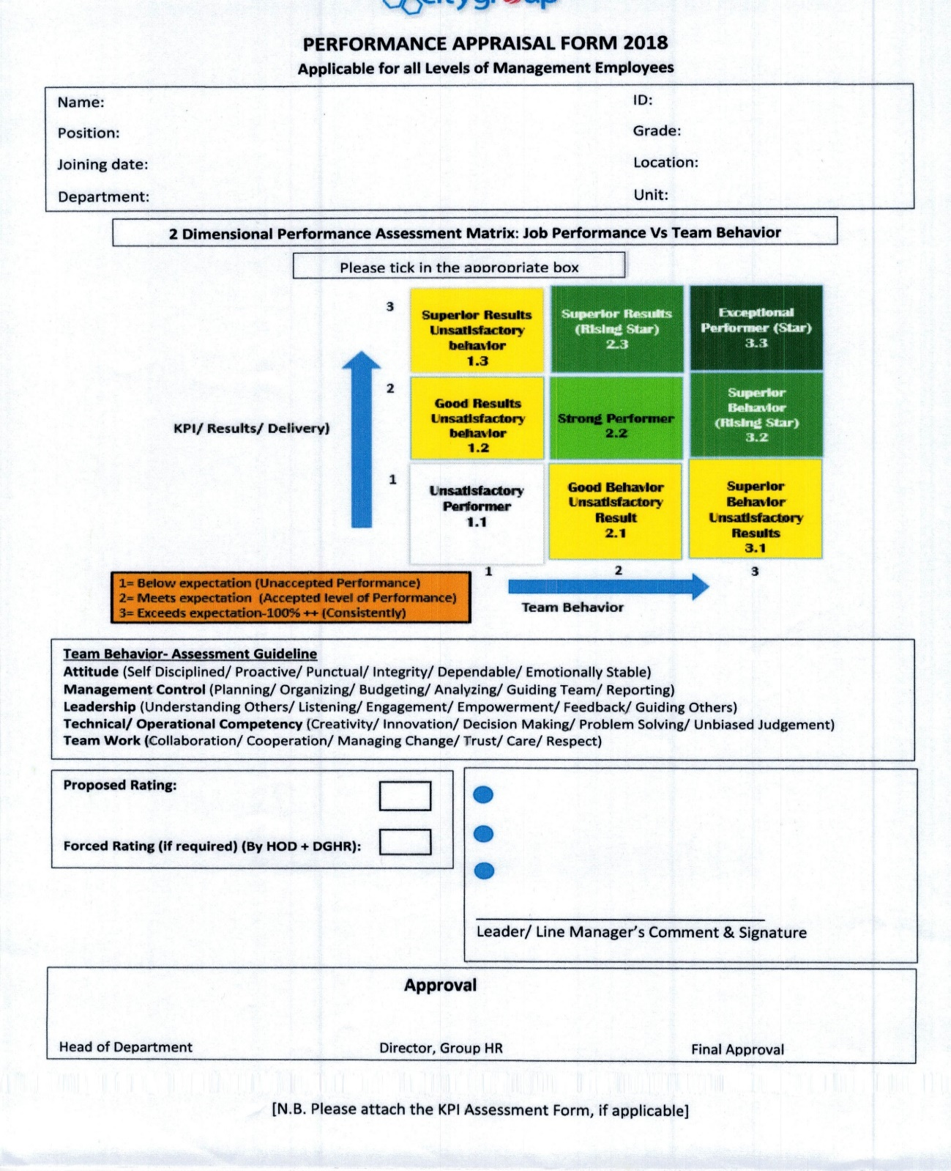
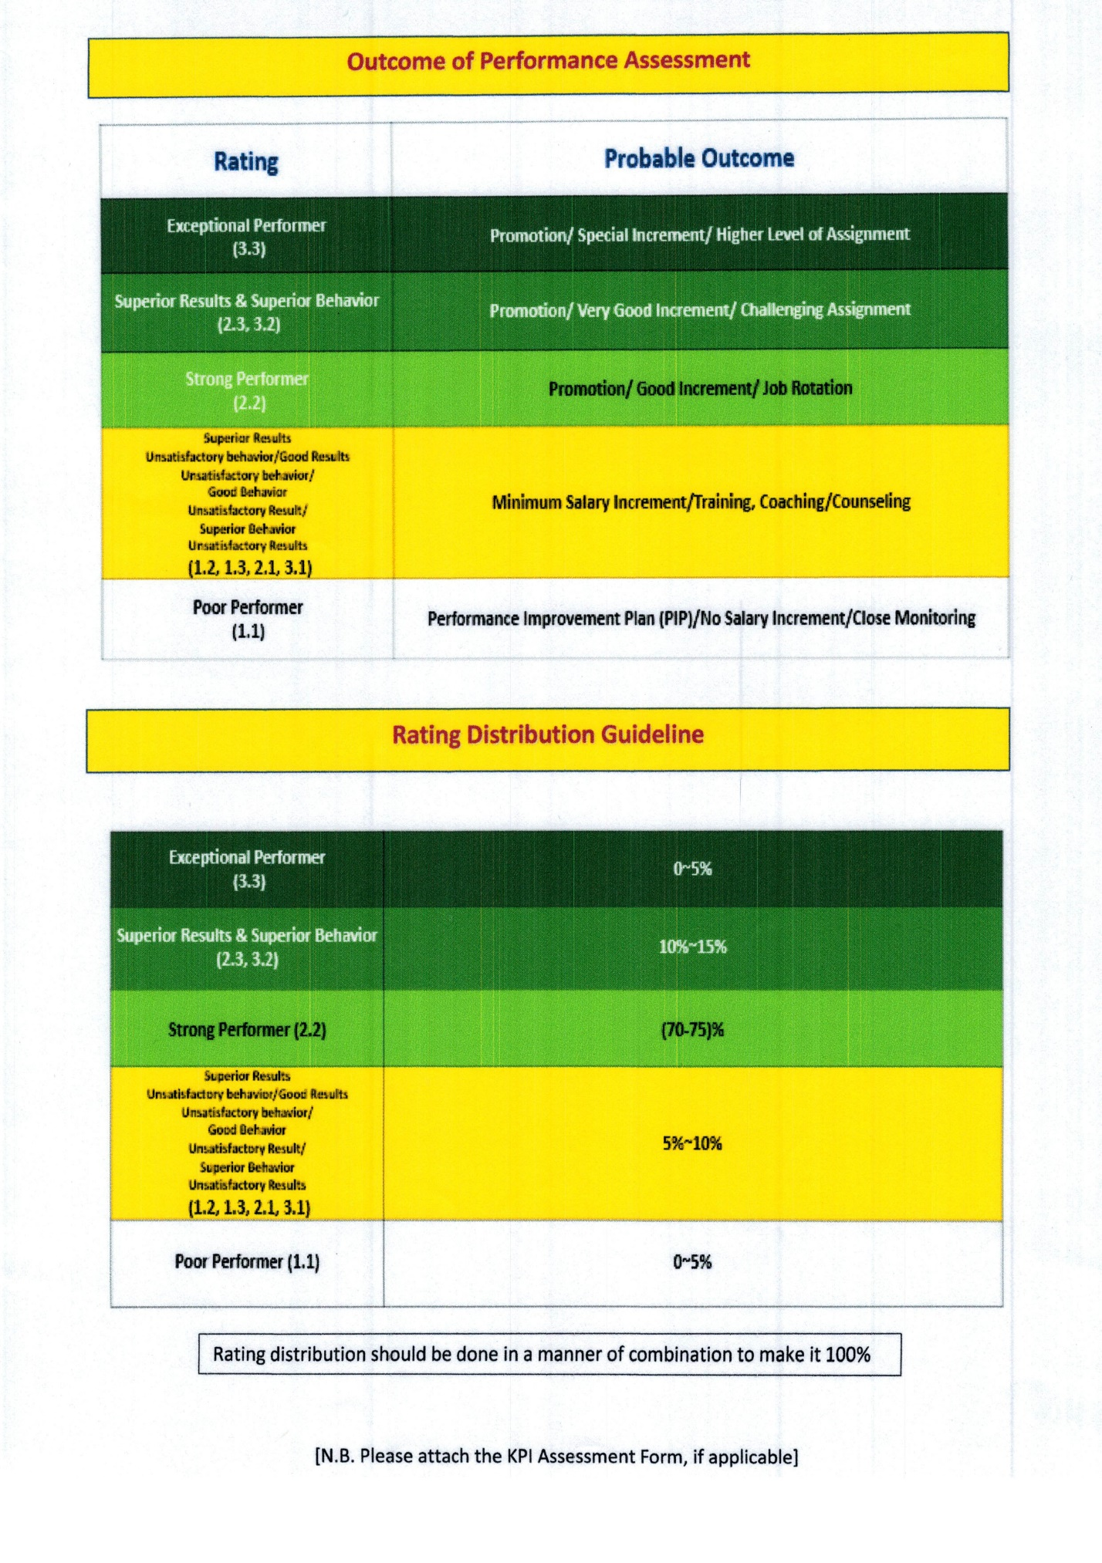
Appendix 4
Job nomenclature of City Group

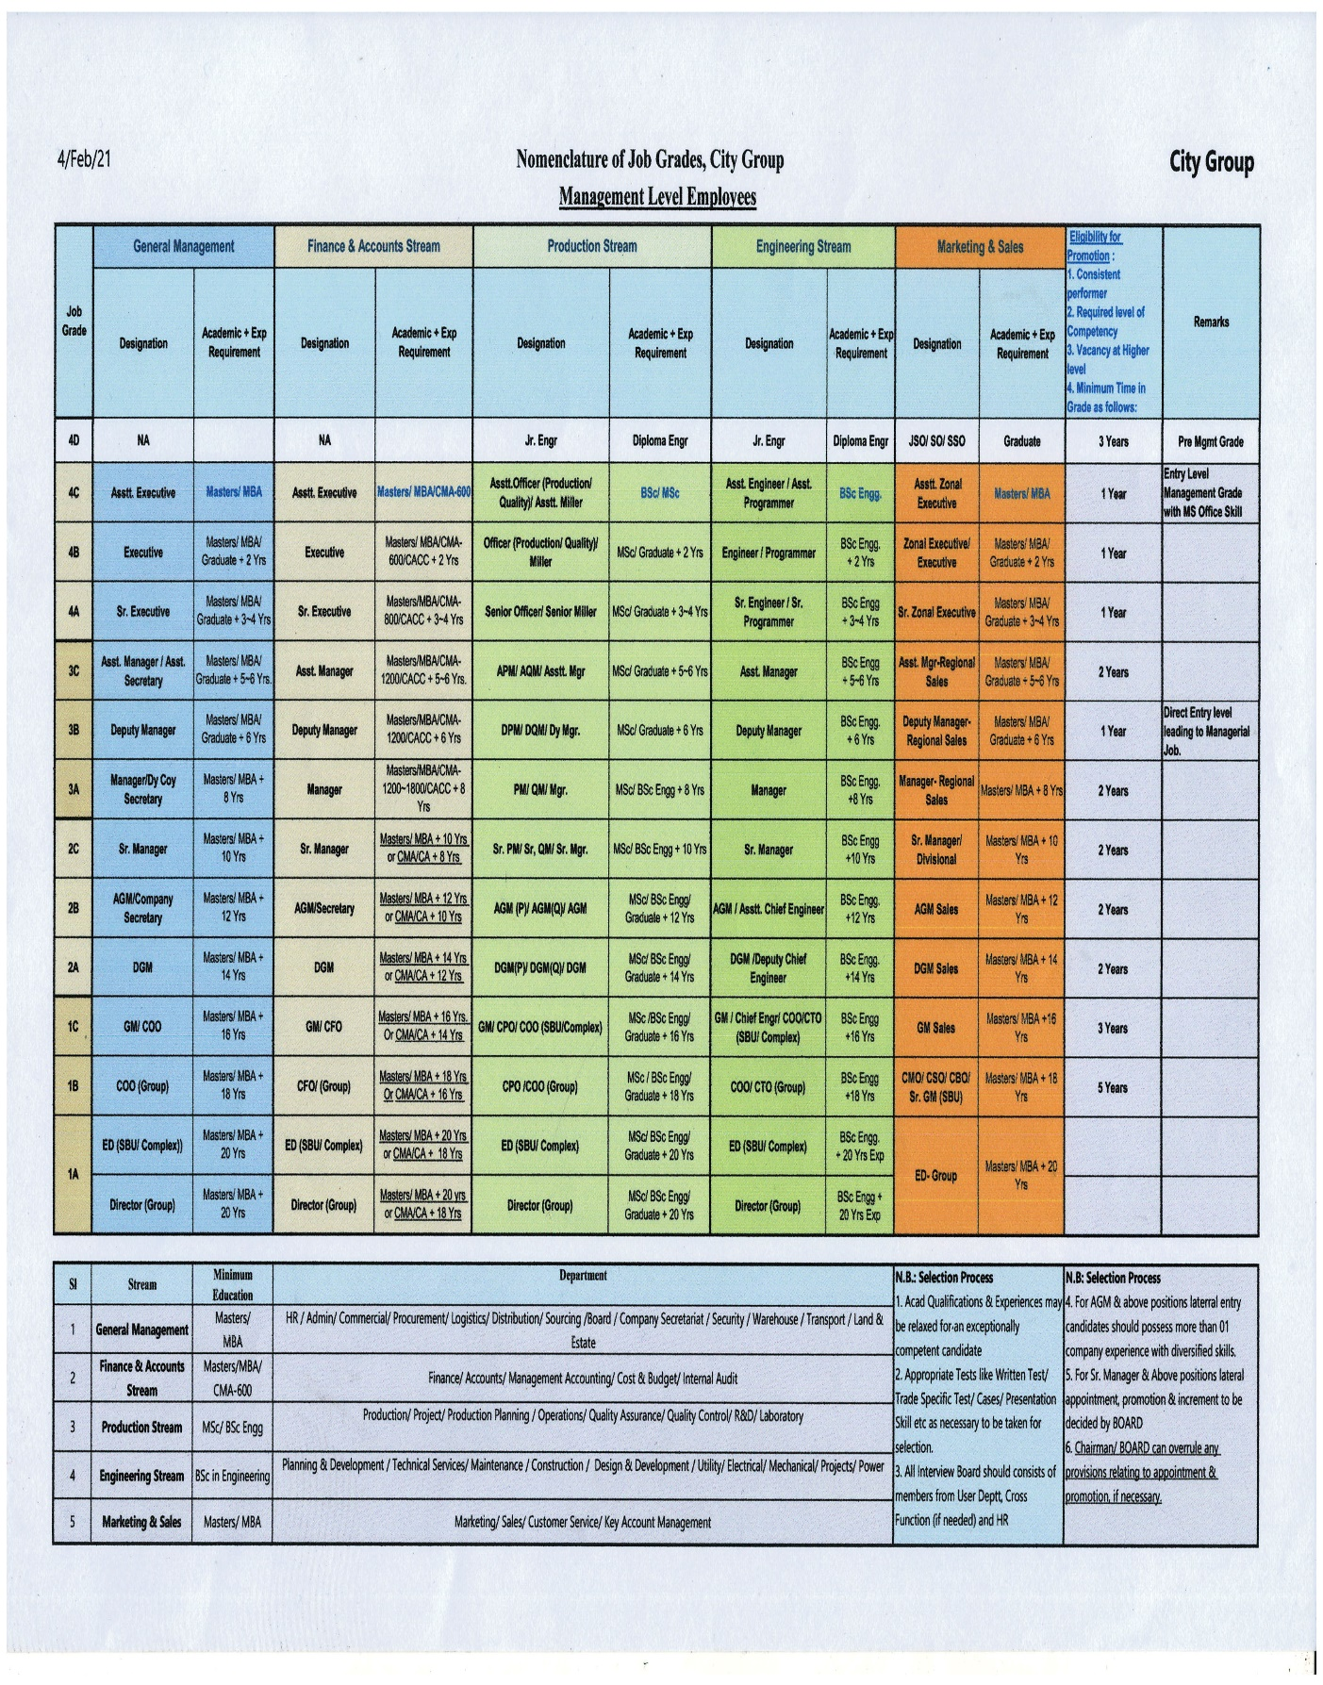
Appendix 5
Abbreviation:
HCM  Human Capital Management | SPP  Succession Planning Program | CFO  Chief Finance Officer
PDP  Personal development plan | COO  Chief Operation officer | L&D  Learning and development

