

___________________________________________________________________________
LOAN PROCESSING AND CREDIT APPRAISAL OF DHAKA BANK LIMITED
___________________________________________________________________________


Internship Report on ‘Loan Processing and Credit Appraisal of Dhaka Bank Limited’.

Submitted To
Mofijul Hoq Masum
Assistant Professor
School of Business & Economics
United International University

Submitted By
Md Linkon
ID: 111 152 193
Department: BBA (Major in Accounting)
School of Business & Economics
United International University

Date of Submission
18-1-2020

Letter of Acknowledgement
First of all, I would to like to thank almighty Allah for his grace that accomplishing my internship report on time.
As a business graduate student, Internship is must needed and most important requirement for completing my BBA program. Without a successful internship period BBA program will not be completely done. For that regard, I must give a special thank to all the faculty members of United International University whose helped to me for finishing excellently all the BBA program courses.
Then, I must thank to my respectable internship supervisor Mr. Mofijul Hoq Masum, Assistant Professor, UIU Business School, most sincerely and warmly. It may not be possible to do this report for me without the help and support of him. I easily understood the critical title by his excellent guiding method. His guidelines created an eagerness for me to carry out my appointed job promptly and enthusiastically.
Also, I can not deny that, Mr Talha Talukder, Management trainee officer, Dhaka Bank Limited (Board Bazar Branch) who guided me on my corporate experience so marvelously that this report, which is a clear part of the program, became easily understandable and drew my attention.

Letter of Transmittal

18 January, 2020
Mofijul Hoq Masum
Assistant Professor
School of Business & Economics
United International University
Subject: Submission of Internship Report.

Dear Sir,
I am so pleased to present the internship document that’s an important component of my BBA Program, Through this I got the opportunity to learn about different tools and techniques about the loan processing and credit appraisal of Dhaka Bank Limited.
Working at Dhaka Bank Limited and publishing the report was a very challenging and accomplished task. It has greatly improved my skills. It gave me the chance to develop practical experience in the various aspects of loan processing and credit appraisal.

It is highly obliging that you receive this internship report and make a valuable assessment. If you find this paper helpful and informative, it will be a great pleasure for you to have an apparent viewpoint about this issue.

Yours Faithfully
Md Linkon

List of Acronyms:
DBL = Dhaka Bank Limited
SME = Small and Medium Enterprise
CIB= Credit Information Bureau
SOD= Secured Overdraft
CC= Cash Credit
BBZ= Board Bazar
CRM= Credit Risk Management
CAD = Credit Administration Department
WCF = Working Capital Financing
NPL= Non Performing Loan

Executive Summary
In Bangladesh banking system has through 3 stages of progress, these are privatization, nationalization and economic section enhance. DBL commenced its banking career as a private limited bank on the date of July 5, 1995. I have done my internship program from DBL as the part of my under graduation program. I have been appointed in General banking and credit department at the time of my internship period. Though I worked in both general banking and credit department but actually appointed in credit department for working. My internship report going to cover about introduction and background of the organization, loan processing and credit appraisal of the organization, analysis and findings and recommendation on the basis of my knowledge acquired.
Opening new accounts, making dormant account letter, preparing charge document sheets, CIB undertaking etc. were my major responsibilities in DBL. My activities were determinate in opening account segment and clearings and bills segment. DBL provided me a specific PC to login with a username and password for doing computer activities. I was imputed to provide account related information to the clients. Daily, my major obligations became capturing updated and old data associated with opening account after that proclaim these facts to customers whose are fond of opening account. In DBL, I also ready up and fulfilling fresh and old documents of credit and general banking department.
The report relies on my important observation whereas operating within the credit section of DBL. One of the major activities of any bank is loaning. Bank provides loan to clients and also laid up clients’ money too. In my report I explained about different types of loans and their procedures as well. For providing any kind of loan needs various documents. I have to fulfill these documents like CIB undertaking, Charge documents etc. as a part of credit department.

Table of Contents
CHAPTER 1………………………………………………………………………………………………………………………………...1
INTRODUCTION 1
1.1 BACKGROUND OF THE STUDY 2
1.2 A BRIEF INTRODUCTION ABOUT THE ORGANIZATION………………………………………………………………….……2
1.3 OBJECTIVE OF THE STUDY 3
1.3.1 BROAD OBJECTIVES 3
1.3.2 SPECIFIC OBJECTIVES 3
1.4 RATIONAL OF THE STUDY 3
1.5 SCOPE AND LIMITATIONS OF THE STUDY 4
CHAPTER 2 6
METHODOLOGY 6
2.1 DATA DESIGN 7
2.1.1 DATA COLLECTION METHOD………………………………………………………………………………………………………7
2.1.2 DATA SOURCES………………………………………………………………………………………………………………………...7
2.2 SAMPLE SIZE……………………………………………………………………………………………………………………………..7
CHAPTER 3 8
ORGANIZATIONAL OVERVIEW 8
3.1 INDUSTRY SCENARIO 9
3.1.1 GLOBAL ECONOMIC SITUATION………………………………………………………………………………………………......9
3.1.2 INDICATORS OF ECONOMIC ACTIVITIES………………………………………………………………………………………..9
3.1.3 BANGLADESH ECONOMY……………………………………………………………………………………………………………9
3.2 HISTORICAL BACKGROUND OF THE ORGANIZATION………………………………………………………………………..10
3.2.1 VISION 10
3.2.2 MISSION 10
3.2.3 CORPORATE VALUES OF THE BANK 10
3.2.4 ORGANIZATIONAL STRUCTURE …………………………………………………………………………………………………10
3.2.5 ORGANIZATIONAL STRUCTURE OF CREDIT RISK MANAGEMENT………………………………………………………12
3.3 OPERATIONAL ACTIVITIES OF THE BANK………………………………………………………………………………………12
3.3.1 PROJECT FINANCE…………………………………………………………………………………………………………………..13
3.3.2 TRADE FINANCE……………………………………………………………………………………………………………………...13
3.3.3 WORKING CAPITAL FINANCE…………………………………………………………………………………………………….13
3.4 SWOT ANALYSIS OF DBL 14
CHAPTER 4 16
LOAN PROCESSING AND CREDIT APPRAISAL………………………………………………………………………………………16
4.1 FORMS OF CREDIT……………………………………………………………………………………………………………………..17
4.2 CHARACTERISTICS OF GOODS SECURITY………………………………………………………………………………………17
4.3 CREDIT FLOW OF DHAKA BANK LIMITED……………………………………………………………………………………..19
4.4 SELECTION OF BORROWER…………………………………………………………………………………………………………19
4.5 TYPES OF LOANS AND ADVANCES AS PER BANGLADESH BANK CRITERIA 19
4.5.1 CONTINUOUS LOAN 20
4.5.2 DEMAND LOAN 21
4.5.3 TERM LOAN 22
4.5.4 AGRICULTURAL AND SME LOAN 23
4.6 LOAN PROCEDURES 23
4.6.1 AT THE TIME OF FRESH PROPOSAL/ADDITION/REPLACEMENT OF COLLATERAL 23
4.6.2 AT THE TIME OF RENEWAL PROPOSAL 23
4.6.3 ENSURING DOCUMENTS BEFORE DISBURSEMENT 24
4.6.4 OTHER REQUIRED DOCUMENTS FOR NEW OR RENEWAL 24
4.6.5 CREDIT INFORMATION BUREAU FOR LOAN PROCESSING 24
4.6.6 CHARGE DOCUMENTS FOR LOAN PROCESSING 26
4.6.7 CLASSIFICATION AND PROVISIONING …………………………………………………………………………………………41
CHAPTER 5 ……………………………………………………………………………………………………………………………….42
FINDINGS AND ANALYSIS………………………………………………………………………………………………………………42
5.1 HYPOTHESIS SCALE…………………………………………………………………………………………………………………43
5.2 HYPOTHESIS DEVELOPMENT……………………………………………………………………………………………………..43
5.3 HYPOTHESIS TEST……………………………………………………………………………………………………………………..43
CHAPTER 6………………………………………………………………………………………………………………………………52
EXPERIENCE DURING INTERNSHIP TENURE 52
5.1 EXPERIENCE DURING INTERNSHIP PERIOD 53
5.1.1 CREDIT DEPARTMENT 53
5.1.2 GENERAL BANKING DEPARTMENT 53
CHAPTER 7………………………………………………………………………………………………………………………………54
CONCLUSION 54
6.1 CONCLUSION 55
REFERENCES 55

Chapter 1
Introduction

1.1 Background of the Study:
Banks are very important establishment at present financial and economic condition for both national and international aspects. In this modern economy banks have a great role by providing different types of services. Most of the people in our country take banking services direct of indirectly involved with banking services. Banks are now not only giving old banking services they also spreading different financing services as well as superior components for customers. One of these modern service is credit banking that spread the global economy. Credit banking system is very new in the perspective of Bangladesh banking system. Loan processing and credit appraisal is one of the part of credit banking. I have started my internship program at DBL(BBZ) credit department which is one of the fasted growing private bank limited in BD. That report is on loan processing and credit appraisal of DBL: A broad lesson of DBL helps me to prepare this report, at the time of preparing this report I got a great support from the employees of employees of credit department of DBL BBZ branch.

1.2 A brief introduction of the organization:
Dhaka bank limited is one the leading private limited commercial bank in Bangladesh. The headquarters of this bank are situated at Dhaka. The bank was established in 1995 by famous Bangladeshi politician Mirza Abbas.
DBL is like that a dream that expanse in profuseness modern banking with dense attachment to its community and culture. A bunch of dreamer entrepreneur friends aroused by a futurist leader set forth the fight of this large company voyage that resounded the speed of technology on the inner soul of BD. The Bank is currently well known as a result of its fantastic services, simplicities, proximities and cutting edges delivery method .
Because of its financial strengths and operational skills DBL has been standing up in all the major places for providing banking services in the whole Bangladesh to make it as a strong market competent. In 2000, DBL has been inclusive in Dhaka stock exchange and Chottogram stock exchange. It has an expand network of branches, ATMs, ADMs, SME banking etc. Currently the bank has a total of 101 branches along with two Islamic banking branches, three small and medium enterprises services center, fifty six ATM booth, twenty ADM, one clients services centre, one business kiosk, and two offshore banking units into whole Bangladesh. DBL has founded a supplementary company naming DBL securities limited for the need of capital markets. It has a total six section around the country. DBL wants to rise from the heart of Bangladesh as a strongest force in the market. It has committed to its goal to create upper shareholder worth in its excellence in banking as it grow and mature into a banking sly.

1.3 Objectives of the Study:
1.3.1 Broad Objectives:
Broad Objectives of my report is to acquire how the services and activities are carried out in the credit department and other related activities of the bank.
1.3.2 Specific objectives
There are some specific objectives which I want to know. There have some specific objectives also. These are:
- To get a clear idea about the credit department and the subordinate division of credit department.
- To know about CRM and CAD.
- To know about various terms & conditions regarding the credit policy.
- To know different types of documentation process of credit division.
- To suggest some possible course of action for improving the existing limitations in the bank.
- To understand the SOD against DPS/FDR, term, demand, and other types of loan procedures of DBL.
1.4 Rational Of the study:
An internship is a specific period of work experience that is offered by an organization for a short period of time. Internship helps to gain the real life experience, to gain knowledge about real life scenario of an organization or work place. I am interested to undertake this report because as a business background student what I have learned from my university that I will try to apply in my internship as well at the time of preparing this report. What I have learnt from my university courses that I will practically applied in the organization. As I have selected Dhaka Bank Limited (DBL) board bazar branch for doing my internship, I have written this report about the credit department of this branch. The report includes a detailed summary of all the services provided to the clients as well as a basic overview of the loan processing and credit appraisal followed and implemented by this bank. This report is so important for me because, what I have learnt from the DBL, I have tried to relate those things in this report which is based on my internship work. Thus the internship will help me to complete my graduation and in near future it will help me to understand the culture of the corporate life. In this report I discuss the work that I have done in Dhaka Bank Limited Board bazar branch as an Intern. The topic of my report is “Loan processing and credit appraisal of DBL, Board bazar Branch” because I have worked in the credit department as well as in other general banking sector also. I’ve worked in the credit department which will help me to achieve the purpose of the report to get ideas about the work life experience based on loan processing and credit appraisal to relate the study and professional life.
Therefore, I, this internship report is based on the function of loan processing in DBL, which is based on my internship experience in the bank’s BBZ branch.

1.5 Scope and limitation of the study:
There have some scopes and limitations of every academic and professional related reporting and research. The scopes and limitations of this report are;
Scopes
- Loan processing and credit appraisal are the prospective topic.
- Data needed for the explanation is much facilitate to access in respect to other commercial banking business related issue.
- My honorable supervisors from the university and bank are very helpful in case of data collection and interpretation.
- Problems and questions are very substantive and related issues are so conducive for future career enlightenment.

Limitations:
Though I have given my best efforts to prepare this report, I have faced some problems at the time of doing this report like scarcity of proper data and the other limitations as well:
- Most of the time, the employees of bank were busy so that I could not gather enough information from them.
- Many new and old information and data were not available.
- Some information were secret and the bank officials did not share these with me.
- In my internship period, I worked only 2 months n credit division , that’s why I could not collect enough information.
- Due to the confidentiality, it was very difficult to access all the papers and the information which is relevant to my study.

Chapter 2

Methodology

2.1 Data design
The report has been conducted to use a descriptive research approach. In accordance with business research methods, descriptive research is the research which has its main objective is providing something’s statement which usually functions or can be market characteristics. Everyone must have to follow some rules and regulations while conducting smooth and accurate study. Both primary and secondary data is used in my report.
2.1.1 Data collection method: Most of the data of this report will be collect from different papers, documents, website, records, statements, operational process and some of personnel of DBL.
    - Data sources: From both primary and secondary source data will be collect in my report.
Primary sources:
- Discussing head-on with management trainee officer, Operation manager, Credit in charge, trainee officer, senior officer and other general banking and credit department personnel of DBL.
- By DBL’s declaration about pertinent field study.
Secondary sources:
- Website data of DBL.
- Annual report 2018 of DBL.
- Various publications and manuals of DBL.
- Different text books and reading materials of bank management.
- Unpublished data collected from different section.
2.2 Sample size:
The population for doing this research will be the employees of DBL BBZ which number is 25 and the clients of the branch which is approximately 6000. So the total population will be 6025. From these population I choose 19 employees and 67 clients as sample by using Raosoft sampling calculator with 10% margin of error and 90% of confidence level. Total sample size will be 19+67=86.

Chapter 3
Organizational Overview

3.1 Industry scenario
At the midway of the age of nation, and affection of the traditions and histories for quicker pace pretend a strong force for changing today’s business world. In the nineties century, for the preference of modern generation grown multiple steady hope for banking mending. DBL, like a dream which expanse in the prodigality new banking hope with intense connection with the bank’s culture and community. DBL established at the date of April 6, 1995 as a private bank under the Company Act 1994. It has been started its banking operation on July 5, 1995.
Dhaka Bank contributes a great role in our economy. It has thousands of shareholder who were always there with trust and support.
3.1.1 Global economic situation : DBL creates a global economic situation and also domestic economy. If we see DBL’s annual report of 2018, it’s global growth was estimated in 3.8% at November 2018 global economy outlook forecast. The world economy is suppose to grow at the rate of 3.5% in 2019.
3.1.2 Indicators of economic activities: In 2018-19, international trade growth is set to moderate at the average rate of 4%,
Fiscal policy: In 2018, fiscal policy is the most positive growth that has been enlighten.
Commodity: In commodity exporters, the price of the energy and metal have been recovered in 2017, on the other hand, agricultural product’s price had been stable. The price of energy and metal gained at the rate of 22% partly due to strong demand from China.
Inflation: Many of structural factors is involve that could favor disinflation. These are, a severe competition for products and services in the international and domestic as well as regional level.
3.1.3 Bangladesh economy: Bangladeshi economy has sustained outstanding growth and achieved GDP Growth at the rate of more than 6% on an average during the last few decades. Following to Bangladesh Bureau of Statistics [BBS], the GDP Growth halt at the rate of 7.86% in Fiscal year 2017-18.
Dhaka Bank Limited has a great scope to enhance its banking sector toward the country.

3.2 Historical background of the organization:
3.2.1 Vision: DBL draws its inspiration from the distance stars. Their vision is maintaining a standard that makes pleasurable experience in every banking transactions. Their attempt is to offer the clients superior service through accuracy, timely delivery, reliability, cutting edge technology and other solution for business needs, international reach in trade and commerce and high yield on client’s investments.
Their discerning customers are aligned to meet the demand by people, products and processes. Their goal is to achieve a distinct providence. Their ultimate objective is to provide a quality to the customers that exhibits a true reflection of their vision which is – Excellence in banking.
3.2.2 Mission : Becoming the country’s premier financial institution by providing high quality products and services backed by newest technology and a group of highly motivated personnel to provide excellence in banking.
3.2.3 Corporate values of the bank:
- Customer focus
- Integrity
- Team work
- Quality
- Individual’s respect
- Responsible citizenship.
- Target pro-active answer
- Good communication system
- Commitment to excellence
- Embrace diversity.
3.2.4 Organizational Structure:
1. Credit Department
2. Treasury Department
3. Financial and Accounts
4. Operators Department
5. Central Accounts Department
6. Personal Banking Department
7. Investment Department
8. Information Technology Division
9. Human Resources Department
10. Audit & Risk Management Department
11. Foreign Exchange Department
12. Dhaka Bank Training Institute Department
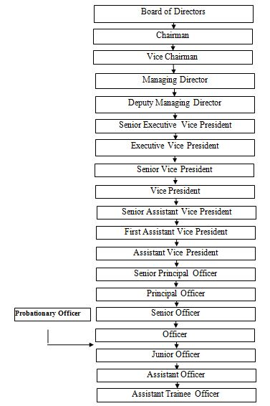

3.2.5 Organizational structure of credit risk management:
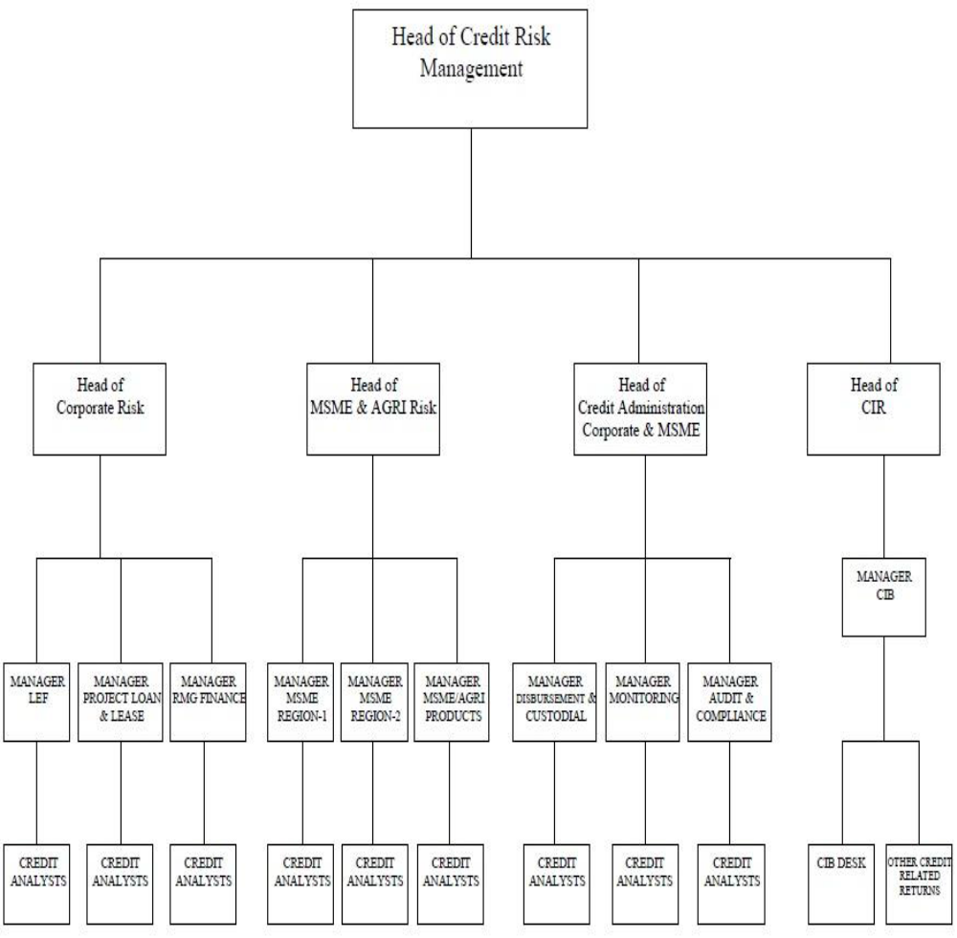
3.3 Operational activities of the organization:
DBL organizes that corporate clients requires customized authorization and vary from one to another is troublesome for successes of their business. Financial goods and services provided by DBL corporate banking which are fulfilling different bank needs for massive corporate houses, also many micro credit organization and financial institutions. DBL’s ranges of products are everyday merchandising operation short term financing to long terms loan to expand the businesses. DBL’s always works for understanding the potential client’s particular need & sketch structured also tailored resolutions to the businesses.
3.3.1 Project finance ( short, mid and long time)
Project finance is a timely financing and unique technique used to fund large-scale corporate projects. Project financing, assessing the risks, preparing the financial plan, raising the funds, designing the financing mix etc includes for understanding the rationale.
A full range of services and products is offered by DBL to the entrepreneurs fulfilling to a project finance that includes:
- Term loans ( Machineries )
- Term Loans ( Constructions)
- Lease financing ( Machinery )
- Foreign exchange loan

3.3.2 Trade Finance
Nowadays business is not only into the country it has become crossed the national boundary. In today’s digital banking foreign trade contributes a major role. To support customers DBL offers trade finance related various range of services and products.
- Export letter of credit
- Import finance
- Shipping guarantee
- Export bill collection etc.
3.3.3 Working capital finance:
WC generally known as vitality of a recent founded projects. With the respect of their nature of operation all kinds of facilities for every sector of industries and businesses are included in DBL’s working capital financing. Product & service of WCF can be segmented as below
Non funded facilities:
- LC
- Bank Guarantee

Funded facilities:
- Short term loans for 3 months. 6 months or 9 months.
- Overdrafts – other
- Overdrafts – working orders
- Time loan etc.

3.4 SWOT analysis of DBL

Strengths:
- A strong ,well known and dynamic board of directors
- Management committee team is highly professional
- An onward looking strong management policies
- Always ensure the quality
- Human resource dedicated line
- Business line is enough diversified
- A strong capital base bank
- Fantastic working environment

Weakness:
- High charges of letter of credit
- Technological difficulties like backdated software system, old model PCs, slow internet connection etc.
- Lack of appropriate motivation
- Absence of many creative items
Opportunities:
- To change the business environment DBL has the ability to become the market leader among all the banks in BD.
- Enhancing business growth for creating sustainable shareholder value
- Increasing the number of customers by providing superior service
- Extend the market among the whole country and capture it from rural to urban areas.

Threats:
- A lots of competitors in the market, it’s becoming difficult to find clients easily, for providing a huge amount of loan, or taking loan ,because behind a single client many banks are involved .
- Comparable items offered by other banks
- Modern downturns and default loans.
- Crisis of sufficient money

Chapter 4

Loan processing and credit appraisal

4.1 Forms of credit:
Commercial banks make advances in different forms . All types of credit facilities can be broadly classified into two groups.
- Funded credit
- Non funded credit

4.2 Characteristics of Goods Security:
Different types of goods, commodities and properties etc are offered as securities while others are immovable. So, generally security means assurance on the contrary of crisis. The purpose for taking securities against an advance only to securitize the advance not to get the property. Because, Loan and advances are to be given purpose wise not the security-wise. But security is taken against an advance only for scrutinizing the same, in case of default of the borrower, then the debt can be realized by way of sale or transfer of the security
Types of Security:
- Tangible security
- Intangible security
Further security can be classified
- Primary security
- Collateral security
Tangible security
Tangible securities are the securities which are realize by selling or transferring.
Tangible Security again divided into the following forms
- Movable: a) Goods/Commodity b) Financial Instruments- FDR, Share, Life Policy, Work Order etc.
- Immovable: Land, Building and Machineries
Intangible security
Intangible security also known as personal security. On the borrowers bankers have a right of action in all advantages. Though borrowers personal liabilities are assumed, bankers also take a promissory note from the borrowers. In certain cases, the bank requires, in addition, the guarantee of a respectable third party as personal security.

Primary Security:
It regards like a principal coating of advances. Such as, stock in trade, Share etc. Any security deposited by the borrower himself will be treated as primary security.
Collateral Security:- It means additional, subsidiary or secondary security as opposed to primary security such as land and building . In case of third party any security will be treated as collateral security.
Characteristics of good security

4.3 Credit flow of Dhaka Bank Limited
CRM is the initial of risk managements, because most of the banking businesses think that it’s the principal risk. For every loans and profitableness banks ought to evaluate degree of risk. For each bank, Bangladesh bank takes a projection for putting in a main CRM systems. DBL conjointly put in identical system in regard to quality liability management, interchange management, control and compliance, opposing hiding. The bank providentially controls quality allocations by limit exposures for business sectors and set consumer limits. In addition, DBL sanctioned an updated organization structures for accommodating CRM perspective. During that association, previous assessments & following au fait a loans dealing represent fundamental elements of CRM method.
4.4 Selection of borrower:
DBL follows some criteria for selecting a borrower. Before the selection of borrower bank verifies some qualifications/ abilities of borrower, that the borrower must have to be. These are:
- Character of the borrower: Whether the borrower is honest or not, his integrity and intentionality for repaying the loan.
- Capability of the borrower: Whether the borrower is financially capable or not to repay loan, he/ she must have some specific profitable sources.
- Capital of the borrower: Financing strengths for covering the business risks.
- Condition against borrower: It’s common business conditions of the economy in general and the concerned area in particular.
- Collateral of the borrower: Borrower’s ability to produce additional securities.
Besides these, there have some other criteria for selecting the borrower.

4.5 Types of loans and advances as per Bangladesh Bank criteria:
a. The loan that hasn’t specific reimbursement schedule, however contains date of ending, credit limit etc. are generally known as cont. loan. For example: Cash credit, secured draft.
b. Demand Loan: To meet short term working capital need which is usually for a period up to 1 year.
- Term loan: : To meet fixed capital expenditure, 'which is usually for the period ranging from one to five years
- Agricultural and SME loan: Dhaka bank SME business team has step by step endeavored to enhance its credit assessment method, transportation regulative compliance in maintenance and handling, making certain correct credit disciplines for handling and managing NPL into MSME and agriculture sectors.

4.5.1 Continuous Loan
SOD
The SOD is a non-stop improve facility by way of this settlement; the banker lets in his client for over drafting the persons present day accounts what they withdraw, for their crediting limit sanctioning through means of banks. Depending on the quantity, interest varies or it may change. DBL sanction secured over-draft in opposition to extraordinary safety. SOD lets you undertaking an asset to the bank as security. Assets could be bank deposits, property, or shares. If you can't repay your debt, the bank has the right to sell your undertaking assets to recover what you take from the bank.
Process of giving SOD loan:
Savings Account
Savings Account
SOD
DPS / FDR

Client NID Card
Clint's Request letter receive

Nominee’s NID card
Client’s 2 copies photo
90% of DPS/FDR

Undertaking
SOD Interest rate =DPS/FDR interest rate + 3%
Collecting DPS/FDR Instrument
Nominee’s 1 copy photo
Or minimum interest rate 10%
SOD account opening
Client’s recent month electricity bills copy
SOD Loan offer for 1 year
Filling up the charge document

NID scan copy send to CVD for verification
Interest charge quarterly
Preparing sanction and journal entries

Fill up Accounts form

Taking Approval from head office
Open Account
Cash Credit
The CC is a rendezvous through that the bankers permit their clients for borrowing cash within particular limits. To meet the asset necessities of trader, industry etc CC maybe one of the felicitated way of borrowing.
CC is mostly approved with hypothecations and pledges of products. Thus money credit is two kinds :
- Money credit hypothecations
- Money credit pledge
Export money credit.
The Export money credits are extended to Associate in Nursing bourgeois to facilitate the export of products & commodities that there's export letter of credit or contract on demand. it's a pre-shipment and short-run credit to be liquidated out of the payoff of export documents that embody negotiation for purchasing the exporting document..

    - Demand Loan
Inland documentary bills purchased/ bill of exchange purchased:
Bill of exchange purchase exchanging arises from business dealing which termed as IDBP.
At the time of enclosing the bills by drawers, the document of title for product like billing of cargo, rail receipts, steamer receipts, with billing that will be deliver for remunerator of B/P. Because the bills could also be termed as documentary bills.
Purpose: Occasionally bank is to get billing exchanges from businessman for facilitating business transaction.
Payment against document
For commerce products importer is to L/C by any banks. Frequently bank increases credits for importer in case of can’t forbidden through People’s Republic of Bangladesh bank, for purchasing needed interchange.
Purpose: That’s related for importing and importing funding.
Foreign documentary bills purchase:
Purchase of bill of exchanges denominating in the overseas currencies pulled in consequence by term of exports letter of credit which named FDBP.
Purpose : That’s the post shipment finance providing for exporting to meet theirs assets would like.
    - Term Loan
Short term loan: That types of loans are generally done for less than 1 year or including 1 year.
Medium term loan: More than 1 year to 5 years
Long term loan: More than 5 years
Unsecured loan:
Trust receipts
That’s briefing underneath that credits are allows in opposition to trusts receipt & foreign product stay within custody into bourgeois nor businesspersons however they have to inure a sealed trusts receipts on behalf of the banks whereby the declarations formed as products import nor purchased by banks money.
Purpose: TR could be the post importing fund of bank allowed to the foremost sure businessperson.
Credit assessment
Bank’s principle objective is earning profits through finance which offered investible fund owing inside norm that come up including financial gain together including exceptions obtaining the principal backs among stipulating amount.
Following things are considered by DBL for accurate assessment for processing credit proposals
- Liquidity
- Security
- Profitability
- Sponsor and
- Purpose.
Types of credit facilities
Bank can go for:
¬ Term finance for brand new project and balancing, modernization, rehabilitation and expansion of existing comes (Large, Medium, SE)
¬ assets for services, industries , trading etc.
¬ Export Import financing
¬ Lease Financing
¬ client Financing
¬ Fee business
¬ Islamic scheme of financing
Generally bank can provide 35% loan of its total capital. The interest rate of this loan basically is 12-15%. It may vary from customer to customer, organization to organization.

    - Agricultural and SME loan
DBL SME trade team has bit by bit endeavored to boost its Credit Assessment method, transferal regulative compliance in custody and handling, making certain correct credit discipline to deal with & managing nonperforming loan in MSME & Agriculture sector. Compliances with directions from Bangladesh Bank, DBL has virtually earned its needed SME exposure of around 25% loan of from bank’s total capital SME portfolio increased by 15.07% in 2018, than that of 2017 and it's been ready to scale back NPL by .96%.
4.6 Loan Procedures:
Required documents:
4.6.1 At the time of fresh proposal /Addition/Replacement of Collateral:
- Vetting/legal opinion of the properties by the panel lawyer.
- Up to date search report of the properties
- Verification of the documents of the properties by branch officials
- Visit and valuation of the properties by branch manager
- Valuation done by the enlisted surveyor
- Up to date rent receipt.
4.6.2 At the time of renewal proposal
- SRO token/copy of original deeds of mortgage
- New search report of the properties
- Verification of documents of the properties by branch officials
- Visit and valuation of the properties by branch managers
- Valuation done by the enlisted surveyor( if surveyor valuation is more than 2 years)
- Up to date rent receipt.
4.6.3 Ensuring Documents before Disbursement
- SRO token/copy of original deeds of mortgage
- Satisfaction certificate by the panel lawyer
- Security compliance certificate and loan documentation check list.
4.6.4 Other required documents for new or renewal
- Loan application in company PAD
- CIB undertaking duly signed by the proprietor/directors
- Net worth statement of the proprietor/director
- Last year audited/management prepared financials last 03 years
- Credit rating from enlisted credit rating agency
- Latest stock report in details attested by the proprietor/director
- Latest list of machineries
- Tax clearance certificate for company
- VAT certificate(if any)
- Up to date trade license
- Latest scheduled X and XII( for listed company)
- Projected sales figure for the year 2019 & 2020
- Other bank statements & sanction letter for last year, if any
- Up to date ground rent BS 1426 of your existing collateral property
- List of accounts receivable with ageing
- List of accounts payable with ageing
- List of customers
- SME req. letter in bangla for SME client with 1 copy PP sized photo
- Latest NID of applicant guarantor, mortgagor along with 13 digit NID number
- Others ( if any)
4.6.5 CIB for Loan processing : For providing any kind of loan to the clients ,CIB is must needed. By CIB, bank can know about the client whether he/ she is good or bad, the client is capable enough to get loan or not.
CIB Undertaking Form:
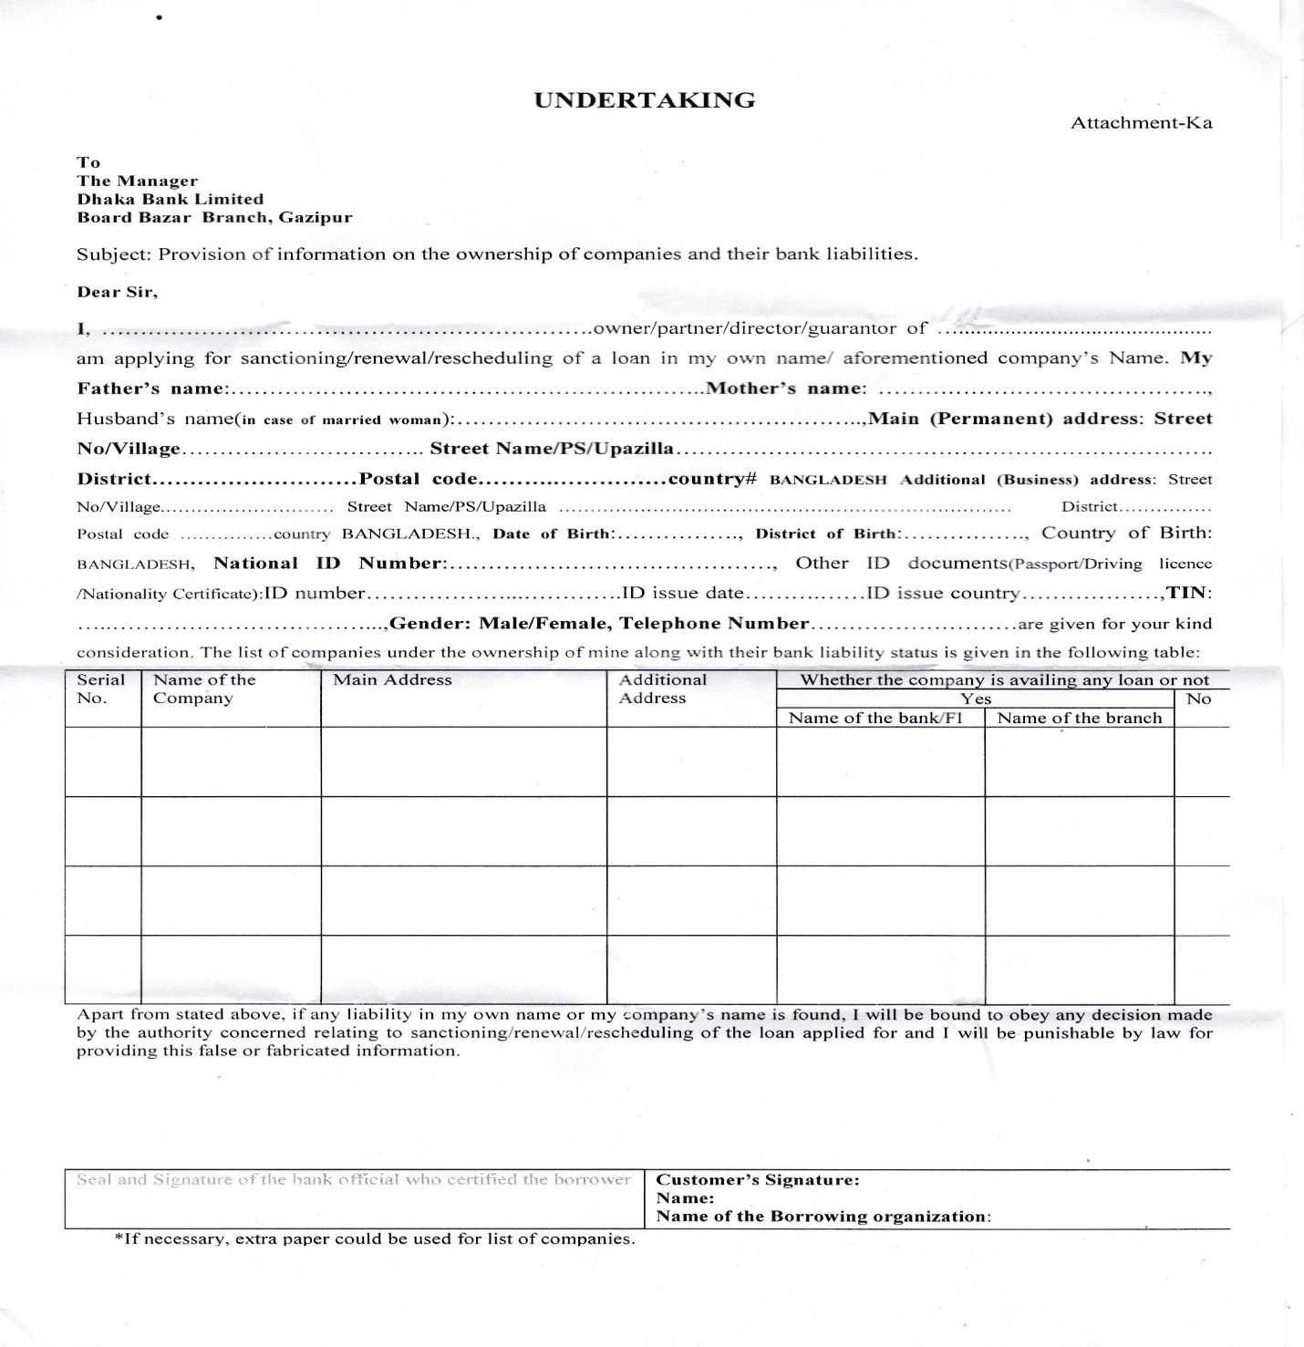

    - Charge Documents for loan processing
- Letter of lien and authority
- Memorandum of deposit of chg
- Right to recall the loan
- Demand promissory note
- Declaration
- Loan disbursement letter
- Letter of continuity
- Letter of undertaking
- Letter of disclaimer
- Account balance confirmation slip
- Letter of authority
- General loan and collateral agreements
- Letter of hypothecation
- Continuing guarantee ( personal)
- Trust receipt
- General counter guarantee
- Letter of indemnity
- Net worth statement
- Request for credit limit
- Hypothecations vehicle
- Mortgage property visit report
- Indemnity for lost instrument
- Miscellaneous

Most Relevant Charge document sheets for Term loan, SOD, demand and other personal loan
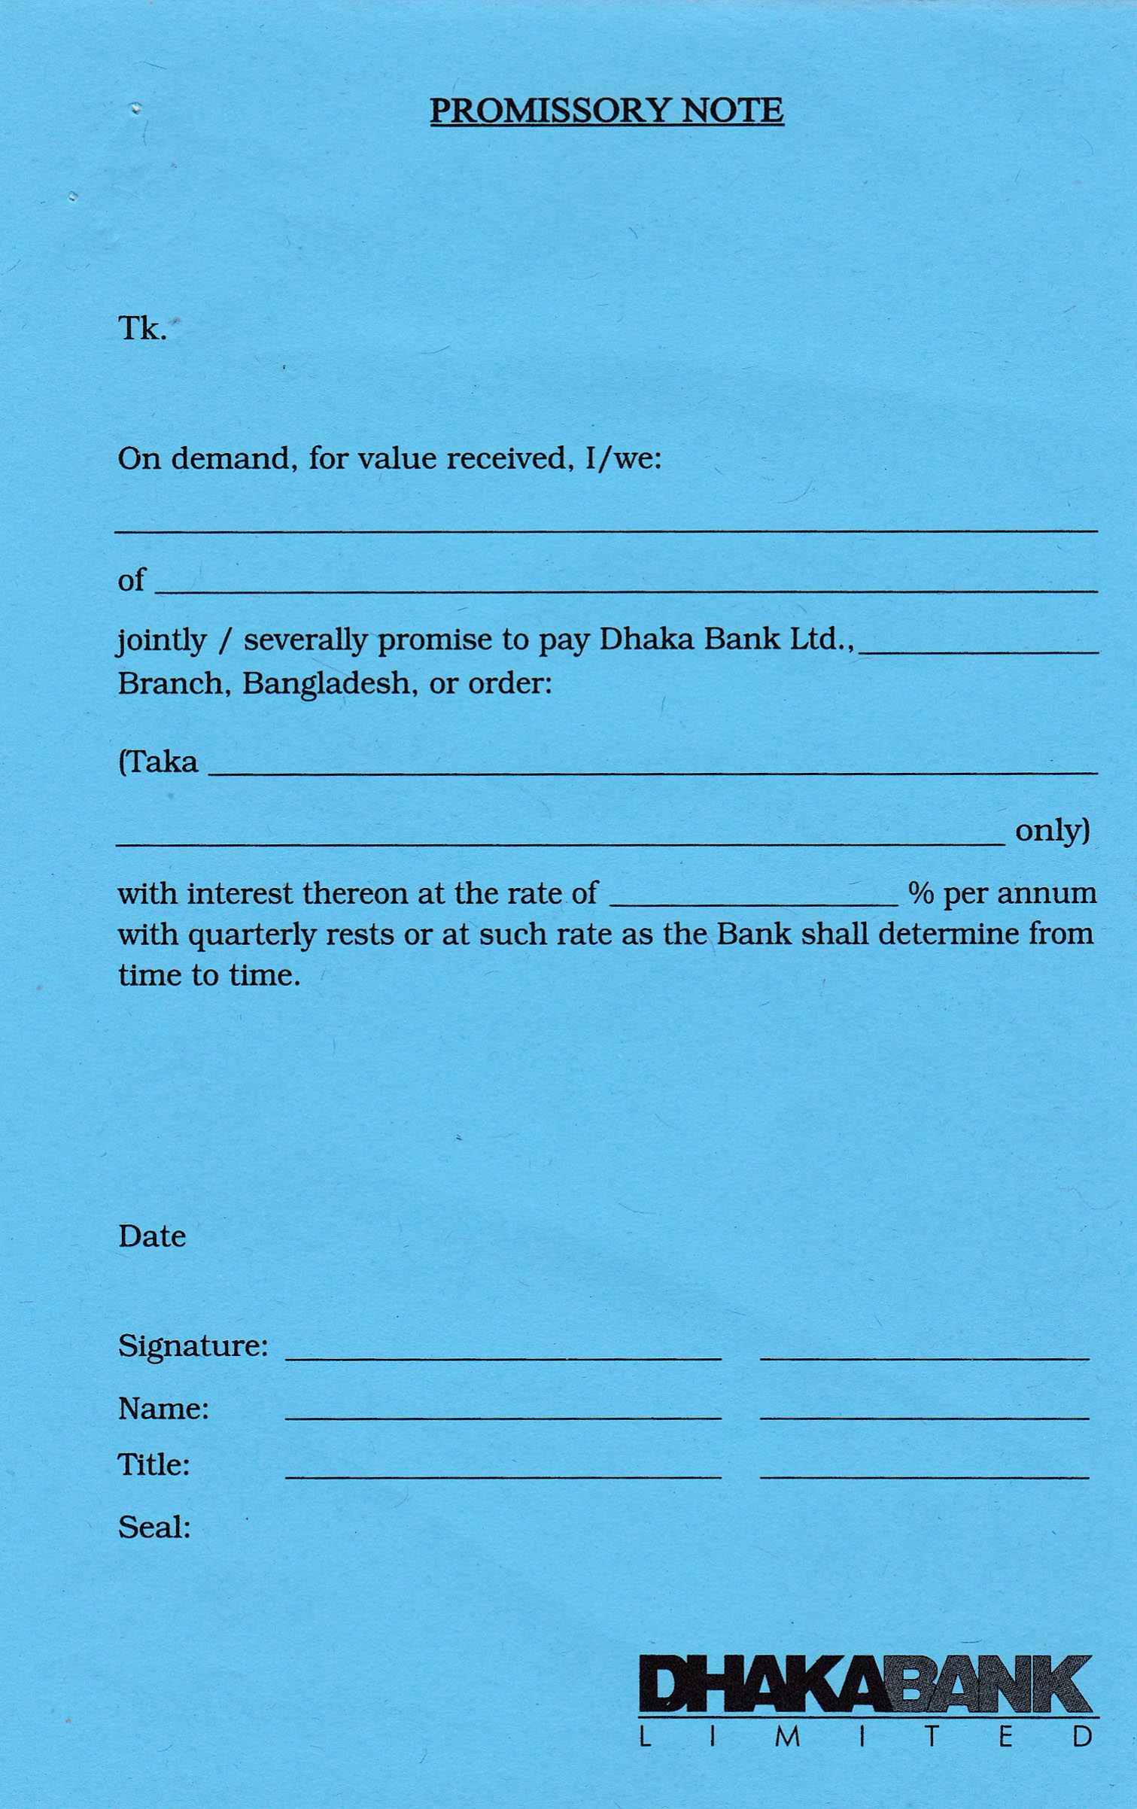
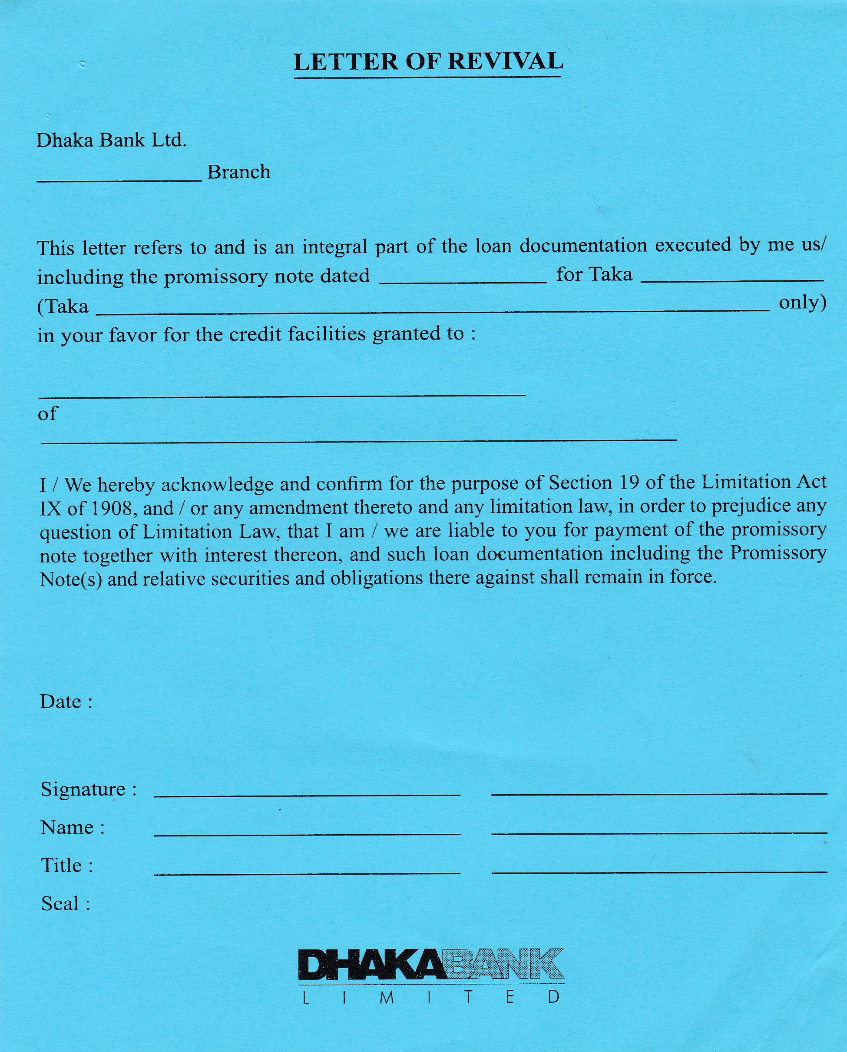

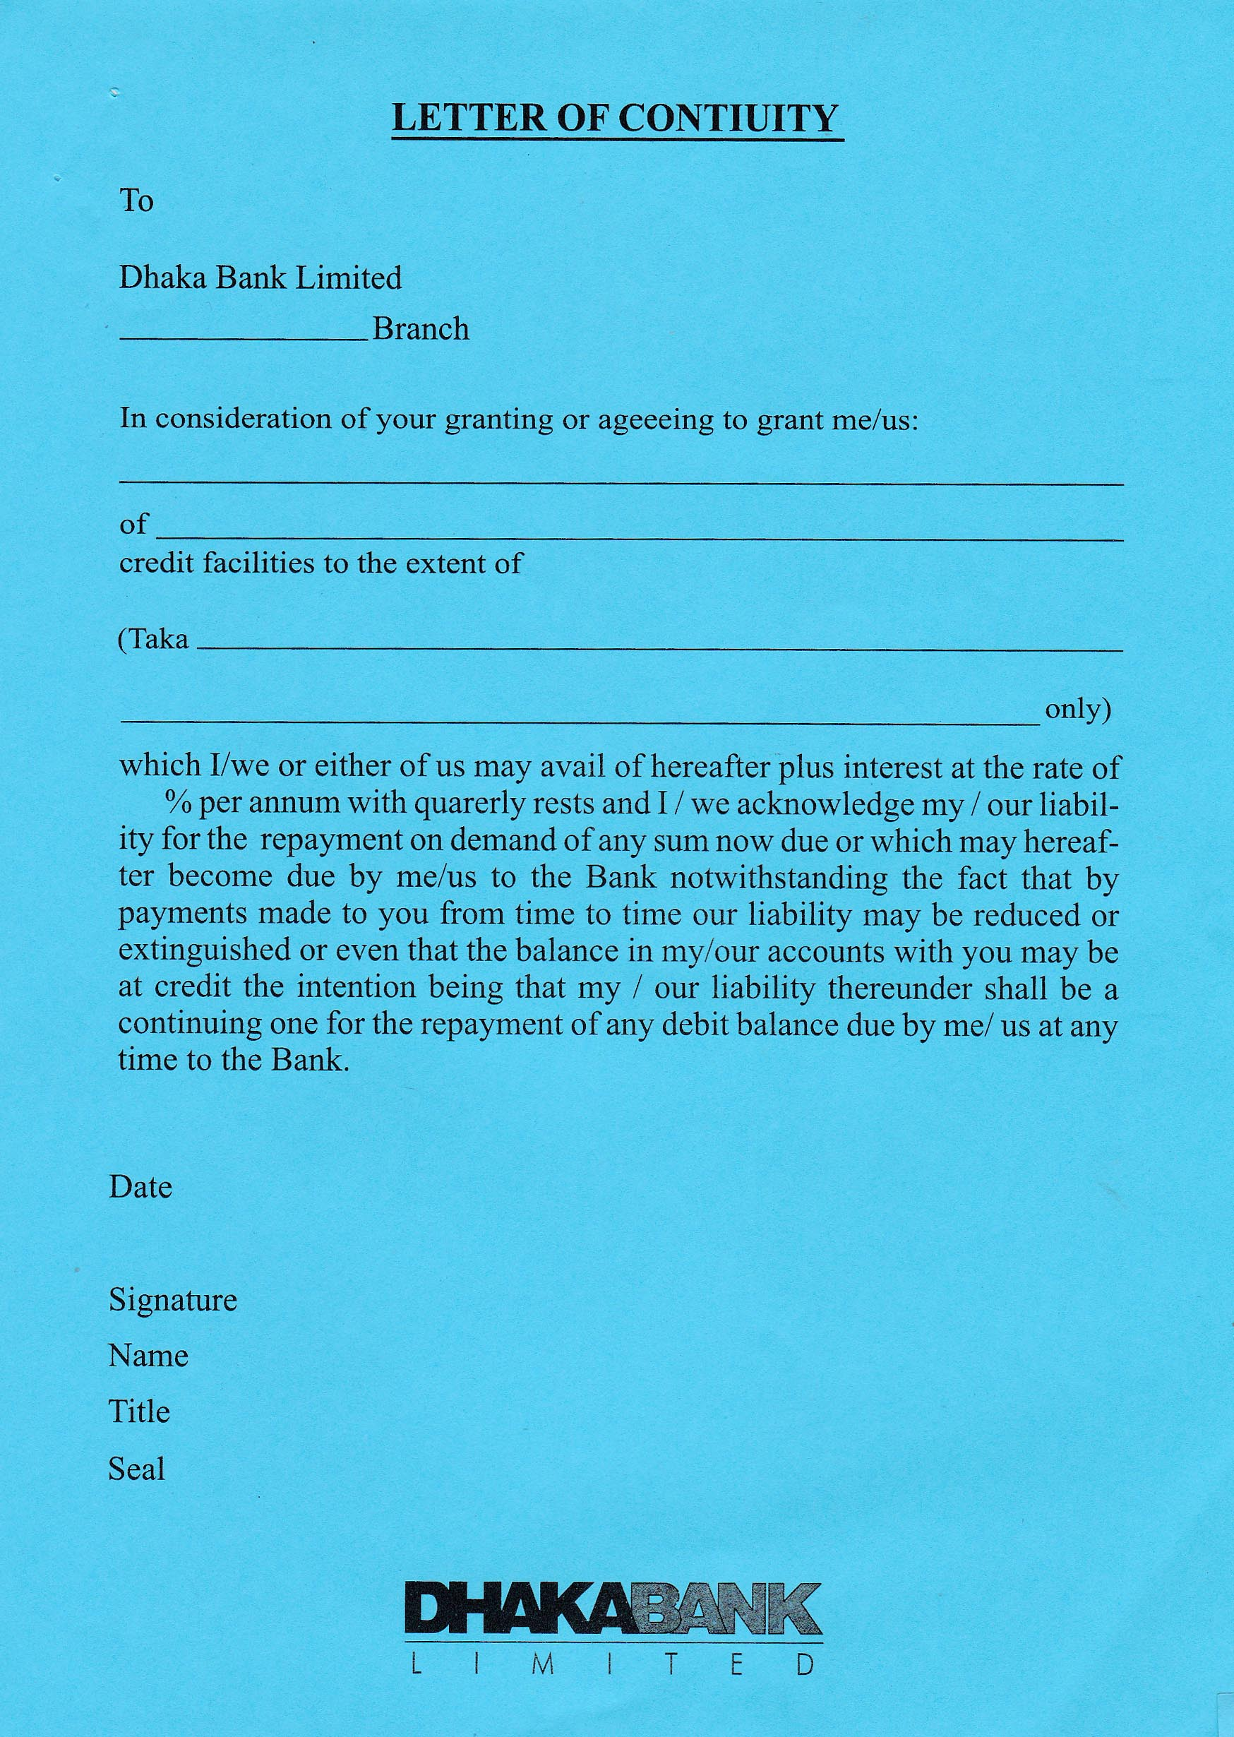
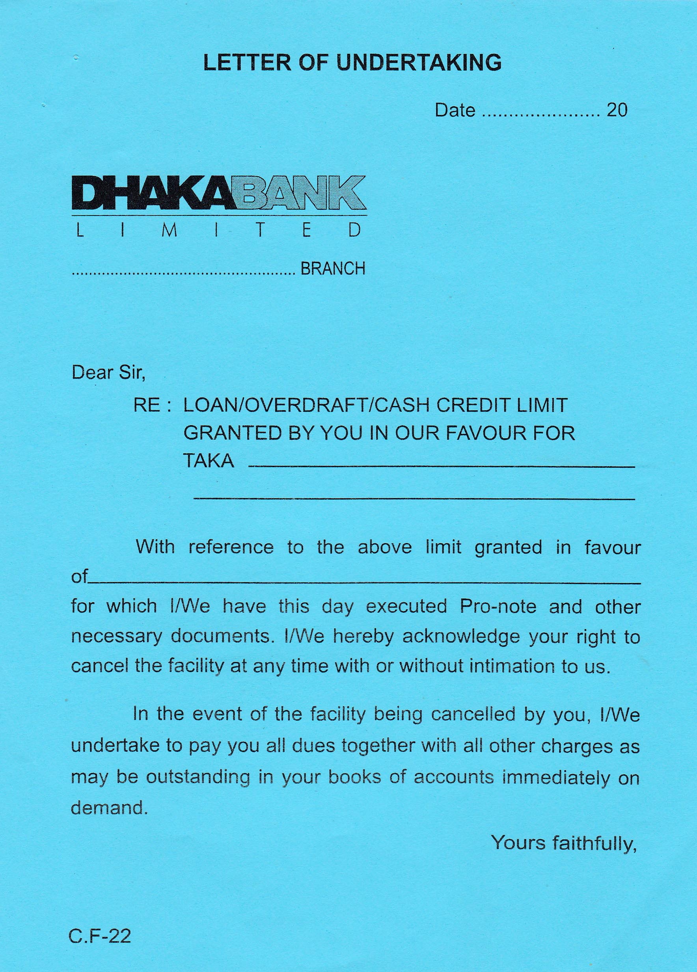

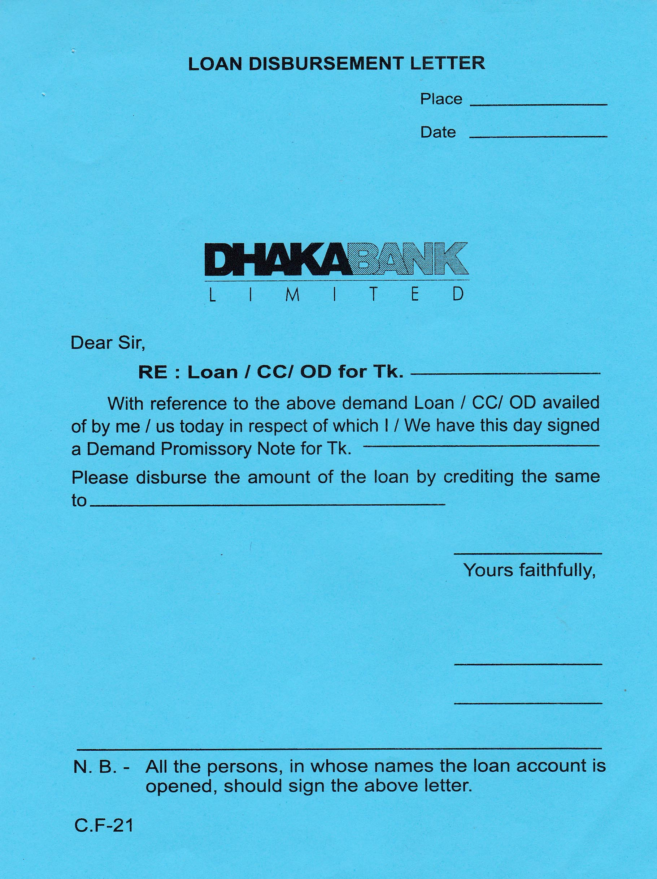

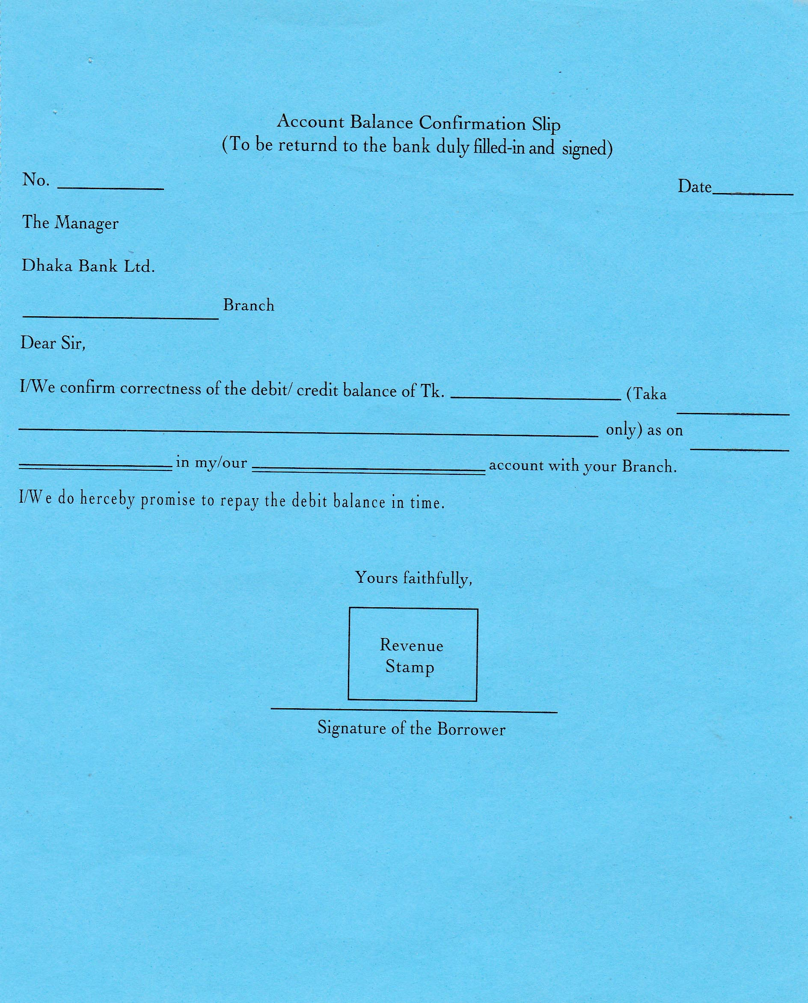

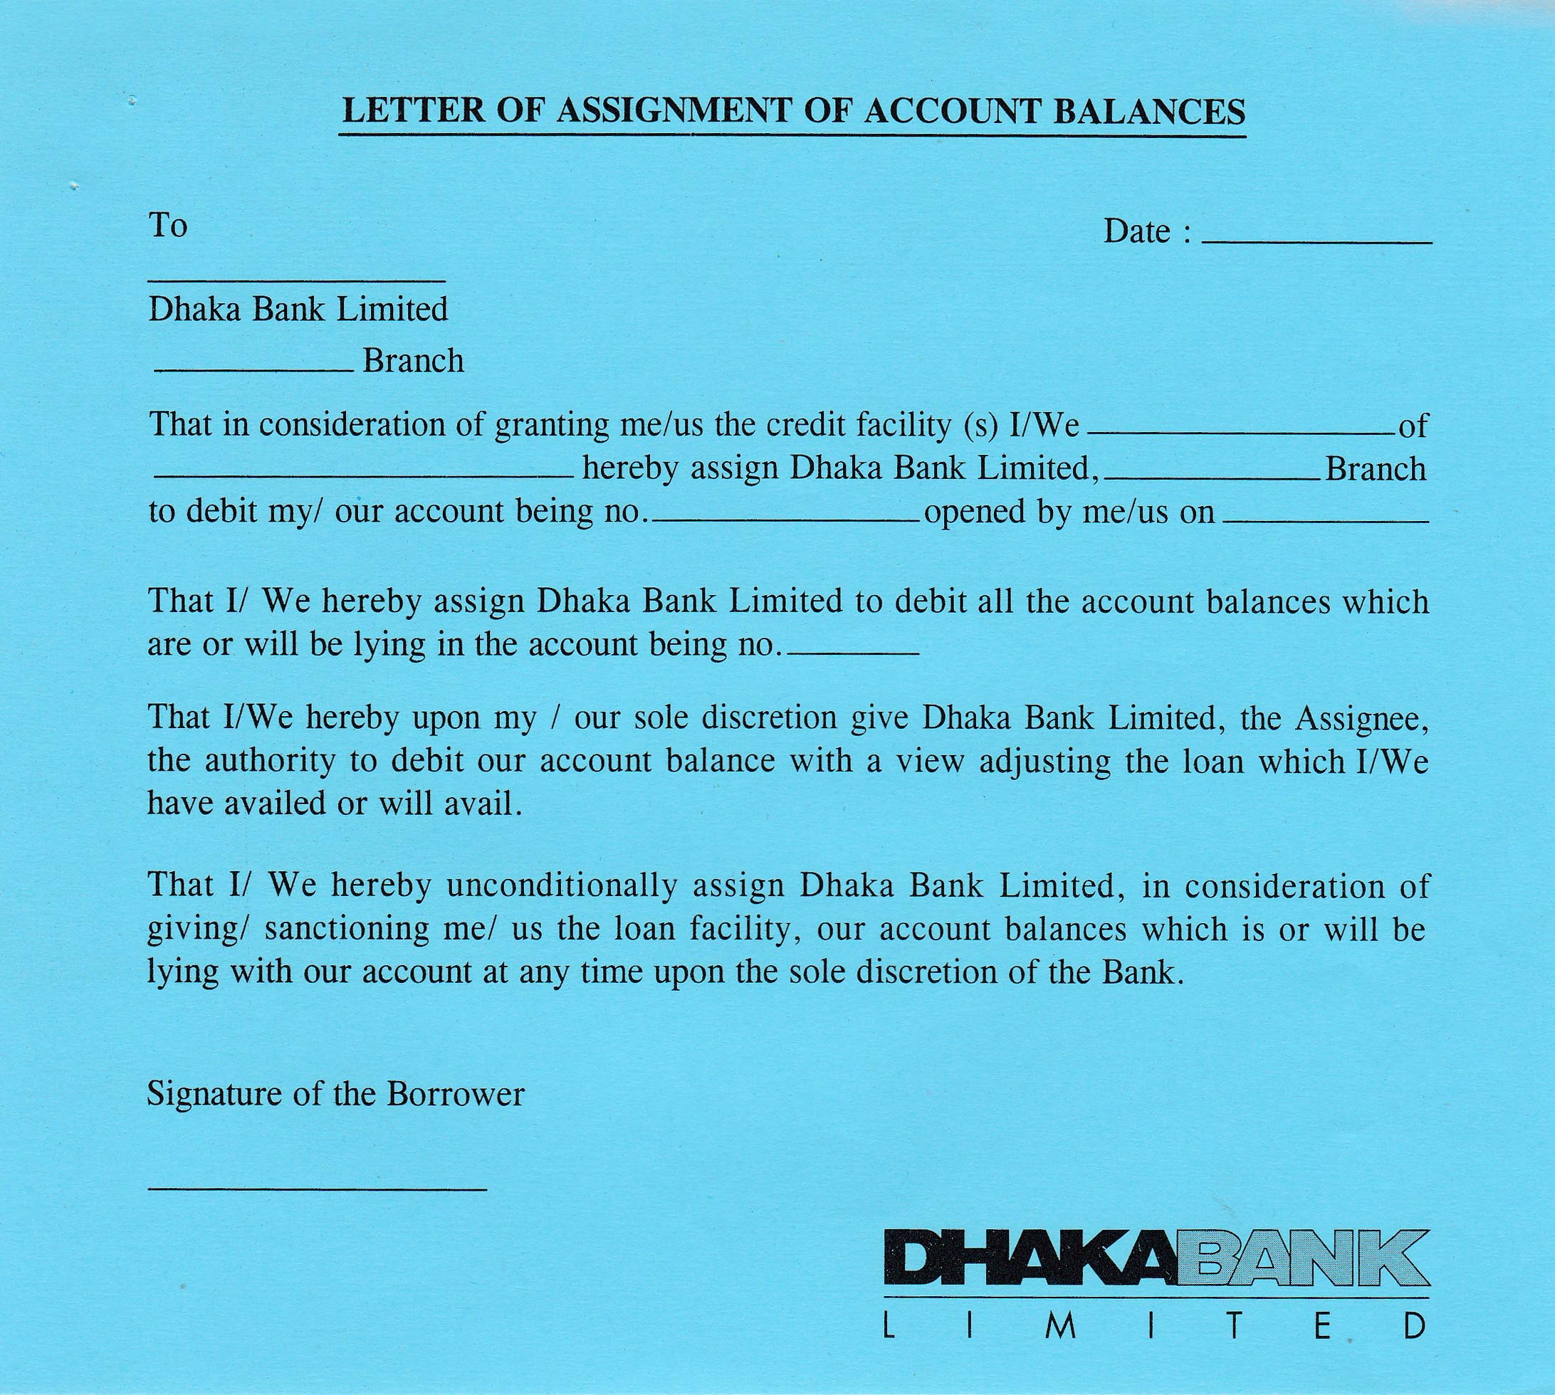
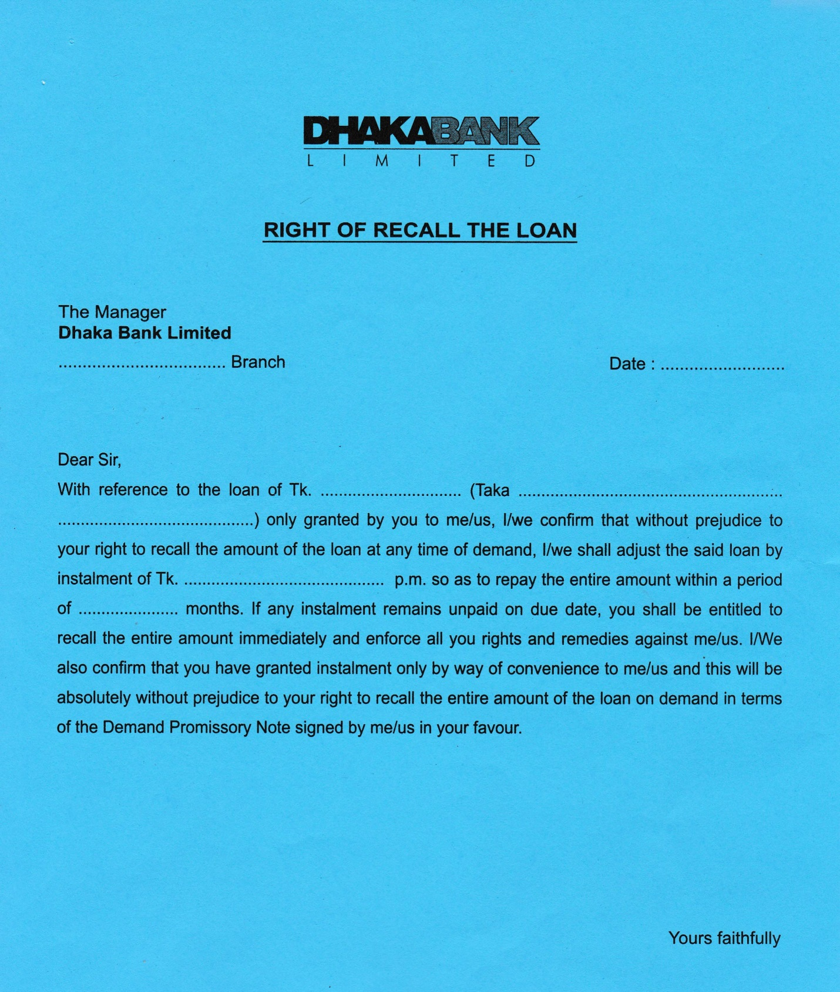

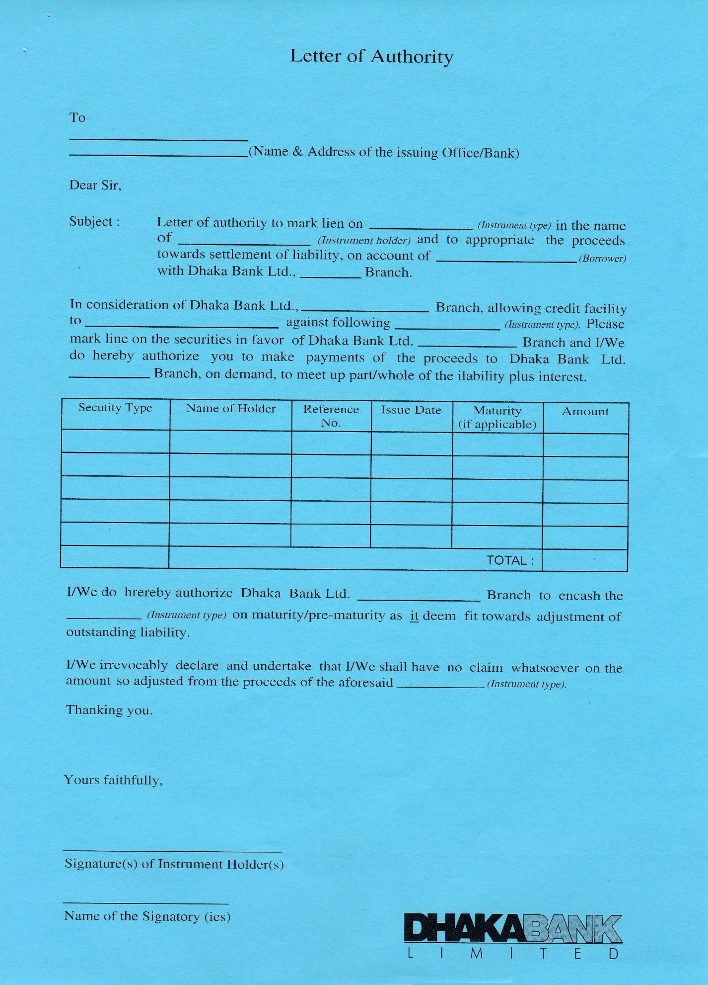
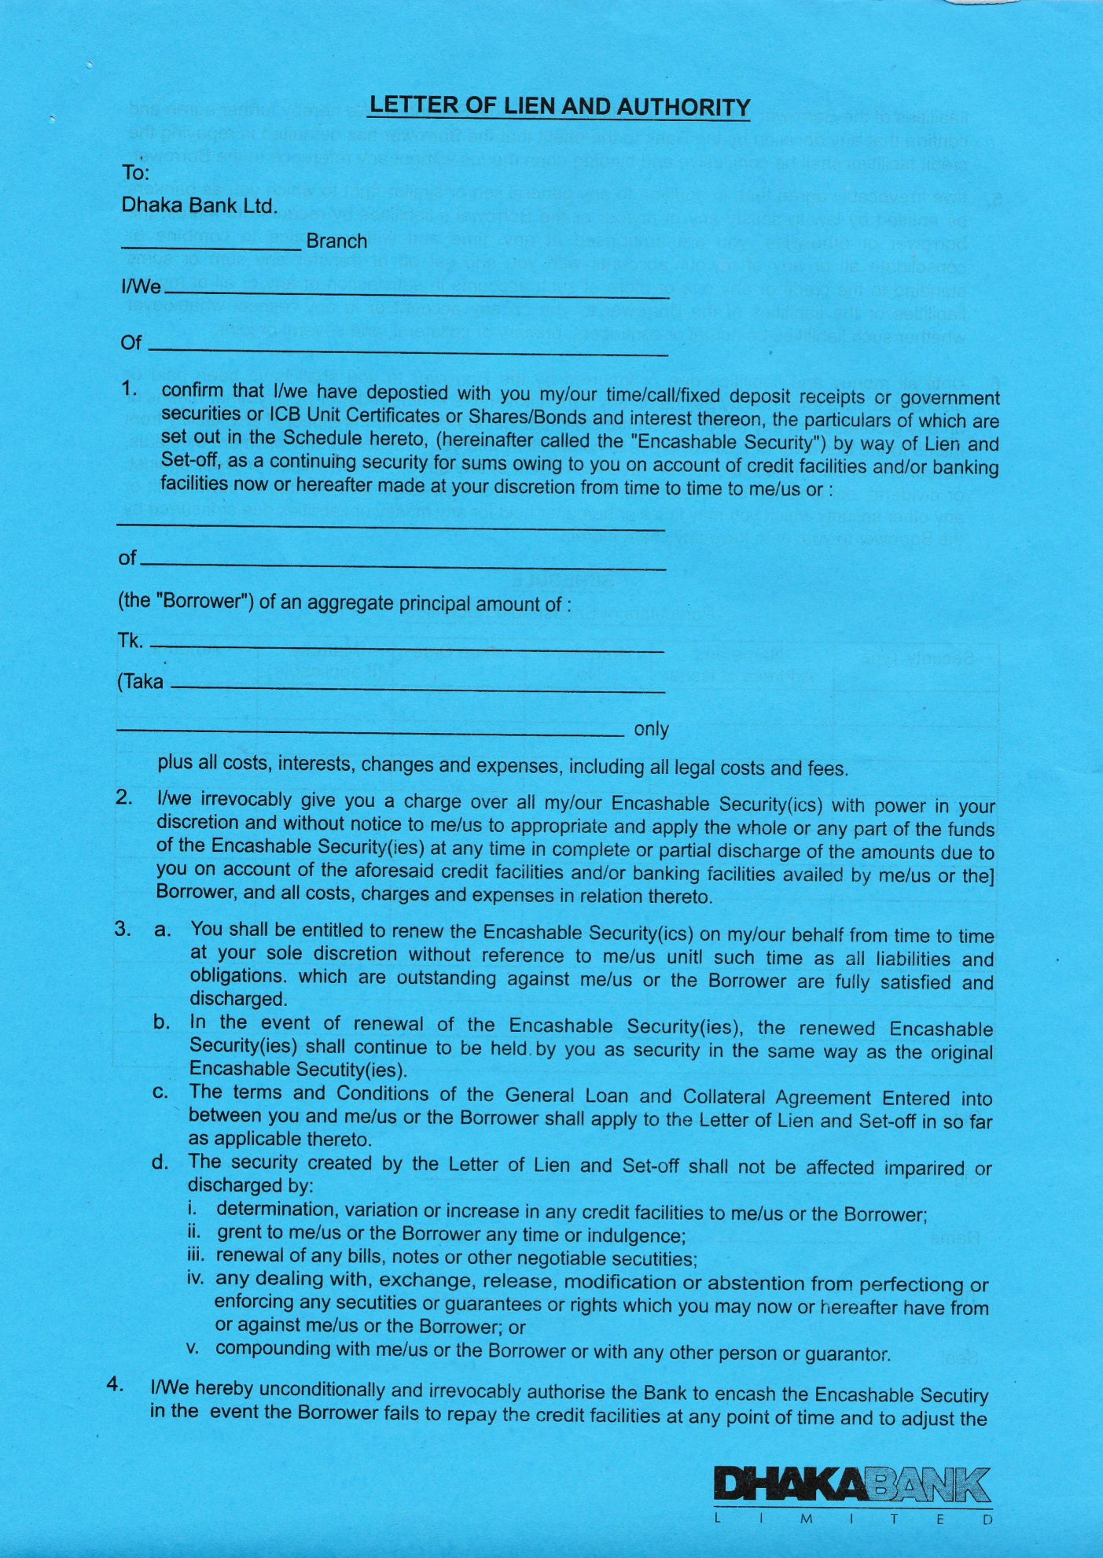
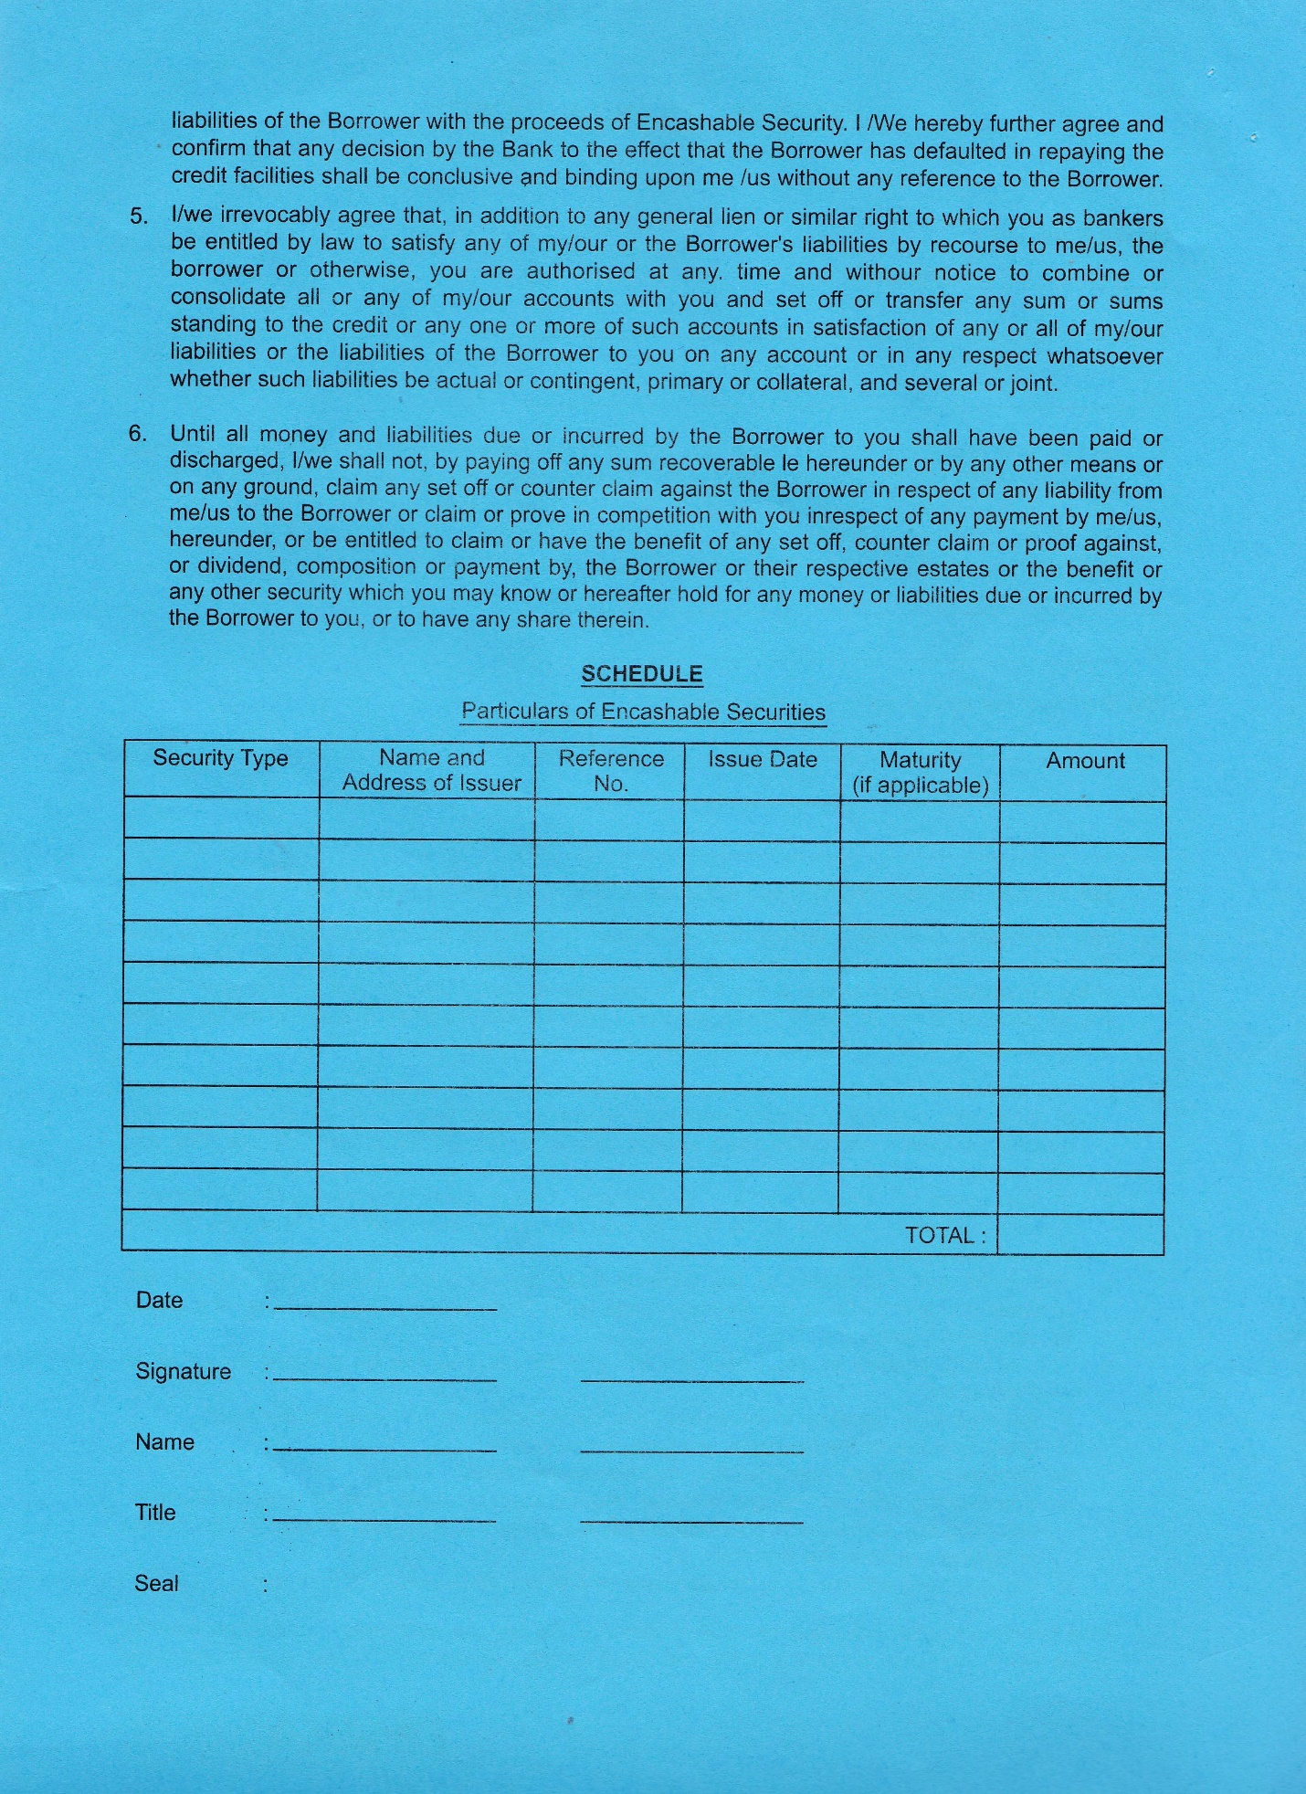
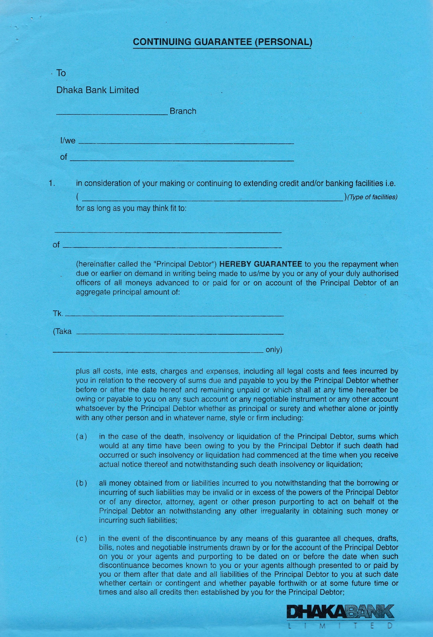
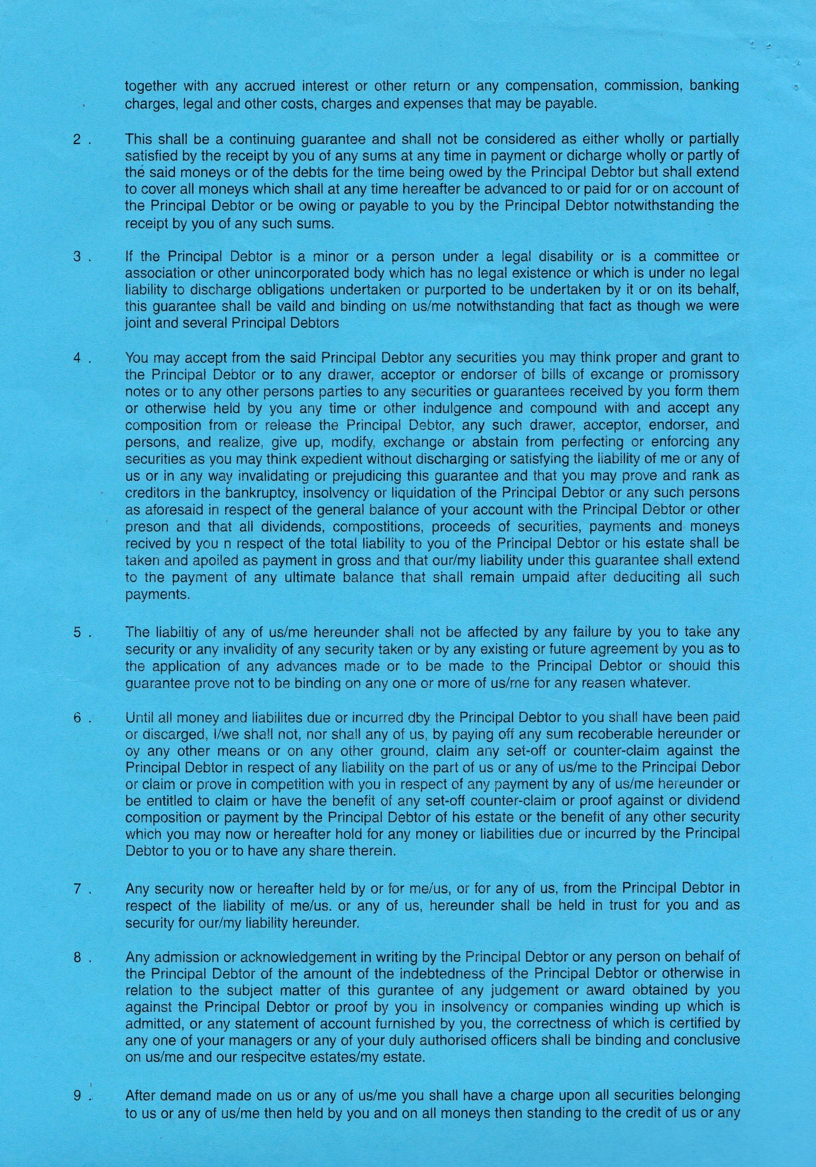
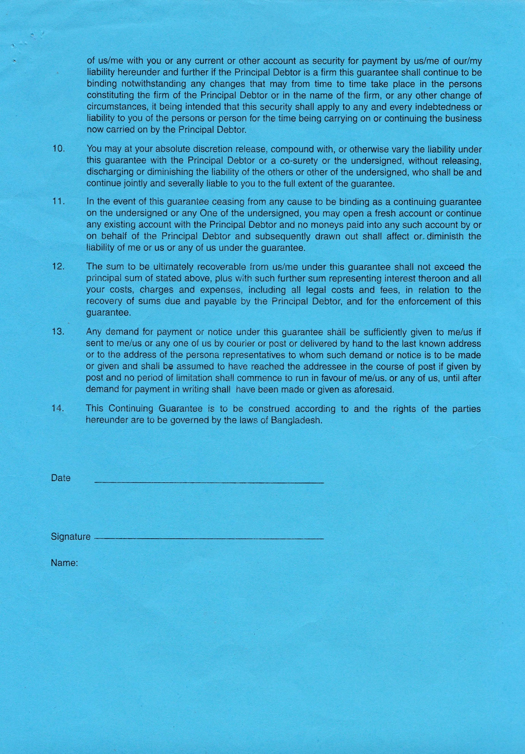

4.6.7 Classifications and provisioning.
For continuous and demand loan :
Past due/ Overdue Classification Status
1. Under three months Unclassified loan
2. Three months to less than six months Special Mention Account
3. Six months to less than nine months Sub standard
4. Nine months to under twelve months Doubtful
5. 12 months or more Bad loss loan
Term loan up to 5 years
Past due/ Overdue Classification Status
1. Under three months Unclassified loan
2. Three months to less than six months Special Mention Account
3. Six months to less than twelve months Sub standard
4. Twelve months to under eighteen months Doubtful
5. Eighteen months or more Bad loss loan
Term loan more than 5 years
Past due/ Overdue Classification Status
1. Under three months Unclassified loan
2. Three months to under twelve months Special Mention Account
3. twelve months to under eighteen months Sub standard
4. eighteen months to under twenty four months Doubtful
5. twenty four months or more Bad loss loan
Short term agri. Credit or micro credit loan
Past due/ overdue Classification status
1. Under twelve months Unclassified loan
2. Twelve months to under thirty six months Sub standard
3. Thirty six months to under sixty months Doubtful
4. Sixty months or more Bad loss loan

Chapter 5

Findings and Analysis

5.1 Hypothesis Scale
Particulars | Weighted
Strongly Disagree | 1
Disagree | 2
Moderate | 3
Agree | 4
Strongly Agree | 5

  - Hypothesis Development:
H1 | Customers avoid to make contact with the bank at the time of loan closing
H2 | The loan amount with interest exceed the DPS/FDR value that discourage the customer to pay the installment
H 3 | For irregular installment bank may face difficulties on their reinvestment activities
H 4 | When bank is not able to collect the loan installment, they may become bankrupt
H 5 | No extra charge for late installment that encourage customer for late payment

  - Hypothesis Test:
Hypothesis has been tested to identify a conclusive result for this study. As my sample size is 86 people (here, 67 people are customer and 19 people are employee), so I have used Z – test for this study. The formula of Z – test are given below:
Z – Test = $\frac{\overline{X}-μ}{\frac{σ}{√n}}$ Where,
X = Average
n = Sample Size
µ = Mean Value
σ = Standard Deviation

Hypothesis Testing:
Likert Scale | H1 | H2 |  | H3 |  | H4 |  | H5
Strongly Disagree | 1*05= 5 | 1*07= 7 |  | 1*1=1 |  | 1*3=3 |  | 1*7=7
Disagree | 2*10= 20 | 2*09= 18 |  | 2*2=4 |  | 2*5=10 |  | 2*3=6
Moderate | 3*20= 60 | 3*23= 69 | 3*25=75 |  | 3*30=90 |  | 3*32=96
Agree | 4*38= 152 | 4*37=148 |  | 4*28=112 |  | 4*27=108 |  | 4*20=80
Strongly Agree | 5*13= 65 | 5*10= 50 |  | 5*30=150 |  | 5*21=105 |  | 5*24=120
Total | 302 | 292 |  | 342 |  | 316 |  | 309
Average, X | 3.51 | 3.40 |  | 3.98 |  | 3.67 |  | 3.59
Standard Deviation, σ | 1.07 | 1.08 |  | 0.92 |  | 1.05 |  | 1.37
Z cal | 4.42 | 3.41 |  | 9.88 |  | 5.92 |  | 3.99

Calculation:
Standard Deviation, σ = $√\frac{\sum{{\left(X-\overline{X}\right)}^{2}}}{n-1}$
=$√\left[\frac{\left\{5{\left(1-3.51\right)}^{2}\right\}+\left\{10{\left(2-3.51\right)}^{2}\right\}+\left\{20{(3-3.51)}^{2}\right\}+\left\{38{(4-3.51)}^{2}\right\}+\left\{13{(5-3.51)}^{2}\right\}}{86-1}\right]$
=$√\left[\frac{97.49}{85}\right]$
= $1.07$
Z – Test, Z _{cal}=$\frac{\overline{X}-μ}{\frac{σ}{√n}}$
=$\frac{3.51-3}{\frac{1.07}{√86}}$
= $4.42$
**For rest hypothesis, standard deviation and Z – test has been calculated using these formulas. **
For Hypothesis 1,
H₀: Customers do not avoid to make contact with the bank at the time of loan closing
H₁: Customers avoid to make contact with the bank at the time of loan closing

Step 1 | Total Data Calculation  5+20+60+152+65 = 302
Step 2 | To find average X  Average,X = $\frac{\sum{Xi}}{n}$  = $\frac{302}{86}$  = 3.51
Step 3 | Standard Deviation, σ  Standard Deviation, σ = $√\frac{\sum{{\left(X-\overline{X}\right)}^{2}}}{n-1}$  =$√\left[\frac{\left\{5{\left(1-3.51\right)}^{2}\right\}+\left\{10{\left(2-3.51\right)}^{2}\right\}+\left\{20{(3-3.51)}^{2}\right\}+\left\{38{(4-3.51)}^{2}\right\}+\left\{13{(5-3.51)}^{2}\right\}}{86-1}\right]$  =$√\left[\frac{97.49}{85}\right]$  = $1.07$  Where,  X = Average  n = Sample Size
Step 4 | Critical Value  Z_{cal}=$\frac{\overline{X}-μ}{\frac{σ}{√n}}$  =$\frac{3.51-3}{\frac{1.07}{√86}}$  = $4.42$Where,  X = Average n = Sample Size µ = Mean Value  = (1+2+3+4+5)/5= 3  σ = Standard deviation  The level of significance = 5% which means,  My confidence level is = 100% − 5% =95% = 0.95  According to Z critical value calculator,  The critical value of 5% significance, Z _{tab} = 1.6449

Interpretation:
According to Z critical value calculator, Z _{tab}= 1.6449 and Z_{cal} = 4.42. If the Z _{cal} value > the Z _{tab} value, then null hypothesis will be rejected. Looking towards the calculation and the rules, I can say null hypothesis (H₀) is rejected. Because the Z _{cal} value > Z _{tab} value. So the decision stands that customers avoid to make contact with the bank at the time of loan closing.
Findings:
In hypothesis1, 6% respondents strongly disagree, 12% disagree, 23% moderate, 44% agree, and 15% strongly agree with my statement. That means 59% respondents are saying that Customers avoid to make contact with the bank at the time of loan closing.
For Hypothesis 2,
H₀: The loan amount with interest exceed the DPS/FDR value that does not discourage the customer to pay the installment
H₁: The loan amount with interest exceeds the DPS/FDR value that discourage the customer to pay the installment
Step 1 | Total Data Calculation  7+18+69+148+50 = 292
Step 2 | To find average X  Average, X = $\frac{\sum{Xi}}{n}$  = 3.40
Step 3 | Standard Deviation, σ  Standard Deviation, σ = $√\frac{\sum{{\left(X-\overline{X}\right)}^{2}}}{n-1}$  = 1.08
Step 4 | Critical Value  Z_{cal}=$\frac{\overline{X}-μ}{\frac{σ}{√n}}$  = 3.41  Z _{tab}= 1.6449

Interpretation:
According to Z critical value calculator, Z _{tab}= 1.6449 and Z_{cal} = 3.41. If the Z _{cal} value > the Z _{tab} value, then null hypothesis will be rejected. Looking towards the calculation and the rules, I can say null hypothesis (H₀) is rejected. Because the Z _{cal} value > Z _{tab} value. So the decision stands that the loan amount with interest exceeds the DPS/FDR value that discourage the customer to pay the installment.
Findings:
In hypothesis2, 8% respondents strongly disagree, 10% disagree, 26% moderate, 41% agree, and 15% strongly agree with my statement. That means 56% respondents are saying that the loan amount with interest exceeds the DPS/FDR value that discourage the customer to pay the installment.

For Hypothesis 3,
H₀: For irregular installment bank may not face difficulties on their reinvestment activities
H₁:For irregular installment bank may face difficulties on their reinvestment activities

Step 1 | Total Data Calculation  1+4+75+112+150 = 342
Step 2 | To find average X  Average, X = $\frac{\sum{Xi}}{n}$  = 3.98
Step 3 | Standard Deviation, σ  Standard Deviation, σ = $√\frac{\sum{{\left(X-\overline{X}\right)}^{2}}}{n-1}$  = 0.92
Step 4 | Critical Value  Z_{cal}=$\frac{\overline{X}-μ}{\frac{σ}{√n}}$  = 9.88  Z _{tab}= 1.6449

Interpretation:
According to Z critical value calculator, Z _{tab}= 1.6449 and Z_{cal} = 9.88. If the Z _{cal} value > the Z _{tab} value, then null hypothesis will be rejected. Looking towards the calculation and the rules, I can say null hypothesis (H₀) is rejected. Because the Z _{cal} value > Z _{tab} value. So the decision stands that for irregular installment bank may face difficulties on their reinvestment activities.
Findings:
In hypothesis 3, 1% respondents strongly disagree, 2% disagree, 29% moderate, 33% agree, and 35% strongly agree with my statement. That means 68% respondents are saying that for irregular installment bank may face difficulties on their reinvestment activities.
For Hypothesis 4,
H₀: When bank are not able to collect the loan installment, they may not become bankrupt
H₁: When bank are not able to collect the loan installment, they may become bankrupt

Step 1 | Total Data Calculation  3+10+90+108+105 = 316
Step 2 | To find average X  Average, X = $\frac{\sum{Xi}}{n}$  = 3.67
Step 3 | Standard Deviation, σ  Standard Deviation, σ = $√\frac{\sum{{\left(X-\overline{X}\right)}^{2}}}{n-1}$  = 1.05
Step 4 | Critical Value  Z_{cal}=$\frac{\overline{X}-μ}{\frac{σ}{√n}}$  = 5.92  Z _{tab}= 1.6449

Interpretation:
According to Z critical value calculator, Z _{tab}= 1.6449 and Z_{cal} = 5.92. If the Z _{cal} value > the Z _{tab} value, then null hypothesis will be rejected. Looking towards the calculation and the rules, I can say null hypothesis (H₀) is rejected. Because the Z _{cal} value > Z _{tab} value. So the decision stands that when bank are not able to collect the loan installment, they may become bankrupt.
Findings:
In hypothesis 4, 4% respondents strongly disagree, 6% disagree, 35% moderate, 31% agree, and 24% strongly agree with my statement. That means 55% respondents are saying that when bank are not able to collect the loan installment, they may become bankrupt.
For Hypothesis 5,
H₀: No extra charge for late installment that does not encourage customer for late payment
H₁:No extra charge for late installment that encourage customer for late payment

Step 1 | Total Data Calculation  7+6+96+80+120 = 309
Step 2 | To find average X  Average, X = $\frac{\sum{Xi}}{n}$  = 3.59
Step 3 | Standard Deviation, σ  Standard Deviation, σ = $√\frac{\sum{{\left(X-\overline{X}\right)}^{2}}}{n-1}$  = 1.37
Step 4 | Critical Value  Z_{cal}=$\frac{\overline{X}-μ}{\frac{σ}{√n}}$  = 3.99  Z _{tab}= 1.6449

Interpretation:
According to Z critical value calculator, Z _{tab}= 1.6449 and Z_{cal} = 3.99. If the Z _{cal} value > the Z _{tab} value, then null hypothesis will be rejected. Looking towards the calculation and the rules, I can say null hypothesis (H₀) is rejected. Because the Z _{cal} value > Z _{tab} value. So the decision stands that no extra charge for late installment that encourage customer for late payment.
Findings:
In hypothesis 5, 8% respondents strongly disagree, 4% disagree, 37% moderate, 28% agree, and 23% strongly agree with my statement. That means 51% respondents are saying that no extra charge for late installment that encourage customer for late payment.

Chapter 6

Experience During Internship Tenure

5.1 Experience during internship period
I have started my internship period at DBL BBZ branch. At the time of my internship, I had to play diverse responsibilities in nature. First of all, I had to know what types of activities have to do and how to do. After that, I worked in several departments. By doing internship at DBL BBZ branch I have learnt a great deal about corporate culture. Though my internship was in credit department, but I had to work both credit and general banking department. My major job responsibilities in both credit and general banking department were:
5.1.1 Credit department:
- Preparing charge document sheets for different types of loan
- Preparing and checking Credit Information Bureau
- Writing dormant accounts for inactive account
- Creating new spreadsheet and updating the old spreadsheets
- Writing business letter to the customers
- Other general activities as per credit dept. officers command.

5.1.2 General Banking Department:
- Opening new savings and current account
- Influencing clients and providing authentic information to clients about account opening related query.
- Listing clearing cheques and writing clearing cheques in clearing register book .
- Handling clients cheque book and ATM card .
- Preparing Mobile banking, DPS, SDPS, Cheque requisition slip etc.
- Other General activities declared by General banking dept. personnel.

Chapter 7

Conclusion

6.1 Conclusion
In Bangladesh, banking sector consists of many nationalized and personal banks. Many banks of BD doing their activities and extremely contributing in the economic system. From them DBL contributes a great role in the economy. DBL carrying out its operations, that’s why not solely DBL however conjointly country’s economy also being profited. DBL also carrying out foreign exchange activity, loans advances, general banking etc that’s why DBL rallying cash & had best for economies. Though some limitations should be included in their services, but for the economy of the country they are doing outstanding jobs. DBL gives special concentration for providing the loan to the customers, so that loan processing became easier in DBL. If DBL can introduce up to date concepts, and scale back its limitations, it will be one of the top bank in our country.

References:
(Dhaka Bank Limited , Discover Our History, 2019) https://dhakabankltd.com/discover-our-history/
(Annual Report, 2018) https://dhakabankltd.com/wp-content/uploads/2019/05/Annual-Report-2018.pdf
(Course Hero, 2019) https://www.coursehero.com/file/p4584oc/14-Methodology-of-the-Study-a-Report-Design-A-descriptive-research-approach-has/
(Products and Service, 2019) https://dhakabankltd.com/product-and-service/
(Credit Risk Grading Manual, Dhaka: Bangladesh Bank, Head Office., 2005)
(Bangladesh Bank (2003), Managing Core Risks in Banking: Credit Risk Management, Dhaka:, 2003)
raosoft. (n.d.). raosoft. Retrieved November 8, 2019, from www.raosoft.com: http://www.raosoft.com/samplesize.html

