

United International University
Thesis Paper
On

“Factor Influencing the Adoption of Big Data Analytics in
Bangladesh SMEs”

Submitted to:
Mr. Ahmed Imran Kabir
Lecturer, School of Business & Economics (SoBE)

Submitted by:
Maruf Hasan Arif
ID: 111 183 092
Date of Submission: 19th December, 2024

Letter of Transmittal

Date: December 19, 2024

To
Mr. Ahmed Imran Kabir
Lecturer, School of Business & Economics (SoBE)
United International University

Subject: Submission to Thesis Titled “Factors Influencing the Adoption of Big Data Analytics in Bangladesh SMEs”

Dear Mr. Kabir,
I’m pleased to submit my thesis titled “Factor Influence the Adoption of Big Data Analytics in Bangladesh SMEs” in order to partially satisfy the requirements of the BBA program at United International University.
This thesis focuses on understanding the technical, administrative, and external aspects that affected the acceptance of Big Data Analytics in SMEs in Bangladesh, with an emphasis on how organizational readiness mediates these factors. The study makes use the Technological-Organizational-Environment (TOE) framework as well as employs quantitative methods to prove actionable insights for practitioners and policymakers.
I am deeply grateful for your guidance and support throughout the research process, which has been instrumental in shaping this work. Be sure to contact me for further clarifications or additional details regarding the submission.
Thank you for your time and consideration.

Sincerely,

Maruf Hasan Arif
ID: 111 183 092
United International University

Acknowledgement

To begin with, I want to sincerely thank Mr. Ahmed Imran Kabir, Lecturer at the School of Business & Economics (SoBE), United International University, for his invaluable guidance, encouragement, and constructive feedback throughout the research process. His insights and expertise were essential to finishing this thesis successfully.
I want to express my appreciation to each and every respondence from various SMEs who took part in the survey and shared their insightful time, which greatly contributed to the findings of the study.
Furthermore, I am grateful to my relatives and close companions for their support, patience, and always backing me, which remained me enthused over this difficult journey.
Finally, I acknowledge the support of United International University, whose resource and academic environment have provided me with the foundation to carry out this research successfully.
To everyone who has made a contribution directly or indirectly until this task is finished, I offer heartfelt thanks and respect.

Abstract

This research looks at the components influencing the application of Big Data Analytics (BDA) in slightly lower and mid-size businesses (SEMs) in Bangladesh, utilizing the Technology Organization Environment (TOE) concept. The research explores how relative benefit, high administration assistance, company readiness, and competitive pressure components affect BDA application, with an attention to the mediating outcome of organizational preparedness. A quantitative survey was conducted among SMEs, and data from 100 valid surveyed answer were evaluated utilizing Partial Least Square-Structural Equational Modeling (PLS-SEM). The outcomes illustrate that relative advantage and top management support significantly impact BDA adoption, both directly and indirectly through organizational readiness. However, competitive pressure was found to have no meaningful influence. The findings highlight the relevance of within administrative elements, particularly authority and readiness, over external forces in achieving successful BDA implementation. This report offers valuable insights for SEMs to enhance their competitiveness and sustainability through effective adoption strategies.
Keywords: Big data adoption, big data adoption, SMEs, Organizational readiness, mediation analysis, TOE Framework, Bangladesh

Table of Content
Letter of Transmittal 1
Acknowledgement 2
Abstract 3
Chapter 1: Introduction 6
Chapter 2: Literature Review 8
Chapter 3: Theorical Framework and Hypothesis Development 10
3.1 Technological Context 11
3.2.1 Relative advantage 11
3.2 Organizational Context 12
3.2.1 Top management support 12
3.2.2 Organizational Readiness 13
3.3 Environmental Context 13
3.3.1 Competitive Pressure 13
Chapter 4: Methodology 14
4.1 Study context 14
4.2 Research and Questionnaire Design 14
4.3 Sampling and Data collection 15
4.4 Data Analysis 15
4.5 Mediation Analysis 16
Chapter 5: Results and Analysis 16
5.1 Respondents Profile 16
5.2 Model Measurement. Validity and Reliability 18
5.3 Discriminant Validity 21
5.3.1 Fornell-Larcker Criterion Analysis 21
5.3.2 Heterotrait-Monotrait (HTMT) Analysis 22
5.3.3 Cross Loads 23
5.4 Assessment of the Structural Model 24
5.5 Hypothesis Testing (Primary and Secondary Effect) 25
Chapter 6: Discussion and Conclusions 26
Chapter 7: Contributions 27
Chapter 8: Limitations and Future Studies 28
Reference 30
Appendix 34

Chapter 1: Introduction

During the rapidly expending period of the fourth industrial revolution, growing exponentially, information has a tremendous influence on obtaining new information, simulating corporate origination, and gaining a competitive lead. As a consequence of technical advancement, especially in information technology as well as computer science, the use of BDA with specified expertise, attributes, and norms has increased fast in individual context. BDA with its data mining methodologies, contributes to the referred to as intellect of all anywhere by enabling immediate, active, resilient, and accurate management abilities (Nasrollahi et al., 2021).

BDA stands out among the many technologies used by companies striving for a dominant market position. According to the basic definition, BDA is a significant technology that support management decision-making by providing, a collection of subject-oriented data with information from a specific time period (Gonzales et al., 2015). The International Data Corporation ((IDC), 2023), projects that the worldwide BDA sector will rise at an regular yearly rate of 157.2 until 2026 from its 2020 valuation of USD 66.2 billion. A large number of enterprise think that BDA has great potential and that its implementation is crucial (Staegemann et al., 2021; Wahab et al., 2021).Many studies have shown that not all companies are using BDA despite the potential advantages of doing so. Choi et al. (Choi et al., 2022), for instance, noted that there is a dubious belief that 80% of firms would not be able to use BDA if they go forward without having well-defined strategic objectives. Recently, BDA adoption has been quite low in most firms (Nam et al., 2019). After the first adoption phase, many firms have not attained integrated usage (Choi et al., 2022). Only a small percentage of firms have used BDA and achieved the desired results, despite the fact that it is becoming more and more popular as a way to make a difference via the creation of new business sectors and business optimization (Al-Sai et al., 2020; Almaiah & Nasereddin, 2020).

Big data analytics adoption generates various benefits for organizations, improving their overall IT infrastructure, increasing storage capacity, and providing digital-based solutions to cut costs and enhance judgement-making ways (Baig et al., 2021). Big data analytics is quickly turning into essential resource to improve business efficiency, especially in developing countries' healthcare organizations. Big data deployment is impact via technology, organization, and environmental variables, with an emphasis on the Technology-Organization-Environment (TOE) framework (Ghaleb et al., 2021).

The TOE substructure’s variables are prejudiced as well as resolute through the technology category, the company’s scale, and the background of the paper (Al-Sai et al., 2020; Alharbi et al., 2016; Sun et al., 2020). Despite there are extensive existing studies on the effect of TOE variables on the uptake of technologies/innovations (Althunibat et al., 2021; Lutfi et al., 2020), the findings are inapplicable and ungeneralizable to the BDA adoption of SMEs. Empirical studies from the literature on technology adoption indicated that many TOE parameters influence the adoption of several technologies (Gangwar et al., 2014). For instance, whereas a relative benefits was discovered by (Sun et al., 2020; Wahab et al., 2021) to be a substantial IT/IS invention acceptance motivator, Lutfi et al. (Idris & Mohamad, 2017) and Yoon and George (Yoon & George, 2013) proved its irrelevant impact upon the acceptance of IT-related invention. Furthermore, the TOE parameters’ effect varies according to company dimensions, plenty data demonstrate the inappropriateness of big companies’ consequences to smaller-scale firms (e.g., SMEs) (Arias-Aranda et al., 2011). In addition, unique distinction in layout, availability of resource, surrounding, and technological frameworks of big-scale company and SMEs effect the TOE components’ effect on the choice to accept technology (Maroufkhani et al., 2019). According to Alharbi et al. (Alharbi et al., 2016), numerous environmental circumstances and nation necessities are primary elements regarding the area where the impact of TOE variables may be faced within companies’ preference for technology. Consequently, in order to illuminate the variables that have prejudiced the acceptance of BDA by SMEs, a novel model is necessary (Al-Sai et al., 2020).

Clearly, there is a need to analyze and comprehend BDA adoption motivations because it is a new issue with little empirical data; hence, systematic understanding in the domain is essential (Al-Sai et al., 2020). on a parallel investigation, following a thorough literature analysis, Al-Sai et al. (Al-Sai et al., 2020) discovered two primary research gaps, one of which is the few investigation of BDA and their overall theoretical character, which demands for new evidence-based studies to supplement the publication. Another study unanswered question is the most studies focus on wealthy nations in the continents of American continent and Europe (Frizzo-Barker et al., 2016), with just a handful discussing BDA difficulties in evolving Middle Eastern countries (Al-Hujran et al., 2015; Hashem et al., 2016). However, it is sufficient and noteworthy to emphasize that some writers have underlined the necessity to investigate BDA in various situation (Agrawal et al., 2015; Sun et al., 2018; Wahab et al., 2021), notably for underdeveloped country, in order to enhance the existing literature (Choi et al., 2022; Nam et al., 2019).

Chapter 2: Literature Review

Big Data Analysis (BDA) is a relatively new yet very effective method for companies to glean useful information from massive data set. While BDA has been widely used by major organizations, it has been slow to catch on among SMEs in developing nations like Bangladesh. Among order to encourage its broad use and capitalize on its advantages, policymakers and practitioners must have an in-depth Knowledge of the variables impacting BDA implementation among SMEs in Bangladesh. With a particular emphasis on small and medium-sized business (SMEs) in Bangladesh, this literature review intends to explore the current research on BDA adoption. This review seeks to provide a comprehensive understanding of the elements impacting BDA adoption in this sector by analyzing the main criteria that determine its adoption as well as the difficulties and potential benefits of implementing it. What follows is an examination of research on BDA’s effects on organizational performance, obstacles to adoption (both technical and otherwise), and methods for overcoming these obstacles so that small and medium-sized business in Bangladesh can successfully implement BDA.

There is various research on the application of BDA in SMEs. For instance, (Ghaleb et al., 2021) analysis focuses on big data adoption in healthcare and used TOE framework also employs the Technological Readiness Index (TRI) for analysis. Their study results classified that complexity of technology factors showed less support for adoption, government IT policies significantly impact big data preparedness.

On the other side (Raguseo & Vitari, 2018) explores big data’s corporate value creations and examines financial outcomes impact from big data analysis. There results revealed customer satisfaction significantly influence financial performance more than market performance. Market performance does not mediate financial performance effectively. Similarly, (Sun et al., 2018) have studied factor affecting big data adoption and identified 26 factors through content analysis. They believe that managerial support is vital for successful big data acceptance. Security, privacy, and ethical issues are increasingly important factors.

In India (Mangla et al., 2021) investigate big data analytics mediating role in project efficiency, they collected 321 response and analyzed using structured equational modeling. There findings indicate big data analysis positively influences project success. (Nasrollahi et al., 2021) have studied BDA influence on the performance of SMEs in Iran organization. There result shows how evolving countries might use BDA components to improve their organizational effectiveness. Furthermore, there studies found 12 characteristics affecting big data adoption in SMEs, also impacts operational and economical success. A new research report published by (Maroufkhani et al., 2020) investigate the essential determinants for BDA adoption and its influence on Iran SMEs productivity. They discovered seven characteristics, notably observability, trialability, high administrative backing, vagueness and unease, sophistication, outside support, and organizational preparedness having a significant impact on Iran SMEs. They found that performance would increase by adopting BDA. In Malaysia, (Loh & Teoh, 2021) aimed at analyzing BDA implementation during COVID-19 widespread to help SMEs business improve their efficiency and surviving the condition. They examined technological aspects influencing BDA adoption in Malaysian SMEs and conclude that relative advantage positively promotes BDA adoption.

(Wamba et al., 2020) The adoption of big data analytics in healthcare was examined, with a focus on how it affects operational effectiveness and service quality. SEM was used to examine the connections between operational performance, service quality, and analytics capabilities in a survey of 215 healthcare business. Their outcomes revels that adoption of BDA was shown to greatly improve service effectiveness and quality. According to the report, two important variables that facilitate successful acceptance are organizational preparedness and data quality.

The impact of Big data Analytics (BDA) capabilities on organizational decision-making performance was investigated by (Shamim et al., 2020). SME was used in the study to investigate the connections among organization culture, technology infrastructure, and decision-making results. Surveys of 215 businesses in the retail and manufacturing industries were used to gather data. The mediating role of analytical capabilities in decision-making performance was tested using SEM. The findings revels that an analytics-driven culture and a robust technology infrastructure greatly improve decision-making performance, The between resources and performance outcomes was significantly mediated by BDA competence.

Chapter 3: Theorical Framework and Hypothesis Development

In this research, a fusion model has been taken proposed by (Lutfi et al., 2022) by using diffusion of innovation theory (DOI) and the technological-organizational-environmental (TOE) model as the theorical framework. Several studies have stated that by using this both will help researchers to study the acceptance of IT in SMEs (Gonzales et al., 2015; Wahab et al., 2021). The DOI concept illustrates the significance technical features in IT adoption within organizations (Sun et al., 2020). Inversely, the TOE concept summaries the inner as well as outdoor elements that could impact company technology acceptance (Hameed et al., 2012; Yoon & George, 2013).

Consequently, this research presents a conceptual model (see Figure 1) that expends upon previous research on technological adoption variables related to BDA and TOE. It focuses on the three core TOE dimension: for technological and from there relative advantage was selected, from organizational top management support was selected along with organizational readiness, and from environmental competitive pressure factor was selected, all of which are known to impact technological adoption. The justification for the proposed hypothesis is provided in the subsequent section.
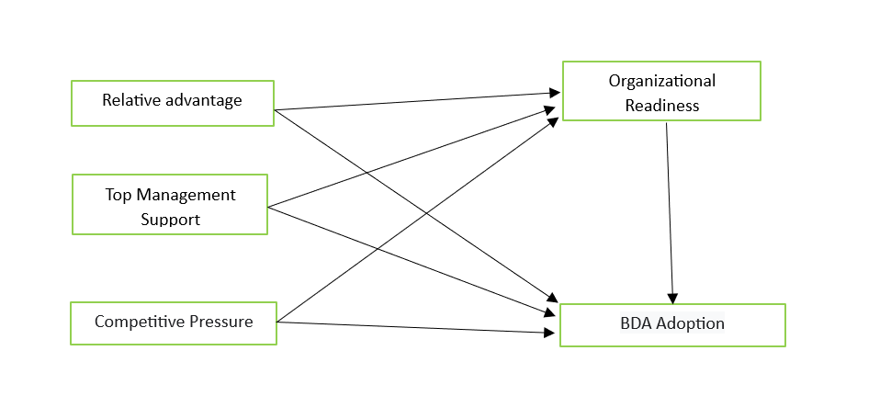

Figure 1. Research Model

3.1 Technological Context

3.2.1 Relative advantage

According to earlier study (Kapoor et al., 2015; Rogers et al., 2014), the technological context in the TOE model emphasizes the importance of both external and internal factors in determining technology adoption. A critical factor to examine in this context is the tangible benefits associated with adopting the innovation. The concept of relative advantage highlights how a specific technology is perceived to outperform earlier versions or available substitutions. This perception plays a key role in influencing whether an organization chooses to embrace a new technological solution. (Lutfi, 2021; Wahab et al., 2021).

There are several dimensions in relative advantage, which includes operational efficiency, cost saving, better decision-making, and increased customer satisfaction. Organizations are more inclined to employ technology that show demonstrable results in these areas. For example, (Oliveira et al., 2014) stated that technologies that are more well-suited with existing systems and processes while also delivering measurable performance benefits are more likely to be adopted. Likewise, (Lutfi, 2021) discovered that SMEs select technology that are aligned with their strategic goal and offer a clear ROI.

Furthermore, in the context of Big Data Analytics (BDA), relative advantage is critical for adoption. (Wahab et al., 2021) stated that BDA allows enterprises to successfully process and analyze enormous amounts of data, resulting in insights that can revolutionize decision-making and operational strategies. (Choi et al., 2022) added to this by claiming that organizations who used BDA experienced considerable increases in market responsiveness and competitive positioning.

However, relative advantage is determined by more than just the technological skills. (Kapoor et al., 2015) stated that perceived value is also influenced by organizational readiness and management’s capacity to effectively use technology. Thus, the interaction of perceived benefits and organizational context is important to successful adoption.

(Idris & Mohamad, 2016), SMEs are often drawn to technology adoption when they determine its advantages to be more significant than from various available technology. Therefore, the present study puts forth the following hypothesis:

Hypothesis (H1): In the BDA adoption in Bangladesh SMEs relative advantage has a favorable influence.

3.2 Organizational Context

3.2.1 Top management support
This research examines top management support as well as organizational readiness as crucial organization components driving BDA acceptance in SMEs. To begin with, high administration is known to the capacity of manages to understand and adopt new technological competencies (Sanders, 2008). Managers in SME are frequently composed of a high-management group whose support and devoted effort play a pivotal role in fostering technology adoption outcomes (Jahanshahi & Brem, 2017).

The role of upper management’s assistance is particularly significant because it bridges the gap among people and revolution acceptance, given that the propensity to accept is closely corelated with the firm’s degree of creative ability. Previous studies validate the importance of upper management assistance as a key aspect of new technology adoption (Alshamaila et al., 2013; Cruz-Jesus et al., 2019; Lutfi et al., 2020). Additionally, senior manager in SMEs have shown a high degree of desire For system installations, as documented earlier research (Ramdani & Kawalek, 2008); Consequently, the current study formulates the subsequent hypothesis:

Hypothesis (H2): Top management support has a favorable and significant link with accepting Big Data Analytics (BDA) in SMEs in Bangladesh.

3.2.2 Organizational Readiness
Another key organizational factor examined in this study is organizational readiness, which is the preparedness and ability of firms to embrace including implement emerging technologies (Gangwar, 2018). This concept revolves around a business ability to supervise and allocate resource for the successful acceptance of advanced technologies while building on its existing IT expertise and operational competencies (Yoon & George, 2013). Specially, on big data analytics and business analysis contexts, research highlights the organizational readiness serves an vital influence in facilitating BDA adoption (Gangwar, 2018; Wahab et al., 2021). Organizational readiness in SMEs seem to be particularly linked to the seamless adoption of emerging technology, as demonstrated in earlier study (Asiaei & Ab. Rahim, 2019; Idris & Mohamad, 2016). Thus, this study posits that organization readiness act as a critical determinants and mediator, providing the foundation for the subsequent hypothesis:

Hypothesis (H4): The Organizational readiness mediator improve considerable positive connection in contrast to relative advantage along with BDA Adoption in Bangladesh SMEs.

Hypothesis (H5): The Organizational readiness mediator significantly enhance the favorable relation in contrast to Top Management Support and BDA Adoption in Bangladesh SMEs.

Hypothesis (H6): The connection in contrast to Competitive Pressure along with BDA adoption in Bangladesh SMEs significantly enhance through Organizational readiness mediator.

3.3 Environmental Context

3.3.1 Competitive Pressure
In the TOE framework, competitive pressures emerge as a vital external component affecting firm’s decision to adopt BDA in SMEs. Competitive pressure primarily stems from external market force that compel businesses to stay ahead by adopting advanced technologies (Baig et al., 2021). Firms often experience pressure from supplier, customers, and competitors, which drives their pursuit of innovation solutions (Asiaei & Ab. Rahim, 2019; Lutfi et al., 2020). Supporting this, prior studies emphasize that firms operating under competitive environments are more inclined to embrace technological advancements to maintain a competitive edge (Grandon & Pearson, 2004). Consequently, this study introduces the following hypothesis for validation:

Hypothesis (H3): For BDA adoption in Bangladesh SMEs competitive pressure has a considerable positive connection.

Chapter 4: Methodology

4.1 Study context

This study focuses on the SMEs sector in Bangladesh, a developing country experiencing rapid growth in its small-medium manufacturing industries. The ultimate objective for this study is to discover the factors that affecting BDA adoption in Bangladesh SMEs, with an aim to help these enterprises remain competitive and promote sustainable growth.

4.2 Research and Questionnaire Design

This study followed a scientific approach, which allow us to extract empirical knowledge from data-driven hypothesis. A quantitative analysis carried out to figure out the critical elements that are manipulating BDA in Bangladesh SMEs. Quantitative survey was used for allocating data from industry professionals. The scale elements taken from earlier studies as shown in Appendix A. The survey employed used one to five scale, ranging from one is “Strongly disagree” to five is “Strongly agree” to evaluate replies accurately. To ensure question reliability, the survey was tested using Cronbach’s alpha, with all construct achieving values above 0.70, indicting a reliable consistency level (Hair et al., 2019).

The study theories for this study remained developed based on prior literature investigations. The things measuring BDA adoption remained specially adapted from (Lutfi et al., 2022), besides exogenous elements within the TOE structure were classified as technology, organizational, and environmental. The technological factor included: relative advantage (RA), which were taken from (Agrawal, 2015; Chen et al., 2015; Lai et al., 2018; Salleh & Janczewski, 2016). Besides, the organizational aspects of top-management support (TMS) were examined using things from (Chen et al., 2015), whereas the environmental factors of competitive pressure (CP) were evaluated via things from (Hsu et al., 2014; Lai et al., 2018).

4.3 Sampling and Data collection
Sample of 120 response were collected from the participants. However, for some respondent’s inaccurate answer we had to exclude 20 from our sample. Our response rate was 83.33%. We have informed respondents that their input only uses for research purpose. VIF values were between 1-5, indicating moderate collinearity.

4.4 Data Analysis
To make assure the precision regarding the model, this work applied PLS-SEM (Partial Least Squares Structural Equational Modeling), a powerful mathematical approach that allows real-time evaluation of multiple associations, both uncontrolled and controlled hypotheses, in just one structure. PLS-SEM is particularly well-suited for analyzing complicated models that include both mediation and moderation factors, making it an excellent choice for this study. This method This method effectively supports the analysis of complex relationship and accommodates both moderating and mediating variables, regardless of considerably smaller scale (Al-Okaily et al., 2020; Alqudah et al., 2019; Alshira’h et al., 2020; Alsyouf et al., 2021).

The use of PLS-SEM enabled the simultaneous testing of both controlled and uncontrolled hypotheses, providing a thorough understanding of the interaction between variables. This method allows for the examination of direct, indirect, and total effects inside the model, providing detailed insights into the dynamics of BDA adoption in SMEs. Internal consistency and reliability were assessed using key statistical criteria, such as the alpha coefficient. Additional measures, such as composite reliability and average variance extracted (AVE), were calculated to establish convergent validity, showing that the indicators accurately represent the components.

Discriminant validity was also assessed using recognized criteria, including the Fornell-Larcker criterion and the Heterotrait-Monotrait (HTMT) ratio. These tests ensured that the constructs were different and not too correlated, which validated the model’s structural integrity. This study demonstrated the validity and dependability of its dataset and analytical framework by adhering to strict statistical standards.

Overall, the application of PLS-SEM improved analysis precision while simultaneously ensuring the theoretical model’s robustness. This technique provides actionable insights into the elements driving BDA adoption, emphasizing its usefulness in addressing the challenges of technology acceptance in SMEs.

4.5 Mediation Analysis
This study adopted a two-step approach (Sarstedt et al., 2020) to determine how organizational readiness affect BDA acceptance in Bangladesh SMEs. Firstly, the study examined how relative advantage, top management support, and competitive pressure impacted organizational readiness for BDA adoption. The secondary impact of relative advantage -> Organizational readiness -> BDA adoption and Top management support -> Organizational readiness -> BDA adoption were significant in this research.

Using relative advantage, Top management support, and competitive pressure without eliminating the mediating (Organizational readiness), the scholars glanced at the consequence on BDA adoption for H4 and H5.

Chapter 5: Results and Analysis

5.1 Respondents Profile
The survey gathered demographic insights from professionals from various SMEs company. Based on the figures presented in Table 1, almost all of volunteers are between 26 to 35 years old, making up to 57% of the respondents. This suggests that the workforce is primarily made up of young individuals who are more inclined to adopt to technology developments like Big Data Analytics (BDA). A lower proportion of respondents are under the age of 25 (28%), while those aged 36-55 and over the age of 55 account for 13% and 2%, respectively, indicating a bias toward a younger population.

The survey also finds a significant gender discrepancy, with men comprising 89% of respondents. This shows that the Bangladeshi SMEs workforce is dominated by men, matching industry-wide gender representation patterns. Women account for only 10% of the workforce, with 1% identified as non-binary or choosing not to declare their gender.

Regarding marital status, 61% of respondents identify as single, which is consistent with the younger age profile observed. Married people make up 37% of the sample, with divorcees accounting for only 2%. These members indicate that many professionals in the SEM sector are in the early stages of their personal and professional careers.

In terms of education, 53% of respondents have an undergraduate degree, 46% have postgraduate degrees, and 1% have received a PH.D. This demonstrates that most participants have core level of higher education, which provides them with essential abilities while also leaving potential for advanced training in fields such as data analytics.

Professional experience levels highlight that fledgling character of the workforce, with 70% having less than 5 years of experience. Only 21% indicate 5 to 9 years of experience, with 7% having 10 to 14% years. Those with more than 14 years of experience make up just 2% of the sample. Collectively, these outcomes indicate a relatively new and inexperienced workforce. Which may impact the acceptance of innovative technologies such as BDA. The findings highlight the need for focused training and capacity building programs to improve SEMs preparation for BDA implementation.

Table 1. Demographic Profile of participants.
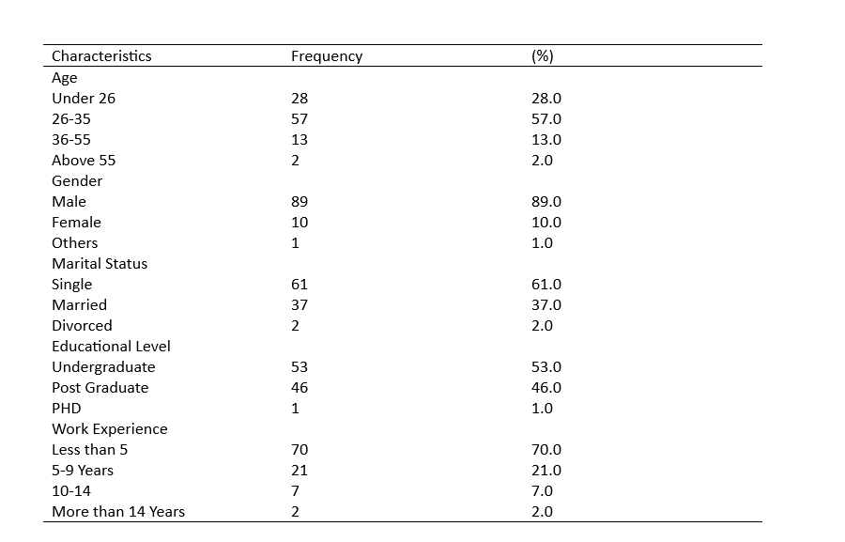

5.2 Model Measurement. Validity and Reliability
In Table 2 the model’s review is shown. The outer loading is permitted of higher than 0,7 or equals to 0.7 (Henseler et al., 2009). The constructs in the model demonstrates strong reliability and validity. All outer loading exceeding 0.7, ensuring good indictor reliability. This reliability is further supported by the Average Variance Extracted (AVE), which shows that all values exceed the 0.7 criterion, indicating strong convergent validity. This suggests that the conceptions sufficiently account for the variance in their observed variables.

Cronbach’s Alpha and Composite Reliability (CR) both exceed the benchmark value of 0.7, indicating strong internal consistency and stability across the constructs. These metrics ensure the measurements model’s soundness, which is critical for obtaining correct and dependable results.

The R² values for the structure model indicate a high level of explanatory power. Organizational Readiness accounts for 53.9% of the variance in its dependent variables, indicating moderate predictive power. Meanwhile, BDA adoption has a R² value of 0.721, indicating strong explanatory power. These findings indicate that the model accurately reflects the interactions between the components, providing useful insights into the causes driving BDA uptake.

Multiple fit indices provide additional support for the model’s overall fix. The Normed Fit Index (NFI) is 0.771, which is somewhat lower than the desired threshold of 0.9 (Bentler & Bonett, 1980) but still shows a satisfactory model fit. The SRMS is (0.069), which is below the boundary level of 0.08 (Hu & Bentler, 1999), confirming a perfect fit among the dataset and the theoretical structure.

These findings support the model’s validity and dependability, indicating that it is well-suited for studying the links between organizational readiness, technological parameters, and BDA adoption in SMEs.

Table 2. Measurement of model assessment
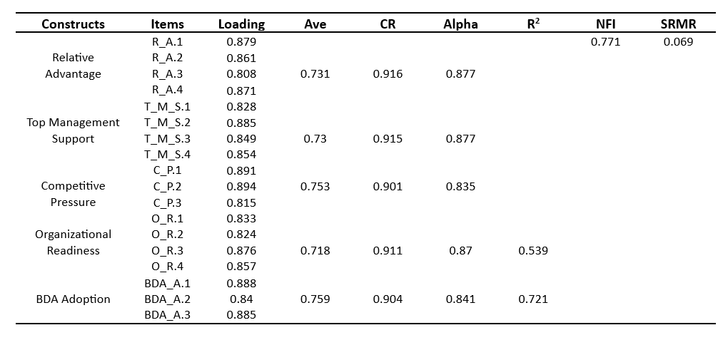

Table 3. The figures of the Stone-Geisser indictor (Q²) and Cohen’s effect size indicator (f²) of the model in the SEM analysis.
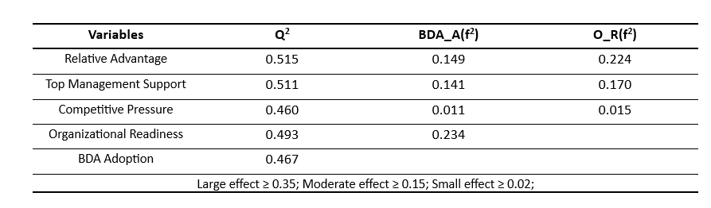

The table highlights Q² and f² factors, which provide insights into the importance of numerous determinants in BDA adoption. Competitive pressure has a smaller effect (0.460), implying that external market forces may not have a significant impact on Bangladeshi SEMs adoption of BDA. This implies that, while external drivers are important, they are insufficient to force BDA adoption without strong internal mechanisms.

Relative advantage (0.515) and top management support (0.511) have moderate direct impacts, underscoring their significance in pushing the choice to implement BDA. Relative advantage highlights the perceive benefits and operational gains provided by BDA, which are important motivators for SMEs. Similarly, senior management support represents leadership commitment and resource development, creating and atmosphere receptive to technology adoption.

Organizational readiness appears as a key mediator, with a significant impact (0.493) on BDA adoption. This emphasizes its importance in closing the gap between affecting variables and successful implementation. Organizational readiness refers to SMEs infrastructure, skill sets, and strategic alignment to effectively implement and integrate BDA. IT magnifies the impact of relative advantage and top management backing, ensuring that these elements produce actionable results.

5.3 Discriminant Validity

5.3.1 Fornell-Larcker Criterion Analysis
To evaluate the model’s reliability and validity, the Fornell-Larcker metric (Fornell, 1981) was applied.

This metric is extensively used to evaluate discriminant validity is structural equation modeling. Discriminant validity ensures that each construct is distinct from the others in the model, which is critical from accurately representing and interpreting variable interactions.

The square roots of AVE (Average Variance Extracted), displayed in Table 4, which represents the proportion of variance collected by each construct compared to the variance attributable to measurement error. These scores, which ranged from 0.848 to 0.871 in our investigation, above the usual criterion of 0.7, indicating strong convergent validity. High AVE values imply that the constructs properly account from the variance in their respective observable variables.

The Fornell-Larcker criterion further states that the square root of each construct’s AVE must be higher than its highest correlation with any other construct. In this study, all dialogue values, which reflect the square roots of the AVEs, outperform the off-diagonal correlation in their corresponding rows and columns. This demonstrates that each construct is more correlated with its own indicators than with the other constructs in the model. By meeting the Fornell-Larcker criterion, the model demonstrates strong discriminant validity. This proves that the constructs are both internally consistent and sufficiently distinct from one another. These outcomes demonstrate that the model’s theoretical structure is reliable and valid, giving confidence in the interpretation of correlations between components in the context of BDA adoption in SMEs.

Table 4. Fornell-Larcker Criterion Analysis
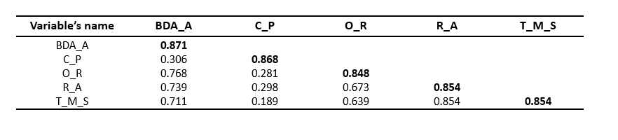

The diagonal values, shown in bold, represents the square root of the AVE for the latent variables and are the largest values in their respective rows and columns.

5.3.2 Heterotrait-Monotrait (HTMT) Analysis
The study of discriminant validity found that all HTMT values were below 0.90, as shown in table 5. HTMT threshold of 0.90 were applied to verify of the variables (Cheung et al., 2023) .

Table.5 The Heterotrait-Monotrait (HTMT) analysis results for assessing discriminant validity.

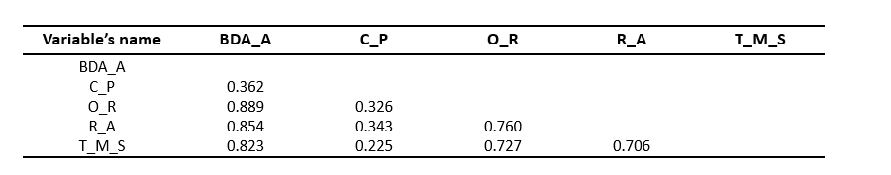

5.3.3 Cross Loads
Within the scope of structure equation modeling (SEM), cross-loadings are an essential metric for verifying discriminant validity. They guarantee that each item has a strong correlation with its corresponding latent variable than it does with any other model construct. According to (Dash & Paul, 2021; Hair et al., 2019), discriminant validity indicates the model’s notions are distinct and able to capture different characteristics of the dataset. In order to prove the accuracy and dependability of measurement models, this a basic prerequisite in SEM.

The cross-loading values for each item across the several latent variables used in the SEM analysis are shown in Table 6. These outcomes illustrate that, in comparison to other constructs, each item exhibits noticeably larger loadings on the assigned latent construct. These results confirms that each measurement item explains its intended construct in a unique way without overlapping with other items.

Items that measure organizational readiness, for instance, have a substantial association with this concept but a far weaker link with unrelated elements like relative advantage or competitive pressure. This finding emphasizes the model’s strong discriminant validity, which is necessary in order to make reliable deductions regarding the connections between the constructs. The model demonstrates its capacity to successfully distinguish between various theoretical notions by guaranteeing that each item only captures the variation pertinent to its assigned latent variables.

Furthermore, the theoretical assumption that every construct is distinct and makes a unique contribution to the SEM is supported by cross-loading analysis. It confirms the validity of the theoretical model supporting the research and makes sure the constructs are not redundant. The results support the model’s accuracy in representing the data and offer a solid basis for testing hypotheses. Therefore, the significant discriminant validity attained here confirms that the SEM approach is suitable for investigating the factors impacting the adoption of Big Data Aanalytics in SMEs in Bangladesh.

Table 6. Values of the cross loads of individual items in SEM.

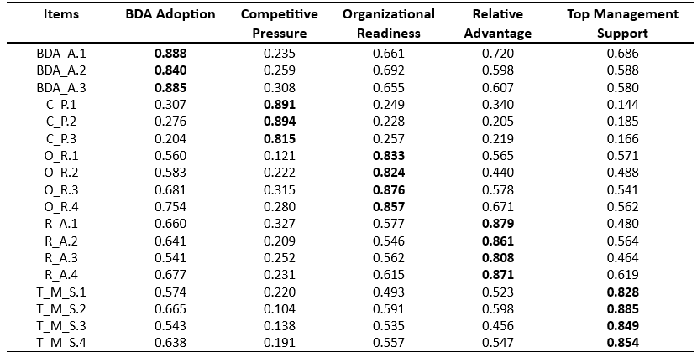

5.4 Assessment of the Structural Model
Figure 2 shows the assessment of the structural model. The t-values and R-squared values were obtained through the bootstrapping method with 1000 subsamples.

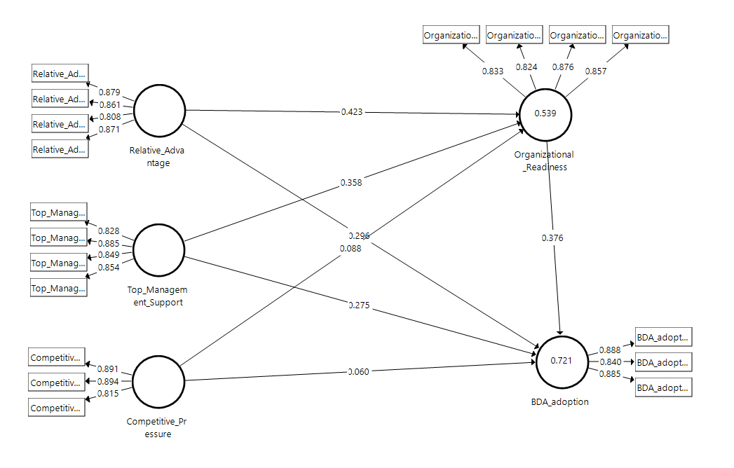
Figure 2. Standardize result of SEM calculation.

5.5 Hypothesis Testing (Primary and Secondary Effect)

The results of primary and secondary hypotheses are presented in Table 7. Statistical bootstrapping was applied to evaluate t-values. A 95% confidence interval was utilized, as supported by the P-value in Smart PLS 3.2.9.

Table 7. Results of direct and indirect effect hypotheses.

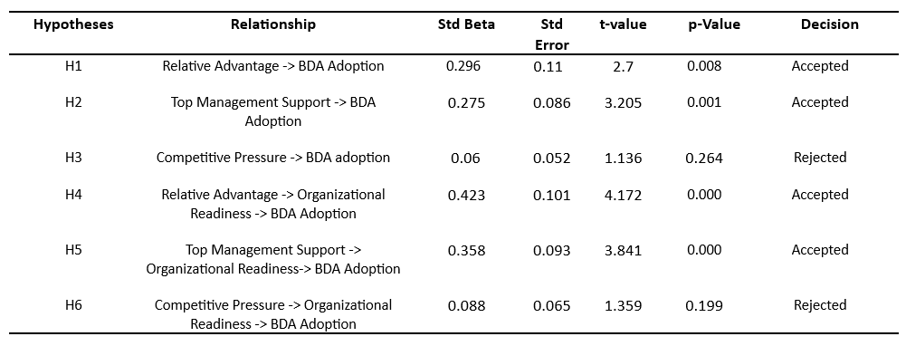

Hypotheses H1, H2, H4, H5 are supported, as their correlations reveled substantial positive impacts. H1 reveals that Relative Advantage significantly effects BDA adoption (β=0.296, t=2.7, p=0.008). Similarly, H2

demonstrates that Top Management Support promotes BDA adoption (β=0.275, t=3.205, p=0.001). H4 stresses that importance of relative advantage in enhancing organizational readiness for BDA adoption (β=0.423, t=4.172, p < 0.001), while H5 indicates the mediating impact of Top Management Support through Organizational Readiness (β=0.358, t=3.841, p < 0.001)

significant impact of competitive pressure on BDA adoption (β=0.06, t=1.136, p < 0.264), while H6 demonstrate Competitive Pressure’s influence through Organizational Readiness lacks significance (β=0.088, t=1.356, p < 0.199). The findings underscore the crucial roles of leadership and perceived advantages in BDA adoption.

Chapter 6: Discussion and Conclusions

In our research we try to investigate the acceptance of Big Data Analytics (BDA) by SMEs in Bangladesh, focusing on technological, organizational, as well as environmental aspects. The results shows that relative advantage (H1) and top Management Support (H2) significantly influence the acceptance of BDA among Bangladesh SMEs. Relative advantage highlights the importance of aligning perceived benefits with operational efficiency and productivity improvements, while top management commitment ensures resource allocation and promote a data-driven culture. Furthermore, organizational readiness (H4) performs a mediating role in the relationship among relative advantage as well as BDA adoption, highlighting its critical importance.

However, Competitive Pressure (H3, H6) does not significantly impact adoption, demonstrating that external factors alone are insufficient without internal readiness or strategic advantage. These results underscore the significance of internal variables, like as leadership and preparedness, above external forces in promoting technology adoption.

This research finds leadership, perceived advantage, and readiness as important drivers of BDA adoption in Bangladesh. Organization should focus on creating internal readiness and getting management support to achieve effective adoption. While Competitive pressure may have a role, their influence is secondary to internal organizational factors. Further research might study industry-specific dynamics or long-term implications of this factors. This study presents a realistic approach for utilizing BDA’s revolutionary potential in data-driven corporate context.

Chapter 7: Contributions

In particular, this study provides significant contributions to the existing body of literature on the topic of technology adoption, particularly with regard to setting of small and medium enterprises (SMEs) in emerging nations. By focusing on the adoption of Big Data Analytics (BDA) in Bangladeshi SMEs, this research gives vital insights into the interplay of technological, organizational, and environmental elements. Through the integration of the Technology-Organization-Environment (TOE) framework, the study presents a detailed understanding of how relative advantage, top management support, organizational preparedness, and competitive pressure influence BDA adoption. A key theoretical advancement is the incorporation of organization readiness as a mediating element. This development highlights the crucial role that organizational readiness plays in bridging the gap between influencing factors and effective adoption.

The research expands the TOE concept by demonstrating that organizational readiness enhances the benefits of relative advantage and top management and support. While prior studies have mostly focused on wealthy nations, this study addresses an essential gap by studying the setting of Bangladesh, a developing country with unique problems and potential for SMEs. The data illustrate that, unlike common assumption, competitive pressure does not significantly increase BDA adoption in this scenario. When conducting an analysis of the adoption of technology, it is essential to take into account aspects that are specific to the local environment and context.

Practically, the report presents concrete advice for SMEs practitioners and policymakers. It emphasizes the necessity of investing in IT infrastructure, training, and strategic alignment to promote organizational preparedness. The capacity of small-medium enterprises (SMEs) to embrace and efficiently exploit BDA can be considerably improved by these initiatives. The research also shows the crucial role of senior management in building a data-driven culture and guaranteeing the deployment of appropriate resources. Policymakers are encouraged to support these activities though targeted financial incentives, capacity-building programs, and technical assistance tailored to the needs of SMEs.

Methodologically, this work adopts Partial Least Square Structural Equational Modeling (PLS-SEM), a powerful analytical approach that allows for the evaluation of complicated connections involving direct, indirect, and mediating effects. The robustness of the findings is ensured by the rigorous application of PLS-SEM, which, when combined with extensive measures of reliability and validity, establishes a standard for future study in this field.

This work tackles wider societal ramifications in addition to academic and practical contributions. The study emphasizes how BDA may change decision-making, boots operational effectiveness, and increase competitiveness by promoting SMEs to adopt data-driven culture. These results promote economic growth and lessen the digital divide while also aiding in the sustainable development of Bangladesh’s SME sector. Additionally, by addressing the particular difficulties faced by SMEs in underrepresented areas, the insights offered support more equitable access to technology.

Although this study makes important contributions it also creates opportunities for more research. This work could be expended upon in the future by looking at dynamics unique to a given industry, investigating behavioral and cultural aspects, or comparing SMEs in developed and developing nations. Further understanding of the long-term effects of BDA adoption or organizational performance and sustainability may also be possible through longitudinal study.

The study concludes by providing important theorical, practical, methodological, and sociological insights on the adoption of BDA in SMEs. It lays the groundwork for future studies and useful developments in technology adoption, especially in the context of developing economies, by filling up current gaps and offering useful insights.

Chapter 8: Limitations and Future Studies

Despite the results, it is vital to pay attention to the different boundaries inherent in this research. Firstly, the study mainly focused on quantitative data, which, while useful for funding trends and linkages, limits the investigation of qualitative constructs such as cultural impacts, leadership styles, and employee attitudes towards Big Data Analytics (BDA) implementation. Incorporating qualitative methodologies into future studies, such as interviews or case studies, may provide further insights into the underling dynamics of SMEs.

Another notable weakness is the study’s sample size and geographic scope. Data were obtained from a small number of SEMs in a specific region of Bangladesh. This constrained score may limit the findings’ applicability to other areas or businesses. Future research should aim for a larger, more diverse sample of SMEs from various geographic regions and sectors to improve the external validity of the conclusions.
Demographic characteristics, such as respondents’ age and professional experience, can limit their options. This study focused on young adult professionals with less work experience. Future research should incorporate a larger demographic profile, including varied level of experience educational background, and organizational responsibilities, to gain a more complete knowledge of the factors driving BDA adoption.

Furthermore, this study looked at only a subset of variables within the Technological-Organizational-Environmental (TOE) paradigm. Future research could include characteristics such as organizational culture, supplier and peer influence, and employee resistance to change, providing a more comprehensive picture.

Finally, longitudinal studies cloud looks into the long-term impact of BDA adoption on organizational performance, sustainability, and competitiveness. Addressing these constraints will provide more detailed insights and increase the practical usefulness of research on BDA uptake in SEMs.

Reference
(IDC). (2023). Worldwide Big Data and Analytics Software Forecast, 2021–2026. Alteryx https://member.reportlinker.com/next/search?date=3y&query=Worldwide+Big+Data+and+Analytics+Software+Forecast&viewedItem=document::f2dee161f5c0a92417a606faeae5a17c3c353f7081a514a8ee13ebde9744a6c6
Agrawal, K. (2015). Investigating the determinants of Big Data Analytics (BDA) adoption in Asian emerging economies.
Agrawal, R., Kadadi, A., Dai, X., & Andres, F. (2015). Challenges and opportunities with big data visualization. Proceedings of the 7th International Conference on Management of computational and collective intElligence in Digital EcoSystems,
Al-Hujran, O., Wadi, R., Dahbour, R., Al-Doughmi, M., & Al-Debei, M. M. (2015). Big data: Opportunities and challenges. The Fifth International Conference on Business Intelligence and Technology,
Al-Okaily, M., Lutfi, A., Alsaad, A., Taamneh, A., & Alsyouf, A. (2020). The determinants of digital payment systems’ acceptance under cultural orientation differences: The case of uncertainty avoidance. Technology in Society, 63, 101367.
Al-Sai, Z. A., Abdullah, R., & Husin, M. H. (2020). Critical success factors for big data: a systematic literature review. IEEE Access, 8, 118940-118956.
Alharbi, F., Atkins, A., & Stanier, C. (2016). Understanding the determinants of Cloud Computing adoption in Saudi healthcare organisations. Complex & Intelligent Systems, 2, 155-171.
Almaiah, M. A., & Nasereddin, Y. (2020). Factors influencing the adoption of e-government services among Jordanian citizens. Electronic Government, an International Journal, 16(3), 236-259.
Alqudah, H. M., Amran, N. A., & Hassan, H. (2019). Factors affecting the internal auditors’ effectiveness in the Jordanian public sector: The moderating effect of task complexity. EuroMed Journal of Business, 14(3), 251-273.
Alshamaila, Y., Papagiannidis, S., & Li, F. (2013). Cloud computing adoption by SMEs in the north east of England: A multi‐perspective framework. Journal of Enterprise Information Management, 26(3), 250-275.
Alshira’h, A. F., Alsqour, M. d., Lutfi, A., Alsyouf, A., & Alshirah, M. (2020). A socio-economic model of sales tax compliance. Economies, 8(4), 88.
Alsyouf, A., Masa’deh, R. e., Albugami, M., Al-Bsheish, M., Lutfi, A., & Alsubahi, N. (2021). Risk of fear and anxiety in utilising health app surveillance due to COVID-19: Gender differences analysis. Risks, 9(10), 179.
Althunibat, A., Binsawad, M., Almaiah, M. A., Almomani, O., Alsaaidah, A., Al-Rahmi, W., & Seliaman, M. E. (2021). Sustainable applications of smart-government services: A model to understand smart-government adoption. Sustainability, 13(6), 3028.
Arias-Aranda, D., Bustinza, O. F., & Barrales-Molina, V. (2011). Operations flexibility and outsourcing benefits: an empirical study in service firms. The service industries journal, 31(11), 1849-1870.
Asiaei, A., & Ab. Rahim, N. Z. (2019). A multifaceted framework for adoption of cloud computing in Malaysian SMEs. Journal of Science and Technology Policy Management, 10(3), 708-750.
Baig, M. I., Shuib, L., & Yadegaridehkordi, E. (2021). A model for decision-makers’ adoption of big data in the education sector. Sustainability, 13(24), 13995.
Bentler, P. M., & Bonett, D. G. (1980). Significance tests and goodness of fit in the analysis of covariance structures. Psychological bulletin, 88(3), 588.
Chen, D. Q., Preston, D. S., & Swink, M. (2015). How the use of big data analytics affects value creation in supply chain management. Journal of management information systems, 32(4), 4-39.
Cheung, G. W., Thomas, H., Lau, R. S., & Wang, L. C. (2023). Correction to: Reporting reliability, convergent and discriminant validity with structural equation modeling: A review and best-practice recommendations. Asia Pacific Journal of Management. DOI, 10.
Choi, H. S., Hung, S.-Y., Peng, C.-Y., & Chen, C. (2022). Different perspectives on BDA usage by management levels. Journal of computer information systems, 62(3), 503-515.
Cruz-Jesus, F., Pinheiro, A., & Oliveira, T. (2019). Understanding CRM adoption stages: empirical analysis building on the TOE framework. Computers in Industry, 109, 1-13.
Dash, G., & Paul, J. (2021). CB-SEM vs PLS-SEM methods for research in social sciences and technology forecasting. Technological Forecasting and Social Change, 173, 121092.
Fornell, C. (1981). Structural equation models with unobservable variables and measurement error: Algebra and statistics. Publications Sage.
Frizzo-Barker, J., Chow-White, P. A., Charters, A., & Ha, D. (2016). Genomic big data and privacy: challenges and opportunities for precision medicine. Computer Supported Cooperative Work (CSCW), 25, 115-136.
Gangwar, H. (2018). Understanding the determinants of big data adoption in India: An analysis of the manufacturing and services sectors. Information Resources Management Journal (IRMJ), 31(4), 1-22.
Gangwar, H., Date, H., & Raoot, A. (2014). Review on IT adoption: insights from recent technologies. Journal of Enterprise Information Management, 27(4), 488-502.
Ghaleb, E. A. A., Dominic, P. D. D., Fati, S. M., Muneer, A., & Ali, R. F. (2021). The Assessment of Big Data Adoption Readiness with a Technology–Organization–Environment Framework: A Perspective towards Healthcare Employees. Sustainability, 13(15), 8379. https://www.mdpi.com/2071-1050/13/15/8379
Gonzales, R., Wareham, J., & Serida, J. (2015). Measuring the impact of data warehouse and business intelligence on enterprise performance in Peru: a developing country. Journal of Global Information Technology Management, 18(3), 162-187.
Grandon, E. E., & Pearson, J. M. (2004). Electronic commerce adoption: an empirical study of small and medium US businesses. Information & management, 42(1), 197-216.
Hair, J. F., Risher, J. J., Sarstedt, M., & Ringle, C. M. (2019). When to use and how to report the results of PLS-SEM. European business review, 31(1), 2-24.
Hameed, M. A., Counsell, S., & Swift, S. (2012). A conceptual model for the process of IT innovation adoption in organizations. Journal of Engineering and Technology Management, 29(3), 358-390.
Hashem, I. A. T., Chang, V., Anuar, N. B., Adewole, K., Yaqoob, I., Gani, A., Ahmed, E., & Chiroma, H. (2016). The role of big data in smart city. International journal of information management, 36(5), 748-758.
Henseler, J., Ringle, C. M., & Sinkovics, R. R. (2009). The use of partial least squares path modeling in international marketing. In New challenges to international marketing (pp. 277-319). Emerald Group Publishing Limited.
Hsu, P.-F., Ray, S., & Li-Hsieh, Y.-Y. (2014). Examining cloud computing adoption intention, pricing mechanism, and deployment model. International journal of information management, 34(4), 474-488.
Hu, L. t., & Bentler, P. M. (1999). Cutoff criteria for fit indexes in covariance structure analysis: Conventional criteria versus new alternatives. Structural equation modeling: a multidisciplinary journal, 6(1), 1-55.
Idris, K. M., & Mohamad, R. (2016). The influence of technological, organizational and environmental factors on accounting information system usage among Jordanian small and medium-sized enterprises. International Journal of Economics and Financial Issues, 6(7), 240-248.
Idris, K. M., & Mohamad, R. (2017). AIS usage factors and impact among Jordanian SMEs: The moderating effect of environmental uncertainty. Journal of Advanced Research in Business and Management Studies, 6(1), 24-38.
Jahanshahi, A., & Brem, A. (2017). Sustainability in SMEs: Top management teams behavioral integration as source of innovativeness. Sustainability, 9 (10), 1899. In.
Kapoor, K. K., Dwivedi, Y. K., & Williams, M. D. (2015). Examining the role of three sets of innovation attributes for determining adoption of the interbank mobile payment service. Information Systems Frontiers, 17, 1039-1056.
Lai, Y., Sun, H., & Ren, J. (2018). Understanding the determinants of big data analytics (BDA) adoption in logistics and supply chain management: An empirical investigation. The International Journal of Logistics Management, 29(2), 676-703.
Loh, C.-H., & Teoh, A.-P. (2021). The adoption of big data analytics among manufacturing small and medium enterprises during covid-19 crisis in Malaysia. Ninth International Conference on Entrepreneurship and Business Management (ICEBM 2020),
Lutfi, A. (2021). Understanding cloud based enterprise resource planning adoption among SMEs in Jordan. J. Theor. Appl. Inf. Technol, 99(24), 5944-5953.
Lutfi, A., Al-Okaily, M., Alsyouf, A., Alsaad, A., & Taamneh, A. (2020). The impact of AIS usage on AIS effectiveness among Jordanian SMEs: A multi-group analysis of the role of firm size. Global Business Review, 0972150920965079.
Lutfi, A., Alsyouf, A., Almaiah, M. A., Alrawad, M., Abdo, A. A. K., Al-Khasawneh, A. L., Ibrahim, N., & Saad, M. (2022). Factors influencing the adoption of big data analytics in the digital transformation era: Case study of Jordanian SMEs. Sustainability, 14(3), 1802.
Mangla, S. K., Raut, R., Narwane, V. S., Zhang, Z., & Priyadarshinee, P. (2021). Mediating effect of big data analytics on project performance of small and medium enterprises. Journal of Enterprise Information Management, 34(1), 168-198.
Maroufkhani, P., Tseng, M.-L., Iranmanesh, M., Ismail, W. K. W., & Khalid, H. (2020). Big data analytics adoption: Determinants and performances among small to medium-sized enterprises. International journal of information management, 54, 102190.
Maroufkhani, P., Wagner, R., Wan Ismail, W. K., Baroto, M. B., & Nourani, M. (2019). Big data analytics and firm performance: A systematic review. Information, 10(7), 226.
Nam, D., Lee, J., & Lee, H. (2019). Business analytics adoption process: An innovation diffusion perspective. International journal of information management, 49, 411-423.
Nasrollahi, M., Ramezani, J., & Sadraei, M. (2021). The impact of big data adoption on SMEs’ performance. Big Data and Cognitive Computing, 5(4), 68.
Oliveira, T., Thomas, M., & Espadanal, M. (2014). Assessing the determinants of cloud computing adoption: An analysis of the manufacturing and services sectors. Information & management, 51(5), 497-510.
Raguseo, E., & Vitari, C. (2018). Investments in big data analytics and firm performance: an empirical investigation of direct and mediating effects. International Journal of Production Research, 56(15), 5206-5221.
Ramdani, B., & Kawalek, P. (2008). Exploring SMEs adoption of broadband in the northwest of England. In Handbook of research on global diffusion of broadband data transmission (pp. 504-523). IGI Global.
Rogers, E. M., Singhal, A., & Quinlan, M. M. (2014). Diffusion of innovations. In An integrated approach to communication theory and research (pp. 432-448). Routledge.
Salleh, K. A., & Janczewski, L. (2016). Adoption of Big Data Solutions: A study on its security determinants using Sec-TOE Framework.
Sanders, N. R. (2008). Pattern of information technology use: The impact on buyer–suppler coordination and performance. Journal of Operations Management, 26(3), 349-367.
Sarstedt, M., Ringle, C. M., Cheah, J.-H., Ting, H., Moisescu, O. I., & Radomir, L. (2020). Structural model robustness checks in PLS-SEM. Tourism Economics, 26(4), 531-554.
Shamim, S., Zeng, J., Khan, Z., & Zia, N. U. (2020). Big data analytics capability and decision making performance in emerging market firms: The role of contractual and relational governance mechanisms. Technological Forecasting and Social Change, 161, 120315.
Staegemann, D., Volk, M., Lautenschläger, E., Pohl, M., Abdallah, M., & Turowski, K. (2021). Applying test driven development in the big data domain–lessons from the literature. 2021 international conference on information technology (ICIT),
Sun, S., Cegielski, C. G., Jia, L., & Hall, D. J. (2018). Understanding the factors affecting the organizational adoption of big data. Journal of computer information systems, 58(3), 193-203.
Sun, S., Hall, D. J., & Cegielski, C. G. (2020). Organizational intention to adopt big data in the B2B context: An integrated view. Industrial Marketing Management, 86, 109-121.
Wahab, S. N., Hamzah, M. I., Sayuti, N. M., Lee, W. C., & Tan, S. Y. (2021). Big data analytics adoption: an empirical study in the Malaysian warehousing sector. International Journal of Logistics Systems and Management, 40(1), 121-144.
Wamba, S. F., Dubey, R., Gunasekaran, A., & Akter, S. (2020). The performance effects of big data analytics and supply chain ambidexterity: The moderating effect of environmental dynamism. International Journal of Production Economics, 222, 107498.
Yoon, T. E., & George, J. F. (2013). Why aren’t organizations adopting virtual worlds? Computers in Human Behavior, 29(3), 772-790.

Appendix

