Business Development and Client Servicing
of
Jarvis Digital BD



Umme Kulsum Sonia

This report is submitted to the school of Business and Economics, United International University as a partial requirement for the degree fulfillment of Bachelor of Business Administration

Business Development and Client Servicing
Of Jarvis Digital BD

Submitted to:
Dr. Md. Shariful Alam
Associate Professor
Marketing

Submitted by:
Umme Kulsum Sonia
111 153 081


School of Business and Economics
United International University

Date of Submission: 29th July, 2020

Letter of Transmittal

July 29, 2020
Dr. Md Shariful Alam
Associate Professor, SOBE
United International University
Subject: Submission of internship report

Dear Sir,
I would humbly present the report on ‘Business Development and Client Servicing’ of the promising creative agency- Jarvis Digital BD, which has been assigned to me with the aid of my supervisor to submit as a partial requirement for the completion of BBA internship. The course provided me with ample opportunities to synthesize the learning I have experienced during my stay with the organization.
I would like to convey my sincerest gratitude for your kind cooperation and guidance.

Yours sincerely,
Umme Kulsum Sonia
ID: 111153081
School of Business & Economics
United International University
Client Servicing Intern, Jarvis Digital BD

Certification of Similarity Index

Name of the Supervisor: Dr. Md Shariful Alam
Name of the Author: Umme Kulsum Sonia
Subject: Internship (Marketing)
Title of the Study: Business Development and Client Servicing of Jarvis Digital BD

I, hereby declare that the above-mentioned research work is original & it doesn’t contain any plagiarized contents. The similarity index of this research work is 6 %
The plagiarism of the report is checked by the supervisor and I further declare that-
- I shall be solely accountable in case of any plagiarism found in this report and the University will have rights to take legal actions.
- I shall be responsible in case of any legal dispute or case filled due to violation of anti-plagiarism policy or copyright act by any party.

Date: 29-06-2020

Sign:
______________________________ __________________________
Signature of the Supervisor Signature of the Author

Declaration

I, Umme Kulsum Sonia, bearing the ID: 111 153 081, hereby declare that the internship report titled ‘Business Development and Client Servicing of Jarvis Digital BD’, submitted to United International University, is an original dissertation prepared by me over the experiences gathered from my four months’ tenure as an intern in the concerning organization, under the apt guidance and supervision of Dr. Md Shariful Alam, Associate Professor, School of Business and Economics.
I also confirm that the report is strictly prepared for academic purposes only and is not intended to hold any commercial value attached to it. It is a uniquely prepared report and has not been used in any form partial or fully for any degree/diploma/associateship/fellowship or other similar title of any University.

_______________________________
Umme Kulsum Sonia
ID: 111153081
School of Business & Economics
United International University
Client Servicing Intern, Jarvis Digital BD

Acknowledgement

At first, I would like to convey my humble submission to the almighty Allah, for guiding me and allowing me the required energy and capability to carry on the daunting task of preparing this report. Then I would forward my sincerest gratitude to my honorable supervisor, Dr. Md Shariful Alam, for his integral support to guide me towards a successful completion of this report.
I am also thankful to Mr. Omar Khayaam, Senior Coordinator, Jarvis Digital BD, who helped me gain thorough insight into the operations of the organization and the industry big picture, which has facilitated my work progression for the preparation of this report.
A special acknowledgement to my fellow internship colleague, Ms. Shaba Anjum, for her insightful tips and advice in preparation of the internship report.
I am humbled by and grateful to all the personnel of Jarvis Digital BD for their kind support and exemplary mentoring, that has been instrumental in making this report.

Abstract

This report is prepared as fulfillment of requirements of my Internship in Jarvis Digital BD. The report covers my experience over the course of internship and the insights I have gained on the company and industry at large. The discussion includes the industry analysis of the growing digital marketing industry and the major players exploring the horizon. It also covers the operational flow of Jarvis Digital BD and the skills I used to adapt to the working culture over my 4 months’ stay at the company. The operational teams and their duties to understand the client, prepare the services and aptly deliver the value to customers. There is also a small, personal recommendation on the betterment of the company towards the end of the report. The report is a mixture of primarily my own experiences and then secondary sources of information.

Table of Contents for Internship

Table of Contents
Letter of transmittal 1
Certification of similarity index 2
Declaration of the student 3
Acknowledgement 4
Abstract/ Executive summary 5
Table of contents for Internship 6
List of Figures 8
List of Tables 8
CHAPTER I: INTRODUCTION 9
I.1 Background of the Report 9
I.2 Objectives of the Report 9
I.3 Motivation of the Report 10
I.4 Scope and limitations of the Report 10
CHAPTER II: COMPANY AND INDUSTRY PREVIEW 11
2.1 Company Analysis 11
2.1.1 Overview and history 11
2.1.2 Trend and growth 11
2.1.3 Customer mix 13
2.1.4 Service mix 14
2.1.5 Operations 15
2.1.6 SWOT analysis 17
2.2 Industry analysis 17
2.2.1 Specification of the industry 17
2.2.2 Size, trend, and maturity of the industry 18
2.2.3 External economic factors 19
2.2.4 Technological factors 20
2.2.5 Barriers to entry 21
2.2.6 Supplier Power 21
2.2.7 Buyer Power 22
2.2.8 Threat of Substitutes 22
2.2.9 Industry rivalry 23
CHAPTER III: INTERNSHIP EXPERIENCE 24
4.1 Position, duties, and responsibilities 24
4.2 Training 24
4.3 Contribution to departmental functions 25
4.4 Evaluation 25
4.5 Skills applied 26
4.6 New skills developed 26
4.7 Application of academic knowledge 27
CHAPTER IV: CONCLUSION AND KEY FACTS 28
5.1 Recommendations for improving departmental operations 28
5.2 Key understanding 29
5.3 Conclusion 30
Reference 30

List of Figures

- Fig 01: Major Clients of Jarvis Digital BD
- Fig 02: Number count of fans managed in Face Book
- Fig 03: Revenue Portfolio of Jarvis Digital BD
- Fig. 4: Digital Content Traffic for Jarvis Digital BD
- Fig. 6: SWOT Analysis of Jarvis Digital BD
- Fig. 7: Social Media User Growth
- Fig. 8: Economic & Demographic growth in Bangladesh
- Fig. 9: Major Market Players of Digital Marketing Agency

List of Tables

- Fig. 5: Service Portfolio of Jarvis Digital BD

Chapter 01: Introduction

1.1 Background of the Report:

The report has tried to capture the operational procedure of Jarvis Digital BD and how strategic decisions are aligned with its client servicing, alongside their zeal for creative expression. This report is prepared for academic purposes only and is not intended to be commercially used in any way. Information used in preparation of the report is factual and does not aim to misrepresent the organization or the industry. The data used is confidential and the components of the report should not be regenerated in full or partial.

1.2 Objectives of the Report:

1.2.1 Broad Objective
The broad objective of the report is to analyze the effectiveness of the operational flow of Jarvis Digital BD in providing state of the art client servicing.

1.2.2 Specific Objective
- To understand the supply chain of end services of Jarvis Digital BD
- To find out the mode of service creation of Jarvis Digital BD
- To understand the client perception of the provided services
- To find out the market effectiveness of the contents
- To understand the client study process of Jarvis Digital BD
- To find out the market readiness of Jarvis Digital BD

1.3 Motivation of the Study:

- To complete the requisites of internship under the BBA program of United International University
- To analyze and portray my learning experience from internship tenure
- To synthesize the business practices of one of the prominent creative agencies of Bangladesh- Jarvis Digital BD
- To find out the common practices in the creative and digital agency market of Bangladesh
- To understand the operations of the largely growing digital marketing ecosystem
- To highlight the factors involving with client management in the digital marketing service-scape

1.4 Scope & Limitation of the Report:

1.4.1 Scope:

- The study was conducted on the information received while working for Jarvis Digital BD for assessing the business development
- Only activities that are carried out as a service output by Jarvis Digital BD was taken into considerations
- The study utilizes the information on current status quo of the industry and state-of-the-art processes involved
- The study emphasizes on the business practices within the Bangladeshi market, mostly covering within the capital area

1.4.2 Limitations:

- Only four months’ experience as intern is insufficient to cover an area of such magnitude
- Company policy to withhold sensitive information on business process and client details
- Secondary sources of data are not eligible to serve the study purpose
- Only digital agency business practices are covered, a large chunk of the services provided by 360-degree agencies are left out

Chapter 02: Company & Industry Preview

2.1 Company Analysis:

2.1.1 Overview & History

Jarvis Digital is a digital marketing agency facilitating the brands in online space with effective online strategies, technical innovations and graphical expertise. Jarvis adds value to the client businesses connecting them with the right audience in the right context in the digital market sphere. The Dhaka based digital agency started its journey with the contract of managing the official social media handles of the celebrated cricketer ‘Shakib Al Hasan’ in 15 November, 2014. The then Jarvis comprising of only five people, has grown over the next six years to become one of the prominent IT and digital marketing service providers in the highly growing agency industry of Bangladesh. The mission of the organization is to develop elegant, affordable and effective tech solutions that enable small to large businesses to establish visibility in digital space, increase sales/meet personal objectives, and improve productivity. (daily sun, 2019)

2.1.2 Trend & Growth

Jarvis Digital was named after the IT specialist character in ‘Iron Man’, since the founders were enthusiasts of fantasy adventures. And the growth of Jarvis Digital has not been any short of an adv

enturous ride. Starting with only one mega client, it has grown on to manage the digital presence of some notable brands in Bangladesh.
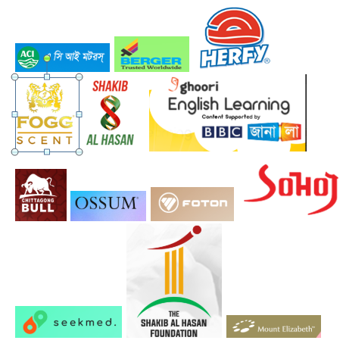

Fig. 1: Major Clients of Jarvis Digital BD

Jarvis digital started its journey with managing the Facebook, Twitter and Instagram handles of Shakib Al Hasan, but now it provides strategic plans on digital and PR campaigns, alongside initiating and implementing the production and apt placement of these contents. Jarvis Digital looks into the day to day operations of two of the largest social media pages of Bangladesh and manages more than 10 million fans in these pages. Overall, it now manages more than 30 million of fans only in Face book, let alone other social media handles. A sneak peek into the growth of Jarvis Digital in managing the number of fans over the years:

Fig. 2: Number count of fans managed in Face Book

2.1.3 Customer Mix

A visual representation of the customer mix on the basis of total revenue earned by Jarvis Digital BD. Most prominent customers are taken into consideration while creating this mix. According to the needs of different customers, the type of services provided by Jarvis Digital can change. Each service has its own pricing range and the gross earnings of Jarvis from its clientele has been shown in the chart. Percentage of contribution to the overall revenue has been included for a better comparative analysis.
Fig. 3: Revenue Portfolio of Jarvis Digital BD
Besides revenue earned from each client, it is also important to analyze the service traffic required for each client. Most common forms of services such as creatives, both static and animated, have been taken into consideration to create a comparative among the existing prominent client brands. The comparative provides a platform to understand the weightage of service hours required for each client and cross examining it with the previous chart on revenue weightage will allow figuring the best output level for Jarvis Digital. (jarvis digital, 2014)

2.1.4 Service Mix

Jarvis Digital provides a range of services aimed at providing customer support in the digital market sphere. The range of services fall under four broader categories:
Fig. 4: Digital Content Traffic for Jarvis Digital BD
- Social Media Services

- Creatives Support

- Media Buying and Analytics Services

- Web & Apps Development and Support

Some of the notable services under these broader categories are:
Social Media | Creatives | Media Buying  & Analytics | Web & Apps
- Online-Offline Campaigns  - Content Planning  - Customer Query Management  - Blogging | - Graphic Designing  - Videography  - Photography  - Printing | - Media Buying  - Online Ad Placement  - Reach Media  - Analytics & Reporting | - Website Development  - Mobile Apps  - E-Commerce Solution  - Search Engine Optimization  - E-mail Marketing

Fig. 5: Service Portfolio of Jarvis Digital BD

2.1.5 Operations

Jarvis Digital BD follows the general Digital IT organizational organogram in its organization. A five personnel board of directors hold the peak of the organogram. They are:
- Mr. Omra Zaman Mozumder
Chairman

- Mr. Syed Abu Yousuf
Managing Director

- Mr. Abdullah Ashraf
Finance Director

- Mr. Abdullah Abu Bakr
CEO

- Mr. Adnan Ahmed
Chief Creative Officer

The operations in Jarvis are carried out by synchronized performance of four teams- Client Accounts team, Content & Strategy team, Creative Art & Graphics team and Finance, HR & Admin team. A brief overview of the operational responsibilities of the teams are as followed:
  - Client Accounts Team: The prime contact point between Jarvis and the clients. The responsibilities are to directly communicate with the clients, understand their requirements, and forward the agenda, insight and instructions to the content & strategy team to generate ideas and develop branding elements.

  - Content & Strategy Team: The team analyzes the target market, formulate contents, campaign plans and ideas to effectively deliver them to the intended audience through most efficient channels.

  - Creative Art & Graphics Team: Jarvis Digital boasts a very qualified team of graphic designers. The prime responsibility is to provide creative output to the plans and designs. The outputs can range from static, animated contents to web page carousels and many more.

  - Finance, HR, & Admin Team: The team handles all monetary dealings of Jarvis Digital and planning regarding efficient allocation of resources. The admin team takes the matter of maintaining a suitable work environment closely to provide a comfortable atmosphere for the
troopers of Jarvis.

2.1.6 SWOT

Strength

Qualified Graphic Designers
In-house teams for multiple digital services
Top Quality Customer Base

Weakness

Unattractive remuneration packages
Dependency on Creative Art & Graphics' Team
Over flexibility

Opportunities

Increasing supply of graphic designers
More digital inclusion of Brands
Explore 360-Degree Services

Threat

Imminent market saturation
No governing body in the industry
Turnover rate in the industry

Fig. 6: SWOT Analysis of Jarvis Digital BD

2.2 Industry Analysis:

2.2.1 Specification of the Industry

Any company wanting to reach out to an audience nowadays, needs to have an intermediary marketing agency working as an outsourcing partner. Agencies working on behalf of the brands undertake all the responsibilities of marketing to relieve the companies from the burden of marketing specific activities and allow them to focus on their specific product/service-oriented core activities. There are roughly three major types of agencies in the industry:
- All Purpose Agencies (360 Degree), that provides support and expertise in all aspects of marketing, starting from market research, ad shoots, digital solutions to providing facilitation in mainstream offline marketing.
- Full Service Digital Marketing Agencies, that provides support and expertise in creation and facilitation of all branding elements present in the digital market sphere. Digital marketing is an umbrella term that encompasses all kinds of activity which takes place online to promote a brand, or to drive sales and the agency performs the task on behalf of the company.
- Niche Marketing Agencies, that provides support and expertise in selective outlets of the marketing sphere. It requires far less resources than the other two and provides an avenue to become a specialist in the concerning niche segment. There are lots of niche marketing agencies, for example, agencies providing only web development solutions, or customer query management services etc. (the daily star, 2020)

2.2.2 Size, Trend and Maturity of the Industry

Digital media inarguably has a distinctive edge over traditional media in connecting to customers with greater effect but at lower costs. The non-conventional media has the ability to reach the intended audience more aptly and quickly to expose them to the advertisers through the vast user-base and technological inclusion in customer lifestyle. This advantage has made this particular media, a gift of digitalization, very popular among all the companies over the world.
There is no official number on the market size of the digital marketing industry in Bangladesh, however, according to a study conducted by the leading newspaper, The Daily Star, the market valuation stands at roughly Tk. 1000 Crore. According to the industry experts, almost 50% of the total spends are directed towards Facebook and Google. The high number of social media users also have great implications for the brands to explore different common social media platforms. The growth rate of population active in different social media is as of present:
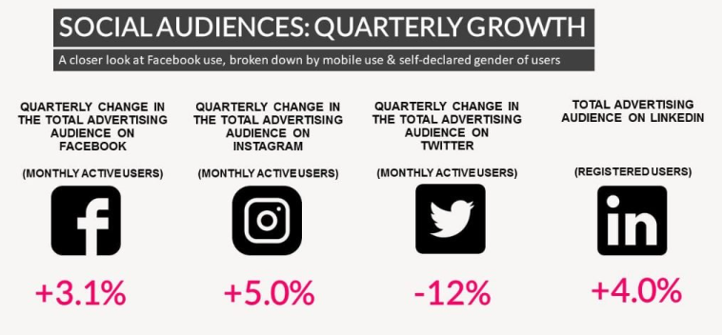

Fig. 7: Social Media User Growth

The market maturity is hard to forecast at this moment. However, a growing concern for the quality of products/services being developed in the market. At times, the contents are more recurring and the creative output of the industry seems saturated.

2.2.3 External Economic Factors

The increased growth of GDP in Bangladesh over the last decade has seen the life standard of its population ever on the rise. Owning a smartphone has become an essential part of lifestyle even in rural communities. Thus, the users of mobile phones are gradually exploring different features of the internet and allowing the digital marketers to connect them through multiple platforms. The high popularity of digital marketing solutions is by-product of technological advancement; a brief view on the numbers:
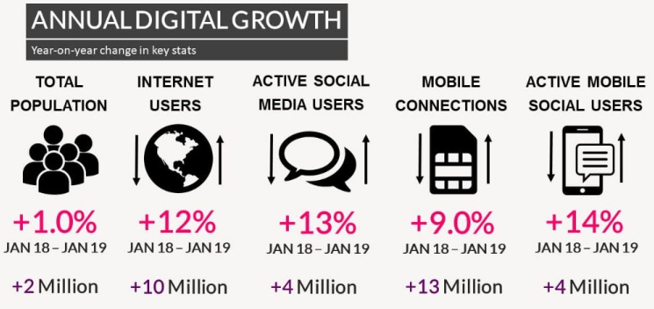

Fig. 8: Economic & Demographic growth in Bangladesh
Moreover, government 's promise to make the country digital has seen implications of more digital inclusion in government and non-government services. As a result of economies of scope, people are getting habituated to more digital services. As much as it provides digital marketers the opportunity to connect them through digital channels, it also allows the customers to be an active influencer in shaping the economic traction of the digital marketing industry.

2.2.4 Technological Factors

Bangladesh has advanced remarkably in the last decade in technology, including the launch of its own satellite- Bangabandhu 1. The infrastructural development has allowed the country to implement more digitized services and start practicing IOT (Internet of Things) solutions. Bangladesh has also rolled out fourth generation mobile internet connectivity and the mobile network operators are providing connectivity coverage in all 64 districts of Bangladesh. This has prompted the population to grab the digital lifestyle and in turns, allowed the digital marketers to tap into these netizens.
The advancement in connectivity is further achieved through the increased bandwidth allocation by the government and extending the broadband services to Unions of Bangladesh. The union service points of A2i project is providing the mass people with a facility to get into the digital world.
The resources of production houses, such as advertising agencies, small time movie makers etc. are being used in the production of quality content in the digital marketing sphere. The increased number of digital marketing agencies has allowed these small businesses and freelancers to aid the technological backup of the digital marketing industry. Moreover, digital marketing of different MNCs in Bangladesh has allowed the agencies to learn global digital marketing techniques and exposed them to global standardized technical support.

2.2.5 Barriers to Entry

The barriers to enter the market are extremely low in this industry. There are almost 180+ digital marketing agencies licensed under income tax provision. However, much of the industry is unregulated and there is no governing body in the industry. Thus, there are many smaller and niche agencies throughout the capital city. A large portion of the unregulated agencies are formed by friend groups at tertiary education level. Know-how of basic video editing, graphics designing etc. are enough to form a small agency. The defining factor of starting an agency is the available clientele, for example, even the concerning agency of this report, Jarvis Digital BD started its journey with the support of a big client, Shakib Al Hasan. No governing body means there is no requirement for official license or certification of expertise and only availability of clients is enough to start an agency. In most cases, the excessive number of restaurants present in Bangladeshi markets serve as the clients to newly formed agencies.

2.2.6 Supplier Power

The employee bank serves as suppliers to the industry, such as Graphic Designers, Web Developers, Video Editors, Coders etc. There is a growing number of agency specific employee availability in the market. As a result, the remuneration packages are getting low for the employees. However, there is a scarcity of quality designers in the industry and thus, the agencies try to appoint quality designers from other competitors. So, the turnover rate is high.
Besides employee banks, the advent of PayPal and other online transaction modules in Bangladesh has allowed the agencies to avail licensed subscription of different software which are being used to create content and deliver services. (Wahid-Uz-Zaman, 2015)

2.2.7 Buyer Power

The buyer power in the industry is quite high understandably. The huge supply of digital marketing agencies has allowed the clients to choose from most affordable options. As a result, there is a disproportionate growth of service standard in the industry. As much as the lack of a governing body allows many unregulated agencies to conduct business, it also provides an avenue to the clients to exploit the agencies in terms of minimum payments, basic relationship management etc. Again, the services are handpicked by the clients. Even after the strategic advice from the agencies, the clients take the final calls on the services of the digital marketing agencies. From choosing suggested campaigns to approving every design, it is the satisfaction of the concerning brand manager that is most important in this service industry. (the daily star, 2020)

2.2.8 Threat of Substitutes

The excessive number of small and medium range agencies provide the clients with a high number of substitution options. Many small agencies do the same graphic designing at a cheaper rate and in turns, causes the industry pricing go even below par. The switching cost for the clients is also pretty low, providing more substitute threat to the agencies. The rise of many specialized niche digital marketing agencies also provides an option to the clients to distribute different elements of the entire digital presence to different agencies. For example, appointing different agencies for each of web development, media buying and communication activities instead of receiving all the services from a 360-degree agency. (digital in bangladesh, 2020)

2.2.9 Industry Rivalry

The competitive rivalry is very high within the industry. The top 10-15 digital marketing agencies hold the majority of the market share, while the growing number of small and unregulated agencies scrap through the market for survival. Some of the major market players in the industry are:
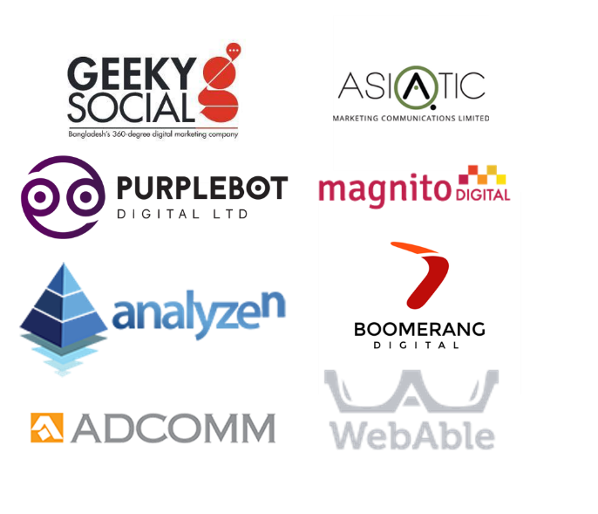

Fig. 9: Major Market Players of Digital Marketing Agency Industry

The competition is visible on two major factors:
- Competition for bagging clients
- Competition for better employees from other agencies

Chapter 03: Internship Experience

3.1 Position, Duties and Responsibilities:

I joined Jarvis as an intern in the Client Servicing Department on January 13, 2020. My duty in the initial week was to get acquainted with the people of Jarvis and the operational process. I was also guided about the expected behaviors in online groups and organizational culture. The core duties that were handed to me are:
- Communicating with clients to discuss and facilitate the content plans and requirements for implementation.
- Providing personal customer insights to derive better content plans
- Working in collaboration with the idea, content and creative team.
- Drafting client specific plans for content marketing
- Facilitating client approval for creatives and contents
- Assisting in campaign launches
- Preparing budget for different campaigns and clients
- Operating software and social media handles for smooth data transfer and communication

3.2 Training:

The four-month span of internship was too short to get substantial training. However, the development was achieved much through soft skills development, such as: pitching to clients, negotiation skills, communication strategies etc. rather than hard skill training. The impact of the worldwide pandemic Covid-19 resulted in Jarvis Digital BD adopting a work-from-home employment scheme and we were trained to operate different software accordingly. We were also sent various resource material on skill development and successful digital marketing techniques as online training modules.

3.3 Contribution to Departmental Functions:

I was assigned with looking after three client accounts throughout my tenure as an intern. They are: Vini (both Fogg and Ossum), Pran and Shakib Al Hasan. The specific contributions I have delivered while managing these accounts are:
- Formulating monthly content plans with the clients and overseeing the efficient application to adhere to the content calendar
- Pitching proposed campaign plans to clients, receiving feedback and formulating better strategies in collaboration with the Clientele and Content team
- Briefing the Design team about the content and client expectations and making sure of the timely development of the creatives
- Forwarding the creatives to the clients and managing approval
- Social media management as ‘Admin’ of Client Facebook Pages

3.4 Evaluation:

As my tenure as an intern progressed and I showed signs of promise, I was assigned more specific job responsibilities. Soon enough, I started managing three client accounts, namely, Fogg, Ossum and The Pran. The increased vote of confidence in me is an example of positive evaluation of my work as an intern. The departmental heads and client team leaders evaluated each task completed closely and provided feedback for further development. The top management held the power to determine appraisals for the employees and the direct supervision model helped in this case. I was also blessed with an offer to join as a full-time employee upon much evaluation of my work as an intern in the organization for four months.

3.5 Skills Applied:

Some of the existing skills that I already possessed which has helped me in my tenure as an intern are:
- Basic photoshop skills to conduct small edits in creatives and provide visual feedback to both clients and creative team
- Preparing budget in Microsoft Excel and using advanced formulas
- Using Google Sheets to keep clear communication between different parties
- Negotiation skills in client pitching sessions
- Consumer insight evaluation skills to create more engaging content plan
- Basic Web development skills to adjust website panel alignments
- Social Media handles’ management skills
- Advanced Microsoft PowerPoint skills to prepare pitch decks in short notice

3.6 New Skills Developed:

Along my internship journey, I gathered valuable experience and learned the following skills:
- Communicating with clients and other professional personnel appropriately
- Managing office time schedule by entering acceptable window of 8:30 am to 10:30 am and completing 09-hour work schedule everyday
- Learning office etiquettes and handling challenges professionally
- Understanding different brand perspectives on different consumer variables
- Using the discord server to conduct the fundraiser auction of Shakib Al Hasan
- Operating zoom to conduct in and out house meetings
- Learning efficient audio recording techniques omitting maximum noise
- Basic video recording know-hows

3.7 Application of Academic Knowledge:

For an informal industry like digital marketing agencies, at times, it might be perceived that experience can overshadow any other academic expertise, but my experience has provided me a different perspective of this idea. Albeit, with experience, one can get to learn the procedural functions of Agencies, however, academic knowledge, specially the know-how of terminologies can help a great deal in aptly communicating with concerning groups. It decreases the lag time of service preparation and delivery. Some of the regular usage of academic theories I required in my tenure are:
- SWOT Analysis
- TOWS Matrix
- Fish Bone Analysis
- BCG Matrix
- Consumer insight researches
- Understanding consumer perceptions
- Brand Re-positioning
- STP
- Business Communication
- Porter’s 5 forces
- PESTEL and many more

Chapter 4: Conclusion & Key Facts

4.1 Recommendations for Improving Dept. Operations

- In spite of the friendly working environment in Jarvis, the power gap is evident as most decisions require approval from top management. As much as it is understandable to maintain the quality of the service provided, it is also necessary to create an evaluation plan with relative criteria to assess any decision in case of absence of concerning top management personnel. In other words, decentralization of decision making based on set criteria.

- More empowerment of the Client Accounts Team is required. As they get client feedback directly, it is easier and more effective if they directly supervise the tasks carried out by the Content Team and Creative Team. This also allows to omit any dispersity of communication through the vertical supply chain of service production.

- Provide more on field man power under the jurisdiction of the Content & Strategy team. There is no alternative to market research to understand the customers better and draft better content & campaign plans.

- Employ more manpower in the Creative Art & Graphics Team. In many cases, the work in hand stays idle due to no availability of concerning designer or video editor.

- More proactive support from Admin and HR to evaluate the soft skill developments of the employees as well. During my stay, I went through some complications and found no visible support rather only words of promises to rectify the issue from the concerning department.

4.2 Key Understanding

- I had a perception that interns are given to perform very basic tasks and the learning curve is hardly substantial. However, my tenure in Jarvis Digital BD has allowed me to reposition my views. I was given the opportunity to handle full accounts of three leading clients: (Vini, Pran and Shakib Al Hasan).

- The over glorification of the informal work environment is a wrong move. In many cases, it is important to have formal procedures to carry on specific tasks.

- When the competition in the market is fierce and there is a huge customer base to fight for, companies might tend to not create governing bodies to regulate the industry and try to tap into the market through brand value.

- The job sector is very volatile and the challenges are hard to predict. It is important to remain vigilant enough to adapt to the changes and requirements and overcome the struggles.

- It is hard to keep a work-life balance in the agency industry. Employees need to find a suitable way to make room for work even in personal times and the both have to co-exist peacefully.

- High CGPA means nothing if one does not develop skill-based ability to implement the academic knowledge in a real-life setting. The future of the workplace is all about a more skill-based work environment.

- The communication with different stakeholders might differ in type and it is essential to make a good first impression.

4.3 Conclusion

It has been an eventful period of internship in Jarvis Digital BD for me. I am very fond of the experiences I have gathered and the networks I have established. It is more fulfilling for me since I could implement my graphics designing skills alongside my knowledge from the BBA program. The digital marketing industry has a huge potential and it is only time before the industry takes newer turns. My internship at Jarvis has only increased my interest to work further in this industry since no consecutive days at office are the same in this market and that is an exciting challenge for me. The industry also allows the employees to explore a variety of markets of the diverse client base and I am grateful that I chose this sector.

References
daily sun. (2019, december 29). Retrieved from www.dailysun.com: https://www.daily-sun.com/printversion/details/360275/Digital-Bangladesh:-A-decade-of-technological-transformation
digital in bangladesh. (2020, june 5). www.hype.com. Retrieved from https://hypedhaka.com/digital-data-bangladesh-2019/
jarvis digital. (2014, nov 26). www.jarvisdigital.com. Retrieved from https://jarvisdigitalbd.com/
the daily star. (2020, june 7). www.thedailystar.com. Retrieved from https://www.thedailystar.net/frontpage/bangladesh-ad-market-two-global-giants-gobble-most-1537759
the daily star. (2020, june 7). www.thedailystar.com. Retrieved from https://www.thedailystar.net/opinion/news/digital-marketing-two-thousand-crore-taka-market-1793365
Wahid-Uz-Zaman, M. (2015). Mobile Infrastructure Sharing in Bangladesh:. Journal of Business Studies, https://fbs-du.com/news_event/15053046994.pdf.

